

Rail Safety Investigation

Report No 2009/05

Platform overruns

Siemens Nexas EMU

Connex / Metro Trains Melbourne

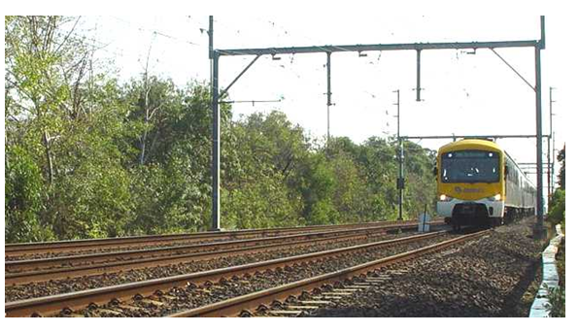

TABLE OF CONTENTS

The Chief Investigator 5

Executive Summary 7

1. Introduction 11

1.1 Background 11

1.2 Platform overruns in February and March 2009 11

1.3 Scope of investigation 12

2. The Nexas Electric Multiple Unit 13

2.1 Configuration overview 13

2.2 Procurement 15

2.3 Fleet Operations 19

3. The Ormond Overrun on 25 February 2009 21

3.1 Circumstances 21

3.2 Environmental conditions 24

3.3 Infrastructure 24

3.4 The train 31

3.5 Wheel-rail interface 34

3.6 Operation of the train 35

3.7 Network risk management 36

3.8 Ormond simulation 37

4. Generic Factual Information 39

4.1 Introduction 39

4.2 Event history 39

4.3 Environment 40

4.4 The nature of adhesion 41

4.5 Infrastructure 43

4.6 Nexas physical characteristics 45

4.7 Nexas braking in low-adhesion conditions 50

4.8 Other (post-acceptance) testing of the Nexas 52

4.9 Train handling 54

5. Analysis 57

5.1 Overrun incidents 57

5.2 The wheel-rail interface and adhesion 58

5.3 The factors influencing available adhesion 59

5.4 Train braking control systems 61

5.5 Train handling 62

5.6 Network risk management 63

5.7 Rolling stock procurement 64

5.8 Testing of the Nexas following an overrun event 65

5.9 Delay in resolution of issues associated with platform overrun 65

6. Conclusions 67

6.1 Scope 67

6.2 Findings 67

6.3 Contributing factors 68

7. Safety Actions 69

7.1 Safety Actions advised by the rail operator 69

7.2 Recommended Safety Actions 70

The Chief Investigator

The Chief Investigator, Transport Safety is a statutory position under Part 7 of the *Transport Integration Act 2010*. The objective of the position is to seek to improve transport safety by providing for the independent no-blame investigation of transport safety matters consistent with the vision statement and the transport system objectives.

The primary focus of an investigation is to determine what factors caused the incident, rather than apportion blame for the incident, and to identify issues that may require review, monitoring or further consideration. In conducting investigations, the Chief Investigator will apply the principles of ‘just culture’ and use a methodology based on systemic investigation models.

The Chief Investigator is required to report the results of an investigation to the Minister for Public Transport or the Minister for Ports. However, before submitting the results of an investigation to the Minister, the Chief Investigator must consult in accordance with section 85A of the *Transport (Compliance and Miscellaneous) Act 1983*.

The Chief Investigator is not subject to the direction or control of the Minister in performing or exercising his or her functions or powers, but the Minister may direct the Chief Investigator to investigate a transport safety matter.

Executive Summary

The Siemens-manufactured Nexas[1] train was first introduced into service on the Melbourne metropolitan train network in 2003 as part of a program to upgrade the ageing suburban fleet. Its procurement and subsequent operation spans three rail operators: National Express Group Australia, Connex and MTM (Metro Trains Melbourne).

Since its introduction, the Nexas has been involved in a relatively high number of reported overrun events when compared to other types of train operating on the network. The six platform overruns between 8 February and 3 March 2009 suggested that systemic issues remained unresolved and triggered this investigation. In the event at Ormond Railway Station on 25 February 2009, the train overran the platform by about 250 metres and entered the North Road level crossing before the boom barriers had fully lowered. There were further reported overrun events in 2009, 2010 and in 2011 prior to the finalisation of the report.

The investigation examined the Ormond event, the broader history of overruns and other investigative material related to overrun on the Melbourne network. During the investigation it became evident that the proportional contribution of factors would have varied between events and that the investigation should take a holistic view of overrun events in its identification of those factors most likely to have contributed.

The investigation concluded that the predominant condition associated with the overrun events was the presence of low levels of adhesion between wheel and rail. In considering this condition and other factors potentially contributing to platform overruns, the investigation explored five thematic areas: the environment, the track, the train, train handling and network risk management.

*The Environment*

The majority of overrun events have occurred with rail head moisture resulting from light rain or dew. The investigation concluded that moisture combined in particular proportion with rail head contaminants such as iron oxides and mineral clay produces a liquid suspension sufficient to result in low coefficient of friction conditions including instances of low shear strength within the interfacial layer[2]. Environmental conditions that encourage the formation of such a medium are seen as the typical pre-condition for the development of low levels of adhesion between wheel and rail on the Melbourne metropolitan network.

*The Track*

The contact conditions and the level of adhesion between wheel and rail can be influenced by the track geometry and the rail head profile. The investigation concluded that the condition of the track was generally within the tolerances defined for the network and while its condition may have contributed in some instances, the track was unlikely to have been highly contributory to the frequency of overrun events. However, the investigation did conclude that maintaining track in ideal condition would contribute to maintaining a good wheel-rail contact interface with the potential to optimise braking performance.

*The Train*

The higher relative frequency of overrun events involving Nexas trains suggested that characteristics of the train or the train’s interaction with its operating environment were contributory. The investigation concluded that there was no identified defect on Nexas trains involved in the overrun events but as an integrated system the Nexas was more prone to overrun than other types of train running on the network. Those features of the train identified as most likely to be contributing to the overrun events related to the train’s influence on adhesion between wheel and rail and the response of the braking system during a wheelslide event.

Train features potentially impacting adhesion are those that can affect the wheel-rail contact conditions and the interfacial layer. Such features include the wheel’s geometric interface with the track, wheel surface condition, axle loads and braking equipment configuration. The investigation concluded that, when compared to the X’Trapolis, the other late-model train operating on the suburban network, the most significant differentiating factor affecting the wheel-rail interface was the use by the Nexas of disc brakes for friction braking and the absence of tread brakes. Disc brakes do not provide the wheel conditioning and adhesion enhancing qualities of tread brakes that act directly on the wheel tread surface to remove friction modifying contamination. As an integrated system, other physical features of the train such as weight may also have contributed to the formation of low-adhesion conditions at the wheel-rail interface.

The second area to have potentially contributed to overrun was the braking system’s response to a wheelslide event. The Nexas is fitted with WSP (wheelslide protection) systems to manage braking performance in low-adhesion conditions. The investigation found that the WSP associated with the EP (electro-pneumatic) friction braking system had been proved by independent testing to have no design or software-related defect and to have performance comparable with similar (bogie-controlled) systems. However, the investigation concluded that the bogie-controlled WSP system is inherently less capable than more refined axle-controlled systems. It was also identified that during a severe wheelslide event as may occur under braking in low-adhesion conditions, there can be a lag in braking effort during and after the transition from ED (electro-dynamic) to EP braking while the system attempts to bring axle rotation back to train speed and recover its estimate of ground speed. High levels of wheel creep[3] during a wheelslide event may also exacerbate the loss of braking effort by reducing the available adhesion at the wheel-rail interface.

*Train handling*

The investigation concluded that driving techniques could in some instances have contributed to the onset of wheelslide and an overrun event. The very good dry braking performance of the Nexas may have established high driver expectation and heavy braking in more difficult conditions can induce early transition to WSP-assisted braking. Enhanced guidance for driving in adverse conditions was developed in 2008. However, the investigation concluded that train handling in adverse conditions could continue to be improved by providing drivers with a deeper understanding of the train’s braking systems and more specific guidance on operational practices in reduced-friction conditions.

*Network risk management*

The management of train operations provides the opportunity to minimise the frequency of overrun and the potential for adverse consequences. To this end the previous network manager, Connex, and the current manager, MTM, have used a number of strategies to mitigate risk associated with platform overrun. This has reduced the frequency of overrun. However, the investigation concluded that at the time of the Ormond incident on 25 February 2009 there remained the potential for severe consequences and that the network risk management systems that were in place were inadequate.

*Other investigation conclusions*

The investigation found that performance requirements for braking in low-adhesion conditions were not adequately defined within the procurement documentation for the train. The investigation also found that acceptance testing did not fully verify the braking performance of the Nexas for some conditions that were later to be experienced in service.

The investigation concluded that the purpose of conducting full wet-track testing of trains involved in an overrun event was unclear. To date, in no case of post-overrun testing has a Nexas train been found to have had a defect that significantly contributed to the event. Train behaviours are systemic to the fleet and not particular to individual car-sets.

*Safety actions taken since the events*

Following the overrun events in February and March 2009, the rail operators introduced new operating procedures and reinforced a number of others. Such mitigating strategies have included speed restrictions for Nexas trains at several locations. The roll-out of defensive driving training to existing drivers was also completed in 2009.

MTM has advised that sanding devices[4] have been fitted to the Nexas fleet, with implementation completed on 18 June 2011. MTM has concluded that based on international experience and local testing, the application of sand to the wheel-rail interface should eliminate most overruns caused by low-adhesion conditions.

*Recommendations*

The investigation makes recommendations to Metro Trains Melbourne in the areas of train performance monitoring, track condition monitoring and driver training.

The investigation makes recommendations to the Department of Transport and Metro Trains Melbourne in the area of rolling stock procurement, including the definition of performance requirements and whole-of-train acceptance criteria.

# Introduction

## Background

The Nexas was introduced into service on the Melbourne metropolitan network in 2003; the type name having been derived from the original project customer, National Express Group Australia. This name subsequently fell out of use and was not replaced. However, given the absence of any other train model descriptor, Nexas is used throughout this report to designate the Siemens-manufactured trains delivered for the Melbourne metropolitan network between 2003 and 2006.

Since its introduction, the Nexas has been involved in a relatively high number of reported overrun incidents when compared to other train types on the network. Concerns increased in late 2006 and early 2007 after a series of platform overrun events that also led to a significant number of Nexas trains being temporarily withdrawn from service. These overruns resulted in more intensive investigations by the rail operator (at that time Connex), the train manufacturer and the braking system supplier, with a range of potential contributing factors being identified.

As a result of the investigations during 2007, a number of remedial actions were taken and the frequency of Nexas platform overruns was less between mid-2007 and early 2009. The rail operator had also implemented a number of mitigating strategies to manage potential outcomes associated with platform overrun events.

Reduced braking performance in low-adhesion conditions is an acknowledged part of rail operations. However, the recurring incidence of platform overrun in damp conditions but with often no other obvious rail head contamination has for some time suggested the existence of underlying system issues.

## Platform overruns in February and March 2009

Between 8 February and 3 March 2009, Nexas trains were involved in a further six platform overrun incidents at four locations. The overrun on the Down[5] line at Ormond on 25 February resulted in the train entering the road level crossing before the boom barriers were fully lowered. This was the only platform overrun incident of the six for which data relevant to the event was captured by the driver correctly activating the train data recorder. Of the other five reported incidents, there were two platform overruns of almost the six-car train length at Ormond on 8 February 2009. Both of these were in the Down direction but on the Centre line. There were overruns of less than a train-car-length at Noble Park and Yarraman on 8 February and Murrumbeena on 3 March 2009.

## Scope of investigation

In the context of a history of platform overrun events involving Nexas trains, the cluster and nature of overrun events during February and March 2009 was the trigger for this investigation. Of the six overruns, the investigation examined the event at Ormond on 25 February more closely due to the availability of recorded data.

In recognition that there have been a number of overrun events over a long period of time, the investigation also examined more broadly the background to braking performance and factors associated with environmental conditions, the track, the train, train handling and network risk management.

The investigation recognises that a number of parties, including the rail operators, have expended significant resources in an effort to reduce the frequency of train overruns on the Melbourne network. The investigation has not sought to duplicate these other investigations.

The accredited rail operator changed from Connex to Metro Trains Melbourne during the course of this investigation. The investigation has sourced information from both organisations.

# The Nexas Electric Multiple Unit

## Configuration overview

### Cars and bogies

The three-car Nexas EMU (Electric Multiple Unit) consists of two driving motor cars (DM-cars) either end of a non-powered trailer car (T-car). Two three-car trains can be coupled together to form a six-car set. The design of the Nexas would not have been considered novel as it drew on similar designs supplied by Siemens to other parts of the world.

The primary carbody structure is described by the manufacturer as being an integrated design providing a high level of reliability with minimum maintenance. The carbody is a self-supporting monocoque structure constructed of stainless and various other grades of steel. It is based on designs used for a number of other metropolitan rail systems.

The Nexas uses the same types of bogies as have been used on trains supplied to Slovenia, Greece and Brazil. Car bogies and suspension are designed to support, guide and suspend the car body and to drive and brake the cars. Each DM-car is equipped with two motor bogies and each T-car is fitted with two (non-powered) trailer bogies. Suspension system design including stiffness and damping characteristics was optimised for stability and ride quality using proprietary software and other modelling software developed in-house by Siemens.

### Braking system

Service braking is achieved using an ED (electro-dynamic) braking system, blended with or supplanted by an EP (electro-pneumatic) braking system, as required. Braking control systems are used to manage the application and blending of the ED and EP systems with braking effort varied to compensate for the passenger load. Emergency braking uses the EP system only. This braking philosophy and the use of a combination of systems are typical for a modern EMU.

The ED system uses the traction motors on the DM-car bogies to provide retardation force to the EMU. When braking, the kinetic energy of the motors is converted into DC power that is fed back to the overhead line (regenerative braking) or dissipated at the braking resistor (rheostatic braking). To assist the management of wheelslip (under traction power) and wheelslide (under braking) in low-adhesion conditions, the ED system is fitted with a wheelslip and wheelslide protection system. An input to this system is the estimated train’s speed Vref (reference velocity) that is based on the axle speed most likely to be representative of the train’s actual speed.

The EP system utilises friction braking to provide retardation force to the EMU. The microprocessor controlled system is supplied by Knorr-Bremse GmbH and uses the pressure-application of brake pads onto discs mounted on the inner and outer sides of each wheel. For management of braking effort in low-adhesion conditions, the EP system is fitted with WSP (wheelslide protection) controlled on a per-bogie basis. This means that the system reduces braking effort across both axles of a bogie if the wheels on either axle begin to slide beyond acceptable limits.

The train is also equipped with a park brake with the actuators being spring-applied. Air pressure from the main air reservoir is used to hold the actuators in the released position during normal driving operations.

Driver operation of the service braking (and traction) system is via a master controller with stepped braking through a series of notches. Emergency braking can be applied by pushing the master controller fully forward or by using a separate, panel-mounted push-button.

### Original braking concept

In dry conditions braking would be undertaken using the ED system on the DM-cars only, except when EP braking was required to supplement braking effort from higher speeds and at very slow speeds as the ED becomes ineffective. In low-adhesion conditions leading to transition from ED to EP, the EP braking on the T-car would be introduced. This braking concept was applicable to the first train delivered (in 2003) and is shown in Figure 1.

|  |  |  |  |
| --- | --- | --- | --- |
|  | **Leading DM-car** | **T-car** | **Trailing DM-car** |
| **Dry track** | 50% in ED | Nil | 50% in ED |
| **WSP leading DM** | 33.3% in EP | 16.7% in EP | 50% in ED |
| **WSP trailing DM** | 50% in ED | 16.7% in EP | 33.3% in EP |
| **WSP all cars** | 33.3% in EP | 33.3% in EP | 33.3% in EP |

Figure 1 - Braking concept showing the preference for DM-car braking when feasible

### Modification to the braking concept

There have been a number of modifications to the braking arrangements since the first delivery including changes to the control systems, software and system functionality. One of the key changes to the braking system was the introduction of braking across all cars in all braking scenarios. In June 2008 following extensive assessment of the Nexas’ braking performance, the braking control systems were modified to incorporate balanced braking across all vehicles, including T-cars (see Figure 2).

|  |  |  |  |
| --- | --- | --- | --- |
|  | **Leading DM-car** | **T-car** | **Trailing DM-car** |
| **Dry track** | 33.3% in ED | 33.3% in EP | 33.3 in ED |
| **WSP leading DM** | 33.3% in EP | 33.3% in EP | 33.3 in ED |
| **WSP trailing DM** | 33.3% in ED | 33.3% in EP | 33.3% in EP |
| **WSP all cars** | 33.3% in EP | 33.3% in EP | 33.3% in EP |

Figure 2 - Braking concept following the introduction of balanced braking across the trainset

The objective of introducing T-car braking in all scenarios was to reduce the level of braking effort on the DM-cars and in so doing reduce the adhesion threshold at which the system activated its WSP. Once under full EP braking, the operation of the braking system is unchanged from the initial design configuration.

All trains involved in the overruns in February and March 2009 were configured in this way, with balanced braking across all cars for all braking scenarios.

### Data recorder

The data recorder fitted to the Nexas is capable of collecting a limited amount of data associated with events to assist with the maintenance of the vehicles. At the time of vehicle procurement there was no contractual requirement to fit an event recorder. A contract variation was issued in 2004 to utilise the basic maintenance data logger within the traction control system. If an event occurs, the driver is required to activate the recorder (by push button) which will then capture and store data for about the last kilometre of distance travelled. If the button is not pushed following an event, this data will be overwritten.

A program exists to fit all trains in the metropolitan fleet with the Vigilance Control Event Recorder System (VICERS) with the aim of enhancing data collection for train operations, maintenance and events. This system is not yet fitted to the Nexas.

## Procurement

### Context

In 1998, the operational areas of the State Public Transport Corporation were split into five separate businesses in preparation for privatisation. In 1999, the Melbourne metropolitan rail network was franchised to two operators; the National Express Group Australia operating as Bayside Trains and Melbourne Transport Enterprises (Connex) operating as Hillside Trains. Each operator was responsible for a part of the metropolitan network.

Both operators sought to replace the aging Hitachi trains in their fleets; National Express ordering the Siemens Nexas and Connex ordering the Alstom X’Trapolis.

In 2002, National Express decided it would no longer operate its franchise, leaving its metropolitan train services in the hands of receivers. A new franchise was negotiated with the remaining operator, Connex, to operate the entire Melbourne metropolitan train network from April 2004, including the management and operation of the Nexas fleet.

### The purchase

National Express had ordered 62 three-car Nexas trains and Connex ordered a further 10 three-car sets after taking over the franchise for the complete network, bringing the total order to 72.

The first three-car Nexas EMU achieved provisional acceptance in February 2003 and the first Nexas operated from Flinders Street Station in April that year. The last three-car set was delivered in 2006.

### Technical governance

Technical oversight of the delivery of the Nexas EMU was undertaken by an Independent Certifier (an appointed rail industry consulting firm) and a Review Panel comprising representatives of the Contractor (Siemens), the Director of Public Transport, the Lessee (National Express[6]) and the Purchaser (GATX Rail[7]). The functions of the Review Panel included providing guidance and advice to the Independent Certifier and reviewing methods and strategies adopted by the Independent Certifier.

The oversight by the Independent Certifier and the Review Panel included the review of test plans and verification that the vehicles complied with the requirements of the Manufacture and Supply Agreement[8]. This verification culminated in the Independent Certifier issuing acceptance certificates. The Review Panel, acting unanimously, could instruct the Independent Certifier to issue an acceptance certificate[9].

### Contract specifications addressing braking systems and performance

At the time of contract, the technical specification stipulated a full-service braking rate of 1.0 m/s2 and an emergency braking rate of 1.3 m/s2. The maximum full-service rate was subsequently reduced to 0.9 m/s2 in July 2003 with the aim of lowering the adhesion threshold at which the WSP system would be activated during full-service brake applications in low-adhesion conditions. In the case of EP braking, the specified rates were defined as being time-averaged and measured over the stop after 90 per cent of the commanded brake cylinder pressure had been achieved. The specification quoted the braking rates as being the expected braking performance with existing infrastructure. In other parts of the technical specification, the same braking rates are quoted but with the qualifier that rates were “net rates on clean, dry, well maintained level track”. There was no requirement or test criterion specified for braking in low-friction conditions.

Contract specifications described how service braking would be achieved using the ED and EP systems The specification also described the WSP (wheelslide protection) systems in braking and noted that the WSP of the EP system would be performed on a ‘per-bogie’ basis. There was a number of functional specifications that further described the train’s systems although none included any additional or expanded braking performance requirements.

Neither the *List of Standards* nor the *List of Test Standards* that were included within the contract documentation identified standards directly applicable to whole-of-train braking performance and testing. Detailed testing procedures were to be developed during the project and, specifically, the Contractor was to develop a test plan setting out the processes and procedures applicable to testing prior to vehicle acceptance. Testing was to be based on ‘Testing Principles’ defined within the contract.

### Acceptance testing

Whole-of-train braking acceptance testing was preceded by factory type testing, static tests and other system tests and checks. The EP braking system supplier advised that the commissioning of its EP control systems included the fine-tuning of settings to optimise system performance.

The whole-of-train braking trials were conducted in accordance with test specifications and procedures developed by the manufacturer and approved by the Independent Certifier. Testing in low-adhesion conditions was conducted in accordance with the *Test Procedure Slip Slide Functionality Onsite Type Test*. Slip criteria apply to an EMU when in traction (powering) and slide criteria apply to braking. The stated purpose of the test procedure was to verify that the slip and slide protection requirements of the train were in compliance with the following four documents, described below:

1. IEC 1133[10], Clause 6.5.7

The IEC is an international standard for the testing of electric rolling stock. It is mostly written at a high level and is not overly prescriptive. Clause 6.5.7 states in part that “where the braking system includes a wheelslide protection device, the braking tests shall be carried out with the device in operation, reducing the adhesion by artificial means as agreed between user and manufacturer”. It then describes an ethylene glycol and water mixture which can be used to simulate such conditions.

1. Contract documentation *Schedule 1 Chapter 2, Technical Description* clauses 11.7.8 and 14.4.5

These clauses are references to the contracted technical description and provide general commentary on the wheelslide protection system. They do not contain detailed performance requirements.

1. Contract documentation *Schedule 14, Test Principles*

This schedule provides the principles against which the Specific Test Plan was to be developed. The schedule scopes type-testing on components and systems and type-testing and routine testing of complete vehicles at standstill and moving. For deceleration and stopping distances, the type-testing scope identifies IEC 1133 Clause 6.5 *(Line braking tests)* and the routine testing scope identifies the IEC Clauses 6.4.2 (which pertains to traction and acceleration) and 6.5.4 *(Method of measuring stopping distances)*. The schedule also specifies that the routine testing on railway line is to include a running test without passengers for 2500km of reasonable operation of approximately six hours per day to determine that each unit is fit for passenger services and in compliance with contract specifications.

Section 6.5 has some scope for interpretation. Clause 6.5.2 states that “… type tests are first carried out on dry track, and then on wet track, or on a track where adhesion conditions have been artificially degraded to simulate actual conditions to be found in service …” but is not otherwise explicit in the nature of and performance measurement in low-adhesion conditions.

1. Efficiency of slip/slide protection A52834-E0315-U996

This is a Siemens document that describes how an *efficiency factor* is derived. In braking, the efficiency factor is derived by comparing the actual deceleration with an ‘ideal’ deceleration, integrated over the time domain. ‘Ideal’ deceleration is assumed to occur at the points of peak deceleration, with ideal deceleration between these points calculated by interpolation. A premise of this assumption is that at each peak in deceleration, full use is being made of available adhesion at the wheel-rail interface.

Brake testing was to be conducted under simulated low-adhesion conditions by spraying the rails with a solution following IEC 1133, Cl. 6.5.7 or UIC 541-05 OR[11], item 2.3. Each braking mode was to be tested separately; specifically the electric brake (ED), friction brake (EP), blended brake (ED + EP) and the emergency brake (which utlises the EP system). The pass/fail criteria were specified as:

1. No (wheel) flat-spots occur;
2. No blocking of wheels occurs;
3. The train decelerates steadily;
4. The wheel slip does not exceed 50 per cent of the reference velocity for more than three seconds (this applies to speeds above 5 km/h for braking involving EP); and
5. A minimum efficiency factor of 75 per cent is achieved.

The first-of-type testing was conducted in October 2002 on a three-car unit in an empty condition (AW0[12]). For the testing of the wheelslide protection systems, 12 runs were undertaken; three for each braking mode. The investigation has estimated that average wheel-rail adhesion for the nine service braking tests was mostly in the range of 5 to 8 per cent, whereas the three emergency braking tests appear to have had levels of adhesion in excess of 10 per cent. In all cases, the pass/fail criteria were satisfied and the efficiency factor found to exceed the test criterion of 75 per cent by a significant margin. In all cases except one, the calculated efficiency factor was over 90 per cent.

Notwithstanding the results of the formal type testing, the Independent Certifier and Review Panel sought further verification of braking performance in wet conditions and additional tests were conducted.

### Acceptance certificates

On 7 February 2003, the Independent Certifier was directed by the Review Panel to issue an EAC (Early Acceptance Certificate)[13] for the first car-set, then on 28 February a PAC (Provisional Acceptance Certificate)[14] was issued for each set of the first tranche of eight three-car sets.

At the time of this provisional acceptance, there remained concerns with braking performance in wet conditions and wet-track brake testing continued for several months. It was acknowledged at the time by Siemens and the Review Panel that further work was required to resolve outstanding braking issues. This work, which included system modification, was effectively separated from the certification process.

In November 2003, the Review Panel instructed the Independent Certifier to issue FACs (Final Acceptance Certificates) for the first tranche of eight three-car sets when they had completed 3 months or 40,000 km in operational service. The Review Panel instructed the Independent Certifier to issue the FACs for the second tranche of eight three-car sets in February 2004.

## Fleet Operations

Nexas trains make up about 25 per cent of the combined metropolitan fleet. They operate on the Pakenham, Cranbourne, Frankston, Sandringham, Williamstown, Werribee, Craigieburn, Sydenham and Upfield lines. The fleet is maintained by Siemens Australia under contract to the rail operator.

# The Ormond Overrun on 25 February 2009

## Circumstances

### Overview

At 0749 on 25 February 2009, the 0729 service from Melbourne to Frankston was approaching Ormond Railway Station on the Down (eastern) line. It was the first train on that track that morning. In light rain and with the train travelling at just below 80 km/h on a descending grade, the driver made a service brake application and then, when about 165 metres from the approach end of Platform 3, applied the emergency brake. The train did not decelerate as expected by the driver and continued past the platform, an automatic signal at Stop, and through the North Road level crossing. It came to rest with the rear of the train beyond the crossing on the south side of North Road. The train had overrun the platform by about 250 metres.

When the train crossed North Road the flashing light crossing protection was operating but the boom barriers had only just commenced to lower. No injury or damage resulted from this event. The passengers were detrained at the next station and the train driven to Mordialloc and impounded for later testing.

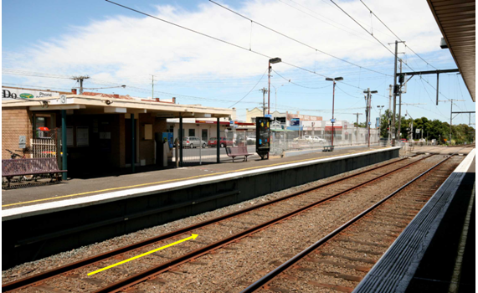

Figure 3 – Ormond Railway Station, looking towards Platform 3 and the North Road level crossing

The total event took place over about 850 metres of track. Figure 4 provides an overview of the location of key braking events from the commencement of wheelslide.

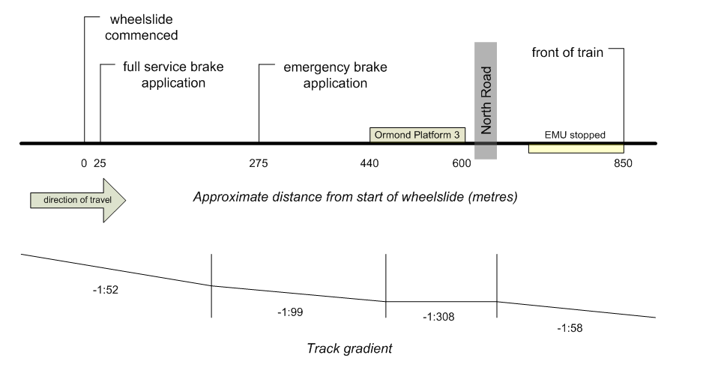

Figure 4 - Train braking and stopping points in relation to platform, level crossing and track gradient

### Ormond Station Platform CCTV

The south-facing CCTV on Ormond Platform 2 provided a clear view of the Down end of Platform 3, the North Road level crossing and the train passing through the station and coming to a stop south of the level crossing. A summary of key events recorded against the CCTV time-clock is provided at Figure 5.

|  |  |
| --- | --- |
| **CCTV Time** | **Event** |
| 07:49:07.6 | * The level crossing warning lights commence to flash. * Eight road vehicles travelling from West to East traverse the crossing while the lights are flashing and before the boom barrier arms have commenced to lower. * One road vehicle travelling from East to West stops abruptly at the halt line just before the train enters the crossing. |
| 07:49:15.3 | * The front of the train passes the Down end of the Platform 3. * The level crossing is clear of road vehicles and pedestrians but the boom barrier arms are still raised. * Passengers arriving at the island platform are aware of the Down train and are watching its progress through Platform 3 and onto the crossing. |
| 07:49:16.3 | * The front of the train is at the edge of the pedestrian crossing between the platform and North Road. * The boom barrier arms have commenced lowering; estimated to be at about 60 degrees to the horizontal. |
| 07:49:16.7 | * The front of the train enters the roadway. * The boom barrier continue to lower. |
| 07:49:18.6 | * The front of the train is through the crossing. * The boom barrier arms continue to lower; estimated to be at about 30 degrees to the horizontal. |
| 07:49:25.3 | * The boom barrier arms are fully lowered, with about five train car lengths having passed the end of Platform 3. |
| 07:49:28.7 | * The rear of the last car of the train clears the platform. |
| 07:49:34.7 | * The rear of the last car of the train clears the level crossing. |
| 07:49:42.9 | * The boom barrier arms commence to lift. * The complete train is on the descending grade beyond the crossing and is still moving. |
| 07:49:49.9 | * The train comes a stop with the rear of the last car about 100 metres past the Down (southern) end of the platform. |

Figure 5 - Sequence of events at North Road level crossing

## Environmental conditions

January and February 2009 in Melbourne had been characterised by hot, dry weather with devastating bushfires on 7 February and a number of other fire outbreaks during the period. Prior to the Ormond overrun of 25 February, there was a further period of hot weather and on the day before the overrun there were severe bushfires in the Daylesford area. Northerly winds had been associated with the hot weather.

The Bureau of Meteorology advised that at the time of the Ormond overrun the temperature was 16ºC with a relative humidity of 77 per cent. There was no measurable precipitation; the most recent having been on the 21 February. However, the driver of the train reported that light rain had commenced falling immediately prior to the incident, describing it as “drizzle”.

## Infrastructure

### Track and signaling configuration

Ormond Railway Station has three tracks; the Up, Centre and Down lines. The Down line passes Platform 3 which is about 160 metres long. North Road is about 18 metres from the Down end of Platform 3. A pedestrian crossing is between the platform and North Road and there is a second pedestrian crossing on the south side of North Road.

The Down line approaches Ormond from Glenhuntly and at the time of this incident had a permissible line speed of 80 km/h. The track is on a descending grade from Dorothy Avenue, about half way between Glenhuntly and Ormond, with the track gradient varying to and through Ormond as shown at Figure 4.

Rail traffic on all tracks through Ormond is controlled by the Automatic Block Signalling system with the passage of trains through the level crossing controlled by automatic signals. This system operates in either ‘Stopping’ or ‘Express’ mode depending upon the schedule of the approaching train and is designed to provide road traffic with a standard warning time[15] of 25-30 seconds.

Down automatic signal F441P is located at the departure end of Platform 3, about 20 metres before North Road. It will only clear for a train to proceed when the level crossing warning protection is detected as working and the barriers are locked in position. When the train overran the Ormond platform, signal F441P was indicating Stop as the train was scheduled to stop at Ormond. The train passed the signal (a SPAD[16] event) and was thus ‘tripped’ by the automatic train stop[17]. As the train was already in emergency braking, this had no effect.

### North Road

North road is a six-lane arterial road running east–west. The level crossing is equipped with active protection, consisting of several flashing light assemblies together with double boom barriers on both approaches. The two pedestrian crossings are equipped with pedestrian mazes and powered gates.

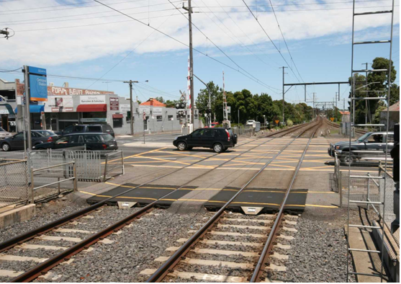

Figure 6 – Down (left) and Centre lines at North Road level crossing

### Site inspection and track measurements

The Monash University Institute of Railway Technology (IRT) was engaged to undertake an inspection and assessment of the track and the wheel-rail interface conditions at the Ormond incident site, including sampling of rail head contamination. Key elements of the IRT inspections and measurements[18] are summarised within this section.

Two sets of measurements were taken; designated Site 1 and Site 2. On the day of the overrun, track measurements were taken at Site 1; a segment of about 220 metres of track running from about 100 metres on the approach side of the platform to a point about 120 metres along the platform. Following the review of the train data-records and the identification of the point of wheelslide initiation, a second set of measurements encompassing this point was taken on 4 March and designated Site 2. This Site 2 data covered a track segment of about 225 metres in length on the more distant approach to the platform; from Dorothy Avenue bridge (550 metres before the platform) to stanchion ST424, about 325 metres before the platform.

*Track structure and geometry*

On the approach to the platform, the track was comprised of 60 kg/m rail on concrete sleepers fastened with Pandrol ‘e’ clips until about 90 metres before the start of the platform where the track structure changed to 53 kg/m rail supported on timber sleepers and double-shoulder sleeper plates and fastened with dog-spikes and rail anchors. IRT reported that in the section with concrete sleepers, track support was observed to be in good condition with no obvious defects. Throughout the timber-sleepered section, track support was observed to be in average condition.

The track alignment was generally straight with a short section of left-hand curve on the approach to the Up end of the platform. There were no significant top or line variations[19].

The wheel-rail contact band through the site was relatively central around the crown of the rail head, with some contact observed on the gauge-face[20]. A short section of cyclic gauge-face contact was also observed around the curved section of track on the approach to the platform.

The track gauge varied around the nominal rail-to-rail gauge of 1600 mm. The gauge was tight throughout the concrete sleepered section; ranging between 1594 and 1598 mm. Gauge increased through the timber sleepered area on the approach side of the platform, peaking at 1607 mm before reducing again through the platform with an average of about 1595 mm and a minimum of 1594 mm. No gauge measurement taken within Sites 1 and 2 was tighter than 1594 mm and no measurement was below the maintenance limits of gauge minus 8 mm (1592 mm), requiring monitoring, and gauge minus 14 mm (1586 mm), requiring corrective action. The maintenance limits for tight gauge used on the Melbourne metropolitan network are similar to standards used on other railways in Australia.

*Friction coefficient measurements*

Friction coefficient measurements were made using a hand-pushed tribometer. The basic operating principle of this device[21] is to progressively increase braking torque on the measuring wheel until slip occurs between the wheel and rail. The coefficient of friction is then calculated based on the peak torque measured just prior to the onset of slip.

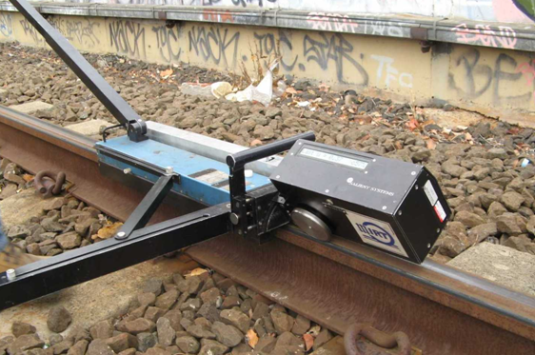

Figure 7 - Hand-pushed tribometer used for coefficient of friction measurements

Friction coefficient measurements were taken in dry and simulated wet conditions at four locations at Site 1 and two at Site 2. At Site 1, friction coefficient measurements were taken on the top (running surface) and gauge corner[22] of each rail. At Site 2, visual inspection suggested limited contact in the gauge corner region and the friction measurements were limited to the top of each rail.

The average friction coefficient measured at Site 1 for both rails under a dry (untouched) condition was found to range between 0.36 and 0.43 (arithmetic mean 0.38) on the top of the rail and between 0.26 and 0.46 (arithmetic mean 0.35) on the gauge corner.

Only a moderate reduction in average friction coefficient was achieved under simulated wet-rail conditions. The average measured friction coefficient after water was applied to the rail ranged between 0.29 and 0.39 (arithmetic mean 0.33) on the top of the rail and between 0.26 and 0.44 (arithmetic mean 0.33) on the gauge corner.

Measurements taken at Site 2 showed that under relatively dry conditions the friction coefficient was quite constant, ranging between 0.48 and 0.50 (arithmetic mean 0.50) on the top of the rail. The friction coefficient after water was applied to the running surface ranged between 0.32 and 0.40 (arithmetic mean 0.36).

The coefficient of friction measurements taken at Sites 1 and 2 were considered by IRT to be relatively typical for railway operations. The friction results were also compared with other testing done on the network following overrun events. For friction under simulated wet conditions, the mean at Site 1 was found to be the same as the previous average of network measurements and Site 2 results were slightly above the average (see Figure 8).

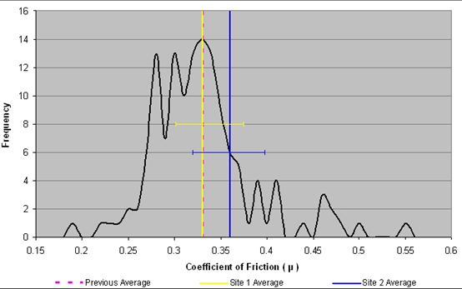

Figure 8 - Comparison of Ormond with previous network measurements (simulated wet conditions)

*Interpreting tribometer results*

The measured coefficients of friction are unlikely to fully reflect the actual coefficients at the time of the incident due to changes in environmental and rail head conditions. Even though measurements at Site 1 were taken on the morning of the incident, at a minimum the rail head surface conditions would have been affected by the passage of the train involved in the incident.

Coefficient of friction measurements using this method also differ from adhesion at the wheel-rail interface for a number of reasons. IRT commented that the friction values measured by the tribometer represent the maximum (saturation) adhesion limit present between the measurement wheel and the rail surface under low speed, longitudinal creep conditions, and portable tribometers invariably read high. IRT also commented that actual conditions at the wheel-rail interface will vary due to train speed, the contact patch and creep characteristics.

IRT commented that the friction as measured by train on-board systems may not correlate well with tribometer measurements unless the slope of the friction-creep relationship is zero (neutral friction) when operating above the saturation-full slip point (see Figure 9). Various contaminants and environmental conditions can alter the friction-creep relationship. For example, a negative slope will result in a reduction in adhesion with increasing creep past the saturation point. The tribometer does not record the level of friction either side of saturation.

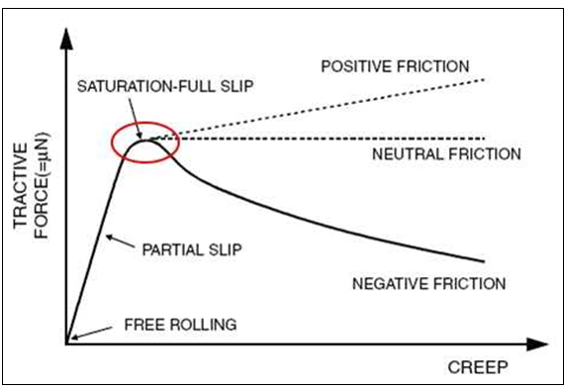

Figure 9 – The relationship between friction (expressed as tractive force) and wheel creep[23]

It is also known that as the speed of a train increases, the ‘static’ or low speed friction (as measured by a tribometer) will not be available at the wheel-rail interface. IRT estimated[24] that the friction at both sites would be reduced by about one third at a train speed of 80 km/h. Given the speed-sensitive nature of adhesion, the braking capacity should typically increase as a train slows.

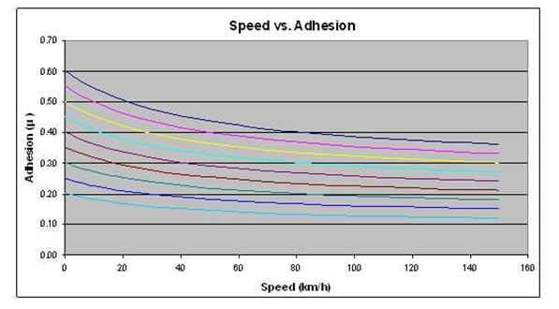

Figure 10 – The effect of train speed on the adhesion limit[25]

*Rail profile*

The section of Down track on the approach to and through the platform at Ormond was last rail-ground in June 2005. Residual grinding marks were visible outside the main wheel-rail contact band.

Measured rail profiles were assessed by aligning each of the profiles taken along the length of the rail. At Site 1, variations in profile were clearly seen around the gauge and field corners with differences in rail head height also apparent. The greatest variation was found to occur around a cyclic wear pattern observed through the curved section of track in the close approach to the platform. The plastic flow lip (see example at Figure 11) observed on the gauge corner of some rails would have contributed to the tight gauge readings measured through the site. At Site 2, profiles did not exhibit plastic flow on either the field or gauge corners. Rail through this site showed little variation in rail profile and the overall variation in gauge was also relatively small (4mm). Some evidence of flange scrubbing was observed on the gauge-face of the rails.

*Rail surface condition*

Rolling contact fatigue was generally limited to plastic flow on the gauge and field edges of the older 53 kg/m rail. Most of the flow appeared to be residual damage not fully removed during grinding works. No head checking[26] or other significant surface defects were observed during the inspection.

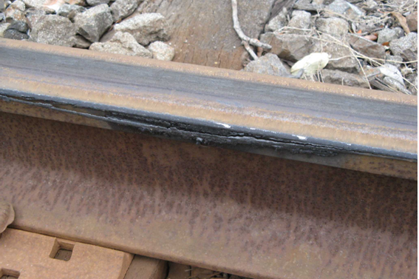

Figure 11 – Older rail in the approach to the platform, with plastic flow on the gauge corner

*Rail surface residue analysis*

Visual inspection of the Down track on the approach to and at Ormond platform did not identify any significant amounts of unusual rail head contamination such as leaf matter, grease or oils.

Scrapings from rail surfaces were taken at Site 1 on the day of the incident. Laboratory analysis found that most samples contained similar residues. The dominant material was iron oxide (rust) followed by clay particles. There were small amounts of other materials, but nothing considered to be of consequence. No organic matter of significance was detected nor were oil or related products found. The laboratory analysis also concluded that there was no clear evidence of residues that may have been due to debris associated with bushfire activity.

The analysis results were consistent with the visual observations of dark residue (iron oxide and clay) on the rail surfaces. IRT commented that under damp/wet conditions, a mixture of iron oxide and/or clay can reduce the available adhesion level at the wheel-rail interface. This condition is most critical when light rain follows a period of dry weather.

## The train

### Configuration

The train involved in the Ormond overrun was a six-car set consisting of two three-car EMUs; 715M-2508T-716M leading and 806M-2553T-805M trailing.

### Maintenance data recorder

The data recorder provided information on a number of train parameters for the final 900 metres of travel. While the initiation of braking (to step 1) was outside the range of the recorded data, there are clear records of changes to service braking, the start of wheelslide, the transition from ED to EP braking and the subsequent application of the emergency brake.

|  |  |  |
| --- | --- | --- |
| **Approximate distances** | | **Event** |
| **To stop** | **To platform** |
| >900 metres | >500 metres | * Service braking had been initiated * Speed just below 80 km/h |
| 860 m | 450 m | * Service braking to step 3 |
| 850 m | 440 m | * Drop off in reference velocity (Vref) * Measured adhesion suddenly drops to approx 3% * ED braking system ‘actual torque’ reduces |
| 825 m | 415 m | * Service braking to step 6 (maximum service) * Speed approximately 78 km/h |
| 815 m | 405 m | * Stand-by brake request (to EP brake) * ED brake system transitions out * ED WSP no longer operational |
| 575 m | 165 m | * Emergency brake application * Speed approximately 78 km/h |
| 410 m | 0 m | * Speed approximately 70 km/h |

Figure 12 – Key recorded events on the lead car (715M) on the approach to the Ormond platform

Between the initial full-service brake application and the emergency brake application, there was little reduction in train speed. Over this period of 11 seconds the train travelled about 250 metres. Those things acting to slow the train, including braking effort, were countered by the descending grade.

The investigation estimated that from the time that the emergency brake was applied to the time the train came to a stop, the average deceleration of the train was 0.4 m/s2. The deceleration varied throughout the stop and tended to increase as the train closed on the platform before decreasing again after leaving the platform and running onto the 1:58 descending grade. This 0.4 m/s2 average deceleration led to the stopping distance of about 575 metres which equates to an average adhesion of around 6 per cent assuming a braking efficiency of 80 per cent. In dry conditions under emergency braking, the EMU stopping distance from 78 km/h is about 200 metres.

The maintenance data record also showed a sharp reduction in estimated adhesion between wheel and rail to around 3 per cent[27] at the point of initiation of the slide. The train’s systems calculate an estimation of the adhesion level when the slide commences but once the system transitions from ED to EP braking, there is no further estimate. The calculation assumes the wheelslide protection system is working close to the limit of available adhesion and uses motor torque and relevant geometric and mass characteristics of the vehicle and rotating components as inputs. Siemens advised that the estimation should be considered an average and as being only informative in nature.

### Record of EP braking system activity

The BCU (Brake Control Unit) recorded event codes that indicated that both axles of the lead bogie of car 715M had locked during the event. The brake manufacturer, Knorr-Bremse, advised that these recorded events were consistent with extreme low-adhesion conditions. In an extreme wheelslide event, the braking system vents air pressure in an attempt to release the wheels and bring rotation up to parity with the speed of the train. However, if the wheels have not recovered rotation after seven seconds of brake cylinder venting, the system times out and the brakes are re-applied on those wheels. The event codes indicate that this occurred in this instance.

### Post incident train inspections

The train was inspected by maintenance personnel and no system defect or fault was found which may have contributed to the overrun incident.

*Wheel profiles*

The wheel profile is the shape of the transverse section made through the wheel tread and flange and is an important feature defining the contact between wheel and rail. In practice, different profiles may be used and are typically matched to the track and rail head profile. Alpha-numeric descriptors are used to designate a particular wheel profile and those used on metropolitan trains in Melbourne are defined in more detail at section 4.6.1.

Nexas trains running on the Melbourne network are fitted with the MP2 wheel profile. Siemens advised that car-set 715M-2508T-716M had been involved in a trial of the MP1 wheel profile but its wheels had been machined back to the MP2 profile in 2007. The investigation noted that the wheel machining history was different for each three-car set.

|  |  |  |
| --- | --- | --- |
| **Train** | **last machined** | **km since machining** |
| 715M-2508T-716M | 9 July 2007 | 149,250 |
| 805M-2553T-806M | Manufacture (2002) | 443,127 |

Figure 13 - Wheel machining history

All wheels were measured to ascertain their condition and profile and were found to be in a worn but serviceable condition. Siemens advised that over time the MP2 profile wears towards the MP1 shape.

The measurement results for car-set 715M-2508T-716M showed slightly more flange wear on the car-set’s right-hand side. Tread wear was also slightly greater on this side while flange height was relatively consistent throughout the train. The trailer car exhibited slightly less wear than the motor cars.

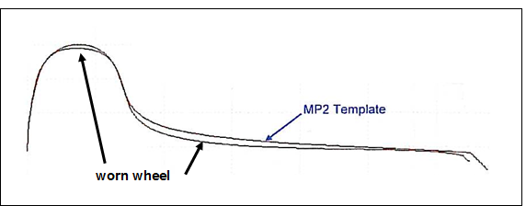

Figure 14 - The profile of the leading left-hand wheel of car 715M compared to the MP2 template

Wheel flat-spots were identified on all four wheels of the train’s leading bogie indicating that the two leading axles had been ‘locked’ (not rotating) at some stage during the slide event.

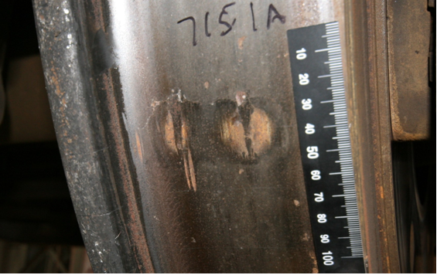

Figure 15 - Wheel flat-spots on the right-hand leading wheel

This is consistent with the recorded activity of the EP system that indicated system venting on the lead bogie, resulting in full brake application after the system had been unable to bring the wheel back up to the full rolling speed in the required timeframe.

As would be expected from its higher service life, wheel wear on car-set 805M-2553T-806M was significantly greater. Wheels on both sides of the car-set had relatively even flange wear. Tread wear and flange height were also relatively consistent. Again the trailer car exhibited less wear.

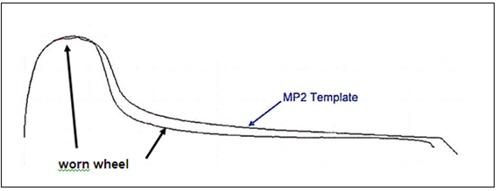

Figure 16 – The profile of the leading left-hand wheel of car 806M compared to the MP2 template

## Wheel-rail interface

For the most part, the contact between wheel and rail was found to be reasonably central to the rail head. A typical worn MP2 profile was used to examine the contact band at different locations along the approach to Ormond Railway Station and through the platform.

In the area of initial slide with newer rail, the contact between wheel and rail was found to be central and consistent along the length of Site 2. On the older track at the close approach to and through the platform, there was less consistent contact but nonetheless, a continuing central contact band. There was some evidence of cyclic wear, which would correlate with a laterally varying point of contact.

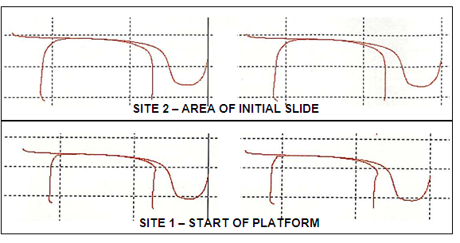

Figure 17 - Worn MP2 wheel contact with rail in the initial area of slide (top) and at start of platform

## Operation of the train

### Driver experience and qualifications

The driver became qualified to drive on the Melbourne metropolitan network in November 2001. At the time of the Ormond incident, he was permitted to perform driver duties on all types of suburban trains on the network and was last audited in December 2008, with no issues being identified. The driver had also been assessed as medically fit to perform driver duties.

The driver had not completed the Block 18 continuation training incorporating the *Brake Handling and Defensive Driving Techniques* booklet (see section 4.9.1) prior to the Ormond incident. This training was completed on 12 March 2009.

### Driver interview

The driver advised that he was based at Frankston and had been driving Nexas trains for about 18 months. He said that he found them to be a good train and that he had not previously experienced any problems with their operation. On the day of the incident the driver commenced his shift at 0251 and was due to complete it after driving the 0729 service from Flinders Street Station to Frankston. For this service, the driver was accompanied by a supervisor conducting infrastructure audits.

He said that the operation of that train was normal up until and including the arrival at Glenhuntly Railway Station. After departing Glenhuntly, the driver accelerated the train to 70 km/h and then allowed it to pick up speed to 75 km/h. After passing over the Dorothy Avenue bridge, the driver applied braking to slow the train in preparation for the stop at Ormond. He reported that the train did not respond and that he immediately increased the brake application 2 to 3 notches and then more, but the train did not respond. He then applied the emergency brake, which he said was done before reaching signal F425 (about 250 metres from the Ormond platform). He said that the train continued through the station and across North Road before stopping with the last car about 150 meters past the crossing. The driver said that when the brakes did take effect the train braking performance appeared to him to be normal.

The driver said that after the train stopped, he was unable to contact the train controller at Metrol on the train radio and used his mobile phone. After being approved to move the train he drove it to McKinnon Station where the passengers were detrained. The driver said that en route to McKinnon he tested the brakes and they operated normally. The train was subsequently driven at reduced speed to Mordialloc where it was stabled.

At interview, the driver commented that when he undertook conversion training to the Siemens train he believed that the training was not as extensive as it should have been in that he was not given adequate information on the technical aspects of the train.

### Record of train operation

The maintenance data record includes information on the brake applications made on the approach to Ormond station. The brake setting was in step 1 when the train was 500 metres from the platform and the train travelling at just below 80 km/h. The train had just traversed Dorothy Avenue Bridge and reached a 1:52 descending grade. The driver then applied more braking; moving from step 1 to full-service braking (step 6) over about two seconds and a distance of around 45 metres. The wheels had begun to slide as the controller was moved through step 3. About 250 metres and 11 seconds later, the driver applied the emergency brake.

## Network risk management

### Risk mitigation by network manager prior to February 2009

Due to the history of overrun in the preceding years, the rail operator had implemented a number of control measures to manage risk associated with overrun events although most of the operational restrictions had been removed prior to the Ormond overrun.

The rail operator provided the following summary of control measures implemented prior to the overrun events in February 2009:

1. Siemens operation risk assessment undertaken.
2. Siemens trains restricted to six-car running.
3. BCU/TCU software changes. Balanced braking incorporated into brake software version 5.1.
4. 25 km/h speed restrictions put in place for all level crossings, special instructions for approach speed to signals at Stop and nominated curves - removed 27/07/2007.
5. 40 km/h speed restrictions put in place for all level crossings, special instructions for approach speed to signals at Stop and nominated (curves) ….... - introduced 27/07/2007 and removed 19/09/2007.
6. Selected level crossings altered for express running (Track Circuit alteration for approach clearing of selected level crossings).- removed 04/10/2007.
7. Signaller operating procedures implemented for signalboxes that a Track Circuit alteration (as in 6 above) that could not be changed – removed 04/10/2007.
8. Stage 18 driver training ‘Brake Handling and Defensive Driving Techniques’ implemented.
9. Monitoring of speeds and random speed checks.
10. Driver advisory notices and safety bulletins issued.
11. All trains involved in an Overshoot subject to full brake testing procedures before re-entry into revenue service.

The only operational control measure remaining at the time of the Ormond incident was the requirement to run Nexas trains as six-car sets (item 2).

## Ormond simulation

On 31 March 2009, the rail operator conducted a series of tests at Ormond using the same train as that involved in the incident. Three test-runs were conducted; the first in dry conditions and two subsequent runs in simulated wet conditions using water spray apparatus fitted to the front of the train. The climatic conditions for the test were fine and sunny.

For the trials, an emergency brake application was made at the point estimated by the rail operator to be the point of emergency application during the overrun on 25 February. In all three tests the train braking performance was satisfactory, with only small variations in stopping distance. In the dry test the train stopped in approximately 175 metres from an initial speed of 76 km/h. In the ‘wet’ tests the train stopped in about 217 metres from 81 km/h and 206 metres from 78 km/h.

IRT was tasked by the investigation with the measurement of rail head friction levels for each test run. Using the hand-pushed tribometer, the average (arithmetic mean) coefficient of friction was found to be above 0.40 for all tests and higher than the levels measured on the day of the Ormond event. The investigation noted that the measurements taken may not have been fully representative of the conditions experienced by the train due to the conditioning of the rail by its passage and the rapid drying of the rail following each test run.

The investigation was also advised that following the overrun incident and prior to the simulation, the rail head on this section of track had been ground, the leading wheel-sets of unit 715M had been machined to remove flat spots and there had been heavy rain that would have assisted in cleaning the rail head.

The investigation concluded that the tests were of limited value due to differences between the test conditions and the conditions on the day of the incident

# Generic Factual Information

## Introduction

The investigation examined the broader history of overrun events and the generic material associated with the environment, the track, the train and its operation and network risk management. This section is a collation of additional factual information relevant to the factors that may have contributed to the higher relative frequency of overrun incidents involving Nexas trains on the Melbourne metropolitan network.

## Event history

### History of overrun events prior to February 2009

There have been intermittent issues with the braking performance of the Nexas train since its introduction in 2003. In the early years there were a number of platform overruns with the most significant being an incident at Williamstown Railway Station on 15 June 2004, when an early-morning Down train overran the platform and impacted the end-of-line baulks[28]. In its investigation of this incident, Connex concluded that the rail head conditions were of a low standard in that the rail had been reused and exhibited some top wear and heavy plastic flow. The Connex investigation also concluded that the combination of the wheel profile (MP2) and adverse rail head conditions provided a reduction in the wheel-rail contact area. It was reported that this, combined with rail contamination and adverse weather conditions, had resulted in a reduction in braking performance.

Following a spike in overrun frequency between November 2006 and January 2007, the rail operator commenced further investigations into overrun events. More detailed records of platform overrun had been kept since March 2006 and a review of overrun events from March 2006 to the end of January 2007 found that there had been 64 reported overrun incidents involving Nexas trains compared to two Comeng, one Hitachi and nil X’trapolis. Forty overrun events (39 Nexas) had occurred in the period November 2006 to January 2007.

For the remainder of 2007 (February to December) there was a total of 30 reported overrun events comprising 18 Nexas, 10 Comeng and two unidentified trains. In 2008 there were a further 20 overrun events (11 Nexas, five Comeng, three X’Trapolis and one unidentified). Only three of these events occurred in the second half of the year, the last on 19 December. There were no further events until 8 February 2009; the first of the six events that triggered this investigation.

### Overrun events since 3 March 2009

Since the overrun at Murrumbeena on 3 March 2009, there were a further 32 reported overrun incidents up to 30 June 2010, the end date of the data set examined in this investigation. Of these events, 21 involved Nexas trains, 10 involved Comeng trains of disc and tread brake type, and one involved an X’trapolis. There were further reported overruns in the second half of 2010 and the first half of 2011 prior to the finalisation of this report.

### Trends

Data for the period March 2006 to June 2010 indicates a mostly downward trend in the number of reported overrun events involving the Nexas train. A small increase was evident in the first half of 2010, driven to a large extent by a cluster of eight reported events between 6 and 9 March. Over this four year reporting period, the lowest number of events occurred in the months of July through to October.

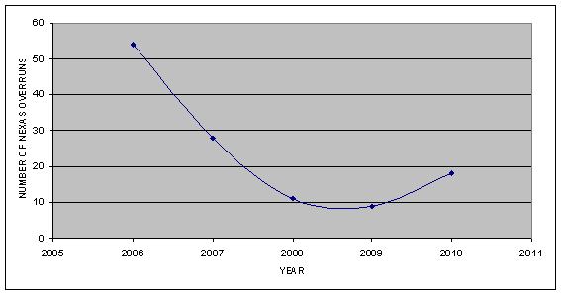

Figure 18 - Nexas overruns in years 2006 (from March) to 2010 (to June)

Reported overrun events occurred predominantly on descending grades or level track conditions. The investigation estimated from available records that for around 50 per cent of the overruns, the approach to the platform and/or through the platform was on a descending grade, whereas the grade was ascending in only about 10 per cent of cases.

Overrun events were reported as having occurred in both wet and dry conditions. However in the majority of cases, and particularly those involving Nexas trains, there were reports of light rain, drizzle, dew or generally wet and slippery conditions.

## Environment

Environmental conditions are known to influence the available adhesion at the wheel-rail interface. Specifically, the presence of moisture (particularly in combination with rail head contamination) can promote a layer of slurry and produce slippery conditions.

In the case of overrun events on the Melbourne network, there is consistent reporting of light rain, drizzle or dew being present. There is also evidence suggesting that slippery conditions often occur after a period of warm weather and with the onset of the first light rains. In no case was the presence of heavy rain reported. Leaf matter can sometimes be associated with low-adhesion conditions, however leaves or overhanging foliage was not often reported as being present at an event. The rail operator’s incident data did not indicate the presence of oil or grease on the rail head, although Siemens indicated that they had received reports of malfunctioning infrastructure greasing equipment and of other trains dropping oil on the rail head.

## The nature of adhesion

### Introduction

A minimum level of adhesion between a train’s wheels and the running surface of the rails is necessary for safe and reliable operation. When powering, adhesion (sometimes referred to as traction*[29]*) allows the propulsive system to transfer motive power into motion. In braking, adhesion is needed for the transmission of retardation forces onto the rail to slow and stop the train.

Adhesion is developed through friction between the wheel and rail. The friction force is the resistance encountered by one body rolling or sliding over another and the coefficient of friction (µ) is defined as the friction force divided by the normal force[30].

The behaviours at the contact patch between a wheel and rail are a complex combination of rolling and sliding between the contacting surfaces. The contact area is described[31] as having a combination of *stick* (no slip) and *slip* in varying proportions. The proportion of the patch in slip increases with higher tractive or braking forces, with consequent increasing creep[32] between the wheel and rail. As the contact patch reaches a point of 100 per cent slip, the tractive (or braking) force is said to reach saturation (typically at 1-2 per cent creep), the point at which the contact patch has maximum ability to absorb tangential forces. At the point of saturation, the ratio between tractive (or braking) and normal forces is often defined as the nominal coefficient of friction for the contacting surfaces and is also sometimes referred to as the ‘available adhesion’ when expressed as a percentage.

### Contamination causing friction modification

The coefficient of friction between wheel and rail can be strongly influenced by the introduction of other materials at the interface, either unintentionally through contamination or intentionally using friction-modifying media. The implication for friction and the available adhesion will depend to a large extent on the rheological[33] behaviour of the interfacial layers between the wheel and rail.

There is a significant amount of literature on the implications of different types of rail head contamination. Common contaminants that typically reduce coefficients of friction include moisture, leaf matter, insect swarms and oils and grease. Certain levels of moisture in combination with oxides and other naturally-occurring particles are also known to form media which can reduce friction. In contrast, heavy rain will normally wash rails, resulting in good levels of adhesion.

Other materials can be intentionally introduced to optimise adhesion levels by either reducing or increasing coefficients of friction, often on different parts of the rail. The application of sand has been used to address a loss of adhesion in wet or greasy conditions. There have also been a number of commercial products developed with well-defined rheological behaviours that are suitable for various applications requiring modification or greater control of the wheel-rail interface.

### Other factors influencing adhesion

The level of available adhesion can be influenced by other physical factors that affect the wheel-rail interface and the make-up and behaviour of interfacial materials.

The contact geometry between wheel and rail will affect the size and shape of the contact patch and the pressure distribution across the patch. This interface is governed by the wheel and rail profiles and the geometry of the bogie and track.

The roughness of the wheel and rail head surfaces also has implications for adhesion. There is evidence to suggest that roughness of the contacting surfaces can significantly affect adhesion in wet conditions, with increased friction coefficients being associated with higher surface roughness[34].

Other dynamic factors such as speed and wheel creep also have implications. As previously described at section 3.3.3, adhesion is known to reduce with increasing train speed and can reduce or increase with increasing wheel creep depending on the rheological behaviour of the interfacial layers. Figure 19 provides examples of how friction can vary after the point of saturation, depending on the properties of the interfacial materials.

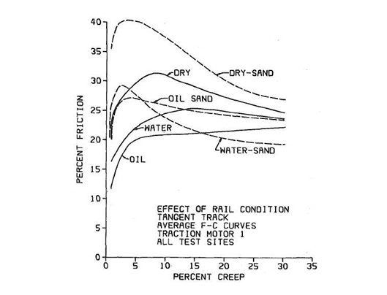

Figure 19 - The nature of the friction-creep relationship for various interfacial materials[35]

Relative humidity has also been reported to influence the frictional behaviour of a wide variety of materials.[36]

### Creation of a ‘third body’ of materials

The behaviour and nature of adhesion at the wheel-rail interface is the subject of continuing research and development and there are many aspects of these behaviours that remain unknown. Some of the science involves the examination of the development of interfacial layers that can separate the contacting surfaces. While this science is continuing to develop, the investigation has formed an understanding, based on a range of literature, that such a body of materials can form between wheel and rail and that the presence of a layer or layers with low shear strength can promote a state of very low adhesion.

## Infrastructure

### Overview

The Melbourne metropolitan rail network is owned by VicTrack[37], leased to the Director of Public Transport and until November 2009, was franchised to Connex Melbourne Pty Ltd and maintained by MainCo Melbourne; a joint venture between the United Group Limited and Connex. Since MTM commenced the new franchise on 30 November 2009, the track has been maintained by MTM.

### Track condition

*Condition monitoring*

The condition of the track on the metropolitan network is monitored by the franchisee to assure its ongoing suitability for intended train operations. A number of measurement and inspection regimes are used to identify defects and general track condition and drive both maintenance and network improvement programs.

On suburban lines, track geometry is assessed using the EM100 track recording car. Measured parameters are evaluated against pre-defined defect criteria and the maintenance procedures define the limits and required actions for faults at different levels of severity.

Track measurement is supplemented by visual inspection to determine that the track is ‘fit-for-purpose’. Track inspectors are required to have an intimate knowledge of their area of responsibility and to identify issues requiring rectification. Rail on the mainline metro network is also currently reviewed on a six-monthly basis (previously annually) using ultrasonic testing. This allows the tester to detect flaws within the rail head that are not visible to the naked eye and aims to prevent these flaws from developing into large cracks and failure of the rail.

Introduced in 2005, rail head wear is evaluated each year in November using a Hi-Rail truck[38] fitted with laser rail profile measurement systems. The equipment measures the rail head profile at five metre intervals and compares it against the as-new profile. Parameters measured include top and side wear, loss of cross sectional area and gauge face angles.

*Track Quality Index*

In Victoria there is a well-established system of monitoring the general condition of track geometry, termed the VQI (Victorian Quality Index). At regular intervals, the VQI is evaluated for a section of track or a particular corridor using track geometry parameters measured by the EM100 track recording car. Parameters used for the VQI include track gauge, top (vertical irregularity), line (lateral alignment), cant (superelevation) and twist. A higher VQI indicates track with greater variation from the ideal geometry. The VQI is used to provide a general indication of track geometry condition and does not identify individual faults or track irregularity.

For the period 2004 to 2009, the VQI for the surburban network was reasonably consistent, typically averaging in the range 65 to 70. For that part of the network on which the Nexas trains operated, the average VQI was mostly within the range 60 to 65. For the same period, the average VQI for that part of the network on which X’Trapolis trains operated was always higher and mostly in the range 70 to 75.

### Rail head grinding

Rail grinding, also called ‘rail rectification’, is undertaken as a maintenance measure and can be used to ensure the preferred running surface for rolling stock.

In 2005, Marich Consulting Services was tasked by Connex with assessing the potential benefits of controlling the wheel-rail contact characteristics through rail grinding, particularly with respect to the braking characteristics of the Nexas train[39]. The study concluded that rails in a worn condition can lead to adverse wheel-rail contact characteristics, particularly with the MP2 wheel profile and that a modified rail profile which had been successfully implemented by rail grinding had established a preferred wheel-rail contact band for both the MP1 and in particular the MP2 wheel profiles.

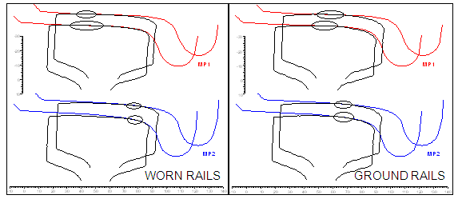

Figure 20 - Contact between MP1 and MP2 new wheel profiles and worn (left) and ground rails[40]

The study also concluded that under a range of conditions, the improved wheel-rail contact characteristics achieved through grinding led to noticeable reductions in the braking distances and increases in the brake efficiency values, indicating more stable braking behaviour.

The Department of Transport advised that this practice has become more extensive on the Melbourne metropolitan network since 2008. In April 2010, MTM published a new rail grinding standard describing the ongoing strategy for the metropolitan network. The standard establishes rail profiles for track and describes the methods by which they are to be applied and the quality standards to be achieved.

### Network coefficients of friction

Coefficients of friction measured at the locations of platform overrun using the hand-pushed tribometer and with simulated wet conditions, were mostly in the range 0.25 to 0.35 (see Figure 8). These are not considered to be unusually low for a rail network.

## Nexas physical characteristics

### Wheels

*Profile*

The Nexas trains are fitted with wheels machined to the MP2 profile. As noted by Marich[41], the MP2 wheel profile was developed in the 1980s with the aim of reducing the rate of flange deterioration through wear associated with curving performance. Improved curving performance was achieved by establishing a fuller wheel throat region (compared to the MP1 profile) as shown at Figure 21. The MP2 wheel profile is also used on the X’trapolis and Comeng disc-braked trains. Comeng tread-braked and Hitachi trains are fitted with wheels machined to the MP1 profile.

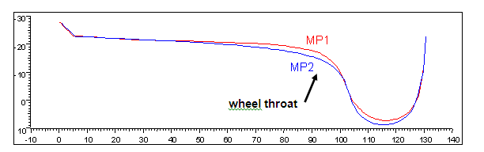

Figure 21 – Comparison between the MP1 and MP2 profiles[42]

In 2007, tests were carried out to compare braking performance of the Nexas train with the MP2 and MP1 wheel profiles. Car-set NX08 (715M-2508T-716M) had its wheels re-profiled to MP1 on 6 February 2007 and a series of tests were conducted with that profile. The wheels were re-profiled to MP2 on 9 July 2007 and a number of tests in low-adhesion conditions were conducted during that month.

Neither the new rail operator, MTM, nor Siemens were able to supply the investigation with a report that described the methodology of the testing and a comparison of performance. MTM has advised that, based on their knowledge of the trials, the MP1 profile provided no clear, measurable performance improvement.

The investigation sourced, from a third party, results of some testing with MP1 profiles conducted between February and April 2007 and with MP2 profiles in July 2007. The results reviewed by the investigation suggest potentially improved braking performance on the test track for trains with the MP2 profile. However, given the lack of clear and recorded methodology, the results are considered inconclusive.

*Material*

The wheels fitted to the Nexas trains are made of solid wheel material R8T in accordance with standard UIC 812.3[43]. Siemens reported conducting a hardness test of wheels, comparing new against mid-life and near end-of-life and finding no significant variation. The X’Trapolis wheel tread material is R7T in accordance with UIC 510[44]. The rail operator advised that a simple comparison of the base wheel materials of the two wheels found that they were similar.

*Tread roughness*

The investigation conducted a series of measurements comparing wheel tread surface roughness on Nexas and X’Trapolis trains currently in service; the aim being to assess whether there was any significant difference in wheel tread surface condition. Two three-car sets of each train type were selected, all having travelled comparable distances since last having wheels machined. The Nexas trains had travelled an average of about 153,000 km since last having the wheels machined and profiled, and the X’Trapolis had travelled an average of about 157,000 km.

Roughness measurements were taken in the transverse (lateral) direction and the longitudinal (parallel to the axis of travel) direction at the laterally mid-tread position considered to represent a typical wheel-rail zone-of-contact.

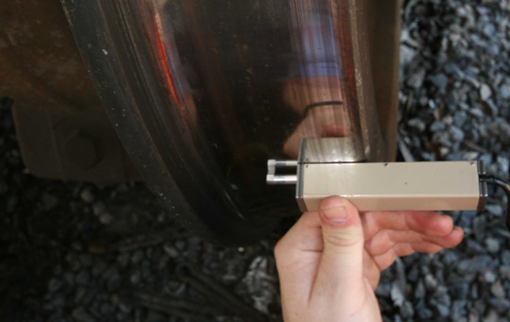

Figure 22 – Lateral (transverse) roughness measurement

Three types of roughness measurements were taken: Ra, Rz and Ry. Ra is the arithmetic mean of the absolute values of the tread profile departures from the centerline of the surface. Rz is the average highest peak to lowest valley height of five one-fifth segments of the evaluated length. Ry is the maximum peak to valley height occurring within any one of these one-fifth segments.

Both types of train were found to have similar Ra values with transverse and longitudinal levels also of comparable magnitude. For the data set taken, average Ra values were found to be in the band 0.4 μm ± 0.1 μm.

The peak-to-valley results were more volatile and an additional Nexas car-set was measured in an attempt to verify possible trends. However, none could be confirmed and it was concluded by the investigation that a significant number of additional measurements in controlled conditions would be required in order to identify any consistent difference in the tread roughness profile between the two types of train.

### EP system brake equipment

The Nexas friction brake system utilises disc brakes only; an inner and outer disc being mounted at each wheel on both the DM-car and T-car. The disc pads are comprised of an organic material, Becorit 984. Knorr-Bremse advised that selection of the pad material is within the scope of their design and that this material is used on many vehicles around the world. They also advised that at no time during their involvement in the review of the braking performance of the Nexas was brake pad material considered to be an issue.

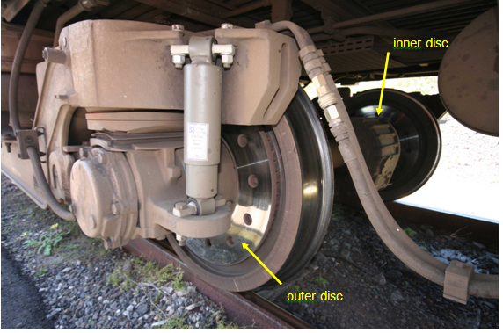

Figure 23 – Discs fitted on inner and outer side of each wheel

By comparison, X’Trapolis trains are fitted with a single tread brake on each wheel with axle-mounted disc brakes also fitted to the motor car axles. The tread brakes apply in all pneumatic brake applications.

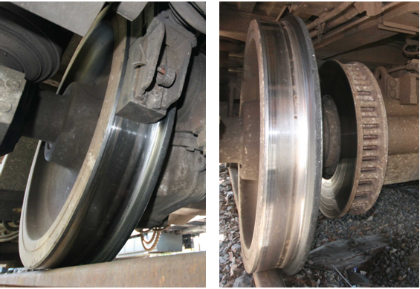

Figure 24 - X'Trapolis tread brake (left) fitted on all wheels and disc (right) on motor car axles only

### Train weight

A comparison of MTM published rolling stock masses is provided at Figure 24. The quoted mass of a three-car Nexas EMU is 120.5 tonnes, seven tonnes less than its nominal design weight as reported in contract specifications. The Nexus and X’Trapolis are comparable in weight. As three-car sets, both these later-model trains are lighter than the older rolling stock and their motor cars are significantly lighter.

|  |  |  |  |
| --- | --- | --- | --- |
| **Train Type** | **MASS (tonnes)** | | |
|  | **Motor Car** | **Trailer Car** | **3-Car Set** |
| **Siemens NEXAS** | 41.5 | 37.5 | 120.5 |
| **Alstom X’Trapolis[45]** | 43.3 | 35.5 | 122.1 |
| **Comeng (Disc-braked)** | 47.1 | 31.1 | 125.3 |
| **Comeng (Tread-braked)** | 50.6 | 34.7 | 135.9 |
| **Hitachi** | 51.7 | 36.4 | 139.8 |

Figure 25 Comparison of train masses based on MTM published data

### Train and bogie dynamics

Siemens describes the intention of the integrated bogie and carbody design as being to minimise wheel-rail forces and accelerations in the car body and components. The primary suspension is comprised of steel coil springs with hydraulic dampers arranged in parallel. The secondary suspension between bogie and car body uses two air springs per bogie with parallel vertical hydraulic dampers, a lateral hydraulic damper and an anti-roll bar leveling system. The air springs draw on the train’s compressed air system to compensate for different passenger loads. Transmission of longitudinal forces between car body and bogie frame is via a traction rod. The geometrical arrangement and stiffness of the traction rod system is described as being designed with consideration to the optimisation of wheel-unloading requirements and longitudinal and vertical dynamics.

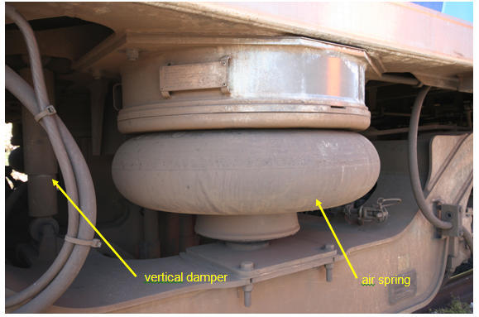

Figure 26 – Air spring within the secondary suspension and vertical damper (in background)

The investigation sought information on the dynamic behaviour of the train and bogie subsystems during braking, including any modelling or testing undertaken to assure braking performance would not be detrimentally affected by dynamic behaviour. The original design-modelling conducted at the manufacturer’s facility in Austria was not available for demonstration in Australia and modelling information provided to the investigation was limited to a computer-simulated manoeuvre involving braking from 60 to 20 km/h, running through a turnout at this speed and then braking to stop. The modelling was performed using track with significant irregularities and appears primarily to pertain to assuring adequate car and bogie behaviour on irregular track and that the vehicle is not at risk of derailment. This modelling was reported by Siemens as showing that “…no remarkable wheel unloading occurs…”.

In 2007 the rail operator (then Connex) together with contracted experts met with Siemens engineers to discuss the dynamic behaviour of the trains. As a result of these discussions, it was concluded by the rail operator that there was no evidence that the vehicle or bogie dynamic behaviour was either unusual or could be considered as having a contributory effect on train braking irregularities.

### Knorr-Bremse comparison of Nexas and X’Trapolis braking systems

In 2006, the brake system manufacture, Knorr-Bremse, was requested by Connex to compare the braking systems on the Nexas and X’Trapolis trains and identify differences in configuration that could cause different performance in low-adhesion conditions. The review encompassed the similarities and differences in EP WSP control, bogie equipment, blending concepts, deceleration rates and signalling between the train control system and the Knorr-Bremse system at slide initiation.

Knorr-Bremse concluded that the most important difference that could affect WSP performance was the different bogie equipment; specifically, that Nexas trains are fitted with disc brakes only whereas X’Trapolis trains use a combination of disc and tread brakes. Knorr-Bremse commented that tread brakes cause a ‘roughing’ and cleaning effect to the surface of the wheels and that it is known that this effect can improve the braking performance under low-adhesion conditions.

### Comparison of Nexas with other trains on the network

The other trains that operate on the Melbourne network are the variants of the Comeng and the Hitachi. Both types of train are considerably older than the Nexas and X’Trapolis; the Comeng entering service in 1981 and the Hitachi in 1972. Due to their age and the many equipment and system variables, the investigation has not attempted to make comparisons between the configuration and performance of these trains and the Nexas.

## Nexas braking in low-adhesion conditions

### Wheelslide protection systems

Wheelslide protection (WSP) is fitted to manage braking in low-adhesion conditions and on the Nexas is incorporated into both the ED and EP systems. The purpose of WSP is to manage braking effort at the wheel-rail interface and to reduce the likelihood of wheel damage. The ED and EP WSP systems operate independently.

The WSP in ED braking is electronically controlled by Siemens proprietary systems including the TCU (Traction Control Unit). Braking effort can be managed directly through control of the traction motors. The ED system uses an estimate of the train speed, Vref (reference velocity), as an input to its management of braking effort. Vref is based on speeds of the four motors on each DM-car and a reference sensor on the adjacent axle of the T-car. The system selects the most appropriate speed for the given scenario as being the best estimate of train speed. In the case that all monitored axles are sliding during braking in low-adhesion conditions, Vref will be lower than the actual ground speed.

The train will continue to utilise ED braking while it remains effective but will transition to EP braking if the system identifies that it cannot achieve requested braking effort due to the onset of wheelslide. In ED, the system monitors performance by comparing the braking effort achieved with the brake demand (requested by the driver). A pre-determined reduction in the braking achieved will trigger the system to transition from ED to EP. In the original design, this threshold was reached when the braking achieved dropped below 90 per cent of that requested. This threshold setting was changed to 99 per cent in December 2006, then returned to 90 per cent in March 2007. When transitioning from ED to EP, the TCU disables the ED brake. The EP system BCU (Brake Control Unit) can also disable the ED brake in the same car if excessive wheelslide is detected. ED braking can be re-initiated by the driver returning the controller to the zero position or any powering position, then reapplying the brake.

The transition from ED to EP is known to have the potential to introduce a lag in brake application in some instances of severe wheelslide. As part of its 2006 review, Knorr-Bremse commented that on the transition from ED to EP braking, “If handover to EP brake is started by the TCU with all axle speeds very low compared to real ground speed EP WSP can show very poor performance or no activity at all for some time.” In cases of severe wheelslide, the EP WSP system will attempt to recover the rotation of axles on affected bogies by fully releasing brake cylinder pressure.

Once in the EP braking mode, the Knorr-Bremse electronic BCU controls the EP WSP system. There is one BCU per car controlling two electro-pneumatic BCMs (Brake Control Modules); one for each bogie. Associated with each BCM is one anti-skid valve meaning both axles are similarly managed; what is known as a bogie-controlled EP WSP system[46]. The EP WSP control systems are the same for service and emergency braking. In EP mode, the system operates independently of the TCU, including in its estimation of train speed which is based on four axle-speed sensors on each car and incorporates algorithms to identify erroneous speed measures.

### Service brake adhesion threshold

The adhesion threshold for service braking is the theoretical level of adhesion below which the full-service brake request cannot be achieved. When adhesion drops below this threshold, it is not physically possible to achieve full-service braking.

For the 1.0 m/s2 service braking rate initially specified for the Nexas, and utilising only the DM-cars and not the T-car braking, the theoretical threshold of adhesion at which full-service braking could be achieved before WSP was activated was approximately 15 per cent[47] on level track. For adhesion below this level, WSP activity would be expected to be initiated during a full-service braking application.

In July 2003, the maximum service braking rate was reduced from 1.0 m/s2 to 0.9m/s2, with the aim of lowering the adhesion threshold at which the WSP system would be activated during full-service braking. This reduction in deceleration rate reduced the theoretical adhesion threshold to about 14 per cent on level track.

The subsequent modification of the braking concept in 2008 to include balanced braking across all cars in all braking scenarios further reduced the adhesion threshold; theoretically enabling braking at full-service rates without WSP involvement down to an adhesion level of approximately 9 per cent on level track.

### Braking performance in low-adhesion conditions

A train’s braking performance will diminish and stopping distances will extend as adhesion conditions reduce to and below the nominal adhesion threshold; in the case of the re-configured Nexas, a theoretical value of 9 per cent for full-service braking on level track. Around this value, the WSP system would be expected to become active and the achieved deceleration rate to be less than dry braking. Below this threshold, the achieved deceleration will be directly linked to the adhesion available at the wheel-rail interface, lower adhesion resulting in less deceleration.

The expected deceleration and stopping distance can be estimated for different levels of adhesion although, in practice, the adhesion available at wheel-rail interfaces varies during a stop and along the consist. Estimations are therefore simple theoretical calculations based on a nominal coefficient of friction. By way of example, a Nexas braking (full-service) from 80 km/h in dry conditions on level track would be expected to stop in less than 300 metres. By comparison, for an adhesion of 6 per cent, stopping distance would be expected to be of the order 450 to 550 metres, depending on the efficiency that the WSP system achieved in the particular stop. This assumes no lag in braking during or after the ED to EP transition. In the case of a severe wheelslide that resulted in such a lag, a further lengthening of the stopping distance would be expected.

### Implication of gradient on braking performance and stopping distances

Gradient will influence both the adhesion threshold at which WSP systems become active during braking and the stopping distance achieved. An ascending grade will reduce the adhesion threshold (allowing lower levels of adhesion before requiring WSP activation) and shorten stopping distances, whereas a descending grade will raise the adhesion threshold at which WSP will activate and lengthen stopping distances. The practical implications are that on a descending grade and in conditions conducive to low-adhesion, the train is prone to earlier WSP activation and extended stopping distances compared to operation on level track.

## Other (post-acceptance) testing of the Nexas

### EP WSP performance testing by the WSPER® test facility

In 2007, Connex commissioned an evaluation of the performance of the train’s pneumatic (EP) braking wheelslide protection system. The evaluation was undertaken using the WSPER® test facility, owned and operated by DeltaRail Group Limited in the United Kingdom.

The WSPER® test rig integrated the train’s EP brake control system and pneumatic valves into a hardware and software simulation of the braking systems for the DM-car and T-car. For each car, assessed individually, braking performance was then evaluated for a range of rail adhesion profiles, simulating conditions that have been measured on the UK network. The potential dynamic behaviour of a pair of bogies and their impact on braking performance was simulated using empirical weight transfer algorithms developed by DeltaRail. The actual suspension configuration of the Nexas was not simulated.

The principal aim of this type of testing is to verify the performance of the brake control system low-adhesion braking control algorithm in terms of wheel damage, braking distance and air consumption. The performance of key physical elements of the pneumatic system, including valves, is also confirmed as part of the evaluation. The WSPER® testing was not intended to examine the actual behaviour of the Nexas cars and bogies during braking nor characteristics or behaviours at the wheel-rail interface. Neither was it intended to consider the full train and any potential interaction between cars.

DeltaRail reported that the performance of the supplied Knorr-Bremse brake control system was comparable with equivalent bogie-controlled systems and vehicle configurations tested on WSPER®. Control electronics and pneumatic valves were reported to perform reliably throughout the test program that included about 1000 low-adhesion brake stops.

DeltaRail also reported that all versions of the software performed as well as may be expected for a bogie-controlled WSP and no serious deficiencies were seen throughout the testing. Three versions of software were tested with minor variations in performance in some adhesion conditions. An occasional time-out occurred on one bogie, that would typically be expected to lead to wheel flat-spots. Otherwise, testing of the Brake Control Unit with all versions of software generally did not give rise to serious wheel lock or tread damage and air consumption was within specification.

The WSPER® testing found that the system did not fully comply with all performance criteria for WSP acceptance typically used in the UK. Notably, not all stopping distance criteria were met for all adhesion profiles although this was not unexpected given that the criteria have been developed for axle-controlled WSP systems and could be considered onerous for bogie-controlled systems of the type being tested.

As would be expected, modelling found that stopping distances under wet conditions were greater than those for dry braking due to the low-adhesion profiles. In most cases, stopping distances were also greater than the modelled ideal braking performance (which assumes full utilisation of the available adhesion). The stopping distance in some individual cases was more than 50 per cent greater than the ideal.

At the time of the 2007 testing, the WSPER® facility had no capability to model the transition from ED to EP braking in low-adhesion conditions. Since 2007, the facility has been re-developed, extending its flexibility and range of testing and creating the potential for the ED to EP simulation in the future.

### Testing following an overrun

Following an overrun incident, the train involved was impounded and subjected to a series of tests in accordance with the rail operator’s procedure, *Brake Testing of Existing Suburban Trains*. The testing to be undertaken was tailored by the rail operator to match the needs of the case and drew on a range of checks, inspections, static tests and braking performance tests. For those cases where the overrun occurred on wet track and the driver claimed a train fault, testing prior to return to service would include on-track brake tests in low-adhesion (wet) conditions. MTM advised that the requirement for ‘wet track’ testing was being reviewed.

MTM reported that of those Nexas trains impounded following an overrun event, none have had faults identified that significantly affected the overrun and none have had an identified defect or fault in their WSP systems.

## Train handling

### Driver training

Drivers on the metropolitan rail network undertake training on four types of train (and their variants) in order to provide full flexibility in rostering. Initial training is conducted on the Comeng with additional training modules for each of the other train types, including the Nexas.

The theory component of the Nexas training module focuses on the identification of equipment and its location, train preparation, and trouble-shooting. Drivers are provided with a basic overview of the braking system. This module does not address specific train-handling techniques for the train; for example, operating in low-adhesion conditions.

At the time of the introduction of the Nexas, qualified drivers were given five days of training comprising three days covering theory, one day of instruction in train preparation and a final day involving a supervised practical run from Dandenong to Pakenham and return. Qualified drivers were then expected to gain further experience on the train and its operating characteristics in the course of their regular rostered duties.

For trainee drivers, the same Nexas theory training was used as for qualified drivers but delivered over four days. Practical on-the-job training was conducted over a period of 25 weeks, spread over a number of depots throughout the network and undertaken on all types of train. This training included assessment by a principle driver in the operation of each type of train. Prior to presenting for each of these assessments, the trainee must have successfully completed a minimum of three on-the-job checklist runs on the particular train type.

*Brake Handling and Defensive Driving Techniques* booklet

In 2008, Connex developed a *Brake Handling and Defensive Driving Techniques* booklet. The objective of the booklet was to provide drivers with a clear understanding of the impact of adverse seasonal and climatic conditions on braking. Guidance on brake handling and defensive driving is provided for all types of trains on the network.

Drivers are reminded of the safety imperative and the potential implications of low adhesion on braking performance. The factors that contribute to the development of low-adhesion conditions are described and a list of things for a driver to consider when stopping provided. The list details a range of environmental, infrastructure (including descending grade) and other operational factors. This generic section on braking techniques also notes that disc-braked trains are more prone to wheelslip and wheelslide due to the wheels not having the benefit of the scrubbing effect of a brake blocks that exists on tread-braked trains. Other train handling and braking techniques generic to all train types are discussed within the booklet including the advice that when braking under adverse conditions, braking should be applied in lower settings. There are also comments reinforcing that increased running times are preferable to the risk of overrunning a platform, or a signal at Stop.

Specific train handling techniques are also mentioned and there is a comment that, where wheelslide occurs, partially releasing the brake can assist in allowing the axles to rotate (back up to train speed). Conversely, it is also stated that the WSP systems should be allowed to carry out their function.

There are a number of more specific sections covering running brake tests, operation of the EP and ED braking systems, and WSP systems. There are also sections specific to train types, including the Nexas.

In the concluding section, drivers are asked to exercise additional caution during adverse weather conditions when approaching platforms with a level crossing or signals at Stop at the far end of the platform. However, no specific guidance is given about the speeds a train should be operated at or the stopping distances that could be expected under low-adhesion conditions.

The booklet was initially distributed to all drivers in June 2008 and incorporated into Stage 6 of the trainee driver courseware. It was also added to Block 18 of continuation training[48] for existing drivers. The roll-out of Block 18 continuation training commenced in July 2008 and was completed in May 2009.

### Operational practices

There is no prescribed platform approach speed for suburban trains on the metropolitan network, except for dead-end platforms. However, at certain locations the Nexas train has been subjected to a speed restriction.

Both driver-trainers and principal drivers[49] have set an informal maximum expected train speed of 50-55 km/h at the approach end of platforms for stopping trains.

### Cabin layout and controls

The Nexas cabin provides the driver with good visibility of the track ahead and of the cabin instrumentation. Powering and braking functions are incorporated into a single master controller on the drivers left-hand side with speed indication located in the centre of the console.

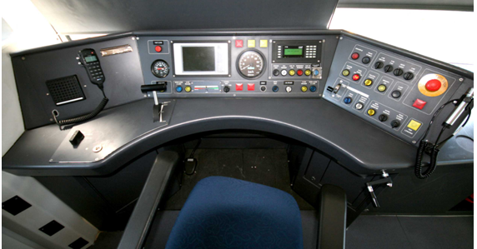

Figure 27 - Nexas driver’s operating console

Also on the main console, the ED braking is displayed on the power/braking indicator and a pressure gauge provides indication of main air reservoir and EP brake cylinder pressure on the lead bogie. There was no dedicated indication of wheel slip/slide in the original design but a modification to include indication was agreed between Siemens and MTM in May 2010 and rollout was scheduled to commence in April 2011.

The braking sector of the master controller has six discrete, service brake positions or ‘notches’ that provide for six discrete brake percentage requests (16.7%, 33.3%, 50%, 66.7%, 83.3% and 100%) plus an emergency brake position. The Nexas was originally delivered with four service brake positions but was modified in 2004 to provide six positions.

By comparison the X’Trapolis controller has an infinitely-variable brake control sector that provides the driver with finer control of service braking effort. The X’Trapolis is also fitted with a control-panel light that provides the driver with an indication of slip/slide activity.

The Comeng and Hitachi have separate powering and braking controllers. In both cases, the brake controller has a seven-step service brake plus an emergency brake position. The Comeng is fitted with a control-panel light that provides the driver with an indication of wheel slip/slide activity.

# Analysis

## Overrun incidents

### High frequency of platform overrun events involving the Nexas EMU

There is strong and consistent evidence that overruns on the Melbourne Metropolitan network were more likely to have occurred in the presence of rail head contamination conducive to the development of low-adhesion conditions at the wheel-rail interface.

There is similarly strong statistical evidence to indicate that the Nexas is more prone to overrun compared to other types of train on the network. This suggests that factors associated with the train, its interaction with the operating environment and/or the way it was operated may have contributed to its higher frequency of overrun.

### Ormond overrun on 25 February 2009

On 25 February 2009, a six-car Nexas EMU was travelling at just below 80 km/h on a 1:52 descending grade when the driver applied the brake in anticipation of stopping at Ormond Railway Station.

The train suffered severe wheelslide as braking was progressively applied through to a full-service application. The investigation concluded that the initiation of wheelslide was due to the level of the brake application exceeding the ability of the wheels to transfer braking force to the track in the low-adhesion conditions that existed and in the presence of the descending grade.

The train measurement systems suggested that very low levels of adhesion were present at the commencement of wheelslide. It was concluded that the coefficient of friction at the rail head had been reduced due to light rain mixing with iron oxides and clay particles. The level of rail head contamination was heightened by this being the first suburban service on this track for that day. It is also possible that the severity of the wheelside and the associated reduced rotation of a number of axles, including the locking of axles on the leading bogie, may have further reduced the level of adhesion available at the interface of a number of wheels with the rail.

The loss of braking effort achieved compared to the brake demand (requested by the driver) triggered the transition from ED to EP braking, as the system design dictates. The EP system then received the train in a pre-condition of wheelslide. As a result of the severity of the initial wheelslide, the EP WSP system took a significant length of time to recover wheel rotation and to verify ground speed. Braking was largely ineffective during this phase.

Once braking started to take greater effect, the average braking rate over the remainder of the stop was still relatively low. This was probably due to ongoing low levels of adhesion available at the wheel-rail interface and the descending grades. The deceleration rate was found to deteriorate again after the train passed the platform and ran onto the steeper 1:58 descending grade.

## The wheel-rail interface and adhesion

### Adhesion levels during overrun events

Modelling the nature and behaviour of the wheel-rail interface is recognised as a complex science, particularly when other materials are introduced at the interface. The addition of moisture is known to impact the coefficient of friction and when mixed with other contaminants can introduce interfacial layers with low shear strength that may cause significant reductions in adhesion.

At the Ormond overrun, the train systems estimated a very low level (3 per cent) of initial adhesion and the stopping distance from the point of emergency brake application suggests an average adhesion in the order of 6-8 per cent[50] from that point. These levels are very low by rail network standards and suggest unusual physical phenomena occurring at the wheel-rail interface during the wheelslide event. These levels of adhesion are most likely to be the result of interfacial material with a combination of physical properties that both separates the wheel and rail surfaces, and provides very low shear strength within the layer(s).

It is extremely difficult to replicate or model the complex interaction occurring between wheel and rail in a wheelslide event. What can be concluded, however, is that a combination of the environmental conditions, the track, and the train contribute to the development of low levels of adhesion at the wheel-rail interface.

### Implications of low adhesion on braking performance

Braking performance is directly limited by the adhesion available at the wheel-rail interface. When adhesion drops below a critical threshold, 9 per cent in the case of the Nexas in full-service braking on level track, the braking system works with the adhesion it perceives as being available at this interface. The braking that can be achieved will be progressively less with lower available adhesion. In an ideal system, the maximum achievable deceleration (in m/s2) is about one tenth of the available adhesion (expressed as a percentage). For example, an average adhesion[51] of 6 per cent will allow, at best, a deceleration of 0.6 m/s2. In practice, the braking system, and specifically the WSP systems, will not be 100 per cent efficient, and a deceleration rate of something less than the ideal will be achieved.

The on-board measurement systems and observed braking performance during overrun events suggest that in certain in-service conditions, levels of adhesion can be well below the threshold that would allow full-service braking. The implications are that in such scenarios, full-service braking will not be achievable and lower deceleration rates will be experienced. This is what has occurred in practice and deceleration rates in the range 0.4 – 0.6 m/s2 were not uncommon in overrun events.

## The factors influencing available adhesion

### Introduction

Adhesion available at the wheel-rail interface can be influenced by a number of factors associated with the environment, the track and the train. The following sections discuss the potential factors associated with each of these areas.

### Environmental conditions conducive to low adhesion

The precise surface conditions at the rail head at the time of any overrun event are unknown. Conditions change during and following an event, often making post-incident measurement of coefficient of friction inconclusive.

What is known is that the majority of overrun events have occurred in the presence of rail head moisture resulting from light rain or dew. It is likely that moisture combined in particular proportion with rail head contaminants such as iron oxides and clay, as found at the Ormond event, produces a liquid suspension sufficient to result in a low coefficient of friction. It is also likely that the adhesion available at the wheel-rail interface and the rheological properties of the interfacial layers are sensitive to the ratio of moisture-to-contaminant, the composition of the contaminant and potentially other environmental conditions such as relative humidity.

The frequency of overrun events has been higher during the warmer months and events have often occurred during the first rains following dry weather. This suggests that such a sequence of environmental conditions may contribute to the initial deposits of dry contamination and the subsequent formation of the liquid suspension likely to promote a low coefficient of friction.

Despite the occasional presence of leaf matter at incident sites and comment on the potential for deposits of oil and grease, the investigation has concluded that vegetation and other potentially adhesion-modifying contaminants such as oil and grease did not play a significant role in the formation of low-adhesion conditions on the network.

### Infrastructure influences

It is recognised within the rail industry that track geometry and the rail head profile can influence the conditions at the wheel-rail interface. However, the investigation did not identify compelling evidence to suggest that the condition of the track had been a major factor contributing to the higher frequency of overrun events involving Nexas trains compared to other types of train on the network.

It is acknowledged that in some instances, such as the overrun at Williamstown in 2004, track geometry and condition may have influenced the initiation of wheelslide and the potential for overrun. The investigation also acknowledges the studies undertaken by Marich[52] and has concluded that maintaining track geometry and the rail head profile in ideal condition would promote a good wheel-rail interface and optimise braking performance.

The investigation did identify that in low-adhesion conditions, descending grade will increase the likelihood of wheelslide and the onset of WSP assisted braking, and will extend stopping distances. The proportion of overrun events was overwhelmingly more common on descending grades compared to ascending. The Ormond event also provided a classic case study of the implications of gradient on such events.

### The train’s influence on adhesion

As an integrated system, the train has the potential to influence the levels of adhesion between wheel and rail. Those features having direct implications for adhesion include the geometric interface of the wheel with the track, wheel surface condition, train weight, system response that might lead to excessive wheel creep and the configuration of the braking hardware.

Comparing the Nexas and X’Trapolis, it can be readily concluded that the feature of the Nexas having the greatest (comparative) influence on adhesion during a braking event is the configuration of the braking hardware. The fully disc-braked friction braking system of the Nexas does not clean the wheel tread during pneumatic (EP) braking. This allows any moisture and contaminant slurry present on the rail head to build up at the wheel-rail interface, facilitating low-adhesion conditions and potentially the development of a significant third body layer.

The geometric interface between wheel and rail is strongly influenced by the wheel profile. The Nexas is fitted with the MP2 profile, as is the X’Trapolis. Comparative wheel profile testing conducted in 2007 did not indicate any improved performance with the MP1 profile and the investigation has concluded that it is unlikely that the wheel profile was a significant contributor to the frequency of overrun events involving the Nexas.

Wheel-tread surface roughness can directly influence the coefficient of friction and the adhesion available at the wheel-rail interface. A study conducted by the investigation comparing the wheel surface condition of the Nexas and X’Trapolis trains identified similar arithmetic mean roughness. Peak-to-valley data was more volatile and specific trends could not be confirmed from the measurements made. The investigation concluded that it was unlikely that wheel surface condition was a significant contributor to the frequency of events involving the Nexas.

The three-car Nexas EMU is comparable in weight to the X’Trapolis but as a car-set, is significantly lighter than the older Comeng and Hitachi trains. The DM-car, in particular, is much lighter than the older motor cars. Modelling the implications of weight on the complex behaviour occurring at the wheel-rail interface was beyond the scope of this investigation and it was not concluded whether, or to what extent the weight of the car-set, or the DM-car in particular, may be influencing adhesion. However, the investigation is of the view that it should be acknowledged that weight may play some role in when and how a condition of low-adhesion is developed at the wheel-rail interface.

The coefficient of friction between wheel and rail can also be affected by the extent of wheel creep (see Figure 9). It is feasible that wheel creep beyond that required to optimise available adhesion during a braking event (saturation) may be reducing the level of adhesion available at the wheel-rail interface. However, it is also recognised by the investigation that the actual composition, including moisture content, of the problematic interfacial materials is not fully known and that any view on the actual rheological behaviour of the material during severe wheelslide is speculative.

## Train braking control systems

### ED system performance

The investigation has formed the view that in less extreme cases of low-adhesion and where wheel creep remains low, the ED WSP system can manage wheelslide. Results of acceptance testing for the ED braking system also suggest that the system in isolation can perform adequately.

In practice and consistent with the design philosophy, the ED system will transition to EP braking in the more severe cases of wheelslide. This transition was evident in the overrun events that the investigation examined, including the Ormond incident. The questions then pertain to the handover from ED to EP and the performance of the EP WSP system.

### EP system response to low-adhesion conditions

The EP WSP software and valve configuration were the subject of independent testing on the WSPER® test rig in 2007. The aim of the testing was to assess the performance of the EP system low-adhesion control algorithm (software) and some EP hardware components. It was not the intention to assess the performance of the EP system as it was integrated into the Nexas. Within these limitations, the investigation concluded that there was no fault in the EP system software or valve hardware and that their performance, in isolation, was consistent with international expectations for similar bogie-controlled EP WSP systems.

The rationale for the procurement decision to select a bogie-controlled EP WSP system as opposed to an axle-controlled system is not known to the investigation. Historical testing by the WSPER® test facility has shown that axle-controlled EP WSP systems typically perform better than bogie-controlled systems. An axle-controlled WSP system allows axles on each bogie to respond independently to the conditions at the local interfaces of the pair of wheels therefore maximising the potential braking effort at each axle. On this basis, the investigation concluded that if fitted to the Nexas, an axle-controlled EP WSP system would probably have exhibited enhanced braking performance.

Due to their coarser control, bogie-controlled WSP systems can be more susceptible to train dynamic behaviour. The investigation was unable to explore the dynamic behaviour of the Nexas in detail because of the unavailability of modelling data and reliance was placed on a third-party review conducted in 2007. This expert review concluded that there was no evidence that the vehicle and bogie dynamic behaviour was either unusual or could be considered as having a contributory effect on train braking irregularities.

### Transition from ED to EP

In the transition from ED to EP braking, the brake manufacturer acknowledged that “If handover to EP brake is started by the TCU with all axle speeds very low compared to real ground speed, EP WSP can show very poor performance or no activity at all for some time.”. In a severe wheelslide event, the EP system will reduce braking effort in its attempt to bring wheels back up to train speed, also permitting the system to verify the speed of the train over the ground. This is consistent with the outcome at Ormond, where the braking effort remained very low for a long period.

This raises the question as to whether this is a braking system deficiency or a vulnerability to a set of circumstances that push the system beyond its normal operating envelope. Such circumstances are a combination of low-adhesion conditions between wheel and rail and a significant rate of brake application. These conditions will be exacerbated by a descending grade, as was the case at Ormond.

The EP WSP system fitted to the Nexas has been internationally benchmarked as being comparable in performance to similar EP WSP systems. On this basis, it is reasonable to conclude that this system, operating in isolation, is not defective. However, it is also reasonable to conclude that there are limitations in the ability of the WSP system to manage particular scenarios including a pre-condition of severe wheelslide at handover.

The investigation is aware of recent developments at the WSPER® test facility that provide the facility with the potential to simulate the ED to EP transition. There may be other facilities internationally with such existing or potential capability. The investigation is of the view that enhanced modelling of ED to EP transition, including the assessment of system behaviours that might lead to a severe wheelslide pre-condition for the EP WSP system at handover, has the potential to enhance EMU WSP systems and train braking performance.

### Stepped braking control

The Nexas controller has six discrete service brake steps; having been modified from the original four-step configuration. A stepped system produces brake applications at specific levels and limits driver discretion in the application of braking. Whether this type of braking control and any potential loss of ‘feel’ has influenced braking performance in some overrun instances could not be determined.

### Distribution of braking effort across all cars

In 2008, the Nexas trains were modified to incorporate balanced braking across all DM-cars and T-cars in all braking scenarios. The result of this modification was to reduce the adhesion threshold at which the braking system on the DM-cars would transition to WSP-assisted braking. It is possible that this modification contributed to the lower frequency of overrun events between 2008 and 2010.

It is acknowledged that should the issue of wheel-rail adhesion be resolved by MTM (see section 7), there may not be an ongoing requirement to retain balanced braking across all cars.

## Train handling

### Operation

The investigation identified that heavy braking in low-adhesion conditions, particularly on a descending grade, can result in early transition to WSP-assisted braking and extended stopping distances. If braking also induces severe wheelslide (the wheels rotating considerably slower that train speed) this is likely to lead to a delay in braking effort as the EP WSP control systems vent brake cylinders in an attempt to bring wheel rotation back up to train speed and to verify ground speed. A severe wheelslide event may also reduce the actual level of available adhesion, depending on the friction-creep behaviour of the interfacial materials.

The extent to which driver technique may have contributed to any particular overrun event could not easily be identified. However, the investigation has formed the view that failure to modify braking behaviour in low-adhesion conditions can contribute to overrun events. It is also reasonable to conclude that greater prudence by drivers in braking under low-adhesion conditions could reduce overrun.

The network manager has identified a number of locations where an overrun could result in significant consequences and has applied an approach speed restriction on stopping Nexas trains. At these locations other types of train are not restricted. At all other locations there is no designated platform approach speed. It is worthy of note that the Victorian regional network manager does have designated platform approach speeds for stopping trains.

### Driver Training

When the Nexas was introduced into service, the theory and supervised practical training for qualified drivers should have been more comprehensive. Had this been the case, it is possible that the number of overrun occurrences may have been less.

The investigation is of the view that the Nexas training module provides insufficient information on the train’s braking systems, and inadequate guidance on its operation under low-adhesion conditions. This was in part addressed by the introduction of the *Brake Handling and Defensive Driving Techniques* booklet in 2008. However, the training could be further improved by providing drivers with a deeper understanding of the train’s braking systems and more specific guidance on operational practices in reduced-friction conditions.

## Network risk management

The management of train operations provides the opportunity to minimise the probability of overrun and the potential severity of adverse consequences. To this end the previous network manager, Connex, and the current manager, MTM, have introduced a number of strategies to mitigate risk associated with this issue. Many of these have proven successful in reducing the frequency of overrun events.

However, as demonstrated by the Ormond event where the train entered the level crossing before the boom barriers were fully lowered, there remained the potential for severe consequence. The network risk management systems in place at that time are therefore considered to have been inadequate, particularly given the history of overrun on the network.

## Rolling stock procurement

### Procurement specification

The specification of braking performance requirements in the Nexas procurement documentation was limited to those for stopping on dry, level and straight track. This technical requirement was otherwise supplemented by general descriptions of the braking systems to be supplied including the wheelslide protection systems.

There was no braking performance requirement specified for stopping in low-adhesion conditions. This is due to the difficulty in defining and then achieving the specified low-adhesion test conditions and so proving compliance with the specification. However, the limitation of this approach is that the specification does not drive or control those factors associated with the train that can have implications for adhesion at the wheel-rail interface.

In describing the systems to be supplied, the specification stipulates the provision of bogie-controlled WSP for the EP braking system. This suggests that this was a purchasing choice and the customer was aware of any potential performance limitations that might result.

### Limitations of acceptance testing

Braking system performance testing in low-adhesion conditions is problematic because adhesion levels are influenced by a number of factors including environmental conditions, the track and interaction between the train and track. The investigation identified that acceptance testing was not designed to evaluate the interaction of the train with the wetted track and any influence the train may have had on available adhesion. The test methodology, including its estimation of a braking ‘efficiency factor’, assumed that the level of adhesion was independent of train characteristics.

Acceptance testing showed satisfactory performance in simulated low-adhesion conditions and an ‘efficiency factor’ of over 90 per cent in all but one instance. This measure provided a false perception of adequacy. In calculating the efficiency factor, there was also an assumption that the measure of available adhesion (for the ‘ideal’ condition) was an accurate measure of the actual maximum adhesion available. The test was reliant on the train’s system accurately evaluating the peak adhesion available at the wheel-rail interface and any underestimation of this would have led to an overestimation of efficiency.

It is also difficult to simulate the worst conditions that will be experienced in service as the wheel-rail interaction will be influenced by the characteristics and composition of the interfacial layer. In hindsight, it is likely that in some in-service instances, the Nexas has experienced more severe low-adhesion conditions than those experienced during acceptance testing of the first-of-type.

It is acknowledged that additional wet-track testing was conducted around the time of and subsequent to the formal acceptance tests. While this testing may have assisted in system development and some level of performance improvement, it too failed to fully verify braking performance in conditions conducive to the development of low levels of wheel-rail adhesion.

## Testing of the Nexas following an overrun event

In no case has vehicle testing following an overrun event identified a train defect that has had any significant impact on the event. This suggests that any train-based characteristic that made the Nexas relatively more prone to overrun was a Nexas fleet-wide phenomenon and was not specific to an individual train-set. The purpose of conducting full wet-track testing of trains involved in an overrun event has therefore not been established and it is considered appropriate that this requirement be reviewed.

## Delay in resolution of issues associated with platform overrun

Since its introduction in 2003, the Nexas has been involved in a relatively high number of reported overrun incidents when compared to other train types on the network. Over many years there have been numerous industry based investigations and a number of strategies employed to mitigate the risks associated with their occurrence. However, in 2011 overruns were continuing to occur on a regular basis.

While the investigation acknowledges the issues are complex and involve the interaction of environmental, engineering, system and human factors, the investigation is of the view that eight years is an excessive period for such matters to remain unresolved.

# Conclusions

## Scope

Findings and contributing factors have been developed considering the broader evidence and issues of overrun on the Melbourne metropolitan network. The investigation has also been informed by the Ormond incident but in drawing its conclusions has not focused on that incident or its causes.

The investigation acknowledges that each overrun event would have been the result of its own set of circumstances and that the proportional contribution of factors would have been different in each case.

## Findings

*Environmental conditions*

1. Moisture combined with rail head contaminants that occur normally, such as iron oxides and clay, can result in conditions on the metropolitan rail network that are conducive to the development of low levels of adhesion between wheel and rail.
2. In the majority of cases, leaf matter did not play a significant role in the development of low-adhesion conditions at the rail head and there were no other contaminants of significance identified.

*The track*

1. The condition of the track was not found to have contributed to the Ormond overrun event on 25 February 2009 and there was no compelling evidence to suggest that track geometry was likely to have been a significant factor in the majority of events.

*The train*

1. The relatively high frequency of overruns involving Nexas trains was neither the result of individual train defects nor any deficiency in train maintenance.
2. Low adhesion conditions of significantly below 10 per cent have developed at the wheel-rail interface of the Nexas train on a number of occassions.
3. A condition of severe wheelslide at the time of transition from ED to EP braking can result in long periods of ineffective braking and extended stopping distances.
4. Procurement documentation for the Nexas did not adequately define performance requirements for some low-friction rail head conditions that the train would subsequently experience in service.
5. Brake acceptance testing for the Nexas did not identify any influence the train may have had on the levels of adhesion developed at the wheel-rail interface.

*Train handling*

1. Heavy or sudden braking in low-adhesion conditions can induce wheelslide and early transition to WSP assisted braking.
2. At the time of the introduction of the Nexas into service, training did not provide the drivers with an adequate understanding of the train’s braking systems or guidance on operational practices.

*Network risk management*

1. Network managers have introduced a number of operational measures that have reduced the frequency of overrun events.
2. At the time of the Ormond overrun event on 25 February 2009, network risk management systems were inadequate.

## Contributing factors

In the majority of instances:

1. The presence of environmental conditions that provided the potential for low-adhesion conditions to develop at the wheel-rail interface of the Nexas train. The conditions are not easily predicted or controlled by the rail operator.
2. Characteristics of the Nexas that allowed the development of low-adhesion conditions at the wheel-rail interface. This is best viewed as the result of the integrated train system rather than isolating a single feature.
3. Inadequacy in procurement specifications and acceptance testing. Specifically, the procurement process did not manage how the train and its interaction with its operating environment could influence adhesion at the wheel-rail interface and braking performance.

In some instances:

1. The manner of response of the train’s braking systems to particular low-adhesion and operational scenarios and specifically the instance of handover from ED to EP braking with a pre-existing condition of severe wheelslide.
2. Train handling that led to the onset or a greater severity of initial wheelslide.
3. Inadequate driver training in the operation of the Nexas.
4. The influence of descending grade on the onset and severity of wheelslide.
5. The influence of rail and track infrastructure on the wheel-rail interface and the level of available adhesion.

# Safety Actions

## Safety Actions advised by the rail operator

### Safety actions following the overrun events in February 2009

The rail operator provided the following summary of safety actions taken following the Nexas overruns in February 2009.

1. Blanket 30 km/h speed restriction (for Nexas trains) placed on approach to all platforms and for approach speed to signals at Stop (introduced 6 March 2009 and removed 1 May 2009).
2. Express mode*[53]* placed on North Road Ormond level crossing (introduced 2 May 2009).
3. Risk assessment undertaken on each level crossing within 100 metres of a platform.
4. Blanket speed restriction lifted and the 30 km/h speed restriction re-imposed (on Nexas trains) on all level crossings/automated pedestrian crossings within 100 metres of a platform (introduced 1 May 2009 and removed 21 June 2011).
5. Special Siemens Speed boards erected 200 metres from the approach to platforms and automated pedestrian crossings within 100 metres of a platform, also approaching Fixed Signals at Stop (removed from 21 June 2011).
6. External consultants engaged to conduct human factors study.
7. Siemens trains restricted to six car running remains in place.
8. BCU/TCU software changes. Balanced braking incorporated into brake software version 5.1 remains in place.
9. Driver advisory notices and safety bulletins re-issued.
10. Monitoring of speeds and random speed checks remain in place.
11. All trains involved in an overrun subject to full brake testing procedures before re-entry into revenue service (remains in place).
12. Prior to trains returning to revenue service, PTSV (now TSV) and DOT to endorse.
13. Advanced warning boards erected in advance of the S30 speed boards (removed from 21 June 2011).
14. Revised Signaller operating procedures implemented for signalboxes switched in.
15. Temporary Speed Restriction of 30 km/h imposed on the Down and centre lines at Ormond (introduced 25 February 2009 and removed 18 May 2009).

### Sanding devices

In March 2010, MTM tested a sanding device jury-rigged to the Nexas train for a concept trial. They reported that the trial proved that utilisation of sand could result in a significant reduction of stopping distance on ‘artificially slippery’ track. MTM also concluded that, based on international experience as well as the local testing, the application of sand to the wheel-rail interface should eliminate most overruns of Nexas trains caused by low-adhesion conditions.

Subsequently, MTM, Siemens and Knorr-Bremse developed a sanding design proposal and commenced trialing the system in September 2010. It was reported in December 2010 that trials of the system had demonstrated significantly improved braking performance in conditions simulating reduced-adhesion conditions.

MTM completed the fitment and commissioning of sanding devices to the Siemens train fleet on 18 June 2011. On 21 June 2011, the speed restrictions applicable to the Siemens fleet were cancelled (see section 7.1.1).

It is also proposed to return to a braking configuration that has the T-car un-braked when brake demand can be achieved solely by ED braking on the DM-cars.

### Summary

As of 25 August 2011, there are only two operational restrictions in force for the Siemens Nexas train fleet on the Melbourne metropolitan network, as follows:

1. The requirement for the train to be operated as a six-car set.
2. The level crossing warning devices associated with the Down and Centre lines at Ormond remain operating in ‘Express’ mode.

## Recommended Safety Actions

Issue 1

The current rail operator has sought to address the potential development of low-adhesion conditions at the wheel-rail interface through the fitting of sanding devices to the Nexas fleet of trains, with implementation completed in June 2011. The decision to fit sanding devices followed trials that are reported to have demonstrated reduced stopping distances on ‘artificially slippery’ track. However, the investigation has found that low-adhesion wheel-rail conditions simulated for testing can differ from those conditions experienced in-service, with consequent differences in the rheological behaviour of interfacial materials.

RSA 2011023

That, following the fitting of sanding devices, Metro Trains Melbourne continues to monitor the performance of the Nexas EMU fleet in service.

Issue 2

In some instances the condition of track and rail may contribute to less-than-optimal braking performance.

RSA 2011024

That Metro Trains Melbourne continues with a program of track condition monitoring and rail grinding as considered appropriate to manage the wheel-rail interface.

Issue 3

While it is recognised that the development of the *Handling and Defensive Driving Techniques* booklet in 2008 filled some gaps that existed in the driver training materials, train handling could be further improved through enhanced training on the operation of the Nexas, including providing drivers with a better understanding of the train’s systems and its operation in reduced-friction conditions.

RSA 2011025

That Metro Trains Melbourne undertakes a review of driver training for the Nexas train, with a view to provide more comprehensive training on the train’s braking system and how the train should be operated in low coefficient of friction conditions.

Issue 4

Procurement specifications did not include clear and measurable requirements for braking performance in low coefficient of friction conditions that may be experienced in-service, leaving a gap in the contractual control of those factors associated with the train that can have implications for adhesion levels at the wheel-rail interface.

RSA 2011026

That the Department of Transport and Metro Trains Melbourne, as applicable for future metropolitan rolling stock procurement, ensure appropriate definition of braking performance in low coefficient of friction conditions that may from time-to-time exist on the Melbourne metropolitan rail network.

Issue 5

Acceptance testing did not adequately verify the in-service braking performance of the Nexas. Testing did not adequately assess the train as an integrated system and specifically did not consider how the train and its configuration might influence adhesion available at the wheel-rail interface. Also, acceptance testing did not adequately simulate the more severe conditions the Nexas would experience in service.

RSA 2011027

That the Department of Transport and Metro Trains Melbourne, as applicable for future metropolitan rolling stock procurement, ensure that acceptance criteria capture how the train and its configuration might influence adhesion available at the wheel-rail interface.

RSA 2011028

That the Department of Transport and Metro Trains Melbourne, as applicable for future metropolitan rolling stock procurement, ensure appropriate definition of acceptance criteria in recognition of the environmental conditions that may from time-to-time exist on the Melbourne metropolitan rail network.

1. The train was originally referred to as the ‘Nexas’, derived from the project customer name, National Express Group Australia. The term Nexas subsequently fell out of use and was not replaced by another type name.
2. The layer of materials between the wheel and rail.
3. Wheel creep is the relative tangential displacement between wheel and rail surfaces. In the braking context, creep occurs when the wheel rotates more slowly than simple (pure) rolling at train ground speed.
4. Applies sand to the wheel-rail interface when required in low-adhesion conditions to improve available adhesion and braking performance.
5. Travelling away from Flinders Street Station.
6. Replaced by a Connex representative in 2004.
7. GATX Rail is a U.S. and European-based global rail, marine and industrial equipment lessor.
8. The train supply contract between the Contractor, the Purchaser and the Lessee, dated 30 March 2000.
9. In accordance with the Independent Certifier Deed (Bayside Trains).
10. IEC is the International Electrotechnical Commission; a global standards organisation with its headquarters in Europe.
11. UIC Leaflet, *Brakes – Specifications for the construction of various brake parts – Wheel Slide Protection device (WSP)*. The UIC, (International Union of Railways) is a member-based organisation with its headquarters in Europe.
12. The mass of train without passengers but otherwise complete and ready to run.
13. An EAC may be issued prior to the original contractual acceptance date if certain contractual obligations are met, including that the unit is substantially complete and has passed the test procedures set out in the test plan.
14. A PAC is issued on or after the contractual acceptance date when certain contractual obligations, similar to those required for the issue of an EAC, are met. A PAC is deemed to be issued on the original contractual acceptance date for a unit that has already had the EAC issued.
15. The warning time is from warning lights starting to flash to the earliest likely entry of the train into the level crossing.
16. A SPAD (signal passed at danger) is a rail industry term used to describe an event where a train proceeds past a signal without authorisation.
17. A train stop is a lineside device that will physically activate the train’s emergency brake.
18. Institute of Railway Technology, *Report No.* *Monash/RT/2009/387 Ormond Down Track Measurements*, Monash University, issued April 2009
19. Top relates to vertical variations and line to lateral variations from design.
20. The inside, vertical face of the rail head.
21. As described by IRT in Monash/RT/2009/387, with reference to Harrison, McCanney and Cotter, *Recent Developments in Coefficient of Friction Measurements and Rail/Wheel Interface*, Wear 252 pp. 114-123, 2002.
22. The gauge corner is the inside, top corner of the rail head.
23. Iwnicki S., *Handbook of Railway Vehicle Dynamics*, CRC Press, 2006 (referenced by IRT in Monash/RT/2009/387).
24. The estimate of the reduced coefficient of friction was made using the DB Curtius-Kniffler equation.
25. Veerbeck H, *Present Knowledge of Adhesion and its Utilisation*, Rail International No. 6, 1973 (referenced by IRT in Monash/RT/2009/387).
26. The cause of ‘head check crack’ defects is usually rolling contact fatigue.
27. A coefficient of friction of about 0.03
28. Baulks are typically timbers fastened across the top of a track; providing a nominal end-of-line barrier.
29. Lewis R. and Olofsson U., *Wheel-rail interface handbook*, Woodhead Publishing Limited, 2009 p514
30. The normal force is the force acting at right angles to the contacting surfaces, typically the train weight acting downward through the wheel.
31. Lewis R. et al., Op. cit., p514
32. Wheel creep is the relative tangential displacement between wheel and rail surfaces
33. Rheology is the science dealing with the flow and deformation of matter.
34. Lewis R. et al., Op. cit., pp 744-745
35. Logston & Itami, Locomotive Friction-Creep Studies, Journal of Engineering for Industry, Trans. ASME, Vol.102 pp.275-281, 1980 (referenced by IRT in Monash/RT/2009/387).
36. Demizu, K., Wadabayashi, R., Ishigaki, H., *Dry friction of oxide ceramics against materials: the effect of humidity*, Tribology Transactions, 33, 505-10 (referenced at Lewis R. et al., Op. cit., p 55).
37. Victorian Rail Track, a statutory corporation established under the Rail Corporation Act 1996 and a State Business Corporation under the State Owned Enterprises Act 1992.
38. Road vehicle specially fitted with equipment to permit travel on ‘Highway and Railway’.
39. The results of this task were reported in Marich Consulting Services Technical Note, dated 29 August 2005.
40. Extracted from technical note by Marich Op. cit..
41. Technical note to Connex by Marich Op. cit..
42. Extract from technical note by Marich Op. cit..
43. UIC 812.3 has since been withdrawn.
44. A series of UIC Leaflets on running and suspension gear.
45. Alstom has supplied data indicating slightly lighter motor and trailer car masses for the X’Trapolis
46. The X’Trapolis is similarly equipped with a bogie-controlled EP WSP system, whereas the Comeng disc-braked train has axle-by-axle control.
47. This is equivalent to a coefficient of friction of 0.15.
48. Drivers are rostered to attend continuation training every 26 weeks. Each new roll-out of continuation training is designated a Block number.
49. A supervisor who conducts driver training and assessments.
50. This estimation of adhesion is influenced by a number of assumptions and should be considered indicative only.
51. In practice, adhesion will vary over time and over the length of the train, with higher levels of adhesion usually found towards the rear of the train due to the conditioning of the rail head by leading cars.
52. Technical note to Connex by Marich Op. cit..
53. When the level crossing protection is set to Express Mode, the systems provides warning times to motorists and pedestrians sufficient for a train that does not stop at the station.