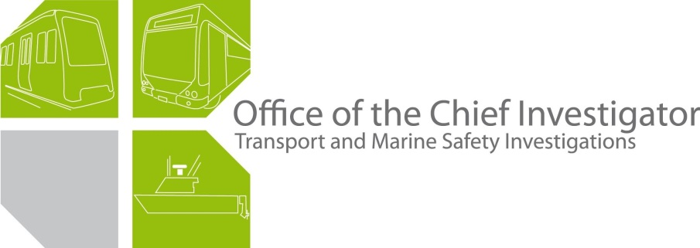

Rail Safety Investigation

Report No 2009/09

Level crossing collision

Edithvale Road Edithvale

15 July 2009

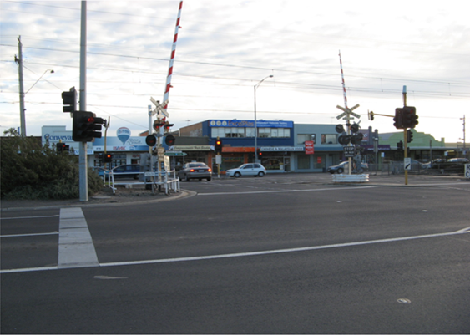

TABLE OF CONTENTS

The Chief Investigator 5

Executive Summary 7

1. Circumstances 9

2. Factual information 11

2.1 Personnel 11

2.2 The vehicles 11

2.3 Infrastructure 12

2.4 Interview information 17

2.5 Recorded information 19

2.6 Environment 19

3. Analysis 21

3.1 The incident 21

3.2 Position of the sun 21

3.3 Vegetation 21

3.4 Road traffic lights 21

4. Conclusions 23

4.1 Findings 23

4.2 Contributing factors 23

5. Safety Actions 25

5.1 Recommended Safety Actions 25

The Chief Investigator

The Chief Investigator, Transport and Marine Safety Investigations is a statutory position established on 1 August 2006 under Part V of the *Transport Act 1983*.

The objective of the position is to improve public transport and marine safety by independently investigating public transport and marine safety matters.

The primary focus of an investigation is to determine what factors caused the incident, rather than apportion blame for the incident, and to identify issues that may require review, monitoring or further consideration. In conducting investigations, the Chief Investigator will apply the principles of ‘just culture’ and use a methodology based on systemic investigation models.

The Chief Investigator is required to report the results of investigations to the Minister for Public Transport and/or the Minister for Roads and Ports. However, before submitting the results of an investigation to the Minister, the Chief Investigator must consult in accordance with section 85A of the *Transport Act 1983*.

The Chief Investigator is not subject to the direction or control of the Minister(s) in performing or exercising his or her functions or powers, but the Minister may direct the Chief Investigator to investigate a public transport safety matter or a marine safety matter.

Executive Summary

At 1702 on 15 July 2009, a motor vehicle driven by a 24 year old male entered the active Edithvale Road level crossing, Edithvale. The motor vehicle was driven under the lowered boom barrier into the path of the 1601 Flinders Street to Frankston service which was running express from Mordialloc to Frankston due to faulty doors on the train. The front of the lead-car of the Comeng train impacted the right side of the motor vehicle pushing it for some distance along the track.

The driver of the motor vehicle received fatal injuries. The two train drivers, the only persons on board the train, were uninjured.

At the time of the collision the sun was low in the north-west sky and its glare is likely to have restricted visibility for the motor vehicle driver as he approached the crossing.

The investigation determined that the level crossing warning devices had operated correctly and that the road traffic lights at the intersection of Edithvale Road and Station Street operated without fault and as designed. However, the design of the traffic lights on Station Street was such that the left turn red arrow extinguished when the rail crossing boom barriers were fully lowered thus not providing any warning to a motor vehicle driver that the crossing was active.

It was also noted that vegetation between Station Street and the rail track restricted a motor vehicle driver’s view of the rail crossing warning lights.

The investigation made recommendations to VicRoads related to the operation of the traffic lights and to the rail operator concerning vegetation between Station Street and the rail track.

# 

# Circumstances

At 1702 on 15 July 2009, the 1601 rail service from Flinders Street Station to Frankston (Train 4827) collided with a motor vehicle at the Edithvale Road level crossing, Edithvale.

The train was operating non-stop from Mordialloc to Frankston after it became defective and off-loaded all passengers at Mordialloc. The motor vehicle had been heading in a northerly direction on Station Street, which parallels the rail line, before turning left towards the Nepean Highway, into the level crossing. When the motor vehicle turned left the level crossing protection was active with the boom barriers down. The motor vehicle proceeded under the boom barrier, which was pushed upward by the passage of the motor vehicle, and was struck by the leading end of the first carriage of the train. The motor vehicle was pushed about 70 metres along the track by the train before it came to rest between the Up and Down tracks.

The driver of the motor vehicle received fatal injuries as a result of the impact. No other person was injured. The motor vehicle was substantially damaged and the train received minor damage.

# 

# Factual information

## Personnel

### Motor vehicle

The motor vehicle was driven by a 24 year old male who was the only occupant.

### Train

The train was being operated by a crew of two, an instructor driver and a trainee driver. There were no passengers on board.

The instructor had about 40 years experience as a train driver in the Victorian rail network. The trainee commenced as a trainee electric train driver about six months prior to the incident. At the time of the incident he was operating the train from the driver’s position situated on the left side of the lead-car. The instructor was seated on the on-the-job trainer’s seat attached to the rear of the driver’s cabin and slightly to the right of centre.

Both drivers commenced their shifts at 1448 at Ringwood Railway Station before proceeding to Flinders Street Station. Both reported that they were in good health. After the incident both drivers were breath tested with negative results.

## The vehicles

### Motor vehicle

The motor vehicle involved in the incident was a 2002 Ford Laser sedan and was extensively damaged by impact forces.

Inspection of the motor vehicle on site found that it had been impacted by the train at about the mid-point of the right side (B pillar). There was evidence of white paint on the left windscreen pillar (A pillar) with the lowest mark being about 1080 mm above ground level.

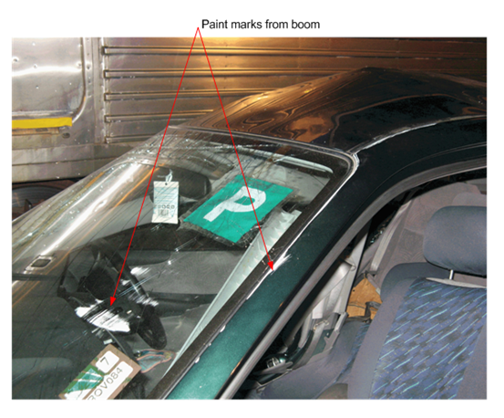

Figure 1 – White paint marks on windscreen and 'A' pillar from the crossing boom.

### Train

The train was a six-car Comeng with the lead-car designated 615M. The coupler and front steps of 615M received minor damage.

An examination of the onboard data logger found that the train horn was sounded prior to entering the station, about 129 metres from impact, and then as it progressed along the station platform commencing around 48 metres from impact for 1.5 seconds. The train was travelling at 58 km/h when the train emergency brake was applied (near the point of impact).

## Infrastructure

### Rail/Road intersection

The rail track passing through Edithvale is part of the Melbourne to Frankston electrified suburban broad-gauge line. At Edithvale there is double track with the Down track (eastern) for trains heading to Frankston and the Up track (western) trains travelling towards Melbourne. The Edithvale Railway Station is situated adjacent to and on the northern side of Edithvale Road level crossing. The track at Edithvale is orientated 350/170 degrees. The maximum allowable line-speed at Edithvale is 95 km/h.

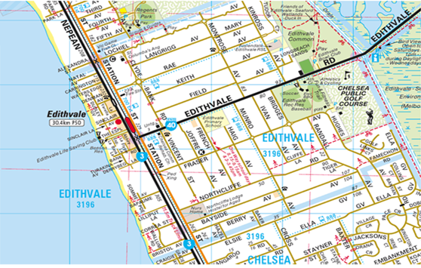

Figure 2 – Map of the Edithvale area. (Copyright Melway Publishing 2008. Reproduced from Melway Edition 35 with permission.)

The rail track is bounded by two roadways that run parallel to it in the Edithvale area. To the west of the track is the Nepean Highway, a primary State arterial road controlled by VicRoads. To the east is Station Street, a major road controlled by local government (Kingston). Edithvale Road approaches the Nepean Highway from an easterly direction crossing both Station Street and the rail lines to form a ‘T’ intersection with the Nepean Highway. Edithvale Road bears 250 degrees as it crosses the rail lines.

The intersections of Edithvale Road with Station Street, the rail lines, and the Nepean Highway are controlled by traffic signals.

### Edithvale level crossing

The crossing is situated 31.753 kilometres by rail from Flinders Street Station. The rail lines crossed by Edithvale Road are actively protected by warning lights and bells and boom barriers. The warning lights for road traffic heading north along Station Street are located in the median strip on Edithvale Road just prior to the entry to the rail crossing. The warning lights are positioned to focus towards traffic heading north on Station Street. Active protection is also provided for pedestrians on the northern side of Edithvale Road adjacent to the station platforms.

The crossing was the subject of an ALCAM (Australian Level Crossing Assessment Model) assessment in June 2006. The inspection observed minor anomalies with crossing signage: the R6-9 sign (Stop on red signal) had white lettering on a black background when the appropriate standard requires the lettering to be black and the background to be white. Also, the RX-9 sign (Railway Crossing) facing Station Street was positioned such that the words were aligned ‘Railway’ on top of ‘Crossing’ when the standard required the signs containing the words to be situated with one word either side of the roadway. The investigation noted that both signs are still as they were in June 2006 but did not believe that the anomaly with either sign would have contributed to the incident.

On the approach to the crossing along Station Street trees between the road and rail lines obscure a motor vehicle driver’s view of the level crossing warning lights until the driver is about 30 metres from the crossing.

The crossing is automatically operated and controlled by the approach of a train. Warning devices at the crossing are designed to provide a minimum warning time to motorists and pedestrians of 25 seconds prior to a train entering the crossing. A functional test of the warning devices after the incident found that all visual and audible devices operated as per design. It should be noted that the design incorporates a feature that turns off the warning bell closest to the south-eastern side of the crossing when the boom barriers are fully lowered. This warning bell is on the opposite side of Edithvale Road to the pedestrian crossing and across Station Street from residential properties. That is, it was the warning bell closest to the incident driver as he turned into the crossing.

An inspection of the boom barrier adjacent to Station Street found that there was damage to the underside of the boom arm. The damage consisted of an area about 200 mm in length, located 3.5 metres from the pivot end of the boom where paint had been scrapped from it. When the boom was fully down the damaged area was about 1090 mm above ground level.

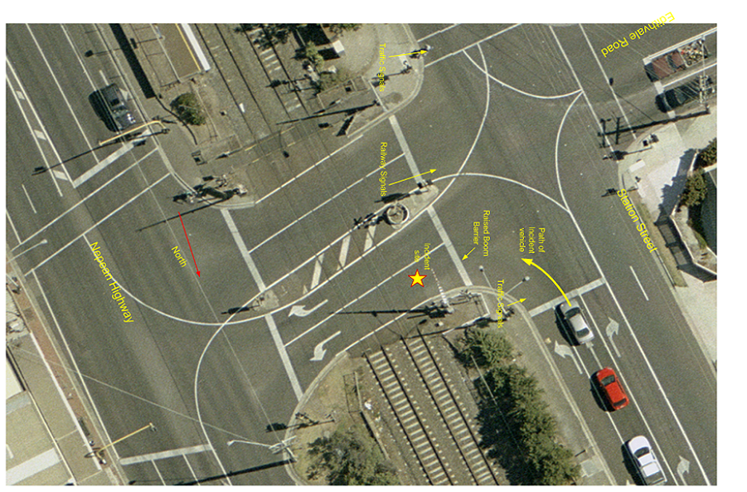

Figure 3 – Drawing of Edithvale Road level crossing.

### Traffic light operation

The traffic signals at the site operate on a six-phase system. The signals are designed to cycle between any demanded phases in sequence. Two of the six phases are designated as ‘train phases’ and are demanded by a train approaching the level crossing. The phases relevant to this incident concern the signals controlling road traffic heading in a northerly direction along Station Street toward Edithvale Road.

The traffic signals at the intersection of Station Street and Edithvale Road allow road vehicles to continue ahead along Station Street, turn right into Edithvale Road and turn left into Edithvale road and enter the level crossing. Of specific interest are the signals that control vehicles turning left to proceed over the rail lines.

When a train is detected approaching the level crossing, the traffic signals operate in ‘train clearance phase’ to ensure that the rail tracks are cleared of road traffic as soon as possible. In this phase, a motor vehicle heading north on Station Street will be confronted with a left red arrow signal to indicate to the driver that the vehicle should be stopped and not turned left towards the Nepean Highway, over the level crossing. When the level crossing boom barriers are fully down the red arrow is extinguished after three to four seconds. The traffic lights then operate in a second ‘train present phase’ and the driver could then be presented with a green light that would allow the vehicle to continue beyond the Stop line though the intersection. The driver is not presented with any left arrow signal of any colour.

An inspection undertaken by VicRoads staff following the incident found that there had been no fault report or alarm at the site; therefore, it can be assumed that the signals were operating in accordance with the signal plan. The mounting heights of the signal lanterns were also found to be in accordance with the Austroads guidelines.

## Interview information

### Train instructor driver

The instructor driver advised that after he and his trainee took over the operation of the train at Flinders Street Station he had the trainee conduct a ‘running brake test’ which confirmed that the air bake system was operating correctly. He added that the train operated normally until a station before Mordialloc when a problem was experienced with the train carriage doors. The problem recurred at Mordialloc and after consultation with Metrol (train control) it was decided to disembark all passengers at Mordialloc and run the train empty and express to Frankston. The instructor said that the door fault did not affect the operation of other train systems.

The instructor advised that as the train was approaching Edithvale Station he was seated on the OJT (on-job-trainer) seat. He observed that the signal at the southern end of the station was presenting a proceed aspect. He also said that from the OJT seat he could observe the trainee but not the rail line directly in front of the trainee. He could however observe the rail directly in front of his seated position. Prior to entering the level crossing the instructor observed that the crossing warning devices appeared to be operating normally.

The instructor then recalled hearing an explosion and thought a brick had hit the windscreen. He asked the trainee what it was and was told that the train had hit a motor vehicle. The instructor said that he pulled the emergency brake pipe cock on his side of the train and at about the same time the trainee placed the drivers brake handle into the emergency position. The instructor reported that he did not observe the motor vehicle prior to impact and that the train stopped about a train length beyond the crossing.

The instructor advised that he made an emergency radio call to Metrol to advise them of the occurrence and they advised that all other affected train traffic had been halted and that they would arrange for emergency services to attend the site. He then instructed the trainee to go forward from the train and fit emergency jumper cables to the adjacent track to protect the site.

A short while later the emergency services arrived on site. Subsequently, the instructor was requested by a fireman to isolate the train from the electrical power supply, which he did.

Both the instructor and his trainee were later relieved of their duties and returned to Flinders Street Station by taxi.

### Trainee train driver

The trainee train driver advised that he was fit and well prior to commencing duty and taking over the train with his instructor at Flinders Street Station. He said the journey was uneventful as far as Cheltenham or Mentone where they began to experience a problem with the carriage doors on the ‘A’ (right in the direction of travel) side of the train. However, he commented that the door problem did not affect the train braking and that the train headlight was on and the horn operational.

The trainee advised that he was seated in the driver’s seat, at the left side of the driver’s cabin, that it was a clear day, with the sun behind him over his right shoulder and that he had a good view of the track in front of him. He estimated that he approached the Edithvale Station at about 40 km/h and at that time the signal at the southern end of the platform, and just before the level crossing, was showing a red aspect. The trainee driver said that as the train entered the platform the signal changed to a yellow aspect which allowed him to proceed beyond it.

The trainee advised that the level crossing was initially clear of road traffic but when the train was about 10 metres from the crossing he observed a small dark-coloured motor vehicle driving north on Station Street. The motor vehicle slowed down to drive around the corner (into the level crossing) and the trainee driver noted that the motor vehicle driver was looking straight ahead towards the Nepean Highway and that the motor vehicle did not stop or appear to slow down. When he realised that the train was going to hit the motor vehicle he applied the emergency brake but could not be sure if this was done prior to or after impact. He then lost sight of the motor vehicle but heard the sound of crumpling metal and glass sprayed over the train’s windscreen. The train did not derail and he estimated that the front came to a stop about five carriage lengths beyond the crossing.

The trainee advised that his instructor called Metrol and advised them of the incident. He then went forward to put the jumper leads on the track but did not look back at the motor vehicle wreckage. He subsequently left the scene with his instructor for Flinders Street Station by taxi.

## Recorded information

### CCTV footage

The train was equipped with CCTV cameras that recorded various views inside the carriages. The recorded footage from the camera in the lead-car (615M) clearly slowed that at the time of the incident the sun was shinning brightly from the right rear of the train, in relation to the direction of travel.

## Environment

The Bureau of Meteorology advised that at Edithvale at the time of the incident (1702 EST) the sun had an azimuth of 299 degrees 33.6 minutes, an altitude of two degrees 20.7 minutes (above the horizon) and a refraction of 18 minutes. They also reported that there was cloud in the area but were unable to say if it would have blocked the sun. The cloud base at Moorabbin (about seven kilometres to the north) was 6,300 feet.

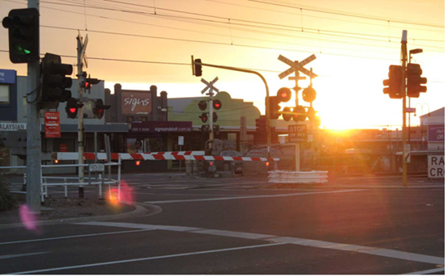

Figure 4 – Photograph taken at about the same time of day as the incident looking in the direction of the setting sun.

# Analysis

## The incident

All the evidence associated with this incident points to the motor vehicle having turned into the crossing without stopping and then pushing up the boom barrier before driving into the path of the train.

The rail crossing infrastructure was functioning correctly and the warning lights, bell and boom barriers had activated in accordance with requirements before the train entered the crossing. The motor vehicle driver was presented with a lowered boom and rail crossing flashing warning lights but no road traffic light that would have indicated that it was not safe to turn left and enter the crossing.

The reason the motor vehicle driver did not comply with the crossing warnings will never be known but the potential influences on his decision to enter the crossing are addressed below.

## Position of the sun

At the time of the collision the setting sun was low in the sky and evidence from the train CCTV footage indicates that it was producing significant glare. The azimuth of the sun positioned it mid-way between the heading of the motor vehicle on Station Street and the heading it had to turn onto to cross the rail lines. As a result, the glare from the sun would have affected the motor vehicle driver’s view of the rail crossing; associated warning lights as he headed along Station Street, and the boom barriers as he turned to cross the rail tracks. Also, while the train would have only been visible for a few seconds prior the impact, the sun glare would have made it more difficult for the motor vehicle driver to see it.

It is worthy to note that the glare from the sun would have only significantly hampered a motor vehicle driver’s view of the crossing for a short period of time and on only a limited number of days of the year.

## Vegetation

Because the vegetation between Station Street and the rail line obscured the rail crossing warning lights until a motor vehicle driver was about 30 metres from the crossing, the opportunity, in terms of time, the driver had to observe the lights would have been diminished.

## Road traffic lights

When a train activated the road traffic lights a driver heading north on Station Street was presented with a red left turn arrow. However, when the booms were fully down the arrow extinguishes after about three to four seconds. This allows the driver to cross the stop line, turn left towards the crossing and queue at the boom until the boom lifts and the crossing warning lights extinguish, presumably to assist with road traffic flow along Station Street.

This traffic light sequence of operation does not provide any secondary warning to alert a motor vehicle driver that the crossing is active. Had the red arrow remained illuminated until the rail crossing was clear of trains and the crossing warning devices had cleared, then, on this occasion, the driver may have remained stopped at the road traffic light and avoided the collision.

# Conclusions

## Findings

1. The rail crossing warning devices operated correctly.
2. The minor discrepancy between the crossing warning signs and the applicable standard are not considered to be a factor in this incident.
3. The road traffic signals operated in accordance to their design.
4. The train was operated in accordance with the prescribed rules.

5. The fault in the train doors did not affect its operation in relation to this incident.

## Contributing factors

1. The vegetation between Station Street and the rail line obstructed a motor vehicle driver’s view of the rail crossing warning devices as the motor vehicle approached the crossing.
2. Sun glare would have made it difficult for a motor vehicle driver to observe the rail crossing warning devices and the approaching train.

3. The design of the road traffic signals did not provide a motor vehicle driver with a secondary indication when the rail crossing was active.

# 

# Safety Actions

## Recommended Safety Actions

Issue 1

The vegetation between Station Street and the rail line restricts the view of the warning lights by a motor vehicle driver until late in the approach to the crossing.

RSA 2009008

It is recommended that Connex (and the subsequent franchisee) review the vegetation at the Edithvale Road level crossing and at similarly configured crossings with the aim of increasing the approach view of motor vehicle drivers of the crossing warning devices.

Issue 2

The road traffic lights on Station Street do not provide an indication to a motor vehicle driver that the crossing may be active.

RSA 2009009

It is recommended that VicRoads reviews the operation of the road traffic lights at Edithvale Road and other similarly configured crossings and considers providing road traffic with an indication that the crossing is active.