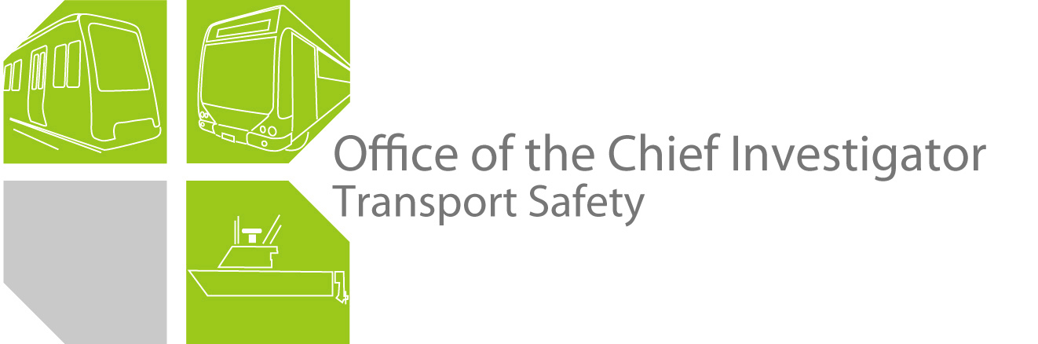

Rail Safety Investigation

Report No 2010/01

Signal passed at danger

Clifton Hill Line, Flinders Street Station

19 January 2010

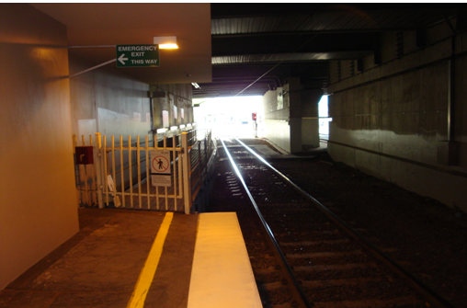

TABLE OF CONTENTS

The Chief Investigator 5

Executive Summary 7

1. Circumstances 9

2. Factual Information 11

2.1 Personnel 11

2.2 The vehicle 12

2.3 Infrastructure 12

2.4 Recorded information 19

2.5 Environment 19

2.6 Rail operating rules 19

2.7 Train operations 19

3. Analysis 21

3.1 The incident 21

3.2 The train driver 21

3.3 Time pressures on drivers 22

3.4 Rail system interventions 22

3.5 Train describer number 22

4. Conclusions 23

4.1 Findings 23

4.2 Contributing factors 23

5. Safety Actions 25

5.1 Safety Actions taken since the event 25

5.2 Recommended Safety Actions 25

The Chief Investigator

The Chief Investigator, Transport Safety is a statutory position under Part 7 of the *Transport Integration Act 2010*. The objective of the position is to seek to improve transport safety by providing for an independent no-blame investigation of transport safety matters consistent with the vision statement and the transport system objective.

The primary focus of an investigation is to determine what factors caused the incident, rather than apportion blame for the incident, and to identify issues that may require review, monitoring or further consideration. In conducting investigations, the Chief Investigator will apply the principles of ‘just culture’ and use a methodology based on systemic investigation models.

The Chief Investigator is required to report the results of investigations to the Minister for Public Transport and/or the Minister for Roads and Ports. However, before submitting the results of an investigation to the Minister, the Chief Investigator must consult in accordance with section 85A of the *Transport (Compliance and Miscellaneous) Act 1983*.

The Chief Investigator is not subject to the direction or control of the Minister(s) in performing or exercising his or her functions or powers, but the Minister may direct the Chief Investigator to investigate a transport safety matter.

Executive Summary

Train 1003 was to operate empty from Flinders Street Station to the Epping maintenance facility after completing services during the morning peak. The train, which arrived about seven to eight minutes late, was to be driven by a different driver who was to complete his shift on arrival at Epping.

At 0853, train 1003 departed platform 14 when the signal controlling its departure (home signal 160) was indicating a stop aspect. As the train passed the signal its train stop contacted the trip valve on the train and the train’s brakes were applied, bringing the train to a stop.

After about 30 seconds the train recommenced its journey, ran through a set of points (points 60) before travelling towards Jolimont Station on the Up Clifton Hill line; against the flow of traffic. The driver reported that when he realised the train was travelling on the Up line instead of the Down line he brought the train to a stand. When the train came to a stand, the lead car was facing train 1242 and about 46 metres from it.

There was no injury to any person or damage to either train. Points 60 received minor damage and required repair by maintenance staff.

The driver of train 1003 made two errors in the operation of the train; starting his train against a signal displaying a stop aspect and not complying with procedures when the train was brought to stand by the signal train stop. The reason/s for his actions could not be positively determined but it is possible that late running and his planned task after completing his shift distracted him during the departure sequence.

The rail infrastructure involved in the incident is not considered to have been causal to the event.

Following the incident the train operator issued a safety notice to all company train drivers to highlight the correct procedure to follow after the operation of a trip valve close to a home signal.

# 

# Circumstances

Train 1003 was to operate empty from Flinders Street Station to the Epping maintenance facility after completing services during the morning peak. On 19 January 2010, the train was scheduled to depart from platform 2/3 at 0840. The driver for the service arrived at Flinders Street Station after operating another service and commenced to make his way to platform 2/3 before being advised that train 1003 would now depart from platform 14. He proceeded to platform 14 arriving there prior to the arrival of the train.

When the train arrived, about seven to eight minutes late, the driver conversed with the inbound driver about its serviceability before boarding and undertaking the pre-departure checks.

At 0853, train 1003 departed platform 14 when the signal controlling its departure (home signal 160) was displaying a stop aspect. As the train passed the signal its train stop contacted the trip valve on the train and the train’s brakes were applied, bringing the train to a stop.

After about 30 seconds the train recommenced its journey, ran through a set of points (points 60) before travelling towards Jolimont Station on the Up Clifton Hill line; against the flow of traffic. The driver reported that when he realised the train was travelling on the Up line instead of the Down line he brought the train to a stand; with the lead car stopping beyond the Wellington Parade South Bridge.

When it came to rest, train 1003 was facing train 1242 with the lead car of both trains about 46 metres apart.

There was no injury to any person or damage to either train. Points 60 received minor damage and required repair by maintenance staff.

Train 1242 was driven back to Jolimont Station before being re-routed to Flinders Street Station via the City Loop. Train 1003 was driven to Burnley sidings to be inspected.

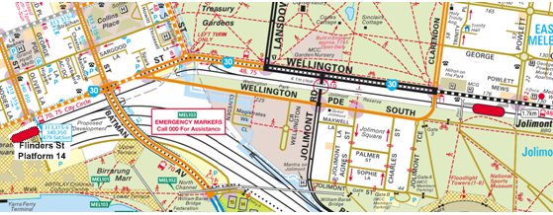

Figure 1 – General location of the incident. (Copyright Melway Publishing 2007. Reproduced from e-Way Electronic Street Directory with permission.)

# Factual Information

## Personnel

### Driver train 1003

The driver was initially qualified to drive Melbourne metropolitan trains in 1982. He left the Victorian rail industry in 1993 but rejoined the previous metropolitan rail network operator in 2005. He completed Conversion Driver training with the metropolitan operator successfully in June 2005. The driver was appropriately certified to operate the incident train on the Flinders Street Station to Epping route and his medical certificate was current at the time of the incident.

Since completing the conversion training the driver has been subjected to a number of routine safety audits, the latest prior to this incident, being in May 2009. All audits had been completed successfully with the auditors commenting favourably on the driver’s performance without noting any areas of concern.

**Driver roster**

The driver recommenced driving duties on Saturday 9 January 2010 after recreation leave. He worked the next seven days before having Sunday 17 January off duty. On Monday 18 January, the driver commenced work at 0439 and completed a seven hour 19 minute shift. On the day of the incident he commenced duty at 0445 and was due to complete a five hour 33 minute shift at 1018. The operator assesses driver rosters against a recognised fatigue assessment program. An analysis of the incident driver’s rostered shifts since 10 January found that given the shifts he had worked his fatigue level should have been well below the company agreed fatigue limit.

**Driver interview**

Following the incident the driver submitted an incident report to the operator and was interviewed separately by investigators. He advised that prior to the incident the shift had been normal with no issues until he was advised that there was a change in the platform from which the empty-car service to Epping was to depart.

The driver commented he walked to platform 14 but that the incoming train was late and he had to wait for it to arrive. After the train arrived he conversed with the inbound driver regarding any faults with the train; the faults included a defective DDU (Driver Display Unit). The inbound driver advised that he would check the train (for lost property and that it was clear of passengers) as he walked back along it and give the driver the all-clear signal. The driver then entered the driver’s cab and checked for train defect notices, as the train was due to be shunted into the maintenance on its arrival at Epping.

The driver then attempted to enter the train describer number[1] in the radio system but was unsuccessful. He said that at about this time he received the all-clear signal[2] from the other driver. He then looked for the signal and the trip (train stop arm), closed the saloon car doors, sounded the whistle, checked that the platform was clear and departed the train, while continuing to attempt to enter the train describer number into the radio system. The driver noted that he was conscious that the train was already late.

The driver said that when the train was stopped by an uncommanded brake application he did not realise that the train had been ‘tripped’ (see 2.3.2) at a signal as he looked in his driver’s side mirror and could not see a signal. After restoring the brake pipe pressure and continuing towards Epping he said that he did not recognise that anything was wrong until he looked out and saw the Down track on his left[3] and realised that the train should have been on that track and not the Up track. He then stopped his train and observed the opposing train on the same line. Before he had the opportunity to call Metrol[4] he received a radio call from them.

The driver said that he could not explain why he had passed Signal 160 when it was indicating a stop aspect except that the signal was not in his direct view (on the left side of the track). When the train was tripped he thought that the train had been tripped by something other than passing a signal at stop. He also commented that at the time of the departure from platform 14 he was distracted by thinking about picking up his sons after he completed work on arrival at Epping.

The driver was asked about the sighting of signals situated on the ‘offside’ (right side of the track instead of the left side) and advised that across the network there were only a few signal so situated and that offside signals were easier to sight from X’Trapolis driver cabins than the Comeng drivers cabin because of the layout and obstruction in the Comeng cabin.

The driver commented that he felt indirect pressure from the train operator to improve service reliability and had noticed that company representatives were on platforms logging departure times and using stop watches. He also commented that in the past drivers did not conduct any ‘driver’s duties’ - such as; setting DDUs, entering train describer numbers into radio systems – while the train was in motion.

## The vehicle

The train involved in the incident was a six-car Comeng (M380-T1040-M379-M509-T1095-M490). It had just completed a passenger service from Belgrave to Flinders Street Station and was being operated empty to the Epping maintenance facility.

Following the incident the train was transferred to Burnley siding for inspection. The train was not damaged as a result of the incident and no faults were found with it that would have been causal to the incident.

## Infrastructure

The section of tracks involved in the incident comprised the Clifton Hills lines that proceed in an easterly direction from Flinders Street Station. The line that is adjacent to platform 14 is a bi-directional track; trains are signalled to travel in both directions. Beyond points 60 there are two lines that are uni-directional forming a dedicated Down line carrying traffic towards Clifton Hill and an Up line carrying traffic towards Flinders Street.

### Signal FSS 160

This signal is a three-position Down Home light signal that controls train movements from platform 14 at Flinders Street Station to the Down Clifton Hill line. The signal is positioned about 45 metres to the east of the platform and about 50 metres from the six-car train stopping position on the platform. It is located on the right side of the track (wrong sided). Most signals throughout the Melbourne metropolitan network are positioned to the left of the rail line.

**Signal review**

On the day following the incident signal 160 was the subject of a review by an operator committee, as is the practice with all such incidents. The review reported that the signal had been passed at danger on two previous occasions since 2006, in February 2006 (following which LED equipment was fitted) and on 26 April 2009.

The review determined that the signal could be observed from the driver’s position in a Comeng train from the platform six-car stopping line and then would remain in the driver’s view for about 30 metres after the train departed. The report noted that, since the last review of signal 160 (following an incident in April 2009), the signal head had been turned to face more to the track and that it would require being re-focussed and turned an estimated 5-10 degrees away from the track to provide correct focussing. It recommended that, because of the brightness of the background and clutter behind the signal, a standard 600 mm background be fitted to the signal head.

The review did not see a benefit in fitting a co-acting signal, on the opposite side of the line, due to the curve in the track for non-stopping trains and for trains stopping at platform 14 there was sufficient distance from the signal to allow a driver adequate view of it.

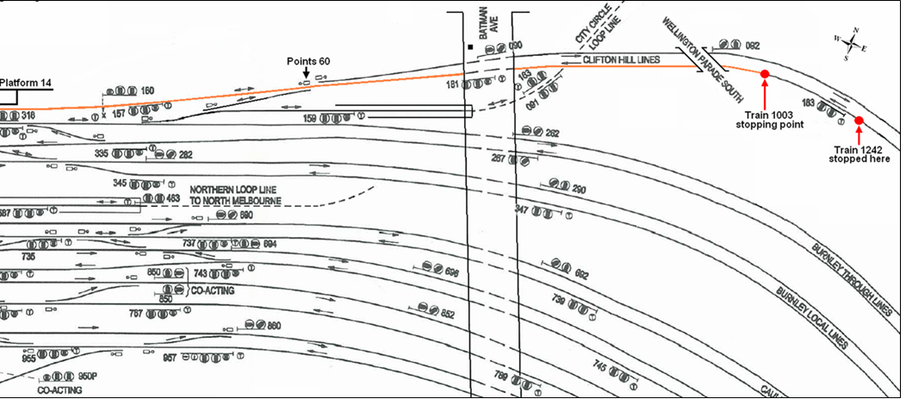

Figure 2 – Diagram of rail lines and signals to the east of Flinders Street Station. Red line shows route taken by train.

### Automatic train stops

An automatic train stop consists of a pivoted lever arm fixed outside the left-hand rail of the running line. When the associated fixed signal[5] shows ‘Stop’ the train stop lever is raised. If the train overruns the signal the train stop lever will operate a trip valve connected to the train brake air pipe and the air brake will operate in emergency and stop the train (known in the industry as being ‘tripped’). All three position running line signals in the Metro Trains network, including signal 160, are fitted with automatic train stops.

### Points 60

Points 60 are located to the east of signal 160 where the Clifton Hill lines begin. The points allow trains travelling east from Flinders Street Station platforms 1, 2, 3 and 14 to be routed via the Clifton Hill Down line and for trains travelling on the Up Clifton Hill line to be routed to these platforms (see Figure 3).

The points received minor damage when the train trailed through them on to the Up line but were able to be ‘clipped’ in position to allow traffic to pass over them after the incident.

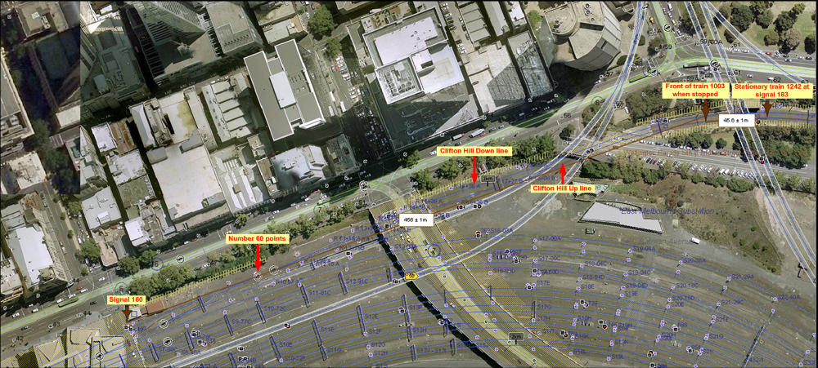

**Figure 3 – Incident overview**

## Recorded information

The train was equipped with a VM-40 data logger which recorded various data about the operation of the train. Analysis of the recorded data determined that at 0853:30 the passenger doors on the train were closed and five seconds later the train horn was sounded, then immediately after current was recorded at the traction motor; indicating that the driver had positioned the master controller to move the train forward.

At 0854:05 the train’s trip valve was activated and the brakes applied in emergency. At this time the speed of the train was about 10 km/h. The train horn was then sounded at 0854:27 and it recommenced its journey 10 seconds later.

At 0855:26 the train was recorded as reaching its maximum speed since departing platform 14 of about 37 km/h. Three seconds later the emergency brake was applied and the train stopped at 0855:40.

A comparison of data from trains 1003 and 1242 (stopped at signal 183 on the Up line) indicated that the distance between them after train 1003 had stopped was about 46 metres (see Figure 3).

## Environment

Weather observations by the Bureau of Metrology for Melbourne at 0900 on 19 January 2010 indicate that the temperature was 15 degrees Celsius; it was fine with an almost complete cloud cover. There were no obstructions to visibility.

The sun was at an azimuth of about 095 degrees T (approximately 25 degrees to the right of the direction of the rail line) and at an altitude of about 28 degrees above the horizon. Observations on site suggest that at the time of the incident the sun would have been obscured by cloud.

## Rail operating rules

The various rules and operating procedures applying to the Victorian rail network are described in the *Book of Rules and Operating Procedures 1994.* Rule 9 (e) describes the actions to be taken by a train driver when a train trip valve has been operated close to a Home Signal. The rule states that the driver ‘must’ bring the train to a stand immediately and inform the train controller and not proceed until instructed by a stationmaster or a signaller.

## Train operations

Trains operating on the Melbourne Metro Trains network are controlled from Metrol (Metropolitan Train Control Centre). For the location of this incident the train controller has a panel and monitors that show, amongst other information, the movement of trains.

The Metrol manager advised that it is general practice for train controllers to give priority to trains carrying passengers. For this incident he advised that train 1003 had arrived at Flinders Street Station platform 14 as train 3620 from Belgrave, running about eight minutes late. It was originally planned to arrive at platform 3 but this was amended by the train controller for operational reasons. The driver who was to operate train 1003 arrived at Flinders Street Station after operating another service about 20 minutes prior to the scheduled departure time of train 1003.

### Traffic situation

Train 1003 was held at platform 14 due to a confliction with train 1038 which was inbound to Flinders Street Station from the east. Train 1038 was en route from the Clifton Hill Up line via signals 183 and 181 and through points 60 to platform 1C (around train 1003). Another inbound train (train 1242) proceeded from Jolimont Station and was held at signal 183. This was because train 1003 was at platform 14 and the control system is set up to hold a train at signal 183 when platform 14 is occupied and the track to Platform 1C has not cleared. The train controller planned to depart train 1003 past signal 160, through points 60 to the Clifton Hill Down line once train 1038 had cleared the track circuit to platform 1C. Train 1242 was to be held at signal 183 until train 1003 had departed and cleared the track circuit onto the Clifton Hill Down line.

### Train controller’s actions

The train controller observed on his monitor that train 1038 had passed points 60 and then that train 1003 had passed signal 160, which was indicating a stop aspect. He then attempted to contact train 1003 but was unable to as the train describer number had not been entered into the radio system. Train 1003 was then observed to continue beyond signal 160 and to enter the Clifton Hill Up line, pass by signal 181 before stopping before signal 183[6].

The senior train controller on duty also observed the event and when he became aware that the train describer number for 1003 was not in the system he ascertained the train’s previous train describer number (3620) and called the train on the fixed train radio.

### Previous SPAD (Signal Passed at Danger) history

When a signal is presenting a stop aspect and is passed by a train it is referred to in the rail industry as a SPAD. The occurrence of such incidents is required to be reported, according to the category of event, by rail operators to the rail safety regulator, PTSV (Public Transport Safety Victoria).

Records held by PTSV for SPADs on the metropolitan rail network from 1 January 2005 to 31 January 2010 against the event ‘Started against signal’ – the type of event involved in this incident – show a total of 12 events for the five-year period. Of these, four have occurred at Southern Cross Station and three at Flinders Street Station.

# Analysis

## The incident

In broad terms, the purposes of a railway signalling system is to ensure separation of trains and prevent conflicting movements. It is therefore essential that trains comply with signal aspects. In this incident the train started its journey when it was presented with a stop aspect on the signal controlling its departure.

Previously it had been recognised by those who managed the Melbourne suburban rail network that a train driver may err and pass a signal that showed a stop aspect. On the network, home signals, such as signal 160, are fitted with train stops that act to stop a train that passes the signal when it is showing a stop aspect. This engineering solution is designed to overcome a human error. However, to reduce the disruption of rail traffic by such an event, a procedure that allowed the train to continue after an uncommanded stop was put in place. This procedure required actions by the train driver, including gaining the approval of a rail operations person not on the train, before the train could continue its journey. This procedure was not followed correctly in this instance which resulted in the train proceeding without approval and subsequently being positioned on the incorrect line facing a Flinders Street bound train.

## The train driver

The train driver was well experienced and aware of the procedures he should follow in the event of being involved in a SPAD incident of this type. Also, train drivers are well aware of the potential outcomes of passing a signal displaying a stop aspect.

When the driver received a hand signal from the previous driver that the train was clear to proceed, an indication only that the train was clear of passengers, he was attempting to enter the train describer number into the train’s radio system. This last action, while important to communications with the train and providing passengers with journey information, was not critical to the operation of the train. The driver reported looking for the signal and train stop arm before closing the saloon doors and sounding the horn. While the signal was on the right side of the track instead of the more usual position on the left side, it was situated far enough to the front of the train to have been easily visible if the driver had looked ahead. It is possible that the driver only looked down to a position that the train stop would have been had the signal been closer to the departure end of the platform to ascertain whether the arm was raised, indicating the signal was at stop. Then, when he did not see a raised arm, he assumed that it was clear to proceed and departed the train.

When the train was stopped by the intervention of the train stop, the driver apparently did not associate this forced stop with the train passing a signal displaying a stop aspect. Possibly because when he looked in the driver’s side rear view mirror he did not see a signal post and so assumed that some non-operational obstruction (such as debris beside the track) had caused the train to ‘trip’.

This was the train driver’s last journey of the shift, the train was operating empty and he may have been more relaxed because of not having to address the safety and convenience of passengers on the journey. Also, at the end of the shift he was due to pick up his children and in planning for this task he may have allowed himself to be distracted to the point of losing situational awareness during the station departure sequence.

## Time pressures on drivers

The driver said that he was aware the train was late and also felt some pressure from the operator to run trains to schedule. It is worth noting that in any scheduled transport system, particularly involving the carriage of passengers, there will always be pressure to run to the schedule. It is task of each driver to ensure that the schedule is maintained but in doing so safety and adherence to the operating rules and procedures are paramount.

## Rail system interventions

The suburban rail system provides an engineering intervention to stop trains should they pass three-position running line signals presenting a stop aspect. The system then assumes that train drivers will recognise what has occurred and follow the procedure to remedy the situation. The train controllers are not given an audible or easily recognised visual (such as a flashing light) warning that a signal has been passed when it was displaying a stop aspect.

In this case, although it may not always be the case across the Metro Trains network, the train controller observed that train 1003 had passed signal 160 but was unable to contact the driver because the train describer number had not been entered into the radio system. It is possible that had the train controller been able to immediately make contact with the driver the train may not have continued after being ‘tripped’. Although that may have prevented this incident, for other similar events the train controller could be otherwise occupied on a different part of their area of responsibility and miss the SPAD event.

## Train describer number

The entry of the train describer number into the train’s radio system is required so the train can be contacted by train control. While train drivers carry company mobile telephones the individual telephone numbers are not readily available to train controllers or signallers.

In this incident, requiring that the train describer number be entered before the train departed may have reduced the number of potential distractions for the driver and would have made it easier for train control to contact the train following the SPAD incident.

The procedures state that the train may depart without the train describer number being entered and also instruct that further attempts to enter the number should only be done when it is safe to do so. Drivers would be aware that until the train describer number is entered they would be effectively out of communications and therefore are likely to continue to enter the number during the departure sequence to ensure communications are available to the train. Allowing this potential distraction at a critical stage of a journey, such as departing a station, should be reviewed by the operator.

# Conclusions

## Findings

1. The train driver was appropriately qualified and experienced to conduct his rostered duty.
2. There were no faults with the train that were causal to this incident.
3. All rail infrastructure, including signal 160, was operating correctly prior to the incident.
4. The position of signal 160 and the minor focussing issues of the signal are not considered to be causal factors.

5. Train 1003 was started against a signal displaying a stop aspect.

6. When the train was subjected to an uncommanded stop close to signal 160, the driver did not follow the correct procedure.

7. The train controller’s attempt to communicate with the train was hampered by the train describer number not having been entered into the train’s radio system.

## Contributing factors

1. The train driver, for reason/s not determined, became distracted to an extent that he lost situational awareness during the departure from the platform.

# 

# Safety Actions

## Safety Actions taken since the event

Immediately following the incident the operator issued a safety notice to all company train drivers that highlighted the correct procedure after the operation of a trip valve close to a home signal.

## Recommended Safety Actions

**Safety Issue 1**

When a train departs before the train describer number is entered into a train’s radio system, a train controller is deprived of an opportunity to expeditiously communicate with a train. Also, there is an opportunity for the train driver to be distracted from the task of operating the train at a critical stage of its journey.

**RSA 2010001**

That Metro Trains Melbourne review the procedure that allows trains to depart before the train describer number is entered into the train’s radio system.

Safety Issue 2

Metrol train controllers are not provided with either an audible or obvious visual warning that a train has passed a signal displaying a stop aspect.

RSA 2010002

That Metro Trains Melbourne investigate the possibility of providing train controllers with audible and/or visual warning when a train passes a signal displaying a stop aspect.

1. Entry of the train describer number into the radio system allows the metropolitan train control centre to directly contact the train and sets the on-train passenger information display.
2. This signal signifies to a driver that the train is ready to proceed on its journey from a passenger loading point of view.
3. The train should have been travelling on the Down track. There is no track to the left of the Down at this location.
4. Metropolitan Train Control Centre.
5. A fixed signal is a signal or sign at a fixed location for displaying indications that affect the movement of trains or engines.
6. Signals 181 and 183 were not positioned to display an indication to trains travelling in the Down direction on the Clifton Hill Up line.