

Rail Safety Investigation

Report No 2010/02

Safeworking incident

worksite protection

Somerton Loop – Tullamarine Loop

9 February 2010

TABLE OF CONTENTS

The Chief Investigator 5

Executive Summary 7

1. Circumstances 9

2. Factual Information 11

2.1 Personnel 11

2.2 Train 2SM5 11

2.3 Infrastructure 11

2.4 Interview information 13

2.5 Locomotive event recorder analysis 15

2.6 Environment 15

2.7 Network processes 15

2.8 Train performance 16

2.9 Pacific National Train Handling Standards 16

3. Analysis 19

3.1 The incident 19

4. Conclusions 23

4.1 Findings 23

4.2 Contributing factors 23

5. Safety Actions 25

5.1 Recommended Safety Actions 25

The Chief Investigator

The Chief Investigator, Transport Safety is a statutory position under Part 7 of the *Transport Integration Act 2010*. The objective of the position is to seek to improve transport safety by providing for the independent no-blame investigation of transport safety matters consistent with the vision statement and the transport system objectives.

The primary focus of an investigation is to determine what factors caused the incident, rather than apportion blame for the incident, and to identify issues that may require review, monitoring or further consideration. In conducting investigations, the Chief Investigator will apply the principles of ‘just culture’ and use a methodology based on systemic investigation models.

The Chief Investigator is required to report the results of an investigation to the Minister for Public Transport or the Minister for Ports. However, before submitting the results of an investigation to the Minister, the Chief Investigator must consult in accordance with section 85A of the *Transport (Compliance and Miscellaneous) Act 1983*.

The Chief Investigator is not subject to the direction or control of the Minister in performing or exercising his or her functions or powers, but the Minister may direct the Chief Investigator to investigate a transport safety matter.

Executive Summary

On Tuesday 9 February 2010, construction activities associated with Coolaroo Station on the Metro Trains Melbourne network required a mobile lift boom to foul the adjacent standard gauge track, part of the Defined Interstate Rail Network (DIRN). During these activities at about 08:15 a Melbourne-bound Pacific National freight train approached and was unable to stop at the flag protection provided for the boom lift operation. The over-run did not cause injury, impact or damage to equipment or infrastructure.

The investigation concluded that although the worksite protection was placed in accordance with DIRN rules, the distance provided between the initial warning for the train crew and the required stopping point did not provide sufficient braking distance for high speed freight trains operating over the falling gradient between Somerton Loop and the Coolaroo worksite. The investigation also concluded that the braking performance of the freight train exceeded the network standard and requirements.

The investigation recommends that the rules applicable to infrastructure works be reviewed by the DIRN manager to ensure the provision of adequate freight train braking distances between flagging positions, particularly on descending gradients. The investigation also recommends that the network manager review the communication protocols and practices with respect to worksite protection.

# Circumstances

On Tuesday 9 February 2010 at about 08:15, Pacific National train number 2SM5 travelling between Somerton and Tullamarine Loops overshot the inner hand signaller[1] displaying a red flag. The inner hand signaller was providing worksite protection for the Coolaroo Station construction site. Train 2SM5 was being flagged to a stop because a mobile boom lift was fouling the single-track standard gauge line. There are varying reports as to the distance 2SM5 came to a stand beyond the hand signaller. The stopping location was not marked for reference before the train was permitted to depart. There were no injuries or damage to equipment as a result of this incident.

The incident was reported by the boom operator to site management and then to the DIRN Network Controller located at Junee NSW at 09:15. Until the incident report the network controller was unaware of the presence of worksite protection on the DIRN at the Coolaroo construction site.

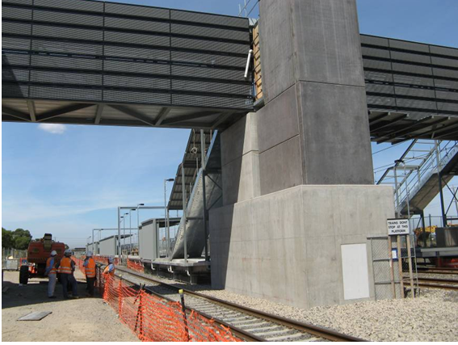

Figure 1 – Coolaroo construction site (Left hand track is DIRN)

# Factual Information

## Personnel

### Protection

All site-protection personnel involved were contracted by Rail Safeworking Solutions and held current qualifications for the tasks allocated on the day of the incident. The protection supervisor commenced duty at about 06:40 and at about 06:45 contacted the Australian Rail Track Corporation (ARTC) network controller at Junee for train running information.

A pre-start meeting for all protection personnel was conducted by the supervisor between 07:10 and 07:25 when the train running information was disseminated.

At 07:29 the network controller at Junee was again contacted and train running information was provided indicating that 2SM5 would cross the Sydney-bound XPT passenger service by entering the Somerton Loop and that the next train towards Melbourne after 2SM5 would be a local train out of Somerton. It was during this conversation that the protection supervisor indicated to the network controller to “put us on the graph” at Coolaroo.

### Train crew

Both train crew members were Melbourne based locomotive drivers and held current qualifications. Both indicated that they were well rested prior to commencing duty at Junee at 03:25. They reported an uneventful journey until their train exploded Audible Track Warning Signals (ATWs)[2] as they passed under the Somerton Road overpass.

## Train 2SM5

Train 2SM5 was a Sydney to Melbourne Pacific National Pty Ltd (PN) intermodal service that departed Sydney on Monday 8 February 2010. It consisted of two NR class locomotives and 26 wagons for a trailing load of 2,488.7 tonnes and a length of 1,201.7 metres. The air brake was isolated on one wagon, which had a mass of 57.96 tonnes, which, according to the PN Train Consist Report, resulted in 2SM5 having 25.39 tonnes-per-operative brake[3]. The un-braked mass was within the network and PN standards for freight trains. The maximum authorised speed for 2SM5 in Victoria was 110 km/h.

## Infrastructure

The track infrastructure between Somerton and Tullamarine loops comprises of concrete sleepers and 60 kg/metre rail with line speeds of 130 km/h for passenger and 110 km/h for freight trains. The descending gradient between Somerton Loop and the stopping location of 2SM5 averaged about 1:86.

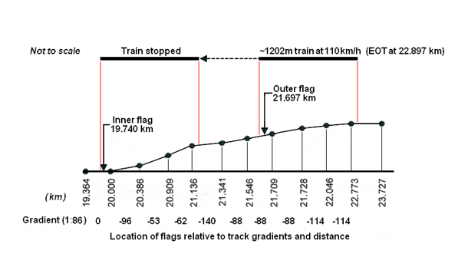

Figure 2 – Track gradient showing 2SM5’s position when at the outer and inner flagging locations

In the direction of travel from Somerton Loop there is a right-hand curve of about 1,187 metres radius followed by about one kilometre of tangent track and then on the approach to the Coolaroo site there is a 1,207 metre radius left-hand curve. The east side rail reserve boundary fence, about seven metres from the track, has a line of medium to high bushes extending from the location of the inner hand signaller towards Somerton Loop for about 300 metres see Figure 3. A drainage ditch immediately adjacent to the ballast shoulder restricted the ability of the hand signaller to stand closer than about three metres to the ballast shoulder to exhibit handsignals to on-coming trains.

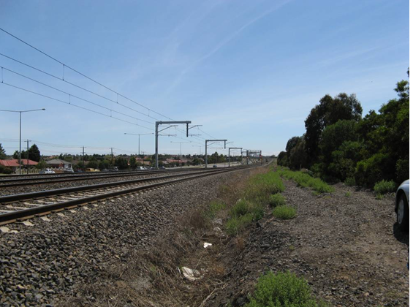

Figure 3 – View towards Somerton Loop from Inner hand signaller’s flagging position

## Interview information

### Site protection supervisor

The supervisor reported that soon after his arrival at Coolaroo he contacted network control at Junee for train running information, which was “Up XPT at 07:15, 2SM5 at 08:20, 9606 anytime and the Down XPT”. The supervisor also reported that control indicated that 2SM5 was going into the loop at Somerton to cross the Sydney bound XPT, which was due at about 09:00. On completion of a toolbox meeting at 07:25 the hand signallers proceeded to their nominated locations on the standard-gauge line and Junee control was again contacted indicating that protection for the works at Coolaroo was being set up. The same train running information was provided by the network controller with the exception of the Up XPT.

At 08:13, the supervisor got a call over the radio from the outer hand signaller that 2SM5 was approaching along the mainline and that the points were set for it to come straight through Somerton, not taking the crossing loop as expected.

The supervisor was aware that a mobile boom lift was extended across the standard- gauge line at this time and made arrangements to have it moved clear of the track. At 08:15 the outer hand signaller announced the train’s progress over the ATWs and the inner hand signaller was told to hold the train until the boom lift had cleared.

About a minute after the train had been announced the inner hand signaller reported that they thought the train was going too fast to stop and then that 2SM5 had passed them by about 60 to70 metres.

As the boom lift was moving clear, the operator observed the train stopping at what they judged to be about 150 metres from the boom. When 2SM5 had stopped the supervisor instructed the inner hand signaller to proceed to the front of the train and be ready to exhibit a green hand signal when the boom lift was clear of the track.

At 08:18 the inner hand signaller was given the okay for the train to proceed and was authorised to give the driver a green hand signal. The then reported the incident to the worksite supervisor.

### Inner Hand Signaller

The inner hand signaller reported that they were in position to flag Up standard gauge trains to protect the Coolaroo site and that at the time of the incident full track protection was in place and that they were displaying a red hand signal for trains approaching from Somerton.

They reported receiving information via the radio from the protection supervisor that the next standard-gauge train due through the work site was the Melbourne to Sydney XPT. They overheard a message to the outer hand signaller indicating that an “Up standard” was in sight at Craigieburn. It was understood that this train was to go into № 2 track at Somerton to cross the Sydney-bound XPT. The outer hand signaller called the approach of a train to the protection officer who indicated that it would go into the loop at Somerton. It was then that the inner hand signaller heard the outer hand signaller’s call indicating that 2SM5 had exploded their ATWs. As the Up standard- gauge train came into sight the inner hand signaller said that they reported this to the protection supervisor and exhibited a red flag. According to the inner hand signaller, the train did not appear to be slowing sufficiently and proceeded beyond their red flag. The situation was reported to the protection supervisor. The inner hand signaller walked towards the front of the train and spoke with the driver who said that they believed there wasn’t enough distance between the inner and outer flag protection and that the red flag being displayed was difficult to see due to the foliage along the boundary fence. At 08:18 the supervisor gave permission for the train to proceed through the worksite.

### Outer Hand Signaller

The hand signaller reported being in position at the Somerton Road overpass when, at about 08:15, a Melbourne bound standard-gauge freight train passed them, exploding three ATWs in place on the line. They also reported that a yellow flag was displayed and that they radioed the inner hand signaller that the train had passed through Somerton and was approaching them. He also said that the train was expected to be held in the Somerton Loop to cross the northbound XPT. It was also reported by this hand signaller that the train appeared not to be slowing down in response to the warnings provided.

### Pre-start tool box meeting record

A site meeting involving all protection staff was conducted at 07:15 where the train information was communicated.

The TPR (Track Protection Record) book records the second call to the network controller advising that a work group under their own protection would be obstructing the standard-gauge line at Coolaroo. Train information was exchanged and the Site protection supervisor made a notation to the effect that 2SM5 would be crossing the XPT at Somerton. The TPR book also logged the positioning of the worksite and the hand signallers as; Worksite at 19.100 - 19.200 kilometres, the inner hand signaller at 19.500 kilometres and the outer hand signaller at 21.900 kilometres. These distances recorded in the TPR book were not consistent with the actual worksite and hand signallers locations.

### Train crew

When interviewed the driver reported that they passed through Somerton Loop with ’Clear normal’ aspects on both the Arrival and Departure signals with the locomotives under full dynamic braking. As they passed under the Somerton Road underpass their train exploded three ATWs and a hand signaller was standing in advance of the overpass exhibiting a yellow flag. He reported that on the approach to the yellow flag a long whistle was sounded and the air brake applied with a final brake pipe reduction on sighting the inner hand signaller who had moved from the boundary tree line exhibiting a red flag. He was unable to stop his train short of the red flag and estimated that the train passed the hand signaller by about an engine length (20 metres). The hand signaller approached the front of the locomotive still exhibiting the red flag and talking on a hand held radio. When they reached the locomotive the hand signaller said everything was okay and exhibited a green hand signal. Before departing the driver asked what was happening and was informed that a boom had been down over the track but that everything was “ok now” and that he could continue.

When asked why the incident was not reported the driver replied that it was a mistake and he should have. However, as the hand signaller had indicated that everything was okay, he believed that there was no issue.

## Locomotive event recorder analysis

A review of the locomotive event recorder found that the dynamic brake was operating on the approach to Somerton Loop and throughout the descent until 2SM5 was brought to a stand. From the commencement of the brake pipe reduction, 1,962 metres from to coming to a stand, sequential split service reductions were used to achieve a ‘Full Service’ brake application at 60 km/h, 316 metres from stopping. The independent brake was applied gradually to supplement the dynamic brake 312 metres from stopping. With the train’s air brakes applied to the full service brake pressure level the retardation rate from 60km/h to stopping was 0.44 m/s² compared to the GW-30 standard of 0.27 m/s².

## Environment

At the time of the incident the weather was fine and sunny with clear visibility.

## Network processes

ARTC utilise ‘Train Notices’ as a method of informing users of their network about changes or conditions affecting the network. For the Coolaroo Station works a Train Notice was issued for the period Saturday 6 February 2010 through to Monday 8 February 2010 informing ARTC network users of the arrangements at Coolaroo Station. There were no other Train Notices referring to the works at Coolaroo valid for the time of this incident.

Track force protection rules applicable on the DIRN are provided for in the ARTC *Code of Practice Victorian Mainline Operations TA20, Section 15, Infrastructure Works* which stipulates the occasions when protection must be provided, how it must be applied and what action a driver of a train must do in response to the protection warning.

Rule 3(b) states that: “an outer flagman must place three ATWs on the line 10 metres apart not less than 2,000 metres and no more than 4,000 metres from the obstruction and that a warning hand signal must be plainly exhibited to any approaching train even if a train is not expected. The inner flagman must plainly exhibit the ‘Stop’ hand signal not less than 200 metres from the obstruction and the protection can only be withdrawn on instructions from the person in charge that the obstruction has been removed. The inner flagman then must plainly exhibit a green flag or light held steadily in the hand, to the driver of the train or light locomotive.”

Rule 3(c) states that: “the driver of an approaching train must reduce speed on observing a ‘Warning’ hand signal or exploding ATWs. The driver must be prepared to stop the train and await further guidance from the inner flagman.”

Rule 3(e) states that: “should the nature of the terrain not allow a good and distant view of the ‘warning’ hand signal then the hand signal and ATWs must be placed to provide a good and distant view.”

On this occasion the requirements of Section 15 Rule 3 parts b, c, and e were applied and complied with, yet train 2SM5 overran the ‘Stop’ hand signal being exhibited by the inner hand signaller.

The ARTC network between Melbourne and Albury allows for the operation of freight trains up to 1,500 metres long at speeds up to 110 km/h.

ARTC’s stopping distance braking calculations for trains less than 1,300 metres long (GW-30) was applicable for 2SM5 (See Figure 4). Network stopping requirements GW-40 for freight trains up to 1,500 metres has also been used to provide a comparison in Figure 4.

### Network Control Centre

Train control functions for the Victorian North-East portion of the DIRN (Tottenham to Albury) are performed by ARTC at their network control centre located at Junee, NSW. The centre also controls trains between MacArthur and Albury, NSW. There are entirely separate and different network operating rules and procedures applicable to the Victorian and New South Wales territories. At certain times of the day the one train controller is responsible for the entire territory between Tottenham and MacArthur. On the day of the incident a change of train controllers took place at about 07:00 - between the Coolaroo worksite protection supervisor’s telephone calls at about 06:50 and 07:30.

Track force locations and out of course events, together with the progress of trains or authorities issued by the train controller on the network, are recorded on the ‘Train Graph’. While the train graph for 9 February records several Track Warrant authorities issued prior to 09:00, the notation recording track force protection being in place at the 19-kilometre mark between Somerton and Tullamarine loops was not recorded as commencing until about 09:35.

## Train performance

The investigation methodology applied for the analysis of 2SM5’s braking performance took into account the averaging of the gradient between where the train stopped and the outer hand signaller’s position and cross referenced this with the ARTC stopping distances in the GW-30 and GW-40 standards for Superfreighters[4].

The average gradient between the outer and inner flag locations was calculated at about 1:86 and assumed, for calculation purposes to be 1:100. Applying both stopping distances and using a train speed of 110 km/h a freight train would require either 2,345 metres (GW-30 braking curve) or 2,599 metres (GW-40 braking curve) to stop. These values assume a ‘Full Service’ air brake application with zero delay or free run time[5] and no dynamic braking.

## Pacific National Train Handling Standards

*Train Handling Standards* document *THS_ 01-R04 section 3*, states that under normal circumstances a ‘split service’ brake pipe reduction (or graduated application) is the desired method to be used for applying train brakes. This type of application is made by making an initial reduction of 50 kPa and waiting for the brake pipe pressure to stabilise throughout the train after which further reductions may be made as required.

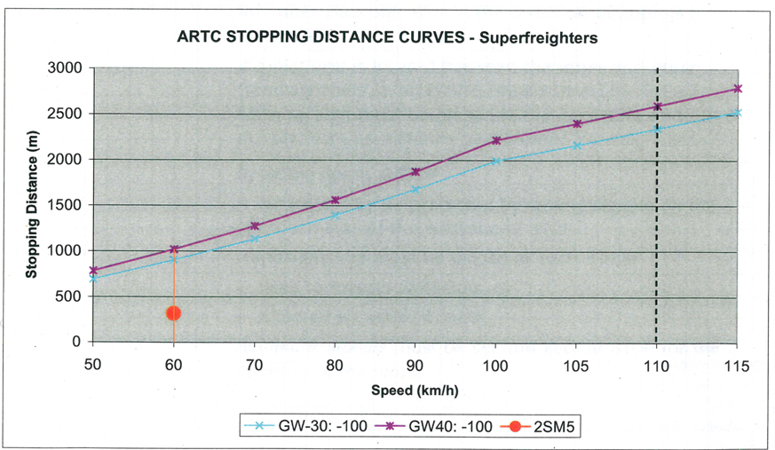

Figure 4 – ARTC GW-30 and GW-40 stopping distances

# Analysis

## The incident

When establishing the positions for the inner and outer hand signallers the supervisor was required to evaluate the terrain and the physical characteristics of the locations. This evaluation identified that the outer hand signaller could be placed at Somerton Road (2,300 metres from the point of work) allowing for the flagging for main line and movements departing the Somerton yard and still comply with the network protection rules.

The inner hand signaller’s position (about 340 metres from the worksite) was identified as being appropriate taking into consideration the terrain and sighting distance for both the worksite and approaching trains together with the need to be compliant with the protection rules. This arrangement, as demonstrated in Figure 5, resulted in a distance of about 1,957 metres between the two hand signallers. As identified in section 1.8 of this report, an intermodal train up to 1,300 metres long and travelling at or near a line speed of 110 km/h requires a minimum braking distance of 2,345 metres on a 1:100 falling grade. A prevailing gradient of 1:86 would slightly increase the stopping distance required.

There was an expectation by all those involved with providing protection for Melbourne-bound train movements that 2SM5 would be held in the crossing loop at Somerton as per the earlier train running information and previous experience.

In this case, the network controller, in accordance with his role and responsibilities for managing the flow of rail traffic, altered the earlier anticipated sequence of train movements between Tullamarine and Somerton Loops. This resulted in 2SM5 approaching and passing the outer flag protection site at Somerton Loop at 106 km/h instead of 40 km/h had it departed from the crossing loop as expected by the track force protection personnel.

### Train handling

Pacific National train handling standards are not prescriptive as to the value of a brake pipe reduction that is to be used for any particular slowing or stopping situation. This is a decision only the driver can make and is totally dependent on the immediate circumstances. In this case, the use of service brake pipe reductions together with full dynamic brake achieved a stopping distance of 1,962 metres, 383 metres less than the ARTC GW-30 stopping distance curve on a 1:100 falling grade.

### Work Site Protection

The positioning of flag protection, in the view of the site protection supervisor, was within the rules and was adequate as it had been located in consideration of the terrain and curvature of the track for approaching Melbourne-bound trains. The total distance from the worksite to the outer hand signaller’s position was recorded in the TPR book as being 2,700 metres. The recorded flagging locations indicated that there was about 2,400 metres between the inner and outer flagging locations whereas in reality there was only about 1,957 metres.

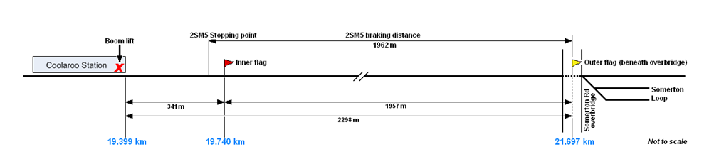

Figure 5 – Schematic of worksite protection and 2SM5 braking distance

### Communications

The network controller on duty at 06:50 provided train running information relevant at that time to the Coolaroo protection supervisor. The subsequent conversation at about 07:30 between the site protection supervisor and the day shift network controller provided the same information as earlier in respect to the working of 2SM5.

A review of the Junee Network Control voice recordings identified that there was a misunderstanding by the day shift network controller of what the site protection supervisor’s term, “put us on the graph” meant. In the protection supervisor’s mind the term was a progression from his earlier conversation with the night shift network controller, in that he was now informing the network controller that his protection team was about to establish worksite protection.

However, the network controller did not have the same understanding. The phase ‘put us on the graph’ was not a standard term to him and held no significant meaning. He did not consider this conversation any differently to other requests for train running information.

The fact that the network controller did not record the establishment of a worksite on the train graph following the conversation with the Coolaroo site protection supervisor reinforces the fact that they did not have the same understanding or expectation of the content of the conversation as did the site protection supervisor. Although this misunderstanding did not contribute to the incident, it highlights the need for all parties to have a clear understanding of what is being established on the network by using clear and precise language.

### Network rules

The network rules for infrastructure works were applied in this case in accordance with TA20. The site protection supervisor and hand signallers believed that they were correctly positioned to provide the level of protection expected by those working at the Coolaroo station worksite. The railway operating environment is dynamic, especially with the scheduling and running of trains over the network. The advancing of 2SM5 beyond the earlier expected crossing location with the Sydney-bound XPT passenger service is not an abnormal circumstance.

The critical aspects of this incident were the descending gradient, the type of train and its speed, the actual distance between the outer and inner hand signalling positions, the expectation of the train running pattern by the protection personnel and the braking distances required for trains. The rules stipulate that the outer flagging position must be between 2,000 and 4,000 metres from the obstruction. However, they do not provide for the minimum braking distance requirements between flagging positions. Had the site protection supervisor at Coolaroo been aware of braking distance requirements for trains on the falling gradient between Somerton Loop and the Coolaroo site he may have reviewed the locations of the hand signallers.

Unlike with Temporary Speed Restrictions (TSRs), the network rules do not require the advance notification to train crew of worksites. Although in this case the establishment of the worksite protection was not recorded until after the incident, it would be advantageous for train crews to be informed to the maximum extent possible of the known conditions affecting the network, particularly when the circumstances involve trains and workers in a joint occupancy situation. This notification would contribute to a higher level of safety for all who are required to be on the network.

# Conclusions

## Findings

1. The worksite protection was placed in accordance with the relevant *ARTC Code of Practice Victorian Mainline Operations TA20*.
2. The distance between the outer and inner hand signallers was insufficient for the braking requirements published in the ARTC GW-30 and GW-40 stopping distance curves for freight trains travelling at 110 km/h on the falling gradient.
3. Train 2SM5’s braking performance exceeded the network standard and requirements published in the ARTC stopping distance table GW-30.
4. The standard of communication between the site protection supervisor and the network controller was inadequate and lead to a misunderstanding of what was taking place on the ARTC network in regards to the Coolaroo worksite.
5. The distances recorded in the site protection supervisor’s Track Protection Book were incorrect.
6. The hand signallers although positioned in accordance with relevant *ARTC Code of Practice Victorian Mainline Operations TA20*, were not in the positions that the protection supervisor estimated or expected.
7. The over-run of train 2SM5 was not reported by the parties involved in accordance with the ARTC network protocols.

## Contributing factors

1. Insufficient distance was allowed between the outer and inner flag warnings to allow freight trains to stop.
2. The *ARTC Code of Practice Victorian Mainline Operations TA20* *Section15,* *Infrastructure Works* does not stipulate a minimum distance requirement between outer and inner flagging locations to address the braking requirements of freight trains.

# Safety Actions

## Recommended Safety Actions

Issue 1

The distance between the outer and inner hand signallers was insufficient for the braking requirements of high speed freight trains.

The protection rules require the outer flagging position to be between 2,000 and 4,000 metres from the point of work or obstruction and the inner flagging position to be no less than 200 metres from the point of work or obstruction. These rules do not provide for a minimum braking distance requirement of freight trains, particularly on falling gradients, between flagging positions.

RSA 2011009

That ARTC reviews the content of the *Code of Practice Victorian Mainline Operations TA20* *Section 15 Infrastructure Works* to incorporate a requirement to take into account the GW-30 and GW-40 braking standards for freight trains when establishing outer and inner flagging positions.

Issue 2

The network controller was not aware of a significant worksite protection activity established on the network. The terminology used during communications between the site protection supervisor and the network controllers was inadequate and lead to a misunderstanding of what was taking place on the network in respect to worksite protection.

RSA 2011010

The ARTC reviews the communication protocols between field personnel responsible for establishing worksite protection and Network control with a view to standardising voice communications phraseology.

Issue 3

Currently the *Code of Practice Victorian Mainline Operations TA20* *Section15 Infrastructure Works* rules does not require or provide for train crew to be advised by Network Control of the location of relevant daily established worksites unless a Temporary Speed Restriction is in place.

RSA 2011011

That ARTC reviews the *Code of Practice Victorian Mainline Operations TA20* with a view to incorporating the requirement for train crews to be notified of the locations of daily worksites involving a joint occupancy situation.

1. A hand signaller is a qualified railway or contract employee who is assigned to protect anyone performing work on a railway. When a train approaches a location where workers may be upon the track, the hand signaller will ensure the workers have cleared the track or stop the train.
2. An Audible Track Warning device (or railway detonator) is a device used to make a loud sound as a warning signal to train drivers. The device is placed on the rail such that when the wheel of the train or locomotive passes over, it explodes emitting a loud bang. One or more ATWs may be used to provide the required message.
3. The gross trailing tonnage of the train divided by the total number of bogies having operative brakes.
4. Industry term for intermodal freight trains operated at 100 km/h or higher.
5. Free run time - the time it takes for a brake application to become effective on all vehicles throughout a train.