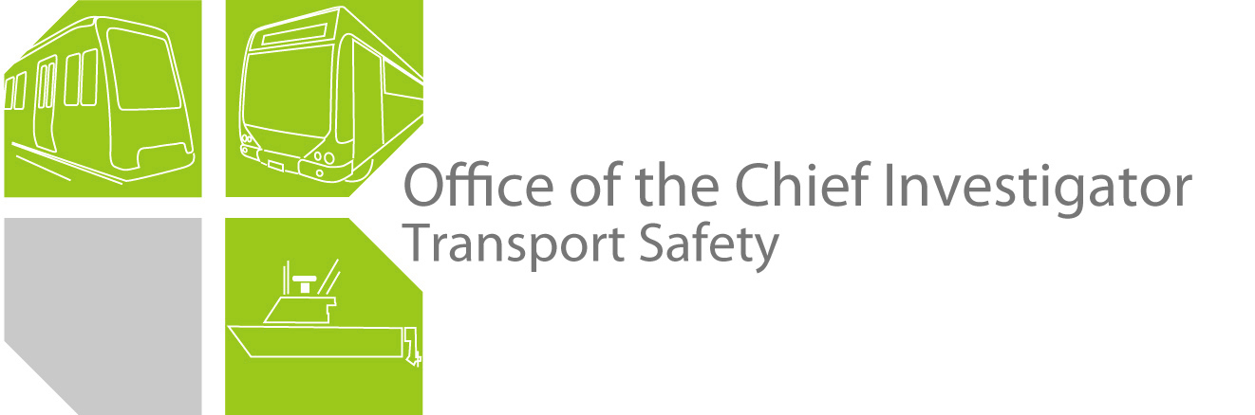

Rail Investigation

Report No 2010/04

Comeng Train Fire

Croxton Railway Station

17 March 2010

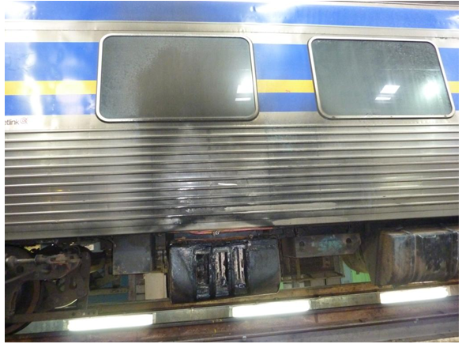

TABLE OF CONTENTS

The Chief Investigator 5

Executive Summary 7

1. Circumstances 9

1.1 The incident 9

2. Factual Information 11

2.1 Metro Trains Melbourne (MTM) 11

2.2 Driver – Comeng train 11

2.3 Metropolitan electrified rail network 11

2.4 Comeng controls 13

2.5 Traction circuit 14

2.6 Traction circuit protection system 14

2.7 Traction motors 15

2.8 Linebreakers 16

2.9 Maintenance 18

2.10 Environment 20

3. Analysis 21

3.1 The incident 21

3.2 Substation DCCBs 22

3.3 Linebreakers 22

3.4 Traction motors 22

3.5 Incident response 23

4. Conclusions 25

4.1 Findings 25

4.2 Contributing factors 25

5. Safety Actions 27

5.1 Safety Actions taken since the event 27

5.2 Recommended Safety Actions 27

6. Appendix A – Comeng Train Electrical Schematic 29

The Chief Investigator

The Chief Investigator, Transport Safety is a statutory position under Part 7 of the *Transport Integration Act 2010*. The objective of the position is to seek to improve transport safety by providing for the independent no-blame investigation of transport safety matters consistent with the vision statement and the transport system objectives.

The primary focus of an investigation is to determine what factors caused the incident, rather than apportion blame for the incident, and to identify issues that may require review, monitoring or further consideration. In conducting investigations, the Chief Investigator will apply the principles of ‘just culture’ and use a methodology based on systemic investigation models.

The Chief Investigator is required to report the results of an investigation to the Minister for Public Transport or the Minister for Ports. However, before submitting the results of an investigation to the Minister, the Chief Investigator must consult in accordance with section 85A of the *Transport (Compliance and Miscellaneous) Act 1983*.

The Chief Investigator is not subject to the direction or control of the Minister in performing or exercising his or her functions or powers, but the Minister may direct the Chief Investigator to investigate a transport safety matter.

Executive Summary

On 17 March 2010, at about 0030, a Metro Trains Melbourne (MTM) Comeng train was departing the Croxton Railway Station when the driver observed sparks and flames emanating from the undercarriage of the last motor car of the train. The driver stopped the train and disembarked the passengers. The fire was subsequently extinguished by the Metropolitan Fire Brigade.

The train was carrying about 50 passengers at the time of the incident. None of the occupants were injured in the incident.

Damage was sustained by the linebreakers, linebreaker casing and equipment, undercarriage components and electrical cabling of car 449M. The paint work on the left side of the train’s exterior also sustained fire and smoke damage. The pantograph sustained corking damage and the overhead contact wire parted due to overheating.

The investigation found that there had been a flash-over of the №1 traction motor of car 449M. It was also found that the contacts of one linebreaker created a sustained arc between its contacts and the casing. The intense heat generated from this arc melted the steel casing and ignited the fiberglass insulation material causing the fire. The investigation was unable to establish with certainty the initiating cause of the incident due to the severe fire damage and the fact that MTM was unable to provide records of the testing or repair of the flashed-over traction motor.

It is possible that the fault initiated at the linebreaker and an electrical short circuit between the linebreaker contacts and its casing resulted in the generation of intense heat that started the fire. It is also possible that a short circuit in the traction motor (evidenced by the flash-over) tripped two linebreakers, but the defective third linebreaker did not trip and struck an arc between its contacts and the casing resulting in the fire.

The investigation found that a substation’s circuit breaker settings were incorrectly adjusted and as a result the train was not protected against over-current. The failure of the substation circuit breaker to operate correctly allowed the continuation of an excessive current flow resulting in the overheating and parting of the overhead contact wire.

The investigation concluded that the train’s electrical components and the substation circuit breaker were not maintained to a satisfactory standard and this led to the mechanical and electrical failure of these components.

The investigation recommends that MTM reviews the maintenance requirements, standards, and maintenance frequencies for train and substation electrical components. The investigation also recommends that MTM maintains records of electrical equipment maintenance and repairs.

# Circumstances

## The incident

On 17 March 2010, Train 1103, which consisted of Comeng motor car 450M, trailer car 1075T and motor car 449M, was operating the midnight service from Flinders Street Railway Station to Epping Railway Station.

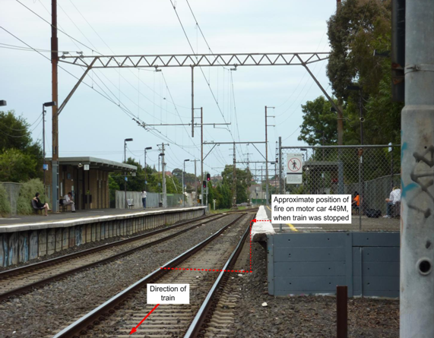

Figure 1: Croxton railway station

At about 0030, as the train was departing the Croxton Railway Station, the driver observed sparks and flames emanating from the undercarriage of the third car (449M) and arcing at the overhead contact wire. The driver stopped the train, lowered the pantographs, and disembarked about 50 passengers.

Initially the driver attempted to extinguish the fire with a portable extinguisher but was unable to do so. The Metropolitan Fire Brigade subsequently extinguished the fire.

### Damage

The overhead power line overheated and parted and required repair. Components of the train’s electrical system, electrical cabling and structural components of the undercarriage sustained fire damage. The side panelling of car 449M suffered smoke and heat damage. The pantograph carbon strips sustained arcing damage and the roof panels of car 449M were damaged due to contact with the live overhead contact wire. Signs of arcing were also observed in №1 traction motor of car 449M.

# Factual Information

## Metro Trains Melbourne (MTM)

MTM is the franchisee for the operation of the Melbourne metropolitan train services. MTM also has the responsibility for asset maintenance of the metropolitan rail network. Specific areas of responsibility include: rolling stock; track structure; the overhead electrical distribution system and substations; signalling systems; and communications, including centralised control facilities such as Metrol (Metropolitan Train Control centre) and Electrol (Electric Traction Power Control centre).

## Driver – Comeng train

The driver of the train was appropriately qualified to drive Comeng trains.

The driver stated that the train arrived at Croxton Railway Station without incident. However, as the train was leaving the station, he noticed the flickering of fault indication lamps in the driver’s console, prior to losing overhead power. He said that he looked in the side mirrors and noticed arcing on the overhead contact wire and “massive sparking” from the undercarriage of motor car 449M. He stated that he “then pressed the panto down button” and noticed “massive flames under 449M”. He tried to use the train radio, but as it was “dead” he contacted Metrol through his mobile phone, advised them of the situation, and requested that the fire brigade and ambulance services be dispatched to the train. He also requested alternative transport for about 50 passengers. He then walked along the train and got the passengers off the train. He said that he noticed that the overhead contact wire had parted and was dangling between the middle car and the third car, and ensured that the passengers were “well clear of the train” when they disembarked. After ensuring that all the passengers were off the train, he attempted to extinguish the fire with a portable extinguisher but was unable to get close enough to do so due to the intensity of the heat. He said that the fire services arrived and extinguished the fire. The driver stated that at about 0050 he left Croxton Railway Station by taxi after the relief driver and overhead repair crews arrived.

## Metropolitan electrified rail network

The Melbourne metropolitan electrified rail network operates on a 1,500 volt direct current (DC) supply to an overhead wire system with a return to substations via one or both running rails. The 22,000 volt alternating current (AC) supply from the main transmission lines is transformed and rectified at the substations to generate a line voltage of 1,500 volts DC to a train traction system and auxiliary systems via a roof mounted pantograph. The roof mounted pantograph is raised and contact with the overhead wire is maintained by air pressure.

The overhead electrical network is divided into sections supplied by substations or tiestations[1]. The tiestations allow the isolation of discrete sections of overhead contact wire in case of electrical faults and facilitates better control of the voltage. Electrical supply sections are made up of a number of shorter overhead wire sections of approximately 1,000 metres known as ‘tension lengths’ to allow for the adjusting of the tension of the contact wire. Substation systems incorporate devices such as ‘high-speed’ circuit breakers (DCCB) to protect the overhead contact wires and the train traction system. The overload tripping current for these circuit breakers can be set between 2,500 and 5,000 Amps and the tripping duration set between 20-40 milliseconds. The tripping current settings of the DCCBs for the incident section were required to be set to 3,000 Amps.

The incident section is supplied by Croxton and Reservoir substations. The Croxton substation DCCB was set to trip at 3,000 Amps and tripped in this incident. The investigation was advised that the Reservoir substation DCCB had “drifted” to 3,500 Amps and “failed to trip on the fault”. The faulty DCCB was subsequently manually tripped by MTM’s technical staff.

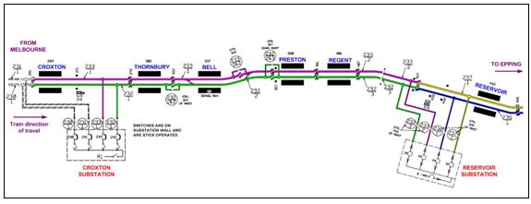

Figure 2: Croxton to Reservoir station & substation schematic

In this incident the overhead wire was observed to have suffered overheating in tension and parted. The separated wire came into contact with the roof panels of motor car 449M and car 1075T causing arcing damage (Figure 3).

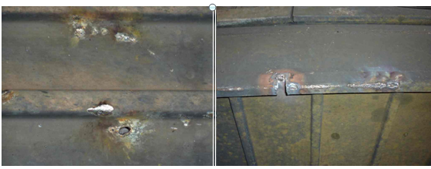

Figure 3: Arcing damage on roof panels due to contact with overhead contact wire

The overhead contact wire diameter before the point of failure was approximately 12 millimetres. The condemning limit for overhead contact wire is 9 millimetres. The melting point of contact wire material, which is a copper alloy, is approximately 1,000 degrees Celsius. However, the annealing temperature[2] where a contact wire may separate due to the wire being under tension will be lower than the melting point of the wire. Overhead contact wires are typically laboratory tested to 200 degrees Celsius, a temperature considered to be much higher than the temperatures achieved when a train is in operation.

The pantograph model M-01222-03L is designed by Brecknell, Wallis & Co. Ltd and was manufactured by Austbreck Pty Ltd, Victoria, Australia. It was of the single-arm design with a pneumatic piston operating a lever arm connected to the frame of the pantograph. The head of the pantograph (pan head) has two metallised carbon collector strips. Metallised carbon consists of a combination of carbon and copper compounds. The nominal and maximum current rating for a pantograph is determined by the configuration and material used in the collector strips. Each collector strip of this pantograph was rated at 12 Amps/millimetre of width, and each collector strip was 26 millimetres in width, giving each strip a 312 Amps continuous nominal current rating. The collector strips on the pan head had signs of ‘corking’[3] (Figure 4).

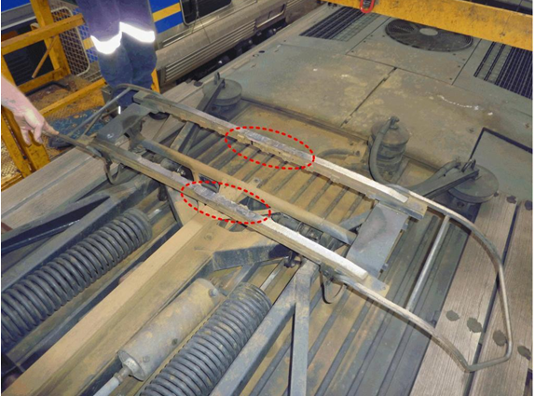

Figure 4: Damaged pantograph with areas of corking highlighted

## Comeng controls

The Comeng train has three controls: the master controller, the reverser and the brake controller. The master controller has five positions: off, shunt, series, parallel and weak-fields. The reverser has four positions: off, neutral, forward and reverse. The master controller can only be operated when the reverser is in ‘forward’ or ‘reverse’ positions.

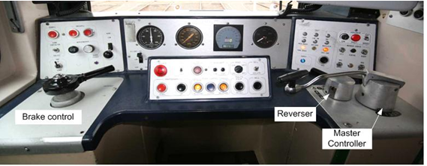

Figure 5: Comeng traction and brake control panel

## Traction circuit

When the master controller is operated, the three linebreakers close and current is supplied to the traction motors. The traction motors initially operate in shunt mode and as the maximum current is reached, the controller is moved first to the series mode and then to the parallel mode. In these two modes, step-up contactors are sequentially closed by the notching relay and the corresponding resistors are by-passed (Appendix A), increasing the current to the traction motors and in turn increasing the power output from the motors.

Once all the resistors have been by-passed, the maximum current in each controller position is reached. Once the maximum current and hence the maximum power is reached in the parallel mode, the ‘weak-fields’ position can be selected to further increase the current to the motors for the highest acceleration rate.

## Traction circuit protection system

As shown in the electrical schematic in Appendix A and Figure 6, when the pantograph of the train is in contact with the overhead wire the current flows through the main isolation switch (MIS) in the driver’s cabin to the traction overload relay (TFR) and linebreakers L1, L2 and L3 located within the linebreaker case.

Overload Motoring Relays (OLM) 1 and 2 sense the current to the traction motors and if an overload current is detected in either the TFR or OLM, linebreaker L3 is opened and the Fault Limit Resistor (FLZ), which is in parallel with L3, reduces the current flow through linebreakers L1 and L2. As soon as L3 opens, control contacts within L3 de-energise the holding coils of L1 and L2, opening these linebreakers as well, and interrupting the current flow to the traction motors.

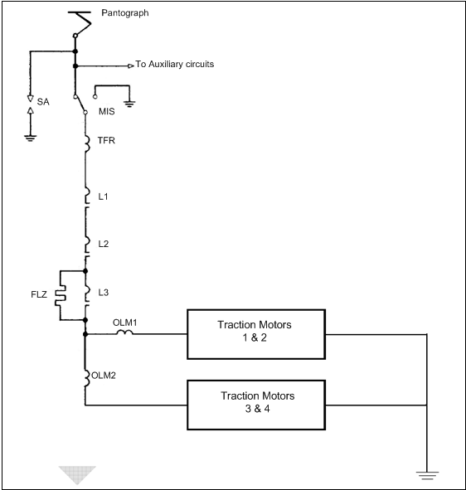

Figure 6: Simplified traction power circuit (Traction motors shown only in parallel configuration)

## Traction motors

Each motor car has four traction motors that are mounted in groups of two on either end of the motor car and are suspended between the bogie frame and the driven axle. The traction motors on car 449M were GEC type G317AZ, series-wound DC motors. Arcing damage was observed on the arc posts in №1 traction motor commutator. The purpose of these arc posts is to provide a preferred path to the frame (earth) for an arc created by a short circuit fault in a traction motor. As soon as this earthing occurs the higher current flow is detected by OLM1 and linebreaker L3 is opened.

MTM advised the investigation that the flashed-over traction motor was removed from car 449M and repaired. However, they were unable to provide the investigation with details of the defects found on the traction motor or the repairs that were carried out on this motor.

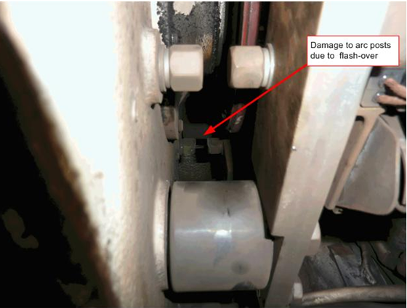

Figure 7: Arcing damage to arc posts in commutator chamber of car 449M

### Traction motor failures

MTM advised that Comeng traction motors experience regular arcing and shorting problems resulting in the tripping of the linebreakers. They stated that in many instances they continue operating the trains with faulty sets of traction motors isolated due to limited availability of maintenance facilities. They further advised that the performance of the train is not greatly affected when only one set of traction motors is out of service.

Transport Safety Victoria (TSV) advised the investigation that prior to this incident there were two other incidents of fires related to Comeng train traction motors in the last five years. One incident was in June 2007 and another in August 2009.

## Linebreakers

Linebreakers L1, L2 and L3 are all housed in one casing along with the TFR and OLM.

The fire caused extensive damage to the casing and in particular to linebreaker L1 (Figure 8). The contactors and the cable connections of L1 were completely burnt. The arc chute of L1 was also severely burnt with fiberglass residue and parts of the pole pieces remaining. The right-side pole piece had indications of arc flash-over and the casing adjacent to the L1 power contactor had a hole burnt through the casing (Figure 9).

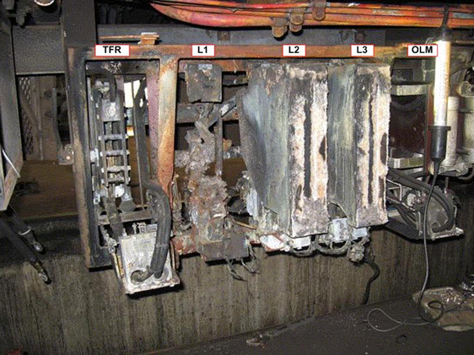

Figure 8: Damaged equipment inside casing

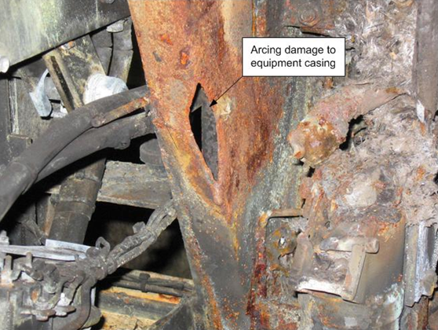

Figure 9: Damage to equipment casing adjacent to linebreaker L1

The fire had also severely damaged the TFR and OLM and their cable connections. Due to the fire damage it could not be ascertained if the TFR relay had tripped, however the trip flag of OLM1 was observed in the tripped position.

### Contactor wiping action and air blowing system

When electrical contactors close in a high-current circuit, arcing occurs, resulting in high temperatures and welded contacts. Contactors incorporate a contact wiping device that causes a shearing motion to break welds and clear oxidation or contaminants between a set of contacts. A spring-loaded toggle-lever-actuator engages and directly bears upon the movable contactor to rock the contactor on the actuator support. After initial contact is made, a lost motion connection between the actuator and contactor support imparts a rocking action to the contactor to shear and break any welds between the fixed contact and moving contact. The spring is an integral component in this mechanism and the spring tension is critical for its correct operation.

In addition, each linebreaker is equipped with an air pipe that is fitted directly behind the contacts and assists with quenching the arc that is created each time the linebreaker opens. The positioning of the air pipe is critical to ensuring that the arc is extinguished. The linebreakers are also equipped with fibreglass arc chutes that are designed to contain the arc and direct it away from the other equipment within the casing. In cases where the contactor wiping action fails, or the air-blowing system does not function satisfactorily, welding of contacts may take place.

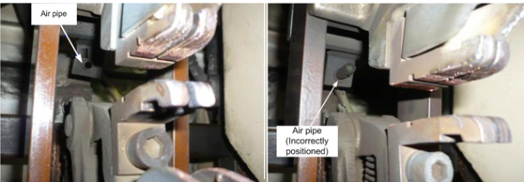

Figure 10: Air pipe positioning in linebreakers

## Maintenance

### Rolling stock

MTM’s rolling stock maintenance procedures require a ‘D examination’ every 40,000 kilometres. Five days prior to the incident motor car 450M, trailer car 1075T and motor car 449M were subjected to a ‘D examination’, which required the examination of saloon doors, pantograph, motors, wheels, couplers, trip and camshaft power-head, and traction control equipment and extensive system function checks.

### Traction motors

MTM maintenance procedures refer to work instructions RCMI 3.16 and 3.21, and the manufacturer’s maintenance manuals and drawings with respect to the maintenance of the Comeng traction motors.

The work instruction specifically addresses the securing arrangements for the motors, connections and the checking of all internal drive gear including armature windings, field coils, brush gear and the commutator. Once the maintenance work is completed the traction motor is required to be tested under power. The maintenance procedure has no requirement for a traction motor to be insulation resistance tested at any stage of the examinations. The manufacturers maintenance manual states that: “regular cleaning of the creepage surfaces of the commutator and brush-gear should maintain an adequate insulation resistance value between overhauls and there should be no necessity for measurement of insulation resistance during inspection unless a fault is suspected”.

### Linebreaker and associated equipment

MTM maintenance procedures, and in particular work instruction RCMI 3.5, details the inspection and maintenance requirements for Comeng train linebreakers and the other equipment in the linebreaker casing.

The procedure requires the following:

“• Clean all arc chutes: Remove copper dust by vacuum cleaner and wipe with dry clean cloth.

Check all arc chutes are in place & properly secure at completion of maintenance.

Check air blast hose for damage & alignment. Depress/release armature plate to generate air blast, feel for air blast across contacts, correct alignment as required.

Check for damage & for signs of excessive wear & flash-over marks. Ensure retaining bar & press lever are serviceable. Replace arc chute with new as required.

Check auxiliary contactor block for cracked end plates, broken contacts, contact alignment & correct contact gap tolerance including operation.

Check for air leaks of all hoses & fittings, security of all components & Armature guide post for grooving.

Check contact closing action and check tips for wear & arc horns for wear, check response time.

Check closing action & lubricate piston rod with petroleum jelly as required.

Inspect all linebreaker cables, bus bars, insulators and contactor security. Clean all parts.”

MTM advised the investigation that a post-incident inspection of the other linebreakers on the incident train indicated that some air blast hoses were incorrectly positioned.

### Substation equipment

MTM advised the investigation that the Reservoir substation DCCB was replaced in September 2008 and that the scheduled maintenance of DCCBs is on a three-year cycle. The DCCB that did not trip was sent to the manufacturer for testing and the manufacturer states that several settings (original factory settings) of the DCCB had been changed. Specifically, the screws that alter the ‘main latch gap’, ‘blocking catch gap’ and ‘trip nose’ had been changed. They further state that: “The circuit breaker initially would not close due to these settings being in the incorrect position. We adjusted the settings to the stage where the circuit breaker opened and closed correctly.” They conclude that: “It is hard to establish if the tripping problem was caused by these settings being in the incorrect position.”

## Environment

At the time of the incident the weather was fine with light winds and the temperature was approximately 20 degrees Celsius.

# Analysis

## The incident

There are two probable scenarios that may have led to this incident. The first is that the fault initiated at linebreaker L1 due to a short circuit between the linebreaker contacts and the casing. Under normal circumstances the substation DCCBs would have tripped and interrupted the current flow. In this instance, the Reservoir DCCB did not trip and continued supplying power to the system. The resulting over-current would have been detected by OLM1 and tripped linebreakers L3 and subsequently L2. The over-current may have also caused the flash-over in the motor. The intense heat generated from the arc between the linebreaker L1 contacts and the casing melted the steel casing and ignited the fiberglass insulation material causing the fire.

It is also possible traction motor №1 on the Comeng motor car 449M flashed-over due to an earth fault caused by a breakdown in insulation. The excess current drawn due to the flash-over would have been detected by the overload relay OLM1 and tripped linebreaker L3. Although the fault limit resistor FLZ would have reduced the current flow through linebreakers L1 and L2, a significantly high current would have still flowed through these linebreakers. It is possible that while linebreaker L2 tripped, the contacts of linebreaker L1 struck a sustained arc between the contacts and the casing resulting in the melting of the casing and the fire.

MTM advised the investigation that the flashed-over traction motor was replaced, but could not provide details of any testing or repair that had been carried out on this motor. It is apparent that no records were kept of the testing or repair of this faulty traction motor. Had the flashed-over traction motor been tested by MTM, the motor could have been eliminated or confirmed as the root cause of the incident. The fact that there is a history of flash-over faults with these traction motors makes it extremely probable that the fault initiated at the traction motor.

Due to the severe fire damage, the investigation was unable to establish with certainty the reason for the arcing between the contacts of linebreaker L1 and the casing. It is inevitable that an arc will be formed between the contacts every time a linebreaker opens. The arc chute is designed to contain the arc and direct it away from the other equipment and the casing. In this case it is possible that the arc chute was not correctly installed and allowed arcing between the contacts and the casing. It is also possible that the contacts of linebreaker L1 were welded together due to incorrect clearances between contacts, corrosion and resulting friction between the moving contact arm spindle, or a faulty spring preventing contactor wiping action. The incorrect positioning of the air blast hose may have also led to the welding of contacts due to the air blast not quenching the arc when the linebreaker operated.

In this incident, the overhead contact wire was observed to have suffered overheating in tension and parted. Overhead contact wires are rated to 200 degrees Celsius and the melting point of contact wire material is approximately 1,000 degrees Celsius. The heat generated between the carbon collector strips on the pantograph and the contact wire is a function of the magnitude of the current and the interface resistance. The interface resistance is a function of the pantograph contact materials, the area of contact, and the contact force. When a train is in motion the contact period is minimal and heat is removed through the cooling effect of the wind flow. When a train is at a standstill, the contact faces are static and the generated heat is removed only through conduction and radiation. However, when a train is stationary, the current drawn is greatly reduced as only auxiliary services are provided and the traction system is not in operation. When traction power is first applied the current drawn by the traction motors are at a minimum as all the resistors are in-circuit. However, in this instance, due to the defective linebreaker and the resulting short-circuit, the fault current would have been excessively high.

Although the temperature where a contact wire may anneal and separate will be lower than the melting point of the wire due to the wire being under tension, it is reasonable to assume that in this instance the temperature of the wire would have been well in excess of 200 degrees Celsius as a result of a very high fault current flow between the overhead contact wire and the pantograph collector strips.

## Substation DCCBs

The substations feeding the network are specifically designed to protect the overhead contact wires during a short circuit in the distribution system or a major short circuit on a train. The substation circuit breaker is required to act as secondary electrical protection for trains. In this instance the Reservoir substation DCCB did not trip and the continued current flow generated sufficient heat that resulted in the live overhead contact wire parting and contacting the roof of the train. The fact that the Croxton substation DCCB, which was set at 3,000 Amps tripped, indicates that the current in the overhead contact wire exceeded this value. The investigation was advised that the Reservoir DCCB tripping current setting had ‘drifted’ to 3,500 Amps. Although it is possible that the Reservoir substation DCCB did not trip due to the fault current being below 3500 Amps, it is unlikely that this was the reason for the non-interruption of the excess current flow, as faults of this nature tend to create fault currents well in excess of the above values. The manufacturer’s finding that the circuit breaker would not close due to the settings being in the incorrect position, substantiates the fact that the failure of the Reservoir DCCB to operate correctly could be directly attributed to a failure in the maintenance of this DCCB. Further, it is apparent that the three-year maintenance cycle for DCCBs is not appropriate, and maintenance that includes regular testing of DCCBs should be carried out more frequently.

## Linebreakers

Due to the traction control circuit design, linebreakers experience a large number of operations during normal service. As a result, linebreakers are subjected to heavy wear and require frequent maintenance. In order to ensure the correct functioning of linebreakers it is critical that: they are free of carbon dust and dirt; arc chutes are correctly fitted and secured; clearances between contacts are maintained in accordance with the manufacturer’s specifications; and devices for arc reduction and quenching are functioning satisfactorily. In this instance it is clear that linebreaker L1 did not function as required and this can be attributed to a failure in the maintenance of this linebreaker.

## Traction motors

MTM advised the investigation that Comeng train traction motors experience regular arcing and shorting problems. When problems are detected, MTM can operate these trains with these faulty traction motors isolated. Although the manufacturer does not require insulation resistance testing during inspections, in light of the above failures it may be appropriate for MTM to consider a more rigorous maintenance regime that includes regular insulation resistance and continuity testing of the Comeng traction motors.

## Incident response

In this incident the driver ensured the safety of the passengers, and his actions were appropriate. That the train was carrying only about 50 passengers at the time of the incident, and the incident occurred at a station, made the driver’s task of assisting the egress of passengers relatively straightforward. A three-car Comeng train is rated for a capacity load of about 760 passengers. The driver’s task of safely disembarking the passengers would have been made more complex if the train had been carrying a larger number of passengers and/or the incident had occurred in a less convenient location.

# Conclusions

## Findings

1. The driver was appropriately qualified to drive the Comeng type of train.
2. There was a flash-over in №1 traction motor of car 449M. The reason for the flash-over could not be determined.
3. There was a severe short circuit and arcing between the contacts of linebreaker L1 and the linebreaker casing.
4. An abnormally high current flow resulted in the tripping of linebreakers L3 and L2 on motor car 449M.
5. The fire was the result of a sustained electrical arc that occurred between the steel casing and the contacts of linebreaker L1.
6. The Reservoir substation Direct Current Circuit Breaker failed to trip due to incorrect alteration of the factory settings and had to be manually tripped by MTM’s technical staff.
7. The periodical maintenance requirements for Comeng train traction motors do not include insulation resistance or continuity testing.

## Contributing factors

1. Linebreaker L1 on motor car 449M was not maintained to a satisfactory standard.
2. The Reservoir sub-station Direct Current Circuit Breaker factory settings were altered, resulting in the DCCB not tripping to protect the overhead electrical system and the train from over-current.

# Safety Actions

## Safety Actions taken since the event

After the incident MTM issued maintenance bulletins with respect to the inspection and positioning of the air blast hoses, and the inspection, cleaning and correct alignment of arc chutes on linebreakers.

## Recommended Safety Actions

Issue 1

The linebreaker on Comeng motor car 449M was not maintained to a satisfactory standard.

RSA 2011012

Although Metro Trains Melbourne has issued two maintenance bulletins with respect to the maintenance of specific components of linebreakers, MTM should holistically review all maintenance standards with respect to Comeng train linebreakers.

Issue 2

Insulation resistance testing of traction motors is only carried out at major overhauls and periodical maintenance requirements do not include insulation resistance or continuity testing. The manufacturer of these traction motors states that “there should be no necessity for measurement of insulation resistance during inspection unless a fault is suspected”.

RSA 2011013

In view of the fact that Metro Trains Melbourne is experiencing regular faults with Comeng traction motors, MTM should review the current maintenance standards and procedures with respect to incorporating a more rigorous inspection and testing regime during periodical maintenance of Comeng train traction motors.

Issue 3

The Reservoir substation circuit breaker settings were incorrectly altered and as a result the train and the overhead electrical system were not protected against over-current by the circuit breaker.

RSA 2011014

Metro Trains Melbourne should review the maintenance requirements for substation circuit breakers, including frequent periodic function testing of DCCB’s to ensure their correct operation.

Issue 4

Metro Trains Melbourne was unable to provide records of the post-incident testing and rectification work carried out on the defective traction motor in car 449M.

RSA 2011015

Metro Trains Melbourne ensures that repair and maintenance of all train traction system equipment is documented and maintained.

# Appendix A – Comeng Train Electrical Schematic

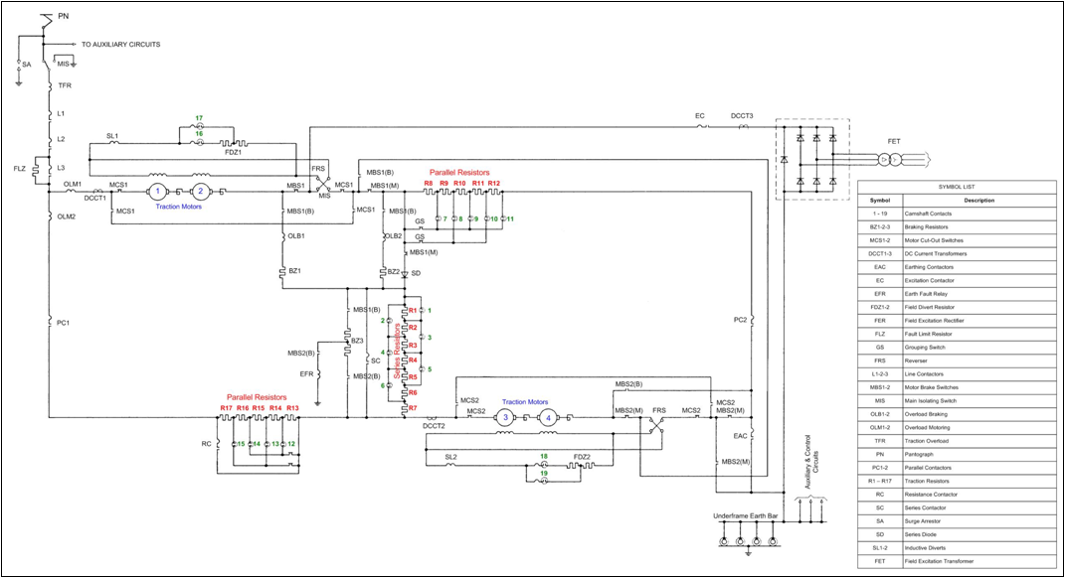

1. A substation not equipped with a rectifier or transformer. In this respect it might be referred-to as a ‘DC switching station’.
2. The temperature at which a material becomes malleable/soft during the initial heating process of annealing.
3. Overheating and burning of carbon.