

Rail Safety Investigation

Report No 2010/05

Sideswipe collision

Metro Trains Melbourne Passenger Train 3318

and El Zorro Transport Pty Ltd Plant Train 7263

Ringwood Station

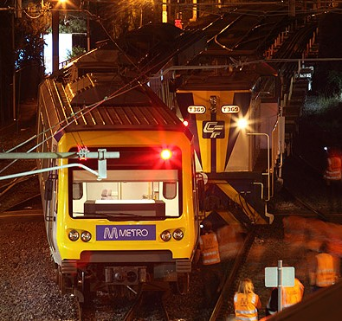21 March 2010

TABLE OF CONTENTS

The Chief Investigator 5

Executive Summary 7

1. Circumstances 9

2. Factual Information 11

2.1 Personnel 11

2.2 The trains 13

2.3 Infrastructure and Works 14

2.4 Ringwood track circuits and layout 16

2.5 Environment 18

2.6 Legislation, Rules, Guidelines 18

3. Analysis 19

3.1 The incident 19

3.2 Caution Order 20

3.3 Track circuits and insulated rail joints 20

3.4 Signal control room 22

3.5 The collision 23

4. Conclusions 25

4.1 Findings 25

4.2 Contributing factors 25

5. Safety Actions 27

5.1 Safety Actions taken since the event 27

5.2 Recommended Safety Actions 27

The Chief Investigator

The Chief Investigator, Transport Safety is a statutory position under Part 7 of the *Transport Integration Act 2010*. The objective of the position is to seek to improve transport safety by providing for an independent no-blame investigation of transport safety matters consistent with the vision statement and the transport system objective.

The primary focus of an investigation is to determine what factors caused the incident, rather than apportion blame for the incident, and to identify issues that may require review, monitoring or further consideration. In conducting investigations, the Chief Investigator will apply the principles of ‘just culture’ and use a methodology based on systemic investigation models.

The Chief Investigator is required to report the results of investigations to the Minister for Public Transport and/or the Minister for Roads and Ports. However, before submitting the results of an investigation to the Minister, the Chief Investigator must consult in accordance with section 85A of the *Transport (Compliance and Miscellaneous) Act 1983*.

The Chief Investigator is not subject to the direction or control of the Minister(s) in performing or exercising his or her functions or powers, but the Minister may direct the Chief Investigator to investigate a transport safety matter.

Executive Summary

At about 2035 hours[1] on 21 March 2010, the 2010 hours Up Metro Trains Melbourne (MTM) Electric Multiple Unit (EMU) suburban passenger service from Lilydale contacted the rear-end locomotive of an engineering maintenance train (plant train) near Ringwood Station in a sideswipe collision.

Moving in the Down[2] direction, the plant train had been admitted to and stopped on the Up Belgrave track but its trailing end was fouling the route set for the MTM suburban passenger train. The passenger train was travelling on the authority of a proceed indication on a fixed signal. The signal panel indicated the plant train had cleared the points and the interlocked track circuit when it stopped for the driver to discuss requirements with track works staff. This enabled the signaller to set a route and clear an Up Home signal for the suburban train to approach platform 2, however although the track circuit was free and permitted the route to be set for the passenger train movement, there was insufficient space for the MTM train to pass across the rear of the stationary plant train without contacting it.

There were no reported injuries to staff or passengers. Passengers were assisted in detraining and were escorted a short distance to the Ringwood Station. Both the EMU and the locomotive it collided with sustained minor damage to side panels and handrails.

The incident was the result of a track circuit limit not being correctly located with respect to the required clearance distance.

Following an Interim Investigation, MTM have since issued an operational instruction and have modified track inspection and recording processes to prevent a recurrence of this incident.

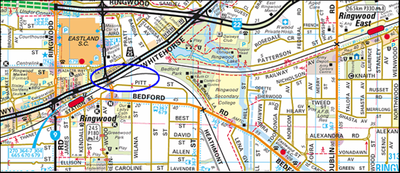

Figure 1 – Location map . (Copyright Melway Publishing 2007. Reproduced from e-Way Electronic Street Directory with permission.)

# Circumstances

Metro Trains Melbourne leases the plant train — both wagons and locomotives — from a major national rollingstock supplier. El Zorro Transport P/L were contracted to provide locomotive crewing. The train had originated in Spotswood and was conveying replacement rail for discharge between Ringwood and Upper Ferntree Gully. Under the provisions of the applicable safeworking circular[3], the train was to proceed to Ringwood, enter an absolute track occupation[4] between Ringwood and Belgrave as instructed by the Safeworking Co-ordinator and discharge rail on the Down Line between Ringwood and Boronia, working as locally arranged. Following this, the train was scheduled to run to Upper Ferntree Gully, cross to the Up line then travel back to Ringwood and to work as locally arranged.

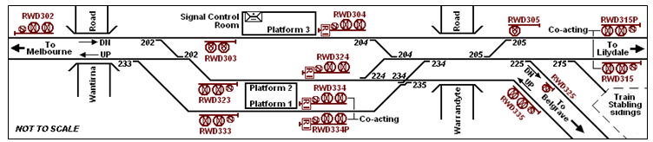

Figure 2 – Ringwood location, signalling layout

At some point subsequent to the distribution of Circular S.2401/10 it was realised that its provision for the discharge of rail to occur on the Down line was incorrect. Arrangements were therefore intended to be made with the Ringwood signaller to direct the arriving plant train to platform 2 at Ringwood Station (the intended move being from signal 302 via the crossover points 202; see Figure 2), from where it could be despatched directly onto the Up Belgrave line; that is to say, running ‘Wrong Line’. In the event, this advice to the signaller was overlooked and — following normal procedure for an expected movement onto the Down Belgrave line (as provided-for in Circular S.2401/10) the signaller routed the plant train into Ringwood Station on platform 3. To then be positioned for a departure onto the Up track as subsequently required, the train was required to pull ahead past signal 305 and shunt back onto platform 2 (via points 205 and 224). From platform 2, the driver of the plant train was then authorised — by reading and signing the Occupation Authority, and being issued with a Signaller’s Caution Order[5] to pass signal RWD324 at Stop — to proceed directly ahead onto the Belgrave Up line.

After departing onto the Up Belgrave line, the plant train travelled about 250 metres before stopping so the driver could discuss work requirements with works personnel who were standing trackside. At this point, the train had moved sufficiently far to clear the track interlocking[6] behind it, and this was reflected on the Ringwood signaller’s mimic panel[7]. The signaller was therefore able to select a route for an Up passenger train from Lilydale to approach the now-vacated platform 2 and to clear the signal permitting this move. However, the stationary plant train — although its trailing wheelset had cleared the insulated rail joint (IRJ) defining the start of the track section it had just moved into — remained physically foul of the track crossover behind it due to structural overhang of the rear-end locomotive (see Figure 3).

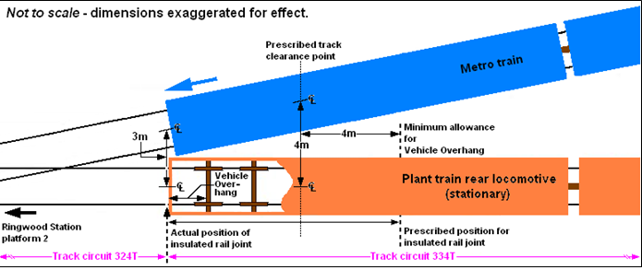

Figure 3 – Plan view of collision point showing actual v prescribed position for location of an insulated rail joint.

As a result, the Up passenger train moving toward platform 2 contacted the left-hand rear corner of the locomotive attached to the rear of the plant train.

There were no reported injuries to staff or passengers. Approximately 20 or 30 passengers were assisted by the MTM train driver and Ringwood Station Master in being detrained and escorted to the station.

Both the EMU and the locomotive it collided with sustained minor damage to side panels and handrails.

# Factual Information

## Personnel

### Train drivers

**El Zorro Transport Solutions**

The driver and co-driver of plant train 7263 held current medical certification as Fit for Duty and both returned a zero result for the Preliminary Breath Test. The driver is employed by El Zorro as a Special Class Instructor Driver. On this trip he was providing route learning tuition to both the co-driver and an accompanying competent employee[8].

The Special Class Instructor Driver holds an *Electric Train Leading Brakevan Authority* issued by Connex Melbourne Ltd (the previous operator of the metropolitan rail system) for travel in the ‘...leading brakevan [drivers cab] between 0800 hours and 1900 hours of electric trains operating on all [metropolitan] lines for the purpose of gaining or maintaining Driver Route Knowledge’. This authority had been issued on 22 January 2007 and included no expiry date. The Special Class Instructor Driver, who is not employed as an electric train driver but who requires to maintain metropolitan route familiarity for the purposes of operating locomotive-hauled services as required from time-to-time by his company, stated that he had used this means for refreshing his route knowledge since June 2003. He reported that he last operated over the line between Blackburn and Ringwood on 1 January 2010.

The Special Class Instructor Driver informed the investigation that he did not maintain a work diary, did not record individual trips undertaken to maintain route awareness, and was not required by his company to provide it with written evidence of these trips. He stated that on this trip the train had been pathed[9] to Upper Ferntree Gully but ‘wrong-routed’[10] towards Lilydale.

**Metro Trains Melbourne**

The driver of passenger train 3318 held current safeworking qualifications and was medically fit to perform his duties. He returned a zero result for a Preliminary Breath Test.

In moving his train from the Lilydale Up line towards platform 2 at Ringwood, the driver proceeded properly on the authority conveyed by a legitimate indication on signal RWD315. When it became apparent that the end of the plant train was foul of his route (see Figure 4, position 6), the driver was unable to stop in time to prevent a collision.

### MTM Safeworking Coordinator

The Safeworking Coordinator is the link between the operator (MTM) and the track maintenance forces at the worksite, and is responsible for the planning and implementation of all safeworking practices. This may include applying for and implementing Absolute Occupations, and the placement of handsignallers and safeworking supervision. The Safeworking Coordinator held current safeworking qualifications and medical certification appropriate to his duties.

Both the Safeworking Coordinator and the MTM Safeworking Manager (functioning for this works project as the Pilot[11]) attended the Ringwood signal control room to discuss arrangements with the signaller. The Safeworking Coordinator has reported that he advised the signaller he would notify him when the plant train had arrived ‘in clear’ within the occupation; this being corroborated by the MTM Safeworking Manager. Note that the Safeworking Manager reports to the Safeworking Coordinator.

The Safeworking Coordinator has stated that he noticed the plant train stop short of the track occupation and that he advised the train crew to continue with the movement.

### MTM Safeworking Manager (Pilot)

The Pilot held current safeworking qualifications and medical certification and was responsible for accompanying the plant train and liaising with the crew as required by the 1994 Book Of Rules and Operating Procedures (PTC). She stated that the Safeworking Coordinator advised the signaller that he (the Co-ordinator) would notify the signaller when the plant train was ‘in clear’ within the occupation.

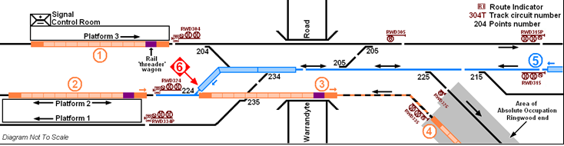

Figure 4 – Ringwood station. Depiction of train movements.

### Signaller

At the time of this occurrence the signaller’s medical status and qualifications were current. He was managing the arrival of Down plant train № 7263 under the provisions of Circular S.2401/10 and Up passenger train № 3318 from Lilydale with reference to the altered arrangements conveyed by Circular S.2254/10. Circular S.2401/10 related to the plant train movements in support of the planned rail discharge operation. This circular provided for the plant train to enter the track occupation and discharge rail on the Down line; that is to say, in the ‘correct’ running direction. Circular S.2254/10 conveyed timetable variations and altered train arrangements due to the track occupation at Ringwood. This circular provided for Up Metro passenger train № 3318 to arrive at Ringwood on platform 2 instead of platform 1 as normal.

Having not been notified that the MTM Safeworking Coordinator desired the plant train to arrive at Ringwood on a different platform to what would normally be expected for a movement continuing onto the Down line to Belgrave, the signaller routed the plant train to platform 3 (see Figure 4, position 1). At about this time, the Safeworking Co-ordinator arrived at the signal control room and advised the signaller that the plant train was required on platform 2 to be positioned for a departure into the track occupation via the Up (‘wrong’) line. The plant train was then moved ahead on the Lilydale Down line and back through a crossover onto Ringwood platform 2 (Figure 4, position 2). At this point, the Safeworking Coordinator noticed that the plant train was orientated incorrectly to permit rail discharge in the Down direction.[12]

At 20:05 hours the signaller granted Absolute Occupation of the Up and Down lines between Ringwood and Ferntree Gully (Belgrave line) and at 20:15 hours issued an amended Caution Order to the driver of plant train 7263 to pass Home signal RWD324 and proceed ‘wrong line’ into the occupation. The plant train moved ahead onto the Belgrave Up line and travelled about 250 metres before stopping.

The signaller stated that he does not recall the MTM Safeworking Coordinator informing him that he (the Coordinator) would confirm when the plant train had *cleared* *into*[13] the track occupation. This would have been once it was entirely on the Down side of signal RWD335 (Figure 4, position 4).

Having moved from Ringwood platform 2 onto the Belgrave Up line the driver of the plant train was requested by the Safeworking Manager to stop beside some works personnel to discuss intentions with reference to the unexpected configuration of the train (Figure 4, position 3 [approx.]). Although, at this point, the train was a considerable distance away from clearing into the track occupation, its rear end — in this case the trailing locomotive — had, by coincidence, cleared the track circuit that freed up the interlocking to points 224 immediately behind it.

In this occurrence, the signaller — located within the station building and largely out-of-sight of the plant train — observed from his panel indications that the plant train had cleared the interlocking for 224 points, and that he could now set a route for a passenger train (located at position 5 on Figure 4) to proceed from the Lilydale Up line into platform 2. Accordingly, the passenger train received a *Proceed* indication on signal RWD315. The route for the passenger train took it alongside and then across the rear of the stationary plant train.

## The trains

### Train 7263

The plant train consisted of locomotives B80 and T373 on the leading end, 1 x CFCF rail threader flat wagon, 7 x CQRX container flat wagons (also used to carry rail), and locomotive T369 attached to the rear. The train was 224.3 metres long and weighed 601.6 tonnes. The plant train was stationary at the time of the occurrence.

### Train 3318

Train 3318 was a timetabled Up passenger service departing Lilydale at 2017 hours. This train would normally arrive at Ringwood platform 1 routed from the Lilydale Up line via points 234 and 235, however due to altered arrangements on account of the track maintenance occupation, this service was routed to platform 2.

Data retrieved by MTM from the passenger train indicated that it was moving at 29 kmh at the time heavy braking was applied; taking 70 metres to stop.

## Infrastructure and Works

### Ringwood signal control room

Ringwood Station is approximately 25 km from the Melbourne CBD, and is a double-line junction for lines diverging to and converging from Lilydale and Belgrave. Trains are worked under the 3-position colour light Automatic Block Signalling system. Control of the computer-based track and signal interlocking at Ringwood is conducted from a control panel located in a signal control room within the station building on platform 3. The location of this room on platform 3 is such that it does not provide a clear view of most of the Ringwood interlocking, which is located distant from the station platform area in both Up and Down directions.

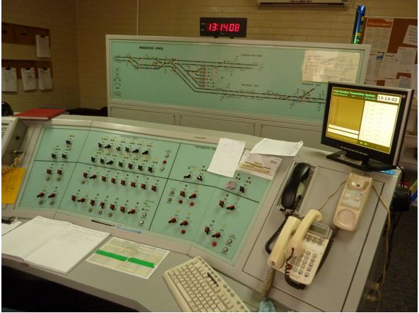

Figure 5 – Ringwood signal control room - signaller's workstation.

The layout within the Ringwood signal control room places the signaller’s workstation plus the separate mimic display panel within the room in such a way that the signaller faces away from the window (see Figure 5). To obtain any exterior view, the signaller must turn away from the desk and control panel and even then, has a relatively restricted view from a bay window of modest obtrusion. For this reason, the signaller relies almost totally upon the displays and indications conveyed by the control and mimic panels. Additionally, the schematic arrangement of the mimic panel display, while depicting and denoting individual track circuits and their limits, is representational only; it is not necessarily intended that the presentation convey the specific locations of these limits as installed in the field. Nonetheless this schematic presentation of track circuit limits tends to be graphically explicit; the adjoining limit of track circuits 324T and 334T (see red arrow, Figure 6) is presented as being a significant distance from the 224 points – in fact clear of the fouling points of both adjacent tracks. It is reasonable to assume that a signaller glancing at the panel might notice track circuits 334T and 335T occupied — with circuit 324T now vacant and 224 points free — and choose to route another train into platform 2 via 205, 204 and 224 points (as also depicted in Figure 6). It is not apparent that the IRJ might, in fact, have been installed so close to the 224 points as to be inside the fouling point and outside of contemporary specification.

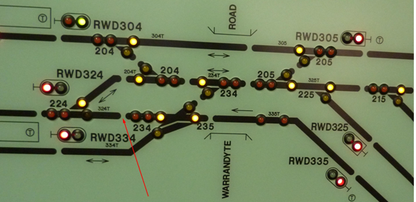

Figure 6 – Ringwood signal control mimic panel detail.

### Works planning

Planning for rail discharge and associated works to occur overnight on Saturday and Sunday 20 and 21 March 2010 had included an initial site inspection (3 March 2010) and walk-through (16 March 2010) of the discharge area on the Belgrave line by staff from MTM Infrastructure and contractor John Holland Melbourne Rail Franchise Pty Ltd. From these activities it was identified that the exposure of various trackside structures to potential damage necessitated that the rail discharge occur on the Up line. Planning arrangements were agreed with MTM Safeworking staff by which the plant train would enter the occupation from Ringwood on the Up line and that the signaller would be briefed on the night regarding requirements for plant train movement.

The process for obtaining a circular detailing plant train requirements is for MTM Infrastructure to advise the train operations contractor (in this case, El Zorro) who create the application for the circular. The application[14] is forwarded to MTM Network Planning who compose and distribute the circular. This circular stated that the plant train would enter the occupation and, *“…discharge rails as locally arranged on the down line…”.*

The planned movement of the plant train required notification to ARTC[15] for passage over relevant portions of their trackage between Sims Street Junction, West Melbourne, and Anzac Sidings at Newport (where the plant train was to be loaded) but planners neglected to apply for this access and were therefore unaware that it could not be granted due to planned ARTC track maintenance works. At a late stage it was realised that the plant train could not be moved as intended due to these ARTC works, and the project was delayed by some 24 hours; requiring re-issue of the safeworking circular.

The loaded plant train eventually departed Newport some 20 hours later and travelled on the Goods lines via Brooklyn, Tottenham, Sims Street Junction, West Tower and Viaduct Junction onto the Through Suburban line at Flinders Street Station. Resulting from the plant train’s orientation at Anzac Sidings and its subsequent passage via the route mentioned above, it arrived at Ringwood with the ‘rail threader wagon’[16] located at the Belgrave end. This necessitated that the process of discharging the rail be made in the Up direction (that is to say, in the Belgrave-toward-Ringwood direction).

The absolute occupation was contained within MTM Network Safety ‘O’ circular № O.209/2010, 11 March 2010. This specified the limits at the Ringwood (Up) end of the occupation as being signals RWD325 (dwarf signal on Down line) and RWD335 (Up Home signal); see Figure 4.

## Ringwood track circuits and layout

For a train movement onto a wrong line, the signaller must ensure the proper authority for the movement is issued. This process includes interlocking control measures to ensure against the unintended movement of points beneath the train. In this occurrence, the driver of the plant train was authorised to move past signal RWD324 at

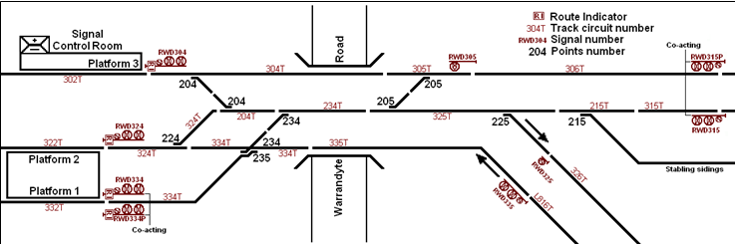

Figure 7 – Ringwood station track layout east end.

Stop and enter the Up line from Belgrave. This movement took the plant train from track circuit 322T onto track circuit 324T thence onto track circuits 334T and 335T. When the driver stopped the train to confer with personnel standing trackside, the locomotive forming the last vehicle of the train had just moved from track circuit 324T onto 334T. That is to say, the № 4 axle of the locomotive — the last axle of the train in the direction of travel — had cleared the 324T track circuit and was now occupying the 334T track circuit. In this position, that portion of the superstructure of the trailing locomotive that protruded behind the last axle (in other words, the *overhang*) was still physically encroaching upon the clearance width required for rail vehicles on the adjacent converging track (see Figure 3, page 10). Note that Home Departure signal RWD324 is provided to control entry to the Ringwood centre track[17] only, and from there to either the Lilydale or Belgrave Down tracks (or the Ringwood stabling sidings). Since a train movement from Ringwood platform 2 onto the Up line from Belgrave would be an ‘abnormal’ one, the applicable track circuitry at this location is not designed with this intention and this signal does not control such a movement.

The arrangement of track circuitry at this location within Ringwood Station limits was last altered during track works in 1999 to install a Computer-Based Interlocking system. If a signalled movement from platform 2 onto the Belgrave Up line had been provided for, standard track circuit design principles would have required the rail movement to clear behind the ‘protecting signal’[18] (for movement in the opposite direction), in this case, Down Home signal 335 (in other words, vacating track circuits 334T and 335T) in order for 224 points to be operated. Since a Down movement from platform 2 onto the Up Belgrave line was *not* an intended signal move, the design of track circuitry did not provide for the occupation of track circuit 334T (and 335T; see Figure 7) to preclude either the control of Up Home signal RWD315 or operation of 224 points. This meant — in this incident — that once the plant train had physically cleared onto the 334T track circuit, 224 points were freed for operation and signal RWD315 was able to be cleared for a movement across them. This might still have been safe had the IRJ that isolated track circuit 324T from 334T been located in compliance with contemporary requirements[19]. These provide for a minimum clearance point being a distance between adjacent track centres of four metres as well as an allowance for structural overhang. Together, these ensure that a rail vehicle standing immediately clear of an IRJ will be wholly clear of the ‘fouling point’ (within which a vehicle on the adjacent, converging line might come into contact with the standing vehicle). In fact, the distance between track centres at the location of this IRJ was only about 3 metres (see Figure 3, page 10).

Since the interlocking display provided to the signaller in the signal control room now showed track circuit 324T as being clear, the signaller was free to reverse 224 points and clear signal RWD315 to permit the Up Lilydale passenger train to approach platform 2.

## 

## Environment

The weather was fine and not contributory to this incident.

## Legislation, Rules, Guidelines

2.6.1 Track circuit location - Victorian Rail Industry Operators Group Standards

The Victorian Rail Industry Operators Group is an industry forum designed for member organisations to discuss research and resolve issues affecting them. This may occur via endorsement of a Standard or agreement on a specified course of action. All outcomes must be consistent with Department of Transport strategic and policy direction in regard to Victorian rail and tram networks.

The purpose of Victorian Rail Industry Operators Group Standards (VRIOGS) is as a suite of rail industry network principles which — through statewide implementation — will facilitate the interoperability of infrastructure and ensure the safety potential and long-term sustainability of the Victorian rail network. The first VRIOGS have existed since 2005; prior to this time (the Public Transport Corporation era), the requirement for conformity to industry standards was significantly less defined, and design protocols tended to be less prescriptive. Application of the Standards is not prescribed by law, but if adopted, conformity with their provisions is mandatory in order to achieve their purpose.

*VRIOGS 012.0 Victorian Signalling Principles, Revision B, 16/12/2009*) defines, under Section 4.4, Track Vacancy Detection, the ‘track clearance point’ (minimum distance between adjacent rails) in points and crossing trackwork beyond which a train is clear of another train movement. The accepted principle is that, *“The placement of insulated rail joints (IRJs) or other form of track circuit limit is to be at a distance beyond the track clearance point; which provides for vehicle overhang, such that a vehicle standing beyond the IRJ will not extend foul of the track clearance point.”*

*“For broad gauge track work the track clearance point is the point at which there is 4 metres between the centerlines of the adjacent rail tracks. The allowance made for vehicle overhang is 4 metres. This requires that the minimum distance from the clearance point to the IRJ is 4 metres.”* (see Figure 3).

2.6.2 Rules and operating procedures

Rule 8 (a), Section 15, of the Book Of Rules and Operating Procedures 1994 (PTC) provides [for the purposes of establishing an Absolute Occupation] that a minimum of ten working days’ notice must be given by the respective Division or Section to allow for sufficient time for special instructions to be issued. This provides time for the processing of staff circulars.

Section 15 [Rule 8 (g)] specifies that where a special train is to enter an Absolute Occupation, applicable fixed signals must be operated for that train and that if the applicable departure signal cannot be placed to ‘Proceed’, then a signaller’s Caution Order must be issued to the train driver for authority to proceed past that signal.

# 

# Analysis

## The incident

MTM Network Planning create and distribute the ‘S’ circular defining the plant train pathing for a works project. In this instance, they programmed the plant train to enter the track occupation on the Down line when MTM Infrastructure engineers intended for it to do so via the Up line. The intention for the track occupation to be accessed from the Up line had been decided during the original site inspection, and from information supplied to the investigation MTM Network Planning has been unable to account for the discrepancy. Also overlooked during the production of this circular was the necessity to consult ARTC, some of whose trackage (being portions of dual-gauge line between West Melbourne and Newport) the movement would be required to traverse. This delayed the project for 24 hours and required production of a new ‘S’ circular. The new circular also altered the intended route of the loaded plant train in its move from Newport to Ringwood, resulting in the rail threader wagon being on the wrong end of the train for rail discharge in the Down direction within the track occupation. This latter fact was not identified until the plant train arrived at Ringwood.

It should be noted that, whereas the rules require the agency requesting an absolute track occupation to provide at least 10 days’ notice to permit the issuing of special instructions, the timeframe in this instance — from the walk-through of 16 March 2010 to the planned works date of 20 March 2010 — left just four days to complete the process.

Since the works were taking place under an ‘absolute occupation’ (and rail discharge activities could be adapted, if required, to cater for the orientation of the plant train), this fact did not materially affect the requirement to or intention of entering the occupation from platform 2 onto the Up line. Local requirements within the occupation regarding movements and activities of the plant train were supervised by the MTM Safeworking Coordinator in conjunction with a Safeworking Manager (Pilot).

The plant train was operated by a senior El Zorro instructor driver who held an authority to ride in the driving cabs of MTM electric passenger trains for the purpose of maintaining route knowledge over metropolitan corridors. This authority had originally been issued — in perpetuity — by the previous operator almost three years earlier. The instructor driver was free to make his own decisions as to where and how frequently he exercised the privileges of this authority, and he stated that there is no requirement upon him to maintain detailed records of his use of it. Under these circumstances it is questionable as to how much detailed knowledge the organisation maintains regarding the route currency of employees. From this concern, arise questions as to the maintenance of staff records by the company (El Zorro Transport P/L) and how the end-user of the service (MTM) satisfies itself — with regard to Section 3 of their *Train Path Request Process and Protocol*, *Assessment of Access Application* — (1) that all contractor personnel are appropriately qualified and (2) that their (that is to say, MTMs) accreditation remains secure.

The MTM Infrastructure Safeworking Coordinator has stated that the Ringwood signaller was informed that he (the signaller) would be advised when the plant train had cleared into the Absolute Occupation — this being a practice expected of field personnel controlling such rail movements — and this was confirmed by the MTM Infrastructure Safeworking Manager (Pilot). The intent of this advice is to verify for the signaller that the plant train is wholly inside the limits of the occupation; in this case behind Up Home signal RWD335. Until this occurs, applicable track circuits occupied by the plant train as it moves into the occupation would not clear. The signaller, however, cannot recall the Safeworking Coordinator informing him that he would confirm when the plant train had cleared into the track occupation. The Safeworking Coordinator reported that when he noticed the plant train stop he advised the driver to continue into the track occupation. Less than three minutes later — and before the plant train had moved — the inbound passenger train collided with it.

The location of this activity cannot easily be seen from the signal control room and the signaller would very likely be unaware that the plant train had stopped during the movement into the track occupation. When the mimic display panel indicated that the route was clear for an Up passenger train from Lilydale to be directed to the platform vacated by the plant train, the signaller could rightly expect that this movement could be made. The signaller would not have expected that the plant train might have stopped and had no indication that its trailing vehicle was standing foul of the route set for the passenger train. The driver of the plant train was quite at liberty to unexpectedly stop his movement at any time for a valid reason. In this case, he stopped — of necessity — to confer with works staff and would have been mindful that he might be occupying the interlocking and preventing any other movements while his train was stationary. It would have been prudent for the driver to have minimised this interruption to the move, however apart from the possibility of delaying other trains, this was not a hazardous action and contributed to the incident only because the track circuit limit was incorrectly located.

## Caution Order

Operating rules require that where a departure signal controlling entry into an Absolute Occupation cannot be placed to *Proceed* for a movement into that occupation, a signaller’s Caution Order must be issued to the train or locomotive driver. This regulation assumes that the subject signal is *designed to control entry* into the route leading to the Absolute Occupation. However, in this incident the issue of a Caution Order was not warranted as Home Departure signal RWD324 did not control entry onto the Belgrave Up line. Although the driver of the plant train could have, in this case, proceeded from platform 2 under verbal authority of the signaller (as well as after signing the Absolute Occupation), the issuance of the Caution Order and its acceptance by the driver of the plant train — while revealing a lack of detailed comprehension by operating staff of applicable operating rules and local signalling peculiarities — was not material to the incident.

## Track circuits and insulated rail joints

By electrically isolating adjoining rails, an insulated rail joint separates one track circuit from the next in order to achieve safe control of interlocking. IRJs consist of insulation material (an ‘end post’) fixed between the ends of two adjacent lengths of rail, and secured by bolted joint bars (fish-plates) that connect the two rails (see Figure 8). When a portion of track that is part of an interlocking is occupied by a train or other non-insulated rail vehicle, then the setting of routes for other movements that might conflict with this one is denied. When the train or vehicle moves from that circuit, across an IRJ and onto another circuit so that no part of the train or vehicle remains standing on the former circuit, that former circuit is ‘vacated’ and any points arranged as part of that circuit are ‘freed’. Other legitimate movements through that portion of interlocking are now permitted. It follows that the physical location of IRJs as part of turnout interlockings (converging/diverging routes) must be such that trains that have vacated a track circuit — thus permitting a signaller to reset the route behind for a legitimate converging or diverging move — will not be intruding upon the clear space required by that converging or diverging move. Signalling and interlocking design principles exist to ensure these clearances (and associated safety margins) are maintained.

There are numerous reasons why a train might come to a stand unexpectedly and it cannot be assumed by interlocking designers or operating staff that a train in the process of conducting any move will necessarily continue until it is clear of any fouling point even though, prior to stopping, it may have vacated a particular interlocked track circuit. Such a circumstance would result in a stopped train standing in conflict with another legitimate move, and it must be considered an obvious intent of Track Vacancy Detection provisions as conveyed in the VRIOG Signalling Principles to preclude this possibility along with other potential threats. The Signalling Principles contain no qualification permitting dilution of these precepts, such as that they need not apply where a move is not signalled or where the likelihood of such a move occurring is considered to be remote. It seems reasonable to expect — at any interlocking location — that any ‘wrong-line’ move that is physically possible might, at some time, be required to be made. It would seem, therefore, to be prudent for those involved with the design of signalling and interlocking — when considering the application of established signalling design principles — to provide for such movements, even though they might be ‘abnormal’.

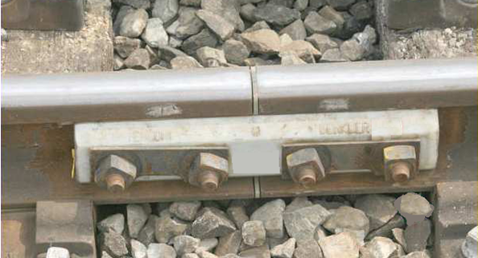

Figure 8 – Typical insulated rail joint

The immediate cause of this incident was the non-compliant location of an IRJ that allowed a vehicle to legitimately stand foul of an adjacent, converging track. This condition appears to have existed since a technical upgrade project was undertaken during 1998-1999. Information provided to the investigation suggests that this part of the project was commissioned in mid-1999; it being of note that Melbourne Transport Enterprises (later called Connex Melbourne Ltd) was awarded the franchise to operate the region that includes Ringwood in August 1999.

It appears either that designers deliberately chose to install this IRJ in a position foul of the adjacent track (perhaps to facilitate the track layout desired at this location, which includes an overbridge across a major street) since a train movement from platform 2 onto the Up Belgrave line was not expected to occur or be required, or it was a design oversight that was never identified. MTM Infrastructure — the current operator and track manager — have been unable to determine the rationale, at the time, for this decision. MTM Infrastructure have also stated that, while the fouling and clearance point requirements are understood, the practice of confirmation of existing infrastructure has not previously been conducted by signal maintenance personnel and that signalling records did not indicate that the IRJ was incorrectly located. Standards now exist that prescribe these and many other aspects of the design of signalling and interlocking[20], although there are inconsistencies. For example, VRIOGS 012.1 contains, in Section 5.3 *Designers’ Completed Design*, a list of design items - any number of which may be included in a completed signalling and interlocking project, and therefore might warrant depiction on a system drawing. While this list includes the provision that, for railway Level Crossing Control layout plans, the *“...design shall include the positioning of insulated rail joints...”*, no such requirement exists for the depiction of IRJs in other design layouts. This might be an oversight easily corrected.

It may also be questioned why all signalling system plans and schematics that existed prior to the introduction of VRIOGS should not already have been updated or should not now be updated to ensure that all critical detail is appropriately recorded and accurately depicted; including the location of IRJs generally.

## Signal control room

The signaller at Ringwood is required to operate under several constraints:

1. Whereas, historically, this role was conducted from an elevated signalbox that usually afforded the signaller an extensive view of the interlocking they operated, the introduction of advanced technologies has provided the opportunity for remote control of signals and points. This has resulted in the removal of many signalboxes and the advent of the *signal control room*. The related expectation is clearly that — even though such control may be undertaken locally — the operation of the interlocking and presentation of system status can be accomplished using control panels and reactive displays; the signaller no longer requiring an operational view of the interlocking. While, in theory, this sounds reasonable, in practice it is only safe and effective if all physical aspects of the infrastructure are known and understood and the reality in the field accords with the signaller’s perception and comprehension of it. Although the Ringwood signal control room has a bay window looking onto the station platform, it is *behind* the signaller and provides only a limited view of the total Ringwood Station interlocking.
2. The manner in which the schematic presentation of trackage within Ringwood station limits is provided on the signaller’s mimic panel is a generic interpretation of the location of track circuit limits (defined by insulated rail joints). The graphic representation tends to convey that all track circuit limits are clear of fouling points for adjacent, converging tracks, although — clearly — this may not be the case; indeed was not in this instance. A considerable degree of detailed local knowledge is required for signallers to be able to accurately interpret the mimic panel display, especially where local peculiarities may exist. It is reasonable to expect that a signaller not in possession of this detailed knowledge, glancing at the panel might notice track circuits 334T and 335T occupied — with circuit 324T now vacant and 224 points free — and choose to route another train into platform 2 via 205, 204 and 224 points (as also depicted in Figure 6). It is not apparent from the display that the IRJ might, in fact, have been installed so close to the 224 points as to be inside the fouling point.

## The collision

The route of the Lilydale EMU arriving towards platform 2 at Ringwood took it alongside the stationary plant train, then across the plant train’s trailing end. It could be argued that the driver of the passenger train might have exercised a greater degree of caution based upon the proximity of the end of the plant train to his converging route, however the fact is that the driver had proceeded on the authority of a valid fixed signal indication and was permitted a maximum speed of 40 km/h through this interlocking. He was entitled to expect his route to be clear and would not have anticipated the plant train to be standing foul.

# 

# Conclusions

## Findings

1. Production of the special circular prescribing plant train movement in support of the infrastructure works neglected to consider the requirement to traverse ARTC trackage. This caused a 24-hour delay to the project and necessitated production of a revised circular which altered the train working arrangements. This oversight had results that contributed to a sense of urgency surrounding events on the evening of the commencement of the works.
2. The timeframe given for completion of the safeworking circular was six days less than the minimum time required by regulation and the circular did not accurately convey the requirements of MTM Infrastructure.
3. All staff involved in the incident were appropriately qualified.
4. The conduct of train operations — of themselves — did not contribute to the incident.
5. The plant train was not marshalled as expected by operations and works personnel involved in the works.
6. The plant train made an abnormal but legitimate move, stopping before the move was completed. Although having cleared the track circuit behind it, the standing train was encroaching upon the clearance envelope of the adjacent, converging track. This was not apparent to the signaller, who signalled another train movement that collided with the standing plant train.

## Contributing factors

1. The location of the insulated rail joint defining the limit between track circuits 324T and 334T lacked compliance with Victorian signalling and interlocking design principles.
2. The location of track circuit limits (for example, IRJs) at metropolitan interlockings had not been recorded by previous operators. When planning new works, MTM had no process by which to identify their location and therefore assess their likely impact.

# Safety Actions

## Safety Actions taken since the event

An Initial Infrastructure Investigation carried out by MTM Infrastructure notes that it must be assumed that there may be other instances around the network with similarly non-compliant track circuit limits. As a result, MTM have undertaken the following;

A: Short term

1. Issued operational instruction SW 052/2010 to the train control centre, all Metro stations, signalboxes and depots specifying that after conducting a non-signalled movement, no other signalled move toward the area from which the non-signalled movement is being conducted is permitted until the first movement has cleared beyond the protecting signal, or if not, that the Signaller has ascertained — by personal observation or by liaison with the operator in charge of the movement — that the movement is clear of the fouling point of any adjoining line.
2. To ensure that all project works design is compliant with signalling standards and principles and that completed works are checked for such compliance.
3. To ensure — prior to commencement and after completion — that the clearance location of all insulated rail joints is confirmed for projects undertaken as part of the Annual Works Plan.
4. To ensure that — during the planning phase — the fouling and clearance points applicable to track occupations is reviewed.
5. To ensure that MTM staff are trained in the recognition of track circuit limit locations and how to determine fouling and clearance points.

B: Medium term

1. The location of all insulated rail joints applicable to points junctions throughout the metro network to be measured for compliance, and recorded.
2. All such junctions identified as being non-compliant to be risk-assessed, with operations and signal engineering divisions to determine appropriate remedial solutions in each case.

C: Long term

1. Installations identified as non-compliant to be rebuilt to standard.

## Recommended Safety Actions

Safety Issue 1

The introduction of new technology has resulted in elevated signal boxes being replaced with enclosed signal control rooms to provide remote operation of signals and points. Since signallers in these control rooms cannot clearly see much (in some cases, any) of their interlocking, it is vital that their feedback displays provide accurate information on system layout and status. The schematic presentation of these displays should represent — as literally as possible — the geographic situation in the field and signallers should be familiar with any operational peculiarities applying to their interlocking, such as the existence of non-compliant track circuit limits.

RSA 2010008

That — whereas actions proposed by MTM in Section 4.2 can be expected, in time, to address any non-compliant installations — MTM take action to ensure that signallers are made aware of non-compliant installations and of any abnormal signalling moves that might be affected as a result.

Safety Issue 2

VRIOGS 012.1, *Standard for Signalling Design and Documentation* contains a provision that layout plans for railway Level Crossing Control include detail of the positioning of insulated rail joints, however no parallel requirement exists for IRJs to be depicted in other types of signalling and interlocking design layout. This would appear to be an oversight.

RSA 2010009

That the Victorian Rail Industry Operators Group consider adding to VRIOGS 012.1 the provision that the measured location of insulated rail joints be depicted in all instances.

1. All times are expressed as Australian Daylight Saving Time.
2. The ‘Down’ direction is away from Melbourne City. The ‘Up’ direction is towards Melbourne.
3. MTM Network Planning S2401/10, 18 March 2010.
4. A track *occupation* is a planned period of track works during which a section or portion of track is closed to all normal train and vehicle movements (apart from those required in support of the work) in order to carry out works required to maintain the permanent way infrastructure. The track occupation provides safe access to authorised persons and equipment. An *absolute occupation* is not defined in the Book Of Rules & Operating Procedures 1994, (PTC) but is designed to permit unrestricted movement of rail vehicles in either direction as locally required by site supervision. MTM use the term *‘Total Occupation’*, which is not consistent with terminology used in references within the Book Of Rules & Operating Procedures 1994, (PTC)
5. A paper instrument conveying authority from a signaller to a train driver to pass a Home signal displaying a Stop indication.
6. An *interlocking* is an arrangement of signals and signal appliances so interconnected that their movements must succeed each other in proper sequence. An interlocking is designed so that it is impossible to give ‘Proceed’ signals to trains unless the route to be used is clear and proven to be safe (correctly aligned and, where appropriate, locked). Such an arrangement is designed to prevent conflicting movements wherever tracks cross or intersect.
7. A signal control *mimic display pane*l is a panel (often free-standing) simulating the geographical layout of a railway interlocking, in which small indicator lamps display the status of track circuits, points and signalling. It does not normally include control switches.
8. A Competent Employee is one who is qualified in the safeworking applicable to the area or route but does not possess ‘route knowledge’ currency and/or possibly the required approval on the particular locomotive type.
9. Scheduled for a particular time interval, including an entry time and day and an exit time and day, through which applicant’s rolling stock may travel over a section of the Network from origin to destination (including stopping points).
10. Refers to a train being signalled (and the line ahead set) for a route other than the one the train is supposed to take. The phrase is also used to describe circumstances where the train actually proceeds onto an incorrectly-set route.
11. The Pilot (historically known as ‘Pilotman’) is a person qualified in the safeworking system for the area who is designated to authorise or accompany out-of-course train movements when the normal signalling or safeworking system for the area is non-operational, and/or when local infrastructure works require abnormal or out-of-course train movements.
12. For the process of rail discharge, the plant train requires a ‘threader’ wagon to be the last wagon in the consist. This wagon is designed to feed the strings of rail off the train and onto the ground beside the track as the train moves forward. In this instance, the plant train had the ‘threader’ wagon attached at the Belgrave end when—for rail discharge in the Down direction—it needed to be at the Melbourne end. For this reason, rail discharge could not proceed in the direction originally planned. Note that if a plant train is assembled with a locomotive at each end (as was the case on this occasion), the rail discharge operation requires detaching of the locomotive coupled next to the ‘threader’ wagon and operating the train in the opposite direction. Such activity is facilitated by the operational flexibility afforded by an Absolute Occupation.
13. Become wholly within the limits of.
14. Per MTM (the ‘Access Provider’) Train Path Request Process and Protocol – November 2009.
15. The Australian Rail Track Corporation, manager of interstate standard-gauge track, including those such routes providing access to Melbourne.
16. This wagon contains equipment to facilitate the discharge of strings of continuous welded rail from the train. For this task, it is required to be the trailing (last) wagon on the train during the process of rail discharge.
17. The investigation uses this term to denote the track situated between the Lilydale Down line and the Belgrave Up line (coloured blue on Figure 4). This track is effectively both an extension of the Lilydale Up line and the Belgrave Down line.
18. A signal — usually a Home signal — located such as to control movement through a section of interlocking and to defend that section of interlocking against a potentially conflicting move.
19. Victorian Rail Industry Operators Group Standards (VRIOGS 012.0, *Victorian Signalling Principles*) Rev. B, Section 4.4 Track Vacancy Detection.
20. VRIOGS 012.1, *Standard for Signalling Design and Documentation*, Rev. B, 12/12/2008.