

Rail Safety Investigation

Report No 2010/09

Derailment

Pacific National Train № 9102

Points 127D South Dynon

15 October 2010

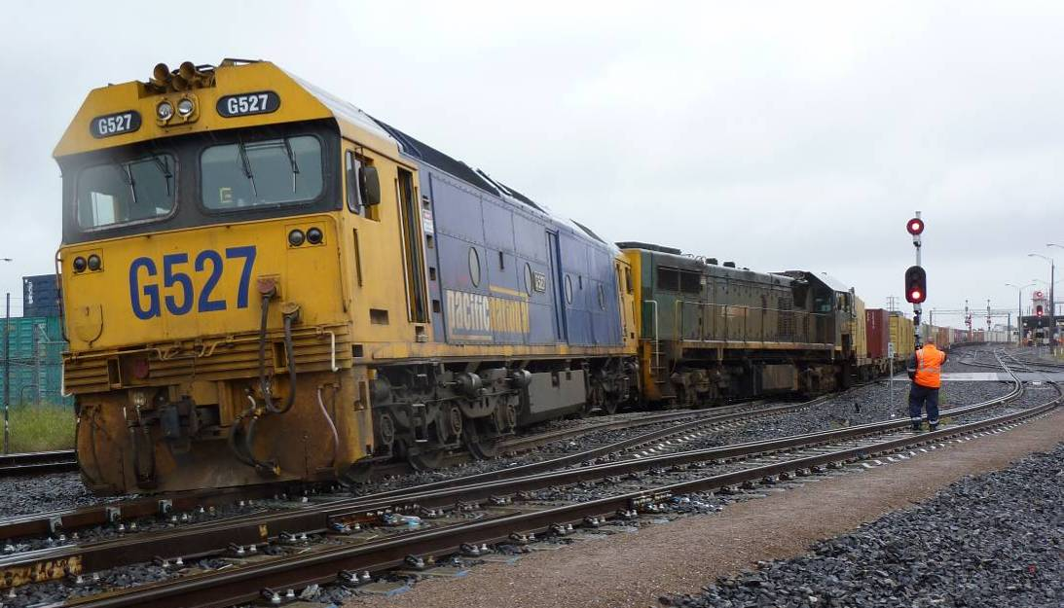

TABLE OF CONTENTS

The Chief Investigator 5

Executive Summary 7

1. Circumstances 9

2. Factual Information 11

2.1 Infrastructure 11

2.2 Operations during commissioning works 12

2.3 Site inspection 13

2.4 Personnel 15

2.5 Environment 17

2.6 Organisations 17

2.7 Missing Link and W Track Project 18

3. Analysis 23

3.1 The incident 23

3.2 Commissioning planning and processes 23

3.3 Change over from ARTC Mile End operation to SIA local operation 23

3.4 Route integrity 24

4. Conclusions 25

4.1 Findings 25

4.2 Contributing factors 25

5. Safety Actions 27

5.1 Recommended Safety Actions 27

The Chief Investigator

The Chief Investigator, Transport Safety is a statutory position under Part 7 of the *Transport Integration Act 2010*. The objective of the position is to seek to improve transport safety by providing for the independent no-blame investigation of transport safety matters consistent with the vision statement and the transport system objectives.

The primary focus of an investigation is to determine what factors caused the incident, rather than apportion blame for the incident, and to identify issues that may require review, monitoring or further consideration. In conducting investigations, the Chief Investigator will apply the principles of ‘just culture’ and use a methodology based on systemic investigation models.

The Chief Investigator is required to report the results of an investigation to the Minister for Public Transport or the Minister for Ports. However, before submitting the results of an investigation to the Minister, the Chief Investigator must consult in accordance with section 85A of the *Transport (Compliance and Miscellaneous) Act 1983*.

The Chief Investigator is not subject to the direction or control of the Minister in performing or exercising his or her functions or powers, but the Minister may direct the Chief Investigator to investigate a transport safety matter.

Executive Summary

On 15 October 2010 at about 1140, the locomotives and the leading wagon of the Pacific National Mildura to Appleton Dock freight train № 9102 derailed at 127D points at South Dynon Junction. This set of points connected the recently constructed North Dock Line to the existing Australian Rail Track Corporation network. The derailment occurred during the South Improvement Alliance ‘Missing Link’ Stage 3 commissioning works that involved the introduction of the North Dock Line together with other track and signalling infrastructure between South Dynon Junction and Appleton Dock. Train № 9102 was the first revenue train to operate through the commissioning area and was done so under the local signaller’s authorisation.

As a consequence of the derailment, rail traffic was disrupted and Dock Link Road was closed to road traffic for several hours. The site was cleared at 1430 on 16 October 2010; however, the Greensill Lead connection to the North Dock Line was not commissioned until June 2011.

The investigation found that the broad-gauge blade of 127D points was not connected to the dual-control point machine and that it was secured against movement for the broad-gauge route towards the North Dock Line. The derailment was caused by the left-hand point blade of 127D points being in the Reverse position while the right-hand broad-gauge point blade was secured against the standard-gauge rail in the Normal position. This resulted in the locomotives and lead wagon attempting to traverse two routes.

The derailment was a consequence of the failure of the commissioning planning, operations and safeworking processes to identify the condition of 127D points, and the signallers not ensuring the integrity of the route set for train № 9102.

The investigation makes recommendations to South Improvement Alliance in the areas of the processes for identifying the position of field equipment prior to train movements and the practices applied by signallers.

The investigation also recommends that the Victorian Network Managers review the Australian Rail Track Corporation *Network Rules and Procedures (TA20)* and the Public Transport Corporation *1994 Book of Rules and Operating Procedures* in relation to the operation and working of dual-control point machines when in the Hand mode.

# Circumstances

On 15 October 2010 at about 0940 the South Improvement Alliance (SIA)[1] assumed control of a portion of the Australian Rail Track Corporation (ARTC) network in order to conduct track infrastructure and signalling upgrades associated with the final stage of the Missing Link Project. The area affected encompassed Moonee Ponds Creek Junction, Appleton Dock, South Dynon and North Dynon. The transition from ARTC to SIA control and operating procedures was conducted under an absolute occupation[2]. A condition of the occupation and commissioning works program was that the signalling system would be disabled preventing operation from the ARTC Train Control Centre. Rail traffic coordination and signalling in the affected area was to be performed on site by SIA and contracted signalling personnel.

When the occupation was granted, several sets of points, which were normally remotely operated, were required to have their dual-control point machines[3] placed into the Hand operating mode by signallers. With the dual-control point machines in the Hand mode the relevant signals governing movements over these points were held at Stop. Under these circumstances, individual train movements require authorisation, either verbally or by a written caution order[4], to pass signals at Stop.

Pacific National Pty Ltd train № 9102, the Mildura to Appleton Dock freight service, presented the commissioning team with the first opportunity to route a broad-gauge service along the new North Dock Line. This train was held at Tottenham waiting for the handover from ARTC to SIA control to be completed.

Prior to accepting train № 9102 from Tottenham, the SIA coordinator requested the South Dynon Junction signallers to set the route for this movement. The points involved were 137U, 129D, 127D, 127U and 125D. After setting the route and performing a cross check of the point settings, the signallers reported to the coordinator that the route was set and secure for the passage of train № 9102.

At about 1140 the driver of train № 9102 was presented with a caution order authorising his train to pass signal DYN136 at Stop. While proceeding from the Local Line towards the new dual-gauge North Dock Line the two locomotives and first wagon derailed at points 127D. The speed of train № 9102 at the time of the derailment was about 10 km/h.

# Factual Information

## Infrastructure

The ARTC track infrastructure in the incident area included a local dual-gauge line, a standard-gauge main line and the W Track, which is a dual-gauge connection from North Dynon to South Dynon and to Swanson and Appleton Docks. Train operations in this area are managed by ARTC and are controlled from their train control centre at Mile End, South Australia. A significant proportion of the track in and around the South Dynon Junction was dual gauge.

There are four Pacific National facilities, the Melbourne Freight Terminal (MFT), the Melbourne Operations Terminal (MOT), the Wagon Maintenance Centre (WMC) and the Locomotive Provisioning Centre (LPC), located in this area with direct connections to the ARTC network.

Points 127U and127D formed the crossover known as Greensill Lead. Both were ARTC type-30 dual-gauge points mounted on concrete bearers and fitted with Westinghouse dual-controlled point machines. Points 127D was a right-hand turnout with the straight route forming part of the Greensill Lead crossover, while the diverge route formed part of the South Dock Line.

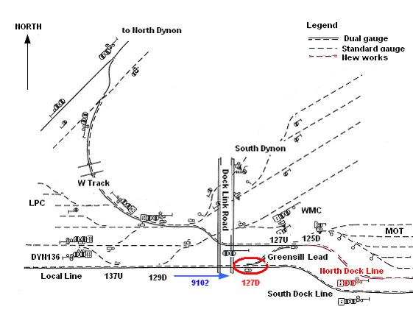

Figure 1 - Diagram of incident site and surrounding infrastructure

## Operations during commissioning works

### Overview

Under normal circumstances the points and signals in the area are operated by the ARTC train controller in Mile End. To facilitate the commissioning works, all signalling between Moonee Ponds Creek Junction, Appleton Dock, North Dynon Junction, South Dynon Junction, MFT, MOT and the LPC was rendered inoperative. The Dock Link Road level crossing was required to be operated manually.

At the commencement of the works and prior to the operation of any trains through the area, all dual-control point machines were placed and secured in Hand mode. This action placed and held all signals relevant to those points at Stop.

Regular rail traffic service levels were expected to be maintained throughout the duration of the works. In order to manage the rail traffic, operations coordinators were located on site near Dock Link Road to coordinate train movements under the direction of the ARTC train controllers. The ARTC train controllers retained the role of prioritising movements through the area.

Signallers at various locations hand operated points in order to set the route as required and issued caution orders under the direction of the coordinators. A signaller mentor and a safeworking technical person were also available to provide general support for the coordinators and signallers. The signaller mentor position was created as a result of experience from previous commissioning works. Their role was to ensure quality assurance in relation to safeworking management.

### Route integrity

Under normal control, relevant signals cannot be set to a ‘Proceed’ indication until all points for the intended route are detected by the signalling circuitry to be set and locked in the correct position; that is, the position called-for by the remote network controller. However, when in Hand mode each set of points must be operated individually to set the desired route. The route integrity under these circumstances relies entirely on the actions and observations of signallers in the field. Train movements are authorised past signals at Stop by procedure. At South Dynon Junction this procedure required the issuing of a Signaller’s Caution Order for movements involving signal DYN136.

Since January 2009, SIA had been engaged on several infrastructure upgrades in the general South Dynon Junction area associated with the Melbourne–Sydney rail corridor Missing Link Project. These commissioning works also required the signalling system to be temporarily rendered inoperative and the use of manual route setting procedures to facilitate rail movements. During each of these commissionings, a revenue service was derailed due to route integrity failures.

### Use and issuing of Signaller’s Caution Orders

A Signaller’s Caution Order must be issued to the train driver to allow a train to proceed past a Home signal at Stop when that signal governs facing or trailing points or protects the fouling point of a crossover. Prior to issuing a caution order the signaller is required to ensure that the route is set and secured for the intended movement.

## Site inspection

On site it was observed that locomotives G527 and X39 were derailed and that the leading bogie of the first wagon had also derailed along Greensill Lead after attempting to negotiate 127D points. All derailed vehicles remained upright and coupled. The left hand wheels on the trailing bogie of the first wagon (VQOF1086T) had lifted with their flanges running along the rail head until dropping on the gauge side of the common rail of the diverging route.

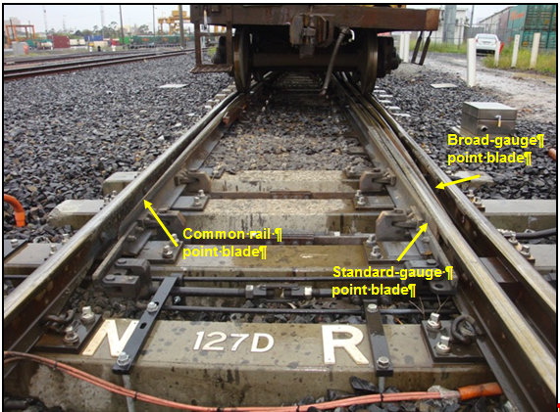

Figure 2 - Position of 127D points and leading wagon VQOF1086T

After the rear portion of the train was uncoupled and hauled clear of Dock Link Road, 127D points were able to be inspected. It was evident that the broad-gauge blade of these points was secured against the standard-gauge rail and that the broad-gauge spreader bar brackets were not connected; thus the broad gauge was unavailable for movements via Greensill Lead towards the North Dock Line.

Figure 3 - Status of broad-gauge point blade and spreader bar connections

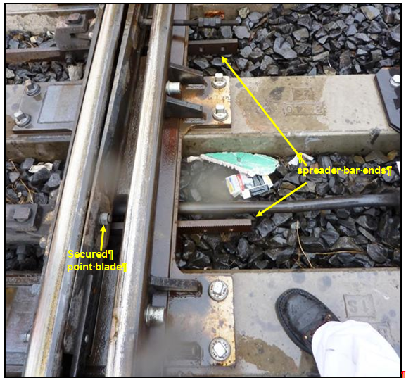

## Personnel

### Train driver/s

In the report provided by the driver of train № 9102 it was stated that while waiting for clearance to proceed beyond signal DYN136, both he and his co-driver observed two signallers walk along the track towards their train. One of the signallers boarded their locomotive (G527) and advised that the delay was due to the route being double-checked and that train № 9102 would be proceeding along a new track immediately to the east of Dock Link Road. While stationary at signal DYN136, the driver overheard the radio conversation between the two signallers confirming that the route for train № 9102 had been checked and that all points were set. The driver was then issued a Signaller’s Caution Order to proceed past DYN136 at Stop.

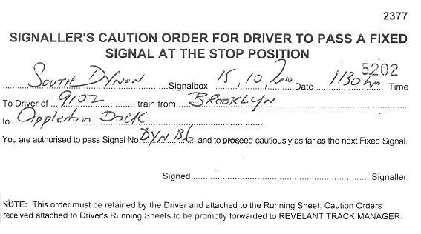

Figure 4 - Copy of Signaller’s Caution Order issued to train № 9102, with signature deleted

As the train crossed Dock Link Road both drivers reported that they observed that the points were in the correct position to proceed along the new track and that they both believed that the route was set correctly. As the locomotive passed over 127D points the drivers reported that it rose sharply upwards and bounced along the track. The air brake was applied in Emergency and train № 9102 took about 50 metres to come to a halt.

### Signallers

The signaller team assigned to the South Dynon area consisted of a senior signaller and three signallers.

All signallers held Level 3 Track Force Protection Coordinator[5] qualifications and had been trained and qualified in an ARTC authorised, modified version of the Automatic Block Signalling (ABS) safeworking system. This modified safeworking qualification certified the holder to act as a signaller during the SIA commissioning works.

### Signaller training

In order to conduct duties as a signaller, personnel are required to be qualified in ABS. The ABS course is based on the rules and operating procedures as detailed in the Public Transport Corporation (PTC) *1994 Book of Rules and Operating Procedures[6].* At the request of SIA, Skilled Rail Services (SRS) conducted a modified version of the ABS course that qualified the person to work as a signaller during the SIA commissioning works. The restricted nature of the course is highlighted in the SRS training manual.

The training course material addressed the working of points and signals, automatic block signalling, train signals and three-position signals. The method of operation of a dual-control point machine is incorporated in the working of points and signals section. Regarding the issuing of caution orders, the course material stated that the signaller is to ensure that the points are correctly set before issuing a caution order.

All signallers involved in this incident were assessed as competent and accredited by SRS in this modified version of the ABS system.

The SIA documentation for the ‘operational safeworking of trains’ during the commissioning stated that prior to the commencement of the commissioning, signallers would be provided theory training on their responsibilities and tasks. Safeworking competencies were re-assessed during the SIA training session.

**Site familiarisation training**

On Saturday 9 October 2010 practical safeworking training was conducted by SIA for about 35 safeworking personnel who were to be involved in the Stage 3 commissioning. This session was conducted between 2120 on 9 October and 0130 on 10 October. Three training groups were established consisting of South Dynon, South Dynon and Appleton Dock, and South Dynon and North Dynon signallers. The signallers involved in setting the route for train № 9102 were all in the South Dynon and Appleton Dock group. The training for this group focused on identifying crossovers and routes that had the potential for movements to ‘run out of gauge’[7]. The signallers reported that during this training they were advised that it was only necessary to check the common rail on dual-gauge points to ensure the points were set for the desired route. None of the signallers interviewed had any recall of operating any points during the field familiarisation or being advised of any route restrictions on points 127D.

### Interviews

The two signallers involved with setting the route for train № 9102 stated they each set one end of the crossover incorporating points 127U and 127D and that the common rail blade on both points was observed to be open as shown on 127D in Figure 2.

The route for train № 9102 was reported to be set and checked as shown in Figure 5.

|  |  |
| --- | --- |
| **Point number** | **Setting** |
| 137U | Normal - laying along the Local Line |
| 129D | Normal - laying along the Local Line towards points 127D. |
| 127D | Reverse - laying from the Local line towards Greensill Lead and points 127U. |
| 127U | Reverse - laying from Greensill Lead to points 125D. |
| 125D | Normal - laying along the North Dock Line. |

Figure 5 - Point settings as per signaller’s report

## Environment

At about 1140 on 15 October 2010 the weather conditions in the West Melbourne area were overcast with moderate rain, a south to southwestly wind blowing at about nine km/h, and a temperature of about 12 degrees Celsius.

## Organisations

### South Improvement Alliance

SIA is a group of organisations established by ARTC to plan, design and deliver a range of improvements on the Melbourne-Sydney rail corridor. The alliance consists of ARTC and primary partners:

* John Holland Rail - a project management, engineering, construction and maintenance business that provides services to the rail industry throughout Australia and internationally
* MVM Rail - a railway construction company specialising in rail and railway track maintenance and infrastructure projects
* O’Donnell Griffin - an electrical and communications engineering solutions provider that designs, builds and maintains infrastructure, such as railway signalling systems, and
* two sub-alliance partners: Kellogg Brown and Root and Aurecon.

### Skilled Rail Services Pty Ltd

SIA contracted SRS to provide field operations personnel including signallers, signaller mentors and track force protection workers. SRS filled these positions with sub-contracted casual employees usually employed to perform track protection roles at work sites.

## Missing Link and W Track Project

### Overview

This commissioning was a stage of the Melbourne-Sydney rail corridor upgrade project. The commissioning encompassed Moonee Ponds Creek Junction, Appleton Dock, North Dynon Junction and South Dynon Junction. The scope of works included the introduction of a new line (the North Dock Line) and the establishment of W Track as a dual-gauge connection to Appleton and Swanson Docks, together with new track infrastructure and signalling between South Dynon Junction and Appleton Dock. In addition the signal control system for the Appleton Dock, North Dynon and South Dynon junctions was also updated during this stage of the project.

### Stage 2

Stage 2 of the Missing Link Project involved trackwork re-arrangement and signalling works at Dock Link Road and the conversion of W Track from standard gauge to dual gauge. It also included the installation and commissioning of the crossover that consisted of points 127U and 127D. This crossover provided dual-gauge connection between the ARTC Local Line, the South Dock Line and the Appleton Dock sidings. Only standard-gauge connections were available to the Melbourne Operations Terminal and from the Melbourne Operations Terminal towards the Locomotive Provisioning Centre and W Track.

For the construction of point 127D, left-hand end-brackets instead of the required right-hand end-brackets had been supplied. The unavailability of the end-brackets prevented the installers connecting the broad-gauge point blade to the point motor rodding as planned. The correct end-brackets were delivered in June 2010 but were not fitted prior to the Stage 3 commissioning works.

On 7 January 2010 a Certification Inspection and Test Checklist was completed for 127D points. This checklist identified the broad-gauge blade as disabled. These points were commissioned into service with a Conditional Certification of Signalling dated 23 January 2010, subject to compliance with Section 8 of Train Notice[8] 2529 by 1 February 2010. Section 8 in Train Notice 2529 did not exist. Also there was no reference on the Conditional Certification of Signalling to the broad-gauge blade being disabled.

### Stage 3

**Commissioning countdown meetings**

To coordinate and manage Stage 3, SIA conducted several commissioning countdown meetings that involved the Commissioning, Project and Signalling Managers together with other SIA and industry stakeholders. The Operations and Safeworking Plan Manager, who was responsible for drafting the document, *Specification for the Operational Safeworking of Trains during the Signalling Commissioning of Missing Link Stage 3,* also attended these meetings. Agenda items addressed at these meetings included: Operations, Design, Procurement & Installation, Testing, Commissioning, Logistics & Resourcing, and Training.

Regarding 127D points, the minutes of the commissioning meeting dated 7 September 2010 (Meeting 1), recorded that the draft Train Notice for the Stage 3 commissioning was included in the Operational Safeworking Plan and that this document was discussed at the meeting. The meeting agenda item ‘Commissioning Activities’ recorded that broad-gauge hangers (end-brackets) were required to be installed on 127D points. This agenda item carried over from the 7 September meeting through four other meetings to the 5 October 2010 meeting with no comment as to any action or close-out date. The minutes of the Go/No-Go meeting, conducted on 12 October 2010, made no mention of this item.

Train Notices applicable to Stage 3 operations were compiled on the understanding of the Operations and Safeworking Planning Manager that the physical configuration of 127D points allowed for both broad and standard-gauge movements. Draft Train Notices were presented, discussed and accepted at the Missing Link Countdown Committee meetings.

**Commissioning program**

This program documents critical tasks and deadlines for the project, beginning with the booking-out of the signalling equipment at 0930 on 15 October 2010 through to its return-to-service at 1600 on 22 October 2010.

Items 32/33 of the program identified that point machine rodding installation was required on points 41U, 122D, and 133. Items 41/42 (Certify Point Machines) recorded the requirement to ‘set-to-work and certify’ several point machines and install detection components on 13 sets of points in the Dynon and Appleton Dock areas.

**Operations structure**



Figure 6 - SIA commissioning operations structure

**Operations roles and responsibilities**

### Signals Tester-in-charge

The *Specification for the Operational Safeworking of Trains during the Signalling Commissioning of Missing Link Stage 3*, stipulated that this position was responsible for providing accurate information to the Operations Coordinator regarding the status of all signalling[9] prior to the passage of each movement and for ensuring that all testing was undertaken in liaison with the Operations Coordinator.

The Tester-in-charge reported that the signalling control system was configured to prevent selection (by the network controller) of any route on to non-commissioned track. The Conditional Certification of Signalling was completed and issued by the Tester-in-charge as part of the Stage 2 signalling system sign-off and was presented to the Signalling Project Manager. He was aware of the unavailability of the correct end-brackets for 127D points and that the broad-gauge point blade had been secured to permit broad-gauge movements along the South Dock Line.

### Operations and safeworking planning

The Operations and Safeworking Planning Manager was responsible for the development and implementation of The *Specification for the Operational Safeworking of Trains during the Signalling Commissioning of Missing Link Stage 3.*

The Operations and Safeworking Planning Manager reported that he had been involved with all stages of the Missing Link Project in regard to the development of the safeworking and operation specifications. He stated that at no time during the development, review and acceptance of the Stage 3 safeworking and operation specifications was it indicated, apart from the minute item of meeting 1, that there was any restriction on the operation of 127D points when Stage 3 commenced. The *Specification for the Operational Safeworking of Trains during the Signalling Commissioning of Missing Link Stage 3* andrelevant Train Notices were developed with this understanding.

### Operations Coordinator

Operations Coordinators report to the Safeworking Supervisor and were in attendance 24 hours a day to ensure the safe passage of trains. This role was required to liaise with the Tester-in-charge and network controllers to ensure all testing had ceased and that the correct conditions existed for the passage of each move.

The Operations Coordinator on duty reported that they had no knowledge of any hand operation restrictions for any points within the commissioning. They were not informed by any of the key personnel of any issue with the proposal to route train № 9102 along the North Dock line.

**Operations procedures**

SIA produced and issued the document, *Specification for the Operational Safeworking of Trains during the Signalling Commissioning of Missing Link Stage 3 (Version 2b),* dated 22 September 2010.

This document identified the scope, operational status of signalling equipment, and the roles and responsibilities of those involved with the management of train movements at the various locations affected by the commissioning.

As part of the development of the Stage 3 procedures and in response to de-brief sessions from the Stage 2 commissioning, a risk assessment was conducted by SIA and the Missing Link Project Risk Assessment and Control Planwas developed.

This risk assessment identified the hazard of a train being derailed by incorrect operation of points or derails[10]. This hazard was mitigated by the administrative control of ‘Signaller procedures and site specific training’, together with the requirement for the set route to be confirmed and checked by another person.

An additional mitigation against the hazard of a derailment was the provision—in addition to training on the procedures—that signallers would be provided with in-field familiarisation. A further outcome of the risk assessment was the decision to provide signaller mentors.

Work instructions that required the use of the South Dynon Points Logto assist the signallers in ensuring that points were operated and set correctly for the desired movement were also implemented by SIA. Signallers were required to record in the Points Log the date, time, train number and gauge, origin and destination, together with the arrival and departure times of each move. It was also required to record when the route was reset to Normal. Blank fields were provided on a schematic for signallers to record the position the points were required to be set to. These administrative requirements were not met for the passage of train № 9102.

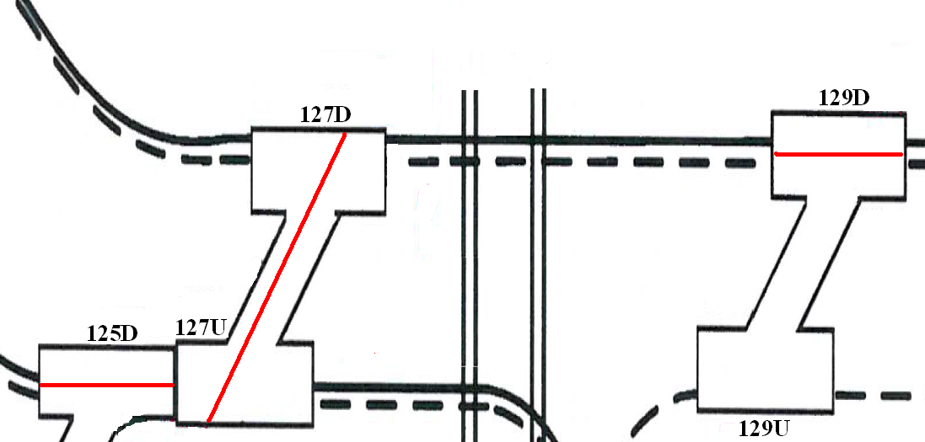

Figure 7 - Points Log extract with red lines indicating how the log should have been completed

ARTC *TA20* and PTC *1994 Book of Rules and Operating Procedures*

Section 27 (Operating Procedures Working of Points and Signals), Procedure 17 of both documents is identical and refers to dual-control point machines and their operation during failure which, in the context of the instruction, is when it is necessary for the points to be operated by hand.

Clause (d) (Points Not Moving to Full Normal or Reverse Positions) states*:*

“If the points move to the full ‘Normal’ or ‘Reverse’ position by the operation of the hand throw lever, but the lever will not travel on to its stop, the points are unlocked.

In these circumstances, arrangements must be made for the points to be secured with a point clip before a train is permitted to pass over the points.”

# Analysis

## The incident

Broad-gauge freight train № 9102 presented the commissioning team with the first opportunity to route a revenue train along the new North Dock Line. Local signallers were instructed to set the route from signal DYN136 along the Local Line to the North Dock Line for this movement.

After receiving a caution order to proceed beyond signal DYN136 at Stop, train № 9102 travelled along the Local Line towards the North Dock Line via Greensill Lead. The route included points 137U and 129D, which were negotiated without incident. However, while traversing points 127D train № 9102 derailed. The derailment was caused by the left-hand point blade being in the Reverse position while the right-hand broad-gauge point blade was secured against the standard-gauge rail in the Normal position. This resulted in the locomotives and lead wagon attempting to traverse two routes.

## Commissioning planning and processes

Given that the North Dock Line was not constructed until after the completion of Stage 2, the interlocking of the signalling system at South Dynon Junction was configured to prevent the selection of the broad-gauge route using the Reverse position of points 127D. In addition, because the broad-gauge end-brackets had not been installed on points 127D, the broad-gauge point blade was bolted in the Normal position allowing broad-gauge traffic to be routed along the South Dock Line.

Despite the condition of 127D points being noted at the initial commissioning countdown meeting, the requirement to provide and install broad-gauge end-brackets was not addressed in subsequent meetings. The purpose of the Go/No-Go meeting was to review the status of any outstanding issues and actions that would impact on the commissioning; however, the condition of points 127D, and the effect this would have on the commissioning, was overlooked. This item did not flag as an outstanding issue in the meeting’s documentation. The commissioning did not recognise that without all routes being available on 127D points the Operational Safeworking Plan was flawed.

Prior to the implementation of the Operational Safeworking Plan it would have been appropriate for a ‘desktop’ review to be conducted to ensure that all works had been completed as required to allow the passage of trains. Also, it could be argued that, given the relative simplicity of the works, a physical walk-through of the site should have been conducted to confirm the documented condition of the infrastructure.

## Change over from ARTC Mile End operation to SIA local operation

The SIA documentation was extensive and detailed the procedures to be followed during the commissioning project. However, the documentation was silent in regard to local signallers ensuring that all points placed in the Hand mode were tested for correct operation.

About two hours prior to the arrival of train № 9102, SIA assumed responsibility for operations in the area and all affected dual-control point machines were placed and secured in the Hand operation mode. Signallers were at this time presented with an opportunity to test and verify the operation of this equipment in the Hand mode. However, as this was not a requirement in the Operations and Safeworking Plan, such tests were not conducted. This action would have been prudent given that signallers were taking responsibility for the operation of this equipment and would have identified the condition of 127D points prior to the passage of train № 9102. An opportunity to prevent the derailment was missed.

## Route integrity

Signalling design principles for route integrity detection requires that all point blades of any type of point are detected in the correct position before any signalled train movement is permitted. The instruction by SIA that signallers need only check the common point blade is not only inconsistent with good practice because it does not, as in this case, ensure that the intended route is correctly set, but presumes that the other point blades could not have been restricted in their movement. The instruction was also contrary to SRS training.

Although signallers reported that the setting of the route for train № 9102 had been correctly carried out and checked, it is apparent that this process did not identify the position of all the point blades on 127D points, resulting in the compromised integrity of the required route. This was despite the provision by SIA of several additional defences for this commissioning.

Both drivers reported that they observed the route to be set towards the North Dock Line; however, given that the broad-gauge point blade was secured and unable to be set for the desired route, it is reasonable to conclude that they also relied on sighting position of the common point blade. It must be noted however, that when a driver is issued with a Signaller’s Caution Order the onus of ensuring route integrity remains with the signaller.

Since January 2009, previous infrastructure upgrade commissionings have experienced loss of route integrity resulting in derailments through the failure of procedures applied by SIA. Although this commissioning applied several additional mitigations to prevent route integrity incidents, the additional defences have proven to be ineffective.

## Network Rules and Procedures

Wording in both the ARTC *TA20* and the PTC *1994 Book of Rules and Operating Procedures*, Section 27, Procedure 17, is inconsistent and ambiguous. The title of Procedure 17 refers to the points not moving, but the body of the procedure goes on to state: “If the points move to the full ‘Normal’ or ‘Reverse’ position …”. The procedure does not state that point blades should be inspected but their position could only be assessed as to have moved to the ‘Normal or ‘Reverse’ position if they were observed to be in that position by a signaller. As these procedures stipulate the Victorian network’s requirements, it would be prudent for the network managers to mandate a visual inspection of point blades in addition to the hand throw lever in this instruction.

# Conclusions

## Findings

1. The completion of 127D points was delayed due to the incorrect end-brackets being supplied.
2. The status of 127D points was inadequately documented on the Conditional Certification of Signalling.
3. The signallers were trained and qualified to the extent required by Australian Rail Track Corporation and South Improvement Alliance to conduct signalling operations necessary for the project.

## Contributing factors

1. The South Improvement Alliance Stage 3 commissioning team did not identify that 127D points were not available for North Dock Line broad-gauge movements.
2. The practice promoted by South Improvement Alliance for signallers to only check the position of the common point blade of dual-gauge points.
3. Signallers did not correctly check the route integrity at 127D points after setting the route for train № 9102.

# Safety Actions

## Recommended Safety Actions

Issue 1

The South Improvement Alliance commissioning management team did not identify that the Reverse route on 127D points was not available for broad-gauge movements prior to commencement of the Stage 3 commissioning activities. Previous infrastructure upgrade commissionings in the South Dynon area have also experienced loss of route integrity resulting in derailments through the failure of procedures.

RSA 2011038

South Improvement Alliance reviews the process for identifying the status of field equipment prior to permitting train movements through a commissioning area.

Issue 2

Signallers did not correctly check the route integrity at 127D points after setting the route for train № 9102. There was an accepted practice on the South Improvement Alliance site of only checking the common point blade position of dual-gauge points.

RSA 2011039

South Improvement Alliance review the practices applied by signallers operating on their sites for ensuring route integrity, particularly when dual-gauge points are involved.

Issue 3

Section 27, Procedure 17 of both the Australian Rail Track Corporation *Network Rules and Procedures (TA20)* and the Public Transport Corporation *1994 Book of Rules and Operating Procedures*, which are identical, do not lay down procedures to be undertaken by signallers in regard to observing the position of point blades during hand operation of dual-control point machines.

RSA 2011040

The Victorian Network Managers (Australian Rail Track Corporation, V/Line and Metro Trains Melbourne) review and re-write the hand lever operation section of each document to provide clearer instructions for users.

1. The South Improvement Alliance is the group of organisations brought together by the ARTC to plan, design and deliver a range of improvements along the Sydney–Melbourne rail corridor.
2. An absolute occupation is designed to permit unrestricted movement as required by site supervision.
3. Dual-control point machines can be operated in Motor (remote operation) or Hand (manual operation) modes.
4. Authority from a signaller or network controller to a train driver to pass a Home signal displaying a Stop

   indication.
5. This qualification allows the holder to take out occupations of a track, provide protection (under live train running), and supervise and coordinate large work groups.
6. ARTC’s Victorian safeworking rules and procedures document *TA20* does not incorporate the Automatic Block Signalling system of safeworking.
7. When a rail movement on dual-gauge trackage reaches a point at which the track gauge on which it is running comes to an end (is truncated, temporarily or otherwise) while the other continues.
8. The method used by ARTC to disseminate information to network users.
9. This also includes associated field equipment such as mechanical connections to point motors.
10. A device designed to make rolling stock or locomotives leave the rails at a particular location to avoid a collision or to prevent the obstruction of another line.