

Rail Safety Investigation

Report No 2010/10

Derailment

At points 133D

South Dynon Junction

20 October 2010

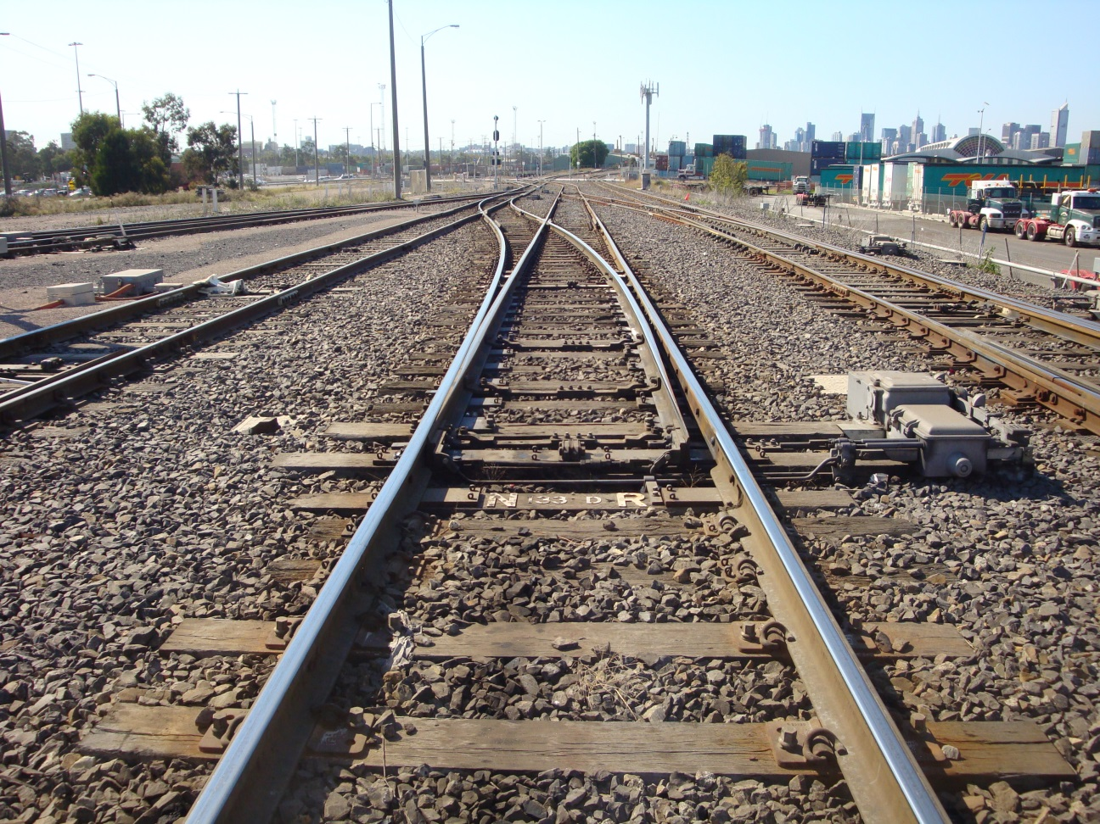

TABLE OF CONTENTS

The Chief Investigator 5

Executive Summary 7

1. Circumstances 9

2. Factual Information 11

2.1 The vehicles 11

2.2 Site inspection 11

2.3 Infrastructure 13

2.4 Organisations 13

2.5 Organisational systems and processes 13

2.6 Missing Link Project 14

2.7 Personnel 15

2.8 Environment 17

2.9 Commissioning incident history 17

3. Analysis 19

3.1 The incident 19

3.2 Organisational factors 19

3.3 Individual actions 20

4. Conclusions 21

4.1 Findings 21

4.2 Contributing factors 21

5. Safety Actions 23

5.1 Recommended Safety Actions 23

The Chief Investigator

The Chief Investigator, Transport Safety is a statutory position under Part 7 of the *Transport Integration Act 2010*. The objective of the position is to seek to improve transport safety by providing for the independent no-blame investigation of transport safety matters consistent with the vision statement and the transport system objectives.

The primary focus of an investigation is to determine what factors caused the incident, rather than apportion blame for the incident, and to identify issues that may require review, monitoring or further consideration. In conducting investigations, the Chief Investigator will apply the principles of ‘just culture’ and use a methodology based on systemic investigation models.

The Chief Investigator is required to report the results of an investigation to the Minister for Public Transport or the Minister for Ports. However, before submitting the results of an investigation to the Minister, the Chief Investigator must consult in accordance with section 85A of the *Transport (Compliance and Miscellaneous) Act 1983*.

The Chief Investigator is not subject to the direction or control of the Minister in performing or exercising his or her functions or powers, but the Minister may direct the Chief Investigator to investigate a transport safety matter.

Executive Summary

Between 10 October and 21 October 2010, the South Improvement Alliance was engaged in commissioning signalling and track infrastructure upgrades associated with the Melbourne–Sydney rail corridor upgrade Missing Link Project. The upgrades affected the North Dynon, South Dynon Junction and Appleton Dock areas of operation on the Australian Rail Track Corporation network. During this period it was necessary to render the signalling system inoperative and to manage rail traffic utilising a sub-system of administrative procedures.

On 20 October 2010 at about 2040, a Pacific National shunt movement that required access to the main line was being conducted from the Melbourne Freight Terminal. When the shunt move was setting back from the main line into the Melbourne Freight Terminal two wagons in the middle of the rake derailed at points 133D on the main line at South Dynon Junction.

Damage was sustained to the motor, rodding and blades of 133D points, track infrastructure and trackside signalling equipment. There were no injuries and all wagons remained coupled and upright with minimal damage. Points 133D were unavailable for use until 1030 on 21 October 2010.

This was the fourth main line derailment associated with South Improvement Alliance commissionings in the South Dynon Junction general area since January 2009.

The investigation found that points 133D were incorrectly set for the shunt movement and that these points sustained damage when the locomotive wheels trailed through the points during the hauling movement from Melbourne Freight Terminal to the main line.

The investigation also found that the senior signaller did not adhere to the South Improvement Alliance work instructions when setting the route for the shunt movement over points 133D.

The investigation found that Skilled Rail Services did not employ a formal or robust process in the appointment of senior signallers for these commissioning works associated with the Missing Link Project.

The investigation has recommended that the network manager, Australian Rail Track Corporation, and South Improvement Alliance review the practice of permitting the access of normal revenue services to the network during infrastructure commissionings that require the signalling system to be rendered inoperative.

The investigation also recommends that South Improvement Alliance and Skilled Rail Services review the roles, responsibilities and training of signalling staff for commissioning works.

# Circumstances

At about 2040 on 20 October 2010, Pacific National Pty Ltd (PN) was conducting a shunting movement at the Melbourne Freight Terminal (MFT). The PN terminal interfaces with the Australian Rail Track Corporation (ARTC) network at South Dynon Junction about three rail kilometres from the Melbourne Central Business district. The shunt move from №2 track to №10 track was in order to place empty wagons into storage at the freight terminal. The derailment occurred immediately to the west of Dock Link Road.

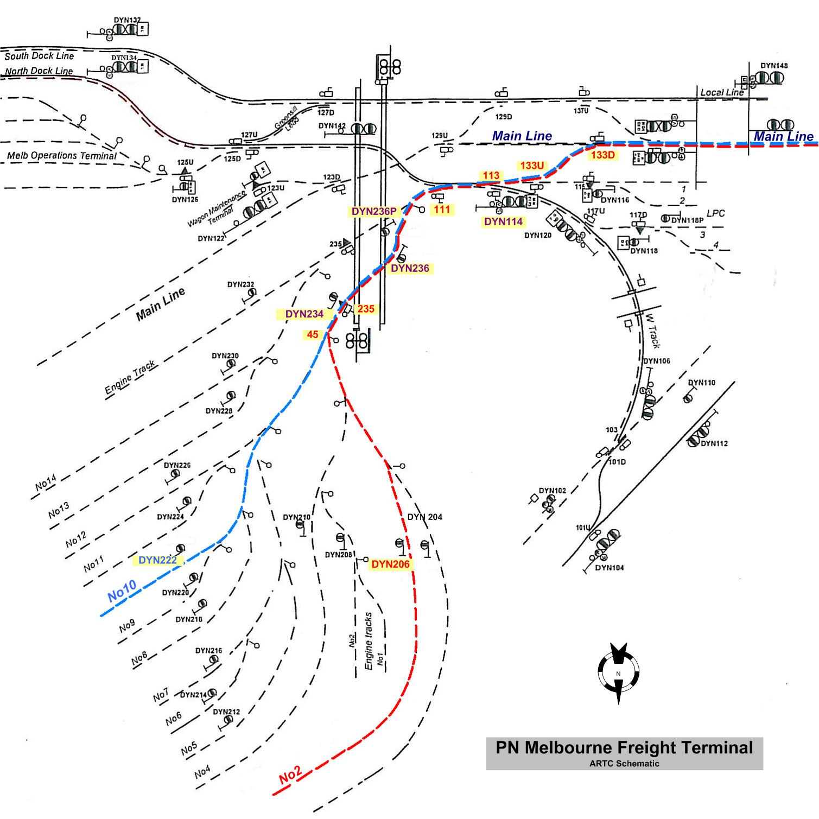

Figure 1: Incident shunt movement route

As a consequence of the commissioning works several points in the area that would normally be remotely operated were required to be operated locally. Prior to the commencement of the works the relevant points in the system that were usually remotely operated were placed in the ‘hand’ position (local/manual operation). When these points are in the ‘hand’ position the associated signals are held at the Stop position. In these circumstances rail movements are required to be authorised to pass these signals at Stop, either verbally or by a written authority (Caution Order).

To facilitate the shunt move, the signaller was required to manually set each point in the route to the required position. This involved the setting of derail and wheel crowder[1] 235, and points 111, 113, 133U and 133D. After setting the route the signaller issued a Caution Order to the locomotive driver authorising the shunt move to pass signal DYN114 at Stop.

The shunt involved two movements; the first, out of №2 track, was to haul the wagons clear of MFT hand points 45, while the second move involved propelling the wagons into №10 track clear of signal DYN222.

During the second move, when the wagons were being propelled towards the MFT, two wagons derailed causing damage to sleepers, rail fastenings and trackside signalling equipment. The Dock Link Road level crossing was blocked as were all rail movements from the east end of the LPC and ‘W’ Track. There were no injuries.

# Factual Information

## The vehicles

The shunt rake consisted of locomotive 8115, a standard container flat wagon RQSY34369-H and four five platform articulated container flat wagons RRYY20-P, TRAY1002-W, RRYY45-H and TRAY1004-R, giving a total length of 387.056 metres. All the wagons were empty.

## Site inspection

The point motor selector lever of point 133U was locked in the ‘hand’ operating position with the hand throw lever secured in the Reverse position. The inspection of point 133D identified that this point motor selector lever was in the ‘hand’ position as required; however, the hand operating lever was locked in the Normal position.

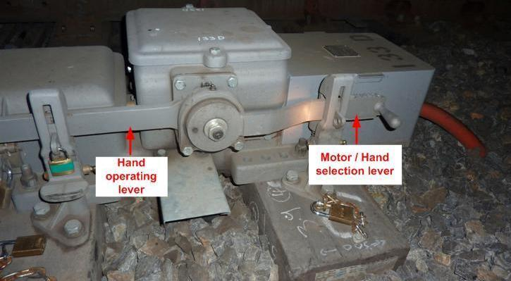

Figure 2: Dual control point machine at 133D points

The point rodding connecting the point blades was bent with neither point blades home against a stock rail, thus leaving these blades open, presenting the potential for a derailment for any facing movement over them. The damage to the rodding was consistent with the point blades of 133D being forced across from the Normal position towards the Reverse position during a trailing movement. Further inspection revealed that the toe of the right-hand point blade had a fresh strike mark consistent with having been struck by a wheel. This, together with the path taken by the last bogie of TRAY1002-W, indicated that the lead right hand wheel of the trailing bogie on this wagon struck the point blade when being propelled towards the MFT, forcing it open sufficiently to allow this bogie and those following to track along the main line. Wheel flange marks and wheel gouges in the ballast indicated that the rake was propelled until the MFT lead track and the main line separated a sufficient distance to cause both the leading bogie of RRYY20-P and the trailing bogie of TRAY1002-W to derail.

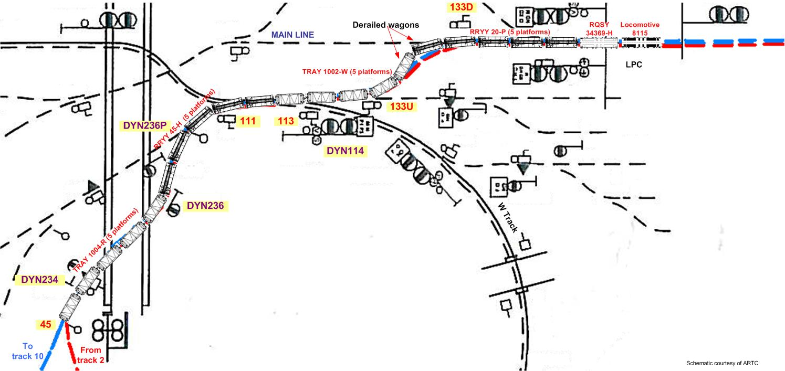

Figure 3: Schematic of derailed wagons

When brought to a stand on the main line, 8115, RQSY34369-H and RRYY20-P, together with the leading bogie of TRAY1002-W, had traversed trailing points 133D. As the rake was being propelled towards №10 track in the MFT, the bogies of TRAY1002-W and the wagons that had not traversed 133D points tracked as required, that is towards №10 track. However, the bogie of TRAY1002-W and RRYY20-P that had traversed 133D points travelled along the main line resulting in the trailing platform of TRAY1002-W being spread between the two tracks. The rake continued travelling in this state for about 30 metres before derailing.

## Infrastructure

The Australian Rail Track Corporation (ARTC) track infrastructure in the incident area included a local dual gauge line, a standard gauge main line, and the ‘W‘ Track, which was a dual gauge connection from North Dynon to South Dynon, Swanson and Appleton Docks. Train operations in this area are managed by ARTC and are controlled from their train control centre in Mile End, South Australia. A significant proportion of the track in and around the South Dynon Junction was dual gauge.

Pacific National had four facilities located in this area with direct connections to the ARTC network: Melbourne Freight Terminal (MFT), Melbourne Operations Terminal (MOT), the Wagon Maintenance Centre (WMC) and the Locomotive Provisioning Centre (LPC).

## Organisations

South Improvement Alliance (SIA) is a group of organisations established by ARTC to plan, design and deliver a range of improvements on the Melbourne-Sydney rail corridor. The alliance consists of ARTC and primary partners, John Holland Rail, MVM Rail, O’Donnell Griffin and two sub-alliance partners, Kellogg Brown and Root and Aurecon.

SIA contracted Skilled Rail Services (SRS) to provide field operations personnel such as signallers, signaller mentors and track force protection workers. SRS filled these positions with sub-contracted casual employees usually employed to perform track protection roles for work sites.

## Organisational systems and processes

SIA produced and issued a document specifying the operational safeworking protocols for trains during the commissioning of Missing Link Project, Stage 3*.* This document identified the scope, the operational status of signalling equipment and the roles of persons responsible for the management of train movements at the various locations affected by the commissioning. SIA advised the investigation that they conducted a safeworking risk assessment and that the outcomes of the assessment were incorporated into their procedures.

Role specific training for signallers consisting of a ‘walk through’ of the commissioning area that was to include the practical setting of points for various moves, ‘lessons learnt’ from previous incidents during commissionings, and the provision of mentors, were some of the outcomes adopted from the risk workshops.

Additionally, work instructions were provided by SIA that included the use of a Points Logto record train movements and assist the signaller to ensure that the correct points were operated for the desired movement. It was a mandatory requirement for the signaller to complete the Points Log for each movement as part of the route confirmation process.

## Missing Link Project

### Overview

This commissioning was a stage of the Melbourne-Sydney rail corridor upgrade project. The scope of the works included the introduction of a new line, the North Dock line, and the establishment of ‘W’ Track as a dual gauge connection to the Melbourne Docks. It also included the commissioning of new track infrastructure and signalling between South Dynon Junction and Appleton Dock. The area of the commissioning encompassed Moonee Ponds Creek Junction, Appleton Dock, North Dynon Junction and South Dynon Junction. The commissioning of an updated signal control system for the Appleton Dock, North Dynon and South Dynon junctions was also a part of this stage.

### Operation during commissioning works

Regular rail service levels were expected to be maintained throughout the duration of the works associated with the commissioning. In order to manage the rail traffic, operations coordinators were located on a site adjacent to ‘W’ Track near the LPC to coordinate train movements under the direction of the ARTC train controller, who retained the role of prioritizing movements into and out of the area.

Signallers, who were located at various locations, operated points in order to set routes as required and issued Caution Orders under the direction of the coordinators. A signaller mentor and a safeworking technical person were also available to provide general support for the coordinators and signallers. The signaller mentor position was created as a result of ‘lessons learnt’ from previous commissioning works to assist the signallers. Their role was not to supervise or to perform signalling duties, but to provide a quality assurance role, and to verify route settings by signallers were in compliance with the SIA requirement that each route setting be checked by at least two people.

### Route Integrity – South Dynon Junction

Under normal operations, points, crossovers and signals in the South Dynon Junction area are operated remotely by the ARTC control centre. The points are fitted with both mechanical and electrical interlocking systems to prevent signals being cleared for a movement unless the route integrity is verified. During remote operation, points 133U and 133D are designed and configured to operate in tandem to ensure the correct setting of the route. Signal DYN114 that controls movements over these points cannot be placed to proceed until both points are detected in the correct position.

During ‘hand’ operation to set the desired route, each set of points must be operated individually. The route integrity in these circumstances relies entirely on the actions and the observations of the signaller operating the points.

### Use and issuing of Caution Orders

A signaller’s Caution Order must be issued to the train driver to allow a train to proceed past a Home signal[2] at the Stop position when that signal protects facing or trailing points or the fouling point of a crossover. Caution Orders are completed by signallers and issued to the train driver. Prior to issuing a Caution Order the signaller is required to ensure that the route is set and secured for the intended movement and provides the locomotive driver with confirmation that is the case. There is no requirement for the locomotive driver to inspect points in the route once a Caution Order is issued under the circumstances that existed at South Dynon Junction.

## Personnel

### Signallers

The signalling personnel assigned to South Dynon Junction consisted of a senior signaller, a signaller mentor and three signallers. All held Level 3 Track Coordinator[3] qualifications. The signallers working on the ‘missing link commissioning’ were trained and qualified in a modified version of the Automatic Block Signalling (ABS) safe working system.

### Signaller training

In order to conduct duties as a signaller, personnel are required to be qualified in the Automatic Block Signalling (ABS) safe working system. The ABS course is based on the rules and operating procedures as detailed in the *1994 Book of Rules and Operating Procedures.* At the request of SIA, Skilled Rail Services conducted a modified version of the ABS course that qualified and authorized successful participants to work as signallers during the SIA commissioning works. The restricted nature of the course is highlighted in the SRS training manual. The signallers involved in this incident were assessed to be competent and accredited by SRS in the modified version of the ABS system.

The training course material addressed the working of points and signals, automatic block signalling, train signals and three position signals. The method of operation of a dual control point machine is incorporated in the ‘Working of Points and Signals’ section.

With respect to the issuing of Caution Orders, the course material clearly states that the signaller is to ensure that the points are correctly set before issuing a Caution Order.

The SIA documentation for the ‘operational safeworking of trains’ during the commissioning stated that, prior to the commencement of the commissioning, signallers would be provided theory training on their responsibilities and tasks. Safeworking competencies were also required to be assessed during the training session. SRS advised the investigation that the theoretical and practical components of the training program were conducted by them. In addition, a ‘walk through’ of the commissioning sector was conducted by SIA to enable signallers to familiarize themselves with the infrastructure equipment in the commissioning sectors.

### Senior signaller

The senior signaller at South Dynon Junction was responsible for setting routes, coordinating the duties of the three other signallers, and liaising with the operations coordinator, the Pacific National yard coordinator and the level crossing keeper. SRS advised the investigation that a senior signaller was not a formal appointment. SRS further advised that no additional training was provided for the individuals who accepted the additional responsibilities associated with this role.

In his interview the senior signaller in this incident stated that he was rostered for his shift from 1500 to 2300. He said that he was involved in several moves from the time he commenced his shift. He stated that after completing a move from the main line to the MOT, he was requested to facilitate two further movements within a short period of time - one from North Dynon via ‘W’ Track towards the Dock area and another from Moonee Ponds Creek to the LPC. He advised the investigation that he tasked the other signallers with the requested movements and was by himself at Dock Link Road when the request for the shunt move in the MFT was received.

The senior signaller stated that he was aware of the requirements to set the derail and wheel crowder 235, and points 111, 113, 133U and 133D for the route from the MFT to the main line. He stated that after he set the points he “re-walked” the route to check the setting of these points. He said that he did not get the point settings checked by another signaller as required as this would delay the move and that he was confident that the route was set correctly. He said that it was usual practice to work as a team of two but this time, because of the multiple moves and the location of the moves, he decided he would set and check the route himself. He also stated that he prepared the Caution Order to pass signal DYN114 and confirmed the route with the driver when issuing the order. He could not offer any explanation as to the reason points133D were not set correctly for the shunt move.

He stated that he had previously worked as a signaller during SIA commissionings on six occasions at various locations between December 2008 and July 2010, before acting in the senior signaller’s role during the commissioning in October 2010.

The other signallers and the mentor were otherwise occupied and not involved with any activities associated with the setting of the route for the shunt move. Two signallers were travelling by motor vehicle to facilitate a move from Moonee Ponds Creek Junction to the LPC. The other signaller and the mentor were returning to the hut near Dock Link Road after facilitating a move from North Dynon to West Gate Sidings via ‘W’ Track.

### Locomotive driver

The driver had 27 years experience driving locomotives and had been operating in the MFT, South Dynon Junction area for approximately 15 years. He was appropriately qualified to operate the locomotive and had been rostered on PN shunt operations for about 12 months.

The driver stated that after the locomotive was attached to the wagons in №2 track, and after receiving verbal authority to pass dwarf signal DYN206, the rake proceeded towards signal DYN114. At signal DYN114 he was issued with a Caution Order to proceed past this signal at Stop to perform the shunt move. When proceeding beyond DYN114 he observed that points 133U were set towards the main line and that he had a medium speed warning indication on signal DYN150 (the next signal in advance and the first signal not included in the commissioning area). At that time he was also in communication with the shunting staff as well as monitoring activities and locomotive movements within the LPC. He did not observe the position of points 133D, nor did he notice anything unusual as the locomotive passed over them. He received a shunt command to stop the move followed by a command to ‘set-back’ towards №10 track in the MFT. He said that during the set-back movement he was “red-lighted”[4] by the shunting staff and informed that some wagons in the rake had derailed between the LPC and Dock Link Road.

## Environment

On the night of the incident the temperature was 15 degrees with a southeastly wind of about 9 to18 km/h; visibility was unrestricted with no precipitation or cloud. Overhead lighting in the LPC and surrounding area provided some spill-over lighting in the vicinity of points 133U and 133D.

## Commissioning incident history

Since January 2009, South Improvement Alliance had been engaged in several infrastructure upgrades associated with the Melbourne–Sydney rail corridor Missing Link Project in the general South Dynon Junction area. These commissioning works also required the signalling system to be temporarily rendered inoperative and the use of administrative procedures to facilitate rail movements. During each of the commissionings, a revenue service was derailed due to route integrity failures.

# Analysis

## The incident

To facilitate the shunt movement the senior signaller was required to either set or ensure the correct position of derail and wheel crowder 235, points 111,113 133U and 133D. Although he set the derail and wheel crowder 235, and points 111 and 113 in the correct position and points 133U in the Reverse position, he erroneously left points133D in the Normal position.

As the locomotive progressed through points 133D its wheels forced the blades across from the Normal position towards the Reverse position resulting in damage to the point motor and point rodding. The locomotive driver was not aware of this damage and continued with the shunt move until the rear of the rake was clear of MFT points 45 when he received the shunter’s radio command to stop. This resulted in the leading bogie of TRAY1002-W being clear of 133D’s point blades, which were open.

During the propelling move the toe of the point blades were struck by the leading wheels of TRAY1002-W’s bogie forcing them across sufficiently to allow this bogie to travel along the main line resulting in the rear platform of TRAY1002-W travelling along two tracks until derailing.

## Organisational factors

### South Improvement Alliance

The SIA documentation was extensive and detailed the procedures to be followed during the commissioning project. Points Log books were provided for each location with the intent of assisting the signallers with the correct setting of routes and providing a record for each movement. However, the use and utilisation of the Points Log was not consistent across all shifts or all signallers assigned to South Dynon Junction.

The training that was required to be provided to SRS contractors was stipulated by SIA and was structured to meet their specific needs for commissioning works associated with the Missing Link Project. The training program and training outcomes were approved by the ARTC and the Rail Safety Regulator as being suitable for the tasks required.

### Skilled Rail Services

SRS appointed a senior signaller at the beginning of the Stage 3 commissioning. This appointment was a casual arrangement relying on volunteers to be the senior signaller for each shift. The person performing the role of senior signaller at South Dynon Junction had additional tasks to that of a signaller. The senior signaller was responsible for liaising with the area coordinator, the Pacific National yard coordinator, allocating signaller tasks and setting routes for rail movements. SRS did not have specific criteria or a robust method for selecting senior signallers. It is apparent that SRS did not appreciate that the role of the senior signaller was more complex than a signaller’s role and also did not take into account the additional responsibilities that came with the role. Additionally, the points and signalling system in the South Dynon Junction area is relatively complex and can become quite demanding when multiple rail movements are being conducted simultaneously. SRS did not give any consideration to these factors or consider additional training or experience when appointing senior signallers.

Further, no person was designated as the person ‘in charge’ or responsible for managing the movements, monitoring the progress or ensuring that procedures and work instructions were being followed. None of the signallers, including the senior signaller, or the mentor saw this as part of their role.

## Individual actions

### The senior signaller

On 20 October 2010 the rail traffic in the area was quite intensive with a move occurring about every eight minutes from the commencement of the shift up to the time of the incident when three rail movements were simultaneously being facilitated by the signallers. The senior signaller had dispatched signallers to perform the route setting for two of these movements and decided to progress the shunt movement by himself. Believing he had set the route correctly, he issued a Caution Order for the shunt to proceed beyond signal DYN114 onto the main line.

It is apparent that although the senior signaller was aware of the requirement that all route settings were to be confirmed by another person, this requirement was not adhered to in the attempt to minimise any delays. In addition, the fact that the Points Log was not referred to or completed also demonstrates a lack of application and adherence to procedures.

Had the senior signaller complied with the route integrity confirmation requirements and completed the Points Log as required, the incorrect setting of points 133D may have been detected and the derailment prevented.

# Conclusions

## Findings

1. Main line points 133D were not set to the correct position for the Pacific National shunt movement.
2. There was no formal process applied by Skilled Rail Services for the appointment of a senior signaller, nor were his duties specified by Skilled Rail Services.
3. The route for the shunt move was not recorded in the Points Log nor was the Points Log referred to by the senior signaller during the process of setting the route for the shunt movement as required by procedures.

## Contributing factors

1. The senior signaller’s decision not to have the route for the shunt movement verified as required.
2. The reliance of South Improvement Alliance on the sub-system administrative controls to manage normal revenue train operations during the commissioning.
3. The failure of the sub-system administrative controls to ensure route integrity for the shunt movement over points 133D.
4. The decision by South Improvement Alliance to conduct the Missing Link ‘W’ Track and signalling commissioning activities while maintaining normal access to the network for revenue services.

# Safety Actions

## Recommended Safety Actions

Issue 1

The management and operation of revenue rail traffic by administrative controls during the Missing Link Project commissioning.

RSA 2011019

That South Improvement Alliance and the Australian Rail Track Corporation review the necessity to manage the operation of revenue rail traffic by administrative sub-systems during infrastructure upgrade commissionings that require the signalling system to be rendered inoperative.

Issue 2

There was no formal process for the appointment of a senior signaller, nor were the duties specified by Skilled Rail Services.

RSA 2011020

That Skilled Rail Services review the method of selection of employees to senior signaller roles.

Issue 3

The senior signaller did not follow the South Improvement Alliance work instructions when setting the route for the shunt movement.

RSA 2011021

That South Improvement Alliance and Skilled Rail Services review the training and field supervision of operational staff for commissionings such as the Missing Link Project.

1. A safety device consisting of a pivoted bar fastened in a heavy duty frame. It operates in conjunction with a derailer to divert the wheel from the rail at the same time as the opposite wheel is lifted from the rail by the derailer.
2. A signal that controls movements over points and crossovers.
3. This qualification allows the holder to be in charge of a work party that is responsible for the placement of flagmen and also safe working measures implemented for the protection of a work group.
4. A radio voice command to stop the shunt movement.