

Rail Safety Investigation

Report No 2010/13

Derailment

Pacific National Freight Train

West Melbourne

9 December 2010

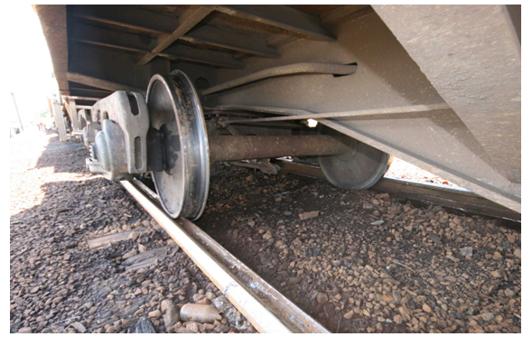

TABLE OF CONTENTS

The Chief Investigator 5

Executive Summary 7

1. Circumstances 9

2. Factual Information 11

2.1 Train crew 11

2.2 The train 12

2.3 Train operations 14

2.4 Infrastructure 15

2.5 Incident site observations 18

2.6 Environment 23

2.7 Track maintenance 24

3. Analysis 27

3.1 The incident 27

3.2 Operation of the train 28

3.3 Loaded condition of wagons 28

3.4 The train route 29

3.5 Infrastructure 29

4. Conclusions 31

4.1 Findings 31

4.2 Contributing factors 31

5. Safety Actions 33

5.1 Safety Actions taken since the event 33

5.2 Recommended Safety Actions 33

The Chief Investigator

The Chief Investigator, Transport Safety is a statutory position under Part 7 of the *Transport Integration Act 2010*. The objective of the position is to seek to improve transport safety by providing for the independent no-blame investigation of transport safety matters consistent with the vision statement and the transport system objectives.

The primary focus of an investigation is to determine what factors caused the incident, rather than apportion blame for the incident, and to identify issues that may require review, monitoring or further consideration. In conducting investigations, the Chief Investigator will apply the principles of ‘just culture’ and use a methodology based on systemic investigation models.

The Chief Investigator is required to report the results of an investigation to the Minister for Public Transport or the Minister for Ports. However, before submitting the results of an investigation to the Minister, the Chief Investigator must consult in accordance with section 85A of the *Transport (Compliance and Miscellaneous) Act 1983*.

The Chief Investigator is not subject to the direction or control of the Minister in performing or exercising his or her functions or powers, but the Minister may direct the Chief Investigator to investigate a transport safety matter.

Executive Summary

A Pacific National freight train carrying containerised steel departed Hastings (Western Port) in the early hours of 9 December 2010, destined for the Melbourne Steel Terminal. Near the end of its journey, seven wagons derailed as the train travelled up the embankment to the Loco Flyover rail bridge in West Melbourne. The derailment occurred near the network management interface between Metro Trains Melbourne (MTM) and V/Line. There were no injuries.

The investigation found that the derailment was the result of the track spreading and the consequent loss-of-gauge[1]. The first wheels to derail dropped inside the right-hand rail. Two possible scenarios for the initiation of the derailment were identified: one in MTM territory at catch point 412D, and the other in V/Line territory on the left-hand curving track ascending towards the flyover.

The investigation found that the track on the embankment to the flyover was not in a condition suitable for the transit of the steel train. In the weeks prior the steel trains had been subject to re-routing, but this was the first and only steel train to run over this section of track in either direction. It was unusual for this type of traffic to be routed via the broad-gauge track on the flyover and it is probable that the additional loads applied by the freight consist were sufficient to cause the track to spread.

The routing of the steel train over the Loco Flyover was the result of operational considerations, influenced by other routes being affected by works and a signal failure. This was not a pre-planned train movement; the decision was made in the hours prior and with the knowledge that the track was unrestricted and authorised to carry such traffic.

The investigation questioned the appropriateness of the track condition monitoring regime, which was based on the classification of the track as a siding by V/Line and MTM; even though, as utilised in this instance, it was available for traffic transiting to terminal destinations. In addition, the derailment occurred adjacent to main lines, including those used by suburban passenger services. While the derailed wagons remained upright, coupled and close to the route of the track, there existed the potential for the wagons to foul these other lines.

Since the event MTM has introduced changes to its track maintenance systems.

Recommendations are made to V/Line and MTM in the areas of track maintenance and communication protocols.

# Circumstances

At around 0300 on 9 December 2010, Pacific National (PN) freight train № 9552 carrying containerised steel departed Long Island Terminal[2], Hastings destined for the Melbourne Steel Terminal for the transfer of freight to standard gauge wagons and further distribution. The train travelled without incident to Southern Cross Station and was routed to proceed to the terminal via the broad-gauge track of the Loco Flyover.

At about 0445 on the flyover embankment in West Melbourne, seven wagons of the train derailed. The derailment occurred near the infrastructure management interface between Metro Trains Melbourne (MTM) and V/Line. About 120 metres of track was severely damaged and the derailed wagons sustained minor damage. There were no injuries to persons.

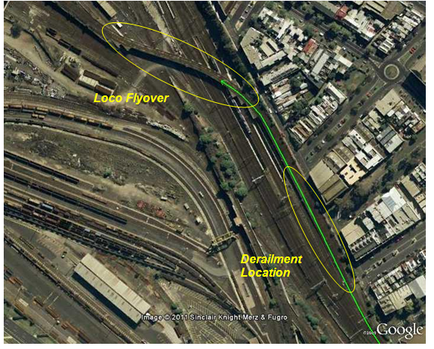

Figure 1 – The train route (shown in green) and the location of the derailment

# Factual Information

## Train crew

### Overview

The train was crewed by a locomotive driver and a trainee driver. Both were qualified for their respective duties and both had been assessed in early 2010 as being medically fit for duty. Following the incident, both crew members underwent an alcohol breath test and no alcohol was detected.

### Locomotive driver report

The locomotive driver reported that he signed on for duty at 2200 on 8 December. He prepared and took PN freight train № 9555 from the Melbourne Steel Terminal to Long Island. His return train was the PN freight train № 9552. The driver reported departing Long Island Junction at 0308 and proceeding to Flinders Street Station without incident. He then departed Flinders Street Station and was routed towards Southern Cross Station via the Northern Viaduct.

The driver commented that he pointed out route features to the trainee driver following departure from Southern Cross Station and on the approach to the flyover. He reported that he applied the brake to check the train speed as the train approached Signal 539, which was displaying a Low Speed Caution indication [permitting a maximum operating speed of 15 km/h]. With the speed reduced to about 5 km/h, the driver released the train brake and then started to increase power as the track gradient rose towards the flyover. The driver reported checking the Hasler speed recorder and that he thought he was travelling at 15 km/h. He also reported being in low power settings as the train travelled on the flyover.

At about this time and while the driver was instructing the trainee on the next signal and its location, the driver “felt the train jerk and run out”. He reported backing off power and coming to a rapid stop and commented that the train did not lose brake pipe pressure. At about 0445 he was contacted by the signaller in the West Tower “about the loud noise and sparks coming from the train”. The driver then reported to the West Tower and V/Line train control that the train had derailed.

When asked why the train was routed towards the flyover, the driver responded that this was “due to demolition of the hump” and, he believed, point failure at South Kensington.

When asked about the train speed, he commented that “as you travel towards Signal 539 the track gradient falls away slightly then rises as you approach the flyover”. He started to apply power to overcome the gradient and commented that he “may have notched up a bit early”.

### Trainee driver report

The trainee driver reported that she also signed on for duty at 2200 on 8 December. She worked alongside the locomotive driver taking train № 9555 to the Long Island Junction and the return train № 9552 to Melbourne.

Her description of the departure from Long Island Junction and travel to Flinders Street Station and then Southern Cross Station was consistent with that of the locomotive driver.

She commented that the route over the flyover was new to her. She confirmed that Home Signal 539 was displaying a Low Speed Caution indication and that after passing this signal and proceeding towards the flyover the locomotive driver started to point out the next signal. Then, at about 0445, the train jerked and came to a stand.

## The train

### Consist

Train № 9552 was comprised of locomotives BL29 and XR551 and 23 freight wagons. Twenty coil wagons (type RKLX) and three flat container wagons (type VQOF) were marshalled as shown at Figure 2. The train had an overall length of 382 metres and a mass of 1754 tonnes.

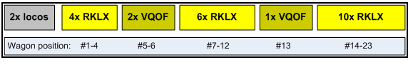

Figure 2 – Train consist

All wagons were loaded with containerised steel. The Train Consist Report indicated that the masses of the 20 RKLX wagons were within a range of 74 to 79 tonnes. The VQOF wagons, at positions 5, 6 and 13 in the consist, were listed as having masses of 79, 78 and 46 tonnes respectively. The reported loaded mass of each wagon was calculated by combining the tare mass of wagons and containers with the mass of steel product loaded on each wagon. Loading records were verified by the investigation and found to be consistent with the Train Consist Report.

For both the RKLX and VQOF wagons, the Pacific National *Wagon Data for Train Operations*[3] indicated potential operation at 80 km/h at 76 tonne gross mass (C19 Speed Category) and 80 tonne (C20 Speed Category).

The V/Line Network Service Plan stated that RKLX and VQOF wagons “may be loaded to 80 tonnes gross [20 tonne axle load] at 80 km/h max speed”. The MTM *Vehicles Authorised to Operate over the Metro Melbourne Leased Network* indicated that RKLX wagons “may load to 80 tonnes gross at 80 km/h max. speed”; however, there is no similar comment for the VQOF. It quoted the nominal mass of VQOF wagons as 18.5 tonnes Tare plus a nominal carrying capacity of 56.5 tonnes, equating to a gross mass of 75 tonnes, at a maximum speed of 80 km/h.

### Locomotive recorders

Locomotive BL29 was fitted with a Hasler type data recorder. The recording indicated that the train slowed to around 14 km/h two minutes prior to the derailment, then the speed slowly increased to a maximum of 18-19 km/h and then reduced to zero. The coarseness of the recording precludes a more detailed assessment of the speed and deceleration. The record of brake pipe pressure suggests that the train had either almost or had already come to a stop before brakes were applied.

The recorder on locomotive XR551 provided additional information on train speed and throttle control over time and over distance. The recording indicated the speed reached a peak of 20 km/h in the minutes prior to the derailment, with throttle either off or in notch 1. About 160 metres and 30 seconds before coming to a stop, the indicated speed began to reduce. Shortly after, the throttle position was increased to notch 2 and then to notch 3. About 90 metres before coming to a stop, the indicated train speed was 17 km/h and the throttle was increased to notch 4. About 40 metres later (50 metres before stopping) and with the speed at 15 km/h, the throttle was increased to notch 5. Shortly after, speed rapidly reduced to zero, with the throttle being placed to notch 6 for a very short period before being reduced to idle.

### Post-incident wagon inspections

Seven consecutive wagons at positions 9 to 15 derailed (see section 2.5.1 for further detail). Inspection of the derailed wagons included couplers, draw gear, bogies and wheels. With one exception, nothing was found to suggest that the wagons might not have been roadworthy prior to the incident. The one exception was the (all around) flattened tip of the flange of the leading left-hand wheel of the leading derailed wagon. It was considered that the flatness, as a shape irregularity, would render the wheel contour condemnable, but it was also considered that the defect would not have given rise to the incident as the working surfaces of the wheel contour were within gauge.

### Wagon maintenance

Ten of the wagons, including three of the derailed wagons, were identified in the Train Consist Report as being due for maintenance in accordance with planned maintenance schedules. None were identified as exceeding the allowable tolerance requiring their removal from service.

## 

## Train operations

### Normal route

Steel trains between Long Island Terminal and the Melbourne Steel Terminal operated daily and normally used a route via the Goods Lines and the Reversing Loop. This route did not incorporate the Loco Flyover.

### Altered route

Commencing on 19 November 2010 and planned to continue until 19 December 2010, the routing of steel trains was altered due to works being undertaken by the South Improvement Alliance and Regional Rail Link Project. Demolition works at the ‘hump’ were directly impacting the normal route. Steel trains operating into and out of the Melbourne Steel Terminal were routed via South Kensington (and ARTC trackage). This planned ‘altered’ route was not via the Loco Flyover.

### Route on this day

At 0028 on the morning of the incident, the V/Line Train Controller for Frankston to Stony Point requested that the signaller at West Tower arrange to route train № 9552 via the flyover because of a defective signal at South Kensington, which had affected the use of the pre-planned ‘altered’ route. West Tower subsequently requested that the Metro Area Controller route train № 9552 via the flyover and this was arranged. Train № 9552 was the first steel train routed over the flyover in either direction. It was not a pre-planned train movement and there was no assessment made by either V/Line or MTM of any additional risks associated with this re-routing.

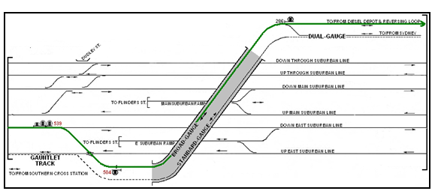

Figure 3 – Schematic of train route, shown in green

## 

## Infrastructure

### Track management

On the embankment to the Loco Flyover, the management of the broad gauge track changes from MTM to V/Line. This interface is marked by a blue painted sleeper near Signal 504.

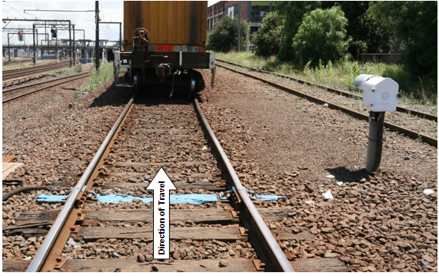

Figure 4 – Looking towards flyover, track management boundary (blue sleeper) and Signal 504

The change of track management at this location is defined within a safety interface agreement between V/Line and MTM, effective from 8 February 2010. The interface at this location is described as being the IRJ (insulated rail joint[4]) between track circuits 412AT and 904T, located at 1.206 km[5]. The agreement stated that all track assets beyond the interface point in the Down[6] direction would be maintained by V/Line and in the Up[7] direction by MTM. The interface agreement addressed interface risk though general discussion on the identification of potential risks to safety and on risk management. It also referred to management of interface risks via Safety Interface meetings. The agreement did not otherwise identify or comment on communication between V/Line and MTM asset management groups.

The Department of Transport had taken the opportunity when refranchising the metropolitan network in 2009 to simplify the interfaces with adjoining network managers by aligning interfaces of track and signalling systems and other infrastructure as applicable. The new interfaces were agreed as of 30 November 2009 and formally documented in the February 2010 interface agreement. Previously interfaces were often different for different assets, leading to inconsistent track maintenance in the management transition zones.

### The Loco Flyover

The Loco Flyover is a rail bridge that carries both a broad-gauge track and a standard-gauge track across a number of suburban lines that run between Southern Cross and North Melbourne Stations. The broad-gauge track on the Loco Flyover is bi-directional[8] and provides access between Southern Cross Station and the South Dynon diesel depot and the Reversing Loop. The broad-gauge track is typically used by light locomotives[9] and empty passenger rolling stock. The standard-gauge track is the ARTC main line to-and-from Sydney (via Sunshine) and Adelaide (via Newport and North Geelong) for passenger services into and out of Southern Cross Station.

West Tower (V/Line) controls the broad-gauge movements into and out of the diesel depot and reversing loop. Up movements from the flyover are controlled by Signal 504. A catch point (412D) is located on the Up side of this signal and protects the suburban line should a train pass Signal 504 at Stop. For trains travelling in the Down direction (from Southern Cross Station towards Dynon), MTM controls movements from MTM territory up onto the flyover embankment via Signal 539, and coordinates with West Tower. Prior to clearing Signal 539 authorising a movement towards V/Line’s territory, MTM obtains a ‘Release’ from West Tower.

### The embankment leading to the Loco Flyover

From the Gauntlet Track (see Figure 3), the track curves to the right to a point about five metres past catch point 412D, beyond which the track transitions to a generally left-handed curve, with segments as detailed at Figure 5.

|  |  |  |  |  |
| --- | --- | --- | --- | --- |
| Segment description | Radius (metres) | Length (metres) | Approx. end point passed Gauntlet Track (metres) | Approx. end point passed the catch point (metres) |
| Right-hand curve | 510 | 26 | 26 | 5 |
| Transition | n/a | 26.3 | 52 | 31 |
| Left-hand curve | 899 | 35.3 | 88 | 67 |
| Transition | n/a | 30.6 | 118 | 97 |
| Straight | n/a | 20 | 138 | 117 |
| Transition | na | 91.1 | 229 | 208 |
| Left-hand curve | 177 | 73.8 | 303 | 282 |

Figure 5 - Track segments form Gauntlet Track towards and onto the Loco Flyover[10]

For the route taken by the steel train, there is a section of descending track before crossing the Gauntlet Track. From the Gauntlet Track towards and onto the Loco Flyover, there is a recorded[11] uphill gradient of between 0 and 0.4 degrees (1:143).

Track was constructed of wooden sleepers supporting 53 kg/m rail through catch point 412D to the rail joint about 18 metres past the toe of the catch point blade. Beyond this point, towards the flyover, the rail was 47 kg/m. In MTM territory through the catch point to the management interface, rails were fastened by flat (shoulder-less) plates and dog spikes, excepting for screw fastened chair plates supporting the catch point blade and for one sleeper past the toe of the blade on the right-hand side. From the interface with V/Line territory to the change of rail weight at the next rail joint, fastening was by lock spiked Pandrol plate fastenings. From the rail joint where the rail transitioned to 47 kg/m, rails were fastened by dog spiked double shoulder plates. On the flyover proper and beyond the derailment area, rail was attached using screw bolted Pandrol plate fastenings.

Following the derailment, the track was repaired in V/Line territory using low profile concrete sleepers with Pandrol fastenings. In MTM territory, fastening through the catch point and to the management interface was replaced with Pandrol plate fastenings screw bolted to the timber sleepers.

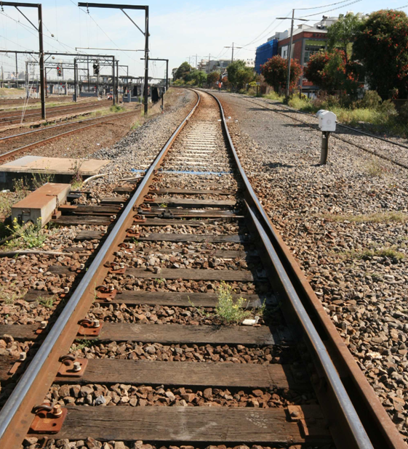

Figure 6 - The track (after being rebuilt), from catch point to Loco Flyover

## Incident site observations

### Overview

Seven wagons had derailed at positions 9 to 15 in the mid-portion of the train consist. All had remained coupled and upright. From the leading locomotive to the first derailed wagon was about 158 metres; the seven derailed wagons totalled about 104 metres in length and there were a further eight wagons (119 metres) on the track behind the derailed wagons.

The rear-most derailed wheel was the trailing right-hand wheel of wagon RKLX308M, which was about 13 metres beyond the toe of the point blade of catch point 412D. Both right-hand wheels of the trailing bogie had dropped in on the gauge side[12] of the right-hand rail. The wheels of this wagon’s leading bogie had dropped in on the gauge side of the left-hand rail.

Beyond this, all right-hand wheels of the other six derailed wagons had dropped to the inside of the right-hand rail. Most of the left-hand wheels had also derailed, with some inside the left-hand rail, some outside the rail, and others resting on the web of the left-hand rail, which was rolled outward from (forward of) about the mid-length of wagon RKLX375S.

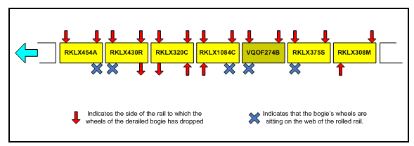

Figure 7 - Position of derailed wheels relative to right-hand and left-hand rails

### Track spread and associated indicators

Measured track gauge progressively widened from catch point 412D to the rear most derailed wagon. In the static, post-incident condition with the derailed wagons still on track, the measured gauge was around 40 mm wide on the Down side of the toe of the catch point blade, about 45 mm wide at the management interface and about 90 mm wide at the first derailed wheels.

Between the catch point and the rear-most derailed wagon there was evidence of the right-hand rail moving laterally outward, including fresh splintering of sleepers at the outside edge of base plates.

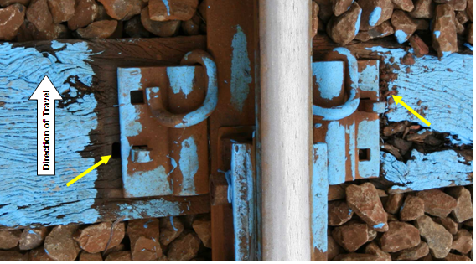

Figure 8 - The right-hand rail with the elongated spike hole and fresh timber splintering

On the left-hand rail, fastenings had been lifted indicating that there had been outward rotation of this rail at some time during the derailment.

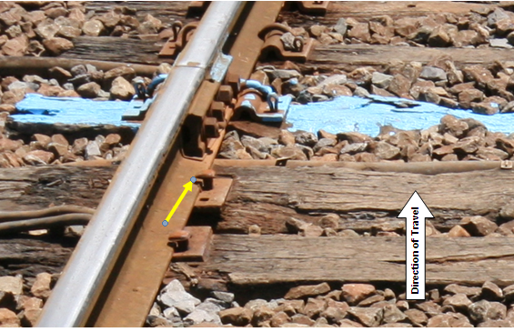

Figure 9 - Left-hand rail with lifted fastenings

From the rear-most derailed bogie, track damage was progressively more severe towards the front of the train. The first break in the left-hand rail was a separated fishplated joint at the transition from 53 to 47 kg/m rail, about 5 metres forward of the trailing axle of RKLX308M. The first break in the right-hand rail was a separated joint about a further 15 metres forward, between bogies on wagon RKLX375S. Opposite this break, the left-hand rail was rolled outward, this being about 33 metres on the Down side of the catch point (see Figure 13).

At leading derailed wagon RKLX454A, all right-hand wheels had dropped inside the gauge and the left-hand wheels of the rear bogie were riding on the outwardly rolled left-hand rail.

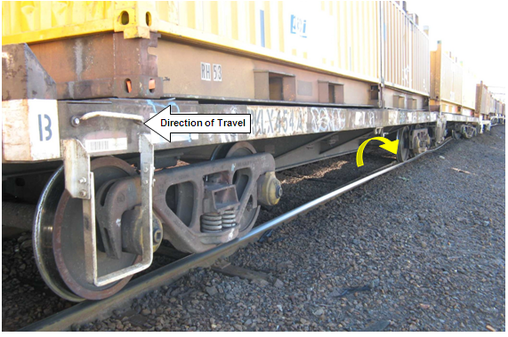

Figure 10 – The left-hand side of leading derailed wagon RKLX454A

### Derailment marks

The derailment marks furthest behind the rear-most derailed wagon were those on and near the toe of the blade of catch point 412D. The marks were consistent with a wheel running off the rail head at the end of the point blade before striking the foot of the right-hand rail. For the next 11 metres there were marks on the rail foot and rail fasteners consistent with a single wheel being derailed.

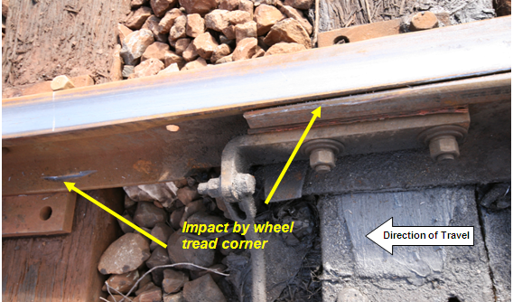

Figure 11 - Wheel derailment near catch point with tread corner mark on foot of the right-hand rail

About 11.2 and then 11.7 metres beyond the point blade and prior to the rear-most derailed wheel, rail head marks indicated two other wheels had dropped onto the gauge side of the right-hand rail. Around this same area there were marks on the rail foot consistent with three wheels being derailed. Beyond the trailing derailed axle, there were multiple marks on the foot of the right-hand rail indicating that at least five wheels had been derailed at this location.

About three metres beyond the rear-most derailed wheel, there were two marks on the left-hand rail head consistent with wheels dropping in on the gauge side of the left-hand rail. Indications on site were that these marks were probably made by the left-hand wheels of the leading bogie of RKLX308M. About nine metres forward of the trailing derailed axle there were two tread corner marks on the right-hand rail indicating wheels had dropped inside the rail at this location. Further forward the rails were disturbed making identification of individual derailment marks inconclusive.

### Track condition

The condition of the sleepers and ballast varied throughout the section. Proceeding up the embankment towards the flyover, ballast and support structures deteriorated with increasing fouling of ballast in the V/Line territory. Neither V/Line nor MTM could provide a history of sleeper age and replacement.

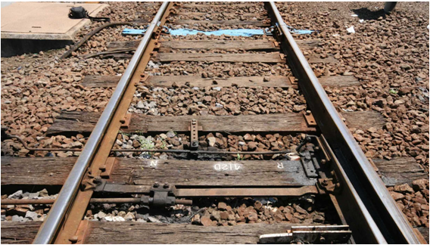

Figure 12 - Track and ballast condition on the Up side of the track management interface

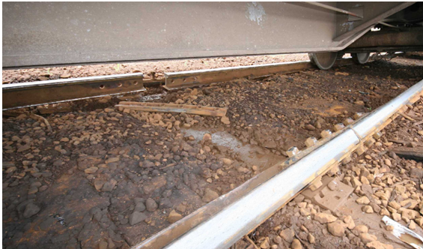

Figure 13 - Fouled track 30-35 metres beyond the track management interface

### KRAB trolley measurements

Following the incident, MTM utilised a lightweight KRAB[13] trolley to measure the track geometry in the section leading up to the derailment location. Measured parameters included gauge, alignment, top, cant and twist; however, alignment, top and cant were not recorded for about the final 15 metres (up to the trailing derailed wagon) because of the way the measuring equipment processes data.

For the 50 metres on the Up side of the catch point, no geometric parameters exceeded limits requiring urgent action. There was one gauge measurement of 24 mm wide about 40 metres before the interface boundary.

From the catch point towards the trailing derailed wagon, measured track gauge increased. The KRAB measured a gauge of 36 mm wide at about the toe of the catch point blade, and 40 mm wide at the blue sleeper.

## Environment

At the time of the incident, the temperature was about 15 degrees Celsius and wind conditions were calm. There had been about 29 mm of rainfall since 0900 the previous day.

The recorded Melbourne rainfall for the six calendar months prior to the derailment is shown in Figure 14.

|  |  |  |  |  |  |  |
| --- | --- | --- | --- | --- | --- | --- |
| **Month in 2010** | **Jun** | **Jul** | **Aug** | **Sep** | **Oct** | **Nov** |
| **Actual rainfall (mm)** | 63.4 | 30.8 | 68.2 | 53.0 | 144.8 | 115.2 |
| **Statistical mean** | 49.1 | 47.6 | 50.2 | 58.0 | 66.4 | 60.1 |

Figure 14 - Rainfall in Melbourne for the six months prior to the derailment

## Track maintenance

### Management of track

Both V/Line and MTM consider this section of track to be a siding for maintenance purposes. A siding is defined as a section of railway track connected by points to a running line or another siding on which rolling stock can be placed clear of the running line, and normally used for purposes such as stabling, loading, rolling stock maintenance or passing of trains[14].

### V/Line

The V/Line standard for preventative maintenance inspection of Melbourne yard sidings, including the flyover, specified a requirement for inspections by foot every two months. However, for this particular section of track, the track supervisor was also having the track inspected at the same frequency (weekly) as the Main Goods lines. V/Line uses Maximo Asset Management software to program and record work.

V/Line standards for siding track geometry specified a wide gauge limit of 30 mm as the Sub-Level A exceedence level and 20 mm as the Sub-Level B exceedence level. Sub-Level A is a priority exceedence and faults at this level are required to receive prompt attention. Sub-Level B is the general maintenance exceedence and is used to programme general track maintenance. The standard also specified an absolute gauge limit of 38 mm above which trains were not permitted to operate.

V/Line advised that the most recent inspection of this section of track prior to the incident was on 1 December 2010. On that day the entire flyover track under V/Line responsibility was checked for wide gauge, cant and twist and places where gauge was more than 20 mm wide were identified for repair. V/Line reported that on 4 December the repairs were carried out. Work orders indicated that all gauge more than 20mm wide were repaired, excepting one of 24 mm at the 1.248 km position, which is shown as being reassessed.

### MTM

The MTM track maintenance standard specified that all sidings with timber sleepers be inspected at least once every month. General inspections of sidings by foot were required: monthly by a Track Inspector; three monthly by a Track Ganger; and six monthly by the Track Foreman. MTM procedures provided guidance on inspection of track, including sleeper and fastener condition, and included a Track Inspector’s checklist for track fault identification. Inspections were visual and supported by manual measurement as required.

Track Inspector reporting was by exception, with instances below unacceptable maintenance standards to be recorded and submitted weekly. The investigation was advised that weekly reports included recording of faults and their prioritisation in accordance with the MTM Track Geometry Standard. For track limited to a train speed of 15 km/h, as this section was, this standard specified[15] wide gauge of 30 mm and over as an A Fault, and 23 mm and over as a B Fault. An A Fault required prioritised corrective action and a B Fault required monitoring as part of routine track inspection and consideration when planning maintenance programs.

The maintenance crew responsible for this section of track reported that they had inspected the area three days before the incident and that in their view there had been no need to do any works. They reported that three to four months prior they had replaced dog spikes in the area, although the works had not been documented. Wide gauge of 10 mm had been measured, but the rest of the track was “OK”.

When questioned about claims by V/Line staff that an area of 30 mm wide gauge had been reported to MTM, both of the MTM maintenance staff said they had no knowledge of being told of this situation by V/Line. One of the workers stated that if there had been anything close to 30 mm (wide gauge) it would be high priority to rectify.

### Track recording car

Because both V/Line and MTM treated this section of track as a siding for maintenance purposes, neither had a requirement to utilise track recording car data to monitor the condition of the broad gauge track on the Loco Flyover and its embankment. However, the EM100 track recording car had conducted two recent surveys of the track, one in July 2010 and one in November 2010. In both cases the referencing of the measured data to the actual track location was imprecise.

On 4 July 2010, the EM100 surveyed the flyover and reversing loop. The recorded data indicated a wide gauge of 31mm in the area of the derailment, although its position was not explicitly recorded. In reviewing the data and with consideration of approximate measurement location markers, it was ascertained that this wide gauge was probably in the vicinity of the catch point.

More recent measurements were taken on the 21 November 2010 but were limited to the flyover area. A wide gauge of 34 mm was identified although attempts to locate the defect using similar assumptions to the July data were inconclusive. However, a review of the data comparing graphical output suggested that the 34 mm wide gauge was probably coincident with the 31 mm wide gauge identified in July.

# Analysis

## The incident

### Derailment mechanism

The derailment was the result of the track spreading and losing gauge. The incident site evidence including the derailed position of wheels is consistent with the left-hand rail having initially spread allowing right-hand wheels to drop inside the right-hand rail.

### Possible derailment scenarios

The investigation considers two scenarios to be plausible:

*Scenario 1*

The first possibility, supported by the pre-existence of wide gauge in the vicinity of the catch point, is that the track spread in an orthodox manner with the leading right-hand wheel of a bogie (potentially leading wagon RKLX454A) derailing to the inside of the rail at the toe of the blade of catch point 412D as the bogie traversed the right-hand curve. With the left-hand leading wheel bearing on the left-hand rail, the loading of this rail would likely be exacerbated by the tendency of the mid-portion of the consist to pull to the left as the leading end transited the left-hand curve towards the flyover.

The wheels and wagons following the first derailed bogie would have derailed as the track continued to spread and the rails were disturbed. In such a scenario, and assuming no forward spreading of the derailment, the train would have been derailed for around 115 metres before coming to a stand.

*Scenario 2*

The second possibility is that the track initially spread some distance beyond the catch point as a result of the consist loading the inside of the left-hand curve towards the flyover. The potential for this action would have been created by the locomotives proceeding under power up the ascending grade, the wagons trailing through the shallow reverse curve[16], and the train in a predominantly draft condition. In this type of loading scenario, the lateral forces on the inside of a curve typically occur mid-consist, which is consistent with the outcome in this case; that is, the derailment of wagons 9 to 15 (of 23).

In such a scenario, once gauge was lost it would have been necessary for the derailment to have spread back along the track (and possibly forward). The site evidence suggests that any such spreading would have involved lateral spreading of the right-hand rail and outward rotation of the left-hand rail. In this scenario, the derailment of a single wheel at the catch point would have occurred late in the derailment sequence.

### Implications of the train consist

For either scenario, the investigation has concluded that the freight consist applied additional and unusual loading to the track on the embankment to the flyover. The steel trains had been subject to re-routing because of works and infrastructure failure, but this was the first and only steel train to run over this section of track in either direction.

This track had regularly accommodated a mix of traffic but the traffic was limited to locomotives without wagons or empty passenger rolling stock. What was unusual in this case was the passage of a loaded freight train and the resultant additional loads associated with the consist.

### Proximity of derailment to main line services

While the derailment remained contained in this instance, there existed the potential to foul adjacent mainline tracks, including those served by suburban passenger trains.

## Operation of the train

Shortly before the derailment, the train reached a maximum speed 3-5 km/h over the designated speed. However, prior to the derailment and as the train proceeded up the embankment to the flyover, the speed began to reduce. The extent to which the speed of the train reduced before the first wheel derailed is not known with certainty, but the speed was probably no more than 18 km/h and may have been close to the designated speed of 15 km/h, depending on when the first wagon derailed as the train climbed the embankment.

Notwithstanding the exceedence of the designated speed, the action of the locomotive driver to increase power as the train ascended towards the flyover is otherwise considered consistent with normal train operation. However, the train was still under power 50 metres before the train came to a stop and it is probable that power continued to be applied, and potentially increased, after the first wagon had derailed. It is also probable that, initially, the locomotive driver did not distinguish between the power required to overcome the gradient and that to overcome derailed wagons.

## Loaded condition of wagons

The loaded condition of all derailed wagons was within the mass limits specified by the network managers and accordingly the loading of the wagons was not considered contributory to the derailment.

Two of the VQOF wagons (that did not derail) exceeded the nominal mass specified by MTM by a small margin but were compliant with V/Line requirements. While not considered contributory to the incident, this is an unwarranted inconsistency in requirements between the abutting networks.

## 

## The train route

Due to works preventing the use of the normal route taken by the steel train, an altered train route via South Kensington had been used for about three weeks prior (since 19 November). However, a signal failure had affected this planned route and it was decided to route this train via the Loco Flyover.

While the flyover is predominantly used for light locomotives and empty passenger rolling stock, there is no requirement for signallers to limit the type of traffic on the route. The decision to route the train over the flyover was therefore consistent with the class and availability of the track. However, in this instance the track was incapable of accommodating the transit of the steel train.

## Infrastructure

### Condition

Given the failure of the track infrastructure in the absence of other contributing factors, the investigation has concluded that the track was not in a condition suitable for the transit of a loaded freight train, and specifically the steel train.

### Maintenance

*V/Line*

The frequency of V/line maintenance inspection was consistent with or exceeded V/Line procedures for a siding and maintenance staff had undertaken remedial works in the week before the derailment. The investigation concluded that it was unlikely that there was any pre-existing geometric defect requiring urgent attention.

The second incident scenario represents a type of derailment which could result from degraded fastening but may not present as a pre-existing geometric defect. Given the heavily fouled condition of the track, it is plausible that inspection may not have identified a deterioration of rail fastening.

*MTM*

Maintenance inspection had taken place three days before the incident and the maintenance crew reported that there had been no need to do any works. However, the investigation concluded that there probably existed a wide gauge defect of around 34 mm in the vicinity of catch point 412D, which would have exceeded the MTM A Fault requiring prioritised corrective action. This indicates the existence of deficiencies in inspection practices.

The most recent remedial maintenance taken by MTM was not documented and there was no apparent method of tracking maintenance works except by exception for significant defects. This indicates a deficiency in the tracking of maintenance activities.

*Treatment as a siding*

For the purposes of track condition monitoring and maintenance, the section of broad-gauge track from the Gauntlet Track towards and over the Loco Flyover is considered by V/Line and MTM to be a siding. Given its availability for general traffic proceeding to terminal locations (the Melbourne Steel Terminal) and its proximity to other main line traffic including that on the adjacent ARTC standard-gauge and the suburban network, the investigation questions whether the track should continue to be regarded as a siding.

# Conclusions

## Findings

1. There were no special traffic restrictions applicable to the Loco Flyover and it was available for freight traffic including the steel train.
2. The routing of the steel train via the Loco Flyover was unusual.
3. Shortly before the derailment, the train reached a maximum speed 3-5 km/h over the maximum permitted speed of 15 km/h.
4. There was a wide gauge defect in the vicinity of catch point 412D.

## Contributing factors

1. The track was not fit-for-purpose.
2. Track conditioning monitoring was not commensurate with the type of train permitted to operate on the track.

# Safety Actions

## Safety Actions taken since the event

### Metro Trains Melbourne (MTM)

MTM has advised that since the event a number of changes have been made to its track maintenance systems, including:

The review and updating of the asset register including improved tracking of identified defects and their repair

The restructuring of the maintenance team to give a more robust governance around defect management

Enhanced training of maintenance employees

Enhancement of the GPS capabilities of the EM-100 Track Recording Car.

## Recommended Safety Actions

Issue 1

Maintenance inspection on this section of track did not identify its vulnerability to the passage of a loaded freight train, which was an unusual but a permitted train movement for this section. In the case of MTM, a specific gauge defect requiring prioritised corrective action was not detected.

In addition, given the operational availability of this track and risks associated with its proximity to main line traffic, it is questioned whether the track should continue to be regarded as a siding.

RSA 2012002

That V/Line and Metro Trains Melbourne review their track maintenance policy and practices as applied to the Loco Flyover and its approach track.

Issue 2

Even though the track management interface between V/Line and MTM is supported by an interface agreement, there was not proactive and documented communication between V/Line and MTM to discuss any interface issues, including the identification of any infrastructure issues under the others jurisdiction. Following the incident there was also conflicting reports of communications between the parties.

RSA 2012003

That V/Line and Metro Trains Melbourne review communication protocols associated with maintenance at and near infrastructure interfaces.

1. In this instance wide gauge, when the rails spread apart and/or roll outwards.
2. Servicing the BlueScope steel mill
3. Document version number WDO_34 dated 3 March 2010
4. Separates electrical track circuits
5. Kilometres from Melbourne (Southern Cross Station)
6. Away from Melbourne
7. Towards Melbourne
8. Trains can travel in either direction
9. Without wagons
10. From PASS Assets XFC (the database for state wide train and tram fixed infrastructure)
11. From PASS Assets XFC
12. To the inside of the rail, dropping between the rails
13. A device for measuring track geometry, manufactured by KZV s.r.o., Prague
14. Rail Industry Safety and Standards Board *Glossary of Rail Terminology Volume 1, 2010*
15. Standard MTMI 3.01 indicates the potential for using higher limits for curves, but only with the approval of the Track Manager.
16. Where a curve in one direction is followed by a curve in the opposite direction.