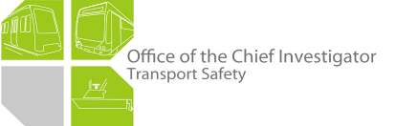

Rail Safety Investigation

Report No 2011/11

Signal passed at danger

V/Line Passenger Train 8415

Flinders Street Station

30 November 2011

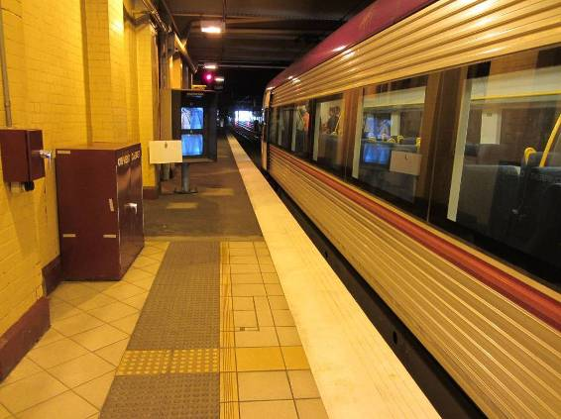

TABLE OF CONTENTS

The Chief Investigator 5

Executive Summary 7

1. Circumstances 9

2. Factual Information 11

2.1 The driver 11

2.2 The train 12

2.3 Infrastructure 12

2.4 Operations 15

2.5 Recorded information 16

2.6 Communications 17

2.7 Safety management systems 18

2.8 Signal Passed at Danger risk controls 19

3. Analysis 21

3.1 The incident 21

3.2 Operation of the train 21

3.3 Infrastructure 22

3.4 Network operations 23

4. Conclusions 25

4.1 Findings 25

4.2 Contributing factors 25

5. Safety Actions 27

5.1 Recommended Safety Actions 27

The Chief Investigator

The Chief Investigator, Transport Safety is a statutory position under Part 7 of the *Transport Integration Act 2010*. The objective of the position is to seek to improve transport safety by providing for the independent no-blame investigation of transport safety matters consistent with the vision statement and the transport system objectives.

The primary focus of an investigation is to determine what factors caused the incident, rather than apportion blame for the incident, and to identify issues that may require review, monitoring or further consideration.

The Chief Investigator is required to report the results of an investigation to the Minister for Public Transport or the Minister for Ports. However, before submitting the results of an investigation to the Minister, the Chief Investigator must consult in accordance with section 85A of the *Transport (Compliance and Miscellaneous) Act 1983*.

The Chief Investigator is not subject to the direction or control of the Minister in performing or exercising his or her functions or powers, but the Minister may direct the Chief Investigator to investigate a transport safety matter.

Executive Summary

On 30 November 2011, a V/Line passenger train departed Flinders Street Station passing a controlling signal that was displaying a Stop indication. After travelling about 340 metres the driver realised that the train was not proceeding along the correct route and made an Emergency brake application, bringing the train to a stand within a further 40 metres. There was no damage to track, signalling infrastructure or the vehicles involved and there was no injury to passengers or crew. Suburban train services were disrupted for about one hour.

The investigation found that the view of the signal indication from the operating cab of a six-car VLocity train when stopped at the platform was severely compromised by the characteristics of the signal lamps, the sighting focus of the signal heads, and the detrimental spill-over effect from security lighting. The investigation concluded that the compromised sighting of the signal contributed to the driver losing awareness of the signal and departing against the Stop indication.

The investigation also found that the absence of a signal engineering intervention for V/Line rolling stock allowed the unauthorised movement to travel 380 metres before being brought to a stand.

Although aware of the incident as it unfolded, the Metrol[1] area controller was unable to communicate with the train driver due to the limited radio system available for communications with non-suburban services in the area. The driver’s attempt to report the incident using the local radio system was also unsuccessful due to poor radio coverage. The driver and Metrol were subsequently able to communicate using the mobile phone network.

The investigation makes a recommendation to Metro Trains Melbourne to review the adequacy of the signal configuration at the incident site. Recommendations are also made to Metro Trains Melbourne and V/Line in the areas of signal sighting from V/Line stopping positions, the risk management of changes to operational conditions and communication between V/Line trains and the metropolitan network control.

# Circumstances

On 30 November 2011 V/Line train 8415, the 1225 Melbourne (Southern Cross) to Traralgon passenger service, was routed into Platform 9 at Flinders Street Station. This service was usually accommodated at Flinders Street on Platform 8. However, on this occasion train 8415 had departed late from Southern Cross Station and Platform 8 was occupied by a Frankston suburban service.

At 1249, after receiving the Conductor’s radio message that ‘station work was complete’, the driver of train 8415 departed from Platform 9, passing Down[2] Home signal 756 while it was displaying a Stop indication. The driver reported that when he realised the train was travelling on the Up Special instead of the Down Special line he immediately brought it to a stand−about 380 metres beyond signal 756.

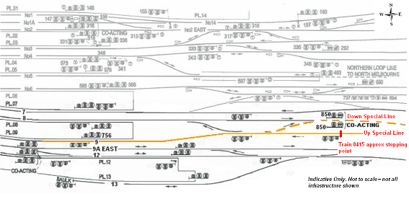

Figure 1: Solid orange line indicates path taken by train 8415 from Platform 9 onto the Up Special line. Dotted line indicates intended route to the Down Special line

There were no opposing movements on the Up Special line. No injury occurred to passengers or train crew and there was no damage to the train or infrastructure.

Several Frankston suburban services were required to use alternative platforms at Flinders Street Station until the incident train was recovered and returned to Southern Cross Station.

# Factual Information

## The driver

The driver had been qualified for 22 years. He had been employed on the suburban system as both a Driver and Instructor Driver prior to returning to V/Line. His medical assessment was current and a safety audit had been conducted on 1 September 2011 with no recorded adverse comments or remedial actions required. This was the first occasion that the driver had been involved in a SPAD event.

The driver’s roster for the previous fourteen days was analysed using both FAID and FAST instruments[3] and the results indicated that the driver should not have been fatigued. His previous day off duty was two days prior to the incident. On the day of the incident he commenced duty at 1210 and was due to complete an eight-hour shift at 2010. The incident occurred about 50 minutes into the shift.

At interview the driver reported that he signed on to relieve and run the 1235 Traralgon service scheduled to depart from Platform 8 at Southern Cross Station and that the service arriving to form his train to Traralgon was running about 12 minutes late into Southern Cross Station. After relieving the incoming driver he departed Southern Cross Station towards Flinders Street Station where the train was routed into Platform 9. The driver indicated that the train was brought to a stand with the driving cab beyond the MTM platform monitors[4] to ensure the rear passenger door of his train would be on the platform (a passenger safety consideration).

He reported that after receiving the conductor’s radio message that ‘station work was complete’ he looked ahead, saw a ‘bottom green’[5], and departed the train. Upon reaching the crossover providing access to the Down Special line he observed that the points were set straight ahead onto the Up Special Line. The driver’s immediate reaction was to make an Emergency brake application. At this stage he believed that Metrol had wrong-routed the train. After coming to a stand he made an emergency call over the local radio system that went unanswered. However, Metrol was able to contact him on this frequency and informed him that he had passed signal 756 at Stop and provided him with a contact telephone number. Apart from this initial radio transmission, which was corrupted with interference, all other communication with Metrol and the driver’s supervisors was by mobile phone.

The driver reported that Metrol requested that the train be driven back to Flinders Street Station, however V/Line required a relief driver to be provided before the train was moved. The driver remained in his cab (now the rear cab) as the relief driver ran the train back into Platform 9. When it was brought to a stand the rear cab was close to where he had initially stopped on the outbound journey. He noted that signal 756 was partially obscured and difficult to sight from the driving position.

With regard to the departure from Flinders Street Station Platform 9, the driver reported that he was not distracted by any external influences; nor was he using the radio or telephone during the station stop. He also stated that he was not preoccupied with any domestic or other issues. He believed he was well rested and not under schedule pressure from the late running of the train.

## The train

### General description

VLocity Diesel Multiple Units (DMUs) consist of two and three-car sets of which combinations of up to seven cars can be coupled together. Each driving cab is fitted with two seats with the driving position located slightly left-of-centre. The driving console is a desk-type with the instrument dash panel below window height, permitting an unrestricted view ahead. Driver alertness is monitored by a task-activated vigilance system.

### Train 8415

On 30 November 2011, train 8415 consisted of two three-car sets—VL35 and VL36—with a seating capacity of 444. This consist was 150.4 metres long and weighed 342 tonnes.

## Infrastructure

### Platform 9

Platform 9 at Flinders Street Station is 204 metres long on a slight convex curve and is signalled for bi-directional running. The distance between Home signal 756 and the stopping mark for a six-car suburban train is 17.9 metres. An array of platform monitors, providing Down suburban train drivers with views towards the rear of their train, is located ahead of this stopping mark.



Figure 2: Diagram showing dimensions relevant to the incident

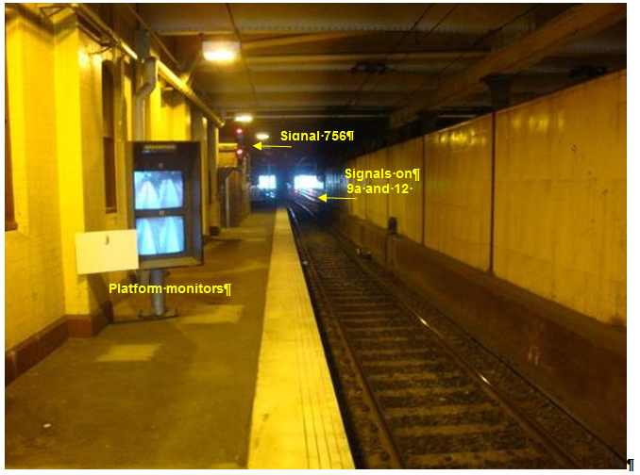

Figure 3: East end of Platform 9 showing platform monitors, signal 756 and other signals in the distance on tracks 9a and 12

The east end of Platform 9 is covered by Swanston Street and Federation Square, requiring the use of security lighting in the general area of signal 756 and towards the east end of the platform. This lighting has a detrimental spill-over effect on the visibility of signal 756.

Tracks 9a and 12 are adjacent to track 9. There is a solid bridge support beneath Swanston Street[6] between Platform 9 and track 9a East that extends eastward to a point opposite the east end of Platform 9. When looking eastward along Platform 9 the signals applicable to eastward (Down) movements along tracks 9a East and 12—which are fitted with LED heads—are clearly visible to a driver when stationary at signal 756 on track 9.

MTM prohibits X’Trapolis trains from using Platform 9—and several other platforms at Flinders Street—due to difficulties around signal sighting[7] from the cabs of six-car X’Trapolis trains.

### Signal 756

Signal 756 is a three-position Home signal designed to display Medium and Low-Speed indications[8] and is located to the left of the track about 1.5 metres in from the platform edge. The signal lamps are incandescent (10 volt, 3.5 watt).

The signal heads were focused to provide optimum visibility to the drivers of stopping MTM suburban services and regional through (non-stopping) services. The positioning of the signal heads[9] favoured sighting for approaching trains when they were about half way along Platform 9 about 120 metres from the signal. However, visibility of the signal display reduced significantly from this point on, until approximately the suburban six-car train stopping mark where again—from the driver’s cab of an MTM suburban train—the signal display could be easily viewed.

A Train-Stop (see section 2.8.3) is fitted to this signal and provides an intervention for MTM suburban trains should they pass the signal at Stop. The Train-Stop does not interface with a non-suburban train passing this signal at Stop.

There was no record of any previous SPADs occurring at this signal prior to this incident.

**Signal-sighting tests**

On Thursday 15 December 2011, sighting tests of signal 756 were conducted utilising a six car VLocity train. Observations were recorded from the driving position while moving along Platform 9 and at various stopping points near signal 756. With the driver’s cab positioned at the six-car suburban train stopping mark the view of the signal 756 display was good, however the rear passenger door of the train was not on the platform.

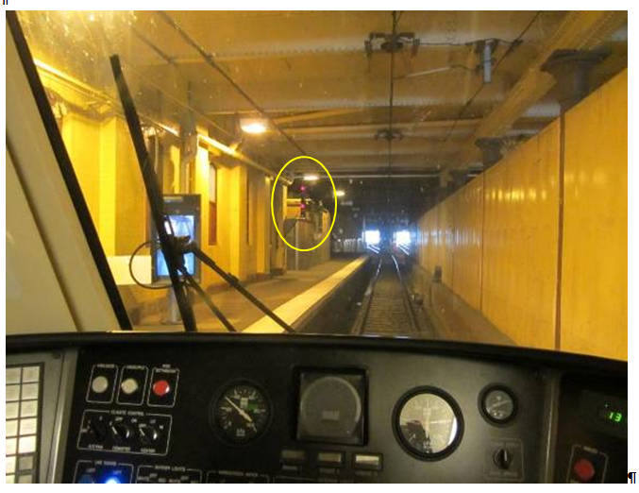

Figure 4: View of signal 756 from the VLocity driver’s cab at the six-car suburban stopping mark

With the driver’s cab of a VLocity train positioned forward of the platform monitors—as was the case with train 8415 on 30 November 2011—the sighting of any signal aspect from the driving position was severely restricted (Figure 5). The Signal Sighting Working Committee representatives conducting this review identified that the sighting of signal 756 would be significantly improved by conversion from incandescent lamps to wide spread (medium range) light-emitting diode (LED) lamps.

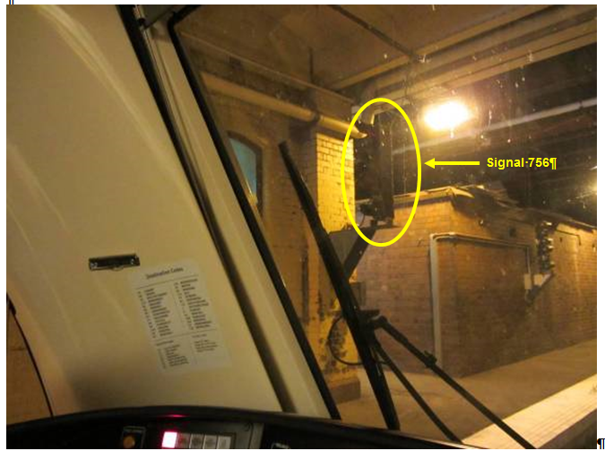

Figure 5: Driver’s line-of-sight view from a VLocity cab to signal 756 at the approximate stopping location of train 8415

## Operations

### Overview

Trains operating on the Melbourne suburban network are controlled by MTM from Metrol. For Flinders Street Station, the area controller has a control panel and VDU monitors that show, amongst other information, the status of points and signals and the movement of trains (Figure 6).

Metrol has the ability to communicate by radio directly with MTM services. However, apart from limited local radio system access within the inner metropolitan area, Metrol cannot communicate directly with non-MTM services. It is possible for Metrol to establish radio communications with non-MTM services via a phone ‘patch’ facility provided at the V/Line control centre. MTM and V/Line train and locomotive drivers are supplied with company mobile phones to supplement the radio communications systems.

All desk phone lines and radio transmissions through Metrol are recorded.

### Train 8415

It is general practice for area controllers to give priority to trains running to schedule. In this incident train 8415 was about 12 minutes late and therefore off its scheduled path into Flinders Street. This, together with suburban service delays, resulted in train 8415 being routed into Platform 9 instead of Platform 8 as scheduled.

Train 8415 was held at Platform 9 due to a Down suburban Frankston service that was departing from Platform 8. The Metrol controller having set and cleared the route for this service, pre-selected the route[10] for train 8415 to follow along the Down Special line once the suburban train had cleared the applicable track sections.

### Area controller

The area controller, who was providing practical instruction to another controller in the operation of the signalling control panel, observed on the system display monitor that train 8415 had departed Platform 9 while the suburban train on Platform 8 had a signal to proceed towards the Down Special line. The area controller reported that they attempted to contact the driver of train 8415 without success. However, the Metrol radio operator was able to make contact with the driver on the local radio channel 1 and provided him with a phone number for further communications. The senior area controller was advised of the situation and the driver was informed not to move the train until a relief driver was provided.

## Recorded information

### Train data logger

VLocity DMUs are equipped with a logger that records data about the train’s operation. An analysis of the logger identified that train 8415 remained stationary at Flinders Street Station for 42 seconds before restarting at 1248:41 and that it travelled for 338 metres, reaching a maximum speed of 38 km/h before the brake was applied in Emergency. Train 8415 came to a stand 40 metres after the initiation of the Emergency brake application.

### Metrol signal logging

The Metrol Signal Logging system ‘Log and Playback’ confirmed that train 8415 at Platform 9 Flinders Street passed signal 756 at Stop and that the track section beyond this signal was occupied at 1248:52. At this time the route was set with the Home signal cleared for a Down suburban train to depart Platform 8. The signals for tracks 9A and 12 were at Stop and signal 850, about 350 metres ahead on the Down special line, was at Proceed (Green-over-Red).

There was no opposing traffic to train 8415 on the Up Special Line between Richmond Junction and Flinders Street.

Figure 6: Signal logging system snapshot at time of incident. V/Line train 8415 at Platform 9 has passed signal 756 and is heading towards the Up Special line. MTM train 4417 is at Platform 8 and is cleared to proceed on the Down Special line

## Communications

### General

V/Line locomotives and DMUs are fitted with a train-to-base radio system to communicate directly with Centrol, the V/Line train control centre. Direct train-to-base radio communication with Metrol is not available; however, communication can be established with Metrol via a telephone patch at Centrol. When questioned on the use of this facility both Metrol and Centrol personnel indicated that this feature was rarely used.

V/Line drivers are provided with company mobile phones and when operating on the MTM network a custom and practice has developed where the mobile phone is utilised for communication with Metrol in lieu of the radio network.

Neither company could provide the investigation with an interface co-ordination plan or agreement that stipulated communication protocols between the two organisations. However, V/Line document *OPPR-195 Trains Stopped Due to Abnormal Running Conditions* states in part:

‘If for any reason, a train service is required to stop whilst in running due to a collision or an abnormal operating condition, the driver must advise Centrol (or the ARTC network control if the train is on the ARTC network) the nature of the incident, time and location. If the train is able to proceed following resolution of the incident/fault, the train driver must seek authority from the Network Controller at Centrol (or via network control if the train is on the ARTC network) prior to proceeding’.

The driver on train 8415 did not initiate or receive any communication with Centrol during this incident. The investigation was informed that procedure *OPPR-195* was available on the company’s intranet however it was not included in the training curriculum for drivers.

V/Line trains are also equipped with a local radio system that enables direct communication between other regional services and some MTM signal boxes. Metrol also has access to this local radio system however the coverage is limited to within the immediate inner metropolitan area bordered by Richmond and North Melbourne.

Conversations on the Metrol radio and telephone land lines are recorded. These records were interrogated and confirmed the transmission of outgoing local radio messages from Metrol to the driver of train 8415. However, the system did not record any of the transmissions from the driver to Metrol.

### Future network radio communications project

Radio communications is one of the most critical components of train operations. Inquiries into major incidents such as Glenbrook, NSW (December 1999), Hexham, NSW (July 2002), Waterfall, NSW (January 2003), and Chiltern, Victoria (March 2003) all identified the need to establish effective train communications.

The existing Non-Urban Train Radio System (NUTRS) employed on the regional network is approaching the end of its maintainable life, and the need to upgrade has become apparent. In recognition of this, a project has commenced to replace it. In addition to the NUTRS renewal project, the metropolitan radio network is undergoing a replacement program to upgrade the current system to a GSM-R network. The MTM train fleet fitment to accommodate the upgraded system is expected to be completed in 2013. However, the completion of the V/Line communications upgrade project is not expected until 2017.

## Safety management systems

### Overview

Metro Trains Melbourne manages the Melbourne metropolitan network and provides access to other Accredited Rail Operators (AROs) such as V/Line Pty Ltd.

As AROs, MTM and V/Line are each required to maintain a Safety Management System that provides, among other things, for hazard identification and risk management in accordance with their statutory obligations. Both organisations operate single-person trains[11] over the metropolitan network however the risk mitigations and defences against SPADs for each company differ.

### MTM

An MTM Risk Register extract provided to the investigation identified the following hazard: ‘...a SPAD leading to a collision due to another operator’s train crew error due to the poor visibility of signals from the cab’. The existing control recorded for this risk was; rolling-stock approval processes and access agreement conditions.

### V/Line

V/Line’s *Principle Risk Register Controls and Treatments* document provided to the investigation did not identify the risk of a train-to-train collision following a SPAD on the MTM network or the risk of a SPAD due to poor signal sighting.

VLocity DMU train consists on the Traralgon corridor increased from four to five cars in 2009. Both these configurations provided the driver with a considerable amount of flexibility when determining the optimal stopping position at a suburban platform such as Platform 9 at Flinders Street. However, with the introduction of six-car VLocity DMUs in June 2010 that flexibility was reduced. Prior to introducing the six-car consists, V/Line did not conduct any change management exercise that addressed the altered operational configurations for VLocity DMUs between Melbourne and Traralgon.

## Signal Passed at Danger risk controls

### Background

When a signal is displaying a Stop aspect and is passed by a train without authorisation it is referred to as a SPAD. The occurrence of such incidents is required to be reported, according to the category of event, by rail operators to the rail safety regulator, Transport Safety Victoria (TSV).

Data held by TSV for SPADs on the metropolitan rail network from 1 January 2006 to 31 January 2011 against the event ‘Started against signal’[12]—the type of event involved in this incident—recorded a total of 16 such incidents for the five-year period. Of these, five occurred at Flinders Street Station; none involving a V/Line service.

### Procedural defences

Both MTM and V/Line operate under the *Book of Rules and Operating Procedures 1994*. Section 10, Rule 18(b) provides that ‘Before starting the train, the Driver must ensure by observation or by obtaining the appropriate fixed signal, that the line ahead is clear.’ In this case the ability to observe the applicable fixed signal was severely compromised due to its poor visibility from the driver’s cab.

### Engineering defences

### Train-Stops and trip levers

A Train-Stop is a trigger device installed adjacent to fixed signals that operates in conjunction with the signal indication. It has a motorised arm that is raised when the signal to which it applies is at Stop, and is lowered when the signal displays a Proceed indication. Should a suburban train pass a signal at Stop; the Train-Stop will actuate an associated trip-lever mounted on the train and initiate an Emergency brake application.

MTM suburban trains are fitted with trip levers which are lowered and active on the lead driving car. The levers are located adjacent to the leading left-hand wheel (in the direction of travel) of the leading bogie and when actuated an Emergency brake application will be initiated. V/Line trains are not equipped with this apparatus.

### Train Protection Warning System (TPWS)

TPWS is an electronic train protection system that will activate emergency brakes where a train passes a signal at danger. The system comprises track mounted transmitters and train mounted receivers that are interfaced to the train brake system. All the V/Line passenger fleet are equipped with the TPWS vehicle equipment.

On 29 October 2009 the Director of the then Public Transport Safety Victoria[13] wrote to the Director of Public Transport recommending that train protection for regional trains operating in the metro area be introduced. The recommendation was confined to the Craigieburn, Pakenham and Stony Point lines. Other lines that accommodate regional services were not identified in the correspondence as the signalling systems associated with them are scheduled to be upgraded as part of the Regional Rail Link[14] project.

The investigation was informed by Metro Trains Melbourne that as of November 2012 the status of TPWS installations was:

* Dandenong had four installations as part of an equipment type approval process. However, these sites were decommissioned due to them not complying to MTM requirements. These installations will be modified and re-commissioned as part of an infrastructure program for 2013/2014.
* Newport is equipped with six installations which are programed to be commissioned in November 2012.

In addition eight installations are scheduled to be commissioned between Kensington and Essendon as part of an infrastructure project scheduled for Easter 2013.

# Analysis

## The incident

The purpose of railway signalling is to ensure separation of trains and to prevent conflicting movements. In this incident the train departed the platform when signal 756, controlling its departure, was displaying a Stop indication. The visibility of this signal was compromised due to the stopping location of the train and the signal configuration, and the driver did not sight its aspect.

In this incident there was no intervention mechanism to stop the train or alert the driver that the train had passed a signal displaying a Stop indication. The unauthorised movement was able to continue for about 340 metres beyond the signal before the driver became aware that the route ahead was not aligned towards the Down Special Line.

At Metrol the area controller observed the unauthorised movement of train 8415 from Platform 9. However, he was unable to contact the driver of 8415 to stop the movement.

## Operation of the train

The train driver had extensive experience in the route and the signalling infrastructure at Flinders Street Station. When arriving on Platform 9 he applied his experience and drove beyond the suburban train stopping mark before coming to a stand. In his mind, had he not done so, the rear passenger car door of train 8415 would not have been positioned against the platform - presenting a risk to passengers. However, this stopping position reduced the visibility of signal 756.

The late running of this service was not an unusual event and the driver did not feel any pressure due to this, nor was he distracted by any in-cab activities or external influences while stationary.

At the time of departure, the only signal displaying a Proceed indication in the driver’s line-of-sight was co-acting signal 850[15], located about 350 metres in advance and applying to the Down Special line. Given its distance from the departure point, the investigation concluded that the SPAD did not occur as a result of the driver ‘reading through’ to this signal.

The most probable explanation for the SPAD is that the driver lost awareness of signal 756 during the time that his train was standing beside it, completely missing the Stop aspect displayed, and reacted instinctively to the train conductor’s message that ‘station work was complete’.

## Infrastructure

### Home Signal 756

Signal 756 was focused to favour viewing by the drivers of six-car suburban commuter trains stopping at the pre-determined location on Platform 9. When a six-car VLocity train is required to stop at the platform and signal 756 is at Stop, there is barely enough available platform length. As a result, the V/Line train was required to approach close to signal 756 to ensure the whole train was against the platform.

Signal 756 was equipped with standard incandescent lamps with standard lens hoods that provided a degree of protection for the display against the effect of the background security lighting. However, the close proximity of train 8415 to the signal meant that the driver’s view of the signal display was compromised due to the limited viewing angle of the incandescent lamps, the sighting focus of the signal heads, the type of signal hoods fitted and the detrimental spill-over effect from security lighting. The sighting of this signal may have been improved by fitment of medium range LED lamps.

### SPAD defences

On the Melbourne metropolitan network, Home signals such as 756 are fitted with Train-Stops that act to stop suburban (Electric Multiple Unit) trains that pass the signal when it is set at Stop. As of November 2012, there is no active enforcement interface between the metropolitan network signalling system and regional passenger trains or freight locomotives, placing sole reliance on the vigilance of the train crew. MTM, through their risk assessment process, have identified several sites for TPWS installation and activation by 2014.

### Communication systems

In this incident the area controller observed that train 8415 had passed signal 756 at Stop but was unable to contact the driver because of the limitations of the local radio and the absence of a Metro radio system on V/Line locomotives and DMU. It is possible that had the area controller been able to immediately contact the driver the train may not have travelled the distance it did before being stopped.

Due to incompatibility between the MTM network radio system and radio equipment installed on regional rolling stock, the radio communication link between Metrol and V/Line services is convoluted. As a result, V/Line drivers have developed the custom of relying on mobile phones for their communication requirements with Metrol. This established practice was known to both the operator and the network manager; however, no attempt had been made to educate V/Line train drivers operating on the MTM network in the requirements of *OPPR-195*.

MTM and V/Line did not have an interface agreement that addressed critical communications requirements relevant to the occurrence of SPAD events involving V/Line trains on the MTM network. Had such an interface agreement been in place the post-SPAD communications may have been more effective.

## Network operations

Apart from the limited application of TPWS, MTM permit V/Line Driver-Only Operated (DOO) services to operate on their network utilising rolling stock not equipped with an intervention system—the Train-Stop apparatus—to interface with the MTM signalling system. Therefore V/Line DOO services are predominantly reliant on a single defence—the driver—to mitigate the risk of SPADs when negotiating the suburban network.

As part of the introduction of Single-Person-Operated Trains, MTM introduced designated platform stopping locations for suburban three-car and six-car trains throughout the metropolitan network. The purpose of these markings for six-car trains was to provide guidance to suburban train drivers to ensure their train was wholly against a platform, and in certain locations to provide the optimum stopping location for the driver to obtain a clear view of signal indications when at or near the departure end of a platform. At locations where signal sighting was not satisfactory, other risk controls such as co-acting signals or operational limitations were applied.

The six-car stopping mark at the East end of Platform 9 provided suburban train drivers with stopping location guidance to ensure an acceptable view of signal 756 from all but one type of suburban train (which was excluded from using this platform). Had a similar practice of providing stopping location guidance been adopted by V/Line for their services and had V/Line conducted a change management risk assessment for stopping locations when introducing six-car VLocity consists on the Traralgon services, the issues with the sighting of signal 756 at Flinders Street would probably have been identified and mitigations implemented that may have prevented this incident.

# Conclusions

## Findings

1. The V/Line train driver stopped train 8415 close to the Home signal 756 in order to have the entire length of his train against the platform. This placed the driver’s cab in a position from which the driver could not clearly see the signal indication.
2. Neither V/Line nor Metro Trains Melbourne conducted risk assessments prior to the introduction of six-car VLocity trains on the Traralgon corridor.
3. The Metro Trains Melbourne Risk Register did not adequately address the risk of ‘a SPAD leading to a collision due to another operator’s train crew error due to the poor visibility of signals from the cab’.
4. When operating on the Metro Trains Melbourne network, V/Line services do not have direct Train-to-Base radio communications with Metrol.
5. The capability of the local radio system provided at Metrol to communicate with V/line trains was, in this instance, inadequate.
6. The radio patch link available for communications between Metrol and V/Line trains was not utilised due to a reluctance to use the facility.
7. The Metro Trains Melbourne voice data recording system did not capture all local radio transmissions between Metrol and the driver of train 8415.

## Contributing factors

1. The limited visibility of signal 756 from the driving cab of the six-car VLocity when stopped with all saloon doors against Platform 9.
2. The driver of train 8415 lost awareness of signal 756.
3. The absence of an engineering intervention to control the risk of a collision following a SPAD event involving V/Line rolling-stock.

# Safety Actions

## Recommended Safety Actions

Issue 1

The six-car VLocity is considerably longer than a six-car suburban train, resulting in its driving cab being further advanced when stopped at Platform 9 Flinders Street Station. As a result, the sighting of signal 756 from the driving cab of a six-car VLocity is compromised. The factors influencing the visibility of the signal include the direction of focus, the arrangement of signal hoods, the luminous intensity of the incandescent lamps and the background security lighting.

RSA 2012031

That Metro Trains Melbourne reviews the configuration and visibility of signal 756 from the driving position of a six-car VLocity stopped at Platform 9 Flinders Street Station.

Issue 2

Neither V/Line nor Metro Trains Melbourne considered the risks posed by six-car V/Locity DMUs stopping at Platform 9 Flinders Street Station.

RSA 2012032

That Metro Trains Melbourne and V/Line conduct risk assessments of any problematic signal sighting locations at Metro Trains Melbourne station platforms at which V/Line services are to stop.

RSA 2012033

That V/line considers providing guidance to their train drivers in the form of ‘stopping markers’ at suburban platforms to ensure an optimal view of signals when all passenger doors on their train are located against the platform.

RSA 2012034

That whenever the regular operational consist configurations of V/Line services are proposed to be increased, Metro Trains Melbourne require V/Line to conduct signal sighting and passenger access risk assessments at stopping locations.

Issue 3

Communication systems used on the metropolitan and regional networks are incompatible and the existing metropolitan local radio system that potentially provides a communication link between the metropolitan network control (Metrol) and non-urban rolling stock has limited area coverage and is unreliable. A number of projects have been commenced to upgrade communication systems on the urban and non-urban networks that will address these limitations. However, seamless communication between Metrol and non-urban rolling stock, including V/Line, is not planned to be achieved until at least 2017.

Considering the use of existing systems, the investigation has found that Metrol does not effectively communicate with regional services operating on the Metro Trains Melbourne network. There is no interface agreement between Metro Trains Melbourne and V/Line that addresses critical communications requirements, and the radio patch facility that could provide a direct communication link is not utilised by either Metro Trains Melbourne or V/Line.

RSA 2012035

That Metro Trains Melbourne and V/Line develop and implement a communications interface plan that addresses radio communications between Metrol and V/Line services, to better utilise available communications facilities.

RSA 2012036

That Public Transport Victoria in conjunction with the rail industry considers opportunities for accelerating the upgrade of systems that will achieve reliable communication between Metrol and non-urban rolling stock.

1. Metropolitan train control centre (Melbourne).
2. ‘Down’ is the rail direction travelling away from Melbourne.
3. Bio-mathematical models used by industry to manage the risk of human fatigue in the workplace.
4. These monitors are provided for MTM drivers to observe the entire platform side of the train.
5. Industry jargon for a Red-over-Green proceed indication. This informs the driver that the train may proceed at medium speed (up to 40 km/h).
6. Prior to the construction of Federation Square, Swanston Street—adjacent to Flinders Street Station—was carried over the rail lines on a bridge. This bridge abutted the Princes St Bridge spanning the Yarra River.
7. Refers to the degree of visibility of signal aspects as viewable by a train or locomotive driver.
8. Signal indications that restrict the speed of a train to either 40 or 15 km/h respectively.
9. This is sometimes also referred to as ‘focusing’. The process involves ensuring the signal heads on the mast are positioned such as to optimise the ability of train drivers to view signal displays from their cab position.
10. ‘Pre selection’ is the selection by the train controller of a signalling function prior to the route becoming available, so that it is automatically set when some other function is restored (such as when track circuits clear after a preceding train movement).
11. This refers to train or locomotive operations where there is only one operating crew member. MTM refer to the practice as Single Person Operation of Trains (SPOT) while V/Line use the national industry convention of Driver-Only Operation—DOO—meaning there is no second-person (for example, Co-driver/Locomotive Observer) provided as part of the crew complement.
12. This differentiates the circumstances under which this event occurred from those applying to other SPAD events: such as a train failing to stop at a red signal while running on-track or a train inadvertently passing a red signal while shunting).
13. Now Transport Safety Victoria.
14. A new rail line running from West Werribee through Deer Park and suburbs including Sunshine and Footscray to Southern Cross Station. The project will separate regional trains from suburban metropolitan trains by providing dedicated tracks for regional services through the metropolitan system from Sunshine and Warnambool/Geelong to Southern Cross Station.
15. A Co-acting signal is positioned where the signal to which it relates cannot readily be seen by the driver of an approaching train due to an intervening obstruction. The two signals are interpreted as one.