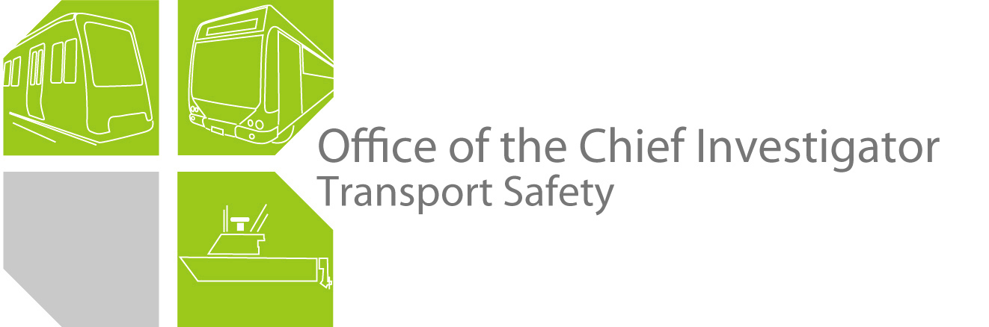

Rail Safety Investigation

Report No 2011/13

Derailment

Freight Train № 9162

Donald

23 December 2011

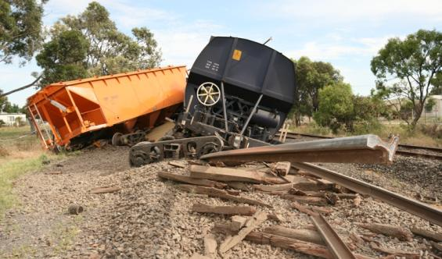

TABLE OF CONTENTS

The Chief Investigator 5

Executive Summary 7

1. Circumstances 9

2. Factual Information 11

2.1 Donald Loop 11

2.2 The train 12

2.3 Train crew 13

2.4 Other witness information 13

2.5 Incident site and inspections 14

2.6 Track 22

2.7 Train loading 24

3. Analysis 27

3.1 The incident 27

3.2 Wagon WGSY02008 28

3.3 Wagon ZHBF10000 28

3.4 Track 28

3.5 Loading of wagons 29

4. Conclusions 31

4.1 Findings 31

4.2 Contributing Factors 31

5. Safety Actions 33

5.1 Safety Actions taken since the event 33

5.2 Recommended Safety Actions 33

The Chief Investigator

The Chief Investigator, Transport Safety is a statutory position under Part 7 of the *Transport Integration Act 2010*. The objective of the position is to seek to improve transport safety by providing for the independent no-blame investigation of transport safety matters consistent with the vision statement and the transport system objectives.

The primary focus of an investigation is to determine what factors caused the incident, rather than apportion blame for the incident, and to identify issues that may require review, monitoring or further consideration.

The Chief Investigator is required to report the results of an investigation to the Minister for Public Transport or the Minister for Ports. However, before submitting the results of an investigation to the Minister, the Chief Investigator must consult in accordance with section 85A of the *Transport (Compliance and Miscellaneous) Act 1983*.

The Chief Investigator is not subject to the direction or control of the Minister in performing or exercising his or her functions or powers, but the Minister may direct the Chief Investigator to investigate a transport safety matter.

Executive Summary

On the afternoon of 23 December 2011, eight wagons of a loaded grain train operated by El Zorro derailed when passing through Donald in north-western Victoria. The track was a freight-only line managed by V/Line and the train had been travelling at the permitted track speed of 50 km/h.

The investigation concluded that the trailing bogie of wagon WGSY02008 was probably the first to derail. The derailment was an abrupt flange climb event that led to the trailing bogie separating from this wagon and the trailing end of the wagon dropping to the track and uncoupling from the following wagon. Presented with disturbed track and a separated bogie, several of the following wagons derailed. The leading section of the train continued across the level crossing, the rear-most dragging wagon having picked up a rail that had pierced its underside.

The investigation found that the derailment occurred a short distance after a lateral alignment track defect although this defect, when measured about three weeks prior to the event, was within permissible limits for the class of track. Evidence did not support the possibility of track buckling and neither were rail fractures contributory to the derailment.

Having been separated from its wagon, the trailing bogie of wagon WGSY02008 was pushed along the track by following wagons and sustained significant damage. Post-incident inspections did not find clear evidence of any pre-existing defect with the bogie other than greater-than-expected wear on some bogie components.

The investigation did not conclude a single definitive causal factor. The track defect was a pre-existing condition and it is possible that the first bogie to derail had tracking characteristics that compromised its ability to traverse this track defect.

The investigation found that loading of the grain wagons was imprecise and that most wagons were loaded beyond the design load for the spring configuration of the broad-gauge bogies and the load limit specified for the track. It was also found that the network manager did not have adequate systems to monitor compliance with network load limits.

Recommendations have been made in the areas of track maintenance, wagon loading, wagon performance monitoring and wagon labelling.

# Circumstances

At about 1725 on 23 December 2011, eight wagons of the loaded El Zorro Transport Pty Ltd train № 9162 derailed at Donald Loop in north-western Victoria. The train had been loaded with grain earlier that day at Birchip and was travelling south to Maryborough, with its final destination being North Geelong. The line between Birchip and Maryborough is used only for freight operations and is managed by V/Line Pty Ltd.

The wagons derailed and the train parted about 130 metres north of the Sunraysia Highway level crossing in Donald. The trailing 14 wagons remained to the north of the crossing while the leading section comprising the locomotives and 25 wagons continued for about 280 metres before coming to a stand to the south of the crossing. There was extensive track damage at and to either side of the level crossing. No persons were injured.

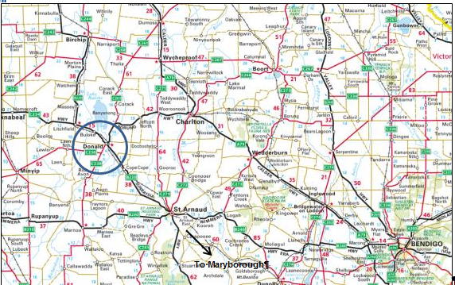

Figure 1: Copyright Melway Publishing. Reproduced from Melway edition 2007 with permission.

# Factual Information

## Donald Loop

Donald Loop is located just over 336 rail kilometres from Melbourne, via North Geelong, on the Maryborough to Yelta line. It is an unattended crossing loop equipped at each end with trailable facing points[1] that are configured to lay for the right hand track in the direction of travel. A standard set of points at the Up (Melbourne) end of № 2 track provides access to a siding.

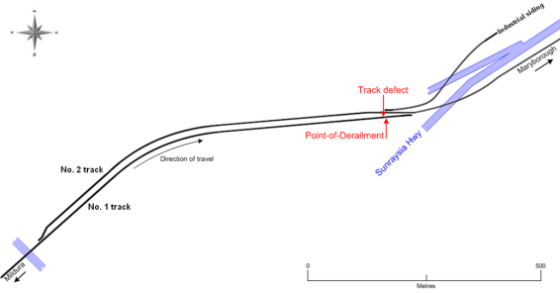

Figure 2: Donald Loop and the route taken by train 9162

The line was Class 3, freight-only, with a maximum permitted speed of 80 km/h reducing to a 50 km/h permanent speed restriction at the Maryborough-end of the loop and through the Sunraysia Highway level crossing. The trailable facing points were located within this curve.

In the vicinity of the derailment, the track was timber sleepered with 94 lb/yd (47 kg/m) rail secured on dogspiked double-shoulder base-plates, transitioning to 60 kg/m rail and Pandrol ‘e-Clip’ fastenings within the turnout at the Maryborough-end of the loop.

Following the incident, track repairs did not include the re-establishment of the crossing loop. The loop was subsequently re-established in 2012 with the turnout at the Maryborough-end moved north, away from the curve and joining at a tangent section of № 1 track.

## The train

### Consist

Train 9162 was comprised of three locomotives (G521, S303, and X31), 38 WGSY hopper wagons and one ZHBF hopper wagon. The recorded gross trailing tonnage was 2758.3 tonnes and length 617 metres. All vehicles were leased, apart from the ZHBF wagon that was owned by El Zorro, and all were certified to run on the network.

In the Train Consist form, all fully loaded WGSY wagons were recorded as having a gross of 76 tonnes, which was their maximum permitted gross wagon mass for this track. Of the others, the fourth-last wagon had a recorded gross of 29 tonnes and the trailing three wagons were recorded as being empty. Following the incident, the intact WGSY wagons to the south of the crossing were hauled to Geelong and their grain loads measured. All but one was found to be loaded in excess of that recorded in the consist report; the wagons averaging 82 tonnes gross. The greatest wagon mass was 87 tonnes, equating to an axle load of about 22 tonnes.

The Train Consist form recorded that the ZHBF wagon, the twenty-seventh wagon in the consist, had a gross mass of 73.3 tonnes, exceeding its permitted gross of 67.3 tonnes by 6 tonnes.

### Wagons

The WGSY wagons in this consist were manufactured in China and delivered new with standard-gauge bogies to AWB Australia Limited in March 2010. To meet operational needs, the bogies on this set of wagons were replaced with new broad-gauge bogies in May 2010. The Certificate of Acceptance for the wagons specified that:

* Standard-gauge bogie suspension was rated for a 23-tonne axle load.
* Broad-gauge bogie suspension was rated for a 20-tonne axle load, with side frames and bolster designed for a 23-tonne axle load for future conversion to standard-gauge operations.

The WGSY wagons were stencilled as having a tare of 24 tonnes and maximum load of 68 tonnes, giving a maximum gross of 92 tonnes; equivalent to a 23-tonne axle load. They were not stencilled for the broad-gauge load restrictions.

### Wagon maintenance

The wagons were subject to Programmed Preventative Maintenance (PPM) inspection each 14 days. The 14-day PPM comprised a visual examination to assess the adjustment, condition and security of the wagon, including bogie brake equipment, springs, side bearers, centre castings and wheels. The most recent inspection prior to the derailment was completed on 12 December 2011 with no notable defects relevant to the derailment.

### Data recorders

All three locomotives were equipped with data recorders however only one provided usable data. The maximum speed reached after departing Birchip was 75 km/h with the majority of the journey being run at about 70 km/h. About two kilometres before coming to a stand at Donald, the speed of the train reduced from 70 to 45 km/h then gradually increased to 50 km/h over the next kilometre. At about 1726 (on the recorder time-stamp), the speed decreased from 50 km/h to zero over a distance of approximately 400 metres.

## Train crew

### Crew information

There were three El Zorro train crew personnel in the lead locomotive cab; the rostered driver, a trainee driver and a driver who was undergoing route knowledge familiarisation. At the time of the derailment the rostered driver was providing practical train handling tuition to the trainee driver.

The rostered driver, although qualified in the applicable safeworking system, was overdue for re-assessment. The trainee driver was not qualified in the safeworking system. Medical certification for both the driver and the trainee was current.

All crew members were subjected to a preliminary breath test conducted by local police, with no alcohol detected.

### Reports and interviews

The trainee driver recalled that on the approach to Donald Loop, about one kilometre distant, the dynamic brake was selected to reduce the train speed gradually from about 70 km/h down to the curve speed of 50 km/h at the Maryborough-end of the Loop. He recalled that the train speed had been reduced to about 40 km/h before the dynamic brake was released when the lead locomotive was near the Maryborough-end points[2]. Power was then applied—one or two notches at a time—to gently change the state of coupling slack throughout the train from buff to draft[3].

The locomotives were in maximum power (Throttle Notch 8) when he noticed a loss of brake-pipe air on the brake-pipe pressure gauge. The End-of-Train brake pipe monitor display also confirmed a reduced brake pipe pressure at the rear of the train. The driver brought the train to a stand and an Emergency radio call was made to Centrol to report the incident.

The trainee driver also reported that there was no obstruction on the track and that the locomotive ride was neither different nor rougher than what he had experienced on previous runs. The locomotive did not have any extraordinary side movement on the approach or when running over the Maryborough-end points.

## Other witness information

A local resident had stopped his car on the Melbourne-side of the Sunraysia Highway level crossing when the derailment occurred. The resident reported that he observed the first 10 to 15 wagons travel across the level crossing. He looked along the track to his right and observed what he believed to be the lead axle of the rear bogie of a wagon ‘fall away’ from the wagon to the right-hand side. When this occurred the rear end of this wagon dropped to the ground and became detached from the trailing part of the train.

## Incident site and inspections

### Overview

The Point-of-Derailment and train parting was determined to be about 130 metres to the north of the Sunraysia Highway, leaving the trailing 14 wagons to the north of the crossing and the leading portion of the train comprising the locomotives and 25 wagons to the south. There was extensive track damage.

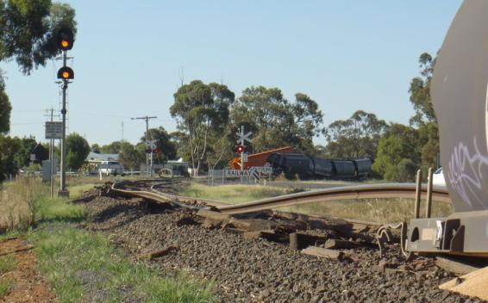

Figure 3: Derailment site viewed from the trailing wagon (WGSY2008) of the leading portion of the train and across the level crossing to the north (photograph courtesy V/Line)

Six wagons in the trailing portion of the train and two in the leading portion had derailed.

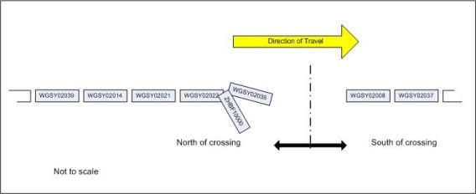

Figure 4: Order of derailed wagons (WGSY02035 was leading ZHBF10000)

### North of level crossing

The first evidence of derailment was a flange climb mark on the gauge face and corner of the right-hand rail, about 900 mm past a mechanical rail joint. The track was ‘in-gauge’ at this point. The flange-track continued on the rail head for about 600 mm before the wheel dropped to the field side of the rail. On both rails, between four and eight metres beyond the joint, there was severe rail head scuffing and several tread corner derailment marks, indicating that wheels had fallen inside the rails as the track lost gauge. On both rails there was also blue paint on the rail head commencing about eight metres past the joint. This was later identified as being paint from wagon WGSY02008 that had lost its trailing bogie.

Beyond the initial area of derailment activity, the track was progressively more severely disturbed. The left and right rails were crippled about eight and ten metres respectively beyond the joint, and both rails were fractured at a point approximately 28 metres beyond the joint.

The four rear-most derailed wagons remained generally in line with the track. Wagon ZHBF10000 had uncoupled from WGSY02035 and slewed to the right, impacting track-side infrastructure. Ahead of wagon WGSY02035 was a separated bogie, later identified as the trailing bogie from wagon WGSY02008 that had remained with the leading portion of the train.

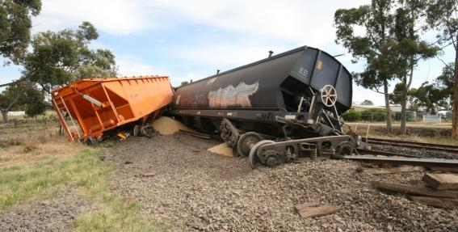

Figure 5: Leading wagons WGSY02035 and ZHBF10000 on portion of train north of level crossing

Ahead of the trailing portion of the train, the track was severely disturbed, with several rail fractures, all considered consequential and not contributory to the incident.

### Right-hand rail joint condition

The rail on the Maryborough-side of the mechanical joint in the right-hand rail was subject to detailed visual and metallurgical examination.

All evidence indicated that the fish-plated joint had been in good condition and was well supported with no signs of significant vertical displacement or wear. The connection was found to be sound with no apparent ovality in the bolt holes.

The end of the rail had not been battered by passing wheelsets. Spalling of the rail head indicated it had been subjected to fluctuating loading in service. The wear angle of the gauge face was approximately 13 degrees and did not exceed network standards.

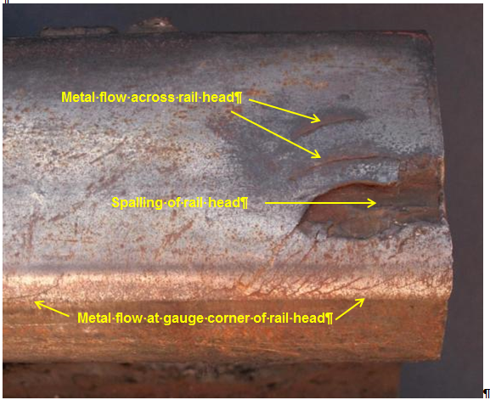

Figure 6: Rail end from the right-hand rail, in direction of travel, Maryborough-side of joint

In this instance subsurface fatigue had originated at the rail end from longitudinal crack-like indications present as a result of the localised metal flow. These surface metallurgical defects act as stress concentrators and contribute to fatigue initiation in the rail material. The resultant cracking had propagated from these stress concentrators as subsurface fatigue and had contributed to the spalling of the rail head at the rail end.

At the rail head gauge corner there were numerous zones of metal flow that had produced crack-like indications. The plastic flow and crack-like indications were most prevalent closer to the rail end, indicating that contact stresses had been higher closer to the joint.

### Rail fracture metallurgy

The first rail fractures ahead of the Point-of-Derailment occurred about 28 metres past the rail joints in both rails, just prior to the connection with the turnout. Both fractures occurred at or near welds and were subject to metallurgical evaluation.

The rail fractures were found to be mostly transverse or oblique and were consistent with instantaneous overload failure. Material testing conducted on the subject rails and welds indicated that they were of suitable quality for service. The fractures were new and did not exhibit any pre-existing defects.

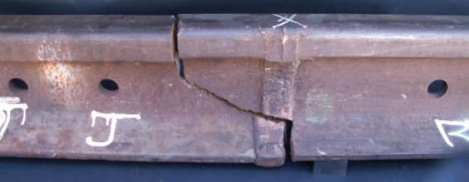

Figure 7: Rail fracture in right-hand rail, 28 metres ahead of the mechanical joint

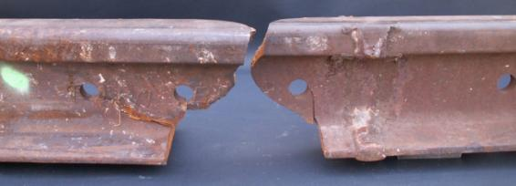

Figure 8: Rail fracture in left-hand rail, 28 metres ahead of the mechanical joint

### South of level crossing

The leading portion of the train was south of the level crossing. The trailing bogie of wagon WGSY02008 had separated from the vehicle and the right-hand rail had pierced the underside of the wagon, exiting at the rear above the frame. The rail had pierced the wagon on the north side of the crossing causing the rail to be dislodged from its fasteners and lifted as wagon WGSY02008 continued until the train came to a stand.

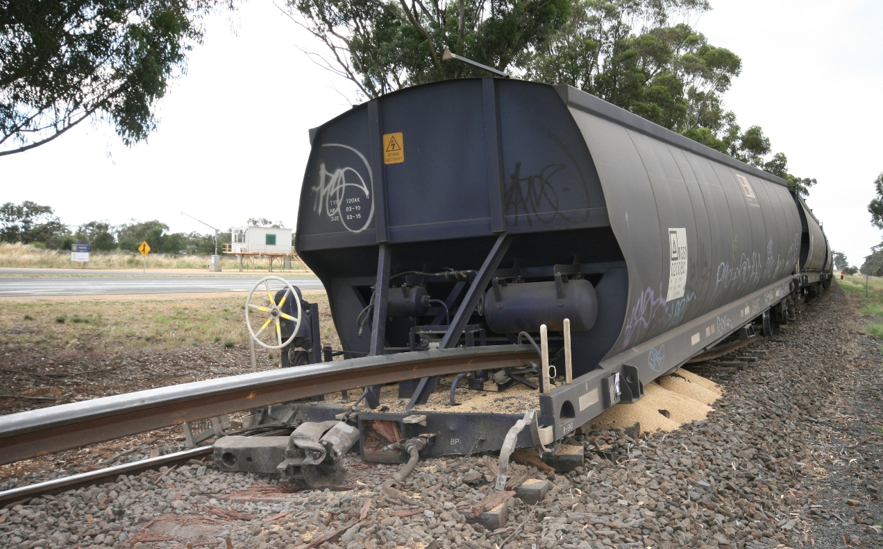

Figure 9: Trailing wagon WGSY02008 on south side of crossing

The trailing bogie of wagon WGSY02037, ahead of WGSY02008, had been derailed and had re-railed. There were marks on the bogie side frame, consistent with the lifted right-hand rail having chafed against the side of the bogie. There was no evidence to suggest the leading bogie of this wagon or any wagons ahead of this point had derailed.

### Wagon inspections

Wagons derailed in the trailing portion of the train were inspected on site and no aspect identified that may have contributed to the derailment. The two derailed wagons with the leading portion of the train were returned to Melbourne for independent inspection.

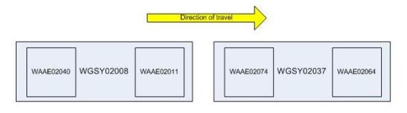

Figure 10: Wagons subject to workshop inspection - trailing wagons from leading portion of train

The WGSY wagon is designed for the transport of grain. Originally configured with standard-gauge bogies and constant-contact side bearers, the broad-gauge configuration uses gap side bearers.

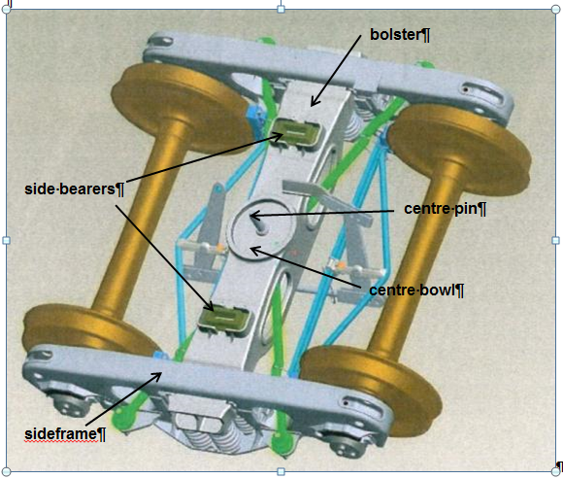

Figure 11: Model of broad-gauge bogie as supplied

**Wagon WGSY02037**

Wagon body-to-bogie interfaces were inspected and a general inspection of the body was undertaken. Body centre plates, brake lever connection points and side bearers were found to be in good condition apart from minor derailment damage.

There was no evidence that the leading bogie (WAAE02064) had been derailed and inspection of this bogie did not reveal any noteworthy abnormalities.

The trailing bogie (WAAE02074) was found to have markings on the wheels and frame that indicated it had been derailed. There were light witness marks that indicated forced contact between the centre pin and bogie centre bowl bore (in which the centre pin sits) during the derailment. The bogie, including wheels, was otherwise in a serviceable condition.

**Wagon WGSY02008**

No irregularities were found with side bearers apart from damage as a consequence of the derailment and no abnormalities were found with the wagon-to-bogie brake rigging interface.

Inspection of the leading end wagon-to-bogie (WAAE02011) interface identified bruising and galling marks on the wagon centre plate. The location of these marks corresponded to where the rim of the bogie centre bowl liner had been folded over and become trapped under the centre plate. The inspecting engineer’s opinion was that the plastic centre bowl liner could have travelled in this condition since the bogie exchange in 2010. The face of the bogie centre bowl also had an unusual wear mark indicating that the wagon had travelled for a time with the wagon body centre plate disengaged from the bogie centre bowl and riding on the lip of the centre bowl casting.

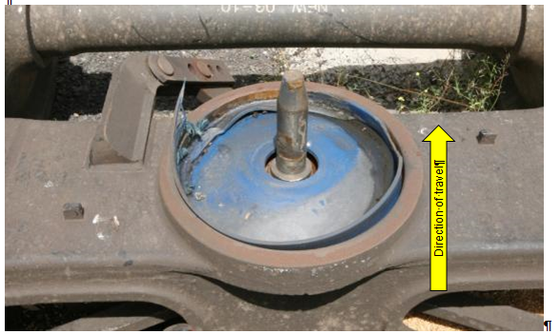

Figure 12: Centre bowl and liner on bogie WAA02011, the leading bogie of wagon WGSY02008

The bogie centre pin was damaged but remained intact. There was corresponding damage on the forward edge of the associated centre plate bore. The damage to the pin and the bore was assessed as having occurred during the derailment. The bogie, including wheelsets, was otherwise considered to be in good condition, although with more-than-expected gib[4] wear for a bogie of its age.

Inspection of the trailing end wagon-to-bogie interface (WAAE02040) identified that the wagon centre plate was heavily scored as a result of the wagon having been dragged along the track and ballast after the trailing bogie became separated. The centre plate bore had been deformed consistent with the pin having been in place at the time of the derailment. The damage was towards the trailing edge of the bore, indicating that the motion of the bogie was rearward relative to the wagon.

A detailed inspection of bogie WAAE02040 did not reveal conclusive evidence of any pre-existing defect or damage, excepting for characteristic wear on the gibs. Damage resulting from wheels impacting the bogie frame was assessed as probably having occurred after the derailment.

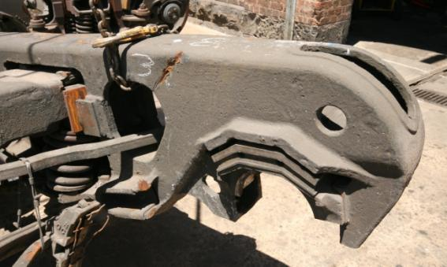

Figure 13: Bogie WAAE02040 inspection, including frame damage

**Gib wear**

The independent inspection reported unusual wear in the gib area on a number of bogies, caused by either hunting or lateral movement of the bolster through track irregularities. The inspecting engineer considered the gib wear to be inconsistent with the age of the bogies and their otherwise good condition. This observation was provided to El Zorro at the time of the inspection.

### Centre pin metallurgy

Three centre pins from derailed wagons were subject to detailed metallurgical analysis, including the intact pin from bogie WAA02011. Examinations found material composition and hardness consistent with Q235-A material; a base grade[5] structural steel and the material specified for the pins used on the WGSY bogies. None of the pin samples showed signs of pre-existing defect.

The pin from the leading bogie of WGSY02035 had failed as a result of a shear fracture mechanism that was consistent with instantaneous overload in a direction perpendicular to the pin axis. This failure was consistent with the site evidence of the wagon and leading bogie impacting the disengaged bogie and the bogie separating.

The pin belonging to bogie WAA02040 was not found within the site debris and so could not be tested. The marks in the centre plate and centre bowl bores confirmed the pin had probably been in place at the time of the derailment and had been heavily loaded.

## Track

### Inspections

Track inspections are carried out in accordance with the network standard and include a combination of track patrol (Hi-Rail vehicle), walking inspection, track geometry recorder car measurement and ultrasonic testing. The track geometry was recorded three weeks prior to the derailment and provided the most pertinent information relevant to this derailment.

### Track geometry

Prior to the incident, the track geometry was most recently recorded on 3 December 2011 using the EM100 track evaluation vehicle. In the area of the derailment, the only fault noted was at the 336.349 kilometre location coinciding with the rail joints just prior to the initial Point-of-Derailment. The geometric line fault[6] was recorded as 28 mm on the left rail and 29 mm on the right rail (in the direction of travel). This was described as a Class B fault. Video from the recording car confirmed the presence of an angular lateral discontinuity in alignment at the rail joints just prior to the derailment location.

The track is measured over a 10-metre chord and permitted levels specified for different classes of track. For Class 3 track (speeds of up to 80 km/h), the network standard specifies a sub-level B (Class B fault) exceedence level of 20 mm and sub-level A exceedence (Class A fault) level of 30 mm. The fault was therefore correctly categorised as a ‘B’ fault.

A ‘B’ fault—described in procedural documentation as a General Maintenance Exceedence—is used to program general track maintenance. Had the fault reached the Class A fault level, it would have required priority attention (to be repaired as soon as possible) or have had speed restrictions applied where considered appropriate.

No changes were made to the site in the three weeks leading up to the derailment, which was consistent with network procedure. Given the short time between measurement and incident, it is unlikely that the geometry had changed significantly from that measured.

### Rail Creep

Rail creep is the longitudinal movement in rail over time that leads to a change in the state of rail tension. Rail is maintained in tension to prevent buckling due to thermal expansion resulting from high ambient temperatures. Bunching of rail can lead to the development of compressive stresses and the potential for rail to buckle in high-temperature conditions. The amount of creep is monitored as a means to manage these rail stresses.

Rail creep monuments are located at intervals of one kilometre and the track position relative to these fixed points is checked twice per annum. The records for the two years prior to the event were reviewed and levels of creep found to be within prescribed limits.

### Weather and heat-related speed restrictions

The town of Donald lies at the eastern edge of the Wimmera region. The forecast for the Wimmera on the day of the incident was mostly sunny, 35°C. Charlton, about 35 kilometres to the north-east, was the nearest weather station with comprehensive observations for that day. It recorded temperatures of between 33 and 36°C in the five hours preceding the incident and 35°C at the time of the derailment. The weather in Donald was fine.

During periods of hot weather conditions there is an increased risk of track misalignment due to rail expansion. To reduce risk of derailment associated with this condition, the speed of trains within the affected area is temporarily reduced. The application of a heat-related speed restriction is accomplished by publishing a notice called a WOLO. The name is not an acronym, but derives from an historical telegraph code for such a notice. The temperature and environmental conditions that result in the publication of such a notice are often known as WOLO conditions.

The temperature at which this section of line becomes subject to WOLO restriction is 36°C. A WOLO was in place for 23 December, specifying that trains between Donald and Mildura were restricted to 60 km/h. This information, however, had not been disseminated to the crew of the El Zorro train and they unwittingly exceeded the heat-related speed between Birchip and Donald.

The WOLO that applied to the section between Donald and Yelta was also not received by the track maintenance supervisor at Donald. The patrolman responsible for conducting heat patrols on this day reported that he became aware of the WOLO at about 1230. He patrolled between Speed loop (north of Birchip) and Birchip but was unable to patrol between Birchip and Donald prior to the passage of train 9162. He reported checking the temperature when in Birchip at around 1630 and recalled the broadcast temperature in Horsham as having been 33°C.

## Train loading

### Loading of train 9162

Post-incident inspection identified that most wagons in the consist were loaded beyond the limit allowed for this corridor while the three trailing wagons remained empty and the fourth-last wagon was almost empty. Had the grain load been spread evenly along the consist, each WGSY wagon would have been at or near the permitted gross mass of 76 tonnes.

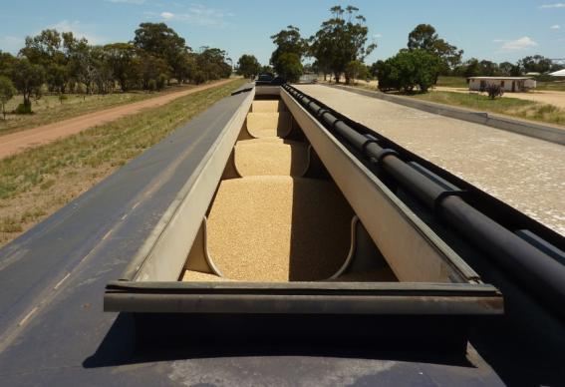

Figure 14: Typical loaded wagon at incident site (end compartments were loaded)

### Wagon capacity

The WSGY wagon hopper has a volumetric capacity of 85 cubic metres and a loading capacity of 68 tonnes, giving a maximum gross of 92 tonnes. This assumes a grain loading density of 0.8 t/m3. Depending on climatic conditions affecting the harvest, bulk wheat density will typically vary between 0.68 and 0.82 t/m3 therefore it would be unusual for a wagon load to attain the 92 tonne maximum, even fully loaded.

To meet the network requirement of 76 tonnes and to match the broad-gauge bogie configuration sprung for a 20-tonne axle load, WGSY wagons must be only partially loaded. The maximum grain load permitted was thus 52 tonnes, which was exceeded by 11 tonnes in at least one instance in this consist.

The wagon maintenance manual specifies that the load should be evenly distributed and indicated that loading the centre bay and not the end bays will achieve a lesser wagon mass. The wagons were also stencilled with this loading advice (Figure 15) that provided nominal wagon weight with and without loading of end bays.

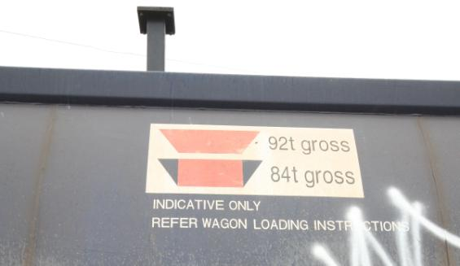

Figure 15: WGSY wagon loading markings

### GrainFlow loading facility

The amount of grain to be loaded onto a train is known in advance and is transferred to two silos that straddle the track within the loading facility. A typical total net load is 2080 tonnes which, for a 40-wagon train, equates to 52 tonnes net per wagon; the desired load to meet the network maximum of 76 tonnes gross.

To load the wagons, the train is run slowly and continuously below the silos. A GrainFlow staff member (the ‘loader’) stationed on a platform above the train opens and closes the silo chutes to release grain into the wagons. There is provision for the loader to direct the flow of the grain longitudinally along the wagon to fill forward or rear bays of the hopper as required. There is also provision for two loaders to work together, one dumping from the first silo at a faster rate, and the second topping up to complete the fill. With both silos being controlled, the loading can be completed in a shorter time. The loading is complete when the silos are empty. At the time of the incident there was no system of measuring the load in each wagon.

In this instance the loading was completed prior to the pass of the final trailing wagons, thus leaving several wagons empty. Managing the loading in this way avoids the situation whereby all wagons might have passed the train loader and a portion of the grain load remains in the silos. The investigation was advised that there can be reluctance on the part of train crews to backing-up a train and topping up wagons in order to complete the loadout. As a consequence, it is not uncommon for the forward-most wagons to be extra-loaded to ensure the full grain load gets on the train in a single pass. This results in hopper wagons with capacity in excess of the load permitted, such as the WGSY, often being overloaded.

Loaders working at the Birchip facility have varying levels of skill and experience. Training was on the job. There was no guidance at the loading point that clearly articulated how to achieve the 76-tonne load in a WGSY wagon. The investigation was supplied with loading diagrams for the WGSY wagon that are intended to assist loaders to achieve different loaded weights, however these were not in use at the time of the incident.

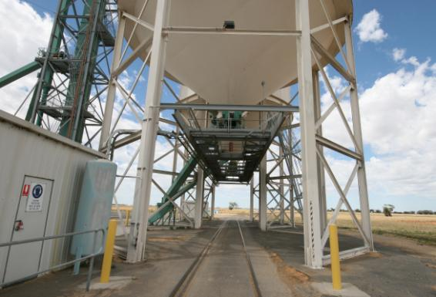

Figure 16: GrainFlow loading facility, Birchip

### Post-incident loading trials

Following the incident, GrainFlow and El Zorro conducted a loading trial of WGSY wagons using a variety of loading diagrams. Using the loading diagram intended to provide a 76-tonne gross wagon mass (52-tonne grain load), the load achieved was an average of 42.5 tonnes, equating to the wagons being under-loaded by an average of almost 10 tonnes. Fully loading the mid-sections of the wagon but not the end bay, as pictured on the wagon side, achieved an average load of 50 tonnes, with a maximum overload of 2.5 tonnes.

### Network management oversight of loading

V/Line, as the network manager, specifies the maximum permitted wagon mass of 76 tonnes. Compliance with this requirement is overseen by the checking of consist reports. There was no other system identified that assured that loading of grain wagons met the network requirements.

# Analysis

## The incident

### Derailment mechanism

The derailment occurred less than one metre beyond a significant track alignment defect. While the defect would not normally be expected to be sufficient to cause a derailment, in this instance it was probably the interaction of the rollingstock with this defect that led to the derailment. Rail head markings indicated an abrupt flange-climb event with high lateral loads and it is therefore unlikely that this was an instance of wheel unloading. More likely is that the tracking characteristics of a bogie were sub-optimal.

The investigation considered the possible role in the derailment of a number of wagons and concluded that the first to derail was wagon WGSY02008. Soon after the Point-of-Derailment, this wagon’s trailing bogie separated and the trailing end of the wagon dropped to the track; uncoupling from the following wagon, WGSY02035. This following wagon and the next five wagons—when presented with disturbed track and a detached bogie—derailed and the trailing section came to a stop. The leading portion of the train continued across the Sunraysia Highway level crossing, the rear-most dragging wagon having picked up a rail that pierced its underside.

After reducing speed on approach to the curve speed restriction, the driver then progressively increased locomotive power over a distance of more than 400 metres leading up to the derailment. At the time of the derailment the train couplings would have been in draft and slack action is unlikely to have occurred. Train handling is therefore considered not to have been contributory.

### Bogie WAAE02011

The interface between wagon WGSY02008 and its leading bogie exhibited unusual characteristics that might have explained compromised tracking characteristics. Independent inspection identified various wear marks in the wagon body centre plate and bogie centre bowl that indicated that the wagon had travelled for a time with the centre plate disengaged from the bowl. The rim of the bogie centre bowl liner had been folded over and had become trapped under the centre plate, and the inspecting engineer was of the view that the plastic centre bowl liner could have travelled in this condition since the bogie exchange in 2010. However, the investigation concluded that it is unlikely that bogie WAAE02011 was the first to derail and it is probable that the pinching of the liner and damage to the wagon centre plate and bogie centre bowl occurred after the trailing bogie was lost and the wagon body was angled down at its trailing end.

### Bogie WAAE02040

It is considered that the trailing bogie of wagon WGSY02008 was more likely to have been the first to derail. The bogie was severely damaged in the incident and post-incident inspection did not identify conclusive evidence of a pre-existing defect. Similarly to other bogies inspected, it did exhibit greater-than-expected gib wear for a bogie of its age and distance travelled but was otherwise in good condition. The view of the independent inspecting engineer was that this suggested either hunting behaviour or dynamic response to track irregularities.

## Wagon WGSY02008

### Configuration

These wagons were originally delivered with standard-gauge bogies rated for a 23-tonne axle load. The bogies were subsequently replaced with broad-gauge bogies sprung for a 20-tonne axle load and it is probable that the wagons were often loaded beyond this rating. In this instance one wagon was recorded as having an average axle load of 22 tonnes.

### Maintenance and condition

There was nothing in the maintenance records or post-incident inspection that suggested that the wagons and bogies were in an unserviceable condition. The bogies on this train were relatively new and subject to regular inspection. Gib wear was greater than might be expected suggesting that bogie hunting had occurred.

## Wagon ZHBF10000

The ZHBF wagon was the second wagon trailing the wagon first to derail. Given its location relative to WGSY02008, it is unlikely that any differing dynamic characteristics affected the tracking behaviour of that wagon.

## Track

### Geometry

Track geometry measurement taken shortly before the derailment identified a Class B fault at the rail joints just prior to the Point-of-Derailment. This defect was treated in line with network policy but was very close to being categorised as a Class A fault that would have required priority action. While the defect was implicated in the derailment, it is unlikely to have been the only factor.

### Rail fractures

Both left and right rails fractured about 27 metres beyond the Point-of-Derailment. The fractures were not the result of pre-existing defect and given their location relative to the Point-of-Derailment are considered consequential rather than contributory.

### Position of turnout at Maryborough-end of Donald Loop

At the time of the incident, the straight leg of the trailable facing points at the Maryborough-end of Donald loop was located within the curve. When reinstated it was relocated to be positioned within tangent track towards Birchip. Notwithstanding, the original position of the turnout is not considered to have been contributory in this incident.

### WOLO and track buckling

Administrative oversight resulted in the notification of the existence of a heat speed restriction (WOLO) for this section of track not being provided to the train crew. This meant that the restricted speed of 60 km/h was exceeded during the journey from Birchip, though not at the incident location at which a 50 km/h curve speed already applied.

Again due to administrative oversight, staff responsible for conducting heat patrols at Donald did not receive the WOLO notification. This restricted their ability to conduct the patrols and the Donald location was not inspected prior to the passage of train 9162.

Notwithstanding the breakdown in administrative procedure, in this instance there was no evidence to suggest that the track had suffered misalignment due to high temperatures.

## Loading of wagons

The precise loading of WGSY02008 is unknown due to the disturbance of the load resulting from the derailment and it is not known whether its loaded condition affected the wagon’s behaviour when negotiating the track defect. However, based on the loading profile of the train, this wagon was probably over-loaded beyond the 76-tonne gross requirement of the network and possibly beyond the 80-tonne gross rating of its broad-gauge bogies.

To achieve the load contracted for haulage, wagons were required to be loaded precisely to their network limit of 76 tonnes. In practice, the loading methods used could not achieve this precision and a practice developed of over-filling wagons to ensure that the full consignment of grain was loaded onto the train in a single pass, even if that meant leaving a number of the trailing wagons empty. To reduce the likelihood of overloading would have required either a substantial improvement in the accuracy of loading, a more conservative approach to loading, or an increase in wagon and network limits to accommodate the potential for higher loads.

The over-loading of WGSY wagons beyond the network limit was common practice. In recognition of some of the practical difficulties facing the loading operation, there was an opportunity and obligation on the network manager to have engaged with both the network user and the grain loading facility to improve compliance with network requirements.

# Conclusions

## Findings

1. The derailment occurred shortly after the train encountered a track defect.
2. This defect was being managed in line with rail network maintenance policy.
3. Wagon WGSY02008 was the first wagon to derail.
4. The trailing bogie of WGSY02008 was probably the first bogie to derail.
5. The bogies on inspected WGSY wagons had greater-than-expected gib wear.
6. The grain hopper wagons were overloaded by up to an additional 21 per cent grain load, resulting in axle loads up to about 15 per cent above the network requirement and about 10 per cent above that specified for the spring configuration of a broad-gauge bogie.
7. A practice had developed when filling WGSY wagons that led to the overloading of leading wagons, while leaving some rear-end wagons empty.

## Contributing Factors

1. A track alignment fault at the 336.349 kilometre location on № 1 track within Donald Loop.
2. The inability of wagon WGSY02008 to negotiate the track alignment fault at Donald Loop.

# Safety Actions

## Safety Actions taken since the event

### Train crew training and qualifications

Following this incident and the identification of driver qualification currency that was inconsistent with its safety management systems, El Zorro has reviewed and modified its processes for assuring that train crew qualifications are current.

## Recommended Safety Actions

Issue 1

Grain hopper wagons with volumetric capacity greater than the load to be carried can be and were frequently overloaded beyond the limits of the bogie suspension configuration and the track network. In this instance, loading systems did not provide for precise loading and the network manager did not have systems in place to adequately assure compliance with its network requirements for axle loads.

RSA 2013004

That El Zorro and GrainFlow review methods used for loading grain onto WGSY wagons to assure compliance with network management and wagon limits.

RSA 2013005

That V/Line takes action to enhance its method of assuring that wagon loading is compliant with network service plan requirements.

Issue 2

The track had a significant defect in rail alignment that was close to requiring priority corrective action. In this instance a bogie with no clearly identifiable defect but exhibiting sub-optimal tracking behaviour derailed at the defect, raising a question of the adequacy of network standards.

RSA 2013006

That V/Line reviews the adequacy of its network standard for alignment defects on Class 3 track and its suitability for current-user rollingstock.

Issue 3

The broad-gauge WGSY wagon bogies inspected had greater-than-expected gib wear for their age, distance travelled or their otherwise good condition. This suggests bogie hunting behaviour or a potential for adverse response to track irregularities.

RSA 2013007

That El Zorro monitors the performance of broad-gauge WGSY wagons and their bogies.

Issue 4

The WGSY wagons are stencilled with weight limits that are inconsistent with their broad-gauge bogie suspension configuration.

RSA 2013008

That El Zorro correct the labelling of WGSY wagons to accurately reflect the load limitations for broad gauge operations.

1. On departure from the crossing location, the train forces the trailing points across to accommodate the movement (the ‘trailable’ condition). The blades will return to their intended facing position a short time after the train has passed.
2. At this point the train had around 450 metres to travel before the derailment would occur.
3. The state of the drawgear between wagons, either being in compression (buff) or tension (draft).
4. That limits lateral movement of the bolster within the bogie sideframes.
5. Based on AAR (Association of American Railroads) specifications and terminology.
6. ‘Line’ or ‘alignment’ describes the track uniformity (straightness) of the rails in the horizontal plane.