

Rail Safety Investigation

Report No 2012/05

Safeworking irregularity

Hi-rail track maintenance vehicle

Kyneton

20 August 2012

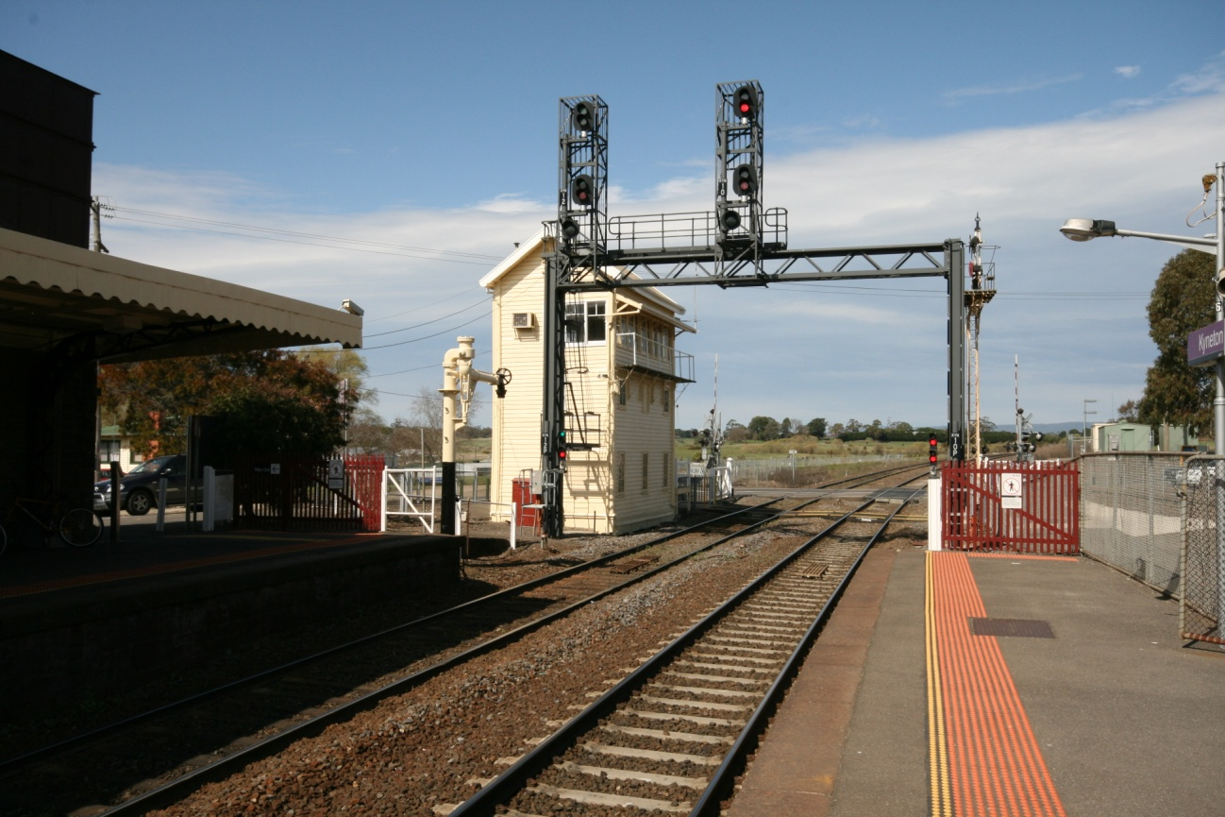

TABLE OF CONTENTS

The Chief Investigator 5

Executive Summary 7

1. Circumstances 9

2. Factual Information 11

2.1 Infrastructure 11

2.2 Network Control 14

2.3 Road/Rail vehicle - Hi-Rail 22

2.4 Voice communication between the Hi-Rail operator and signaller 24

2.5 Rules for Hi-Rail operations 24

2.6 Regulatory audit 25

2.7 V/Line passenger train 25

3. Analysis 27

3.1 The incident 27

3.2 Communication 27

3.3 System information available to the signaller 27

3.4 Notification of Hi-Rail planned works 28

3.5 Night Operation of Hi-Rail vehicles 28

4. Conclusions 29

4.1 Findings 29

4.2 Contributing Factors 29

5. Safety Actions 31

5.1 Actions taken since the event 31

5.2 Recommended Safety Actions 32

The Chief Investigator

The Chief Investigator, Transport Safety is a statutory position under Part 7 of the *Transport Integration Act 2010*. The objective of the position is to seek to improve transport safety by providing for the independent no-blame investigation of transport safety matters consistent with the vision statement and the transport system objectives.

The primary focus of an investigation is to determine what factors caused the incident, rather than apportion blame for the incident, and to identify issues that may require review, monitoring or further consideration.

The Chief Investigator is required to report the results of an investigation to the Minister for Public Transport or the Minister for Ports. However, before submitting the results of an investigation to the Minister, the Chief Investigator must consult in accordance with section 85A of the *Transport (Compliance and Miscellaneous) Act 1983*.

The Chief Investigator is not subject to the direction or control of the Minister in performing or exercising his or her functions or powers, but the Minister may direct the Chief Investigator to investigate a transport safety matter.

Executive Summary

On 20 August 2012 at about 2325 a safeworking irregularity occurred on the V/Line network between Kyneton and Gisborne. The incident involved a Hi-Rail vehicle that had been contracted to conduct weed spraying and the 2215 Melbourne to Bendigo passenger train.

The Hi-Rail had network approval to operate on the East Line from Kyneton to Sunbury. Following a number of conversations between the Hi-Rail operator and the controlling signaller, the Hi-Rail was instead placed on the West Line at the Mollison Street level crossing adjacent to Kyneton Railway Station. It then travelled towards Gisborne in conflict with an approaching passenger train that was also on the West Line. After the Hi-Rail had travelled about 1500 metres, its presence was detected by an axle counter, resulting in the signal facing the on-coming passenger train reverting to Stop. Around the same time the operator of the Hi-Rail became concerned that they were on the wrong track and contacted the signaller. The driver of the passenger train was able to respond to the Stop indication and the train was brought to a stand at the signal. The separation between the Hi-Rail and the passenger train at this time was about 1300 metres. Had the train passed the signal before the Hi-Rail activated the axle counter, the vehicles would probably have collided.

The Hi-Rail had accessed the West Line at Kyneton following the path of a Melbourne-bound freight train. The freight service had passed through on the West Line and had subsequently been routed to the East Line via a crossover just past Kyneton. The Hi-Rail operator thought that he was to get on the same track as the freight train. In contrast, the controlling signaller expected the Hi-Rail to on-track on the East Line and provided an appropriate block for that track.

The investigation concluded that communication between the signaller and the Hi-Rail operator was casual, imprecise and ineffective. The result was that the signaller and the Hi-Rail operator had different understandings of the track to be accessed at the Mollison Street level crossing. Since the incident, V/Line has introduced organisation-wide training and competency assessment for safety critical verbal communications.

On the V/Line network Hi-Rail vehicles are not required to be detected on conventional circuits and administrative processes are used to monitor their location and protect against conflicts with trains. The investigation makes a recommendation that V/Line considers introducing a method of positive identification of Hi-Rail vehicles.

# Circumstances

At about 2150 on 20 August 2012 two contractors arrived at Kyneton Railway Station and prepared their vehicle for a weed spraying task that was scheduled to commence at 2300. They had network approval to spray the East Line from Kyneton towards Gisborne and then Sunbury. The operator in-charge of the Hi-Rail contacted the Bendigo signaller for permission to go on-track and it was arranged that the Hi-Rail would on-track at the Mollison Street level crossing after the passage of a freight train. On receipt of permission to occupy the line, the Hi-Rail on-tracked on the West Line (behind signal KYN10) and proceeded towards Gisborne in direct conflict with a Bendigo bound passenger train.

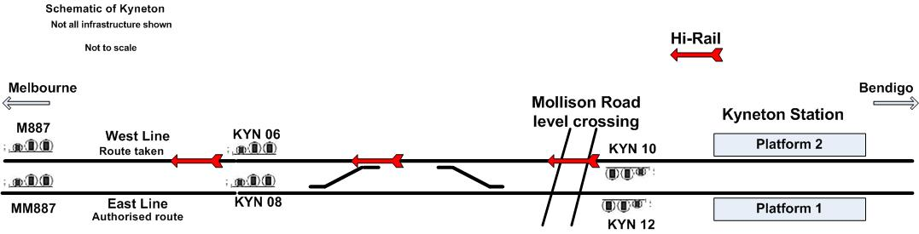

Figure 1: Route taken by Hi-Rail

The Hi-Rail travelled beyond an axle counter located about 1500 metres from Mollison Street level crossing and 98 metres on the Gisborne side of signal KYN06. Detection of the Hi-Rail by this axle counter resulted in signal M887 reverting to the Stop position and the approaching passenger train was brought to a stand at this signal under Emergency braking. At this time the Hi-Rail was occupying the track section between signals KYN06 and M887.

After passing beyond signal KYN06 the Hi-Rail operator observed its indication and contacted the signaller at Bendigo to determine if the Hi-Rail was on the correct line. It was identified that it was not and the signaller directed the Hi-Rail to return to Kyneton and off-track.

The Hi-Rail reversed back to Kyneton and, on confirmation that it was clear of the line, the signaller verbally authorised the train to continue.

Weed spraying activities were curtailed and all personnel involved were tested for blood alcohol content. The presence of alcohol was not detected in any test. There were no injuries and no damage to infrastructure or vehicles.

# Factual Information

## Infrastructure

### Layout

This section is part of a Regional Fast Rail (RFR) corridor. The track infrastructure between Gisborne and Kyneton consisted of two parallel bi-directional lines, identified as the East Line and the West Line. V’Locity type trains were permitted to travel at speeds of up to 160 km/h on the West Line and 130 km/h on the East. Beyond Kyneton, the track infrastructure towards Bendigo consisted of a single bi-directional line with intermediate crossing locations.

Within the Kyneton station precinct, the tracks are referred to as №1 Road (the eastern track) and №2 Road (the western track). The platforms are similarly numbered №1 and №2.

### Signalling system

Home signal KYN10 is located on №2 Road (the western track) at the Melbourne end of Kyneton station. It controls Up (towards Melbourne) train movements from the №2 Road to either the West Line directly, or to the East Line via the West Line and a crossover. This signal was controlled by the signaller at Bendigo and by the passage of trains via conventional track circuits. It was the reference signal used by the Hi-Rail operator in conversations with the signaller when discussing track permissions and access to the track.

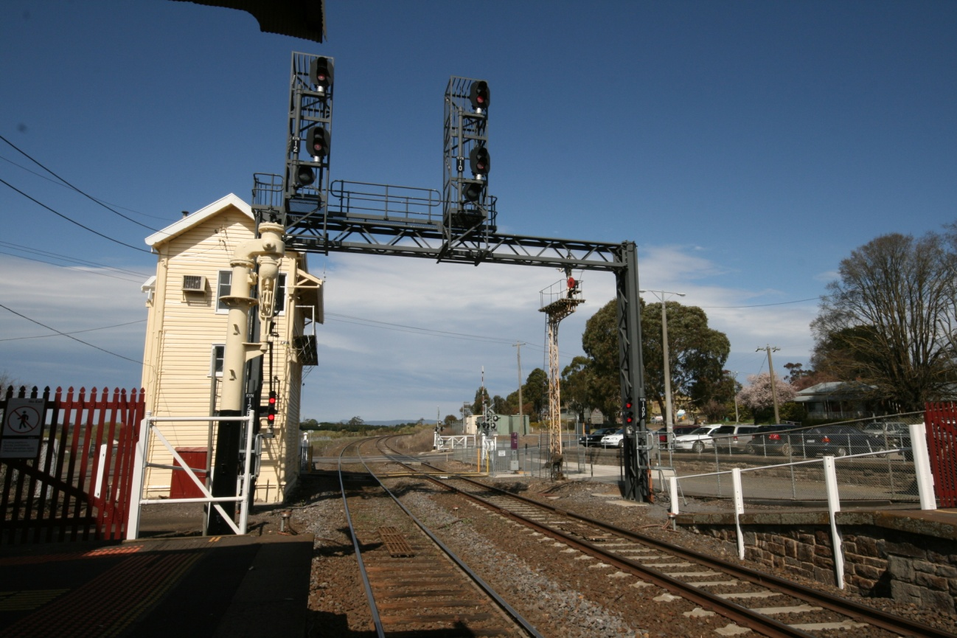

**KYN12**

**KYN10**

Figure 2: Signals KYN12, KYN10 and Mollison Street level crossing looking towards Melbourne

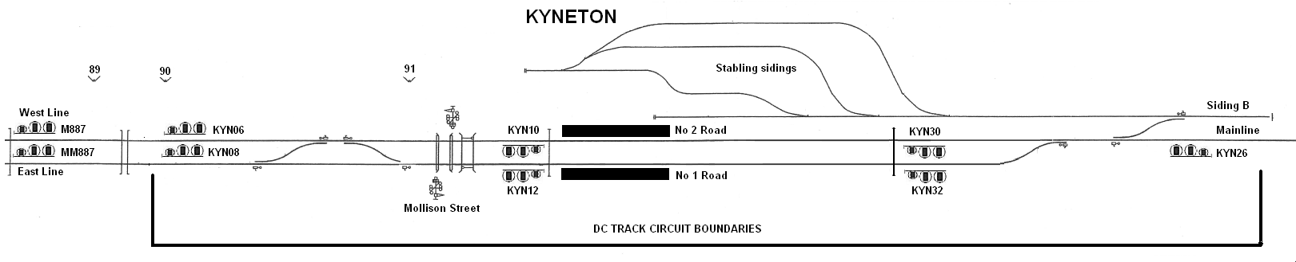

Figure 3: Kyneton signalling schematic (not to scale)

Home signal KYN06 controls Down movements (away from Melbourne) along the West Line to either №2 Road, directly, or №1 Road via a crossover shortly before Kyneton station. Its operation was controlled by the signaller at Bendigo and by the passage of trains via conventional track circuits.

Signal M887 is located at the 88.611 km mark and is the approach signal for signal KYN06 at 90.00 km. Its operation is activated by the detection of the passage of trains past axle counters.

### Vehicle detection systems

On the Melbourne side of Kyneton station, rail vehicle detection is by conventional track circuit near and through the station, and by axle counter further towards Melbourne (Figure 4).



Figure 4: Schematic of Kyneton Up end vehicle detection systems

**Conventional track circuits**

Kyneton, like other locations on the Bendigo line, employs standard track circuitry for points and signal interlocking, occupancy detection, and the operation of other infrastructure such as level crossing equipment. From Kyneton station, the conventional track circuit extends for about 1500 metres towards Melbourne. The boundary is about 98 metres on the Melbourne side of KYN06 where an axle counter is located. These circuits require a rail vehicle to make an electrical connection across the rails. Hi-Rail vehicles as currently configured to operate in Victoria do not activate these circuits. However, some Hi-Rail vehicles that operate elsewhere are fitted with positive detection systems.

**Axle counters**

An axle counter is a device used instead of track circuits to detect the passing of a rail vehicle. A counting head (or 'detection point') is installed at each end of the section. As each axle passes the counting head at the start of the section, the count increases. Detection points comprise two independent sensors therefore the device can detect the direction of a train or vehicle by the order in which the sensors are passed. When the train passes a similar counting head at the other end of the section the counter counts down. If the net count from the entry to exit counter is evaluated as zero, the section is presumed to be clear. A Hi-Rail vehicle will be detected by an axle counter.

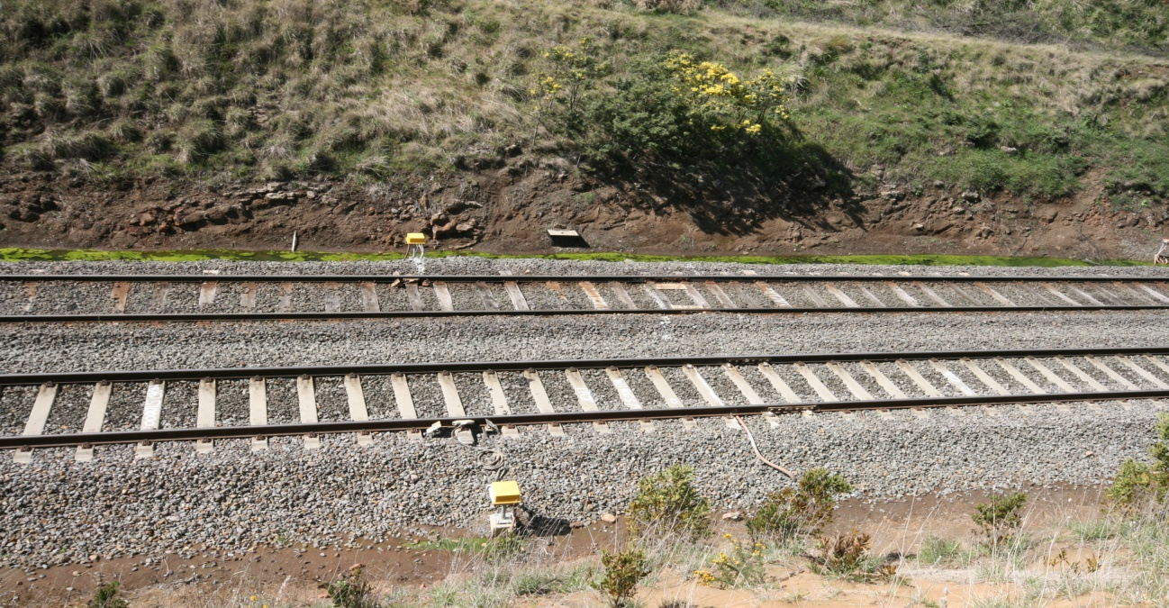

Figure 5: Axle counters near signals KYN06 and KYN08

## Network Control

### Overview

All train movements and on-track maintenance activities on the V/Line network are conducted under the direction of a Train Controller located at Centrol in Melbourne. A number of sections within the Victorian network also have localised signal control. In this instance, the signals and points between Sunbury and Bendigo were controlled from the Bendigo signal box.

The complete signalling function for the Bendigo corridor was transferred to Centrol in April 2013. This was a planned change and was not a result of this incident.

### Signalling procedures

Rail Traffic is managed under the rules of the Automatic and Track Control Safeworking System. When trains are to proceed in opposite directions, signals are electrically controlled to prevent more than one train being in the single line section between two crossing locations at any one time. Three-position colour light Home Signals control the entrance of trains into the single line section.

Hi-Rail vehicle movements between locations are conducted by means of Track Permissions, not signal indications. When authorising such movements, V/Line’s operating procedures require the signaller to apply specific blocking commands into the system to protect the Hi-Rail movement.

Train movements and work on-track authorities are recorded by the signaller on a Train Graph[1] and in the Train Register Book.[2]

### Scheduled weed spraying operations

Hi-Rail weed spraying activities between Bendigo and Sunbury were scheduled and circularised (S.12/5455) by V/Line Network Services to occur from 20 August 2012 to 22 August 2012. For Monday 20 August, the circular stated that the Hi-Rail was to follow train 9072—the Up freight—on the East Line from Kyneton at 2300 and conduct weed spraying through to Sunbury. It was to off-track at the Reas Road level crossing at the 42.19 km mark and conduct weed spraying on the West Line to Castlemaine at 0120 on Tuesday 21 August.

### Signaller

The signaller had about 37 years service mostly in the signalling grades and predominantly at Bendigo. He was qualified in the safeworking system and rules applicable between Sunbury and Bendigo.

The signaller recalled that on the night of the incident he first became aware of the Hi-Rail activities when called by the contractor seeking to arrange access to the track. The signaller had no knowledge of the circular authorising the weed spraying. The signaller recalled his understanding that the Hi-Rail was to on-track on the East Line and conduct weed spraying through to Gisborne after the passage of a Melbourne bound freight train and its clearance through Gisborne.

The signaller recalled that he routed the freight train along №2 Road and the West Line to the East Line via the crossover on the Melbourne side of Kyneton station. The signaller could not recall when the crossover route was changed after the freight train went onto the East Line, but indicated that this would probably have been done straight away, in preparation for the Down passenger service.

When the freight train cleared Gisborne, the Hi-Rail was granted on-track time (2320-0030) to travel on the East Line from Mollison Street to signal GIS28 at Gisborne. Not long after granting this permission the signaller received a call from the Hi-Rail operator indicating that they thought they were travelling on the wrong line.

Bendigo Signaller rotational shifts are: day 0600-1400, afternoon 1600-2400 with a bridging shift 1300-2100 and night 2400-0800. On Monday 20 August 2012 he was working the afternoon shift and was near the end of his shift when the incident occurred. Nothing within the signaller’s rostering was considered contributory to the incident.

### Bendigo signalling system display and functionality

The Bendigo signalling complex was located at the Bendigo Railway Station and was operated by the signaller under the direction and supervision of a train controller at Centrol.

The signaller’s display was typical of a Westinghouse Control and Display (WestCAD) system and provided representation of trackage, signals and detected rail traffic. Three Visual Display Units (VDUs) displayed the track layout at locations selected by the signaller. Rail traffic direction for each line was displayed by a small white triangle and the condition of the track was identified using colour coding as described below.

|  |  |
| --- | --- |
| **Condition** | **Display** |
| Track clear | Grey |
| Track occupied | Red |
| Route set | White |

Home signals are identified by a unique location code (KYN for Kyneton) and identification number. Intermediate uncontrolled signals have differing prefixes and identification numbers. Signals on the West Line have a single M prefix and signals on the East Line have an MM prefix.

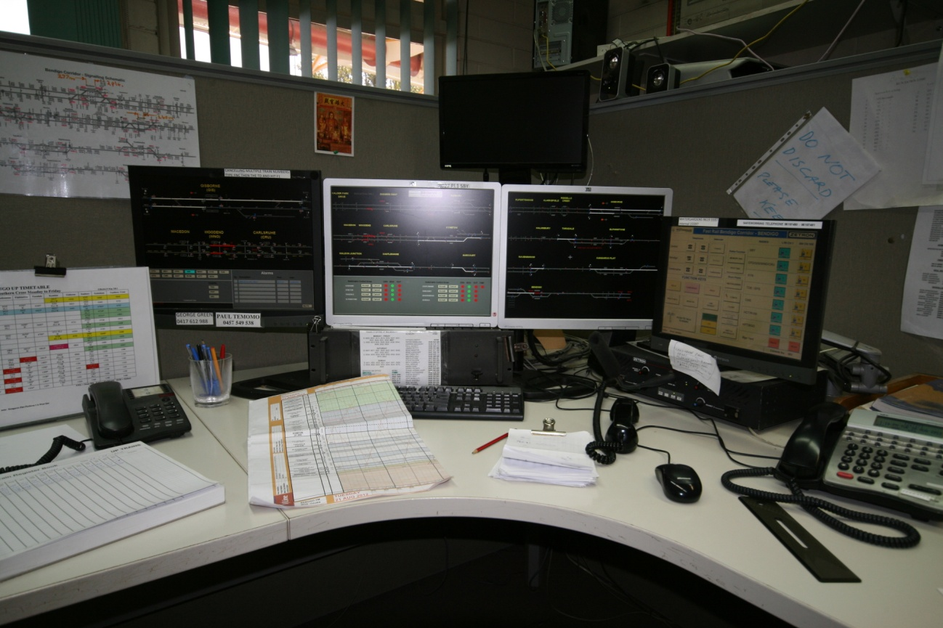

Figure 6: Bendigo signaller's work station and display

The signal display and panel control could be utilised to apply six types of track control, including managing occupation by Hi-Rail vehicles, as described below:

|  |  |
| --- | --- |
| **Command** | **Outcome** |
| Place Road Rail vehicle in section (Hi-Rail Block) | This sends an on-track vehicle request to the interlocking. The option is disabled when the track is occupied. |
| Remove Road Rail vehicle in section (Hi-Rail Block lifted) | This sends an on-track vehicle cancel to the interlocking. This option is only enabled when there is a Hi-Rail in section set, and the section is no longer occupied. |

### Bendigo signalling system display playback recordings

The signalling system logger and display playback recordings provide a detailed sequence of events. The screen shots reproduced in this report have been annotated and some detail removed for clarity.

The sequence of events displayed in the following diagrams commences with the Melbourne-bound freight train negotiating the crossover from the West Line to the East Line (Figure 7).

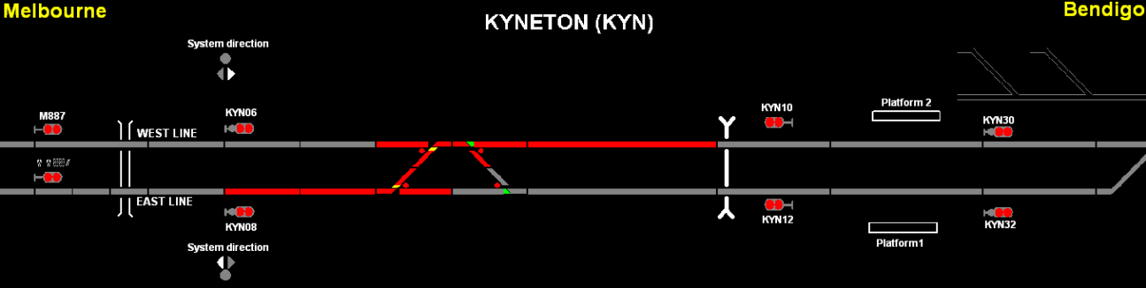

Figure 7: Display information - freight train occupying crossover

The freight train then cleared the crossover (Figure 8). At this point the crossover remained set to Reverse and the Hi-Rail was off-track at Kyneton waiting for permission to access the track.

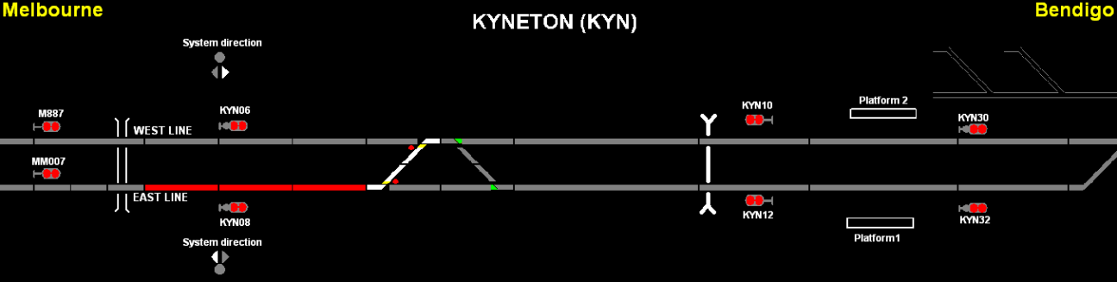

Figure 8: Display information - freight train clear of crossover

After the freight train had cleared the crossover, the signaller reset the crossover to the straight (Figure 9). This was in preparation for clearing the route for the Bendigo-bound passenger train to travel along the West Line into №2 Road at Kyneton. Note the system direction indicator that indicates this direction of traffic.

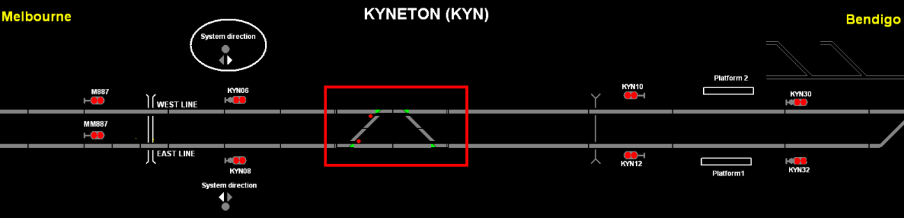

Figure 9: Display information - crossover points set to the straight

The route was now established for the passenger train to travel along the West line (white) into Kyneton with signals M887 and KYN06 at Proceed (Figure 10). At this point in time, the freight train, although not shown on this screen, had not yet reached Gisborne and the Hi-Rail was still off-track at Kyneton.

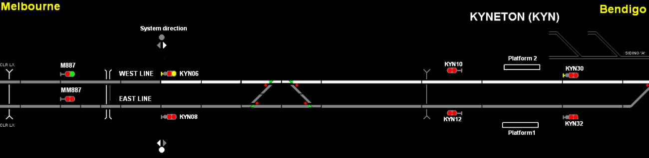

Figure 10: Display information - route established for Bendigo-bound passenger service

Figure 11 shows that the route was now set and signals (M887, KYN06 and KYN30) were all cleared for the passenger train to travel into and through Kyneton from the West Line along №2 Road.

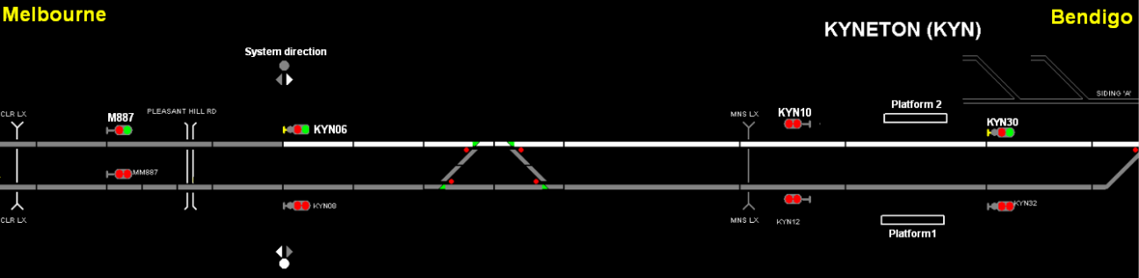

Figure 11: Display information – route and signals set through Kyneton for passenger service

At about this time and with the route and signals set for the passenger service, the Hi-Rail operator was granted permission to go on-track and travel on the East Line. However, the Hi-Rail on-tracked on the West Line. This track occupancy was not detected by the system.

Reflective of the permission, a ‘Place Road-Rail vehicle in section’ command (Hi-Rail block) was applied on the East Line between Kyneton and Woodend. Shortly after, a further Hi-Rail block was applied for the same line between Woodend and Gisborne. These commands are recorded in the tabular records (log); however, they are not visible on the playback screen images.

The next screen (Figure 12) illustrates the position of the passenger train on the West Line. At this point it had passed signal M869 and was approaching signal M887 that was at Proceed. The Hi-Rail had not yet been detected by the system. It was also travelling on the West Line and was located between Kyneton and signal M887, but not yet past the axle counter.

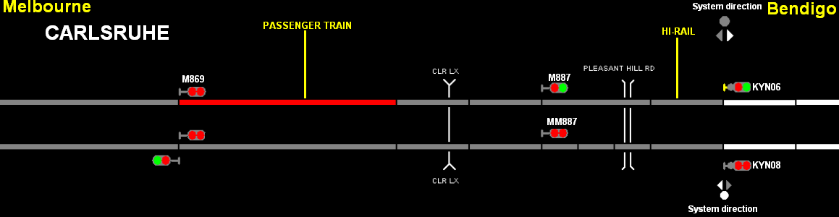

Figure 12: Display information extending further towards Gisborne - passenger train detected on approach to signal M887, Hi-Rail not detected by axle counter

The Hi-Rail then activated the axle counter, causing signal M887 to revert to the Stop position (Figure 13).

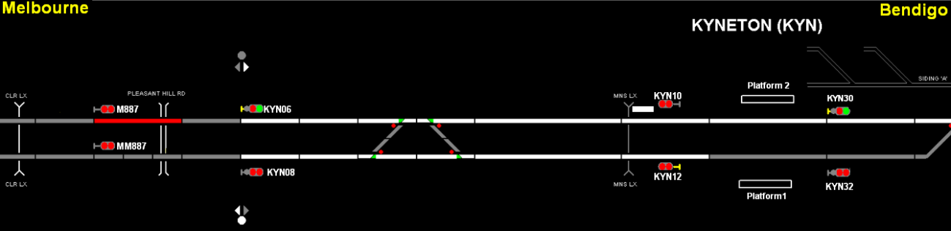

Figure 13: Display information – Hi-Rail has been detected by axle counter and signal M887 has reverted to the Stop position

The next display screen (Figure 14) shows the passenger service and Hi-Rail in adjacent track sections.

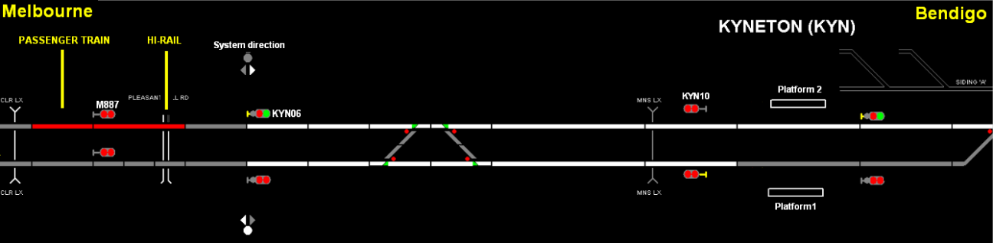

Figure 14: Display information - passenger train stopped at signal M887 and Hi-Rail on-track

Figure 15 shows that the signaller then placed signal KYN06 to Stop. The Hi-Rail was still in the section monitored by the axle counter and the passenger train was stopped at signal M887.

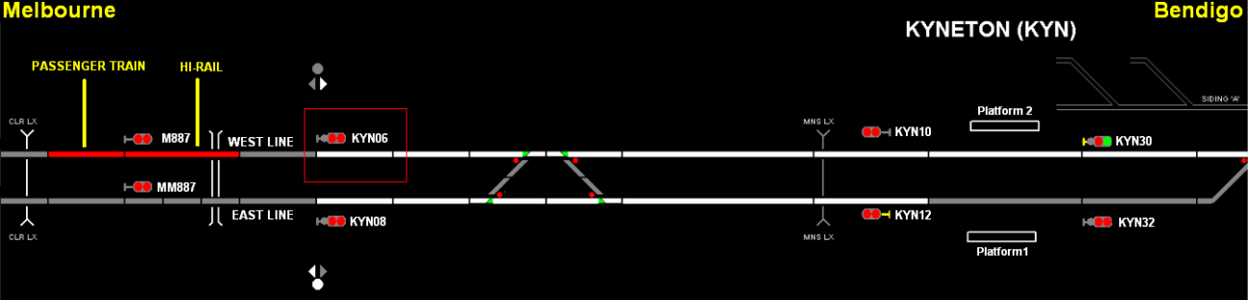

Figure 15: Display information – signal KYN06 put back to stop

The Hi-Rail then retreated over the axle counter and was no longer detected by the system (Figure 16).

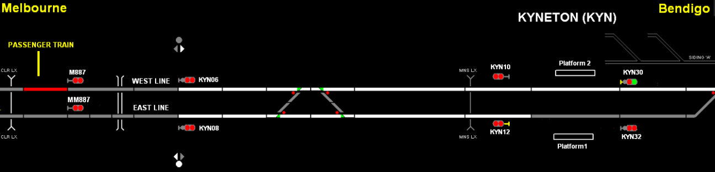

Figure 16: Display information - Hi-Rail retreated from monitored section and track section beyond signal M887

### Summary sequence of events

The following provides a summary of the times of key events within the described sequence. Times are from a number of sources including the signalling system, telephone recordings and the train data logger.

|  |  |  |
| --- | --- | --- |
| **Time stamp** | **Event** | **Hi-Rail status** |
| 22:57:35 | The Melbourne bound freight train occupies the crossover and travels from the West to the East Line | The Hi-Rail is off-track and the operator has observed the passage of the freight train through Kyneton |
| 22:58:01 | The freight train has cleared the crossover | The Hi-Rail operator is off-track at Kyneton and the freight train is out of sight |
| 23:00:57 | The crossover is restored to the straight and set for the West Line |  |
| 23:10 | Passenger train departs Gisborne |  |
| 23:16:39 | Signals M887 and KYN06 are cleared for the movement of the passenger train along the West Line into Kyneton | The Hi-Rail is off-track at Kyneton preparing to go on-track behind signal KYN10 |
| 23:19:00 | The signaller grants permission for the Hi-Rail to on-track | The Hi-Rail commences to on-track on the West Line behind signal KYN10 |
| 23:20:00 | The route and signals are set and cleared for the passenger service to proceed along the West Line and beyond Kyneton |  |
| 23:23:32 | A Hi-Rail block is applied to the East line between Kyneton and Woodend and then on to Gisborne |  |
| 23:24:36 | The passenger train has departed Woodend station about 13 km from Kyneton | The Hi-Rail is travelling on the West Line towards KYN06 |
| 23:28:53 | The axle counter detects the Hi-Rail and Signal M887 reverts to Stop in front of the passenger train | The Hi-Rail passes the axle counter on the Melbourne side of KYN06 |
| 23:29:06 | The passenger train comes to a stand at signal M887 | The Hi-Rail is occupying the track section immediately ahead of the train |
| 23:30:14 | Signal KYN06 is placed to Stop by signaller. |  |
| 23:30:40 | The axle counter resets and the system is able to clear signal M887 for a train movement. | The Hi-Rail has retreated over the axle counter and is returning to Kyneton. |

## Road/Rail vehicle – Hi-Rail

### Vehicle description

The Hi-Rail involved was an ISUZU FSR 700 rigid truck with an overall length of 9150 mm. It had a maximum carrying capacity of 18000 kg and had been fitted out by the contractor for vegetation spraying. For rail operations it was fitted with a Train-to -Base radio. When conducting on-track spraying operations it was restricted to a speed of about 20 km/h. Reversing speed on track was estimated by the operator to be between 10 and 15 km/h.

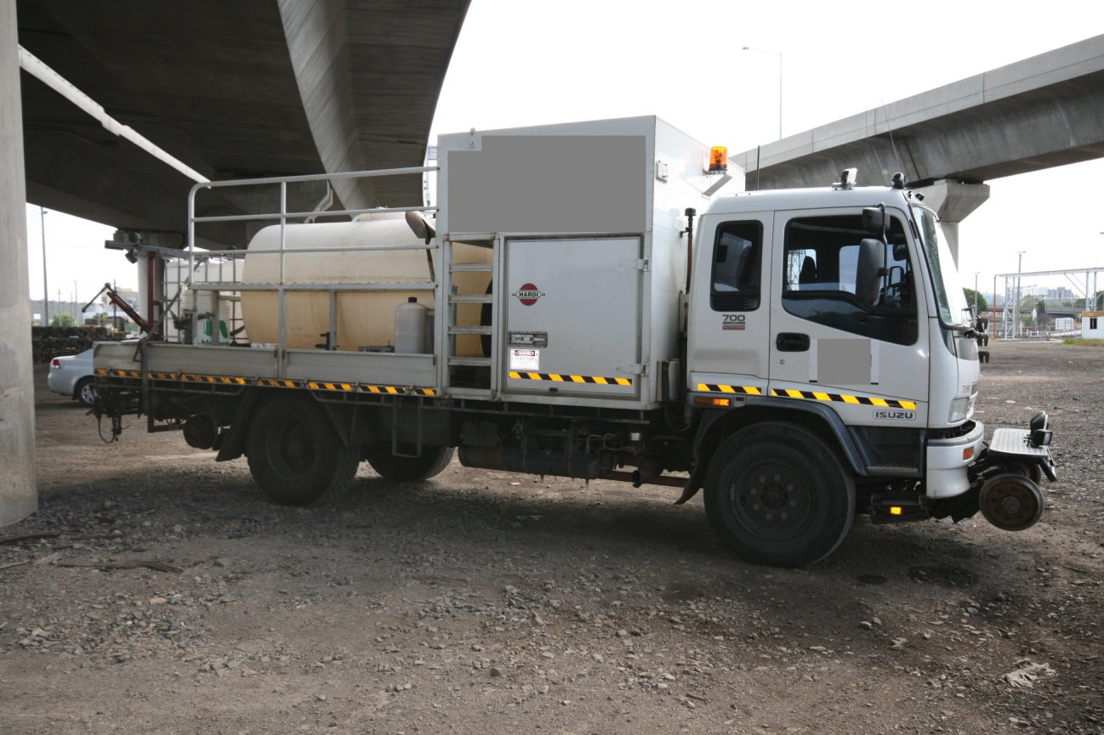

Figure 17: Hi-Rail vehicle involved in the incident

### Contractual arrangements

The contractor had provided vegetation management services to the rail industry since 2001 and had operated on mainlines and sidings. These services had been provided on the three major Victorian networks managed by V/Line, Metro Trains Melbourne and the Australian Rail Track Corporation.

In order to reduce operational conflict with train services, weed spraying activities on the V/Line network were typically scheduled to occur in the early hours of the morning.

### Hi-Rail driver

The Hi-Rail driver was in charge of the vehicle and rail safeworking requirements. He was qualified as a level 4 Operator and Competent Employee level 5 with RFR accreditation. On the 20 August 2012 he was to conduct weed spraying activities between Kyneton and Sunbury on the East line, returning on the West Line through to Castlemaine. He had operated between Bendigo and Kyneton during the week prior to the incident.

He reported that he and a co-worker arrived at Kyneton at about 2150 and commenced preparing for the night’s spraying. The initial contact with the signaller at Bendigo was at about 2230 when he was informed that he would have to wait for a Melbourne bound freight train. After that train went through Kyneton at about 2254, he again contacted the signaller and was informed that the Hi-Rail could not be given permission until the freight train had cleared Gisborne. During this conversation the Hi-Rail operator understood that he was to get on the same track as the freight train and he indicated to the signaller that he was intending to on-track behind signal KYN10. At 2316 he was granted track time from 2320 to 0030 to travel from Mollison Street Kyneton on the East Line to signal GIS28 at Gisborne. The action to occupy the track (behind KYN10) was recorded on the Road/Rail Vehicle Permission Form. The Hi-Rail was put on-track at Mollison Street behind KYN10 and on the same line as the freight train that had passed through. They then proceeded towards Gisborne.

The driver stated that when he saw the crossover set for the straight he was uneasy but continued on. After passing signal KYN06 he looked back and noticed that it was displaying a green over red. At this point he was concerned that he may be on the wrong track and contacted the signaller and asked if Bendigo had picked him up on the axle counter. It was identified that the Hi-Rail was on the wrong track and the Hi-Rail operator was instructed to reverse to Mollison Street and to get off the track. The operator recalled that the Bendigo signaller called him at about 2336 and advised him that the spraying activities were cancelled for the night.

### Second Hi-Rail crew member

The second crew member assisting on the Hi-Rail was qualified as a level 4 Operator and Competent Employee level 5 with RFR accreditation. On the night of the incident he was receiving familiarisation training in the physical characteristics of the line between Kyneton, Sunbury and Castlemaine.

The assisting crew member confirmed the events of the night but could not add to the information provided regarding the safeworking arrangements or communications as he was not involved in these activities.

### Hi-Rail operator training

The Hi-Rail operators were trained to Hi-Rail Operator level 4 and Competent Employee 5 applicable to Road/Rail vehicle operations. This training included, but was not limited to fixed signals and the granting of permission on the RFR. Both Hi-Rail operators had successfully passed all assessments at level 4 and 5 and were RFR accredited.

In addition to the mandatory rules training required by the Network Manager, both Hi-Rail operators received training on track access locations on all corridors. This practical training provided by their employer was not documented or assessed.

## Voice communication between the Hi-Rail operator and signaller

The initial conversations occurred when the Hi-Rail operator contacted the signaller for permission to access the track. It was established that the Hi-Rail was operating under Circular S.12/5455 and that it was to travel on the East Line following freight train 9072.

After the passage of this freight service, the Hi-Rail contacted the signaller again but was told permission could not be granted until the freight train had travelled beyond Gisborne. The Hi-Rail operator sought clarification as to whether they were getting on the same track as the freight train and behind signal KYN10, both on the West Line. The response of the signaller was imprecise. The Hi-Rail operator’s acknowledgment of the signaller’s response suggests that he considered it a positive response to his inquiry.

The signaller initiated a call to the Hi-Rail after the freight service had cleared Gisborne. This conversation included granting permission to on-track from 2320 to 0030 up the East Line from Mollison Street, Kyneton to Gisborne GIS28. During this conversation the Hi-Rail operator again sought to confirm that it was ‘ok’ to get on track behind KYN10. The signaller’s response did not specifically address this inquiry and instead confirmed that they were to get on track at Mollison Street. The signaller did not make reference to KYN10 or the East Line. Neither did the Hi-Rail operator refer to the East or West Line.

In the next conversation when on track, the Hi-Rail operator questioned whether the signaller had him on the axle counter. When told that he was not, the Hi-Rail operator reported that he had observed a signal [KYN06] behind him displaying a ‘Green over Red’ and queried if he was on the wrong line. When asked by the signaller if he got on the East Line, the Hi-Rail operator reported that he got on behind KYN10. The Hi-Rail was instructed to return to Mollison Street.

Several of the conversations were casual and imprecise and there was limited use of repeat-back to confirm clear understanding between the parties. Some hesitancy could also be detected in the voice of the Hi-Rail operator, potentially reflective of an authority gradient between himself and the signaller.

## Rules for Hi-Rail operations

Hi-Rail operations are conducted on the Victorian regional network in accordance with Section 30 of the *Book of Rules and Operating Procedures 1994*. Part 3(h) of section 30 stipulates in part that; ‘No track vehicle must be placed on the running line at night or when visibility is less than 500 metres’. The weed spraying activities were programed by V/Line in the knowledge that they were in conflict with these operational restrictions.

The Network Operating Requirements section 7 was also applicable to the operation and required Hi-Rail vehicles travelling on the network to be equipped with a Train-to-Base radio. Mobile telephone communication was not sanctioned on running lines unless specially authorised. In this case the Hi-Rail was fitted with a Train-to-Base radio but not a local radio to communicate with the signaller at Bendigo. Instead a mobile telephone was used. While not sanctioned, the mode of communication used was not contributory to the incident.

## Regulatory audit

Between 1 and 6 August 2012, about two weeks before the incident, Transport Safety Victoria (TSV), the rail safety regulator in Victoria, conducted an audit into the risk management of Hi-Rail vehicles[3] and track machines on the V/Line network. The audit was initiated as a result of an increased number of incidents and subsequent safety alerts from industry and regulators related to these operations. The stated objective of the audit was to determine whether V/Line was satisfactorily complying with the requirements of Parts 3 and 5 of the Rail Safety Act 2006 with particular respect to V/Line’s Safety Management System in relation to the management of Hi-Rail vehicles.

The final audit report was issued after the incident, on 19 October 2012, and identified fifteen compliance matters. The report identified that evidence demonstrating compliance could not be provided in a number of areas including the assessment and recording of risks associated with Hi-Rail operations, the management of rail safety worker (Hi-Rail operator) competence and Hi-Rail design, engineering and operational standards and procedures. The audit concluded that TSV was not satisfied that V/Line could ensure, so far as reasonably practicable, the safety of its rail infrastructure and rolling stock operations pertaining to Hi-Rail vehicles. TSV advised at the time of finalising this report that it is monitoring the implementation of actions taken by V/Line in relation to the findings of the TSV Audit.

## V/Line passenger train

### Train driver

The driver, who was assigned to the Bendigo Drivers Depot, was qualified in the route, the vehicle, and the rules and operating procedures applicable between Melbourne and Bendigo.

He stated that he was driving the 2215 Southern Cross to Bendigo service and had departed two minutes late, at about 2217. He recalled passing a Melbourne-bound freight train when between Macedon and Gisborne and that the trip was uneventful until after departing Woodend - still about two minutes late. It was a clear and cold night.

The train was travelling at about 160 km/h on clear signals near Carlsruhe. When preparing to reduce speed for an approaching 140 km/h curve he observed that signal M887 ahead was at Stop. He made an Emergency Brake application and stopped short of the signal. He then called the Bendigo signal box and was told that he should stand-by.

After about two to three minutes the indication on signal M887 went to a bottom yellow (proceed) aspect. The driver accepted this signal and proceeded at reduced speed. He had the train’s headlights on high beam and could see that the line was clear up to a cutting ahead. Within metres of passing this signal, he was red-lighted (told to stop) by the Bendigo signaller who had called him on the local radio (local channel 1).

The driver estimated that the train remained stationary at this location for about seven to nine minutes, at which time signal KYN06 cleared to green over red. The driver didn’t move the train until the signaller called, a short time later, and reported that the track was clear and that the train was ‘OK to go’. It was then about 2335. The train proceeded to Bendigo without further incident. At his request, the driver was breath tested when he reached Bendigo and returned a zero reading.

# 

# Analysis

## The incident

On the night of the incident, the contractor arrived at Kyneton prepared to conduct weed spraying on the East Line towards Sunbury in accordance with the published circular.

The trigger for confusion was the Hi-Rail operator’s observation of the passage of the freight train through Kyneton on the West Line. This created a belief in the operator’s mind that he should access the same track. Just past Kyneton and out of sight of the Hi-Rail operator, the freight service was routed onto the East Line and then the crossover reset for the straight.

After the passage of the freight train through Kyneton there were a number of conversations between the Hi-Rail operator and the signaller. The Hi-Rail operator attempted to clarify if he was to on-track on the same line as the freight train. Signal KYN10 (on the West Line) was used as a reference to clarify his understanding of the on-track position. The responses received from the signaller were casual and imprecise and it is not unreasonable for the Hi-Rail operator to have thought that the signaller understood his intentions.

In contrast it never entered the signaller’s mind that the Hi-Rail would on-track on anything other than the East Line, in accordance with the authorisation. The fact that the signaller followed procedure and applied Hi-Rail blocking commands on the East Line indicates that he believed that the Hi-Rail was to take this route and that it had been protected. The reference to on-tracking behind KYN10 (the West Line) did not register with the signaller who had a different understanding of what was occurring in the field.

## Communication

Management of Hi-Rail vehicles on the V/Line network is reliant on administrative processes of which communication is a critical component. Much of the communication between the signaller and Hi-Rail operator was casual and imprecise. There was similarly very limited use of repeat-back to confirm a mutual understanding of the on-track position at the Mollison Street level crossing. This poor communication between the signaller and Hi-Rail operator led to a different understanding of which track was to be accessed.

## System information available to the signaller

The signalling system display provided information on the position of rail traffic. However, the Hi-Rail vehicle was not configured to be positively detected in territory monitored by conventional track circuits. Instead, there was a reliance on the manual application of a Hi-Rail block to the control system and the use of paper-based systems (Train Graph, Train Register Book) to manage the position and passage of the Hi-Rail. The use of manual monitoring and recording systems in conjunction with a computerised train control system introduced greater potential for human error.

The route and signals had been set and cleared on the West Line for the passenger train prior to the Hi-Rail going on track at Mollison Street. The absence of Hi-Rail detection meant that the Hi-Rail’s presence did not automatically activate signals. Had this been the case it would have provided an additional defence and it is unlikely that the incident would have occurred.

## Notification of Hi-Rail planned works

Signallers managing the operation of the system should be aware of all scheduled on-track activities. In this case the signaller was unaware of the Hi-Rail activities until contacted on the night by the operator. V/Line’s S-Circular distribution process was less than satisfactory.

## Night Operation of Hi-Rail vehicles

The conduct of Hi-Rail operations at night was in contravention of the *Book of Rules and Operating Procedures 1994* that forms part of V/Line's safety management system. This contravention was known to V/Line and accepted as a pragmatic operational practice given the limitations to track availability during daylight hours. If the decision to operate Hi-Rail vehicles at night was made using sound risk-based assessments and mitigations, the rules should have be changed to reflect this decision.

# Conclusions

## Findings

1. The Hi-Rail was granted permission to travel from the Mollison Street level crossing at Kyneton along the East Line to Gisborne. However, it accessed the West Line in conflict with a Bendigo bound passenger train.
2. The Hi-Rail was able to travel undetected on the West Line for about 1500 metres before being detected by an axle counter beyond signal KYN06.
3. The positive detection of the Hi-Rail’s presence by the axle counter resulted in signal M887 reverting to the Stop position, halting the passenger train and preventing a collision.

## Contributing Factors

1. Communication between the V/Line signaller and the Hi-Rail operator was imprecise and ineffective leading to a different understanding of which track was to be accessed.
2. The Hi-Rail vehicle was not positively detected by the signalling system when it accessed the track.

# Safety Actions

## Actions taken since the event

### Transport Safety Victoria

In an immediate response to this incident, rail regulator Transport Safety Victoria issued V/Line with a Prohibition Notice against:

*‘Allowing contractors to undertake rolling stock operations on V/Line’s running lines under V/Line’s accreditation other than in the company of and under the supervision of qualified V/Line personnel, other than heritage operations’.*

This Prohibition Notice was lifted on 25 November 2013.

### V/Line

**Direct actions**

Actions taken by V/Line as a direct result of this incident include:

* The direct supervision of non-accredited Hi-Rail vehicles by qualified V/Line employees (satisfying the TSV Prohibition Notice).
* Organisation-wide training and competency assessment for safety critical verbal communications, including the re-training, supervision and auditing of signallers.
* The review and update of communication protocols.
* The development of a standard communication protocol for accessing the track.
* The development of instructional material to address potential authority gradients between signallers and Hi-Rail operators.
* The authorisation of weed spraying activities during the hours of darkness provided that the Hi-Rail vehicles lighting system has been verified as complying with Australian Standard AS7531.4.
* The introduction of specific safeworking requirements for Hi-Rail vehicle operation on parallel lines in specified corridors.
* The review of processes for the distribution of S-Circular.
* The review of radio requirements for Hi-Rail vehicles.

**Indirect actions**

In the context of external audit and internal review of Hi-Rail operations, V/Line also initiated a review of the management and operation of Hi-Rail vehicles on the V/Line network. The scope of the review encompassed risk controls, engineering standards, operating procedures, communication protocols and Hi-Rail operator competencies and qualifications.

## Recommended Safety Actions

Issue 1

On the higher risk segments of the V/Line network such as the RFR corridors, detection systems are used to control and monitor train movements. In contrast, Hi-Rail vehicles in these same corridors are not required to be detected on conventional circuits and instead administrative processes are used to manage their track access. This use of manual monitoring systems for Hi-Rail vehicles in combination with the computerised train control system introduces greater potential for human error and loss of separation between Hi-Rail vehicles and trains.

RSA 2014001

That V/Line considers introducing a method of positive identification of Hi-Rail vehicles on those areas of its network that use track circuits for vehicle detection.

1. A graphical diagram (x axis = time, y axis = distance) used by a train controller for a particular operational area depicting planned and actual operational information for that area.
2. The instrument used to record train movements and other on track activities applicable to a signal box control area.
3. Referred to as Road Rail Vehicles (RRV) in TSV documentation.