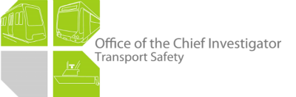

Rail Safety Investigation

Report No 2013/01

Derailment of

suburban passenger train TD3224

between Mooroolbark and Croydon

3 January 2013

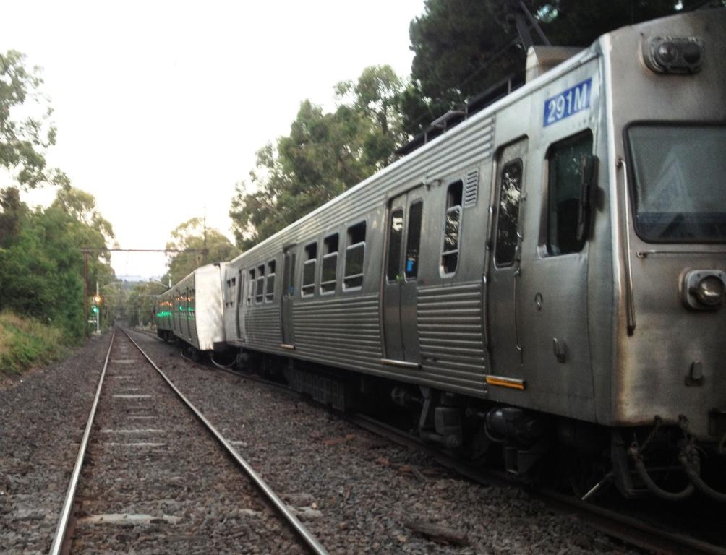

TABLE OF CONTENTS

The Chief Investigator 5

Executive Summary 7

1. Circumstances 9

2. Factual Information 11

2.1 Train 11

2.2 Observations by previous drivers 11

2.3 Track Infrastructure 11

2.4 Track works prior to the incident 13

2.5 Management of Continuous Welded Rail 14

2.6 MTM management of works and track condition 15

2.7 Operational measures in hot conditions 17

2.8 Track geometry condition monitoring 17

2.9 History of heat related track misalignment 17

3. Analysis 19

3.1 The derailment 19

3.2 Management of rail stress 19

3.3 Fastening of rail following re-railing 20

3.4 Effect of axle-load on the track misalignment 20

4. Conclusions 21

4.1 Findings 21

4.2 Contributing Factors 21

5. Safety Actions 23

5.1 Safety Actions taken since the event 23

The Chief Investigator

The Chief Investigator, Transport Safety is a statutory position under Part 7 of the *Transport Integration Act 2010*. The objective of the position is to seek to improve transport safety by providing for the independent no-blame investigation of transport safety matters consistent with the vision statement and the transport system objectives.

The primary focus of an investigation is to determine what factors caused the incident, rather than apportion blame for the incident, and to identify issues that may require review, monitoring or further consideration.

The Chief Investigator is required to report the results of an investigation to the Minister for Public Transport or the Minister for Ports. However, before submitting the results of an investigation to the Minister, the Chief Investigator must consult in accordance with section 85A of the *Transport (Compliance and Miscellaneous) Act 1983*.

The Chief Investigator is not subject to the direction or control of the Minister in performing or exercising his or her functions or powers, but the Minister may direct the Chief Investigator to investigate a transport safety matter.

Executive Summary

The incident occurred on 3 January 2013, during which the temperature had reached about 37°C. The Metro Trains Melbourne (MTM) suburban train was en-route from Lilydale to Melbourne when it derailed at about 1730, approximately 350 metres on the Mooroolbark side of the Dorset Road street overbridge. The track and rails were out-of-alignment as a result of instability arising from heat-induced stress within the rails. Four of the train’s passenger cars derailed, but all remained upright. There were no injuries to passengers or to the driver of the train.

In October 2012 rail replacement works had been undertaken on this section of track. Works early in October involved the replacement of both rails for 82 metres of track and on 23-24 October, following the detection by ultrasonic inspection of a significant transverse defect, an emergency repair was made involving the insertion of a seven-metre section of rail.

The investigation found that the track had not been re-stressed[1] following the October works, a necessary measure to retain track stability in hot conditions. In addition, the works conducted on 23-24 October had not followed normal practice for re-fastening rail to timber sleepers. Both the deferred re-stressing and the inadequate re-fastening locally at the seven-metre rail insert contributed to the instability of the track in the hot summer conditions.

Even though this track section, along with several others, had been identified as requiring re-stressing after re-railing works, the summer planning process did not identify the risk of leaving the track unstressed and the resultant potential for track misalignment at this location.

Following the incident, MTM immediately applied temporary speed restrictions to the 11 similar re-railed sites that were yet to be re-stressed and undertook to immediately re-stress the rail at these sites.

MTM also undertook a substantial review of the processes and procedures associated with the management of continuous welded rail. Outcomes of this process included: the refinement of summer planning processes; the strengthening of compliance with track standards on rail replacement works; and audit of the competency of welding contractors.

# Circumstances

Suburban passenger train TD3224, the 1709 service from Lilydale to Melbourne, was travelling between Mooroolbark and Croydon stations at an estimated 65 km/h and ascending a 1-in-40 grade. As it approached the Dorset Road street overbridge, the driver noticed the track ahead ‘move’. The train ran onto a section of track that was out-of-alignment and derailed the four intermediate cars. All wheels of the leading car remained on the rails, all wheels of the second car derailed to the right and all wheels of the third car derailed to the left. The fourth and fifth cars derailed between the spread rails. All wheels of the sixth car remained on the rails.

The train came to a stand with its leading end approximately 230 metres on the Down (Mooroolbark) side of the overbridge. There were no injuries and passengers were detrained and conveyed by bus for the remainder of the route to the city.

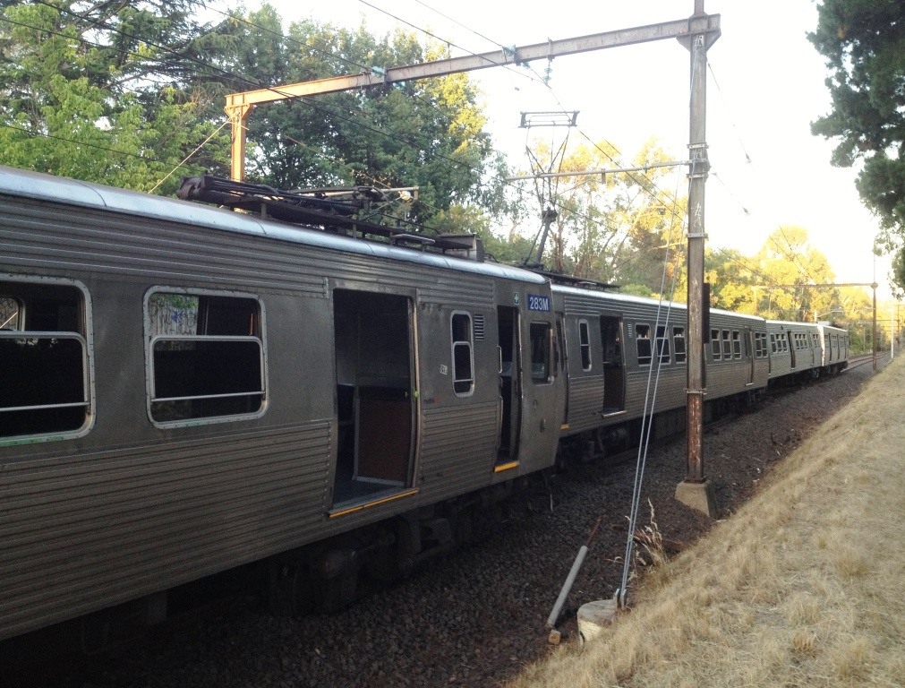

Figure 1: Derailment scene looking rearward (towards Lilydale)

The train was an older-style Hitachi type. Prior to this train, recent traffic over this location had been X’Trapolis suburban trains.

Bureau of Meteorology records indicate that the temperature in the area peaked at about 37°C around an hour prior to the incident, reducing to around 36°C at the time of the incident. Rail temperatures are normally higher than the ambient and it is probable that the rail temperature at the incident location was more than 50°C.[2]

# Factual Information

## Train

### Vehicles

The train was a 6-car Hitachi Electric Multiple Unit (EMU) comprising car-sets 284M-1975T-283M and 291M-1982T-292M[3]. The Hitachi M-car has an axle load (tare) of about 13 tonnes (and a 3-car mass of 140 tonnes), compared to the newer X’Trapolis type that has an M-car axle load of about 10.4 tonnes (and a 3-car mass of 118 tonnes).

The train was operating with one motor car isolated. Post-incident inspection did not identify faults or abnormalities that may have contributed to derailment. At the incident site, there was a small fire below number 1 bogie of car 283M. This indicated the possibility of a dragging tread brake, causing the wheel to overheat. However, post-incident inspection did not reveal evidence of there having been a hot wheel.

### Driver

The train driver was appropriately qualified and medically fit for the rostered duty. The driver reported that as he approached the incident site he observed the track move and buckle in front of the train and he made an immediate Emergency brake application. The driver estimated that when he applied the Emergency braking, he was travelling at between 60 and 65 km/h. Hitachi trains are not fitted with data loggers, so the train’s exact speed cannot be verified.

## Observations by previous drivers

The driver of the previous train, the 1654 from Lilydale to the city, reported that approaching the Dorset Road Bridge he noticed that the right-hand rail looked odd and that the light reflecting off the rail head appeared uneven. The driver stated that he drove over the track section at approximately 65 km/h and noted that the train rode rougher than normal. He concluded the track must have deteriorated recently and that there was the beginning of another mud hole, and did not report the rough ride.

The drivers of the 1624 and 1639 services from Lilydale to the city reported that they observed nothing unusual.

## Track Infrastructure

The stretch of tangent track along which the derailment occurred was approximately two kilometres in length and extended between two curves that had previously received maintenance activity; one curve having been re-railed and the other having its gauge rectified (Figure 2).

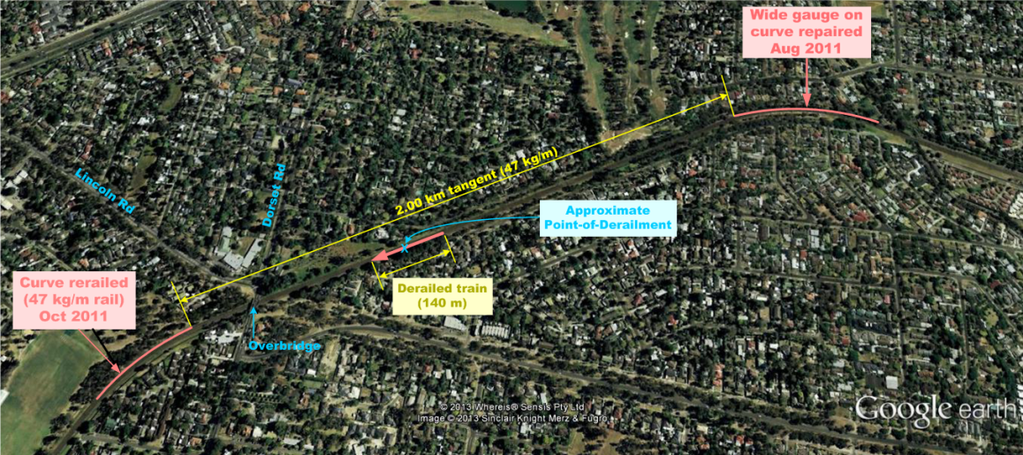

Figure 2: Incident location and adjacent track (© Google Earth 2012)

The track through this area was comprised of continuous welded 47 kg/m rail fastened on timber sleepers using sleeper plates and dogspikes. Continuous Welded Rail (CWR) is used extensively through the rail network and uses welded rail connections to achieve a continuous rail running surface.

Timber sleepers through this section were in a degraded condition and a tie-renewal program using concrete sleepers was scheduled for July 2013.

## Track works prior to the incident

### Context

Cyclic loading from the passage of trains produces stresses within rails that can result in the development of cracks in the rail material and surface defects. Critical rail defects have the potential to lead to rail breakages and so are removed through rail-replacement works.

Rail flaw detection had identified several sites on the network requiring rail replacement. At this location, rail head wheel burns[4] had also been identified.

### Works on 6-7 October 2012

On 6-7 October, re-railing work was conducted proximate to the derailment location. The rail of 82 metres of both the Up and Down tracks[5] was replaced. As part of these works, the sleepers were cross-bored[6] for re-spiking and box anchoring[7] was re-applied. However, only the Down track was re-stressed. The requirement and intention to re-stress the Up track was noted and logged on a list of sites that required further work.

### Works on 23-24 October 2012

Later in October a Rail Flaw Detection vehicle identified a transverse defect in the Down rail (right-hand rail looking in the Up direction of travel) of the Up track that required removal within 24 hrs. The defective rail was removed and a seven-metre rail insert installed on the night of 23 (morning of 24) October. The derailment occurred within two metres of this closure rail.

There was no indication that the installation involved punch-marking (see section 2.5.4) in an attempt to retain rail stress nor was the rail stressed at the time of installation. It was recorded that the rail would require re-stressing at a later date.

When the rail closure was installed, sleepers were not cross-bored for re-fastening of the rail. Combined with the degraded condition of the sleepers, this meant that the foot of the rail was poorly restrained and susceptible to misalignment.

### Works contractor and supervision

The rail replacement works in October were carried out by Nash Rail Pty Ltd under the supervision of MTM.

## Management of Continuous Welded Rail

### Rail stresses

A length of unconstrained steel rail will expand or contract by around 0.115 mm for every one metre in length and for every 10°C change in rail temperature. When rail is welded into a continuous length and fastened to sleepers, the rails are dimensionally constrained and rather than causing expansion and contraction, changes in temperature result in changes in rail stress.

The temperature at which a section of constrained rail is stress-free is termed its neutral temperature. Rail temperatures above the neutral temperature will cause compressive stresses to develop in the rail and may result in the rail and/or track becoming misaligned (an event known as ‘buckling’). Conversely, temperatures below the neutral temperature will result in tensile forces in the rail that can result in the rail breaking (an event known as ‘pull-apart’).

In the case of high compressive stresses, track structure and rail fastenings are designed to resist the tendency for sideways movement. However, if the ability of the track structure to withstand buckling forces is exceeded, the rails will move (and will often carry the sleepers with them) into a state of misalignment.

### Managing rail stresses

CWR is installed and maintained in a way that manages rail compression and tension across the range of environmental conditions the track is expected to experience. A rail Design Neutral Temperature (DNT) is established that best balances the risk of buckling at high rail temperatures against the risk of rail breakage at low temperatures. The DNT used by MTM is 38 °C on the basis that it provides the best balance given the extremes of heat and cold experienced across the Melbourne metropolitan region.

Rail temperatures can be of the order of 1.5 times the air temperature[8] and so in the summer months rail temperatures will often exceed the DNT and rails will be in a state of compression. Reliance is then placed on having effective track structures to control the tendency for misalignment. In addition, restrictions on train speeds are used to reduce the operational loads on the track, and inspection regimes such as heat patrols are used for the early identification of misalignment.

### Maintaining installed rail neutral temperature at the DNT

At initial installation, CWR is installed with a neutral (stress-free) temperature equal to the DNT. However, the neutral temperature of in-service rail will inevitably deviate from the DNT due to a number of operational and maintenance factors, and for this reason track is monitored to assure the desired state of rail stress is maintained.

In the case of maintenance works, re-railing is typically undertaken in the cooler months or at times when the rail is at a temperature below the DNT. This means that at the time of the works the rails will be in tension and the desired stress condition of the rail can be lost when the rail is cut. The punch-tensing method (see section 2.5.4) can be used to ensure rail is returned to its pre-works state of stress, particularly for small rail inserts. Alternatively newly-welded sections of rail can be re-stressed after installation. Cross-boring of fasteners (which should be done as a matter of course) reduces the risk of track destabilisation in the interim if re-stressing cannot be performed immediately and also contributes to the long term stability of the track.

### Punch-tensing method

For small rail inserts, the punch-tensing method provides a simple way of maintaining rail tension to a level similar to that present before the works. The method involves the indelible inscription (by punch marking) of the rail at two locations proximate to what will be the rail-ends once the cut has been made, and the accurate measurement of the distance between these marks. Once the rail is cut, the damaged section removed, and the new section (the ‘closure’) inserted, the gap in the rail is closed (drawn-in)—by the application of a horizontal hydraulic force—to retain, as near as possible, the exact distance between the punch marks, whereupon the closure is welded. Any difference in the distance between the punch marks before and after closure is recorded on the Weld Permission form (see section 2.6.1). The measurements from this form are used to assess whether subsequent re-stressing is required.

## MTM management of works and track condition

### Permission-to-Disturb (track) and CWR works

This process involves the use of a formal system of documentation to permit works such as project work or contractor activities that will ‘disturb’ (or have the potential to disturb) the state of the track tension to proceed, and ensure the risk of unintended rail tension change is managed.

The cutting of rail requires the approval of the Track Maintenance Engineer and the welding works on CWR are managed through a series of forms including the Weld Permission form and others that provide a record of the works. These forms include a record of the method by which the length of rail (and tension) through the works area has been maintained. There is also provision for the recording of rail temperatures.

Regarding the emergency repair work undertaken close to the Point-of-Derailment on 23-24 October, a Weld Permission form was raised for the rectification of transverse defect № 998. In the supporting documentation for the works there was no record of punch tensing and it was subsequently confirmed that this method was not employed. There was also no record made of the rail temperatures at the time of the works.

### Staff awareness – Welded Track Stability Summer Briefing

An MTM training officer reinforces with track personnel the approaching potential for track instability as well as occupational health and safety concerns that are likely with the onset of hot weather. This takes the form of briefings and pre-summer training sessions. The training for the 2012-13 summer was completed in mid-November.

### Summer Planning Process

The planning for the 2012-13 summer involved senior supervisors and engineers convening as the Summer Planning Committee. Before the commencement of summer, the group met fortnightly to manage track resources in preparation for the summer period. From 1 December the committee met weekly, looking at forecast temperatures and ‘at-risk’ sites listed for attention, and reviewing WOLOs[9].

The Summer Planning Committee managed issues pertinent to welded rail in order to minimise the risk in the network of track misalignment due to hot weather. Activities pursuant to the control of rail stress were conducted through the Welded-rail Management Plan (WMP). Prior to the Christmas break of 2012-13 there were 52 sites listed in the WMP that required remedial work. A post-derailment review of those sites revealed that 11—where new rail had been inserted and welded—required re-stressing. The other sites either had rail work that hadn’t commenced, had mechanical joints cut into the section of track to allow for rail expansion, or were protected in the interim by a Temporary Speed Restriction.

The Summer Planning Committee did not identify any inherent risks associated with the 11 sites where new rail was welded into the track and required re-stressing. The Croydon derailment location was one of the 11 sites.

At the last meeting for 2012 (held on 19 December, 15 days prior to the derailment) there were no ‘at-risk’ sites identified and the foremen for the four MTM track sectors completed their ‘Summer Sign-off’ in mid-December.

## Operational measures in hot conditions

### Temporary speed restrictions for high temperatures (WOLOs)

MTM applies a two-tiered regime for the institution of WOLO notices. From 38-41 °C a blanket TSR of 80 km/h is applied on the corridor, and when the temperature reaches 42 °C, a 70 km/h limit is generally applied. A lower temporary speed can be applied if required.

On the day of this derailment, a TSR had not been applied to this section and in any case the permitted line speed was already 80 km/h.

### Heat Patrols

When temperatures reach 35 °C, track inspectors conduct heat patrols (from the driver’s cab of EMUs). The purpose of the patrols is to detect any signs of developing misalignment.

On the day of the derailment, the temperature dropped below 35 °C leading to heat patrols for this track being cancelled. The temperature subsequently rose to again be above 35 °C in mid-afternoon however the patrols were not re-instituted and no patrol occurred over this section prior to the derailment.

## Track geometry condition monitoring

Track geometry is checked monthly using the EM100 track evaluation vehicle. Post-incident review of the EM100 data identified that, in the months prior the derailment, key track geometry parameters (gauge, top and line) were deteriorating at the derailment location. However, there was no single fault outside safety tolerances and the trend was not identified.

## History of heat related track misalignment

Records indicate that there had been a significant reduction in the reported incidence of heat-related track misalignment on the Melbourne network, dropping from 41 in 2009 to 3 in 2012.

# Analysis

## The derailment

It can be concluded that the derailment was the result of heat-induced misalignment within the track. The track was already in an unstable condition before the arrival of the 1509 Lilydale-to-Melbourne service and misalignment worsened during the approach of the train and as it passed over the section, causing the four intermediate cars to derail.

Misalignment was probably predominant in the right-hand rail (in the direction of travel) close to a seven-metre rail insert that had been installed on 23-24 October to remove a rail defect.

## Management of rail stress

### The stress-condition of the track

Maintaining the stress-condition of rail is critical in the management of CWR and the prevention of heat-induced track misalignment. When rail replacement works occur, there is the potential to adversely affect the controlled state of rail stress.

Rail replacement works were conducted on this section of track in early October and again on 23-24 October. In neither case was the stress in the rail managed, but rather the section identified for later re-stressing. In the case of the later works involving the short insert, there were simple options available to either maintain the stress state through the punch-tensing method, or to allow for expansion by using temporary fish-plated joints, but neither option was used.

As a result of the works conducted, the ongoing stability of the track was reliant on re-stressing of the rails being performed before the onset of hotter weather. This was not done and as a result the track was vulnerable to high temperatures causing significant compressive stresses within the rails and creating the potential for misalignment.

### Summer Planning Processes

The Summer Planning Process is an important review and assurance activity to ensure compliance with established CWR management processes. In this case it was ineffective in that it failed to follow up on 11 sites, including the derailment site, where rail had been replaced but not re-stressed.

## Fastening of rail following re-railing

The procedural requirement after installing replacement rail is for new dogspikes to be used and for the sleeper to be cross-bored to receive them. In the case of the works conducted on 23-24 October, the sleepers were not cross-bored and the previously-used dogspikes were re-inserted into the old spike-holes. As a result, this seven-metre rail insert was inadequately fastened and vulnerable to misalignment in the presence of compressive stresses.

## Effect of axle-load on the track misalignment

The deteriorating condition of the track at this location was evident prior to the passage of this train and the track was already in an unstable condition as the train approached. Given that the first car did not derail, the track probably moved further as the train passed over it. However, it is unlikely that being a Hitachi train was of significance.

# Conclusions

## Findings

1. The train was operated within the line speed.
2. It is unlikely that the type of train influenced the derailment.
3. Track geometry at the derailment location had deteriorated markedly in the latter part of 2012.

## Contributing Factors

1. The stress-condition of the track was not maintained during works conducted during October 2012 and the track was not subsequently re-stressed in preparation for summer conditions.
2. In the works carried out on 23-24 October, sleepers were not cross-bored for the fastening of the insert rail, leaving this section of track vulnerable to misalignment.
3. MTM supervision of the works conducted on 23-24 October did not ensure that the process of rail replacement followed MTM work practices.
4. Although this site was one of several identified as requiring re-stressing after rail replacement works, the summer planning processes did not identify the risk of track misalignment at this location.

# Safety Actions

## Safety Actions taken since the event

### Immediate actions

Immediately following the derailment at Croydon, Metro Trains Melbourne applied a Temporary Speed Restriction at other sites on the network that had been re-railed but had not yet been re-stressed, and committed to re-stress the rail at these sites.

Concerned at the possible contribution of the train to the derailment, Metro Trains Melbourne discontinued the operation of Hitachi trains when ambient temperature exceeded 36 °C.

### Subsequent actions

Following this incident, Metro Trains Melbourne initiated several actions to address identified system deficiencies that had led to the track instability and the subsequent derailment. Safety actions taken include:

1. The review and refinement of summer planning processes and the assessment of risk associated with unstressed rail.
2. The strengthening of systems supporting the application of track standards on rail replacement works, including compliance with rail stressing requirements and track construction.
3. The review and refinement of internal MTM training for the management of welded track.
4. Audit of the training and competency of welding contractors.
5. The review and revision of WOLO procedures.
6. The addition of software tools to assist with the analysis of recorded track geometry data.

1. Stressing (also referred-to as ‘tensioning, tensing’ or ‘de-stressing’) is used to reduce the potential for track misalignment arising from excessive compressive stresses in Continuous Welded Rail during hot weather.
2. Wu Y., Munro P., Rasul M.G., Khan M.M.K., A review of Recent Developments in Rail Temperature Prediction for use in Buckling Studies, *RTSA Conference on Railway Engineering, Wellington, 2010.*
3. ‘M’ cars are motor (powered) cars and ‘T’ cars are trailer (non-powered) cars.
4. A wheel burn (or rail burn) is an indentation ground into the head of the rail by a train or locomotive drive wheel that has been rotating without any or sufficient forward progressive movement.
5. The Up track on a double-line corridor is the track carrying trains toward Melbourne.
6. Drilled to accept dogspikes or screws in the opposite diagonal pattern to the previous application. This ensures the new fasteners are employed in a fresh part of the sleeper.
7. The application of four rail anchors to a sleeper; that is, two to each rail with one anchor on each side of the sleeper. Rail anchors grip the foot of the rail and inhibit the tendency for it to ‘creep’ longitudinally. Applying anchors in a ‘box’ pattern is a normal process to assist in stabilising track.
8. Wu et al, *ibid*.
9. The application of a heat-related speed restriction is accomplished by publishing a notice called a WOLO. The name is not an acronym, but derives from the original telegraph code for such a notice. The temperature and environmental conditions that result in the publication of such a notice are often known as WOLO conditions.