

Rail Safety Investigation

Report No 2014/02

Derailment of tourist and heritage train

Victorian Goldfields Railway

near Castlemaine

15 June 2014

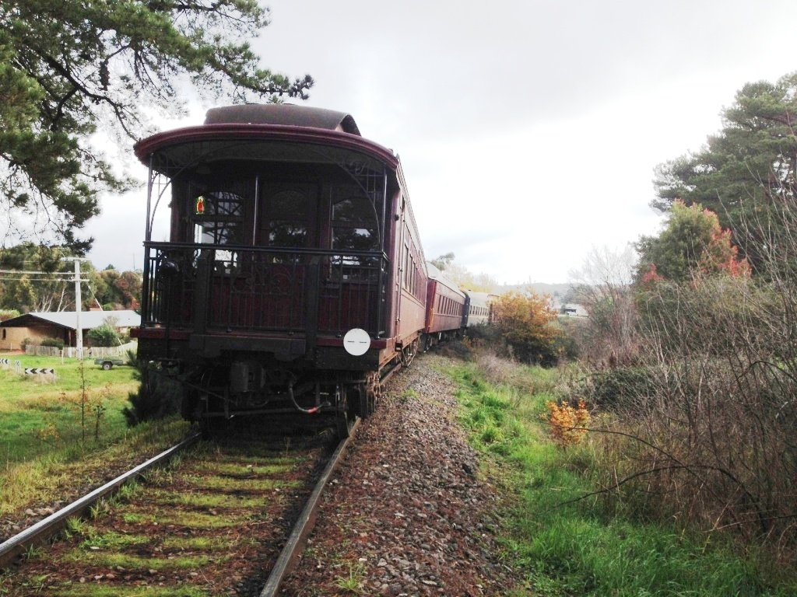

The Chief Investigator

The Chief Investigator, Transport Safety is a statutory position under Part 7 of the *Transport Integration Act 2010*. The objective of the position is to seek to improve transport safety by providing for the independent no-blame investigation of transport safety matters consistent with the vision statement and the transport system objectives.

The primary focus of an investigation is to determine what factors caused the incident, rather than apportion blame for the incident, and to identify issues that may require review, monitoring or further consideration.

The Chief Investigator is required to report the results of an investigation to the Minister for Public Transport or the Minister for Ports. However, before submitting the results of an investigation to the Minister, the Chief Investigator must consult in accordance with section 85A of the *Transport (Compliance and Miscellaneous) Act 1983*.

The Chief Investigator is not subject to the direction or control of the Minister in performing or exercising his or her functions or powers, but the Minister may direct the Chief Investigator to investigate a transport safety matter.

Safety Summary

What happened

The Victorian Goldfields Railway (VGR) tourist passenger train had departed from Castlemaine and was running to Maldon when it derailed at a location approximately 1.15 km from Castlemaine Station as a result of degraded track conditions. The steam locomotive was not derailed but its tender was, as were all four passenger cars. All rollingstock remained upright and there were no injuries to passengers or crew.

What was found

The Chief Investigator found that the track at the derailment location was not in a suitable condition for train operations and that the degraded condition of sleepers had compromised its structural integrity. The continuation of passenger operations was permitted without the implementation of appropriate risk mitigation controls.

It was also found that limit boards for a Temporary Speed Reduction just beyond the derailment location had been missing for an extended period and had not been replaced.

What has been done as a result

VGR has advised its intention to implement improvements to track condition monitoring and asset management, and to accelerate the replacement of sleepers in critical areas.

Remaining safety issues

The specific actions proposed by VGR partly address the identified safety issues. To address remaining safety issues, recommendations are made to VGR to develop track condition criteria to assist operational decision making, and to review its processes for maintaining track-side signage.

Safety message

Setting specific criteria for assessing safety-critical infrastructure would assist network managers to more objectively judge the suitability for operations of infrastructure that might be in varying states of fitness.

TABLE OF CONTENTS

1. The Occurrence 7

2. Context 9

2.1 The Victorian Goldfields Railway (VGR) 9

2.2 The train 9

2.3 Train personnel 10

2.4 Infrastructure 10

2.5 VGR track maintenance 13

2.6 Previous incidents 14

3. Safety analysis 15

3.1 Track condition 15

3.2 Certification of track for operations 15

3.3 Excess cant 15

3.4 Train speed 16

3.5 Signage for Temporary Speed Reduction 16

4. Findings 17

4.1 Contributing factors 17

4.2 Other factors that increased risk 17

5. Safety issues and actions 18

# The Occurrence

The Victorian Goldfields Railway (VGR) steam-hauled train 103 departed Castlemaine at about 1215 on Sunday 15 June 2014. It was returning from Castlemaine to Maldon to complete the first of two round trips scheduled for the day. On a right-hand curve about 1.15 km out of Castlemaine, at around mileage 78.75[1] between the Rowe Street and Maclise Street level crossings, the locomotive tender and all four trailing passenger cars derailed. The speed of the train immediately prior to the derailment was approximately 18 mph (29 km/h).[2]

Figure 1: Incident location map showing route of the VGR

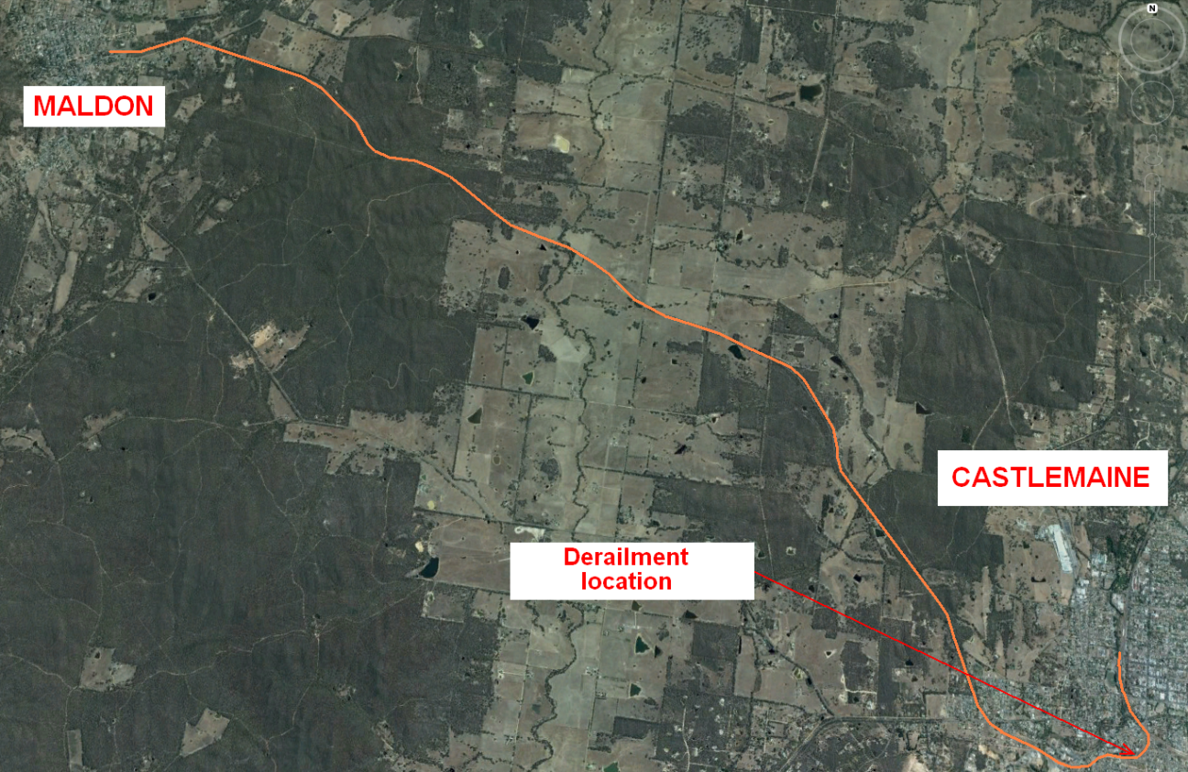

Source: Google 2014 ©. Annotated by Chief Investigator Transport Safety

The derailment occurred on a section of degraded track that had wide gauge that spread further under the passage of the train. From the point of derailment, the train travelled a further 90 m before being brought to a stand. The tender and all passenger cars remained upright and connected to the locomotive that did not derail.

None of the 60 passengers or seven staff on board were injured. Passengers were assisted by staff to detrain and were transported by bus to Maldon Station.

Figure 2: View of derailed vehicles rearward from the locomotive tender

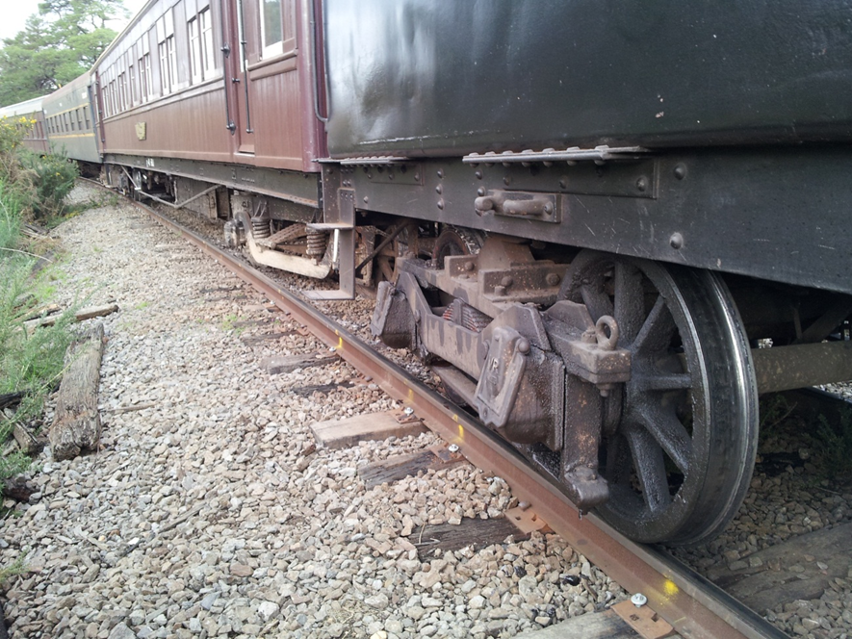

Source: VGR

Site inspection indicated that the leading right-hand wheel of 41BU (Figures 2 and 3) was probably the first to derail by dropping to the gauge side of the inside rail. During the derailment, some wheels on the outer side of the curve climbed over that rail and dropped on the field side. The trailing axle of the tender was then pulled from the rails.

Figure 3: Derailment plan

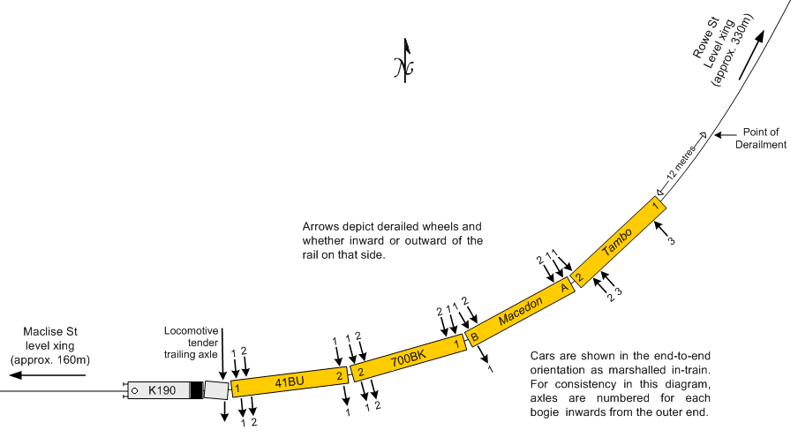

Source: Chief Investigator Transport Safety

# Context

## The Victorian Goldfields Railway (VGR)

The VGR is an accredited Tourist & Heritage railway operated by the Castlemaine & Maldon Railway Preservation Society, an incorporated not-for-profit entity. The railway is a remnant rural Victorian broad-gauge (1,600 mm) branch line built in 1884 to the ‘light-line’ standards of the day and preserved, as a minimum, to these same standards. The restored railway has been in operation since 1986 and currently provides a tourist passenger service between Maldon and Castlemaine—operating a regular schedule two days per week and special trips as arranged—with steam or diesel motive power.

## The train

Train 103 comprised ex-Victorian Railways 2-8-0 steam locomotive K190 (on loan from Streamrail Victoria), passenger cars 41BU and 700BK, rebuilt ex-VR/SAR Pullman sleeping car, *Macedon*, and ex-VR/SAR 1st Class Sitting/Parlour Car, *Tambo*. The trailing consist was around 270 feet (82 m) long and weighed approximately 167 tons (170 t).

Following rerailing, the rollingstock was recovered by VGR technical staff to Maldon and car 41BU—the vehicle considered to have been the first to derail—was examined. The inspection concluded that there were no obvious defects with the vehicle that might have contributed to the incident.

Figure 4: Train 103 following the derailment

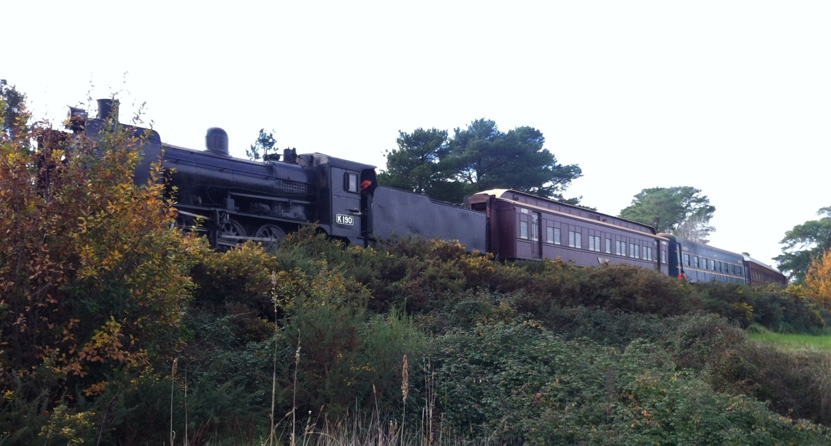

## Train personnel

There were three locomotive crew members on board the locomotive. All were qualified for their duty and current in required competencies. Preliminary Breath Tests of the locomotive crew members were conducted by Castlemaine Police, with neither result evidencing alcohol.

There were also four VGR passenger service staff on board the train; a Guard, a Conductor and two car attendants. The Guard was the senior officer on the train and was responsible for discharging safeworking requirements. All staff members were qualified to VGR requirements.

## Infrastructure

### Overview

The incident occurred at a 12-chain (241 metre)[3] radius right-hand curve on a descending grade of approximately 1:40 (2.5 per cent). The track structure through the location consisted of 94 lb/yd (47 kg/m) rail in approximately 80-m welded lengths secured to timber sleepers using double-shoulder sleeper plates with a mixture of dogspikes and screwspikes, on gravel ballast. The VGR had been progressing a sleeper upgrade program from Maldon towards Castlemaine but had not yet progressed past the Maldon Junction-Maclise Street location.

The permitted speed through this section was 15 mph (24 km/h) and the train was approaching a 10 mph (16 km/h) Temporary Speed Reduction (TSR) effective from about 100 m east of Maclise Street to Maldon Junction. The starting point of the TSR was beyond the point of derailment, although its precise location was not documented.

Figure 5: Derailment location

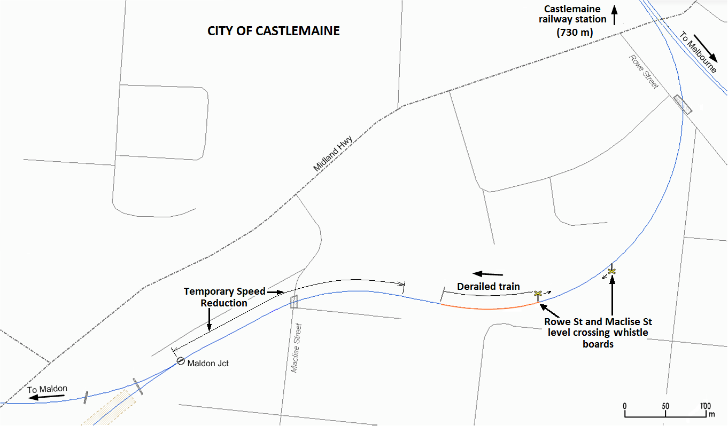

Source: Pass Assets, PTV. Diagram to scale, annotated by Chief Investigator Transport Safety

Figure 6: Track profile diagram

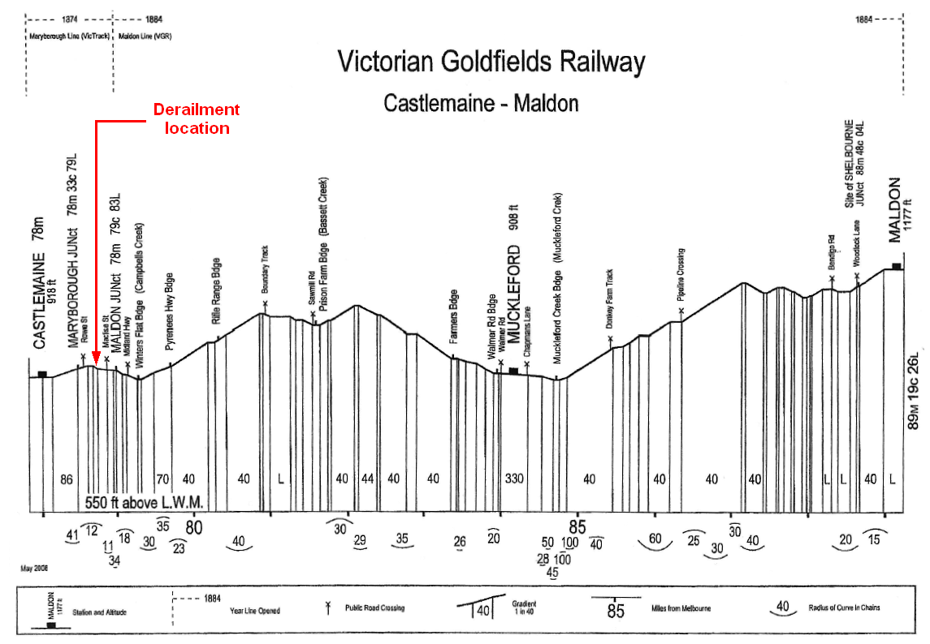

Source: VGR

### Incident site inspection

The track at the Castlemaine end of the derailment site (that is to say, the track traversed by the train immediately prior to the derailment) was comprised of timber sleepers in poor-to-very-poor condition. In the three metres prior to the derailment location, there was also a cluster of degraded sleepers that would have been unable to afford effective lateral and vertical support to the rails. Ballast condition was observed to be fair-to-poor, with a consistent level of fouling and contamination.

Track superelevation in the curve just ahead of the derailment varied between 60 and 90 mm and was in excess of the ideal of about 30 mm for this curve and the track speed of 25 km/h. Excess cant can increase the loading on the inner rail causing—among other things—a propensity for the inner rail to tilt (roll) outwards from the track centre towards the centre of the curve.

The rail was in a serviceable condition. The rail on the high leg of the curve (outside rail, left-hand in direction of travel) had approximately 10 mm of wear on the gauge face, the angle of which was between 15 and 20 degrees and within the accepted 26-degree maximum for such wear.

The rail was fastened to the sleepers using dogspikes predominantly, with 1-in-4 sleepers having screwspikes in place of and sometimes in addition to the dogspikes. There was evidence along the 100 m of track leading up to the point-of-derailment (PoD) that on average, 50 per cent of sleepers would be unable to hold gauge or provide sufficient lateral and vertical support to the rail due to ineffective fastening of baseplates.

There was also evidence—on the edge of the rail foot—of abrasion against the retaining shoulders of some baseplates (Figure 7), showing that the rail was also moving within the plates. This would have permitted additional movement of the rail under rollingstock operational loads.

Figure 7: Rail sitting high in baseplate, right-hand (low leg) rail, field side shown

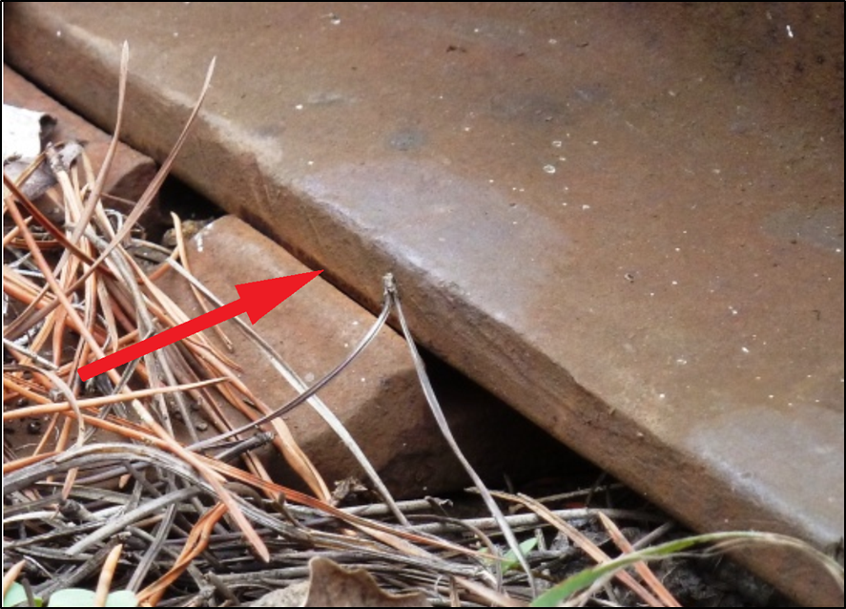

A PoD was identified by a brief tread-corner track[4] and associated bruising along the gauge corner of the inside rail (right-hand in direction of travel). This was consistent with a right-hand wheel having run for a brief distance on the innermost edge of the rail before dropping inside. At this point the measured static gauge was about 35 mm wide. Beyond this point, the track was further spread as a result of the derailed wheels, with gauge readings exceeding 1,680 mm.

At some point during the derailment some wheels had climbed the outside rail (left-hand in direction of travel). However, markings showing flange climb locations were not clearly evident and it is unclear at what point this occurred. The angle of wear on the gauge face of the outside rail combined with the potential for its outward rotation due to poor fixing at several locations would have increased the potential for flange climb.

There were no extreme environmental factors that had affected the site. In the seven days leading up to the incident, the Castlemaine area had received 16 mm of rain.

The signage demarcating the 10 mph Temporary Speed Reduction (TSR) commencing about 100 m east of Maclise Street was not in place.

Figure 8 shows the rear end of the last car at the position in which it came to a stand. The PoD is arrowed.

Figure 8: Approach end of derailment site, looking in the direction of travel

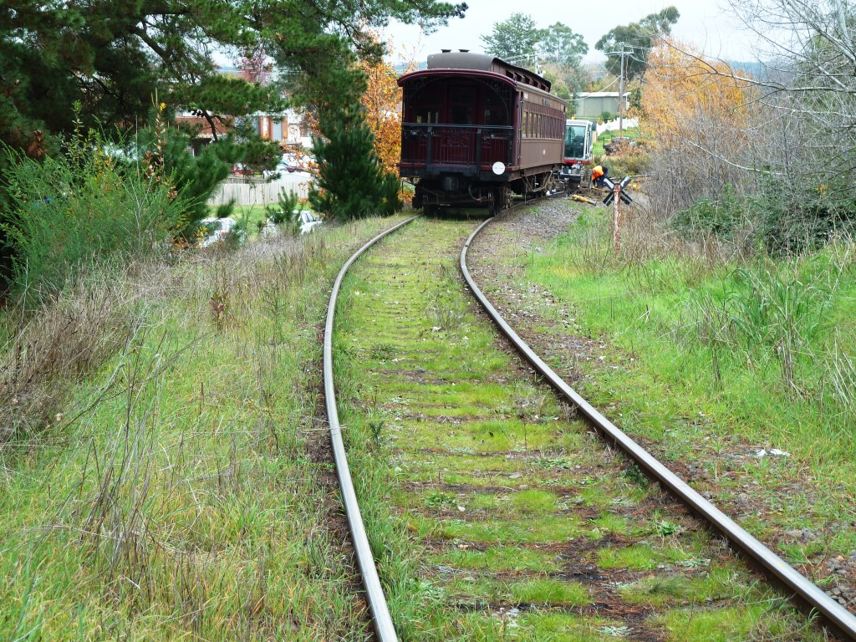

## VGR track maintenance

### Overview

Track maintenance on the VGR is managed by the railway itself. Designated paid and volunteer staff carry out day-to-day track maintenance activities as well as 6-monthly walking track inspections, and a contracted railway infrastructure company conducts an annual infrastructure inspection in accordance with the VGR’s Safety Management System. VGR personnel conduct a low-speed track patrol by Hi-Rail[5] vehicle at the commencement of each running day and prior to any train operation.

### VGR Permanent Way Manual

A Permanent Way Manual (issued 1st September 2006) is provided for the information and guidance of staff and volunteers engaged in engineering activities on the track and formation. The manual prescribes that comprehensive inspections of the railway shall be carried out twice annually, the purposes being: (1) to provide an informed view and documented report of the condition and fitness-for-purpose of the railway; (2) to provide a background for the planning of programmed maintenance and associated capital works; (3) to fulfil accreditation obligations; and (4) to consolidate and review the matters reported by track patrollers.

The scope of inspections is specified in detail and persons undertaking inspection and maintenance tasks are required to hold the formal qualifications appropriate to their duty.

### Daily inspection on 15 June 2014

An inspection was carried out by Hi-Rail, as normal, on the morning of the derailment and did not identify any track anomaly at the derailment location.

### 6-monthly track inspection

The last walking track inspection prior to this incident had been conducted on 11 March 2014 by the VGR Acting Manager of Civil Engineering & Infrastructure and the Track Works Supervisor. The Rowe St level crossing-to-Maldon Junction segment was marked as being in ‘Poor’ condition with the curve being 25 mm over-gauge and requiring the installation of 120 sleepers.

### 12-Monthly track inspection

The most recent contractor’s inspection of track and associated infrastructure was conducted on 25 March 2014 in company with the VGR Manager of Civil Engineering & Infrastructure and the Track Works Supervisor. With regard to the Maldon Junction-to-Castlemaine section, the report stated that additional work to replace deteriorated sleepers was required to ensure safety and rectify any track issues.

The report concluded that the track was in a satisfactory condition for operations but that there were many areas that were becoming due for sleeper renewal and maintenance. The report also suggested that the timely completion of such works might be beyond the current resources of the railway and that VGR would need to consider both the increased level of maintenance currently required and longer-term track maintenance planning.

### Remedial works

VGR had acquired a quantity of second-hand 80 lb/yd (40 kg/m) rail and good-quality used timber sleepers that were being progressively installed on the railway. Sleeper replacement works had not yet reached the site of the derailment.

## Previous incidents

On 4 March 2012, a similar derailment occurred on the Victorian Goldfields Railway as a result of the track having spread due to degraded track conditions. The subsequent investigation[6] concluded that the load placed upon the track structure by the passage of the train overcame the ability of the sleeper fasteners to retain the rail in position, with the result that the track gauge widened and permitted the train to derail. Along with other portions of the railway, this particular curve had been identified by VGR inspections as requiring significant sleeper replacement.

The report stated that bi-annual and annual inspections had identified the degraded condition of sleepers but did not adequately articulate the scope of corrective action required, nor the degree of urgency. It was recommended that the VGR review its track inspection and maintenance regime to ensure defects and deficiencies are identified and programmed for prompt rectification.

# Safety analysis

## Track condition

The derailment occurred during a period of works designed to improve the structural integrity of the track, however these improvement works had not advanced as far as the location of this derailment. The derailment location was on the tightest curve on the Victorian Goldfields Railway.

A significant number of sleepers were in a degraded state and rail fasteners were not properly securing the rail. The load placed upon the track structure by the passage of the train overcame the ability of the fasteners to retain the rail in position, with the result that the track ‘spread’, widening the gauge and permitting the commencement of a derailment sequence.

## Certification of track for operations

The external contractor’s annual inspection is designed to provide independent oversight of the condition of the infrastructure. Following the most recent inspection, the contractor reported that many areas were becoming due for extensive sleeper renewal and maintenance. The report also questioned the capacity of the railway to undertake these works in a timely period. Potentially contrary to these observations and without reference to specific criteria, the report concluded that the track condition was satisfactory for current operations.

Along with other portions of the railway, this particular curve had been identified during VGR inspections as requiring significant sleeper replacement. A judgement was made that it was safe to continue passenger operations without restriction and at line speed with the track in this degraded condition; a judgement that proved to be incorrect. A more prudent approach would have been to implement appropriate risk mitigation through this location until remedial works had been completed.

The outcome of this incident is not dissimilar to that of March 2012. That investigation concluded that although track inspection had identified sleepers that were in a degraded state, inspection reports did not adequately articulate appropriate and timely corrective action.

Both incidents highlight the tension that exists between the railway’s desire to maintain operations and the maintenance of its track infrastructure at an acceptable safety level; a conflict sometimes evident in Tourist & Heritage operations. VGR is resource-constrained, both in its acquisition of materials for maintenance works and—perhaps more critically—in its resourcing of labour to undertake those works. Two passenger train derailments within just over two years suggests that a re-balancing of priorities is required. Specific criteria setting out the minimum track conditions that should exist would help to improve the reliability of decision-making for permitting train operations.

## Excess cant

Rail-to-rail superelevation through this curve was two to three times the ideal for the defined section line speed of 15 mph. Significant excess cant can lead to less-than-ideal curving performance, increased lateral forces on the inner rail and in the presence of high wheel-to-rail friction, greater gauge spreading forces.

## Train speed

The locomotive speed recorder indicated that the train had attained a speed of about 18 mph immediately prior to derailing, about 3 mph (5 km/h) above line speed. The train was running on a 1:40 downgrade that would have encouraged this exceedence.

Small excursions beyond the line speed normally fall within operational tolerances and track should be maintained to accommodate such exceedences. However, in this instance, the degraded condition of the track rendered it more susceptible to the effect of train speed. Higher speeds also tend to increase the severity of consequences associated with a derailment.

## Signage for Temporary Speed Reduction

The train derailed as it approached a Temporary Speed Reduction (TSR) that the locomotive crew had acknowledged as part of their sign-on procedure and were familiar with from normal rostered operations. However, the limits of this TSR were not defined by speed boards, therefore increasing risk to the operation. Signage had originally been erected but was not in place at the time of the incident and reportedly had not been for a considerable time.

The VGR Permanent Way Manual contains explicit instructions around the maintenance of trackside and on-track signage, however despite regular track patrols, this deficiency was not rectified over an extended period.

# 

# Findings

The following findings are made with respect to the derailment of Victorian Goldfields Railway train 103 on 15 June 2014. These findings should not be read as apportioning blame or liability to any particular organisation or individual.

A safety issue is an event or condition that increases safety risk and: (a) can reasonably be regarded as having the potential to adversely affect the safety of future operations; and (b) is characteristic of an organisation or a system, rather than of a specific individual, or is characteristic of an operating environment at a specific point in time.

## Contributing factors

* The track structure was degraded and lacked the capacity to sustain operational loads. A significant number of sleepers were in a poor condition and rail fasteners were not adequately securing the rail.
* Passenger operations were permitted to continue without restriction and at line speed with the track in a degraded condition. Inspections had identified the need for sleeper replacement at the derailment location, however, the scheduled maintenance works had not yet been completed and temporary risk management controls were not implemented. **[Safety Issue]**

## Other factors that increased risk

* The track geometry exhibited excessive cant for the defined track speed.
* Train speed exceeded the defined track speed approaching the derailment location. Whereas such small excursions beyond the line speed would normally fall within operational tolerances, the condition of the track at this location was such that increased speed may have heightened the risk of derailment.
* Limit boards were not in place for the Temporary Speed Reduction in the vicinity of the Maclise Street level crossing. **[Safety Issue]**

# 

# Safety issues and actions

The safety issues identified during this investigation are listed in the Findings and Safety issues and actions sections of this report. The Chief Investigator, Transport Safety expects that all safety issues identified by the investigation should be addressed by the relevant organisation(s).

Any person or body who assisted the Chief Investigator, Transport Safety with this investigation or to whom the report may be relevant was provided with a copy of the draft report and invited to provide comment.

Certification of track for passenger operations

|  |  |
| --- | --- |
| Number: | 2014-02-001 |
| Issue owner: | Victorian Goldfields Railway |

***Safety issue description***

Passenger operations were permitted to continue without restriction and at line speed with the track in a degraded condition. Inspections had identified the need for sleeper replacement at the derailment location, however, the scheduled maintenance works had not yet been completed and temporary risk management controls were not implemented.

***Proactive action taken by the Victorian Goldfields Railway***

The VGR has advised its intention to:

* conduct an engineering assessment of the suitability of track fasteners used;
* accelerate the replacement of sleepers in critical areas;
* undertake ongoing monitoring of rail and sleepers impacted by this derailment but left in-situ;
* require its track certification consultant to include more explicit detail on track maintenance requirements in their reports;
* continue development of an Asset Management Plan; and
* expedite the conduct of an audit of the Safety Management System.

***Chief Investigator comment in response***

When implemented, the actions proposed by the VGR will partly address this safety issue. Additional safety action to support the objective assessment of track suitability for operations is considered warranted.

***Chief Investigator recommendation***

That Victorian Goldfields Railway develops minimum track condition criteria on which to base decisions as to whether or not to operate, restrict operations, or suspend operations over any section of track.

Signage for Temporary Speed Reduction

|  |  |
| --- | --- |
| Number: | 2014-02-002 |
| Issue owner: | Victorian Goldfields Railway |

***Safety issue description***

Limit boards were not in place for the Temporary Speed Reduction in the vicinity of the Maclise Street level crossing.

***Chief Investigator recommendation***

That Victorian Goldfields Railway reviews its processes for ensuring that track signage is maintained to meet operational safety requirements.

1. Approximately 126.673 km, PASS Assets (Public Transport Victoria). The VGR uses the original Victorian Railways mileposts and imperial terminology to define distance along the railway (measured from Melbourne).
2. From the Flaman Speed recorder on the locomotive. The speed recorder drive is taken from a locomotive trailing drive wheel. None of the locomotive drive or carrying wheels derailed during this incident.
3. Castlemaine-Maldon Rail Records – VGR.
4. A marked line across the rail head (or along its gauge corner) that has been inscribed by the outside chamfered edge of a wheel tread.
5. Generic rail industry term for a road vehicle that has been modified to also travel on rail lines and that can be configured quickly to travel in either mode (hence ***Hi***ghway-***Rail***way).
6. Chief Investigator Transport Safety - Rail Safety Investigation Report No. 2012/01.