

Bus Safety Investigation

Report No 2017/06

Passenger coach rollover

Sunraysia Highway, Tanwood

14 October 2017

The Chief Investigator

The Chief Investigator, Transport Safety is a statutory position under Part 7 of the *Transport Integration Act 2010*. The objective of the position is to seek to improve transport safety by providing for the independent no-blame investigation of transport safety matters consistent with the vision statement and the transport system objectives.

The primary focus of an investigation is to determine what factors caused the incident, rather than apportion blame for the incident, and to identify issues that may require review, monitoring or further consideration.

The Chief Investigator is required to report the results of an investigation to the Minister for Public Transport or the Minister for Ports. However, before submitting the results of an investigation to the Minister, the Chief Investigator must consult in accordance with section 85A of the *Transport (Compliance and Miscellaneous) Act 1983*.

The Chief Investigator is not subject to the direction or control of the Minister in performing or exercising his or her functions or powers, but the Minister may direct the Chief Investigator to investigate a transport safety matter.

Investigation scope

The Chief Investigator may limit the scope of an investigation. The focus of this investigation was to identify the safety factors leading to this incident, and research areas for safety improvement. This event is also subject to investigation by Victoria Police and the Victorian Coroner.

Safety summary

What happened

At about 1500 on Saturday 14 October 2017, a passenger coach travelling from Mildura to Ballarat left the Sunraysia highway at Tanwood and rolled onto its side. The coach was carrying 27 passengers. Two passengers sustained fatal injuries and 12 suffered injuries classified from moderate to severe. The remaining passengers and the driver sustained minor injuries.

What was found

It was found that the coach left the road as a result of driver inattention. The inattention was probably due to the driver experiencing a microsleep. A combination of disturbed sleep, a mid-afternoon circadian low and post prandial somnolence (sleepiness after a heavy meal) increased the likelihood of a microsleep.

Currently, there is no requirement under Australian design rules to fit systems that detect driver impairment in passenger coaches. However, the National Road Safety Action Plan is implementing strategies to influence the transport industry to uptake safer vehicle technologies including those that detect driver fatigue and distraction.

Although mandated in law, almost half the occupants were not wearing seat belts making them more vulnerable to projection from their seat and ejection from the vehicle. The rate of moderate or more severe injury was higher in the passenger group not wearing seat belts.

What's been done as a result

The coach operator has installed a computerised real-time electronic work diary in each vehicle that records drivers work and rest hours and provides automatic rest reminders. They have also implemented an audit process to identify non-compliance with respect to work-rest periods and provide non-conformance reports.

The Department of Transport advised that they are taking steps to investigate fatigue management technology from the roadside and is contributing to both the National Heavy Vehicle Law Reform and the Heavy Vehicle Licencing Reform initiatives.

Safety message

Passenger coach drivers should be aware that there is an increased likelihood of microsleeps during mid-afternoon, especially after a heavy meal.

This incident highlighted that the severity of injury to passengers not wearing seat belts was significantly higher than those wearing seatbelts. The passenger transport industry should consider the introduction of systems to influence greater passenger compliance with respect to the wearing of seatbelts.

TABLE OF CONTENTS

1. The Occurrence 1

2. Context 2

2.1 Location 2

2.2 The coach operator 2

2.3 The coach 3

2.4 The driver 4

3. Safety Analysis 5

3.1 The incident 5

3.2 Cognitive workload 5

3.3 Driver distraction 5

3.4 Attentional disengagement (mind wandering) 5

3.5 Fatigue 6

3.6 Microsleeps 7

3.7 Fatigue Management 8

3.8 Technologies for improving safety 10

3.9 Seat belts 12

4. Findings 14

4.1 Contributing factors 14

4.2 Other factors that increased risk 14

5. Safety issues and actions 15

5.1 Wearing of seat belts 15

Additional safety action taken 15

# The Occurrence

At about 0830 on 14 October 2017, a passenger coach carrying 27 passengers departed Mildura. The passengers were members of the Ballarat District Bowls Division and were returning to Ballarat (Figure 1).

The coach arrived at Sea Lake at about 1058 to drop off one of the passengers. It departed Sea Lake at 1113 and arrived at Donald at 1232. The driver and the passengers had lunch at a hotel in Donald and departed Donald at 1409. At about 1504 at Tanwood, the coach veered off the Sunraysia Highway, rolled down an embankment before coming to rest on its side. The coach suffered significant impact damage to its front and roof.

Figure : Route of coach from Mildura to Tanwood

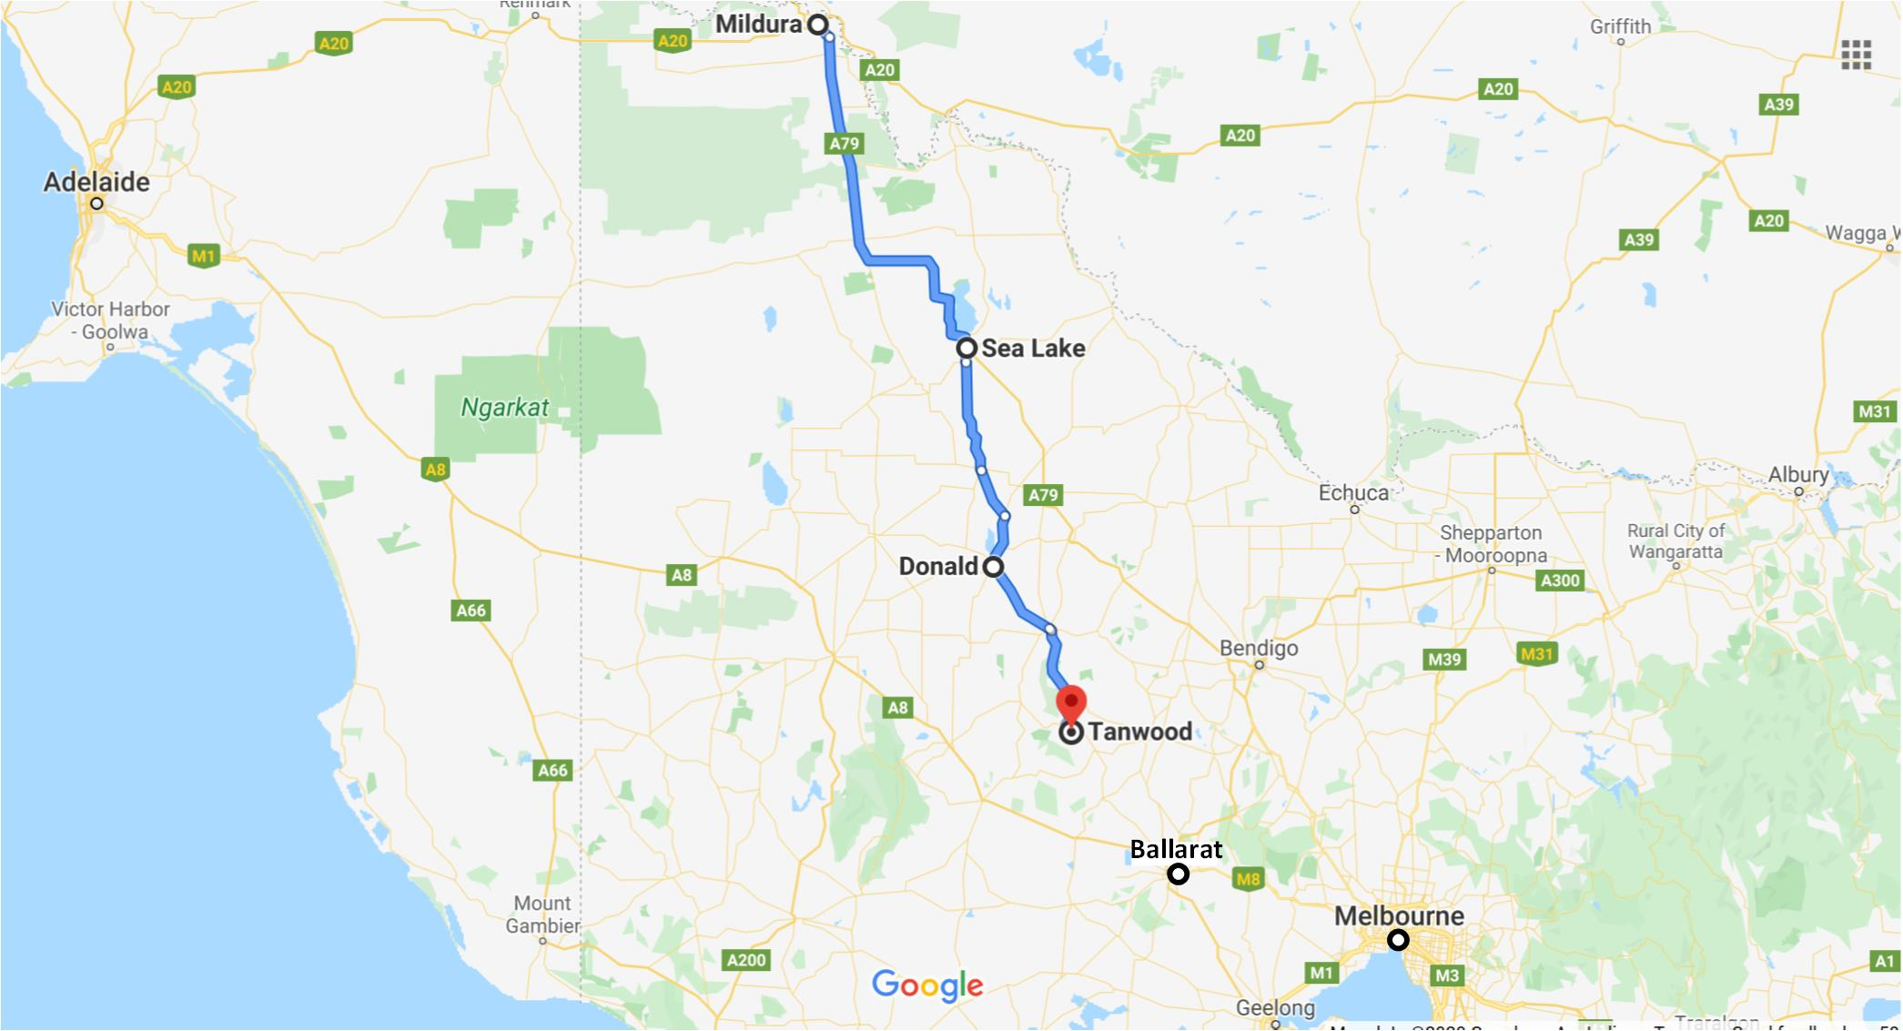

**Source: Google Earth – Annotated by Chief Investigator, Transport Safety, Victoria**

One passenger sustained fatal injuries at the scene of the accident. Three passengers were airlifted to Melbourne with significant injuries and one of these passengers subsequently passed away. The other injured passengers were treated in Ballarat, Avoca and on site.

# Context

## Location

The incident occurred on the Sunraysia Highway. At this location, the highway was a two-way single carriage road with the carriageways separated by double white lines. The road edges were marked by plain, untextured white lines and the road’s shoulders were unsealed on both sides.

The maximum speed for this section of highway was 100 km/h and at this location the road gently curved to right in the direction of the coach’s travel (Figure 2).

Figure : Location where the coach started to leave the road.

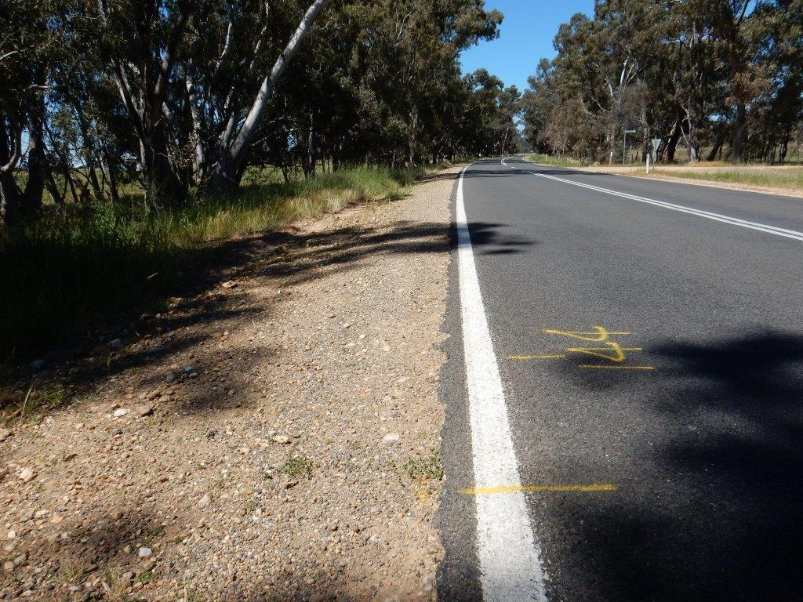

**Source: Chief Investigator, Transport Safety**

## The coach operator

The coach charter service was being provided by Ballarat Coachlines. The operator was accredited by Transport Safety Victoria (TSV)[1] under the *Bus Safety Act 2009* (Vic), to operate a commercial bus service or a local bus service.

Ballarat Coachlines operated 22 vehicles that were used as school buses, route buses and tour and charter coaches. They employed five full-time drivers and about 15 casual drivers.

## The coach

### Construction standards

The Vehicle Safety Standards Unit of the Commonwealth Government’s Department of Infrastructure, Regional Development and Cities (DIRDC) administers the *Motor Vehicle Standards Act 1989* (Cth), which requires that all new road vehicles, whether they are manufactured in Australia or are imported, comply with national vehicle standards known as the Australian Design Rules (ADR), before they can be offered to the market for use in transport in Australia. The ADRs set minimum standards for safety and emissions performance.

The ADRs specify design and construction standards for vehicles operating on Australian Roads. ADR 58/00 – Requirements for Omnibuses Designed for Hire and Reward, ADR 59/00 – Omnibus Rollover strength and ADR 68/00 – Occupant Protection in Coaches are the applicable standards with respect to coach superstructure strength and occupant protection.

### Configuration

This coach was manufactured in 2004. The chassis was a Scania K124 built by Scania AB of Sweden. The engine was a turbocharged and intercooled 6-cylinder Diesel engine. It had an automatic transmission, but with a manual clutch for starting. The vehicle had completed 1,152,935 km at the time of the incident.

The coach was designed for long-distance passenger operations and had a recorded passenger capacity of 50, with all seats fixed, forward-facing and fitted with seat belts. An illuminated sign at the front of the coach informed passengers to wear their seat belts.

The driver typically set the cabin temperature at 22 °C.

### Post incident vehicle inspection

A post-accident inspection was carried out by the Mechanical Investigations Unit (MIU) of Victoria Police. The MIU concluded that the accident was not caused by a mechanical fault with the vehicle.

The steering and suspension system components were examined and found to be in good condition. Except for one tyre that had deflated due to impact damage, all the other tyres were inflated to the required pressures and the tread depths were above the minimum required. The coach was also road tested by the MCIU to about 40 km/h and the steering, suspension and brake systems were found to operate satisfactorily.

### Seat belts and injuries

From available evidence, it was concluded that 14 passengers and the coach driver were wearing seat belts, 12 were not and two could not be confirmed. Of the fatally injured passengers, one passenger was not wearing her seat belt and was projected from her seat. The other fatally injured person was wearing her seat belt and was seated in the forward-most seat on the left side, but sustained crush injuries due to deformation of the barrier in front of her seat. Of the passengers with non-fatal injuries, three with seat belts sustained moderate to severe injuries and nine without seat belts sustained moderate to severe injuries.

## The driver

The driver of the coach was a 69-year-old male and held all required certification to drive this coach. He held a valid and current Victorian heavy vehicle driver licence and a current driver accreditation certificate issued by the Taxi Services Commission under the *Transport (Compliance and Miscellaneous) Act 1983* (Vic). The driver had no recorded traffic offences in the previous five years.

The driver had been driving coaches for about nine years since commencing with Ballarat Coachlines. He had five years’ experience driving this model of coach. This was the third time he had been the driver for the annual Ballarat-Mildura-Ballarat bowling club charter.

The driver had completed a medical assessment in July 2017 to renew his driver accreditation certificate. The assessment did not indicate any medical conditions that may have contributed to this incident.

### Driver work/rest schedule

The driver had driven the bowling group from Ballarat to Mildura 3 days earlier on 11 October. His driving duties were light over the subsequent days, ferrying the group between the hotel and various venues around Mildura with reportedly at least 8 hours sleep each night.

On the night before returning to Ballarat, the driver parked the coach at about 2322. He then retired to his room to sleep. He reported waking at about 0715 the next morning. There are reports of a disturbance outside the hotel in the early hours of the morning, and it is probable that the driver’s sleep was disturbed.

After preparing for the day, the driver had breakfast at the hotel. The coach was then prepared, passengers boarded, and the coach departed the hotel at about 0830. The coach stopped at Sea Lake for about 15 minutes before departing at 1113. The coach arrived at Donald at about 1232. The driver had a reasonably heavy lunch and a soft drink during this stop and departed Donald at 1409.

# Safety Analysis

## The incident

At 1504, the coach was traversing a gentle right-hand curve when it left the road. It was travelling at about 98 km/h, that was below the road speed limit. The coach had commenced to negotiate the curve by steering right before leaving the road. Tyre track marks indicate that the coach continued straight and that the left-hand wheels entered the unsealed road shoulder. The left wheels then proceeded into the gully to the left of the road and the coach rolled onto its left-hand side. The coach also impacted several trees resulting to severe damage to its front and roof.

The coach was not steered right in order to follow the curve. There was no evidence that the driver attempted to steer the coach back onto the road once it entered the unsealed road shoulder.

The coach driver reported being awake as the road curved but could not recall why the coach left the sealed road surface. Statements by the coach driver to several witnesses just after the coach rolled over, indicate that the driver was unsure as to why he had lost control of the vehicle. Based on the information available, the driver lost control of the coach due to inattention. Inattention to driving a motor vehicle can be due to several factors such as cognitive overload, distraction, attentional disengagement (mind wandering) and microsleep due to fatigue or other factors.

There was no evidence to suggest that a medical condition of the driver or a mechanical defect in the coach contributed to the incident. The road surface was in good condition and the weather conditions were fine.

## Cognitive workload

The driver was experienced and familiar with the operation of the vehicle. This was the third time he had been the driver for the annual Ballarat-Mildura-Ballarat bowling club charter and was familiar with this road. There was no evidence to suggest that the driver’s cognitive workload impeded the performance of his driving tasks.

## Driver distraction

Distraction can be understood as a type of inattention, where a person’s attention is diverted by an event or object. There was no evidence to indicate that the driver was operating or otherwise attending to any equipment on the approach to the curve that could have led to inattention. Further, there was no conclusive evidence that supported distraction of the driver by any other event.

## Attentional disengagement (mind wandering)

While driver distraction is widely acknowledged as impeding performance of driving tasks, it is important to recognise that people can also become unintentionally inattentive to driving tasks without the presence of a competing activity.[2] Attentional disengagement, or mind wandering, can be described as occurring when attention normally directed toward the primary task momentarily shifts away from the external environment, even though the individual continues to show well practiced automatic responding.[3] [4] Mind wandering or ‘zoning out’ can occur in situations where tasks are protracted, unvarying, familiar, repetitive or undemanding.[5] Typically a driver experiencing mind wandering would immediately react to being alerted by any tactile stimulation such as a change in road surface. Evidence indicated that the driver did not react to the change of surface and mind wandering was unlikely to be the primary factor in his inattention.

## Fatigue

### Disturbed sleep

Fatigue is a function of four basic elements:

* Time spent continuously awake,
* The time of day,
* Fatigue prior to duty (acute fatigue),
* Fatigue accumulated over the prior 7 days (cumulative fatigue).

There was no evidence to indicate that the driver was affected by cumulative fatigue and his recorded work/rest periods complied with the national law requirements.

Based on the driver’s finishing time the night before departing Mildura and when he awoke, there was an opportunity for about 7 hours sleep. However, there was evidence that the driver was probably disturbed at around 0300 and this would have led to a less effective rest period. Sleep of less than 6 hours in a 24-hour period[6] [7] can lead to acute fatigue, and the disturbance to the driver’s sleep that night probably increased the likelihood of a microsleep (See 3.6).

### Mid-afternoon circadian low

The mid-afternoon circadian low is a specific phenomenon, based on the normal human circadian rhythm. It occurs to an extent in everyone, albeit to varying degrees between people. It is a less significant dip in alertness than the window of circadian low that occurs in the early hours of the morning, but both periods can produce a physiological need for sleep.[8] There is clear evidence that individuals working through either of these two low points in the circadian rhythm are at higher relative risk of an accident.[9]

### Postprandial Somnolence (Sleepiness after a meal)

Postprandial somnolence is the term used to describe the sleepiness experienced after a meal. It has been linked with subsequent performance impairments, particularly in terms of tasks requiring vigilance and attention.[10] It has been implicated as a contributing factor to various occupational injuries.[11]

There appear to be two main reasons for postprandial somnolence to occur. The first is a mass effect on the digestive system, whereby the arrival of food into the stomach and the small intestine leads to a sense of relaxation and restfulness, making the subjective sensation of sleepiness more likely. This effect appears to be directly related to meal size: the bigger the meal, the larger the degree of postprandial sleepiness.

The second cause is a function of the glycaemic index (GI) of the food consumed. This index relates to how quickly blood glucose levels rise following consumption. High GI foods are digested more easily than low GI foods, meaning that more glucose is available for absorption into the blood. With the arrival of glucose into the blood, insulin is released to help return the blood glucose level to normal. As a result of the insulin release, several other hormonal changes occur, such as a relative increase in the brain levels of both Serotonin and Melatonin. Melatonin is tightly linked with the day-night cycle, and as such has a significant role to play in the synchronisation of the internal body clock and the regulation of the human sleep-wake cycle. The relative increase in the brain levels of both serotonin and melatonin promotes a subjective feeling of sleepiness.

In the case of this incident, the event occurred approximately 2 hours after a relatively large meal that also included some high GI components. Studies have shown an increase in sleepiness 1.5 to 3 hours after eating a meal.[12] Several studies have documented performance impairments to various degrees in the postprandial phase, including on learning tasks and sports performance,[13],[14] but also significantly on vigilance and attention tasks.[15]

Postprandial somnolence can lead to drowsiness on its own, but when it occurs in conjunction with the mid-afternoon circadian low the resultant effect on drowsiness is accentuated.

## Microsleeps

A microsleep is a transient episode of sleep, lasting for only a short time (up to several seconds).[16],[17] It has also been defined as “episodes of psychomotor unresponsiveness secondary to sleep-related lapses of alertness.”[18],[19] It is often associated with behavioural markers such as head nodding and slow eyelid-closure, as well as encephalography (EEG) changes.[20],[21],[22]

A vehicle operator is unable to process sensory information during a microsleep episode. This is dangerous in a situation that demands constant vigilance, such as driving a vehicle.[23]

Studies have also shown that microsleep events can occur in non-sleep-deprived individuals engaged in prolonged monitoring and vigilance tasks such as driving, even during normal working hours.[24] In one study, drivers showed significant deterioration in vehicle control during microsleep events. The degree of performance impairment, particularly on curved roads, was correlated with duration of microsleep. The results indicated that driving performance deteriorates during microsleep events.[25]

Predisposing factors such as acute fatigue due to disturbed sleep, mid-afternoon circadian low and post prandial somnolence increased the likelihood of a microsleep and these would have been accentuated by the effects on the driver performing a vigilance and attention task with little actual physical work. Therefore, it is probable that the driver experienced a microsleep and the resultant inattention led to the vehicle leaving the road.

## Fatigue Management

### Heavy Vehicle National Law (HVNL)

The coach involved in this incident was a fatigue-regulated heavy vehicle,[26] operating under Basic Fatigue Management (BFM) accreditation[27]. The company had provided the driver with a National Driver Work Diary which included work and rest hour options[28] as required by the National Heavy Vehicle Accreditation Scheme.[29]

The Heavy Vehicle National Law (HVNL) was established in 2014 to provide nationally consistent arrangements for regulating the use of heavy vehicles to improve safety, and better manage the impact of heavy vehicles on the environment, road infrastructure and public amenity. It is administered by the National Heavy Vehicle Regulator (NHVR) in all States and Territories except for Western Australia (WA) and the Northern Territory (NT).

### Fatigue management regulation

The Heavy Vehicle (Fatigue Management) National Regulations (Regulations) are made under the HVNL. Under the Regulations, maximum work requirements and minimum rest requirements for heavy vehicle drivers are specified. Schedule 1 of the Regulations outlines standard hours and risk categories for contraventions of standard hours. The hours worked by the driver were below the maximum permitted under fatigue laws.

Part 4 of the Regulations details steps to be taken to minimise risk of contravening HVNL and these steps could fit within a Fatigue Risk Management System (FRMS) as part of an overall Safety Management System (SMS). New training competencies that came into effect on 1 July 2018 now include competencies for applying and administering an FRMS.[30]

An FRMS is an evidence-based system for the measurement, mitigation, and management of fatigue risk. It is a non-prescriptive and data-driven way to monitor fatigue risk associated with transport operations and involves a continuous process of monitoring and managing fatigue risk.12

In general, an FRMS involves various measures that can be adopted into practice at several levels, such as organisational and individual, to reduce fatigue. An FRMS will also allow workers to better adapt to different work schedules with no potential adverse impact on their performance or that of the organisation.

Ideally, a properly considered and constructed FRMS should contain the following components:

* A well-documented set of policies needs to be developed, published and promulgated within the organisation that sets out how fatigue will be managed.
* Appropriate initial and refresher training of at all relevant personnel, such as individual workers, their supervisors.
* If a fatigue model is used as part of a FRMS, personnel responsible for the model are trained and educated in how to interpret the scores derived from the model and ensure appropriate scheduling of workers.
* All countermeasures that are relevant to the organisation such as scheduling tools and techniques, managing broken sleep, strategic napping, sleep habits, sleep environment and an appropriate food and alcohol policy.
* A mechanism to provide feedback and evaluation of the system including information derived from the actual operational environment.

The FRMS is a performance-based method of dealing with fatigue and a holistic, fully integrated approach to management of fatigue. Adoption of an FRMS by bus operators, should lead to improvements in the effectiveness of managing driver fatigue. Regulators and other stakeholders such as the Bus Industry Confederation (BIC) should encourage the incorporation of FRMS into the SMS of passenger coach operators.

### Research in fatigue management on heavy vehicles

In 2016, the National Transport Council (NTC), in collaboration with industry and the Heavy Vehicle National Regulator (HVNR), developed a national framework to facilitate collecting operational data to better inform future fatigue policy. The framework will evaluate the impacts of the Heavy Vehicle National Law (HVNL) on heavy vehicle driver fatigue. In collaboration with Alertness CRC[31], the NTC is conducting a research study to measure driver drowsiness and sleeping patterns. The research and data collection initiatives are designed to address priority fatigue issues in heavy vehicle drivers.[32] The research will use alertness and sleep monitoring devices, as well as driving impairment indicators, to measure sleeping patterns, driver drowsiness and driving performance both on the road during real-world work shifts and off the road in a laboratory setting.

## Technologies for improving safety

### Profile edge lines

Profile edge lines (textured road-edge markings) are an existing technology used as a road safety treatment. They alert drivers that have inadvertently strayed out of a marked lane by providing aural and tactile stimuli. They are especially effective in alerting drivers in a reduced state of awareness. Profile edge lines reduce run-off-road crashes and they reduce head-on and run-off-road to the right collisions when used as profile dividing lines.[33]

The VicRoads criteria for the installation of profile edge lines are set out in the VicRoads supplement to AS 1742.2-2009[34]. The criteria include a traffic flow of at least 2,000 vehicles per day (VPD) and other risk factors. VicRoads advised that the traffic for this section of the highway was approximately 905 VPD and in the absence of additional identified risks or safety concerns, this section of the Sunraysia Highway fell outside the criteria where profile edge lines are usually installed.

### In-vehicle technologies

#### Lane departure

There are a range of vehicle technologies that are being introduced to road vehicles. Lane departure technology can provide an indication that a driver has a reduced state of awareness and is moving outside a demarcated lane. Lane departure is detected using mounted cameras to monitor the position of the vehicle relative to road markings. An image processing system can also assess the driver actions and ascertain whether the vehicle has left its lane intentionally, such as when overtaking another vehicle or unintentionally. If the system determines that the vehicle is leaving the lane unintentionally, it provides alerts such as steering vibration or acoustic alerts.[35]

#### Fatigue and drowsiness detection

The risk of falling asleep or suffering a lapse in attention is at its highest during long-distance journeys in unchanging conditions. Research studies indicate that after four hours of non-stop driving, driver reaction times can be 50 per cent slower.[36] Several heavy vehicle manufacturers are incorporating technological measures to mitigate these risks.

There are several in-cab technologies for detecting drowsiness. Some involve the driver wearing specific items such as spectacles for eye blink rate monitoring or special caps for brain activity monitoring. Both systems detect symptoms of fatigue and provide a warning. Other systems use in-cab cameras to monitor the driver’s facial activity to determine alertness and eye gaze movement to detect distraction[37].

Systems have also been developed to observe driver behaviour and record driver profile at the beginning of the trip. Sensors then monitor behaviour during the journey and continuously compare that data with the original driver profile. This form of monitoring detects transition from wakefulness to drowsiness.

Steering wheel movement, driver operation of controls and vehicle behaviour such as speed and lateral and longitudinal acceleration are also potential inputs for systems that detect early stages of drowsiness.[38]

These in-cab systems can be effective in detecting decreased driver alertness and can alert a driver by providing in-cab stimuli (acoustic alert and/or seat vibration).

### Policy position on fatigue detection technologies

Presently Vehicle Standard ADR 58/00 is being reviewed by a working group (SIWG)[39] and consists of regulators, including the National Heavy Vehicle Regulator and relevant industry participants, including the Bus Industry Confederation (BIC). The scope of ADR 58/00 is to specify requirements for the minimum construction of omnibus design, but fatigue detection and lane keep assist are not requirements in this standard. However, the National Road Safety Action Plan 2018-2020 (NRSAP) identifies the following fatigue and use of new technologies as priority actions with stated outcomes:

* Improve heavy vehicle safety through improvements to licencing arrangements and fatigue laws. The outcome would require an improved heavy vehicle accreditation framework to strengthen safety management by heavy vehicle operators by 2020.
* Increase the market uptake of safer new and used vehicles and emerging vehicle technologies with high safety benefits. By the implementation of several strategies such as influencing industry to apply new safety technologies such autonomous emergency braking, fatigue detection, distraction mitigation, vehicle control and aftermarket vehicle warning technologies.

The European Union has recently reached provisional agreement on proposed new EU legislation[40] where new safety features[41], including driver warnings for drowsiness and distraction, will become mandatory in all new vehicles in 2020. Some of the features that would be applicable to trucks and buses include:

* Alcohol interlock installation facilitation.
* Drowsiness and attention detection.
* Distraction recognition / prevention
* Event (accident) data recorder
* Emergency stop signal
* Intelligent speed assistance
* Reversing camera or detection system
* Tyre pressure monitoring system
* Vulnerable road user detection and warning on front and side of vehicle
* Vulnerable road user improved direct vision from driver’s position

## Seat belts

### Injury mechanisms

Studies[42] into severe coach crashes identify four main injury mechanisms; *projection,*[43] *total ejection,*[44] *partial ejection*[45]and *intrusion*.[46]

Intrusionis the mechanism of injury causation that ADR 59 aims to address. In this instance, the coach impacted several trees causing significant damage to the front and roof of the vehicle.

### Seats and seat belts

Projection and totaland partial ejectionare the mechanisms of injury causation addressed by ADR 68. Seat strength and padding requirements in ADR 68 are there to reduce projection. Seat belts help spread out the collision energy over the chest, pelvis, and shoulders, while also preventing or ejection.

In this instance, all passenger seats remained mounted and it was reported that seat belts performed as intended and passengers who were wearing their seat belts were prevented from being projected from their seats.

Almost half of the passengers were not wearing their seat belts at the time of the incident. This increased the risk of them being projected from their seats and ejected. Analysis of passenger injuries indicated that approximately 80 per cent of those not wearing seatbelts sustained moderate or more serious injury and approximately 30 per cent of those wearing seatbelts sustained moderate or more serious injury.

In Australia, passengers are required to wear seat belts where they are fitted to passenger coaches.[47] The responsibility for wearing a seat belt on a passenger coach rests with the adult passenger. The coach driver did not recall making an announcement regarding the wearing of seatbelts but believed that the leader of the bowls group had done so prior to departing Mildura.

Compliance with seat belt laws was low in this instance. Ballarat Coachlines and the bus industry should consider the introduction of systems to influence greater passenger compliance.

# Findings

The following findings are made with respect to the passenger coach rollover on Sunraysia Highway, Tanwood 14 October 2017. These findings should not be read as apportioning blame or liability to any organisation or individual.

Findings are expressed as safety factors. A *safety factor* is an event or condition that increases safety risk, and if it occurred in the future would increase the likelihood of an occurrence and/or the severity of the adverse consequences associated with an occurrence. Safety factors include occurrence events, individual actions such as errors and violations, local conditions, risk controls, and organisational influences.

## Contributing factors

A *contributing factor* is a safety factor that, had it not occurred or existed at the time of an event, the event would probably not have occurred, and/or its adverse consequences would probably not have occurred or would have been less.

For this event, the identified contributing safety factors were:

* The coach left the road due to driver inattention. It is probable that the inattention was due to a microsleep. Disturbed sleep and post prandial somnolence coincident with a circadian low increased the likelihood of a microsleep event.
* At least 12 of the 27 passengers were not wearing seat belts at the time of the incident. The severity of injury to passengers not wearing seat belts was significantly higher than those who were wearing seatbelts.

## Other factors that increased risk

O*ther factors that increased risk* are safety factors that existed but did not meet the test for directly contributing to this event. These other factors are considered important to communicate in an investigation report in the interests of improved transport safety.

The identified other factors that increased risk were:

* Systems to detect impaired driver performance including in-cab fatigue monitoring and lane departure technologies are not typically fitted to road coaches in Australia. These technologies would provide additional defences against driver inattention.

# Safety issues and actions

## Wearing of seat belts

|  |  |
| --- | --- |
| Number: | 2017/06-001 |
| Issue owner: | Bus Industry Confederation (BIC) |

***Safety issue description***

The severity of injury to passengers not wearing seat belts was significantly higher than those who were wearing seatbelts.

***Safety action recommended by the Chief Investigator***

That the Bus Industry Confederation in consultation with passenger coach operators consider the introduction of systems to influence greater passenger compliance with respect to the wearing of seatbelts.

***Response by Bus Industry Confederation on Safety action recommended by the Chief Investigator***

The BIC advised that it would consider the introduction of systems/processes to communicate to bus and coach passengers their obligations in respect of the wearing of seat belts, but notes the Industry’s view that operators should generally be left to decide the best way of achieving that objective, taking into account their specific circumstances.

**Additional safety action taken**

Ballarat Coachlines

Ballarat Coachlines has installed a computerised real-time electronic work diary and fatigue management system. The system which will be installed in each vehicle will record drivers work and rest hours and provides automatic driver rest reminders. They have also implemented an audit process to identify non-compliance with respect to work-rest periods and provide non-conformance reports.

Department of Transport (DoT)

The Department of Transport advised that they are taking steps to investigate fatigue management technology from the roadside and is contributing to both the National Heavy Vehicle Law Reform and the Heavy Vehicle Licencing Reform initiatives.

Transport Safety Victoria (TSV)

The Bus Safety Branch of Transport Safety Victoria (TSV) advised that they intend consulting the Bus Industry Confederation (BIC) and Victorian permissioned operators on how TSV might encourage operators to improve seatbelt wearing by passengers.

In addition, they noted the fatigue risk factors identified in this report may not be well understood within the tour and charter industry and are proposing to include an awareness campaign as part of their work program in the 2020/21 year.  This campaign would include the less well understood risk factors such as interrupted sleep, effects of postprandial somnolence and mid-afternoon circadian low.

1. The independent statutory office of the Director, Transport Safety was established under the *Transport Integration Act 2010* (Vic) on 1 July 2010.
2. Regan, M.A., Hallett, C., and Gordon, C.P. (2011). Driver distraction and driver inattention: Definition, relationship and taxonomy. *Accident Analysis and Prevention, 43,* 1771-1781.
3. Smallwood, J. & Schooler, J.W. (2006). The Restless Mind. *Psychological Bulletin, 132 (6),* 946-958.
4. Cheyne, J.A., Soman, G.J.F., Carriere, J.S.A., and Smilek, D. (2008). Anatomy of an error: A bidirectional state model of task engagement/disengagement and attention-related errors. *Cognition, 111,* 98-113.
5. Cheyne, Soman, Carriere and Smilek, (2008).
6. Dawson, D. & McCulloch, K. (2005). Managing fatigue: It’s about sleep. Sleep Medicine Reviews, 9, 365-380.
7. Thomas, MJW. & Ferguson, SA. (2010). Prior sleep, prior wake, and crew performance during normal flight operations. Aviation, Space, and Environmental Medicine, 81 (7), 665-670.
8. Rosekind. M, 1999, 'Fatigue in Transportation: Physiological. Performance and Safety Issues', National Transportation Safety Board, Evaluation of US Department of Transportation Efforts in the 1990s to Address Operator Fatigue, Safety Report NTSB/SR-99/01, Washington DC, p.71.
9. Australian Parliament, House of Representatives’ Standing Committee on Communication, Transport and the Arts. Beyond the Midnight Oil: an inquiry into managing fatigue in transport. October 2000, Commonwealth Government.
10. Colquhoun WP, Blake MJ, Edwards RS. Experimental studies of shift-work III: Stabilized 12-hour shift systems. Ergonomics. 1969 Nov 1;12(6):865-82.
11. Justis EJ, Moore SV, LaVelle DG. Woodworking injuries: an epidemiologic survey of injuries sustained using woodworking machinery and hand tools. The Journal of hand surgery. 1987 Sep 1;12(5):890-5.
12. Wells AS, Read NW, Idzikowski C, Jones J. Effects of meals on objective and subjective measures of daytime sleepiness. Journal of applied physiology. 1998 Feb 1;84(2):507-15.
13. Craig A, Baer K, Diekmann A. The effects of lunch on sensory-perceptual functioning in man. International Archives of Occupational and Environmental Health. 1981 Nov 1;49(2):105-14.
14. Monk TH. The post-lunch dip in performance. Clinics in sports medicine. 2005 Apr 1;24(2):e15-23.
15. Monk TH, Buysse DJ, Reynolds CF, Kupfer DJ. Circadian determinants of the post-lunch dip in performance. Chronobiology international. 1996 Jan 1;13(2):123-33.
16. Durmer JS, Dinges DF. Neurocognitive consequences of sleep deprivation. In: Seminars in Neurology 2005 Mar (Vol. 25, No. 01, pp. 117-129).
17. Tirunahari VL, Zaidi SA, Sharma R, Skurnick J, Ashtyani H. Microsleep and sleepiness: a comparison of multiple sleep latency test and scoring of microsleep as a diagnostic test for excessive daytime sleepiness. Sleep medicine. 2003 Jan 1;4(1):63-7.
18. Risser MR, Ware JC, Freeman FG. Driving simulation with EEG monitoring in normal and obstructive sleep apnea patients. Sleep 2000;3:393–8.
19. Guilleminault C, Billiard M, Montplasir J, Dement W. Altered states of consciousness in disorders of daytime sleepiness. J Neurol Sci 1975;26:377-93.
20. Malla AM, Davidson PR, Bones PJ, Green R, Jones RD. Automated video-based measurement of eye closure for detecting behavioural microsleep. In: Engineering in Medicine and Biology Society (EMBC), 2010 Annual International Conference of the IEEE 2010 Aug 31 (pp. 6741-6744). IEEE.
21. Shoorangiz R, Weddell SJ, Jones RD. Prediction of microsleeps from EEG: preliminary results. In: Engineering in Medicine and Biology Society (EMBC), 2016 IEEE 38th Annual International Conference of the 2016 Aug 16 (pp.4650-4653). IEEE.
22. Poudel GR, Innes CR, Bones PJ, Jones RD. The relationship between behavioural microsleeps, visuomotor performance and EEG theta. In: Engineering in Medicine and Biology Society (EMBC), 2010 Annual International Conference of the IEEE 2010 Aug 31 (pp. 4452-4455). IEEE.
23. Poudel GR, Innes CR, Bones PJ, Watts R, Jones RD. Losing the struggle to stay awake: divergent thalamic and cortical activity during microsleeps. Human brain mapping. 2014 Jan 1;35(1):257-69.
24. Peiris MT, Jones RD, Davidson PR, Carroll GJ, Bones PJ. Frequent lapses of responsiveness during an extended visuomotor tracking task in non‐sleep‐deprived subjects. Journal of Sleep Research. 2006 Sep 1;15(3):291-300.
25. Boyle LN, Tippin J, Paul A, Rizzo M. Driver performance in the moments surrounding a microsleep. Transportation research part F: traffic psychology and behaviour. 2008 Mar 1;11(2):126-36.
26. A coach with a Gross Vehicle Mass (GVM) over 4.5t fitted to carry more than 12 adults (including the driver).
27. Maximum hours of work and minimum hours of rest are stipulated for drivers of vehicles operating under BFM accreditation.
28. Part 4 of the National Driver Work Diary.
29. A scheme administered by the National Heavy Vehicle Regulator under the National Heavy Vehicle National Law.
30. <https://www.nhvr.gov.au/safety-accreditation-compliance/fatigue-management/training-in-fatigue-risk-management> retrieved 24 July 2018
31. Alertness CRC is an industry focused research program for maximising alertness in the workplace. 
32. http://www.ntc.gov.au/current-projects/heavy-vehicle-driver-fatigue-data/
33. VicRoads supplement to Australian Standard 1742.2:2009 – Edition 1, Revision 2, December 2017.
34. Manual of uniform traffic control devices for general use, Part 2: Traffic control devices for general use.
35. Daimler communications, 70546 Stuttgart, Germany.
36. Daimler communications, 70546 Stuttgart, Germany.
37. <http://www.seeingmachines.com/industry-applications/automotive/> retrieved 24 July 2018
38. Daimler communications, 70546 Stuttgart, Germany.
39. Single Issue Working Group (SIWG)
40. https://eur-lex.europa.eu/legal-content/EN/TXT/?uri=CELEX:52018PC0286
41. https://ec.europa.eu/docsroom/documents/34588
42. Botto, P. Caillieret, M. Tarrier, C. Got, C. & Patel, A. 1994, Evaluation of Restraint System for Coach Passengers. Paper presented at the Fourteenth international technical conference on enhanced safety of vehicles, Munich, Germany.
43. Occupant contact with other occupants and the interior of the coach.
44. Occupant being ejected or thrown out of the vehicle.
45. Part of the occupant’s body thrown out of the compartment.
46. Occupant being injured inside the vehicle, due to structural deformation or intrusion of an object.
47. In Victoria, the mandated fitting of seat belts applies to road coaches constructed after 1994. This coach was manufactured in 2004.