**Rail Safety Investigation**

**Report No 2007 / 11**

Collision

Combino Tram No 3519

and Combino Tram No 3522

St Kilda Road and Leopold Street

24 September 2007

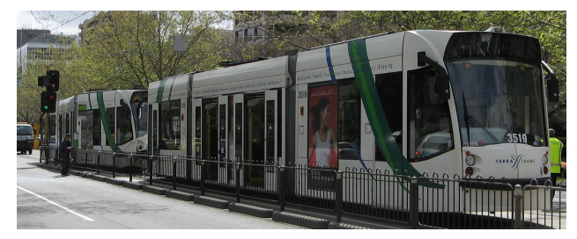

**TABLE OF CONTENTS**

THE CHIEF INVESTIGATOR 9

1. EXECUTIVE SUMMARY 11

2. CIRCUMSTANCES - INCIDENT 1 13

2.1 Incident 13

2.1.1 Tram 3522 (the receiver) 13

2.1.2 Tram 3519 (the aggressor) 13

2.1.3 The collision 13

3. FACTUAL INFORMATION 15

3.1 Personnel 15

3.1.1 Tram 3522 driver 15

3.1.2 Tram 3519 driver 15

3.1.3 Passengers 16

3.2 Recorded information 16

3.3 The vehicles 16

3.3.1 The Driving control 17

3.3.2 The Vigilance Alarm 18

3.3.3 Emergency braking system 18

3.3.4 Maintenance and servicing 18

3.3.5 Driver’s cabin atmospheric conditions 19

3.4 The Incident Site 19

3.5 Yarra Trams 19

3.5.1 General operations, rules and procedures 20

3.5.2 Driver recruitment and training 20

3.6 Environmental conditions 21

3.7 Interviews 21

3.7.1 Tram 3522 driver 21

3.7.2 Tram 3519 driver 22

3.7.3 Passenger reports 23

3.8 Post Incident 23

3.8.1 Operational tests 23

3.8.2 Tram damage 24

3.9 Governing Rules, Regulations and Guidelines 24

3.9.1 Rail Safety Act 2006 24

4. ANALYSIS 25

4.1 The incident 25

4.2 The driver, Tram 3519 26

4.2.1 Loss of concentration 26

4.2.2 Lack of sleep 26

4.2.3 Medical condition of the driver 28

4.2.4 Ambient environmental conditions 28

4.2.5 Arousal levels 29

4.3 Fatigue management 29

4.4 Other incidents 31

4.5 Collision warning and avoidance systems 31

5. Conclusions 33

5.1 Findings 33

5.2 Contributing factors 33

6. SAFETY ACTIONS 35

6.1 Safety Actions taken since the event 35

6.1.1 Short term actions 35

6.1.2 Medium to long term actions 35

6.2 Recommended Safety Actions 36

7. APPENDIXES 38

Appendix A - Similar Incidents 38

Incident 2 - Tram 196 & Tram 132 collision outside the Arts Centre 38

Incident 3 - Tram 2080 & Tram 134 collision on Flemington Road 40

Appendix B - Combino Tram 47

Appendix C - Tram Route Incident 1 49

Appendix D – Stop 24 St Kilda Road 51

Appendix E - Tram Route Incident 2 53

Appendix F - Tram Route Incident 3 55

# THE CHIEF INVESTIGATOR

The Chief Investigator, Transport and Marine Safety Investigations is a statutory position established on 1 August 2006 under Part V of the *Transport Act 1983*.

The objective of the position is to improve public transport and marine safety by independently investigating public transport and marine safety matters.

The primary focus of an investigation is to determine what factors caused the incident, rather than apportion blame for the incident, and to identify issues that may require review, monitoring or further consideration. In conducting investigations, the Chief Investigator will apply the principles of ‘just culture’ and use a methodology based on systemic investigation models.

The Chief Investigator is required to report the results of investigations to the Minister for Public Transport and / or the Minister for Roads and Ports. However, before submitting the results of an investigation to the Minister, the Chief Investigator must consult in accordance with section 85A of the *Transport Act 1983*.

The Chief Investigator is not subject to the direction or control of the Minister(s) in performing or exercising his or her functions or powers, but the Minister may direct the Chief Investigator to investigate a public transport safety matter or a marine safety matter.

# 1. EXECUTIVE SUMMARY

On the morning of 24 September 2007, Tram 3522 departed Camberwell Junction at 0924[1] destined for the Melbourne Central Business District (CBD) on Route 72 via Commercial and St Kilda Roads. At 0937 Tram 3519 departed High Street Malvern Terminus also bound for the CBD on Route 6 via High Street and St Kilda Road.

At about 1005 Tram 3522 stopped at Stop 24 on St Kilda Road, at the intersection with Leopold Street. About a minute later Tram 3519 approached Stop 24 but did not stop and collided with Tram 3522.

Within the next month two further collisions occurred under similar circumstances.

At about 0636 on 16 October 2007, Tram 132 collided with Tram 196 at Stop 14 on St Kilda Road. The trams were outbound from the CBD.

At about 0540 on 23 October 2007, Tram 134 collided with Tram 2080 at Stop 20 on Flemington Road. The trams were inbound to the CBD.

The three collisions resulted in significant damage to the trams and several passengers received injuries, some requiring transport to hospital although all were released on the day of the various incidents. Following the collisions the trams were driven to their respective depots and tested. In all cases the tram driving and braking systems were found to be within the designed operational specifications.

The investigation has found that the significant contributing factor to the first collision was the driver’s loss of situational awareness resulting in him not observing the tram ahead thereby failing to stop his tram as required. In the other two collisions, due to the non-cooperation of the respective aggressor tram drivers, the causal factors contributing to the collision could not be established.

Since the incidents, the operator of the tram network has initiated a number of short term and medium to long term safety actions addressing driver training, awareness and behaviour. The operator is also conducting a review into its rules, procedures and training manuals to update the ‘safe driving’ sections; and have contracted an independent expert consultant to conduct a systemic review of tram incidents in the previous year.

The investigation recommends that the operator extends the consultation to include human factors risk assessment of daily driving operations. Also, that the operator develop strategies for tram driver fatigue management and post incident driver impairment testing, and consider installing data loggers in all trams.

# 2. CIRCUMSTANCES - INCIDENT 1

## 2.1 Incident

At about 1006 on 24 September 2007, Tram 3519 collided with Tram 3522 at Stop 24 at the intersection of St Kilda Road and Leopold Street in Melbourne. Both trams were ‘Combino’ type trams headed towards the Melbourne Central Business District (CBD). They were managed and operated by Yarra Trams.

### 2.1.1 Tram 3522 (the receiver)

On 24 September 2007, Tram 3522 departed from the Malvern Depot at about 0627 and commenced its daily passenger commuter operations. The driver involved in the incident took over driving duties at about 0700 at Camberwell Junction. The tram completed one round trip to the University without incident, arriving back at Camberwell Junction at 0917. It departed Camberwell Junction at 0924 for the University.

From Camberwell Junction the route was south along Burke Road to Malvern Road, then west to Commercial Road and St Kilda Road then along St Kilda Road in a north-northwesterly direction to the CBD. Tram 3522 arrived at St Kilda Road Stop 25 at 10:02:48 and departed the Stop at 10:04:24.

The tram arrived at Stop 24 at the intersection of St Kilda Road and Leopold Street at 10:05:35 and stopped to disembark and embark passengers. The tram remained stationary at the Stop waiting for a change in the traffic / tram signal to give it clear way across the road intersection.

### 2.1.2 Tram 3519 (the aggressor)

That same day, Tram 3519 departed from the Malvern Depot at about 0552. At about 0923 the driver involved in the incident took charge of the tram. Tram 3519 departed the Malvern High Street Terminus at 0937 for the University. The route was along High Street to St Kilda Road, then along St Kilda Road to the University.

Tram 3519 arrived at the intersection of St Kilda Road and High Street (Stop 27) at about 1002 and at 10:04:24 stopped at Stop 25, the intersection of St Kilda Road and Commercial Road. The tram departed from Stop 25 at 10:04:45. The next scheduled stop was Stop 24 on St Kilda Road.

### 2.1.3 The collision

At 10:05:45, the signal changed for the Tram 3522 to proceed along St Kilda Road. The driver released the brake but before he engaged the drive motor into ‘forward gear’, Tram 3519 which was travelling at 31 km/h, collided with the rear of his tram. The impact caused Tram 3522 to surge ahead about eight metres and derailed the rear module.

The impact damaged both trams’ control circuits causing a power failure to the internal and external communications system. The incident was reported to Yarra Trams’ Fleet Operations Centre (FOC) by the driver on an oncoming tram. Emergency services were called to the site by a number of passengers and other witnesses, by dialling ’000’.

An inspection of the driver’s cabin of Tram 3519 immediately after the incident indicated that the emergency stop button on the driving console was depressed and the driving control was in the upright (stop) position, indicating that the service brake was not applied.

# 3. FACTUAL INFORMATION

## 3.1 Personnel

### 3.1.1 Tram 3522 driver

The driver of Tram 3522 joined M>Tram[2] in March 2004 and in August 2004 qualified as a tram driver. He was assigned to the Malvern depot. The driver is qualified to drive ‘Z’ and Combino trams and had completed his latest tram driver refresher course in September 2007. His latest medical examination was conducted in August 2004 and no abnormalities were noted.

Perusal of the driver’s roster indicates that he had normal duties of between seven and eight hours of tram driving each day in the three days preceding the incident. On the day of the incident he reported for duty at 0703. After the incident the driver was breathalysed and the result indicated zero alcohol content. The driver of Tram 3522 did not suffer any injury.

### 3.1.2 Tram 3519 driver

The driver of Tram 3519 was 65 years old at the time of the incident. He joined the Public Transport Corporation in July 1989 as a tram conductor and since then, has been in continuous employment with M>Tram and later Yarra Trams. He qualified as a tram driver in October 1990 and for the next three years worked as a tram driver / conductor. In 1996 when the position of tram conductor was discontinued on Melbourne’s trams, he became a full time driver.

The driver of Tram 3519 has undergone regular Yarra Trams mandated awareness, training and driver refresher courses. The driver completed Combino Conversion Training in September 2003 and since that time has been driving Combino trams. The driver was also qualified to drive ’W’ Class, ‘D’ Class and ‘B’ Class trams.

In July 2001 a tram he was driving made slight rear-end contact with a stationary tram ahead. There was no damage to either tram or injury to personnel. He received a written warning from M>Tram. Records indicate that in the three years prior to this incident, the driver had been involved in three collisions between a tram he was driving and a motor vehicle. The driver was found not at fault in these incidents.

The record of check-trips and periodic assessments available at Yarra Trams indicate that the driver had a competent driving record. He was also up-to-date with the requisite driver refresher training and first aid training. The driver’s medical records indicate that he was fit for duty.

The driver of Tram 3519 had been on rostered leave on 20 and 21 September, worked from 0614 to 1531 on 22 September and was rostered off on 23 September. He reported for duty at 0457 on 24 September, the day of the incident.

As a result of the collision, the driver of Tram 3519 was trapped in the tram cabin until freed by ambulance staff. He was taken to hospital for further treatment and discharged the next day. Immediately after the incident the driver was breathalysed and the result indicated zero alcohol content.

### 3.1.3 Passengers

Tram 3522 carried 15 passengers. On impact a number of passengers fell over suffering minor injuries. Four passengers were treated by ambulance staff at the site and five were transported to nearby hospitals for further treatment but were reported to have been discharged that day.

Tram 3519 carried 20 passengers. On impact a number of passengers (including a two year old child sitting in a pram) fell over suffering minor injuries. Four persons were treated by ambulance staff at the site and four persons were transported to nearby hospitals for further treatment but were reported to have been discharged that day.

## 3.2 Recorded information

Both trams were fitted with a Journey Data Evaluation (Darec) logger built by Messma GmbH Germany, for Siemens. Darec is evaluation software that continuously records critical operating systems on the tram into graphics and tables. A print out of the loggers in the form of a ‘data evaluation sheet’ was made available to the investigation.

Both trams’ progress was also monitored by Automatic Vehicle Monitoring (AVM) Polling Data[3] at the FOC. AVM data indicated that both trams had uneventful trips that morning, until the collision. They travelled at an average speed of about 30 km/h for the most part of their respective trips.

Tram 3522 departed Stop 25 on St Kilda Road at 10:04:24. En route to Stop 24, the ‘request to stop’ button was activated by a passenger. Tram 3522 arrived at Stop 24 at 10:05:17. At 10:05:45 the brake was released, but ‘drive’ was not selected. Tram 3522 was at rest when the collision occurred.

Tram 3519 arrived at Stop 25 at 10:04:24, the same time that Tram 3522 departed from that Stop. Twenty one seconds later the tram departed Stop 25 and slowly increased speed to about 27 km/h. At 10:05:24 Tram 3519 commenced reducing speed and at 10:05:31 was travelling at about 22 km/h. Two seconds later Tram 3519 increased speed to 31 km/h before colliding with Tram 3522 at 10:05:47.

The logger indicated that at the same time as the collision, Tram 3519 emergency stop brake was activated along with the bell and hazard indicators. The service brake was not activated.

There was no record of the passenger ‘request to stop’ button being activated on Tram 3519.

## 3.3 The vehicles

Both trams in this incident were Combino 3-part-trams (see Appendix B) built by Siemens, Germany. They commenced service in September 2003 and were assigned to the Malvern tram depot.

The Combino tram has an overall length of 20 metres, an extreme width of 2.65 metres and weighs 26.8 tonnes. The tram is driven by a Siemens 100 kW motor giving it a maximum service speed of 70 km/h. Each tram is configured to carry a maximum of 168 passengers.

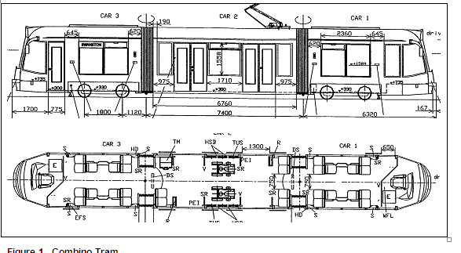

**Figure 1. Combino Tram**

A driver’s cabin is located at each end of the tram. The adjustable driver’s seat is equipped with an armrest and is situated on the centre line of the tram. The chair can be adjusted so that the driver can operate the driving control and at the same time reach the console controls with minimal movement in the chair. Forward of the driver’s chair is the main operating console and to the right is the driving control.

The windows around the driver’s cabin are of laminated glass, giving the driver about 1800 field of vision, with minimum obstruction in the line of the corner frames. Rear view mirrors are installed outside the cabin on each side, to provide the driver sight along the sides of the tram and to the rear.

The driver’s cabin is secluded from the passenger section. The windows are of fixed glass and the egress door to the passenger section is maintained closed when the tram is in service, preventing the free flow of air into the cabin. The cabin is air conditioned with recirculated air.

### 3.3.1 The Driving control

The Driving control controls the driving and braking movement of the tram. When the control is in the upright (central) position the driving motor remains in neutral. When the control is pushed forward the motor accelerates, commensurate with the amount of pressure applied on the control. The service braking system is engaged when the control is pulled backwards from the upright position, activating the hydraulic disc brakes which gradually slows the rotation of the wheels and brings the tram to a stop. The rate of slowing is commensurate with the amount of pressure applied to the control.

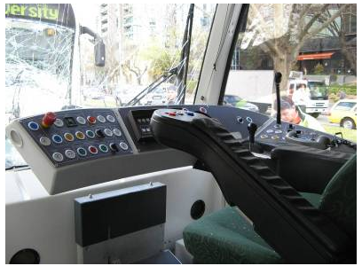

**Figure 2. Driver’s cabin driving console**

### 3.3.2 The Vigilance Alarm

On one side of the control handle where the thumb of the driver’s right hand rests, is the vigilance alarm button. The vigilance alarm is a safety device to ensure driver alertness. If the vigilance button is not depressed every 60 seconds, an alarm sounds for four seconds, within which time the button must be depressed. If it is not pressed, the tram emergency brakes are automatically activated.

For the ergonomic convenience of the driver, an alternative vigilance alarm button is situated on the side of the left arm rest where the thumb of the driver’s left hand rests.

### 3.3.3 Emergency braking system

When the emergency brake button is depressed both the service brake and the emergency magnetic brakes are activated. The emergency braking system is also activated if the driving control is pulled backwards to the limit.

### 3.3.4 Maintenance and servicing

Both trams were up to date with their maintenance schedule, carried out by Siemens Rail Services. Tram 3522 had its 5-Week maintenance on 10 August 2007 and the last 30-Week maintenance was carried out on 12 September 2007. Tram 3519 had its 5-Week maintenance was carried out on 3 September 2007 and the last 30-Week maintenance was carried out on 30 July 2007.

The maintenance reports indicate that the maintenance servicing was routine and found no defect or malfunction with the trams. The service history of each tram indicates that neither had been involved in any prior collision nor had they experienced any serious damage or malfunction.

### 3.3.5 Driver’s cabin atmospheric conditions

In their evidence, Yarra Trams stated that the management was not aware of any issues that have been reported by drivers of the Combino Trams that relate to the driver cabin air-conditioning. They stated that the air conditioning system has multiple settings and that the tram manufacturer had not supplied them with any information that would alert them to the potential of air-conditioning system within the driver cabin interfering with the use of contact lenses.

## 3.4 The Incident Site

The tram tracks run along the centre of St Kilda Road and are separated from road vehicles. Stop 24 is on St Kilda Road at the intersection with Leopold Street, about three kilometres south-southeast (SSE) of the CBD.

High Street joins St Kilda Road about 1050 metres SSE of Stop 24 and Commercial Road joins St Kilda Road about 410 metres SSE of that stop (see Appendix C). After joining St Kilda Road both trams travelled in a straight line up to Stop 24. St Kilda Road continues in a straight line for another 800 metres after Stop 24. Vision along St Kilda Road for road vehicles and tram drivers is good.

The intersection of St Kilda Road and Leopold Street at Stop 24 was fitted with a set of road traffic and tram signal lights, synchronised with each other, so as to clearly separate ‘right of way’ and ‘stopped’ road vehicles and trams.

Stop 24 is a ‘request stop’ on St Kilda Road (see Appendix D) located on the outbound side of the Leopold Street intersection, for passengers headed towards the CBD.

The length of the Stop from the ‘Safety Zone’ sign to the ‘Stop line’[4] is about 44 metres. The length of the designated ‘Safety Zone’[5] is 40.8 metres. The ‘Safety Zone’ is separated from the road by a protective metal fence barrier.

## 3.5 Yarra Trams

In April 2004 Yarra Trams acquired responsibility for running the entire Melbourne tram network. The company has eight tram depots, 29 routes, a fleet of nearly 500 trams and about 1,800 staff of which about 1,200 are tram drivers.

Yarra Trams’ Fleet Operations Centre, located in South Melbourne, controls day-to-day operations, monitoring and communications with trams. Control is achieved through the AVM system, which enables controllers to pinpoint the location of every tram on the network, receive individual tram scheduling data and provide two-way voice communication between the operations centre and each tram.

### 3.5.1 General operations, rules and procedures

As part of its safety management system, Yarra Trams has developed and implemented ‘General Operational Rules and Procedures’. The manual provides guidelines on operational procedures, tram operations, safe interaction with traffic, interaction with the public and general road rules. New notices and information regarding the operating rules are disseminated to drivers through their depot mail boxes.

Yarra Trams’ ‘Rostering Procedures’ defines the procedure for scheduling and rostering of crews. Each depot is responsible for rostering its crew. Two types of shifts are worked:

a shift of eight hours with a break of about 40 minutes at approximately the middle of the shift; or

a ‘broken-shift’ of two four hour stints with a break of about three to four hours in between.

The management of driver working hours is primarily monitored by depot administration staff, who ensure compliance with the Award (workplace agreement for the maximum hours a driver is permitted to work) and a secondary compliance review is also undertaken by the Yarra Trams payroll system, which immediately identifies drivers who report more than the designated hours of work per day and / or per week.

Yarra Trams has a fatigue management policy to address the risks associated with work related fatigue. The policy requires managers to develop appropriate fatigue management plans. At the time of the incident Yarra Trams had commenced training managers to develop plans specific to their respective depots.

With regard to safe operating procedures after an accident, Yarra Trams requires every driver to undergo an alcohol and drug impairment test in accordance with the DOI Code of Practice. The tests must be carried out within three hours of the accident occurring. In the three incidents the attending police took charge of the incident site and Yarra Trams officers were not given access to the drivers concerned.

### 3.5.2 Driver recruitment and training

Recruitment as a tram driver is a process where candidates are required to undergo aptitude tests in verbal, mathematical and mechanical reasoning and a medical assessment.

Medical assessments are conducted in accordance with the Code of Practice for Health Assessment of Rail Safety Workers, July 2004, which in turn is adopted from the National Standard for Health Assessment of Rail Safety Workers. Drivers are required to be physically, medically and psychologically fit for duty and, if required, can be subjected to drug screening on commencement of duties. Drivers are reassessed every five years until age 50, then every two years until age 60 and every year thereafter.

New recruits undergo a five-week theory and practical training course. Once the training course is completed, the prospective driver initially practices his or her skills driving ‘out of service’ (without passengers) trams under the supervision of the depot trainer before progressing to driving a commercial (passenger commuter) route under the supervision of a senior driver.

Once qualified to drive trams independently, the driver is subject to six-monthly follow-up assessments, where his / her driving ability and safety adherence is assessed by the senior depot trainer. Drivers are required to undertake a refresher training course every 12 months on tram operations and procedures and general skills on interaction with other traffic and public behaviour. Since July 2007, Yarra Trams has included fatigue awareness and management as part of the refresher course.

Yarra Trams also conducts safety workshops at each tram depot, approximately once a year. The workshop is conducted by a senior safety manager and attended by all workers assigned to that depot, other than those on rostered leave and those engaged in driving trams at that time.

When a new model of tram is introduced, the driver is required to undergo ‘conversion training’ involving theory and practical components covering fault finding, cabin layout and controls, and driving / braking on-road test. Conversion to Combino trams involves 10 days training. Yarra Trams has developed a training manual for each model of tram.

When a new route is opened, the driver is required to undergo ‘route familiarisation’ training, involving a number of trips on that route as an observer until the depot trainer is satisfied that the driver is familiar with the route.

## 3.6 Environmental conditions

At the time of the incident, the day was dry, sunny and clear. The sun was about 430 above the horizon and approximately 600 to the right of the driver. The temperature at that time was about 140C. There was slight cloud cover and an upper level haze but visibility at ground level was about 25 kilometres. Wind at that time was blowing from the west to southwest direction at about five km/h gusting to 15 km/h.

## 3.7 Interviews

### 3.7.1 Tram 3522 driver

The driver of Tram 3522 commenced driving at about 0700. He had completed one round trip from Camberwell Junction to University and was on his second trip University. The driver reported that when the tram turned off Commercial Road into St Kilda Road, the road and pedestrian traffic ‘quietened down’ compared to the previous trip.

The trip down St Kilda Road was uneventful until the collision. The driver stated that there was no road or pedestrian traffic to distract him and the position of the sun did not affect his vision.

Approaching Stop 24, the driver said that he noted the ‘request to stop’ signal and also noticed one person waiting at the stop. He stopped the tram and released the doors. When the tram signal changed to ‘proceed’, the driver closed the tram doors and released the brake. He had not yet put the motor into drive when he felt the collision at the rear of his tram.

At that point the driver looked into his rear view mirror and noted that another tram had collided with his. This was the first time that he was aware of the tram behind his. He tried getting out of his cabin but the door was wedged closed by a passenger who had fallen against it. The driver then attempted to call fleet control to report the accident but found that the tram had lost communication power.

The driver said that other passengers helped remove the passenger wedged against the driver’s cabin door, after which he was able to get out of his cab and approach the other tram. He noted that the driver of Tram 3519 was slumped in his seat with some blood around him and was being comforted by other persons. There was nothing he could do so he went back to his tram to assist the passengers.

In his evidence the driver said that he completed his last driver refresher training course in September 2007. He stated that he could not recall with surety whether fatigue management was discussed at the course.

### 3.7.2 Tram 3519 driver

In his interview, the driver of Tram 3519 stated that he remembered stopping at the traffic lights at Commercial Road; but he remembers nothing after that. He stated that his next recollection was finding himself slumped over the driving console.

On the day of the incident, the driver awoke at 0300. He reported for duty at the Malvern depot a little before 0500. He said that he felt fit and well prepared for his shift that morning. His first assignment was from 0457 to 0813 on another tram operating between Malvern, University and Kew. This run was routine and there was nothing untoward. The driver had his scheduled break at 0813. He relaxed at the Malvern depot until 0921 before going to Malvern Town Hall for his next assignment, to drive Tram 3519.

The driver recalled that the driver he relieved mentioned that the seat armrests were swung out and could not be retrieved. He recalled that he managed to reset the armrests to suit his posture.

On leaving the Malvern Town Hall, Tram 3519 proceeded to the Glen Iris terminus. After about a seven to eight minute wait, it commenced its journey to the city. The driver stated that the route was fairly busy with road traffic. Additionally, it being the school holidays, there were a lot of people and children on the road. He tried to maintain an average speed of about 30 km/h to maintain his schedule.

The tram turned from High Street into St Kilda Road. There was some traffic on the road but the driver said there was nothing to cause concern. The traffic did not interfere with the tram’s progress.

The driver remembered stopping Tram 3519 at the signal lights at the intersection with Commercial Road. He does not recall sighting Tram 3522. His next recollection was finding himself slumped over the driving console at which time he realised that he had collided with a tram ahead of his. He found himself wedged between the console and the chair.

He stated that this was his first experience of ‘blanking out’.

When questioned about his routine, the driver said that he normally works the afternoon shift. When working the afternoon shift, the driver awakens at around 0600, undergoes his routine exercise, breakfast and morning chores and then relaxes before reporting for duty at about 1200 or 1300. At the end of the shift he engages in light social activity and usually goes to sleep at about 2200.

However, this being the season of Ramadan, he opted for the early morning shift as it coincided with his religious custom to wake before sunrise to have a meal, then fast (no food or drink) until after sunset. This was the first year that he opted for the early morning shift, awakening at about 0300 each day, but he still retired to sleep at about 2200 each day.

The driver also stated that he suffered from high blood pressure which he kept under control with medication.

When questioned about his job as a tram driver, the driver stated that it was normal procedure to drive different models of trams on the same day. He was very familiar with the Combino tram. The driver stated that the Combino driver’s seat was comfortable. The seat could be adjusted to suit his posture and all controls were within easy reach, except the public address microphone for which he had to stand up. In the seated position he could see all around the tram.

The driver stated that the atmosphere in the driver’s cabin in a Combino tram can become uncomfortable. He stated that his normal practice when driving was to switch off the air conditioner as the cool air fogged up his contact lenses. At the time of the incident the driver’s cabin air conditioner was switched off.

As the cabin has fixed glass windows, the driver stated that it gets stuffy and claustrophobic inside the cabin. The driver also stated that the sun shades were inadequate. When the sun first shines through the windows, the heat and glare has an unsettling effect on him. He stated that these conditions were also present at the time of the incident.

The driver undertook a driver refresher training course in June 2007. He commented that he enjoyed the course because it refreshed his memory on some issues. However, he does not recall training in fatigue management.

### 3.7.3 Passenger reports

Two passengers in Tram 3522 reported to the attending police that they noticed Tram 3519 approaching at slow speed, then it started to speed up. They stated that the tram did not appear to brake.

## 3.8 Post Incident

Following the incident Tram 3519 was driven under its own power to the Malvern depot and Tram 3522 was driven under its own power to the Preston workshops.

### 3.8.1 Operational tests

The master controller was removed from the damaged end of Tram 3519 and installed in Tram 3516 for the purpose of conducting an operational test. Tram 3516 was driven within the depot using a series of drive and brake commands to test the functionality of the controller.

Analysis of data recordings taken during the testing indicate that the master controller functioned normally. The master controller signals were consistent with the drive, service braking and emergency braking applications made by the driver during the tests. The vigilance control worked to specification.

### 3.8.2 Tram damage

#### Tram 3522

The impact caused the rear module of Tram 3522 to derail. There was permanent upward deformation of the floor and panel compression at the bottom of the side window. The impact tore the bumper and steel support fabrication. The driver’s cab door pillar appeared to have been forced back slightly at the lower joint.

There was no damage to the side windows. Some seats in the passenger compartment became detached but there was no other significant damage to the compartment.

#### Tram 3519

The impact shattered both side windows of the driver’s cab and forced the electrical equipment cabinet backwards, which shattered the driver’s cab rear window and cracked the rear cab wall.

There was permanent deformation of the floor backwards and downwards, which caused the driver’s cab door pillar bottom connection to be pulled out of the floor channel. The horizontal window beam was pushed back causing the window pillar to shear off the bottom.

The impact tore the bumper and steel support fabrication pushing back the floor mounted equipment into the driver’s cabin. All passenger doors and windows remained undamaged.

## 3.9 Governing Rules, Regulations and Guidelines

### 3.9.1 Rail Safety Act 2006

Part 6 of the Act permits a Transport Safety Officer or a member of the police force to require a person involved in an accident or irregular incident, to undergo alcohol and / or drug impairment assessment. Such assessment must be done within three hours of the accident or incident occurring.

# 4. ANALYSIS

## 4.1 The incident

Tram collisions can occur for a number of reasons that either act independently or in combination. Post incident testing found that the tram was serviceable and the driving and braking systems were operating within the designed safety specifications. Likewise, the prevailing weather conditions were not considered to be a factor in the incident. Thus the actions or inactions of the tram driver of Tram 3519 are considered to be causal to the incident.

The driver may have suffered a physical and / or mental impairment, made an error of judgement when assessing the distance from the tram ahead or in some way been distracted from the driving task.

The tram operator had procedures aimed at determining if drivers involved in incidents were suffering from impairment from the effects of alcohol or drugs. However, in this case, no drug testing was undertaken as Yarra Trams could not get access to the drivers once the police took charge of the accident site.

The driver of Tram 3519 could not recall the events immediately preceding the collision of his tram. Therefore, in the absence of evidence to the contrary, driver distraction and / or impairment cannot be discounted as factors in the incident.

The presence of a functional data evaluation logger installed in the Combino tram assisted the investigation to identify the mechanical actions that occurred immediately preceding and at the time of the collision. The investigation was able to determine the actions of the driver by reviewing the information obtained from the data logger. Such data also provided an indication of the driver’s situational awareness.

If the vigilance alarm button is not depressed every 60 seconds, an alarm sounds for four seconds and if the button is still not depressed, the emergency braking system is automatically activated. The driver’s last recollection was stopping at Stop 25, at 10:04:24. The collision occurred at 10:05:45; a period of 79 seconds. If the driver had ‘blanked out’ on arrival at Stop 25, the emergency braking system would have been activated some time before collision occurred at Stop 24. At some time between Stop 25 and the collision the driver must have been alert enough to depress the vigilance alarm button.

The emergency brake button was activated on impact. The emergency button is designed to withstand accidental activation. Also, there must be a deliberate action by the driver to lean over the driving console and depress the button. The fact that the emergency brake button had been depressed indicates that either the driver activated the button at the time of collision or the force of collision caused a part of his body to impact against the emergency stop button. The investigation did not find any other cause for the emergency stop button to get activated.

A recount of the evidence of the drivers and Tram 3519 AVM indicates that the tram started accelerating at about the same time that the signal light changed to ‘proceed’ (green light for road traffic, white T for trams). It is possible, for the reasons specified below, that the change of signal registered subconsciously with the driver causing him to accelerate, but the tram ahead of him did not register in his mind.

It is therefore reasonable to assume that the driver may have been subconsciously driving the tram but may have lost concentration for a short time or had a micro-sleep. It is also possible that the driver suffered retrograde amnesia,[6] however without an in depth medical examination following the incident, the exact cause of his apparent memory loss cannot be determined.

The fact that Tram 3522 had released its brake preparatory to moving forward, reduced consequences of impact. The tram rolled forward absorbing the force of impact, which probably prevented more serious injuries.

## 4.2 The driver, Tram 3519

### 4.2.1 Loss of concentration

The driver stated that he was unaware of Tram 3522 being in front of him prior to the accident. This is an important corroborating fact, and may well reflect the degree of degraded information processing due to the combined effects of decreased vigilance and increased sleepiness

From a human performance perspective, it is highly probable that the driver of Tram 3519 was affected by a combination of the existing conditions (physical, medical and environmental) prevailing at the time of the collision. It is likely that he was suffering from a combination of fatigue due to insufficient sleep and the hot stuffy ambient environmental conditions in the cabin.

The possibility that the driver’s fasting contributed to this combination of circumstances cannot be discounted. This combination of conditions could have significantly impaired his level of vigilance and alertness, and may well have led to an involuntary micro-sleep in the crucial seconds prior to the accident.

It is probable that the driver may not have been able to react quickly or adequately enough to a critical situation as a consequence of fatigue (see 4.2.2) and the ambient environmental conditions (see 4.2.4).

### 4.2.2 Lack of sleep

The driver of Tram 3519 stated in his interview that this was the first time he had attempted the early morning roster and that he was not fully comfortable with the new routine. In his evidence he stated that he still went to bed at about 2200 each night but awoke the next morning at the earlier time of about 0300. In effect, the driver had about five hours of sleep per day, in the previous two weeks since Ramadan commenced; as opposed to about eight hours sleep on his previous roster.

In controlled laboratory experiments, investigators have demonstrated decrements in most components of human performance as a result of sleep loss. Sleep loss creates sleepiness, which can be associated with decrements in vigilance, reaction time, memory, psychomotor coordination, information processing and decision making (eg. fixation on certain aspects of a situation to the neglect of other information) (Rosekind et al., 1996)[7].

The possibility that fatigue might have been a factor in this incident was assessed using the computer program FAID 330E from Interdynamics Pty Ltd. Two sets of data were analysed using this program. The first set of data used in the analysis was from the driver’s actual hours of duty only. The result of this analysis was that there were standard to moderate levels of fatigue at the most demanding periods of work. At the time of the incident, the driver’s fatigue score was between standard and moderate.

However, when the driver’s hours of work and all other activities, other than times when he was asleep, were utilised, the results of this analysis were that high to very high fatigue scores were obtained for a number of days preceding the incident. At the time of the incident as well, his fatigue score was between high and very high, suggesting that fatigue may have been a contributory factor in the incident.

Fatigue leads to reduced performance on every level. Decision-making is impaired, vigilance and attention are reduced, judgement is often less than optimal, and individuals are more inclined to accept a lower standard of performance than they normally would.

Reducing sleep by one hour a night leads to increased daytime sleepiness, which is cumulative over successive nights. Reducing sleep by two hours a night leads to impaired alertness and measurable levels of reduced performance. It is also known that such fatigue can lead to short spontaneous involuntary sleep events known as micro-sleeps.

### 4.2.3 Medical condition of the driver

Given that it was Ramadan and that the driver was fasting, it is probable that his last food or fluid intake was six to seven hours prior to the accident. This is important, given the role of dehydration and hypoglycaemia in fatigue, vigilance and cognitive impairment.

In general terms, dehydration will seriously reduce performance, impair judgement, vigilance and decision-making abilities, and increase the risk of suffering a variety of heat disorders. Hypoglycaemia (low blood sugar) due to prolonged abstinence from eating can result in weakness, tremors, dizziness, sweating, disturbed thinking, changed behaviour, lethargy and ultimately unconsciousness.

It is not likely that the driver’s treated high blood pressure condition contributed to the accident.

### 4.2.4 Ambient environmental conditions

In their evidence, Yarra Trams stated that the driver’s cabin air-conditioning had multiple settings and therefore did not need to be switched off. Furthermore, they had not received any complaints from drivers or information from the manufacturers that the air-conditioning could affect contact lenses.

The driver’s action in switching off of the air conditioner led to stuffy environment in the cabin. The windows of the driver’s cabin are fixed, and as such without air conditioning there was no flow of fresh air into the cabin. This would have caused a stagnant air environment.

On the day of the tram collision, the ambient temperature was 140C. While this represents a mild day outside, within a glass-sided cabin with no air circulation, the internal cabin environment was probably warmer than the atmospheric temperature (green house effect), although it is not possible to give a precise value for the internal cabin temperature.

As such, there was the potential for heat stress to affect the performance of the driver over time, especially if he was not regularly hydrating. Mild heat strain can lead to fatigue, inattention and distraction, as well as reduced vigilance. Memory may be affected, as well as various higher-level cognitive functions such as decision-making, reasoning, tracking and reaction times, serial choice accuracy and concentration.

### 4.2.5 Arousal levels

In his interview, the driver mentioned that there was considerable road and pedestrian traffic along High Street. The investigation has found that High Street is a very busy thoroughfare. There being no clear separation between road traffic and trams, tram drivers need to be continuously alert for close quarter situations, and take action accordingly. Drivers also need to have heightened awareness for pedestrians crossing the road.

When the tram turned onto St Kilda Road, the situation was less challenging for the tram driver. There was definite separation between road traffic and tram tracks, and the pedestrian footpaths were situated on the far side of the road. Additionally, the track route along St Kilda Road was straight and flat.

It is quite probable that the driver’s arousal level dropped when moving to a less challenging situation, accelerated by the combined effects of increased sleepiness, stuffy environment, dehydration and hypoglycaemia, resulting in reduced vigilance and impaired alertness.

## 4.3 Fatigue management

While Yarra Trams includes fatigue awareness and management in its refresher training, neither driver recalled this being part of the training. Such fatigue management training should ordinarily be a crucial aspect of all driver training, at both initial and refresher level.

The investigation found that the driver of Tram 3519 underwent the refresher course in the month prior to fatigue management being included in the course syllabus. The investigation believes that fatigue management was discussed at every refresher course from July 2007 onwards however, for some reason the driver of Tram 3522 cannot remember the course discussion.

Fatigue is typically the result of [working](http://en.wikipedia.org/wiki/Labour_%28economics%29), mental [stress](http://en.wikipedia.org/wiki/Stress_%28medicine%29), [jet lag](http://en.wikipedia.org/wiki/Jet_lag) or active [recreation](http://en.wikipedia.org/wiki/Recreation), [depression](http://en.wikipedia.org/wiki/Clinical_depression), and also [boredom](http://en.wikipedia.org/wiki/Boredom), [disease](http://en.wikipedia.org/wiki/Disease) and [lack of sleep](http://en.wikipedia.org/wiki/Sleep_deprivation). Even just waking up too early can cause you to be fatigued. Fatigue may also be the result of chemical causes, such as [poisoning](http://en.wikipedia.org/wiki/Poison) or [mineral](http://en.wikipedia.org/wiki/Mineral) or [vitamin](http://en.wikipedia.org/wiki/Vitamin) deficiencies (Anca Jr, JM : 2007)[8].

Yarra Trams sets the roster in accordance with the Award and monitors workers’ hours of work through their payroll system. However, in a system where overtime work and swapping of rosters is permitted, this in effect is a reactive system which identifies a past occurrence but does not inform management in advance, of potential fatigue issues at various stages of the rostered week.

This can be dangerous when performing tasks that require constant concentration, such as driving a [vehicle](http://en.wikipedia.org/wiki/Vehicle). For instance, a person who is sufficiently somnolent (decreased wakefulness) may experience [micro-sleeps](http://en.wikipedia.org/wiki/Microsleeps).

There is a need to proactively address the problem of fatigue inducing work practices and its impact on decision making. There is increasing recognition that loss of sleep has occurred due to changing economic and social patterns and of the risks involved with roster related fatigue. Work related fatigue and consequent changes in alertness, reaction time, decision making and communication are all major risks for shift workers (Anco Jr).

Employers and safety critical workers need to be acutely aware of the causes and symptoms of fatigue. The circadian rhythm[9] of individual workers may be physiologically unsuitable to early morning shifts or to broken shifts. Employers and workers should also be aware that commuting to and from work, daily chores and social activities reduce the amount of rest obtained and over a period of time loss of sleep can accumulate to a dangerous level of operational impairment and can also lead to chronic fatigue syndrome.

An awareness of the causes, symptoms and effects of fatigue will assist management and workers to develop appropriate fatigue management plans and duty rosters.

## 4.4 Other incidents

The circumstances of the tram collisions that occurred on 16 and 23 October 2007 are detailed in Appendix A. The incidents have a number of similarities.

The driver of aggressor tram 196 returned to work after one day rostered leave and had an accident within the first hour of returning to work. The driver of aggressor tram 134 returned to work after two days of rostered leave and had an accident within half an hour of commencing his shift.

In both incidents, the aggressor tram followed the receiver tram for a considerable distance before colliding, so it is reasonable to assume that the aggressor driver would have been aware of the tram ahead of his. Collision occurred at the first stop on an open road with a straight line of sight ahead of at least two kilometres, and after exiting a comparatively busier thoroughfare.

Weather was not a factor in either incident. Following the collisions the trams driving and braking systems were tested and found to be operating satisfactorily.

The drivers of the aggressor trams have not made themselves available to assist with the investigation. This, combined with the lack of data loggers in the ‘Z’ Class trams inhibited reconstruction of the sequence of events leading up to the collisions and the determination of causal factors.

## 4.5 Collision warning and avoidance systems

The investigation has noted that Yarra Trams is conducting a world wide search on collision warning and avoidance systems suitable for application on trams, which will provide a secondary safety feature to alert drivers of the presence of a tram ahead. Had there been such a system installed on trams, the incidents discussed in this report may have been avoided.

# 5. CONCLUSIONS

## 5.1 Findings

1. The trams were maintained and serviced in accordance with the manufacturer’s designed specifications.

2. The tram’s driving and braking systems were found to be operating within the design safety specifications.

3. The drivers were appropriately qualified to drive the trams.

4. Fatigue management training was included in the driver refresher course from July 2007.

5. At the time of the incident Yarra Trams did not have fatigue management plans for individual work groups.

6. The driver of Tram 3519 changed his usual shift roster and therefore his sleep pattern about two weeks prior to the incident.

8. A drug test and / or impairment assessment was not carried out on the drivers of the aggressor trams.

9. The atmosphere in the driver’s cabin can become stuffy and claustrophobic due to lack of fresh air if the air-conditioning system is not used.

## 5.2 Contributing factors

1. The driver’s changed routine in the period immediately prior to the incident probably resulted in the driver suffering fatigue.
2. A loss of situational awareness by the driver resulted in him not sighting the tram ahead and therefore he did not stop his tram in time.
3. This loss of situational awareness was probably contributed to by fatigue resulting from a combination of lack of sleep, the environment in the driver’s cab, a reduction in the driver’s arousal level and reduction in the driver’s hydration level.

# 6. SAFETY ACTIONS

## 6.1 Safety Actions taken since the event

Since the incidents, Yarra Trams have initiated the following safety actions:

### 6.1.1 Short term actions

1. All drivers underwent refresher training including revisions of the main rules, defensive driving and cycle of service.
2. All the senior managers and the CEO held safety toolbox talks.
3. There has been increased on-road traffic officer supervision at the Arts Centre and Domain interchange.
4. Senior depot trainers rode on trams mainly in St Kilda Road to advise drivers of safe driving techniques.
5. A one day safety workshop was held on 26 October 2007 chaired by the CEO and attended by several layers of Yarra Trams staff.
6. A senior manager now addresses the weekly driver refresher class emphasising the need to apply defensive driving practices.

### 6.1.2 Medium to long term actions

1. A review is being undertaken of the tram driver training manual and the Rules and Procedures book.
2. A training document titled ‘Operations Minimum Requirements’ has been developed.
3. A review of work instructions regarding ‘driver follow-up’ was carried out to strengthen the process for dealing with unsatisfactory driver behaviour.
4. A Tram Driver Profile Report has been developed to assist in focussing on driver behaviour issues.
5. Depot managers are now being trained and are currently developing fatigue management plans for their respective worksites.
6. Yarra Trams has instigated Incident Cause Analysis Method (ICAM) investigation training for all managers.
7. World wide search is being undertaken on collision warning and avoidance systems suitable for application on trams.
8. Yarra Trams has contracted an independent expert consultant to conduct a review of incidents including “identifying and reporting on possible strategic interventions to reduce risk, prevent recurrence and improve safety based on the lessons learnt from the review”.
9. A steering committee has been established to analyse all the options to improve on-road issues on St Kilda Road and Swanston Street.

## 6.2 Recommended Safety Actions

#### YARRA TRAMS

Safety Issue 1

Yarra Trams has a policy for alcohol and drug impairment testing to be carried out on tram drivers within three hours of an incident occurring. Following the incidents described in this report, the police breathalysed the drivers but Yarra Trams officers were not given access to the drivers to carry out impairment tests.

RSA 2008036

Yarra Trams should develop a strategy with the transit police to implement its policy of drug and alcohol testing of drivers and a comprehensive impairment assessment following an accident.

Safety Issue 2

A review of incidents including “identifying and reporting on possible strategic interventions to reduce risk, prevent recurrence and improve safety based on the lessons learnt from the review” will provide evidence of the causal factors into those incidents but may not identify the issues which may give rise to those causes.

RSA 2008037

Yarra Trams should extend its systemic review of incidents to complete the remaining phases of its project with the independent consultant namely:

* inspection / familiarisation visit to examine equipment, view routes, driving tasks, etc;
* discussions / information from key personnel in a focus group setting; and
* assessment / evaluation of current defences.

Safety Issue 3

There are a number of human factors issues regarding rostering, shifts and personal habits of drivers and driving ergonomics which may result in fatigue. The drivers assisting with the investigation cannot recall fatigue management training as part of their initial and refresher courses.

RSA 2008038

Yarra Trams and tram drivers should work collaboratively to improve driver fatigue awareness and training as well as safe driving techniques and driver’s cabin ergonomics (atmospheric and physical), at the initial training course and every refresher course.

Safety Issue 4

With reference to Incident 2 and Incident 3, the ‘Z’ Class trams are not fitted with data loggers, inhibiting the investigation’s ability to reconstruct the status of the trams driving and braking systems and the actions of the drivers at the time of and immediately preceding the collisions.

RSA 2008039

Yarra Trams should consider fitting Journey Data Evaluation Loggers in all trams.

# 7. APPENDIXES

## Appendix A - Similar Incidents

### Incident 2 - Tram 196 & Tram 132 collision outside the Arts Centre

#### Circumstances

On 16 October 2007, Tram 196 departed the Brunswick depot at about 0602 and arrived at University at 0621 to commence its passenger commuter service to and from University and Toorak tram terminus on Route 8. The route takes it along St Kilda Road for part of the journey.

Tram 132 departed the Glenhuntly depot at about 0518 and proceeded to Carnegie tram terminus. It then commenced its passenger commuter service to and from University and Carnegie tram terminus on Route 67. A part of this route is along St Kilda Road.

Tram 132 also arrived at University at 0621 on the inbound track, shunted on to the outbound track and departed at 0623, following Tram 196 along Swanston Street and onto St Kilda Road.

At about 0631 Tram 196 arrived at the Flinders Street Stop and Tram 132 stopped behind it. Tram 196 departed shortly thereafter. After disembarking and embarking passengers, Tram 132 departed the stop at 0633.

At about 0635, Tram 196 stopped at Stop No 14 on St Kilda Road, opposite the Arts Centre. The tram was stopped for about 90 seconds when Tram 132 approached but did not stop and collided with the rear of Tram 196.

At the time of collision Tram 132 was travelling at a speed of about 20 km/h (AVM information). The investigation has not been able to establish whether the driver activated the brakes of Tram 132 prior to the collision.

As a result of the collision 14 passengers on Tram 132 received minor injuries and were treated by paramedics at the scene. The rear of Tram 196 and the front of Tram 132 suffered damage to their respective ends that came into contact.

Both trams were driven under their own power to their respective depots for testing and repair. Tram 132 driving and braking systems were tested at the Glenhuntly depot. The brake chart test indicated that all brake levels were within the designed safety specifications.

**Tram 196 (the receiver)**

Tram 196 was a ‘Z3’ Class double bogie tram (see Fig 3). It entered service in June 1982 and was based at and operated out of the Brunswick depot. It underwent its last 2-weekly check on 4 October 2007 and its 10,000 km servicing on 15 August 2007. The service logs indicate that there were no major defects and that the tram was roadworthy prior its release for passenger operations on 16 October 2007.

The driver of Tram 196 joined Yarra Trams in May 1999 and in June 1999 qualified as a tram driver. He was assigned to the Brunswick depot. The driver was qualified to drive ‘B’, ‘W’ and ‘Z’ Class trams and had completed his latest tram driver refresher course in June 2007. In his evidence the driver stated that he cannot recall with surety if fatigue management was included in his driver refresher training course. His latest medical examination was conducted in February 2007 and no abnormalities were noted.

The driver’s roster indicates that he had a rostered day off on 14 October 2007 and had normal duties of between seven and eight hours of tram driving each day on 13 and 15 October 2007. On the day of the incident he reported for duty at 0552. After the incident the driver was breathalysed and the result indicated zero alcohol content.

In his interview the driver stated that he commenced driving Tram 196 at about 0600. At the University he passed Tram 132 which was on the inbound track and was being shunted to follow Tram 196 on the outbound track. The driver noted that Tram 132 stopped behind him at the Flinders Street Stop to disembark and embark passengers. The road at that time was free of road and pedestrian traffic and the position of the sun did not obscure his vision.

The driver said that he did not observe Tram 132 approaching his tram at the Arts Centre stop. The impact caused the driver to fall forward and hit his head on the driving console.

He stated that he may have been unconscious for a few minutes and when he revived he called the FOC to report the accident. His back was very sore and he could not move without severe pain. He waited in his cabin until help arrived and he was transported back to the depot.

**Tram 132 (the aggressor)**

Tram 132 was also a ‘Z3’ Class double bogie tram. It entered service in May 1980 and was based at and operated out of the Glenhuntly depot. It underwent its last 2-weekly check on 9 October 2007 and its 10,000 km servicing on 11 September 2007. The service logs indicate that there were no major defects and that the tram was roadworthy prior to its release for passenger operations on 16 October 2007.

The driver of Tram 132 joined the Public Transport Corporation in October 1994 as a conductor and in June 1998 qualified as a tram driver. He was assigned to the Glenhuntly depot. The driver was qualified to drive ‘A’, ‘B’ and ‘Z’ Class trams and had completed his latest tram driver refresher course in August 2007. His latest medical examination was conducted in March 2007 and no abnormalities were noted.

He was on rostered leave for the two days preceding the incident. On the day of the incident he reported for duty at 0508. After the incident the driver was breathalysed and the result indicated zero alcohol content.

The driver’s records indicate that he had three tram-to-tram collisions in the last few years.

Following the incident and the ensuing Yarra Trams investigation, the driver was re-deployed but in a non-driving role within the organisation. He has not made himself available to assist with the investigation.

**The incident site**

Swanston Street has a single lane road on each side of the tram tracks. Swanston Street leads onto St Kilda Road at Flinders Street Station, where the road widens to have two road vehicle lanes on each side of the tracks. After crossing Princess Bridge, and in the vicinity of the Arts Centre, the road widens still further to four road vehicle lanes on either side of the tram tracks.

Tram Stop 14 on St Kilda Road is opposite the Melbourne Arts Centre, about 325 metres from the CBD. It is a ‘request stop’. The approach to Stop 14 from the CBD runs through Swanston Street and onto St Kilda Road in an approximately straight line for about 1.5 kilometres.

At the time of the incident the road traffic along St Kilda Road near the Arts Centre was light. The road in this section is flat. The wind was from the west to southwest direction at about 30 km/h gusting to 40 km/h. At this time there was three-eights cloud cover and the sun was approximately 100 above the horizon and 670 to the left of the driver. Visibility was clear and without obstruction.

The length of the Stop from the stop line to the ‘Safety Zone’ sign on the outbound track is about 54 metres. The length of the ‘Safety Zone’ is 50 metres. The ‘Safety Zone’ is separated from the road by a protective metal fence sitting on a concrete barrier (prowl).

Incident 3 - Tram 2080 & Tram 134 collision on Flemington Road

**Circumstances**

At about 0533 on 23 October 2007 Tram 2080 departed the Essendon Depot. The tram was operating a passenger commuter service on Route 59, destined for Elizabeth Street terminus. At the same time Tram 134 followed Tram 2080 out of the Essendon depot destined for Abbotsford terminus, but was not in service.

Tram 2080 made a number of routine stops en route, to disembark and embark passengers. Tram 134 followed Tram 2080 down Mt Alexander Road which leads into Flemington Road. At about 0540 Tram 2080 stopped at Stop 20 on Flemington Road. A short time later Tram 134 arrived but did not stop and collided with the rear of Tram 2080.

At the time of collision Tram 134 was travelling at a speed of about 25 km/h (AVM information). The investigation has not been able to establish whether the driver of Tram 134 activated the brakes prior to the collision. Following the incident, the driver resigned from Yarra Trams and has not assisted with the investigation.

A number of passengers fell over, resulting in minor injuries. Five passengers from Tram 2080 and the driver of Tram 134 were taken by ambulance staff to nearby hospitals for further treatment and were discharged the same day. The driver of Tram 2080 was not injured.

The rear of Tram 2080 and the front of Tram 134 suffered damage to their respective ends that came into contact.

Both trams were driven under their own power to the Essendon depot for repair and further testing of their driving and braking systems. Tram 134 braking systems were tested and all brake levels were found to be within designed safety specifications.

**Tram 2080 (the receiver)**

Tram 2080 is a ‘B2’ Class articulated triple bogie tram. It entered service in November 1994 and was based at and operated out of the Essendon depot. It underwent its last 2-weekly check on 12 October and its 10,000 km servicing on 27 September 2007. The service logs indicate that there were no major defects and that the tram was roadworthy prior to its release for passenger operations on 23 October 2007.

The driver of Tram 2080 was intermittently employed by M>Tram between 1973 and 1985. He has been permanently employed with M>Tram and then Yarra Trams since October 1986 as a tram driver. He was assigned to the Essendon depot. The driver is qualified to drive ‘B’ and ‘Z’ Class trams and had completed his latest tram driver refresher course in November 2005. His latest medical examination was conducted in October 2006 when no abnormalities were noted.

The driver’s roster indicates that he had normal duties of between seven and eight hours of tram driving each day in the three days preceding the incident. On the day of the incident he reported for duty at 0523. After the incident the driver was breathalysed and the result indicated zero alcohol content.

The driver of Tram 2080 resigned from Yarra Trams shortly after the incident and has refrained from assisting with the investigation.

**Tram 134 (the aggressor)**

Tram 134 is a ‘Z3’ Class double bogie tram. It entered service in June 1980 and was based at and operates out of the Essendon depot. It underwent its last 2-weekly check on 18 October 2007 and its 10,000 km servicing on 22 October 2007. The service logs indicate that there were no major defects and that the tram was roadworthy prior its release for passenger operations on 23 October 2007.

The driver of Tram 134 joined Yarra Trams in March 2005 and in April 2005 qualified as a tram driver. He was assigned to the Essendon depot. The driver is qualified to drive ‘B’ and ‘Z’ Class trams and had completed his latest driver refresher course in November 2005. His latest medical examination was conducted in March 2005 when no abnormalities were noted. This was the driver’s first collision accident.

The driver of Tram 134 resigned from Yarra Trams shortly after the incident and has refrained from assisting with the investigation.

Perusal of the driver’s roster indicates that he was on rostered leave for the two days preceding the incident. On the day of the incident he reported for duty at 0523. After the incident the driver was breathalysed and the result indicated zero alcohol content.

**The incident site**

Stop 20 is on Flemington Road, Flemington and lies about 2.75 kilometres northwest of the CBD on the outbound side of the Melrose Street intersection. It is a ‘request stop’. Flemington Road runs in an approximately straight line to the Elizabeth Street intersection, the start of the CBD.

Flemington Road is shared by road vehicles and by trams. There are a number of intersections along the road, for crossing road vehicles. The tram tracks run along the centre of the road with traffic lanes on each side.

When approaching Stop 20 from the northwest direction, the tram travels along Mt Alexander Road. Mt Alexander Road has a single road vehicle lane on each side of the tram tracks.

At about 400 metres from Stop 20, the road melds into Flemington Road and then runs in an approximately straight line towards Elizabeth Street. The road in this section is level. Visibility along the road is good and without obstruction.

At the time of the incident the road traffic along Flemington Road was light. The wind was from the southeast at about 15 km/h gusting to 25 km/h. At this time there was five-eights cloud cover and the sun had just arisen about 340 to the left of the driver but was not yet visible behind the city structures. Visibility was clear and without obstruction.

There is a tram traffic signal installed at the forward end of the Stop. At the time of the incident the signal was showing a red light. The length of the ‘Safety Zone’ on the inbound track is 40.8 metres. The ‘Safety Zone’ is separated from the road by a protective metal fence barrier.

**Tram configurations – Incidents 2 and 3**

The ‘Z3’ and ‘B2” trams were built by Commonwealth Engineering. They have similar driving consoles, which are ergonomically modelled. The driver’s seat can be adjusted to suit the driver’s posture and when seated, the controls and foot pedals are within easy reach. A driver’s cabin is situated at each end of the tram, the seat being on the right hand side of the cabin. Driver visibility in the forward direction and up to 900 on each side is unobstructed. Rear view mirrors are installed outside the cabin on each side, to provide the driver sight along the sides of the tram and to the rear.

**‘Z3’ Class Tram**

The single car ‘Z3’ tram is driven by two 195 kW AEG Siemens motors giving it a service speed of 65 km/h. It has an overall length of 16.64 metres, extreme width 2.67 metres and tare weight of 21.8 tonnes. It can carry a maximum of 125 passengers.

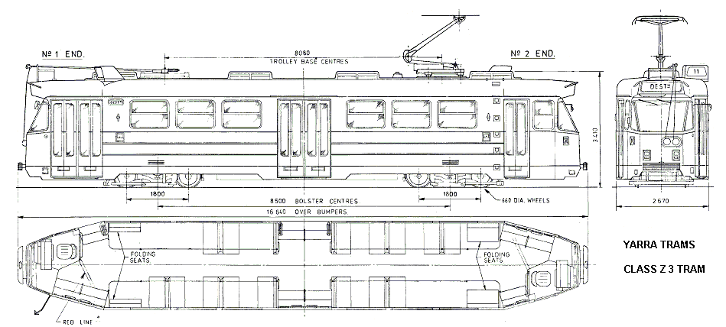

**Fig 3. Yarra Trams ‘Z3’ Class tram**

**‘B2’ Class Tram**

The double car ‘B2’ tram is driven by two 195 kW AEG Siemens motors giving it a service speed of 65 km/h. It has an overall length of 23.63 metres, extreme width 2.67 metres and tare weight of 34 tonnes. It can carry a maximum of 182 passengers.

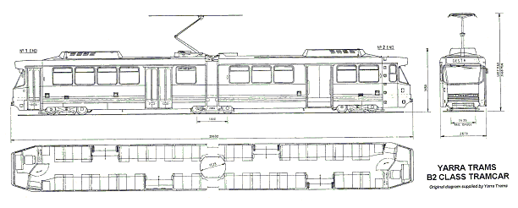

**Fig 4. Yarra Trams ‘B2’ Class tram**

**Driving and braking**

The driving and braking system is by means of foot pedals. The right leg operates the accelerator and brake, whilst the left leg controls the Driving Safety Pedal (deadman’s alarm).

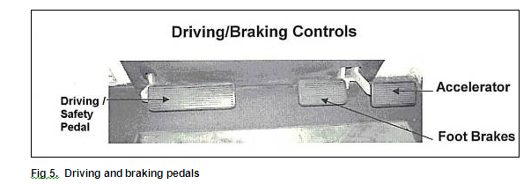

**Fig 5. Driving and braking pedals**

When the brake pedal is depressed, the electric brake is activated, which reduces the speed of the electric motors to slow down the tram. When the tram speed reduces (to seven km/h for Z3 and 10-12 km/h for B2 trams), the mechanical disc brake then takes over to bring the tram to a standstill. The disc brake acts as the holding brake when the vehicle is stopped.

If the brake pedal is fully depressed, the emergency braking system is activated, which results in the electric and disc braking systems operating at maximum rate and the emergency magnetic brake deploying.

The driving safety pedal should be maintained depressed half-way when the tram is in operation. If pressure on the pedal is eased or if the pedal is fully depressed, the emergency braking system is activated, bringing the tram to a stop.

## Appendix B - Combino Tram

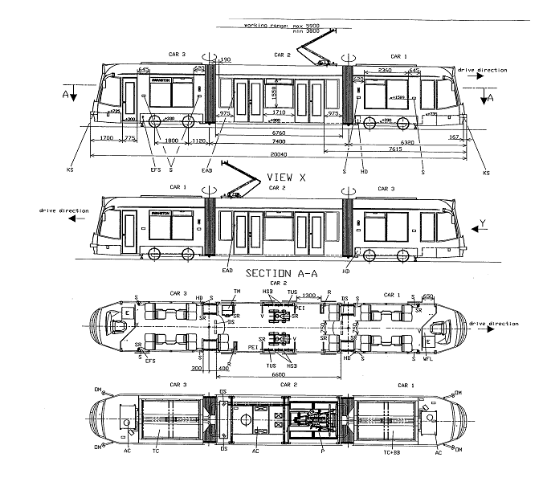

## Appendix C - Tram Route Incident 1

### MELWAYS Edition 35 2008 Pages 57- 58

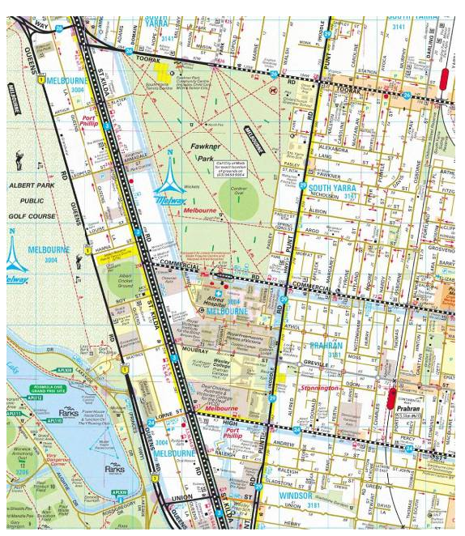

## Appendix D – Stop 24 St Kilda Road

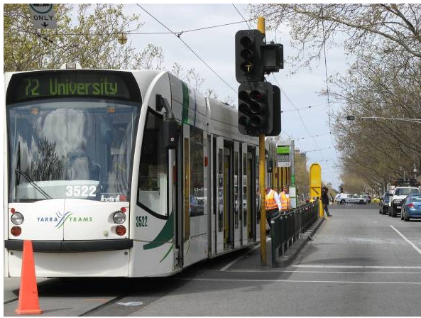

## Appendix E - Tram Route Incident 2

### MELWAYS Edition 35 2008 Pages 29 & 43

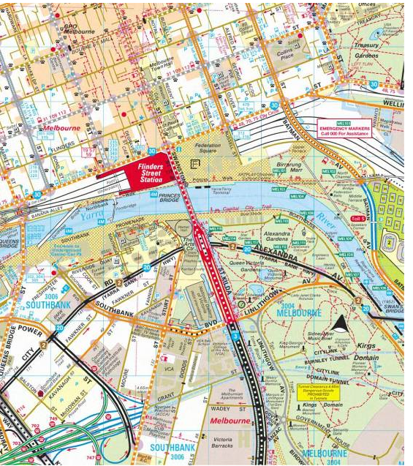

## Appendix F - Tram Route Incident 3

### MELWAYS Edition 35 2008 Page 2F

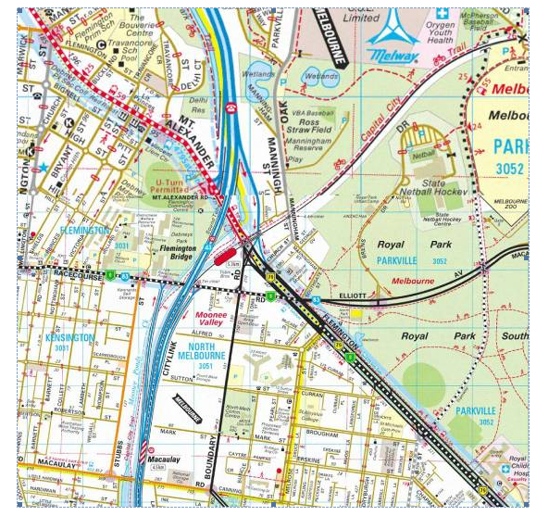

1. All times are in Australian Eastern Standard Time taken from the respective trams DAREC Data Loggers.
2. M>Tram was later taken over by Yarra Trams
3. A system by which the tram transmits pertinent information at specific points to the Fleet Operations Centre.
4. The white line drawn on the road, similar to traffic stop lines, behind which point trams must stop when awaiting a ‘proceed’ signal.
5. The ‘Safety Zone’ is measured from the flag pole to the ‘Safety Zone’ side of the yellow safety prowl.
6. Retrograde amnesia is a loss of memory that occurs in the time immediately preceding the event, probably due to trauma.
7. Rosekind MR, Gander PH, Gregory KB, Smith BS, Miller DL, Oyung R, Webbon LL, Johnson JM, *Managing Fatigue in Operational Settings 1: Physiological Considerations and Countermeasures* in Behavioural Medicine, Vol 21, Winter 1996, Heldref Publications, Washington DC, USA.
8. Jose M Anca Jr, 2007, Multimodal Safety Management and Human Factors, Swinburne University, Australia.
9. The body’s preferred waking and sleeping cycle in a 24 hour period.