**Rail Safety Investigation**

**Report No 2006 / 03**

Level crossing collision

V/Line passenger train 8203

with a motor vehicle

near Winchelsea, Victoria

12 November 2006

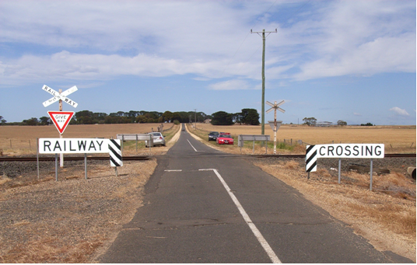

**TABLE OF CONTENTS**

THE CHIEF INVESTIGATOR 5

1. EXECUTIVE SUMMARY 7

2. CIRCUMSTANCES 9

3. FACTUAL INFORMATION 11

3.1 Rail 11

3.2 Operation 13

3.3 Road 14

3.4 Infrastructure 15

3.5 Weather information 19

3.6 Train control 19

4. ANALYSIS 21

4.1 Level crossing 21

4.2 Utility driver distraction 21

4.3 Emergency response 21

5. CONCLUSIONS 22

5.1 Findings 22

5.2 Contributing factors 22

6. SAFETY ACTIONS 24

6.1 Recommended safety actions 24

7. APPENDIX 26

Appendix A – Diagram of Buckley Road level crossing signage 26

# THE CHIEF INVESTIGATOR

The Chief Investigator, Transport and Marine Safety Investigations is a statutory position established on 1 August 2006 under Part V of the *Transport Act 1983*.

The objective of the position is to improve public transport and marine safety by independently investigating public transport and marine safety matters.

The primary focus of an investigation is to determine what factors caused the incident, rather than apportion blame for the incident, and to identify issues that may require review, monitoring or further consideration. In conducting investigations, the Chief Investigator will apply the principles of ‘just culture’ and use a methodology based on systemic investigation models.

The Chief Investigator is required to report the results of investigations to the Minister for Public Transport and / or the Minister for Roads and Ports. However, before submitting the results of an investigation to the Minister, the Chief Investigator must consult in accordance with section 85A of the *Transport Act 1983*.

The Chief Investigator is not subject to the direction or control of the Minister(s) in performing or exercising his or her functions or powers, but the Minister may direct the Chief Investigator to investigate a public transport safety matter or a marine safety matter.

# **1. EXECUTIVE SUMMARY**

On Sunday 12 November 2006 at about 1026[1] a utility motor vehicle drove into the path of a V/Line passenger train at the Buckley Road level crossing near Winchelsea, Victoria.

Buckley Road level crossing is a passive control level crossing protected by ‘Give Way’ signs and advance warning signage.

The V/Line passenger train #8203 was the 0900 scheduled service from Southern Cross Station to Warrnambool and consisted of a V/Line locomotive N461, four passenger cars, and one baggage car.

As a consequence of the collision the vehicle was destroyed and the male driver of the utility and his accompanying dog sustained fatal injuries. There were no injuries to the passengers or crew on the train #8203.

Train #8203 was terminated at the scene and road coaches used to transfer the passengers to their destinations. Emergency services attended, with all services responding within twenty minutes. The track and associated infrastructure was inspected and declared fit for normal service at 1735 on the same day.

The investigation concluded that for reasons unknown the occupant of the utility failed to identify the approach of train #8203 or to take action to avoid the collision.

This report makes recommendations in the areas of event recording standards for rolling-stock operating in Victoria.

# **2. CIRCUMSTANCES**

Train #8203 is the scheduled 0900 V/line service from Southern Cross Station to Warrnambool. This service was introduced on 3 September 2006 replacing a rail connecting Road Coach service operating between Geelong and Warrnambool.

Marshall Station was the last stop made by the train prior to the collision. The departure time from this location was 1010, four minutes behind schedule.

As the train approached the Buckley Road crossing the locomotive crew observed the utility approaching from their right. The air horn on N461 was sounded continuously for 10 seconds over a distance of approximately 250 metres before impact. Approximately 64 metres prior to train #8203 entering Buckley Road the air brake was applied in Emergency.

The utility was travelling along Buckley Road in a southerly direction. The purpose of the journey was to allow the driver to inspect livestock at a nearby property located south of the railroad line.

As the utility entered the crossing, locomotive N461 collided with the passenger side door pillar and propelled the vehicle along the track for approximately 682 metres.

# **3. FACTUAL INFORMATION**

## 3.1 Rail

### 3.1.1 Train

Train service #8203 consisted of:

* one locomotive N461, and
* five vehicles identified as car set #FN19:
  + D322 baggage car
  + BZN275 coach
  + BN55 coach
  + BRN56 coach / buffet
  + ACN57 coach / luggage.

The total weight of the train consist was 340 tonnes.

In accordance with company operating procedures the consist of train #8203 was inspected and certified fit for service prior to departure from Southern Cross Station.

### 3.1.2 N class locomotives

N461 is a diesel-electric type locomotive with a mass of 124 tonnes and a power rating of 1846kW. They are also fitted with an auxiliary generator to provide Head End Power (HEP) to passenger cars. The maximum operating speed is 115 km/h.

N class locomotives are fitted with Leslie RS 5-chime air horns as the primary audible warning device and a single trumpet “low note” air horn as a secondary warning device for use in confined areas.

The Leslie RS 5-chime air horn is recommended for railroad applications with operating specifications of 115 db at 30.5 metres. With a decaying effect of 6 db as distance doubles. See Figure 1.

|  |  |
| --- | --- |
| **Distance - Metres** | **Sound Level - db** |
| 30.5 | 115 |
| 61 | 109 |
| 122 | 103 |
| 244 | 97 |

**Figure 1**

Safety lighting is provided in the form of headlights, marker lights and ditch lights. Ditch lights were fitted as a result of industry studies and programs to improve locomotive / train visibility at level crossings.

The N class is fitted with Fisher Mark 2 event recorder which records a number of operating parameters associated with the performance and operation of the locomotive. These parameters include time, direction, active cab, speed, air brake pressures, dynamic braking, crew alerter operation and air horn operation, however the operation of the head and ditch lights is not recorded.

### 3.1.3 Locomotive crew

Train #8203 was operating as a two-crew service and both locomotive drivers were current on the locomotive being operated and safeworking qualified for the route. They were assigned to V/line’s Southern Cross Depot and had twenty years passenger and freight train driving experience each. Both drivers held the position of Practical Locomotive Driver Trainer.

Neither locomotive driver sustained injury as a result of the incident. In line with company policy, stress and trauma counselling was provided together with stress leave.

Post incident preliminary breath tests were conducted on both drivers at the scene by Victoria Police. The result for each test was negative.

### 3.1.4 On board customer service crew

Two Conductors were assigned to train #8203, one engaged in general customer service duties incorporating train running duties and the other involved with the on board refreshment services. Neither conductor reported any injury as a result of the incident.

### 3.1.5 Passenger information

Sixty seven passengers were being conveyed, none were reported to have been injured in the incident.

## 3.2 Operation

The line between Werribee and Warrnambool is owned by VicTrack[2] and, at the time of this occurrence, it was leased via the Public Transport Division of the Department of Infrastructure to Pacific National Pty Ltd who were responsible for track maintenance.

The Pacific National Network Service Plan “Network Operating Requirements” identifies the line speed for the track between South Geelong and Warrnambool as 115 km/h for passenger trains when hauled by N class locomotives.

The journey to Marshall was normal and without any reported incidents. Train #8203 made a scheduled station stop at Marshall and departed approximately four minutes behind schedule at 1010.

The event recorder on N461 indicated that on the approach to the Buckley Road level crossing train #8203 was travelling at 114 km/h and the air horn was sounded continuously for 10 seconds over a distance of approximately 250 metres. An emergency brake application was initiated at 111 km/h approximately 64 metres before the locomotive entered the crossing.

Post impact, train #8203 continued to decelerate coming to a stand approximately 682 metres from Buckley Road. The total braking distance of approximately 750 metres is consistent with V/Line braking specifications (emergency application) for locomotive hauled trains.

Train #8203 did not derail as a result of the collision. Locomotive N461 sustained damage to the front pilot, ditch lights, pneumatic piping and electrical connections.

An emergency radio call was initiated by the locomotive driver informing Train Control of the collision and establishing emergency services response requirements.

An analysis of the locomotive event recorder indicated that train #8203 was operating within the permitted speeds applicable on this section of the network.

During the analysis of the event recorder data it was identified that there is no provision for recording the operation of the locomotive headlight or ditch lights. The locomotive headlights and left hand ditch light were illuminated when investigators arrived at the scene.

## 3.3 Road

### 3.3.1 Vehicle

The road vehicle involved in the incident was a single cab Holden Rodeo one tonne tray utility.

A post collision mechanical inspection conducted by the Mechanical Investigation Unit of Victoria Police found that the vehicle did not have any mechanical fault that would have contributed to the collision and stated that prior to impact this vehicle would have been classed as roadworthy.

### 3.3.2 Driver / occupant

The vehicle was occupied by the 58 year old male diver, who resided in the township of Leopold, Victoria and his dog.

The vehicle driver held a current Victorian drivers licence. He travelled the route along Buckley Road about two or three times a week, particularly on the weekends when it was his custom to travel at about 1030.

The vehicle driver was reported to be in good health, using glasses for reading purposes only. His hearing was unaided.

Post-incident toxicology tests were negative for alcohol and drugs.

The driver received fatal injuries as a result of the incident.

The travelling position of the dog within or on the vehicle could not be determined as it was thrown clear of the utility some distance along the track from the crossing. The dog also sustained fatal injuries.

### 3.3.3 Operation

The vehicle was being driven south along Buckley Road and according to the locomotive drivers’ statements and a passenger travelling on the train the driver did not appear to respond to the warning sounded by the train or slow down on the approach to Buckley Road level crossing.

There were no signs of braking tyre marks on the road surface, however tyre marks were present on the crossing indicating the post impact movement of the utility.

The condition of the vehicle was such that it was not possible to identify the status of the car radio at the time of the collision.

Mobile phone records of the occupant identified that there were no incoming or outgoing calls within several hours of the collision.

## 3.4 Infrastructure

### 3.4.1 Road

Buckley Road is a class ‘C’ road running north / south with a 100 km/h speed limit. The crossing is situated 103.859 rail kilometres from Melbourne on the Melbourne to Dennington railway line. The road surface is sealed and intersects with the railway at 90 degrees. The width of the sealed surface on the approach to the level crossing is approximately 4.1 metres broadening out to approximately 5.5 metres within the rails. The level crossing is situated about 1.69kms along Buckley Road from the intersection with the Princess Highway.

On the date of the collision, the surrounding vegetation and farmland growth was minimal and did not obstruct the view from Buckley Road in the direction of the approach of train #8203.

### 3.4.2 Level crossing signage / protection

Railway level protection is assessed in accordance with the provisions of Australian Standard Manual of Uniform Traffic Control Devices Part 7: Railway Crossings (AS1742.7-1993) which was the current standard at the time of the incident. The standard specifies traffic control devices to be used to warn and control road traffic in advance of and at railways crossing together with the manner in which they are to be applied.

AS1742.7 defines a passive control level crossing as: “The controlled movement of vehicular or pedestrian traffic across a railway level crossing by signs and devices, none of which are activated during the approach or passage of a train and which rely on the road user detecting the approach or presence of a train by direct observation.”

Buckley Road level crossing was a passive controlled level crossing protected by advance warning and ‘Give Way’ signage***.***

### 3.4.3 Level crossing assessment

To assist in informing the level crossing upgrade program assessments are being made of each level crossing. These assessments are conducted using the Australian Level Crossing Assessment Model (ALCAM)[3].

ALCAM has been designed as a tool for use in the risk assessment of road and pedestrian railway level crossings. It is a mathematical tool which models the characteristics of crossings and the protective controls present to determine the likelihood of given accident mechanisms occurring.

The model provides a risk score for each crossing which enables the comparison of relative risk across all crossing within a jurisdiction.

The model has been approved by the Australian Transport Council of Ministers (ATC) and the Standing Committee of Transport (SCOT)as the national standard for the assessment of level crossings in Australia.

ALCAM has been adopted in Victoria as a tool to assist with prioritising level crossing upgrades. There is an ongoing program to asses Victoria’s crossings using the ALCAM methodology with assessment due to be complete by the end of 2007.

An ALCAM assessment was conducted at Buckley Road on 23 August 2006. This assessment identified that the sight distance (S2) for motorists when approaching in a Southerly direction (S1) with a train approaching from the West - Left down Quadrant) - was between 80 and 100% of the required sight distance. All other quadrants, including that pertinent to the incident had sight distances in excess of the required ALCAM parameter. See Figure 2.

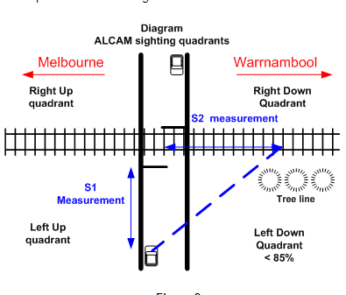

**Figure 2**

The signage was identified as having some wear and tear but understandable to road users. Construction materials used to display the cross buck signs were identified as been non frangible (recycled rail) which is not in compliance with current installation signage standards.

The type and size of signage met the standard, however the advance warning signs (W7-7) were placed at a greater distance from the crossing than stipulated in the standard. The pavement marking "RAIL X” is not situated between the W7-7 and the “Look for Trains” (RX-3-1) warning sign, however this marking was understandable and clearly visible for 50 metres as per the AS 1742.7 standard.

The outcome from the ALCAM assessment produced a risk score of 254 and has been forwarded to the network manager. Buckley Road crossing has been scheduled for upgrade in 2008.

### 3.4.4 Legislation

The *Victorian Road Safety Act 1986* incorporates the Road Rules – Victoria in part 10, Section 123 and states:

“Entering a level crossing when a train or tram is approaching etc…

a driver must not enter a level crossing if:

1. warning lights (for example, twin red lights or rotating red lights) are operating or warning bells are ringing; or
2. a gate, or barrier at the crossing is closed or is opening or closing; or
3. a train or tram is on or entering the crossing; or
4. a train or tram approaching the crossing can be seen from the crossing, or is sounding a warning, and there would be a danger of a collision with the train or tram if the driver entered the crossing; or
5. the driver cannot drive through the crossing because the crossing, or a road beyond the crossing, is blocked.”

## 3.5 Weather information

The weather conditions were fine and sunny, with some cloud cover. There were no obstructions to visibility.

## 3.6 Train control

Pacific National Train Control centre received an emergency radio call from train #8203 reporting the incident and a location between kilometre posts 102 and 104 at 1026:41. On receipt of this call train control contacted ‘000’ for emergency services. They responded to Pacific National’s call at 1028.

During the initial stages of responding to the emergency call from train #8203 and establishing the emergency services response there was some initial confusion identifying the exact location of the incident. It took from 1028 to 1034 to clearly establish the level crossing as being on Buckley Road and that emergency services were heading to the correct location.

# **4. ANALYSIS**

## 4.1 Level crossing

International and Australian studies into level crossing incidents have established that the majority occur at passive crossings and, as in this incident, the driver is more often than not familiar with the level crossing. It has also been established that under these circumstances motorists can become desensitised to audible alarms such as train air horns and passive warnings such as signs.

In Victoria statistics for the period 2000 to 2006 indicate that 55% of level crossing fatalities involving road vehicles have occurred at level crossings which are actively protected.

There is no tactile stimulus to attract the motorist’s attention on the approach towards Buckley Road level crossing.

Although reported as non-compliant in the ALCAM assessment conducted in August 2006, the signage placement on the approach to Buckley Road provided motorists with a clear view of these signs. The condition of the signage was such that all signs were identifiable and clearly understandable.

Motorists travelling south along Buckley Road have good visibility of a train approaching on their left.

## 4.2 Utility driver distraction

With the exception that the dog may have distracted the driver, the investigation was not able to determine any other source of distraction. Equally, the driver was familiar with the crossing and often passed over it at about the same time of day as this incident.

The reasons for the vehicle driver’s apparent lack of response to the audible warning or to any visual recognition of the approach of train #8203 could not be determined

## 4.3 Emergency response

Emergency services were on site within fifteen minutes of the incident being reported.

# **5. CONCLUSIONS**

## 5.1 Findings

1. The signage placement and markings applied to the Buckley Road level crossing at the time of the incident did not comply with Australian Standard AS1742.7 1993 in respect to cross buck support post material and road marking “RAIL X” placement.

2. The advance warning signage location, condition and crossing sight distances did not contribute to this incident.

3. The V/Line train crew were appropriately qualified.

4. Train #8203 was in possession of the appropriate safeworking authority for the section of track being traversed.

5. The speed of train #8203 was within the permitted track speed for the type of service being operated.

6. The driver of train #8203 sounded an appropriate warning on the approach to Buckley Road.

7. Train #8203 was under emergency braking prior to entering Buckley Road level crossing.

8. The occupant of the utility vehicle was a licensed driver.

9. The occupant of the vehicle did not yield to the passage of train #8203 or take any obvious action to avoid the collision.

10. The weather and road conditions did not contribute to the collision.

## 5.2 Contributing factors

1. The failure of the vehicle driver to identify the approach of train #8203 and to avoid the collision. The reasons for this behaviour could not be determined by this investigation.

# **6. SAFETY ACTIONS**

## 6.1 Recommended safety actions

**RSA 2008001**

It is recommended that the Rail Industry Safety and Standards board in conjunction with industry establish an Australian Standard for Train Event Recorder Inputs.

# **7. APPENDIX**

## Appendix A – Diagram of Buckley Road level crossing signage

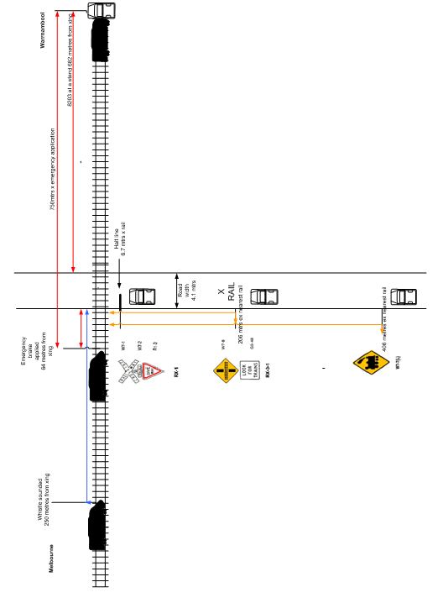

1. All times are denoted in Australian Eastern Daylight Saving Time (UTC + 11 hours).
2. VicTrack is a Victorian Government business enterprise established to own land and infrastructure used for the public train and tram services and to ensure the maintenance of that land and infrastructure.
3. 3 ALCAM is a risk assessment model taking into account over 70 factors for each site. This model can generate multiple proposed mitigation measures which are scored to determine the optimum treatment for each level crossing.