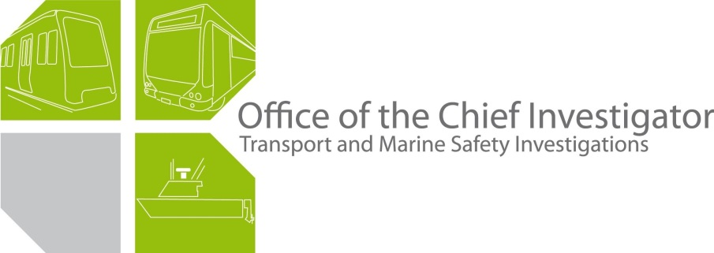

Rail Safety Investigation
No 2007 / 02

Brief Report

Overrun of
Connex train TD 4648
Springvale
18 February 2007

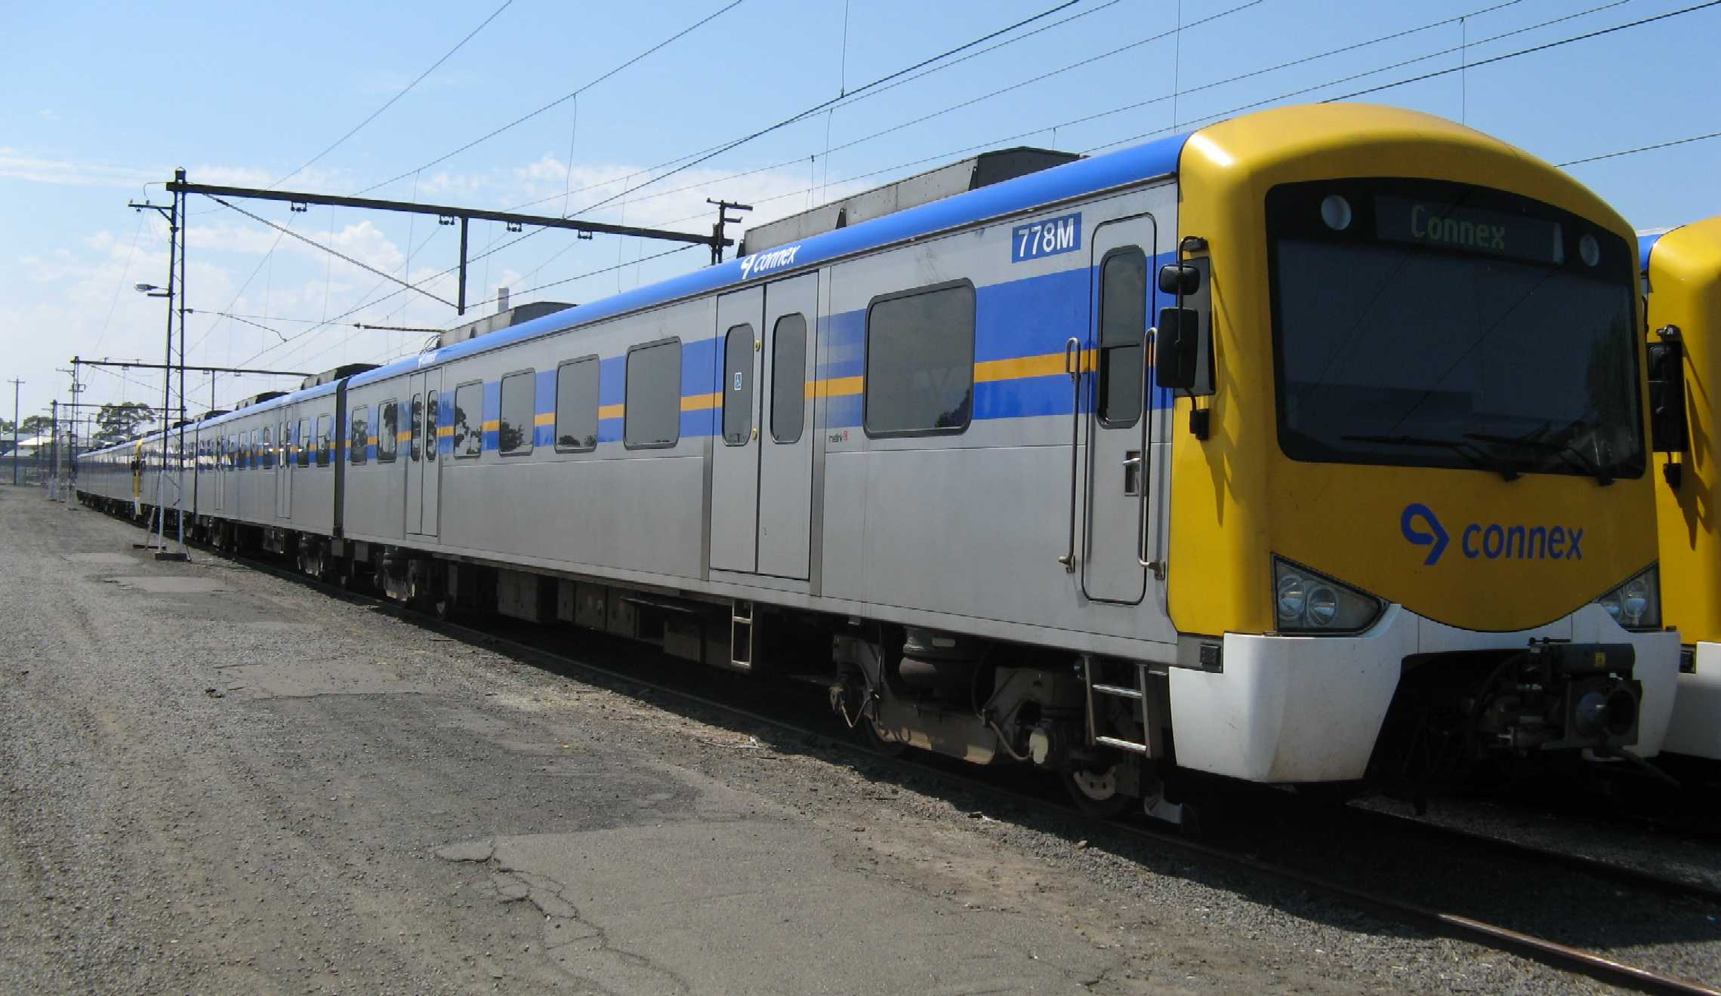
Figure 1: Train involved in incident impounded at Newport

Scope and reporting
The Chief Investigator
The Chief Investigator, Transport and Marine Safety Investigations is a statutory position established on 1 August 2006 under Part V of the Transport Act 1983.
The objective of the position is to improve public transport and marine safety by independently investigating public transport and marine safety matters.
The primary focus of an investigation is to determine what factors caused the incident, rather than apportion blame for the incident, and to identify issues that may require review, monitoring or further consideration. In conducting investigations, the Chief Investigator will apply the principles of ‘just culture’ and use a methodology based on systemic investigation models.
The Chief Investigator is required to report the results of investigations to the Minister for Public Transport and / or the Minister for Roads and Ports. However, before submitting the results of an investigation to the Minister, the Chief Investigator must consult in accordance with section 85A of the Transport Act 1983.
The Chief Investigator is not subject to the direction or control of the Minister(s) in performing or exercising his or her functions or powers, but the Minister may direct the Chief Investigator to investigate a public transport safety matter or a marine safety matter.

Issuing of a Brief Report
In those cases where an investigation is curtailed or a full investigation report is not considered warranted, the Chief Investigator may issue a Brief Report.
A Brief Report will typically include the particulars of the event, a description of the incident, a summary of pertinent investigation information and key findings and, as applicable, a description of identified safety issues and recommended safety actions.

Occurrence details
Date: 18 February 2007
Time: 2152
Location
The train overran Springvale Railway Station and entered Springvale Road level crossing adjacent to and on the Up side of the station platform.
Trip / route details
The train was the timetabled 2118 service from Pakenham to Flinders Street.
The train was scheduled to stop at Springvale Railway Station at 2151 having had its previous stop at Sandown Park.
Incident outcomes
There were no reports of injury to passengers or crew.
The train was impounded by Connex to undergo further testing.
Vehicle details
The train comprised two Siemens 3-car sets forming a 6-car set with vehicle designations from the leading end, 778M - 2539T - 777M and 807M - 2554T - 808M.
The vehicles are fitted with a sophisticated braking system comprising electro-dynamic (ED) and electro-pneumatic (EP) systems. To assist the management of wheel slip and slide in low adhesion conditions, the braking control system includes a wheel slip/slide protection (WSP) feature which activates automatically on the detection of loss of traction when under power or the on-set of wheel slide under braking.
Vehicle operator
The train was being operated by Connex which had taken operational responsibility for the Siemens fleet of vehicles in 2004. Prior to this, the Siemens fleet had been managed by National Express (M>Train).
Infrastructure manager
Connex was and remains responsible for the management of track infrastructure and the coordination of metropolitan rail network operations.
Environmental details
A cool change with accompanying rain had moved through Melbourne during the evening and prior to the time of the reported incident. Ambient temperature at the time was approximately 24 degrees Celsius with a relative humidity of 72 per cent.
The track was reported as wet.
Other information
This overrun incident is one of a number involving the Siemens fleet of trains.

Circumstances
Background / context
There had been intermittent issues with the braking performance of the Siemens fleet of vehicles since their introduction into service in 2003. There were 64 reported overrun incidents involving Siemens vehicles between March 2006 and the end of January 2007. This compares with three reported overrun incidents for the remainder of the metropolitan fleet over the same period.
Following an increased frequency of overrun incidents in December 2006 and January 2007, a significant portion of the Siemens fleet was impounded for re-testing, including the vehicles involved in this incident.
The majority of impounded vehicles were subsequently returned to service in early February 2007 following testing to verify braking system performance. In conjunction with the re-introduction of the vehicles to service, drivers were required to reduce the speed of Siemens trains to 25 km/h by the approach end of stations at which they were intending to stop. Connex also introduced earlier activation of level crossing protection to protect against the unintended encroachment of a train onto a crossing.
Sequence of events
After its stop at Sandown Park, the train had some difficulty gaining traction as it accelerated up the grade on wet rail. The train subsequently obtained a speed of about 60 km/h before commencing braking on the approach to Springvale Railway Station.
Due to the train data retrieval system being activated by the driver prior to the train coming to rest, the records of train speed and braking events cannot be precisely correlated with the position of the train relative to the station platform. Accordingly the following provides a best estimate of the likely scenario.
Records indicate that brake application in ED mode commenced at least 250 metres before the station platform. Braking was predominantly in notch 2 until increased by the driver to notch 4 at a location estimated to be between 30 and 80 metres before the start of the platform. The on-set of wheel slide followed soon after, the WSP system activated automatically and the braking system commenced transitioning to EP mode. At around this time, the brake command was increased to notch 6 (full service braking) for a very short period before being backed off to notch 4 where it was retained for a distance of about 90 metres. It is likely that the train entered the platform during this phase of braking and at a speed of between 33 and 40 km/h.
The brake command was then increased to notch 6 for a distance of about 40 metres followed by the application of the emergency brake when the train was travelling at about 24 km/h. The driver described activating the emergency brake about three quarters of the way down the platform.
Under emergency braking, the train is estimated to have travelled between 110 and 160 metres before coming to a stop, overrunning Springvale Railway Station platform, with the leading end coming to rest about 70 metres beyond the end of the platform and the train on Springvale Road level crossing. At the time of the incident the rail crossing was protected from road and pedestrian traffic by boom barriers and flashing lights.
After the incident, the train was driven back to the platform allowing passengers to alight. The train was subsequently impounded by Connex.

Summary investigation information and findings
Personnel
The driver was found to be qualified and current for the train being operated. It was reportedly his first experience of an overrun event in a Siemens train.
With the on-set of wheel-slide and soon after increasing the controller to full service braking (notch 6), the driver was found to have backed off the brake control to notch 4, possibly in an effort to re-establish effective wheel-rail interface. It was not determined by the investigation whether manipulation of the control at this time influenced the response of the train braking control systems.
The driver did not achieve the station platform entry speed of 25 km/h specified for Siemens trains.
Vehicle(s) and equipment
The vehicles had recently been returned to service following an overrun incident on 31 January 2007, their subsequent impoundment and the testing of braking systems to prove adequate performance in wet conditions. The testing had utilised a detergent / water mix on the rails to simulate low adhesion conditions.
Following this incident (on 18 February), the vehicles were again impounded and similarly tested. The results of this testing were considered by the operator to be satisfactory.
The low adhesion (wet) braking performance criteria used in testing are defined by the Comeng Max + 10 per cent braking curves. These braking curves are based on the maximum permitted braking distances for the Comeng vehicle in dry conditions with an additional 10 per cent margin for low adhesion conditions. These performance requirements are understood by the investigation to have been agreed between Siemens and National Express (M>Train) at the time of vehicle acceptance.
Records from the data retrieval system indicate that in this incident (on 18 February) the retardation of the train was significantly less than the braking performance criteria described above.
Infrastructure
Springvale Railway Station lies on the Pakenham line. The Up approach to the station is straight with a slight down-hill grade to the platform proper.
There is no available information on the specific friction properties of the rail head at the time of the incident. It is however reasonable to conclude that low adhesion conditions were present. The track is known to have been wet. In addition, that the train had difficulty gaining traction after departing Sandown Park supports the view that the rail head was slippery.
Visual inspection on the day following the incident identified small amounts of petroleum products and leaf matter on the track adjacent to the platform. In the approach to the station, there were no significant amounts of leaf matter on the rail head nor were any other unusual contaminants identified.
Of note is that overrun incidents have occurred throughout the network and have not been particular to this or any other location.

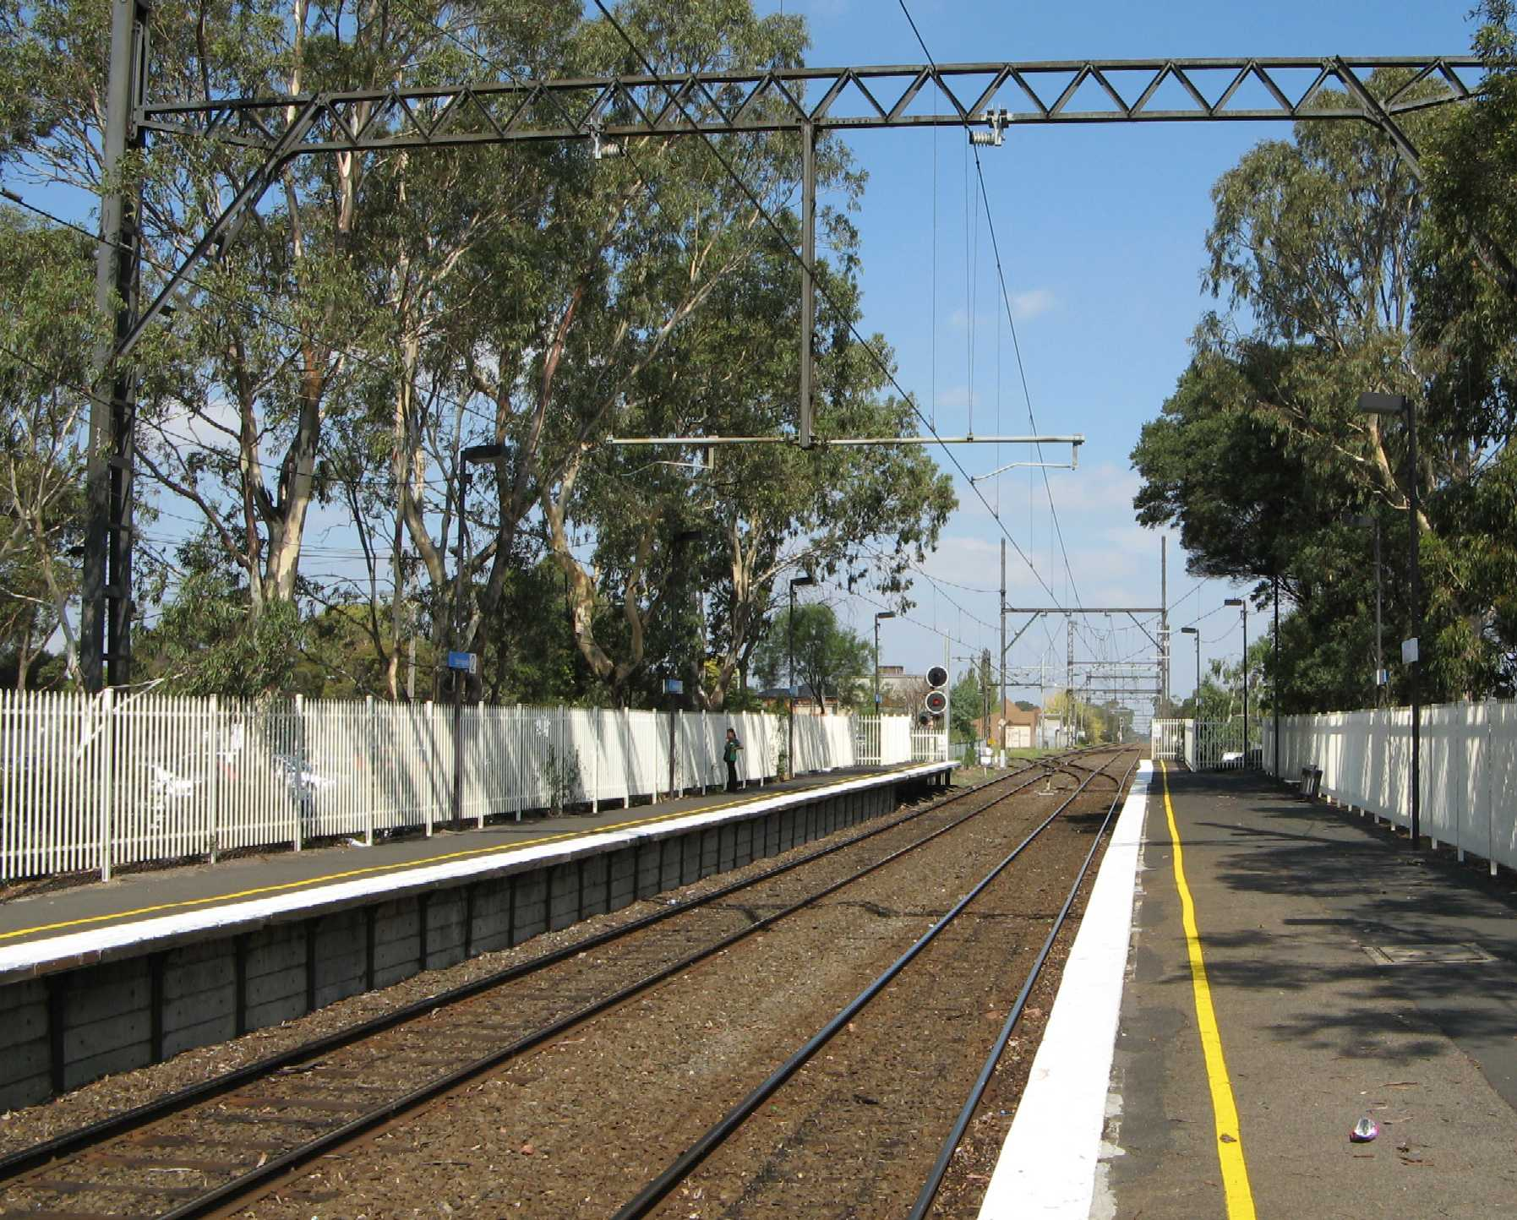
Figure 2: Springvale Railway Station looking towards Sandown Park

Regulatory systems
The rail operator (Connex) has carriage of the management of its operational risks, with oversight by the rail safety regulator, Public Transport Safety Victoria (PTSV).
PTSV has advised that it is continuing to monitor the braking performance issue to assure that Connex is managing the risks in an appropriate manner.

Identified safety issues
Braking performance
This incident is one of a number of cases where in-service braking performance of a Siemens train has been below expectation.
The higher incidence of overrun by Siemens vehicles compared to the remainder of the metropolitan fleet suggests a braking performance issue. Further, the evidence suggests that overrun incidents are most likely to occur in low adhesion conditions.
The process of slowing and stopping a train involves complex interaction between the train driver, the train’s braking systems and the track infrastructure as influenced by the prevailing environmental conditions. The intermittent failure in performance of this interactive system and the role of each of its components has been and continues to be the subject of considerable and lengthy research and investigation by Connex.
Safety issue
The braking behaviour of the Siemens vehicle is at times unpredictable in low adhesion conditions which may be encountered in service.
Braking system testing regime
Testing of the train prior to and after the incident suggests that the vehicle braking systems generally met the performance criteria for wet conditions (Comeng Max+10 per cent). Yet, in this incident the train did not slow in accordance with these braking curves. This indicates either an intermittent fault in the train braking system or, more likely, a difference between the test conditions and the conditions experienced by the train in-service. Specifically, it is feasible that lower adhesion conditions existed in service.
Safety issue
The braking system test regime may not reflect conditions encountered in service.

Safety actions taken since the event
In the 12 months from February 2007 to January 2008, Connex has continued to investigate the braking system issues, engaging local and international specialists in its attempts to identify factors contributing to the overrun incidents and improve the braking performance of the Siemens fleet.
The reducing frequency of overrun incidents suggests that considerable ground has been made on addressing braking performance issues. At the same time there is recognition that a number of matters remain to be addressed.

Key actions taken since the Springvale incident include:
- extensive performance testing of Siemens vehicles and their sub-systems;
- the upgrade of braking system control software on Siemens vehicles;
- an examination of network infrastructure including an associated review of Siemens vehicle wheel-rail contact characteristics; and
- an examination of human factors potentially contributing to overrun incidents and a review of the adequacy of driver training for Siemens trains.

In concluding its investigations to January 2008, Connex has identified a number of areas for further consideration and potential action including:
- the consolidation of all software modifications across the Siemens fleet including the resolution of open issues;
- the introduction of balanced braking across all vehicles including trailer cars;
- slip / slide indication within the driver cab;
- a further review of driver conversion training to Siemens vehicles;
- the introduction of an “adhesion awareness” driver training module;
- a program of rail grinding including the development of relevant standards;
- the development of protocols for failure reporting and investigation;
- a review of braking curves for testing, including a review of pass / fail criteria, particularly for low adhesion conditions; and
- enhanced engagement of driver representatives on the development of train design when buying new trains.

The rail safety regulator (PTSV) continues to monitor the operator’s management of risks associated with the braking performance of Siemens trains.

Decision to curtail investigation
Further investigation into the Springvale incident by the Office of the Chief Investigator is not considered warranted. It is recognised that the issue of Siemens vehicle braking performance is broader than this isolated incident and that the matter has been the subject of extensive investigation by Connex during the 12 months since this incident.
Connex investigations have been supported by a wide range of local and international specialists and accordingly it is considered appropriate that the braking performance issues continue to be led by Connex until the satisfactory resolution of all outstanding matters. Resolution of braking performance issues is not seen as a matter for this investigation.
It is also recognised that ongoing monitoring of the issue to final and complete resolution rests with the rail safety regulator (PTSV).

