

Bus Safety Investigation

Report No 2010/12

Run off road

V/Line passenger bus

Ouyen

30 November 2010

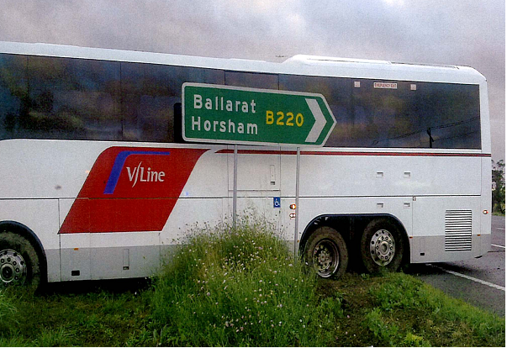

TABLE OF CONTENTS

The Chief Investigator 5

Executive Summary 7

1. Circumstances 9

2. Factual Information 11

2.1 Sunraysia Highway 11

2.2 The driver 14

2.3 Other interview information 16

2.4 The bus 17

2.5 Broadmeadows Bus Charter Pty Ltd 18

2.6 Standard driving hours 19

2.7 Rostering and fatigue management 21

2.8 Human factor research 22

2.9 Bus Association Victoria 25

3. Analysis 27

3.1 The incident 27

3.2 Human factors 27

3.3 Road design 29

3.4 Post incident tests 29

4. Conclusions 31

4.1 Findings 31

4.2 Contributing factors 31

5. Safety Actions 33

5.1 Safety actions commenced 33

5.2 Recommended Safety Actions 33

The Chief Investigator

The Chief Investigator, Transport Safety is a statutory position under Part 7 of the *Transport Integration Act 2010*. The objective of the position is to seek to improve transport safety by providing for the independent no-blame investigation of transport safety matters consistent with the vision statement and the transport system objectives.

The primary focus of an investigation is to determine what factors caused the incident, rather than apportion blame for the incident, and to identify issues that may require review, monitoring or further consideration. In conducting investigations, the Chief Investigator will apply the principles of ‘just culture’ and use a methodology based on systemic investigation models.

The Chief Investigator is required to report the results of an investigation to the Minister for Public Transport or the Minister for Ports. However, before submitting the results of an investigation to the Minister, the Chief Investigator must consult in accordance with section 85A of the *Transport (Compliance and Miscellaneous) Act 1983*.

The Chief Investigator is not subject to the direction or control of the Minister in performing or exercising his or her functions or powers, but the Minister may direct the Chief Investigator to investigate a transport safety matter.

Executive Summary

On the evening of 29 November 2010, a V/Line bus departed Southern Cross Station in Melbourne, bound for Mildura. After passing Ballarat, the bus followed a route along the Sunraysia Highway, which joins the Calder Highway about 13 km south of Ouyen.

At about 0454 on 30 November 2010, the bus arrived at that intersection, but the driver missed the turnoff into the left slip lane that merges with the Calder Highway. Instead, the bus continued to the right, crossed the Calder Highway and came to a halt on the other side of the highway. There was no crossing traffic on the Calder Highway at that time.

There were no reported injuries to the 17 passengers or to the driver. The bus left side rear view mirror was damaged when it came in contact with a signboard on the other side of the Calder Highway.

The investigation found that due to a combination of consecutive night-driving shifts, a monotonous and predictable route and a lack of internal and external stimuli the driver lost situational awareness at about the time that the bus was approaching the intersection.

VicRoads is currently investigating treatment options including tactile stimuli on the Sunraysia Highway on the approach to the Calder Highway.

The report recommends that the bus company reviews driver rostering and fatigue awareness training and that Bus Association Victoria facilitates fatigue education for the bus industry. Also, that VicRoads reviews the ‘Standard Hours’ for heavy vehicle (solo) drivers and fatigue awareness information for all long distance/overnight heavy vehicle drivers.

# Circumstances

On 29 November 2010, a scheduled V/Line passenger bus operated by Broadmeadows Bus Charter Pty Ltd departed Southern Cross Station in Melbourne at about 2145[1] bound for Mildura carrying 16 passengers.

At about 2310 the bus arrived at Ballarat Railway Station. One passenger boarded and at around 0005 on 30 November the bus resumed its journey. The bus travelled via Clunes and Talbot to Maryborough, then through Avoca and St Arnaud before stopping at Donald at about 0245.

The bus departed Donald at about 0305 and travelled via the Sunraysia Highway through Watchem, Birchip, Woomelang, Speed and Tempy and was due to arrive at Ouyen at 0510. About 13 km before Ouyen, the Sunraysia Highway merges with the Calder Highway (see Figure 1).

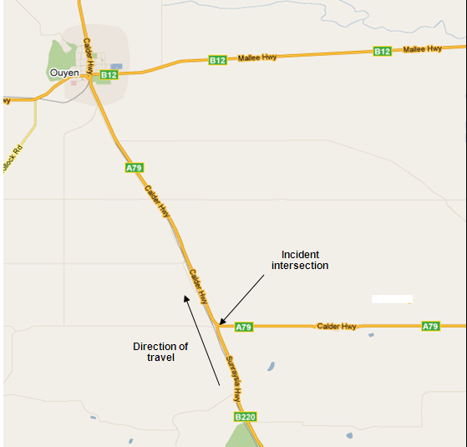

Figure 1: Intersection of Sunraysia Highway and Calder Highway (courtesy Google Maps)

At about 0454, as the bus approached the intersection at approximately 80 km/h, the driver missed the turnoff into the left slip lane. He applied the brakes as the bus continued to the right, travelled across the Calder Highway and came to a halt on the other side of the highway. At that particular moment there were no vehicles travelling in that section of the Calder Highway.

There were no reported injuries to the passengers or to the driver. The only damage to the bus was to its left rear view mirror that struck a signboard on the northern side of the Calder Highway.

At the time of the incident it was dark and overcast with intermittent drizzle. The temperature was about 14 degrees Celsius and there was a south-easterly wind averaging 18 km/h.

# Factual Information

## Sunraysia Highway

The Sunraysia Highway from Birchip until its intersection with the Calder Highway is a two-lane single carriageway with road signs on the approach to the intersection as shown at Figure 2. The speed limit on both highways is 100 km/h.

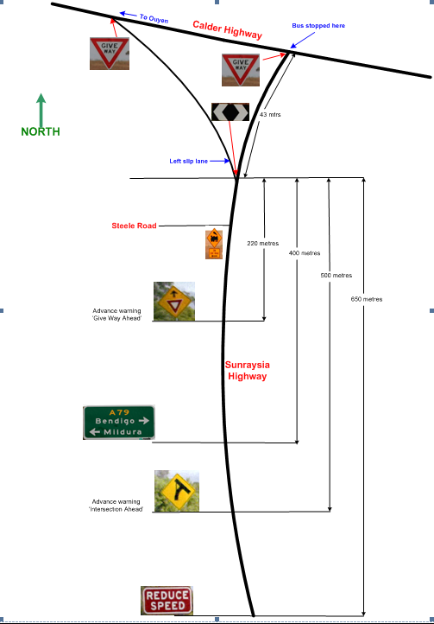

Figure 2: Illustration of road signs when approaching the intersection

The road signage associated with the approach to the intersection first becomes visible about 250 metres before the ‘Reduce Speed’ sign.

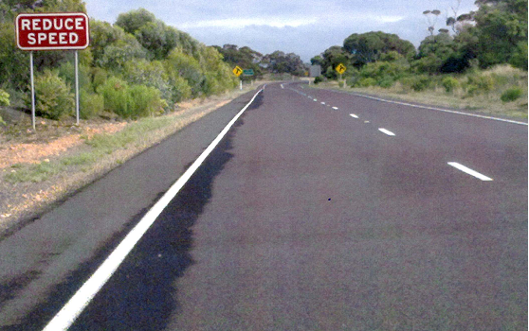

Figure 3: ‘Reduce Speed’ sign and other signboards in the distance

As the ‘A79’ signboard is passed (400 metres before the slip lane), the white arrow board (on black background) indicating the start of the left slip lane comes into view, although the slip lane is not yet visible. About 300 metres prior to the slip lane, the highway veers to the right and the slip lane comes into view.

Figure 4: Approaching the intersection.

When approaching the slip lane, numerous tyre track marks, particularly in the right hand lane were observed (see Figure 5). None of these tyre marks could be attributed to the bus in this incident.

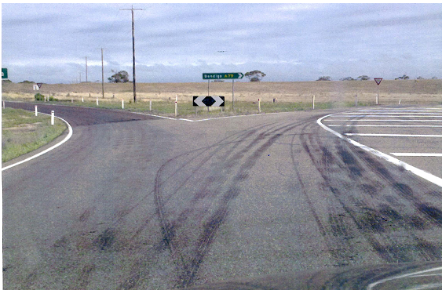

Figure 5: Tyre track marks on the approach to the intersection with the Calder Highway.

Figure 6 shows the wheel rut made by the bus off the sealed surface of the Sunraysia Highway before crossing the Calder Highway and where the bus came to a stop on the other side of the Calder Highway.

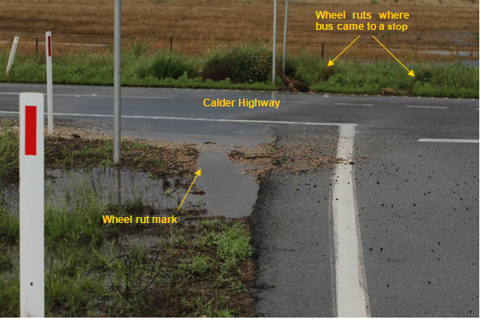

Figure 6: The intersection of the Sunraysia Highway with the Calder Highway

The signage on the approach to the intersection complied with the *Manual of Standard Drawings for Road Signs*[2] and the *Traffic Engineering Manual Vol 2*[3] in respect to size, visibility and positioning.

## The driver

### Background

The driver had about 15 years experience driving metropolitan route buses and long-haul freight trucks before joining Broadmeadows Bus Charter Pty Ltd in January 2008. On completion of his training he commenced driving metropolitan bus routes and for the two years prior to the incident was also assigned to drive the Melbourne to Mildura V/Line passenger service. At the time of the incident he was accredited to drive a commercial passenger vehicle.

The driver completed the company’s prescribed driver operation and competency evaluation in December 2009 and was deemed to be a competent driver. He last completed the prescribed medical examination for bus drivers in August 2010 and was declared fit for duty.

When the driver first commenced on the V/Line service he was rostered to drive for one week in every three. However, in the two months prior to the incident the company was a driver short, so the driver was required to drive the V/Line bus more frequently.

For the weeks commencing Monday 1 November and Monday 8 November, the driver completed two round trips between Melbourne and Mildura each week. He first departed Melbourne on the Monday evening and finished the second round trip back in Melbourne on the Friday morning. The driver then had Saturday and Sunday off duty.

The driver’s work diary indicated that each leg of the round trip was of about 12 hours duration, commencing at about 2000 and ending at about 0800 the next day.

From Monday 15 November 2010, the driver’s roster was amended as follows, to accommodate his leave request:

| **Date** | **Time** | **Total** | **Detail** |
| --- | --- | --- | --- |
| 15/11/2010 |  |  | Day Off |
| 16/11/2010 | 0530 - 1845 | 13hrs 15mins | Route work |
| 17/11/2010 | 0650 - 1020 | 3hrs 30mins | Route work (left early on sick leave) |
| 18/11/2010 | 1432 - 2205 | 7hrs 33mins | Route work |
| 19/11/2010 | 1432 - 2205 | 7hrs 33mins | Route work |
| 20/11/2010 | 1047 - 2202 | 9hrs 15mins | Route work |
| 21/11/2010 |  |  | Day Off |
| 22/11/2010 | 0553 - 0930 | 3hrs 37mins | Route work (left early on carer’s leave) |
| 23/11/2010 | 1328 - 2202 | 8hrs 34mins | Route work |
| 24/11/2010 | 2000 – 0800 (+1) | 12hrs | Night run Melbourne to Mildura |
| 25/11/2010 | 2000 – 0800 (+1) | 12hrs | Night run Mildura to Melbourne |
| 26/11/2010 | 2000 – 0800 (+1) | 12hrs | Night run Melbourne to Mildura |
| 27/11/2010 |  |  | Day Off (Mildura) |
| 28/11/2010 | 2000 – 0800 (+1) | 12hrs | Night run Mildura to Melbourne |
| 29/11/2010 | 2000 – 0455 (+1) | 8hrs 55mins | Night run Melbourne to Mildura (the incident occurred at 0455) |

The driver was rostered to drive the bus back to Melbourne on the evening of 30 November and would have done so had the incident not occurred that morning.

Post-incident tests indicated that the driver did not have any alcohol in his system. The driver was not tested for drugs in his system.

### Interview

The driver stated that on 29 November he went to bed at about 0930 after returning from the Mildura run. He awoke at about 1645 and reported to the Campbellfield depot shortly before 2000. At about 2000 he drove the bus from the depot to Southern Cross Station, arriving at about 2100. At 2145 the bus departed Southern Cross Station and arrived at Ballarat Railway Station at 2310. The driver relaxed in the station master’s office and passed his time scanning the internet and talking on his phone to a friend.

The bus departed Ballarat at 0005 on 30 November. It then stopped at Donald at 0245 where the driver chatted to the local baker before departing at 0305. The next scheduled stop was at Ouyen.

The driver stated that the road trip after Donald is “very boring” with little to see between Birchip and Ouyen. On this day, after departing Donald it was overcast and the road was wet. The road along the Sunraysia Highway is not very wide and the verge is soft gravel so he preferred to drive the bus “sitting over the white line”[4]. The passengers were quiet and probably asleep. He had his cab radio on. He did not encounter much traffic during that section of the trip, perhaps one vehicle every half hour or so. The driver could not recall passing any vehicles in the minutes prior to the incident.

The driver also stated that to relieve the boredom he would sometimes call up a friend using his ‘hands free’ mobile phone, to have a chat. During this trip, he said that he did speak a number of times to friends during the first part of the trip but that after departing Donald he did not make or receive any calls.

The driver reported that he saw the ‘Reduce Speed’ sign on the approach to the intersection of the highways. The next thing he noticed was that he had reached the left slip lane, still travelling in the centre of the road and his speed was a little higher than it should have been. The driver said that he usually takes that turn into the slip lane at about 50 km/h. He realised that on this occasion he would not be able to make the turn into the left slip lane, so he continued to the right along the curve of the road, and applied the brakes. The bus crossed the intersection and came to a stop on the other side of the Calder Highway.

When asked about his sleeping habits, the driver said that he did not have a problem sleeping during the day after his night runs and that he usually slept from about 0930 to about 1630. His hotel room in Mildura and his bedroom in Melbourne are fitted with ‘black-out’ curtains over the windows. He also stated that he was not on any medication at the time of the incident.

With regard to fatigue awareness training, the driver stated that he did not receive any briefings or training other than training on how to complete the newly legislated driver’s work diary.

## Other interview information

### Witnesses

One of the passengers reported that during the trip they observed the driver talking on his mobile phone during the journey from Southern Cross Station to the Tullamarine freeway and then heard him talking on his phone several times during the night. However, the passenger is sure that at the time of the incident the driver was not talking on the phone.

The investigation also spoke to other persons who had contact with the driver when the bus stopped at its scheduled stops and all confirmed that they did not notice anything different with the driver on the night of the incident compared with other nights.

The police officer who attended the incident scene stated that he breathalysed the driver; the test confirmed that the driver did not have any alcohol in his system. The officer stated that the driver appeared to be slightly shaken by the incident but otherwise appeared normal and he did not believe it was necessary to test the driver for drugs. The police officer then checked the bus tachograph and noted that the bus speed was about 80 km/h just before the incident.

### Other persons

The investigation spoke to the other V/Line driver for Broadmeadows Bus Charter Pty Ltd, who confirmed that buses and trucks tend to drive more towards the centre of the road on the Sunraysia Highway between Birchip and the Calder Highway, and move over to the left only when there is on-coming traffic or another vehicle wants to overtake. He also mentioned that traffic density is very low on this stretch of road and that at night, due to the trees on either side, it is like driving through a tunnel and the sighting distance ahead is only as far as the illumination from the headlights of the bus.

The driver further stated that the approach to the Calder Highway is not easily noticed from a distance and that there is no street lighting at the intersection.

The V/Line driver and other persons the investigation spoke to mentioned that they had heard of several instances where vehicles had approached the intersection at a higher than desired speed, and of some instances of vehicles overshooting the intersection. The investigation was advised that no report had been made to VicRoads[5] or to the local police following such incidents.

## The bus

### Specifications

The bus was built in 2009 for Broadmeadows Bus Charter Pty Ltd. It has a Mercedes Benz 0500RF 3-axle Euro 5 chassis. The body is a 12.5 metre Luxury Coach Body built by Coach Design Australia Pty Ltd to V/Line specifications for the transport of 44 seated passengers. The bus braking system complied with the Australian Design Rule (ADR 35/02) Commercial Vehicle Braking Systems, which provides for a nominal deceleration rate of 3.8 m/s2.

Post incident tests indicated that the driving and braking systems of the bus were operating normally.

### Maintenance

In accordance with company procedures, all buses undergo routine maintenance service every three months or 10,000 km, whichever is the earlier. Maintenance action is recorded on a prescribed form, and on completion of each service the bus is taken for a test run to ensure all systems are operating satisfactorily before being returned into service.

Records indicate that the bus underwent its routine maintenance on 12 November 2010 after which it was returned to service. In the time between its routine maintenance and the incident, the bus was reported to have operated normally. At the time of the incident, the bus complied with the VicRoads Licensed Passenger Vehicle Standards.

### Bus tachograph

The tachograph indicated that from 0305 until about 0452 the bus was travelling at speeds varying between 80 km/h and 100 km/h. At 0452 the bus was travelling at 100km/h when it started slowly reducing speed, and at about 0454 its speed was 80 km/h; the speed then rapidly dropped to zero.

## Broadmeadows Bus Charter Pty Ltd

### The company

Broadmeadows Bus Charter Pty Ltd was established in 1947. The company provides a range of bus and coach services including Melbourne metropolitan route service operations, school bus operations, and the V/Line Melbourne to Mildura coach service. The company had an agreement with Donric Pty Ltd (trading as Sunbury Coaches), the franchise holders for the Melbourne to Mildura passenger service, to operate one bus on this service.

### Driver recruitment and training

To be employed as a bus driver by Broadmeadows Bus Charter Pty Ltd, an applicant must hold a valid ‘Heavy Vehicle Driver Licence’ issued by VicRoads and a ‘Driver Accreditation Certificate’ issued by the Victorian Taxi Directorate. A prerequisite for issuing the ‘Driver Accreditation Certificate’ is that the driver must pass the prescribed medical examination and be declared fit for duty. In addition, bus drivers must hold a valid ‘Working With Children Check’ issued by the Department of Justice.

New drivers are first trained in the company’s policies and procedures before undertaking route familiarisation trips with another driver. Once a driver is familiar with a route, they undertake check trips on that route under the supervision of a senior driver. When deemed to be competent, a driver is permitted to drive solo on that bus route. The process is repeated for each bus route the driver will be required to drive.

The company has implemented a system of ‘Driver Operation/Competency’ evaluation. At least once a year each driver’s competency with regard to driving skills and passenger service is audited by the company’s driver trainer/supervisor.

To be assigned to the V/Line service, Broadmeadows Bus Charter Pty Ltd conducts an internal review of a driver’s performance driving route buses before confirming the assignment. A driver will first undergo familiarisation trips, followed by check trips, before being approved as a solo bus driver on this route.

As part of its safety management system, the company has developed the *Driver Training* manual and the *General and Operational Rules and Procedure* manual, which all drivers are required to read. The manuals provide instruction and guidance on general driving operations and customer service.

In August 2008, a memo was circulated to all drivers to inform them that: “On the 29th of September 2008 new ‘National’ Heavy Vehicle Fatigue Driving Laws come into effect in Victoria. The main focus of the reform changes are designed to regulate hours to manage fatigue. The basis is working safer, not less hours with the new laws setting revised work and rest limits for heavy vehicle drivers and requires better fatigue management.”

### Driver rosters

Driver rosters for the V/Line service were compiled in accordance with VicRoads’ guidelines (see section 2.6.2) to achieve compliance with Part 10A – Fatigue Management Requirements of the *Road Safety Act 1986*. Part 10A specifies the standard driving hours and the amount of rest a driver operating a heavy vehicle must have.

For the night run from Melbourne to Mildura, drivers are rostered to commence work at 2000 at the Campbellfield depot. The bus is driven from the depot to Southern Cross Station. The driver then has a break of between 45 minutes and one hour prior to departing Southern Cross Station at 2145. Further breaks of about 45 minutes at Ballarat around midnight, about 20 minutes at Donald at around 0300, and about 30 minutes at Ouyen at around 0500, are taken en route. The arrival time at Mildura is about 0700.

On the return run from Mildura to Melbourne, the driver reports for duty at Mildura Railway Station at 2000 but does not commence driving until departure at 2145. He has a break of about 30 minutes at Ouyen at around midnight, about 20 minutes at Donald at around 0200, and about 45 minutes at Ballarat at about 0500. Arrival at Southern Cross Station is at about 0700, and at Campbellfield Depot at about 0800.

Broadmeadows Bus Charter Pty Ltd did not have, nor was it required to have, a fatigue management program for their V/Line drivers.

## Standard driving hours

### Heavy vehicle driver fatigue laws

Model legislation entitled *Road Traffic (Heavy Vehicle Driver Fatigue) Regulations 2008* was drafted by the National Transport Commission[6] and approved by the Australian Transport Council[7] for implementation by each State and Territory. On 29 September 2008, the new laws were implemented by Victoria under Part 10A – Fatigue Management Requirements of the *Road Safety Act 1986*.

The new driver fatigue laws, administered by VicRoads, require improved management of driver fatigue, making all parties in the supply chain responsible for the prevention of fatigue and include revised work and rest limits for drivers of heavy vehicles.

Information received from VicRoads indicates that a National Heavy Vehicle Regulator is scheduled to commence from January 2013 and the administration of heavy vehicle driver fatigue will come under the management of the new national regulator from that date.

### VicRoads guidelines

The *Victorian Bus and Truck Drivers’ Handbook (July 2010)* and associated fact sheets on *Heavy Vehicle Driver Fatigue Reform* produced by VicRoads provides guidance to drivers on how they may comply with the ‘Standard Hours’ for heavy vehicle (solo) drivers as prescribed in Part 10A of the *Road Safety Act 1986* as follows:

| **Time** | **Work** | **Rest** |
| --- | --- | --- |
| **In any period of …** | **A driver must not work for more than a MAXIMUM of …** | **And must have the rest of that period off work with at least a MINIMUM rest break of …** |
| 5 ½ hours | 5 ¼ hours | 15 continuous minutes |
| 8 hours | 7 ½ hours | 30 minutes in blocks of 15 continuous minutes |
| 11 hours | 10 hours | 60 minutes in blocks of 15 continuous minutes |
| 24 hours | 12 hours | 7 continuous hours stationary rest time |
| 7 days | 72 hours | 24 continuous hours stationary rest time |
| 14 days | 144 hours | 2 x night rest breaks and 2 x night rest breaks taken on consecutive days |

Under the ‘Standard Hours’ option, drivers are not permitted to work shifts of more than 12 hours. Should a driver wish to work more than 12 hours a day, he/she must enter into a Basic Fatigue Management (BFM) program for up to 14 working hours a day, and an Advanced Fatigue Management (AFM) program for working hours in excess of 14 hours per day. The relevant fatigue management program is administered by the bus/truck company in accordance with VicRoads guidelines.

BFM and AFM offer drivers greater flexibility in when they can work and rest and for how long, providing that the risks of working long hours and night shifts are properly managed. In return for this flexibility, the driver must demonstrate greater accountability for managing fatigue risks.

The difference between the ‘Standard Hours’ specified above and a BFM program is that in a BFM program a driver may work for up to 14 hours in a 24 hour period. However, in any period of 7 days a driver is only permitted a total of 36 hours of long shifts (in excess of 12 hours in a 24 hour period) or night time work (between midnight and 0600). In addition, the driver must comply with the BFM standards covering:

Scheduling and rostering

Fitness for duty

Fatigue knowledge and awareness

Responsibilities

Internal review

Records and documentation.

## Rostering and fatigue management

### FAID® analysis

A number of transport operators in Victoria in the train, tram and marine industry currently use the FAID (Fatigue Audit InterDyne) program when rostering personnel. FAID is a software program to assess the risk of fatigue associated with shifting rotations or a rostering system. By analysing a set of work hours over a period of seven days, the software calculates a fatigue score using algorithms.

The driver’s roster data was entered into FAID. A risk management assessment of the task was set at ‘moderate’ and a Fatigue Level set at 80[8]. The FAID results indicated that the compliance level of the driver to the Fatigue Level was met 74.3% of the time in the seven days immediately preceding the incident. The Fatigue Level scores ranged from 39 through to a maximum of 111. While the first night run on 24 November 2010 from Melbourne to Mildura resulted in a peak score of 72, the subsequent night run peak scores were much higher, at 93 on 25 November; 110 on 26 November; 105 on 28 November; and 111 on 29 November, the shift on which the incident occurred.

Studies undertaken by the Centre for Sleep Research in Adelaide have found that a FAID score of 40 to 80 is indicative of a moderate level of fatigue, a score between 80 and 100 is indicative of a high level of fatigue, and a score over 100 is indicative of a very high level of fatigue. The studies also concluded that the impairment observed in an individual working with a fatigue score between 80 and 100 is comparable to the impairment of an individual intoxicated with alcohol to a blood alcohol content of 0.05% or greater.

### FAST analysis

FAST (Fatigue Avoidance Scheduling Tool) was originally developed for the United States Air Force to assess and forecast performance changes induced by sleep restriction and time of day. FAST predicts task effectiveness using calculations developed from empirical research findings of studies into the effects that wakefulness and circadian rhythms have on cognitive performance. The investigation had the driver’s work routine leading up to the incident assessed by experts in the use of FAST.

The driver’s roster, his reported sleep time duration and quality of sleep were analysed using the FAST analysis model. In the modelling it was assumed that the driver commenced his roster with no sleep debt. It was also assumed that he received the sleep he reported but where he reported that he received “at least seven hours sleep” it was assumed that he had received eight hours sleep to provide a best-case scenario. In addition, for the modelling it was assumed that the driver’s quality of sleep was excellent.

FAST provides a score that is an indication of an individual’s overall fatigue/alertness. The bio-mathematical calculations used in FAST are designed to establish a score denoting an individual’s task effectiveness. In the best-case scenario the driver had an overall task effectiveness score of 66% and a mean cognitive score of 78%, which indicates that he was operating at about two-thirds effectiveness and at about three-quarters of normal cognitive levels.

The modelling indicated that at the time of the incident the driver had accumulated a chronic sleep debt[9] of 8.54 hours. Other parameters assessed by FAST indicated that the driver would have had a 21% increased accident risk. He had a reaction time of about one and a half times that of a well-rested person and was 6.3 times more likely to have a lapse in attention than a well-rested person.

The driver commenced the night shift on 28 November, following his day off in Mildura, with a sleep debt of 6.3 hours. One day off following three night shifts was shown to be insufficient to overcome the driver’s sleep debt. The modelling showed that following three 12-hour night shifts, workers will need at least four nights of good sleep to overcome the sleep debt accumulated during night shifts.

## Human factor research

### Introduction

The research drew on a wide range of literature and opinion from human factors specialists and is summarised below.

### Vigilance

‘Vigilance’ is a person’s ability to maintain attention and alertness over prolonged periods of time. Research has shown that on prolonged monotonous driving there is a marked decrease in vigilance. It has been found that there are limits in a driver’s ability to sustain alertness in situations where there are long periods of low-level stimulation. Under such conditions it is often found that people experience involuntary lapses in alertness.

Where a stimulus situation remains unchanged, such as on a highway, or only changes in a predictable and repetitive way, drivers have reported that they have no conscious recollection of some parts of the journey (known as a ‘time-gap’). When a time-gap occurs, there is reduced vigilance of the task at hand.

When a road is clear or there are no junctions or traffic lights and little traffic, the predictable conditions can induce feelings of monotony and boredom. Under such conditions the frequency of time‐gap experiences can increase.

The frequency of these time-gaps appears to be strongly related to driving on monotonous and familiar journeys. It has also been found that when the route being travelled is perceived as predictable, driving tasks can sometimes be performed automatically.

### Fatigue

Fatigue is a complex state characterised by a lack of alertness and reduced mental and physical performance, often accompanied by drowsiness. It is largely caused by a combination of cumulative sleep debt (often referred to as a ‘sleep bank’) and an individual’s circadian rhythm (see section 2.8.4). The sleep bank can be depleted over time by loss of sleep accumulated over several nights, or by an acute loss of sleep from staying awake too long, or a combination of both. The sleep bank can be replenished when the individual sleeps; however, if the sleep bank is too depleted, the individual may not fully recover even with eight hours of good sleep. This has implications for recovery time or time off to sleep for individuals who work long hours.

Increases in fatigue can result in:

Measurable changes in performance

Lapses in attention and vigilance

Delayed reactions

Impaired logical reasoning and decision-making

Reduced situational awareness

Low motivation to perform optional activities

Poor assessment of risk

Failure to appreciate consequences of action

Operator inefficiencies.

The VicRoads website (June 2011), states that driver fatigue contributes to more than 20% of road crashes in Victoria.

### Circadian rhythm

A person's circadian rhythm is an in‐built biological clock that regulates a variety of biological processes according to an approximate 24‐hour period. The body system with the most prominent circadian variations is the sleep‐wake cycle. Humans are ‘programmed’ to be awake during the day and asleep at night. Any disruption of the body’s rhythms will increase fatigue and stress.

The body’s circadian rhythms increase and decrease body temperature over a roughly 24-hour period, reaching a low point at approximately between 0300 and 0500 with a less severe low point between 1500 and 1700. These low points induce a strong physiological need for sleep at around these times.

Studies show that the poorest performance occurs at the low point in the circadian rhythm. If people are working against their natural circadian rhythm, they are most likely to be physically and mentally fatigued.

Operational performance can be affected to the point where it deteriorates when there is a mismatch between the nature of the task and the time of day at which it must be performed. Performance of a vigilance dependent task such as long-distance driving is demanding of effort and alertness, and can deteriorate substantially during the midnight to dawn hours when physiological arousal is at a low point.

Studies have shown that long-haul bus and truck drivers are recognised as the main occupational groups potentially at catastrophic accident risk due to disruption to their circadian rhythm. Accident data often shows a clear clustering of sleep related accidents occurring during early mornings when people’s circadian rhythm brings sleep propensity to its highest.

Given that one of the symptoms of fatigue is the decreased ability to judge your own level of tiredness, a typical response is to fight fatigue and try to stay awake. When a fatigued person is trying to stay awake in order to perform a monotonous task such as driving, microsleeps are likely to occur.

### Shiftwork

Time of day is the most consistent factor influencing driver fatigue and alertness. It has been found that night-shift workers typically get 1.5 fewer hours of sleep per 24 hours compared to day workers. The midnight-to-0800 shift carries the greatest risk of sleep disruption because it requires workers to contradict circadian patterns (see section 2.8.4) in order to sleep during the day.

Driver drowsiness is markedly greater during night driving than during daytime driving, with drowsiness peaking from late evening until dawn. Where shifts are constantly being rotated, there are strong views that two 12‐hour night shifts are the recommended maximum number of consecutive shifts that should be worked, and rostered days off should not be in the middle of a night shift sequence.

Shiftworkers can be six times more likely to be involved in a fatigue-related road accident than other workers. They are at a greater risk when they:

drive when their body clock is saying they should be asleep, and

are not getting enough quality sleep, as daytime sleep is not as high a quality as night-time sleep.

According to the *International Maritime Organisation’s MSC Circular 1014*, “Irregular schedules caused by shifting rotations cause the circadian rhythms to be out of synchronization. The internal clock can only adjust by an hour or two each day. Sometimes, depending on the new schedule, it takes several days to adjust. In the meantime, the internal clock wakes a person up when they need to sleep and puts them to sleep when they need to be awake.”

The body’s internal clock (circadian rhythm) can be reset over time if external events change for an extended period, such as time zone changes for an extended period. However, research shows that it cannot be permanently adjusted to a reversed cycle of work and sleep if external events remain the same, such as occurs in shiftwork.[10]

### Microsleeps

A microsleep is a brief, unintentional episode of loss of attention associated with events such as a blank stare, head snapping and prolonged eye closure that typically last between 2 and 30 seconds. Microsleeps are not controllable by the individual and the perceptual isolation accompanying them can lead to disorientation after the sleep episode and an initial decrease in performance.

Microsleeps are likely to occur when a driver is driving at the times they would normally be asleep and when they are tired and trying to stay awake. The danger for fatigued drivers is that during a microsleep they may not react to a hazardous situation; for example, see a red light, notice that the road has taken a curve, or notice that their vehicle has travelled to the incorrect side of the road.

Due to the fact that microsleeps are involuntary and no warning is given, they can result in accidents, particularly while driving.

## Bus Association Victoria

Bus Association Victoria is the representative body for Victoria’s bus and coach operators. The primary role is to encourage increased use of buses as part of the development of more sustainable transport systems and to develop and maintain the positive public perception of safety, reliability, efficiency and ethical conduct.

# Analysis

## The incident

The bus tachograph indicated that the bus was travelling at a speed of 100 km/h at about 0452 and from that time it gradually reduced speed until at about 0454 when the speed was about 80 km/h. In that time the bus would have travelled about three kilometres. This very gradual reduction in speed could be attributed to the pressure on the accelerator pedal being reduced but the investigation has not been able to confirm whether this was a deliberate act on the part of the driver.

The driver reported that he saw the “Reduce Speed” sign and the next thing he remembered is that he had reached the slip lane. This amounts to about a 30-second gap in the driver’s memory, within which time the bus travelled about 650 metres and passed four other road signs, which the driver cannot recall seeing.

At about 0454 the tachograph indicates that the bus speed dropped from 80 km/h to zero. This suggests that the brakes were applied to bring the bus to a halt. If the brakes were applied when the bus was travelling at 80 km/h, at a nominal deceleration of 3.8m/s2, the bus would have come to a stop in just under six seconds and within about 65 metres. This is about the distance from the start of the slip lane to the final position of the bus on the other side of the Calder Highway. Therefore, it may be concluded that the driver did apply the brakes at or around the slip lane.

## Human factors

### Driver vigilance

If stimuli remain unchanged or change in a predictable and repetitive way then there is a possibility that a driver may have no recollection of some parts of a journey. The nature of the Sunraysia Highway gave rise to long stretches of monotonous driving and at night there was very little visual stimulus or interaction with other road vehicles. In such situations it is difficult to sustain alertness.

In addition, there was a certain familiarity with and predictability about the route, the driver having traversed it at least 80 times in each direction in the previous two years. There is a possibility therefore, that this predictability coupled with the lack of stimuli may have affected the driver’s vigilance.

Although the driver was experienced in long-haul night driving, consecutive night-driving shifts had reduced his effectiveness and cognitive abilities. Added to this, he was driving during the hours when the human body is usually at the low point in its circadian rhythm. A combination of these factors may have given rise to fatigue along with a strong physiological need to sleep.

When a fatigued person is trying to stay awake in order to perform a monotonous task such as driving, microsleeps are likely to occur, which could explain why the driver did not have a clear recollection of events just prior to the incident.

### Driver’s roster

When the driver’s hours of work and sleep were analysed independently by the FAID and FAST programs, the driver’s FAID score indicated that at the time of the incident he was operating at a very high level of fatigue and his FAST scores indicated that he was performing well below the levels of a well-rested person.

Had the driver entered into the VicRoads BFM option for heavy vehicle drivers, he would have been permitted to drive only 36 hours of night-time work in any seven-day period. Also, it would have provided him with an awareness of fitness for duty and scheduling and rostering, and fatigue knowledge. It is possible that adherence to this program would have reduced the possibility of him getting fatigued. Instead, the driver’s roster was compiled in accordance with VicRoads guidelines to comply with the ‘Standard Hours’ for heavy vehicle (solo) drivers.

The driver could have worked up to six nights of 12 hours duration in a seven day period, provided that the following week consisted only of day shifts, and still complied with the ‘Standard Hours’. He was rostered to drive the bus back to Melbourne the next night (30 November). Therefore, had the incident not occurred, the driver would have completed six overnight trips in the previous seven days.

It is apparent that the back-to-back night runs represented a high risk of driver fatigue after just one night off. It should also be noted that there are strong views by fatigue researchers that two 12-hour night shifts are the maximum number of consecutive shifts that should be worked, and rostered days off should not be in the middle of a night-shift sequence. This research has been corroborated by the FAST modelling which showed that following three consecutive overnight shifts of 12 hours each, workers will need at least four nights of good sleep to overcome the sleep debt accumulated during the night shifts.

The FAST modelling adds credence to the BFM option to permit only 36 hours (or three shifts of 12 hours) night-time driving, provided that the three night shifts are followed up with four nights rest.

### Fatigue management

It appears that Broadmeadows Bus Charter Pty Ltd was satisfied that adherence to the mandated ‘Standard Hours’ would prevent driver fatigue. The only reference the company made regarding fatigue was in its memo of August 2008 advising drivers that the new heavy vehicle fatigue laws had come into force in Victoria and that work and rest limits for drivers required better fatigue management (see last paragraph of section 2.5.2).

Fatigue awareness involves recognising the factors that could lead to fatigue, understand the signs of fatigue and developing strategies to combat the symptoms of fatigue. Issues such as the effects of long or overnight shifts, weekly shift rotations, individual sleep requirements, circadian rhythm and how driving patterns and the environment can contribute to fatigue are an integral part of fatigue awareness.

If transport operators and drivers have a better understanding of the causes and signs of fatigue, then they will be in a better position to take action collectively and individually, to combat the likelihood of driver fatigue.

Fatigue management also involves analysis of the driver’s roster through an industry accepted bio-mathematical model, before the driver is permitted to drive those rostered hours; for example, the FAID and FAST models, which are used by several transport operators. In this incident, the results of both the FAID and FAST models indicated that compliance with the legislated ‘Standard Hours’ for heavy vehicle drivers did not prevent the driver from becoming fatigued and the evidence indicates that the driver’s personal habits did not contribute to his state of fatigue.

## Road design

### Audio-tactile road markings

In this incident the driver’s loss of situational awareness caused him to miss the visual cues (road signs) to the approaching intersection, suggesting that audio-tactile road marking (rumble strips) could be an effective addition to attention-capturing measures.

Rumble strips are a series of closely-spaced, small, raised bumps in the road surface. This type of road marking is designed to generate noise and steering-wheel vibration when traversed by a road vehicle. Rumble strips are commonly used to indicate the road edge as well as approaches to road intersections and is recognised as an effective tool to combat driver fatigue. The installation of rumble strips may assist in enhancing safety by alerting inattentive drivers that immediate action is necessary.

In this incident, the driver approached the intersection at a higher than desirable speed because he had lost situational awareness. It is possible that audio-tactile warnings may have alerted the driver to the approaching intersection.

### Speed limits

Incidental to this investigation, the numerous tyre skid marks on the Sunraysia Highway approaching the intersection indicates that vehicles have used heavy braking, probably due to their vehicle approaching the intersection at a higher than desired speed. The investigation was also provided with anecdotal evidence that there were some instances of vehicles ‘overshooting’ the intersection. A reduced speed limit on the approach to the intersection may provide an additional indication to drivers of the presence of the intersection and reduce the number of vehicles required to use heavy braking or ‘overshooting’ the intersection.

## Post incident tests

The investigation noted that, post incident, the bus driver was breathalysed but not drug tested. The investigation does not suggest that the bus driver may have been under the influence of drugs and none of the witnesses who came in contact with the driver noted anything different from his normal composure.

# Conclusions

## Findings

1. The driver was appropriately qualified to drive the bus.
2. There was no fault detected with the bus mechanical systems.
3. The driver’s roster complied with VicRoads fatigue guidelines.
4. The driver did not receive fatigue awareness training, nor was he required to.
5. FAID and FAST modelling indicated that the driver was fatigued despite complying with the ‘Standard Hours’ for heavy vehicle (solo) drivers.
6. Post incident drug testing of bus drivers is not mandatory.

## Contributing factors

1. The driver was fatigued at the time of the incident.
2. The driver’s roster contributed to his state of fatigue.
3. On the approach to the intersection with the Calder Highway, the bus driver lost situational awareness and may have had a microsleep.

# Safety Actions

## Safety actions commenced

VicRoads has informed the investigation that they are currently investigating treatment options for this site including the use of tactile stimuli options and any appropriate treatments will be considered for future funding.

## Recommended Safety Actions

Issue 1

Long distance driving, especially solo overnight trips, can lead to vigilance impairment and fatigue. Drivers may suffer fatigue despite complying with the ‘Standard Hours’ for heavy vehicle (solo) drivers.

RSA 2011029

That Broadmeadows Bus Charter Pty Ltd reviews the potential for driver fatigue when rostering their drivers.

RSA 2011030

That Broadmeadows Bus Charter Pty Ltd reviews bus driver training with the aim of providing their drivers with fatigue awareness training.

RSA 2011031

That Bus Association Victoria considers facilitating an industry wide fatigue education initiative based on the findings of this investigation.

RSA 2011032

That VicRoads review the ‘Standard Hours’ for heavy vehicle (solo) drivers especially where it permits continuous overnight shifts.

RSA 2011033

That VicRoads brings to the attention of the National Transport Commission the potential issues for driver fatigue that may result from adherence to ‘Standard Hours’ driver rosters.

RSA 2011034

That VicRoads considers providing fatigue-awareness information to all long distance/overnight heavy vehicle solo drivers operating under the ‘Standard Hours’.

1. All times are in Australian Daylight Saving Time (ADST) extracted from the driver’s log book and the bus tachograph.
2. Issued by VicRoads to provide uniform sign face designs for road signs that have been approved for use in Victoria.
3. Issued by VicRoads to provide guidance in establishing a standardised system of signs, pavement markings and associated devices on declared freeways and arterial roads throughout Victoria. The manual supplements the Austroads Guide to Traffic Management series of publications.
4. Driving on the centre line of the road.
5. VicRoads is a Victorian statutory authority established under the *Victorian Transport Act 1983*, to administer a number of Acts and Regulations concerning road transport, including the *Road Management Act 2004* and the *Road Safety Act 1986*.
6. The National Transport Commission is an independent statutory body formed by inter-Governmental agreement in 1991 to develop and submit transport reform recommendations to the Australian Transport Council for approval and to coordinate and monitor implementation of approved reforms.
7. The Council of Commonwealth, New Zealand, State and Territory transport ministers.
8. A Fatigue Level score of 80 is usually used by other transport modes when preparing their rosters.
9. The difference in the sleep needed over a period of time and the sleep actually obtained.
10. “*Beyond the Midnight Oil*”, an inquiry into managing fatigue in transport by the House of Representatives Standing Committee on Communication, Transport and the Arts, The Parliament of the Commonwealth of Australia, October 2000