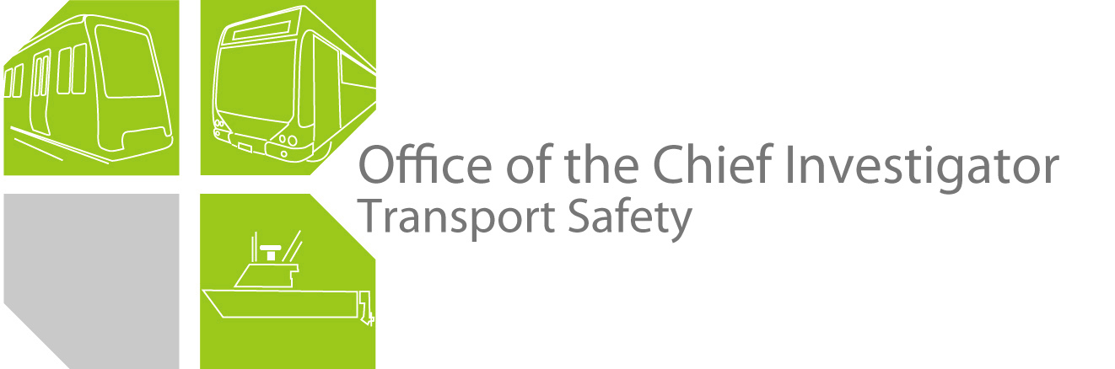

**Rail Safety Investigation**

**No 2011/ 01**

Brief Report

Tram-to-tram collision

Yarra Trams

Intersection of Kings Way and Sturt Street

South Melbourne

12 January 2011

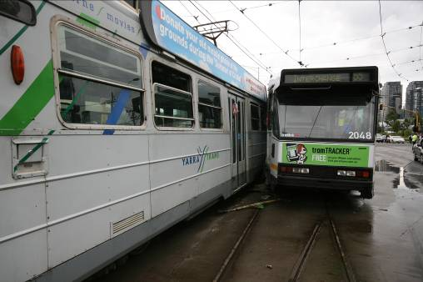

# The Chief Investigator

The Chief Investigator, Transport Safety is a statutory position under Part 7 of the *Transport Integration Act 2010*. The objective of the position is to seek to improve transport safety by providing for the independent no-blame investigation of transport safety matters consistent with the vision statement and the transport system objectives.

The primary focus of an investigation is to determine what factors caused the incident, rather than apportion blame for the incident, and to identify issues that may require review, monitoring or further consideration. In conducting investigations, the Chief Investigator will apply the principles of ‘just culture’ and use a methodology based on systemic investigation models.

The Chief Investigator is required to report the results of an investigation to the Minister for Public Transport or the Minister for Ports. However, before submitting the results of an investigation to the Minister, the Chief Investigator must consult in accordance with section 85A of the *Transport (Compliance and Miscellaneous) Act 1983.*

The Chief Investigator is not subject to the direction or control of the Minister in performing or exercising his or her functions or powers, but the Minister may direct the Chief Investigator to investigate a transport safety matter.

# Issuing of a Brief Report

In those cases where an investigation is curtailed or a full investigation report is not considered warranted, the Chief Investigator may issue a Brief Report.

A Brief Report will typically include the particulars of the event, a description of the incident, a summary of pertinent investigation information and key findings and, as applicable, a description of identified safety issues and recommended safety actions

# Occurrence Details

**Date:** 12 January 2011

**Time:** 1610

Location

Intersection of Kings Way and Sturt Street, South Melbourne.

Trip/route details

Both trams Route 55, Domain Interchange to-and-from West Coburg

Incident outcomes

Tram-to-tram oblique-angle collision.

Vehicle details

Tram Z3 180, city-bound.

Tram B2 2048, outbound.

Both vehicles and drivers are based at the Essendon Depot.

Vehicle operator

Yarra Trams.

Infrastructure manager

Yarra Trams.

Environmental details

Approximately 25ºC, intermittent light rain showers.

Other information

Three of the approximately ten passengers on tram № 180 received minor injuries and were treated by paramedics at the scene. There were no reported injuries to any of the estimated five passengers aboard tram № 2048.

Circumstances

**Background**

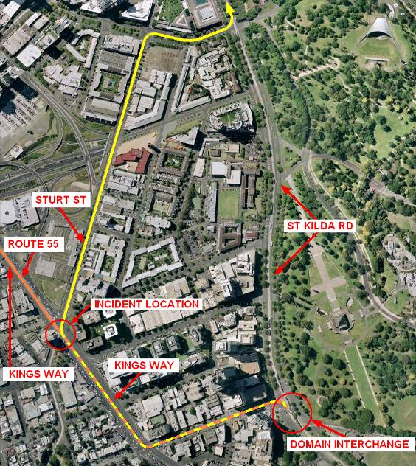A defective tram on the city-bound track along St Kilda Road was preventing movements on the city-bound portion of St Kilda Road between the Domain Interchange and the CBD. City-bound tram services on St Kilda Road were being diverted from Domain Interchange via Park Street and Kings Way thence onto Sturt Street for access to the city. This diversion is provided-for by a turnout connecting Kings Way and Sturt Street. Such diversions are required infrequently, and on this occasion the diversion had been in effect for about 20 minutes prior to this incident.

Figure 1: Tram diversion route, Domain Interchange-to-City, showing incident location

Sequence of events

Two trams on Route 55 along Kings Way (one outbound, one city-bound) approached each other at the Sturt Street intersection. A previous tram movement on the city-bound track some minutes previously had been a diverted St Kilda Road service (described on the previous page). In accordance with normal operating procedure, this left the manually-operated points set for the turn from Kings Way into Sturt Street, requiring the driver of any following Route 55 tram to alight and manually restore their setting.

In this case, the next tram on the city-bound track *was* a Route 55 service. This tram stopped at the № 116 Tram Stop immediately prior to the intersection. When the traffic lights changed to ‘Proceed’, the tram moved ahead—the driver responding to the ‘straight-ahead’ tram priority arrow (Figure 3)—and turned unintentionally and unexpectedly into the side of the opposing Route 55 tram that was passing on the adjacent track.

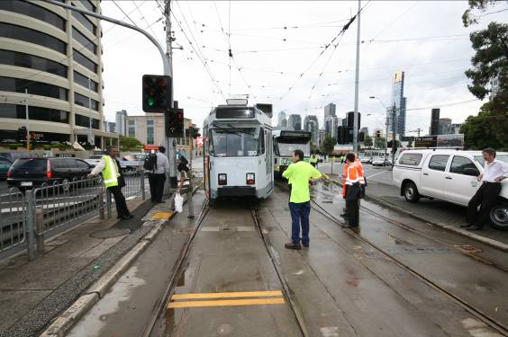Figure 2: Kings Way-to-Sturt St turnout showing direction taken by tram No. 180, and adjacent tram priority signal displaying a 'straight-ahead' arrow

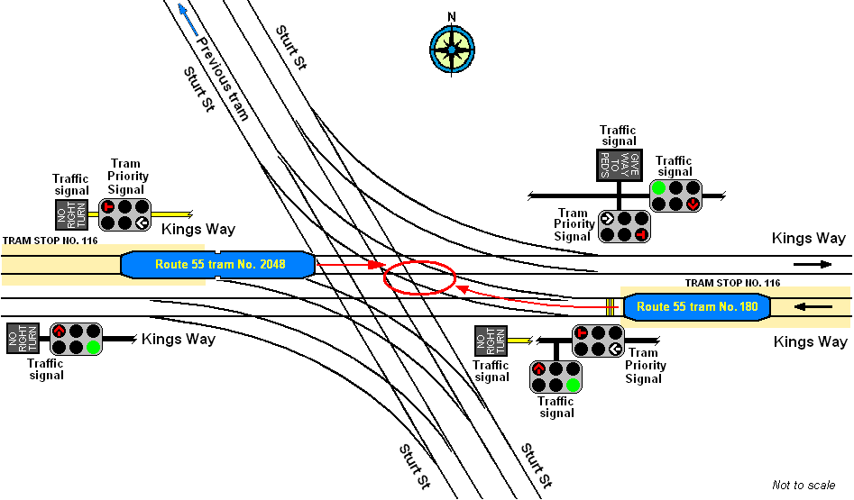 Figure 3: Kings Way/Sturt St tramway intersection and incident location

# Summary of investigation information and findings

Tram drivers

Neither driver was injured and both were breath-tested, with negative results. The driver of tram № 180—who qualified as a tram driver in September 2010 and who was last assessed for on-job competency in December 2010—was interviewed at site. He acknowledged that the points ahead of him must have been set for the turn and he had not noticed.

Both drivers were operating with current medical certificates and were considered to be fit for duty.

Damage to trams

The leading bogies of both trams derailed; tram № 180 by 4.5m from the track, and tram № 2048 by 0.5m from the track. Both vehicles sustained significant exterior damage at the points of impact; for tram № 180 the right-hand side of the cab as well as the exterior side sheathing and structural members, and for tram № 2048 a window.

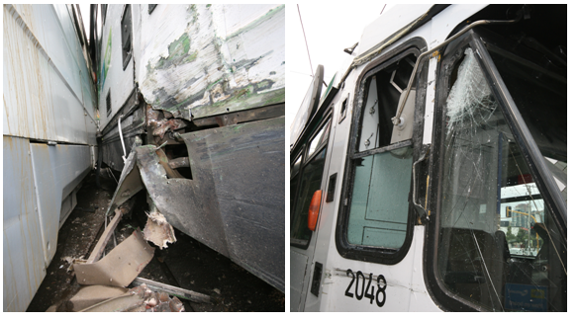

Figure 4: Damage to trams

Infrastructure and operations

The Kings Way/Sturt Street tramway intersection provides a double-track (that is, for trams in both directions) connection between Kings Way to the east of the intersection and Sturt Street to the north, and between Kings Way to the west of the intersection and Sturt Street to the south (see Figure 2). This intersection is furnished with manually-operated points and manual operation of the tram priority turn signal[1].

The connection between Kings Way (east) and Sturt Street (north) is used infrequently whenever there is an operational requirement to bypass that portion of St Kilda Road extending between the Domain Interchange (St Kilda Road and Park Street) and Southbank Boulevard. Because of this occasional use, the intersection is equipped with manually-operated points. This requires tram drivers to stop and, if required, to alight and physically alter the setting of the points for the intended route. For right-hand turns, the tram priority arrow signal must also be manually called-for by operation of a button on an adjacent pole. When the traffic light sequencing permits, the tram priority arrow will illuminate to authorise the driver to proceed in the intended direction.

The points and tram signals on the Melbourne tram network are not interlocked. Although the points may be set against the intended direction for a tram, the tram priority signal will display a ‘straight-ahead’ arrow indication as long as the adjacent ‘turn arrow’ call button has not been pressed.

`

In this case, the driver of the city-bound Route 55 tram had stopped on Kings Way at Stop № 116, a compulsory stop due to the existence of the points controlling the turn into Sturt Street. Although these points had been left lying for the turn following the passage of a tram some minutes ahead, the driver of the following tram failed to notice this. When the traffic and tram lights changed to a ‘Proceed’ indication, the tram priority indication displayed would have been the default white vertical arrow denoting ‘Proceed straight ahead’. Unmindful that the points were set for the turn, the driver moved ahead expecting to travel directly across the intersection.

Operating rules

Yarra Trams rules specify that it is always the tram driver’s responsibility to satisfy themselves that points are correctly set prior to moving over them and that tram drivers must not attempt to travel over any points that are not correctly set.

These directives are contained within their training module, *Points and Shunting* and the book of *General Operational Rules and Procedures*.

Response to safety issues - previous incidents

In response to a request from the investigation, Yarra Trams have supplied details of their response to Safety Issues and Recommended Safety Actions arising from previous collision incidents investigated by the Office of The Chief Investigator.

1. Responding to recommendations that they give consideration to the provision of an interlocking system to prevent conflicting movements at tram junctions, Yarra Trams have informed the investigation that a proposal is currently being prepared for the Department of Transport (for submission in June 2011) as part of a Track System Integrity Improvement Strategy for endorsement in the next financial year. The following extract from the submission refers:

“**To Address the Impact on Safety, Performance and Reliability of Current Points and Crossing Standards.**

The track construction standards for points and crossings should be upgraded to European standards.... The safety systems for the automatic points across the network should be upgraded to SIL-3 standards[2]. This will be achieved through replacement of older autopoint motors and controllers to modern standards, including failsafe detection and signalling, automatic route setting, interlocked junctions to prevent conflicting moves and remote diagnostic and monitoring systems.”

Yarra Trams advise that the application of SIL-3 to automatic points installations would include treatment of the points themselves, the point motors, associated controllers and detection systems, and interlocking with the phasing of traffic signals.

1. Following an undertaking to institute tram driver refresher training, Yarra Trams have implemented a Defensive Driving Course as part of a tram driver’s 18-monthly refresher training course.
2. Following an undertaking to train depot managers in fatigue management and to develop fatigue management plans for their respective worksites, Yarra Trams have implemented a *Fatigue Management Policy* that includes the administration of a *Fatigue Management Program* and *Fatigue Management Awareness* training for staff.
3. In consideration of a comment made in a previous Chief Investigator’s report, Yarra Trams have reaffirmed—during refresher training and via promulgation of operational notices and safety alerts—the vital requirement for tram drivers to be at all times aware of the setting of points.
4. In response to a recommendation that they review their Safety Management System with respect to the adequacy of risk mitigations to prevent collisions between trams at junctions, Yarra Trams has stated that it is in continuous review of its risk register as part of its zero harm philosophy and quest for continual improvement. The *Tram-to-Tram Collision Risk Register* was last reviewed in July 2010.
5. A previous report by the Chief Investigator recommended that Yarra Trams review and analyse its tram-to-tram collision data and adopt a strategy to isolate contributory factors. The company has stated that they review this data annually and are currently in the process of absorbing the Contributory Factors Framework[3] into their Incident Investigations procedure.

# Identified safety issues and recommended safety actions

Interlocking at intersections

Unintended turns by trams at junctions—by which one tram turns into the path of another—have occurred before on the Melbourne tram network and have resulted in significant damage. It is fortunate there have been no serious injuries or fatalities from these incidents. Consequent reports by the Chief Investigator have recommended that some form of interlocking of tram and traffic signals with track points control should be considered by Yarra Trams.

A response from Yarra Trams addressing this issue is detailed on the previous two pages. There is no further recommendation around this issue.

Driver performance

Manual junction points that are seldom used, on routes where other junction points normally encountered are predominantly automatic, constitute areas of potential danger. Drivers of trams on some routes routinely encounter points that automatically restore their setting for the straight-ahead route upon the approach of the tram. Such drivers who routinely operate over manual points that are infrequently used for tram diversion and that seldom require deliberation, might be expected to develop a degree of complacency about the critical need to remain alert at such locations.

Nonetheless, it is vital for all personnel who are authorised to operate railway or tramway points or to operate rail vehicles over such infrastructure, to ensure that these operations result in the intended route being correctly set. Yarra Trams’ instructions to staff regarding checking points for the correct setting before passing over them and checking to ensure their tram is following the intended route are explicit. Had these instructions been adhered to it is unlikely this incident would have occurred.

Yarra Trams have a *Corrective and Preventive Action* procedure (c207wi0001, revised Feb 2011) that is applied to manage the application of remedial actions following the identification of an opportunity for improvement. There is no further recommendation around this issue.

Tram control and communications

Although used relatively infrequently, the connection between Kings Way (east) and Sturt Street (north) is a vital alternative route to-and-from the city should that portion of St Kilda Road extending between the Domain Interchange and the intersection with Southbank Boulevard require to be bypassed.

Because of the requirement for only intermittent use, the points infrastructure at the Kings Way/Sturt Street tramway intersection is non-automatic. When such points are not set for a tram’s intended route, the driver is required to alight and physically alter their setting. This means that when tram drivers are maintaining normal operations along a route—part of which is being used for a diversion—they will, from time-to-time, encounter manual points set against them at junctions where such would not normally occur. Under these circumstances it is possible that tram drivers not focused on this vital aspect might forget that these points will not automatically reset for the intended route upon their approach.

When operating under conditions such as these, it would seem prudent for Yarra Trams to make use of the Fleet Operations Centre[4] and their communications broadcast ability to maintain regular contact with trams operating over a diversion route as well as those trams operating within normal service over that portion of the route that is carrying diverted traffic. Such communications could contain reminders to tram drivers to be alert for changed circumstances.

**RSA 2011022**

That Yarra Trams consider requiring Fleet Operations Centre to broadcast regular alert messages to the drivers of trams operating on diverted routes and on routes where some section being traversed is part of the diversion, alerting them to the out-of-course conditions.

# Safety actions taken since the event

Yarra Trams has erected new warning signage for drivers at the № 116 tram stop, reminding them of the requirement to observe the setting of points ahead.

See also, content on p.8 under heading, ‘Response to safety issues - previous incidents’.

# Decision to curtail investigation

Further investigation into this incident by the Office of the Chief Investigator is not

considered warranted. It is recognised that the issue of driver performance is subject to the operator’s established procedures; the effective functioning of which is the responsibility of the operator.

It is also recognised that ongoing monitoring of the operator—including their compliance with variations in and additions to their Safety Management System—rests with the safety regulator.

1. Traffic signals that operate in the same way as—or together with—traffic lights, but that apply only to trams. They display either a white ‘T’ light or a white arrow. Trams may proceed on a ‘T’ light or turn in the direction indicated by the arrow despite a red traffic light being displayed.
2. A *Safety Integrity Level* is a measure of the reliability of a safety control system. The applicable level is determined by the Probability-of-Failure-on-Demand per year (PFD) for the particular system. Yarra Trams advise that the PFD for Safety Integrity Level 3 is ‘More or Equal to 0.0001 but Less than 0.001’. It is achieved by redundant hardware (power supply and other electronics componentry), diagnostic hardware and software. Within the European Functional Safety standards, four SILs are defined, with SIL 4 being the most dependable and SIL 1 being the least.
3. The CFF is a consistent and structured system for coding the systemic contributors to rail safety occurrences. The system facilitates the recording and analysis of the contributing factors identified during systemic investigations.
4. Yarra Trams’ centralised operational control centre. Controllers maintain two-way communication with trams at all times.