

**Rail Safety Investigation**

**No 2008 / 04**

Brief Report

Wrong-railing of Yarra Trams

C Class Tram № 3032

Collins Street Melbourne CBD

3 April 2008

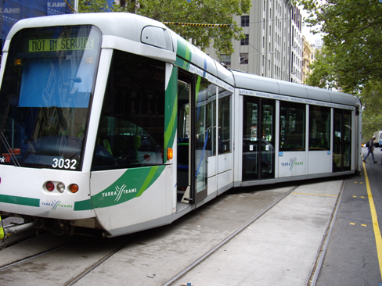

# Scope and reporting

The Chief Investigator

The Chief Investigator, Transport and Marine Safety Investigations is a statutory position established on 1 August 2006 under Part V of the *Transport Act 1983*.

The objective of the position is to improve public transport and marine safety by independently investigating public transport and marine safety matters.

The primary focus of an investigation is to determine what factors caused the incident, rather than apportion blame for the incident, and to identify issues that may require review, monitoring or further consideration. In conducting investigations, the Chief Investigator will apply the principles of ‘just culture’ and use a methodology based on systemic investigation models.

The Chief Investigator is required to report the results of investigations to the Minister for Public Transport and / or the Minister for Roads and Ports. However, before submitting the results of an investigation to the Minister, the Chief Investigator must consult in accordance with section 85A of the *Transport Act 1983*.

The Chief Investigator is not subject to the direction or control of the Minister(s) in performing or exercising his or her functions or powers, but the Minister may direct the Chief Investigator to investigate a public transport safety matter or a marine safety matter.

Issuing of a Brief Report

In those cases where an investigation is curtailed or a full investigation report is not considered warranted, the Chief Investigator may issue a Brief Report.

A Brief Report will typically include the particulars of the event, a description of the incident, a summary of pertinent investigation information and key findings and, as applicable, a description of identified safety issues and recommended safety actions.

Occurrence details

**Date:** 3 April 2008

**Time:** 1347

**Location**

Crossover track on Collins Street between Russell Street and the Exhibition Street tram stop.

**Trip / route details**

The tram was operating from the Southbank depot as a replacement for a defective tram on Route 31 (between City Terminus, Collins Street West and St Vincent’s Plaza). The tram was reversing direction via a cross-over between the Up and Down tracks to return to its schedule.

**Incident outcomes**

The front bogie of the tram followed an unintended route while the rear bogie followed the intended but different route; however, the tram was stopped before derailing.

There were no reports of injury to passengers, employees or public.

Damage to the tram was limited to a crushed side traffic indicator lens and a slightly creased body panel (refer left-hand photo on next page), both of these caused directly by the extreme degree of relative yaw between modules.

**Vehicle details**

‘C’ class tram № 3032 is a Citadis 202 model, 3-section, low-floor vehicle built during 2001/02 in France by Alstom Transport. It entered service in Melbourne in late June 2002.

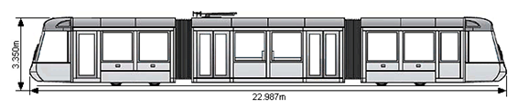

The vehicle has a non-swivelling drive-motor-and-wheel assembly, referred to as a ‘bogie’, fixed to the carbody structure, and located beneath the rear-ward half of each end-section. The centre section is carried between the two end-sections and pivots from each of these about an articulation point.

**Vehicle operator**

Yarra Trams

**Infrastructure manager**

Yarra Trams

**Environmental details**

Daylight, fine, dry.

# Circumstances

Background / context

*(Note: A rail incident where the rail vehicle wholly takes and / or follows an unintended route is generally referred to as ‘wrong-routing’. A similar incident where one part of the rail vehicle follows the correct path whilst another part − e.g. one bogie − takes the wrong rail but does not derail is a ‘wrong-rail’ incident).*

The tram was being brought into service to replace a unit that had a defective destination board. The driver of the defective tram had been required to return it to the Southbank depot to obtain a replacement and then continue with his run. When returning to his route with the replacement tram, and upon reaching the intersection of Spencer and Collins Streets, the driver resumed service but due to closely following another tram did not uplift any passengers.

In an attempt to resume his timetable by returning to service mid-route, the driver was instructed by Fleet Operations Centre to stop at the crossover beyond the Russell Street intersection and shunt the tram to the opposite track to continue service in the opposite direction.

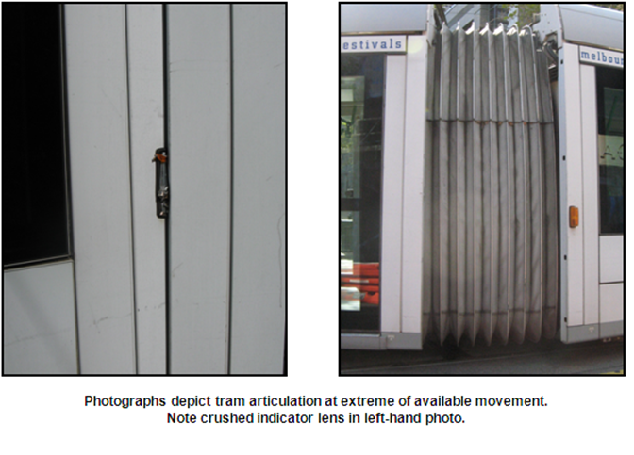

# Summary investigation information and findings

Personnel

The tram driver was qualified and medically fit for his duty. He had been qualified on C class trams since January 2003.

Vehicle(s) and Equipment

Tram 3032 was last serviced in February 2008 (‘A’ service – 10,000 km). A download of the tram event recorder indicated no faults and the tram wheels were found to be within specification.

Regulatory Systems

The tram system franchisee (Yarra Trams) is responsible for management of its operational risks, with oversight by the safety regulator, Public Transport Safety Victoria (PTSV).

Sequence of events

The tram was being driven from the leading driving cab in the direction of travel. The driver stated that he stopped at the points and left the cab to manually operate them. He then returned to the tram and moved forward. When asked if he looked at the points blades after manipulating them he stated that ‘he thought’ he did.

From observations made, and a function test carried out after the occurrence, the T-bolt used to fasten the points blade connecting rod assembly to the left-hand facing point blade had become disconnected and had fallen into the drain area beneath the rails. The T-bolt had apparently worked loose over the preceding four days and either fell out as the tram driver operated the points (using his manual lever) or was already unfastened and lying (as found) in the drain area beneath the left-hand switch structure.

Whilst traversing the manually-operated points the leading end-section of the tram followed the straight-ahead route (not intended) while the trailing end-section took the turn-out for the cross-over (as originally intended) so that each end of the tram followed a different routing. This resulted in the tram occupying both Up and Down tracks at the one time, with the centre section spanning both tracks and assuming a position relative to the others at the extremities of permitted horizontal rotational movement, or ‘yaw’ (see diagram below).

The ‘wrong-rail’ traverse was eventually stopped ⎯ before derailment or further damage could occur ⎯ when the tram driver realised that the trailing section of his tram was following the wrong route.

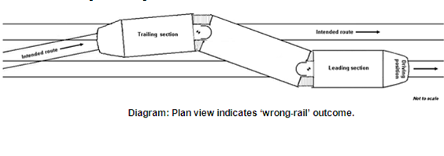

Infrastructure details

The points mechanism at this location is an Integron Industries point switching system operating in ‘Normal’ mode, whereby the points are set by manual operation. The system consists of a steel earth box enclosure (see photo below) which is covered and mounted between the rails. It contains the points-setting mechanism and lies flush with the pavement surface. The apparatus comprises a spring-loaded toggle mechanism and pivot (also referred to by Yarra Trams as the ‘centrepiece’) − which is operated by the tram driver’s lever − to which is attached, at each end, an adjustable connecting *tie-rod* and a *ball-joint* pivot rod-and-socket assembly. A 105 mm T-bolt then fastens each point blade to its adjacent ball joint, with a *retention sleeve* located under tension between the ball joint pivot rod and both the head of the T-bolt and the inner face of the points blade (see diagrams on page 8). The retention sleeve functions both as a spacer and to facilitate rotation − for adjustment − of the adjacent ball joint pivot rod.

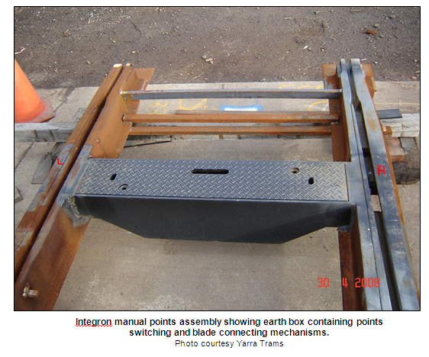

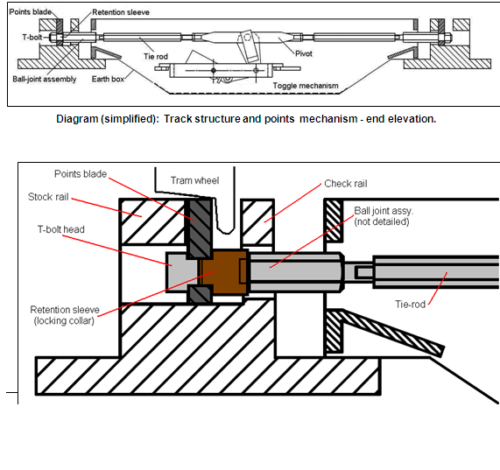The flexible ball joint assembly is provided to accommodate the constant dynamic action − mostly vertical pumping − of the points blade under the influence of passing tram wheels.

In this occurrence the T-bolt became detached from the ball-joint pivot rod and both the bolt and retention sleeve had fallen into the drain area beneath the rails.

Damage to the T-bolt indicated both compression of the retention sleeve against the thread (see description [1] below) and severe abrasive flogging of portions of the thread of that part of the bolt nearer the head (see photo on page 13).

[1] The T-bolt is applied by presenting it head-first through an elongated hole in the web of the points blade and then rotating it through 90 degrees to permit the T-head to bear against the outer face of the web. The *retention sleeve* (referred to by Yarra Trams staff as the ‘locking collar’) – its internal diameter providing a generous clearance − is then slipped over the bolt to bear against the inner face of the points blade web. The outer end of the *ball-joint* sub-assembly is then screwed onto the bolt and tightened against the retention sleeve. The retention sleeve thus acts as a spacer, and is held in **tension** between the points blade and the ball-joint sub-assembly which itself forms part of the greater points blade connecting system. The design of this sub-assembly, though − through constant flogging of the points blade resulting from the passage of trams − permits the bolt and retention sleeve to work vertically, relative to each other, due to the aforementioned design intentional clearance. The subject retention sleeve showed evidence of an imprint (matching the bolt-thread) at a point on its internal diameter that corresponded with sections of severely deformed thread crest along the length of the T-bolt.

From observations and measurements made on the day of the occurrence, it was apparent that the points were considerably contaminated with stormwater silt and leaf litter, and that the right-hand facing point blade was some 20 mm longer than the left-hand one.

The crossover had last been used by a tram running in the same direction, on the evening prior to the day of the occurrence.

Analysis

Distance travelled before stopping

Since the leading wheels of a C class tram are 4.173 metres behind the leading edge of the tram carbody, at a nominal five km/h it will take about three seconds from the time the points disappear from view beneath his driving cab before the driver can become aware that the tram is not following the expected route. The driver stated that he stopped as soon as he realised he was going the wrong way. The reality is, however, that by the time it stopped, the entire vehicle – which is about 23 metres long – had travelled some 19 metres past the facing points. The tram driver realised his predicament when he noticed the tram carbody moving sideways onto the adjacent line in his left-hand mirror. Assuming he had originally stopped the tram five metres prior to the points (in order to set them for the crossover), then by the time he came to a stand after realising his predicament he would have travelled some 47 metres in total. Why he was unable to appreciate at an earlier opportunity that his tram had taken the wrong route at the points and to stop the movement before its trailing end diverged could not be established.

Wrong-railing of the tram

In the absence of any evidence of rail ‘climb-over’ by any of its wheels, the means by which the tram was able to take first one direction and then the other at these points − without derailing − is open to conjecture. However it is known that the two points blades were disconnected and thus able to operate independently of each other, the points were observed to be fouled with silt and leaf litter (this would have tended to render them stiff and less-free in operation), and one blade was slightly longer than the other. It is therefore possible for the occurrence to have developed as follows:

1. If the driver had manipulated the points and moved the tram forward without correctly checking their position, it is possible the points may have been half-cocked[1]. When operated immediately after the occurrence, only the right-hand facing blade was found to be connected to the mechanism.

The left-hand blade was unrestrained; and being worn and loose from constant pounding by the passage of daily tram traffic (it being the ‘active’ blade – carrying all traffic in the normal, straight-through direction), tended to be free to move at will from any inducement.

1. Due to its slightly greater length, the right-hand blade (for the tram in this occurrence) is likely to have been encountered initially by the leading right-hand wheel. If this wheel-flange took the straight route (by nudging the points blade to the left), this probably caused the left-hand wheel flange to take the same side of the left-hand points blade. This would have permitted the leading bogie of the tram to run straight ahead without derailing.
2. These combined actions would have set the leading ‘bogie’ of the tram down the straight-ahead route without derailing.
3. With the passage of the front bogie through the points, the right-hand points blade may have been ‘unsettled’ sufficiently for it to also be presented ‘half-cocked’ to the wheels of the trailing-end ‘bogie’ such that these flanges might also go either side of the blade. Note also, that it is possible that this blade was never forced fully across to the left by the flange that contacted it. It may, therefore, have remained half-cocked after passage of the front portion of the tram.

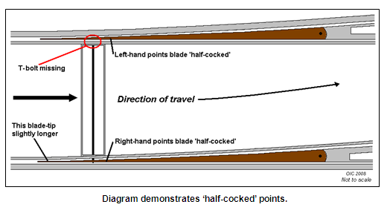

1. The left-hand points blade (in direction of travel of this occurrence) showed evidence of a recent ‘bruise’ to the left-hand upper edge of the blade tip. This suggests that the leading left-hand wheel-flange of the trailing ‘bogie’ of the tram has nudged this blade to the right thus opening the route for the left-hand wheels to take the turnout route as originally intended. Given that the right-hand blade may have been biased to the right-hand setting by the original position of the points-setting handle, it may have been sitting sufficiently to the right such that the right-hand wheel-flanges of this bogie ran to its left-hand side, thus also taking the route for the turnout.

In this manner, it is possible for the two separate ends of the tram to have taken two separate routes without derailing and without the wheel flanges having jumped any rails. It would be next-to-impossible to replicate these circumstances in the field.

Track maintenance

Integron points are inspected per Yarra Trams’ Routine Inspection Program every two weeks. This set of points had been inspected four days prior to the occurrence. A review of the Routine Inspection Program Checklist indicated that although there was provision for five separate inspection items to be positively recorded (either by a tick or a comment), only one of these items – the Function test – had been recorded as carried out. The other four items unrecorded on this checklist included the condition of the points blades, the blade connection links and drains as well as required lubrication.

In the case of points blades and drains the written maintenance procedure specifies their condition to be positively recorded as ‘Good / Fair / Worn’ and ‘¼ Full / ½ Full / Full’ respectively. This had not been done. The procedure also provides for the points to be washed out ‘if required’, however the checklist form contains no provision to record this. The procedure also makes no mention of a process for the fitment of the ‘retention sleeve’ (refer to diagram on page 8).

Yarra Trams track maintenance procedures provide for the points to be checked *“…under normal tram traffic conditions”*. In such an environment it is inevitable that there will be times when track work is hastened due to the approach of a tram, and track maintenance staff have stated they are cautioned against delaying trams.

If not well-managed, this increases the potential for excessive haste to cause mistakes to be made or tasks not to be completed correctly.

Staff directly involved with this work also stated they had never before seen a T-bolt become disconnected in this fashion. The investigation was unable to establish how an assembly − functionally tested as satisfactory four days prior to the occurrence − could then work loose to the point of disconnection. This suggests that something different from the norm existed at this location; the most obvious possibility in this instance being faulty or improper installation and / or inspection. It is left for investigators to infer that either the T-bolt was not applied correctly and was able to loosen-off and back out and / or it was not inspected properly at the last inspection.

This points blade received a heavy pounding from passing tram traffic. When observed by investigators in the field, its tip hammered up-and-down by some 30mm when under traverse by a tram. Such treatment would have had a severe effect upon the blade and anything attached to it. This was evident from the damage that had occurred to the T-bolt and retention sleeve (see photos on page 13) as it worked loose and was subject to sustained dynamic treatment by the hammering points blade through which the T-bolt passed and against which the retention sleeve was clamped. Similar damage to the adjacent ball-joint pivot and the check rail through which it passed was also evident at this location (see lower right-hand photo on page 13).

The damage caused to Integron manual points through general usage was such that Yarra Trams instigated (prior to this incident) an ongoing remedial programme of welding that involves building up critical surface areas of the points blade and the recess for its rotating spigot. These measures remove certain surface inconsistencies and dimensional deficiencies that have both permitted and promoted the severe vertical hammering that has historically occurred as trams traverse the ‘active’ points blade. The remedial measures also include welding lugs to the side of the points blades. These lugs bear against the under-surface of the adjacent rail head, thus preventing the blade tip from rising when the weight of a tram wheel is applied at its heel area (spigot).

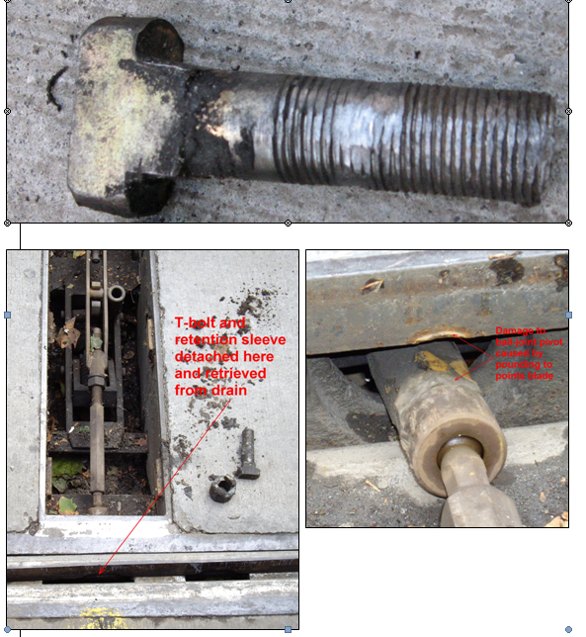

# Identified safety issues and recommended safety actions

Driver performance

It is incumbent upon all personnel who are authorised to operate railway or tramway points to ensure that such operation results in the intended route being correctly set.

Yarra Trams instructions to staff regarding checking points for the correct setting before passing over them and checking to ensure the tram is following the intended route are explicit. These directives are contained in their TRAINING MODULE – POINTS AND SHUNTING (Section’s 6, 7, 8.2, and 12.1) and the book of GENERAL OPERATIONAL RULES AND PROCEDURES (Instruction 83). Had these instructions been adhered to it is unlikely the incident would have occurred.

The tram driver in this occurrence did not comply with these requirements.

**RSA 2008033**

It is recommended that Yarra Trams use this occurrence to reconsider their management of tram driver performance and their oversight of compliance with company requirements.

**Track Maintenance**

The integrity of the tramway infrastructure is critical to the safety of the operation. It follows that appropriate technical processes and procedures must exist and be adhered to. Yarra Trams’ procedures for the routine maintenance of manual crossover points are considered adequate however in this case the Routine Inspection Program Checklist was completed in a cursory manner making it impossible to assess whether inspection was carried out effectively.

Yarra Trams’ track maintenance procedures are carried out, *“…under normal tram traffic conditions”*. This process supports the potential for mistakes to be made or for tasks not to be completed correctly due to anxiety and resultant haste on the part of track maintenance staff. This aspect requires careful management.

It is clear that the fault that developed at this location was different to the norm; such an occurrence had not been seen before by track maintenance personnel. Either the T-bolt had not been installed correctly or it was not inspected properly at the last inspection.

Observations made by maintenance staff, and remedial action and other work undertaken when attending to points must be fully and correctly documented. Extra care is required when completing work during scheduled tram operations.

**RSA 2008034**

It is recommended that Yarra Trams use this occurrence to emphasise to track maintenance personnel the critical necessity for ensuring that vital maintenance tasks have been completed and for the proper completion of maintenance records.

# Decision to curtail investigation

Further investigation into this incident by the Office of the Chief Investigator is not considered warranted. It is recognised that the issues of driver performance and track maintenance are subject to established procedures of the operator. The operator is responsible for ensuring the effective functioning of these processes.

It is also recognised that ongoing monitoring of the operator rests with the safety regulator.

1. Points are *half-cocked* when the blades are left sitting within the switch neither fully across to left nor right (see diagram next page).