YOUTH ACCESS INITIATIVE REFERRAL FORM

Helping bridge the gap between education and disadvantage for young people in Victoria.
This Referral Form must be completed in order to obtain a tuition fee waiver under the Youth Access Initiative. Please refer to the Youth Access Initiative: Guidebook prior to completing this form. The Youth Access Initiative provides a tuition fee-waiver for Victorian young people undertaking government subsidised accredited training who:
- be eligible for Skills First government-subsidised training which includes being an Australian citizen, an Australian permanent resident, or a New Zealand citizen. For more information, refer to Victorian Skills Gateway – how to check your eligibility
- be aged 24 years or under, and
- have been or are currently on a Child Protection Order or a Youth Justice Order (but are not currently in custody), or
- a young person who has participated or is participating in the Children's Court Youth Diversion Service, or
- be a young person who is a part of the Unaccompanied Minor Humanitarian program, or
- be a resident of an Education First Youth Foyer (for a list of relevant orders and foyer information refer to guidelines).
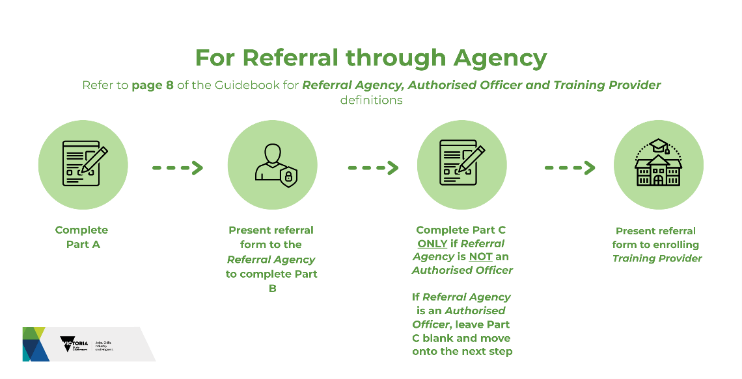
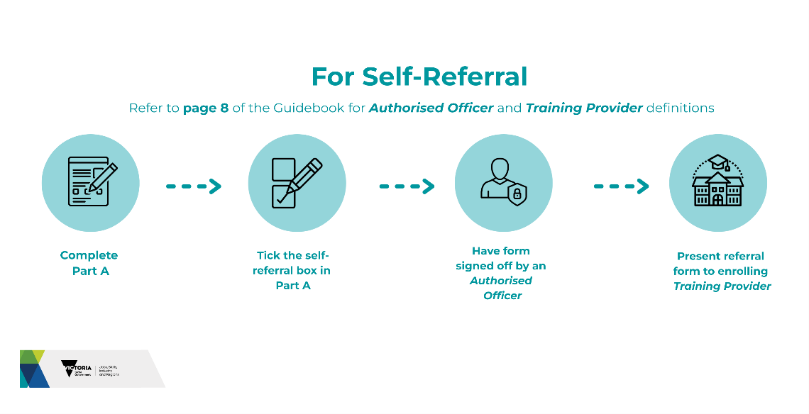

Refer to Definition for an explanation of "Referral Agency, Training Providers and Authorised Officer"

PART A – To be completed by the eligible young person
Note: Part A must be completed by the eligible young person for information sharing. If the participant is under 16 years of age, their legal guardian should complete it.
☐ Tick this box if you are self-referring without the support of a Referral Agency and proceed to PART C.
If the Referral Agency staff member completing the form is an Authorised Officer, DO NOT complete PART C.

Name:
Date of birth: / /
Phone:
Email:

Assistance with completing this form
- If you have previously been on a Youth Justice Order and are no longer managed by a youth justice case worker, you can email a copy of your referral form with PART A completed and signed to youthaccessinitiativeeligibilty@justice.vic.gov.au to have your eligibility confirmed. By signing and sending the form to the Department of Justice and Community Safety (DJCS) you’re consenting to your personal information regarding any previous youth justice history being shared with the Department of Jobs, Skills, Industry and Regions (DJSIR) and the enrolling training provider for the purpose of accessing the tuition fee-waiver.
- If you’ve previously been on a Child Protection Order and are no longer engaged with a child protection service, please contact the leaving care hotline on:1300 532 846 or email: leavingcare@mcm.org.au for assistance in authorising eligibility for the Youth Access Initiative.

Privacy statement:
I (Print Name) , consent to the information provided on this form being shared between Referral Agencies, Authorised Officers, DJSIR, DJCS, Department of Families, Fairness and Housing (DFFH) and Training Providers for the purpose of assessing my eligibility to the tuition fee-waiver under the Youth Access Initiative.
Signed: PLEASE SIGN HERE Date: / /

PART B – To be completed by the Referral Agency (not to be completed if you are self-referring)

Name of Referring Agency:
Is the Referral Agency staff member an Authorised Officer (see definition) ? ☐YES ☐NO
Print Name of Referring Agency Staff:
I confirm that the young person described in Part A (tick all the appropriate boxes):
is currently 24 years of age or under; and
‘has been’ or is ‘currently on’ a Child Protection Order or a Youth Justice Order (but is not currently in custody); or
is a young person who has participated or is participating in the Children's Court Youth Diversion Service; or
is a young person who is a part of the Unaccompanied Minor Humanitarian program; or
is an Education First Youth Foyer resident; and
wants to enrol in suitable government subsidised training at an appropriate training provider as described in the Youth Access Initiative: Guidebook.

Signed: PLEASE SIGN HERE Date: / /
Phone / Mobile: Email:

PART C – To be completed by an “Authorised Officer” from one of the following:
- the Department of Families, Fairness and Housing (DFFH)
- the Department of Justice and Community Safety (DJCS)
- an Education First Youth Foyer
If PART B is completed by an Authorised Officer, DO NOT complete PART C.
I confirm that the young person described in Part A (tick all the appropriate boxes):
will be 24 years of age or under; and
‘has been’ or is ‘currently on’ a Child Protection Order or a Youth Justice Order, (but is not currently in custody); OR
is an Education First Youth Foyer resident; and
wants to enrol in suitable government subsidised training at an appropriate training provider as described in the Youth Access Initiative: Guidebook.
Name of staff member: Position:
Name of the Department: Division: Branch / Unit:
Signed: PLEASE SIGN HERE Date: / /
Phone / Mobile: Email:

PART D – To be completed by a representative of the enrolling Training Provider
The young person is eligible to enrol in government subsidised training under Skills First and has been enrolled in a suitable course.
The eligible young person has been granted a waiver of their student tuition fees under the Youth Access Initiative.
Enrolling training provider must keep the ORIGINAL referral form and give a COPY to the enrolling young person and Referral Agency (where applicable).
Name of the Training Provider:
Address of the Training Provider:
TOID: Course Code:
Course Name:
Course Start Date: / / Expected Course End Date: / /
Contact Name: Phone / Mobile:

Definition

Referral Agency

Any organisation based in Victoria that currently receives funding from or is contracted by the Victorian Government or the Commonwealth Government to provide services to children, young people and/or families can act as a Referral Agency for the Youth Access Initiative and support the eligible young person in completing the Referral Form and enrolling in a suitable course. All Referral Agencies are required to retain a COPY of the Referral Form for audit purposes.

Authorised Officers

Authorised Officers can sign off on the eligibility of a young person for the Youth Access Initiative. These include:
- Department of Family, Fairness and Housing (DFFH) authorised staff
- Child Protection Post-Care (manager/case manager)
- Education First Youth Foyer authorised staff
- Department of Justice and Community Safety (DJCS) authorised staff
- Youth Justice case managers
- Parkville College authorised transition staff
- Department of Job, Skills, Industry and Regions (DJSIR) authorised staff.

Non-Authorised Officers, those outside the above organisations and positions will need to refer the young person to an Authorised Officer.

Training Providers

Skills First contracted Training Providers approved to offer a tuition fee waiver under the Youth Access Initiative (being only TAFE and Dual Sector Universities and Learn Local providers), must NOT charge eligible Youth Access Initiative young people any tuition fees for government subsidised accredited training.

Relevant training providers are required to retain the ORIGINAL of this Referral Form for audit purposes and return a copy to the Referral Agency (where relevant), and to the enrolling student. The Training Provider will receive a contribution from DET for the tuition fee-waiver under the Youth Access Initiative.

The Training Provider must report all training delivered to the eligible young person under the Youth Access Initiative in accordance with the reporting requirements outlined in the Victorian VET Student Statistical Collection Guidelines, including using the Fee Exemption/Concession Type Identifier.

