**Transport Safety Investigation**

**Report No 2006 / 05**

Passenger injury

on-board a suburban bus service

Werribee Plaza Shopping Centre

12 December 2006

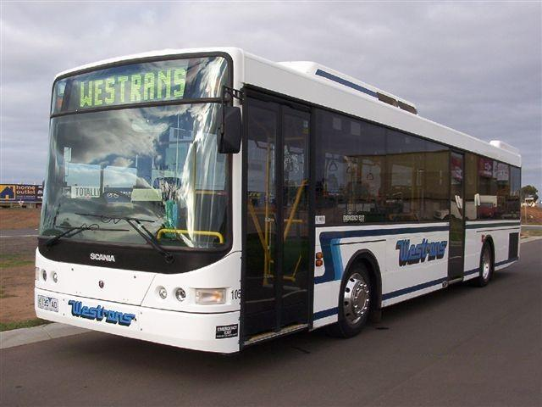

**TABLE OF CONTENTS**

THE ROLE OF THE CHIEF INVESTIGATOR 5

1. EXECUTIVE SUMMARY 7

2. CIRCUMSTANCES 9

2.1 The incident 9

3. FACTUAL INFORMATION 11

3.1 The powered mobility aid 11

3.2 The bus 12

3.3 Werribee Bus Service – Route 437 12

3.4 The bus driver 13

3.5 The passenger 13

3.6 Interviews 13

3.7 The road 14

3.8 Post-incident observations 14

3.9 Applicable Legislation, Rules, Guidelines 14

3.10 Applicable Government and Industry Bodies 16

3.11 Mobility aid on-board stability – engineering assessment 16

4. ANALYSIS 19

4.1 Stability of powered mobility aids 19

4.2 On-board restraint and securement 19

4.3 Bus manoeuvring 20

5. CONCLUSIONS 21

5.1 Findings 21

5.2 Contributing factors 21

6. SAFETY ACTIONS 23

6.1 Identified Safety Issues and Recommended Safety Actions 23

7. APPENDIXES 25

Appendix 1 – Bus Floorplan 25

Appendix 2 – Bus Route 437 Werribee - Hoppers Crossing 27

Appendix 3 – Engineering assessment 29

THE ROLE OF THE CHIEF INVESTIGATOR

The Chief Investigator, Transport and Marine Safety Investigations is a statutory position established on 1 August 2006 under Part V of the *Transport Act 1983*.

The objective of the position is to improve public transport and marine safety by independently investigating public transport and marine safety matters.

The primary focus of an investigation is to determine what factors caused the incident, rather than apportion blame for the incident, and to identify issues that may require review, monitoring or further consideration. In conducting investigations, the Chief Investigator will apply the principles of ‘just culture’ and use a methodology based on systemic investigation models.

The Chief Investigator is required to report the results of investigations to the Minister for Public Transport and / or the Minister for Roads and Ports. However, before submitting the results of an investigation to the Minister, the Chief Investigator must consult in accordance with section 85A of the *Transport Act 1983*.

The Chief Investigator is not subject to the direction or control of the Minister(s) in performing or exercising his or her functions or powers, but the Minister may direct the Chief Investigator to investigate a public transport safety matter or a marine safety matter.

**1. EXECUTIVE SUMMARY**

On 12 December 2006, at about 1039[1] whilst on board a Westrans bus operating the route № 437 service between Werribee and Hoppers Crossing, a male passenger seated on a powered mobility aid (rechargeable battery-electric ‘scooter’) was injured when the device overturned while the bus was negotiating a right-hand turn into the Werribee Plaza Shopping Centre.

The passenger suffered a cut to his forehead and was taken to the Werribee Plaza Medical Centre for treatment.

The investigation found that the bus complied with relevant specifications in all aspects apart from a minor discrepancy in the dimensions of the allocated space for mobility aids and was operated according to company requirements. The bus driver was fit and correctly licensed for his duty.

The investigation found that there are no mandated requirements regarding mobility aid stability and on-board bus securement and restraint systems.

The report recommends that the bus operator develops instructions for drivers regarding bus handling and manoeuvring speeds when passenger-occupied mobility aids are aboard.

The report also recommends that the Bus Association of Victoria:

* Progress discussions with stakeholders regarding the development of standards and specifications for on-board securement and restraint systems for powered and other wheeled mobility aids on public transport conveyances.
* Progress discussions with government and industry to develop protocols to enable easy identification by bus and coach drivers of powered mobility aids suitable for acceptance for transit.

**2. CIRCUMSTANCES**

2.1 The incident

At about 1025 on 12 December 2006, the passenger riding a mobility aid boarded the bus at Werribee Railway Station to travel to the Werribee Plaza Shopping Centre. Recorded Closed-Circuit TV vision indicated that he took considerable time to manoeuvre his mobility aid into position in the allocated space, turning it through 180 degrees to face forward. In doing so, he made full use of the manoeuvring area provided by the two proximate allocated spaces – one on each side of the bus (see Appendix 1). The passenger parked lengthwise in the allocated space and at a slight angle to the longitudinal centre-line of the bus (estimated to be between 15 and 30 degrees from parallel) and to took hold of the adjacent horizontal, wall-mounted grabrail.

As the bus negotiated various suburban streets and made numerous turns, the passenger held the grabrail and appeared to remain secure against unintentional movement. Approximately 16 minutes into the journey the passenger was observed to release the grabrail and engage in conversation with a passenger seated opposite. At about this time the bus stopped at traffic lights on Heaths Road at the intersection to the Werribee Shopping Plaza entrance (see Appendix 2). When the bus moved ahead and was turning into the Shopping Plaza entrance the mobility aid overturned onto its left side.

The passenger remained in a roughly seated position on the overturned mobility aid, with his right arm thrown out for support on the passenger seated immediately opposite. His head lodged between an opposite wall-mounted seat and adjacent modesty panel. The passenger’s head injury was consistent with contact with either the seat or the modesty panel frame.

Police and emergency services were not called to the incident.

**3. FACTUAL INFORMATION**

3.1 The powered mobility aid

The mobility aid involved in this incident (see Figure 1) was a Rascal Model 240 rechargeable battery-electric scooter manufactured in China and partially assembled in the USA by The Rascal Company, a subsidiary of Electric Mobility Corporation. It was supplied by Microsafe Australia Pty Ltd to the Sunshine Hospital Community Rehabilitation Centre who provided it to their client, the user in this incident. This model is no longer in production.

The mobility aid has a mass of approximately 74 kg (including batteries) and a load capacity in excess of about 180 kg. It is 1170 mm long (overall) and 635 mm wide, and has a turning radius of 1040 mm and a fully-raised seat height of 550 mm above ground level.

The mobility aid has pneumatic tyres and soft-spring suspension and is operated using a horizontal ‘rocking’ Forward / Reverse paddle control on the handlebar. When this control is released by the rider it returns to its central ‘stop’ position and a strong electric brake is applied. This brake will stop the scooter quickly if it is moving when the control is released, or hold it static on all but severe grades.

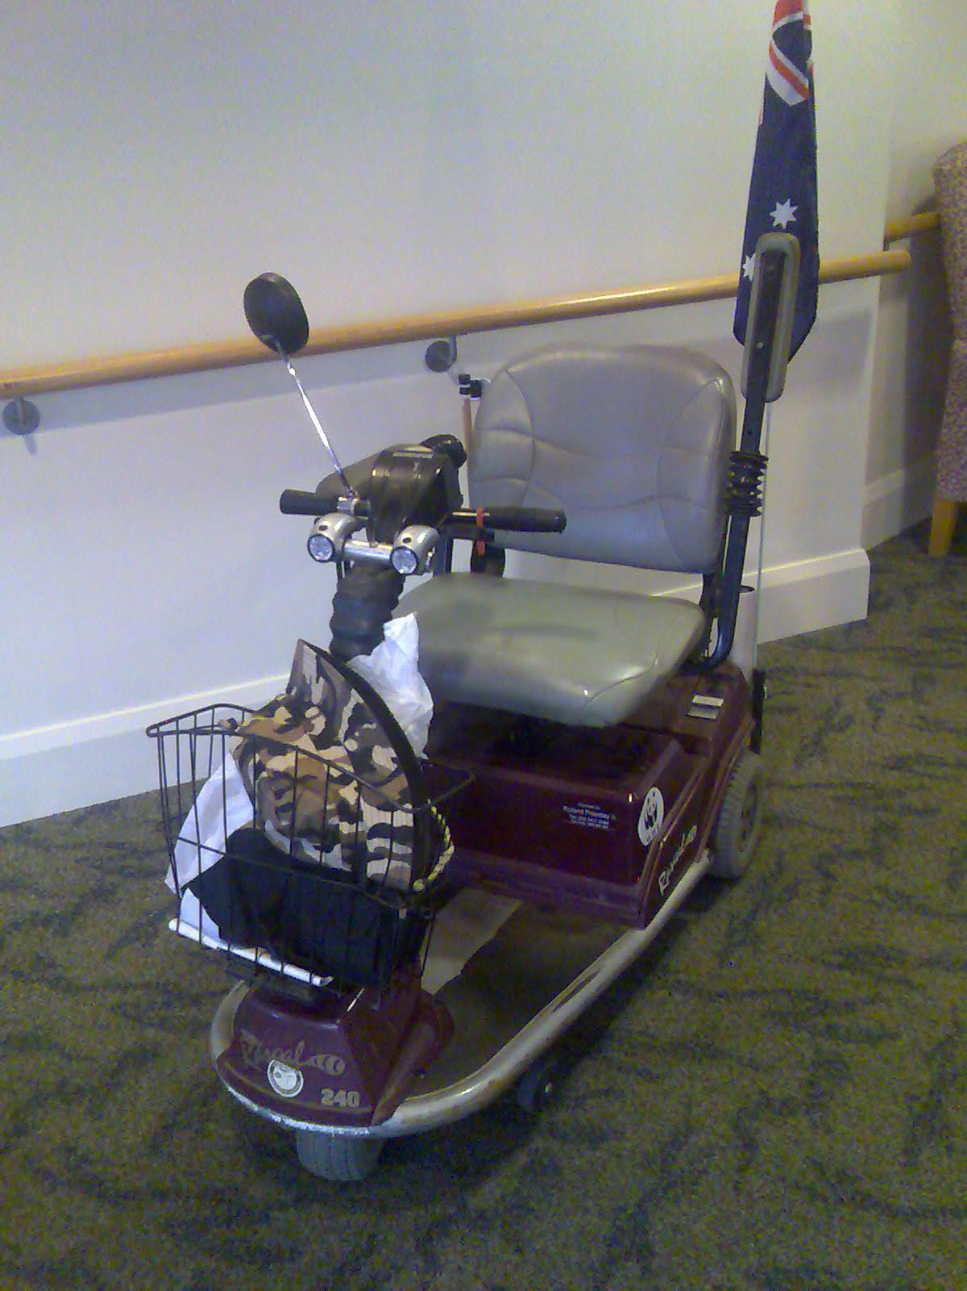

**Figure 1**

3.2 The bus

The Scania Model L94UB low entry / low floor route bus is an imported chassis of standard design produced for worldwide application. The purpose-built CR228L-model body structure, applied by Volgren Australia Pty Ltd, is designed for point-to-point public transport operations in urban and suburban street environments. It provides 33 fixed seats with an additional six folding seats in the spaces allocated for mobility aids.

The Federal *Disability Discrimination Act 1992* (including Standards and Guidelines) prescribes standards with respect to the design of buses providing public transport. For buses, one of these requirements is for an allocated space for stationary mobility aids of dimension 800 mm wide by 1300 mm long. Buses with more than 32 fixed seats require two of these spaces. The applicable allocated spaces on the bus involved in this incident are approximately 870 mm by 1260 mm.

One clear ‘allocated space’ is provided in a position immediately behind each front wheel arch for wheelchairs or similar mobility aids. These clear spaces are created by folding three wall-mounted, moulded seat squabs on each side. The allocated spaces are defined by the left- and right-hand front wheel arches at the forward extremity of the spaces and modesty panels to the rear. Each allocated space includes a horizontal grabrail of contrasting colour running for the length of the space at a height slightly below the lower window ledge level. There is no advisory signage recommending that occupiers of mobility aids maintain a handhold during transit.

The two allocated spaces combine with the conjoining aisle space to provide a ‘manoeuvring area’. The bus design seating layout and floor plan is to Volgren drawing number B4029403 (see Appendix 1)

The bus is equipped with a ramp for access by passengers using wheelchairs and powered mobility aids. This ramp, which is built-in to the floor step, is deployed manually by the bus driver. The bus is also furnished with active air suspension by which the driver can lower the front left-hand corner of the vehicle at passenger stops to enhance access. Termed ‘kneeling’, this feature is capable of reducing the front door lower step height by about 70 mm relative to the ground.

3.3 Werribee Bus Service – Route 437

This route is a suburban public transport service operated for Metlink[2] by Point Cook Werribee Passenger Service Pty Ltd, trading as Westrans, a subsidiary of Kefford Corporation. The business operating from the company’s Werribee depot trades as Westrans−Werribee and is accredited by Public Transport Safety Victoria (PTSV).

The № 437 service operates between the Werribee and Hoppers Crossing railway stations on the Melbourne-Geelong railway and serves the Werribee Plaza Shopping Centre.

3.4 The bus driver

The driver, aged 53, has been driving city route buses for 12 months. He has more than 20 years of previous heavy transport and bus experience, both in military and civilian service, and holds an appropriate heavy vehicle driver’s licence plus a valid Department of Infrastructure (DOI) Driver’s Certificate. Apart from a diabetic condition he was medically fit.

On the day of the occurrence the driver commenced duty at 0715. His roster for the three preceding days was:

* 11 December 2006: 0755 to 1959 (total 12hrs 04min);
* 10 December 2006: 0845 to 1851 (total 10hrs 04min);
* 09 December 2006: Off Duty.

3.5 The passenger

The passenger (casualty), a male aged 50 and weighing approximately 86 kg, has used this mobility aid since January 1999.

The passenger suffered a laceration to his forehead that required nine stitches. After the incident the bus moved ahead to the Shopping Centre bus stop and treatment was administered by staff from the adjacent Werribee Medical Centre.

3.6 Interviews

* + 1. **Bus driver**

The driver stated that the passenger was a frequent traveller on this service. He commented that mobility-impaired passengers did not generally result in service delays, although this could depend on the number of stops made throughout the run and the number of passengers requiring such assistance. He could not recall his exact speed at the time the scooter rolled over, however he assumed it would have been about 15 km/h or less due to the presence on-board of the mobility-impaired passenger.

The driver stated that there was no ‘procedural speed’ prescribed for manoeuvres such as turning, or special instructions or training provided regarding driving with passengers seated in wheelchairs or powered mobility aids and that it was left up to the driver to handle the bus so as to ensure the general comfort of passengers. The driver stated that there was a verbal instruction that due to space constraints no more than two passengers with wheelchairs or powered mobility aids could be accepted aboard a route bus at any one time.

When asked about his personal approach to driving buses with occupied mobility aids aboard, the driver stated that he tries to handle the bus with due regard for these passengers, especially when turning. He said that in these circumstances he would drive a little slower than normal.

The driver believed that his diabetic condition was well-managed, under control, and was not affecting him in any way at the time of the incident.

**3.6.2 The passenger**

The passenger stated that he regularly rode this bus service. On the day of the incident the journey had appeared to be normal up to the time of the incident, however as the bus moved away from the traffic lights in Heaths Road it accelerated and turned sharply, causing his scooter to overturn.

* 1. The road

The occurrence site was the right-angled, cross-road intersection of Heaths Road and Glendale Court where the latter extends across Heaths Road to become the Werribee Shopping Centre access drive. The right-hand turn from the westbound Heaths Road turning lane at the intersection into the shopping centre access road is generally flat but exhibits a slight bias toward reverse camber. Calculations made from field observations and VicRoads scale plans for the intersection indicate that the likely radius of the turning manoeuvre would have been between 11 and 14 metres.

Road and weather conditions were dry at the time of the occurrence.

* 1. Post-incident observations

With the cooperation of the bus company, a test run was operated across a latter portion of the subject route. From observations made during this trip as well as of bus traffic at that intersection at other times it appears highly likely that ⎯ for a bus stationary at the intersection traffic lights and being first vehicle in the queue to move ⎯ speed throughout the turn exceeded 20 km/h. Engineering calculations subsequently indicated that the bus speed at which the mobility aid overturned was most likely to have been between 22-26 km/h.

3.9 Applicable Legislation, Rules, Guidelines

**3.9.1 Disability Discrimination Act 1992, including (under s31)**

* Disability Standards for Accessible Public Transport 2002 (No. 2)
* Disability Standards for Accessible Public Transport Guidelines 2004 (No. 3)

The purpose of this legislation is to eliminate discrimination ‘as far as possible’ against people with disabilities. In pursuit of this, the Standards prescribe national requirements that public transport service providers and facility operators must meet in order to comply with the Act in certain key areas regarding accessibility, while the Guidelines provide assistance with understanding and interpreting these Standards.

The Guidelines list criteria that are described as reflecting assumptions underlying the Disability Standards. These criteria are intended to be of use as a guide for designers of mobility aids, and for consideration by intending purchasers of mobility aids expected to be used on public transport.

The Guidelines also prescribe certain specifications for mobility aids regarding dimension, mass and performance. One such item states that, *“Mobility aids need to have effective braking systems to maintain stability and be able to withstand acceleration, braking, cornering and pitching of conveyances.”* In this context, ‘conveyances’ refers to the route bus. Another listed criterion states that, *“If anchoring devices are required by regulation, mobility aids need to be able to accept and travel with anchoring devices fitted”*.

The Act and the Standards do not provide any prescriptive detail regarding the provision of on-board restraint and securement systems for powered mobility aids.

**3.9.2 VicRoads Guidelines and Standards Australia**

The VicRoads *Guide for choosing and using Motorised Mobility Devices* is a resource for users of these devices. It discusses the various legal requirements and aspects of purchasing, owning and using such devices. The Guide advises that there are various Australian Standards for motorised mobility aids that are not mandatory. Potential purchasers of these devices are recommended to request a written statement of compliance with the Standards from the supplier. None of these Standards specifically address the issue of stability where the device is stationary under carriage.

AS 3695 addresses various minimum requirements for wheelchairs and motorised mobility aids, including setting acceptable performance levels for static and dynamic stability.

AS 3696 specifies the methodology for determining the stability of manual and electric wheelchairs.

Standards Australia states that they are adopting many of the ISO 10542 series. These address wheelchair tie-down and occupant-restraint systems.

**3.9.3 The Kefford Corporation Employee Handbook**

This handbook covers all personnel employed by Kefford Corporation companies and provides their standing instructions and policies. Drivers are advised on aspects of providing for the needs of disabled passengers and are instructed that police must be called if any person is hurt, no matter how apparently minor the injury.

There are no explicit instructions to bus drivers with regard to bus handling and manoeuvring speeds when passenger-occupied mobility aids are aboard.

3.10 Applicable Government and Industry Bodies

**3.10.1 Public Transport Division**

The Public Transport Division of the Department of Infrastructure, as the Office of the Director of Public Transport, is the Government-appointed custodian of Victoria's public transport system, responsible for the development and delivery of public transport services across Victoria. The division oversees the contracts for bus, train and tram services and assumes the planning and performance management functions of the former Public Transport Corporation. It is also responsible for overseeing taxi and tow truck operations through the Victorian Taxi Directorate.

**3.10.2 Bus Association Victoria**

Bus Association Victoria (BusVic) is the peak bus and coach industry body in Victoria. The Association's stated primary role is to encourage increased use of public transport as part of the development of more sustainable transport systems.

**3.10.3 Bus Industry Confederation**

The BIC is Australia's peak organisation representing the interests of the bus industry. This encompasses bus operators, suppliers and associated businesses. The organisation represents the collective interests of its members and aims to assist them in promoting the long term sustainability of bus and coach transport in Australia.

3.11 Mobility aid on-board stability – engineering assessment

The investigation undertook to determine the mechanism by which the mobility aid overturned and the probable speed of the bus at the time of the incident. The assessment methodology is described at Appendix 3.

The investigation found that the mobility aid overturned as a result of centrifugal forces acting on it and its occupant. The overturning forces were induced by the bus negotiating a right-hand turn as part of normal manoeuvring. Without any active restraint to prevent the mobility aid from tipping, the centrifugal forces induced by the motion of the bus were sufficient to overturn the aid.

The investigation found that at the time the mobility aid overturned, it is probable that the bus was travelling at a speed of between 22 and 26 km/h.

The susceptibility of the mobility aid to overturning in the bus is governed by its static stability. To benchmark the stability of the mobility aid, the engineering assessment also examined whether the aid was likely to have complied with the static stability performance requirement of AS 3695 which states that the device, “…shall not tip on a slope of less than 10 degrees”. The assessment was undertaken by calculation rather than using the full methodology of the associated test standard AS 3696. The assessment also used the characteristics of the operator in question (86 kg) rather than the full load capacity of the aid. Using these methods, it was estimated that with the same occupant on board and remaining in the seated position without slipping, the angle at which the mobility aid would “tip” would be in the order of 20 degrees and in any case significantly in excess of the requirement of 10 degrees. This result indicates that with a nominal 86 kg loading condition, the mobility aid would be expected to satisfy the stability requirement of AS 3695.

Given that the aid did overturn, it can be concluded that compliance with AS 3695 alone is insufficient to prevent a mobility aid from overturning during a 22-26 km/h bus turning manoeuvre unless the aid is restrained either directly within the bus or by the mobility aid occupant counteracting overturning forces by holding an adjacent grabrail or other appropriate handhold.

**4. ANALYSIS**

Bus industry sources describe an increase over recent years in the numbers of mobility-impaired passengers using powered mobility aids. This is an emerging challenge for operators since the right to the provision of a safe, efficient public transport service applies equally to the impaired and disabled, many of whom use a wide variety of these devices. It is a matter for the transport operators, government and the greater community to decide how much space on public transport vehicles can and should be devoted to the accommodation of mobility aids and their users, whether mobility aids can be practically and adequately secured during transit, and if so, what systems might be employed.

Comment from senior bus industry representatives indicates that the industry is currently engaged in discussions with stakeholders regarding issues to do with the provision of on-board securement systems and the development of standard protocols to facilitate identification for carriage of AS-compliant powered mobility aids. However, these discussions have been prolonged and are incomplete, with several issues unresolved. This investigation has identified a need for the industry, perhaps through its peak body, to take ownership of these issues and finalise them.

* 1. Stability of powered mobility aids

Australian Standards applicable to the determination of the ‘static’ and ‘dynamic’ stability of mobility aids do not specifically address the issue of their stability when they are stationary under carriage. It is impractical to expect public transport operators to provide customised methods of securement and restraint for every type and style of mobility aid available. It is also impractical to expect all drivers of public transport conveyances to be able to quickly assess all available such devices as to their suitability for transit.

4.2 On-board restraint and securement

The Disability Standards recognise the use of both ‘active’ and ‘passive’ restraining systems. An active restraint is defined as one that anchors a mobility aid into an allocated space; anchorage belts being an example. Since regulations that would normally require passengers to wear safety belts apply equally to all passengers, operators of services on which safety belts were mandatory would be required to provide restraints for use by passengers with disabilities.

A passive restraining system, by comparison, is defined as one that contains movement of a mobility aid to within an allocated space to prevent the device from rolling or tipping. An example might be a vertical surface of suitable dimension, such as the sides of a conveyance, a step to restrain sideways movement, or a bulkhead to restrain forward movement. A padded rail may also be used.

Since the bus involved in this occurrence has more than 32 seats, two allocated spaces are required. On this particular vehicle, these are of minimally non-compliant dimension; being 870 mm wide versus the required 800 mm and 1260 mm long versus the required 1300.

The Guidelines note that, *“Public transport necessarily involves motion such as acceleration, deceleration, cornering and pitching…”* and state that, *“The Disability Standards assume that passengers and their mobility aids are capable of tolerating such motion.”* Considering this occurrence it may be wise for the industry to consider the validity of this assumption.

In addressing matters of safety, another stated assumption made by the Disability Standards is that, *“…mobility aids are stable under normal conveyance manoeuvring forces.”* In the context of this occurrence, the validity of this assumption might likewise be debated.

A securement system is currently fitted to specialised, multipurpose taxis such as Maxi Taxi’s (lift-equipped mini bus type) or Flash Cabs (the extended-height station wagon-type vehicle especially built to convey passengers seated in wheelchairs). Both of these vehicle-types are generically referred to as Wheelchair Accessible Taxi’s in which occupied wheelchairs are required to be positively restrained for carriage. Industry sources have stated that there is some expectation within the public transport industry ⎯ in particular the operators of suburban and interurban route buses ⎯ that this issue has potentially wider application and will need to be addressed.

The alternative would appear to be for all party’s to continue with the assumption that all occupants of mobility aids must be physically able to grasp an available handhold and to rely on an ability to consciously maintain this grasp at all times the conveyance is in motion.

4.3 Bus manoeuvring

In this occurrence, the driver stated at interview that he endeavoured to drive with due consideration for passengers and that he deemed his performance on this trip to be consistent with this concern. For his part, the passenger at the centre of this incident also felt the trip was relatively normal up to the point at which he overturned. Westrans-Werribee does not provide specific instruction to their drivers on bus manoeuvring or handling techniques for the comfort and safety of passengers occupying mobility aids.

The circumstances of this event strongly suggest the necessity for specific instructions to drivers regarding the operation of buses that are conveying occupied mobility aids.

**5. CONCLUSIONS**

5.1 Findings

1. The occupant of the powered mobility aid was within its weight limit.

2. The powered mobility aid complied with published design criteria that are described as assumedly underlying the Disability Standards.

3. The Standards with respect to required characteristics of static stability for powered mobility aids do not address circumstances whereby the device may be stationary under carriage.

1. Current legislation does not provide for the restraint and securement of occupied wheelchairs and mobility aids by any means other than the physical ability of the occupant to maintain a grasp on available handholds.
2. Industry stakeholders are yet to resolve questions regarding the formulation of standards and protocols to control and regulate the carriage of occupied, powered mobility aids.
3. The bus operator provided no specific instructions or guidance to drivers regarding manoeuvring the bus with passenger-occupied mobility aids aboard.
4. The driver was fit and licensed for his duty
5. Westrans-Werribee route buses do not display advisory signage warning that occupiers of mobility aids should maintain a secure handhold during transit and there is no legislative requirement for operators to do so.
6. The speed of the bus during the turn at the intersection was sufficient to cause the unrestrained mobility aid and its occupant to overturn.

5.2 Contributing factors

1. The mobility aid was not physically secured within the bus and the occupant released his grasp on the nearby grabrail at the critical moment.

2. The speed of the bus during the turn at the intersection exceeded the capacity of the unrestrained mobility aid to remain upright.

**6. SAFETY ACTIONS**

* 1. Identified Safety Issues and Recommended Safety Actions

**Safety Issue 1**

The bus operator relied upon the professional judgement of individual drivers in general bus handling and provided no specific instructions or guidance to drivers regarding manoeuvring the bus with passenger-occupied mobility aids aboard. In this instance the speed of the bus during the intersection turn exceeded the capacity of the unrestrained mobility aid to remain upright.

**RSA 2008002**

That Kefford Corporation provide specific instructions to bus drivers with regard to bus handling and manoeuvring speeds when passenger-occupied mobility aids are aboard.

**Safety Issue 2**

Route buses are not required to display advisory signage warning that occupiers of mobility aids should maintain a secure handhold during transit. It is possible that users of wheeled mobility aids, who believe that these vehicles are reasonably stable during operation, assume they will remain secure and stable whilst stationary under conveyance aboard a bus. This occurrence indicates that such an assumption may not be sound and that occupiers of these mobility aids may benefit from a reminder to ensure their own security at all times the bus is moving.

**RSA 2008003**

That all suburban and interurban route bus operators display appropriate advisory signage adjacent to allocated spaces warning occupiers of mobility aids to maintain a restraining handhold at all times.

**Safety Issue 3**

There is no legislative requirement for bus operators to provide for the restraint and securement of occupied wheelchairs and mobility aids by any means other than the physical ability of the occupant to maintain a grasp on available handholds. Industry stakeholders are yet to resolve questions regarding the formulation of standards and protocols to control and regulate the carriage of occupied, powered mobility aids.

**RSA 2008004**

That the Bus Industry Confederation develops standards and specifications for fixed on-board restraint systems for powered and other wheeled mobility aids on buses and coaches.

**7. APPENDIXES**

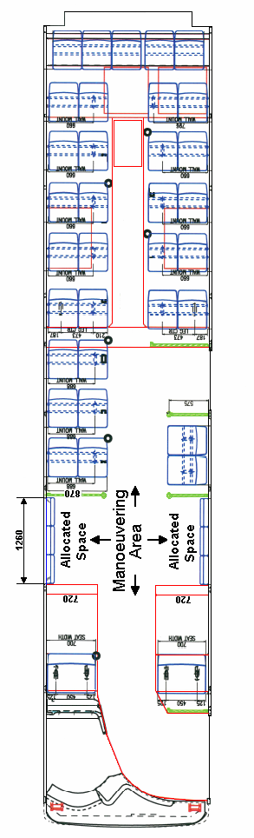Appendix 1 – Bus Floorplan

Appendix 2 – Bus Route 437 Werribee - Hoppers Crossing

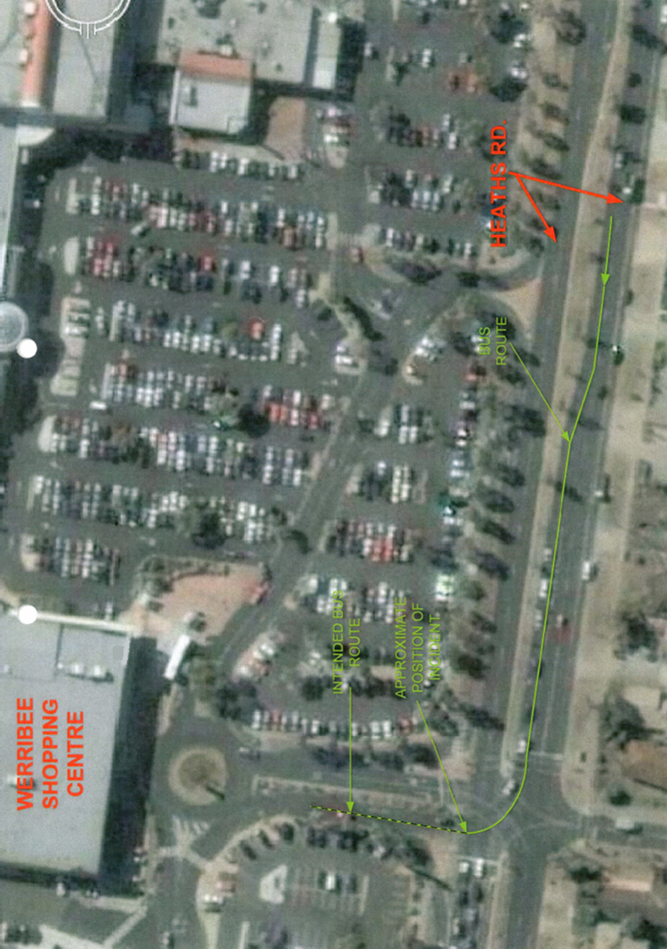

Appendix 3 – Engineering assessment

**1. Approach**

The investigation drew on a number of information sources to assess the stability of the mobility aid and the mechanism by which it overturned in this instance. In the absence of detailed specifications for the mobility aid, the device involved in the incident was inspected to ascertain critical dimensions and to estimate device and operator centres of gravity. In addition, the assessment was supported by bus route inspection and internal bus video surveillance footage

The potential bus speed envelope was developed by estimating:

a) The bus speed required to overturn the mobility aid.

b) The potential range of bus speeds based on the video evidence.

c) The maximum bus speed attainable in its loaded condition.

**2. Overturning mechanism**

As a bus turns, an otherwise static (parked-on-board) mobility aid may overturn due to the action of centrifugal forces on the aid and its operator. The action of overturning requires a mobility aid of three-wheel configuration to pivot about a line joining the central forward wheel and the back wheel on the outside of the turn.

Considering moments about this pivot line, the centrifugal force produces an overturning moment while the normal gravitational forces acting on the aid and its operator produce a restoring or stabilizing moment. Overturning is initiated when the overturning moment exceeds the stabilizing moment, at which point the back wheel of the mobility aid on the inside of the turn lifts off the floor. At this point reaction at the inside-back wheel is zero.

In considering moments about the pivot line just at the point that the inside-back wheel lifts off the floor, the relevant forces are the previously described centrifugal and gravitational forces. By equating their associated overturning and stabilizing moments, an equation for the speed at which the mobility aid will overturn can be developed. In this given instance, overturning will occur when:

|  |  |
| --- | --- |
|  | v  √ (g.r.d2/d1) |
| where: | v = speed of vehicle in turn (m/s) |
|  | g = acceleration due to gravity (9.8m/s2) |
|  | r = radius of turn (m) |
|  | d2 = offset of scooter/operator centre of gravity from pivot line (mm) |
|  | d1 = height of scooter/operator centre of gravity above floor (mm) |

The critical ratio in this formula is d2/d1. As would be expected intuitively, an increase in the height of the scooter/operator centre of gravity (d1) results in a less stable configuration and a lower bus speed required to overturn the vehicle. By contrast, an increase in the wheelbase width equates to an increase in the offset distance between scooter / operator centre of gravity and pivot line (d2), resulting in a more stable configuration and a higher bus speed required to overturn the vehicle.

**3. Bus speed required to overturn the mobility aid**

In evaluating the bus speed required to overturn the mobility aid, the following assumptions have been made:

##### a) The mobility aid and operator are assumed to move as a single body. This assumption is supported by the video footage which shows the operator to be reasonably constrained between the side arms of the scooter seat and the combined scooter and operator overturning in a single motion. In light of this assumption, the vertical centre of gravity (VCG) for the combined (scooter and operator) body was estimated to lie in the range 415 – 492 mm.

##### b) Based on observation, the longitudinal centre of gravity (LCG) of the operator is assumed to align with the LCG of the mobility aid. As this assumption directly affects the offset distance, its potential implications on d2 were considered in a sensitivity analysis.

##### c) The operator is assumed to have had a reasonably upright posture and not leant forward or towards the outside of the turn. This assumption is supported by the video footage notwithstanding a detectable slight twisting and leaning of the operator towards other passengers. Again this assumption has a direct bearing on d2 and accordingly was also considered in the sensitivity analysis.

##### d) Bus roll during the turn is not modeled in detail. While modern buses roll significantly less than buses of older type, a small roll action would be expected. Due to its impact on d2 the implications of the assumption were also considered in the sensitivity analysis.

##### e) No special consideration of mobility aid location within the bus is made. The mobility aid was located a little forward of mid-length and on the right side of the vehicle (inside of turn), about 700 mm off the bus centerline. In calculating the centrifugal force acting on the scooter / operator, an average turn radius and an approximated (average) vehicle speed are used. This is considered to provide reasonable methodology for estimating the centrifugal force acting on the mobility aid and operator. This assumption is expected to lead to a slight underestimate of speed required to overturn the mobility aid.

##### f) No consideration is made of the forward stabilizing wheels fitted to the mobility aid. Once significant overturning motion has been initiated, the small stabilizing wheels are not expected to provide significant resistance. This assumption is consistent with comments from the Melbourne supplier / agent for Rascal that these “anti-rollover” wheels are only effective in “stabilizing” the mobility aid when cresting a gradient transition on an angle.

##### g) The centrifugal force is assumed to act horizontally and perpendicular to the mobility aid pivot line. This assumes alignment of the wheel-to-wheel pivot line with the centerline of the bus (the mobility aid at 17 degrees to the bus centerline). In actuality, the alignment angle is likely to have been slightly greater. The assumed 17 degree alignment results in the full centrifugal force acting to overturn the mobility aid and will tend to give a slight underestimate of the turn speed required to overturn the mobility aid.

##### h) The turn from Heaths Road into the shopping centre entrance road is assumed to comprise an initial acceleration phase followed by constant bus speed at a constant turn radius. This is considered to be a realistic assumption for a significant portion of the turning arc, including the point at which the mobility aid overturned.

##### i) In the absence of any relevant evidence, there is no consideration of mobility aid tyre pressure and any potential implications of low pressure to the susceptibility of the mobility aid to overturning forces.

##### j) Consistent with the video evidence, the mobility aid is assumed not to have slipped laterally prior to overturning. Friction between the mobility aid tyres and the floor of the bus is assumed to have been sufficient to resist slippage. There is also no evidence of the mobility aid rolling in the forward or reverse directions

Based on the available data and with due consideration to the sensitivity of the analysis to a number of assumptions, it is concluded that the speed required to overturn the mobility aid in this instance, was likely to have been at least 22 km/h.

**4. Estimation of bus speed during turn using video footage**

Bus video records enable an estimate of the speed of the bus during the turn. Road markings have been used to estimate the position of the bus at various stages of the turn and in combination with the time record permit an estimation of vehicle speed. The accuracy of the estimation is limited due to the coarse video framing and the coarse time counter.

Based on the video records, it has been estimated that the speed of the bus at the time of the incident is likely to lie in the range 20-28 km/h.

**5. Consideration of bus capability**

To confirm that the assumed speed-distance scenario is not inconsistent with the capabilities of the bus, Scania was requested to provide pertinent bus performance data. To this end, Scania utilised its Scania Optimising Program (SCOP) to estimate straight line bus acceleration performance in fully loaded and lightly loaded conditions. The lightly loaded data represents the potential performance of the bus at the time of the incident.

Assessment of the SCOP results indicates that the bus was capable of achieving the upper limit speed (28 km/h) of the probable speed range during the turn. However, there are a number of factors which suggest that the bus may have had difficulty in achieving this speed. Relevant factors considered are:

a) The SCOP program models optimised acceleration, which may have been difficult to attain in normal operational conditions.

b) The SCOP program models straight line acceleration which in this case is only valid for the initial stage of the acceleration phase. It is expected that it would be more difficult to achieve the SCOP optimised speeds with the bus accelerating in a curve.

c) Video footage suggests that the mobility aid began to overturn between 3 and 4 seconds after the commencement of bus travel from Heaths Road, suggesting that the time available to achieve the maximum speed was limited.

d) Similarly it should be recognised that the distance available to achieve the maximum speed was limited.

On balance, while it is not inconceivable that a speed of 28 km/h could have been attainable, it is probable that the lesser speed of 26 km/h represents the more likely upper limit of speed attainable during the turn.

**6. Probable speed range**

Results of the above described analyses are summarized below:

|  |  |
| --- | --- |
| Likely minimum speed required to overturn mobility aid | 22 km/h |
| Probable range of actual bus speed (video record) | 20 – 28 km/h |
| Probable maximum attainable speed | 26 km/h |

Overlaying these results provides a realistic assessment of the potential speed envelope for the bus at the time of the incident, as shown below:

|  |  |
| --- | --- |
| ***It is probable that at the time the mobility aid overturned, the bus was travelling at a speed within the following range:*** | ***22 - 26 km/h*** |

**7. Assessment of the mobility aid against AS 3695**

Mobility aid product requirements are addressed within AS 3695, notwithstanding that the standard is not currently mandated. Pertinent to this investigation and the overturning mechanism is the requirement for static stability which states that the device “shall not tip on a slope of less than 10 degrees”.

Utilising assumptions consistent with the previously described analyses, it has been estimated that with the same operator on board and with the operator remaining in the seated position without slipping, the angle at which the mobility aid would “tip” is of the order of 20 degrees and in any case significantly in excess of the requirement of 10 degrees. This result is considered an approximation only given that the assessment has been made by calculation using the characteristics of the operator in question (86 kg) rather than using the testing methodology of AS 3696.1.

Notwithstanding the approximate methods used, the result indicates that with an operator load of 86 kg, the mobility aid would satisfy the stability requirements of AS 3695. This in turn indicates that compliance with this standard alone is not sufficient to prevent a mobility aid from overturning during the turn of a bus and that restraint, whether by hand or fixed is required.

1. All times are denoted in Australian Eastern Daylight Saving Time (UTC + 11 hours).
2. Metlink is a private, not-for-profit organisation co-owned by Melbourne's train and tram operators. The organisation is contracted by the State Government to provide services across the public transport network.