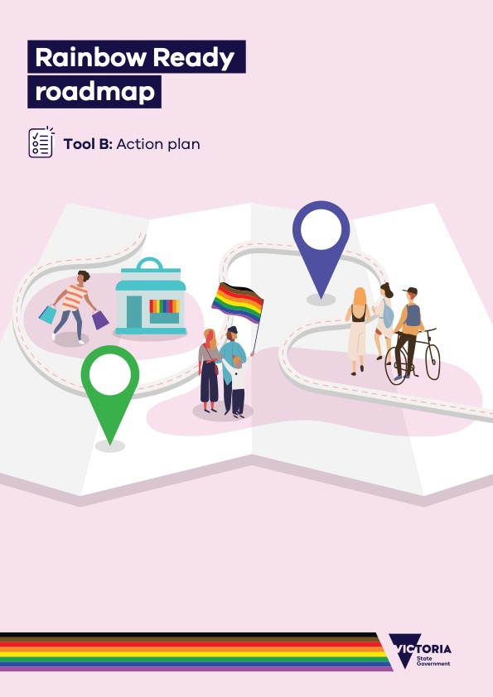

# Rainbow Ready roadmap

## Tool B: Action plan

## About this tool

The action plan tool supports teams in identifying the steps required to achieve LGBTIQA+ inclusivity, how long the desired change will take, what it will cost and how your progress and success can be measured.

## When to use this tool

This tool should be used as part of **Phase 3: Plan**, to outline the steps you’ll take to achieve your project aims. It should follow review of the indicators of LGBTIQA+ inclusivity within your relevant settings guide and your current state using the measurement and evaluation tool.

## How to use this tool

1. Aims: Identify the goals of the project
   * The overall aim will be to build a more LGBTIQA+ inclusive and welcoming community, town, region, service or group.
   * Select other relevant aims, such as to increase LGBTIQA+ visibility, safety or service use.
2. Team: Identify who will be involved in undertaking the work
   * Engage support from within a broad community group, to ensure diverse perspectives.
   * Clarify team roles and the required time commitment.
   * Consider strategies for promoting the safety of LGBTIQA+ team members.
   * Identify other partners within the community who will champion and promote your   
     project. This includes opportunities for collaboration with other settings to ensure widespread LGBTIQA+ inclusion.
   * Consider partnering with state-wide LGBTIQA+ service providers.
3. Core principles: Identify how your project will align with the core LGBTIQA+ principles
   * Consult with LGBTIQA+ community members to understand the importance of the core principles of LGBTIQA+ inclusivity, as outlined in the *Rainbow Ready roadmap user guide.*
   * Consider how your project will prioritise LGBTIQA+ visibility, inclusion, coordination and safety.
4. Key actions: Identify the steps required to achieve the project aims
   * Consult with LGBTIQA+ community members about what local actions are required
   * Check that planned actions align with the aims and indicators within your settings guide
   * Consider how each action will address intersectionality, and support inclusion of all LGBTIQA+ people
5. Outputs: Identify what will be produced or delivered
   * Brainstorm a list of key actions and identify any outputs produced by the actions.
   * Sharing your leanings and stories of sucess as an output, if this is one of your aims.
   * Outputs may include webpages, reports, brochures, training, workshops or events.
6. Resources: Identify the required resources, including staff time, event, or meeting costs
   * Identify LGBTIQA+ education and consultant costs.
   * Identify staff and volunteer remuneration.
   * Identify costs for hosting or taking part in LGBTIQA+ events.
7. Outcomes: Identify the expected results
   * Consider the changes you expect to see. These might include, increased service use, improved service experience, increased LGBTIQA+ visibility and increased perceptions of LGBTIQA+ safety.
   * Identify how the changes will be measured, for example via surveys. Your change must be measurable.
   * Describe any decreases in LGBTIQA+ discrimination or violence.

## Next Steps

**Phase 4: Activity**  
Deliver activities under your action plan, continuing to engage with LGBTIQA+ members and stakeholders as project leaders, consultants, collaborators and feedback providers. Be sure to capture your stories to share the steps you took with others across rural and regional Victoria and elsewhere.

To receive this document in another format, [email the Equality Unit](mailto:equality@dffh.vic.gov.au)<equality@dffh.vic.gov.au>.

Authorised and published by the Victorian Government, 1 Treasury Place, Melbourne.

© State of Victoria, Australia, Department of Families, Fairness and Housing, May 2022.

In this document, ‘Aboriginal’ refers to both Aboriginal and Torres Strait Islander people.

ISBN 978-1-76096-805-2 (online/PDF/Word)

ISBN 978-1-76096-806-9 (print)

Available at [Rainbow Ready roadmap](https://www.vic.gov.au/rainbow-ready-roadmap) <https://www.vic.gov.au/rainbow-ready-roadmap>.

|  |  |  |  |  |
| --- | --- | --- | --- | --- |
| Aims | To build LGBTIQA+ inclusivity in Insert name of organisation, group, service, region or township.  Other aims of this project include: Insert aims. | | | |
|  | | | | |
| Team | Name | Role | | Time commitment |
| Identify the people involved in the project. | Insert description of team member’s role. | | Insert time commitment. |
| Identify the people involved in the project. | Insert description of team member’s role. | | Insert time commitment. |
|  | | | | |
| Core principles | Visibility | Participation | Coordination | Safety |
| Outline how the project will support increased visibility of LGBTIQA+ people. | Outline how the project will enable LGBTIQA+ people to participate in and provide feedback on LGBTIQA+ initiatives. | Outline how the project team will operate and support LGBTIQA+ team members to feel safe. | Outline how the project will identify and develop strategies to increase the safety of LGBTIQA+ people. |
|  | | | | |
| Actions | Indicator | Steps to achieve the project aims | | Intersectionality |
| Identify the indicator being addressed from your settings guide. | Identify the steps required to achieve the project aims. | | Outline how this action will support LGBTIQA+ people with diverse and intersecting identities. |
| Identify the indicator being addressed from your settings guide. | Identify the steps required to achieve the project aims. | | Outline how this action will support LGBTIQA+ people with diverse and intersecting identities. |
|  | | | | |
| Outputs | Identify what will be produced or delivered as part of the project. | | | |
|  | | | | |
| Resources | Identify the resources associated with the project’s activities, including team member time and costs, event expenses, consultation costs. | | | |
|  | | | | |
| Outcomes | Identify the expected outcomes of the project. | | | |

# Action Plan