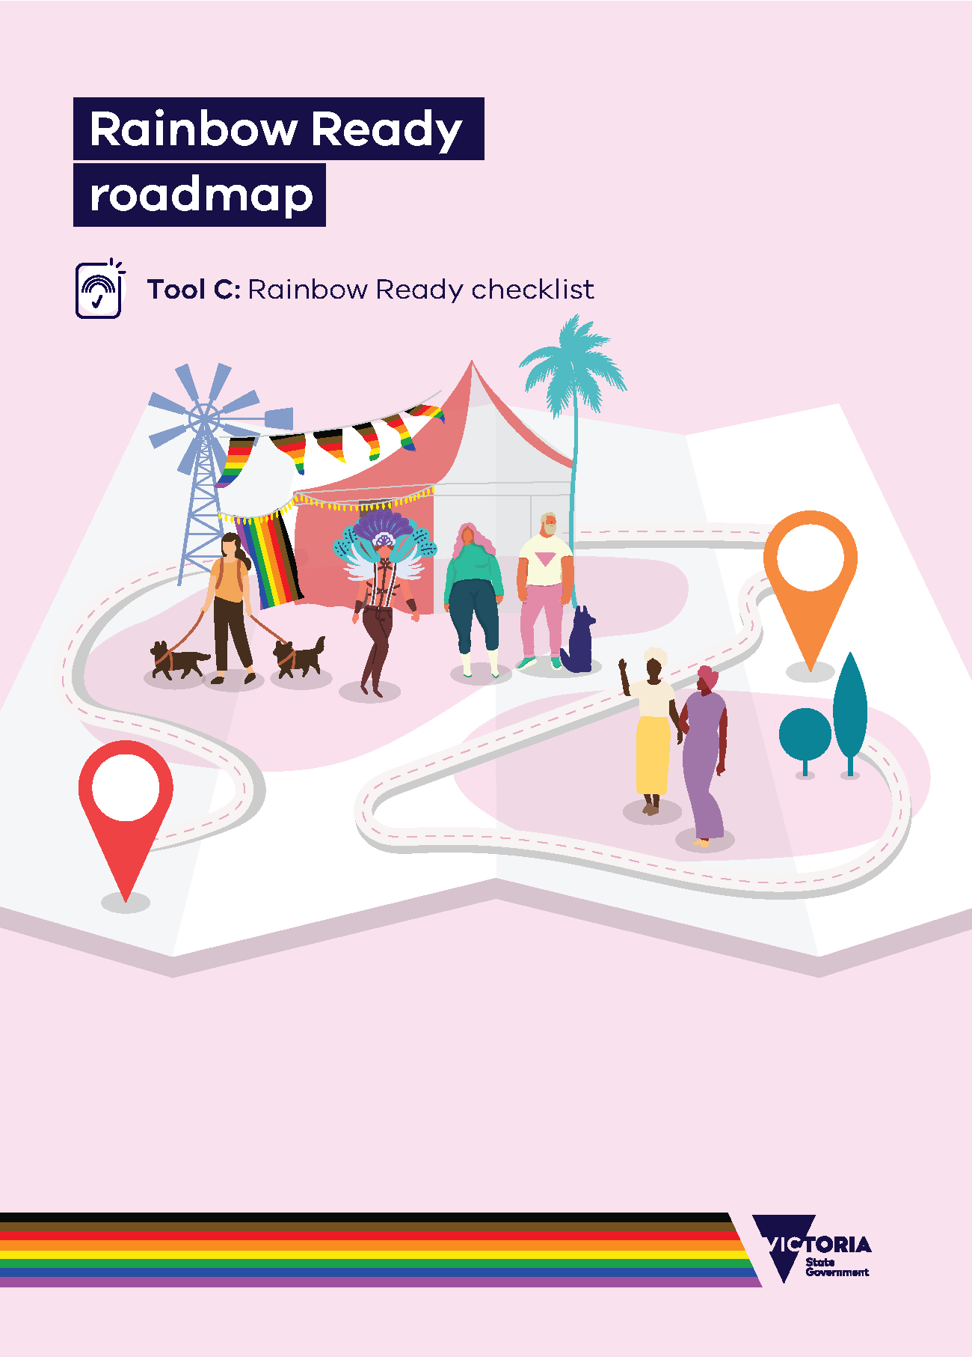

# Rainbow Ready roadmap

## Tool C: Rainbow Ready checklist

## About this tool

Being Rainbow Ready is a public symbol to the broader community that a community, organisation, group, or service has begun the journey to be safe, inclusive and welcoming of LGBTIQA+ people.

## Being on the journey to Rainbow Ready requires a commitment to transparency and accountability. You can use this tool at any time in your project to see where you are up to, and what work remains to be done. It would be helpful, once you feel you’ve finished, if your evaluation results could be publicly shared – for example, via your group or organisation’s website, or on your local council’s website. This shows your community the work you’ve done to be Rainbow Ready and will be helpful to others in the future who may want to continue your work.

## The checklist below outlines the steps required to becoming Rainbow Ready. This includes satisfying as many of the indicators that you can of LGBTIQA+ inclusivity within your relevant setting guide, providing evidence to substantiate progress, sharing your stories of lessons learned and your successes, and perhaps even releasing evaluation reports via a public-facing website.

## When to use this tool

This checklist can be used to measure your own progress at any time during, or at the end of, your work. You can use it as part of **Phase 6: Demonstrate Rainbow Ready status**, after completing the **evaluation tool**to measure your progress towards achieving LGBTIQA+ inclusion.

## How to use this tool

1. Review your progress against the steps below.
2. If all steps in the checklist are marked as complete, you may feel that you have done what you intended to become Rainbow Ready.

## Next Steps

You may want to display your final Rainbow Ready roadmap work so that others in your region, town, organisation or community can see what you’re working to achieved.

It’s one of the main purposes of this project, as LGBTIQA+ people across the state told us they would like to see how inclusion work was done. We want you to share your stories so that others can apply the lessons in their own town, community or organisation. Making your results publicly accessible will also help those who come along later and wish to carry the work forward.

To receive this document in another format, [email the Equality Unit](mailto:equality@dffh.vic.gov.au)<equality@dffh.vic.gov.au>.

Authorised and published by the Victorian Government, 1 Treasury Place, Melbourne.

© State of Victoria, Australia, Department of Families, Fairness and Housing, May 2022.

In this document, ‘Aboriginal’ refers to both Aboriginal and Torres Strait Islander people.

ISBN 978-1-76096-802-5 (online/PDF/Word)

ISBN 978-1-76096-806-9 (print)

Available at [Rainbow Ready roadmap](https://www.vic.gov.au/rainbow-ready-roadmap) <https://www.vic.gov.au/rainbow-ready-roadmap>.

|  |  |
| --- | --- |
| Rainbow Ready status checklist | |
|  | A Rainbow Ready project to improve LGBTIQA+ inclusion within a community, group or service has been undertaken. |
|  | All indicators from the relevant settings guide have been entered into the evaluation tool. |
|  | An evaluation team has been identified to evaluate of progress towards LGBTIQA+ inclusion, as documented in the attached evaluation tool. |
|  | All applicable indicators as listed in the evaluation tool have been evaluated as ‘Met’.  **Note:** Indicators that have been marked ‘Unable to be met’ are not considered for the purpose of this checklist. |
|  | All indicators as listed in the evaluation tool have been sufficiently evidenced with supporting documentation. |
|  | The evaluation is dated and includes the names of the people who conducted it. |
|  | The evaluation, including supporting documentation, is made available through a public website. |
|  | The evaluation is scheduled to be repeated every two years. |
|  | Historical evaluation reports are made publicly available to enable community members to provide feedback. This helps build trust in continuous progress being made to achieve LGBTIQA+ inclusion. |

# Rainbow Ready status checklist