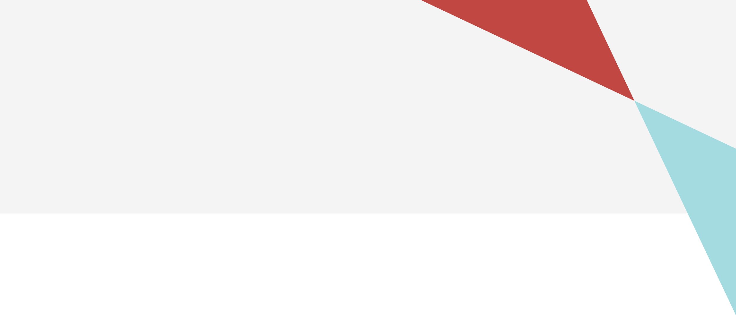

Victorian autism plan: 2023 refresh

Summary

Contents

[Why we are refreshing the plan 2](#_Toc149653480)

[What is in the plan 2](#_Toc149653481)

[What we have done so far 3](#_Toc149653482)

[Overview of the plan 4](#_Toc149653483)

[Vision 4](#_Toc149653484)

[Pillars and priority areas 4](#_Toc149653485)

[Inclusive communities 4](#_Toc149653486)

[Health, housing and wellbeing 4](#_Toc149653487)

[Fairness and safety 4](#_Toc149653488)

[Opportunity and pride 4](#_Toc149653489)

[Areas for major change 5](#_Toc149653490)

[Co-design with people with disability 5](#_Toc149653491)

[Aboriginal self-determination 5](#_Toc149653492)

[Intersectional approaches 5](#_Toc149653493)

[Accessible communications and universal design 5](#_Toc149653494)

[Disability-confident and inclusive workforces 5](#_Toc149653495)

[Effective data and outcomes 5](#_Toc149653496)

[Commitments 6](#_Toc149653497)

[1. Inclusive communities 6](#_Toc149653498)

[2. Health, housing and wellbeing 6](#_Toc149653499)

[3. Fairness and safety 7](#_Toc149653500)

[4. Opportunity and pride 7](#_Toc149653501)

[How we will know the plan is working 8](#_Toc149653502)

[More information 8](#_Toc149653503)

# Why we are refreshing the plan

The *Victorian autism plan* is Victoria’s plan to make things fairer and more inclusive for autistic people. It lasts for six years to the end of 2025.

It says what we will do to make Victoria better for autistic people. This includes making sure autistic people can take part in everything Victoria has to offer.

When we released the plan in December 2019, we said we would update the plan at the halfway point. We want to make sure the plan is still looking at the right things.

This refreshed plan is not a new plan. The vision and objectives are still the same. However, we have changed the actions. We want to make sure that the actions focus on the most important things for autistic people.

We have:

* removed the actions that we completed
* updated actions and combined ones that are related
* recommitted to actions that were delayed due to the COVID-19 pandemic
* added new actions – in particular, we added actions that autistic people themselves told us about.

This refreshed plan matches up with the things in *Inclusive Victoria: state disability plan 2022–2026*. This plan looks at six major areas that we will focus on changing.

The Autism Plan Advisory Group helped us with this refreshed plan. The Advisory Group includes people from autism-led organisations and other autism and disability organisations.

# What is in the plan

The actions in the refreshed plan say what we will do to build a fairer community for autistic people. Departments and agencies across the whole Victorian Government will do these actions.

The Advisory Group told us what was most important to put in the refreshed plan.

This includes making sure:

* we can help people sooner by finding out about them early and giving them the right supports
* autistic people do not miss out on health and mental health supports
* autistic people do not miss out on education and finding a job
* we have better data and research.

The Advisory Group also told us we need to focus on peer-to-peer support. This is when autistic people get together to help each other.

In addition, they told us we need to boost support for autism advocacy. This means making sure we can hear the voices of autistic people when we make decisions that affect them.

The refreshed plan focuses on these things. It also focuses on the other priorities that sit under the four pillars of *Inclusive Victoria*.

# What we have done so far

The refreshed plan looks at what we have done so far. Even though the COVID-19 pandemic happened, we have still made lots of progress. This includes:

* Change Your Reactions – a public education campaign that helps people be more understanding towards autistic people and their families
* the *Autism Education Strategy* and other things to make education better for autistic people
* increasing access to autism assessment and diagnosis
* supporting autism organisations to use online methods of doing their work during the pandemic.

We also made progress in including people with disability more broadly. This includes:

* the Disability Liaison Officer program, which helps people with disability access and use health services
* meeting increased demand for advocacy supports during the pandemic.

We have completed some actions from the original plan. These include:

* work at the national level on the national autism strategy, and making it fairer for autistic people to transition to the NDIS
* making sure there are enough maternal and child health nurses, early childhood educators, health and mental health workers
* making it easier for autistic people to do sport and recreation – including building sensory rooms in sporting facilities
* making sure services have the right skills to do autism assessments
* developing a youth justice strategy to better support autistic young people who are in the justice system
* introducing new policies and tools to support autistic school students.

# Overview of the plan

## Vision

An inclusive Victoria where autistic people enjoy lives with real opportunities for choice, participation and contribution within our community.

## Pillars and priority areas

### Inclusive communities

Priority areas:

* Community attitudes
* Transport
* Sports and recreation
* Arts and cultural life

### Health, housing and wellbeing

Priority areas

* Health
* Mental health
* Housing
* Access to the NDIS
* Children and families

### Fairness and safety

Priority areas

* Safety in emergencies
* Disability advocacy
* Justice
* Personal safety
* Family violence reforms

### Opportunity and pride

Priority areas

* Inclusive education
* Skills and training
* Employment and economic participation
* Voice and leadership
* Pride and recognition

## Areas for major change

*Inclusive Victoria* sets out six areas for major changes to our disability system. This includes the way government works with and for people with disability.

We used this framework when we developed the autism plan.

### Co-design with people with disability

We will continue to work with autistic people when we design government policies, programs and services.

### Aboriginal self-determination

We will work in partnership with Aboriginal communities and organisations to improve the lives of autistic Aboriginal people. This includes working with Aboriginal organisations to become NDIS providers. It also includes making sure autism assessment is culturally sensitive.

### Intersectional approaches

We know autistic people are diverse. We also know ableism connects with other forms of discrimination and disadvantage. We will make sure our work reflects this diversity. We will try to overcome the multiple barriers that autistic people experience.

### Accessible communications and universal design

We will work across government to do a better job of communicating with autistic people. We will consider autistic people’s needs before, during and after emergencies.

We will work with autistic people to develop a guide for universal design practice. This will include applying universal design principles to sport and recreation initiatives for autistic young people.

### Disability-confident and inclusive workforces

We will make sure that people who work in the public sector understand autism. We want them to be able to give good services to autistic people. This includes employing more autistic people in public sector roles and delivering training and education programs.

### Effective data and outcomes

We will do a better job of collecting and using data about autistic people. This includes improving how we report on our progress on the refreshed plan.

## Commitments

### Inclusive communities

| Priority area | Summary of actions |
| --- | --- |
| **1.1 Changing attitudes** | Work across government and the wider community to change people’s attitudes about autistic people. |
| **1.2 Transport** | Work with autistic people to create a transport system that is easier to use. |
| **1.3 Sport and recreation** | Ensure all Victorians can participate in high-quality, welcoming and suitable sport and active recreation. |
| **1.4 Arts and cultural life** | Help autistic people work and take part in the creative industries. |

### Health, housing and wellbeing

| Key priorities | Summary of actions |
| --- | --- |
| **2.1 Health** | Improve access to autism assessment, diagnosis and early intervention in the community**.** |
| **2.2 Mental health** | Improve mental health supports for autistic people. Involve them in designing and building mental health programs and services. |
| **2.3 Housing** | Work towards making more housing accessible for autistic people. This includes social housing. |
| **2.4 Access to NDIS** | Promote the needs of autistic people in the National Disability Insurance Scheme (NDIS).  Work with the Commonwealth Government to build the size and skills of the disability workforce. |
| **2.5 Children and families** | Help families with children with disability to access supports. Help children thrive by supporting the whole family. |

### Fairness and safety

| Key priorities | Summary of actions |
| --- | --- |
| **3.1 Safety in emergencies** | Make sure autistic people are involved in the way we prepare, respond and recover from emergencies. |
| **3.2 Disability advocacy** | Ensure all Victorians have equal rights and can challenge discrimination. We will do this through a strong disability advocacy sector. This will be led by and for people with disability including autistic people. |
| **3.3 Justice** | Work with autistic people to make the justice system more accessible, safe and inclusive.  Ensure autistic people involved in the justice system have access to the right supports and services, including NDIS supports. |
| **3.4 Personal safety** | Increase police workforce capability to better serve autistic Victorians. |
| **3.5 Family violence reforms** | Make sure that autistic people and their families seeking to get away from family violence situations are provided the right supports to keep them safe and help them to get on with their lives. |

### Opportunity and pride

| Key priorities | Summary of actions |
| --- | --- |
| **4.1 Inclusive education** | Continue to work with the sector to help autistic children to get a high-quality education.  Make inclusive education part of everyday practice in all schools and classrooms. This will help autistic students to take part and succeed.  Help school leaders and staff to better understand and meet the needs of autistic students.  Involve autistic students, families and experts in planning for the students’ education.  Develop programs and resources to support autistic students’ health and wellbeing and help meet their education needs.  Ensure autistic learners have access to training and job-based education. |
| **4.2 Skills and training** | Strengthen individual support for autistic students in Vocational Education and Training. |
| **4.3 Employment and economic participation** | Improve job prospects for autistic people. Work with existing Victorian Government programs, networks and Jobs Victoria to achieve this.  Continue to build a Victorian public sector that is as diverse as the community it serves.  Improve job opportunities for Aboriginal people, including autistic Aboriginal people. |
| **4.4 Voice and leadership** | Work across government and the community to support autistic people into leadership positions.  Work with the Advisory Group to engage with autistic people across Victorian government departments and the community. |
| **4.5 Pride and recognition** | Work with autistic people to promote autism pride and recognition and celebrate achievements. |

## How we will know the plan is working

We will measure the plan’s success based on the impact it has on the lives of autistic people. We will track progress against the outcomes framework and reporting approaches used for *Inclusive Victoria***.**

We will produce a final report on the plan around the end of 2025.

## More information

You can read a full copy of the plan on the [Victorian Government’s autism plan website](https://www.vic.gov.au/victorian-autism-plan-refresh) <https://www.vic.gov.au/victorian-autism-plan-refresh>

To find out more email the Office for Disability [ofd@dffh.vic.gov.au](mailto:ofd@dffh.vic.gov.au) or call **1300 880 043**.

|  |
| --- |
| To receive this document in another format, phone the Office for Disability on **1300 880 043** or email [ofd@dffh.vic.gov.au](mailto:ofd@dffh.vic.gov.au)  If you are d/Deaf, hard of hearing or have a speech communication difficulty you can contact us through the [National Relay Service](https://urldefense.com/v3/__https:/www.accesshub.gov.au/about-the-nrs/nrs-call-numbers-and-links__;!!C5rN6bSF!F4JQ61UFmw_NYmYwDv92fCCe-UIPIEwWBDwPgwppab5A226JEkVZ9SDPNWBF16TiNRR46TMQfzJ6_xi8y8T5rCm-Ttzlcz01N14$)  https://www.accesshub.gov.au/about-the-nrs/nrs-call-numbers-and-links  or call the NRS Helpdesk on **1800 555 660** or text **0416 001 350** for assistance, and provide **1300 880 043.**  Authorised and published by the Victorian Government, 1 Treasury Place, Melbourne.  © State of Victoria, Australia, Department of Families, Fairness and Housing, November 2023  [Description: CC (Creative commons)_by](https://creativecommons.org/licenses/by/4.0/)  With the exception of any images, photographs or branding (including, but not limited to the Victorian Coat of Arms, the Victorian Government logo or the Department of Families, Fairness and Housing logo), this work, *Victorian autism plan 2023 refresh – summary*, is licensed under a Creative Commons Attribution 4.0 licence.  The terms and conditions of this licence, including disclaimer of warranties and limitation of liability are available at Creative Commons Attribution 4.0 International Public License https://creativecommons.org/licenses/by/4.0/  You are free to re-use the work under that licence, on the condition that you credit the State of Victoria, Australia (Department of Families, Fairness and Housing) as the author, indicate if any changes have been made to the work and comply with the other licence terms.  In this document, ‘Aboriginal’ refers to both Aboriginal and Torres Strait Islander people. ‘Indigenous’ or ‘Koori/Koorie’ is retained when part of the title of a report, program or quotation.  Except where otherwise indicated, the images in this document show models and illustrative settings only, and do not necessarily depict actual services, facilities or recipients of services. This document may contain images of deceased Aboriginal and Torres Strait Islander peoples.  **ISBN** 978-1-76130-380-7 **(pdf/online/MS word)**  Available at [Victorian Government autism plan website](https://www.vic.gov.au/victorian-autism-plan-refresh)  https://www.vic.gov.au/victorian-autism-plan-refresh  (2302415) |