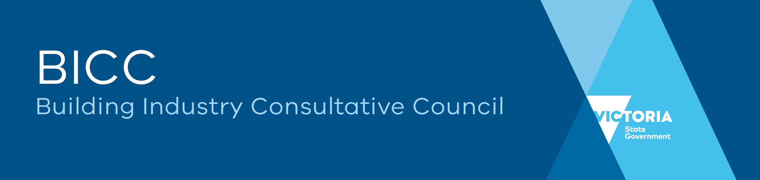

**Strategic Plan 2023-26**

1. **Context**

The Building Industry Consultative Council (BICC) was established in 2001 as a high-level advisory council to the [Minister for Industrial Relations](https://w.www.vic.gov.au/contactsandservices/directory/?ea0_lfz149_120.&roleWithSubordinates&fac10631-792c-4cde-b9e9-2fadc1098272) on economic and industrial relations issues affecting the building and construction industry.

The BICC is governed by a Charter that sets out three objectives:

* to promote an environment that will stimulate building activity and jobs growth
* to promote diversity and inclusion
* to provide a forum for dialogue between the Victorian Government, employers, peak bodies, and unions

The BICC Objectives and Charter are at Attachment 1.

1. **Our Vision**

The BICC is a trusted advisory group for the Victorian building and construction sector. It is the sought-out adviser on industry issues that fall within the BICC Objectives and Charter, that pose challenges or new opportunities.

The BICC provides an avenue for the:

* Victorian Government to seek advice on significant industry issues
* Industry to advise the Government on matters of interest and concern

The BICC values cooperation between stakeholders and Government to drive a strong, profitable, and harmonious building and construction industry.

1. **Our shared commitment**

By working together, employers, industry associations, unions, and the Government will create an innovative, sustainable, safe, inclusive, and productive industry where everyone can thrive.

1. **Our shared ambitions**

The BICC will provide clear leadership that reflects the strong and enduring partnership between the Victorian Government and industry. Our joint ambitions are that the industry is:

* a **positive work environment** where everyone is safe, appreciated, respected, and valued and where safety, inclusiveness and wellbeing is paramount
* an **industry of choice** for a diverse group of creative, thought leading, considerate, future focussed, purpose driven, leadership enabled people inspiring them to take up rewarding careers
* a leader in **innovation** fully embracing the transition to a digital economy and the rise of smart construction technologically
* driving **sustainable** change economically, environmentally, and socially
* efficient, competitive, profitable and drives **economic growth** across the economy
* driving change through **leadership** by discovering and advancing progressive initiatives and policies

1. **Strategic priority areas 2023-26**

While the BICC has oversight of all industry issues, its strategic priority areas for 2023-26 comprise:

* excellence in safety, health, culture, and wellbeing
* building workplaces that are diverse, equitable, and inclusive
* growing the workforce capability, productivity and capacity
* embracing and promoting the uptake of smart construction and digital design

1. **The drivers of change**

The industry is facing significant challenges over the coming years which will adversely impact productivity. The key challenges include labour and skill shortages, increases in the cost of materials inappropriate apportionment of risk and lack of diversity in the workforce.

To be an industry of choice for future generations of workers and a model for other industries to follow, the industry and government need to work together to find solutions that will benefit everyone.

1. **Actions to support change**

The building and construction industry is dynamic, adaptive, and capable of change.

To deliver the strategic priorities, changes are needed to the way the industry currently operates. The BICC has an important leadership role to play in driving this change.

Culture and wellbeing

The BICC aims to improve culture for workers to promote mental and physical wellbeing. It will do this by:

* establishing a Mentally Healthy Workplaces Committee
* improving mental and physical health outcomes for workers by undertaking research, promulgating policy recommendations and best practice outcomes
* helping businesses assess and manage health risks, protect industry participants, and promote wellbeing
* developing and showcasing best practice approaches to health and safety
* creating a more inclusive environment for all building and construction workers, regardless of gender, age, ethnicity, and sexual orientation. It will do this by starting with actions such as:
  + delivering the actions in the *Women in Construction Strategy 2019-22*
  + promoting the *Building Equality Policy*
  + supporting the implementation of the new *Building Equality Strategy 2023-31*

Workforce skills capability and capacity

The BICC aims to support the sector to attract people by offering careers of choice and being a positive and fulfilling place to work. It will do this by:

* identifying the future workforce gaps, skills and capabilities needs
* engaging and partnering with government and industry bodies to add value to data sets on industry trends, the pipeline of projections and skills demand
* supporting growth and modernisation of the sector through the development, delivery, and showcasing of projects and the career opportunities
* creating conditions for construction supply chains to thrive, including considering issues such as security of payment, sham contracting, visa compliance, and auditing

Smart construction and digital design

The BICC aims to support industry to adapt to the rapidly evolving technological changes in the sector. It will do this by:

* supporting the industry in modernising its working practices and broadening its appeal through supporting the industry to change
* supporting the Digital Build program led by the Office of Projects Victoria which aims to improve project delivery efficiency, uplift design, and delivery capability, and provide greater data insight and analysis to continuously improve project performance.

# 

**Objectives and Charter**

**Objectives**

1. The objectives of the Building Industry Consultative Council are to:

* promote an environment that will stimulate building activity and jobs growth in Victoria
* provide a high-level forum for regular dialogue between Government, employers and representative associations and unions on significant economic and industrial relations issues in the building industry
* promote diversity and inclusion across the building and construction industry

**Charter**

1. The Building Industry Consultative Council will:

* through consultation on key issues, foster a harmonious working environment in the Victorian building industry
* promote cultural change in the industry, through examination of initiatives that will improve Victoria’s construction productivity, reduce industrial disputation, enhance occupational health and safety, encourage skills development, and enhance employment security
* promote and encourage initiatives which will facilitate investment into Victoria
* encourage constructive dialogue about effectiveness of industry structures to promote and achieve a best practice environment
* provide advice to the Victorian Government on matters relevant to its role
* provide a forum that can both co-ordinate and promote showcase projects to encourage best practice in the industry
* supervise and manage the operations of the Victorian Building Industry Disputes Panel

**October 2020**

**Note:** The Building Industry Consultative Council Objectives and Charter April 2001 was varied in July 2005, by approval of the Minister for Industrial Relations, to include the supervision and management of the operations of the Victorian Building Industry Disputes Panel.