Foundation (Prep) Enrolment Information Pack for the Early Childhood Sector

Guidance and resources for the early childhood   
sector regarding 2025 government school Foundation enrolments

Contents

Introduction 3

Steps to enrol in Foundation for 2025 school year 3

How you can support families 4

For more information 4

Helpful resources 5

Downloadable resources 5

Useful links 5

Suggested social media content 6

Posts 6

Social media tiles 6

Suggested newsletter content 7

Suggested website content 8

Poster 9

Factsheet 10

# Introduction

Early childhood education and care service providers and services are invited to share information about the statewide Foundation (Prep) enrolment timeline with staff and families.

The Department of Education has released the statewide timeline for enrolling in Foundation (Prep) for the 2025 school year.

The timeline advises parents and carers when and how to enrol their child in Foundation at a government school. It seeks to make the enrolment process simple, clear and fair for families.

The timeline applies for children starting Foundation in 2025 at a Victorian government primary school. All Victorian government primary schools will follow the timeline in 2024 to support enrolments for the 2025 school year.

Please note that the timeline does not apply to non-government schools (Independent or Catholic schools).

## Steps to enrol in Foundation for 2025 school year

**Parents and carers can apply to enrol their child in a Victorian government primary school from the start of Term 2, 2024 (Monday 15 April 2024). Parents and carers are asked to apply to enrol by Friday 26 July 2024.**

**What parents and carers need to do:**

1. **Read about when and how to enrol their child in Foundation** at [vic.gov.au/enrolling-foundation-prep](https://www.vic.gov.au/enrolling-foundation-prep)**. The pack for parents and carers is available on this webpage and includes an application form.**
2. **Find their child’s local (zoned) school and other nearby government schools on** [findmyschool.vic.gov.au](https://www.findmyschool.vic.gov.au/)**.**
3. **Contact a government primary school to book a school tour and learn more about the school and the enrolment application process.**
4. **Submit an enrolment application for Foundation by Friday 26 July 2024.**
5. **Parents and carers will be notified of the outcome of their application between Monday 29 July and Friday 9 August 2024. If they receive an enrolment offer, parents and carers should accept the offer by Friday 23 August 2024.**

**While parents and carers are asked to submit an enrolment application by Friday 26 July 2024, applications after this date will still be accepted. Enrolment applications submitted after 26 July 2024 will be processed by the school as they are received, in accordance with the department’s Placement Policy.**

**In Victoria, children have the right to attend their local (zoned) school under the *Education and Training Reform Act 2006*.**

**Families can also apply to a school that is not their local school.** The school should enrol the child if there is a place available, in line with the department’s Placement Policy.

Information about the department’s Placement Policy is available at [vic.gov.au/how-choose-school-and-enrol](https://www.vic.gov.au/how-choose-school-and-enrol).

## How you can support families

We have put together this pack to help early childhood education and care services understand the timeline and share information about the timeline with staff and families.

This pack provides a range of optional materials, including a poster, factsheet, social media content, website content and newsletter template. It also includes links to Victorian Government webpages.

We encourage you to share and distribute these materials with your staff and families through your own communications channels.

## For more information

More information and resources about the enrolment timeline are available on the Enrolling in Foundation (Prep) webpage at: [vic.gov.au/enrolling-foundation-prep](https://www.vic.gov.au/enrolling-foundation-prep). You may direct families to this webpage and advise families to contact the primary school they want to apply to regarding any questions they have about the enrolment process.

More information and resources about how to best support children and families with the transition to school, are available at: [vic.gov.au/moving-primary-school](https://www.vic.gov.au/moving-primary-school). This includes the [Transition: a positive start to school resource kit](https://www.vic.gov.au/transition-school-resource-kit) and information on completing [Transition Learning and Development Statements](https://www.vic.gov.au/transition-learning-and-development-statements).

If your organisation has any questions, you can contact your relevant regional office. Contact information can be found here: [vic.gov.au/contact-early-childhood-improvement-branch](https://www.vic.gov.au/contact-early-childhood-improvement-branch).

# Helpful resources

These resources will help you to understand more about the statewide enrolment timeline. We encourage you to reference and use these resources in your communications with staff and families.

## Downloadable resources

**Poster**

You can print the poster on page 9 of this pack for display in settings where staff, parents and carers will see it. The poster provides a step-by-step guide of the enrolment process. The poster does not include any specific dates for 2025 enrolments so can be displayed all year round and in future years. The QR code on the poster links parents and carers to the Enrolling in Foundation (Prep) webpage for more information and key dates.

The poster is also available in more than 40 languages. You can download all the posters from [vic.gov.au/enrolling-foundation-prep](https://www.vic.gov.au/enrolling-foundation-prep).

**Factsheet**

You can read and distribute the factsheet on pages 10-12 of this pack to staff, parents and carers.

The 3-page factsheet provides a summary of the Foundation enrolment process and includes key dates in the timeline for children commencing Foundation in the 2025 school year. The factsheet also includes Frequently Asked Questions (FAQs) and references to relevant policies.

Please note, in addition to this plain English factsheet, translated factsheets are also available for download in more than 40 languages from [vic.gov.au/enrolling-foundation-prep](https://www.vic.gov.au/enrolling-foundation-prep).

**Enrolment information pack** **for parents and carers**

The pack for parents and carers includes more comprehensive information and detailed FAQs for families compared to the factsheet. The pack can be downloaded from [vic.gov.au/enrolling-foundation-prep](https://www.vic.gov.au/enrolling-foundation-prep).

## Useful links

Online resources will always include the most accurate and up-to-date information about the statewide Foundation enrolment timeline and process for enrolling in school. We ask that you reference and refer parents and carers to these websites for more information.

**Enrolling in Foundation (Prep)** – [vic.gov.au/enrolling-foundation-prep](https://www.vic.gov.au/enrolling-foundation-prep)

**Enrolling in school** – [vic.gov.au/how-choose-school-and-enrol](https://www.vic.gov.au/how-choose-school-and-enrol)

**Find my School** – [findmyschool.vic.gov.au](https://www.findmyschool.vic.gov.au/)

**Information on school zones** – [vic.gov.au/school-zones](https://www.vic.gov.au/school-zones)

**Disability and inclusive education** – [vic.gov.au/disability-and-inclusive-education](https://www.vic.gov.au/disability-and-inclusive-education)

**Regional office contacts** – [vic.gov.au/office-locations-department-education-and-training](https://www.vic.gov.au/office-locations-department-education)

# Suggested social media content

We have developed sample social media posts and tiles that you may use across your own social channels to help raise awareness of the enrolment timeline. It is optional for you to do so. If you wish to post content to social media, please do so prior to the application due date of Friday 26 July 2024, using the template wording provided below. You can mix and match the post and social media tile options based on your preference.

## Posts

**Option A**

Is your child starting primary school in 2025? Apply by Friday 26 July 2024 to enrol in a government school. For more information, visit [vic.gov.au/enrolling-foundation-prep](https://www.vic.gov.au/enrolling-foundation-prep)

**Option B**

The first year of primary school is called Foundation or Prep. If your child is starting school in 2025, it’s time to enrol. Apply by Friday 26 July 2024 to enrol in a government school. For more information, visit [vic.gov.au/enrolling-foundation-prep](https://www.vic.gov.au/enrolling-foundation-prep)

**Option C**

If your child will be 5 years old by 30 April 2025, they can start school next year. Apply by Friday 26 July 2024 to enrol in a government school. For more information, visit [vic.gov.au/enrolling-foundation-prep](https://www.vic.gov.au/enrolling-foundation-prep)

## Download social media tiles

Please click on the images below to download the social media tiles.

**Option 1 Option 2**

**[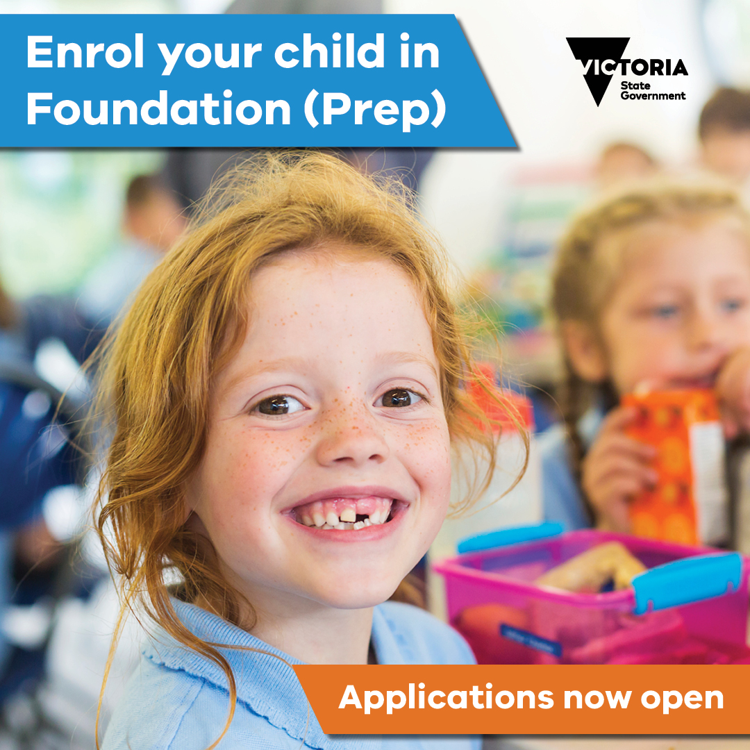](https://www.education.vic.gov.au/Documents/school/parents/Foundation-Prep-enrolment-social-media-tile-option-two.jpg)**[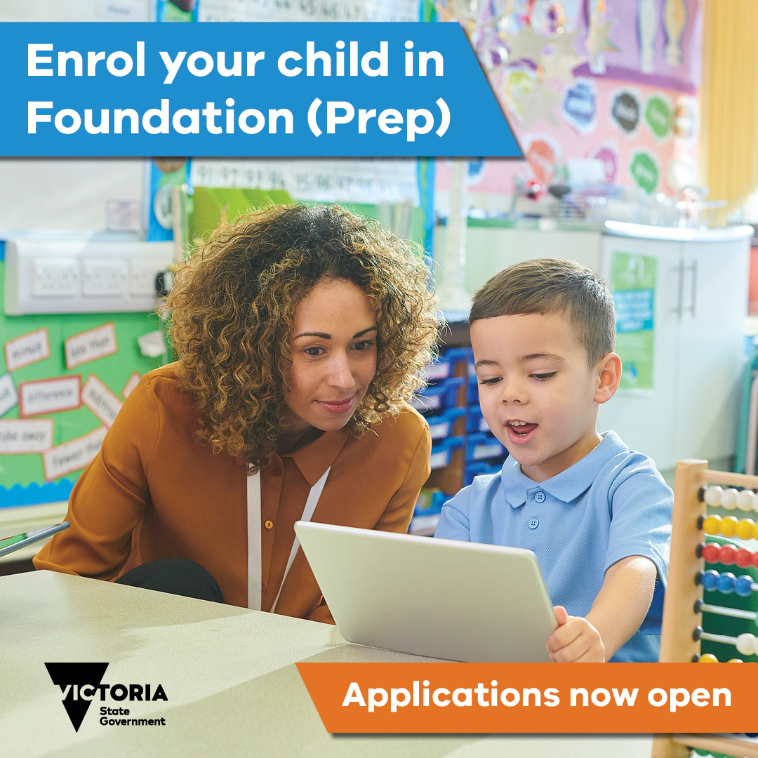](https://www.education.vic.gov.au/Documents/school/parents/Foundation-Prep-enrolment-social-media-tile-option-one.jpg)

# Suggested newsletter content

We have developed template content below that you may use in your newsletter or preferred communications channel to families to help raise awareness of the enrolment timeline. If you wish to share this information, please do so prior to the application due date of Friday 26 July 2024. It is optional for you to do so.

## Starting primary school in 2025?

If your child is turning 5 years old by 30 April 2025 and is eligible to start school next year, it is time to decide where they will go to school.

The first year of primary school is called Foundation or Prep. The Department of Education has released a statewide Foundation enrolment timeline that all Victorian government primary schools follow. The timeline helps you to understand when and how to enrol your child in Foundation at a Victorian government school.

The Foundation enrolment timeline only applies to government primary school enrolment. If you wish for your child to attend a non-government school (Catholic or Independent school), please contact individual non-government schools for their enrolment processes. **Applications to government schools for the 2025 school year open from the start of Term 2, 2024 (Monday 15 April 2024). You should apply to the school by Friday 26 July 2024.**

What you need to do:

1. **Read about when and how to enrol your child in Foundation** at [vic.gov.au/enrolling-foundation-prep](https://www.vic.gov.au/enrolling-foundation-prep)**. The pack for parents and carers is available on this webpage and includes an application form.**
2. **Use** [findmyschool.vic.gov.au](https://www.findmyschool.vic.gov.au/) **to find your child’s local (zoned) school and other nearby government schools.**
3. **Contact a school to book a tour and to learn more about the school and the enrolment application process.**
4. **Submit an enrolment application for Foundation by Friday 26 July 2024.**
5. **You will be notified of the outcome of your application between Monday 29 July and Friday 9 August 2024. If you receive an enrolment offer, you should accept the offer by Friday 23 August 2024.**
6. Take part in information and transition sessions during Term 4, 2024.
7. Your child will start Foundation from Wednesday 29 January 2025.

In Victoria, your child has a right to enrol in their local school. Your local school is determined on the basis of your child’s permanent residential address.

You can also apply for a place at a school that is not your local school. The school should enrol your child if there is a place available, in line with the Department of Education’s Placement Policy.

You can contact a government primary school if you have any questions about enrolling in school. Information and resources are also available on the Victorian Government website at [vic.gov.au/enrolling-foundation-prep.](https://www.vic.gov.au/enrolling-foundation-prep)

This is one important part of the transition to school process. Further information on transition to primary school, including Transition Learning and Development Statements, will be provided to parents and carers later this year.

# Suggested website content

We have developed template content below that you may publish on your website to help raise awareness of the enrolment timeline. It is optional for you to do so. The content does not include any specific dates and so does not require updating year on year.

### Foundation (Prep) enrolments

Starting primary school is an exciting time for children, parents and carers. In Victoria, the first year of primary school is called Foundation or Prep.

The Department of Education has a statewide Foundation enrolment timeline. The timeline advises families when and how to enrol their child into Foundation at a Victorian government primary school.

Enrolments for Foundation open the year before your child starts school. Families are asked to submit enrolment applications by the last Friday in July.

For more information and resources about the enrolment timeline, please visit: [Enrolling in Foundation (Prep)](https://www.vic.gov.au/enrolling-foundation-prep).

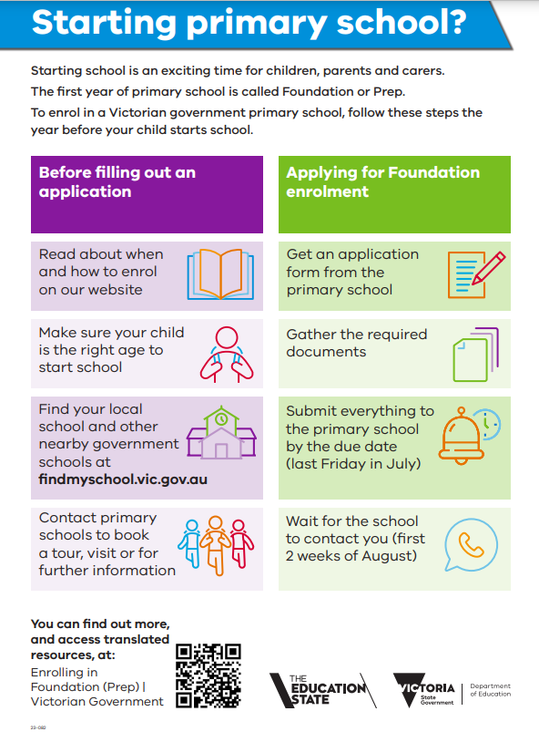

**Enrolling in primary school for 2025**

Starting school is an exciting time for children, parents and carers. We want to help make the enrolment process as easy as possible for you.

In Victoria, your child has the right to attend their designated neighbourhood school (your ‘local school’) under the *Education and Training Reform Act 2006*.

You can also apply for a place at a school that is not your local school. The school will consider your application in line with the Placement Policy. For more information on the Placement Policy, visit the [Enrolling in school](https://www.vic.gov.au/how-choose-school-and-enrol) page.

**New statewide timeline for Foundation (Prep)**

The first year of primary school is called Foundation or Prep. We have released the Foundation enrolment timeline for all Victorian government primary schools to follow (see page 3). The timeline aims to help you understand when and how to enrol your child into Foundation for the 2025 school year.

**When should I enrol my child in their first year of primary school?**

Your child must be 5 years old by 30 April in the year that they start school.

Schooling is compulsory for children who have turned 6 years old.

To enrol your child in a Victorian government primary school for the 2025 school year, submit an enrolment application to the school by 26 July 2024.

**How do I enrol my child in their first year of primary school?**

Take these steps to enrol your child in their first year of primary school:

1. Find your local school on the Find my School website (see below).
2. Contact a government primary school to book a school tour or to learn more about the school and the enrolment application process.
3. Download the Foundation (Prep) enrolment information pack from [Enrolling in Foundation (Prep)](https://www.vic.gov.au/enrolling-foundation-prep). The pack will be available from Monday 15 April 2024 and will include an application form. The school may also provide you with a copy of the form to complete.
4. Submit an enrolment application for Foundation **by Friday 26 July 2024**.
5. You will be notified of the outcome of your application **between Monday 29 July and Friday 9 August 2024**. If you receive an offer, you should accept the offer **by Friday 23 August 2024**.
6. Take part in enrolment information and transition sessions **during Term 4 2024**.
7. Your child will start Foundation **from Wednesday 29 January 2025**.

**How do I find my local school?**

Find your local school on the Find my School website by following the steps below:

1. Enter [findmyschool.vic.gov.au](http://www.findmyschool.vic.gov.au/) into your browser.
2. Enter your permanent residential address under ‘Enter your address to get started’.
3. Select 2025 under ‘Enrolment year’. **Note:** 2025 school zones will be available late Term 1, 2024.
4. Select Primary under ‘School type’.

The map will then show your address, your local school, and on the left the contact details for the school. If you scroll down, it will also show you the five closest schools to your address.

You can also search by school name under ‘Search for school’.

**Can my child apply to a government primary school that is not our local school?**

Yes, you can apply to schools other than your local school. The school will consider your application in line with the Placement Policy and available space. You can find information on how applications are prioritised on the [Enrolling in school](https://www.vic.gov.au/how-choose-school-and-enrol) page.

**What happens if I receive a letter saying my enrolment application was unsuccessful?**

You should apply to enrol your child in another school. Your child is guaranteed a place at their local school. Your child’s local school is determined on the basis of their permanent residential address. Visit [Find my School](https://www.findmyschool.vic.gov.au/) to locate your child’s local school. The [Enrolling in school](https://www.vic.gov.au/how-choose-school-and-enrol) page can also help you to confirm your child’s address for enrolment.

You can also appeal the decision. The [Enrolling in Foundation (Prep)](https://www.vic.gov.au/enrolling-foundation-prep) page has information on the process to appeal an enrolment application outcome.

**What happens if I miss the enrolment timeframes?**

You can apply to enrol your child into Foundation for the 2025 school year at any time from Term 2, 2024.

While you are asked to submit an enrolment application by Friday 26 July 2024, applications after this date will still be accepted from those families who miss enrolment timelines, move permanent residence or newly arrive to Victoria.

Enrolment applications submitted after 26 July 2024 will be processed by the school as they are received, in accordance with the department’s Placement Policy.

**Where can I find further information on enrolling in primary school?**

You can ask your local primary school for further information on the Foundation enrolment process.

At the start of Term 2, 2024 you can also find an information pack on the Foundation enrolment process on the [Enrolling in Foundation (Prep)](https://www.vic.gov.au/enrolling-foundation-prep) page.

If you require help translating the information pack, please talk to your local primary school for assistance.

**Who do I contact for help?**

The Transition Coordinator, Enrolment Officer or Principal of the primary school you want to apply to can help you with any questions you may have about the enrolment process.

**Useful links**

Please find some useful links below that may be helpful for you as your child starts primary school in 2025:

Find my School – [findmyschool.vic.gov.au](http://www.findmyschool.vic.gov.au/)

Information on school zones – [vic.gov.au/school-zones](http://www.vic.gov.au/school-zones)

Enrolling in Foundation (Prep) – [vic.gov.au/enrolling-foundation-prep](https://www.vic.gov.au/enrolling-foundation-prep)

Enrolling in school – [vic.gov.au/how-choose-school-and-enrol](https://www.vic.gov.au/how-choose-school-and-enrol)

Disability and inclusive education – [vic.gov.au/disability-and-inclusive-education](https://www.vic.gov.au/disability-and-inclusive-education)

Regional office contacts – [vic.gov.au/office-locations-department-education](https://www.vic.gov.au/office-locations-department-education)

# Timeline for 2024-25

|  |  |
| --- | --- |
| 2024 Dates | Activity |
|
| Term 2: Monday 15 April 2024 – Friday 28 June 2024 | |
| Terms 1 and 2, 2024 | Primary schools conduct tours, information sessions and other activities for families seeking Foundation (Prep) enrolment for their child for 2025. |
| By the start of Term 2, 2024 | School zones for the 2025 school year go live on [findmyschool.vic.gov.au](http://www.findmyschool.vic.gov.au/)  Parents and carers should go to [findmyschool.vic.gov.au](http://www.findmyschool.vic.gov.au/) to locate their designated neighbourhood school (local school) for 2025.  The Enrolment Information Pack for Parents and Carers is available to download from [Enrolling in Foundation (Prep)](https://www.vic.gov.au/enrolling-foundation-prep). |
| From Week 1, Term 2 2024 | Primary schools may distribute the Enrolment Information Packs to prospective families and their local community. |
| From Week 1, Term 2, 2024 | **Enrolment applications open** – parents and carers submit their completed enrolment application to a government primary school from this date. |
| Term 3: Monday 15 July 2024 – Friday 20 September 2024 | |
| By Friday 26 July 2024 | **Enrolment applications due** – parents and carers submit their completed enrolment application to a government primary school by this date. |
| Between Monday 29 July and Friday 9 August 2024 | Primary schools notify parents and carers in writing of Foundation (Prep) enrolment outcomes, as per the department’s Placement Policy. This may include a letter of offer, a letter confirming enrolment, or an unsuccessful application letter.  Parents and carers sent an unsuccessful application letter may start submitting a written appeal to the primary school. |
| By Friday 23 August 2024 | Parents and carers sent a letter of offer indicate acceptance of their child’s place by this date. |
| By Friday 23 August 2024 | **Closing date** for parents and carers to submit a written appeal to a primary school. |
| By Friday 6 September 2024 | Primary schools notify all parents and carers, in writing, of the outcome of their appeal by this date. |
| By Friday 20 September 2024 | **Closing date** for parents and carers to submit a written appeal with the relevant Regional Director, where they have been unsuccessful with their appeal to the primary school. |
| Term 4: Monday 7 October 2024 – Friday 20 December 2024 | |
| During Term 4, 2024 | Primary schools host transition sessions. |
| By Friday 1 November 2024 | Regions notify all parents and carers in writing of the outcome of Regional Director appeals by this date. This only applies to appeals received by the closing date of Friday 20 September 2024. |