

|  |
| --- |
| September 2022 |

|  |
| --- |
| Service Standards Framework  A framework for service standards under the *Circular Economy (Waste Reduction and Recycling) Act 2021* |

|  |
| --- |
| Acknowledgment  We acknowledge and respect Victorian Traditional Owners as the original custodians of Victoria's land and waters, their unique ability to care for Country and deep spiritual connection to it. We honour Elders past and present whose knowledge and wisdom has ensured the continuation of culture and traditional practices.  We are committed to genuinely partner, and meaningfully engage, with Victoria's Traditional Owners and Aboriginal communities to support the protection of Country, the maintenance of spiritual and cultural practices and their broader aspirations in the 21st century and beyond. |
| © The State of Victoria Department of Environment, Land, Water and Planning 2022  This work is licensed under a Creative Commons Attribution 4.0 International licence. You are free to re-use the work under that licence, on the condition that you credit the State of Victoria as author. The licence does not apply to any images, photographs or branding, including the Victorian Coat of Arms, the Victorian Government logo and the Department of Environment, Land, Water and Planning (DELWP) logo. To view a copy of this licence, visit <http://creativecommons.org/licenses/by/4.0/>  ISBN 978-1-76136-055-8 (pdf/online/MS word)  Disclaimer  This publication may be of assistance to you but the State of Victoria and its employees do not guarantee that the publication is without flaw of any kind or is wholly appropriate for your particular purposes and therefore disclaims all liability for any error, loss or other consequence which may arise from you relying on any information in this publication.  Accessibility  If you would like to receive this publication in an alternative format, please telephone the DELWP Customer Service Centre on 136186, email [customer.service@delwp.vic.gov.au](mailto:customer.service@delwp.vic.gov.au), or via the National Relay Service on 133 677 [www.relayservice.com.au](http://www.relayservice.com.au). This document is also available on the internet at [www.delwp.vic.gov.au](http://www.delwp.vic.gov.au). |

1. Introduction 2

2. The Legislative Framework 3

2.1. Overview of the Circular Economy Act 3

2.2. Regulations 3

2.3. Service Standards 4

2.4. Guidelines 4

3. Service Standards 6

3.1. What is a service standard and who can it apply to? 6

3.2. How is a service standard prepared, made, reviewed, amended and revoked? 6

3.3. How is a service standard applied and enforced? 8

4. Staged approach to developing service standards 11

4.1. First service standard 11

4.2. Potential future service standards 11

5. Further information 13

Glossary 14

Contents

1. Introduction

The Victorian Government’s circular economy policy, *Recycling Victoria: a new economy*, sets out the systemic change that’s needed to cut waste and boost recycling and reuse of our precious resources.

Key aspects of the policy are embedded in the *Circular Economy (Waste Reduction and Recycling) Act 2021* (the Circular Economy Act). The Circular Economy Act provides for the establishment of the Head of Recycling Victoria (RV), a regulator within the Department of Environment, Land, Water and Planning (DELWP). It allows the Head of RV to oversee and provide strategic leadership for the waste and recycling sector, and enshrines in law reforms to household waste and recycling services. It also allows for service standards to be made to ensure consistency and transparency in how waste and recycling services are delivered.

This document outlines the framework under which service standards may be made under the Circular Economy Act. It explains the relevant legislative provisions that set out what a service standard is, what they can cover and who they can apply to. It also explains how they can be prepared, made, reviewed, amended and revoked, the mandatory consultation requirements, and how they will be implemented and enforced by government.

This Service Standards Framework is intended to provide necessary context so that councils, alpine resorts and waste, recycling and resource recovery service providers can understand what service standards are and how they may apply to them. It will also ensure they are best equipped to make a meaningful contribution to the development of service standards as these are prepared over the coming years. Therefore, it is recommended that this Framework be read in conjunction with any proposed or existing service standards.

1. The Legislative Framework

## Overview of the Circular Economy Act

The overarching objective of the Circular Economy Act is to promote Victoria's transition to a circular economy. The specific purposes of the Circular Economy Act include:

* to introduce a circular economy in Victoria that maximises the continued use of products and waste material over their life cycle and accounts for their environmental impacts
* to establish the Head of RV and their functions and powers
* to require councils and alpine resorts to provide municipal residual waste and municipal recycling services
* to support best practice procurement and contract management of waste and recycling services by councils and alpine resorts, and facilitate strategic procurement for councils and alpine resorts
* to provide for service standards
* to establish a container deposit scheme
* to provide for data collection and reporting and
* to provide for a system of criminal and civil penalties and other enforcement measures.

Under the Circular Economy Act, subordinate legislation including regulations, service standards and guidelines can be established.

## Regulations

Regulations may be developed in relation to a range of matters outlined in Schedule 1 of the Circular Economy Act.

Regulations may complement and shape service standards that are developed – for instance, in terms of who the standard applies to, the scope/content of the standard, and when it takes effect. Regulations may be developed ahead of, or in parallel with, corresponding service standards.

For example, section 60 of the Circular Economy Act requires that councils and alpine resorts provide municipal residual waste and municipal recycling services. This section of the Circular Economy Act outlines the four core services that are expected to be provided, but regulations are needed to specify the dates from which these services must be provided. These regulations will also prescribe offences and penalties for not having services in place by the prescribed date(s) and may also specify some exclusions or exceptions from the requirement to provide the four services and any other clarifications deemed necessary. The regulations can also provide further detail as to how the services must be provided and can also prescribe additional services that must be provided.

Regulations can specify data collection and reporting requirements for a waste, recycling or resource recovery service. Implementation of data and reporting regulations will be key to monitoring compliance with any service standards, as well as providing details of the overall operation of the waste and recycling sector and its future needs. The content of data and reporting regulations may inform the requirements set out in a service standard, and vice versa, to ensure the information gathered is relevant, targeted and effective.

Regulations are also used to outline requirements for exemption applications under the Circular Economy Act – including the form that applications must be submitted in, and the information to be contained in an application. These regulations would apply if the need arose to seek an exemption from a regulation or service standard.

The preparation and making of a regulation is subject to requirements specified in the *Subordinate Legislation Act 1994* (the SL Act), which may include the preparation of a Regulatory Impact Statement (RIS).

## Service Standards

Service standards may be developed under the Circular Economy Act to specify the quality and performance expected of a provider of a waste, recycling and resource recovery service.

The Circular Economy Act:

* provides for the making of service standards and sets out the steps that must be followed in the preparation, making, review, amendment and revocation of a service standard, including the formal consultation requirements and consideration of advice from advisory committees established under the Circular Economy Act
* includes information on what a service standard may provide for (its purpose and content), as well as the requirement to incorporate service standards into relevant agreements
* outlines offences and penalties that apply in the case of non-compliance
* provides the Head of RV with the power to exempt a person or class of person from any provision of the regulations or of a service standard.

The Circular Economy Act places high level obligations or requirements on various waste and recycling service providers and other entities. Where this is the case (e.g. in relation to mandatory service provision by councils and alpine resorts), the detail of this requirement will be contained in regulations and/or service standards. These service providers must comply with any applicable service standards that are in place. It is an offence to refuse or fail to comply with a service standard without a reasonable excuse.

The Circular Economy Act also does not limit the number of service standards that may be prepared – the overall service standards architecture (the scope and number of service standards and how they ultimately fit together) is for the Head of RV to advise on (through preparing the service standards), and the Minister to decide on by approving service standards. The broad approach to the development of different service standards is outlined in section 4 of this Framework, noting the intent that there will ultimately be multiple complementary service standards in effect.

## Guidelines

Guidelines may also be issued under the Circular Economy Act to provide guidance to regulated parties on how to comply with the law. For instance, the Head of RV may issue guidelines relating to the procurement of waste, recycling or resource recovery services by councils or alpine resorts. Where procurement guidelines are issued, they must be published on a departmental website and councils/alpine resorts must have regard to these. The Circular Economy Act also allows the Minister to issue guidelines relating to the administration of the Circular Economy Act, and compliance and enforcement.

A summary of the legislative framework that applies to the making and operation of service standards is provided in Diagram 1. These legislative and regulatory aspects are expanded on in the following sections.

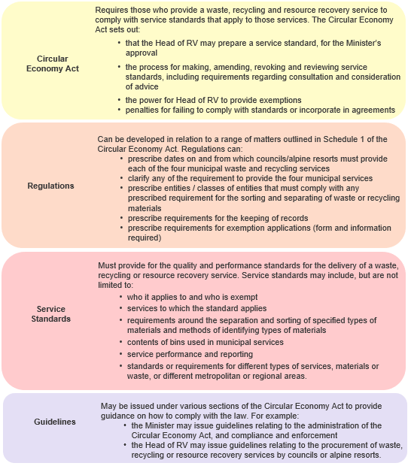

***Diagram 1****. A summary of the legislative framework for the making and operation of service standards.*

1. Service Standards

## What is a service standard and who can it apply to?

Service standards are legislative instruments for the purposes of the *Subordinate Legislation Act 1994* (the SL Act).

The purpose of a service standard is to outline the specifics or detail of what is expected in relation to service provision or delivery. The power to make service standards under the Circular Economy Act is very broad – service standards can be set for any waste, recycling or resource recovery services and for all waste streams, including municipal solid waste, commercial and industrial waste and construction and demolition waste, and enforced against those who provide such services.

The Circular Economy Act states that a service standard *must* provide for the quality and performance standards for the delivery of a waste, recycling or resource recovery service.

The Circular Economy Act notes that a service standard *may* provide for:

* 1. the persons or classes of person, or entities or classes of entity, to whom the standard applies; and
  2. the persons or classes of person, or entities or classes of entity, exempt from the standard; and
  3. the services or classes of service to which the standard applies; and
  4. separating and sorting specified types of waste; and
  5. separating and sorting specified types of recycling material; and
  6. the methods of identifying types of waste and recycling material; and
  7. the contents of particular bins used in municipal waste or municipal recycling services provided for or on behalf of a council; and
  8. service performance and reporting (across a range of possible measures); and
  9. different standards or requirements for different types of services; and
  10. different standards or requirements for different types of material or waste; and
  11. different standards or requirements for different metropolitan or regional areas; and
  12. any other matter the Head of RV considers relevant or that the Minister directs

A service standard will also specify the day or days that the standard is to commence (when it will take effect and be enforceable).

## How is a service standard prepared, made, reviewed, amended and revoked?

The process for preparing, making, reviewing, amending and revoking a service standard is outlined in sections 62 – 68 of the Circular Economy Act (refer to Diagram 2).

### 3.2.1 Preparation and making of a service standard

The Circular Economy Act assigns the Head of RV with the power to prepare a service standard. The Head of RV must submit a service standard to the Minister for approval. If the service standard is approved by the Minister, the Minister must publish notice of the approval in the Government Gazette.

### 3.2.2 Consultation requirements

The Minister must publish notice of the Minister's proposal to make, amend or revoke a service standard (a proposal notice). The proposal notice must be published in the Government Gazette and any other publication the Minister considers appropriate. The service standard must be made available for comment for at least 28 days.

The preparation and making of a service standard is also subject to requirements specified in the SL Act, which may include the preparation of a RIS. Where a RIS is necessary, the SL Act dictates that it must be published by the responsible Minister, with a notice inviting comments and submissions from the public. The notice must set out:

* the reason for, and the objective of, the proposed legislative instrument,
* the locations (including the Government website) where a copy of the RIS and the proposed legislative instrument can be obtained, and
* an invitation for public comments or submissions within a specified time not less than 28 days from the publication of the notice.

### 3.2.3 Consideration of advice

Before deciding whether to make, amend or revoke a service standard, the Minister *must* consider any advice or comment the Minister receives from:

* the Head of RV
* the formal public consultation process noted above and
* the advisory committee referred to in section 37(2) of the Circular Economy Act (the advisory committee that the Minister must establish that includes persons with relevant skills, knowledge and experience relating to local government and rural and regional communities)

The Minister *may* also consider any advice the Minister receives from any other advisory committee the Minister considers relevant.

### 3.2.4 Review of a service standard

The Minister *must* review a service standard at intervals of no longer than three years but *may* also review a standard at any time at the request of the Head of RV if the Minister is satisfied it is in the public interest to do so.

The Minister may also, at any time, direct the Head of RV to review the operation of a service standard and to report to the Minister on the results of that review.

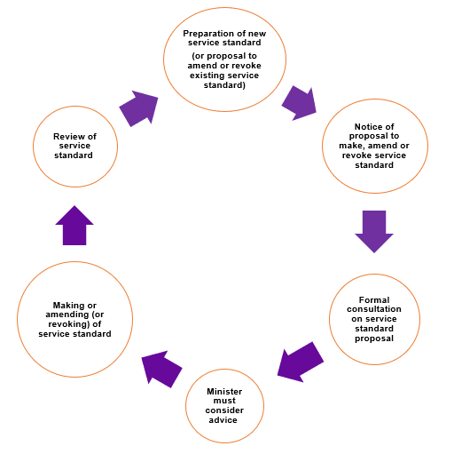

***Diagram 2****. The process for preparing, making, reviewing, amending and revoking a service standard.*

## How is a service standard applied and enforced?

### 3.3.1 Application

The persons or classes of person, or entities or classes of entity, to whom the standard applies, will be responsible for complying with the requirements set out in the standard from the date or dates that the service standard commences or takes legal effect (noting that the date/dates that a service standard commences may be some time after a service standard is made).

Once a service standard commences, it must also be incorporated in any relevant waste, recycling or resource recovery agreement concerning the provision of a service that is the subject of that service standard. The responsibility to do this sits with the person providing the service. This requirement must also be set out in any invitations for applications to enter into such agreements (tender processes and the like). Under the Circular Economy Act, the Head of RV may provide councils or alpine resorts with procurement advice and support.

### 3.3.2 Compliance and enforcement

RV is responsible for supporting and enforcing compliance with the Circular Economy Act, including service standards and regulations. RV will provide clear communication ahead of the commencement of a service standard and ensure regulated parties understand their obligations and are supported to meet them.

The Circular Economy Act contains a graduated and proportionate suite of compliance and enforcement mechanisms, including the use of information gathering notices, improvement notices and enforceable undertakings, to enable the Head of RV to adequately discharge its regulatory duties. Tools to support, monitor and enforce compliance are summarised in Diagram 3.

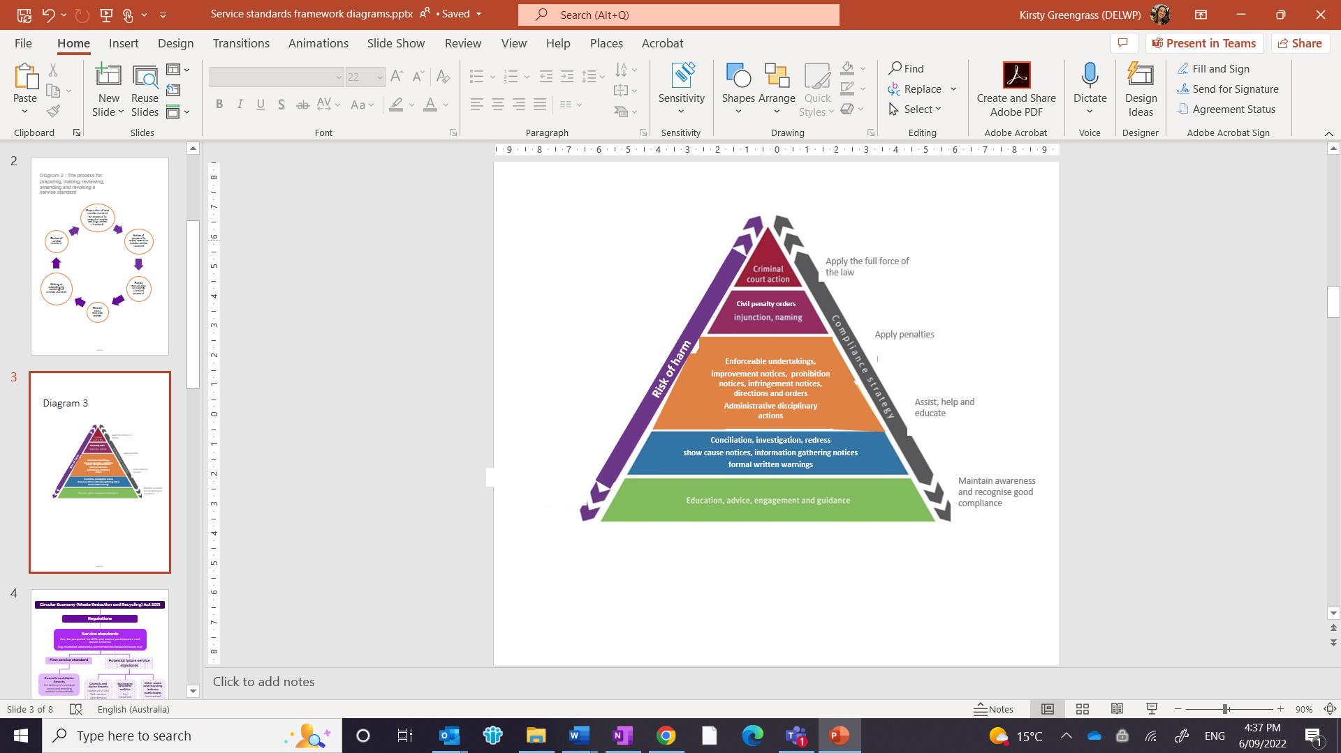

***Diagram 3****. Tools to support, monitor and enforce compliance.*

The Circular Economy Act also allows for mandatory data collection and reporting to the Head of RV. The detail of this, including who must report and the information to be reported will be outlined in regulations focused on mandatory data collection and reporting. The provision of this data will, among other things, further enable the Head of RV to monitor compliance with any applicable service standards.

The Head of RV may appoint authorised officers to perform required compliance and enforcement activities.

#### Offences and penalties

Refusing/failing to comply with a service standard or refusing/failing to incorporate relevant service standards into agreements are specific offences under the Circular Economy Act. The offences apply to a person who provides a waste, recycling or resource recovery service (not members of the public generally). The penalty in both instances is 500 penalty units (or $92,460 for the 2022/2023 financial year) for a natural person and 1200 penalty units ($221,904 for the 2022/2023 financial year) for a body corporate.

Other general offences under the Circular Economy Act may also apply in the context of the Head of RV monitoring and enforcing compliance with service standards. For example, a person must not, without reasonable excuse, refuse or fail to comply with a notice requiring information that is issued by the Head of RV – and failure to comply is an offence (with associated penalties). Under the Circular Economy Act it is also an offence to, without reasonable excuse, fail to keep records and information about the services provided, so far as is reasonably practicable. Again, failure to comply is an offence, with associated penalties.

#### Exemptions

A person may apply for an exemption from requirements in a service standard. Exemption applications will be considered by the Head of RV on a case-by-case basis. The Circular Economy Act stipulates that the Head of RV must not grant an exemption unless they are satisfied that:

* the exemption will not pose a serious risk of failure of, or disruption to, waste, recycling or resource recovery services
* it is not practicable for the person (or class of person) to comply with the relevant provision, and
* the exemption is necessary to enable the efficient administration of the relevant provision.

1. Staged approach to developing service standards

Government is adopting a staged approach to the development of service standards over time. All service standards will be developed in consultation with key stakeholders in accordance with the process described in this Framework.

## First service standard

The first service standard prepared under the Circular Economy Act by the Head of RV will apply to household waste and recycling services provided by council and alpine resorts. It will outline how the four service streams (residual waste, mixed recycling, glass, and food organics and garden organics) are to be delivered.

This service standard is proposed to comprise elements that are essential to give effect to the obligation on councils and alpine resorts to deliver the four streams under section 60 of the Circular Economy Act. It is proposed that it will, at a minimum, include requirements in relation to standard bin contents and bin lid colours. The detail of these (and other possible elements) will be developed in consultation with councils, alpine resorts, industry and the broader Victorian community.

The first service standard is intended to provide for statewide consistency but also provide for flexibility in how services are delivered in certain circumstances. Councils and alpine resorts are transitioning to the new household waste and recycling system at different times and the standard will need to set a strong foundation that can be built on over time as required.

## Potential future service standards

It is anticipated that multiple service standards will be made over time. For example, standards may be made to give effect to the requirement in the Circular Economy Act for prescribed businesses and other entities to sort waste and recycling materials.

Development of requirements for mandatory sorting by prescribed businesses will be subject to consultation with businesses and other key stakeholders, with these rules expected to come into effect by 2025. Mandatory separation of commercial recyclable materials is a commitment within the government’s circular economy policy.

Updates to existing service standards will also be made as necessary over time – for instance, there may be a need to make amendments from time to time to the standard content lists for each service stream to reflect advances in technology.

Any future service standards for waste and recycling industry participants will be informed by key stakeholder views, and are subject to formal consultation requirements. The scope of any service standards will be considered in the context of any other regulations that will apply to industry, for example in relation to data collection and reporting.

The staged approach to the development of service standards is depicted in Diagram 4.

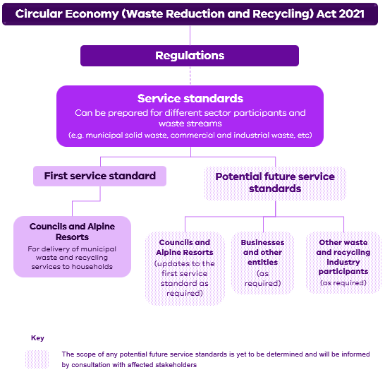

***Diagram 4****. The staged approach to the development of service standards.*

1. Further information

For further information on the new recycling laws and governance visit [New recycling laws and governance | Victorian Government (www.vic.gov.au)](https://www.vic.gov.au/new-recycling-laws-and-governance). Information on the Circular Economy Act itself is also available [Circular Economy (Waste Reduction and Recycling) Act 2021 (legislation.vic.gov.au)](https://www.legislation.vic.gov.au/as-made/acts/circular-economy-waste-reduction-and-recycling-act-2021).

Should you have any questions about the Circular Economy Act or this Framework, please email the Waste and Recycling Legislative Reform Team of DELWP via [circulareconomy.legislation@delwp.vic.gov.au](mailto:circulareconomy.legislation@delwp.vic.gov.au)

For information on Recycling Victoria and its functions and activities, please visit [Strengthening our waste and recycling system | Victorian Government (www.vic.gov.au)](https://www.vic.gov.au/strengthening-our-waste-and-recycling-system). You can also contact RV via phone 136 186 or submit an online request via Contact Recycling Victoria | Victorian Government (www.vic.gov.au).

# Glossary

|  |  |
| --- | --- |
| Alpine resorts | Alpine Resort Management Board as per the Circular Economy Act. |
| Circular Economy Act | *Circular Economy (Waste Reduction and Recycling) Act 2021* |
| DELWP | Department of Environment, Land, Water and Planning |
| Guidelines | Guidance material produced under the Circular Economy Act to provide guidance to regulated parties on how to comply with the law. |
| Head of Recycling Victoria | The Head of Recycling Victoria, employed under Part 3 of the *Public Administration Act 2004*, provides leadership, stewardship and oversight of waste, recycling or resource recovery services and supports the development of a circular economy. |
| Minister | Minister for Environment and Climate Action |
| Municipal waste and recycling services | A waste and recycling service provided by or on behalf of a council or alpine resort. The municipal waste and recycling services may also be described as the four-stream system. |
| Offences | An act or behaviour that is prohibited by law and punishable by a prescribed penalty. |
| Penalties | A monetary fine to be prescribed through the regulations for failing to comply with the regulations or service standard (section 183(2) of the Circular Economy Act). |
| Recycling Victoria (RV) | A business unit within DELWP that supports the Head of RV |
| Regulations | Subordinate legislation established under primary legislation to further prescribe matters set out in the primary legislation (in this case, the Circular Economy Act). |
| Regulatory Impact Statement (RIS) | An assessment that the government uses to analyse how regulations will impact the community. This helps the government choose the best approach for achieving better community outcomes. |
| Service Standard | A standard approved under section 63 of the Circular Economy Act which must provide for the quality and performance standards for the delivery of a waste, recycling or resource recovery service. A service standard is subordinate legislation. |
| SL Act | *Subordinate Legislation Act 1994* |

vic.gov.au/circular-economy