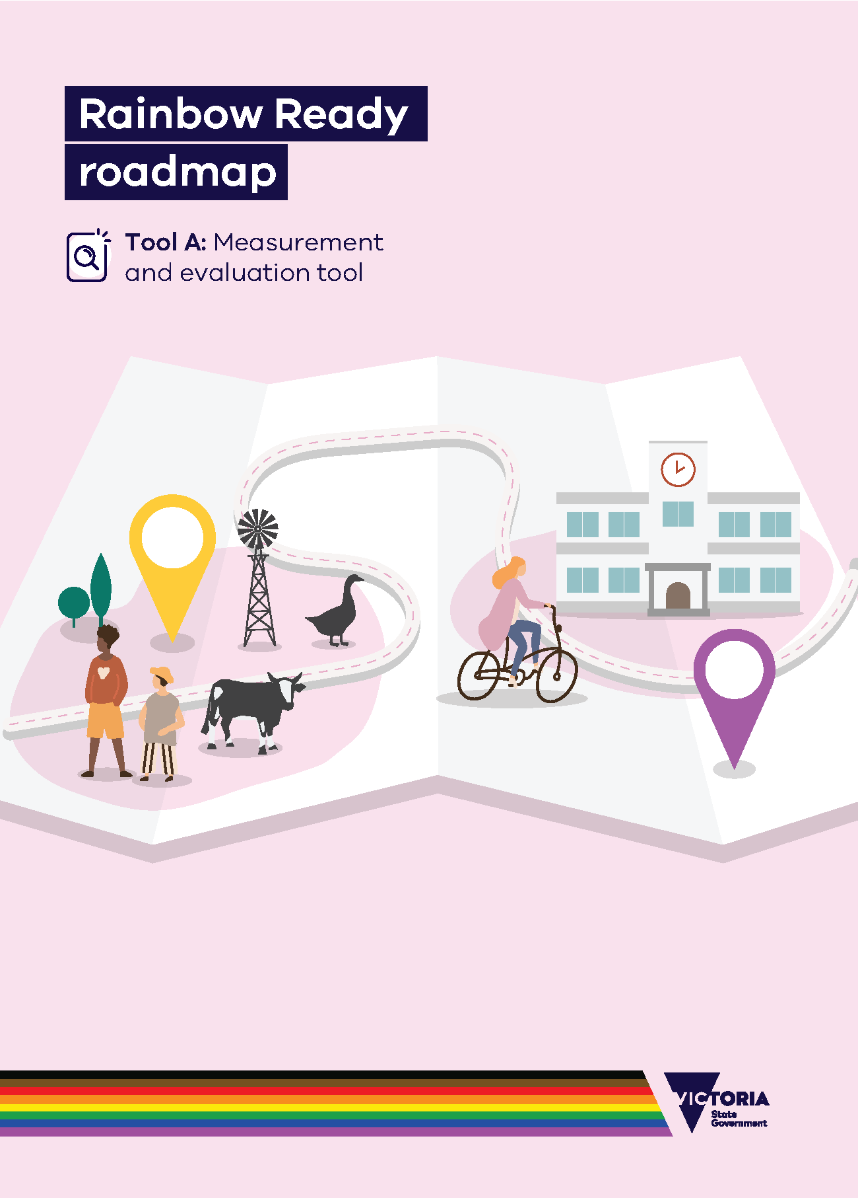

# Rainbow Ready roadmap

## Tool A: Measurement and evaluation tool

## About this tool

## As you undertake Rainbow Ready activities, it’s important to assess areas for improvement, evaluate progress towards achieving LGBTIQA+ inclusion and celebrate project achievements. Completing this tool is also a key step to tracking your progress along the way as you work towards being Rainbow Ready.

## When to use this tool

This tool should firstly be used as part of **Phase 2: Assess**, to understand your setting’s current state of LGBTIQA+ inclusion. inclusion. It will help you identify key areas for improvement and potential projects.

Either during your work or after completing a Rainbow Ready project or activity, this tool should be revisited and used again. Use it as part of **Phase 5: Evaluate** to measure progress against the indicators for LGBTIQA+ inclusion. Evaluations should be repeated regularly to monitor continuous progress.

## How to use this tool

1. Plan your assessment or evaluation
   * Assemble an evaluation team that can help gather and compile your evidence, provide different perspectives, including those independent of the core project team.
   * Consider engaging with a range of staff, including LGBTIQA+ employees.
   * Consider engaging LGBTIQA+ service users and community members.
2. Discuss and agree your approach
   * What is the purpose of the evaluation?
   * Will action be taken to address identified gaps?
   * Who will the evaluation results be communicated with?
3. Undertake your assessment or evaluation
   * Enter the indicators from your relevant settings guide into the table below, adding rows to the table for additional indicators as required.
   * Select from the drop down a rating of ‘Not met’, ‘Partially met’ or ‘Met’ from the drop-down.
   * Against the indicators, detail achievements and areas for improvement.
   * Have enough evidence to demonstrate indicators marked as ‘Met’.
   * Supporting evidence could include project deliverables, community and stakeholder surveys,
   * images, videos and feedback from participants.
   * There may be instances where genuine group, team or organisational constraints will not allow you to meet an indicator for the foreseeable future. For these indicators, mark them as ‘Unable to be met’. In the ‘evidence’ section, state why it will not be possible for your team to meet this indicator.
   * Note: These instances will still be useful as stories and case studies for others doing Rainbow Ready work. There are always lessons to be learned for yourselves and others when indicators are deemed ‘Unable to be met’. Usually it’s when circumstances change drastically, or something turns out to be beyond your control.
4. Address your findings
   * Discuss the findings and the current state of your group, organisation or service with the project team, LGBTIQA+ people in your community and key stakeholders.
   * Brainstorm activities and actions you could implement to ensure indicators marked ‘Partially met’ or ‘Met’ are addressed, or to gather evidence to substantiate the rating provided.
   * Consider sharing lessons learnt and challenges with others undertaking LGBTIQA+ inclusion projects. This may help them in their work, too.
5. Repeat the evaluation
   * Use the evaluation tool regularly to check progress. Continue repeating the process until all indicators are met.

## Next Steps

Phase 3: Action plan  
Once you have assessed progress against the indicators for LGBTIQA+ inclusion, plan activities to address areas for improvement or sustainability. Revisit the evaluation tool after completing of activities. When all applicable indicators that can be met are met, consider completing the Rainbow Ready status checklist under **Phase 6: Checklist.**

To receive this document in another format, [email the Equality Unit](mailto:equality@dffh.vic.gov.au)<equality@dffh.vic.gov.au>.

Authorised and published by the Victorian Government, 1 Treasury Place, Melbourne.

© State of Victoria, Australia, Department of Families, Fairness and Housing, May 2022.

In this document, ‘Aboriginal’ refers to both Aboriginal and Torres Strait Islander people.

ISBN 978-1-76096-805-2 (online/PDF/Word)

ISBN 978-1-76096-806-9 (print)

Available at [Rainbow Ready roadmap](https://www.vic.gov.au/rainbow-ready-roadmap) <https://www.vic.gov.au/rainbow-ready-roadmap>.

# Measurement and evaluation tool

### Name: Click to enter name of organisation/group/service undertaking Rainbow Ready.

### Date: Click to enter a date.

### Evaluator names: Click to enter names.

|  |  |  |
| --- | --- | --- |
| **Purpose of this evaluation:** Click to enter text. |  | **Communication plan to share evaluation results:** Click to enter text. |

|  |  |  |  |  |  |
| --- | --- | --- | --- | --- | --- |
| **No.** | **Indicator** | **Rating** | **Achievements** | **Areas for improvement** | **Supporting evidence** |
| **1** | Click to enter the indicator being measured. | Select from the drop-down. |  |  | Click to enter text. |
| **2** | Click to enter the indicator being measured. | Select from the drop-down. |  |  | Click to enter text. |
| **3** | Click to enter the indicator being measured. | Select from the drop-down. |  |  | Click to enter text. |
| **4** | Click to enter the indicator being measured. | Select from the drop-down. |  |  | Click to enter text. |
| **5** | Click to enter the indicator being measured. | Select from the drop-down. |  |  | Click to enter text. |
| **6** | Click to enter the indicator being measured. | Select from the drop-down. |  |  | Click to enter text. |
| **7** | Click to enter the indicator being measured. | Select from the drop-down. |  |  | Click to enter text. |
| **8** | Click to enter the indicator being measured. | Select from the drop-down. |  |  | Click to enter text. |

|  |
| --- |
| **Other comments:** Click to enter text. |