Communications kit – Password campaign
Contents
Campaign 2
How to share the campaign 2
Key messages 4
Content
Campaign promo 4
News article content 5
Social media content 6
Campaign imagery 7
Video content 11

Introduction
Victorians are becoming increasingly vulnerable to attacks from sophisticated cybercriminals who exploit their personal information.
Through this campaign, the Victorian Government is encouraging Victorians to reduce their cyber risk and protect their personal information by strengthening their passwords.
We are sharing this kit with you to promote the campaign through your channels and reach as many Victorians as possible.

Campaign
Many Victorians are currently using weak passwords for their accounts, heightening their risk of compromise and further harms such as identity theft.
DGS has developed a digital communications campaign to build awareness of the risks of a weak password and provide advice on how to improve password behaviour.
The campaign promotes six simple behaviours people can do to protect their information and be safer online. The behaviours include:
- Use passphrases
- Use a different password for each account
- Make your passwords harder to guess by avoiding predictable words
- Use a password manager
- Update your passwords when required
- Turn on multi-factor authentication
The campaign theme is “future proof your online security” and leverages futuristic landscapes to represent a Victoria in the future. The campaign promotes two tag lines “will your password stand the test of time?” and “Don’t wait for tomorrow. Make a simple change today.”
It is supported by a “Stay Safe Online” web presence on vic.gov.au and a password strength tester and passphrase generator on the Service Victoria website.
The campaign will begin on World Password Day on Thursday 2 May and finish on 30 June 2024.

How to share the campaign
To support Victorians to protect themselves from cyber threats, we need your help to share the message.
To support this campaign, we have created this pack which includes information about the campaign and assets for you to share. We would appreciate your support in sharing the overarching campaign messaging to your stakeholders and networks in the Victorian community.
You can share our posts and share these materials on your own channels (e.g. LinkedIn, Facebook, Instagram) to help spread awareness.
Please tag us in any posts:
- DGS LinkedIn page @department-of-government-services
- DGS Facebook page @VicGovDGS
Social media assets can be downloaded from the campaign page.
We ask that you please share any data, feedback and analytics relating to this campaign at the end of the campaign period (2 May – 30 June) to include in our campaign evaluation.
We thank you in advance.
If you have any questions, please contact communications@dgs.vic.gov.au.

Key messages
- Strong and secure passwords protect your most important personal information from cybercriminals.
- If your password is weak and a cybercriminal figures it out, they could gain access to your online accounts and your private information.
- There are simple things you can do to create stronger passwords that are difficult for cybercriminals to hack.
- To protect your online accounts from hackers:
    - Use passphrases (four or more random words)
    - Use a different password for each account
    - Make your passwords harder to guess by avoiding predictable words
    - Use a password manager
    - Update your passwords when required
    - Turn on multi-factor authentication
- Go to vic.gov.au/passwords to learn more
- The tools that can be accessed on the Service Victoria app and website can test the strength of a password but also generate suggested strong passphrases, with each passphrase being unique and random.
- Both tools are completely anonymous and secure, and no information is collected, tracked, or stored.

Content
Campaign promo
This content can be used for a news story, promoting the campaign in a group forum or other.
Summary line: Try out the government’s new password tester tool and boost your online security.
To mark World Password Day (2 May) the Victorian Government has launched a campaign to encourage Victorians to test their password and stay safe online.
The campaign is all about improving your password hygiene so that you can better protect yourself and your information online from cybercriminals.
The campaign, “Will your password pass the test of time?”, illustrates how a strong password can take cyber criminals centuries to hack. It encourages Victorians to head online to:
- the Service Victoria website to test the strength of a password using a secure online tool and get advice on how to improve it.
- the Victorian Government’s new Stay Safe Online website to improve your knowledge of good cybersecurity hygiene.
Help us spread this important message by sharing it with your friends, family, and colleagues. You can also visit DGS on LinkedIn and Facebook to view the social media campaign.

News article content
This content can be used for any articles, newsletters, or news stories.
Headline: It’s World Password Day – will your password pass the test of time?
Today is World Password Day and the perfect time for you to test the strength of your passwords and boost your online security.
Cyber threats are increasing, posing a higher risk of cybercrime for Victorians. That means we all need to be savvier about protecting our information online.

A new campaign – “Will your password pass the test of time?” – has launched today by the Department of Government Services. It encourages Victorians to up their game when it comes to passwords.

A new password strength tester has been developed so that you can check your password strength and get tips on how to increase it. You can check out the secure tool on the Service Victoria app and website.

There are simple things you can do to create stronger passwords that are more difficult for cybercriminals to hack. To protect your online accounts from hackers:
- Use passphrases (four or more random words)
- Use a different password for each account
- Make your passwords harder to guess by avoiding predictable words
- Use a password manager
- Update your passwords when required
- Turn on multi-factor authentication
Victorians can also learn more about broader cybersecurity hygiene at the Vic Gov’s new Stay Safe Online website. The website covers a broad range of information on:
- Passwords
- Multi-factor authentication
- Backing up your data
- Looking out for scams
- Updating your devices
- Information leaks
Don’t wait for tomorrow. Make simple changes today.
This campaign is brought to you by the Department of Government Services.
Help us spread the message by sharing this with your friends, family and colleagues.
Visit DGS on LinkedIn and DGS Facebook to view the social media and video campaign.

Social media content
After the launch posts on DGS LinkedIn and DGS Facebook, we welcome anyone to share the posts and any other campaign content on their channels throughout the campaign (2 May – 30 June). Depending on your channels, please feel free to use the below content to create your own content.
We also encourage you to use page tags and hashtags as appropriate and link to the password campaign page.
You can download any assets from the campaign web page
We encourage use of page tags and hashtags appropriate:
Our primary social media hashtags are:
- #StaySafeOnline
- #WorldPasswordDay
- #WillYourPasswordPassTheTestOfTime
- #PasswordSecurity
- #CyberSafety
- #UseAPassphrase
Please tag us in any posts:
- LinkedIn: @Deparment of Government Services
- Facebook: @VicGovDGS
Facebook / LinkedIn / Instagram / X
Post 1 – Thursday 2 May – Campaign Launch – World Password Day
Caption to use when resharing DGS Content on Facebook / LinkedIn:  Today on World Password Day, the Victorian Government has launched a campaign to encourage Victorians to help future proof their online security.  The difference between a weak password and a strong password can be measured in a matter of seconds or centuries.  Don’t wait for tomorrow, make simple changes today.  Learn more and to test the strength of your password at vic.gov.au/passwords.  #StaySafeOnline  #WorldPasswordDay  #WillYourPasswordPassTheTestOfTime  <TAGS: Victorian Government, Australian Signals’ Directorate> | Asset:  This is an auto downloadable mp4 file that you can use on your channels.  Strong passwords - moving visual asset  You can also access static frames of this mp4 on the campaign web page.
Alternative caption for World Password Day or anytime between 2 May and 30 June
Will your password pass the test of time?
Don’t wait for tomorrow, make simple changes today to strengthen your password.
Get creative and make it memorable. Using at least 4 random words will help keep hackers away. The longer it is, the stronger it is.
Learn how to protect your personal information and test the strength of a password at vic.gov.au/passwords
#StaySafeOnline
#WillYourPasswordPassTheTestOfTime
<Tags:
Department of Government Services, Victorian Government, Australian Signals’ Directorate>

Campaign imagery
We have a range of imagery that can be used in relation to the campaign. These are pasted below and also available to download on the campaign web page.
These assets can be used for social media, any internal SharePoint or Intranet, email or entity newsletter.
This asset is a mp4 file and can be downloaded for use. | Strong passwords - moving visual asset
Static images of the mp4.  These can be saved from this doc or campaign web page and used in carousel. | 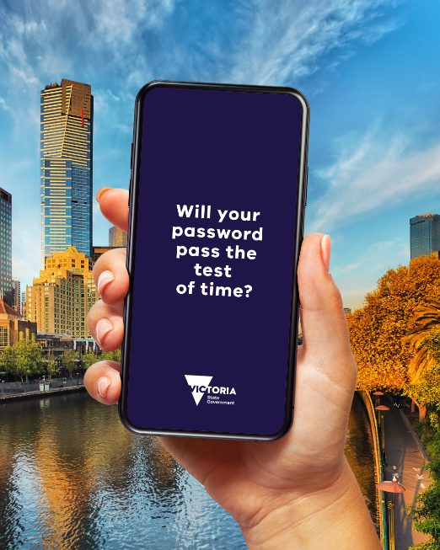  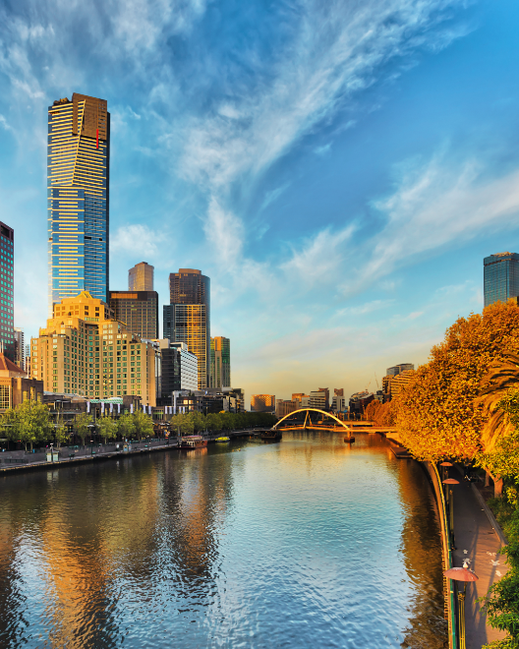  Image 1 Image 2

Image 3 Image 4
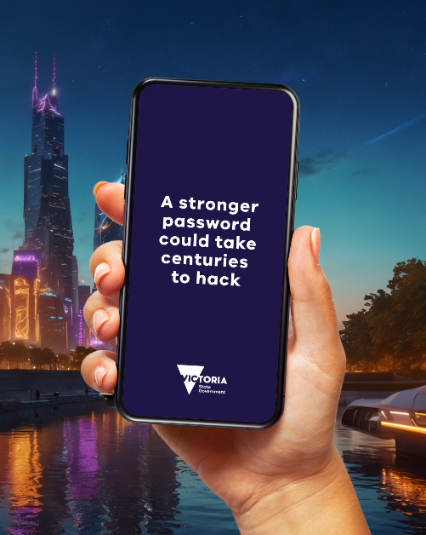
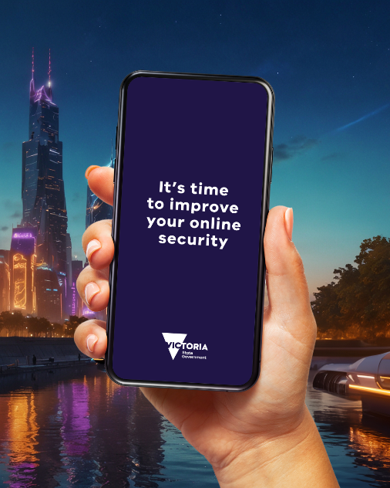
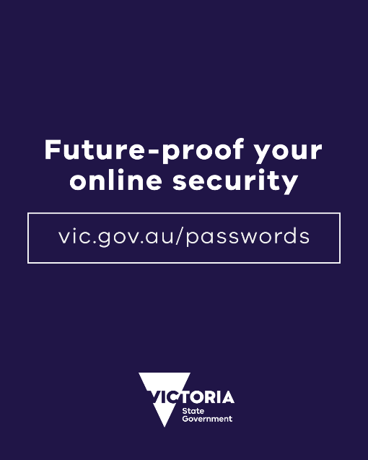
Image 5 Image 6
Web banner | 
Web tiles – 533x300px | 
Size: 400 x 300 |     
Secondary image | 

Video content
We have produced a suite of short, shareable videos. The videos will be available to be embedded across websites, eDMs and social media channels.

These will be shared on DGS on LinkedIn and DGS Facebook and can be reshared across other Vic Gov channels.

We will have 3 different lengths for the campaign videos, 30 second, 15 second and 6 second videos.
When these are ready, they will be available for download on the campaign page.

