- Photos are to show damage to an essential public asset (for example, a local road, bridge or culvert. Trees are not considered to be an essential public asset.
- Photos are to be provided with the metadata embedded.
- For more information please refer to DRFA Guideline 1: https://www.emv.vic.gov.au/drfa/guideline-1

Post Disaster | Post Disaster  Example | Post Disaster
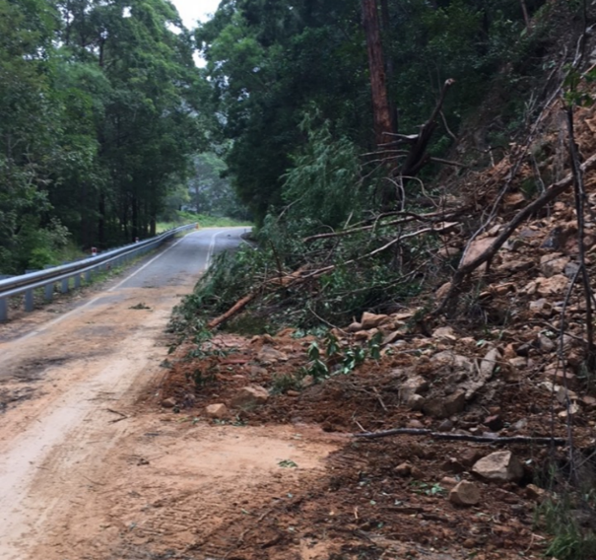 | 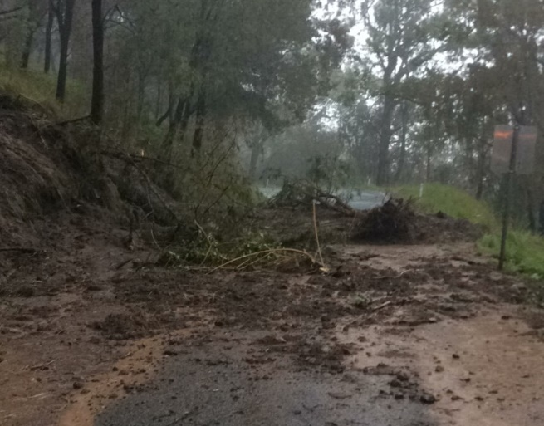
Asset ID: 001  Asset description: sealed road, Derby Road  Photo ID: Photo one  Chainage: [Insert chainage, where applicable]  Latitude: 37° 49' 14''  Longitude: 147° 11' 14''  Date taken: 22 February 2022 | Asset ID: 002  Asset description: sealed road, Derby Road  Photo ID: Photo two  Chainage: [Insert chainage, where applicable]  Latitude: 28° 3' 6''  Longitude: 153° 2' 37''  Date taken: 22 February 2022 | Asset ID: [Insert asset ID]  Asset description: [Insert asset description]  Photo ID: [Insert photo ID]  Chainage: [Insert chainage, where applicable]  Latitude: [Insert latitude]  Longitude: [Insert longitude]  Date taken: [Insert date taken]
This first page is an example
Delivery Agency to add photos and complete required photo report information

Post Disaster | Post Disaster | Post Disaster
Asset ID: [Insert asset ID]  Asset description: [Insert asset description]  Photo ID: [Insert photo ID]  Chainage: [Insert chainage, where applicable]  Latitude: [Insert latitude]  Longitude: [Insert longitude]  Date taken: [Insert date taken] | Asset ID: [Insert asset ID]  Asset description: [Insert asset description]  Photo ID: [Insert photo ID]  Chainage: [Insert chainage, where applicable]  Latitude: [Insert latitude]  Longitude: [Insert longitude]  Date taken: [Insert date taken] | Asset ID: [Insert asset ID]  Asset description: [Insert asset description]  Photo ID: [Insert photo ID]  Chainage: [Insert chainage, where applicable]  Latitude: [Insert latitude]  Longitude: [Insert longitude]  Date taken: [Insert date taken]

Post Disaster | Post Disaster | Post Disaster
Asset ID: [Insert asset ID]  Asset description: [Insert asset description]  Photo ID: [Insert photo ID]  Chainage: [Insert chainage, where applicable]  Latitude: [Insert latitude]  Longitude: [Insert longitude]  Date taken: [Insert date taken] | Asset ID: [Insert asset ID]  Asset description: [Insert asset description]  Photo ID: [Insert photo ID]  Chainage: [Insert chainage, where applicable]  Latitude: [Insert latitude]  Longitude: [Insert longitude]  Date taken: [Insert date taken] | Asset ID: [Insert asset ID]  Asset description: [Insert asset description]  Photo ID: [Insert photo ID]  Chainage: [Insert chainage, where applicable]  Latitude: [Insert latitude]  Longitude: [Insert longitude]  Date taken: [Insert date taken]

