- Photos to show pre-disaster condition, post disaster condition for the essential public asset (for example, a local road, bridge or culvert. Trees are not considered to be an essential public asset.
- Photos to be provided with the metadata embedded.
- For more information please refer to DRFA Guideline 1: https://www.emv.vic.gov.au/drfa/guideline-1
Example
Pre-condition | Post Disaster
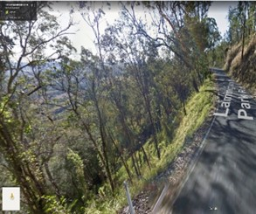 | 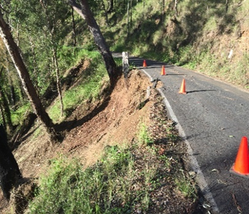
Asset ID: 001  Asset description: sealed road, Derby Road  Photo ID: Photo one  Chainage: [Insert chainage, where applicable]  Latitude: 37° 49' 14''  Longitude: 147° 11' 14''  Date taken: 22 February 2021 | Asset ID: 001  Asset description: sealed road, Derby Road  Photo ID: Photo one  Chainage: [Insert chainage, where applicable]  Latitude: 37° 49' 14''  Longitude: 147° 11' 14''  Date taken: 22 June 2021

Pre-condition | Post Disaster
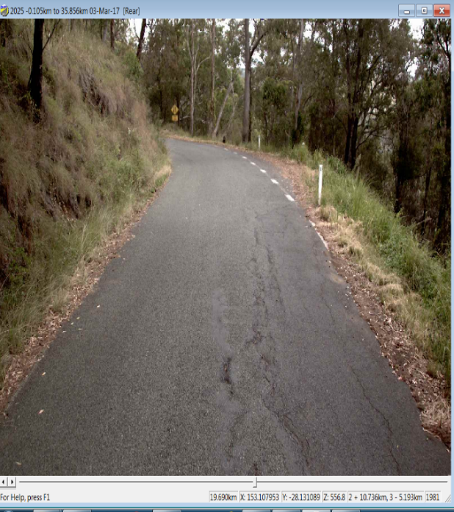 | 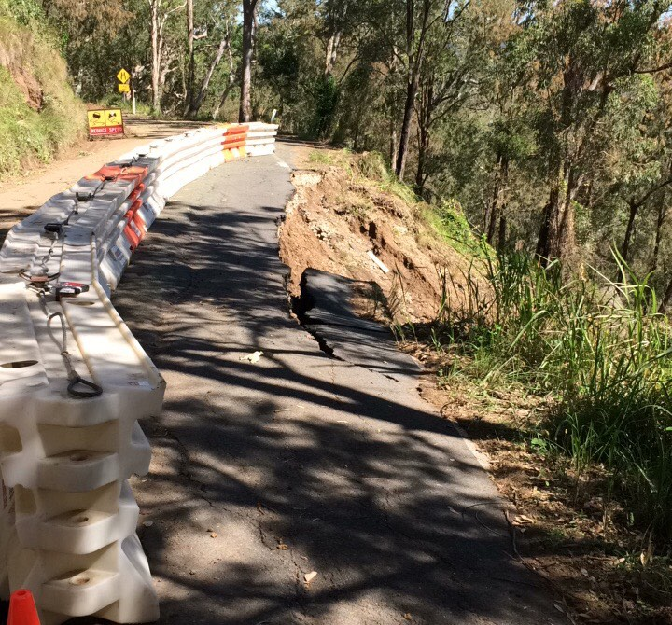  Example
Asset ID: 002  Asset description: sealed road, Derby Road  Photo ID: Photo two  Chainage: [Insert chainage, where applicable]  Latitude: 36° 47' 24''  Longitude: 146° 12' 16''  Date taken: 16 February 2021 | Asset ID: 002  Asset description: sealed road, Derby Road  Photo ID: Photo two  Chainage: [Insert chainage, where applicable]  Latitude: 36° 47' 24''  Longitude: 146° 12' 16''  Date taken: 22 June 2021

Pre-condition | Post Disaster
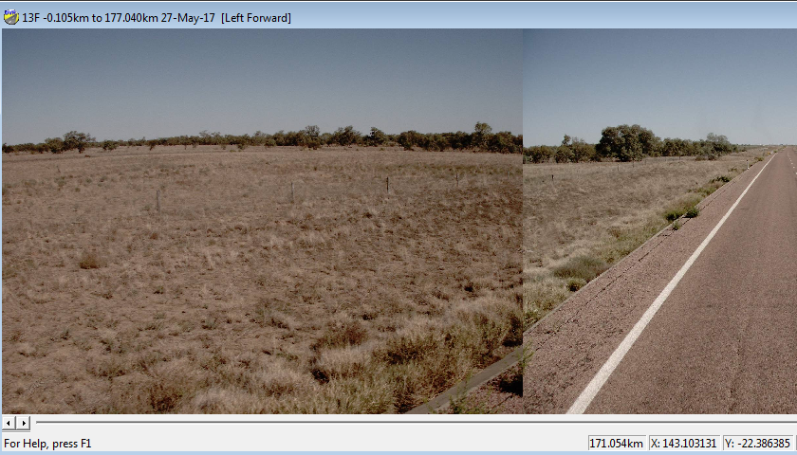 | 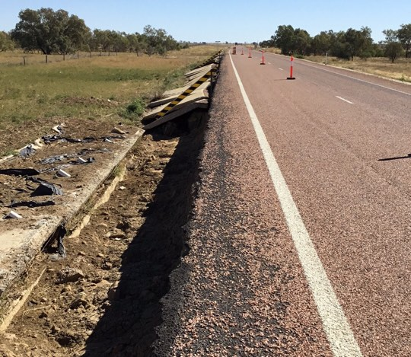  Example
Asset ID: 003  Asset description: sealed road, Derby Road  Photo ID: Photo three  Chainage: [Insert chainage, where applicable]  Latitude: 22° 23' 11''  Longitude: 143° 11' 14''  Date taken: 19 February 2021 | Asset ID: 003  Asset description: sealed road, Derby Road  Photo ID: Photo three  Chainage: [Insert chainage, where applicable]  Latitude: 22° 23' 11''  Longitude: 143° 11' 14''  Date taken: 13 November 2021
The first three pages provide example of photos that should be included in the Reconstruction Works Closeout photo report
Delivery Agency to add photos and complete required photo report information

Pre-Condition | Post Disaster
Asset ID: [Insert asset ID]  Asset description: [Insert asset description]  Photo ID: [Insert photo ID]  Chainage: [Insert chainage, where applicable]  Latitude: [Insert latitude]  Longitude: [Insert longitude]  Date taken: [Insert date taken] | Asset ID: [Insert asset ID]  Asset description: [Insert asset description]  Photo ID: [Insert photo ID]  Chainage: [Insert chainage, where applicable]  Latitude: [Insert latitude]  Longitude: [Insert longitude]  Date taken: [Insert date taken]

Pre-Condition | Post Disaster
Asset ID: [Insert asset ID]  Asset description: [Insert asset description]  Photo ID: [Insert photo ID]  Chainage: [Insert chainage, where applicable]  Latitude: [Insert latitude]  Longitude: [Insert longitude]  Date taken: [Insert date taken] | Asset ID: [Insert asset ID]  Asset description: [Insert asset description]  Photo ID: [Insert photo ID]  Chainage: [Insert chainage, where applicable]  Latitude: [Insert latitude]  Longitude: [Insert longitude]  Date taken: [Insert date taken]

