- Photos are to show pre-disaster condition, post disaster condition and post completion of works for the essential public asset (for example, a local road, bridge or culvert. Trees are not considered to be an essential public asset.
- Photos are to be provided with the metadata embedded.
- For more information please refer to DRFA Guideline 1: https://www.emv.vic.gov.au/drfa/guideline-1
Example
Pre-condition | Post Disaster |  | Post Completion
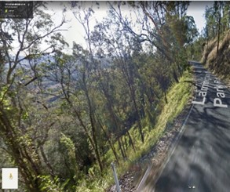 | 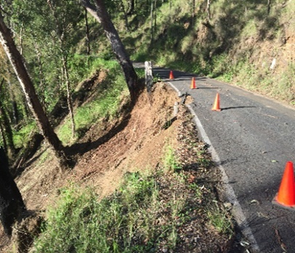 |  | 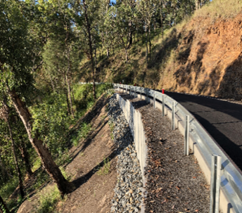
Asset ID: 001  Asset description: sealed road, Derby Road  Photo ID: Photo one  Chainage: [Insert chainage, where applicable]  Latitude: 37° 49' 14''  Longitude: 147° 11' 14''  Date taken: 22 February 2022 |  | Asset ID: 001  Asset description: sealed road, Derby Road  Photo ID: Photo one  Chainage: [Insert chainage, where applicable]  Latitude: 37° 49' 14''  Longitude: 147° 11' 14''  Date taken: 22 June 2022 |  | Asset ID: 001  Asset description: sealed road, Derby Road  Photo ID: Photo one  Chainage: [Insert chainage, where applicable]  Latitude: 37° 49' 14''  Longitude: 147° 11' 14''  Date taken: 22 July 2022  Please note that where further damage has occurred during reconstruction works being undertaken, a guard rail has been included and allowed under current engineering and design standards. This explanation has been included in the claim comments column in the V Form C-RW.

Pre-condition | Post Disaster | Post Completion
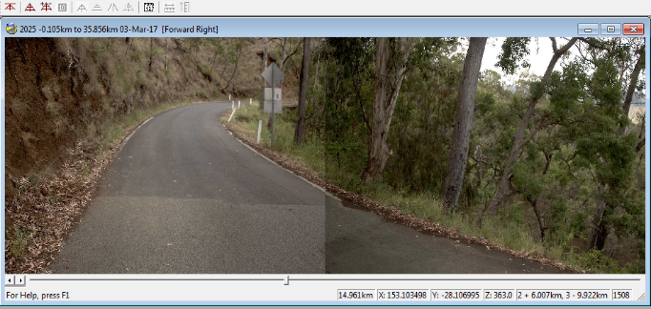 | 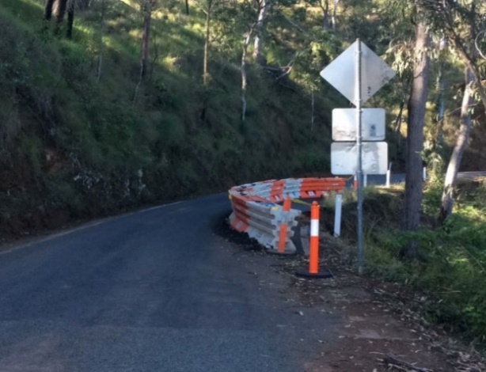  Example | 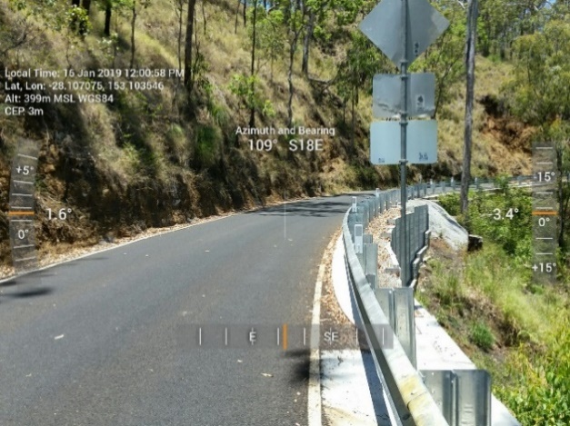
Asset ID: 001  Asset description: sealed road, Derby Road  Photo ID: Photo one  Chainage: [Insert chainage, where applicable]  Latitude: 28° 25' 46''  Longitude: 153° 12' 76''  Date taken: 7 January 2018 | Asset ID: 001  Asset description: sealed road, Derby Road  Photo ID: Photo one  Chainage: [Insert chainage, where applicable]  Latitude: 28° 25' 46''  Longitude: 153° 12' 76''  Date taken: 15 November 2018 | Asset ID: 002  Asset description: sealed road, Derby Road  Photo ID: Photo two  Chainage: [Insert chainage, where applicable]  Latitude: 28° 25' 46''  Longitude: 153° 12' 76''  Date taken: 16 January 2019  Please note that where further damage has occurred during reconstruction works being undertaken, a guard rail has been included and allowed under current engineering and design standards.  This explanation has been included in the claim comments column in the V Form C-RW.

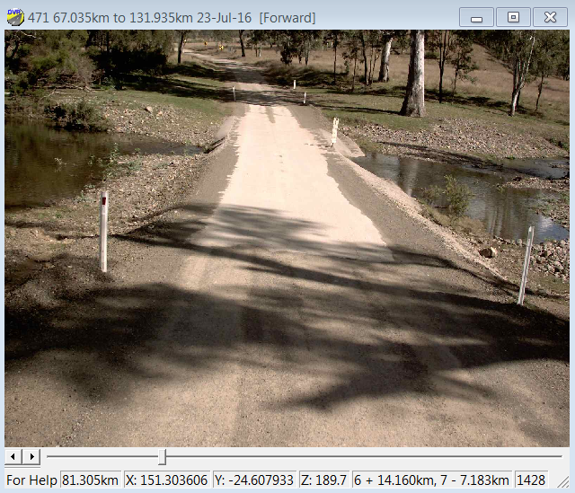 | 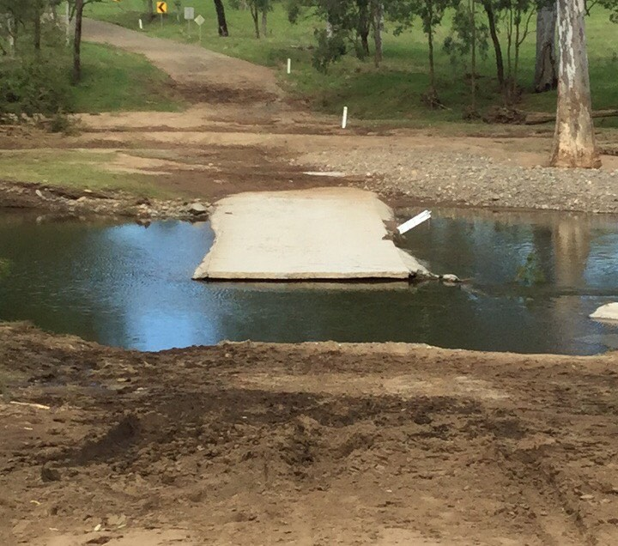  Example | 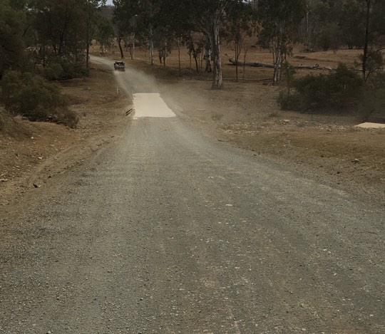
Asset ID: 001  Asset description: unsealed road, Derby Road  Photo ID: Photo three  Chainage: [Insert chainage, where applicable]  Latitude: 28° 25' 46''  Longitude: 153° 12' 76''  Date taken: 13 December 2018 | Asset ID: 001  Asset description: unsealed road, Derby Road  Photo ID: Photo three  Chainage: [Insert chainage, where applicable]  Latitude: 28° 25' 46''  Longitude: 153° 12' 76''  Date taken: 22 June 2019 | Asset ID: 001  Asset description: unsealed road, Derby Road  Photo ID: Photo three  Chainage: [Insert chainage, where applicable]  Latitude: 24° 36' 27''  Longitude: 151° 18' 13''  Date taken: 7 August 2019
The first three pages are examples of immediate reconstruction works photos.
Delivery Agency to add photos and complete required photo report information.

Pre-condition | Post Disaster | Post Completion
Asset ID: [Insert asset ID]  Asset description: [Insert asset description]  Photo ID: [Insert photo ID]  Chainage: [Insert chainage, where applicable]  Latitude: [Insert latitude]  Longitude: [Insert longitude]  Date taken: [Insert date taken] | Asset ID: [Insert asset ID]  Asset description: [Insert asset description]  Photo ID: [Insert photo ID]  Chainage: [Insert chainage, where applicable]  Latitude: [Insert latitude]  Longitude: [Insert longitude]  Date taken: [Insert date taken] | Asset ID: [Insert asset ID]  Asset description: [Insert asset description]  Photo ID: [Insert photo ID]  Chainage: [Insert chainage, where applicable]  Latitude: [Insert latitude]  Longitude: [Insert longitude]  Date taken: [Insert date taken]

Pre-condition | Post Disaster | Post Completion
Asset ID: [Insert asset ID]  Asset description: [Insert asset description]  Photo ID: [Insert photo ID]  Chainage: [Insert chainage, where applicable]  Latitude: [Insert latitude]  Longitude: [Insert longitude]  Date taken: [Insert date taken] | Asset ID: [Insert asset ID]  Asset description: [Insert asset description]  Photo ID: [Insert photo ID]  Chainage: [Insert chainage, where applicable]  Latitude: [Insert latitude]  Longitude: [Insert longitude]  Date taken: [Insert date taken] | Asset ID: [Insert asset ID]  Asset description: [Insert asset description]  Photo ID: [Insert photo ID]  Chainage: [Insert chainage, where applicable]  Latitude: [Insert latitude]  Longitude: [Insert longitude]  Date taken: [Insert date taken]

