Victorian Disaster Recovery Funding Arrangements
How To Sheet 1: Examples of Best Practice Claim Forms for Category A & B Counter Disaster Operations

Introduction
Victoria's Natural Disaster Financial Assistance (NDFA) scheme is available to Delivery Agencies including local councils, to relieve some of the financial burden that may be experienced following a disaster in accordance with the Australian Government’s Disaster Recovery Funding Arrangements (DRFA). The DRFA does not cover all costs resulting from a disaster.
This How To Sheet relates to illustrating how a Delivery Agency can provide best practice examples of claim forms, general ledger and invoices relating to Category A or Category B CDO expenditure.
For eligible early relief and recovery and counter disaster activities under the DRFA, Delivery Agencies in Victoria will be reimbursed by the State through the Administering Authority. Please refer to the individual Tip Sheets 1 – 5 on Category A and Category B CDO for advice on how to seek reimbursement on eligible expenditure associated with Category A and Category B Counter disaster operations including funding contributions, the allowable time period and the supporting documentation required for each claim type.

Example of best practice claim forms, general ledger and invoices

General Ledger: shows payment of invoice for the in full for $20K | Invoice: shows portion of works being claimed | Claim form: shows amount being claimed (form reduced to show only relevant info)
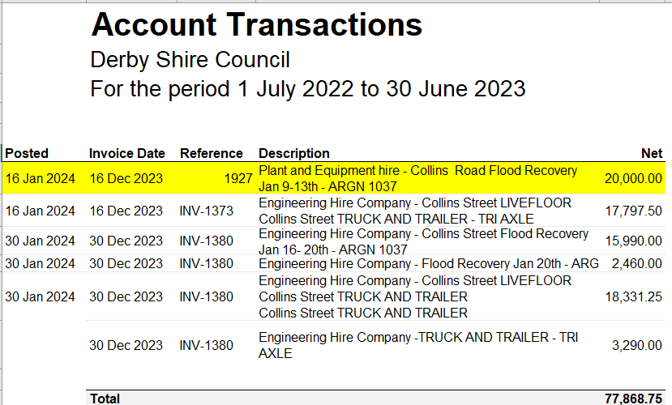 | 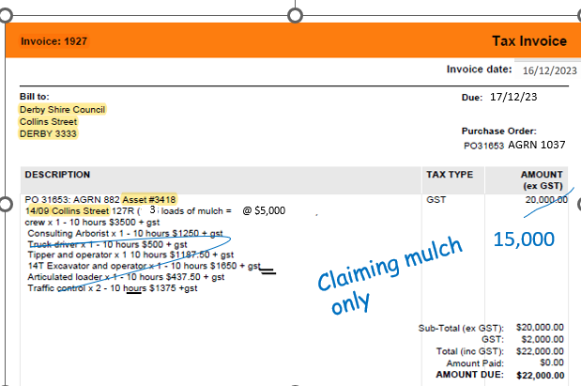 | 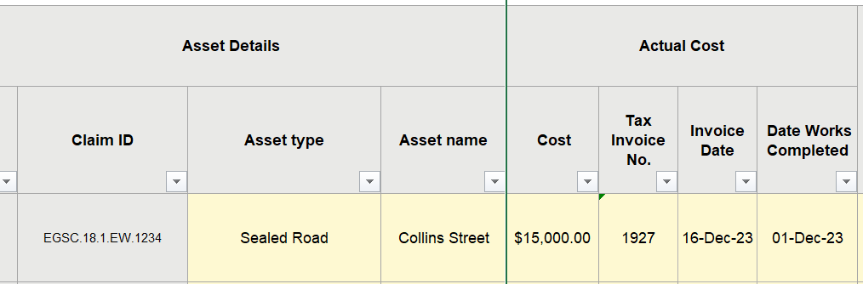

Reimbursement and payment process
Full reimbursement for early relief and recovery and counter disaster operations activities, based on actual costs, can be made following lodgement and approval of the claim(s) by the Assessing and Administrating Authority, using the V Form A- Relief Recovery or V Form A2-CDO. Eligible expenditure incurred during the financial year is required to be lodged with the required supporting documentation as expenditure is incurred throughout the financial year and no later than 31 July (within one month from the end of the financial year in which the expenditure was incurred).

Claim acquittal and completion requirements
All claims are required to be lodged in the financial year that the expenditure is incurred. The Assessing Authority will consult with the Delivery Agency to ensure all available information has been appropriately considered as part of the final claim.
All acquitted claims may be subject to further review by the State and Australian appointed auditors.
All supporting documents submitted are to be structured and cross referenced to allow third party verification. This will facilitate the timely processing of claims and the State and Australian audit review process.

Further information
For further information, refer to the Victorian DRFA Guideline 3: Claims and eligibility for relief and recovery activities (Category A) and counter disaster operations (CDO) – Category A & B.

Document details
Criteria | Details
TRIM ID:
Document title: | How To Sheet 1: Best Practice Examples of Claim Forms, general ledger and Invoices – Category A and B Counter Disaster Operations
Document owner: | Emergency Recovery Victoria, Department of Justice and Community Safety

Version control
Version | Date | Description | Author
V1.0 | 29.01.24 | Creation of How To Sheet 1: Best Practice Examples of Category A and B Counter Disaster Operations
4

