

|  |
| --- |
| How the Assessing Authority uses QGIS to validate information to assess claims & REPA certified estimates |
| How To No. 3 - for Delivery Agencies |

# Table of Contents

Purpose 1

Software 2

Data 3

Figure 1: 4

Figure 2 5

Images 6

Figure 3: 7

Photo Report 9

Asset Data 10

Other Supporting Documentation 11

# Purpose

The purpose of this How to No. 3 is to provide Delivery Agencies with information about how Assessing Authority Assessors validate the information they are submitting against Claims and Certified Estimates under the Disaster Recovery Funding Arrangements (DRFA) in Victoria so that they may undertake review of the information internally prior to submission if they so choose.

There is no requirement for Delivery Agencies to use these tools prior to submission and they are not required to submit any files produced by the software as part of the claim.

As such, software specific training is outside the scope of training provided to Delivery Agencies by the Assessing Authority.

# Software

The Assessing Authority has adopted the use of QGIS to assist with the assessment of claims. This allows the Assessing Authority the ability to spatially review claim data and supporting evidence supplied by the Delivery Agency in line with the requirements of [Guideline 1](https://content.vic.gov.au/sites/default/files/2024-07/GL-1-Victorian-DRFA-Guideline-1-Claims-and-eligibility-for-essential-public-assets-v21-June-2024-v2-.pdf) of the Victorian Disaster Recovery Funding Arrangements.

QGIS is an open-source software that is readily available to anyone who wishes to use it. It can be downloaded free of charge from [https://www.qgis.org](https://www.qgis.org/).

# Data

The Assessing Authority retrieves the claim data submitted by the Delivery Agency to plot the identified damage locations.

This includes all data from the second row-header of the claim, beginning from the cell containing “Line No” and all columns through to “Comments” which are to be filled in by the Delivery Agency (see Figure 1).

It is important that Delivery Agencies are aware that the start and end location data required is related to the damage location, not the start and end of the Asset impacted. When the data from the claim has been imported to QGIS it will be represented as points and/or lines (see Figure 2).

Data

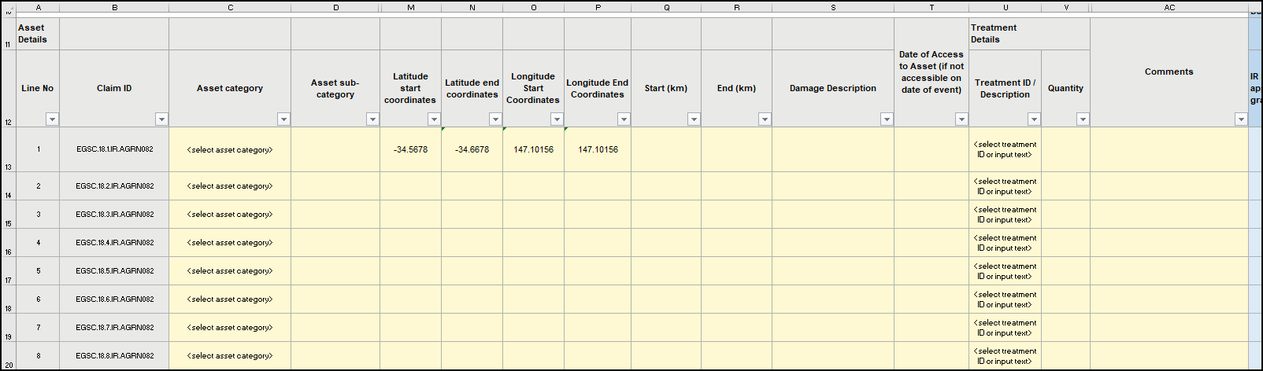

First column

Last column

Start and End of Damage Location

**INSTRUCTIONS ONLY (DELETE WHEN READ)**

To add image right click image on the left and select Change Picture > From a file

To move image around freely without moving text right click and select Wrap Text > Behind Text or In Front of text

**Figure 1:**

Example of the data imported to QGIS by the Assessing Authority for assessment of claims and Certified Estimates. Please note, the image has columns which have been hidden purely to enable an image with the first and last required columns to be included. All data between the first and last column is required under the Victorian DRFA Guidelines and needs to be completed.

Data

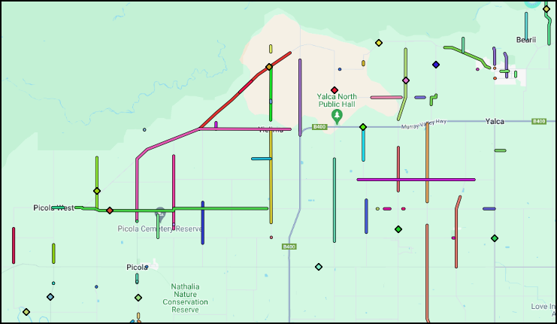

Figure 2**:**

This image depicts imported claim data with a mix of point and linear items which have been included in the same claim. Once imported, the Assessing Authority can see the spatial representation of the claim against base maps and satellite and aerial imagery which may be available in the area.

# Images

The Assessing Authority imports the supporting documents supplied by the Delivery Agency to QGIS to overlay with the claim data already imported.

This allows for simple spatial validation of the supporting evidence against the identified damage location specified by the Delivery Agency (see Figure 3).

The Assessing Authority utilises the “Import geotagged photos” tool from the Processing Toolbox to import the images supplied. This tool also identifies a list of images which could not be imported due to invalid metadata.

Images

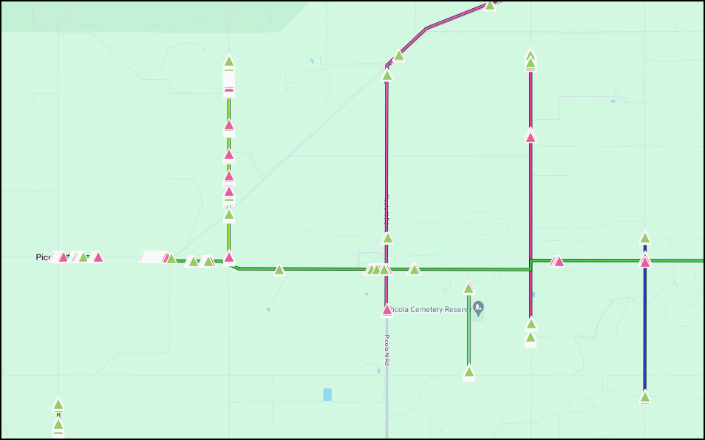

Figure 3:

This image depicts imported claim data with the imported images overlaid and categorised (coloured) based on the folder the image was saved to (i.e. pre-event and post-disaster).

Images

Images are categorised based on the photo folder they are submitted under (i.e. pre-event, post-disaster, completion etc) using the following script. This allows the Assessing Authority to simply review the required images against one another and removes the need for the previous style of Photo Report required.

CASE

WHEN "directory" ILIKE '%01_Pre-Event_Photos%' THEN '01 Pre-Event'

WHEN "directory" ILIKE '%02_Post-Disaster_Photos%' THEN '02 Post-Disaster'

WHEN "directory" ILIKE '%03_TempRepair_MakeSafe_Photos%' THEN '03 TempRepair MakeSafe'

WHEN "directory" ILIKE '%04_Damage_Monitoring_Photos%' THEN '04 Damage Monitoring'

WHEN "directory" ILIKE '%05_Construction_Photos%' THEN '05 Construction'

WHEN "directory" ILIKE '%06_Completed_Works_Photos%' THEN '06 Completed Works'

WHEN "directory" ILIKE '%07_Reimpacted_Location_Photos%' THEN '07 Reimpacted Location'

ELSE 'Type not identified'

END

# Photo Report

Where images supplied by the Delivery Agency have missing, incorrect, or incomplete metadata, the Delivery Agency will need to complete a Photo Report that is compatible with QGIS (see DRFA Toolbox for template) along with the image files referenced in the Photo Report.

The Photo Report is imported to QGIS in the same way as the claim data. The form designer is used to create a link to the image so it can be viewed in QGIS.

A similar categorisation method as for the imported images is used to visually represent which stage the image sits under.

**Asset Data**

Where a Delivery Agency can supply their Asset Data in a shapefile format, the Assessing Authority can use this information to spatially validate Essential Public Assets identified in claims.

The information included in the shapefile should be able to be readily cross-referenced between the Delivery Agency’s Road Management Plan (RMP) / Road Asset Management Plan (RAMP), Public Road Register, and the Asset ID referenced on any claim forms submitted.

**Other Supporting Documentation**

Other supporting data for submitted claims may be submitted by Delivery Agencies in addition to the claim form and images.

Supporting data, such as Condition Data, Customer Requests, Inspection Reports, Defect Reports, or Task Reports, that are supplied in a .xlsx or .csv format can be reviewed spatially against the claim data if it contains Start and End Location attributes.