Guidelines for Responsible Entity Risk, Consequence and Contingency Plans:

Identifying as a responsible entity and meeting your obligations

#### Acknowledgements

We are committed to genuinely partner, and meaningfully engage, with Victoria's Traditional Owners and Aboriginal communities to support the protection of Country, the maintenance of spiritual and cultural practices and their broader aspirations in the 21st century and beyond.

© The State of Victoria Department of Energy, Environment and Climate Action 2024

This work is licensed under a Creative Commons Attribution 4.0 International licence. You are free to re-use the work under that licence, on the condition that you credit the State of Victoria as author. The licence does not apply to any images, photographs or branding, including the Victorian Coat of Arms, the Victorian Government logo and the Department of Energy, Environment and Climate Action (DEECA) logo. To view a copy of this licence, visit <http://creativecommons.org/licenses/by/4.0/>

ISBN 978-1-76136-679-6 (pdf/online/MS word)

#### Disclaimer

This publication may be of assistance to you but the State of Victoria and its employees do not guarantee that the publication is without flaw of any kind or is wholly appropriate for your particular purposes and therefore disclaims all liability for any error, loss or other consequence which may arise from you relying on any information in this publication.

#### Accessibility

If you would like to receive this publication in an alternative format, please telephone the DEECA Customer Service Centre on 136 186, email [customer.service@deeca.vic.gov.au](mailto:customer.service@deeca.vic.gov.au) or via the National Relay Service on 133 677 or [www.relayservice.com.au](http://www.relayservice.com.au). This document is also available on the internet at [www.recycling.vic.gov.au](https://www.vic.gov.au/strengthening-our-waste-and-recycling-system?redirectSrc=www.recycling.vic.gov.au)

#### Authority

These guidelines are issued by the Head, Recycling Victoria in accordance with section 74K of the *Circular Economy (Waste Reduction and Recycling) Act 2021*.

#### Commencement

These guidelines commence operation on the day they are approved by the Head, Recycling Victoria. They will be reviewed by the Head, Recycling Victoria annually, or in response to relevant statutory change.

#### Document information

Approval date: 9 May 2024

Version: 1.0

Version history

|  |  |  |
| --- | --- | --- |
| **Version** | **Version Date** | **Change** |
| 1.0 | 09 May 2024 | Guidelines issued by the Head, Recycling Victoria |

Contents

Acronyms 4

Glossary 5

1. Introduction 10

1.1. Who these guidelines apply to 11

1.2. The CE Act applies a principles-based approach 11

1.2.1 Proportional measures for risks are applied to responsible entities 11

1.2.2 Serious sector risks identified in the CERCC Plan 12

1.3. Guideline objectives and principles 13

1.3.1 Objectives 13

1.3.2 Principles 14

1.4. Risks in the waste, recycling and resource recovery sector 15

1.5. Relevant risk, consequence and contingency documents 18

1.6. Information privacy and security 19

1.7. How to seek support 20

2 Application of the guidelines and becoming a responsible entity 21

2.1 Duty of providers of essential waste, recycling or resource recovery services 21

2.2 Becoming a responsible entity 21

2.3 Responsible entity self-assessment procedure 22

2.4 Notification process 25

2.5 Responsible entity risk-related roles and responsibilities under the CE Act and CE RCCP Regulations 27

3 Responsible Entity Risk, Consequence and Contingency (RERCC) Plans 30

3.1 Process and timeframes for preparing and submitting a RERCC Plan 30

3.2 Preparing a RERCC Plan 31

3.3 Alignment with risk standards 31

3.4 Key principles for preparing a RERCC Plan 32

3.5 Detailed requirements of a RERCC Plan 33

3.6 RERCC Plan content 34

3.6.1 Part 1: Entity overview 34

3.6.2 Part 2: Operating context 36

3.6.3 Part 3: Risk assessment 40

3.6.4 Part 4: Risk profile 47

3.6.5 Part 5: Monitoring and management of residual risks 51

3.6.6 Part 6: RERCC Plan preparation 53

3.6.7 Part 7: RERCC Plan monitoring and evaluation 54

4 Plan compliance by responsible entities 56

5 Review of RERCC Plans by Recycling Victoria 58

5.1 RERCC Plan suitability 58

5.2 Request for additional assurance information 59

5.3 Reports prepared on RERCC Plans 60

6 Statement of Assurance arrangements 61

6.1 Statement of Assurance 61

6.2 Attestation 61

6.3 How to prepare and submit a Statement of Assurance 63

7 Responsible entity exemptions 64

8 Appendices 65

Appendix 1: Table of prescribed essential waste, recycling or resource recovery services 65

Appendix 2: Responsible entity notification form 74

Appendix 3: Declared waste, recycling and resource recovery regions 76

# Acronyms

|  |  |
| --- | --- |
| **Abbreviation** | **Full name** |
| ABN | Australian Business Number |
| ACN | Australian Company Number |
| CE Act | the Circular Economy (Waste Reduction and Recycling) Act 2021 |
| CE RCCP Regulations | the Circular Economy (Waste Reduction and Recycling) (Risk, Consequence and Contingency Plans and Other Matters) Regulations 2023 |
| CERCC | Circular Economy Risk, Consequence and Contingency |
| DEECA | Department of Energy, Environment and Climate Action |
| EP Framework | Environment protection (framework) |
| AS ISO | Australian Standards International Organization for Standardization |
| ISO | International Organization for Standardization |
| RERCC Plan | Responsible Entity Risk, Consequence and Contingency Plan |
| RCC Framework | Risk, Consequence and Contingency Framework |
| s | Section (of the CE Act) |
| ss | Sections (of the CE Act) |

Glossary

| **Term** | **Definition** |
| --- | --- |
| Circular Economy Risk, Consequence and Contingency (CERCC) Plan | An annual plan prepared by the Head, Recycling Victoria in accordance with s 16(ca) and s 74B approved by the Minister under s 74B of the CE Act. |
| Current risk rating | The level of risk after initial control measures have been put in place. (Hopkin, P and Thompson, C (2021) *Fundamentals of risk management* 6th edition, Institute of Risk Management, p.19) |
| Duty on providers | As defined in s 74 (1) of the CE Act, a person who is providing an essential waste, recycling or resource recovery service, so far as is reasonably practicable, must minimise the risk of serious failure, disruption or hinderance of the service. |
| Enterprise risk | Refers to all risks an entity is exposed to across all risk categories, which together, comprise the entity’s risk profile. This could encompass work, health and safety, financial, cyber-security, technology, environmental and operational risks specific to the entity. |
| Environment protection framework | Overarching *Environment Protection Act 2017* and related subordinate instruments that regulate the human health and environmental impacts of pollution and waste. |
| Essential waste, recycling or resource recovery service | A waste, recycling or resource recovery service that is prescribed as an essential waste, recycling or resource recovery service under section 5 of the Regulations and specified in Column 2 of Table 1 in Schedule 1 of the CE RCCP Regulations, that provides services described in the corresponding entry in Column 3 of the table. |
| Hazard | Source of potential harm. A hazard can be a risk source. A risk source is an element which alone or in combination has the intrinsic potential to give rise to risk. (ISO: 73:2009 *Risk management — Vocabulary*) |
| Head, Recycling Victoria | Statutory body established under s 15 of the CE Act to deliver the functions under s 16 of the CE Act. |
| Inherent risk rating | The level of risk before any actions have been taken to change the likelihood or magnitude of the risk. (Hopkin, P and Thompson, C (2021) *Fundamentals of risk management* 6th edition, Institute of Risk Management p.19) |
| OFFICIAL: Sensitive | Security classification under the Australian Government Protective Security Policy Framework (PSPF) is used for information that if compromised, unauthorised release could cause limited damage to an individual, organisation or government generally. |
| Ongoing arrangement (as a service interval) | As defined in regulation 4 of the CE RCCP Regulations, ‘an arrangement to provide a service (whether in accordance with a contract or not) for a period of at least 12 months.’ |
| PROTECTED | Security classification under the Australian Government PSPF is used for information that could result in damage to the national interest, organisations or individuals if compromised. |
| Risk, Consequence and Contingency (RCC) Framework | Legislative framework established through the CE Act to protect continuity of service delivery of prescribed essential waste recycling and resource recovery services. |
| Regular intervals (as a service interval) | As defined in regulation 4 of the CE RCCP Regulations ‘in relation to the provision of a service’ means provided on a periodic basis at a frequency of at least once every 2 months. |
| Residual risk rating | The level or severity of the risk remaining following risk treatment. (ISO: 73:2009 *Risk management — Vocabulary*) |
| Responsible entity | Under s 74A of the CE Act, responsible entity means an entity prescribed for the purposes of Division 4 of the  CE Act. |
| Responsible Entity Risk, Consequence and Contingency (RERCC) Plan(s) | A Responsible Entity Risk, Consequence and Contingency Plan prepared by a responsible entity under s 74F of the  CE Act. |
| Risk of serious failure, disruption or hinderance to the provision of a service | For the purposes of the RERCC Plan, this refers to the consequences of materialised risk in a waste, recycling and resource recovery entity and focuses on risks where the consequence of failure, disruption or hinderance to the provision of waste, recycling or resource recovery services is either sustained or permanent. |
| Risk treatments | Actions and contingency measures that the responsible entity is taking, or proposes to take, to prevent or minimise the risks of serious failure, disruption or hinderance to the provision of essential waste, recycling or resource recovery services by the responsible entity (s 74F (2)(a) and (b) of the CE Act). |
| Sector risks | For the purposes of the CERCC Plan, this refers to risks where the consequence of materialised risk has broad systemic consequences at the sector level. These are risks that require a government response through policy or operational activities should they materialise. |
| Serious sector risks | Risks where the consequence of materialised risk is at the sector level and where the consequence of serious failure, disruption or hinderance to the provision of waste, recycling or resource recovery services is either sustained or permanent. Serious sector risks are those sector risks at the highest rating. Materialisation of these risks may also trigger a state level response. |
| Service continuity | Capability of the organisation to continue delivery of products or services at acceptable predefined levels following a disruptive incident. (AS ISO: 22301:2020 *Business continuity management systems – Requirements*) |
| Statement of Assurance | A statement provided by a responsible entity prepared in accordance with s 74G of the CE Act and regulation 16 of the CE RCCP Regulations. |
| Treatment | Process to modify risk. This can involve avoiding the risk, removing the risk source, changing the likelihood or consequence, sharing or retaining the risk. (ISO: 73:2009 *Risk management – Vocabulary*) |
| Victorian market share | Has the meaning given in Regulation 7 of the CE RCCP Regulations   1. The Victorian market share held by an entity providing an essential waste, recycling or resource recovery service during a specified period is the amount of waste managed in Victoria by the entity in that period—    1. in the course of providing that service, expressed as a percentage of the total amount of waste managed in Victoria by all providers of that service in that period; or    2. in the course of providing that service for a type of waste, expressed as a percentage of the total amount of waste managed in Victoria by all providers of that service for that type of waste in that period as the case requires. 2. In this regulation, specified period means a period specified under regulation 11(b). |

1. Introduction

The *Circular Economy (Waste Reduction and Recycling) Act 2021* (CE Act)   
introduces a risk, consequence and contingency framework to manage significant risks to the waste, recycling and resource recovery sector. These guidelines, together with the CE Act and Circular Economy (Waste Reduction and Recycling) (Risk, Consequence and Contingency Plans and Other Matters) Regulations 2023 (CE RCCP Regulations), strengthen sector resilience and support Victoria to transition to a more circular economy.

These guidelines have been issued in accordance with section 74K of the CE Act and should be read in conjunction with the Circular Economy Risk, Consequence and Contingency (CERCC) Plan. The guidelines are designed to assist waste, recycling and resource recovery sector participants to acquit their legal obligations and in doing so, minimise risks to essential services for the sector.

Participants and operators can use these guidelines to conduct a self-assessment and determine whether they are a Responsible Entity. These guidelines also explain how responsible entities can:

* notify the Head, Recycling Victoria that they are a responsible entity
* prepare a RERRC Plan and
* confirm whether they continue to meet the Responsible Entity criteria in subsequent years.

Unless an exemption applies, Responsible Entities are required to submit a Responsible Entity Risk Consequence and Contingency (RERCC) Plan to the Head, Recycling Victoria by 30 September each year. Responsible Entities must submit their first RERCC Plan by **30 September 2024.**

## Who these guidelines apply to

These guidelines apply to essential waste, recycling or resource recovery service providers that have self-assessed as a responsible entity. However, the guidelines remain relevant to all waste, recycling or resource recovery essential service providers. For example, they offer guidance on how to determine whether a provider is a responsible entity under the CE Act setting out their obligations to monitor and notify the Head, Recycling Victoria (in these guidelines reference to Recycling Victoria is taken to mean the Head, Recycling Victoria as described in the CE Act) should that status change and they identify as a responsible entity.

Responsible entities may use these guidelines to comply with the requirements to prepare their RERCC Plan and Statement of Assurance (see ss 74F(2) and 74G(2) of the CE Act).

## The CE Act applies a principles-based approach

Section 9 of the CE Act introduces the principle of equity. Specifically, in relation to sector risk, section 9(2) provides that ‘People should not be disproportionately affected by disruption, or risks of disruption, to waste, recycling or resource recovery services and any associated harm to human health and the environment.’

The CE Act also includes consideration of a shared responsibility for waste, recycling and resource recovery between all levels of government and industry, business, communities and the people of Victoria.

### **1.2.1** Proportional measures for risks are applied to responsible entities

The RCC framework provides that those entities delivering a significant portion of Victoria’s essential waste, recycling or resource recovery services, must consider the risks to widespread service continuity and in progressing and developing a more circular economy in Victoria. Those entities providing essential waste services of greater volume, across more regions, of significant contract value and with a greater market share, have a proportionally greater requirement than the duty holders to identify and manage risks and comply with the requirements of being a responsible entity.

### 1.2.2 Serious sector risks identified in the CERCC Plan

The Head, Recycling Victoria, on approval of the Minister, will publish annual updates to the CERCC Plan.

Responsible entities must consider their own risks, their mitigations, and have due regard to actions and measures they can take to mitigate CERCC Plan risks and any contributions they may make towards those serious sector risks identified within the CERCC Plans.

The CERCC Plan must be prepared by Recycling Victoria and submitted to the Minister for Environment by 31 December each year. Further, Recycling Victoria must review any CERCC Plan in place, to inform the preparation of a new CERCC Plan.

For all CERCC Plans other than the first one, Recycling Victoria must also make available a draft CERCC Plan to responsible entities and any other public sector body, entity or person that may be affected by the CERCC Plan or that Recycling Victoria considers appropriate for a consultation period of at least 14 calendar days.

Please refer to 2.5 Responsible entity risk-related roles and responsibilities under the CE Act and CE RCCP Regulations of these guidelines on the requirements of responsible entities.

## Guideline objectives and principles

### **1.3.1** Objectives

The objectives of these guidelines is to appropriately guide waste, recycling and resource recovery sector participants to understand their obligations, and to effectively manage risk of serious failures, disruptions or hinderance.to the provision of essential waste, recycling or resource recovery services. The guidelines have been prepared in accordance with s 74K of the CE Act and are consistent with application of the relevant requirements of responsible entities under the CE Act and CE RCCP Regulations. The guidelines are designed to assist responsible entities to comply with these requirements.

Specifically, the guidelines aid and assist responsible entities on how to:

* identify if they are a responsible entity (which remains an ongoing assessment requirement)
* notify Recycling Victoria as a responsible entity, or if they are no longer a responsible entity
* prepare and submit an annual RERCC Plan to Recycling Victoria
* understand how the CERCC Plan interacts with the RERCC Plan
* submit a Statement of Assurance and an accompanying signed attestation
* seek any exemptions from elements of these requirements.

These guidelines outline key processes and submission dates, provide explanatory detail to meet regulatory requirements and include mandatory forms and optional templates to assist responsible entities to comply.

### **1.3.2** Principles

The following principles were considered and addressed by Recycling Victoria when developing the guidelines, based on stakeholder engagement throughout development of the CE RCCP Regulations:

Make it easy for responsible entities to comply with the CE Act, CE RCCP Regulations and CERCC Plan requirements. The guidelines do this by:

* providing sufficient and succinct information
* being easy to read and follow
* being relevant to any size or type of responsible entity
* providing mandatory forms to notify and provide required information to Recycling Victoria
* supplying additional optional templates or resources relevant to preparing a RERCC Plan
* providing required compliance information across the legislation, regulation and CERCC Plan in one guideline, for ease of identification.

Align with existing risk management standards, particularly those adopted in the waste, recycling and resource recovery sector, including *AS ISO: 31000:2018 Risk Management Guidelines*

Enable integration with existing business risk management processes, such as business continuity, governance and oversight and auditing

Adopt a data reuse approach – leveraging existing entity risk management and data to inform RERCC Plan provision

Provide consultation opportunities with Recycling Victoria on interpretation and adoption of the guidelines.

## Risks in the waste, recycling and resource recovery sector

The Risk, Consequence and Contingency Framework (RCC Framework) is designed to assist in identifying and managing risks. By identifying and managing risks, we can minimise the impact of serious failures, disruptions and hinderances to essential waste recycling and resource recovery service delivery.

The RCC Framework aligns with broader emergency management approaches, including the critical infrastructure sector. Development of these guidelines has been informed by review of the Ministerial Guidelines for Critical Infrastructure Resilience.

While complementary to other regulatory tools utilised for the waste, recycling and resource recovery sector in Victoria, the RCC Framework is distinct. Figure 1 demonstrates the role of the RCC Framework.

RERCC Plans are a key requirement of the RCC Framework. They allow Recycling Victoria to understand the sector risks, gain assurance these risks are being managed and be aware of any actions or contingency measures necessary to assist a responsible entity more comprehensively in risk mitigation. In meeting their obligations, responsible entities are encouraged to draw on existing processes, data, reports and leading practice, to support their documentation and submission of RERCC Plans and minimise regulatory burden.

Figure 1: Interrelationship between respective risk management plans to address hazards and risks associated with the waste, recycling and resource recovery sector in relation to service continuity and the transition to a circular economy in Victoria.

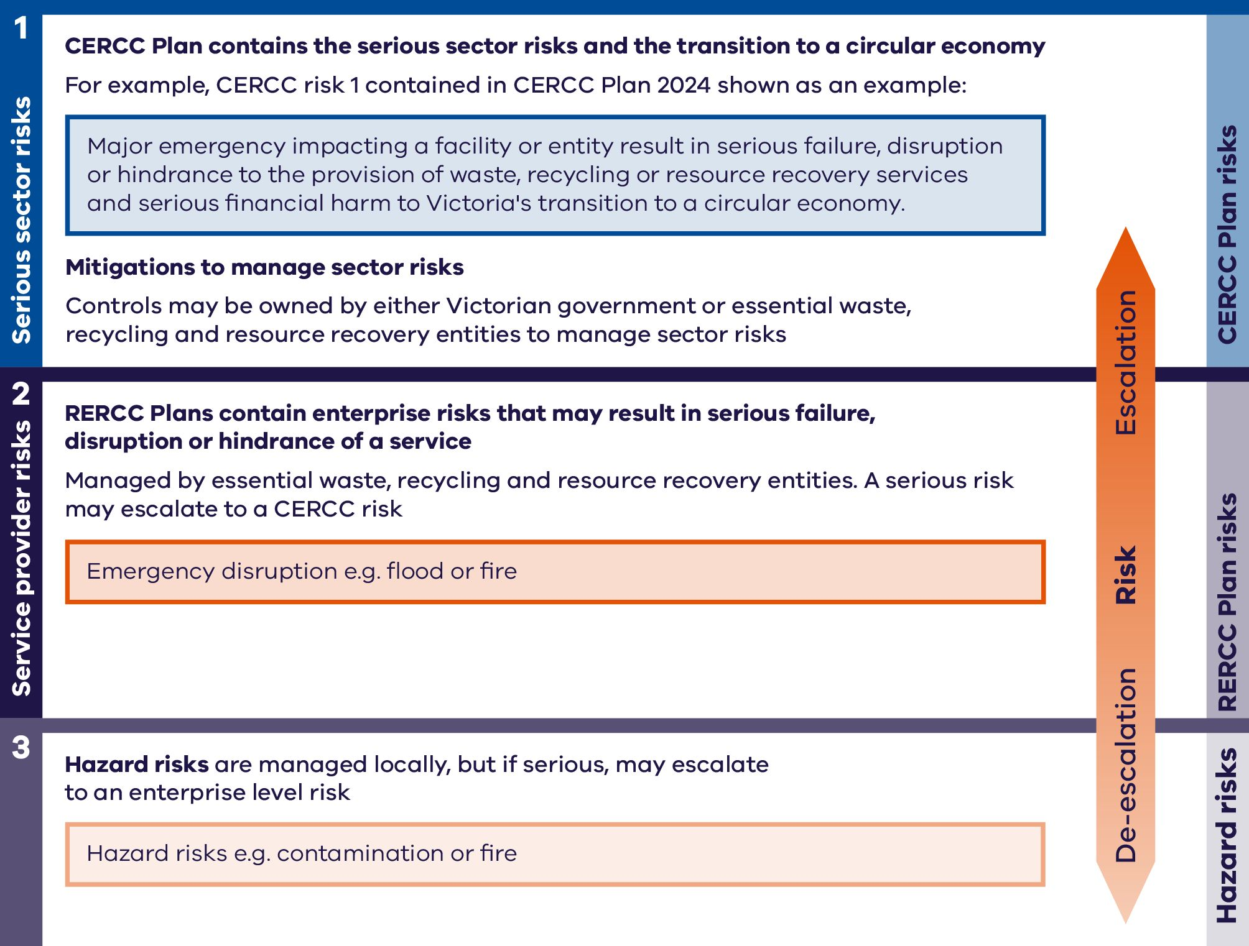

The interrelationship between risks is as follows:

**Serious sector risks** are key risks to the sector, like climate change, leading to emergency events impacting the waste, recycling and resource recovery sector and causing unforeseen demand. They may also be risks of a financial nature to Victoria's transition to a circular economy and to responsible entities. They are system focused, collective and/or aggregated risks, with the potential for system wide impact. Sector risks may be derived from sector risk workshops, RERCC Plans, relevant research or literature reviews.

**Responsible entity risks** are organisational level risks, such as increased emergency events and the associated controls to mitigate them that may result in serious disruption, failure or hinderance of a service. Examples of controls may include resourcing plans, crisis procurement, business continuity, disaster recovery plans or strategic collaboration. Risks at this level, when detailed through RERCC Plans and aggregated, inform serious sector risks to service continuity and the transition to a circular economy.

**Hazard risks** are localised, often site-specific risks arising from sources of risk referred to as hazards. For example, chemical or fuel stores. They are detailed in site specific hazard risk registers and managed using controls such as standardised operating procedures or practices under various regulatory regimes. Risks at this level may inform organisational risks within RERCC Plans if they might lead to serious disruption, failure or hinderance of a service.

## Relevant risk, consequence and contingency documents

Figure 2 illustrates how the guidelines interact with other documents in the RCC Framework.

The RCC Framework, through the [CE Act](https://www.legislation.vic.gov.au/in-force/acts/circular-economy-waste-reduction-and-recycling-act-2021/010) and [CE RCCP Regulations](https://www.legislation.vic.gov.au/in-force/statutory-rules/circular-economy-waste-reduction-and-recycling-risk-consequence-and/001) requires responsible entities to comply with certain requirments in relation to risk assessment and reporting.

Refer to 2.5 Responsible entity risk-related roles and responsibilities under the CE Act and CE RCCP Regulations of these guidelines for further information.

Recycling Victoria is required to prepare and publish a CERCC Plan annually, including consultation on draft content.

Responsible entities must comply with the CERCC Plan.

Responsible entities must prepare and comply with their RERCC Plan, ensuring it is aligned with the CERCC Plan.

Figure 2: Illustrates how the guidelines interact with other documents within the RCC Framework, under the powers of the Head, Recycling Victoria

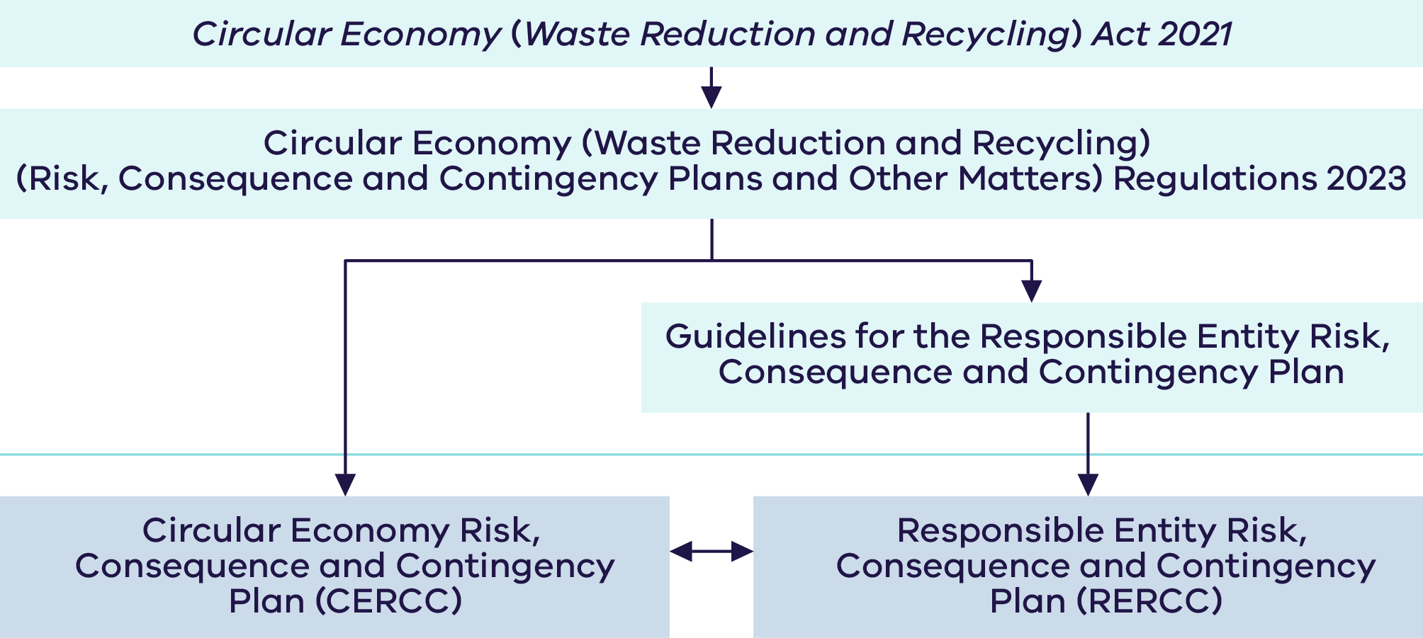

## Information privacy and security

To safeguard commercially sensitive information reported by responsible entities in their RERCC Plans, strict confidentiality measures are implemented in accordance with s 55 of the CE Act which details the use of confidential information by Recycling Victoria in undertaking its functions and duties and the Victorian Government guidelines for information security.

Material provided by prescribed essential waste, recycling or resource recovery service providers responsible entities will be treated as ‘OFFICIAL: Sensitive’ or ‘PROTECTED’ information.

**OFFICIAL: Sensitive:** If compromised, unauthorised release of this information could cause limited damage to an individual, organisation or government generally.

**PROTECTED:** If compromised, unauthorised release of this information could result in damage to the national interest, organisations or individuals.

#### Type of material under each classification

**OFFICIAL: Sensitive** material includes:

* Statement of Assurance
* attestation by company director
* commercial-in-confidence information in RERCC Plans
* details relating to business continuity plans, vulnerabilities, risk appetite or metrics.

**PROTECTED** material includes:

* documentation of this level of classification from responsible entities is not envisaged at this stage, though will be treated accordingly if identified.

#### Applying protective markings

* The appropriate protective markings should be used by responsible entities and will be applied by Recycling Victoria to identify sensitive or security classified information.
* It is the responsibility of the entity generating the information to apply the appropriate protective marking.
* Protective markings cannot be removed from information that is copied or re-used to a new document.
* Documents are to be classified to the highest level of information they contain.

#### Further information

Further information on the measures for handling security classified information can be found in the [Protecting and securing Victorian Government information and assets guide](https://www.vic.gov.au/protecting-and-securing-victorian-government-information-and-assets/information-security).

## How to seek support

For more support or guidance in meeting responsible entity regulatory obligations, please contact Recycling Victoria by emailing [RVResponsible.Entity@deeca.vic.gov.au](mailto:RVResponsible.Entity@deeca.vic.gov.au) or calling 136 186.

Visit the [Recycling Victoria](https://www.vic.gov.au/contact-recycling-victoria) webpage for more information.

1. Application of the guidelines and becoming a responsible entity

The CE Act confers functions and powers on the Head, Recycling Victoria and places high-level obligations or requirements on various waste, recycling and resource recovery service providers to manage risks. Recycling Victoria is implementing the various portions of the CE Act relating to risk via the RCC Framework. These requirements are in line with the proportional measures outlined earlier in these guidelines.

## Duty of providers of essential waste, recycling or resource recovery services

Section 74 of the CE Act requires providers of essential waste, recycling or resource recovery services to minimise the risk of serious failure, disruption or hinderance of the service, in so far as is reasonably practicable. This is referred to as the duty on providers. Responsible entites must first identify that they are providing an essential waste, recycling or resource recovery service, before meeting further criteria. Essential waste recycling or resource recovery service is defined in regulation 5 and Schedule 1 of the CE RCCP Regulations.

Recycling Victoria is considering the needs of essential services providers in managing these risks and the support required to the sector to comply with this duty.

## Becoming a responsible entity

Those entities that meet the criteria for a responsible entity (as defined in regulation 6 of the CE RCCP Regulations) provide for a significant portion of Victoria’s essential waste, recycling or resource recovery services and must consider the risks to widespread service continuity and in progressing and developing a more circular economy in Victoria. These entities have a proportionally greater requirement than other duty holders to identify and manage risks and comply with the requirements of being a responsible entity.

Refer to 2.3 Responsible entity self-assessment procedure in these guidelines for an outline of how responsible entities can self-assess their responsible entity status. For further details, refer to 2.5 Responsible entity risk-related roles and responsibilities under the CE Act and CE RCCP Regulations in these guidelines to confirm the requirements of responsible entities.

## Responsible entity self-assessment procedure

Waste, recycling or resource recovery service providers and operators should follow the steps in Figure 3 to verify their responsible entity status and required actions, as described under the CE Act and CE RCCP Regulations.

Service providers and operators can use Step 1 to assess if their business is one or more of the 15 prescribed essential waste, recycling or resource recovery services.

Then use Step 2 to assess if you meet the responsible entity criteria:

1. Holds 20% or more of the total Victorian market share for the service provided; or
2. Holds one or more government contract to deliver that service, together worth over $50 million over the life of the contract (excluding options to extend); or
3. Provides services under on-going arrangements, or at regular intervals in five or mare declared regions of Victoria.

The market share information will be published in each year’s CERCC Plan. If no data is published in the CERCC Plan for the service or waste type provided, then providers cannot be considered as a responsible entity in relation to the market share assessment. However, providers may be considered a responsible entity if they meet the criteria for government contracts or regions serviced.

Service providers and operators need to review their circumstances frequently, particularly as contracts change or service offerings are adjusted to ensure they notify if they become a responsible entity. This is an ongoing requirement.

If service providers and operators identify as responsible entities in Step 3, refer to 2.5 Responsible entity risk-related roles and responsibilities under the CE Act and CE RCCP Regulations in these guidelines for a summary of annual obligations.

Figure 3: How to determine if you may be a responsible entity

*Refer to Appendix1: Table of prescribed essential waste, recycling or resource recovery servicesfor further detail including prescribed exclusions within provider types.

Information on market share is available in the CERCC Plan. Declared regions are shown in Appendix 3: Declared waste, recycling and resource recovery regions

## Notification process

Entities that identify as responsible entities must notify the Head, Recycling Victoria they are a responsible entity by completing the Responsible entity notification form provided in Appendix 2. Responsible entities are required to make this notification only once and will remain as responsible entities unless they notify Recycling Victoria otherwise.

Notifications must be made in writing in the form provided in Appendix 2 and submitted to Recycling Victoria via [RVResponsible.Entity@deeca.vic.gov.au](mailto:RVResponsible.Entity@deeca.vic.gov.au), in accordance with regulation 8(3) of the CE RCCP Regulations.

Where self-assessment has shown the entity is not a responsible entity, no further action is required.

Note that under regulation 8 of the CE RCCP Regulations, it is an offence to fail to notify Recycling Victoria:

* within 60 calendar days of the publication of the first CERCC Plan if it meets criteria to become a responsible entity before the publication of that CERCC Plan
* within 60 calendar days after the publication of the CERCC Plan containing the data that allows the entity to determine that it has become a responsible entity based on market share
* within 60 calendar days after any change relating to the entity's service provision that results in the entity becoming a responsible entity.

An offence under regulation 8 could result in the following penalties:

* in the case of a natural person, 60 penalty units
* in the case of a body corporate, 300 penalty units.

Following notification as a responsible entity, entities have until 30 September of that year to prepare and submit their RERCC Plan to Recycling Victoria.

When an entity’s status changes from being a responsible entity to no longer being a responsible entity, that entity must notify Recycling Victoria within 60 calendar days of the change. Notifications must be made in writing in the form provided in Appendix 2 and submitted to Recycling Victoria via [RVResponsible.Entity@deeca.vic.gov.au](mailto:RVResponsible.Entity@deeca.vic.gov.au).

Note that under regulation 9 of the CE RCCP Regulations, it is an offence to fail to notify Recycling Victoria that an entity has ceased to be a responsible entity.

An offence under regulation 9 could result in the following penalties:

* in the case of a natural person, 10 penalty units.
* in the case of a body corporate, 50 penalty units.

The monetary value of a penalty unit is revised annually. For the current monetary value of a penalty unit, visit the [Victorian Government indexation of fees and penalties](https://www.dtf.vic.gov.au/financial-management-government/indexation-fees-and-penalties) webpage.

## Responsible entity risk-related roles and responsibilities under the CE Act and CE RCCP Regulations

Waste, recycling or resource recovery sector service providers and operators have roles and responsibilities in relation to managing risk under the CE Act and CE RCCP Regulations, as outlined in Table 1.

Table 1: Risk-related roles and responsibilities of waste, recycling and resource recovery sector entities under the CE Act and CE RCCP Regulations

| Responsibility | Reference |
| --- | --- |
| **Circular Economy (Waste Reduction and Recycling) (Risk, Consequence and Contingency Plans and Other Matters) Regulations 2023** |  |
| Notify the Head, Recycling Victoria in writing, and in the manner and form approved, that it is a responsible entity | reg 8(1) |
| Within 60 days after the publication of the first CERCC Plan, notify the Head, Recycling Victoria that they are a responsible entity | reg 8(2)(a) |
| Monitor operating changes that may alter responsible entity status and notify the Head, Recycling Victoria of a change in responsible entity status | reg 8(2)(b) |
| Notify the Head, Recycling Victoria in writing, and in the manner and form approved, when it ceases to be a responsible entity | reg 9(1) |
| Ensure application for exemption or amending an exemption are made in the prescribed form and accompanied by the prescribed fee. (Refer to 7 Responsible entity exemptions of these guidelines for more information) | reg 14  reg 15 |
| ***Circular Economy (Waste Reduction and Recycling) Act 2021*** |  |
| Ensure an exemption is made in the prescribed form, contains the prescribed information and is accompanied by any prescribed fee | s 24(1) |
| Notify the Head, Recycling Victoria if unable to comply with any condition of an exemption | s 28 |
| Comply with any condition of an exemption granted under s 23 | s 29 |
| Comply with the CERCC Plan unless there is a reasonable excuse | s 74D(1) |
| Notify the Head, Recycling Victoria as soon as reasonably practicable after becoming aware if unable to comply with the CERCC Plan without reasonable excuse | s 74D(3) |
| Prepare and submit a RERCC Plan  (a) on or before 30 September 2024 and  (b) on or before 30 September each subsequent year | s 74F(1) |
| Submit a Statement of Assurance to the Head, Recycling Victoria  (a) on or before 30 September 2024 and  (b) on or before 30 September each subsequent year | s 74G |
| Comply with a RERCC Plan unless there is a reasonable excuse | s 74H(1) |
| Notify the Head, Recycling Victoria as soon as reasonably practicable after becoming aware if unable to comply with a requirement of its RERCC Plan without reasonable excuse | s 74H(3) |
| Provide the Head, Recycling Victoria with any information or documentation to determine compliance and/or plan suitability to prevent or minimise the risks of serious failure, disruption or hinderance to the provision of waste, recycling or resource recovery services, if requested | s 74J(1) |

1. Responsible Entity Risk, Consequence and Contingency (RERCC) Plans

Responsible entities must prepare a RERCC Plan annually and submit it to Recycling Victoria by 30 September each year.

## Process and timeframes for preparing and submitting a RERCC Plan

Figure 4: illustrates the annual process and timing for preparing and submitting a RERCC Plan that is aligned with and considers the CERCC Plan.

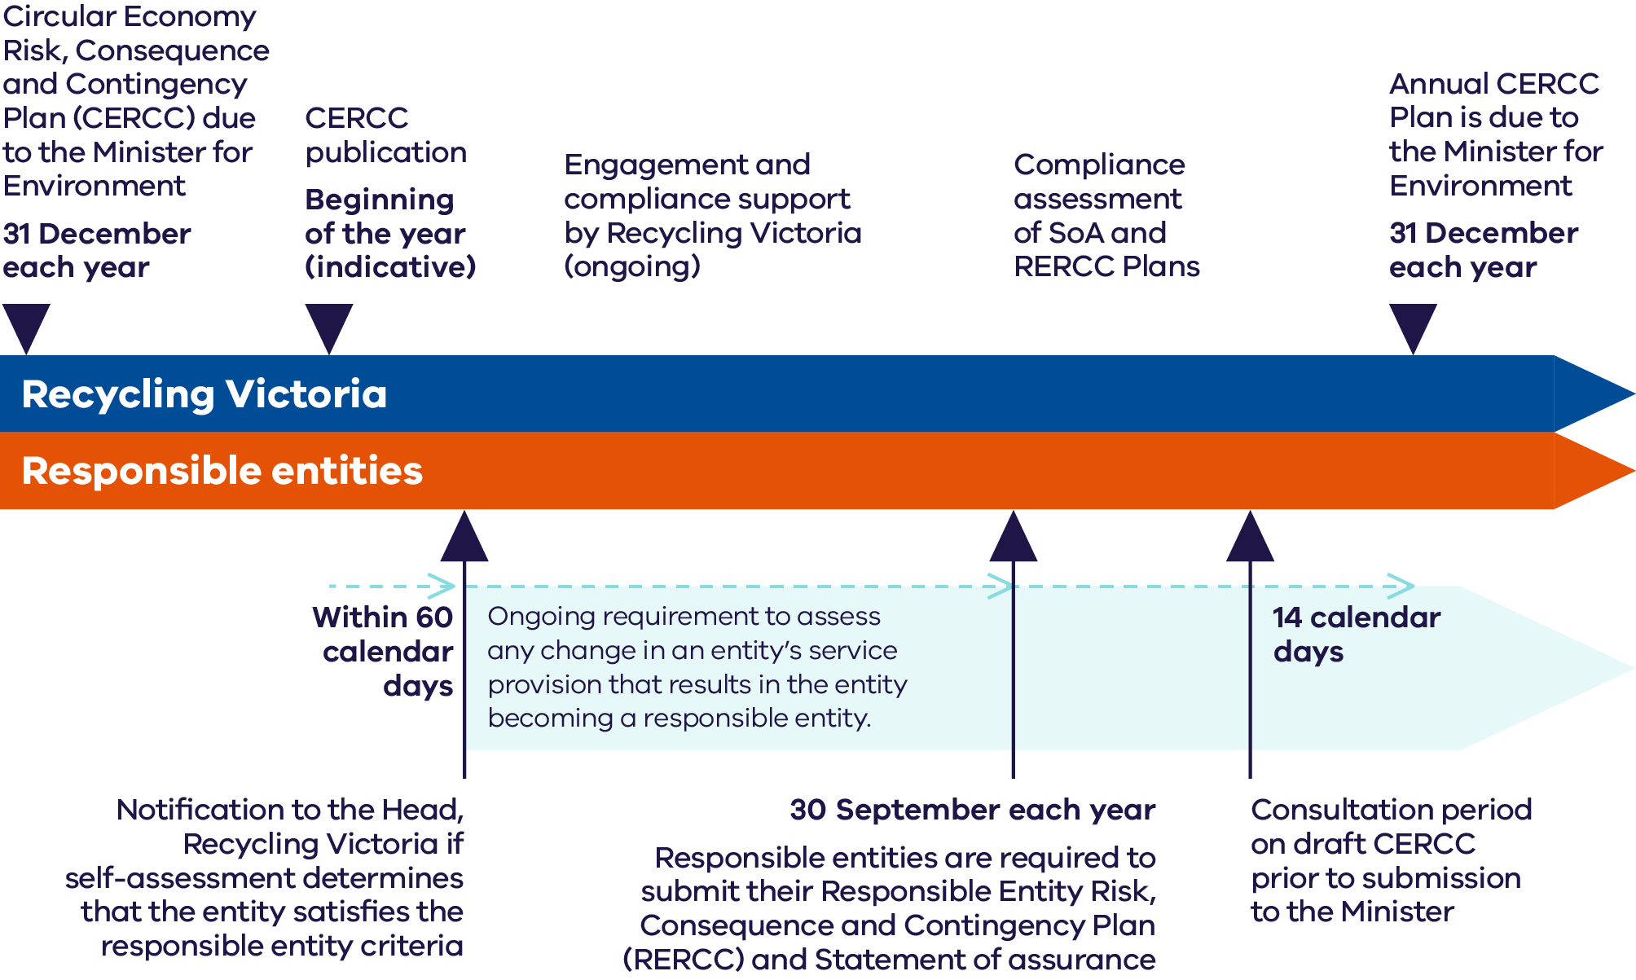

RERCC Plans are to be prepared accordingly by responsible entities:

* **One per entity** that assesses as a responsible entity.
* Include **serious** **risks relating to all waste, recycling and resource recovery services** to which the entity identifies as a responsible entity.
* Include **all sites and locations** relevant services are delivered by the entity.

## Preparing a RERCC Plan

Responsible entities must demonstrate that their RERCC Plans comply with, and have been prepared having regard to, the CERCC Plan. Responsible entity RERCC Plans must identify risks of serious failure, disruption or hinderance to the provision of waste, recycling or resource recovery services. RERCC Plans must specify the actions and contingency measures that the responsible entity is taking, or proposes to take, to prevent or minimise such risks.

This means entities should:

* highlight the CERCC Plan risks relevant to their operation, including any controls they maintain in their operation that contribute to the management of the risks
* consider and report on any risks managed by the responsible entity, that if not managed appropriately, may eventuate as a serious sector risk
* consider whether movement in existing sector risks, or emergence of new sector risks, will affect the resilience of their business, and how they propose to respond to the change.

## Alignment with risk standards

In preparing their RERRC Plans, responsible entities are encouraged to apply [AS ISO 31000:2018 Risk Management Guidelines](https://www.standards.org.au/standards-catalogue/standard-details?designation=as-iso-31000-2018) (or an international equivalent standard). Recycling Victoria also encourages entities to draw from existing standards and practices including, but not limited to:

* [22301:2020 Security and Resilience Business Continuity Management Systems](https://www.standards.org.au/standards-catalogue/standard-details?designation=as-iso-22301-2020)
* [22313:2020 Security and Resilience Business Continuity Management Systems – Guidance on the use of 22301](https://www.standards.org.au/standards-catalogue/standard-details?designation=as-iso-22313-2020)
* [27002:2022 Information security, cybersecurity and privacy protection - Information security controls](https://www.standards.org.au/standards-catalogue/standard-details?designation=as-nzs-iso-iec-27002-2022)
* [45001:2018 Occupational Health and Safety Management systems – Requirements](https://www.standards.org.au/standards-catalogue/standard-details?designation=as-nzs-iso-45001-2018)

The minimum requirements for a RERCC Plan are set out in Part 2, Section 12 of the CE RCCP Regulations, and further informed by these guidelines. Refer to 3.5 Detailed requirements of a RERCC Plan part of the guidelines for more detail.

## Key principles for preparing a RERCC Plan

In preparing their RERCC Plans, responsible entities are encouraged to apply the following principles aligned with AS ISO 31000:2018 Risk Management Guidelines:

#### Integrated

Information contained in the RERCC plan should be drawn from an entity’s existing strategic plan, risk profiles, governance structures, key processes and audit and incident information.

RERCC Plans should reflect an entity’s already documented operating context, risk appetite and risk acceptance position.

#### Proportionate

RERCC Plan content and resilience improvement activities should be proportionate to the responsible entity’s internal and external operating context and risk profile. Proportionality considers the size, complexity and business type.

#### Use best available data and evidence

RERRC Plans should include timely, clear and accurate data, drawing on historical and current information that clearly informs future expectations.

#### Consistent

To support the CE Act objectives and allow adequate data analysis to support key sector decision making, RERCC Plans should be consistent with the requirements described in 3.5 Detailed requirements of a RERCC Plan of the guidelines, comply with and have regard to the content of the CERCC Plan and consider utilising concepts contained in AS ISO31000:2018 Risk Management Guidelines.

## Detailed requirements of a RERCC Plan

RERCC Plans may be prepared using the **optional** templates supplied by Recycling Victoria, or responsible entities may opt to develop their own plan, providing all relevant requirements of the CE Act and CE RCCP Regulations are met.

The following parts provide guidance on the content required of a RERCC Plan to comply with s 74F of the CE Act and prescribed in regulation 12 of the CE RCCP Regulations. Should entities opt to develop their own plan, prescribed requirements **must be included as part of a RERCC Plan**.

Parts of the **optional** templates request some information over and above the CE Act and CE RCCP Regulations requirements and have been clearly distinguished. Completing these parts is optional.

**Optional** templates have been prepared by Recycling Victoria to assist responsible entities to comply with the legislative requirements:

1. Responsible Entity Risk, Consequence and Contingency Plan - Optional Template
2. Risk Register – Optional Template

#### Tips for RERCC Plan preparation

* Look for opportunities to provide required information once. For example, in Part 1: Entity overview and Part 4: Risk profile, the list of key services, waste types and site locations could be described once and referenced elsewhere in the plan, when relevant.
* Utilise maps and tables where relevant.
* Where relevant information is already contained in existing documents, consider including these or portions of these, as attachments. To be compliant, the pertinent information in the attachment must be adequately identified or referenced in the RERCC Plan.

## RERCC Plan content

#### Document information

* Document – draft, final or version number.
* Preparation date.
* Document action such as preparation, review and document approval.
* Detail on what was changed.
* name and title of person approving the document.

### 3.6.1 Part 1: Entity overview

Part 1: Entity overview gives definition to the entity types that provide waste, recycling and resource recovery services in Victoria and their corresponding geographic locations.

Information under Part 1 is required in accordance with regulation 12(a), (d), (f)and (g) of the CE RCCP Regulations.

**The following information is mandatory:**

**3.6.1.1** Entity details for all relevant services:

* Entity name (registered).
* Australian Company Number (ACN) or Australian Business Number (ABN).
* Registered address(es) of entity.
* Postal address (if different from registered address).
* Address of any other sites where the entity operates.
* Name and contact details of any directors, the chief executive officer, the chief financial officer, the secretary or any other officer who has control or substantial control over the management of the entity.
* A description of the essential waste, recycling or resource recovery services provided by the responsible entity.
* The roles and responsibilities of employees of the responsible entity in relation to the preparation of and compliance with the RERCC Plan.

**3.6.1.2** Details of any notifications submitted to the Head, Recycling Victoria

Responsible entities are required under the CE Act to notify the Head, Recycling Victoria as soon as reasonably practicable after becoming aware that the responsible entity is unable, without reasonable excuse, to comply with a requirement of:

* the CERCC Plan (s74D(3)) (penalty applies if not included)
* its RERCC Plan (s 74H(3)) (penalty applies if not included).

Information about notifications submitted to the Head, Recycling Victoria should include:

* the relevant reporting period
* relevant section of the CE Act or CE RCCP Regulations
* notification type such as identification as a responsible entity, ceasing to be a responsible entity
* detail of the notification.

### 3.6.2 Part 2: Operating context

Part 2: Operating context refers to the specific internal and external circumstances or characteristics of an organisation and the environment within which it operates. Information under Part 2 is required in accordance with regulation 12(e), (h) and (i) of the CE RCCP Regulations.

RERCC plans must include information on how responsible entities meet the responsible entity criteria, the essential waste, recycling or resource recovery services they deliver, the services they rely upon and who relies on their services. The guidelines also request some additional information described under ‘optional.’ Responsible entities may choose whether to provide the optional information.

Recycling Victoria applies strict confidentiality measures to safeguard commercially sensitive information reported by responsible entities in their RERCC Plans, as described in 1.6 Information privacy and security.

**The following information is mandatory:**

For the purposes of the RERCC Plan, the mandatory requirements for this part include the following:

3.6.2.1Responsible entity self-assessment summary

Having completed the responsible entity self-assessment in accordance with regulation 6(1) of the CE RCCP Regulations, responsible entities are required to describe how the responsible entity meets any of the following criteria:

1. Holds 20% or more of the Victorian market share for that service or that service for a type of waste.
2. Holds one or more government contracts under which it delivers that service, with a total combined value of over $50 million over the life of the contracts, excluding extension options.
3. Provides services under ongoing arrangements or at regular intervals in 5 or more declared regions (refer to the Glossary in these guidelines for a definition of service interval).

3.6.2.2Essential waste, recycling or resource recovery services provided

Provide a list of the essential waste, recycling or resource recovery services delivered, listed by service type categorised in Column 2 of Schedule 1 – Table of essential waste, recycling or resource recovery services of the CE RCCP Regulations.

Included in the list should be a short description of the service provided.

3.6.2.3Upstream services

Upstream services refer to those services waste, recycling and resource recovery sector entities receive and rely upon at specified service intervals and related to the delivery of the service for which the responsible entity meets the relevant criteria. These include key product and service suppliers responsible entities cannot operate without. Examples include the following:

* Transport networks, for example, freight and logistics companies.
* Third-party providers such as information technology, offsite processors, chemical suppliers, equipment suppliers other facilities owners.
* Public entities such as regulators for licensing, Victoria Police for high consequence transport operations.

The RERCC Plan should include details of services that responsible entities deliver that require continuity of service from upstream providers. For example, any contracts that specify a >90% uptime in the service level agreement.

**The following information is mandatory:**

* Name of each vendor or supplier that provides services under ongoing arrangements or at regular intervals to the responsible entity that are related to the delivery of the relevant service (regulation 12 (h)).
* Service provision frequency, either an ongoing arrangement, or at regular intervals (refer to the Glossary in these guidelines for these service interval definitions).(regulation 12 (h)).

**The following information is optional:**

* The service provided by the vendor, as it relates to the relevant service by the responsible entity.
* Should you lose a supplier, are there alternative suppliers in the market?
* Could you still operate if the supplier failed?
* What would allow continued operation should the supplier fail? For example, contract arrangements with alternative suppliers, work arounds or alternative business processes.

**3.6.2.4 Downstream services**

Downstream services refer to the services responsible entities deliver to their customers, the end users of the services, at specified service intervals and related to the delivery of the service for which you meet the responsible entity criteria.

Consider the following customer groups as an example:

* Hospitals / medical centres.
* Aged care facilties.
* Education centres.
* Research institutes.
* Cleaning services.

**The following information is mandatory:**

* Name of each customer that receives services under ongoing arrangements or at regular intervals from the responsible entity that are related to the delivery of the relevant service regulation 12 (i).
* Service provision frequency, at regular intervals, or as an ongoing arrangement. (Refer to the Glossary for these service interval definitions regulation 12 (i).

**The following information is optional:**

* The waste, recycling or resource recovery service provided to the customer or customer type, categorised using Column 2 of Schedule 1 – Table of essential waste, recycling or resource recovery services of the CE RCCP Regulations.
* Is the customer or customer type in one or more regions? List the regions.
* Is the organisation a sole provider of the service?
* Could the customer continue operation if the responsible entity were unable to deliver the service?

**Tip:** Ensure this part includes services described in 3.6.2.2 Part 2 Operating context - Essential waste recycling or resource recovery services provided.

### 3.6.3 Part 3: Risk assessment

Part 3: Risk assessment guides responsible entities to provide mandatory information in RERCC Plans to identify and detail the risks of serious failure, disruption or hinderance to the provision of the essential waste, recycling or resource recovery service. This includes an assessment of the likelihood and consequences of the risk occurring and an assessment of the gravity, or overall severity of the risk, based on its likelihood and consequences, in accordance with s. 74F(2) of the CE Act and regulation 12 (j) of the CE RCCP Regulations.

Standardised risk criteria are recommended to be used to determine risk likelihood and consequence. The use of standardised criteria allows organisations to compare the different types of risk an organisation is exposed to, informing mitigation decision making. Organisations should develop their risk criteria using measures based on the individual operating context of the entity and provide these measures to staff using likelihood, consequence, risk rating and risk response tables as shown in the examples below.

Tables 2-5 are examples of suitable risk rating tables typically used for assessing enterprise risks and are provided as example risk assessment scales for responsible entities to undertake their own risk assessment.

Table 2 provides an example risk likelihood assessment.

Table 3 provides an example risk consequence assessment, related to the level of harm that may result from a risk materialising, across a range of domains.

Table 4 provides an example risk rating matrix, to assess risk gravity. Refer to 3.6.4 Part 4: Risk profile in relation to the risks Recycling Victoria considers serious.

A key feature of the risk criteria tables is the Risk Acceptance and Response Table. While this may look slightly different between entities, in all instances, this table should provide guidance to staff on the required actions to be taken at each level of the organisation’s risk rating scale. Refer to the example in Table 5.

These tables align to the risk assessment approach undertaken by Recycling Victoria in conducting the risk assessment to prepare the CERCC Plan.

Table 1: Risk likelihood criteria (EXAMPLE ONLY)

|  |  |  |
| --- | --- | --- |
| Rating | Likelihood | Rate of occurrence |
| 1. **Rare** | 0-10% | Conceivable but only in extreme circumstances / once in every 10 years |
| 1. **Unlikely** | 11-30% | Hasn’t happened yet but could / once in every 5 years |
| 1. **Possible** | 31-50% | Could happen or known to happen / once a year |
| 1. **Likely** | 51-75% | Could easily happen / once a month |
| 1. **Almost Certain** | 76-100% | Often occurs / once a week |

Table 2: Risk consequence criteria table (EXAMPLE ONLY)

|  | Consequence domains | | | | |
| --- | --- | --- | --- | --- | --- |
| Level of harm | People | Financial | Operational service delivery | Legal | Environment |
| **(1) Negligible** | Insignificant, no first aid or medical treatment required | Budget variance <=5% or financial cost <[insert $ value] | Negligible impact on ability to deliver critical services  No inconvenience to customers | Non-compliance with legislation identified resulting in review | Negligible effect on the natural and/or built environment.  Contained locally within a single site or area |
| **(2) Minor** | First aid, physical or mental medical assessment with no treatment required | Budget variance >5 and <10% or financial cost >=[insert $ value] and <[insert $ value] | <3 days impact on ability to deliver critical services | Non-compliance with legislation or breach of a duty identified and resolved or resulting in civil action with minor compensation or negative precedent | Limited effect on the natural and/or built environment.  Limited to a single township or locality |
| **(3) Moderate** | Physical or mental treatment by a medical practitioner requiring time-limited treatment | Budget variance >=11 and <20% or financial cost >=[insert $ value] and <[insert $ value] | >3 and <5 days impact on ability to deliver critical services | Non-compliance with legislation or breach of a duty resulting in an improvement notice and/or short-term suspension. | Moderate effect on the natural and/or built environment.  Requires environmental recovery for up  to 5 years.  Impacts on a municipality or multiple localities |
| **(4) Major** | Physical or mental, immediate admission to hospital as an inpatient | Budget variance >21 and <30% or financial cost >=[insert $ value] and <[insert $ value] | >6 and <10 days impact on ability to deliver critical services | Non-compliance with legislation or breach of a duty resulting in long term suspension, investigation, civil or criminal action or sanctions imposed by a regulator | Major effect on natural and/or built environment.  Requires environmental recovery for 5-10 years |
| **(5) Extreme** | Permanent impairment or fatality | Budget variance >31% financial cost >=[insert $ value] | >10 days impact on ability to deliver critical services. | Non-compliance with legislation or breach of a duty resulting in prosecution leading to imprisonment, severe sanctions imposed by a regulator, business closure | Extreme effect on natural and/or built environment.  Requires environmental recovery for >10 years |

Table 3: Risk rating matrix (EXAMPLE ONLY)

|  |  |  |  |  |  |
| --- | --- | --- | --- | --- | --- |
|  | Negligible (1) | Minor (2) | Moderate (3) | Major (4) | Extreme (5) |
| **Almost Certain (5)** | **Medium** | **Significant** | **High** | **High** | **High** |
| **Likely (4)** | **Medium** | **Medium** | **Significant** | **High** | **High** |
| **Possible (3)** | **Low** | **Medium** | **Medium** | **Significant** | **High** |
| **Unlikely (2)** | **Low** | **Low** | **Medium** | **Medium** | **Significant** |
| **Rare (1)** | **Low** | **Low** | **Low** | **Medium** | **Significant** |

Table 4: Risk acceptance and response table (EXAMPLE ONLY)

| Rating | Risk evaluation decision | Risk management response | Monitoring cycle |
| --- | --- | --- | --- |
| **High** | Not accepted | Extreme-rated risks are not accepted by the organisation. Immediate action must be taken to develop and implement treatments to further reduce this risk. | Fortnightly |
| **Significant** | Not accepted | High-rated risks are not normally accepted. Immediate action must be taken to reduce the risk. However, should there be a situation whereby the inherent risk is ‘high’ and the service must be delivered, provided the risk has controls that are regularly reviewed and assessed for effectiveness, and the risk is closely monitored, there may be rare instances where a high-rated risk may be accepted. | Monthly |
| **Medium** | Accepted | Medium risks would normally be accepted unless there is an emerging condition that is heightening this risk. These risks should be regularly reviewed for changes that may be amplifying the risk. | Twice yearly |
| **Low** | Accepted | Low-rated risks | Annually |

### 3.6.4 Part 4: Risk profile

Information in the risk profile should focus on those risks that may lead to serious failure, disruption or hinderance in waste recycling and resource recovery service delivery which have the highest risk ratings.

In their RERCC Plans, responsible entities are expected to provide the following:

* A summary of their risk profile including explanatory background narrative to further inform the context of the risk profile. For example, briefly highlight any key challenges in the operating environment that is putting pressure on your ability to manage your risks to an acceptable level.
* An explanation of the link between CERCC Plan risks and RERCC Plan risks in the risk register or RERCC Plan risk assessment form.
* A copy of the risk register in an MS Excel format containing the detail of the risks that comprise the summary. Refer to expected risk profile content below for the expected risk information.

Under s 74J of the CE Act, the Head, Recycling Victoria has the power to request further information if required, to support forming a view.

3.6.4.1Demonstrating the RERCC Plan has due regard to the CERCC Plan

In accordance with s 74F(2)(c) RERCC Plans must comply with and have due regard to the CERCC Plan. Responsible entities may have direct responsibility to implement further actions to mitigate sector-level risk documented in the CERCC Plan, or they may have risks that are the same as or similar to CERCC Plan risks. For example, key business processes to ensure ongoing service to the community may also function as a control to mitigate a sector-wide risk. This would be especially relevant where the responsible entity is also a sole service provider in the sector.

Where either of these conditions exist, entities must demonstrate compliance with delivering on any actions documented in the CERCC Plan and that they are taking action to further reduce their highest rated risks. The RERCC Plan risk register (MS Excel format) includes CERCC Plan risks to support compliance. Entities may opt to utilise the supplied MS Excel risk register spreadsheet or incorporate the same approach into their own MS Excel risk register.

**The following information is mandatory:**

#### 3.6.4.2 Expected risk profile content

**Tip:** The information may be provided as:

1. a high-level summary (refer to Part 4.1 in the **optional** RERCC Plan Template)
2. a detailed copy of the relevant risks submitted in a risk register, in MS Excel format and provided as an attachment.

In determining inclusions for this part, responsible entities should restrict their risk profile information to:

* risks with the highest risk ratings as per the responsible entity risk matrix and risk acceptance table
* lower-rated risks, with very high levels of uncertainty that may become highest-rated risks if the likelihood changes.

The following information must be provided to comply with this part:

* A summary of the key risks.
* A risk register or risk report that provides sufficient detail to clearly understand the risk profile. For the purposes of this part, ‘detail’ means the:
  + risk ID
  + date risk was identified
  + risk event
  + causes
  + consequences
  + risk owner
  + risk category
  + controls (including control effectiveness and review dates)
  + control owner
  + current risk rating (including current likelihood and consequence)
  + risk treatment option (risk acceptance)
  + treatment title
  + treatment owner
  + treatment status
  + residual risk rating (including residual likelihood and consequence)
  + date the risk was last reviewed
  + relevant comments about the risk or review of the risk.

Ensure treatments that are also actions from the CERCC Plan are clearly identifiable. An example summary is provided in Part 4.1 in the RERCC Plan Template (MS Word format).

#### 3.6.4.3 Risk treatments to minimise or prevent risks

Risk treatments are referenced in the CE Act and CE RCCP Regulations as ‘actions and contingency measures taken, or proposed to be taken by the responsible entity, to minimise such risks.’ The following information is required for the purposes of s 74F(2)(b) of the CE Act and regulation 12(k) of the CE RCCP Regulations.

Responsible entities are required in the RERCC Plan to detail the treatments listed in the risk register to further reduce the highest rated risks.

This includes indicating:

* what treatments have been conducted to further reduce the highest rated risks?
* which of the treatments are also actions from the CERCC Plan?
* which of these treatments are delayed, meaning exposures are being carried for longer than anticipated?
* what challenges are delaying completion of the key treatments and how are the challenges being managed?

Information should be provided in the following layout:

* Treatment description.
* Treatment owner.
* Treatment status.
* Treatment due date.
* Treatment completion date.
* RERCC Plan Risk that the treatment addresses.
* Current rating of the RERCC Plan Risk.
* Relevant risk in the CERCC Plan.

**Tip:** The purpose of investing in a risk treatment is to further reduce the current risk rating if the risk is outside of the entity’s risk appetite and/or the entity does not accept the risk at the assessed rating. Following completion of the risk treatments in the last reporting cycle, did any of the completed treatments lower the risk rating?

#### 3.6.4.4 Risk treatments programmed for completion in the next reporting cycle

The following information is required for the purposes of s 74F(2)(b) of the CE Act and regulation 12(k) of the CE RCCP Regulations.

Information should be provided in the following layout:

* Treatment detail.
* Treatment owner.
* Treatment due date.
* Treatment status.
* RERCC Plan risk that the treatment is against.
* Current rating of the RERCC Plan.
* Relevant risk in the CERCC Plan.

Under regulation 13(a) of the CE RCCP Regulations, and s 74H(1) of the CE Act, it is an offence for a responsible entity to fail to take the actions and contingency measures the responsible entity is taking or plans to take within the specified timeframe.

Should a responsible entity be in this position, they must notify Recycling Victoria as soon as reasonably practicable after becoming aware that it is unable to comply with a requirement of its RERCC Plan under s 74H(3) of the CE Act. Refer to 4. Plan compliance by responsible entities of these guidelines for further support.

### 3.6.5 Part 5: Monitoring and management of residual risks

For the purposes of regulation 12(l) of the CE RCCP Regulations, responsible entities are required to describe the steps they must take for the monitoring and management of any inherent and residual risks remaining following application of actions and contingency measures to prevent or minimise identified risks.

This part is about monitoring and management of the risks after mitigations or treatments have been applied, not the effectiveness of the plan. Refer to 3.6.7 Part 7 RERCC Plan monitoring and evaluation. Where responsible entities have committed to implementing additional mitigations to further reduce the highest rated risks, is the progress of implementing the additional action(s) on track and are the additional actions achieving the expected result of reducing the risk?

The following information may be supplied using a narrative approach and/or attaching copies of relevant documentation, illustrating entity practice relevant to risk monitoring, reporting and escalation.

**The following information is mandatory:**

In this part the intention is to understand:

* which risks are in focus for regular monitoring and why?
* have any of the previous risks changed between RERCC Plans? If so, why?
* are there new priority risks since the last RERCC Plans?
* risk ownership and accountability – who within the organisation is required to monitor and manage risks?

#### 3.6.5.1 Risk reporting

* How will the risk information be collected and recorded?
* With whom is risk information shared in the organisation?
* How does the risk report inform staff, stakeholders or shareholders about risks?
* What activities (decisions) do the risk reports inform?
* How is risk information used by the board, executive or owners to inform key decisions? (Noting, information not related to risk information may be redacted from that provided in RERCC Plans).

#### 3.6.5.2 Risk escalation process

Where internal or external pressures might have the effect of heightening one or more risks carried by the entity:

* What risk thresholds does the entity apply to trigger risk management or mitigation action?
* How does the entity monitor, compare and rank or prioritise risks?

Under regulation13(c) of the CE RCCP Regulations, it is an offence for a responsible entity to fail to comply with, monitor and manage inherent and residual risks as detailed in the RERCC Plan in accordance with regulation 12(l).

### 3.6.6 Part 6: RERCC Plan preparation

**The following information is mandatory:**

In accordance with regulation 12(f) of the CE RCCP Regulations, responsible entities must provide a list of the responsible entity employees with roles and responsibilities in relation to the preparation of and compliance with the RERCC Plan.

Under regulation 13(b) of the CE RCCP Regulations, it is an offence for a responsible entity to fail to comply with ensuring that employees carry out their roles and responsibilities as detailed in the RERCC Plan in accordance with regulation 12(f).

In accordance with regulation 12(m) of the CE RCCP Regulations, responsible entities must provide a list of the documents used in the preparation of the RERCC Plan.

Examples of the types of information that is expected in this part, may include, but is not limited to:

* meeting minutes
* audit recommendations and action tracking
* timetable of workshops held, and an example of the content related to the current RERRC Plan
* risk report provided to the board, executive, relevant operations or other governance committees
* post-incident review recommendations
* relevant research sourced and applied during analysis of key risks.

Optional tables are provided in Part 6 of the RERCC Plan Template.

### 3.6.7 Part 7: RERCC Plan monitoring and evaluation

**The following information is mandatory:**

For the purposes of regulation 12(n) of the CE RCCP Regulations, responsible entities must provide an explanation setting out how the implementation of the RERCC Plan will be monitored and evaluated.

RERCC Plan monitoring and evaluation is about monitoring the application of the RERCC Plan and evaluating plan suitability and appropriateness for managing risk. That is, it is about the monitoring and evaluation of the plan, as opposed to the monitoring and evaluation of the risks within the plan.

It is recommended responsible entities should adopt a proportionate approach based on the size and complexity of their organisation, taking into consideration their risk management maturity. Where an entity is at the developmental stages of their risk management practices, it is important they demonstrate how they are adopting and applying continuous improvement techniques.

All entities are expected to identify and document performance measures for monitoring and evaluating the effectiveness of the RERCC Plan. The following example measures illustrate what to look for, but entities should identify measures appropriate and specific to their plan:

* Is the risk information generated by risk processes used by the board, the chief executive officer, company executives or leaders to support decision making?
* Are those with a role specified in the risk management or RERCC Plan performing their job?
* Are all staff aware of the risk profile and their role in managing the risks?
* Are risk treatments completed on time?
* Are risk treatments reducing risk?

Provide a high-level description of the process and timing used to determine plan suitability and appropriateness to managing risk.

Under regulation 13(d) of the CE RCCP Regulations, it is an offence for a responsible entity to fail to comply with monitoring and evaluating the implementation of the RERCC Plan as detailed in accordance with regulation 12(n).

1. Plan compliance by responsible entities

In accordance with s 74D of the CE Act, responsible entities must not, without reasonable excuse, fail to comply with the CERCC Plan that is in force. In accordance with s 74H of the CE Act, responsible entities must not without reasonable excuse, fail to comply with a requirement of its RERCC Plan.

Further, responsible entities must not, without reasonable excuse, fail to notify the Head, Recycling Victoria as soon as reasonably practicable after becoming aware that they are unable to comply with a requirement of the CERCC Plan (s 74D(3) of the CE Act) or their RERCC Plan (s 74H(3) of the CE Act).

Responsible entities are also required under regulation 13 of the CE RCCP Regulations to satisfy their obligations under the following paragraphs:

1. The responsible entity must take the actions and contingency measures identified in the RERCC Plan in accordance with s 74F(2)(b) of the Act and in accordance with the timeframes specified in the RERCC Plan in accordance with regulation 12(k)
2. The responsible entity must ensure that employees carry out their roles and responsibilities as detailed in the RERCC Plan in accordance with regulation 12(f)
3. The responsible entity must monitor and manage inherent and residual risks as detailed in the RERCC Plan in accordance with regulation 12(l)
4. The responsible entity must monitor and evaluate the implementation of the RERCC Plan as detailed in accordance with regulation 12(n).

Where a responsible entity finds it is unable to comply with a requirement of the CERCC Plan in force, or their RERCC Plan, they must notify Recycling Victoria as soon as reasonably practicable after becoming aware that the responsible entity is unable, without reasonable excuse, to comply with such a requirement. Refer to 1.7 How to seek support of these guidelines for more information.

Non-compliance with plans and/or requirements to notify is an offence under sections 74D and 74H.

1. Review of RERCC Plans by Recycling Victoria

## RERCC Plan suitability

Recycling Victoria will review RERCC plans to determine their suitability and to acquit various statutory functions in relation to RERCC Plans.

Section 16(c) functions under the CE Act, require Recycling Victoria is to identify, monitor, manage and mitigate risks and harm associated with waste, recycling or resource recovery services.

Functions of Recycling Victoria under the CE Act, also include the requirements to monitor and review:

* compliance by responsible entities with the CERCC Plan and RERCC Plans (under s 16(cb) of the CE Act), and
* whether RERCC Plans are suitable to prevent or minimise risks of serious failure, disruption or hinderance to the provision of essential waste, recycling or resource recovery services (under s 16(cc) of the CE Act).

Information documented in the risk profile part of RERCC Plans must contain sufficient detail for these purposes, that is, that an assessment of risks and harm associated with waste, recycling or resource recovery services can be made, and to determine whether RERCC Plans are suitable to prevent or minimise these risks.

Recycling Victoria will support the Head, Recycling Victoria to review RERCC Plans and on the direction of the Minster, prepare a report on a specified responsible entity, or a class of responsible entities, in accordance with s 74I of the CE Act to improve understanding of:

* the sector’s overall resilience
* key sustainability risks faced by the sector and its entities
* key dependencies and interdependencies between sector entities, and with government agencies
* resilience improvement activities completed in the previous 12 months
* resilience improvement activities to be undertaken by entities in the coming 12 months.

## Request for additional assurance information

Where the Head, Recycling Victoria is unable to form a view of the suitability of the RERCC Plan to prevent or minimise risks of serious failure, disruption or hinderance to the provision of essential waste, recycling or resource recovery services, they may, under ss 74J and 117(1) of the CE Act, request additional information from responsible entities.

Recycling Victoria, may inform the responsible entity in writing, which parts or statements in the RERCC Plan require further information to be provided within a specified timeframe.

Information that may be requested includes:

* information or documents relating to the Statement of Assurance accompanying the RERCC Plan
* any document used by the the entity to prepare the RERCC Plan or Statement of Assurance
* any document prepared during the prepartion, development or implementation of the RERCC Plan.

It is an offence under the CE Act, without a reasonable excuse not to provide information requested by Recycling Victoria , with penalties applying (s 117 of the CE Act).

## Reports prepared on RERCC Plans

Under s 22(1) of the CE Act, the Head, Recycling Victoria is required to publish in the Recycling Victoria Annual Report, the total number of responsible entities that are required to prepare a RERCC Plan under s 74F and the total number of statements of assurance submitted under s 74G of the CE Act.

The Head, Recycling Victoria, may also report to the Minister under s 74I of the CE Act on responsible entity compliance with RERCC Plans and any actions they have or propose to carry out in response to the report.

In preparing reports and sharing information, Recycling Victoria is bound by the requirements under ss 53 and 55 of the CE Act in relation to collection, management and disclosure of any confidential or commercially sensitive information and the privacy obligations under the *Privacy and Data Protection Act 2014*. Refer to 1.6 Information privacy and security of the guidelines.

1. Statement of Assurance arrangements

## Statement of Assurance

Responsible entities must prepare and submit a Statement of Assurance to accompany their RERCC Plan and submit this to the Head, Recycling Victoria, by 30 September each year, in accordance with s 74G(1) of the CE Act. The Statement of Assurance must be prepared in accordance with the regulations and the guidelines, and contain an attestation signed by an officer of the responsible entity who has control, or substantial control, over the management of the responsible entity.

The Statement of Assurance must contain a signed attestation affirming the completeness and accuracy of the RERCC Plan in accordance with s 74G(3).

**Optional** templates are provided to support responsible entities to meet these requirements.

## Attestation

In accordance with s 74G(3) of the CE Act, the Statement of Assurance must contain an attestation that states:

1. that the RERCC Plan prepared under s 74F to which the attestation relates—
   * 1. is prepared in accordance with this Act and the regulations; and
     2. is prepared having regard to, and complies with, the CERCC Plan; and
     3. is prepared using accurate and up-to-date information; and
     4. does not contain any information or statement that is false or misleading in a material particular; and
2. whether the responsible entity has carried out each action or contingency measure that is specified in the RERCC Plan to be carried out before the submission of the statement of assurance; and
3. if the responsible entity has not carried out an action or contingency measure described in paragraph (b), the reason for the failure to do so; and
4. that the responsible entity will carry out each action and contingency measure that is specified in the RERCC Plan to be carried out after the submission of the statement of assurance.

If there are any actions and contingency measures that were not completed as planned in the previous RERCC Plan, it is recommended responsible entities provide an overarching statement at paragraph 5 in the signed attestation letter, explaining why those actions and contingency could not be completed. The detail on the reasons why should then be provided in the optional template titled ‘Risk treatments (actions or contingency measures) not completed in the last reporting cycle.’

If the supplied template isn’t used, the following information is required:

* Treatment description.
* Treatment owner.
* RERCC Plan risk that the treatment relates to.
* Current risk rating of the RERCC Plan risk.
* Reason for the failure to carry out the action or contingency measure (in accordance with 74(G)(3)(c)).
* Related CERCC risk, if relevant.

## How to prepare and submit a Statement of Assurance

**Optional** templates for responsible entities to complete the Statement of Assurance, including an attestation, are provided in the RERCC Plan optional template document. Responsible entities may prepare a Statement of Assurance and attestation of their own accord. Responsible entities must ensure mandatory requirements are met, if electing not to use the **optional** template provided.

#### Package contents into one file

Responsible entities are advised to package the RERCC Plan, Statement of Assurance, signed attestation and any appendices into one electronic file.

The file should be named using the following file naming convention: RERCC and SoA [entity name] [DAY] [MM] [YYYY]

Note: the nominated date is the date the plan is submitted to the Head, Recycling Victoria.

#### Submit a Statement of Assurance

Submit a Statement of Assurance to Recycling Victoria via [RVResponsible.Entity@deeca.vic.gov.au](mailto:RVResponsible.Entity@deeca.vic.gov.au).

Following successful submission, a confirmation receipt will be emailed to a nominated officer.

1. Responsible entity exemptions

In accordance with s 23 of the CE Act, exemptions may be granted from any provision of the regulations made under the CE Act or of a service standard. Exemptions cannot be granted from obligations in the CE Act itself.

In relation to RERCC planning, this means exemptions may not be sought by responsible entities for:

* complying with the CERCC Plan
* preparing and submitting a RERCC Plan
* submitting a Statement of Assurance and attestation
* complying with a RERRC Plan.

The Head, Recycling Victoria cannot give an exemption unless satisfied of all the following conditions:

* The exemption will not pose a serious risk of failure of, or disruption to, waste, recycling or resource recovery services.
* It is not practicable for the person or class of person to comply with the relevant provision.
* The exemption is necessary to enable the efficient administration of the relevant provision.

Responsible entities seeking an exemption are encouraged to contact Recycling Victoria (refer to 1.6 How to seek support of these guidelines) to discuss their circumstances and request an exemption application form.

There is an application fee for exemption applications. This fee may be waived at the discretion of the Head, Recycling Victoria, in special circumstances

1. Appendices

## Appendix 1: Table of prescribed essential waste, recycling or resource recovery services

Table 5: Prescribed essential waste, recycling or resource recovery services

| Column 1 Item | Column 2 Essential waste, recycling or resource recovery service | Column 3 Description of the service | Column 4 Exclusions |
| --- | --- | --- | --- |
| 1 | Landfill services | Services relating to the operation of a landfill facility that receives, discharges or deposits solid waste to land, including waste containment and all associated services including but not limited to landfill gas management and leachate disposal. This includes landfill services related to the disposal of any of the following—   1. Hazardous waste; 2. Putrescible waste; 3. Solid inert waste. | Services relating to–   1. the operation of a municipal landfill facility occupied by a council servicing fewer than 5000 people; or 2. a landfill used only for the discharge or deposit of mining or extractive industry wastes in accordance with the Mineral Resources (Sustainable Development) Act 1990 that discharges or deposits waste solely to land; or 3. the care and maintenance of a closed landfill facility. |
| 2 | Hazardous waste services | Services relating to any of the following–   1. the management of reportable priority waste; 2. the management of the disposal of radioactive materials; 3. services relating to the disposal of dangerous goods. | Services relating to the temporary storage of–   1. 40 m3 or less of any biomedical waste not generated at the site by a council, a health service or an ambulance service; or 2. less than 10 m3 of double wrapped, non-friable asbestos not generated at the site for a period of no more than 60 days on land– 3. permitted under a planning scheme made under the *Planning and Environment Act 1987* for use as a transfer station and which is allowed to accept asbestos; or 4. used as a depot by a public utility or a contractor of the public utility that stores only asbestos generated by the public utility or a contractor of the public utility and that is 100 metres or more from sensitive land uses, including residential premises, health services, childcare centres and education centres; or 5. 1000 litres or less of designated waste not generated at the site if the storage is for a period of no more than 60 days. |
| 3 | Residual waste services | Services relating to residual waste arising from any of the following—   1. Municipal activities; 2. Commercial activities; 3. Industrial activities; 4. Public waste services. |  |
| 4 | Thermal waste to energy services | Services relating to the operation of a thermal waste to energy facility. |  |
| 5 | E-waste services | Services relating to the management or disposal of e-waste. |  |
| 6 | Long-term waste containment services | Services relating to the long-term on-site retention of any waste type in a structure (other than a landfill) specifically designed to contain waste. |  |
| 7 | Construction and demolition waste services | Services relating to wastes generated by construction and demolition activities. | Services related to skip bin services for private domestic construction and demolition works. |
| 8 | Metal recycling services | Services related to waste metals. |  |
| 9 | Municipal resource recovery centre and transfer station services | Services provided by or on behalf of a council or Alpine Resorts Victoria relating to the operation of a:   1. resource recovery centre; or 2. transfer station. |  |
| 10 | Recycling services (commingled) | Services relating to any of the following—   1. Recyclable materials (commingled) collected from— 2. municipal activities; or 3. commercial activities; or 4. industrial activities; or 5. public waste services 6. recycling from waste arising from municipal, commercial or industrial activities. |  |
| 11 | Organics services | Services related to organic wastes, including any of the following—   1. Municipal food organics and garden organics services; 2. Commercial and industrial food organics and garden organics services; 3. Municipal green waste services; 4. Commercial and industrial green waste services; 5. Services processing organic waste by aerobic or anaerobic biological conversion; 6. Rendering, in which substances derived from animals are manufactured or extracted. | Services related to operations processing organic waste generated on-site where the processed organic waste is retained on-site. |
| 12 | Public waste services | Waste services provided by or on behalf of a government agency on public land, including any of the following—   1. Waste services; 2. Litter services; 3. Waste-related maintenance of public assets including roadways (street sweeping and removal of roadkill); 4. Collection, transportation and disposal of illegally dumped waste. |  |
| 13 | Secure waste destruction services | Services providing secure destruction of waste, including any of the following—   1. Documents; 2. Records; 3. Products; 4. E-waste; 5. Hazardous waste; 6. Other waste of a secure or confidential nature. |  |
| 14 | Recycling services (glass) | Services relating to—   1. Recyclable glass materials collected from any of the following— 2. Municipal activities; 3. Commercial activities; 4. Industrial activities; 5. Public waste services; 6. The container deposit scheme; 7. the recycling of glass arising from municipal, commercial or industrial activities. |  |
| 15 | Container deposit scheme services | Services relating to the operation of the container deposit scheme. |  |

## Appendix 2: Responsible entity notification form

**Responsible entity notification form**

Complete highlighted areas. Remove this text once the form is completed.

|  |  |  |  |
| --- | --- | --- | --- |
| Responsible entity name: | [Required] | ACN/ABN: | [Required] |

This notification is made in accordance with the following sections of the Circular Economy (Waste Reduction and Recycling) (Risk, Consequence and Contingency Plans and Other Matters) Regulations 2023:

|  |  |
| --- | --- |
|  | Regulation 8 (1) A responsible entity must notify the Head, Recycling Victoria that it is a responsible entity in accordance with this regulation. |
|  | Regulation 9 (1) An entity must notify the Head, Recycling Victoria that it has ceased to be a responsible entity within 60 days after ceasing to be a responsible entity. |

I, [Name…] being the [officer of the responsible entity who has control or substantial control over the management of the responsible entity, such as the owner, Director …] for the responsible entity [name of responsible entity] trading as [trading name] advise that [name of responsible entity] trading as [trading name] [is / is no longer] a responsible entity within the meaning of section 74A of the *Circular Economy (Waste Reduction and Recycling) Act 2021* and regulation 6 of the Circular Economy (Waste Reduction and Recycling) (Risk, Consequence and Contingency Plans and Other Matters) Regulations 2023.

………………………………………………. Date: [DD/MMM/YYY]

[Name]

Owner / Director / Officer

[Name of responsible entity]

[Address of responsible entity]

## Appendix 3: Declared waste, recycling and resource recovery regions

Figure 5: Declared regional waste and resource recovery regions under the Environment Protection Act 2017.

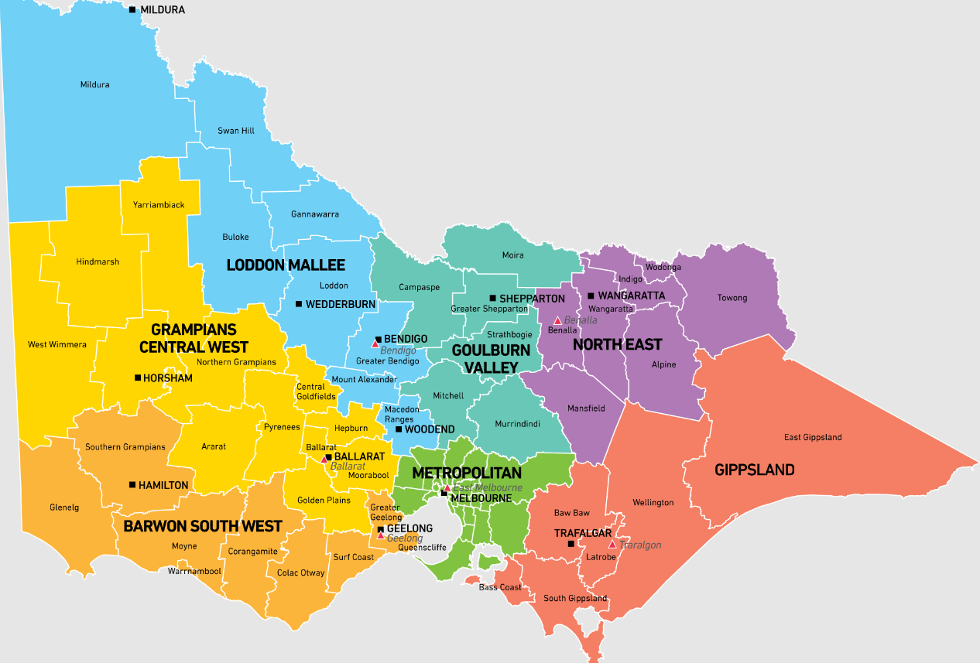

**Source:** Sustainability Victoria <https://assets.sustainability.vic.gov.au/susvic/RWRRIP-Map-of-Victorian-regions.png>