Focus species

Hooded plover

Figure : An illustration of an adult hooded plover with her chick

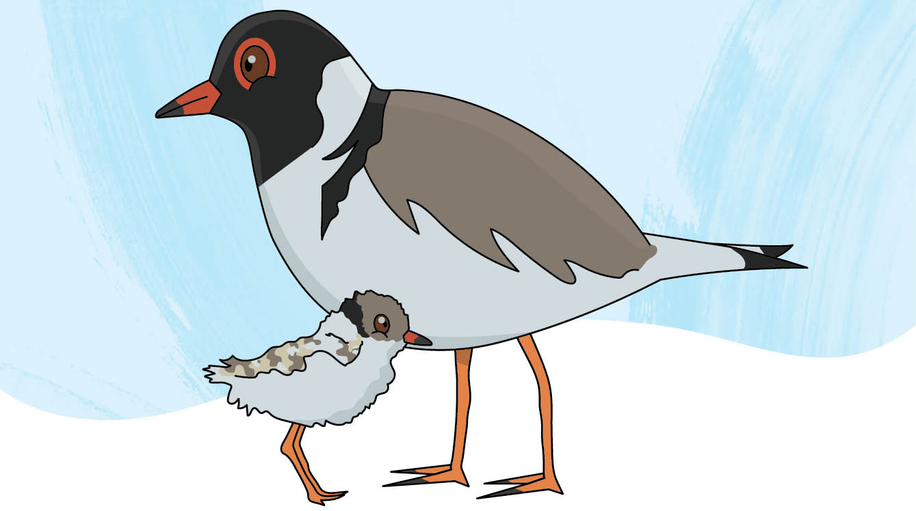

**Scientific name:** *Thinornis cucullatus*

**Conservation status:** Vulnerable

**Average life span:** 20 years

**Range/distribution:** Australia’s eastern and southern coastlines

**Habitat:** Open, sandy beaches

**Classification:** Coastal bird

# Who am I?

I am a shy little bird who lives on sandy ocean beaches, and you can call me a “hoodie” – it’s my nickname!

I have a black ‘hood’, white collar, black-tipped red beak, and red rings around my eyes, and my chicks are sandy-brown all over to help them camouflage from predators. You might see me scurrying about the beach, bobbing my head, and snacking on insects, worms, and sandhoppers.

We pair up for life and between August and March every year, we make a nest in shallow sand and washed-up seaweed. We take turns incubating 1-3 speckled eggs for about 30 days before they hatch, and my chicks are vulnerable for another 35 days until they can fly.

Sadly, there are only around 750 of us left in Victoria, and keeping my eggs and chicks safe can be hard.

# How can you help me?

Over summer, I live on the beach so when you come to visit for a walk or swim, remember to look out for me and my nest and give us plenty of space! I’m easily startled, so if you get too close, I might leave my nest and expose my eggs to the sun. My eggs and chicks are also small, fragile, and blend in with the sand to protect them from predators. To help keep us safe, please keep your distance, and make sure your dog is on a lead.

**Keep us safe, give us space.**

# Complete the crossword puzzle

Can you solve the clues and fill in the grid?

Figure : A crossword puzzle grid

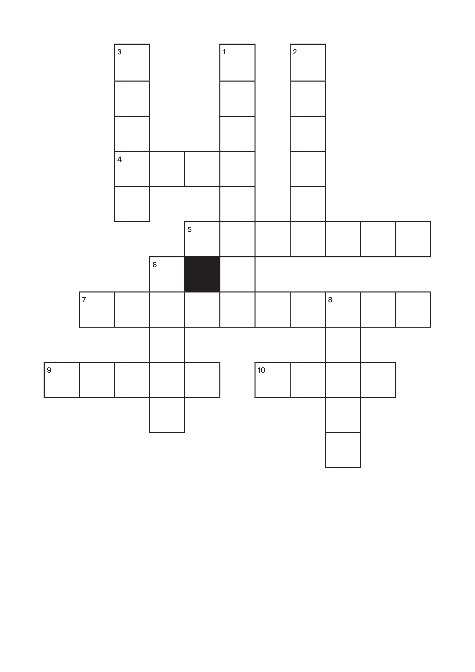

## Down:

**1.** Keep your ________ to help protect hooded plovers.

**2.** A nickname for a hooded plover.

**3.** Adult birds take __________ incubating their eggs.

**6.** What colour is a plovers ‘hood’?

**8.** Hooded plovers nest on the _______.

## Across:

**4.** Eggs stay in this until they hatch.

**5.** Something hooded plovers snack on.

**7.** What is the conservation status of the hooded plover?

**9.** Word for a baby bird.

**10.** An item to clip onto a dog’s collar.

# Fill in the blanks

There are only around __ __ __ hooded plovers left in Victoria.

Hint! The answer is on the first page and crossword answers are below.

Answers are:

DOWN

1. distance

2. hoodie

3. turns

6. black

8. beach

ACROSS

4. nest

5. insects

7. vulnerable

9. chick

10. lead

Conservation Regulator Focus Species have been selected to raise awareness about the small changes people can make to protect wildlife in the wild and in captivity.

Find out more at [conservationregulator.vic.gov.au](http://conservationregulator.vic.gov.au/)

**End of document.**