Focus species

Southern right whale

Figure : A Southern right whale and her calf swimming in the ocean

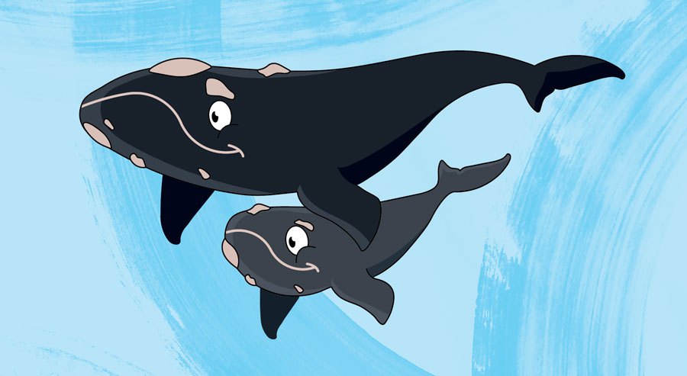

**Scientific name:** *Eubalaena australis*

**Conservation status:** Endangered

**Average life span:** 70 years

**Range/distribution:** Warmer months in the sub‑antarctic oceans and the cooler months along the southern coastline of Australia

**Habitat:** Coastal waters and oceans

**Classification:** Marine mammal

# Who am I?

I am one of Victoria’s most loved large whales, growing up to 18 metres and 80,000kg, and have some unique features that make me one of the easiest whales to identify.

My body is mostly black, but some of my friends are dark brown or grey, and I have a massive head and belly normally covered in rough white patches called callosities. I have no dorsal fin, which can sometimes make me look like a floating log.

I’m also a special type of whale called a baleen whale, named for my baleen plates; the comb-like teeth I use to filter mouthfuls of seawater for my food such as plankton and krill.

I migrate to Australia’s southern coastline in winter to breed, give birth, and raise my calf before returning to colder environments.

# How can you help me?

When going out on a boat remember to look out for me! The boat driver must slow down to **5 knots** as they get closer and keep their distance.

Boats must stay at least **200 metres** and jet skis must stay **300 metres** away – any closer and they can scare me. My baby calf and I need rest and quiet as we talk in whispers to avoid predators. If you find yourself too close to me, the boat driver should turn off the boat and let me pass.

**Keep us safe, give us space.**

# Complete the maze and colour them in

Can you help the boat reach its destination without hitting the whales?

Figure : A circular maze puzzle

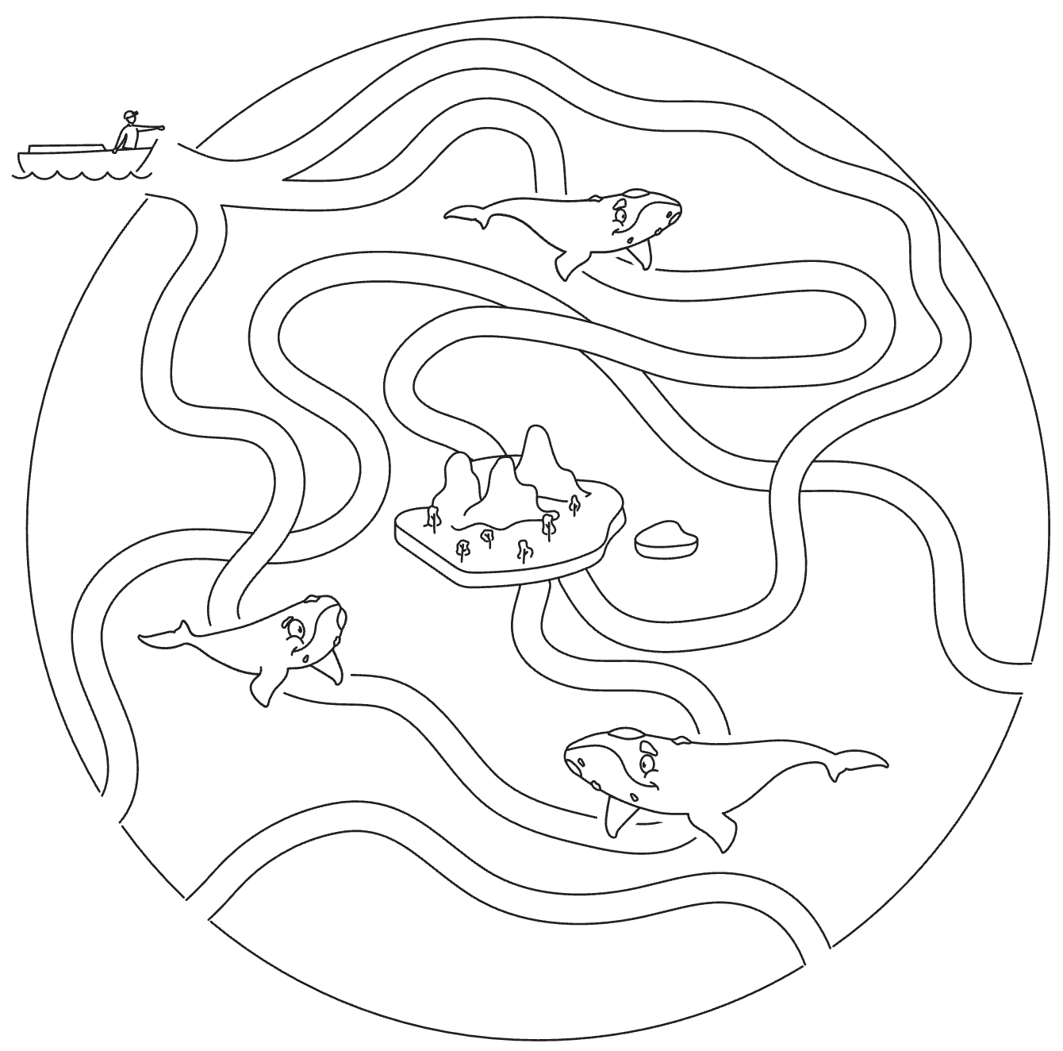

# Fill in the blanks

A southern right whale can look like a floating _ _ _ because it has no _ _ _ _ _ _ _ _ _.

Hint! The answer is on the first page.

Conservation Regulator Focus Species have been selected to raise awareness about the small changes people can make to protect wildlife in the wild and in captivity.

Find out more at [conservationregulator.vic.gov.au](http://conservationregulator.vic.gov.au/)

**End of document.**