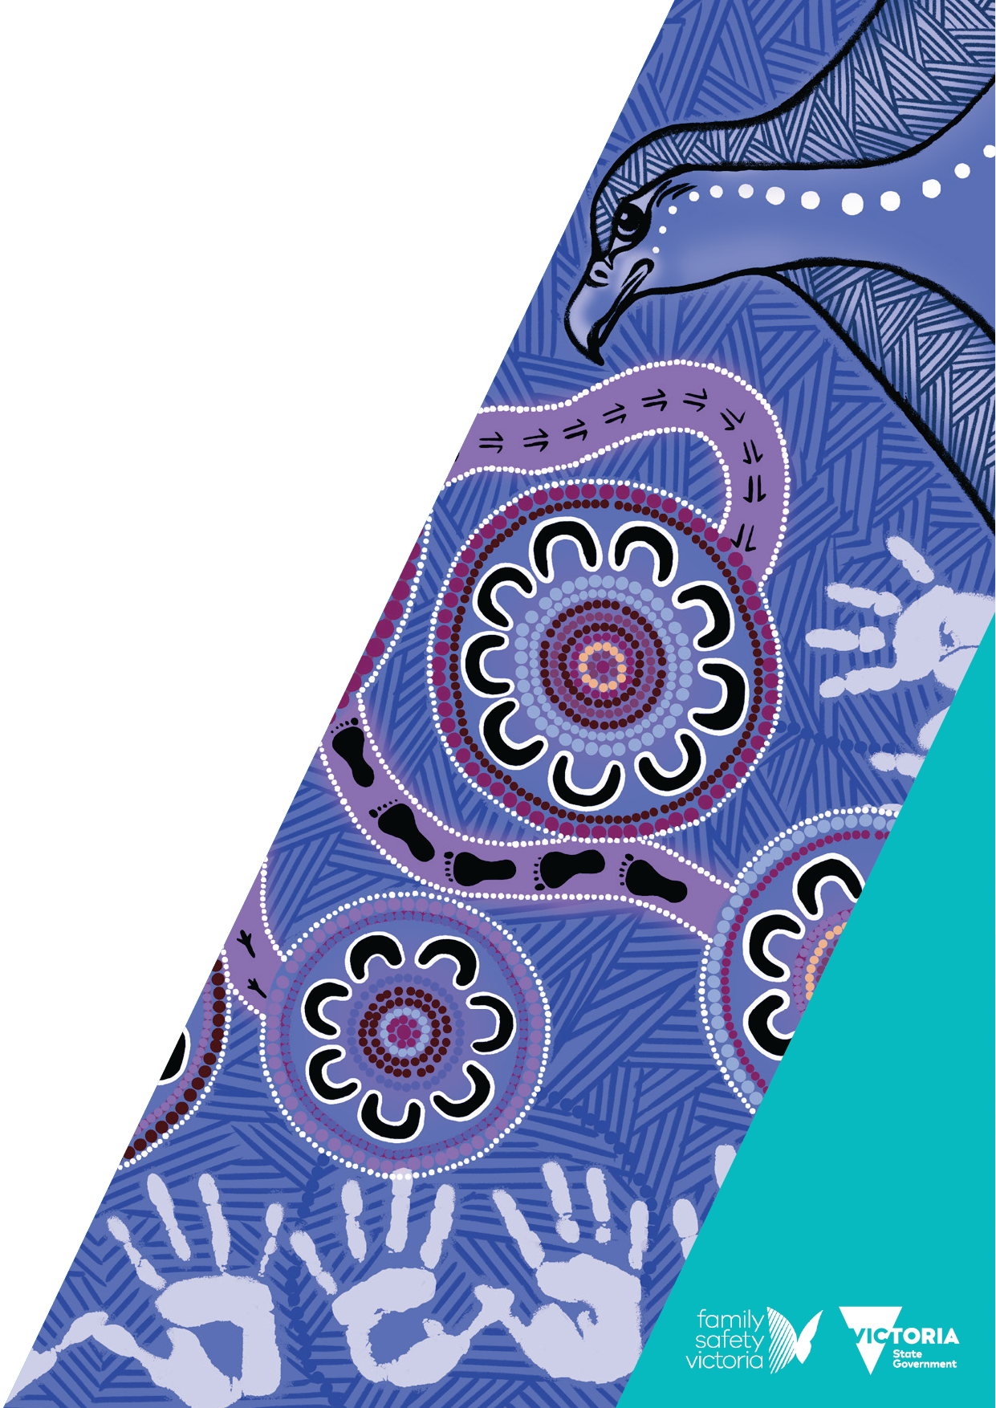

Victorian Aboriginal Community Initiatives Fund

Funding guidelines   
2024–25

**We acknowledge the Traditional Owners of Country throughout Victoria and pay respects to their Elders past and present. We acknowledge that Aboriginal self-determination is a human right and recognise the hard work of many generations of Aboriginal people.**

# Cover artwork and artist

Trina Dalton-Oogjes is a proud Wadawurrung/Wathaurung woman.

Trina’s painting centres around the 11 community Dhelk Dja Action Groups across Victoria, leading into a central gathering/yarning circle, empowering Aboriginal communities based on a healing and trauma informed process, to lead collaborative partnerships through a culturally safe service system.

Around the 11 community Dhelk Dja Action Groups are Aboriginal organisations/agencies, government departments and non-government agencies working together to address family violence.

Bunjil the Creator oversees to empower strength and self-determination.

Hand prints of the adults and children represent the family unit.

The kangaroo and emu footprints represent partnership moving forward (kangaroos and emus only move forward).

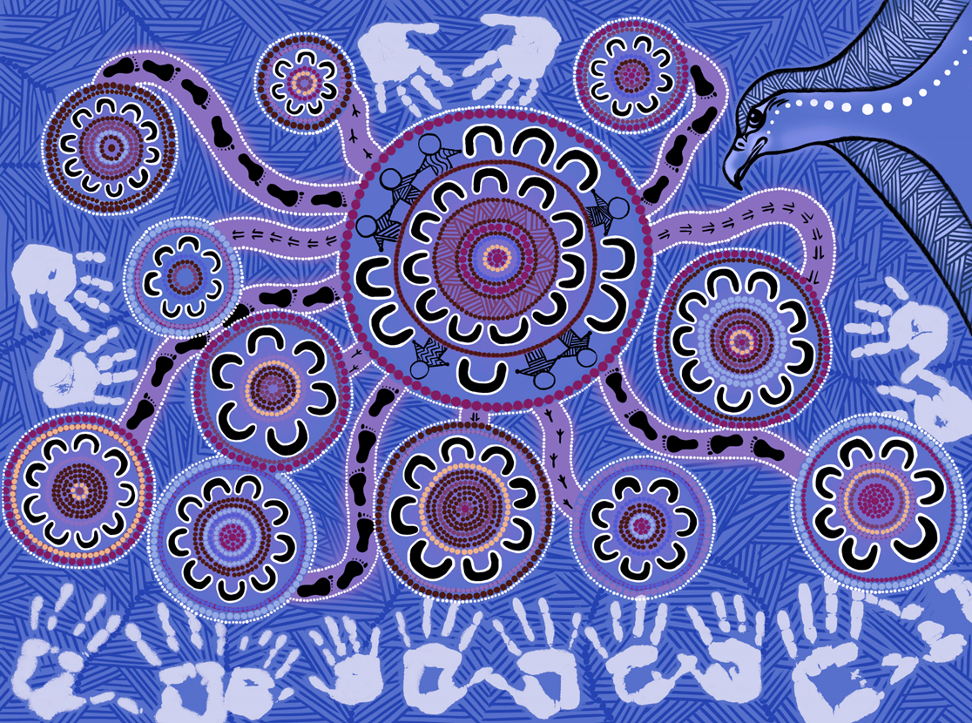

To receive this document in another format, email [dhelk.dja@familysafety.vic.gov.au](mailto:dhelk.dja@familysafety.vic.gov.au)

Authorised and published by the Victorian Government, 1 Treasury Place, Melbourne.

© State of Victoria, Australia, Department of Families, Fairness and Housing, January 2025.

[](https://creativecommons.org/licenses/by/4.0/)

With the exception of any images, photographs or branding (including, but not limited to the Victorian Coat of Arms, the Victorian Government logo or the Department of Families, Fairness and Housing logo), this work, *Victorian Aboriginal Community Initiatives Fund: funding guidelines 2024–25*, is licensed under a Creative Commons Attribution 4.0 licence.

The terms and conditions of this licence, including disclaimer of warranties and limitation of liability are available at [Creative Commons Attribution 4.0 International Public License](https://creativecommons.org/licenses/by/4.0/) https://creativecommons.org/licenses/by/4.0/.

You are free to re-use the work under that licence, on the condition that you credit the State of Victoria, Australia (Department of Families, Fairness and Housing) as the author, indicate if any changes have been made to the work and comply with the other licence terms.

In this document, ‘Aboriginal’ refers to both Aboriginal and Torres Strait Islander people. ‘Indigenous’ or ‘Koori/Koorie’ is retained when part of the title of a report, program or quotation.

ISBN 978-1-76130-752-2 (pdf/online/MS word)

Available at [Aboriginal Community Initiatives Fund: 2024–2025 funding round](https://www.vic.gov.au/aboriginal-cif) https://www.vic.gov.au/aboriginal-cif

(2412251)

Contents

Cover artwork and artist 2

Victorian Aboriginal Community Initiatives Fund 5

Key dates 5

Dhelk Dja action groups 6

Dhelk Dja Action Group Regions 8

Grampians Dhelk Dja Action Group 8

Barwon Southwest Dhelk Dja Action Group 8

Mallee Dhelk Dja Action Group 8

Loddon Campaspe Dhelk Dja Action Group 8

West Metro Dhelk Dja Action Group 8

North Metro Dhelk Dja Action Group 9

East Metro Dhelk Dja Action Group 9

South Metro Dhelk Dja Action Group 9

Inner Gippsland Metro Dhelk Dja Action Group 9

East Gippsland Metro Dhelk Dja Action Group 10

Hume Dhelk Dja Action Group 10

Funding 10

Eligibility 11

Who is eligible to apply for CIF funding? 11

Eligible organisations 11

Who is not eligible to apply for CIF funding? 12

What is not eligible for CIF funding 12

What types of projects are eligible for CIF funding? 12

Application process 13

How will applications be assessed? 14

Where do I obtain further information? 15

What happens if my application is successful? 16

Funding expectations 17

Attachment 1: Conflict of interest 19

Financial interest 19

Immediate family 19

Personal obligation 19

Perceived conflict of interest 19

Management of conflict of interest 19

Dhelk Dja Action Groups 19

CIF Assessment Panel 19

# Victorian Aboriginal Community Initiatives Fund

The Victorian Government, through the Department of Families, Fairness and Housing is providing $1.1 million for the Aboriginal Community Initiatives Fund (CIF) in 2024-25. The funds are to implement community-led projects that educate, prevent, reduce, and respond to family violence in Aboriginal communities across Victoria.

Projects funded through CIF support and address priorities that are identified by the 11 Dhelk Dja action groups to address family violence at a local level.

It supports projects that:

* are Aboriginal led, including Aboriginal led partnerships
* are consistent with the goals and objectives of action groups and strengthen the capacity of Aboriginal communities and Aboriginal organisations to address family violence at a local level
* will provide an ongoing or long-term benefit to the community
* complement existing local community projects or initiatives and demonstrate partnerships with other government or non-government initiatives
* align with the *Dhelk Dja: Safe Our Way – Strong Culture, Strong Peoples, Strong Families 10 Year Agreement (2018-2028)*.

# Key dates

| Process | Date |
| --- | --- |
| Call for applications | 20 January 2025 |
| Application closing date and time | 14 February 2025 at 5 pm |
| Pre-panel applicant contact | TBC by the Region |
| CIF Assessment Panels | 17 February 2025 to 28 February 2025 |
| Applicant interviews convened | TBC by the Region |
| All applicants advised of outcome by | Early April 2025 |
| Project commencement from | June 2025 |
| Project completion by | June 2026 |

The Department of Families, Fairness and Housing reserves the right to vary the key dates as necessary at its absolute discretion.

# Dhelk Dja Action Groups

The 11 action groups play a leadership role across Victoria. They are Aboriginal community-led structures to drive local and regional responses to prevent and respond to family violence. See Figure 1: Dhelk Dja Action Group Regions.

At a statewide level, the 11 action group chairpersons influence change and support family violence reform in Victoria. The chairpersons represent Aboriginal communities on the Dhelk Dja Partnership Forum (Partnership Forum). The Partnership Forum:

* is the strategic leadership group that brings together Aboriginal communities, Aboriginal services and Government
* drives reform to aim to prevent and respond to family violence affecting Aboriginal communities.

At a local and regional level, action group chairpersons and members:

* develop action plans that aim to respond to local community needs through the establishment of strategies and initiatives
* play a key role in supporting Aboriginal community-led projects to prevent and respond to family violence. They do this by managing, reporting, and implementing CIF processes at the local and regional level.

Figure 1: Dhelk Dja Action Group Regions

A map of Victoria indication the Department of Families, Fairness and Housing division and areas and the local government authority (LGA) areas that fall within them. This maps shows only shows non-metro Melbourne LGA's

Divisions, areas and local government areas are listed on the following pages.

A map of metro Melbourne indicating the Department of Families, Fairness and Housing division and areas and the local government authority (LGA) areas that fall within them.

Divisions, areas and local government areas are listed on the following pages.

# Dhelk Dja Action Group Regions

## Grampians Dhelk Dja Action Group

DFFH Division West local government areas:

* Hindmarsh
* Horsham
* Northern Grampians
* West Wimmera
* Yarriamblack

## Barwon Southwest Dhelk Dja Action Group

DFFH Division West local government areas:

* Colac Otway
* Greater Geelong
* Surf Coast
* Corangamite
* Glenelg
* Hindmarsh
* Mayne
* Southern Grampians

## Mallee Dhelk Dja Action Group

DFFH Division North local government areas:

* Mildura
* Swan Hill
* Buloke
* Gannawarra

## Loddon Campaspe Dhelk Dja Action Group

DFFH Division North local government areas:

* Campaspe
* Central Goldfields
* Greater Bendigo
* Loddon
* Macedon Ranges
* Mount Alexander

## West Metro Dhelk Dja Action Group

DFFH Division West local government areas:

* Hobsons Bay
* Maribyrnong
* Melbourne
* Moonee Valley
* Wyndham

## North Metro Dhelk Dja Action Group

DFFH Division North local government areas

* Banyule
* Darebin
* Nillumbik
* Whittlesea
* Yarra

## East Metro Dhelk Dja Action Group

DFFH Division East local government areas:

* Knox
* Maroondah
* Yarra Ranges
* Boroondara
* Manningham
* Monash
* Whitehorse

## South Metro Dhelk Dja Action Group

DFFH Division South local government areas:

* Cardinia
* Casey
* Greater Dandenong
* Bayside
* Frankston
* Glen Eira
* Kingston
* Mornington Peninsular
* Port Phillip
* Stonnington

## Inner Gippsland Metro Dhelk Dja Action Group

DFFH Division South local government areas:

* Bass Coast
* Baw Baw
* LaTrobe
* South Gippsland

## East Gippsland Metro Dhelk Dja Action Group

DFFH Division South local government areas:

* East Gippsland
* Wellington

## Hume Dhelk Dja Action Group

DFFH Division South local government areas:

* Alpine
* Benalla
* Indigo
* Mansfield
* Towong
* Wangaratta
* Wodonga
* Greater Shepperton
* Mitchell
* Moira
* Murrindindi
* Strathbogie

# Funding

One off funding will be made available for local and/or regional based Aboriginal-led projects that educate, prevent, reduce, and respond to family violence in Aboriginal communities across Victoria. Only Aboriginal-led organisations and/or community groups can apply.

$1.1 million is equally divided across the 11 Action Group regions. A total of $100,000 is allocated per Action Group region to support multiple CIF projects of varying amounts. Projects are to be delivered from **June 2025 to June 2026**.

The CIF aims to:

* support Aboriginal self-determination
* support community groups or activities to strengthen ability to make positive choices about their lives, building leadership skills and confidence as well as sharing knowledge
* support innovative Aboriginal-led prevention and early intervention initiatives to address family violence
* deliver positive outcomes which will benefit the Aboriginal community in addressing family violence
* demonstrate inclusiveness of all Aboriginal people. This includes:
  + Elders
  + women
  + men
  + children and young people (including those in out of home care)
  + people from the lesbian, gay, bisexual, trans and gender diverse, intersex, queer, and asexual (LGBTIQA+) community
  + people living with disabilities or mental health issues
  + people living in rural, remote or regional communities
  + people exiting prisons.
* complement but not duplicate existing funded community initiatives. CIF is unlikely to support activities or projects that the applicant is currently funded for and considered as ‘core business’ or ‘business as usual’.

The following funding expectations will apply to all projects that receive CIF funding:

* provide an alcohol, drug and smoke free environment
* provide a culturally safe environment free from violence
* volunteers and staff to hold a current Working with Children’s Check
* be covered be all appropriate insurance, including public liability insurance for not less than $5 million
* have a positive working relationship with the Dhelk Dja Action Group.

In addition, all publicity, promotional materials and signage relating to the project must prominently display the Dhelk Dja Action Group logo from your region (available from the Regional Coordinator).

All media/promotional material generated by the funded organisation relating to the project must include the line:

‘The (insert name of region) Dhelk Dja Action Groups supports this event, with funds provided by the Victorian Government Aboriginal Community Initiatives Fund.’

# Eligibility

## Who is eligible to apply for CIF funding?

Funding is available to:

* Victorian Aboriginal led not-for-profit organisations, or
* Victorian Aboriginal community groups whose work supports Aboriginal families and/or communities in Victoria.

Aboriginal-led organisations may choose to partner with non-Aboriginal organisations where specific content knowledge or other expertise is required. However, the Aboriginal-led organisation and/or community group **must be the lead or senior partner** throughout the partnership-based project(s) to be considered for CIF funding.

Applicants that do not have current Service Agreements with the Department of Families, Fairness and Housing must enter into an auspice agreement with an organisation that has a current Service Agreement with the Department of Families, Fairness and Housing to be eligible for funding. To check the status of your agreement please contact the relevant Regional Coordinator in the region you are applying for funding.

## Eligible organisations

Eligible organisations are:

* controlled, led or directed by Aboriginal Victorians
* not-for-profit organisations
* established for the purpose of promoting Aboriginal community objectives or outcomes in Victoria
* legally Incorporated under Victorian or Commonwealth legislation
* able to demonstrate financial and administrative capacity to manage the funding and the project or activity for which funding is received
* person representing a volunteer based Aboriginal community group (Authorised Signatory) partnered with an organisation who has a current Service Agreement with the Department of Families, Fairness and Housing
* organisations or groups that have previously received funding from the CIF must be compliant with reporting requirements in order to be eligible to apply for further funding.
* In addition, you must have an Australian Business Number (ABN) or be willing to provide a Statement by Supplier Form (reason for not quoting an ABN).

## Who is not eligible to apply for CIF funding?

Organisations that are not eligible to apply for funding include, but are not limited to:

* sole traders
* for-profit organisations
* professional associations
* Non-corporate Commonwealth entity
* Non-corporate State/Territory entity
* Non-corporate Commonwealth Statutory Authority
* Local government entities
* organisations outside of Victoria
* individuals who are not office holders or authorised signatories of volunteer-based community groups.

## What is not eligible for CIF funding

The Aboriginal Community Initiatives Fund will not fund the following:

* wages/salaries for staff
* infrastructure, major planning or capital projects
* court/legal costs
* emergency relief/brokerage funding
* funeral funds and expenses
* commercial or business ventures
* purchase or large non portable and tangible equipment
* projects currently receiving funding from another government department
* donations.

## What types of projects are eligible for CIF funding?

Table 1: Project examples that align with the Strategic Priorities of *Dhelk Dja: Safe Our Way – Strong Culture, Strong Peoples, Strong Families* 10 Year Agreement

| Strategic Priority | Project examples |
| --- | --- |
| Strategic Priority 1 – Aboriginal Culture and Leadership | Cultural activities such as traditional dance, shield making and basket weaving |
| Strategic Priority 2 – Aboriginal-led Prevention | Family camps supporting and strengthening families in finding solutions to negative behaviours such as family violence |
| Strategic Priority 2 – Aboriginal-led Prevention | Sporting events and family days that provide community with messages about respectful behaviour and information on support services |
| Strategic Priority 3 – Self-determining Aboriginal family violence support and services | Support groups or activities to strengthen ability to make positive choices about their lives, building leadership skills and confidence as well as sharing knowledge |
| Strategic Priority 3 – Self-determining Aboriginal family violence support and services | Workshops and training to improve cultural safety and responsiveness to family violence |
| Strategic Priority 4 – System transformation based on self-determination | Youth forums to ensure the voices of Aboriginal children & young people are embedded in system transformation work |
| Strategic Priority 5 – Aboriginal-led and informed innovation, data, and research | Feasibility studies or evaluations of existing CIF projects with objective of building on what works |

# Application process

The application process is as follows:

1. Contact the Regional Coordinator who supports the Dhelk Dja Action Group in your region, to express your interest and discuss your project proposal for the Aboriginal Community Initiatives Fund. The Regional Coordinator will advise you on regional processes i.e. information sessions/forums being held.
2. The Regional Coordinator will provide you with a copy of the Dhelk Dja: Safe Our Way – Strong Culture, Strong Peoples, Strong Families 10 Year Agreement 2018–2028 and the Dhelk Dja Regional Action Group Plan.
3. Complete the CIF 2024-25 Application Form and submit it to the Regional Coordinator, along with all supporting documentation. The closing date for applications is 14 February 2025 at 5pm. No late applications will be accepted.
4. Applications will be reviewed to ensure that the eligibility criteria are met and that all sections are completed. Applications that do not meet the eligibility criteria will not proceed to the Assessment Panel.
5. All eligible applications will be presented to the CIF Assessment Panel which comprises:

* Two Aboriginal community representatives of the Dhelk Dja Action Group
* Independent Aboriginal representative, as identified by the Dhelk Dja Chairpersons
* Senior Aboriginal representative from Department of Families, Fairness and Housing (DFFH), as identified by the Dhelk Dja Chairpersons
* Team Leader(s), Aboriginal Governance and Engagement, Aboriginal Initiatives Unit (AIU) to provide guidance and ensure compliance with the CIF process.

The Regional Coordinator provides secretariat support and advice to the panel and does not have any decision-making capacity.

1. The CIF Assessment Panel will assess applications against set criterion. As part of the assessment process, applicants must attend an Assessment Panel Interview to discuss their application. Interviews will be advised by the Regions.
2. At the completion of the process, you will be advised of the outcome in writing by Aboriginal Initiatives Unit and given the opportunity to obtain feedback about your submission
3. Any queries should be directed to the relevant Regional Coordinator.

## How will applications be assessed?

Eligible applications will be assessed against the following assessment criteria:

### Assessment criterion 1: Eligibility to apply for funding

* Confirmation of eligible organisations
* Confirmation of eligibility of project criterion
* Applicant details (sections 1 and 2 of the application completed and signed)
* All supporting documents are provided:
  + Copy of the organisation’s Certificate of Incorporation and Statement of Purpose (or where applicable, a copy of the auspice organisation)
  + Copy of the organisation’s (or where applicable, the auspice organisation) previous years audited financial statements
  + Letters of support and any agreements/Memorandum of Understanding (MOU) with partnering organisations

### Assessment criterion 2: Level of need for the project in your community

* Details of proposed target audience participants in the project provided
* Details provided of how participants will be selected.
* How will the project be inclusive of different groups in your local Aboriginal communities?
* Provide details of the areas where the project will be delivered within your region
* Describe how the project addresses local needs in your community (as identified by the Dhelk Dja Action Group) Refer to the Regional Dhelk Dja Action Plan

### Assessment criterion 3: Project alignment to *Dhelk Dja: Safe Our Way – Strong Culture, Strong Peoples, Strong Families* 10 Year Agreement (the Agreement)

* List the project objectives and how they align with the Strategic Priorities of the Agreement

### Assessment criterion 4: Capacity of project manager to deliver the project

* Provide details of the Project Plan
* Details what measures will be used to evaluate success of the project
* Provide any previous performance on CIF projects

### Assessment criterion 5: Financial details

* List the income and expenditure for the project
* Provide details of financial or in-kind contributions from the applicant organisation or any other partners

### Assessment criterion 6: Determining understanding of the funding expectations and declaring any conflict of interest

* Provide details on how you will address the CIF funding expectations
* Declaration of Interest

## Where do I obtain further information?

The Aboriginal Community Initiatives Fund Guidelines and Application Form can be downloaded from the [Aboriginal Community Initiatives Fund webpage](http://www.vic.gov.au/aboriginal-cif) https:// www.vic.gov.au/aboriginal-cif.

### Regional Coordinator contact information

For further information contact the Regional Coordinator or regional representative at the relevant office listed below:

#### Metro

##### East Metro Region

Sam Lampard

Team Leader

Mob: 0457 335 219

Email: sam.lampard@familysafety.vic.gov.au

##### North Metro Region

Lynda Whitaker

Regional Coordinator

Mob: 0418 900 718

Email: [Lynda.Whitaker@familysafety.vic.gov.au](mailto:Lynda.Whitaker@familysafety.vic.gov.au)

##### South Metro Region

Sam Lampard

Team Leader

Mob: 0457 335 219

Email: sam.lampard@familysafety.vic.gov.au

##### West Metro Region

Ashlee Feeney

Regional Coordinator

Mob: 0418 611 896

Email: [ashlee.feeney@familysafety.vic.gov.au](mailto:ashlee.feeney@familysafety.vic.gov.au)

#### Regional

##### Barwon South West Region

Tania Dalton

Regional Coordinator

Mob: 0417 396 946

Email: [tania.dalton@familysafety.vic.gov.au](mailto:tania.dalton@familysafety.vic.gov.au)

##### Grampians Region

Nicole Rethus

Regional Coordinator

Mob: 0409 347 537

Email: [nicole.rethus@familysafety.vic.gov.au](mailto:nicole.rethus@familysafety.vic.gov.au)

#### Regional

##### Hume Region

Kellie Marsters

Regional Coordinator

Mob: 0448 946 101

Email: [kellie.marsters@familysafety.vic.gov.au](mailto:kellie.marsters@familysafety.vic.gov.au%20)

##### Inner Gippsland Region

Shannon Nicholson

Regional Coordinator

Mob: 0429 423 152

Email: [shannon.nicholson@familysafety.vic.gov.au](mailto:shannon.nicholson@familysafety.vic.gov.au )

##### Loddon Campaspe Region

Tara Hicks

Regional Coordinator

Mob: 0409 855 128

Email: [tara.hicks@familysafety.vic.gov.au](mailto:tara.hicks@familysafety.vic.gov.au)

##### Mallee Region

Shannon Oates

Regional Coordinator

Mob: 0428 760 396

Email: [shannon.oates@familysafety.vic.gov.au](mailto:shannon.oates@familysafety.vic.gov.au)

##### East Gippsland Region

Jodie Douthat

Regional Coordinator

Mob: 0457 229 908

Email: [jodie.douthat@familysafety.vic.gov.au](mailto:jodie.douthat@familysafety.vic.gov.au)

# What happens if my application is successful?

#### Applicants with a current Service Agreement with the Department of Families, Fairness and Housing

The Department of Families, Fairness and Housing (DFFH) will vary their Service Agreement with the successful applicants. This agreement specifies the services to be delivered and sets out funding conditions and reporting requirements.

Any proposed changes or variation to the project and project budget must be submitted to the Regional Coordinator and approved by the department.

Projects are to be compliant with the reporting requirements. A standard template will be provided for reporting purposes. The reporting requirements include:

* verbal reports updating the Regional Coordinator and by attending the Dhelk Dja Action Group meetings in your region, throughout the duration of the project
* a written progress report halfway throughout the project timeline, providing a summary of the activities against milestones provided in the project plan
* a final written report within six weeks of completion of the project, including photographs, films, or mixed media, where appropriate
* a financial acquittal
* reports are to be submitted to the Regional Coordinator.

#### Applicants that do not have a Service Agreement the Department of Families, Fairness and Housing

Applicants that do not have a current Service Agreements with the Department of Families, Fairness and Housing must enter into an auspice agreement with an organisation that has a current Service Agreement with the Department of Families, Fairness and Housing to be eligible for funding.

The auspice organisation must vary their Service Agreement with DFFH. The auspice organisation must ensure that all obligations in the Service Agreement are met, including service delivery, financial accountability, and client confidentiality requirements.

To avoid any misunderstanding in relation to the responsibilities and accountability, both parties must undertake the following steps prior to applying for CIF funding:

* clarify the obligations and responsibilities of both parties in the form of a written MOU. A copy of the MOU must be provided to the Regional Coordinator.
* agree on the budget and project plan, including the auspice fee (no more than 10%)
* ensure that correct and adequate insurance policies are held.

Once the project has commenced, the auspice organisation will arrange for payment of invoices submitted in relation to the budget lines specified in the project plan. A standard template will be provided for reporting purposes. The reporting requirements include:

* verbal reports updating the Regional Coordinator and by attending the Dhelk Dja Action Group meetings in your region, throughout the duration of the project
* a written progress report halfway throughout the project timeline, providing a summary of the activities against milestones provided in the project plan
* a final written report within six weeks of completion of the project, including photographs, films, or mixed media, where appropriate
* a financial acquittal
* reports are to be submitted to the Regional Coordinator.

Where a community group is partnering with an incorporated organisation who auspices the grant (or it’s funds):

* the community group delivering the project will provide the verbal and written reports
* the organisation who auspices the funding will submit the financial acquittal.

The Regional Coordinator, Dhelk Dja Action Group Chairperson and DFFH will make reasonable efforts to work with the community group and auspice organisation to resolve any disputes or grievances that may arise during the project.

## Funding expectations

The following funding expectations will apply to all projects that receive CIF funding.

* The event and/or activities provide a culturally safe environment free from violence
* That all event and/or activities are alcohol, drug, and smoke free environment
* Ensure that all volunteers and staff hold a current Working with Children’s Check
* To ensure that your organisation or program is covered by all appropriate insurance, including public liability insurance for not less than $5 million
* To engage in a positive working relationship with the Dhelk Dja Action Group.

In addition, all publicity, promotional materials, and signage relating to the project must prominently display the Dhelk Dja Action Group logo from your region (available from the Regional Coordinator).   
All media/promotional material generated by the funded organisation relating to the project must include the line:

‘This event is supported by (region) Dhelk Dja Action Group, with funds provided by the Victorian Government Aboriginal Community Initiatives Fund’

**Please note that any breach of CIF funding by not adhering to the funding expectations may result in your project being cancelled, funding being recouped and may impact your ability to receive future funding.**

# Attachment 1: Conflict of interest

A conflict of interest is deemed to occur where an individual has any of the following:

## Financial interest

Any individual having a direct or indirect financial interest in any of the applications for funding constitutes a conflict of interest. This includes an individual being an employee, board member or a member of a committee of management of an organisation that is seeking funding.

## Immediate family

Any individual having an immediate family member who is likely to receive a financial benefit from an application for funding, or who would be involved in the delivery of the proposed project constitutes a conflict of interest.

An ‘immediate family member’ is considered as a sibling, parent, child, partner or any other person whom the individual considers as immediate family.

## Personal obligation

Any personal obligation, allegiance, or loyalty (either actual or perceived) which affects the member’s ability to make an unbiased decision (in relation to the funding application) constitutes a conflict of interest.

## Perceived conflict of interest

If it could be perceived that an individual has private interests’ that could conflict with their public or official duties. If a third party could form the view that an individual interests or obligations could influence their decision making or performance.

## Management of conflict of interest

The Department of Families, Fairness and Housing will effectively manage any conflict of interest (actual, potential, or perceived) that any person involved in the selection process has with any application or any applicant organisation, to produce results that are in the best interests of the Victorian Aboriginal community.

## Dhelk Dja Action Groups

Each Action Group is responsible for ensuring adherence to its own conflict of interest procedures as stated in the guidelines, taking into account that:

* any person, who has an actual, potential, or perceived conflict of interest, must declare their interest and note this in the template that accompanies the completed CIF application.

## CIF Assessment Panel

The CIF Assessment Panel is formed by identifying members who would have no or limited conflict of interest with regards to incoming applications. All members must declare any conflict of interest with any application. Assessment Panel members will not assess any application where they have a conflict of interest but may still participate in discussions about that project. In addition, Regional Coordinators only have an administrative role in the panel process and do not assess any application.