Student eligibility for Skills First

This fact sheet explains how you should apply Skills First eligibility rules and includes helpful example scenarios.

Eligibility requirements
To be eligible for Skills First funding, a student must be:
- an Australian citizen or permanent resident, or a New Zealand citizen
- doing all training and assessment while physically present in either:
  - Victoria
  - a border region that’s specified by postcode in the guidelines about eligibility.
Eligibility requirements are described in the VET funding contract and the guidelines about eligibility.
You must apply the eligibility requirements unless there’s an exemption in part C of schedule 1 of the contract or under any special initiatives. To grant an exemption you must follow the requirements of the relevant initiative.

Volume limits
There are 3 limits on how much Skills First-subsidised training a student can do, to maximise program completions and encourage students to make informed decisions about their training and employment opportunities.
Limit | Description | Not taking into account
2 skill sets in a year | The student may make a maximum of 2 commencements in skill sets in a calendar year | - Moving from a superseded program to the current version of the same program  - Recommencing training in the same program (at either the same or a different training provider)  - Course in identifying and responding to family violence risk  - LN support subjects  - Plumbing licence skill sets
2 AQF qualifications in a year | The student may make a maximum of 2 commencements in AQF qualifications in a calendar year | - Moving from a superseded program to the current version of the same program  - Recommencing training in the same program (at either the same or a different training provider)  - Seeking to enrol in an apprenticeship after doing an pre-apprenticeship pathway program
2 at a time | The student may do a maximum of 2 programs (skill sets and AQF qualifications) at any one time | - Course in identifying and responding to family violence risk  - LN support subjects  - Plumbing licence skill sets

Attachment 1: example scenarios
These scenarios show examples of how to assess a student’s eligibility.

Example 1 – Mohammed wants to enrol in the Certificate II in Signage and Graphics
This calendar year, Mohammed:  - commenced and completed the Certificate II in Food Processing (Skills First subsidised)  - commenced and completed the Certificate II in Auslan (Skills First subsidised). | Is Mohammed eligible?  - NO. Mohammed has reached the ‘2 AQF qualifications in a year’ limit, so he can’t get Skills First funding for any more AQF qualifications this calendar year.  - However, he is still eligible to enrol in up to 2 Skills First funded skill sets this year.

Example 2 – Sarah wants to enrol in the Certificate III in Engineering
This calendar year, Sarah:  - continued her training in the Certificate III in Beauty Services that she started last year (Skills First subsidised)  - commenced the Certificate III in Retail this year (Skills First subsidised).  Both programs are still in progress. | Is Sarah eligible?  - NO. Sarah has reached the ‘2 at a time’ limit.  - However, she can commence the Certificate III in Engineering later in the year if she completes or withdraws from one of her current courses.  - If this happens, she will not be exceeding the ‘2 AQF qualifications in a year’ limit because she commenced the Certificate III in Beauty Services last year.

Example 3 – Stefan wants to enrol in the Certificate III in Tourism
This calendar year, Stefan:  - commenced the Certificate III in Pet Grooming (Skills First subsidised)  - commenced the Certificate III in Science (fee for service).  Both programs are still in progress. | Is Stefan eligible?  - YES. Stefan hasn’t reached the ‘2 in a year’ or the ‘two at a time’ limit, because only one of the programs he commenced this year was Skills First subsidised.

Example 4 – Nisha wants to enrol in the ‘Assist Clients with Medication Skill Set’
This calendar year, Nisha:  - commenced the Certificate II in Health Support Services (Skills First subsidised)  - commenced the Course in Supporting People with Disability to use Medications (Skills First subsidised).  Both programs are still in progress. | Is Nisha eligible?  - NO. Nisha has reached the ‘2 at a time’ limit.  - However, because Nisha hasn’t reached the ‘2 skill sets in a year’ limit, they’d be eligible for the ‘Assist Clients with Medication Skill Set’ after they either finish or withdraw from one of the other programs.

Attachment 2: student eligibility flowchart
This flowchart helps you understand the steps to assess eligibility. It is a guide only and doesn’t cover all individual student circumstances. Refer to the guidelines for comprehensive information on eligibility rules.
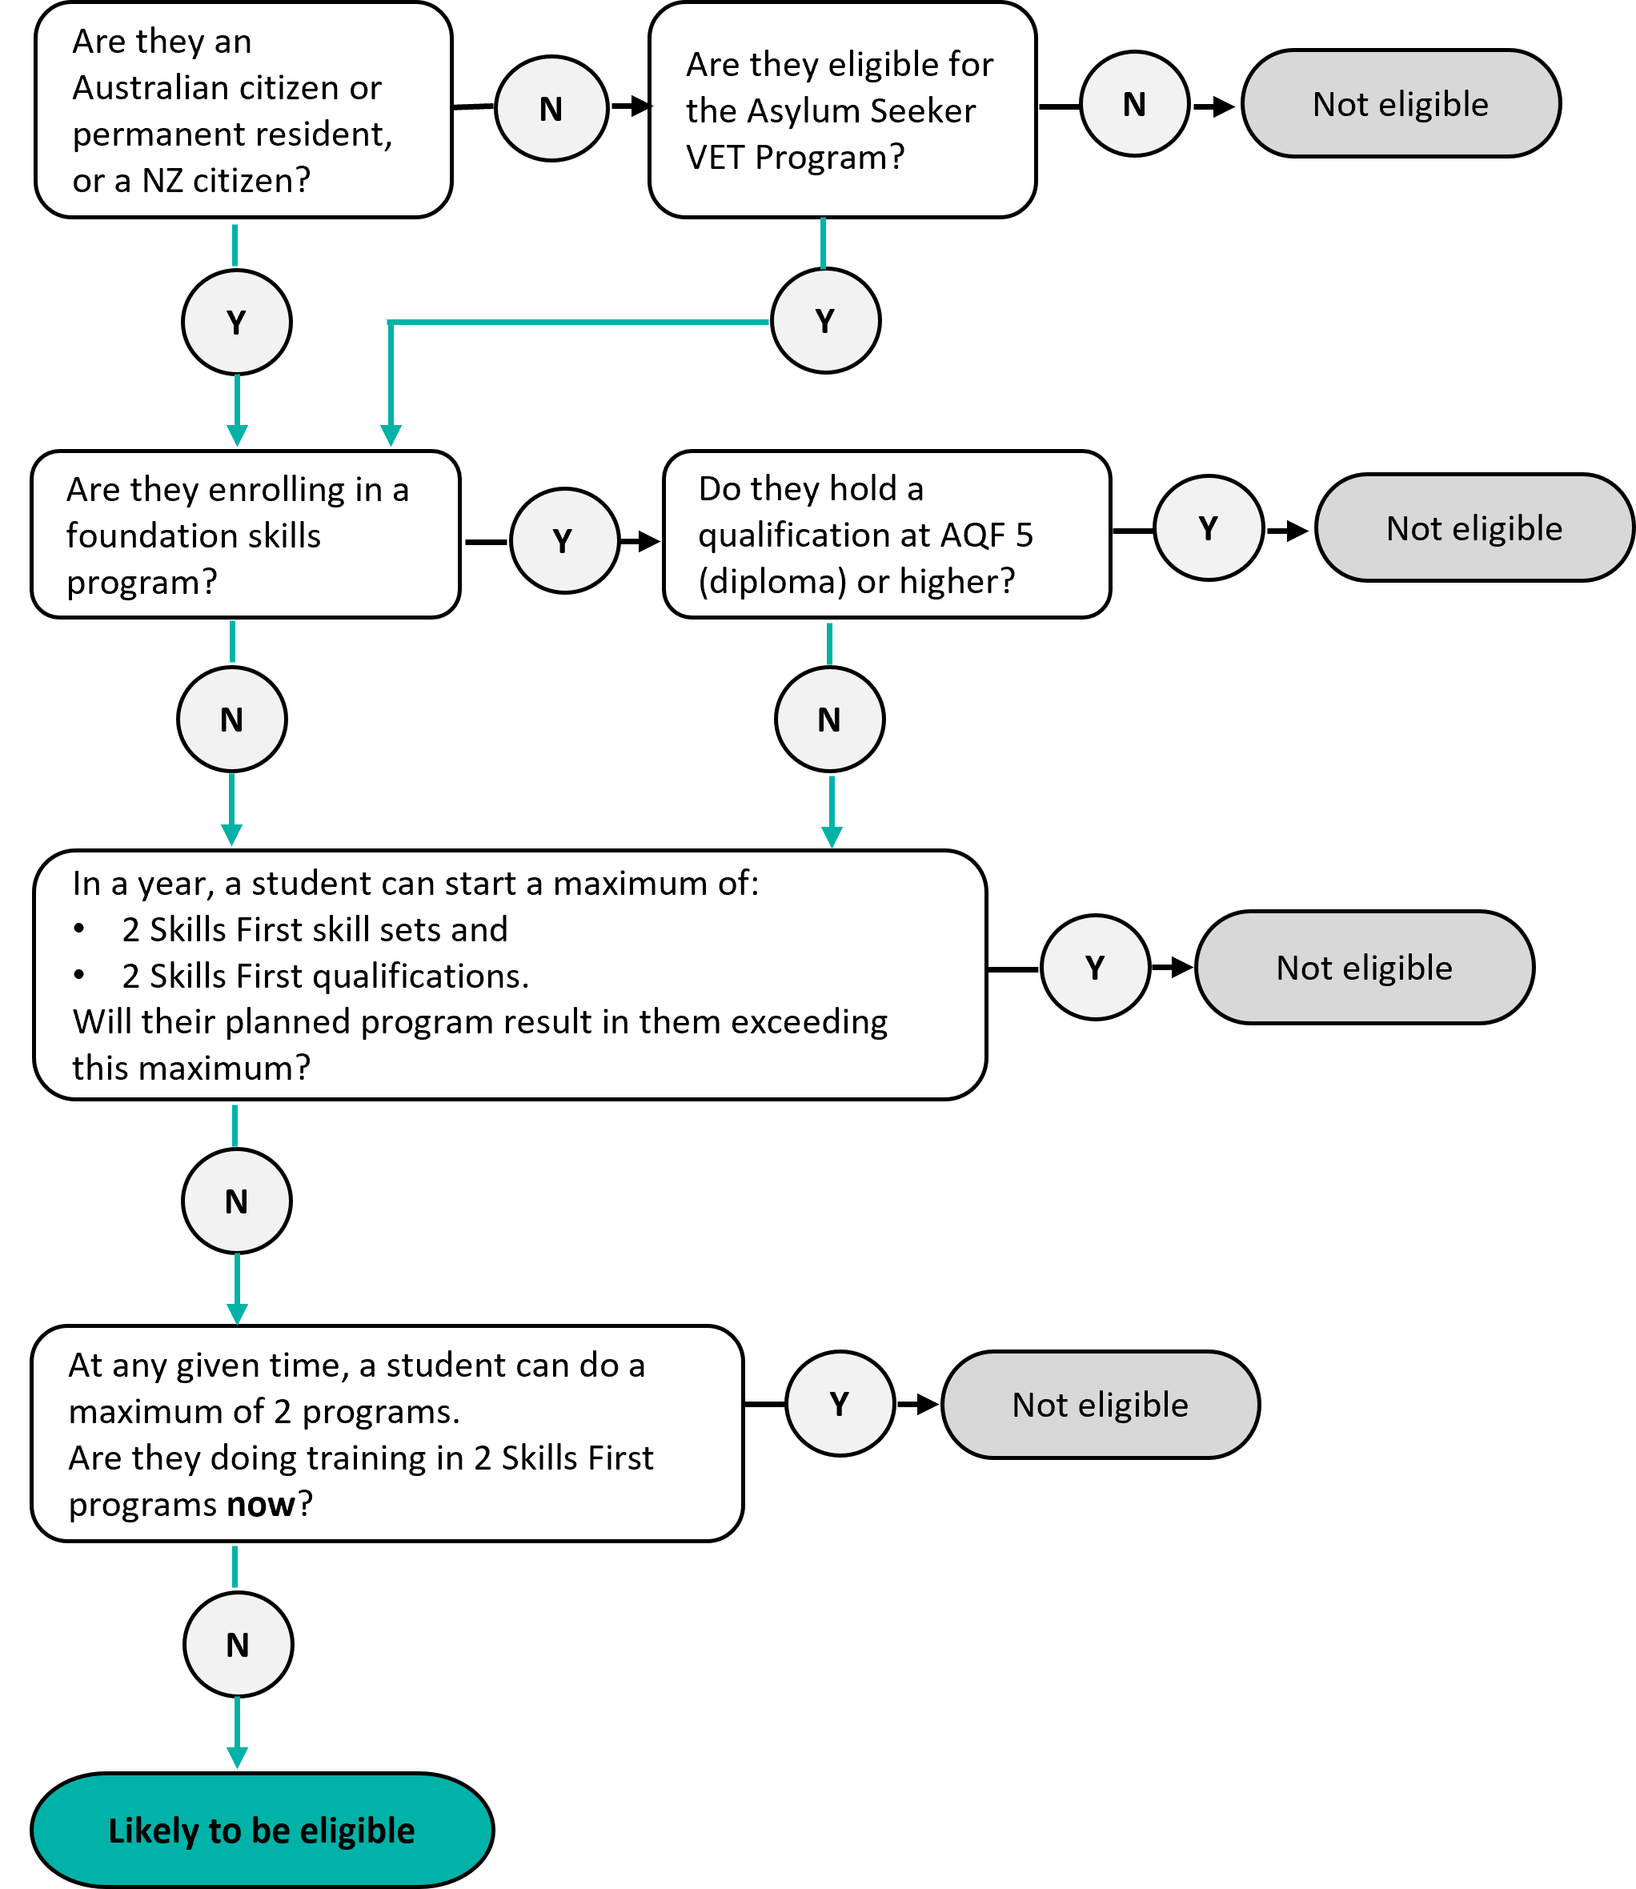

© Copyright State of Victoria, Department of Jobs, Skills, Industry and Regions 2025
Except for any logos, emblems, trademarks, artwork and photography this document is made available under the terms of the Creative Commons Attribution 3.0 Australia licence.

