Fisheries Regulations 2019
S.R. No. /2019
table of provisions
Regulation Page
Part 1—Preliminary 20
1 Objectives 20
2 Authorising provision 20
3 Commencement 20
4 Revocations 20
5 Definitions 20
6 Additional types of fishing equipment prescribed for the purposes of the Act 46
7 Definition of fisheries 48
8 References to geographic coordinates 48
9 Interpretation of periods of time 48
10 Methods of measurement of fishing nets and mesh sizes 48
11 Method of measuring bait jig hook 49
12 Method of identifying boundary between waters of lakes and rivers 49
13 Application of these Regulations to traditional owners 49
Part 2—Commercial fishery licences 51
Division 1—Classes of commercial fishery licences 51
14 Classes of access licence 51
15 Class of fish receiver licence 52
16 Classes of aquaculture licence 52
Division 2—Administration of commercial fishery licences 53
Subdivision 1—Classes of licences prescribed for certain purposes 53
17 Classes of commercial fishery licences that are transferable 53
18 Classes of commercial fishery licences that may be held by a corporation 53
19 Classes of access licences where licence holder must not personally carry out fishing activities unless permitted 54
20 Classes of access licences where services of other person not to be used unless permitted 54
21 Classes of access licence where use of boat for fishing prohibited unless authorised 54
Subdivision 2—Maximum numbers of access licences 55
22 Maximum number of access licences that can be issued for a class of access licence 55
23 Register of adjustment numbers 56
Subdivision 3—Matters relating to the issue, transfer, renewal, suspension and surrender of licences 56
24 Aquaculture licences to be renewable 56
25 Grounds on which Victorian Fisheries Authority must refuse to issue aquaculture licence 56
26 Application to transfer commercial fishery licence 57
27 Ground for refusing the transfer of access licence 57
28 Eligibility criterion for issue, renewal or transfer of access licence 58
29 Individual quota units not to be transferred if levies not paid 58
30 Process for voluntary surrender of commercial fishery licence 58
31 Prescribed grounds for suspension of a fishery licence 58
Subdivision 4—Compensation payable under section 63 of the Act 59
32 Definitions 59
33 Process for determination of compensation payable under section 63 61
34 Making an offer for compensation—cancelled transferable access licences 61
35 Making an offer for compensation—cancelled non-transferable access licences 62
36 Making an offer for compensation—holder of registered financial interest 62
37 Provision of notification to holder of a cancelled licence etc. 63
38 Making applications for compensation 63
39 Appointment and role of independent negotiator 64
40 Time limits for applications for compensation 64
41 Manner in which compensation is payable if claim accepted in full 64
42 Manner in which compensation is payable if Secretary makes an offer of compensation 65
Subdivision 5—Miscellaneous duties and powers of Victorian Fisheries Authority and Secretary 65
43 Matters to be specified by Victorian Fisheries Authority in a commercial fishery licence 65
44 Victorian Fisheries Authority may give directions or authorisations relating to lost, stolen or damaged documents 66
45 Victorian Fisheries Authority may direct return of fisheries documents 67
46 Victorian Fisheries Authority may allocate forfeited individual quota units in respect of fishery by tender 67
47 Victorian Fisheries Authority to confirm receipt of catch and effort record or specified details to licence holder 67
48 Victorian Fisheries Authority to advise of means of accessing the fisheries notification service 68
49 Victorian Fisheries Authority to notify holders of Trawl (Inshore) Fishery Access Licence when aggregated limit reached 69
50 Victorian Fisheries Authority to notify holders of abalone fishery access licence of commercial abalone reef area codes 69
Division 3—Activities authorised by every access licence 69
51 Activities authorised by every access licence 69
Division 4—Conditions on all commercial fishery licences 70
52 Every commercial fishery licence subject to conditions in this Division 70
53 Keeping or provision of information 70
54 Fisheries documents and copies to be kept in safe place 70
55 Lost, stolen, destroyed or damaged fisheries documents or copies 71
56 Fisheries documents to be used in sequential numerical order 72
57 Fisheries documents not to be lent, given or made available to others 72
58 Licence holder to retain all unused fisheries documents in book issued 72
59 Licence holder must return unused or partly used documents 72
60 Licence holder to notify of change of name, address or telephone number 73
61 Return of fish and animals to water or natural habitat 73
62 Fees, levies, royalties in respect of licences to be paid by due date 73
63 Levies and royalties in respect of individual quota units to be paid by due date 73
64 Accuracy of weight measurements of fish 74
Division 5—Conditions of all access licences 74
65 Every access licence subject to conditions in this Division 74
66 Assistance with fishing activities 74
67 Commercial and recreational fishing not to be undertaken at same time 74
68 Taking of fish in a recreational reef zone prohibited 75
69 Taking of fish in an aquaculture fisheries reserve prohibited 75
70 Fish not to be transferred or received at sea 75
71 Licence holder or licence operator to be in presence of crew 76
72 Catch limit for certain species of fish 76
73 Taking or possession of certain fish prohibited 76
74 Taking fish by dragging net on to dry land or shallow water prohibited 76
75 Marking of equipment 76
Division 6—Conditions applicable to certain commercial fishery licences 77
Subdivision 1—General 77
76 Certain commercial fishery licences subject to conditions in this Division 77
Subdivision 2—Vessel monitoring system requirement 78
77 Requirement for vessel monitoring system 78
Subdivision 3—Pre-fishing reporting requirements 79
78 Specified classes of access licences subject to conditions in this Subdivision 79
79 Notification of intention to take fish for sale 79
Subdivision 4—Place of landing 80
80 Specified classes of access licences subject to conditions in this Subdivision 80
81 Fish must be landed at a specified place 80
Subdivision 5—Weighing and post-fishing reporting requirements 81
82 Specified classes of access licence subject to conditions in this Subdivision 81
83 Weighing of fish taken 82
84 Notification of post-landing details to the Victorian Fisheries Authority 82
85 Fish not to be dealt with unless regulations 83 and 84 complied with 82
86 Notification of intention to retrieve live rock lobster from coff 82
87 Notification of removal of fyke nets 83
Subdivision 6—Catch disposal records 84
88 Specified classes of access licence subject to conditions in this Subdivision 84
89 Requirement to complete and keep catch disposal record 84
90 Location of catch disposal record book to be notified 84
91 Requirements for keeping catch disposal records 85
92 Errors made while completing catch disposal records 85
Subdivision 7—Catch and effort reporting 85
93 Catch and effort records—Hard copy 85
94 Catch and effort records—Electronic 87
Subdivision 8—Maintaining access to fisheries notification service 88
95 Maintaining access to internet or mobile telephone network 88
Part 3—Recreational fishery licences 89
Division 1—Class of recreational fishery licence 89
96 Class of recreational fishery licence 89
Division 2—Exemptions from requirement to hold recreational fishery licence 89
97 Exemptions from requirement to hold recreational fishery licence 89
Division 3—Activities authorised by recreational fishery licences 90
98 Activities authorised by recreational fishing licences 90
Division 4—General provisions applying to recreational fishery licences 90
99 Definition 90
100 Recreational fishery licence must not be transferred or lent 90
101 Recreational fishery licence holder must not allow another person to fish under licence 90
102 Offence to fail to return unissued recreational fishery licences 91
103 Offence to issue recreational fishery licence with incorrect date and time 91
Part 4—Permits 92
Division 1—Protected aquatic biota permits 92
104 Eligibility criteria for permit under section 72 92
Division 2—Noxious aquatic species permits 92
105 Specified purposes under section 81 92
Division 3—Conditions of permits 93
106 Conditions of a permit 93
Part 5—Boat registration 94
107 Registration of a boat used for fishing 94
108 Renewal of registration of a boat 94
109 Victorian Fisheries Authority to issue certificate of registration 95
110 Duration of boat registration 95
111 Offence to use boat for commercial fishing without identifying mark 95
112 Manner of displaying identifying mark on boat 95
113 Additional identifying mark required on boats exceeding 8 metres 96
114 Transfer of registration of boat 96
115 Offence to not remove identifying mark on expiry of boat registration 97
116 Offence to use unregistered boat with false identifying mark 97
Part 6—General restrictions and prohibitions relating to fishing, fishing equipment, fishing methods, boats and signage 98
Division 1—Restrictions relating to recreational fishing equipment 98
117 Application of Division 98
118 Number of items of recreational fishing equipment that may be used 98
119 Use and possession of spear gun not permitted in certain waters 99
120 Use and possession of hand-held spear not permitted in certain waters 100
121 Use of recreational bait net not permitted in certain waters 101
122 Use and possession of recreational hoop nets or open top lift nets 102
123 Recreational hoop net, open top lift net and bait trap must be correctly tagged 103
124 Offence to use certain equipment in intertidal zone 104
125 Use and possession of recreational fishing equipment prohibited in certain areas 104
126 Use of rods and lines and handlines 105
127 Offence to use or possess certain equipment in certain circumstances 105
128 Offence to use or possess a line and hook or handline in certain inland waters during the salmonid closed season 105
Division 2—Other restrictions relating to taking fish 106
129 Offence to possess certain fish other than whole or in the form of carcass 106
130 Offences relating to certain fish in berry 106
131 Offences relating to marine invertebrates in Port Phillip Bay 107
132 Offence to take molluscs from intertidal zone 107
133 Offence to take certain fish in specified areas 107
134 Offence to tag or mark fish 108
135 Offence to fail to return fish to water without injury or damage 108
136 Offence to tether fish 109
137 Offence to use certain substances as bait or berley 109
138 Offence to use as bait or release live European green shore crab 110
Division 3—Prohibitions relating to use or possession of boats, equipment or fish 110
139 Application of Division 110
140 Use, possession or sale of trammel net prohibited 110
141 Use and possession of Danish seine net prohibited 111
142 Use of certain fishing nets near Killarney boat ramp prohibited at certain times 111
143 Use of certain fishing nets in Portland Bay prohibited at certain times 111
144 Use of certain fishing nets or scallop dredge prohibited in certain waters 111
145 Use of boat for towing certain fishing nets prohibited 112
146 Use of floating fish traps prohibited 112
147 Use of rock lobster pot or fish trap prohibited near Merri River mouth 112
148 Use of firearm or other weapon to take, destroy or injure fish prohibited 112
149 Use of electrical device to take or attract fish prohibited 112
150 Use of coff or cage during closed season prohibited 113
151 Use of commercial fishing equipment or commercial abalone equipment prohibited in certain waters 113
152 Use of unregistered boat for commercial fishing prohibited 114
153 Taking of trout cod prohibited other than in trout cod waters 114
154 Statewide prohibition on the possession of certain fish 114
155 Prohibition on sale of Murray cod exceeding maximum size 116
Division 4—Miscellaneous offences 116
156 Interference with fisheries signs and fishing boundary posts 116
Part 7—Fish other than abalone, giant crab, rock lobster, scallop and sea urchin 118
Division 1 – Minimum and maximum sizes, catch limits and closed seasons for fish other than abalone, giant crab, rock lobster, scallop or sea urchin 118
157 Minimum sizes 118
158 Maximum sizes 118
159 Persons to whom minimum and maximum sizes do not apply 119
160 Methods for measuring size of fish 119
161 Catch limits 120
162 Persons to whom the catch limits in regulation 161 do not apply 121
163 Closed seasons 122
164 Prohibition against taking or possession of fish in the closed season 122
165 Persons to whom regulation 164 does not apply 123
166 Additional penalty for contravention of regulation 164 123
Division 2—Activities authorised by Bait (General) Fishery Access Licences 124
167 Activities authorised by Bait (General) Fishery Access Licences 124
Division 3—Conditions of Bait (General) Fishery Access Licences 124
168 Bait (General) Fishery Access Licences subject to conditions in this Division 124
169 Restriction on use of equipment 125
170 Taking or selling of fish for human consumption prohibited 125
Division 4—Activities authorised by Banded Morwong Fishery Access Licences 125
171 Activities authorised by Banded Morwong Fishery Access Licences 125
Division 5—Conditions of Banded Morwong Fishery Access Licences 125
172 Banded Morwong Fishery Access Licences subject to conditions in this Division 125
173 Closed season for banded morwong 126
174 Minimum and maximum size 126
175 Use and possession of mesh nets 126
176 Licence holder must be in attendance of every fishing operation 126
177 Restriction on fishing effort to 2 persons 126
178 Banded morwong held in land-based holding facility not to be returned to Victorian waters 126
Division 6—Activities authorised by Corner Inlet Fishery Access Licences 127
179 Activities authorised by Corner Inlet Fishery Access Licences 127
Division 7—Conditions of Corner Inlet Fishery Access Licences 127
180 Corner Inlet Fishery Access Licences subject to conditions in this Division 127
181 Use of commercial fishing equipment prohibited at certain times 128
182 Use and possession of seine nets 128
183 Use and possession of mesh nets 128
184 Use and possession of fishing lines 129
185 Use and possession of commercial hoop nets 129
186 Use and possession of bait pumps 129
187 Catch limit for taking and possession of wrasse 130
Division 8—Activities authorised by Eel Fishery Access Licences 130
188 Activities authorised by Eel Fishery Access Licences 130
Division 9—Conditions of Eel Fishery Access Licences 130
189 Eel Fishery Access Licences subject to conditions in this Division 130
190 Fyke net to be used for taking eels 131
191 Marking of fyke nets 131
192 Setting of fyke nets 132
193 Maximum number of fyke nets permitted to be used or possessed 132
194 Clearing of nets 132
195 Return of other fish and animals to water or natural habitat 132
Division 10—Activities authorised by Gippsland Lakes Fishery Access Licences 133
196 Activities authorised by Gippsland Lakes Fishery Access Licences 133
Division 11—Conditions of Gippsland Lakes Fishery Access Licences 133
197 Gippsland Lakes Fishery Access Licences subject to conditions in this Division 133
198 Use of certain commercial fishing equipment prohibited in certain places 134
199 Restrictions on use of commercial fishing equipment in Cunninghame Arm 134
200 Use and possession of seine nets 135
201 Use and possession of mesh nets 135
202 Use of seine net and mesh net at same time prohibited 136
203 Use of seine net and mesh net prohibited at certain times 136
204 Use and possession of stake nets 136
205 Certain equipment prohibited for taking certain fish 137
206 Use and possession of fishing lines 137
207 Use and possession of spider crab traps 137
208 Use and possession of bait pumps 137
209 Taking of mussels permitted only at certain times 137
210 Weekly catch limit of mussels 137
211 Cleaning of mussels 138
212 Storage of mussels 138
213 Catch limit for taking and possession of wrasse 138
Division 12—Activities authorised by Gippsland Lakes (Bait) Fishery Access Licences 138
214 Activities authorised by Gippsland Lakes (Bait) Fishery Access Licences 138
Division 13—Conditions of Gippsland Lakes (Bait) Access Fishery Licences 139
215 Gippsland Lakes (Bait) Fishery Access Licences subject to conditions in this Division 139
216 Restrictions on use and possession of commercial fishing equipment 139
217 Marking of pots, traps and nets 140
218 Use and possession of stake nets 140
219 Taking or selling of fish for human consumption prohibited 141
Division 14—Activities authorised by Gippsland Lakes (Mussel Dive) Fishery Access Licences 141
220 Activities authorised by Gippsland Lakes (Mussel Dive) Fishery Access Licences 141
Division 15—Conditions of Gippsland Lakes (Mussel Dive) Fishery Access Licences 141
221 Gippsland Lakes (Mussel Dive) Fishery Access Licences subject to conditions in this Division 141
222 Taking of mussels permitted only at certain times 142
223 Weekly catch limit of mussels 142
224 Cleaning of mussels 142
225 Storage of mussels 142
Division 16—Activities authorised by Lake Tyers (Bait) Fishery Access Licences 142
226 Activities authorised by Lake Tyers (Bait) Fishery Access Licences 142
Division 17—Conditions of Lake Tyers (Bait) Fishery Access Licences 143
227 Lake Tyers (Bait) Fishery Access Licences subject to conditions in this Division 143
228 Restrictions on use and possession of commercial fishing equipment 143
229 Taking or selling of fish for human consumption prohibited 144
Division 18—Activities authorised by Mallacoota Lower Lake (Bait) Fishery Access Licences 144
230 Activities authorised by Mallacoota Lower Lake (Bait) Fishery Access Licences 144
Division 19—Conditions of Mallacoota Lower Lake (Bait) Fishery Access Licences 144
231 Mallacoota Lower Lake (Bait) Fishery Access Licences subject to conditions in this Division 144
232 Restrictions on use and possession of commercial fishing equipment 145
233 Taking or selling of fish for human consumption prohibited 145
Division 20—Activities authorised by an Ocean Fishery Access Licences 145
234 Activities authorised by Ocean Fishery Access Licences 145
Division 21—Conditions of Ocean Fishery Access Licences 146
235 Ocean Fishery Access Licences subject to conditions in this Division 146
236 Use and possession of seine nets 147
237 Use and possession of mesh nets 147
238 Use and possession of fishing lines 147
239 Licence holder must not lease licence 148
240 Catch limits for certain fish 148
Division 22—Activities authorised by Octopus Fishery Access Licences 148
241 Activities authorised by Octopus Fishery Access Licences 148
Division 23—Conditions of Octopus Fishery Access Licences 149
242 Octopus Fishery Access Licences subject to conditions in this Division 149
243 Use of octopus pots 149
244 Fishing in more than one octopus commercial fishing management zone prohibited 149
Division 24—Activities authorised by Pipi Fishery Access Licences 150
245 Activities authorised by Pipi Fishery Access Licences 150
Division 25—Conditions of Pipi Fishery Access Licences 150
246 Pipi Fishery Access Licences subject to conditions in this Division 150
247 Taking of pipi only by hand collection or dip net 151
248 Fishing in Venus Bay recreational pipi zone prohibited 151
249 Minimum size for pipi 152
250 Entry to or exit from Discovery Bay pipi zone only via designated access points 152
251 Pipi only to be taken between sunrise and sunset 152
252 Fishing in more than one pipi commercial fishing management zone prohibited 152
253 Labelling requirements where pipi sold as bait 152
254 Restriction on fishing effort to 2 persons 152
Division 26—Activities authorised by Purse Seine (Ocean) Fishery Access Licences 153
255 Activities authorised by Purse Seine (Ocean) Fishery Access Licences 153
Division 27—Conditions of Purse Seine (Ocean) Fishery Access Licences 153
256 Purse Seine (Ocean) Fishery Access Licences subject to conditions in this Division 153
257 Use and possession of purse seine and lampara nets 154
Division 28—Activities authorised by Snowy River (Bait) Fishery Access Licences 154
258 Activities authorised by Snowy River (Bait) Fishery Access Licences 154
Division 29—Conditions of Snowy River (Bait) Fishery Access Licences 154
259 Snowy River (Bait) Fishery Access Licences subject to conditions in this Division 154
260 Restrictions on use and possession of commercial fishing equipment 155
261 Taking or selling of fish for human consumption prohibited 155
Division 30—Activities authorised by Sydenham Inlet (Bait) Fishery Access Licences 155
262 Activities authorised by Sydenham Inlet (Bait) Fishery Access Licences 155
Division 31—Conditions of Sydenham Inlet (Bait) Fishery Access Licences 156
263 Sydenham Inlet (Bait) Fishery Access Licences subject to conditions in this Division 156
264 Restrictions on use and possession of commercial fishing equipment 156
265 Taking or selling of fish for human consumption prohibited 156
Division 32—Activities authorised by Trawl (Inshore) Fishery Access Licences 157
266 Activities authorised by Trawl (Inshore) Fishery Access Licences 157
Division 33—Conditions of Trawl (Inshore) Fishery Access Licences 157
267 Trawl (Inshore) Fishery Access Licences subject to conditions in this Division 157
268 Use and possession of trawl nets 158
269 Snapper to be landed before boat departs port or mooring 158
270 Fishing in more than one snapper zone prohibited 158
271 Catch limits for certain fish 158
272 Minimum size for certain species of bug 159
Division 34—Activities authorised by Western Port/Port Phillip Bay Fishery Access Licences 160
273 Activities authorised by Western Port/Port Phillip Bay Fishery Access Licences 160
Division 35—Conditions of Western Port/Port Phillip Bay Fishery Access Licences 161
274 Western Port/Port Phillip Bay Fishery Access Licences subject to conditions in this Division 161
275 Annual catch limit and prohibitions on fishing when annual catch limit has been reached 161
276 Use and possession of fishing lines in or on Western Port 163
277 Catch limit for taking and possession of wrasse in or on Western Port 163
278 Use and possession of fishing lines in or on Port Phillip Bay 164
279 Use and possession of mesh nets in or on Port Phillip Bay 164
280 Use and possession of purse seine net and lampara net in or on Port Phillip Bay 165
281 Use and possession of seine net in or on Port Phillip Bay 165
282 Use and possession of commercial hoop nets in or on Port Phillip Bay 166
283 Restrictions on method of taking of mussels from Port Phillip Bay 166
284 Restrictions on use of certain commercial fishing equipment in certain places in or on Port Phillip Bay 167
285 Use and possession of bay fish traps in or on Port Phillip Bay 167
286 Taking or selling of mussels for human consumption prohibited 168
287 Catch limit for taking and possession of wrasse in or on Port Phillip Bay 168
Division 36—Activities authorised by Wrasse (Ocean) Fishery Access Licences 168
288 Activities authorised by Wrasse (Ocean) Fishery Access Licences 168
Division 37—Conditions of Wrasse (Ocean) Fishery Access Licences 169
289 Wrasse (Ocean) Fishery Access Licences subject to conditions in this Division 169
290 Use and possession of certain fishing lines 169
Part 8—Abalone 170
Division 1—Minimum sizes and closed seasons for abalone 170
291 Minimum sizes for abalone 170
292 Persons to whom the minimum sizes in regulation 291 do not apply 171
293 Method for measuring size of abalone 171
294 Closed seasons for abalone 172
295 Prohibition against taking or possession of abalone in the closed season 172
296 Persons to whom regulation 295 does not apply 173
297 Additional penalty for contravention of regulation 295 174
298 Taking of abalone between sunset and sunrise prohibited 174
299 Prohibition on taking of greenlip abalone from Port Phillip Bay 174
Division 2—Catch limits and other restrictions and prohibitions in relation to recreational abalone fishing 175
300 Application of Division 175
301 Catch limits for abalone 175
302 Persons to whom catch limits in regulation 301 do not apply 177
303 Use of certain equipment for taking abalone prohibited 178
304 Offences regarding shucked abalone 178
305 Offence to remove abalone from its packaging 179
Division 3—Activities authorised by abalone fishery access licences 180
306 Activities authorised by Abalone Fishery (Western Zone) Access Licences 180
307 Activities authorised by Abalone Fishery (Central Zone) Access Licences 181
308 Activities authorised by Abalone Fishery (Eastern Zone) Access Licences 181
Division 4—Conditions of all abalone fishery access licences 182
309 Abalone fishery access licences subject to conditions in this Division 182
310 Abalone boat not to be used as base for underwater diving operation 182
311 Abalone only to be taken using abalone tool or catch bag 182
312 Blacklip abalone not to be taken from more than one blacklip abalone size zone 182
313 Taking of abalone from different abalone zones 183
314 Shucking of abalone prohibited 183
315 Instrument to measure abalone to be carried 183
316 Abalone to be placed in bins and sealed with bin tags 183
317 Abalone not to be moved from boat until sealed in bins 184
318 Landing requirements for abalone 184
319 Notification of details to the Victorian Fisheries Authority 185
320 Restriction on moving abalone from place of landing or entering processing premises 185
321 Abalone must be delivered to holder of Fish Receiver (Abalone) Licence within 24 hours 186
Division 5—Activities authorised by Fish Receiver (Abalone) Licences 186
322 Activities authorised by Fish Receiver (Abalone) Licences 186
Division 6—Conditions of all Fish Receiver (Abalone) Licences 187
Subdivision 1—General 187
323 Fish Receiver (Abalone) Licences subject to conditions in this Division 187
Subdivision 2—General and administrative conditions 187
324 Abalone only to be received from certain sources 187
325 Requirement to mark or label abalone packaging 188
Subdivision 3—Abalone received from abalone fishery access licence holder 188
326 Application of Subdivision 188
327 Abalone to be received no more than 24 hours after landing 189
328 Bins of abalone that are not properly sealed 189
329 Weighing and notification of details to the Victorian Fisheries Authority 189
330 Bins not to be opened until regulation 329 complied with 190
Division 7—Other matters relating to abalone 190
331 Abalone only to be sold in properly labelled packaging 190
332 Exemptions from labelling and packaging requirements in the Act 191
333 Offence to write on or otherwise alter bin tags 192
334 Authorisation to possess, write on or otherwise alter bin tags 192
335 Unused bin tags to be returned by former licence holders within 48 hours 193
336 Prescribed information for abalone quota unit holding statement 193
337 Notification of nomination of licence holder by holder of individual abalone quota unit 193
Part 9—Giant crab 195
Division 1—Minimum size and closed season for giant crab 195
338 Minimum sizes for giant crab 195
339 Persons to whom the minimum sizes in regulation 338 do not apply 195
340 Method for measuring size of giant crab 196
341 Closed season for giant crab 196
342 Prohibition against taking or possession of giant crab in closed season 196
343 Additional penalty for contravention of regulation 342 197
Division 2—General restrictions and prohibitions regarding giant crab 197
344 Application of Division 197
345 Offences relating to giant crab in berry 197
346 Offence to possess dismembered giant crabs 198
Division 3—Activities authorised by Giant Crab Fishery (Western Zone) Access Licences 198
347 Activities authorised by Giant Crab Fishery (Western Zone) Access Licences 198
Division 4—Conditions of Giant Crab Fishery (Western Zone) Access Licences 199
348 Giant Crab Fishery (Western Zone) Access Licences subject to conditions in this Division 199
349 Giant crab only to be taken by use of rock lobster pot 199
350 Specifications for rock lobster pot 199
351 Restrictions on numbers of rock lobster pots that may be used 200
352 Rock lobster pot not to be used or be on board boat during closed season for male giant crab 200
353 Rock lobster pot set by boat not to be hauled using another boat 200
354 Taking, possession, etc. of berried giant crab prohibited 200
355 Possession of dismembered giant crab prohibited 201
356 Catch limits for fish other than giant crab 201
357 Restrictions relating to giant crab when quota unit balance is zero or less 201
Part 10—Rock lobster 203
Division 1—Minimum sizes and closed seasons for rock lobster 203
358 Minimum sizes for rock lobster 203
359 Persons to whom the minimum sizes in regulation 358 do not apply 203
360 Method for measuring size of rock lobster 204
361 Closed season for rock lobster 204
362 Prohibition against taking or possessing rock lobster in closed season 204
363 Additional penalty for contravention of regulation 362 205
Division 2—Catch limits and other restrictions regarding rock lobster 205
364 Application of Division 205
365 Catch limits for rock lobster 206
366 Persons to whom the catch limits in regulation 365 do not apply 206
367 Taking of rock lobster other than by certain methods prohibited 207
368 Offences relating to marking rock lobster 207
369 Offences to sell marked rock lobster 208
370 Offences relating to rock lobster in berry 208
371 Offence to take soft-shelled rock lobster 209
372 Offence to possess rock lobster unless the tail and carapace are attached 209
Division 3—Activities authorised by rock lobster fishery access licences 209
373 Activities authorised by Rock Lobster Fishery (Western Zone) Access Licences 209
374 Activities authorised by Rock Lobster Fishery (Eastern Zone) Access Licences 210
Division 4—Conditions of all rock lobster fishery access licences 211
375 Rock lobster fishery access licences subject to conditions in this Division 211
376 Rock lobster only to be taken by use of rock lobster pot 211
377 Specifications for rock lobster pot 212
378 Restrictions on numbers of rock lobster pots that may be used 212
379 Rock lobster pot not to be used during closed season for male rock lobster 213
380 Rock lobster pot set by boat not to be hauled using another boat 213
381 Taking, possession, etc. of berried or soft-shelled rock lobster prohibited 213
382 Possession of dismembered rock lobster prohibited 214
383 Restriction on possession of rock lobster 214
384 Catch limits for fish other than rock lobster 214
385 Use of coff or other fishing equipment 214
386 Restrictions relating to rock lobster when quota unit balance is zero or less 215
387 Rock lobster coff register 215
388 Wet well register 216
Part 11—Scallop 218
Division 1—Minimum size and catch limits for scallop 218
389 Minimum size for scallop 218
390 Catch limits for scallop 218
391 Persons to whom the catch limits in regulation 390 do not apply 218
Division 2—Activities authorised by Scallop (Ocean) Fishery Access Licences 219
392 Activities authorised by Scallop (Ocean) Fishery Access Licences 219
Division 3—Conditions of Scallop (Ocean) Fishery Access Licences 220
393 Scallop (Ocean) Fishery Access Licences subject to conditions in this Division 220
394 Scallop dredge specifications and stowage 220
395 Shucked scallop not to be on boat 221
396 Possession of recreationally caught scallop at commercial premises prohibited 221
397 Catch limits for possession and landing of fish other than scallop 221
Division 4—Activities authorised by Scallop Dive (Port Phillip Bay) Fishery Access Licences 222
398 Activities authorised by Scallop Dive (Port Phillip Bay) Fishery Access Licences 222
Division 5—Conditions of Scallop Dive (Port Phillip Bay) Fishery Access Licences 222
399 Scallop Dive (Port Phillip Bay) Fishery Access Licences subject to conditions in this Division 222
400 Annual catch limit for scallop under Scallop Dive (Port Phillip Bay) Fishery Access Licences 223
401 Instrument to measure scallop to be carried 223
402 Shucked scallop not to be on boat 223
403 Possession of recreationally caught scallop at commercial premises prohibited 223
404 Possession of commercial fishing equipment or scallops prohibited in a scallop commercial fishing exclusion zone 223
405 Taking scallop in certain parts of Port Phillip Bay prohibited 223
Part 12—Sea urchin 225
Division 1—Catch limits and other restrictions in relation to recreational sea urchin fishing 225
406 Offence to remove roe from sea urchins 225
407 Catch limits for sea urchin 225
408 Persons to whom the catch limits in regulation 407 do not apply 226
Division 2—Activities authorised by Sea Urchin Fishery Access Licences 227
409 Activities authorised by Sea Urchin Fishery Access Licences 227
Division 3—Conditions of Sea Urchin Fishery Access Licences 227
410 Sea Urchin Fishery Access Licences subject to conditions in this Division 227
411 Possession of recreationally caught sea urchin at commercial premises prohibited 228
Part 13—Aquaculture 229
Division 1—Activities authorised by aquaculture licences 229
412 Activities authorised by Aquaculture (Crown Land—Abalone) Licences 229
413 Activities authorised by Aquaculture (Crown Land—Bivalve Shellfish) Licences 230
414 Activities authorised by Aquaculture (Crown Land—Eels) Licences 230
415 Activities authorised by Aquaculture (Crown Land—Offshore) Licences 231
416 Activities authorised by Aquaculture (Crown Land—Other) Licences 232
417 Activities authorised by Aquaculture (On-shore Abalone) Licences 232
418 Activities authorised by Aquaculture (Private Land—Eels) Licences 233
419 Activities authorised by Aquaculture (Private Land—Indoor Intensive) Licences 234
420 Activities authorised by Aquaculture (Private Land—Marine) Licences 235
421 Activities authorised by Aquaculture (Private Land—Ornamentals) Licences 235
422 Activities authorised by Aquaculture (Private Land—Other) Licences 236
423 Activities authorised by Aquaculture (Private Land—Salmonids) Licences 237
424 Activities authorised by Aquaculture (Private Land—Tourism) Licences 237
425 Activities authorised by Aquaculture (Private Land—Warm Water Finfish) Licences 238
426 Activities authorised by Aquaculture (Private Land—Yabbies) Licences 239
427 Activities authorised by Aquaculture (Private Land—Yabbies Multi-waters) Licences 239
Division 2—Conditions of all aquaculture licences 240
428 Every aquaculture licence subject to conditions in this Division 240
429 Record keeping in relation to priority species 240
430 Completion of aquaculture production return 241
431 Labelling and documentation requirements for transport or sale of fish 241
432 Aquaculture incoming stock record to be kept of source of all fish 242
Division 3—Conditions of aquaculture licences relating to abalone 242
433 Aquaculture licences relating to abalone subject to additional conditions in this Division 242
434 Shucking of abalone prohibited 243
435 Additional packaging and labelling requirements for sale or transport of abalone 243
Division 4—Conditions of all Crown land aquaculture licences 244
436 Definition 244
437 Crown land aquaculture licences subject to additional conditions in this Division 244
438 Introduction of feeds, fish and other products to licensed area 245
439 Marking of boundaries of licensed area 245
440 Commercial aquaculture equipment to be marked and located within licensed area 245
Division 5—Conditions of certain private land aquaculture licences 246
441 Additional condition of Aquaculture (Private Land—Indoor Intensive) Licences 246
442 Additional condition of Aquaculture (Private Land—Tourism) Licences 246
Division 6—Exemptions relating to aquaculture activities 247
443 Exemption from offence in Act relating to display of fish on certain premises 247
444 Exemption from offence in Act relating to stocking fish into protected waters 247
Division 7—Other matters relating to aquaculture licences 249
445 Obligations of Victorian Fisheries Authority regarding aquaculture production returns 249
Part 14—Fish receipts and other documentation requirements 250
446 Species and quantity of fish prescribed for purposes of section 120AA of the Act 250
447 Specified quantity of fish prescribed for purposes of section 120AB of the Act 250
448 Required form of documentation for sale of fish 250
449 Document requirements for possessor of fish 253
450 Exemptions from documentation requirements in the Act relating to possession of fish 255
Part 15—Priority species and exemptions 257
451 Further fish prescribed as priority species 257
452 Commercial quantities of priority species 257
453 Exemptions relating to the receipt of a priority species 257
454 Exemptions relating to selling, receiving, processing or possessing a priority species in a commercial quantity 258
455 Exemptions relating to the sale of a priority species 259
Part 16—General exemptions 260
Division 1—Exemptions from offences in the Act 260
456 Exemption relating to possession of commercial fishing equipment in general 260
457 Exemption relating to possession of yabby pots 261
458 Exemption relating to possession of rock lobster pots 261
459 Exemption relating to receipt of fish for sale 262
Division 2—Exemptions from licence conditions 262
460 Victorian Fisheries Authority may exempt licence holder from licence condition 262
Part 17—General 264
Division 1—Enforcement and legal proceedings matters 264
461 Designated licence conditions 264
462 Prescribed positioning device 264
463 Time for bringing proceedings extended for certain offences 264
464 Offences in the Act subject to additional penalties 265
465 Classes of licences where agents of licence holders subject to additional penalties 265
Division 2—Vessel monitoring systems 265
Subdivision 1—Conditions for use of vessel monitoring system 265
466 Definitions 265
467 Conditions for use of vessel monitoring system set out in this Subdivision 265
468 Vessel monitoring system installed on boat 266
469 Requirement to specify and maintain method of communication 266
470 Operation of vessel monitoring system 267
471 Fishing not to be carried out from boat with non-operational system 268
472 Inspection of vessel monitoring system to be allowed 268
Subdivision 2—Other matters regarding vessel monitoring systems 269
473 Victorian Fisheries Authority may require inspection of vessel monitoring system 269
474 Offences to interfere with vessel monitoring system 269
Division 3—Miscellaneous 269
475 Secretary or Victorian Fisheries Authority may approve documents, things and equipment 269
476 Specified bodies and persons to which confidential documents or information may be given 270
Part 18—Transitional and savings provisions 272
477 Catch disposal records 272
478 Catch and effort records 272
479 Fish receipts 273
Schedule 1—Revoked regulations 274
Schedule 2—Details for aquaculture production return 275
Schedule 3—Blacklip abalone size zones 276
Schedule 4—Abalone zones 279
Schedule 5—Octopus commercial fishing management zones 280
Schedule 6—Sea urchin commercial fishing management zones and ports and mooring areas 281
Schedule 7—Central Victorian waters 284
Schedule 8—Pipi fishing zones and designated access points 286
Schedule 9—Rock lobster zones 291
Schedule 10—Snapper zones 292
Schedule 11—Family fishing lakes 293
Schedule 12—Murray cod waters 296
Schedule 13—Recreational reef zones 297
Schedule 14—Scallop Dive (Port Phillip Bay) Fishery Access Licence exclusion zones and ports and mooring areas 300
Schedule 15—Sea-run trout rivers 303
Schedule 16—Definitions of fisheries 304
Schedule 17—Base number of licences for purposes of calculating maximum number of licences 308
Schedule 18—Catch limits for access licence holders 310
Schedule 19—Ports and mooring areas at which giant crab and rock lobster may be landed 312
Schedule 20—Banded morwong commercial fishing ports and mooring areas 313
Schedule 21—Western Port/Port Phillip Bay ports and mooring areas 314
Schedule 22—Toorloo Arm and Nowa Nowa Arm of Lake Tyers 316
Schedule 23—Areas in the Gippsland Lakes where use of commercial fishing equipment by Gippsland Lakes Fishery Access Licence holders is prohibited 317
Schedule 24—Minimum and maximum sizes and catch limits for fish (other than abalone, giant crab, noxious aquatic species, rock lobster, salmonids, scallop and sea urchin) 329
Schedule 25—Minimum sizes for access licence holders 339
Schedule 26—Minimum and maximum sizes, catch limits and closed seasons for salmonids 340
Schedule 27—Species of fish that may be taken by holders of certain access licences 342
Schedule 28—Ports and mooring areas at which abalone may be landed 343
Schedule 29—Commercial quantities of priority species 345
Schedule 30—Designated licence conditions subject to higher penalties if breached 346
Schedule 31—Offences for which time for bringing proceedings is extended 349
Schedule 32—Offences in the Act subject to additional penalties 351
Endnotes 353

Fisheries Regulations 2019
S.R. No. /2019

Part 1—Preliminary

1 Objectives
The objectives of these Regulations are—
(a) to provide for the control and management of fisheries in Victoria on a sustainable basis; and
(b) to provide for matters authorised to be prescribed under the Fisheries Act 1995.

2 Authorising provision
These Regulations are made under section 153 of the Fisheries Act 1995.

3 Commencement
These Regulations come into operation on 1 February 2020.

4 Revocations
The Regulations listed in Schedule 1 are revoked.

5 Definitions
In these Regulations—
abalone fishery access licence means any one of the following classes of access licence—
(a) Abalone Fishery (Western Zone) Access Licence;
(b) Abalone Fishery (Central Zone) Access Licence;
(c) Abalone Fishery (Eastern Zone) Access Licence;
abalone label means the mark or label on the packaging of abalone—
(a) by the holder of a Fish Receiver (Abalone) Licence in accordance with regulation 325; or
(b) in accordance with regulation 331; or
(c) by the holder of an Aquaculture (Crown Land—Abalone) Licence or an Aquaculture (On-shore Abalone) Licence in accordance with regulation 435;
abalone tool means a blunt lever with rounded ends and does not include a screwdriver or a knife;
abalone zone means any of the following zones—
(a) the western abalone zone;
(b) the central abalone zone;
(c) the eastern abalone zone;
Anderson Inlet means the total area of the inlet bounded by a straight line running between the mean high water marks on the seaward extremities of each side of the Anderson Inlet entrance;
animal means any animal except a human or fish, whether vertebrate or invertebrate, in any stage of biological development and whether alive or dead;
aquaculture incoming stock record means the record required to be kept and maintained by the holder of an aquaculture licence under regulation 432;
aquaculture production return means a return in the form approved by the Victorian Fisheries Authority that is used by an aquaculture licence holder to record information about activities carried out under an aquaculture licence as required under Part 13 and which includes the information set out in Schedule 2;
bait jig means a continuous series of no more than 6 unbaited lures with hooks that are less than 2 centimetres in length and less than 3 metres in total length that is attached to a fishing line;
bait pump means a hand operated suction pump with a barrel diameter not exceeding 8⋅5 centimetres;
bait trap means a net or trap not exceeding 50 centimetres long, 25 centimetres high and 25 centimetres wide with funnel entrances with an inside diameter not exceeding 5 centimetres;
banded morwong means Cheilodactylus spectabilis;
bay fish trap means a net or trap that is no more than 2 metres in length, 1 metre high and 1⋅5 metres wide and has no more than one entrance;
bin insert means any type of non-absorbent material used as a protective layer for the purpose of packaging live abalone;
bin tag means an individually numbered tag in the form issued by the Victorian Fisheries Authority to the holder of an abalone fishery access licence that is used to seal bins of abalone as required under Part 8;
blacklip abalone size zone means any of the areas of water described in item 1 in the Table at the foot of regulation 291 and shown in the plans in Parts 1, 2 and 3 of Schedule 3;
black sea urchin means Centrostephanus rodgersii;
book of account includes ledger, day book, cash book, account book, and any other document used in the ordinary business of a bank, or in the ordinary course of any other business for recording the financial transactions of the business and also includes any document used in the ordinary course of any business to record goods produced in, or stock in trade held for, the business;
bug means all species of the family Scyllaridae, commonly known as bug or shovelnose lobster;
Cape Liptrap Coastal Park means the areas of land described in Part 15 of Schedule 3 to the National Parks Act 1975;
carcass means—
(a) in relation to shark or elephantfish, the body of a shark or elephantfish which is not cut or mutilated in any manner other than to remove the gut and head forward and clear of the posterior gill slit; and
(b) in relation to scale fish, the body of a fish which is not cut or mutilated in any manner other than to remove the gut or gills or scale the fish; and
(c) in relation to rays, the body of the fish which is not cut or mutilated in any manner other than to remove the gut of the fish; and
(d) in relation to spiny freshwater crayfish, the body of a crayfish which—
(i) is not cut in any way other than to remove one or more legs or claws; or
(ii) is not mutilated in any way other than the absence of one or more legs or claws;
cast net means a circular or elliptical net that—
(a) is weighted around its circumference; and
(b) has a rope attached to its centre to allow the net to be cast and retrieved;
catch and effort record means a record in the form approved by the Victorian Fisheries Authority that is used to record information about fish taken under an access licence;
catch and effort record book means a book containing hard copy catch and effort records issued by the Victorian Fisheries Authority to the holder of an access licence in respect of which an electronic catch and effort reporting requirement does not apply;
catch disposal record means an individually numbered record in the form approved by the Victorian Fisheries Authority that is used to record information in relation to the movement of fish from the place of landing of the fish by the holder of an access licence as required under Subdivision 6 of Division 6 of Part 2;
catch disposal record book means a book containing catch disposal records issued by the Victorian Fisheries Authority to the holder of an access Licence;
central abalone size zone means all marine waters between longitude 143° 58' 30" East (Lorne) and longitude 147° 58' 30" East (Lakes Entrance) except Port Phillip Bay;
central abalone zone means all marine waters between longitude 142° 31' East and longitude 148° East shown on the plan in Schedule 4;
central octopus zone means all marine waters between longitude 143° 40' East and longitude 147° 10' East shown on the plan in Schedule 5 but does not include Port Phillip Bay, Western Port, Corner Inlet or any inlet of the sea;
central sea urchin zone means all marine waters between longitude 142° 31' East and longitude 148° East, excluding Port Phillip Bay, shown on the plan in Part 1 of Schedule 6;
central Victorian waters means the following waters shown on the plans in Parts 1 and 2 of Schedule 7—
(a) all marine waters between longitude 143° 27' 36" East (mouth of the Aire River) and longitude 145° 53' 35" East (Arch Rock); and
(b) all marine waters between longitude 145° 53' 35" East and longitude 145° 53' 53" East, to the north or north-east of a line running from the point 145° 53' 39" East, 38° 50' 21" South (northern part of Arch Rock) to the point 145° 53' 50" East, 38° 50' 18" South, on the mainland;
coff means any of the following things—
(a) in the case of rock lobster, any thing used to hold or keep rock lobster alive in or on Victorian waters whether or not that thing is in or attached to a boat, but excluding any wet well;
(b) in the case of any other fish, any thing used to hold or keep fish alive in or on Victorian waters, where that thing is in or part of or attached to a boat;
commercial abalone reef area means an area of marine waters within the abalone (commercial) fishery containing abalone habitat;
commercial abalone reef area code means the code relating to a commercial abalone reef area notified by the Victorian Fisheries Authority to each holder of an abalone fishery access licence;
commercial fishery licence means any of the following licences—
(a) an access licence;
(b) an aquaculture licence;
(c) a fish receiver licence;
commercial hoop net means a cylindrical net open at the top, consisting of not more than 2 hoops, but does not include a recreational hoop net;
consolidate in relation to an access licence, means the issuing of one access licence in respect of a fishery in the place of 2 access licences that were previously issued in respect of the same fishery;
Corner Inlet means the total area of all the bays, inlets and entrances bounded by a line running south-westerly from the mean high water mark on the south-western end of the Ninety Mile Beach (McLoughlins Entrance) which follows the mean high water mark along the outer or seaward shoreline of the Nooramunga Islands that enclose Shoal or Shallow Inlet, crossing the entrances at McLoughlins Beach, Manns Beach, Kate Kearney Entrance and Port Albert with a straight line between the mean high water marks on the seaward extremities on each side of each entrance, continuing along the mean high water mark on the outer or seaward shoreline of Snake Island to the navigation light on Bentley Point then in a straight line to the mean high water mark on the most northern point of Entrance Point on Wilsons Promontory;
crab pot means a device with a capacity not exceeding 1 cubic metre with no more than one entrance;
crew member in relation to an access licence means a person engaged by the licence holder or a licence operator to assist in carrying out an activity authorised by the licence but does not include a licence operator;
Cunninghame Arm means all of the waters of that arm in the Gippsland Lakes, east of a line running from the south-west point of Bullock Island south-easterly to the rock wall opposite, including the waters of that arm between Bullock Island and the mainland to the ocean side of the bridge between Bullock Island and the mainland;
Danish seine net means any net designed or used to surround fish that is drawn through the water to close the towing ropes and the ends of the net using a vessel under propulsion, but does not include a trawl net, purse seine net or lampara net;
designated access point in relation to the Discovery Bay pipi zone, means an access point specified in Part 5 of Schedule 8 that may be used by the holder of a Pipi Fishery Access Licence to access the Discovery Bay pipi zone;
dip net means a hand-held net not exceeding 90 centimetres wide or deep and attached to a handle;
Discovery Bay pipi zone means either of the following zones—
(a) Discovery Bay (Western) pipi zone;
(b) Discovery Bay (Eastern) pipi zone;
Discovery Bay (Eastern) pipi zone means all the following marine waters (including the intertidal zone) shown on the plan in Part 2 of Schedule 8—
(a) between Sutton Rocks, Discovery Bay and longitude 141° 18' 14⋅76'' East; and
(b) all waters north and west of Discovery Bay Marine National Park between longitude 141° 18' 14⋅76'' East and longitude 141° 24' 49⋅8" East;
Discovery Bay (Western) pipi zone means all marine waters (including the intertidal zone) between the western Victorian border and Sutton Rocks, Discovery Bay, shown on the plan in Part 2 of Schedule 8;
doughboy scallop means Chlamys asperrimus;
eastern abalone size zone means all marine waters east of longitude 147° 58' 30" East (Lakes Entrance) except the Mallacoota airport abalone size zone;
eastern abalone zone means all marine waters east of longitude 148° East shown on the plan in Schedule 4;
eastern octopus zone means all marine waters between longitude 147° 10' East and the eastern Victorian border shown on the plan in Schedule 5 but does not include the Gippsland Lakes or any inlet of the sea;
eastern pipi zone means all marine waters (including the intertidal zone) between the most seaward point of Point Lonsdale and the eastern Victorian border, shown on the plan in Part 1 of Schedule 8 but does not include the Venus Bay commercial pipi zone, the Venus Bay recreational pipi zone, Port Phillip Bay, Western Port, Corner Inlet, the Gippsland Lakes or any inlet of the sea;
eastern rock lobster zone means all marine waters east of longitude 143° 40' East shown on the plan in Schedule 9 but does not include Port Phillip Bay, Western Port, Corner Inlet, the Gippsland Lakes or any inlet of the sea;
eastern sea urchin zone means all marine waters east of longitude 148° East shown on the plan in Part 1 of Schedule 6;
eastern snapper zone means all marine waters east of the Wilsons Promontory lighthouse shown on the plan in Schedule 10 but does not include Corner Inlet, the Gippsland Lakes or any inlet of the sea;
electronic in relation to a notification or communication required to be made under these Regulations, includes a notification or communication by way of a telephone service;
electronic catch and effort record means a record prepared in accordance with regulation 94;
electronic catch and effort reporting requirement means a requirement under regulation 94 that the holder of an access licence use the fisheries notification service to provide catch and effort records to the Victorian Fisheries Authority;
far western abalone size zone means all marine waters west of longitude 142° 30' 35" East (mouth of Hopkins River);
family fishing lakes means the lakes specified in Schedule 11;
firearm has the same meaning as in the Firearms Act 1996;
fish movement record means a record created in accordance with regulation 449(3), (4) and (5) that is used to record information in relation to the acquisition of fish, other than by purchasing the fish, by a fishing industry participant;
fish receipt means a document created in respect of the sale of fish by a person selling the fish that contains the details specified in regulation 448(2) or (3) (as the case requires) in respect of the sale of that fish;
fish trap means any basket, box, net, trap, cage or any other thing that is designed or used to take fish by enticing or allowing fish to enter an enclosure, but does not include a rock lobster pot, bay fish trap, fyke net, stake net, recreational hoop net or commercial hoop net;
fisheries document means—
(a) any of the following documents—
(i) an aquaculture incoming stock record;
(ii) a hard copy aquaculture production return;
(iii) a bin tag;
(iv) a catch and effort record or catch and effort record book;
(v) a catch disposal record or catch disposal record book;
(vi) a fish movement record;
(vii) a fish receipt;
(viii) a book of account; and
(b) any other document required to be completed, kept or maintained under the Act or the regulations under the Act; and
(c) any other document issued by the Victorian Fisheries Authority under the Act or the regulations under the Act—
but does not include—
(d) a copy of any document referred to in paragraph (a), (b) or (c); or
(e) an electronic catch and effort record; or
(f) any details provided to the Victorian Fisheries Authority via the fisheries notification service; or
(g) a rock lobster coff register; or
(h) a wet well register;
fisheries notification service means—
(a) the telephone service or internet application (including any automated response system which captures the information provided) through which—
(i) the holder of an access licence may provide electronic catch and effort records to the Victorian Fisheries Authority; and
(ii) the holder of an access licence may notify specified details to the Victorian Fisheries Authority; and
(iii) the holder of an access licence may complete a rock lobster coff register or a wet well register; and
(iv) the Victorian Fisheries Authority may provide confirmation to a licence holder of the receipt of information provided by the licence holder to the Victorian Fisheries Authority under these Regulations; and
(v) the Victorian Fisheries Authority may provide information about fish consignments and the time of landing of fish to the holders of fish receiver licences; or
(b) if the telephone service or internet application is not available, an alternative method, notified to a licence holder by the Victorian Fisheries Authority, by which the electronic catch and effort records, specified details, completion of a register, confirmation or information referred to in paragraph (a) may be given;
fishing boundary post means any post or sign which bears the words "netting boundary" or "fishing boundary";
fishing dredge means any net or cage attached to a rigid framed device or other thing that is designed for use, or is capable of being used for, or in connection with, the taking of molluscs other than scallop, but does not include a scallop dredge, shrimp dredge or dip net;
fishing industry participant means—
(a) the holder of a commercial fishing licence or a permit authorising the taking of fish for sale; or
(b) a person who carries on the business of selling, transporting, consigning, receiving or processing fish or fish products, including selling fish for consumption in a restaurant or cafe business;
fishing trip means—
(a) in relation to fishing that involves the use of a fishing boat, the interval between a fishing boat leaving a port, mooring or launching point and returning to that, or another port, mooring or launching point; and
(b) in relation to fishing that does not involves the use of a fishing boat, the interval between the commencement of a fishing activity and the end of that fishing activity;
flying gaff means a device other than a harpoon, used in connection with landing a fish controlled by a line, that consists of—
(a) a single hook (with or without a barb); and
(b) a rope or cord that is affixed to the hook; and
(c) a rigid pole—
which is designed so that the hook and rigid pole detach from each other when the hook penetrates the body of a fish, allowing the fish to be landed by hauling on the rope or cord that is affixed to the hook;
fyke net means a collapsible, conical net that has—
(a) meshes measuring no less than 1⋅5 centimetres and not exceeding 3⋅9 centimetres; and
(b) 2 or more internal compartments; and
(c) no more than one entrance; and
(d) a maximum of 3 leaders or wings attached with each leader or wing being no longer than 46 metres and being made of meshes not exceeding 3⋅2 centimetres; and
(e) a frame at the mouth of the net not exceeding 67 centimetres in height;
gaff means—
(a) a barbless hook or a series of barbless hooks, with or without a handle, used in connection with landing a fish controlled by a line; or
(b) a flying gaff;
general permit means a general permit issued under section 49 of the Act;
GDA94 means the geodetic datum designated as The Geocentric Datum of Australia gazetted in the Commonwealth of Australia Gazette No. GN 35 on 6 September 1995;
Gippsland Lakes means the total area of all waters bounded by a line commencing at the seaward end of the western pier at the entrance wall at the entrance to the Gippsland Lakes, continuing in a generally north-westerly direction to the shoreward end of that pier then following the shoreline along the mean high water mark of such waters in a generally clockwise direction to the shoreward end of the eastern pier at the entrance wall at the entrance to the Gippsland Lakes, then following that wall to its seaward end, then in a generally westerly direction to the commencement of that line, but does not include the waters east of Eastern Beach Road or any river, creek or stream flowing into the Gippsland Lakes (except Chinaman's Creek and Boxes Creek which flow into and form part of Bancroft Bay);
Glenelg spiny freshwater crayfish means Euastacus bispinosus;
goatfish means any fish of the family Mullidae;
hand-held spear means a spear with one or more prongs (with or without barbs) that is—
(a) held in the hand and propelled by human power without the use of any explosive, spring, elastic material or mechanism; and
(b) designed so that the prong or prongs do not detach from the spear when they penetrate the body of a fish;
holder of a registered financial interest means a person who has registered details of the person's financial interest in an access licence under section 59 of the Act;
hook includes—
(a) a lure or jig; or
(b) a double or treble hook; or
(c) not more than 4 hooks arranged in a gang; or
(d) a keeper hook;
identifying mark means the combination of letters and numerals that are specified in the registration certificate for a boat as that boat's identifying mark;
intertidal zone means the area of Victoria commencing at the maximum high water mark and continuing to a point where the water is 2 metres deep at that time;
keeper hook means an assembly of 2 hooks arranged to secure one bait in one position at the end of a line and the assembly has—
(a) one hook attached to the end of a line; and
(b) one hook that is capable of sliding down the same line and touching the attached hook when unbaited;
Lake Hume means all waters and land, whether the lake is at full supply level or not, in—
(a) the Murray River arm of the lake, from the weir wall upstream to the point where Seven Mile Creek enters the Murray River on the northern bank of the Murray River; and
(b) the Mitta Mitta River arm of the lake, from the weir wall upstream to the Murray Valley Highway Bridge situated east of Tallangatta;
Lake Mulwala means all waters and land, whether the lake is at full supply level or not, from the Yarrawonga Weir upstream to the point where the Ovens River enters the Murray River marked by the Bundalong boat ramp;
lampara net means a positively buoyant surface net designed or used to surround fish that has a lead line shorter than the float line and is drawn through the water by a vessel under propulsion to close the ends of the net;
landed in relation to fish means—
(a) in the case of fish taken from a part of the intertidal zone that is not covered by water, the place where the fish are taken across the maximum high water mark; or
(b) in any other case, the place where the fish—
(i) are taken ashore; or
(ii) make contact with any man-made fixed structure, including a pier, jetty, or wharf; or
(iii) make contact with any artificial extension of land;
landing net means a hand-held net not exceeding 90 centimetres wide or 90 centimetres deep that is attached to a handle and is used to land a fish that is controlled with a fishing line;
legally obtained in relation to any fish that is received and subsequently possessed by a person, means fish, that before such receipt by the person, had been taken, possessed, or sold (including the packaging and labelling of the fish and documentation accompanying the fish) in accordance with—
(a) the Act and these Regulations; or
(b) the laws of any place other than Victoria in which the fish was taken, possessed or sold;
licence operator in relation to an access licence means a person whose name is specified in an access licence as a person permitted to carry out all fishing activities authorised by the licence;
licence number means the number allocated by the Victorian Fisheries Authority to a fishery licence issued under the Act;
licensing year means a period from 1 April in any year to 31 March of the following year inclusive;
longline means a line to which is attached more than 8 hooks;
Mallacoota airport abalone size zone means the area shown hatched on a plan in Part 2 of Schedule 3;
marine fish means any species of fish that naturally inhabits seawater other than barramundi, salmonids or eel;
marine national park has the same meaning as in the National Parks Act 1975;
marine sanctuary has the same meaning as in the National Parks Act 1975;
master has the same meaning as in the Marine Safety Act 2010;
McLennan Straits includes all of the waters of that strait between a line at the eastern entrance to that strait, running from the extreme outward point of either bank or side to the opposite extreme outward point where that strait joins Lake Victoria and a line running north-east from the northernmost point of the western bank at the western entrance of that strait to a point on the opposite bank;
mesh net means any net that is designed or used to mesh or gill fish and includes a gill net or set net, but does not include a trammel net or a stake net;
mouth in relation to any water flowing permanently or intermittently into the sea or into any lake, bay or inlet connected with the sea, means an imaginary line running between the extreme seaward or outward point of either bank or side, to the opposite extreme seaward or outward point except—
(a) in the case of the Barwon River, means an imaginary line across the downstream side of the Barwon Heads–Ocean Grove Bridge;
(b) in the case of Boggy Creek at Lake Tyers, means an imaginary line running generally south from the extreme seaward point of the limits of Ironstone Creek to the opposite bank of Boggy Creek;
(c) in the case of the Curdies River, means an imaginary line across the downstream side of the Great Ocean Road bridge at Peterborough;
(d) in the case of the Ironstone Creek at Lake Tyers, means an imaginary line running from the extreme seaward or outward point of one bank to the opposite extreme seaward or outward point of the opposite bank where it joins Boggy Creek;
(e) in the case of the Merri River, means an imaginary line across the downstream side of the footbridge over that river between the viaduct leading to the breakwater and Pickering Point;
(f) in the case of Stony Creek at Lake Tyers, means an imaginary line across the downstream side of the Princes Highway bridge;
(g) in the case of the Yarra River, means an imaginary line across the downstream side of the West Gate Bridge;
Murray cod waters means the waters specified in Schedule 12;
Murray spiny freshwater crayfish means Euastacus armatus;
mussel rake means a hand operated rake with a rake head not exceeding 50 centimetres in width and a single row of teeth attached with the teeth not exceeding 10 centimetres in length;
net weight in relation to abalone, means—
(a) in respect of whole unshucked abalone, the weight of the whole abalone including the viscera, shell and any marine growth attached to the shell; and
(b) in respect of shucked abalone, other than abalone in cans, the weight of the abalone meat not including any brine or other fluid; and
(c) in respect of abalone in cans, the drained weight of the abalone meat in the can;
North Arm means all the waters of that arm east of a line running between the south-west side of the ends of the 2 rocky walls at the entrance of the arm, including the waters of the arm between Bullock Island and the mainland up to the south-western side of the bridge between Bullock Island and the mainland;
noxious aquatic species permit means a permit issued under section 81 of the Act;
octopus commercial fishing management zone means any of the following zones—
(a) western octopus zone;
(b) central octopus zone;
(c) eastern octopus zone;
octopus pot means an unbaited container of any description designed for, or capable of, catching octopus;
octopus trigger trap means a trap designed for, or capable of, catching octopus that—
(a) is not more than 62 centimetres long, 20 centimetres wide or 20 centimetres high; and
(b) has only one chamber capable of trapping octopus; and
(c) has only one entrance which is fitted with a self-closing door; and
(d) is designed in such a way as to prevent it from taking any fish once the door of the trap has closed; and
(e) is made of rigid material which is not capable of ensnaring or entangling other fish; and
(f) if baited, is only baited with plastic lures and light emitting diodes;
old regulations means the Fisheries Regulations 2009¹;
open top lift net means a square or rectangular net open at the top that—
(a) is not more than 60 centimetres long and not more than 60 centimetres wide; and
(b) has a mesh net height not more than 15 centimetres perpendicular from the base; and
(c) has a top opening of not less than 20 centimetres by 20 centimetres; and
(d) does not have any internal device designed for use, or capable of use, in connection with the taking of fish;
ornamental fish means fish, other than abalone, that are—
(a) hatched, reared, bred, or grown for display only; and
(b) not for human consumption;
permit number means the number allocated by the Victorian Fisheries Authority to a permit issued under the Act;
personal file number means the unique identifying number allocated by the Victorian Fisheries Authority to a person who holds one or more commercial fishery licences or a person acting on behalf of the holder of a commercial fishery licence;
pipi means any species of the genus Donax;
pipi commercial fishing management zone means any of the following zones—
(a) Discovery Bay (Western) pipi zone;
(b) Discovery Bay (Eastern) pipi zone;
(c) western pipi zone;
(d) Venus Bay commercial pipi zone;
(e) eastern pipi zone;
place of landing means—
(a) for the purposes of abalone fishing by an abalone fishery access licence holder, a place of landing specified in regulation 318;
(b) for the purposes of banded morwong fishing by the holder of a Banded Morwong Fishery Access Licence, a place of landing specified in regulation 81(1)(a);
(c) for the purposes of giant crab fishing by the holder of a Giant Crab Fishery (Western Zone) Access Licence, a place of landing specified in regulation 81(1)(b);
(d) for the purposes of rock lobster fishing by the holder of a rock lobster fishery access licence, a place of landing specified in regulation 81(1)(c);
(e) for the purposes of scallop fishing by the holder of a Scallop Dive (Port Phillip Bay) Fishery Access Licence, a place of landing specified in regulation 81(1)(d);
(f) for the purposes of sea urchin fishing by the holder of a Sea Urchin Fishery Access Licence, a place of landing specified in regulation 81(1)(e);
(g) for the purposes of fishing by the holder of a Western Port/Port Phillip Bay Fishery Access Licence, a place of landing specified in regulation 81(1)(f);
(h) in any other case, a place where fish is landed;
Port Phillip Bay means all the waters within the bays lying north of a line from the most seaward point of Point Lonsdale to the most seaward point of Point Nepean and includes the waters of Hobson's Bay and Corio Bay, but not the waters of Swan Bay;
Port Phillip Bay abalone size zone means Port Phillip Bay;
Port Phillip Bay sea urchin zone means the waters of Port Phillip Bay shown on the plan in Part 1 of Schedule 6;
priority rivers and streams means the following rivers and streams—
(a) Nariel Creek upstream of the Colac Colac bridge;
(b) Rubicon River;
(c) Mitta Mitta River upstream of Lake Dartmouth;
(d) Ovens River upstream of the Porepunkah bridge;
product description in relation to abalone, means whether the abalone is unshucked or processed and, if processed, the exact form of the abalone product;
protected aquatic biota permit means a permit issued under section 72 of the Act;
public officer has the same meaning as in the Public Records Act 1973;
purse seine net means a positively buoyant surface net designed or used to surround fish that is closed by the tightening of the lead line;
quota unit balance in relation to an individual quota unit allocated to an access licence, means the remaining amount of fish permitted to be taken under that quota unit during a specified quota period, taking into account any authorisation in a quota order given to the holder of the access licence to take fish in excess of the allocated quota for the individual quota unit;
ray includes any species of ray, skate or guitarfish;
recreational bait net means a net not exceeding 6 metres in length designed, or capable of being used, for the purpose of taking fish by being drawn through the water, with hauling lines attached to each end not exceeding 6 metres in length, but does not include a cast net;
recreational hoop net means a cylindrical net open at the top, consisting of not more than 2 hoops not exceeding 77 centimetres in diameter with a maximum drop of 50 centimetres;
recreational reef zone means any area of marine waters hatched on the plans in Parts 1, 2 and 3 of Schedule 13;
registered establishment number means the registration number allotted to a registered establishment under paragraph 4.09(a) of the Export Control (Prescribed Goods—General) Order 2005 of the Commonwealth by the Secretary to the Department of Agriculture and Water Resources of the Commonwealth;
registered in relation to a boat, means registered under Part 5;
registration number means the number allocated by the Victorian Fisheries Authority to a boat under regulation 109;
restaurant or cafe means premises that are used by the public, or a section of the public, to purchase cooked, prepared or pre-prepared food or drink for immediate consumption (whether that food or drink is consumed on the premises or not);
rock lobster coff register means—
(a) a register that contains individually numbered records in the form approved by the Victorian Fisheries Authority that is used to record information about the movement of rock lobster in and out of a coff; or
(b) a rock lobster coff register within the meaning of regulation 5 of the old regulations;
rock lobster fishery access licence means any one of the following classes of access licence—
(a) Rock Lobster Fishery (Western Zone) Access Licence;
(b) Rock Lobster Fishery (Eastern Zone) Access Licence;
rock lobster pot means any basket, box, net, trap, cage or any other thing that is designed for use, or is capable of being used, for or in connection with the taking by trapping of rock lobster or giant crab, but does not include a bay fish trap, recreational hoop net or commercial hoop net;
salmonid means any fish of the family Salmonidae, including brown trout, rainbow trout, Atlantic salmon and chinook salmon;
scallop means Pecten fumatus or doughboy scallop;
scallop commercial fishing exclusion zone means an area shown hatched on a plan in Parts 1 and 2 of Schedule 14;
scallop dredge means any net or cage attached to a rigid framed device or any other thing that is designed for use, or is capable of being used for, or in connection with, the taking of scallop, but does not include a fishing dredge, shrimp dredge or dip net;
sea urchin means black sea urchin or white sea urchin;
sea urchin commercial fishing management zone is comprised of all of the following zones—
(a) the western sea urchin zone;
(b) the central sea urchin zone;
(c) the Port Phillip Bay sea urchin zone;
(d) the eastern sea urchin zone;
sea-run trout rivers means the rivers and streams specified in Schedule 15;
seine net means any net designed or used to surround fish that is drawn through the water to close the ends of the net but does not include a recreational bait net, trawl net, purse seine net, lampara net, Danish seine net or dip net;
Shallow Inlet means the total area of that inlet bounded by a straight line running between the mean high water mark on the seaward extremities of each side of the Shallow Inlet entrance;
shell shovel means a hand-held shovel with a blade not exceeding 30 centimetres in width and attached to a handle;
shrimp dredge means a net bag attached to a frame not exceeding 1 metre by 40 centimetres and that forms an opening or mouth to the net bag;
shuck means to remove the meat from the shell of a mollusc in any manner;
skipjack tuna means any species of the genus Katsuwonus;
snapper means Pagrus auratus;
snapper zone means either of the following zones—
(a) western snapper zone;
(b) eastern snapper zone;
soft-shelled rock lobster means a rock lobster where the carapace, if depressed along the dorsal median line, fails to immediately return to its original shape;
southern rock cod means any species of genera Lotella and Pseudophycis;
spear gun means a mechanical device or other thing that is capable of imparting propulsive energy to a spear or arrow, but does not include a crossbow or a bow and arrow;
specified details means any details required to be given by the holder of a commercial fishery licence to the Victorian Fisheries Authority, via the fisheries notification service, under regulations 79, 84, 86, 87, 319 and 329;
spider crab trap means a device constructed of sticks or mesh not exceeding 1 metre in length and 40 centimetres in diameter used for the purpose of catching crab;
spiny freshwater crayfish means Glenelg spiny freshwater crayfish, Murray spiny freshwater crayfish and all other species of genera Euastacus and Cherax (except for Cherax destructor);
stake net means a net joined to a stake or stakes or any other object in a fixed position, which is designed for use or capable of being used to catch fish by the movement of water through the net;
Swan Bay includes all the waters of that bay lying westward of a line from Black Billy Point to Point Norgate westward from the mouth of the Queenscliff Creek;
tare weight in relation to bins containing landed abalone, means the weight of all those bins including the bin lids and bin inserts, but does not include the abalone;
tender boat means a boat that is not registered that—
(a) in a rock lobster fishery or giant crab fishery, is used by the holder of a rock lobster fishery access licence or a Giant Crab Fishery (Western Zone) Access Licence to assist with the landing of rock lobster or giant crab (as the case may be) from the registered boat specified in the licence; and
(b) in any other fishery, is engaged in a fishing operation (other than an operation involving the use of purse seine nets) with—
(i) one other larger boat that is registered; or
(ii) 2 other boats, one of which is registered; and
(c) has the letter "T" and the identifying mark of the registered boat displayed on both sides of the bow;
the Act means the Fisheries Act 1995;
trammel net means a configuration of multi-panelled nets set one behind the other, all or some or part of which are attached to the same section of a head line;
trawl net means any net that is towed through the water by a boat or boats making way, but does not include a purse seine net, seine net, Danish seine net or a lampara net;
trout means rainbow trout and brown trout;
trout cod waters means any of the following waters—
(a) Lake Kerferd, Stanley;
(b) Lake Sambell, Beechworth;
tuna means skipjack tuna and any species of the genus Thunnus, including albacore, longtail tuna, southern bluefin tuna, yellowfin tuna and bigeye tuna;
use includes assist in the use of;
Venus Bay commercial pipi zone means all marine waters (including the intertidal zone) between longitude 145° 50' East and longitude 146° 11' 36'' East as shown on the plan in Part 3 of Schedule 8 but does not include Shallow Inlet;
Venus Bay recreational pipi zone means the marine waters (including the intertidal zone) shown hatched on the plan in Part 4 of Schedule 8;
warm water finfish means any fish other than marine fish, aquatic invertebrates, salmonids and eel;
western abalone size zone means all marine waters between longitude 142° 30' 35" East (mouth of Hopkins River) and longitude 143° 58' 30" East (Lorne);
western abalone zone means all marine waters west of longitude 142° 31' East shown on the plan in Schedule 4;
western octopus zone means all marine waters between the western Victorian border and longitude 143° 40' East, shown on the plan in Schedule 5 but does not include any inlet of the sea;
western pipi zone means all marine waters (including the intertidal zone) between longitude 141° 18' 14⋅76" East and the most seaward point of Point Lonsdale, shown on the plan in Part 1 of Schedule 8 but does not include—
(a) any waters north or west of Discovery Bay Marine National Park; or
(b) Port Phillip Bay or any inlet of the sea;
Western Port means all of the waters of the bay known as Western Port which lie north of a line bearing 53° East from Cape Woolamai to the opposite shore and a line running directly from West Head at Flinders to the southernmost point of Point Grant on Phillip Island;
western rock lobster zone means all marine waters west of longitude 143° 40' East shown on the plan in Schedule 9 but does not include any inlet of the sea;
western sea urchin zone means all marine waters west of longitude 142° 31' East shown on the plan in Part 1 of Schedule 6;
western snapper zone means all marine waters west of the Wilsons Promontory lighthouse shown on the plan in Schedule 10 but does not include Corner Inlet, Port Phillip Bay, Western Port or any inlet of the sea;
wet well means a thing used to hold or keep fish alive that is part of a boat;
wet well register means a register that contains individually numbered records in the form approved by the Victorian Fisheries Authority that is used to record information about the death of rock lobster that are kept or held in a wet well;
white sea urchin means Heliocidaris erythrogramma;
yabby means Cherax destructor;
yabby pot means any pot or net that is designed for use, or is capable of being used for, or in connection with, the taking of yabby that does not exceed—
(a) 90 centimetres in length; or
(b) 30 centimetres in height; or
(c) 90 centimetres in width.

6 Additional types of fishing equipment prescribed for the purposes of the Act
(1) For the purposes of paragraph (g) of the definition of commercial fishing equipment in section 4(1) of the Act, a snare is prescribed to be commercial fishing equipment.
(2) For the purposes of the definition of commercial aquaculture equipment in section 4(1) of the Act, the following equipment is prescribed as commercial aquaculture equipment—
(a) any commercial fishing equipment;
(b) any commercial abalone equipment;
(c) any structure or equipment that is designed for use in, or is capable of being used for or in connection with, the hatching, rearing, breeding, displaying or growing of fish.
(3) For the purposes of the definition of recreational fishing equipment in section 4(1) of the Act, the following equipment is prescribed as recreational fishing equipment—
(a) a rod and line;
(b) a handline;
(c) a dip net;
(d) a bait trap;
(e) a landing net;
(f) a spear gun;
(g) a hand-held spear;
(h) a recreational bait net;
(i) a recreational hoop net;
(j) an abalone tool;
(k) a bait pump;
(l) a baited line with no hook;
(m) a hook;
(n) a bait jig;
(o) an open top lift net;
(p) a winch for the purposes of deploying or retrieving an anchor on a boat used in connection with the taking of fish;
(q) a sonar device used in connection with the taking of fish;
(r) a satellite global positioning system receiver used in connection with the taking of fish;
(s) an electric fishing reel that has a hand cranking mechanism and is designed for attaching to a rod;
(t) a gaff.

7 Definition of fisheries
For the purposes of section 7 of the Act, a fishery specified in Column 2 of the Table in Schedule 16 is defined by reference to the species of fish, type of fishing equipment or area of waters specified in Column 3, 4 or 5 of the Table that corresponds to that fishery.

8 References to geographic coordinates
For the purposes of these Regulations, a reference to the longitude or latitude of a geographical point or line is, unless a contrary intention expressly appears, based on GDA94.

9 Interpretation of periods of time
In these Regulations, a reference to a period of time beginning on one day and ending on another day includes the whole of both days unless the contrary intention expressly appears.

10 Methods of measurement of fishing nets and mesh sizes
(1) The method for measuring the size of a fishing net is as follows—
(a) the length of a net is to be measured along the float line on which the net is hung;
(b) the depth of a net is the distance from the float line to the lead line of the net.
(2) The method for measuring the size of the mesh of a fishing net is as follows—
(a) a knot of the mesh is to be designated knot 1, the next knot to the right on the same line is knot 2, the knot immediately below knot 2 is knot 3 and the knot to the left of knot 3 on the same line is knot 4 (so that with the net open, knot 1 is diagonally opposite knot 3 and knot 2 is diagonally opposite knot 4);
(b) the mesh is to be closed by bringing knot 2 into contact with knot 4;
(c) the distance from the centre of knot 1 to the centre of knot 3 is to be measured.
(3) The size of the mesh of a fishing net is the distance referred to in subregulation (2)(c) in relation to that net.
(4) If there is a dispute or doubt concerning the measurement of the mesh size of a fishing net, the net is to be hung vertically and a 1 kilogram weight is to be suspended from knot 3 before the measurement is made.
(5) For the purpose of making a measurement under this regulation, it does not matter whether the fishing net is wet or dry.

11 Method of measuring bait jig hook
(1) The method for measuring a bait jig hook is that each hook on a bait jig must be measured from the outer bend of the hook.
(2) For the purposes of subregulation (1), the outer bend of the hook is the part of the hook that is the greatest distance from the outer edge of the eye, or if the hook does not have an eye, the outer edge of the flat end of the hook.

12 Method of identifying boundary between waters of lakes and rivers
For the purposes of these Regulations, the boundary between the waters of a river or stream and the waters of a lake, reservoir or impoundment into which the river or stream flows, is the point at which the flowing water of the river or stream meets the backed up waters of the lake or impoundment, regardless of the water level of the lake, reservoir or impoundment.

13 Application of these Regulations to traditional owners
(1) If a traditional owner group entity has entered into an agreement, any of these Regulations (other than a regulation specified in subregulation (2)) that provides for an offence to carry out an agreed activity under that agreement does not apply to a member of the traditional owner group—
(a) who is bound by the agreement; and
(b) who carries out the agreed activity to which the offence applies in accordance with the agreement and on land to which the agreement applies.
(2) For the purposes of subregulation (1), the following regulations are specified—
(a) regulation 123;
(b) regulation 126;
(c) regulation 135;
(d) regulation 137(2);
(e) regulation 138.
(3) In this regulation—
agreed activity has the same meaning as in section 79 of the Traditional Owner Settlement Act 2010;
agreement means an agreement under Part 6 of the Traditional Owner Settlement Act 2010;
traditional owner group has the same meaning as in the Traditional Owner Settlement Act 2010;
traditional owner group entity has the same meaning as in the Traditional Owner Settlement Act 2010.

Part 2—Commercial fishery licences

Division 1—Classes of commercial fishery licences

14 Classes of access licence
For the purposes of section 38 of the Act, the following classes of access licence are created—
(a) Abalone Fishery (Western Zone) Access Licence;
(b) Abalone Fishery (Central Zone) Access Licence;
(c) Abalone Fishery (Eastern Zone) Access Licence;
(d) Bait (General) Fishery Access Licence;
(e) Banded Morwong Fishery Access Licence;
(f) Corner Inlet Fishery Access Licence;
(g) Eel Fishery Access Licence;
(h) Giant Crab Fishery (Western Zone) Access Licence;
(i) Gippsland Lakes Fishery Access Licence;
(j) Gippsland Lakes (Bait) Fishery Access Licence;
(k) Gippsland Lakes (Mussel Dive) Fishery Access Licence;
(l) Lake Tyers (Bait) Fishery Access Licence;
(m) Mallacoota Lower Lake (Bait) Fishery Access Licence;
(n) Ocean Fishery Access Licence;
(o) Octopus Fishery Access Licence;
(p) Pipi Fishery Access Licence;
(q) Purse Seine (Ocean) Fishery Access Licence;
(r) Rock Lobster Fishery (Western Zone) Access Licence;
(s) Rock Lobster Fishery (Eastern Zone) Access Licence;
(t) Scallop (Ocean) Fishery Access Licence;
(u) Scallop Dive (Port Phillip Bay) Fishery Access Licence;
(v) Sea Urchin Fishery Access Licence;
(w) Snowy River (Bait) Fishery Access Licence;
(x) Sydenham Inlet (Bait) Fishery Access Licence;
(y) Trawl (Inshore) Fishery Access Licence;
(z) Western Port/Port Phillip Bay Fishery Access Licence;
(za) Wrasse (Ocean) Fishery Access Licence.

15 Class of fish receiver licence
For the purposes of section 41 of the Act, the class of Fish Receiver (Abalone) Licence is created.
Note
Section 4(12) of the Act provides that, on or after 1 July 2009, a reference in any subordinate instrument made under the Act to a "fish receiver's licence" or a "fish receivers' licence" is to be read and construed as a reference to a "fish receiver licence" or any derivative thereof.

16 Classes of aquaculture licence
For the purposes of section 43 of the Act, the following classes of aquaculture licence are created—
(a) Aquaculture (Crown Land—Abalone) Licence;
(b) Aquaculture (Crown Land—Bivalve Shellfish) Licence;
(c) Aquaculture (Crown Land—Eels) Licence;
(d) Aquaculture (Crown Land—Offshore) Licence;
(e) Aquaculture (Crown Land—Other) Licence;
(f) Aquaculture (On-shore Abalone) Licence;
(g) Aquaculture (Private Land—Eels) Licence;
(h) Aquaculture (Private Land—Indoor Intensive) Licence;
(i) Aquaculture (Private Land—Marine) Licence;
(j) Aquaculture (Private Land—Ornamentals) Licence;
(k) Aquaculture (Private Land—Other) Licence;
(l) Aquaculture (Private Land—Salmonids) Licence;
(m) Aquaculture (Private Land—Tourism) Licence;
(n) Aquaculture (Private Land—Warm Water Finfish) Licence;
(o) Aquaculture (Private Land—Yabbies) Licence;
(p) Aquaculture (Private Land—Yabbies Multi-waters) Licence.

Division 2—Administration of commercial fishery licences

Subdivision 1—Classes of licences prescribed for certain purposes

17 Classes of commercial fishery licences that are transferable
(1) For the purposes of section 50B of the Act, all classes of access licence are transferable except the following classes—
(a) Bait (General) Fishery Access Licence;
(b) Gippsland Lakes (Mussel Dive) Fishery Access Licence;
(c) Lake Tyers (Bait) Fishery Access Licence;
(d) Ocean Fishery Access Licence;
(e) Purse Seine (Ocean) Fishery Access Licence;
(f) Sea Urchin Fishery Access Licence.
(2) For the purposes of section 50B of the Act, every class of aquaculture licence and fish receiver licence is transferable.

18 Classes of commercial fishery licences that may be held by a corporation
(1) Every class of access licence may be held by a corporation except the following classes—
(a) Bait (General) Fishery Access Licence;
(b) Gippsland Lakes (Mussel Dive) Fishery Access Licence;
(c) Lake Tyers (Bait) Fishery Access Licence;
(d) Ocean Fishery Access Licence;
(e) Pipi Fishery Access Licence;
(f) Sydenham Inlet (Bait) Fishery Access Licence.
(2) Every class of aquaculture licence may be held by a corporation.
(3) Every class of fish receiver licence may be held by a corporation.

19 Classes of access licences where licence holder must not personally carry out fishing activities unless permitted
For the purposes of section 39(1) of the Act, all classes of access licence are specified.
Note
Section 39(1) of the Act provides that the holder of an access licence of a class specified by the regulations for the purposes of that subsection (that is, all classes of access licence) must not personally carry out any of the fishing activities authorised by the licence unless that licence holder is expressly permitted to do so by the licence. The maximum penalty for a contravention of section 39(1) of the Act is 200 penalty units or 12 months imprisonment or both.

20 Classes of access licences where services of other person not to be used unless permitted
For the purposes of section 39(2) of the Act, all classes of access licence are specified except the following classes—
(a) Bait (General) Fishery Access Licence;
(b) Ocean Fishery Access Licence.
Note
Section 39(2) of the Act provides that the holder of an access licence of a class specified by the regulations for the purposes of that subsection (that is, all classes of access licence other than those listed above in paragraphs (a) or (b)) must not use the services of any other person to carry out any of the fishing activities authorised by the licence unless the other person is, in the opinion of the Victorian Fisheries Authority, a fit and proper person to carry out those activities and the licence permits the holder to use the services of that person and states the name of the person on the licence. The maximum penalty for a contravention of section 39(2) of the Act is 200 penalty units or 12 months imprisonment or both.

21 Classes of access licence where use of boat for fishing prohibited unless authorised
For the purposes of section 39(3) of the Act, all classes of access licence are specified except the following classes—
(a) Bait (General) Fishery Access Licence;
(b) Banded Morwong Fishery Access Licence;
(c) Eel Fishery Access Licence;
(d) Gippsland Lakes Fishery Access Licence;
(e) Gippsland Lakes (Bait) Fishery Access Licence;
(f) Gippsland Lakes (Mussel Dive) Fishery Access Licence;
(g) Lake Tyers (Bait) Fishery Access Licence;
(h) Mallacoota Lower Lake (Bait) Fishery Access Licence;
(i) Ocean Fishery Access Licence;
(j) Snowy River (Bait) Fishery Access Licence;
(k) Sydenham Inlet (Bait) Fishery Access Licence;
(l) Wrasse (Ocean) Fishery Access Licence.
Note
Section 39(3) of the Act provides that the holder of an access licence of a class specified by the regulations for the purposes of that subsection (that is, all classes of access licence other than those listed above in paragraphs (a) to (l)) must not use a boat to carry out any of the fishing activities authorised by the licence unless the licence permits the use of that boat and states the registration number of the boat. The maximum penalty for a contravention of section 39(3) of the Act is 200 penalty units or 12 months imprisonment or both.
Under regulation 152, any boat used by the holder of an access licence to carry out any of the fishing activities authorised by the licence must be registered.

Subdivision 2—Maximum numbers of access licences

22 Maximum number of access licences that can be issued for a class of access licence
(1) The maximum number of licences that may be issued for a class of access licence listed in Column 2 of the Table in Schedule 17 is the base number in Column 3 of that Table that corresponds to that class of licence less the adjustment number for that class of licence calculated in accordance with subregulation (2).
(2) The adjustment number for a class of access licence is the total number of licences of that class that, since the commencement of these Regulations, have—
(a) not been renewed within the 2 month period immediately following the date on which any fee, royalty or levy was due in respect of that class of licence; and
(b) been consolidated with another licence of that class; and
(c) been cancelled.

23 Register of adjustment numbers
(1) The Victorian Fisheries Authority must establish and keep current a register that sets out the value of the adjustment number calculated in accordance with regulation 22 in respect of each class of access licence listed in Column 2 of the Table in Schedule 17.
(2) The Victorian Fisheries Authority must publish a copy of the register on the Victorian Fisheries Authority's Internet site.
(3) A failure to comply with this regulation has no effect on regulation 22.

Subdivision 3—Matters relating to the issue, transfer, renewal, suspension and surrender of licences

24 Aquaculture licences to be renewable
In addition to the licences specified in section 57(1) of the Act, every class of aquaculture licence is a renewable licence.

25 Grounds on which Victorian Fisheries Authority must refuse to issue aquaculture licence
For the purposes of section 51(4) of the Act, the Victorian Fisheries Authority must refuse to issue an aquaculture licence if it considers that the issue of the licence would pose an unacceptable risk to fisheries resources, ecosystems or the maintenance of genetic diversity in fisheries resources and ecosystems.

26 Application to transfer commercial fishery licence
An application for the transfer of a commercial fishery licence must—
(a) include the name and address of the holder of the commercial fishery licence to be transferred and any holder of a registered financial interest in that licence; and
(b) specify the name and address of the proposed transferee; and
(c) specify whether the licence is a licence that is required to be consolidated; and
(d) if requested by the Victorian Fisheries Authority, specify any additional information relating to the application; and
(e) if the commercial fishery licence is a licence in respect of which there are relevant eligibility criteria prescribed, specify the proposed transferee's responses to the questions asked by the Victorian Fisheries Authority in relation to the eligibility criteria; and
(f) be lodged with the Victorian Fisheries Authority.

27 Ground for refusing the transfer of access licence
(1) The Victorian Fisheries Authority must refuse to transfer an access licence if in the opinion of the Victorian Fisheries Authority the proposed transferee does not satisfy any relevant eligibility criterion prescribed in respect of the licence.
(2) The Victorian Fisheries Authority must refuse to transfer a Giant Crab Fishery (Western Zone) Access Licence if—
(a) the proposed transferee is not the holder of a Rock Lobster Fishery (Western Zone) Access Licence; or
(b) the boat proposed to be used under the licence is not the boat specified in the Rock Lobster Fishery (Western Zone) Access Licence held by the proposed transferee; or
(c) any proposed licence operator is not also a licence operator specified in the Rock Lobster Fishery (Western Zone) Access Licence held by the proposed transferee.

28 Eligibility criterion for issue, renewal or transfer of access licence
The eligibility criterion that the following persons must satisfy is that the person must have a thorough knowledge of the provisions of the Act and these Regulations that are relevant to the particular fishery in respect of which the person is licensed or to be licensed to operate—
(a) an applicant for the issue or renewal of an access licence;
(b) the proposed transferee of an access licence.

29 Individual quota units not to be transferred if levies not paid
The Victorian Fisheries Authority must not transfer an individual quota unit if the access licence holder who applies to transfer the quota unit has not paid any prescribed levy due in respect of the quota unit or the access licence to which the quota unit is allocated.

30 Process for voluntary surrender of commercial fishery licence
(1) The holder of a commercial fishery licence may advise the Victorian Fisheries Authority, in writing, that the holder wishes to surrender that licence.
(2) The Victorian Fisheries Authority must, within one month after receiving a notice under subregulation (1)—
(a) cancel the licence; and
(b) advise the licence holder, in writing, that the licence is cancelled.

31 Prescribed grounds for suspension of a fishery licence
(1) For the purposes of section 58(2)(c) of the Act, the other grounds on which the Victorian Fisheries Authority may require the holder of a fishery licence to show sufficient cause why the licence should not be suspended are—
(a) the Victorian Fisheries Authority believes on reasonable grounds that the holder of the fishery licence, or a person acting on behalf of the licence holder, has failed to comply with a designated licence condition; or
(b) the holder of the fishery licence has been found guilty of a relevant offence; or
(c) the holder of the fishery licence is a fine defaulter within the meaning of the Fines Reform Act 2014 in relation to an infringement offence within the meaning of that Act that relates to a relevant offence.
(2) In this regulation—
holder in the case of a corporation or co-operative includes an officer of the corporation or cooperative who is acting in the officer's capacity as an officer of the corporation or co-operative;
relevant offence means—
(a) an offence under the Act, the Flora and Fauna Guarantee Act 1988, the Marine and Coastal Act 2018, the National Parks Act 1975, the Wildlife Act 1975 or under a regulation made under any of those Acts; or
(b) an associated offence; or
(c) an offence involving violence against or the assault of a public officer; or
(d) an offence involving the obstruction or hindering of an authorised officer; or
(e) an offence under a law of the Commonwealth, another State, a Territory or New Zealand, that corresponds to a law specified in paragraphs (a), (b), (c) or (d).

Subdivision 4—Compensation payable under section 63 of the Act

32 Definitions
In this Subdivision—
financial documentation means for the purposes of regulation 38—
(a) in the case of item A in the formula in regulation 34, a copy of the written determination of the valuer-general;
(b) in the case of item B in the formulae in regulations 34 and 35—
(i) a statement endorsed by a certified practising accountant, being a member of CPA Australia, the Institute of Chartered Accountants in Australia or the Institute of Public Accountants; or
(ii) a personal taxation statement issued by the Australian Taxation Office;
(c) in the case of item D in the formulae in regulations 34 and 35, any documentation that the Secretary determines is relevant in determining the claim;
(d) in the case of item Y in the formulae in regulations 34 and 35—
(i) a certified copy of a written agreement between the holder of the cancelled access licence and the holder of a registered financial interest in the licence and a statement signed by the holder of the licence and the holder of the registered financial interest that states the terms of the agreement and any dollar amount outstanding at the time the agreement was entered into; or
(ii) if a written agreement was not entered into at the time an arrangement or understanding was made between the holder of the cancelled access licence and the holder of a registered financial interest in the licence, a statement signed by the holder of the licence and the holder of the registered financial interest that states the terms of the agreement and any dollar amount then outstanding;
independent negotiator means a person appointed under regulation 39;
valuer-general means the valuer-general under the Valuation of Land Act 1960 and includes any deputy valuer-general and any valuer nominated by the valuer-general to make valuations of land referred to in section 3 of that Act.

33 Process for determination of compensation payable under section 63
If an access licence is cancelled as a result of a direction under section 61 of the Act, the Secretary must in respect of a claim for compensation made under section 63(3) of the Act—
(a) accept in full the claim; or
(b) make an offer for compensation.

34 Making an offer for compensation—cancelled transferable access licences
For the purposes of regulation 33(b), the compensation payable to the holder of a cancelled transferable access licence must be determined in accordance with the formula—
$$\left[\text{A }+ (\text{B }-\text{ C}) +\text{ D }+\text{ E}\right] -Y$$
where—
A is a fair and reasonable valuation for the licence, including any quota entitlement issued in respect of the licence, as determined by the valuer-general;
B is an income support payment equal to 3 times the average of the 4 highest net incomes before tax expressed in current dollars and returned from the 7 fishing seasons immediately before the cancellation of the licence, and based on catch records held by the Victorian Fisheries Authority;
C is a discounted amount determined by the independent negotiator to adjust for the benefit gained from receiving a lump sum in lieu of future income;
D is a fair and reasonable sum for any financial loss suffered as a natural and direct consequence of the cancellation of the licence that is not met by A or B;
E is a solatium of not more than 10% of the result of $\text{A}+(\text{B}-\text{C})+\text{D}$;
Y is the total amount of the entitlement of the holders of a registered financial interest in the licence.

35 Making an offer for compensation—cancelled non-transferable access licences
For the purposes of regulation 33(b), the compensation payable to the holder of a cancelled non-transferable access licence must be determined in accordance with the formula—
$$\left[\left(B-C\right)+D+E\right]-Y$$
where—
B is an income support payment equal to 3 times the average of the 4 highest net incomes before tax expressed in current dollars and returned from the 7 fishing seasons immediately before the cancellation of the licence, and based on catch records held by the Victorian Fisheries Authority;
C is a discounted amount determined by the independent negotiator to adjust for the benefit gained from receiving a lump sum in lieu of future income;
D is a fair and reasonable sum for any financial loss suffered as a natural and direct consequence of the cancellation of the licence that is not met by B;
E is a solatium of not more than 10% of the result of $(\text{B}-\text{C})+\text{D;}$
Y is the total amount of the entitlement of the holders of a registered financial interest in the licence.

36 Making an offer for compensation—holder of registered financial interest
For the purposes of regulation 33(b), the compensation payable to the holder of a registered financial interest in an access licence must be—
(a) determined in accordance with the financial interest expressed as a dollar amount and declared by the holder of the financial interest and agreed to by the holder of the access licence on the application for compensation form; and
(b) assessed as a component of item Y in the formula set out in regulation 34 or regulation 35, as the case requires.

37 Provision of notification to holder of a cancelled licence etc.
The Secretary must provide to the holder of a cancelled licence and the holder of a registered financial interest in respect of a cancelled licence—
(a) notification of the direction issued under section 61 of the Act; and
(b) an application form for compensation.

38 Making applications for compensation
An application for compensation submitted to the Secretary must—
(a) specify in respect of a claim made by—
(i) the holder of a transferable access licence, the amounts claimed for each item in the formula set out in regulation 34 except items C and E;
(ii) the holder of a registered financial interest in a transferable access licence, the entitlement held in respect of item Y in the formula set out in regulation 34;
(iii) the holder of a non-transferable access licence, the amount claimed for each item in the formula set out in regulation 35 except items C and E;
(iv) the holder of a registered financial interest in a non-transferable access licence, the entitlement held in respect of item Y in the formula set out in regulation 35; and
(b) be supported by financial documentation to substantiate those items in the relevant formula that must be specified in accordance with paragraph (a).

39 Appointment and role of independent negotiator
(1) The Secretary may appoint an independent negotiator who, in the opinion of the Secretary, has extensive knowledge of financial matters and asset valuation to provide the Secretary with advice on the compensation payable in respect of a cancelled access licence by a direction under section 61 of the Act.
(2) The independent negotiator may provide advice to the Secretary on the financial documentation referred to in regulation 38(b).

40 Time limits for applications for compensation
An application for compensation must be submitted by a date specified in writing by the Secretary, being a date not less than 6 months after the date on which the direction under section 61 of the Act is published in the Government Gazette.

41 Manner in which compensation is payable if claim accepted in full
If the Secretary accepts in full a claim for compensation made under section 63(3) of the Act, the Secretary must—
(a) give notice in writing of the acceptance of the claim to—
(i) the holder of the cancelled access licence; and
(ii) the holder of any registered financial interest in the cancelled access licence; and
(b) pay the compensation to the claimant by means of a cheque or bank transfer in accordance with the written direction of the claimant.

42 Manner in which compensation is payable if Secretary makes an offer of compensation
(1) If the Secretary makes an offer for compensation in relation to a cancelled access licence under regulation 33(b), the Secretary must give the holder of the cancelled access licence and the holder of any registered financial interest in the cancelled access licence a notice in writing that sets out—
(a) the total compensation amount offered; and
(b) the compensation amount offered for each item calculated in accordance with regulation 34, 35 or 36, as the case requires.
(2) If the holder of a cancelled access licence or any holder of a registered financial interest in that access licence accepts in writing the offer for compensation, the Secretary must pay the compensation by means of a cheque or bank transfer in accordance with the written direction of the holder of the access licence or the holder of the registered financial interest in that access licence (as the case requires).

Subdivision 5—Miscellaneous duties and powers of Victorian Fisheries Authority and Secretary

43 Matters to be specified by Victorian Fisheries Authority in a commercial fishery licence
(1) The Victorian Fisheries Authority may specify in a commercial fishery licence any of the following matters in relation to the activities authorised by the licence—
(a) the species of fish that is or are authorised by the licence to be taken, possessed, processed, sold, hatched, reared, bred, grown or displayed;
(b) the type or types of commercial fishing equipment, commercial aquaculture equipment or other equipment that is or are authorised by the licence to be used or possessed;
(c) the number of items of, or size of, or specifications for, or marking of, commercial fishing equipment or commercial aquaculture equipment that is authorised by the licence to be used or possessed;
(d) the waters, land, area or premises in or on which the activities authorised by the licence may be carried out;
(e) the number and class of persons who may be engaged to carry out an activity authorised by the licence.
Note
Activities which are authorised by a commercial fishery licence are specified in Division 3 and Parts 7, 8, 9, 10, 11, 12 and 13 in relation to certain types of commercial fishery licence. This regulation allows the Victorian Fisheries Authority to specify further matters in a commercial fishery licence in relation to those authorised activities.
(2) The Victorian Fisheries Authority must specify on a Giant Crab Fishery (Western Zone) Access Licence the licence number of the Rock Lobster Fishery (Western Zone) Access Licence held by that licence holder.

44 Victorian Fisheries Authority may give directions or authorisations relating to lost, stolen or damaged documents
(1) On receiving a report from a licence holder under regulation 55(2) that a fisheries document or the copy of a fisheries document reported as lost or stolen has been located, the Victorian Fisheries Authority may—
(a) direct the licence holder to return that document or copy to the Victorian Fisheries Authority in the manner, and to the place, specified by the Victorian Fisheries Authority in that direction; or
(b) authorise the licence holder to use that document or copy.
(2) On receiving a report from a licence holder under regulation 55(1) that a fisheries document or the copy of a fisheries document has been damaged the Victorian Fisheries Authority may—
(a) direct the licence holder to return that document or copy to the Victorian Fisheries Authority in the manner, and to the place, specified by the Victorian Fisheries Authority in that direction; or
(b) authorise the licence holder to use that document or copy.

45 Victorian Fisheries Authority may direct return of fisheries documents
The Victorian Fisheries Authority may direct a licence holder to return any unused or partly used fisheries document or completed copy of a fisheries document, which was issued or contained in a book issued by the Victorian Fisheries Authority to the licence holder, in the manner, and to the place, specified by the Victorian Fisheries Authority in that direction.

46 Victorian Fisheries Authority may allocate forfeited individual quota units in respect of fishery by tender
(1) This regulation applies to the allocation of an individual quota unit in respect of a fishery that is forfeited under section 66 of the Act.
(2) If the Victorian Fisheries Authority determines that an individual quota unit should be allocated to the holder of an access licence, the Victorian Fisheries Authority may invite each holder of an access licence authorised to take fish in the same specified zone of the fishery in respect of which the quota unit had been allocated to purchase the quota unit by tender in the manner set out in the invitation.

47 Victorian Fisheries Authority to confirm receipt of catch and effort record or specified details to licence holder
(1) Subject to subregulation (3), the Victorian Fisheries Authority must make all reasonable efforts to provide a licence holder with confirmation that it has received an electronic catch and effort record or specified details from the licence holder via the fisheries notification service as soon as is practicable after the licence holder has provided those details via that service.
(2) For the purposes of subregulation (1), confirmation is to be provided by the Victorian Fisheries Authority in the following manner—
(a) on receipt of specified details from the holder of a commercial fishery licence under regulations 84, 319 or 329, by providing the licence holder with a confirmation number, via the fisheries notification service; and
(b) in any other case, by providing the confirmation in the manner determined by the Victorian Fisheries Authority.
(3) Subregulation (1) does not apply if—
(a) the Victorian Fisheries Authority determines that there are reasonable grounds for believing that the licence holder has failed to comply with these Regulations; or
(b) the specified details or electronic catch and effort record were provided via the fisheries notification service by way of sending a text message from a mobile phone.
(4) If the licence holder does not receive confirmation in accordance with subregulation (2), the Victorian Fisheries Authority may issue the licence holder with confirmation by way of an alternative method determined by the Victorian Fisheries Authority.

48 Victorian Fisheries Authority to advise of means of accessing the fisheries notification service
(1) This regulation applies if the holder of a commercial fishery licence, is required under these Regulations to—
(a) provide the Victorian Fisheries Authority with electronic catch and effort records via the fisheries notification service; or
(b) provide the Victorian Fisheries Authority with specified details, via the fisheries notification service; or
(c) complete a rock lobster coff register or a wet well register; or
(d) retrieve information about fish consignments or the time of landing of fish, via the fisheries notification service.
(2) The Victorian Fisheries Authority must notify the licence holder in writing of—
(a) the means of accessing the fisheries notification service for the purposes set out in subregulation (1); and
(b) any changes to the means of accessing the fisheries notification service; and
(c) any alternative method by which the specified details, electronic catch and effort records, completion of a register or information referred to in subregulation (1) may be given by the licence holder.

49 Victorian Fisheries Authority to notify holders of Trawl (Inshore) Fishery Access Licence when aggregated limit reached
The Victorian Fisheries Authority must notify in writing all holders of a Trawl (Inshore) Fishery Access Licence when the aggregated amount (within the meaning of regulation 271) for a snapper zone is met or exceeded.

50 Victorian Fisheries Authority to notify holders of abalone fishery access licence of commercial abalone reef area codes
The Victorian Fisheries Authority must notify in writing all holders of an abalone fishery access licence of the commercial abalone reef area codes for the purposes of providing specified details to the Victorian Fisheries Authority via the fisheries notification service under regulation 319.

Division 3—Activities authorised by every access licence

51 Activities authorised by every access licence
An access licence authorises the licence holder to use and possess the following commercial fishing equipment in, on or next to Victorian waters—
(a) a winch for the purposes of deploying or retrieving an anchor on a boat used in connection with the taking of fish;
(b) a sonar device used in connection with the taking of fish;
(c) a satellite global positioning system receiver used in connection with the taking of fish.
Note
In addition to the equipment specified in this regulation, the holder of an access licence may be authorised to use or possess other types of commercial fishing equipment under Parts 7, 8, 9, 10, 11 or 12 (as the case may be) or the Victorian Fisheries Authority may, under regulation 43, specify in the access licence other types of commercial fishing equipment that may be used or possessed.

Division 4—Conditions on all commercial fishery licences

52 Every commercial fishery licence subject to conditions in this Division
For the purposes of section 52(1)(b) of the Act, the following provisions in this Division set out the conditions to which every commercial fishery licence is subject.
Notes
1 In addition to the conditions set out in this Division, every commercial fishery licence is subject to—
(a) any condition expressed or referred to in the licence by the Victorian Fisheries Authority under section 52(1)(a) of the Act; and
(b) any condition applying to that class of licence set out in Division 5 or 6 or Part 7, 8, 9, 10, 11, 12 or 13.
2 Under section 53 of the Act, the holder of a licence or a person who does a thing on behalf of a licence holder must comply with any condition to which the licence is subject. A contravention of that section may attract a maximum penalty of 50 penalty units and, in the case of an offence involving a priority species or breach of a designated licence condition, a maximum penalty of 100 penalty units or 6 months imprisonment or both.
3 Under regulation 460, the holder of a licence may apply to the Victorian Fisheries Authority for an exemption from one or more conditions in these Regulations to which the licence is subject.

53 Keeping or provision of information
The licence holder must ensure that any information required to be recorded, kept, retained, maintained or provided under the Act or the regulations under the Act, whether in a prescribed form or otherwise, is recorded, kept, retained, maintained or provided in a form that is clear, legible, truthful and accurate.

54 Fisheries documents and copies to be kept in safe place
The licence holder must keep in a safe place at all times any of the following documents that is required to be kept, retained or maintained by the licence holder under the Act or regulations under the Act—
(a) a fisheries document;
(b) a copy of a fisheries document.
Note
Under section 120B of the Act, a person must keep any document that the person is required under the Act (which includes these Regulations) to keep for a period of 3 years after various dates set out in that section. A maximum penalty of 60 penalty units applies if a person contravenes that section.

55 Lost, stolen, destroyed or damaged fisheries documents or copies
(1) If any of the following documents are lost, stolen, destroyed or damaged, the licence holder must report that fact to the Victorian Fisheries Authority in the manner required by the Victorian Fisheries Authority within 5 business days after the document was lost, stolen, destroyed or damaged—
(a) an unused fisheries document issued or provided by the Victorian Fisheries Authority to the licence holder;
(b) a fisheries document or copy of a fisheries document that is required to be completed, kept, retained or otherwise dealt with by the licence holder under the Act or these Regulations.
(2) If a document or a copy of a document that is reported as lost or stolen under subregulation (1) is located, the licence holder must—
(a) report that fact to the Victorian Fisheries Authority in the manner required by the Victorian Fisheries Authority within 5 business days after the document is located; and
(b) ensure that the document is not used unless the licence holder is authorised to do so by the Victorian Fisheries Authority under regulation 44.
(3) If a document is reported as damaged under subregulation (1) the licence holder must ensure that the document is not used unless the licence holder is authorised to do so by the Victorian Fisheries Authority under regulation 44.
(4) The licence holder must comply with any direction of the Victorian Fisheries Authority given under regulation 44 to return a fisheries document or a copy of a fisheries document referred to in subregulation (1) or (3) to the Victorian Fisheries Authority.

56 Fisheries documents to be used in sequential numerical order
If a licence holder is issued with a fisheries document by the Victorian Fisheries Authority in the form of a book containing numbered fisheries documents, the licence holder must ensure that the numbered fisheries documents are used in sequential numerical order.

57 Fisheries documents not to be lent, given or made available to others
The licence holder must ensure that the licence holder or any person acting on behalf of the licence holder does not give, lend, or make available any fisheries document issued or provided to the licence holder by the Victorian Fisheries Authority to any person other than—
(a) the Secretary or the Victorian Fisheries Authority; or
(b) an authorised officer; or
(c) another person as required under the Act or these Regulations.

58 Licence holder to retain all unused fisheries documents in book issued
The licence holder must ensure that any unused fisheries document and any copy of a fisheries document contained in a book issued to the licence holder by the Victorian Fisheries Authority is retained in that book unless directed by the Victorian Fisheries Authority under regulation 45 to return the document to the Victorian Fisheries Authority.

59 Licence holder must return unused or partly used documents
The licence holder must comply with a direction of the Victorian Fisheries Authority under regulation 45 to return unused or partly used fisheries documents or copies of fisheries documents to the Victorian Fisheries Authority in accordance with that regulation.

60 Licence holder to notify of change of name, address or telephone number
The licence holder must notify the Victorian Fisheries Authority within 14 days after any change to—
(a) the name of the licence holder; or
(b) the residential address or postal address and telephone number of the licence holder or, in the case of a licence holder that is a corporation or co-operative, the address and telephone number of the registered office of the corporation or co-operative.

61 Return of fish and animals to water or natural habitat
(1) A licence holder who takes a fish that is not of a noxious aquatic species, and that is not to be retained by the licence holder, must immediately return that fish to the water with the least possible injury or damage.
(2) A licence holder must ensure that any animal taken incidentally while undertaking fishing activities is immediately returned to its natural habitat with the least possible injury or damage or is otherwise dealt with in accordance with the Flora and Fauna Guarantee Act 1988, the Wildlife Act 1975 and any regulations, orders, licences or authorisations under those Acts.

62 Fees, levies, royalties in respect of licences to be paid by due date
The licence holder must ensure that any fee, levy or royalty due in respect of the licence is paid to the Victorian Fisheries Authority by the date specified by the Victorian Fisheries Authority.

63 Levies and royalties in respect of individual quota units to be paid by due date
The licence holder must ensure that any levy or royalty due in respect of an individual quota unit allocated to the licence, which is held by the licence holder, is paid to the Victorian Fisheries Authority by the date specified by the Victorian Fisheries Authority.

64 Accuracy of weight measurements of fish
The licence holder must ensure that any details regarding the weight of fish that are required to be provided under these Regulations are correct to within 1 kilogram of the actual weight.

Division 5—Conditions of all access licences

65 Every access licence subject to conditions in this Division
For the purposes of section 52(1)(b) of the Act, the following provisions in this Division set out the conditions to which every access licence is subject.
Notes
1 In addition to the conditions set out in this Division, every access licence is subject to—
(a) any condition expressed or referred to in the licence by the Victorian Fisheries Authority under section 52(1)(a) of the Act; and
(b) any condition applying to that class of licence set out in Division 4 or 6 or Part 7, 8, 9, 10, 11 or 12.
2 Under section 53 of the Act, the holder of a licence or a person who does a thing on behalf of a licence holder must comply with any condition to which the licence is subject. A contravention of that section may attract a maximum penalty of 50 penalty units and, in the case of an offence involving a priority species or breach of a designated licence condition, a maximum penalty of 100 penalty units or 6 months imprisonment or both.
3 Under regulation 460, the holder of a licence may apply to the Victorian Fisheries Authority for an exemption from one or more conditions in these Regulations to which the licence is subject.

66 Assistance with fishing activities
The licence holder must not use more people to assist in carrying out activities authorised by the licence than the number authorised by the licence (if any).

67 Commercial and recreational fishing not to be undertaken at same time
(1) The licence holder must ensure that, while on a fishing trip involving a boat during which activities authorised by the licence are carried out, no person on the boat takes, or attempts to take, fish other than for sale.
(2) Subregulation (1) does not apply to the holder of an access licence who takes fish to be used for a purpose other than for sale if the holder—
(a) is authorised to take fish of that species for sale by the licence; and
(b) takes the fish in accordance with the licence as if the fish were taken for sale.

68 Taking of fish in a recreational reef zone prohibited
The licence holder must not take or attempt to take any fish in a recreational reef zone.

69 Taking of fish in an aquaculture fisheries reserve prohibited
The licence holder must not take or attempt to take any fish in a fisheries reserve established for aquaculture purposes unless—
(a) the licence expressly authorises the taking of fish in a fisheries reserve established for aquaculture purposes; and
(b) the licence holder, or a person acting on behalf of the licence holder, is acting in accordance with the licence, the Act and these Regulations.

70 Fish not to be transferred or received at sea
(1) The licence holder must ensure that—
(a) subject to subregulation (2), fish are not sold or transferred in or on Victorian waters from the boat specified in the licence to any other boat; or
(b) fish are not sold, transferred or delivered by or on behalf of the licence holder to another person in or on Victorian waters, whether on board a boat or not; or
(c) fish are not received by or on behalf of the licence holder from any person (other than in accordance with the licence) in or on Victorian waters, whether on board a boat or not.
(2) Subregulation (1) does not apply to the transfer of fish between a boat specified in an access licence and a tender boat operated in accordance with the licence.

71 Licence holder or licence operator to be in presence of crew
(1) The licence holder or licence operator must at all times when in charge of any crew member—
(a) ensure that the crew member is in the licence holder's or licence operator's actual physical presence; and
(b) be in control of that crew member; and
(c) ensure that the crew member is not engaged in a separate fishing operation.
(2) Subregulation (1)(a) and (b) do not apply to crew members who are engaged in underwater dive fishing.

72 Catch limit for certain species of fish
(1) The licence holder, on any one day, must not take, possess, retain on board or land from a boat, fish of a species set out in Column 2 of Table A in Schedule 18 in a quantity that exceeds the catch limit set out in Column 3 of that Table corresponding to that species of fish.
(2) Despite subregulation (1), the licence holder, on any one day must not take, possess, retain on board a boat or land from a boat, more than a total of 400 kilograms of fish of any one or more species of fish specified in Column 2 of Table A in Schedule 18.

73 Taking or possession of certain fish prohibited
The licence holder must not take or possess any fish of a species set out in Column 2 of Table B in Schedule 18.

74 Taking fish by dragging net on to dry land or shallow water prohibited
The licence holder must not take fish by dragging or drawing a seine net containing fish on to dry land or into water less than 60 centimetres deep.

75 Marking of equipment
(1) The licence holder must ensure that any of the following equipment that is used by the licence holder is attached to a surface buoy, flag, stake or other object that is clearly and legibly marked with the licence number of the licence holder's licence—
(a) any trap, crab pot, longline, commercial hoop net or mesh net;
(b) any fleet or line of mesh nets, commercial hoop nets or pots;
(c) any cage or coff used for the purpose of holding fish.
(2) The licence holder must ensure that any rock lobster pot used by the licence holder is attached to a surface buoy or flag that is marked with the registration number of the boat used in the setting of that equipment.
(3) The licence holder must ensure that any yabby pot used by the licence holder is attached to a surface buoy that is marked with the licence number of the licence holder's licence.
(4) The licence holder must ensure that any fleet or line of octopus pots or octopus trigger traps set by the licence holder is attached to a surface buoy that is marked with the licence number of the licence holder's licence.
(5) The licence holder must ensure that equipment referred to in subregulation (1), (2), (3) or (4) does not contain any markings other than the licence number of the licence holder's licence or registration number of the boat as appropriate.

Division 6—Conditions applicable to certain commercial fishery licences

Subdivision 1—General

76 Certain commercial fishery licences subject to conditions in this Division
For the purposes of section 52(1)(b) of the Act, the provisions in Subdivisions 2, 3, 4, 5, 6, 7 and 8 set out conditions to which the commercial fishery licences specified in each of those Subdivisions are subject.
Notes
1 In addition to the conditions set out in this Division, a commercial fishery licence is subject to—
(a) any condition expressed or referred to in the licence by the Victorian Fisheries Authority under section 52(1)(a) of the Act; and
(b) any condition applying to the licence set out in Division 4 or 5 or Part 7, 8, 9, 10, 11, 12 or 13.
2 Under section 53 of the Act, the holder of a licence or a person who does a thing on behalf of a licence holder must comply with any condition to which the licence is subject. A contravention of that section may attract a maximum penalty of 50 penalty units and, in the case of an offence involving a priority species or breach of a designated licence condition, a maximum penalty of 100 penalty units or 6 months imprisonment or both.
3 Under regulation 460, the holder of a licence may apply to the Victorian Fisheries Authority for an exemption from one or more conditions in these Regulations to which the licence is subject.

Subdivision 2—Vessel monitoring system requirement

77 Requirement for vessel monitoring system
(1) This regulation applies to the following classes of access licence—
(a) abalone fishery access licence;
(b) Banded Morwong Fishery Access Licence;
(c) Corner Inlet Fishery Access Licence;
(d) Giant Crab Fishery (Western Zone) Access Licence;
(e) Octopus Fishery Access Licence;
(f) rock lobster fishery access licence;
(g) Scallop Dive (Port Phillip Bay) Fishery Access Licence;
(h) Scallop (Ocean) Fishery Access Licence;
(i) Sea Urchin Fishery Access Licence;
(j) Trawl (Inshore) Fishery Access Licence;
(k) Western Port/Port Phillip Bay Fishery Access Licence.
(2) The licence holder must not engage in any fishing activity authorised by the licence unless there is installed in any boat used under the licence to engage in those activities a vessel monitoring system that complies with the conditions for the use of the system set out in Subdivision 1 of Division 2 of Part 17.
(3) Subregulation (2) does not apply to a tender boat.

Subdivision 3—Pre-fishing reporting requirements

78 Specified classes of access licences subject to conditions in this Subdivision
This Subdivision applies to the following classes of access licence—
(a) Eel Fishery Access Licence;
(b) Pipi Fishery Access Licence.

79 Notification of intention to take fish for sale
(1) The licence holder must give to the Victorian Fisheries Authority, via the fisheries notification service—
(a) if the licence holder holds an Eel Fishery Access Licence, the following details, no more than 2 hours after setting any fyke nets in the waters specified in the licence—
(i) the licence number of the access licence;
(ii) the name of any licence operator involved in the setting of the nets;
(iii) the numbers of fyke nets that have been set and the location of the waters in which they were set; and
(iv) the date and time that the fyke nets were set; or
(b) if the licence holder holds a Pipi Fishery Access Licence, the following details, at least one hour before commencing a pipi fishing operation—
(i) the licence number of the access licence;
(ii) the date and time of the proposed fishing operation;
(iii) the location where pipi are proposed to be taken;
(iv) if fishing in the Discovery Bay pipi zone, the designated access point proposed to be used for entry.
(2) If the licence holder holds a Pipi Fishery Access Licence, the licence holder may, via the fisheries notification service, vary the details given to the Victorian Fisheries Authority under subregulation (1)(b), at any time before commencing a pipi fishing operation.
(3) If the licence holder holds a Pipi Fishery Access Licence, the licence holder must advise the Victorian Fisheries Authority, via the fisheries notification service, if the licence holder cancels the proposed taking of pipi for sale.

Subdivision 4—Place of landing

80 Specified classes of access licences subject to conditions in this Subdivision
This Subdivision applies to the following classes of access licence—
(a) Banded Morwong Fishery Access Licence;
(b) Giant Crab Fishery (Western Zone) Access Licence;
(c) rock lobster fishery access licence;
(d) Scallop Dive (Port Phillip Bay) Fishery Access Licence;
(e) Sea Urchin Fishery Access Licence;
(f) Western Port/Port Phillip Bay Fishery Access Licence.

81 Fish must be landed at a specified place
(1) The licence holder must ensure that fish are landed at—
(a) if the licence holder holds a Banded Morwong Fishery Access Licence, a port or mooring area specified in Schedule 20;
(b) if the licence holder holds a Giant Crab Fishery (Western Zone) Access Licence, a port or mooring area specified in Schedule 19;
(c) if the licence holder holds a rock lobster fishery access licence, a port or mooring area specified in Schedule 19;
(d) if the licence holder holds a Scallop Dive (Port Phillip Bay) Fishery Access Licence, a port or mooring area specified in Part 3 of Schedule 14;
(e) if the licence holder holds a Sea Urchin Fishery Access Licence, a port or mooring area specified in Part 2 of Schedule 6;
(f) if the licence holder holds a Western Port/Port Phillip Bay Fishery Access Licence, a port or mooring area specified in Schedule 21.
(2) Subregulation (1) does not apply if—
(a) there is an impending or actual threat to the safety of a person engaged in activities under the licence; and
(b) the licence holder advises the Victorian Fisheries Authority via the fisheries notification service as soon as practicable of another place where fish are to be landed.

Subdivision 5—Weighing and post-fishing reporting requirements

82 Specified classes of access licence subject to conditions in this Subdivision
This Subdivision, except regulation 87, applies to the following classes of access licence—
(a) Giant Crab Fishery (Western Zone) Access Licence;
(b) Octopus Fishery Access Licence;
(c) Pipi Fishery Access Licence;
(d) rock lobster fishery access licence;
(e) Scallop Dive (Port Phillip Bay) Fishery Access Licence;
(f) Sea Urchin Fishery Access Licence;
(g) Trawl (Inshore) Fishery Access Licence;
(h) Western Port/Port Phillip Bay Fishery Access Licence.
Note
Regulation 87 applies to an Eel Fishery Access Licence.

83 Weighing of fish taken
The licence holder must, no later than 60 minutes after landing, weigh the fish taken under the licence.

84 Notification of post-landing details to the Victorian Fisheries Authority
The licence holder must, no later than 60 minutes after landing and before the fish leave the place of landing, ensure that the following details are provided to the Victorian Fisheries Authority via the fisheries notification service—
(a) the licence number of the access licence;
(b) the estimated time at which fish taken under the licence are to be moved from the place of landing;
(c) the total net weight (in kilograms) of whole fish landed under the licence;
(d) if the licence holder holds a Giant Crab Fishery (Western Zone) Access Licence or a rock lobster fishery access licence, the number of giant crab or rock lobster landed under the licence;
(e) if the licence holder holds a Pipi Fishery Access Licence and was fishing in the Discovery Bay pipi zone, the designated access point that was or is to be used for exit.

85 Fish not to be dealt with unless regulations 83 and 84 complied with
Until the licence holder has complied with regulations 83 and 84 in respect of fish taken under the licence, the licence holder must not allow that fish to—
(a) enter any vehicle that already contains fish; or
(b) be sold, consigned or given to another person; or
(c) enter any premises on which fish is processed or held.

86 Notification of intention to retrieve live rock lobster from coff
(1) The holder of a rock lobster fishery access licence must give to the Victorian Fisheries Authority, via the fisheries notification service, the following details before retrieving and landing from a coff, live rock lobster taken under the licence—
(a) the licence number of the access licence;
(b) the number of rock lobster to be landed;
(c) the port or mooring area where the coff from which live rock lobster are to be retrieved is located;
(d) the estimated time and date at which the live fish are to be retrieved.
(2) The licence holder must provide the details referred to in subregulation (1) at least—
(a) one hour before commencing to retrieve and land from a coff, live rock lobster, on any day between the hours of 8 a.m. and 6 p.m.; or
(b) 2 hours before commencing to retrieve and land from a coff, live rock lobster, at any other time.
(3) The licence holder, at any time before retrieving live rock lobster from a coff, may, via the fisheries notification service, vary the details given to the Victorian Fisheries Authority under subregulation (1).
(4) If the licence holder cancels the proposed retrieval of live rock lobster from a coff, the licence holder must advise the Victorian Fisheries Authority to that effect via the fisheries notification service.

87 Notification of removal of fyke nets
The holder of an Eel Fishery Access Licence must give to the Victorian Fisheries Authority, via the fisheries notification service , the following details, no more than 2 hours after removing any fyke nets from the waters specified in the licence—
(a) the licence number of the access licence; and
(b) the name of any licence operator involved in the removal of the nets; and
(c) the numbers of fyke nets that have been removed and the location of the waters from which they were removed; and
(d) the date and time that the fyke nets were removed.

Subdivision 6—Catch disposal records

88 Specified classes of access licence subject to conditions in this Subdivision
The Subdivision applies to the following classes of access licence—
(a) Banded Morwong Fishery Access Licence;
(b) Giant Crab Fishery (Western Zone) Access Licence;
(c) Octopus Fishery Access Licence;
(d) Pipi Fishery Access Licence;
(e) rock lobster fishery access licence;
(f) Scallop (Ocean) Fishery Access Licence;
(g) Scallop Dive (Port Phillip Bay) Fishery Access Licence;
(h) Sea Urchin Fishery Access Licence;
(i) Western Port/Port Phillip Bay Fishery Access Licence.

89 Requirement to complete and keep catch disposal record
The licence holder, before selling or giving any fish taken under the licence to another person—
(a) must ensure all relevant details of the catch disposal record have been completed in the manner and within the time required by the Victorian Fisheries Authority; and
(b) in the case of a disposal of fish by consignment, must ensure that the original of the catch disposal record accompanies the consignment; and
(c) in any other case, must ensure that the original of the catch disposal record is given to the person receiving the fish at or before the disposal; and
(d) must keep the duplicate copy of the catch disposal record.

90 Location of catch disposal record book to be notified
The licence holder must ensure that the Victorian Fisheries Authority is notified of the location of the catch disposal record book if it is not located on the boat specified in the licence (if any) or at the place of landing of fish.

91 Requirements for keeping catch disposal records
(1) The licence holder must not possess, and must ensure that any person acting on behalf of the licence holder does not possess, a signed catch disposal record or a copy of such a record unless all the required details of the record have been completed in the manner required by the Victorian Fisheries Authority.
(2) The licence holder must ensure that all copies of completed, and all unused, catch disposal records and catch disposal record books are kept by the licence holder.
(3) The licence holder must ensure that the duplicate copy of each catch disposal record that has been completed in respect of the fish landed under the licence is retained in the catch disposal record book issued to the licence holder.

92 Errors made while completing catch disposal records
(1) The licence holder must ensure that, if an error occurs whilst completing a catch disposal record, which was initiated by the licence holder—
(a) the words "ERROR—CANCELLED" are written across the catch disposal record and all copies of that document; and
(b) the next sequentially numbered catch disposal record in the catch disposal record book or a new book is used.
(2) The licence holder must ensure that the original and the duplicate copy of the cancelled record are retained in the relevant catch disposal record book.

Subdivision 7—Catch and effort reporting

93 Catch and effort records—Hard copy
(1) This regulation applies to any access licence that—
(a) is not an abalone fishery access licence; and
(b) is not subject to an electronic catch and effort reporting requirement under regulation 94.
(2) The licence holder must ensure that, on each day that a fishing activity is carried out under the licence, all details required to be completed in the catch and effort record are completed in the manner required by the Victorian Fisheries Authority.
(3) The licence holder must ensure that, if no fishing activities are carried out during a particular month, the words "Nil fishing" are entered on the catch and effort record for that month.
(4) The licence holder must ensure that the original catch and effort record completed under subregulations (2) and (3) is removed from the catch and effort record book and sent to the Victorian Fisheries Authority by the 18th day of the following month.
(5) The licence holder must retain the duplicate copy of every catch and effort record in the catch and effort record book.
(6) If the licence holder does not intend to carry out any activities authorised by the licence for a period of one or more months, the licence holder may notify the Victorian Fisheries Authority before the beginning of that period, by completing a form approved by the Victorian Fisheries Authority for that purpose and forwarding it to the Victorian Fisheries Authority.
(7) The licence holder must not carry out any activities authorised by the licence during a period notified to the Victorian Fisheries Authority under subregulation (6), unless the licence holder has notified the Victorian Fisheries Authority in writing before resuming such activities in that period.
(8) The licence holder must ensure the catch and effort record book is—
(a) on board the boat used under the licence at all times—
(i) when the licence holder or a person acting on behalf of the licence holder is on board the boat; or
(ii) when any fish are on board the boat; and
(b) if the licence holder does not use a boat under the licence—
(i) on the licence holder's person while undertaking a fishing activity; or
(ii) if a licence operator is permitted to carry out fishing activities, on the licence operator's person while undertaking a fishing activity; or
(iii) in the licence holder's vehicle if the vehicle is located at the site of the fishing operation being carried out; or
(iv) if a licence operator is permitted to carry out fishing activities, in the licence operator's vehicle if the vehicle is located at the site of the fishing operation being carried out; and
(c) in the licence holder's possession at all times when transporting fish taken under the licence unless the licence holder has created a catch disposal record, fish receipt or fish movement record in respect of those fish.
(9) The licence holder must ensure that the Victorian Fisheries Authority is notified of the location of a catch and effort record book if it is not located at a place referred to in subregulation (8).
(10) The licence holder must, at any reasonable time when requested to do so by an authorised officer, produce the catch and effort record book for inspection by the officer.
Note
Catch and effort reporting requirements in relation to the abalone fishery are specified in regulation 319.

94 Catch and effort records—Electronic
(1) This regulation applies to the following classes of access licences—
(a) a Giant Crab Fishery (Western Zone) Access Licence;
(b) a rock lobster fishery access licence;
(c) a Scallop Dive (Port Phillip Bay) Fishery Access Licence;
(d) a Sea Urchin Fishery Access Licence.
(2) The licence holder must ensure that, on each day that a fishing activity is carried out under the licence, all details required to be completed in the catch and effort record are completed in the manner and form and within the time required by the Victorian Fisheries Authority and are provided to the Victorian Fisheries Authority via the fisheries notification service.

Subdivision 8—Maintaining access to fisheries notification service

95 Maintaining access to internet or mobile telephone network
(1) This regulation applies to the holder of a commercial fishery licence that is—
(a) required under these Regulations to provide specified details, via the fisheries notification service, to the Victorian Fisheries Authority; or
(b) required to submit electronic catch and effort records, via the fisheries notification service, to the Victorian Fisheries Authority.
(2) The licence holder must, to the extent reasonably practicable, maintain—
(a) where the means of accessing the fisheries notification service is telephone-based, a means to access—
(i) the mobile telephone network, at any time when at the point of landing; or
(ii) in the case of the holder of a fish receiver licence, the telephone network at the premises specified in the licence; and
(b) where the means of accessing the fisheries notification service is internet-based, a means to access the Internet—
(i) at any time when at the point of landing; or
(ii) in the case of the holder of a fish receiver licence, at the premises specified in the licence.

Part 3—Recreational fishery licences

Division 1—Class of recreational fishery licence

96 Class of recreational fishery licence
For the purposes of section 45 of the Act, a recreational fishing licence is created as a class of recreational fishery licence.

Division 2—Exemptions from requirement to hold recreational fishery licence

97 Exemptions from requirement to hold recreational fishery licence
(1) A person is exempt from the requirement to hold a recreational fishery licence under section 44 of the Act if the person—
(a) receives an aged or invalid pension under the laws of the Commonwealth for the time being in force in relation to social services; or
(b) is a totally and permanently incapacitated pensioner or service pensioner under the laws of the Commonwealth for the time being in force in relation to the repatriation of discharged servicemen; or
(c) holds a Senior's Card; or
(d) has attained the age of 70 years; or
(e) holds a current pensioner concession card or equivalent as a result of receiving a carer payment under the laws of the Commonwealth for the time being in force in relation to social services; or
(f) identifies as an Aboriginal or Torres Strait Islander person.
Note
Under section 47 of the Act a person under the age of 18 years may take fish for any purpose other than for sale without holding a recreational fishery licence.
(2) In this regulation Senior's Card means—
(a) a Victorian Senior's Card issued by the Victorian Government, other than a Senior's Business Discount Card issued by the Victorian Government; or
(b) a Senior's Card issued by the Government of another State or a Territory, other than a Senior's Business Discount Card.

Division 3—Activities authorised by recreational fishery licences

98 Activities authorised by recreational fishing licences
A recreational fishing licence authorises the licence holder to—
(a) take, or attempt to take, fish from marine waters or inland waters; and
(b) use or possess recreational fishing equipment in, on or next to Victorian waters.
Note
It is an offence under section 44 of the Act to take or attempt to take fish from marine waters or inland waters, or to use or possess recreational fishing equipment in, on or next to Victorian waters, unless authorised to do so by a recreational fishery licence, otherwise authorised under the Act or exempted from the requirement to hold a recreational fishery licence to carry out those activities.

Division 4—General provisions applying to recreational fishery licences

99 Definition
In this Division authorised person means a person authorised by the Victorian Fisheries Authority to issue a recreational fishery licence under section 45(2) of the Act.

100 Recreational fishery licence must not be transferred or lent
The holder of a recreational fishery licence must not transfer or lend that licence to any other person.
20 penalty units.

101 Recreational fishery licence holder must not allow another person to fish under licence
The holder of a recreational fishery licence must not allow another person to carry out fishing activities on the licence holder's behalf.
20 penalty units.

102 Offence to fail to return unissued recreational fishery licences
(1) The Victorian Fisheries Authority may, in writing, request an authorised person to return any unissued recreational fishery licences given to the person by the Victorian Fisheries Authority.
(2) An authorised person must comply with a request under subregulation (1) within 14 days after receiving the request unless—
(a) the unissued recreational fishery licences have been lost or stolen; and
(b) the authorised person has notified the Victorian Fisheries Authority in the manner required by the Victorian Fisheries Authority.
Penalty: 20 penalty units.

103 Offence to issue recreational fishery licence with incorrect date and time
An authorised person must not issue a recreational fishery licence that specifies a date or time which is before the date on which, or the time at which, the licence was issued.
Penalty: 20 penalty units.

Part 4—Permits

Division 1—Protected aquatic biota permits

104 Eligibility criteria for permit under section 72
For the purposes of section 72(1)(a) of the Act, the eligibility criteria that an applicant must satisfy are—
(a) the applicant is carrying out the activity on behalf of a post-secondary education institution, a scientific institution, a research institution or a public museum and the activity is directly related to the work of that institution or museum; or
(b) the applicant is a student of a post-secondary education institution and the activity is directly related to research to be carried out by the student in the course of the student's education at that institution; or
(c) the applicant is, or is acting on behalf of a person who is, authorised under the Act or these Regulations to conduct an aquaculture activity that relates to the protected aquatic biota and the application is to facilitate that activity; or
(d) the applicant is responsible for the preparation of an environment effects statement or a supplementary statement under the Environment Effects Act 1978 and the activity is necessary for or related to the preparation of that statement; or
(e) the applicant is authorised by a consent under Division 2 of Part 7 of the Marine and Coastal Act 2018 to carry out a dredging operation that may affect the protected aquatic biota and the application relates to that activity.

Division 2—Noxious aquatic species permits

105 Specified purposes under section 81
For the purposes of section 81(3)(a)(iii) of the Act the following are specified purposes—
(a) the undertaking of a dredging operation authorised by a consent under the Marine and Coastal Act 2018 that may involve taking, possessing, transporting, or releasing noxious aquatic species;
(b) the taking, keeping, possessing or transporting of noxious aquatic species for public display in a museum, zoo or aquarium;
(c) the taking, keeping, possessing or transporting of noxious aquatic species for use or display in a school or post-secondary education institution;
(d) the taking, keeping, possessing, transporting or selling of noxious aquatic species for commercial purposes.

Division 3—Conditions of permits

106 Conditions of a permit
(1) For the purposes of section 52(1)(b) of the Act, the following provisions in this section set out the conditions to which every permit is subject.
(2) The permit holder must not take or attempt to take any fish in a recreational reef zone, or a fisheries reserve established for aquaculture purposes, unless—
(a) the permit authorises the taking of fish in that zone or reserve; and
(b) the permit holder, or a person acting on behalf of the permit holder, is acting in accordance with the permit, the Act and these Regulations.

Part 5—Boat registration

107 Registration of a boat used for fishing
(1) The owner of a boat may apply to the Victorian Fisheries Authority for the registration of that boat if the boat is to be used for any one or more of the following activities—
(a) the taking of fish for sale;
(b) the setting or use of commercial fishing equipment;
(c) the use of commercial abalone equipment to take abalone for sale;
(d) the landing of fish for sale or marketing;
(e) the setting or use of commercial aquaculture equipment—
(i) on Crown land; or
(ii) in or on the waters covering that land;
(f) the moving of an aquaculture crop.
(2) The Victorian Fisheries Authority may register the boat if—
(a) the Victorian Fisheries Authority is satisfied that the boat is to be used for one or more of the activities specified in subregulation (1); and
(b) the applicant has paid the prescribed fee for the registration of the boat.
Note
Regulation 152 prohibits, for the purposes of section 114 of the Act, the use of a boat for commercial fishing that is not registered under this Part. A maximum penalty of 100 penalty units or 6 months imprisonment or both applies if a person contravenes that section.

108 Renewal of registration of a boat
(1) The owner of a boat may apply to the Victorian Fisheries Authority for the renewal of the registration of that boat.
(2) The Victorian Fisheries Authority may renew the registration of the boat if—
(a) the Victorian Fisheries Authority is satisfied that the boat is to be used for one or more of the activities specified in regulation 107(1); and
(b) the applicant has paid the prescribed fee for the renewal of the registration of the boat.

109 Victorian Fisheries Authority to issue certificate of registration
On the registration or renewal of registration of a boat under regulation 107 or 108, the Victorian Fisheries Authority must issue a certificate of registration which specifies—
(a) the registration number of the boat; and
(b) the identifying mark to be displayed on the boat.

110 Duration of boat registration
(1) The registration of a boat under this Part continues in force for the period specified in the certificate of registration.
(2) The Victorian Fisheries Authority may specify a period of up to one year for the purposes of subregulation (1).

111 Offence to use boat for commercial fishing without identifying mark
A person must not use a registered boat in Victorian waters unless the boat's identifying mark is displayed on the boat at all times in accordance with this Part.
20 penalty units.

112 Manner of displaying identifying mark on boat
The owner of a registered boat must ensure that the boat's identifying mark is clearly and legibly displayed on the boat—
(a) on both sides of the bow outside and clear of the water line or on both sides of the wheelhouse; and
(b) in letters or numbers of no less than 20 centimetres high; and
(c) in either of the following styles—
(i) black letters or numbers on a light background; or
(ii) white letters or numbers on a dark background.
20 penalty units.

113 Additional identifying mark required on boats exceeding 8 metres
In addition to the requirements of regulation 112, the owner of a registered boat exceeding 8 metres in length must ensure that the identifying mark of that boat is clearly and legibly displayed at all times on top of the wheelhouse or some other flat uncluttered surface of the boat—
(a) in a manner that reads from port to starboard or from bow to stern; and
(b) with letters and numbers shown in black on an orange or yellow background in letters at least 90 centimetres high that are spaced at least 20 centimetres apart; and
(c) surrounded by a black border.
20 penalty units.

114 Transfer of registration of boat
(1) A person who becomes the owner of a registered boat must, within 14 days after becoming the owner of the boat, apply to the Victorian Fisheries Authority for the transfer of the registration of the boat if the boat is to be used for one or more activities specified in regulation 107(1).
20 penalty units.
(2) The Victorian Fisheries Authority may transfer the registration of the boat if—
(a) the Victorian Fisheries Authority is satisfied that the boat is to be used for one or more activities specified in regulation 107(1); and
(b) the applicant has paid the prescribed fee for the transfer of the registration of the boat.
(3) On the transfer of the registration of the boat the Victorian Fisheries Authority must issue a certificate of registration in the name of the new owner of the boat that specifies—
(a) the registration number of the boat; and
(b) the identifying mark to be displayed on the boat.

115 Offence to not remove identifying mark on expiry of boat registration
If the registration of a boat under this Part has expired, the owner of the boat must, within 7 days of the date of the expiry of registration, remove from the boat, or cause to be removed from the boat, the identifying mark specified in the certificate of registration.
20 penalty units.

116 Offence to use unregistered boat with false identifying mark
(1) The owner of a boat that is not registered under this Part must ensure that the boat does not display any identifying mark that was previously assigned to the boat or any mark that closely resembles an identifying mark.
20 penalty units.
(2) The master of a boat that is not registered under this Part must ensure that the boat does not display any identifying mark that was previously assigned to the boat or any mark that closely resembles an identifying mark.
20 penalty units.
(3) Subregulations (1) and (2) do not apply to the owner or master of—
(a) a boat that is not in use; or
(b) a boat that is being used to carry out any activity that displays a mark which is required to be displayed under any other law of Victoria or of the Commonwealth.

Part 6—General restrictions and prohibitions relating to fishing, fishing equipment, fishing methods, boats and signage

Division 1—Restrictions relating to recreational fishing equipment

117 Application of Division
This Division does not apply to a person who uses or possesses recreational fishing equipment in contravention of this Division if that person—
(a) is the holder of, or is acting on behalf of the holder of, a commercial fishery licence authorising the use or possession of that equipment and the person is acting in accordance with the licence, the Act and these Regulations; or
(b) is the holder of, or is acting on behalf of the holder of, a permit authorising the use or possession of that equipment who is acting in accordance with the permit, the Act and these Regulations.
Note
Under section 45A of the National Parks Act 1975, a person must not take, or attempt to take, fish or fishing bait from an area in a marine national park or a marine sanctuary unless authorised to do so by a permit under section 21A of that Act. Section 45A further prohibits a person from using recreational fishing equipment in a marine national park or a marine sanctuary. The prohibitions in section 45A of the National Parks Act 1975 prevail over any licence, permit or other authority issued under the Act.

118 Number of items of recreational fishing equipment that may be used
(1) A person, in or on any Victorian waters, must not use more than 2 bait traps.
20 penalty units.
(2) A person, in or on any Victorian waters, must not use more than 10 baited lines with no hooks.
20 penalty units.
(3) A person, in or on any marine waters, must not use more than a combined total of 4 of the following items of recreational fishing equipment—
(a) handlines;
(b) rods and lines.
20 penalty units.
(4) A person, in or on any inland waters, must not use more than a combined total of 2 of the following items of recreational fishing equipment—
(a) handlines;
(b) rods and lines.
20 penalty units.
(5) A person, in or on any Victorian waters, must not use more than 2 hooks, that are not part of a bait jig, or one bait jig on any one line.
20 penalty units.

119 Use and possession of spear gun not permitted in certain waters
(1) A person must not use or possess a spear gun in or on inland waters.
20 penalty units.
(2) A person must not use or possess a spear gun in or on the waters of Anderson Inlet, Corner Inlet, Curdies Inlet, the Gippsland Lakes, Lake Tyers, Mallacoota Inlet, Shallow Inlet, Tamboon Inlet or Wingan Inlet.
20 penalty units.
(3) A person must not use or possess a spear gun in or on waters that are within 30 metres from any pier, jetty or wharf or the mouth of any creek or river.
20 penalty units.
(4) This regulation does not apply to a person who—
(a) uses or possesses a spear gun in or on the following waters in the Gippsland Lakes—
(i) the waters within 20 metres of the rocky groynes off Rigby Island;
(ii) the waters within 20 metres of the barriers in Hopetoun Channel situated west of Barrier Landing;
(iii) the waters within 50 metres of any of the compass beacons in Eagle Point Bay;
(iv) the waters of Lake Victoria between the lines running from Wattle Point to Trouser Point and from Waddy Point to Pelican Point; or
(b) possesses a spear gun in a boat that is proceeding by the most direct route to or from a launching point, boat ramp or mooring to waters in which the use of a spear gun is permitted.

120 Use and possession of hand-held spear not permitted in certain waters
(1) A person must not use or possess a hand-held spear in or on inland waters.
20 penalty units.
(2) A person must not use or possess a hand-held spear in or on the waters of Corner Inlet, Curdies Inlet, the North Arm of the Gippsland Lakes, Lake Tyers, Mallacoota Inlet, Sydenham Inlet, Swan Bay, Tamboon Inlet or Wingan Inlet.
20 penalty units.
(3) A person must not use or possess a hand-held spear in or on waters that are within 30 metres from any pier, jetty or wharf or the mouth of any creek or river.
20 penalty units.
(4) This regulation does not apply to a person who—
(a) uses or possesses a hand-held spear in or on the waters of Corner Inlet east of a line from the mean high water mark on the most northerly point of Entrance Point (on Wilsons Promontory) to the most westerly part of Little Snake Island at the mean high water mark then following the coastline of Little Snake Island generally north and then east to a point directly south of the Long jetty at Port Welshpool and then on a north-south line to the end of that jetty and along the jetty to the shore; or
(b) possesses a hand-held spear in a boat that is proceeding by the most direct route to or from a launching point, boat ramp or mooring to waters in which the use of a hand-held spear is permitted.

121 Use of recreational bait net not permitted in certain waters
(1) A person must not use a recreational bait net in or on Anderson Inlet, Corner Inlet, the Lower Lake of Mallacoota Inlet, Port Phillip Bay, Shallow Inlet, Sydenham Inlet, Tamboon Inlet or Western Port unless the net is used at least 30 metres from any pier, jetty or wharf and at least 400 metres from the mouth of any creek or river in those waters.
20 penalty units.
(2) A person must not use a recreational bait net in or on the North Arm and Cunninghame Arm of the Gippsland Lakes.
20 penalty units.
(3) A person must not use a recreational bait net in or on the Gippsland Lakes, excluding North Arm and Cunninghame Arm, unless the net is used at least 30 metres from any pier, jetty or wharf and at least 400 metres from the mouth of any creek or river in those waters.
20 penalty units.
(4) A person must not use a recreational bait net in or on the waters of the Toorloo Arm and Nowa Nowa Arm of Lake Tyers that flow upstream of the lines shown on the plan in Schedule 22, those lines being indicated by the coordinates shown on that plan.
20 penalty units.
(5) A person must not use a recreational bait net in or on Lake Tyers, excluding the waters described in subregulation (4), unless the net is used at least 30 metres from any pier, jetty or wharf and at least 400 metres from the mouth of any creek or river in those waters.
20 penalty units.
(6) A person must not use a recreational bait net in or on any marine waters that occur on the seaward side of the entrance of the mouth of any inlet or river, other than a river or inlet referred to in subregulations (1) to (5), unless the net is used—
(a) at least 30 metres from any pier, jetty or wharf; and
(b) at least 400 metres from the mouth of any creek or river in those waters.
20 penalty units.
(7) A person must not use a recreational bait net in or on any inland waters other than—
(a) the waters of any lake, reservoir, swamp, marsh or lagoon;
(b) the Curdies River between the Narrows and the Great Ocean Road bridge at Peterborough;
(c) the Fitzroy River downstream from the boat ramp;
(d) the Glenelg River downstream from the southern boundary of the Lower Glenelg National Park;
(e) the Hopkins River downstream from Rowans Lane to within 200 metres of the mouth of the river;
(f) the Merri River downstream from the Princes Highway;
(g) the Snowy River downstream from the Government Wharf at Marlo;
(h) the Surrey River downstream from the Princes Highway at Narrawong;
(i) the Wimmera River downstream from the bridge on the Stawell–Marnoo road to Lake Hindmarsh.
20 penalty units.

122 Use and possession of recreational hoop nets or open top lift nets
(1) A person must not use or possess more than 2 recreational hoop nets in or on any marine waters.
20 penalty units.
(2) Despite subregulation (1), a person must not use a recreational hoop net in marine waters (other than Port Phillip Bay, Western Port, the Gippsland Lakes and any inlet of the sea) during the period commencing on 15 September and ending on 15 November in each year.
20 penalty units.
(3) Despite subregulation (1), a person must not leave a recreational hoop net immersed or set in marine waters (other than Port Phillip Bay, Western Port, the Gippsland Lakes and any inlet of the sea) during the period commencing on 15 September and ending on 15 November in each year.
20 penalty units.
(4) A person must not use or possess an open top lift net in, on or next to any marine waters.
Penalty: 20 penalty units.
(5) A person must not use or possess more than 10 nets that are either recreational hoop nets or open top lift nets in or on any inland waters.
20 penalty units.
(6) Despite subregulation (5), a person must not use an open top lift net or more than 5 recreational hoop nets in the waters of the Goulburn River system, the Ovens River system, the Glenelg River system, the Latrobe River system, the Tarra River system, the Mitta Mitta River, the Kiewa River, Wodonga Creek, Ryans Creek, Waranga Basin, Carrol's Creek or in any streams or tributaries flowing into those waters or in any waters impounded on those waters.
20 penalty units.
(7) Subregulation (6) does not apply to the waters of Lake Eildon, Rocklands Reservoir or Lake Dartmouth.

123 Recreational hoop net, open top lift net and bait trap must be correctly tagged
If a person uses a recreational hoop net, open top lift net or bait trap that is set from a boat, or if the person is not in attendance of that net or trap, the person must ensure that—
(a) each recreational hoop net, open top lift net or bait trap has a tag attached to it which is clearly and legibly marked with the person's full name and place of residence; and
(b) the tag is positioned so that it remains on or above the water surface at all times.
20 penalty units.

124 Offence to use certain equipment in intertidal zone
(1) A person in the intertidal zone must not use a scoop, dredge, fork, spade, shovel or other hand-held digging implement for taking or attempting to take molluscs or other marine invertebrates.
20 penalty units.
(2) Subregulation (1) does not apply to a person who uses a bait pump for taking sand worms, other marine worms and burrowing shrimp (including Bass yabby).

125 Use and possession of recreational fishing equipment prohibited in certain areas
(1) A person must not use recreational fishing equipment in or on the Goulburn River from the walkway over the Eildon Pondage Weir water release gates to the fishing boundary posts situated 200 metres downstream.
20 penalty units.
(2) A person must not use recreational fishing equipment in or on Seven Creeks between the retaining wall of Polly McQuinns Dam and the Galls Gap Road Bridge which crosses Seven Creeks downstream from its junction with Watchbox Creek.
20 penalty units.
(3) A person must not use recreational fishing equipment in, on or next to any Victorian waters north of the Great Dividing Range for the purpose of taking Murray spiny freshwater crayfish during the closed season for that species.
20 penalty units.
(4) A person must not possess recreational fishing equipment in, on or next to any of the waters referred to in subregulations (1) or (2).
20 penalty units.

126 Use of rods and lines and handlines
(1) A person who uses a rod and line or handline in Victorian waters must at all times that the line is in the water remain in a position—
(a) where that rod and line or handline is in sight; and
(b) that is within 50 metres of that rod and line or handline.
20 penalty units.
(2) Subregulation (1) does not apply to a person who uses a baited line with no hook.

127 Offence to use or possess certain equipment in certain circumstances
(1) A person engaged in underwater dive fishing must not use or possess a hook or other device designed for or capable of taking fish.
20 penalty units.
(2) Subregulation (1) does not apply to a person who uses a spear gun or hand-held spear in accordance with these Regulations.

128 Offence to use or possess a line and hook or handline in certain inland waters during the salmonid closed season
(1) A person must not use or possess a line and hook or a handline from midnight on the Monday of the Queen's Birthday weekend in June each year to midnight on the Friday before the first Saturday in September in that same year in any of the waters or areas referred to in subregulation (2).
20 penalty units.
(2) For the purposes of subregulation (1), the waters and areas are as follows—
(a) the Goulburn River and its tributaries upstream of the Trawool Bridge to the fishing boundary posts situated 200 metres downstream of the Eildon Pondage Weir release gates;
(b) the Mitta Mitta River and its tributaries upstream of Peters Bridge (Tallandoon) to the Dartmouth Pondage;
(c) the Kiewa River and its tributaries upstream of Keegan's Bridge (near Dederang);
(d) the Tanjil River and its tributaries upstream of its junction with the Latrobe River, to the Blue Rock Dam;
(e) in, on or next to any of the waters referred to in paragraphs (a) to (d).

Division 2—Other restrictions relating to taking fish

129 Offence to possess certain fish other than whole or in the form of carcass
(1) A person in or on Victorian waters must not possess black bream, dusky flathead, elephantfish, freshwater catfish, golden perch, King George whiting, Macquarie perch, Murray cod, Murray spiny freshwater crayfish, ray, salmonids, shark, silver perch, snapper, trout cod or tuna (other than skipjack tuna) in any form other than whole or in the form of a carcass.
20 penalty units.
(2) Subregulation (1) does not apply to a holder of a fishing concession authorising the possession of elephantfish or shark issued under the Commonwealth Act.

130 Offences relating to certain fish in berry
(1) A person must not take any berried bug, berried yabby or berried spiny freshwater crayfish.
20 penalty units.
(2) A person must not possess berried bug, berried yabby or berried spiny freshwater crayfish.
20 penalty units.
(3) A person must not remove eggs, setae, spawn or fibres from a berried bug, berried yabby or berried spiny freshwater crayfish.
20 penalty units.
(4) This regulation does not apply to a person if—
(a) the person is the holder of, or acting on behalf of the holder of, an Aquaculture (Private Land—Yabbies) Licence or an Aquaculture (Private Land—Yabbies Multiwaters) Licence; and
(b) the licence authorises an activity referred to in subregulation (1), (2) or (3); and
(c) the person is acting in accordance with the licence, the Act and these Regulations.

131 Offences relating to marine invertebrates in Port Phillip Bay
(1) A person must not take or attempt to take marine invertebrates other than sand worms, other marine worms and burrowing shrimp (including Bass yabby) from Port Phillip Bay in the intertidal zone.
20 penalty units.
(2) Subregulation (1) does not apply to a person who—
(a) takes empty shells; or
(b) takes squid, cuttlefish or octopus.
(3) A person must not use an abalone tool, scoop, dredge, fork, spade, shovel or other hand-held digging implement for the purpose of taking, or attempting to take, marine invertebrates from Port Phillip Bay in the intertidal zone.
20 penalty units.
(4) Subregulation (3) does not apply to a person who uses a bait pump for taking sand worms, other marine worms and burrowing shrimp (including Bass yabby).

132 Offence to take molluscs from intertidal zone
(1) A person must not take any mollusc from the intertidal zone.
20 penalty units.
(2) Subregulation (1) does not apply to a person who takes—
(a) bivalve molluscs (including pipi); or
(b) molluscs under an access licence that authorises that activity; or
(c) squid, cuttlefish, octopus; or
(d) empty shells .

133 Offence to take certain fish in specified areas
(1) A person must not take or attempt to take fish in or on the Goulburn River from the walkway over the Eildon Pondage Weir water release gates to the fishing boundary posts situated 200 metres downstream.
20 penalty units.
(2) A person must not take or attempt to take fish in or on Seven Creeks between the retaining wall of Polly McQuinns Dam and the Galls Gap Road Bridge which crosses Seven Creeks downstream from its junction with Watchbox Creek.
20 penalty units.

134 Offence to tag or mark fish
(1) A person must not tag, brand, mark or fin clip any fish.
20 penalty units.
(2) Subregulation (1) does not apply to a person who tags, brands, marks or fin clips a fish—
(a) under an aquaculture licence; or
(b) under a permit that authorises the taking of fish for research, management or scientific purposes; or
(c) under the direction of the Secretary or the Victorian Fisheries Authority acting under section 140 of the Act; or
(d) in accordance with regulation 368 or any other regulations under the Act; or
(e) in accordance with a fisheries notice.

135 Offence to fail to return fish to water without injury or damage
(1) A person who takes a fish that is not of a noxious aquatic species, and that is not to be retained by the person, must immediately return that fish to the water with the least possible injury or damage.
20 penalty units.
(2) Subregulation (1) does not apply to a holder of a commercial fishery licence or a person acting on behalf of a holder of a commercial fishery licence when acting under that licence.
Note
This requirement in this regulation does not apply to a holder of a commercial fishery licence because it is a condition of all commercial fishery licences under Part 2.

136 Offence to tether fish
(1) A person must not place or retain a fish on a tether in, on or next to Victorian waters after the fish has been taken.
20 penalty units.
(2) Subregulation (1) does not apply to a live or dead fish being used as bait or berley.

137 Offence to use certain substances as bait or berley
(1) A person must not use live fish as bait in Seven Creeks or in any tributary to that system upstream from the Galls Gap Road Bridge which crosses Seven Creeks downstream from its junction with Watchbox Creek.
20 penalty units.
(2) A person must not use live carp as bait.
20 penalty units.
(3) A person must not use fish ova, or any form of uncooked trout or salmon, as bait or berley to take or attempt to take fish of any species.
20 penalty units.
(4) A person must not use the blood or offal of any mammal as berley to take or attempt to take fish of any species.
20 penalty units.
(5) Subregulation (4) does not apply to a person who uses berley pellets containing mammal blood or offal.
(6) A person in marine waters must not use more than 10 litres of berley to assist in the taking of fish in Port Phillip Bay, Western Port, the Gippsland Lakes or any inlet of the sea or within 1 nautical mile of the Victorian coastline or any island that forms part of the State of Victoria.
20 penalty units.
(7) A person in marine waters must not use berley to attract fish for any purpose other than as part of a fishing operation.
20 penalty units.

138 Offence to use as bait or release live European green shore crab
(1) A person must not use live European green shore crab as bait in or on any Victorian waters.
Penalty: 20 penalty units.
(2) A person must not release live European green shore crab into or next to any Victorian waters.
Penalty: 20 penalty units.
(3) A person does not commit an offence under subregulation (2) if the person has taken the European green shore crab from those waters and immediately releases the crab into those waters.

Division 3—Prohibitions relating to use or possession of boats, equipment or fish

139 Application of Division
A prohibition in this Division in respect of the use, possession or sale of fishing equipment does not apply to a person who uses, possesses or sells the fishing equipment under a permit that authorises the use, possession or sale (as the case may be) of that equipment and the person is acting in accordance with the permit and with the Act and these Regulations.
Notes
1 Contravention of any prohibition under section 114 of the Act set out in this Division is an offence under section 114(3) of the Act. A maximum penalty of 100 penalty units or 6 months imprisonment or both applies.
2 Contravention of any prohibition under section 67(1) of the Act set out in this Division is an offence under section 67(3) of the Act. A maximum penalty of 100 penalty units or 6 months imprisonment or both applies.

140 Use, possession or sale of trammel net prohibited
(1) For the purposes of section 114 of the Act, the use of a trammel net throughout Victoria is prohibited.
(2) For the purposes of section 114 of the Act, the possession of a trammel net throughout Victoria is prohibited.
(3) For the purposes of section 114 of the Act, the sale of a trammel net throughout Victoria is prohibited.

141 Use and possession of Danish seine net prohibited
For the purposes of section 114 of the Act, the use or possession of a Danish seine net is prohibited in or on any Victorian waters, unless the net is used or possessed in accordance with a fishing concession issued under the Commonwealth Act.

142 Use of certain fishing nets near Killarney boat ramp prohibited at certain times
For the purposes of section 114 of the Act, the use of any kind of fishing net other than a rock lobster pot or a recreational hoop net is prohibited within 1000 metres of the boat ramp at Killarney during the period commencing on 1 December in each year and ending on 30 April of the following year.

143 Use of certain fishing nets in Portland Bay prohibited at certain times
For the purposes of section 114 of the Act, the use of a mesh net, seine net, trawl net, purse seine net or lampara net is prohibited in or on the waters of Portland Bay on the shoreward side of a line commencing at the northern end of the main breakwater and ending at the fishing boundary post erected on Snapper Point during—
(a) the period commencing on 24 December in each year and ending on 22 January in the following year; or
(b) the period commencing on Good Friday and ending on Easter Monday in each year; or
(c) any long weekend period when a public holiday falls on a Friday or Monday.

144 Use of certain fishing nets or scallop dredge prohibited in certain waters
(1) For the purposes of section 114 of the Act, the use of any kind of seine net, a purse seine net, a lampara net, any kind of mesh net, a trawl net or a scallop dredge is prohibited in or on the following waters—
(a) within 500 metres of the mouth of the Merri River;
(b) within 1000 metres of the mouth of the Bemm River or the Snowy River;
(c) within 400 metres of the mouth of any other river, stream or creek.
(2) Subregulation (1)(c) does not apply to the holder of a Gippsland Lakes Fishery Access Licence if the river, stream or creek is shown on a plan in Schedule 23.
Note
Regulation 198 provides that the holder of a Gippsland Lakes Fishery Access Licence must not use certain commercial fishing equipment in any area shown hatched on the plans in Schedule 23.
(3) For the purposes of section 114 of the Act, the use of any kind of trawl net or a scallop dredge is prohibited on the shoreward side of a straight line commencing at the easternmost point of Point Danger and ending at the mouth of the Surrey River.

145 Use of boat for towing certain fishing nets prohibited
For the purposes of section 114 of the Act, the use of a motor boat while it is under propulsion for towing, dragging or hauling a net is prohibited in or on inland waters, Port Phillip Bay, the Gippsland Lakes or any inlet of the sea (other than Corner Inlet).

146 Use of floating fish traps prohibited
For the purposes of section 114 of the Act, the use of a floating fish trap is prohibited throughout Victoria.

147 Use of rock lobster pot or fish trap prohibited near Merri River mouth
For the purposes of section 114 of the Act, the use of a rock lobster pot or fish trap within 400 metres of the mouth of the Merri River is prohibited.

148 Use of firearm or other weapon to take, destroy or injure fish prohibited
For the purposes of section 114 of the Act, the use of a firearm, crossbow or bow and arrow to take, attempt to take, destroy or injure fish is prohibited throughout Victoria.

149 Use of electrical device to take or attract fish prohibited
(1) For the purposes of section 114 of the Act, the use of any electrical device to attract, take or attempt to take fish is prohibited throughout Victoria.
(2) Subregulation (1) does not apply to the following electrical devices—
(a) electric fishing reel;
(b) electric winch;
(c) light;
(d) satellite global positioning system receiver;
(e) sonar device.

150 Use of coff or cage during closed season prohibited
(1) For the purposes of section 114 of the Act, the use of a coff or cage to hold fish during the period specified as the closed season for that species of fish is prohibited throughout Victoria.
(2) Subregulation (1) does not apply to the use of a coff to store live rock lobster if the storage is authorised under a rock lobster fishery access licence.
(3) Subregulation (1) does not apply to the use of a coff or cage to store fish if the use of the coff or cage for that purpose is authorised under an aquaculture licence.

151 Use of commercial fishing equipment or commercial abalone equipment prohibited in certain waters
For the purposes of section 114 of the Act, the use of any commercial fishing equipment or commercial abalone equipment is prohibited in or on the following waters—
(a) the waters of the port of Apollo Bay confined by the boat harbour walls and the waters 30 metres seaward from the boat harbour walls;
(b) Rutherford Inlet of Western Port;
(c) the North Arm of the Gippsland Lakes;
(d) the waters of the Top Lake at Mallacoota and the Narrows, north west of a line commencing at Snapper Point and ending at Bucklands jetty;
(e) within 30 metres of any pier, jetty, wharf or breakwater that is not privately owned, in waters outside the waters referred to in paragraphs (a) to (d);
(f) a recreational reef zone.

152 Use of unregistered boat for commercial fishing prohibited
(1) For the purposes of section 114 of the Act, the use of a boat that is not registered under Part 5 is prohibited for—
(a) the taking of fish for sale; or
(b) the setting or use of commercial fishing equipment; or
(c) the use of commercial abalone equipment to take abalone for sale; or
(d) the landing of fish for sale or marketing; or
(e) the setting or use of commercial aquaculture equipment on Crown land or in or on the waters covering that land; or
(f) the moving of an aquaculture crop.
(2) Subregulation (1) does not apply to a tender boat.

153 Taking of trout cod prohibited other than in trout cod waters
(1) For the purposes of section 67(1) of the Act, the taking of trout cod from Victorian waters, other than trout cod waters, is prohibited.
(2) For the purposes of section 67(1) of the Act, the possession of trout cod in, on or next to Victorian waters, other than trout cod waters, is prohibited.

154 Statewide prohibition on the possession of certain fish
(1) For the purposes of section 67(1) of the Act, the possession of a species of fish specified in Column 2 of the Table at the foot of this subregulation, in a quantity exceeding the possession limit specified in Column 3 of the Table, anywhere in Victoria, is prohibited.
Table
Column 1  Item No. | Column 2  Species of fish | Column 3  Possession limit
1 | Murray spiny freshwater crayfish | 4
2 | Pipi | 100 kilograms
3 | Trout cod | 2
4 | Yabby | (a) 60 litres of whole yabby; or  (b) 400 whole yabby; or  (c) 10 litres of yabby (other than whole yabby) not exceeding 400 tails
(2) This regulation does not apply—
(a) in, on or next to Victorian waters if a different possession limit for a species of fish referred to in subregulation (1) is specified under these Regulations with respect to that area; or
(b) to a person who possesses fish of a species specified in subregulation (1) in a quantity in excess of the possession limit referred to in that subregulation for that species who—
(i) is the holder of, or acting on behalf of the holder of, a commercial fishery licence authorising the possession of that species of fish who possesses the fish in accordance with the licence, the Act and these Regulations; or
(ii) is the holder of, or acting on behalf of the holder of, a general permit under the Act authorising the possession of that species of fish who possesses the fish in accordance with the permit, the Act and these Regulations; or
(iii) possesses that species of fish after receiving it from a person referred to in subparagraph (i) or (ii); or
(c) to a fishing industry participant who possesses pipi or yabby in a quantity in excess of the possession limit referred to in subregulation (1) who received it from a person authorised under the laws of another State or of a Territory to take pipi or yabby for sale or to sell pipi or yabby.
Note
Other statewide possession limits apply. Under section 111C of the Act, a person, anywhere in Victoria, must not possess a commercial quantity of a priority species unless authorised to do so under the Act or the regulations. Commercial quantities for priority species are specified in Schedule 29. Also, see regulation 301(2) which specifies further possession limits with respect to abalone.

155 Prohibition on sale of Murray cod exceeding maximum size
(1) For the purposes of section 67(1) of the Act, the sale of Murray cod in excess of 75 centimetres in length by a person, other than a person who is authorised under a commercial fishery licence or permit to possess and sell Murray cod in excess of 75 centimetres in length, is prohibited.
(2) A person who contravenes the prohibition in subregulation (1) is liable to a further penalty—
(a) in the case of a first offence, a penalty not exceeding 0·5 of a penalty unit for each Murray cod in excess of 75 centimetres in length sold; and
(b) in the case of a subsequent offence, a penalty not exceeding 1 penalty unit for each Murray cod in excess of 75 centimetres in length sold.

Division 4—Miscellaneous offences

156 Interference with fisheries signs and fishing boundary posts
(1) A person must not remove, interfere with, damage or deface a fisheries sign.
Penalty: 20 penalty units
(2) A person must not remove, interfere with, damage or deface a fishing boundary post erected for the purposes of the Act, regulations under the Act, a fisheries notice or an Order under the Act.
Penalty: 20 penalty units
(3) Subregulations (1) and (2) do not apply to a person who is authorised by the Victorian Fisheries Authority or the manager of the land where a fisheries sign or fishing boundary post is located to alter or remove a fisheries sign or fishing boundary post.
(4) In this regulation—
fisheries sign includes a sign or notice—
(a) erected or posted for the purposes of the Act, regulations under the Act, a fisheries notice or an Order under the Act that—
(i) is identified as a notice of the Victorian Fisheries Authority; or
(ii) contains information about compliance with a provision of the Act, any regulation under the Act, a fisheries notice or an Order under the Act; or
(b) erected or posted as part of a response to a shark hazard that contains information about a shark hazard.

Part 7—Fish other than abalone, giant crab, rock lobster, scallop and sea urchin

Division 1 – Minimum and maximum sizes, catch limits and closed seasons for fish other than abalone, giant crab, rock lobster, scallop or sea urchin

157 Minimum sizes
(1) For the purposes of the Act and subject to subregulation (2), the minimum size for the taking or possession of a species of fish specified in Column 2 of the Table in Schedule 24, is the size, if any, specified in Column 3 of the Table corresponding to that species of fish.
(2) For the purposes of the Act and despite anything to the contrary in subregulation (1), the minimum size for fish of a species specified in Column 2 of the Table in Schedule 25 when taken or possessed by a holder of an access licence or a person acting on behalf of an access licence holder, is the size specified in Column 3 of the Table corresponding to that species of fish.
(3) For the purposes of the Act, the minimum size for fish of a species of salmonid that are—
(a) taken from the waters described in Column 2 of the Table in Schedule 26; or
(b) possessed in, on or next to those waters—
is the size, if any, specified in Column 4 of the Table corresponding to those waters.

158 Maximum sizes
(1) For the purposes of the Act, the maximum size for the taking or possession of a species of fish specified in Column 2 of the Table in Schedule 24, is the size, if any, specified in Column 4 of the Table corresponding to that species of fish.
(2) For the purposes of the Act, the maximum size for fish of a species of salmonid that are—
(a) taken from the waters described in Column 2 of the Table in Schedule 26; or
(b) possessed in, on or next to those waters—
is the size, if any, specified in Column 5 of the Table corresponding to those waters.

159 Persons to whom minimum and maximum sizes do not apply
(1) Regulations 157 and 158 do not apply to a person who takes or possesses fish of a species specified in those regulations that is less than the minimum size or more than the maximum size for that species if—
(a) the person—
(i) is the holder of, or is acting on behalf of the holder of, an aquaculture licence authorising the hatching, rearing, breeding, growing or displaying of fish of that species of fish; and
(ii) takes or possesses the fish in accordance with the licence, the Act and these Regulations; or
(b) the person—
(i) is the holder of, or is acting on behalf of the holder of, a permit authorising the taking or possession of that species of fish of that size; and
(ii) takes or possesses the fish in accordance with the permit, the Act and these Regulations.
(2) Regulation 158(1), does not apply to the holder of an access licence that authorises the taking or possession of fish of a species specified in that regulation that is more than the maximum size for that species if the person is acting in accordance with the licence, the Act and these Regulations.
(3) Regulations 157 and 158 do not apply to a person who possesses fish of a species specified in those regulations that is less than the minimum size or more than the maximum size for that species if the person received that fish from a person referred to in subregulation (1) or (2).

160 Methods for measuring size of fish
(1) The following methods must be used for measuring the size of fish—
(a) in the case of spiny freshwater crayfish, the size must be measured from the rear of the eye orbit depression to the nearest part of the posterior edge of the carapace;
(b) in the case of bug of the species Ibacus peronii, the size must be measured from spike to spike at the widest point of the carapace, whether or not it is broken or damaged;
(c) in the case of shark, the size must be measured from the posterior gill slit to the base of the tail fin;
(d) in the case of ray, the size must be measured in a straight line between the wing tips;
(e) in the case of garfish, the size must be measured from the top of the upper jaw to the end of the upper half of the tail;
(f) in the case of other finfish, the size must be measured from the tip of the snout with the mouth closed, to the end of the tail fin.
(2) In this regulation, other finfish means any fish other than the fish referred to in paragraphs (a) to (e) and other than any aquatic invertebrate or mollusc.

161 Catch limits
(1) For the purposes of the Act, the catch limit with respect to—
(a) the taking of fish of a species of fish specified in Column 2 of the Table in Schedule 24 from the waters specified in Column 5 of the Table corresponding to that species is the daily limit specified in Column 6 of the Table that corresponds to that species of fish; or
(b) the possession of fish of a species of fish specified in Column 2 of the Table in Schedule 24 in, on or next to the waters specified in Column 5 of the Table corresponding to that species is the limit specified in Column 6 of the Table that corresponds to that species of fish.
(2) For the purposes of the Act, the catch limit with respect to—
(a) the taking of fish of a species of salmonid from the waters specified in Column 2 of the Table in Schedule 26 is the daily limit, if any, specified in Column 3 of the Table that corresponds to those waters; or
(b) the possession of fish of a species of salmonid in, on or next to the waters specified in Column 2 of the Table in Schedule 26 is the limit, if any, specified in Column 3 of the Table that corresponds to those waters.
(3) For the purposes of the Act, in the case of any fish of a species (other than abalone, giant crab, noxious aquatic species, rock lobster, salmonids, scallop or sea urchin) in respect of which a catch limit is not specified in the Table in Schedule 24, the catch limits are—
(a) for the taking of fish from Victorian waters, a daily limit of 5 fish; or
(b) for the possession of fish in, on or next to Victorian waters, a limit of 5 fish.
(4) For the purposes of the Act, in the case of any noxious aquatic species, there is no limit on the possession or the taking of these fish from Victorian waters.
Note
Some of the species of fish to which catch limits apply under regulation 161 are subject to further catch limits, which, in some cases, prohibit certain persons from taking these species of fish. See, in particular, the catch limits in regulations 72 and 73, which apply to the holder of an access licence.

162 Persons to whom the catch limits in regulation 161 do not apply
Regulation 161 does not apply to a person—
(a) who takes or possesses fish of a species specified in that regulation in a quantity in excess of the catch limit for that species if the person—
(i) is the holder of, or is acting on behalf of the holder of, a commercial fishery licence or a permit authorising the taking and possession of fish of that species; and
(ii) takes or possesses the fish in accordance with the licence or permit, the Act and these Regulations; or
(b) possesses fish received from a person specified in paragraph (a) and the fish is accompanied by a catch disposal record, fish receipt or fish movement record in respect of the fish.

163 Closed seasons
(1) For the purposes of section 67(1) of the Act, the closed season for the taking of fish of a species specified in Column 2 of the Table at the foot of this subregulation from the waters specified in Column 3 of the Table corresponding to that species of fish, is specified in Column 4 of the Table corresponding to that species of fish.
Table
Column 1  Item No. | Column 2  Species of fish | Column 3  Waters | Column 4  Closed season
1 | Macquarie perch | All Victorian waters | 1 October to 31 December in each year
2 | Murray cod | All Victorian waters except Lake Eildon | 1 September to 30 November in each year
3 | Murray spiny freshwater crayfish | All inland waters north of the Great Dividing Range | 1 September in each year to 31 May in the next year following
4 | River blackfish | Victorian waters south of the Great Dividing Range | 1 September to 31 December in each year
(2) For the purposes of section 67(1) of the Act, the closed season, if any, for the taking of fish of a species of salmonid from the waters specified in Column 2 of the Table in Schedule 26, is specified in Column 6 of the Table corresponding to those waters.

164 Prohibition against taking or possession of fish in the closed season
For the purposes of section 67(1) of the Act—
(a) the taking of fish of a species that is subject to a closed season referred to in regulation 163 from waters to which the closed season applies; or
(b) the possessing of fish of a species that is subject to a closed season referred to in regulation 163 in, on or next to waters to which the closed season applies—
during the period specified as the closed season for that species of fish is prohibited.
Note
A failure to comply with the prohibition in this regulation is an offence under section 67(3) of the Act. A penalty of 100 penalty units or 6 months imprisonment or both applies.

165 Persons to whom regulation 164 does not apply
Regulation 164 does not apply to a person who—
(a) takes or possesses fish in the closed season for that species of fish if the person—
(i) is the holder of, or is acting on behalf of the holder of, a commercial fishery licence or permit authorising the taking and possession of fish of that species at that time; and
(ii) takes or possesses the fish in accordance with the licence or permit, the Act and these Regulations; or
(b) possesses fish of a species specified in regulation 164 in the closed season for that species if—
(i) the fish was received from a person specified in paragraph (a); and
(ii) the fish is accompanied by a catch disposal record, fish receipt or fish movement record.

166 Additional penalty for contravention of regulation 164
A person who contravenes the prohibition in regulation 164 is liable to a further penalty—
(a) in the case of a first offence, a penalty not exceeding 0⋅5 of a penalty unit for each fish of that species taken or possessed;
(b) in the case of a subsequent offence, a penalty not exceeding 1 penalty unit for each fish of that species taken or possessed.

Division 2—Activities authorised by Bait (General) Fishery Access Licences

167 Activities authorised by Bait (General) Fishery Access Licences
A Bait (General) Fishery Access Licence authorises the licence holder to carry out the following activities—
(a) in the protected waters specified in the licence—
(i) the taking for sale of fish of the species specified in Schedule 27;
(ii) the use or possession of the commercial fishing equipment specified in the licence under regulation 43;
(b) the engagement of one or more licence operators and one or more crew members.

Division 3—Conditions of Bait (General) Fishery Access Licences

168 Bait (General) Fishery Access Licences subject to conditions in this Division
For the purposes of section 52(1)(b) of the Act, the following provisions in this Division set out the conditions to which every Bait (General) Fishery Access Licence is subject.
Notes
1 In addition to the conditions set out in this Division, a Bait (General) Fishery Access Licence is subject to—
(a) any condition expressed or referred to in the licence by the Victorian Fisheries Authority under section 52(1)(a) of the Act; and
(b) the conditions applying to that class of licence set out in Divisions 4, 5 or 6 of Part 2.
2 Under section 53 of the Act, the holder of a licence or a person who does a thing on behalf of a licence holder must comply with any condition to which the licence is subject. A contravention of that section may attract a maximum penalty of 50 penalty units and, in the case of an offence involving a priority species or breach of a designated licence condition, a maximum penalty of 100 penalty units or 6 months imprisonment or both.
3 Under regulation 460, the holder of a licence may apply to the Victorian Fisheries Authority for an exemption from a specified condition of the licence.

169 Restriction on use of equipment
The licence holder must not use more than 2 bait pumps at the same time.

170 Taking or selling of fish for human consumption prohibited
The licence holder must not take or sell fish for human consumption.

Division 4—Activities authorised by Banded Morwong Fishery Access Licences

171 Activities authorised by Banded Morwong Fishery Access Licences
A Banded Morwong Fishery Access Licence authorises the licence holder to carry out the following activities—
(a) in marine waters east of longitude 147° 13' 22'' East (other than the Gippsland Lakes and any inlet of the sea)—
(i) the taking for sale of banded morwong;
(ii) the use or possession of a mesh net;
(b) the engagement of no more than—
(i) one licence operator; and
(ii) one crew member.

Division 5—Conditions of Banded Morwong Fishery Access Licences

172 Banded Morwong Fishery Access Licences subject to conditions in this Division
For the purposes of section 52(1)(b) of the Act, the following provisions in this Division set out the conditions to which every Banded Morwong Fishery Access Licence is subject.
Notes
1 In addition to the conditions set out in this Division, every Banded Morwong Fishery Access Licence is subject to—
(a) any condition expressed or referred to in the licence by the Victorian Fisheries Authority under section 52(1)(a) of the Act; and
(b) the conditions applying to that class of licence set out in Divisions 4, 5 or 6 of Part 2.
2 Under section 53 of the Act, the holder of a licence or a person who does a thing on behalf of a licence holder, must comply with any condition to which the licence is subject. A contravention of that section may attract a maximum penalty of 50 penalty units and, in the case of an offence involving a priority species or breach of a designated licence condition, a maximum penalty of 100 penalty units or 6 months imprisonment or both.
3 Under regulation 460, the holder of a licence may apply to the Victorian Fisheries Authority for an exemption from a specified condition of the licence.

173 Closed season for banded morwong
The licence holder must not take banded morwong during the period beginning on 1 February and ending on 30 April in each year.

174 Minimum and maximum size
The licence holder must not take or possess banded morwong taken under the licence that is—
(a) less than 40 centimetres in length; or
(b) more than 50 centimetres in length.

175 Use and possession of mesh nets
The licence holder must not—
(a) use more than 400 metres of mesh net; or
(b) possess in, on or next to Victorian waters any mesh net exceeding 400 metres in length.

176 Licence holder must be in attendance of every fishing operation
(1) The licence holder, when using a mesh net, must be in attendance at all times when the net is in the water.
(2) The licence holder must be in attendance at all times when a fishing operation for banded morwong is being conducted under the licence.

177 Restriction on fishing effort to 2 persons
If a licence holder has engaged a licence operator and a crew member, no more than 2 of those 3 persons may undertake fishing activities under the licence at the same time.

178 Banded morwong held in land-based holding facility not to be returned to Victorian waters
The licence holder must ensure that banded morwong taken under the licence that have been landed and taken to a land-based holding facility for live storage are not be returned to Victorian waters.

Division 6—Activities authorised by Corner Inlet Fishery Access Licences

179 Activities authorised by Corner Inlet Fishery Access Licences
A Corner Inlet Fishery Access Licence authorises the licence holder, using the boat specified in the licence, to carry out the following activities—
(a) in or on Corner Inlet—
(i) the taking for sale of fish (other than abalone, giant crab, jellyfish, pipi, rock lobster, scallop and sea urchin);
(ii) the use or possession of a commercial hoop net, longline, seine net, mesh net, fishing line and hooks;
(b) the engagement of no more than one licence operator and one or more crew members.

Division 7—Conditions of Corner Inlet Fishery Access Licences

180 Corner Inlet Fishery Access Licences subject to conditions in this Division
For the purposes of section 52(1)(b) of the Act, the following provisions in this Division set out the conditions to which every Corner Inlet Fishery Access Licence is subject.
Notes
1 In addition to the conditions set out in this Division, every Corner Inlet Fishery Access Licence is subject to—
(a) any condition expressed or referred to in the licence by the Victorian Fisheries Authority under section 52(1)(a) of the Act; and
(b) the conditions applying to that class of licence set out in Divisions 4, 5 and 6 of Part 2.
2 Under section 53 of the Act, the holder of a licence or a person who does a thing on behalf of a licence holder must comply with any condition to which the licence is subject. A contravention of that section may attract a maximum penalty of 50 penalty units and, in the case of an offence involving a priority species or breach of a designated licence condition, a maximum penalty of 100 penalty units or 6 months imprisonment or both.
3 Under regulation 460, the holder of a licence may apply to the Victorian Fisheries Authority for an exemption from a specified condition of the licence.

181 Use of commercial fishing equipment prohibited at certain times
(1) The licence holder, while operating in or on Corner Inlet during the period commencing at midnight on Friday and ending at 5 p.m. on the following Sunday, must not—
(a) use commercial fishing equipment; or
(b) move any boat, which has commercial fishing equipment on board or attached to it, from any moorings, anchorage, pier, jetty, wharf or boat ramp.
(2) Subregulation (1) does not apply to a licence holder if—
(a) the boat has commercial fishing equipment on board in or on Corner Inlet during the period specified in that subregulation; and
(b) that equipment is stored and secured; and
(c) the boat is travelling by the shortest practicable route to a place where the use of that equipment is permitted under another access licence held by the licence holder.

182 Use and possession of seine nets
(1) The licence holder must not—
(a) use in or on Corner Inlet, a seine net exceeding 650 metres in length; or
(b) possess in, on or next to Corner Inlet, a seine net exceeding 650 metres in length.
(2) The licence holder, while operating in or on Corner Inlet, must not use a boat or boats under propulsion to tow both ends of any seine net at the same time.

183 Use and possession of mesh nets
(1) The licence holder, if operating alone in or on Corner Inlet, must not—
(a) use more than 1300 metres of mesh net; or
(b) possess any mesh net exceeding 1300 metres in length.
(2) The licence holder, in or on Corner Inlet, if operating with the assistance of one or more people, or with another holder of a Corner Inlet Fishery Access Licence, must not—
(a) use more than 1650 metres of mesh net; or
(b) possess any mesh net exceeding 1650 metres in length.

184 Use and possession of fishing lines
(1) The licence holder, in or on Corner Inlet, must not—
(a) use a longline, or a combination of longlines, with more than 400 hooks attached; or
(b) possess a longline, or a combination of longlines, with more than 400 hooks attached.
(2) The licence holder, in or on Corner Inlet, must not—
(a) use at any one time more than 6 fishing lines that are not longlines; or
(b) use a fishing line (other than a longline) with more than 3 hooks or more than one bait jig attached to the line; or
(c) possess a fishing line (other than a longline) with more than 3 hooks or more than one bait jig attached to the line.

185 Use and possession of commercial hoop nets
The licence holder, in or on Corner Inlet, must not—
(a) use at any one time more than 20 commercial hoop nets; or
(b) possess more than 20 commercial hoop nets.

186 Use and possession of bait pumps
The licence holder, in, on or next to Corner Inlet, must not—
(a) use at any one time more than 2 bait pumps; or
(b) possess more than 2 bait pumps.

187 Catch limit for taking and possession of wrasse
The licence holder must not take from Corner Inlet, or possess in, on or next to Corner Inlet, more than 8 wrasse on any one day.

Division 8—Activities authorised by Eel Fishery Access Licences

188 Activities authorised by Eel Fishery Access Licences
An Eel Fishery Access Licence authorises the licence holder to carry out the following activities—
(a) in the waters specified in the licence—
(i) the taking for sale of—
(A) eel, goldfish, roach or tench; or
(B) carp or any other noxious aquatic species;
(ii) the use or possession of fyke nets in the number specified in the licence under regulation 43;
(b) the engagement of one or more licence operators and one or more crew members.

Division 9—Conditions of Eel Fishery Access Licences

189 Eel Fishery Access Licences subject to conditions in this Division
For the purposes of section 52(1)(b) of the Act, the following provisions in this Division set out the conditions to which every Eel Fishery Access Licence is subject.
Notes
1 In addition to the conditions set out in this Division, every Eel Fishery Access Licence is subject to—
(a) any condition expressed or referred to in the licence by the Victorian Fisheries Authority under section 52(1)(a) of the Act; and
(b) the conditions applying to that class of licence set out in Divisions 4, 5 and 6 of Part 2.
2 Under section 53 of the Act, the holder of a licence or a person who does a thing on behalf of a licence holder must comply with any condition to which the licence is subject. A contravention of that section may attract a maximum penalty of 50 penalty units and, in the case of an offence involving a priority species or breach of a designated licence condition, a maximum penalty of 100 penalty units or 6 months imprisonment or both.
3 Under regulation 460, the holder of a licence may apply to the Victorian Fisheries Authority for an exemption from a specified condition of the licence.

190 Fyke net to be used for taking eels
The licence holder must not use equipment other than a fyke net to take—
(a) eel, goldfish, roach or tench; or
(b) carp or any other noxious aquatic species.

191 Marking of fyke nets
(1) The licence holder must ensure that every fyke net, or fleet of fyke nets, used by the licence holder in the Gippsland Lakes—
(a) is attached to—
(i) an orange spherical surface float measuring not less than 200 millimetres in diameter, which is clearly marked with the licence number; or
(ii) an orange non-spherical surface float measuring not less than 200 millimetres in length with a width or diameter of not less than 100 millimetres, which is clearly marked with the licence number; or
(b) is marked using an alternative means that is specified in the licence under regulation 43.
(2) The licence holder must ensure that every fyke net, or fleet of fyke nets, used by the licence holder outside the Gippsland Lakes—
(a) is attached to—
(i) a spherical surface float measuring not less than 100 millimetres in diameter, which is clearly marked with the licence number; or
(ii) a non-spherical surface float measuring not less than 100 millimetres in length with a width or diameter of not less than 90 millimetres, which is clearly marked with the licence number; or
(b) is marked using an alternative means that is specified in the licence under regulation 43.

192 Setting of fyke nets
The licence holder, when using any fyke net in a river, stream, creek or other watercourse must ensure that—
(a) the fyke net or any fleet of fyke nets is not set so as to block more than half of the total width of the stream or more than half of the width of the main channel of the river or other watercourse; and
(b) any fyke net or fleet of fyke nets is not set within 5 metres of any other fyke net or fleet of fyke nets.

193 Maximum number of fyke nets permitted to be used or possessed
The licence holder must not use at any one time in or on the waters specified in the licence, or possess in or on those waters—
(a) more than the number of fyke nets authorised by the licence; or
(b) where no number of fyke nets is authorised by the licence, more than a total of 50 fyke nets.

194 Clearing of nets
The licence holder must ensure that all fish and animals are cleared from nets at least once in every 48 hour period.

195 Return of other fish and animals to water or natural habitat
(1) The licence holder must return to the water immediately all fish, other than—
(a) eel, goldfish, roach or tench; or
(b) carp or any other noxious aquatic species.
(2) The licence holder must ensure that any animal taken incidentally while undertaking fishing activities is—
(a) immediately returned to its natural habitat with the least possible injury or damage; or
(b) dealt with in accordance with the Flora and Fauna Guarantee Act 1988, the Wildlife Act 1975 and any regulations, orders, licences or authorisations under those Acts.

Division 10—Activities authorised by Gippsland Lakes Fishery Access Licences

196 Activities authorised by Gippsland Lakes Fishery Access Licences
A Gippsland Lakes Fishery Access Licence authorises the licence holder to carry out the following activities—
(a) in the Gippsland Lakes—
(i) the taking for sale of fish (other than abalone, Australian Bass, giant crab, jellyfish, pipi, rock lobster, scallop and sea urchin);
(ii) the use or possession of a mesh net, seine net, shrimp dredge, crab pot, bait pump, dip net, stake net, shell shovel, spider crab trap, underwater breathing apparatus, fishing line and hooks;
(b) the engagement of one or more licence operators and one or more crew members.

Division 11—Conditions of Gippsland Lakes Fishery Access Licences

197 Gippsland Lakes Fishery Access Licences subject to conditions in this Division
For the purposes of section 52(1)(b) of the Act, the following provisions in this Division set out the conditions to which every Gippsland Lakes Fishery Access Licence is subject.
Notes
1 In addition to the conditions set out in this Division, every Gippsland Lakes Fishery Access Licence is subject to—
(a) any condition expressed or referred to in the licence by the Victorian Fisheries Authority under section 52(1)(a) of the Act; and
(b) the conditions applying to that class of licence set out in Divisions 4, 5 and 6 of Part 2.
2 Under section 53 of the Act, the holder of a licence or a person who does a thing on behalf of a licence holder must comply with any condition to which the licence is subject. A contravention of that section may attract a maximum penalty of 50 penalty units and, in the case of an offence involving a priority species or breach of a designated licence condition, a maximum penalty of 100 penalty units or 6 months imprisonment or both.
3 Under regulation 460, the holder of a licence may apply to the Victorian Fisheries Authority for an exemption from a specified condition of the licence.

198 Use of certain commercial fishing equipment prohibited in certain places
(1) The licence holder must not use commercial fishing equipment—
(a) in any area shown hatched on the plans in Schedule 23; or
(b) in or on the waters of any lagoon (including Victoria Lagoon), backwater or watercourse connected with McLennan Straits.
(2) Despite subregulation (1) the licence holder may—
(a) use a seine net not exceeding 366 metres in length from the shore of Rigby Island; or
(b) use not more than 2 bait pumps within 400 metres of the channels or cuts in the most northern bank of the Mitchell River near Eagle Point which join the river and Jones Bay.
(3) The licence holder must not use mesh net or stake net within 100 metres of any part of the low water mark between Shaving Point at Metung and 50 metres west of the mouth of Chinaman's Creek at Bancroft Bay.

199 Restrictions on use of commercial fishing equipment in Cunninghame Arm
(1) The licence holder, in or on Cunninghame Arm, must not use commercial fishing equipment other than—
(a) up to 10 crab pots, if the licence holder is in attendance of the crab pots at all times; or
(b) a seine net not exceeding 732 metres in length.
(2) The fishing equipment referred to in subregulation (1) may only be used in or on Cunninghame Arm—
(a) during the period commencing on 1 May and ending on 30 November in each year; and
(b) on a Sunday, Monday, Tuesday, Wednesday or Thursday during the period commencing one hour after sunset and ending at sunrise on the following day.

200 Use and possession of seine nets
The licence holder must not—
(a) use in or on the Gippsland Lakes, a seine net exceeding 732 metres in length.
(b) possess in, on or next to the Gippsland Lakes, a seine net exceeding 732 metres in length.

201 Use and possession of mesh nets
(1) The licence holder, if operating alone in or on the Gippsland Lakes, must not—
(a) use more than 1300 metres of mesh net if the meshes of the nets are less than 10⋅7 centimetres; or
(b) possess any mesh net exceeding 1300 metres in length if the meshes of the nets are less than 10⋅7 centimetres; or
(c) use more than 2200 metres of mesh net if the meshes of the nets are 10⋅7 centimetres or more in size; or
(d) possess any mesh net exceeding 2200 metres in length if the meshes of the nets are 10⋅7 centimetres or more in size.
(2) The licence holder, if operating with the assistance of one or more people in or on the Gippsland Lakes, must not—
(a) use more than 2200 metres of mesh net; or
(b) possess any mesh net exceeding 2200 metres in length.
(3) The licence holder must ensure that every mesh net used by the licence holder in the Gippsland Lakes is marked in the following manner—
(a) if one end of the net is positioned initially on the shore or within 10 metres of the shore—
(i) a spherical white surface float measuring not less than 150 millimetres in diameter is attached to the end of the net nearest to the shore; and
(ii) a spherical white surface float measuring not less than 200 millimetres in diameter is attached to the other end of the net;
(b) if neither end of the net is positioned initially on the shore or within 10 metres of the shore, a spherical white surface float measuring not less than 200 millimetres in diameter is attached to each end of the net.

202 Use of seine net and mesh net at same time prohibited
The licence holder, in or on the Gippsland Lakes, must not use a seine net and a mesh net at the same time.

203 Use of seine net and mesh net prohibited at certain times
The licence holder, in or on the Gippsland Lakes, must not use mesh net or seine net during the period commencing at 12 noon on any Friday and ending one hour before sunset on the following Sunday.

204 Use and possession of stake nets
(1) The licence holder, in or on the Gippsland Lakes, must not use a stake net—
(a) that is more than 66 metres in length (including the bunt or bag); or
(b) that has wings that are more than 33 metres in length; or
(c) with meshes measuring less than 0⋅6 centimetres or more than 3⋅9 centimetres.
(2) The licence holder must not possess, in, on or next to the Gippsland Lakes, a stake net—
(a) that is more than 66 metres in length (including the bunt or bag); or
(b) that has wings that are more than 33 metres in length; or
(c) with meshes measuring less than 0⋅6 centimetres or more than 3⋅9 centimetres.
(3) A licence holder who uses a stake net in or on the Gippsland Lakes must be in attendance of the stake net at all times.

205 Certain equipment prohibited for taking certain fish
The licence holder, when operating in the Gippsland Lakes, must not use equipment other than a seine net, shell shovel, spider crab trap, shrimp dredge, crab pot, bait pump, dip net or stake net to take fish of the species specified in Schedule 27.

206 Use and possession of fishing lines
The licence holder, in or on the Gippsland Lakes, must not—
(a) use at any one time more than 6 fishing lines; or
(b) possess more than 6 fishing lines; or
(c) use a fishing line with more than 3 hooks or more than one bait jig attached to the line; or
(d) possess a fishing line with more than 3 hooks or more than one bait jig attached to the line.

207 Use and possession of spider crab traps
The licence holder, in or on the Gippsland Lakes, must not use at any one time, or possess, more than 40 spider crab traps.

208 Use and possession of bait pumps
The licence holder, in or on the Gippsland Lakes, must not—
(a) use at any one time more than 2 bait pumps; or
(b) possess more than 2 bait pumps.

209 Taking of mussels permitted only at certain times
The licence holder must not take mussels from the Gippsland Lakes other than in the period beginning at 6.30 a.m. and ending at 4.30 p.m. on any Monday or Wednesday.

210 Weekly catch limit of mussels
The licence holder, during any 7 day period beginning on a Monday and ending at 12 a.m. the following Sunday, must not—
(a) take mussels from the Gippsland Lakes in a quantity that exceeds 150 kilograms; or
(b) store, hold or possess mussels taken from the Gippsland Lakes in a quantity that exceeds 150 kilograms.

211 Cleaning of mussels
The licence holder must ensure that all mussels taken from the Gippsland Lakes are cleaned within 20 metres of the place where the mussels were taken.

212 Storage of mussels
The licence holder must ensure that any mussels taken from the Gippsland Lakes that are on board the boat used under the licence are contained in a fish bin with a capacity of 54 to 55 litres.

213 Catch limit for taking and possession of wrasse
The licence holder must not take from, or possess in, on or next to, the Gippsland Lakes, more than 8 wrasse on any one day.

Division 12—Activities authorised by Gippsland Lakes (Bait) Fishery Access Licences

214 Activities authorised by Gippsland Lakes (Bait) Fishery Access Licences
A Gippsland Lakes (Bait) Fishery Access Licence authorises the licence holder to carry out the following activities—
(a) in the Gippsland Lakes—
(i) the taking for sale of the species of fish specified in Schedule 27;
(ii) the use or possession of a shrimp dredge, crab pot, bait pump, dip net, seine net, shell shovel, spider crab trap, mussel rake and any other commercial fishing equipment specified in the licence under regulation 43;
(b) the engagement of one or more licence operators and one or more crew members.

Division 13—Conditions of Gippsland Lakes (Bait) Access Fishery Licences

215 Gippsland Lakes (Bait) Fishery Access Licences subject to conditions in this Division
For the purposes of section 52(1)(b) of the Act, the following provisions in this Division set out the conditions to which every Gippsland Lakes (Bait) Fishery Access Licence is subject.
Notes
1 In addition to the conditions set out in this Division, every Gippsland Lakes (Bait) Fishery Access Licence is subject to—
(a) any condition expressed or referred to in the licence by the Victorian Fisheries Authority under section 52(1)(a) of the Act; and
(b) the conditions applying to that class of licence set out in Divisions 4, 5 and 6 of Part 2.
2 Under section 53 of the Act, the holder of a licence or a person who does a thing on behalf of a licence holder must comply with any condition to which the licence is subject. A contravention of that section may attract a maximum penalty of 50 penalty units and, in the case of an offence involving a priority species or breach of a designated licence condition, a maximum penalty of 100 penalty units or 6 months imprisonment or both.
3 Under regulation 460, the holder of a licence may apply to the Victorian Fisheries Authority for an exemption from a specified condition of the licence.

216 Restrictions on use and possession of commercial fishing equipment
(1) The licence holder, in or on the Gippsland Lakes, must not use at any one time—
(a) more than 2 bait pumps; or
(b) more than 2 dip nets; or
(c) more than 10 crab pots; or
(d) more than one seine net, which must not exceed 100 metres in length; or
(e) more than one shrimp dredge; or
(f) more than 40 spider crab traps; or
(g) more than 2 shell shovels; or
(h) more than 2 mussel rakes.
(2) The licence holder, in, on or next to the Gippsland Lakes, must not possess—
(a) more than 2 bait pumps; or
(b) more than 2 dip nets; or
(c) more than 10 crab pots; or
(d) more than one seine net, which must not exceed 100 metres in length; or
(e) more than one shrimp dredge; or
(f) more than 40 spider crab traps; or
(g) more than 2 shell shovels; or
(h) more than 2 mussel rakes.
(3) If the licence holder uses a crab pot in the Cunningham Arm, the licence holder must be in attendance of the crab pot at all times.

217 Marking of pots, traps and nets
The licence holder must ensure that every pot, trap and net used by the licence holder in the Gippsland Lakes is attached to—
(a) an orange spherical surface float measuring not less than 200 millimetres in diameter, which is clearly marked with the licence number; or
(b) an orange non-spherical surface float measuring not less than 200 millimetres in length with a width or diameter of not less than 100 millimetres, which is clearly marked with the licence number.

218 Use and possession of stake nets
(1) If the licence authorises the licence holder to use or possess a stake net, the licence holder must not—
(a) in or on the Gippsland Lakes—
(i) use at any one time more than one stake net; or
(ii) use a stake net exceeding 66 metres in length; or
(b) in, on or next to the Gippsland Lakes, possess—
(i) more than one stake net; or
(ii) a stake net exceeding 66 metres in length.
(2) A licence holder who uses a stake net in or on the Gippsland Lakes must be in attendance of the stake net at all times.

219 Taking or selling of fish for human consumption prohibited
The licence holder must not take or sell fish for human consumption.

Division 14—Activities authorised by Gippsland Lakes (Mussel Dive) Fishery Access Licences

220 Activities authorised by Gippsland Lakes (Mussel Dive) Fishery Access Licences
A Gippsland Lakes (Mussel Dive) Fishery Access Licence authorises the licence holder to carry out the following activities—
(a) in the Gippsland Lakes—
(i) the taking for sale of mussels;
(ii) the use or possession of underwater breathing apparatus;
(b) the engagement of one or more licence operators and one or more crew members.

Division 15—Conditions of Gippsland Lakes (Mussel Dive) Fishery Access Licences

221 Gippsland Lakes (Mussel Dive) Fishery Access Licences subject to conditions in this Division
For the purposes of section 52(1)(b) of the Act, the following provisions in this Division set out the conditions to which every Gippsland Lakes (Mussel Dive) Fishery Access Licence is subject.
Notes
1 In addition to the conditions set out in this Division, every Gippsland Lakes (Mussel Dive) Fishery Access Licence is subject to—
(a) any condition expressed or referred to in the licence by the Victorian Fisheries Authority under section 52(1)(a) of the Act; and
(b) the conditions applying to that class of licence set out in Divisions 4, 5 and 6 of Part 2.
2 Under section 53 of the Act, the holder of a licence or a person who does a thing on behalf of a licence holder must comply with any condition to which the licence is subject. A contravention of that section may attract a maximum penalty of 50 penalty units and, in the case of an offence involving a priority species or breach of a designated licence condition, a maximum penalty of 100 penalty units or 6 months imprisonment or both.
3 Under regulation 460, the holder of a licence may apply to the Victorian Fisheries Authority for an exemption from a specified condition of the licence.

222 Taking of mussels permitted only at certain times
The licence holder must not take mussels from the Gippsland Lakes other than in the period beginning at 6.30 a.m. and ending at 4.30 p.m. on any Monday or Wednesday.

223 Weekly catch limit of mussels
The licence holder, during any 7 day period beginning on a Monday and ending at 12 a.m. the following Sunday, must not—
(a) take mussels from the Gippsland Lakes; or
(b) store, hold or possess mussels taken from the Gippsland Lakes—
in a quantity that exceeds 150 kilograms.

224 Cleaning of mussels
The licence holder must ensure that all mussels taken from the Gippsland Lakes are cleaned within 20 metres of the place where the mussels were taken.

225 Storage of mussels
The licence holder must ensure that any mussels taken from the Gippsland Lakes that are on board the boat used under the licence are contained in a fish bin with a capacity of 54 to 55 litres.

Division 16—Activities authorised by Lake Tyers (Bait) Fishery Access Licences

226 Activities authorised by Lake Tyers (Bait) Fishery Access Licences
A Lake Tyers (Bait) Fishery Access Licence authorises the licence holder to carry out the following activities—
(a) in Lake Tyers—
(i) the taking for sale of the species of fish specified in Schedule 27;
(ii) the use or possession of a bait pump, dip net and seine net;
(b) the engagement of one or more licence operators and one or more crew members.

Division 17—Conditions of Lake Tyers (Bait) Fishery Access Licences

227 Lake Tyers (Bait) Fishery Access Licences subject to conditions in this Division
For the purposes of section 52(1)(b) of the Act, the following provisions in this Division set out the conditions to which every Lake Tyers (Bait) Fishery Access Licence is subject.
Notes
1 In addition to the conditions set out in this Division, every Lake Tyers (Bait) Fishery Access Licence is subject to—
(a) any condition expressed or referred to in the licence by the Victorian Fisheries Authority under section 52(1)(a) of the Act; and
(b) the conditions applying to that class of licence set out in Divisions 4, 5 and 6 of Part 2.
2 Under section 53 of the Act, the holder of a licence or a person who does a thing on behalf of a licence holder must comply with any condition to which the licence is subject. A contravention of that section may attract a maximum penalty of 50 penalty units and, in the case of an offence involving a priority species or breach of a designated licence condition, a maximum penalty of 100 penalty units or 6 months imprisonment or both.
3 Under regulation 460, the holder of a licence may apply to the Victorian Fisheries Authority for an exemption from a specified condition of the licence.

228 Restrictions on use and possession of commercial fishing equipment
The licence holder must not—
(a) use in or on Lake Tyers—
(i) more than 2 bait pumps; or
(ii) more than 2 dip nets; or
(iii) more than one seine net, which must not exceed 30 metres in length; or
(b) possess in, on or next to Lake Tyers—
(i) more than 2 bait pumps; or
(ii) more than 2 dip nets; or
(iii) more than one 1 seine net; or
(iv) a seine net which exceeds 30 metres in length.

229 Taking or selling of fish for human consumption prohibited
The licence holder must not take or sell fish for human consumption.

Division 18—Activities authorised by Mallacoota Lower Lake (Bait) Fishery Access Licences

230 Activities authorised by Mallacoota Lower Lake (Bait) Fishery Access Licences
A Mallacoota Lower Lake (Bait) Fishery Access Licence authorises the licence holder to carry out the following activities—
(a) in the Lower Lake at Mallacoota Inlet—
(i) the taking for sale of the species of fish specified in Schedule 27;
(ii) the use or possession of a bait pump and dip net;
(b) the engagement of one or more licence operators and one or more crew members.

Division 19—Conditions of Mallacoota Lower Lake (Bait) Fishery Access Licences

231 Mallacoota Lower Lake (Bait) Fishery Access Licences subject to conditions in this Division
For the purposes of section 52(1)(b) of the Act, the following provisions in this Division set out the conditions to which every Mallacoota Lower Lake (Bait) Fishery Access Licence is subject.
Notes
1 In addition to the conditions set out in this Division, every Mallacoota Lower Lake (Bait) Fishery Access Licence is subject to—
(a) any condition expressed or referred to in the licence by the Victorian Fisheries Authority under section 52(1)(a) of the Act; and
(b) the conditions applying to that class of licence set out in Divisions 4, 5 and 6 of Part 2.
2 Under section 53 of the Act, the holder of a licence or a person who does a thing on behalf of a licence holder must comply with any condition to which the licence is subject. A contravention of that section may attract a maximum penalty of 50 penalty units and, in the case of an offence involving a priority species or breach of a designated licence condition, a maximum penalty of 100 penalty units or 6 months imprisonment or both.
3 Under regulation 460, the holder of a licence may apply to the Victorian Fisheries Authority for an exemption from a specified condition of the licence.

232 Restrictions on use and possession of commercial fishing equipment
(1) The licence holder, in or on the Lower Lake at Mallacoota Inlet, must not use at any one time—
(a) more than 2 bait pumps; or
(b) more than 2 dip nets.
(2) The licence holder, in or on the Lower Lake at Mallacoota Inlet, must not possess—
(a) more than 2 bait pumps; or
(b) more than 2 dip nets.

233 Taking or selling of fish for human consumption prohibited
The licence holder must not take or sell fish for human consumption.

Division 20—Activities authorised by an Ocean Fishery Access Licences

234 Activities authorised by Ocean Fishery Access Licences
An Ocean Fishery Access Licence authorises the licence holder to carry out the following activities—
(a) in marine waters (other than Port Phillip Bay, Western Port, Gippsland Lakes and any inlet of the sea)—
(i) the taking for sale of fish (other than abalone, giant crab, octopus, jellyfish, pipi, rock lobster, scallop and sea urchin);
(ii) the use, in the numbers specified in the licence under regulation 43, or possession of the following fishing equipment—
(A) a drop line, longline, handline, fishing line and hooks;
(B) a dip net;
(C) a bait trap;
(D) a landing net;
(E) a gaff;
(F) a seine net;
(G) a mesh net;
(H) a bait pump;
(iii) the use and possession of a drum with line and squid jigs attached, if operating from a boat that is—
(A) used under the licence; and
(B) nominated in a fishing concession within the meaning of the Commonwealth Act, which relates to the Southern Squid Jig Fishery within the meaning of the Fisheries Management Regulations 1992 of the Commonwealth;
(b) the engagement of no more than one licence operator and one or more crew members.

Division 21—Conditions of Ocean Fishery Access Licences

235 Ocean Fishery Access Licences subject to conditions in this Division
For the purposes of section 52(1)(b) of the Act, the following provisions in this Division set out the conditions to which every Ocean Fishery Access Licence is subject.
Notes
1 In addition to the conditions set out in this Division, every Ocean Fishery Access Licence is subject to—
(a) any condition expressed or referred to in the licence by the Victorian Fisheries Authority under section 52(1)(a) of the Act; and
(b) the conditions applying to that class of licence set out in Divisions 4, 5 and 6 of Part 2.
2 Under section 53 of the Act, the holder of a licence or a person who does a thing on behalf of a licence holder must comply with any condition to which the licence is subject. A contravention of that section may attract a maximum penalty of 50 penalty units and, in the case of an offence involving a priority species or breach of a designated licence condition, a maximum penalty of 100 penalty units or 6 months imprisonment or both.
3 Under regulation 460, the holder of a licence may apply to the Victorian Fisheries Authority for an exemption from a specified condition of the licence.

236 Use and possession of seine nets
The licence holder must not—
(a) use in or on marine waters, a seine net exceeding 650 metres in length; or
(b) possess in, on or next to marine waters, a seine net exceeding 650 metres in length.

237 Use and possession of mesh nets
(1) The licence holder, in or on marine waters, must not use—
(a) at any one time, more than 10 mesh nets; or
(b) any mesh net containing meshes measuring more than 14 centimetres; or
(c) a mesh net or combination of mesh nets exceeding 2000 metres in length.
(2) The licence holder, in or on marine waters, must not possess—
(a) more than 10 mesh nets; or
(b) any mesh net containing meshes measuring more than 14 centimetres; or
(c) a mesh net exceeding 2000 metres in length.
(3) The licence holder must not use at any time a mesh net in the waters of Portland Bay on the shoreward side of a line commencing at the northern end of the main breakwater and ending at the water tower at the end of Wade Street, Portland.

238 Use and possession of fishing lines
(1) The licence holder, in or on marine waters, must not—
(a) use a longline, or a combination of longlines, with more than 200 hooks attached; or
(b) possess a longline, or a combination of longlines, with more than 200 hooks attached.
(2) The licence holder, in or on marine waters, must not—
(a) use at any one time more than 6 fishing lines that are not longlines; or
(b) use a fishing line (other than a longline) with more than 3 hooks or more than one bait jig attached to the line; or
(c) possess a fishing line (other than a longline) with more than 3 hooks or more than one bait jig attached to the line.

239 Licence holder must not lease licence
The licence holder must not lease the licence to another person.

240 Catch limits for certain fish
(1) The licence holder, on any one day, must not take, or possess on board any boat, or land from any boat, more than a total combined number of 5 gummy shark and school shark.
(2) The licence holder, on any one day, must not take from marine waters, or possess in, on or next to marine waters more than—
(a) 8 wrasse; or
(b) 2 banded morwong.

Division 22—Activities authorised by Octopus Fishery Access Licences

241 Activities authorised by Octopus Fishery Access Licences
An Octopus Fishery Access Licence authorises the licence holder, using the boat specified in the licence, to carry out the following activities—
(a) in or on the octopus commercial fishing management zone specified in the licence—
(i) the taking for sale of octopus;
(ii) the use, in the numbers specified in the licence under regulation 43, of octopus pots and octopus trigger traps;
(iii) the possession of octopus pots and octopus trigger traps in a quantity specified in the licence under regulation 43;
(b) the engagement of no more than one licence operator and one or more crew members.

Division 23—Conditions of Octopus Fishery Access Licences

242 Octopus Fishery Access Licences subject to conditions in this Division
For the purposes of section 52(1)(b) of the Act, the following provisions in this Division set out the conditions to which every Octopus Fishery Access Licence is subject.
Notes
1 In addition to the conditions set out in this Division, every Octopus Fishery Access Licence is subject to—
(a) any condition expressed or referred to in the licence by the Victorian Fisheries Authority under section 52(1)(a) of the Act; and
(b) the conditions applying to that class of licence set out in Divisions 4, 5 and 6 of Part 2.
2 Under section 53 of the Act, the holder of a licence or a person who does a thing on behalf of a licence holder must comply with any condition to which the licence is subject. A contravention of that section may attract a maximum penalty of 50 penalty units and, in the case of an offence involving a priority species or breach of a designated licence condition, a maximum penalty of 100 penalty units or 6 months imprisonment or both.
3 Under regulation 460, the holder of a licence may apply to the Victorian Fisheries Authority for an exemption from a specified condition of the licence.

243 Use of octopus pots
The licence holder or the licence operator must not—
(a) if the numbers of octopus pots that may be used by the licence holder specified in the licence is less than 1000, use a line of octopus pots with more than that number of octopus pots attached; or
(b) in any other case, use a line of octopus pots with more than 1000 octopus pots attached.

244 Fishing in more than one octopus commercial fishing management zone prohibited
The licence holder, during a fishing trip, must not take octopus from more than one octopus commercial fishing management zone.

Division 24—Activities authorised by Pipi Fishery Access Licences

245 Activities authorised by Pipi Fishery Access Licences
A Pipi Fishery Access Licence authorises the licence holder to carry out the following activities—
(a) in the pipi commercial fishing management zone specified in the licence—
(i) the taking for sale of pipi;
(ii) the use, in the numbers specified in the licence under regulation 43, of a dip net;
(iii) the possession, in the numbers specified in the licence under regulation 43, of a dip net;
(b) the engagement of no more than—
(i) one licence operator; and
(ii) one crew member.

Division 25—Conditions of Pipi Fishery Access Licences

246 Pipi Fishery Access Licences subject to conditions in this Division
For the purposes of section 52(1)(b) of the Act, the following provisions in this Division set out the conditions to which every Pipi Fishery Access Licence is subject.
Notes
1 In addition to the conditions set out in this Division, every Pipi Fishery Access Licence is subject to—
(a) any condition expressed or referred to in the licence by the Victorian Fisheries Authority under section 52(1)(a) of the Act; and
(b) the conditions applying to that class of licence set out in Divisions 4, 5 and 6 of Part 2.
2 Under section 53 of the Act, the holder of a licence or a person who does a thing on behalf of a licence holder must comply with any condition to which the licence is subject. A contravention of that section may attract a maximum penalty of 50 penalty units and, in the case of an offence involving a priority species or breach of a designated licence condition, a maximum penalty of 100 penalty units or 6 months imprisonment or both.
3 Under regulation 460, the holder of a licence may apply to the Victorian Fisheries Authority for an exemption from a specified condition of the licence.

247 Taking of pipi only by hand collection or dip net
(1) The licence holder must not take pipi by any means other than by—
(a) hand collection; or
(b) the use of a dip net.
(2) The licence holder must ensure that any person acting on the licence holder's behalf does not take pipi by any means other than by—
(a) hand collection; or
(b) the use of a dip net.

248 Fishing in Venus Bay recreational pipi zone prohibited
(1) The licence holder must not—
(a) take pipi from the Venus Bay recreational pipi zone; or
(b) possess pipi in, on or next to Venus Bay recreational pipi zone.
(2) The licence holder must ensure that any person acting on the licence holder's behalf does not—
(a) take pipi from the Venus Bay recreational pipi zone; or
(b) possess pipi in, on or next to the Venus Bay recreational pipi zone.
(3) Subregulations (1)(b) and (2)(b) do not apply to a licence holder or a person acting on the licence holder's behalf—
(a) who possesses pipi taken in the Venus Bay commercial pipi zone; and
(b) who—
(i) is in the Venus Bay commercial pipi zone; or
(ii) while the pipi is securely contained, passes through the Venus Bay recreational pipi zone in the course of transporting that pipi to a vehicle.
(4) In this regulation—
securely contained means pipi that is secured in a bag or container with one or more cable ties in such a manner that pipi cannot be put into or removed from the bag or container without breaking the cable tie or cable ties.

249 Minimum size for pipi
The licence holder must not take or possess pipi less than 35 millimetres in length, when measured in a straight line at the widest point across the shell.

250 Entry to or exit from Discovery Bay pipi zone only via designated access points
The licence holder, or a person acting on behalf of a licence holder, when entering or exiting the Discovery Bay pipi zone for the purpose of taking pipi, must use a designated access point.

251 Pipi only to be taken between sunrise and sunset
The licence holder must ensure that pipi are only taken between sunrise and sunset on any day.

252 Fishing in more than one pipi commercial fishing management zone prohibited
The licence holder, during a fishing trip, must not take pipi from more than one pipi commercial fishing management zone.

253 Labelling requirements where pipi sold as bait
If offering pipi for sale as bait, the licence holder must ensure that, before the pipi are moved from the licence holder's possession, the pipi are placed in a container bearing a label with the following clearly and legibly marked on it—
(a) the words "BAIT ONLY, NOT FOR HUMAN CONSUMPTION"; and
(b) the licence holder's name or business name.

254 Restriction on fishing effort to 2 persons
If a licence holder has engaged a licence operator and a crew member, no more than 2 of those 3 persons may undertake fishing activities under the licence at the same time.

Division 26—Activities authorised by Purse Seine (Ocean) Fishery Access Licences

255 Activities authorised by Purse Seine (Ocean) Fishery Access Licences
A Purse Seine (Ocean) Fishery Access Licence authorises the licence holder, using the boat specified in the licence, to carry out the following activities—
(a) in marine waters (other than Port Phillip Bay, Western Port, Gippsland Lakes and any inlet of the sea)—
(i) the taking for sale of pilchard, Australian salmon, sprat (all species), anchovy and any other species of fish specified in the licence under regulation 43;
(ii) the use or possession of a purse seine net and a lampara net;
(b) the engagement of one or more licence operators and one or more crew members.

Division 27—Conditions of Purse Seine (Ocean) Fishery Access Licences

256 Purse Seine (Ocean) Fishery Access Licences subject to conditions in this Division
For the purposes of section 52(1)(b) of the Act, the following provisions in this Division set out the conditions to which every Purse Seine (Ocean) Fishery Access Licence is subject.
Notes
1 In addition to the conditions set out in this Division, every Purse Seine (Ocean) Fishery Access Licence is subject to—
(a) any condition expressed or referred to in the licence by the Victorian Fisheries Authority under section 52(1)(a) of the Act; and
(b) the conditions applying to that class of licence set out in Divisions 4, 5 and 6 of Part 2.
2 Under section 53 of the Act, the holder of a licence or a person who does a thing on behalf of a licence holder must comply with any condition to which the licence is subject. A contravention of that section may attract a maximum penalty of 50 penalty units and, in the case of an offence involving a priority species or breach of a designated licence condition, a maximum penalty of 100 penalty units or 6 months imprisonment or both.
3 Under regulation 460, the holder of a licence may apply to the Victorian Fisheries Authority for an exemption from a specified condition of the licence.

257 Use and possession of purse seine and lampara nets
The licence holder must not—
(a) use in or on marine waters, a purse seine net or lampara net exceeding 460 metres in length; or
(b) possess in, on or next to marine waters, a purse seine net or lampara net exceeding 460 metres in length.

Division 28—Activities authorised by Snowy River (Bait) Fishery Access Licences

258 Activities authorised by Snowy River (Bait) Fishery Access Licences
A Snowy River (Bait) Fishery Access Licence authorises the licence holder to carry out the following activities—
(a) in the Snowy River—
(i) the taking for sale of the species of fish specified in Schedule 27;
(ii) the use or possession of a bait pump and dip net;
(b) the engagement of one or more licence operators and one or more crew members.

Division 29—Conditions of Snowy River (Bait) Fishery Access Licences

259 Snowy River (Bait) Fishery Access Licences subject to conditions in this Division
For the purposes of section 52(1)(b) of the Act, the following provisions in this Division set out the conditions to which every Snowy River (Bait) Fishery Access Licence is subject.
Notes
1 In addition to the conditions set out in this Division, every Snowy River (Bait) Fishery Access Licence is subject to—
(a) any condition expressed or referred to in the licence by the Victorian Fisheries Authority under section 52(1)(a) of the Act; and
(b) the conditions applying to that class of licence set out in Divisions 4, 5 and 6 of Part 2.
2 Under section 53 of the Act, the holder of a licence or a person who does a thing on behalf of a licence holder must comply with any condition to which the licence is subject. A contravention of that section may attract a maximum penalty of 50 penalty units and, in the case of an offence involving a priority species or breach of a designated licence condition, a maximum penalty of 100 penalty units or 6 months imprisonment or both.
3 Under regulation 460, the holder of a licence may apply to the Victorian Fisheries Authority for an exemption from a specified condition of the licence.

260 Restrictions on use and possession of commercial fishing equipment
(1) The licence holder, in or on the Snowy River, must not use at any one time more than—
(a) 2 bait pumps; or
(b) 2 dip nets.
(2) The licence holder, in, on or next to the Snowy River, must not possess more than—
(a) 2 bait pumps; or
(b) 2 dip nets.

261 Taking or selling of fish for human consumption prohibited
The licence holder must not take or sell fish for human consumption.

Division 30—Activities authorised by Sydenham Inlet (Bait) Fishery Access Licences

262 Activities authorised by Sydenham Inlet (Bait) Fishery Access Licences
A Sydenham Inlet (Bait) Fishery Access Licence authorises the licence holder to carry out the following activities—
(a) in Sydenham Inlet—
(i) the taking for sale of the species of fish specified in Schedule 27;
(ii) the use or possession of a bait pump and dip net;
(b) the engagement of one or more licence operators and one or more crew members.

Division 31—Conditions of Sydenham Inlet (Bait) Fishery Access Licences

263 Sydenham Inlet (Bait) Fishery Access Licences subject to conditions in this Division
For the purposes of section 52(1)(b) of the Act, the following provisions in this Division set out the conditions to which every Sydenham Inlet (Bait) Fishery Access Licence is subject.
Notes
1 In addition to the conditions set out in this Division, every Sydenham Inlet (Bait) Fishery Access Licence is subject to—
(a) any condition expressed or referred to in the licence by the Victorian Fisheries Authority under section 52(1)(a) of the Act; and
(b) the conditions applying to that class of licence set out in Divisions 4, 5 and 6 of Part 2.
2 Under section 53 of the Act, the holder of a licence or a person who does a thing on behalf of a licence holder must comply with any condition to which the licence is subject. A contravention of that section may attract a maximum penalty of 50 penalty units and, in the case of an offence involving a priority species or breach of a designated licence condition, a maximum penalty of 100 penalty units or 6 months imprisonment or both.
3 Under regulation 460, the holder of a licence may apply to the Victorian Fisheries Authority for an exemption from a specified condition of the licence.

264 Restrictions on use and possession of commercial fishing equipment
(1) The licence holder, in or on Sydenham Inlet, must not use at any one time—
(a) more than 2 bait pumps; or
(b) more than 2 dip nets.
(2) The licence holder, in, on or next to Sydenham Inlet, must not possess—
(a) more than 2 bait pumps; or
(b) more than 2 dip nets.

265 Taking or selling of fish for human consumption prohibited
The licence holder must not take or sell fish for human consumption.

Division 32—Activities authorised by Trawl (Inshore) Fishery Access Licences

266 Activities authorised by Trawl (Inshore) Fishery Access Licences
A Trawl (Inshore) Fishery Access Licence authorises the licence holder, using the boat specified in the licence, to carry out the following activities—
(a) in marine waters (other than Port Phillip Bay, Western Port, Gippsland Lakes and any inlet of the sea)—
(i) the taking for sale of fish (other than abalone, giant crab, jellyfish, pipi, rock lobster, scallop and sea urchin);
(ii) the use or possession of a trawl net or combination of trawl nets of a size specified in the licence under regulation 43;
(iii) the use or possession of other commercial fishing equipment specified in the licence under regulation 43;
(b) the engagement of one or more licence operators and one or more crew members.

Division 33—Conditions of Trawl (Inshore) Fishery Access Licences

267 Trawl (Inshore) Fishery Access Licences subject to conditions in this Division
For the purposes of section 52(1)(b) of the Act, the following provisions in this Division set out the conditions to which every Trawl (Inshore) Fishery Access Licence is subject.
Notes
1 In addition to the conditions set out in this Division, every Trawl (Inshore) Fishery Access Licence is subject to—
(a) any condition expressed or referred to in the licence by the Victorian Fisheries Authority under section 52(1)(a) of the Act; and
(b) the conditions applying to that class of licence set out in Divisions 4, 5 and 6 of Part 2.
2 Under section 53 of the Act, the holder of a licence or a person who does a thing on behalf of a licence holder must comply with any condition to which the licence is subject. A contravention of that section may attract a maximum penalty of 50 penalty units and, in the case of an offence involving a priority species or breach of a designated licence condition, a maximum penalty of 100 penalty units or 6 months imprisonment or both.
3 Under regulation 460, the holder of a licence may apply to the Victorian Fisheries Authority for an exemption from a specified condition of the licence.

268 Use and possession of trawl nets
(1) The licence holder must not use in or on marine waters, any trawl net or combination of trawl nets with a total head line length exceeding 33 metres unless the use of that trawl net or combination of trawl nets with that total head line length is authorised by the licence.
(2) The licence holder must not possess in or on marine waters, any trawl net or combination of trawl nets with a total head line length exceeding 66 metres unless the possession of that trawl net or combination of trawl nets with that total head line length is authorised by the licence.

269 Snapper to be landed before boat departs port or mooring
The licence holder must ensure that when the boat specified in the licence departs any port or mooring, there are no snapper in or on board the boat.

270 Fishing in more than one snapper zone prohibited
(1) The licence holder must not take snapper in more than one snapper zone on any one day.
(2) The licence holder must not use commercial fishing equipment in more than one snapper zone on any one day if—
(a) the licence holder has snapper in their possession or control; or
(b) there are snapper on board the boat specified in the licence.

271 Catch limits for certain fish
(1) The licence holder, on any one day, must not take, or possess on board the boat specified in the licence, or land from that boat, more than—
(a) a total combined number of 5 gummy shark and school shark; or
(b) 40 kilograms of bug unless the Victorian Fisheries Authority has specified in the licence that the licence holder may take more than 40 kilograms of bug; or
(c) 200 kilograms each of flathead, silver trevally or school whiting; or
(d) 50 kilograms of snapper; or
(e) 8 wrasse.
(2) Despite subregulation (1)(c), the licence holder, on any one day, must not take, or possess on board the boat specified in the licence, or land from that boat, more than a total of 400 kilograms of any combination of flathead, silver trevally and school whiting.
(3) Subregulation (1)(d) does not apply to a licence holder if—
(a) the licence holder is operating in the eastern snapper zone and an aggregated amount of less than 10 tonnes of snapper has been caught in the eastern snapper zone during the relevant period; or
(b) the licence holder is operating in the western snapper zone and an aggregated amount of less than 35 tonnes of snapper has been caught in the western snapper zone during the relevant period.
(4) In this regulation—
aggregated amount means the total amount of snapper taken by all holders of a Trawl (Inshore) Fishery Access Licence during the relevant period;
relevant period means the period beginning on 1 September in any year and ending on 31 August of the following year.

272 Minimum size for certain species of bug
The licence holder must not take, or possess on board the boat specified in the licence, bug of the species Ibacus peronii that have a carapace width of less than 9 centimetres.

Division 34—Activities authorised by Western Port/Port Phillip Bay Fishery Access Licences

273 Activities authorised by Western Port/Port Phillip Bay Fishery Access Licences
A Western Port/Port Phillip Bay Fishery Access Licence authorises the licence holder, using the boat specified in the licence, to carry out the following activities—
(a) in or on Port Phillip Bay—
(i) the taking for sale of fish (other than abalone, giant crab, jellyfish, pipi, rock lobster, scallop and sea urchin);
(ii) the use or possession of a seine net, purse seine net, lampara net, mesh net, commercial hoop net, dip net, octopus pot, bay fish trap, fishing line (including a longline), hooks, underwater breathing apparatus, mussel rake and a bait pump;
(iii) the use or possession of any other commercial fishing equipment specified in the licence under regulation 43;
(b) in or on Western Port—
(i) the taking for sale of fish (other than abalone, giant crab, jellyfish, pipi, rock lobster, scallop and sea urchin);
(ii) the use or possession of an octopus pot, bay fish trap, fishing line (including a longline), hooks, underwater breathing apparatus and a bait pump;
(iii) if specified in the licence under regulation 43, the use of any other commercial fishing equipment specified in the licence or possession of that equipment;
(c) the engagement of one or more licence operators and one or more crew members.

Division 35—Conditions of Western Port/Port Phillip Bay Fishery Access Licences

274 Western Port/Port Phillip Bay Fishery Access Licences subject to conditions in this Division
For the purposes of section 52(1)(b) of the Act, the following provisions in this Division set out the conditions to which every Western Port/Port Phillip Bay Fishery Access Licence is subject.
Notes
1 In addition to the conditions set out in this Division, every Western Port/Port Phillip Bay Fishery Access Licence is subject to—
(a) any condition expressed or referred to in the licence by the Victorian Fisheries Authority under section 52(1)(a) of the Act; and
(b) the conditions applying to that class of licence set out in Divisions 4, 5 and 6 of Part 2.
2 Under section 53 of the Act, the holder of a licence or a person who does a thing on behalf of a licence holder, must comply with any condition to which the licence is subject. A contravention of that section may attract a maximum penalty of 50 penalty units and, in the case of an offence involving a priority species or breach of a designated licence condition, a maximum penalty of 100 penalty units or 6 months imprisonment or both.
3 Under regulation 460, the holder of a licence may apply to the Victorian Fisheries Authority for an exemption from a specified condition of the licence.

275 Annual catch limit and prohibitions on fishing when annual catch limit has been reached
(1) Subject to subregulation (4), the licence holder, in any licensing year, must not exceed the annual catch limit calculated in accordance with this regulation.
(2) Subject to subregulation (4), the licence holder, if the annual catch limit is reached, must not—
(a) possess fish in or on Port Phillip Bay or Western Port; or
(b) use commercial fishing equipment in or on Port Phillip Bay or Western Port; or
(c) possess commercial fishing equipment in or on Port Phillip Bay or Western Port unless the commercial fishing equipment is on board a boat that is tied up to a pier, jetty, wharf or mooring.
(3) For the purposes of this regulation the annual catch limit for a licensing year is calculated in accordance with the following formula—
(a) for a licence which may be retained under Division 5 of Part 8 of the Act on and after 1 April 2022—
; and
(b) for a licence which cannot be retained under Division 5 of Part 8 of the Act on and after 1 April 2022—
where—
C is the annual catch limit;
D is A or B (whichever is the greater);
X is the number of kilograms (if any) by which the annual catch limit was exceeded in the previous licensing year;
A is the average weight of fish (in kilograms) taken per year by the licence holder under the licence over the relevant catch period;
B is 11 tonnes;
relevant catch period means either the period from 1 April 2009 to 31 March 2014 inclusive, or the period from 1 April 2011 to 31 March 2014 inclusive, whichever period has a higher average annual catch (in kilograms) based on the catch history of the licence indicated in the records held by the Victorian Fisheries Authority;
records held by the Victorian Fisheries Authority means the record of catch history as recorded in the Integrated Catch and Effort System maintained by the Victorian Fisheries Authority.
(4) A licence holder may take fish in excess of the annual catch limit calculated in accordance with this regulation on the last day on which the licence holder takes fish in any licensing year if the annual catch limit is exceeded by no more than 100 kilograms of fish and for that purpose may carry out any activity referred to in subregulation (2).

276 Use and possession of fishing lines in or on Western Port
(1) Subject to subregulation (4), the licence holder, in or on Western Port, must not—
(a) use at any one time more than one longline; or
(b) use a longline with more than 1000 hooks attached; or
(c) possess a longline with more than 1000 hooks attached.
(2) The licence holder, in or on Western Port, must not use a longline unless it has attached at each end a dahn or a buoy displaying an orange flag of no less than 30 centimetres square.
(3) The licence holder, in or on Western Port, must not—
(a) use at one time more than 9 fishing lines that are not longlines; or
(b) use a fishing line (other than a longline) with more than 3 hooks or more than one bait jig attached; or
(c) possess a fishing line (other than a longline) with more than 3 hooks or more than one bait jig attached.
(4) The licence holder, in or on Western Port during the period between 12.00 noon on any Saturday and 10.00 p.m. on the following Sunday, must not use or possess on board a boat any commercial fishing equipment other than a fishing line that has no more than 3 hooks or one bait jig attached to the line.

277 Catch limit for taking and possession of wrasse in or on Western Port
The licence holder must not take from Western Port, or possess in, on or next to Western Port, more than 8 wrasse on any one day.

278 Use and possession of fishing lines in or on Port Phillip Bay
(1) The licence holder, in or on Port Phillip Bay, must not—
(a) use at any one time more than 2 longlines; or
(b) use at any one time more than a total of 400 hooks whether or not attached to longlines being used by the licence holder; or
(c) possess at any one time more than a total of 400 hooks whether or not attached to longlines possessed by the licence holder.
(2) The licence holder, in or on Port Phillip Bay, must not use any longline unless it has attached at each end a dahn or a buoy displaying an orange flag of no less than 30 centimetres square.
(3) The licence holder, in or on Port Phillip Bay, must not—
(a) use at any one time more than 6 fishing lines that are not longlines; or
(b) use a fishing line (other than a longline) with more than 3 hooks or more than one bait jig attached to the line; or
(c) possess a fishing line (other than a longline) with more than 3 hooks or more than one bait jig attached to the line.

279 Use and possession of mesh nets in or on Port Phillip Bay
(1) The licence holder, in or on Port Phillip Bay, must not use or possess any mesh net or combination of mesh nets, other than—
(a) between 1 April and 31 October in each year, a mesh net or combination of mesh nets not exceeding 2500 metres in length with meshes measuring no more than 13 centimetres;
(b) between 1 November and 30 November in each year, a mesh net not exceeding 360 metres in length with meshes measuring no less than 6⋅3 centimetres or more than 12⋅4 centimetres;
(c) between 1 November and 31 March in the following year, a mesh net or combination of mesh nets not exceeding 2500 metres in length with meshes measuring no less than 12⋅5 centimetres and no more than 13 centimetres and having no more than 12 meshes between the float line and the lead line.
(2) The licence holder, in or on Port Phillip Bay, must not use a drum or spool to hold or store any mesh net with meshes measuring 10 centimetres or more.
(3) The licence holder, in or on Port Phillip Bay, must not use mechanical assistance to haul any mesh net or combination of mesh nets with meshes measuring 10 centimetres or more if the overall length of the net or nets exceeds 1250 metres.
(4) Subregulation (3) does not apply to a licence holder who is working with another holder of a Western Port/Port Phillip Bay Fishery Access Licence in or on Port Phillip Bay and the licence holders are using mechanical assistance to jointly haul a mesh net, or combination of mesh nets, of up to 2500 metres in length with meshes measuring 10 centimetres or more.
(5) The licence holder, when using a mesh net, or combination of mesh nets, in or on Port Phillip Bay, must be in attendance at all times between the hours of sunrise and sunset when the licence holder's mesh nets are in the water.

280 Use and possession of purse seine net and lampara net in or on Port Phillip Bay
The licence holder must not—
(a) use in or on Port Phillip Bay, a purse seine net or lampara net exceeding 460 metres in length; or
(b) possess in, on or next to Port Phillip Bay, a purse seine net or lampara net exceeding 460 metres in length.

281 Use and possession of seine net in or on Port Phillip Bay
(1) The licence holder must not—
(a) use in or on Port Phillip Bay a seine net—
(i) exceeding 460 metres in length; or
(ii) with meshes in the bag of the net that measure between 2⋅9 centimetres and 4⋅5 centimetres; or
(iii) with meshes 25 metres either side of the bag of the net that measure between 2⋅9 centimetres and 4⋅5 centimetres; or
(b) possess in, on or next to Port Phillip Bay, a seine net—
(i) exceeding 460 metres in length; or
(ii) with meshes in the bag of the net that measure between 2⋅9 centimetres and 4⋅5 centimetres; or
(iii) with meshes 25 metres either side of the bag of the net that measure between 2⋅9 centimetres and 4⋅5 centimetres.
(2) The licence holder, in the area of Port Phillip Bay between Rickett's Point at Beaumaris and Snapper Point at Mornington, must not use a seine net—
(a) other than by hauling or winching the net from the beach; or
(b) with more than 660 metres of rope attached at each end of the net.

282 Use and possession of commercial hoop nets in or on Port Phillip Bay
(1) The licence holder, in, on or next to Port Phillip Bay, must not use a commercial hoop net exceeding 3 metres in diameter from a pier, jetty or wharf.
(2) The licence holder must not—
(a) use in or on Port Phillip Bay, more than 50 commercial hoop nets at any one time; or
(b) possess in or on Port Phillip Bay, more than 50 commercial hoop nets.

283 Restrictions on method of taking of mussels from Port Phillip Bay
(1) The licence holder must not take mussels from Port Phillip Bay other than—
(a) by hand; or
(b) by the use of underwater breathing apparatus; or
(c) by the use of a mussel rake from man-made structures.
(2) The licence holder must not allow any person engaged to carry out an activity authorised by the licence to take mussels from Port Phillip Bay.

284 Restrictions on use of certain commercial fishing equipment in certain places in or on Port Phillip Bay
(1) The licence holder, in or on Port Phillip Bay, must not use commercial fishing equipment—
(a) in the area that is north or west of a line running from the seaward end of the Williamstown Breakwater Pier to the most southerly point of Webb Dock in Port Phillip Bay; or
(b) in the waters of Limeburners Bay (Grammar School Lagoon) near Geelong north or east of a line running from the fishing boundary post on Point Abeona to the fishing boundary post on the opposite shore; or
(c) in any shipping channel defined by channel markers.
(2) The licence holder, in the area of Port Phillip Bay that is west of a line from the shoreward end of the Queenscliff Pier to the seaward end of Point Nepean, must not use commercial equipment other than a seine net or fishing line.
(3) The licence holder, in or on the waters of Port Phillip Bay, must not use commercial fishing equipment other than a commercial hoop net or a mussel rake—
(a) within a distance of 400 metres from any part of the St Kilda Pier; or
(b) within a distance of 230 metres from any part of the Kerford Road Jetty, Hobson's Bay; or
(c) within a distance of 30 metres from any part of any other pier, jetty or wharf.

285 Use and possession of bay fish traps in or on Port Phillip Bay
(1) The licence holder must not use at any one time in or on Port Phillip Bay more than 6 bay fish traps.
(2) The licence holder must not possess on board the boat used under the licence in or on Port Phillip Bay more than 6 bay fish traps.

286 Taking or selling of mussels for human consumption prohibited
(1) The licence holder must not take or sell mussels for human consumption.
(2) If offering mussels for sale, the licence holder must ensure that, no more than one hour after landing the mussels and before the mussels are moved from the licence holder's possession, the mussels are placed in a container bearing a label with the following clearly and legibly marked on it—
(a) the words "BAIT ONLY, NOT FOR HUMAN CONSUMPTION"; and
(b) the licence holder's name or business name.

287 Catch limit for taking and possession of wrasse in or on Port Phillip Bay
The licence holder must not take from Port Phillip Bay, or possess in, on or next to Port Phillip Bay, more than 8 wrasse on any one day.

Division 36—Activities authorised by Wrasse (Ocean) Fishery Access Licences

288 Activities authorised by Wrasse (Ocean) Fishery Access Licences
A Wrasse (Ocean) Fishery Access Licence authorises the licence holder to carry out the following activities—
(a) in marine waters (other than Port Phillip Bay, Western Port, Gippsland Lakes and any inlet of the sea)—
(i) the taking for sale of wrasse;
(ii) the use or possession of any fishing line other than a longline and hooks;
(iii) if the licence holder is using a boat that is authorised by a rock lobster fishery access licence to have rock lobster pots on board, the use of those rock lobster pots to take wrasse;
(b) the engagement of one or more licence operators and one or more crew members.

Division 37—Conditions of Wrasse (Ocean) Fishery Access Licences

289 Wrasse (Ocean) Fishery Access Licences subject to conditions in this Division
For the purposes of section 52(1)(b) of the Act, the following provision in this Division sets out conditions to which every Wrasse (Ocean) Fishery Access Licence is subject.
Notes
1 In addition to the conditions set out in this Division, every Wrasse (Ocean) Fishery Access Licence is subject to—
(a) any condition expressed or referred to in the licence by the Victorian Fisheries Authority under section 52(1)(a) of the Act; and
(b) the conditions applying to that class of licence set out in Divisions 4, 5 and 6 of Part 2.
2 Under section 53 of the Act, the holder of a licence or a person who does a thing on behalf of a licence holder, must comply with any condition to which the licence is subject. A contravention of that section may attract a maximum penalty of 50 penalty units and, in the case of an offence involving a priority species or breach of a designated licence condition, a maximum penalty of 100 penalty units or 6 months imprisonment or both.
3 Under regulation 460, the holder of a licence may apply to the Victorian Fisheries Authority for an exemption from a specified condition of the licence.

290 Use and possession of certain fishing lines
The licence holder, in or on marine waters, must not—
(a) use at any one time more than 6 fishing lines; or
(b) use a fishing line with more than 3 hooks or more than one bait jig attached to the line; or
(c) possess a fishing line with more than 3 hooks or more than one bait jig attached to the line.

Part 8—Abalone

Division 1—Minimum sizes and closed seasons for abalone

291 Minimum sizes for abalone
For the purposes of the Act, the minimum size with respect to—
(a) the taking of abalone of a species specified in Column 2 of the Table at the foot of this regulation, from the waters specified in Column 3 of that Table corresponding to that species of abalone, is the size specified in Column 4 of that Table corresponding to that species of abalone; or
(b) the possession of abalone of a species specified in Column 2 of the Table at the foot of this regulation, in, on or next to the waters specified in Column 3 of that Table corresponding to that species of abalone, is the size specified in Column 4 of that Table corresponding to that species of abalone.
Table
Column 1  Item No. | Column 2  Species of abalone | Column 3  Waters | Column 4  Minimum size
1 | Blacklip abalone | Far western abalone size zone | 13 cm
 |  | Western abalone size zone | 12 cm
 |  | Central abalone size zone | 11 cm
 |  | Port Phillip Bay abalone size zone | 10 cm
 |  | Eastern abalone size zone | 12 cm
 |  | Mallacoota airport abalone size zone | 11 cm
2 | Greenlip abalone | Victorian waters (other than Port Phillip Bay) | 13 cm
Note
There are offences in sections 68A and 68B of the Act relating to taking or possessing fish of a species that are less than the minimum size specified for that species of fish in these Regulations. Various penalties apply.

292 Persons to whom the minimum sizes in regulation 291 do not apply
(1) Regulation 291 does not apply to a person who takes or possesses abalone of a species specified in that regulation that is less than the minimum size for that species of abalone if—
(a) the person—
(i) is the holder of, or is acting on behalf of the holder of, an Aquaculture (Crown Land—Abalone) Licence
or an Aquaculture (On-shore Abalone) Licence authorising the hatching, rearing, breeding, growing or displaying of abalone of that species; and
(ii) takes or possesses the abalone in accordance with, the licence, the Act and these Regulations; or
(b) the person—
(i) is the holder of, or is acting on behalf of the holder of, a general permit authorising the taking or possession of that species of abalone of that size; and
(ii) takes or possesses the abalone in accordance with the permit, the Act and these Regulations.
(2) Regulation 291 does not apply to a person acting in accordance with the Act and these Regulations, who possesses abalone of a species specified in that regulation that is less than the minimum size for that species of abalone, if the person received the abalone from a person referred to in subregulation (1) and the abalone is—
(a) marked or labelled with an abalone label; and
(b) accompanied by a fish receipt created by the person referred to in subregulation (1) in respect of the abalone at the time of the sale or consignment of that abalone.

293 Method for measuring size of abalone
The measurement of the size of abalone must be taken at the widest part of the shell, whether or not the shell is broken or damaged.

294 Closed seasons for abalone
For the purposes of section 67(1) of the Act, the closed season for the taking of abalone of a species specified in Column 2 of the Table at the foot of this regulation from the waters specified in Column 3 of the Table corresponding to that species of abalone, is specified in Column 4 of the Table corresponding to that species of abalone.
Table
Column 1  Item No. | Column 2  Species of abalone | Column 3  Waters closed | Column 4  Period of closed season
1 | Abalone, all species | Central Victorian waters, except Port Phillip Bay | The whole year, excluding any period specified by a fisheries notice under section 152 of the Act
2 | Abalone, all species, other than greenlip | Port Phillip Bay | The whole year, excluding any period specified by a fisheries notice under section 152 of the Act

295 Prohibition against taking or possession of abalone in the closed season
(1) For the purposes of section 67(1) of the Act, the taking of abalone of a species specified in Column 2 of the Table at the foot of regulation 294 from the waters specified in Column 3 of the Table corresponding to that species of abalone during the period specified as the closed season for that species of abalone specified in Column 4 of the Table corresponding to that species of abalone is prohibited unless taken by a person of a class specified in regulation 296.
(2) For the purposes of section 67(1) of the Act, the possessing of abalone of a species specified in Column 2 of the Table at the foot of regulation 294 in, on or next to the waters specified in Column 3 of the Table corresponding to that species of abalone during the period specified as the closed season for that species of abalone specified in Column 4 of the Table corresponding to that species of abalone is prohibited unless possessed by a person of a class specified in regulation 296.
Note
A failure to comply with this prohibition is an offence under section 67(3) of the Act. A maximum penalty of 100 penalty units or 6 months imprisonment or both applies.

296 Persons to whom regulation 295 does not apply
For the purposes of regulation 295(1) and (2) the classes of person are as follows—
(a) holders of, or persons acting on behalf of holders of, an abalone fishery access licence authorising the taking and possessing of abalone of that species, who take or possess abalone of that species in accordance with the licence, the Act and these Regulations;
(b) holders of, or persons acting on behalf of holders of, an aquaculture licence authorising the hatching, rearing, breeding, displaying or growing of abalone of that species, who take or possess abalone of that species from the area specified in the aquaculture licence in accordance with the licence, the Act and these Regulations;
(c) holders of, or persons acting on behalf of holders of, a general permit authorising the taking or possession of abalone of that species during the period of the closed season, who take or possess abalone of that species during that period in accordance with the permit, the Act and these Regulations;
(d) holders of, or persons acting on behalf of holders of, a Fish Receiver (Abalone) Licence, who possess abalone of that species in accordance with the licence, the Act and these Regulations;
(e) persons acting in accordance with the Act and these Regulations, who possess abalone received from a person of a class referred to in paragraph (b), (c) or (d) and the abalone is—
(i) marked or labelled with an abalone label; and
(ii) accompanied by—
(A) a fish receipt created by the person of that class in respect of that abalone at the time of the sale or consignment of the abalone; or
(B) a fish movement record created in respect of that abalone.

297 Additional penalty for contravention of regulation 295
A person who contravenes the prohibition in regulation 295 is liable to a further penalty—
(a) in the case of a first offence, a penalty not exceeding 0⋅5 of a penalty unit for each abalone taken or possessed;
(b) in the case of a subsequent offence, a penalty not exceeding 1 penalty unit for each abalone taken or possessed.

298 Taking of abalone between sunset and sunrise prohibited
(1) For the purposes of section 67(1) of the Act, the taking of any abalone in the period beginning at sunset on any day and ending at sunrise on the following day by any person, other than a person who is authorised to take abalone between those times under a general permit or an aquaculture licence, is prohibited.
Note
A failure to comply with this prohibition is an offence under section 67(3) of the Act. A maximum penalty of 100 penalty units or 6 months imprisonment or both applies.
(2) A person who contravenes the prohibition in subregulation (1) is liable to a further penalty—
(a) in the case of a first offence, a penalty not exceeding 0⋅5 of a penalty unit for each abalone taken;
(b) in the case of a subsequent offence, a penalty not exceeding 1 penalty unit for each abalone taken.

299 Prohibition on taking of greenlip abalone from Port Phillip Bay
(1) For the purposes of section 67(1) of the Act, the taking of greenlip abalone from the waters of Port Phillip Bay at any time by any person other than a person of either of the following classes of person is prohibited—
(a) holders of, or persons acting on behalf of holders of, an aquaculture licence authorising the hatching, rearing, breeding, displaying or growing of greenlip abalone who take or possess greenlip abalone from the area of Port Phillip Bay specified in the licence;
(b) holders of, or persons acting on behalf of holders of, a general permit authorising the taking or possession of greenlip abalone from those waters.
Note
A failure to comply with this prohibition is an offence under section 67(3) of the Act. A maximum penalty of 100 penalty units or 6 months imprisonment or both applies.
(2) A person who contravenes a prohibition in subregulation (1) is liable to a further penalty—
(a) in the case of a first offence, a penalty not exceeding 0⋅5 of a penalty unit for each abalone taken;
(b) in the case of a subsequent offence, a penalty not exceeding 1 penalty unit for each abalone taken.

Division 2—Catch limits and other restrictions and prohibitions in relation to recreational abalone fishing

300 Application of Division
This Division does not apply to the holder of an abalone fishery access licence, or a person acting on behalf of that licence holder, when carrying out any fishing activities authorised by the licence.

301 Catch limits for abalone
(1) For the purposes of the Act, the catch limit with respect to—
(a) the taking of abalone of the species of abalone specified in Column 2 of the Table at the foot of this subregulation from the waters specified in Column 3 of the Table corresponding to that species of abalone is the daily limit (if any) specified in Column 4 of the Table that corresponds to that species of abalone; or
(b) the possession of abalone of the species of abalone specified in Column 2 of the Table at the foot of this subregulation in, on or next to the waters specified in Column 3 of the Table corresponding to that species, is the limit specified in Column 4 of the Table that corresponds to that species of abalone.
Table
Column 1  Item No. | Column 2  Species of abalone | Column 3  Waters | Column 4  Daily limit for abalone that may be taken or limit for abalone that may be possessed  (number of abalone)
1 | Abalone, all species, forms and hybrids | All Victorian waters other than Port Phillip Bay | 5 (of which no more than 2 fish may be greenlip abalone)
2 | Abalone, all species, forms and hybrids other than greenlip | Port Phillip Bay | 5
3 | Greenlip abalone | Port Phillip Bay | 0
(2) For the purposes of the Act, the catch limit with respect to the possession of abalone anywhere in Victoria, other than in, on or next to Victorian waters, is 10 abalone (of which no more than 4 may be greenlip abalone).
Note
There are offences in sections 68A and 68B of the Act relating to taking or possessing fish of a species in excess of the catch limit in these Regulations specified for that species of fish. Various penalties apply.

302 Persons to whom catch limits in regulation 301 do not apply
(1) Regulation 301 does not apply to a person who takes or possesses abalone of a species specified in that regulation in a quantity in excess of the catch limit for that species of abalone if—
(a) the person—
(i) is the holder of, or is acting on behalf of the holder of, an aquaculture licence authorising the hatching, rearing, breeding, growing or displaying of abalone of that species; and
(ii) takes or possesses the abalone in accordance with the licence, the Act and these Regulations; or
(b) the person—
(i) is the holder of, or is acting on behalf of the holder of, a general permit authorising the taking or possession of that species of abalone in that quantity; and
(ii) takes or possesses the abalone in accordance with the permit, the Act and these Regulations.
(2) Regulation 301 does not apply to a person who possesses abalone of a species specified in that regulation in a quantity in excess of the catch limit for that species of abalone if the person—
(a) is the holder of, or is acting on behalf of the holder of, a Fish Receiver (Abalone) Licence; and
(b) possesses the abalone in accordance with the licence, the Act and these Regulations.
(3) Regulation 301 does not apply to a person acting in accordance with the Act and these Regulations, who possesses abalone of a species specified in that regulation in a quantity in excess of the catch limit for that species of abalone if the abalone—
(a) was received from a person referred to in subregulation (1) or (2) or any other person; and
(b) was legally obtained; and
(c) was marked or labelled with an abalone label; and
(d) was accompanied by—
(i) a fish receipt created by the person referred to in subregulation (1) or (2) in respect of that abalone at the time of the sale or consignment of that abalone; or
(ii) a fish movement record created in respect of that abalone.
(4) Regulation 301 does not apply to a person acting in accordance with the Act and these Regulations, who possesses abalone of a species specified in that regulation in a quantity in excess of the catch limit for that species of abalone if—
(a) the abalone was received for the purpose of transportation from the holder of an abalone fishery access licence who took the abalone under that licence in accordance with the licence, the Act and these Regulations; and
(b) the abalone is contained in bins sealed in accordance with regulation 316.

303 Use of certain equipment for taking abalone prohibited
For the purposes of section 114 of the Act, the use of any equipment other than an abalone tool or catch bag to take abalone is prohibited throughout Victoria.
Note
Contravention of the prohibition in this regulation is an offence under section 114(3) of the Act. A penalty of 100 penalty units or 6 months imprisonment or both applies.

304 Offences regarding shucked abalone
(1) A person, in or on Victorian waters, must not shuck abalone.
20 penalty units.
(2) A person, in or on Victorian waters, must not possess shucked abalone.
20 penalty units.
(3) A person who possesses abalone must not shuck the abalone unless—
(a) the abalone is to be immediately cooked at a place other than in or on Victorian waters; or
(b) the abalone has been taken to the person's ordinary place of residence.
20 penalty units.
(4) Subregulation (1), (2) and (3) do not apply to a person who—
(a) is the holder of, or is acting on behalf of the holder of, an aquaculture licence authorising the shucking of abalone, who shucks abalone in accordance with the licence, the Act and these Regulations; or
(b) is the holder of, or is acting on behalf of the holder of, a general permit authorising the shucking of abalone, who shucks abalone in accordance with the permit, the Act and these Regulations; or
(c) is the holder of, or is acting on behalf of the holder of, an abalone fishery access licence authorising the shucking of abalone, who shucks abalone in accordance with the licence, the Act and these Regulations; or
(d) is the holder of, or is acting on behalf of the holder of, a Fish Receiver (Abalone) Licence, who shucks abalone in accordance with the licence, the Act and these Regulations.
Note
Subregulations (1), (2) and (3) do not apply to the persons referred to in subregulation (4)(a) and (c) because those persons are subject to similar restrictions under regulations 314 and 434.

305 Offence to remove abalone from its packaging
(1) A person must not remove any abalone from its packaging.
20 penalty units.
(2) Subregulation (1) does not apply to a person who—
(a) removes packaging from abalone at a place where the abalone is to be consumed; or
(b) is acting in accordance with an authority of the Victorian Fisheries Authority under subregulation (3).
(3) For the purposes of subregulation (2)(b), the Victorian Fisheries Authority may, in writing, authorise a person to remove abalone from its packaging, if the Victorian Fisheries Authority considers it necessary or reasonable in the circumstances of a particular case.
(4) The Victorian Fisheries Authority must specify in an authority under subregulation (3)—
(a) the place at which the authority applies; and
(b) the period during which the authority applies; and
(c) the circumstances in which the authority applies; and
(d) any conditions which apply to the authority.

Division 3—Activities authorised by abalone fishery access licences

306 Activities authorised by Abalone Fishery (Western Zone) Access Licences
An Abalone Fishery (Western Zone) Access Licence authorises the licence holder, using the boat specified in the licence, to carry out the following activities—
(a) in the western abalone zone—
(i) the taking of abalone (including a commercial quantity) for sale;
(ii) the use or possession of commercial abalone equipment;
(iii) the packing of abalone (including a commercial quantity) into bins;
(b) the sale of abalone (including a commercial quantity) taken under the licence;
(c) the possession of abalone (including a commercial quantity) taken under the licence;
(d) the engagement of one or more licence operators and one or more crew members.

307 Activities authorised by Abalone Fishery (Central Zone) Access Licences
An Abalone Fishery (Central Zone) Access Licence authorises the licence holder, using the boat specified in the licence, to carry out the following activities—
(a) in the central abalone zone—
(i) the taking of abalone (including a commercial quantity) for sale;
(ii) the use or possession of commercial abalone equipment;
(iii) the packing of abalone (including a commercial quantity) into bins;
(b) the sale of abalone (including a commercial quantity) taken under the licence;
(c) the possession of abalone (including a commercial quantity) taken under the licence;
(d) the engagement of one or more licence operators and one or more crew members.

308 Activities authorised by Abalone Fishery (Eastern Zone) Access Licences
An Abalone Fishery (Eastern Zone) Access Licence authorises the licence holder, using the boat specified in the licence, to carry out the following activities—
(a) in the eastern abalone zone—
(i) the taking of abalone (including a commercial quantity) for sale;
(ii) the use or possession of commercial abalone equipment;
(iii) the packing of abalone (including a commercial quantity) into bins;
(b) the sale of abalone (including a commercial quantity) taken under the licence;
(c) the possession of abalone (including a commercial quantity) taken under the licence;
(d) the engagement of one or more licence operators and one or more crew members.

Division 4—Conditions of all abalone fishery access licences

309 Abalone fishery access licences subject to conditions in this Division
For the purposes of section 52(1)(b) of the Act, the following provisions in this Division set out the conditions to which every abalone fishery access licence is subject.
Notes
1 In addition to the conditions set out in this Division, every abalone fishery access licence is subject to—
(a) any condition expressed or referred to in the licence by the Victorian Fisheries Authority under section 52(1)(a) of the Act; and
(b) the conditions applying to that class of licence set out in Divisions 4, 5 and 6 of Part 2.
2 Under section 53 of the Act, the holder of a licence or a person who does a thing on behalf of a licence holder, must comply with any condition to which the licence is subject. A contravention of that section may attract a maximum penalty of 50 penalty units and, in the case of an offence involving a priority species or breach of a designated licence condition, a maximum penalty of 100 penalty units or 6 months imprisonment or both.
3 Under regulation 460, the holder of a licence may apply to the Victorian Fisheries Authority for an exemption from a specified condition of the licence.

310 Abalone boat not to be used as base for underwater diving operation
The licence holder must ensure that any boat that is being used to take abalone under the licence is not used as a base for underwater diving operations by any person other than a person who is authorised to take abalone under the licence.

311 Abalone only to be taken using abalone tool or catch bag
The licence holder must not use equipment other than an abalone tool or catch bag to take abalone.

312 Blacklip abalone not to be taken from more than one blacklip abalone size zone
The licence holder must ensure that blacklip abalone from more than one blacklip abalone size zone are not taken from, and are not on board, any boat being used under the licence.

313 Taking of abalone from different abalone zones
A licence holder who holds more than one abalone fishery access licence and who is authorised under those licences to take abalone from different abalone zones, must ensure that—
(a) any abalone taken from a particular abalone zone is landed in accordance with regulation 318(a); and
(b) the requirements of regulations 316, 317, 318 and 319 have been complied with in respect of that abalone—
before any abalone is taken from any other abalone zone.

314 Shucking of abalone prohibited
(1) The licence holder must not—
(a) shuck abalone; or
(b) possess shucked abalone.
(2) The licence holder must ensure that any person acting on the licence holder's behalf does not—
(a) shuck abalone; or
(b) possess shucked abalone.

315 Instrument to measure abalone to be carried
The licence holder must ensure that the licence holder or any person acting on behalf of the licence holder when taking abalone under the licence carries an instrument to facilitate the accurate measurement of abalone at all times while—
(a) a boat is being used in connection with the taking of abalone; or
(b) abalone is being taken underwater.

316 Abalone to be placed in bins and sealed with bin tags
(1) The licence holder must ensure that all abalone taken under the licence is placed in bins and that each bin is covered and sealed with a bin lid by means of one or 2 bin tags affixed to both the bin and bin lid in such a manner that—
(a) the bin lid cannot be removed from the bin without breaking the bin tag or tags; and
(b) abalone cannot be put into or removed from the bin without breaking the bin tag or tags.
(2) The licence holder must ensure that, after sealing a bin of abalone with a bin lid and bin tag or tags—
(a) the bin tag is not removed, damaged or broken; and
(b) no abalone is removed from, or added to, the bin.
(3) The licence holder must ensure that a bin containing abalone does not contain any kind of packaging other than bin inserts.
(4) The licence holder must ensure that greenlip abalone is not placed in a bin containing blacklip abalone.

317 Abalone not to be moved from boat until sealed in bins
The licence holder must ensure that no abalone are moved from the boat used under the licence unless all abalone have been placed in bins that have been sealed in accordance with regulation 316.

318 Landing requirements for abalone
The licence holder must ensure that all abalone taken under the licence is—
(a) first landed in Victoria at a place of landing listed in Schedule 28 or another place authorised by the Victorian Fisheries Authority; and
(b) weighed within 60 minutes of landing at that place of landing; and
(c) weighed in full public view which is unobstructed.

319 Notification of details to the Victorian Fisheries Authority
The licence holder must, after abalone taken under the licence has been weighed and no more than 60 minutes after the time of landing of the abalone, ensure that the following details are provided to the Victorian Fisheries Authority via the fisheries notification service—
(a) the licence number of the abalone fishery access licence;
(b) the name and personal file number of the nominated diver;
(c) the time and date of landing of the abalone;
(d) the place of landing of the abalone;
(e) the time and date the abalone was weighed;
(f) the total net weight (in kilograms) of each species of abalone landed in respect of each commercial abalone reef area that was fished;
(g) the total time spent diving in respect of each commercial abalone reef area;
(h) the number of bins containing greenlip abalone secured with bin tags and the number of bins containing blacklip abalone secured with bin tags;
(i) the licence number of the holder of a Fish Receiver (Abalone) Licence to whom the abalone is to be delivered;
(j) the name of the person who will transport the abalone to the nominated receiver;
(k) the serial numbers of all bin tags affixed to bins of abalone landed under the licence;
(l) the total tare weight of the bins;
(m) the total net weight of the abalone.

320 Restriction on moving abalone from place of landing or entering processing premises
(1) The licence holder must ensure that abalone taken under the licence are not moved from the place of landing of the abalone until regulations 318 and 319 have been complied with in respect of the abalone.
(2) The licence holder must ensure that any abalone taken under the licence do not enter an abalone processing premises before regulations 318 and 319 have been complied with in respect of the abalone.

321 Abalone must be delivered to holder of Fish Receiver (Abalone) Licence within 24 hours
The licence holder must ensure all abalone taken under the licence are transferred or delivered to the premises specified in a Fish Receiver (Abalone) Licence no later than 24 hours after the time of landing of the abalone.

Division 5—Activities authorised by Fish Receiver (Abalone) Licences

322 Activities authorised by Fish Receiver (Abalone) Licences
A Fish Receiver (Abalone) Licence authorises the licence holder to carry out the following activities—
(a) the receipt of abalone (including a commercial quantity) for processing and storage at the premises specified in the licence under regulation 43;
(b) the receipt of abalone (including a commercial quantity) for sale;
(c) the possession of abalone (including a commercial quantity);
(d) the processing of abalone (including a commercial quantity) at the premises specified in the licence under regulation 43;
(e) the sale of abalone (including a commercial quantity) from the premises specified in the licence under regulation 43;
(f) the engagement of one or more people to carry out any activity authorised by the licence.

Division 6—Conditions of all Fish Receiver (Abalone) Licences

Subdivision 1—General

323 Fish Receiver (Abalone) Licences subject to conditions in this Division
For the purposes of section 52(1)(b) of the Act, the provisions in this Division set out the conditions to which every Fish Receiver (Abalone) Licence is subject.
Notes
1 In addition to the conditions set out in this Division, every Fish Receiver (Abalone) Licence is subject to—
(a) any condition expressed or referred to in the licence by the Victorian Fisheries Authority under section 52(1)(a) of the Act; and
(b) the conditions applying to that class of licence set out in Division 4 or 6 of Part 2.
2 Under section 53 of the Act, the holder of a licence or a person who does a thing on behalf of a licence holder, must comply with any condition to which the licence is subject. A contravention of that section may attract a maximum penalty of 50 penalty units and, in the case of an offence involving a priority species or breach of a designated licence condition, a maximum penalty of 100 penalty units or 6 months imprisonment or both.
3 Under regulation 460, the holder of a licence may apply to the Victorian Fisheries Authority for an exemption from a specified condition of the licence.

Subdivision 2—General and administrative conditions

324 Abalone only to be received from certain sources
The licence holder must not obtain or receive abalone taken from Victorian waters other than from—
(a) the holder of an abalone fishery access licence, who is acting in accordance with the licence, the Act and the regulations under the Act; or
(b) another holder of a Fish Receiver (Abalone) Licence, who is acting in accordance with the licence, the Act and the regulations under the Act; or
(c) the holder of an Aquaculture (Crown Land—Abalone) Licence or an Aquaculture (On-shore Abalone) Licence, who is acting in accordance with the licence, the Act and the regulations under the Act; or
(d) the holder of a general permit authorising the possession and sale of abalone, who is acting in accordance with the permit, the Act and the regulations under the Act; or
(e) an authorised officer or police officer acting in the course of the officer's duty.

325 Requirement to mark or label abalone packaging
(1) The licence holder must, before the abalone leaves the premises specified in the licence, ensure that the immediate packaging of the abalone is marked or labelled with a label that contains the following details—
(a) the address of the licence holder or the name and address of the person on whose behalf the licence holder packaged the abalone;
(b) the registered establishment number of the place or premises where the abalone was processed or the licence number of the licence holder;
(c) the net weight (in kilograms) of the abalone;
(d) the date that the abalone was packaged.
(2) Subregulation (1) does not apply if the abalone is approved by the Secretary to the Department of Agriculture and Water Resources of the Commonwealth for the purpose of export.
Note
There are labelling requirements in respect of the packaging of abalone to be sold in section 118A of the Act, however the licence holder is exempt from those requirements under regulation 332.

Subdivision 3—Abalone received from abalone fishery access licence holder

326 Application of Subdivision
This Subdivision applies to the holder of a Fish Receiver (Abalone) Licence in respect of abalone that was received from the holder of an abalone fishery access licence.

327 Abalone to be received no more than 24 hours after landing
The licence holder must not receive abalone at the premises specified in the licence any more than 24 hours after the time of landing of the abalone.

328 Bins of abalone that are not properly sealed
If the licence holder receives a bin containing abalone that is not sealed with a bin tag in accordance with regulation 316 or is not sealed with a completely intact bin tag, the licence holder—
(a) must notify the Victorian Fisheries Authority within 30 minutes after receiving the abalone of—
(i) the place where the abalone can be inspected during the next 24 hours; and
(ii) if known, the serial number of the bin tag; and
(b) must not break any bin tags, remove the lid from any bin or remove any abalone from, or add any abalone to, any bin in that consignment.

329 Weighing and notification of details to the Victorian Fisheries Authority
The licence holder must, as soon as practicable after receiving abalone, but no more than 25 hours after the time of landing of the abalone, ensure that—
(a) the abalone is weighed; and
(b) if instructed to do so by the Victorian Fisheries Authority, the licence holder retrieves information, via the fisheries notification service, in relation to the consignment of abalone that has been received; and
(c) the following details are provided to the Victorian Fisheries Authority via the fisheries notification service—
(i) the licence number of the Fish Receiver (Abalone) Licence;
(ii) the time, date and location at which the abalone was received, if received at a location other than the licensed premises;
(iii) the time and date of the abalone entering the licensed premises;
(iv) the licence number of the abalone fishery access licence from which the abalone was received;
(v) the total net weight (in kilograms) of abalone received;
(vi) the serial numbers of all bin tags affixed to bins of abalone received.

330 Bins not to be opened until regulation 329 complied with
The licence holder must not break any bin tag or remove any abalone from a bin, or add any abalone to a bin, or process the abalone, or mix the abalone with other stocks of abalone, until the licence holder has complied with regulation 329 in respect of that abalone.

Division 7—Other matters relating to abalone

331 Abalone only to be sold in properly labelled packaging
(1) For the purposes of section 118A of the Act, the immediate packaging of abalone that is sold must be marked or labelled with an abalone label that contains the following details—
(a) in the case of abalone packaged by the holder of a Fish Receiver (Abalone) Licence, an Aquaculture (Crown Land—Abalone) Licence or an Aquaculture (On-shore Abalone) Licence or by the holder of a general permit authorising the sale of abalone—
(i) the address of the licence or permit holder (as the case requires) or the name and address of the person on whose behalf the licence or permit holder packaged the abalone;
(ii) the registered establishment number of the place or premises where the abalone was processed or the licence number or permit number of the licence or permit holder;
(iii) the net weight (in kilograms) of the abalone;
(iv) the date that the abalone was packaged;
(b) in the case of abalone packaged by a person who holds an authority issued under a corresponding law—
(i) the full name of the holder of the authority or the name and address of the person on whose behalf the holder packaged the abalone;
(ii) the registered establishment number for the processing premises or the authority number issued to the holder of the authority;
(iii) the net weight (in kilograms) of the abalone;
(iv) the date that the abalone was packaged.
(2) In this regulation authority issued under a corresponding law means a licence or registration or other authority issued under a law of another State or Territory of the Commonwealth that authorises the processing or receiving of abalone.
Note
Certain licence holders are exempt from the requirements of section 118A of the Act under regulation 332.

332 Exemptions from labelling and packaging requirements in the Act
(1) A person who is the holder of a Fish Receiver (Abalone) Licence, an Aquaculture (Crown Land—Abalone) Licence or an Aquaculture (On-shore—Abalone) Licence, or a person who is acting on behalf of one of those licence holders, is exempt from sections 118A and 118B of the Act when acting under the licence.
(2) A person referred to in regulation 324(a), (d) or (e) is exempt from section 118A of the Act with respect to abalone sold to the holder of a Fish Receiver (Abalone) Licence.
Notes
1 Under section 4(9) of the Act, a person who is exempted from any provision or requirement under the Act is to be treated as if the person were authorised to do or not to do the thing from which they are exempted from doing or not doing.
2 There are various labelling and packaging requirements relating to abalone placed on licence holders under the conditions of their licences in these Regulations.

333 Offence to write on or otherwise alter bin tags
(1) A person must not write on or otherwise alter a bin tag.
20 penalty units.
(2) A person must not possess a bin tag.
20 penalty units.
(3) Subregulation (2) does not apply to any of the following persons who use or possess a bin tag in connection with the possession, control, conveyance, sale, marketing or transport of abalone in accordance with the Act and these Regulations—
(a) the holder of an abalone fishery access licence;
(b) the holder of a Fish Receiver (Abalone) Licence;
(c) a person who is acting on behalf of the holder of an abalone fishery access licence or a Fish Receiver (Abalone) Licence.
(4) Subregulations (1) and (2) do not apply to a person who is authorised by the Victorian Fisheries Authority under regulation 334 to possess, write on or otherwise alter a bin tag and who is acting in accordance with that authority.
(5) Subregulation (2) does not apply to a person who has held an abalone fishery access licence that has been transferred, cancelled, suspended or has expired and not been renewed, who possesses, controls or conveys bin tags issued or provided to the person while holding the licence.

334 Authorisation to possess, write on or otherwise alter bin tags
(1) The Victorian Fisheries Authority may, in writing, authorise a person to possess, write on or otherwise alter a bin tag if the Victorian Fisheries Authority considers it necessary or reasonable in the circumstances of a particular case.
(2) The Victorian Fisheries Authority must specify in an authority under subregulation (1)—
(a) the period during which the authority applies; and
(b) the circumstances in which the authority applies; and
(c) any conditions which apply to the authority.

335 Unused bin tags to be returned by former licence holders within 48 hours
A person referred to in regulation 333(5) must ensure that all unbroken bin tags that were issued or provided to the person are returned to the Victorian Fisheries Authority within 48 hours after the date of transfer, cancellation, suspension or expiry of the licence unless otherwise authorised or directed by the Victorian Fisheries Authority.
20 penalty units.

336 Prescribed information for abalone quota unit holding statement
For the purposes of section 66H(1) of the Act, the following information must be included in an abalone quota unit holding statement—
(a) the name of the individual abalone quota unit holder;
(b) the date on which the statement was issued;
(c) the individual abalone quota unit numbers for all of the units held by the individual abalone quota unit holder named in the statement.

337 Notification of nomination of licence holder by holder of individual abalone quota unit
(1) For the purposes of section 66J(1) of the Act, the holder of an individual abalone quota unit may notify the Victorian Fisheries Authority of the holder of an abalone fishery access licence nominated to take abalone under the quota unit by submitting to the Victorian Fisheries Authority a completed notification in the form approved by the Victorian Fisheries Authority.
(2) For the purposes of section 66J(3) of the Act, the following matters must be contained in a notification relating to individual abalone quota units that are the subject of a nomination under section 66J(1) of the Act—
(a) the total number of quota units subject to nomination;
(b) the individual abalone quota unit number for each quota unit subject to nomination;
(c) the total net weight (in kilograms) of unshucked abalone permitted to be taken under each quota unit subject to nomination remaining for the current quota period;
(d) the total net weight (in kilograms) of unshucked abalone that is permitted to be taken in the quota period for each quota unit subject to nomination;
(e) if the holder of an abalone fishery access licence is currently nominated to take abalone under any quota unit subject to nomination, the number of that licence;
(f) the licence number of the abalone fishery access licence held by any person who is the subject of a nomination by the holder of a quota unit specified in the notification to take abalone under that quota unit;
(g) the name, address, telephone number, personal file number and dated signature of the following persons—
(i) the individual abalone quota unit holder submitting the notification;
(ii) any holder of an abalone fishery access licence who is currently nominated to take abalone under a quota unit subject to nomination;
(iii) any holder of an abalone fishery access licence who is the subject of a nomination by the individual abalone quota unit holder to take abalone under a quota unit specified in the notification.

Part 9—Giant crab

Division 1—Minimum size and closed season for giant crab

338 Minimum sizes for giant crab
For the purposes of the Act, the minimum size for giant crab is—
(a) 14 centimetres for male giant crab; and
(b) 15 centimetres for female giant crab.
Note
There are offences in sections 68A and 68B of the Act relating to taking or possessing fish of a species that are less than the minimum size specified for that species of fish in these Regulations. Various penalties apply.

339 Persons to whom the minimum sizes in regulation 338 do not apply
(1) Regulation 338 does not apply to a person who takes or possesses giant crab that is less than the minimum size for giant crab specified in that regulation if—
(a) the person—
(i) is the holder of, or is acting on behalf of the holder of, an aquaculture licence authorising the hatching, rearing, breeding, displaying or growing of giant crab; and
(ii) takes or possesses the giant crab in accordance with the licence, the Act and these Regulations; or
(b) the person—
(i) is the holder of, or is acting on behalf of the holder of, a general permit authorising the taking or possession of giant crab of that size; and
(ii) takes or possesses the giant crab in accordance with the permit, the Act and these Regulations.
(2) Regulation 338 does not apply to a person who possesses giant crab that is less than the minimum size for giant crab specified in that regulation if the person—
(a) received the giant crab from a person referred to in subregulation (1); and
(b) is acting in accordance with the Act and these Regulations.

340 Method for measuring size of giant crab
The size of giant crab must be measured in a straight line from the point on the carapace, which is midway between the 2 central horns (between the eyes) to the opposite point at the rear of the carapace, but not including the ligament or any part of the belly flap.

341 Closed season for giant crab
For the purposes of section 67(1) of the Act, the closed season for giant crab is—
(a) in the case of female giant crab, the period from 1 June to 15 November inclusive in each year; and
(b) in the case of male giant crab, the period from 15 September to 15 November inclusive in each year.

342 Prohibition against taking or possession of giant crab in closed season
For the purposes of section 67(1) of the Act, the taking or possessing of any giant crab during the period specified as the closed season for giant crab in regulation 341 by any person other than a person of one of the following classes of person is prohibited—
(a) holders of, or persons acting on behalf of holders of, an aquaculture licence authorising the hatching, rearing, breeding, displaying or growing of giant crab who take or possess giant crab from the area specified in the aquaculture licence in accordance with the licence, the Act and these Regulations;
(b) holders of, or persons acting on behalf of holders of, a general permit authorising the taking or possession of giant crab during that period under a general permit who take or possess giant crab during that period in accordance with the permit, the Act and these Regulations;
(c) persons acting in accordance with the Act and these Regulations who possess giant crab received from a person referred to in paragraph (a) or (b).
Note
A failure to comply with the prohibition in this regulation is an offence under section 67(3) of the Act. A maximum penalty of 100 penalty units or 6 months imprisonment or both applies.

343 Additional penalty for contravention of regulation 342
A person who contravenes the prohibition in regulation 342 is liable to a further penalty—
(a) in the case of a first offence, a penalty not exceeding 0⋅5 of a penalty unit for each giant crab taken or possessed;
(b) in the case of a subsequent offence, a penalty not exceeding 1 penalty unit for each giant crab taken or possessed.

Division 2—General restrictions and prohibitions regarding giant crab

344 Application of Division
This Division does not apply to the holder of a Giant Crab Fishery (Western Zone) Access Licence, or a person acting on behalf of that licence holder, when carrying out any fishing activities authorised by the licence.

345 Offences relating to giant crab in berry
(1) A person must not take any berried giant crab.
20 penalty units.
(2) A person must not possess berried giant crab.
20 penalty units.
(3) A person must not remove eggs, setae or spawn from a berried giant crab.
20 penalty units.

346 Offence to possess dismembered giant crabs
A person, in, on or next to Victorian waters, must not possess any dismembered giant crab or part of a giant crab.
20 penalty units.

Division 3—Activities authorised by Giant Crab Fishery (Western Zone) Access Licences

347 Activities authorised by Giant Crab Fishery (Western Zone) Access Licences
(1) A Giant Crab Fishery (Western Zone) Access Licence authorises the licence holder, using the boat specified in the licence, to carry out the following activities—
(a) in the waters of the western rock lobster zone—
(i) the use of the same number of rock lobster pots authorised to be used by the Rock Lobster Fishery (Western Zone) Access Licence held by the licence holder that is specified in the licence;
(ii) the possession of the same number of rock lobster pots authorised to be possessed by the Rock Lobster Fishery (Western Zone) Access Licence held by the licence holder;
(iii) the taking for sale of giant crab and fish (other than abalone, jellyfish, pipi, rock lobster, scallop and sea urchin);
(b) the engagement of no more than 2 licence operators and one or more crew members.
(2) In addition to the number of rock lobster pots authorised to be used under subregulation (1)(a)(i), a licence holder who is allocated 60 or more quota units in respect of the giant crab fishery may use a number of additional rock lobster pots determined by the Victorian Fisheries Authority and specified in the licence for the purpose of catching giant crab.
(3) For the purposes of subregulation (2), the Victorian Fisheries Authority may determine that a licence holder may use an additional number of rock lobster pots.
(4) A determination made by the Victorian Fisheries Authority under subregulation (3) must not be inconsistent with any relevant fisheries management plan.

Division 4—Conditions of Giant Crab Fishery (Western Zone) Access Licences

348 Giant Crab Fishery (Western Zone) Access Licences subject to conditions in this Division
For the purposes of section 52(1)(b) of the Act, the following provisions in this Division set out the conditions to which every Giant Crab Fishery (Western Zone) Access Licence is subject.
Notes
1 In addition to the conditions set out in this Division, every Giant Crab Fishery Access Licence is subject to—
(a) any condition expressed or referred to in the licence by the Victorian Fisheries Authority under section 52(1)(a) of the Act; and
(b) the conditions applying to that class of licence set out in Divisions 4, 5 and 6 of Part 2.
2 Under section 53 of the Act, the holder of a licence or a person who does a thing on behalf of a licence holder, must comply with any condition to which the licence is subject. A contravention of that section may attract a maximum penalty of 50 penalty units and, in the case of an offence involving a priority species or breach of a designated licence condition, a maximum penalty of 100 penalty units or 6 months imprisonment or both.
3 Under regulation 460, the holder of a licence may apply to the Victorian Fisheries Authority for an exemption from a specified condition of the licence.

349 Giant crab only to be taken by use of rock lobster pot
The licence holder must not take or attempt to take giant crab by the use of any equipment other than a rock lobster pot.

350 Specifications for rock lobster pot
The licence holder must not use or possess in, on or next to Victorian waters a rock lobster pot unless the pot meets the specifications in regulation 377.

351 Restrictions on numbers of rock lobster pots that may be used
(1) The licence holder must not use, or have on board a boat, more than the total of the following—
(a) the number of rock lobster pots authorised by the licence;
(b) the number of rock lobster pots determined by the Victorian Fisheries Authority under regulation 347(3).
(2) Despite subregulation (1), the licence holder, personally or in association or conjunction with one or more other licence holders, must not use or have on board the boat specified in the licence more than 140 rock lobster pots in the western rock lobster zone.

352 Rock lobster pot not to be used or be on board boat during closed season for male giant crab
The licence holder, from the start of the closed season for male giant crab until 9 a.m. on 15 November in each year, must not—
(a) use any rock lobster pot in any Victorian waters; or
(b) leave or have any rock lobster pot immersed or set in any Victorian waters; or
(c) have on board a boat any rock lobster pot in any Victorian waters other than in a port or mooring area specified in Schedule 19.

353 Rock lobster pot set by boat not to be hauled using another boat
The licence holder must not haul or retrieve a rock lobster pot set from the boat specified in the licence using another boat.

354 Taking, possession, etc. of berried giant crab prohibited
The licence holder, at any time, must not—
(a) take any berried giant crab; or
(b) possess berried giant crab; or
(c) remove any eggs from a berried giant crab.

355 Possession of dismembered giant crab prohibited
The licence holder, in, on or next to Victorian waters must not possess—
(a) any dismembered giant crab; or
(b) any part of a giant crab.

356 Catch limits for fish other than giant crab
(1) The licence holder, on any one day, must not take from Victorian waters, or possess in, on or next to Victorian waters, more than—
(a) 8 wrasse; or
(b) 2 banded morwong; or
(c) a total combined number of 5 gummy shark and school shark.
(2) Despite subregulation (1), the licence holder, on any one day, must not take fish of a species specified in subregulation (1) if the licence holder has, on that day, taken the catch limit specified in regulation 384 for that species under the Rock Lobster Fishery (Western Zone) Access Licence specified in the licence.

357 Restrictions relating to giant crab when quota unit balance is zero or less
(1) The licence holder must not have on board the boat specified in the licence any rock lobster pot if—
(a) the quota unit balance for each individual quota unit allocated to the access licence is zero or less; and
(b) the licence holder's rock lobster quota unit balance for each individual quota unit allocated to the Rock Lobster Fishery (Western Zone) Access Licence specified in the licence is zero or less.
(2) Subregulation (1) does not apply to a licence holder who has rock lobster pots on board the boat if—
(a) the boat is in a port or mooring area; or
(b) the boat is in transit and the Victorian Fisheries Authority has approved the rock lobster pots being on board the boat.
(3) The licence holder must not set or immerse a rock lobster pot in Victorian waters if—
(a) the quota unit balance for each individual quota unit allocated to the licence is zero or less; and
(b) the licence holder's rock lobster quota unit balance for each individual quota unit allocated to the Rock Lobster Fishery (Western Zone) Access Licence specified in the licence is zero or less.

Part 10—Rock lobster

Division 1—Minimum sizes and closed seasons for rock lobster

358 Minimum sizes for rock lobster
For the purposes of the Act, the minimum size for rock lobster is—
(a) 11 centimetres for male rock lobster; and
(b) 10⋅5 centimetres for female rock lobster.
Note
There are offences in sections 68A and 68B of the Act relating to taking or possessing fish that are less than the minimum size specified for that species of fish in these Regulations. Various penalties apply.

359 Persons to whom the minimum sizes in regulation 358 do not apply
(1) Regulation 358 does not apply to a person who takes or possesses rock lobster that is of a size that is less than the minimum size for rock lobster specified in that regulation if—
(a) the person—
(i) is the holder of, or is acting on behalf of the holder of, an aquaculture licence that authorises the hatching, rearing, breeding, displaying or growing of rock lobster; and
(ii) takes or possesses rock lobster in accordance with the licence, the Act and these Regulations; or
(b) the person—
(i) is the holder of, or is acting on behalf of the holder of, a general permit authorising the taking or possessing of rock lobster of that size; and
(ii) takes or possesses the rock lobster in accordance with the permit, the Act and these Regulations.
(2) Regulation 358 does not apply to a person who possesses rock lobster that is of a size that is less than the minimum size for rock lobster specified in that regulation if the person—
(a) received the rock lobster from a person referred to in subregulation (1); and
(b) is acting in accordance with the Act and these Regulations.
Note
Regulation 449, which prescribes matters for the purposes of section 120AC of the Act, requires that persons who possess any fish must have in their possession a catch disposal record, fish receipt or fish movement record in respect of those fish.

360 Method for measuring size of rock lobster
The size of rock lobster must be measured along the median line from the foremost edge of the groove (which is the posterior edge of the gap) between the large antennae to the posterior edge of the carapace but not including any hairs attached to the carapace.

361 Closed season for rock lobster
For the purposes of section 67(1) of the Act, the closed season for rock lobster is—
(a) in the case of female rock lobster, the period from 1 June to 15 November inclusive in each year; and
(b) in the case of male rock lobster, the period from 15 September to 15 November inclusive in each year.

362 Prohibition against taking or possessing rock lobster in closed season
For the purposes of section 67(1) of the Act, the taking or possessing of any rock lobster from, or in, on or next to Victorian waters, during the period specified as the closed season for rock lobster in regulation 361 by any person, other than a person of one of the following classes of person is prohibited—
(a) holders of, or persons acting on behalf of holders of, an aquaculture licence that authorises the hatching, rearing, breeding, displaying or growing of rock lobster who take or possess rock lobster from the area specified in the aquaculture licence in accordance with the licence, the Act and these Regulations;
(b) holders of, or persons acting on behalf of holders of, a general permit authorising the taking or possession of rock lobster during that period who take rock lobster during that period in accordance with the permit, the Act and these Regulations;
(c) persons acting in accordance with the Act and these Regulations who possess rock lobster received from a person referred to in paragraph (a) or (b).
Note
Regulation 449, which prescribes matters for the purposes of section 120AC of the Act, requires that persons who possess any fish must have in their possession a catch disposal record, fish receipt or fish movement record in respect of those fish.

363 Additional penalty for contravention of regulation 362
A person who contravenes the prohibition in regulation 362 is liable to a further penalty—
(a) in the case of a first offence, a penalty not exceeding 0⋅5 of a penalty unit for each rock lobster taken or possessed;
(b) in the case of a subsequent offence, a penalty not exceeding 1 penalty unit for each rock lobster taken or possessed.
Note
A failure to comply with the prohibition in this regulation is an offence under section 67(3) of the Act. A penalty of 100 penalty units or 6 months imprisonment or both applies.

Division 2—Catch limits and other restrictions regarding rock lobster

364 Application of Division
This Division does not apply to the holder of a rock lobster fishery access licence, or a person acting on behalf of that licence holder, when carrying out any fishing activities authorised by the licence.

365 Catch limits for rock lobster
For the purposes of the Act, the catch limit with respect to—
(a) the taking of rock lobster from Victorian waters is a daily limit of 2 rock lobster; or
(b) the possession of rock lobster in, on or next to any Victorian waters, is a limit of 4 rock lobster.
Note
There are offences in sections 68A and 68B of the Act relating to taking or possessing fish of a species in excess of the catch limit in these Regulations specified for that species of fish. Various penalties apply.

366 Persons to whom the catch limits in regulation 365 do not apply
(1) Regulation 365 does not apply to a person who takes or possesses rock lobster in a quantity in excess of the catch limit specified in that regulation if—
(a) the person—
(i) is the holder of, or is acting on behalf of the holder of, an aquaculture licence that authorises the hatching, rearing, breeding, growing or displaying of rock lobster; and
(ii) takes or possesses rock lobster in accordance with the licence, the Act and these Regulations and; or
(b) the person—
(i) is the holder of, or is acting on behalf of the holder of, a general permit that authorises the taking or possession of rock lobster in that quantity; and
(ii) takes or possesses the rock lobster in accordance with the permit, the Act and these Regulations; or
(2) Regulation 365(b) does not apply to a person who possesses rock lobster in a quantity in excess of the catch limit specified in that regulation if the person—
(a) received the rock lobster from a person referred to in subregulation (1); and
(b) is acting in accordance with the Act and these Regulations.
Note
Regulation 449, which prescribes matters for the purposes of section 120AC of the Act, requires that persons who possess any fish must have in their possession a catch disposal record, fish receipt or fish movement record in respect of those fish.

367 Taking of rock lobster other than by certain methods prohibited
For the purposes of section 114 of the Act, it is prohibited to take, or attempt to take, rock lobster in Victoria by the use of any equipment other than—
(a) underwater breathing apparatus; or
(b) a recreational hoop net, that is operated from the surface of the water.
Note
Contravention of this prohibition in this regulation is an offence under section 114(3) of the Act. A penalty of 100 penalty units or 6 months imprisonment or both applies.

368 Offences relating to marking rock lobster
(1) A person who takes a rock lobster must mark the central segment of the tail fan of the rock lobster by—
(a) punching in it a hole of not less than 10 millimetres in diameter; or
(b) removing the posterior quarter of the central segment of the tail fan by a transverse cut so that only the anterior three-quarters of the central segment of the tail fan remain attached.
20 penalty units.
(2) If a rock lobster is taken from a boat, the person who takes the rock lobster must mark the rock lobster in accordance with subregulation (1) within 5 minutes after the rock lobster is brought to the boat or before its landing, whichever is the sooner.
20 penalty units.
(3) Subject to subregulation (4), if a rock lobster is not taken from a boat, the person who takes the rock lobster must mark the rock lobster in accordance with subregulation (1)—
(a) within 5 minutes after the rock lobster is taken or before the rock lobster is put into any basket, bag or receptacle, whichever is the sooner; and
(b) within 50 metres of the place of landing of the rock lobster.
20 penalty units.
(4) Subregulation (3)(a) does not apply if the rock lobster is taken by a person engaged in underwater dive fishing until the person lands the rock lobster.
(5) Subregulations (1), (2) and (3) do not apply to a person who—
(a) is the holder of, or is acting on behalf of the holder of, an aquaculture licence authorising the hatching, rearing, breeding, growing or displaying of rock lobster and takes the rock lobster in accordance with the licence, the Act and these Regulations; or
(b) is the holder of, or is acting on behalf of the holder of, a general permit authorising the taking of rock lobster and takes the rock lobster in accordance with the permit, the Act and these Regulations.

369 Offences to sell marked rock lobster
(1) A person must not sell rock lobster that has a punched hole in the central segment of the tail fan.
20 penalty units.
(2) A person must not sell rock lobster that has the posterior quarter of the central segment of the tail fan removed by a traverse cut so that only the anterior three-quarters of the central segment of the tail fan remains attached.
20 penalty units.

370 Offences relating to rock lobster in berry
(1) A person must not take any berried rock lobster.
20 penalty units.
(2) A person must not possess berried rock lobster.
20 penalty units.
(3) A person must not remove eggs, setae, spawn or fibres from a berried rock lobster.
20 penalty units.

371 Offence to take soft-shelled rock lobster
A person must not take or assist in the taking of a soft-shelled rock lobster.
20 penalty units.

372 Offence to possess rock lobster unless the tail and carapace are attached
A person in, on or next to Victorian waters, must not possess any rock lobster unless the tail and carapace of that rock lobster are attached to each other.
20 penalty units.

Division 3—Activities authorised by rock lobster fishery access licences

373 Activities authorised by Rock Lobster Fishery (Western Zone) Access Licences
A Rock Lobster Fishery (Western Zone) Access Licence authorises the licence holder, using the boat specified in the licence, to carry out the following activities—
(a) in the waters of the western rock lobster zone and in any other waters specified in the licence under regulation 43—
(i) the use of rock lobster pots in the numbers specified in the licence under regulation 43;
(ii) the possession of rock lobster pots in the numbers specified in the licence under regulation 43;
(iii) the taking for sale of rock lobster (including a commercial quantity) and fish (other than abalone, giant crab, jellyfish, pipi, scallop and sea urchin);
(iv) the use and possession of fishing lines and hooks to take fish (other than abalone, giant crab, jellyfish, pipi, scallop and sea urchin) for sale or as bait for the purposes of rock lobster fishing;
(v) the use of any other equipment specified in the licence under regulation 43;
(b) the possession of rock lobster (including a commercial quantity) taken under the licence;
(c) the processing of rock lobster (including a commercial quantity) taken under the licence;
(d) the sale of rock lobster (including a commercial quantity) taken under the licence;
(e) the engagement of no more than two licence operators and one or more crew members.

374 Activities authorised by Rock Lobster Fishery (Eastern Zone) Access Licences
A Rock Lobster Fishery (Eastern Zone) Access Licence authorises the licence holder, using the boat specified in the licence, to carry out the following activities—
(a) in the waters of the eastern rock lobster zone—
(i) the use of rock lobster pots in the numbers specified in the licence under regulation 43;
(ii) the possession of rock lobster pots in the numbers specified in the licence under regulation 43;
(iii) the taking for sale of rock lobster (including a commercial quantity) and fish (other than abalone, giant crab, jellyfish, pipi, scallop and sea urchin);
(iv) the use and possession of fishing lines and hooks to take fish (other than abalone, giant crab, jellyfish, pipi, scallop and sea urchin) for bait for the purposes of rock lobster fishing;
(v) the use of any other equipment specified in the licence under regulation 43;
(b) the possession of rock lobster (including a commercial quantity) taken under the licence;
(c) the processing of rock lobster (including a commercial quantity) taken under the licence;
(d) the sale of rock lobster (including a commercial quantity) taken under the licence;
(e) the engagement of no more than 2 licence operators and one or more crew members.

Division 4—Conditions of all rock lobster fishery access licences

375 Rock lobster fishery access licences subject to conditions in this Division
For the purposes of section 52(1)(b) of the Act, the following provisions in this Division set out the conditions to which every rock lobster fishery access licence is subject.
Notes
1 In addition to the conditions set out in this Division, every rock lobster fishery access licence is subject to—
(a) any condition expressed or referred to in the licence by the Victorian Fisheries Authority under section 52(1)(a) of the Act; and
(b) the conditions applying to that class of licence set out in Divisions 4, 5 and 6 of Part 2.
2 Under section 53 of the Act, the holder of a licence or a person who does a thing on behalf of a licence holder, must comply with any condition to which the licence is subject. A contravention of that section may attract a maximum penalty of 50 penalty units and, in the case of an offence involving a priority species or breach of a designated licence condition, a maximum penalty of 100 penalty units or 6 months imprisonment or both.
3 Under regulation 460, the holder of a licence may apply to the Victorian Fisheries Authority for an exemption from a specified condition of the licence.

376 Rock lobster only to be taken by use of rock lobster pot
The licence holder must not take or attempt to take rock lobster by the use of any equipment other than a rock lobster pot.

377 Specifications for rock lobster pot
(1) The licence holder must not use or possess in, on or next to Victorian waters a rock lobster pot unless the pot meets the specifications in this regulation.
(2) A rock lobster pot must—
(a) have no more than one neck or entrance; and
(b) comprise of only one chamber capable of trapping rock lobster or giant crab; and
(c) have one or more escape gaps in its side which comply with subregulation (3); and
(d) not be more than 150 centimetres long by 150 centimetres wide by 120 centimetres high.
(3) For the purposes of subregulation (2)(c), an escape gap must—
(a) be a rectangular opening measuring at least 25 centimetres long by 6 centimetres high and must be placed in the rock lobster pot so that the bottom edge of the orifice is not less than 7 centimetres or more than 10 centimetres from the inside surface of the bottom of the rock lobster pot; and
(b) be formed—
(i) using a solid steel bar of at least 1⋅2 centimetres square section or 1⋅2 centimetres diameter; or
(ii) from steel plate that is at least 0⋅2 centimetres thick and in a manner so that the metal surround is at least 3 centimetres in depth; and
(c) remain unobstructed and open at all times.

378 Restrictions on numbers of rock lobster pots that may be used
(1) Subject to subregulation (2), the licence holder must not use, or have on board a boat, more than the number of rock lobster pots authorised by the licence.
(2) The licence holder, personally or in association or conjunction with one or more other licence holders, must not use or have on board the boat specified in the licence more than the following number of rock lobster pots despite the total number of rock lobster pots authorised to be used or possessed by the licence and any other rock lobster fishery access licence held by the licence holder or the total number of rock lobster pots authorised to be used or possessed by all rock lobster fishery access licences in which the boat is specified—
(a) 140 rock lobster pots in the western rock lobster zone; or
(b) 120 rock lobster pots in the eastern rock lobster zone.

379 Rock lobster pot not to be used during closed season for male rock lobster
The licence holder, from the start of the period specified as the closed season for male rock lobster until 9 a.m. on 15 November in each year, must not—
(a) use any rock lobster pot in any Victorian waters; or
(b) leave or have any rock lobster pot immersed or set in any Victorian waters; or
(c) have on board a boat any rock lobster pot in any Victorian waters other than in a port or mooring area specified in Schedule 19.

380 Rock lobster pot set by boat not to be hauled using another boat
The licence holder must not haul or retrieve a rock lobster pot set from the boat specified in the licence using another boat.

381 Taking, possession, etc. of berried or soft-shelled rock lobster prohibited
(1) The licence holder, at any time, must not—
(a) take any berried rock lobster; or
(b) possess berried rock lobster; or
(c) remove any eggs, setae, spawn or fibres from a berried rock lobster.
(2) The licence holder, at any time, must not—
(a) take a soft-shelled rock lobster; or
(b) possess a soft-shelled rock lobster.

382 Possession of dismembered rock lobster prohibited
The licence holder, in, on or next to Victorian waters, must not possess—
(a) any dismembered rock lobster; or
(b) any part of a rock lobster.

383 Restriction on possession of rock lobster
The licence holder must not possess any rock lobster that has a tail fan with—
(a) a punched hole in the central segment of the tail fan; or
(b) the posterior quarter of the central segment of the tail fan removed by a traverse cut so that only the anterior three-quarters of the central segment of the tail fan remain attached.

384 Catch limits for fish other than rock lobster
The licence holder, on any one day, must not take from Victorian waters, or possess in, on or next to Victorian waters more than—
(a) 8 wrasse; or
(b) 2 banded morwong; or
(c) a total combined number of 5 gummy shark and school shark.

385 Use of coff or other fishing equipment
(1) The licence holder, unless the use of a coff is authorised by the licence, must not—
(a) possess or use a coff in or on Victorian waters; or
(b) load any rock lobster into a coff in or on Victorian waters.
(2) If the licence holder is authorised by the licence to use a coff, the licence holder must ensure—
(a) the coff is not used at a location other than a location authorised by the licence; and
(b) the coff is not used to store live rock lobster taken by any other access licence holder.
(3) The licence holder, in or on Victorian waters, must not—
(a) use at any one time more than 6 fishing lines; or
(b) use a fishing line with more than 3 hooks or more than one bait jig attached to the line; or
(c) possess a fishing line with more than 3 hooks or more than one bait jig attached to the line.

386 Restrictions relating to rock lobster when quota unit balance is zero or less
(1) If the quota unit balance for each individual quota unit allocated to the licence is zero or less, the licence holder must not—
(a) have a rock lobster pot on board the boat specified in the licence in or on any Victorian waters; or
(b) set or immerse a rock lobster pot in Victorian waters.
(2) Subregulation (1)(a) does not apply to a licence holder who has rock lobster pots on board a boat if—
(a) the boat is in a port or mooring area; or
(b) the boat is in transit and an authorised officer has approved the rock lobster pots being on board the boat; or
(c) the licence holder holds a Giant Crab Fishery (Western Zone) Access Licence and the giant crab quota unit balance for any individual quota unit allocated to that licence is greater than zero.
(3) Subregulation (1)(b) does not apply to a licence holder who sets or immerses a rock lobster pot in Victorian waters if the licence holder holds a Giant Crab Fishery (Western Zone) Access Licence and the giant crab quota unit balance for any individual quota unit allocated to that licence is greater than zero.

387 Rock lobster coff register
(1) If the licence holder is authorised by the licence to use a coff, the licence holder must maintain a rock lobster coff register for each coff specified in the licence.
(2) A rock lobster coff register must specify the following details—
(a) the licence number of the rock lobster fishery access licence;
(b) the personal file number of the holder of the rock lobster fishery licence or a person acting on behalf of that holder;
(c) each time rock lobster are moved into or out of the coff—
(i) the number of rock lobster moved into or out of the coff; and
(ii) the date and time at which rock lobster are moved into or out of the coff; and
(iii) the number and weight (in kilograms) of dead rock lobster (if any) removed from the coff; and
(iv) the number of rock lobster remaining in the coff.
(3) The licence holder must ensure that a rock lobster coff register required to be maintained under subregulation (1) is immediately completed whenever rock lobster are moved into or out of the coff.
(4) The licence holder must ensure that the rock lobster coff register is kept in electronic form in the manner required by the Victorian Fisheries Authority and is completed via the fisheries notification service.

388 Wet well register
(1) If the licence holder holds or keeps live rock lobster in a wet well, the licence holder must maintain a wet well register in respect to that wet well.
(2) A wet well register must specify the following details—
(a) describe the location of the wet well;
(b) the personal file number of the holder of the rock lobster fishery licence or a person acting on behalf of that holder;
(c) each time dead rock lobster are removed from the wet well—
(i) the date and time at which dead rock lobster are removed from the wet well; and
(ii) the number and weight (in kilograms) of dead rock lobster removed from the wet well.
(3) The licence holder must ensure that a wet well register required to be maintained under subregulation (1) is immediately completed whenever dead rock rock lobster are removed from the wet well.
(4) The licence holder must ensure that the wet well register is kept in electronic form in the manner required by the Victorian Fisheries Authority and is completed via the fisheries notification service.

Part 11—Scallop

Division 1—Minimum size and catch limits for scallop

389 Minimum size for scallop
(1) For the purposes of the Act, the minimum size for scallop taken under a Scallop Dive (Port Phillip Bay) Fishery Access Licence is 90 millimetres when measured in a straight line at the widest point across the shell.
(2) Subregulation (1) does not apply to doughboy scallop.
Note
There are offences in sections 68A and 68B of the Act relating to taking or possessing fish that are less than the minimum size specified for that species of fish in these Regulations. Various penalties apply.

390 Catch limits for scallop
For the purposes of the Act, the catch limit with respect to—
(a) the taking of scallop from Victorian waters is a daily limit of 100 scallop; or
(b) the possession of scallop in, on or next to any Victorian waters, is a limit of 100 scallop.
Note
There are offences in sections 68A and 68B of the Act relating to taking or possessing fish of a species in excess of the catch limit in these Regulations specified for that species of fish. Various penalties apply.

391 Persons to whom the catch limits in regulation 390 do not apply
(1) Regulation 390 does not apply to a person who takes or possesses scallop in excess of the catch limit specified in that regulation if—
(a) the person—
(i) is the holder of, or is acting on behalf of the holder of, a Scallop (Ocean) Fishery Access Licence or a Scallop Dive (Port Phillip Bay) Fishery Access Licence; and
(ii) takes or possesses scallop in accordance with the licence, the Act and these Regulations; or
(b) the person—
(i) is the holder of, or is acting on behalf of the holder of, an aquaculture licence authorising the hatching, rearing, breeding, growing or displaying of scallop; and
(ii) takes or possesses scallop in accordance with the licence, the Act and these Regulations; or
(c) the person—
(i) is the holder of, or is acting on behalf of the holder of, a general permit authorising the taking or possession of scallop in that quantity; and
(ii) takes or possesses scallop in accordance with the permit, the Act and these Regulations.
(2) Regulation 390 does not apply to a person who possesses scallop in excess of the catch limit specified in that regulation if the person—
(a) received the scallop from a person referred to in subregulation (1); and
(b) is acting in accordance with the Act and these Regulations.

Division 2—Activities authorised by Scallop (Ocean) Fishery Access Licences

392 Activities authorised by Scallop (Ocean) Fishery Access Licences
A Scallop (Ocean) Fishery Access Licence authorises the licence holder, using the boat specified in the licence, to carry out the following activities—
(a) in marine waters (other than Port Phillip Bay, Western Port, Gippsland Lakes and any inlet of the sea)—
(i) the use and possession of a scallop dredge;
(ii) the taking for sale of scallop;
(iii) the taking for sale of fish (other than abalone, bug, giant crab, jellyfish, pipi, rock lobster and sea urchin);
(b) the engagement of one or more licence operators and one or more crew members;
(c) the processing of scallop taken under the licence.

Division 3—Conditions of Scallop (Ocean) Fishery Access Licences

393 Scallop (Ocean) Fishery Access Licences subject to conditions in this Division
For the purposes of section 52(1)(b) of the Act, the following provisions in this Division set out the conditions to which every Scallop (Ocean) Fishery Access Licence is subject.
Notes
1 In addition to the conditions set out in this Division, every Scallop (Ocean) Fishery Access Licence is subject to—
(a) any condition expressed or referred to in the licence by the Victorian Fisheries Authority under section 52(1)(a) of the Act; and
(b) the conditions applying to that class of licence set out in Divisions 4, 5 and 6 of Part 2.
2 Under section 53 of the Act, the holder of a licence or a person who does a thing on behalf of a licence holder, must comply with any condition to which the licence is subject. A contravention of that section may attract a maximum penalty of 50 penalty units and, in the case of an offence involving a priority species or breach of a designated licence condition, a maximum penalty of 100 penalty units or 6 months imprisonment or both.
3 Under regulation 460, the holder of a licence may apply to the Victorian Fisheries Authority for an exemption from a specified condition of the licence.

394 Scallop dredge specifications and stowage
(1) The licence holder must not—
(a) use or have on board the boat specified in the licence any scallop dredge which exceeds 4⋅5 metres in width; or
(b) use or have on board a boat a scallop dredge that is not covered with uniform steel mesh with internal mesh openings measuring at least 6⋅8 centimetres in length by 4⋅4 centimetres in width.
(2) The licence holder must ensure that, when on board the boat specified in the licence in the waters of the Gippsland Lakes or any bay or inlet of the sea, any scallop dredge is securely stowed on board the boat.

395 Shucked scallop not to be on boat
The licence holder must not—
(a) have any scallop that has been shucked on board a boat used under the licence; or
(b) possess any scallop in or on Victorian waters that has been shucked.

396 Possession of recreationally caught scallop at commercial premises prohibited
The licence holder must not possess scallop taken under a recreational fishery licence at the same premises as scallop taken under the licence.

397 Catch limits for possession and landing of fish other than scallop
(1) The licence holder must not possess on board the boat specified in the licence more than—
(a) 10 kilograms of fish other than scallop; or
(b) any abalone, bug, giant crab, jellyfish, pipi, rock lobster or sea urchin.
(2) The licence holder must not land from the boat specified in the licence—
(a) on any one day, more than 10 kilograms of fish other than scallop; or
(b) any abalone, bug, giant crab, jellyfish, pipi, rock lobster or sea urchin.
(3) The licence holder must not take from Victorian waters, or possess in, on or next to Victorian waters, more than 8 wrasse on any one day.

Division 4—Activities authorised by Scallop Dive (Port Phillip Bay) Fishery Access Licences

398 Activities authorised by Scallop Dive (Port Phillip Bay) Fishery Access Licences
A Scallop Dive (Port Phillip Bay) Fishery Access Licence authorises the licence holder, using the boat specified in the licence, to carry out the following activities—
(a) in or on Port Phillip Bay—
(i) the taking of scallop by hand for sale;
(ii) in connection with the taking of scallop by hand, the use of underwater breathing apparatus and any other equipment approved by the Victorian Fisheries Authority;
(b) the engagement of one or more licence operators and one or more crew members;
(c) the processing of scallop taken under the licence.

Division 5—Conditions of Scallop Dive (Port Phillip Bay) Fishery Access Licences

399 Scallop Dive (Port Phillip Bay) Fishery Access Licences subject to conditions in this Division
For the purposes of section 52(1)(b) of the Act, this Division sets out the conditions to which every Scallop Dive (Port Phillip Bay) Fishery Access Licence is subject.
Notes
1 In addition to the conditions set out in this Division, every Scallop Dive (Port Phillip Bay) Fishery Access Licence is subject to—
(a) any condition expressed or referred to in the licence by the Victorian Fisheries Authority under section 52(1)(a) of the Act; and
(b) the conditions applying to that class of licence set out in Divisions 4, 5 and 6 of Part 2.
2 Under section 53 of the Act, the holder of a licence or a person who does a thing on behalf of a licence holder, must comply with any condition to which the licence is subject. A contravention of that section may attract a maximum penalty of 50 penalty units and, in the case of an offence involving a priority species or breach of a designated licence condition, a maximum penalty of 100 penalty units or 6 months imprisonment or both.
3 Under regulation 460, the holder of a licence may apply to the Victorian Fisheries Authority for an exemption from a specified condition of the licence.

400 Annual catch limit for scallop under Scallop Dive (Port Phillip Bay) Fishery Access Licences
In a period from 1 April in any year to 31 March of the following year inclusive, no more than 60 tonnes of scallop may be taken under the licence.

401 Instrument to measure scallop to be carried
The licence holder must ensure that an instrument to facilitate the accurate measurement of scallop is carried on each boat used under the licence at all times while fishing activities are carried out under the licence.

402 Shucked scallop not to be on boat
The licence holder must not—
(a) have any scallop that has been shucked on board a boat used under the licence; or
(b) possess any scallop in or on Victorian waters that has been shucked.

403 Possession of recreationally caught scallop at commercial premises prohibited
The licence holder must not possess scallop taken under a recreational fishery licence at the same premises as scallop taken under the licence.

404 Possession of commercial fishing equipment or scallops prohibited in a scallop commercial fishing exclusion zone
The licence holder must not possess underwater breathing apparatus or scallop in a scallop commercial fishing exclusion zone.

405 Taking scallop in certain parts of Port Phillip Bay prohibited
The licence holder must not take or attempt to take scallop in any of the following areas of the waters in Port Phillip Bay—
(a) a scallop commercial fishing exclusion zone;
(b) the area north or west of a line running from the seaward end of the Williamstown Breakwater Pier to the most southerly point of Web Dock;
(c) part of Limeburners Bay (Grammar School Lagoon) near Geelong, north of a line running from the fishing boundary post on Port Abeona to the fishing boundary post on the opposite shore;
(d) a shipping channel defined by channel markers;
(e) an area west of a line from the shoreward end of the Queenscliff Pier to the seaward end of Point Nepean;
(f) within a distance of 400 metres from any part of the St Kilda Pier;
(g) within a distance of 230 metres from any part of the Kerford Road Jetty, Hobson's Bay;
(h) within a distance of 30 metres from any part of any other pier, jetty or wharf.

Part 12—Sea urchin

Division 1—Catch limits and other restrictions in relation to recreational sea urchin fishing

406 Offence to remove roe from sea urchins
(1) A person, in, on or next to Victorian waters, must not remove roe or any other soft tissues from the shell of sea urchins or any other species of the class Echinoidea.
20 penalty units.
(2) A person in, on or next to Victorian waters, must not possess roe or any other soft tissues which have been removed from the shell of sea urchins or any other species of the class Echinoidea.
20 penalty units.
(3) This regulation does not apply to the holder of a general permit or Sea Urchin Fishery Access Licence or a person acting on behalf of that permit or licence holder who is—
(a) authorised under the permit or licence to undertake the activities referred to in subregulation (1) and (2); and
(b) acts in accordance with the permit or licence, the Act and these Regulations.

407 Catch limits for sea urchin
(1) For the purposes of the Act, the daily catch limit with respect to the taking of sea urchin or any other species of the class Echinoidea from Victorian waters is 40 of one species or a combination of species.
(2) For the purposes of the Act, the catch limit for the possession of sea urchin or any other species of the class Echinoidea in, on or next to Victorian waters is 40 of one species or a combination of species.

408 Persons to whom the catch limits in regulation 407 do not apply
(1) Regulation 407(1) and (2) do not apply to a person who takes or possesses sea urchin in a quantity in excess of the catch limits specified in that regulation if—
(a) the person—
(i) is the holder of, or is acting on behalf of the holder of, a Sea Urchin Fishery Access Licence authorising the taking and possession of sea urchin; and
(ii) takes or possesses the sea urchin in accordance with the licence, the Act and these Regulations; or
(b) the person—
(i) is the holder of, or is acting on behalf of the holder of, an aquaculture licence authorising the hatching, rearing, breeding, growing or displaying of sea urchin; and
(ii) takes or possesses the sea urchin in accordance with the licence, the Act and these Regulations; or
(c) the person—
(i) is the holder of, or is acting on behalf of the holder of, a general permit authorising the taking or possession of sea urchin in that quantity; and
(ii) takes or possesses the sea urchin in accordance with the permit, the Act and these Regulations.
(2) Regulation 407(2) does not apply to a person who possesses sea urchin or any other species of the class Echinoidea in a quantity in excess of the catch limit specified in that regulation, if the person—
(a) received the sea urchin or any other species of the class Echinoidea from a person referred to in subregulation (1); and
(b) is acting in accordance with the Act and these Regulations.
Note
There are offences in sections 68A and 68B of the Act relating to taking or possessing fish in excess of the catch limit in these Regulations for that species of fish. Various penalties apply.

Division 2—Activities authorised by Sea Urchin Fishery Access Licences

409 Activities authorised by Sea Urchin Fishery Access Licences
A Sea Urchin Fishery Access Licence authorises the licence holder, using the boat specified in the licence, to carry out the following activities—
(a) in the sea urchin commercial fishing management zone specified in the licence—
(i) to take sea urchin by hand for sale;
(ii) in connection with the taking of sea urchin, to use underwater breathing apparatus and any equipment approved by the Victorian Fisheries Authority;
(iii) to sample crack sea urchin;
(b) the engagement of no more than three licence operators and one or more crew members;
(c) to process sea urchin taken under the licence.

Division 3—Conditions of Sea Urchin Fishery Access Licences

410 Sea Urchin Fishery Access Licences subject to conditions in this Division
For the purposes of section 52(1)(b) of the Act, this Division sets out the conditions to which every Sea Urchin Fishery Access Licence is subject.
Notes
1 In addition to the conditions set out in this Division, every Sea Urchin Fishery Access Licence is subject to—
(a) any condition expressed or referred to in the licence by the Victorian Fisheries Authority under section 52(1)(a) of the Act; and
(b) the conditions applying to that class of licence set out in Divisions 4, 5 and 6 of Part 2.
2 Under section 53 of the Act, the holder of a licence or a person who does a thing on behalf of a licence holder, must comply with any condition to which the licence is subject. A contravention of that section may attract a maximum penalty of 50 penalty units and, in the case of an offence involving a priority species or breach of a designated licence condition, a maximum penalty of 100 penalty units or 6 months imprisonment or both.
3 Under regulation 460, the holder of a licence may apply to the Victorian Fisheries Authority for an exemption from a specified condition of the licence.

411 Possession of recreationally caught sea urchin at commercial premises prohibited
The licence holder must not possess sea urchin taken under a recreational fishery licence at the same premises as sea urchin taken under the licence.

Part 13—Aquaculture

Division 1—Activities authorised by aquaculture licences

412 Activities authorised by Aquaculture (Crown Land—Abalone) Licences
An Aquaculture (Crown Land—Abalone) Licence authorises the licence holder to carry out the following activities—
(a) on the Crown land specified in the licence under regulation 43 and in or on the marine waters covering that land—
(i) the use, formation or creation of a habitat for hatching, rearing, breeding, displaying or growing of abalone of the species specified in the licence under regulation 43 (including a commercial quantity) for sale or other commercial purposes;
(ii) the hatching, rearing, breeding, displaying or growing of abalone of the species specified in the licence under regulation 43 (including a commercial quantity) for sale or other commercial purposes;
(iii) the use and possession of the commercial aquaculture equipment specified in the licence under regulation 43;
(b) the possession of abalone (including a commercial quantity) which has been hatched, reared, bred or grown under the licence at the area specified in the licence under regulation 43;
(c) the processing of abalone (including a commercial quantity) which has been hatched, reared, bred, displayed or grown under the licence at the area specified in the licence under regulation 43;
(d) the sale of abalone (including a commercial quantity) which has been hatched, reared, bred or grown under the licence at the area specified in the licence under regulation 43;
(e) the engagement of one or more people to carry out any activity authorised by the licence.

413 Activities authorised by Aquaculture (Crown Land—Bivalve Shellfish) Licences
An Aquaculture (Crown Land—Bivalve Shellfish) Licence authorises the licence holder to carry out the following activities⎯
(a) on the Crown land specified in the licence under regulation 43 and in or on the marine waters covering that land⎯
(i) the use, formation or creation of a habitat for hatching, rearing, breeding, displaying or growing of bivalve shellfish of the species specified in the licence under regulation 43 for sale for human consumption or other commercial purposes;
(ii) the hatching, rearing, breeding, displaying or growing of bivalve shellfish of the species specified in the licence under regulation 43 for sale or other commercial purposes including for human consumption;
(iii) the use and possession of the commercial aquaculture equipment specified in the licence under regulation 43;
(b) the engagement of one or more people to carry out any activity authorised by the licence.

414 Activities authorised by Aquaculture (Crown Land—Eels) Licences
An Aquaculture (Crown Land—Eels) Licence authorises the licence holder to carry out the following activities—
(a) on the Crown land specified in the licence under regulation 43 and in or on the protected waters other than marine waters covering that land—
(i) the use, formation or creation of a habitat for hatching, rearing, breeding, displaying or growing of eel of the species specified in the licence under regulation 43 for sale or other commercial purposes;
(ii) the hatching, rearing, breeding, displaying or growing of eel of the species specified in the licence under regulation 43 for sale or other commercial purposes;
(iii) the use and possession of the commercial aquaculture equipment specified in the licence under regulation 43;
(b) the engagement of one or more people to carry out any activity authorised by the licence.

415 Activities authorised by Aquaculture (Crown Land—Offshore) Licences
An Aquaculture (Crown Land—Offshore) Licence authorises the licence holder to carry out the following activities—
(a) on the Crown land specified in the licence under regulation 43 and in or on the marine waters covering that land—
(i) the use, formation or creation of a habitat for hatching, rearing, breeding, displaying or growing of fish of the species specified in the licence under regulation 43 (which must not include bivalve shellfish for human consumption or abalone) for sale or other commercial purposes;
(ii) the hatching, rearing, breeding, displaying or growing of fish of the species specified in the licence under regulation 43 (which must not include bivalve shellfish for human consumption or abalone) for sale or other commercial purposes;
(iii) the use and possession of the commercial aquaculture equipment specified in the licence under regulation 43;
(b) the engagement of one or more people to carry out any activity authorised by the licence.

416 Activities authorised by Aquaculture (Crown Land—Other) Licences
An Aquaculture (Crown Land—Other) Licence authorises the licence holder to carry out the following activities—
(a) on the Crown land specified in the licence under regulation 43 and in or on the protected waters other than marine waters covering that land—
(i) the use, formation or creation of a habitat for hatching, rearing, breeding, displaying or growing of fish of the species specified in the licence under regulation 43 (which must not include bivalve shellfish for human consumption, abalone or eel) for sale or other commercial purposes;
(ii) the hatching, rearing, breeding, displaying or growing of fish of the species specified in the licence under regulation 43 (which must not include bivalve shellfish for human consumption, abalone or eel) for sale or other commercial purposes;
(iii) the use and possession of the commercial aquaculture equipment specified in the licence under regulation 43;
(b) the engagement of one or more people to carry out any activity authorised by the licence.

417 Activities authorised by Aquaculture (On-shore Abalone) Licences
An Aquaculture (On-shore Abalone) Licence authorises the licence holder to carry out the following activities—
(a) on the private land or the Crown land specified in the licence under regulation 43 and in or on the protected waters other than marine waters covering that land—
(i) the use, formation or creation of a habitat for hatching, rearing, breeding, displaying or growing of abalone of the species specified in the licence under regulation 43 for sale or other commercial purposes;
(ii) the hatching, rearing, breeding, displaying or growing of abalone of the species specified in the licence under regulation 43 for sale or other commercial purposes;
(iii) the use and possession of the commercial aquaculture equipment specified in the licence under regulation 43;
(b) the possession of abalone (including a commercial quantity) which has been hatched, reared, bred or grown under the licence at the area specified in the licence under regulation 43;
(c) the processing of abalone (including a commercial quantity) which has been hatched, reared, bred, displayed or grown under the licence at the area specified in the licence under regulation 43;
(d) the sale of abalone (including a commercial quantity) which has been hatched, reared, bred or grown under the licence at the area specified in the licence under regulation 43;
(e) the engagement of one or more people to carry out any activity authorised by the licence.

418 Activities authorised by Aquaculture (Private Land—Eels) Licences
An Aquaculture (Private Land—Eels) Licence authorises the licence holder to carry out the following activities—
(a) on the private land specified in the licence under regulation 43 and in or on the protected waters covering that land—
(i) the use, formation or creation of a habitat for hatching, rearing, breeding, displaying or growing of eel of the species specified in the licence under regulation 43 for sale or other commercial purposes;
(ii) the hatching, rearing, breeding, displaying or growing of eel of the species specified in the licence under regulation 43 for sale or other commercial purposes;
(iii) the use and possession of the commercial aquaculture equipment specified in the licence under regulation 43;
(b) the engagement of one or more people to carry out any activity authorised by the licence.

419 Activities authorised by Aquaculture (Private Land—Indoor Intensive) Licences
An Aquaculture (Private Land—Indoor Intensive) Licence authorises the licence holder to carry out the following activities—
(a) on the private land specified in the licence under regulation 43 and in or on the protected waters covering that land—
(i) the use, formation or creation of a habitat for hatching, rearing, breeding, displaying or growing of fish of the species specified in the licence under regulation 43 for sale or other commercial purposes;
(ii) the hatching, rearing, breeding, displaying or growing of fish of the species specified in the licence under regulation 43 for sale or other commercial purposes;
(iii) the use and possession of the commercial aquaculture equipment specified in the licence under regulation 43;
(b) the engagement of one or more people to carry out any activity authorised by the licence.
Note
It is a condition of this licence under regulation 441 that the aquaculture production facility at which activities authorised by the licence are carried out is wholly or substantially contained indoors, utilises purpose-built biological filtration and wholly or substantially recirculates or reconditions the effluent production water.

420 Activities authorised by Aquaculture (Private Land—Marine) Licences
An Aquaculture (Private Land—Marine) Licence authorises the licence holder to carry out the following activities—
(a) on the private land specified in the licence under regulation 43 and in or on the protected waters covering that land—
(i) the use, formation or creation of a habitat for hatching, rearing, breeding, displaying or growing of the marine fish of the species specified in the licence under regulation 43 (which must not include abalone, eel, ornamental fish and salmonids) for sale or other commercial purposes;
(ii) the hatching, rearing, breeding, displaying or growing of the marine fish of the species specified in the licence under regulation 43 (which must not include abalone, eel, ornamental fish and salmonids) for sale or other commercial purposes;
(iii) the use and possession of the commercial aquaculture equipment specified in the licence under regulation 43;
(b) the engagement of one or more people to carry out any activity authorised by the licence.

421 Activities authorised by Aquaculture (Private Land—Ornamentals) Licences
An Aquaculture (Private Land—Ornamentals) Licence authorises the licence holder to carry out the following activities—
(a) on the private land specified in the licence under regulation 43 and in or on the protected waters covering that land—
(i) the use, formation or creation of a habitat for hatching, rearing, breeding, displaying or growing of ornamental fish of the species specified in the licence under regulation 43 for sale or other commercial purposes;
(ii) the hatching, rearing, breeding, displaying or growing of ornamental fish of the species specified in the licence under regulation 43 for sale or other commercial purposes;
(iii) the use and possession of the commercial aquaculture equipment specified in the licence under regulation 43;
(b) the engagement of one or more people to carry out any activity authorised by the licence.

422 Activities authorised by Aquaculture (Private Land—Other) Licences
An Aquaculture (Private Land—Other) Licence authorises the licence holder to carry out the following activities—
(a) on the private land specified in the licence under regulation 43 and in or on the protected waters covering that land—
(i) the use, formation or creation of a habitat for hatching, rearing, breeding, displaying or growing of fish of the species specified in the licence under regulation 43 (which must not include abalone, Australian bass, barramundi, eel, marine fish, Murray cod, ornamental fish, perch, salmonids or yabby) for sale or other commercial purposes;
(ii) the hatching, rearing, breeding, displaying or growing of fish of the species specified in the licence under regulation 43 (which must not include abalone, Australian bass, barramundi, eel, marine fish, Murray cod, ornamental fish, perch, salmonids or yabby) for sale or other commercial purposes;
(iii) the use and possession of the commercial aquaculture equipment specified in the licence under regulation 43;
(b) the engagement of one or more people to carry out any activity authorised by the licence.

423 Activities authorised by Aquaculture (Private Land—Salmonids) Licences
An Aquaculture (Private Land—Salmonids) Licence authorises the licence holder to carry out the following activities—
(a) on the private land specified in the licence under regulation 43 and in or on the protected waters covering that land—
(i) the use, formation or creation of a habitat for hatching, rearing, breeding, displaying or growing of salmonids of the species specified in the licence under regulation 43 for sale or other commercial purposes;
(ii) the hatching, rearing, breeding, displaying or growing of salmonids of the species specified in the licence under regulation 43 for sale or other commercial purposes;
(iii) the use and possession of the commercial aquaculture equipment specified in the licence under regulation 43;
(b) the engagement of one or more people to carry out any activity authorised by the licence.

424 Activities authorised by Aquaculture (Private Land—Tourism) Licences
An Aquaculture (Private Land—Tourism) Licence authorises the licence holder to carry out the following activities—
(a) on the private land specified in the licence under regulation 43 and in or on the protected waters covering that land—
(i) the use, formation or creation of a habitat for hatching, rearing, breeding, displaying or growing of fish of the species specified in the licence under regulation 43 (which must not include bivalve shellfish for human consumption, abalone, eel or ornamental fish) primarily for tourism purposes including sale;
(ii) the hatching, rearing, breeding, displaying or growing of fish of the species specified in the licence under regulation 43 (which must not include bivalve shellfish for human consumption, abalone, eel or ornamental fish) primarily for tourism purposes including sale;
(iii) the use and possession of the commercial aquaculture equipment specified in the licence under regulation 43;
(b) the engagement of one or more people to carry out any activity authorised by the licence.

425 Activities authorised by Aquaculture (Private Land—Warm Water Finfish) Licences
An Aquaculture (Private Land—Warm Water Finfish) Licence authorises the licence holder to carry out the following activities—
(a) on the private land specified in the licence under regulation 43 and in or on the protected waters covering that land—
(i) the use, formation or creation of a habitat for hatching, rearing, breeding, displaying or growing of warm water finfish of the species specified in the licence under regulation 43 for sale or other commercial purposes;
(ii) the hatching, rearing, breeding, displaying or growing of warm water finfish of the species specified in the licence under regulation 43 for sale or other commercial purposes;
(iii) the use and possession of the commercial aquaculture equipment specified in the licence under regulation 43;
(b) the engagement of one or more people to carry out any activity authorised by the licence.

426 Activities authorised by Aquaculture (Private Land—Yabbies) Licences
An Aquaculture (Private Land—Yabbies) Licence authorises the licence holder to carry out the following activities—
(a) on an area of private land specified in the licence under regulation 43 and in or on the protected waters covering that land—
(i) the use, formation or creation of a habitat for hatching, rearing, breeding, displaying or growing of yabby of the species specified in the licence under regulation 43 for sale or other commercial purposes;
(ii) the hatching, rearing, breeding, displaying or growing of yabby of the species specified in the licence under regulation 43 for sale or other commercial purposes;
(iii) the use and possession of the commercial aquaculture equipment specified in the licence under regulation 43;
(b) the engagement of one or more people to carry out any activity authorised by the licence.

427 Activities authorised by Aquaculture (Private Land—Yabbies Multi-waters) Licences
An Aquaculture (Private Land—Yabbies Multi-waters) Licence authorises the licence holder to carry out the following activities—
(a) on more than one area of private land specified in the licence under regulation 43 and in or on the protected waters covering that land—
(i) the use, formation or creation of a habitat for hatching, rearing, breeding, displaying or growing of yabby of the species specified in the licence under regulation 43 for sale or other commercial purposes;
(ii) the hatching, rearing, breeding, displaying or growing of yabby of the species specified in the licence under regulation 43 for sale or other commercial purposes;
(iii) the use and possession of the commercial aquaculture equipment specified in the licence under regulation 43;
(b) the engagement of one or more people to carry out any activity authorised by the licence.

Division 2—Conditions of all aquaculture licences

428 Every aquaculture licence subject to conditions in this Division
For the purposes of section 52(1)(b) of the Act, the following provisions in this Division set out the conditions to which every aquaculture licence is subject.
Notes
1 In addition to the conditions set out in this Division, every aquaculture licence is subject to—
(a) any condition expressed or referred to in the licence by the Victorian Fisheries Authority under section 52(1)(a) of the Act; and
(b) the conditions applying to that class of licence set out in Division 4 of Part 2; and
(c) any conditions applying to that class of licence under Divisions 3, 4 and 5 of this Part.
2 Under section 53 of the Act, the holder of a licence or a person who does a thing on behalf of a licence holder, must comply with any condition to which the licence is subject. A contravention of that section may attract a maximum penalty of 50 penalty units and, in the case of an offence involving a priority species or breach of a designated licence condition, a maximum penalty of 100 penalty units or 6 months imprisonment or both.
3 Under regulation 460, the holder of a licence may apply to the Victorian Fisheries Authority for an exemption from a specified condition of the licence.

429 Record keeping in relation to priority species
The licence holder must—
(a) maintain a book of account for any priority species showing details of the goods in relation to that species produced in the ordinary course of the business while acting under the licence; and
(b) make the book of account available for inspection by an authorised officer at any reasonable time.

430 Completion of aquaculture production return
(1) The licence holder must complete an aquaculture production return for the periods—
(a) 1 January to 30 June in each year; and
(b) 1 July to 31 December in each year.
(2) The licence holder must ensure that the return completed under subregulation (1) is—
(a) sent to the Victorian Fisheries Authority within 30 days after the end of each period; or
(b) completed in electronic form on the internet site notified by the Victorian Fisheries Authority under regulation 445 and lodged with the Victorian Fisheries Authority within 30 days after the end of each period.
(3) The licence holder must—
(a) in the case of a hard copy aquaculture production return, keep a copy of that return; or
(b) in the case of an aquaculture production return that is lodged in electronic form on the internet site notified by the Victorian Fisheries Authority under regulation 445, keep a record of the verification from the Victorian Fisheries Authority that the return has been lodged.

431 Labelling and documentation requirements for transport or sale of fish
The licence holder must, in relation to the transport or sale of any fish or fish product from the premises specified in the licence, ensure that the licence holder's name and the licence number is clearly marked on—
(a) the outside of the immediate packaging of the fish or fish product; or
(b) in the case of live fish, on the outside of the container in which the fish are being transported.
Note
The holder of an Aquaculture (Crown Land—Abalone) Licence and Aquaculture (On-shore—Abalone) Licence must, in addition to the requirements in this regulation, ensure that the immediate packaging of the abalone is labelled or marked with an abalone label in accordance with regulation 435 before abalone leaves the area specified in the licence.

432 Aquaculture incoming stock record to be kept of source of all fish
The licence holder must, in respect of all fish acquired, purchased or received, keep and maintain an aquaculture incoming stock record which specifies—
(a) the name and address of the person from whom the fish were acquired, purchased or received; and
(b) the licence or permit number, or the reference number of any other authority (as the case may be), of the person from whom the fish were acquired, purchased or received; and
(c) the species and quantity of fish acquired, purchased or received including the form of that fish; and
(d) observations on the health status of the fish acquired, purchased or received; and
(e) the date on which the fish were acquired, purchased or received.

Division 3—Conditions of aquaculture licences relating to abalone

433 Aquaculture licences relating to abalone subject to additional conditions in this Division
For the purposes of section 52(1)(b) of the Act, the following provisions in this Division set out the conditions to which every Aquaculture (Crown Land—Abalone) Licence and Aquaculture (On-shore—Abalone) Licence is subject.
Notes
1 In addition to the conditions set out in this Division, every Aquaculture (Crown Land—Abalone) Licence and Aquaculture (On-shore—Abalone) Licence is subject to—
(a) any condition expressed or referred to in the licence by the Victorian Fisheries Authority under section 52(1)(a) of the Act; and
(b) the conditions applying to that class of licence set out in Division 4 of Part 2; and
(c) any conditions applying to that class of licence set out in Divisions 2 and 4 of this Part.
2 Under section 53 of the Act, the holder of a licence or a person who does a thing on behalf of a licence holder, must comply with any condition to which the licence is subject. A contravention of that section may attract a maximum penalty of 50 penalty units and, in the case of an offence involving a priority species or breach of a designated licence condition, a maximum penalty of 100 penalty units or 6 months imprisonment or both.
3 Under regulation 460, the holder of a licence may apply to the Victorian Fisheries Authority for an exemption from a specified condition of the licence.

434 Shucking of abalone prohibited
(1) The licence holder must not shuck abalone or possess shucked abalone.
(2) Subregulation (1) does not apply to a licence holder who—
(a) is also the holder of a Fish Receiver (Abalone) Licence; and
(b) shucks abalone or possesses shucked abalone under and in accordance with that licence, the Act and these Regulations.

435 Additional packaging and labelling requirements for sale or transport of abalone
(1) The licence holder must ensure that, before abalone leaves the area specified in the licence, the immediate packaging of the abalone is marked or labelled with a label containing the following details—
(a) the address of the licence holder or the name and address of the person on whose behalf the licence holder packaged the abalone;
(b) the registered establishment number of the place or premises where the abalone was processed or the licence number of the licence holder;
(c) the net weight (in kilograms) of the abalone;
(d) the date that the abalone was packaged.
(2) Subregulation (1) does not apply if the abalone is approved by the Secretary to the Department of Agriculture and Water Resources of the Commonwealth for the purpose of export.
(3) In this regulation the packaging in relation to abalone includes a container in which live abalone are being transported.

Division 4—Conditions of all Crown land aquaculture licences

436 Definition
In this Division a Crown land aquaculture licence means any one of the following classes of aquaculture licence—
(a) an Aquaculture (Crown Land—Bivalve Shellfish) Licence;
(b) an Aquaculture (Crown Land—Abalone) Licence;
(c) an Aquaculture (Crown Land—Offshore) Licence;
(d) an Aquaculture (Crown Land—Eels) Licence;
(e) an Aquaculture (Crown Land—Other) Licence.

437 Crown land aquaculture licences subject to additional conditions in this Division
For the purposes of section 52(1)(b) of the Act, the following provisions in this Division set out the conditions to which every Crown land aquaculture licence is subject.
Notes
1 In addition to the conditions set out in this Division, every Crown land aquaculture licence is subject to—
(a) any condition expressed or referred to in the licence by the Victorian Fisheries Authority under section 52(1)(a) of the Act; and
(b) the conditions applying to that class of licence as set out in Division 4 of Part 2; and
(c) any conditions applying to that class of licence set out in Divisions 2 and 3 of this Part.
2 Under section 53 of the Act, the holder of a licence or a person who does a thing on behalf of a licence holder, must comply with any condition to which the licence is subject. A contravention of that section may attract a maximum penalty of 50 penalty units and, in the case of an offence involving a priority species or breach of a designated licence condition, a maximum penalty of 100 penalty units or 6 months imprisonment or both.
3 Under regulation 460, the holder of a licence may apply to the Victorian Fisheries Authority for an exemption from a specified condition of the licence.

438 Introduction of feeds, fish and other products to licensed area
The licence holder must not use in, or introduce into, the area or waters specified in the licence any artificial feed including—
(a) processed or formulated feeds; or
(b) whole fish, parts of fish or by-products of fish.

439 Marking of boundaries of licensed area
(1) The licence holder must ensure that each corner of the area specified in the licence (including the waters covering that area) is marked with a buoy floating on the surface of the water unless that corner is marked with a navigation aid.
(2) This regulation does not apply to the holder of an Aquaculture (Crown Land—Eels) Licence.
(3) In this regulation navigation aid means a device used for navigation and includes a beacon, buoy, marine mark, lighthouse and light ship but does not include a device on board a vessel.

440 Commercial aquaculture equipment to be marked and located within licensed area
(1) The licence holder must ensure that any float, buoy or other item of floating commercial aquaculture equipment within the area specified in the licence (including the waters covering that area) is marked with the name of the licence holder and a telephone number on which the licence holder can be contacted.
(2) The licence holder must ensure that any commercial aquaculture equipment set or deployed by the licence holder in the area specified in the licence (including the waters covering that area), remains within the boundaries of that area at all times.
(3) This regulation does not apply to the holder of an Aquaculture (Crown Land—Eels) Licence.

Division 5—Conditions of certain private land aquaculture licences

441 Additional condition of Aquaculture (Private Land—Indoor Intensive) Licences
It is a condition of an Aquaculture (Private Land—Indoor Intensive) Licence that the licence holder must ensure that any activity authorised by the licence is carried out from an aquaculture production facility that—
(a) is wholly or substantially contained indoors; and
(b) utilises purpose-built biological filtration; and
(c) wholly or substantially recirculates or reconditions the effluent production water.
Notes
1 In addition to the condition set out in this Regulation, every Aquaculture (Private Land—Indoor Intensive) Licence is subject to—
(a) any condition expressed or referred to in the licence by the Victorian Fisheries Authority under section 52(1)(a) of the Act; and
(b) the conditions applying to that class of licence set out in Division 4 of Part 2 and Division 2 of this Part.
2 Under section 53 of the Act, the holder of a licence or a person who does a thing on behalf of a licence holder, must comply with any condition to which the licence is subject. A contravention of that section may attract a maximum penalty of 50 penalty units and, in the case of an offence involving a priority species or breach of a designated licence condition, a maximum penalty of 100 penalty units or 6 months imprisonment or both.
3 Under regulation 460, the holder of a licence may apply to the Victorian Fisheries Authority for an exemption from a specified condition of the licence.

442 Additional condition of Aquaculture (Private Land—Tourism) Licences
It is a condition of an Aquaculture (Private Land—Tourism) Licence that the licence holder must ensure that any fish sold under the licence is sold from the private land specified in the licence.
Notes
1 In addition to the condition set out in this regulation, every Aquaculture (Private Land—Tourism) Licence is subject to—
(a) any condition expressed or referred to in the licence by the Victorian Fisheries Authority under section 52(1)(a) of the Act; and
(b) the conditions applying to that class of licence set out in Division 4 of Part 2 and Division 2 of this Part.
2 Under section 53 of the Act, the holder of a licence or a person who does a thing on behalf of a licence holder, must comply with any condition to which the licence is subject. A contravention of that section may attract a maximum penalty of 50 penalty units and, in the case of an offence involving a priority species or breach of a designated licence condition, a maximum penalty of 100 penalty units or 6 months imprisonment or both.
3 Under regulation 460, the holder of a licence may apply to the Victorian Fisheries Authority for an exemption from a specified condition of the licence.

Division 6—Exemptions relating to aquaculture activities

443 Exemption from offence in Act relating to display of fish on certain premises
A person is exempt from section 42(1)(b) of the Act in respect of the display of fish by the person if the fish are displayed on commercial premises where there is no fee charged for entry to view the fish.
Note
Under section 4(9) of the Act, a person who is exempted from any provision or requirement under the Act is to be treated as if the person was authorised to do or not to do the thing from which they are exempted from doing or not doing.

444 Exemption from offence in Act relating to stocking fish into protected waters
(1) A person may apply to the Victorian Fisheries Authority for an exemption from section 42(1)(ba) of the Act in respect of the stocking of fish into protected waters.
(2) The Victorian Fisheries Authority may exempt a person under subregulation (1), if the Victorian Fisheries Authority considers it necessary or reasonable in the circumstances of a particular case to do so.
(3) The Victorian Fisheries Authority must give a notice in writing containing details of any exemption granted under subregulation (2) to a person within 5 business days after granting the exemption.
(4) The Victorian Fisheries Authority, by notice published in the Government Gazette, may exempt a class of persons from section 42(1)(ba) of the Act in respect of the stocking of fish into protected waters, if the Victorian Fisheries Authority considers it necessary or reasonable in the circumstances and an application has been made under subregulation (1).
(5) An exemption under this regulation takes effect—
(a) in the case of an exemption granted under subregulation (2), on the date specified in the notice given under subregulation (3); or
(b) in the case of an exemption granted under subregulation (4), on any date specified in the notice or the day on which the notice is published in the Government Gazette, whichever is the later.
(6) The Victorian Fisheries Authority may impose conditions on an exemption under this regulation that relate to the stocking of fish into protected waters.
(7) In granting an exemption, the Victorian Fisheries Authority must specify in the notice given under subregulation (3) or published under subregulation (4)—
(a) that the person or class of persons is exempt from section 42(1)(ba) of the Act; and
(b) the place or area at which the exemption applies; and
(c) the period during which the exemption applies; and
(d) the circumstances in which the exemption applies; and
(e) any conditions that apply to the exemption.

Division 7—Other matters relating to aquaculture licences

445 Obligations of Victorian Fisheries Authority regarding aquaculture production returns
(1) The Victorian Fisheries Authority must ensure that every holder of a class of aquaculture licence for which an aquaculture production return may be lodged in electronic form, is notified of the internet site to be used to access and lodge such a return.
(2) If the holder of an aquaculture licence lodges an aquaculture production return with the Victorian Fisheries Authority in electronic form on the internet site notified by the Victorian Fisheries Authority under subregulation (1), the Victorian Fisheries Authority must provide verification of that lodgement to the licence holder within 48 hours of the lodgement.

Part 14—Fish receipts and other documentation requirements

446 Species and quantity of fish prescribed for purposes of section 120AA of the Act
For the purposes of section 120AA(1) of the Act—
(a) the species of fish specified is all fish; and
(b) the specified quantity is any quantity.

447 Specified quantity of fish prescribed for purposes of section 120AB of the Act
For the purposes of section 120AB(1) of the Act, the specified quantity of any fish, is any quantity.
Note
Under section 120AB of the Act, a person who buys any fish in any quantity, must obtain a copy of the document required to be created under section 120AA of the Act and must keep a copy of the document. The maximum penalty for a contravention of section 120AB of the Act is 60 penalty units.

448 Required form of documentation for sale of fish
(1) For the purposes of section 120AA(2) of the Act the document must be in the form of—
(a) a catch disposal record, if fish are sold at the place of landing by the holder of an access licence who is required to complete a catch disposal record before selling any fish taken under the licence to another person; or
(b) a receipt that contains the details specified in subregulation (2), if—
(i) abalone are sold; or
(ii) fish other than abalone are sold for the purpose of resale in circumstances where a catch disposal record is not required to be completed; or
(c) a receipt that contains the details specified in subregulation (3), in any other circumstances where fish other than abalone are sold.
Examples
1. Paragraph (a) would apply to the holder of an access licence such as a rock lobster fishery access licence who is required, under Subdivision 6 of Division 6 of Part 2, to complete a catch disposal record when selling fish.
2. Paragraph (b)(i) would apply if any person sells abalone (including an access licence holder, aquaculture licence holder, fish receiver, wholesaler or retailer) to another person.
3. Paragraph (b)(ii) would apply if the holder of an access licence such as an Ocean Fishery Access Licence who is not subject to Subdivision 6 of Division 6 of Part 2 (and is therefore not required to complete a catch disposal record) sells fish other than abalone to a wholesaler of fish.
4. Paragraph (c) would apply, for example, if a wholesaler or retailer sells fish (other than abalone) to a consumer.
(2) For the purposes of subregulation (1)(b), the following details are specified—
(a) the name and net weight (in kilograms) of each species of fish sold;
(b) a description of the form of the fish sold and, if processed, the manner in which the fish have been processed;
(c) the date of the sale of the fish;
(d) the price per kilogram, price per packet or price per unit of each species of fish sold;
(e) the total sales value of each species of fish sold;
(f) the full name and address of the seller of the fish;
(g) the full name and address of the purchaser of the fish;
(h) in respect of each sale of fish, a unique identifying number allocated to the sale, being a number that is one of a sequence of unique identifying numbers where each subsequent sale is allocated the next number in the sequence;
(i) if the sale of fish is by the holder or a person acting on behalf of the holder of a commercial fishery licence or permit, the licence number or permit number of that licence or permit;
(j) if the sale is of abalone to a person other than the holder of a Fish Receiver (Abalone) Licence—
(i) the date that the abalone was packaged; and
(ii) any one or both of the following details—
(A) the full name and address of the person who processed the abalone;
(B) the registered establishment number of the place or premises where the abalone was processed;
(k) if the sale is of packaged abalone by a person other than the holder of or a person acting on behalf of the holder of an abalone fishery access licence to the holder of a Fish Receiver (Abalone) Licence—
(i) the date that the abalone was packaged; and
(ii) any one or both of the following details—
(A) the full name and address of the person who processed the abalone;
(B) the registered establishment number of the place or premises where the abalone was processed.
(3) For the purposes of subregulation (1)(c), the following details are specified—
(a) the date of the sale of the fish;
(b) the quantity of fish sold;
(c) a description of the fish sold;
(d) the total price paid for the fish;
(e) the full name and address of the seller of the fish;
(f) if the sale of fish is by the holder or a person acting on behalf of the holder of a commercial fishery licence or permit—
(i) the licence number or permit number of the licence or permit;
(ii) a description of the form of the fish sold and, if processed, the manner in which the fish have been processed.
(4) A person who sells fish must possess a copy of the relevant document referred to in subregulation (1) at the same place at which the fish are sold.

449 Document requirements for possessor of fish
(1) For the purposes of section 120AC(1)(a) of the Act, in respect of any species of fish, the specified quantity of fish, is any quantity of fish.
(2) For the purposes of section 120AC(1)(b) of the Act, a person who possesses fish must have in the person's possession, in respect of that fish, either—
(a) an original catch disposal record; or
(b) a fish receipt; or
(c) if subregulation (3) applies, a fish movement record.
(3) For the purposes of subregulation (2)(c), a fish movement record is required to be in the possession of a fishing industry participant who acquires fish other than by purchasing the fish.
Examples
Examples of a fishing industry participant who acquires fish other than by purchasing the fish include the following—
(a) the acquisition of fish by way of gift from any person;
(b) the acquisition of fish taken by any person under a recreational fishing licence, including fish taken by the fishing industry participant under a recreational fishing licence (noting that the taking of fish for sale under a recreational fishing licence is prohibited by sections 36 and 45 of the Act).
(4) A fish movement record must include the following information—
(a) the date of the acquisition of the fish;
(b) the quantity of fish acquired;
(c) a description of the fish acquired, including a description of the form of the fish and, if processed, the manner in which the fish have been processed;
(d) the full name and signature of the person who must complete the record in accordance with subregulation (5)(b);
(e) if the fish are acquired from the holder or a person acting on behalf of the holder of a commercial fishery licence or permit, the licence number or permit number of that licence or permit;
(f) in respect of each acquisition of fish, a unique identifying number generated from a sequential system of numbering each acquisition of fish;
(h) if the fish that are acquired have been processed before acquisition, either or both of the following details—
(i) the full name and address of the person who processed the fish;
(ii) the registered establishment number of the place or premises where the fish was processed;
(i) if the fish that are acquired are packaged, the date that the fish was packaged.
(5) A fish movement record must—
(a) be completed on or before the fish are acquired by the fishing industry participant; and
(b) be completed by—
(i) if the fish are acquired from another person, the person from whom the fish are acquired; or
(ii) in any other case, the fishing industry participant.
(6) A person who possesses fish must possess the relevant document referred to in subregulation (2) at the same place at which the fish are possessed.
Note
Under section 120AC of the Act, a person who possesses a prescribed quantity of a prescribed species of fish must have in the person's possession a document specified by these Regulations (that is the relevant document specified in this regulation) and must, when asked to do so by an authorised officer or a police officer, produce that document for inspection. The maximum penalty for a contravention of that section is 60 penalty units.

450 Exemptions from documentation requirements in the Act relating to possession of fish
(1) Subject to subregulation (2), a person is exempt from sections 120AB and 120AC of the Act with respect to fish if the person purchased or otherwise acquired the fish for consumption or as bait and not for—
(a) resale; or
(b) processing for reward; or
(c) transportation for reward; or
(d) storage for reward.
(2) Subregulation (1) does not apply in relation to any fish found in, on or attached to any boat, premises, aircraft or vehicle used for the—
(a) taking for sale of fish; or
(b) sale of fish; or
(c) receiving for sale of fish; or
(d) processing for sale of fish.
(3) A person who sells fish for immediate consumption in a restaurant or cafe is exempt from section 120AA of the Act with respect to that fish.
(4) The holder of an abalone fishery access licence or a person acting on behalf of the holder that sells or consigns abalone taken under that licence to the holder of a Fish Receiver (Abalone) Licence is exempt from section 120AA of the Act with respect to that abalone.
(5) The holder of a Fish Receiver (Abalone) Licence or a person acting on behalf of the holder is exempt from sections 120AB and 120AC of the Act with respect to abalone received from the holder of an abalone fishery access licence that was taken under that licence.
(6) A person who received abalone from the holder of an abalone fishery access licence for the purpose of transporting the abalone is exempt from sections 120AB and 120AC of the Act with respect to that abalone if the abalone is contained in bins that are each sealed in accordance with regulation 316.
(7) The holder of an access licence or a person acting on behalf of the holder is exempt from section 120AC of the Act with respect to fish taken under the licence.
(8) The holder of an aquaculture licence or a person acting on behalf of the holder is exempt from section 120AC of the Act with respect to fish hatched, reared, bred or grown under the licence if the fish are possessed on land specified in the licence or in or on waters covering that land.
Notes
1 Under section 4(9) of the Act, a person who is exempted from any provision or requirement under the Act is to be treated as if the person were authorised to do or not to do the thing from which they are exempted from doing or not doing.
2 The holder of an abalone fishery access licence that sells or consigns abalone to the holder of a Fish Receiver (Abalone) Licence is required to provide details of the sale or consignment to the Victorian Fisheries Authority under regulation 319.
3 The holder of a Fish Receiver (Abalone) Licence that receives abalone from the holder of an abalone fishery access licence is required to provide details of that receipt under regulation 329.
4 The holder of an access licence is exempt from section 120AC of the Act because the person must complete catch and effort records which are evidence of lawful possession of fish.

Part 15—Priority species and exemptions

451 Further fish prescribed as priority species
For the purposes of paragraph (b) of the definition of priority species in section 4(1) of the Act, southern bluefin tuna (Thunnus maccoyii), is a priority species.

452 Commercial quantities of priority species
The commercial quantity of a priority species listed in Column 2 of the Table in Schedule 29 is the quantity of fish listed in Column 3 of that Table that corresponds to that priority species.

453 Exemptions relating to the receipt of a priority species
(1) A person is exempt from section 40(1)(a) of the Act, in respect of the receipt of fish of a priority species if—
(a) the fish were legally obtained; and
(b) the fish, when received, were accompanied by a catch disposal record, fish receipt or fish movement record; and
(c) the person keeps a copy of that catch disposal record, fish receipt or fish movement record at the place where the fish are received or possessed; and
(d) if the fish are abalone, the abalone is marked or labelled with an abalone label.
(2) A person is exempt from section 40(1)(a) of the Act, in respect of the receipt of a priority species that is not in a commercial quantity if the person receives the fish for preparation for inclusion in a meal.
(3) A person is exempt from section 40(1)(a) of the Act, in respect of the receipt of abalone, if—
(a) the person received the abalone for the purpose of transporting the abalone from the holder of an abalone fishery access licence who took the abalone under that licence; and
(b) the abalone is contained in bins that are each sealed in accordance with regulation 316.
Note
Under section 4(9) of the Act, a person who is exempted from any provision or requirement under the Act is to be treated as if the person were authorised to do or not do the thing from which they are exempted from doing or not doing.

454 Exemptions relating to selling, receiving, processing or possessing a priority species in a commercial quantity
(1) A person is exempt from section 111A of the Act in respect of selling or receiving a commercial quantity of a priority species if—
(a) the fish were legally obtained; and
(b) the fish, when received, were accompanied by a catch disposal record, fish receipt or fish movement record in respect of that fish; and
(c) the person keeps a copy of that catch disposal record, fish receipt or fish movement record at the place where the fish are received or possessed; and
(d) if the fish are abalone, the abalone is marked or labelled with an abalone label.
(2) A person is exempt from section 111A of the Act in respect of processing a commercial quantity of a priority species if—
(a) the fish were legally obtained; and
(b) the fish, when received, were accompanied by a catch disposal record, fish receipt or fish movement record in respect of that fish; and
(c) the person keeps a copy of that catch disposal record, fish receipt or fish movement record at the place where the fish are received or possessed.
(3) A person is exempt from section 111A of the Act in respect of receiving a commercial quantity of abalone and is exempt from section 111C of the Act in respect of possessing a commercial quantity of abalone if—
(a) the abalone were legally obtained; and
(b) the person received the abalone for the purpose of transporting the abalone from the holder of an abalone fishery access licence who took the abalone under that licence and the abalone is contained in bins that are each sealed in accordance with regulation 316.
(4) A person is exempt from section 111C of the Act in respect of possessing a commercial quantity of a priority species if—
(a) the fish were legally obtained; and
(b) the fish, when received, were accompanied by a catch disposal record, fish receipt or fish movement record in respect of that fish; and
(c) the person keeps a copy of that catch disposal record, fish receipt or fish movement record at the place where the fish are received or possessed; and
(d) if the fish are abalone, the abalone is marked or labelled with an abalone label.
Note
Under section 4(9) of the Act, a person who is exempted from any provision or requirement under the Act is to be treated as if the person were authorised to do or not to do the thing from which they are exempted from doing or not doing.

455 Exemptions relating to the sale of a priority species
A person is exempt from section 40(1)(c) of the Act in respect of the sale of fish of a priority species if—
(a) the fish were legally obtained; and
(b) at the time of the sale, the person issues a fish receipt in respect of that fish and keeps a copy of that fish receipt; and
(c) where the fish to be sold are abalone, the person complies with the labelling and packaging requirements in sections 118A and 118B of the Act.
Notes
1. Under regulation 332(1) , a person who is the holder of a Fish Receiver (Abalone) Licence, an Aquaculture (Crown Land—Abalone) Licence or an Aquaculture (On shore—Abalone) Licence, or a person who is acting on behalf of one of those licence holders, is exempt from sections 118A and 118B of the Act when acting under the licence. Under regulation 332(2), certain persons are exempt from section 118A of the Act with respect to abalone sold to the holder of a Fish Receiver (Abalone) Licence.
2. Under section 4(9) of the Act, a person who is exempted from any provision or requirement under the Act is to be treated as if the person were authorised to do or not to do the thing from which they are exempted from doing or not doing.

Part 16—General exemptions

Division 1—Exemptions from offences in the Act

456 Exemption relating to possession of commercial fishing equipment in general
A person is exempt from section 36(2) of the Act, in respect of the possession of commercial fishing equipment by the person in the following circumstances—
(a) the equipment is possessed in the course of conducting a business where commercial fishing equipment is manufactured or sold from a commercial business premises;
(b) the equipment is possessed in the course of conducting a business where commercial fishing equipment owned by the holder of an access licence or an aquaculture licence is repaired by the person and the person has a record of—
(i) the name of that licence holder; and
(ii) the date that the commercial fishing equipment was received; and
(iii) details of the repairs to be effected;
(c) the equipment is stored or secured on board a boat in respect of which the person is in charge and the person is authorised under the laws of another State or of a Territory to possess that equipment in that State or Territory and the boat is travelling by the shortest practicable route—
(i) to or from a place in Victoria; or
(ii) from a place outside Victorian waters to another place outside those waters;
(d) the equipment is possessed in accordance with a fishing concession issued under the Commonwealth Act;
(e) the equipment is stored and secured on a boat in respect of which the person is in charge and—
(i) the person is the holder of an access licence or a person authorised to act under that licence;
(ii) the boat is travelling by the shortest practicable route from a boat ramp, pier, jetty, wharf or mooring to or from a place where the person is authorised by the licence to use that equipment.
Note
Under section 4(9) of the Act, a person who is exempted from any provision or requirement under the Act is to be treated as if the person were authorised to do or not to do the thing from which they are exempted from doing or not doing.

457 Exemption relating to possession of yabby pots
A person is exempt from section 36(2) of the Act in respect of the possession by the person of yabby pots if—
(a) the person possesses the yabby pots for use in another State or Territory; and
(b) the person does not possess the yabby pots in, on or next to protected waters.
Note
Under section 4(9) of the Act, a person who is exempted from any provision or requirement under the Act is to be treated as if the person were authorised to do or not to do the thing from which they are exempted from doing or not doing.

458 Exemption relating to possession of rock lobster pots
A person is exempt from section 36(2) of the Act in respect of the possession of a number of rock lobster pots if—
(a) the person holds a licence or other authority to fish recreationally under the law of another State or Territory; and
(b) the licence or authority authorises the possession of that number of rock lobster pots; and
(c) the person does not possess the rock lobster pots in, on or next to Victorian waters.
Example
An example of a person that this exemption may apply to is a person who is authorised under the law of another State to possess 2 rock lobster pots and who has those pots in the person's possession whilst travelling through Victoria in a motor vehicle.
Note
Under section 4(9) of the Act, a person who is exempted from any provision or requirement under the Act is to be treated as if the person were authorised to do the thing from which they are exempted from doing or not doing.

459 Exemption relating to receipt of fish for sale
A person is exempt from section 40(1)(b) of the Act in respect of the receipt of fish for sale by the person if—
(a) the fish were legally obtained; and
(b) the fish were accompanied by a catch disposal record or fish receipt in respect of that fish; and
(c) the person keeps a copy of that catch disposal record or fish receipt at the place where the fish are received or possessed.
Note
Under section 4(9) of the Act, a person who is exempted from any provision or requirement under the Act is to be treated as if the person were authorised to do or not to do the thing from which they are exempted from doing or not doing.

Division 2—Exemptions from licence conditions

460 Victorian Fisheries Authority may exempt licence holder from licence condition
(1) The Victorian Fisheries Authority may exempt—
(a) the holder of a commercial fishery licence; or
(b) every holder of a class of commercial fishery licence—
from one or more conditions set out in these Regulations to which the licence or class of licences is subject if the Victorian Fisheries Authority considers it necessary or reasonable in the circumstances of a particular case to do so.
(2) The holder of a commercial fishery licence may apply to the Victorian Fisheries Authority for an exemption under subregulation (1).
(3) The Victorian Fisheries Authority may grant an exemption under subregulation (1), on the application of the holder of a commercial fishery licence under subregulation (2) or on its own initiative.
(4) The Victorian Fisheries Authority must give a notice in writing containing details of any exemption granted under this regulation to the licence holder or licence holders (as the case requires) who are the subject of the exemption within 5 business days after granting the exemption.
(5) In granting an exemption under this regulation, the Victorian Fisheries Authority may impose conditions on the exemption relating to—
(a) the taking, possession, landing, weighing, reporting, marketing, hatching, rearing, breeding, displaying, growing, keeping, labelling, packaging, sale, processing, transporting, receiving or sale of fish; or
(b) the use, possession or marking of any boat, fishing equipment or other equipment or the use of any other thing used in connection with the carrying out of an activity authorised by the commercial fishery licence or class of commercial fishery licences; or
(c) matters relating to the use or marking of boundaries of the premises or area specified in the commercial fishery licence or class of commercial fishery licences.
(6) In granting an exemption under this regulation, the Victorian Fisheries Authority must specify—
(a) the condition or conditions from which the licence holder or licence holders (as the case requires) are exempt; and
(b) the place at which the exemption applies; and
(c) the period during which the exemption applies; and
(d) the circumstances in which the exemption applies; and
(e) any other condition which applies to the exemption.
Note
If a licence holder does not comply with an exemption from a condition of the person's licence, the exemption will no longer be of any effect and the licence holder will have to comply with that condition. Noncompliance with a condition of a licence is an offence under section 53(1) of the Act. Various penalties apply.

Part 17—General

Division 1—Enforcement and legal proceedings matters

461 Designated licence conditions
For the purposes of the definition of designated licence condition in the Act, the following licence conditions are specified—
(a) in respect of an access licence or a fish receiver licence, any condition expressed or referred to in the licence by the Victorian Fisheries Authority under section 52(1)(a) of the Act that is expressed or referred to in the licence as a designated licence condition; and
(b) in respect of an aquaculture licence, any condition expressed or referred to in the licence by the Victorian Fisheries Authority under section 52(1)(a) of the Act that is expressed or referred to in the licence as a designated licence condition; and
(c) any of the conditions imposed on a licence by these Regulations that are specified in Schedule 30.

462 Prescribed positioning device
For the purposes of section 125(1)(c) of the Act, a satellite global positioning system receiver is prescribed as a positioning device.

463 Time for bringing proceedings extended for certain offences
For the purposes of section 127 of the Act—
(a) the offences under the Act and these Regulations specified in Column 1 of Schedule 31 are prescribed; and
(b) the period specified in Column 2 of Schedule 31 corresponding to an offence in Column 1 of Schedule 31 is the prescribed period within which proceedings for that offence may be commenced.

464 Offences in the Act subject to additional penalties
For the purposes of section 128(1)(a) of the Act, the sections of the Act listed in Schedule 32 are specified.

465 Classes of licences where agents of licence holders subject to additional penalties
All commercial fishery licences are specified for the purposes of section 128A of the Act.

Division 2—Vessel monitoring systems

Subdivision 1—Conditions for use of vessel monitoring system

466 Definitions
In this Subdivision—
boat means a boat used by a person to conduct a fishing activity authorised under a fishery licence;
responsible person means—
(a) a licence holder referred to in regulation 77; or
(b) a person who is subject to an order under section 130(1)(e) of the Act requiring the person to install a vessel monitoring system.

467 Conditions for use of vessel monitoring system set out in this Subdivision
For the purposes of regulation 77 and section 130(1)(e) of the Act, the conditions that a responsible person must comply with when using a vessel monitoring system installed on a boat are set out in the following provisions of this Subdivision.
Note
Under section 130(1) of the Act, a court may, on the application of an authorised officer, prohibit by order a person convicted of an offence against the Act from engaging in any activity authorised under a fishery licence unless the person has installed a vessel monitoring system on a boat and complies with any prescribed conditions on the use of the system. If the person fails to comply with an order under this section, a maximum penalty of 200 penalty units or 12 months imprisonment or both applies.

468 Vessel monitoring system installed on boat
A responsible person must ensure that a vessel monitoring system installed on a boat includes, or consists of, an automatic location communicator of a type that has been approved by the Victorian Fisheries Authority.

469 Requirement to specify and maintain method of communication
(1) A responsible person must, after a vessel monitoring system is installed on a boat and at least 5 business days before the boat is used to conduct a fishing activity authorised under a fishery licence after the installation of the system, ensure that—
(a) a communication notice is completed in the form approved by the Victorian Fisheries Authority; and
(b) the communication notice is forwarded to the Victorian Fisheries Authority.
(2) A communication notice must specify a method of communication that the Victorian Fisheries Authority may use to communicate with the responsible person whenever that person is on the boat.
(3) The method of communication specified under subregulation (2) must be approved by the Victorian Fisheries Authority and—
(a) must not involve the use of the vessel monitoring system; and
(b) must allow a communication to be received on the boat instantaneously after it is sent by the Victorian Fisheries Authority.
Examples
The method of communication approved by the Victorian Fisheries Authority may include communication by way of a facsimile machine, mobile phone, radiophone or satellite phone.
(4) More than one method of communication may be specified in a communication notice.
(5) The responsible person may change a method of communication stated in a communication notice by giving the Victorian Fisheries Authority a written notice specifying another method of communication.
(6) If the responsible person gives a notice under subregulation (5), the new method of communication must not be used until the Victorian Fisheries Authority has advised the responsible person that it has received the notice.
(7) The responsible person must make all reasonable efforts to respond in a timely manner, when requested, to messages sent by the Victorian Fisheries Authority to the responsible person using the specified communication method.

470 Operation of vessel monitoring system
(1) A responsible person must ensure that, after a vessel monitoring system is installed on a boat—
(a) the system is operated in the manner approved by the Victorian Fisheries Authority; and
(b) the system is maintained in accordance with the manufacturer's instructions; and
(c) the person takes all reasonable steps to ensure the system is not—
(i) interfered with or tampered with in any way; or
(ii) altered, damaged or disabled; and
(d) the system is operating in a state—
(i) whereby the boat's position can be reported on to the Victorian Fisheries Authority; and
(ii) that is using a power mode that is not less than the power mode used in normal operation of the system; and
(e) the system is in full power mode each time the boat departs from a port or mooring area and remains in full power mode for the duration of each fishing trip; and
(f) if the system is not fully operational, the boat does not leave a port or mooring area unless authorised by the Victorian Fisheries Authority.
(2) For the purposes of subregulation (1)(f), the Victorian Fisheries Authority may authorise a responsible person to leave a port or mooring area and to take fish of any species or use commercial fishing equipment if the Victorian Fisheries Authority is satisfied that there are special circumstances justifying such an authorisation.
(3) The Victorian Fisheries Authority must specify in an authority under subregulation (2)—
(a) the place at which the authority applies; and
(b) the period during which the authority applies; and
(c) the circumstances in which the authority applies; and
(d) any conditions which apply to the authority.

471 Fishing not to be carried out from boat with non-operational system
(1) If a vessel monitoring system installed on a boat ceases to operate correctly when the boat is underway, a responsible person, unless authorised by the Victorian Fisheries Authority, must not—
(a) take fish of any species; or
(b) use commercial fishing equipment.
(2) For the purposes of subregulation (1), the Victorian Fisheries Authority may authorise a responsible person to take fish of any species or use commercial fishing equipment if the Victorian Fisheries Authority is satisfied that that there are special circumstances justifying such an authorisation.
(3) The Victorian Fisheries Authority must specify in an authority under subregulation (2)—
(a) the place at which the authority applies; and
(b) the period during which the authority applies; and
(c) the circumstances in which the authority applies; and
(d) any conditions which apply to the authority.

472 Inspection of vessel monitoring system to be allowed
A responsible person must, if required by the Victorian Fisheries Authority under regulation 473, allow a person authorised by the Victorian Fisheries Authority access to a boat to inspect the installation of a vessel monitoring system installed on that boat to determine whether it is installed correctly.

Subdivision 2—Other matters regarding vessel monitoring systems

473 Victorian Fisheries Authority may require inspection of vessel monitoring system
The Victorian Fisheries Authority may, by notice in writing, require a person who uses a boat to carry out an activity authorised under a fishery licence and on which a vessel monitoring system is installed, either during normal business hours or at another time agreed to by that person, to allow access to the boat for a person authorised by the Victorian Fisheries Authority to inspect the installation of the system to determine if it is installed correctly.

474 Offences to interfere with vessel monitoring system
(1) A person must not interfere or tamper with, or damage, the correct operation of a vessel monitoring system installed on a boat used for carrying out an activity authorised under a fishery licence.
20 penalty units.
(2) Subregulation (1) does not apply to a person who is—
(a) repairing, modifying or configuring the automatic location communicator of a vessel monitoring system; and
(b) an agent of the manufacturer of the system.

Division 3—Miscellaneous

475 Secretary or Victorian Fisheries Authority may approve documents, things and equipment
The Secretary or the Victorian Fisheries Authority may approve documents, forms, equipment, electronic or digital notification systems or methods or procedures for providing or submitting information and any other thing for the purposes of these Regulations.

476 Specified bodies and persons to which confidential documents or information may be given
For the purposes of section 146(2)(c) of the Act, the following bodies or persons are specified—
(a) a port manager within the meaning of the Port Management Act 1995;
(b) the Victorian Regional Channels Authority within the meaning of the Transport Integration Act 2010;
(c) the National Native Title Tribunal within the meaning of the Native Title Act 1993 of the Commonwealth;
(d) the Safety Director within the meaning of the Marine Safety Act 2010;
(e) the Director of Biosecurity or a biosecurity officer within the meaning of the Biosecurity Act 2015 of the Commonwealth;
(f) an officer of Customs within the meaning of the Customs Act 1901 of the Commonwealth;
(g) a member of the Australian Federal Police within the meaning of the Australian Federal Police Act 1979 of the Commonwealth;
(h) a body or person responsible for enforcement and detection of offences against a law of the Commonwealth or a law of another State or Territory that corresponds with the Act or these Regulations;
(i) the Director of Public Prosecutions of the Commonwealth or another State or a Territory of the Commonwealth, or in an agency of the Commonwealth or of a State or a Territory Government that is responsible for commencing and carrying on a prosecution for a breach of Commonwealth, State or Territory law;
(j) the Australian Crime Commission established under the Australian Crime Commission Act 2002 of the Commonwealth, also known as the Australian Criminal Intelligence Commission;
(k) the Australian Maritime Safety Authority established under the Australian Maritime Safety Authority Act 1990 of the Commonwealth;
(l) a marine safety inspector within the meaning of the Marine Safety (Domestic Commercial Vessel) National Law Act 2012 of the Commonwealth;
(m) a transport safety officer within the meaning of the Transport (Compliance and Miscellaneous) Act 1983;
(n) a body or person responsible, under the laws of this jurisdiction or of the Commonwealth or of another State or Territory, for—
(i) enforcement and detection of offences relating to food safety or public health; or
(ii) responding to or investigating food safety or public health incidents;
(o) the Emergency Management Commissioner, a State Response Controller or a controller within the meaning of the Emergency Management Act 2013.

Part 18—Transitional and savings provisions

477 Catch disposal records
On and from the commencement of these Regulations, the following documents are taken to be a catch disposal record—
(a) a giant crab catch disposal record within the meaning of the old regulations;
(b) an ocean scallop catch disposal record within the meaning of the old regulations;
(c) a Port Phillip Bay/Western Port catch disposal record within the meaning of the old regulations;
(d) a rock lobster catch disposal record within the meaning of the old regulations;
(e) a scallop dive catch disposal record within the meaning of the old regulations;
(f) a sea urchin catch disposal record within the meaning of the old regulations.

478 Catch and effort records
On and from the commencement of these Regulations, the following documents are taken to be a hard copy catch and effort record—
(a) an abalone docket within the meaning of the old regulations;
(b) a catch and effort record within the meaning of the old regulations;
(c) a giant crab daily catch record within the meaning of the old regulations;
(d) a rock lobster daily catch record within the meaning of the old regulations;
(e) a scallop dive daily catch and effort record within the meaning of the old regulations;
(f) a sea urchin daily catch and effort record within the meaning of the old regulations.

479 Fish receipts
On and from the commencement of these Regulations, the following documents are taken to be a fish receipt under regulation 448(2) or (3) (as the case requires)—
(a) an abalone receipt within the meaning of the old regulations;
(b) an abalone transfer certificate within the meaning of the old regulations;
(c) a rock lobster receipt within the meaning of the old regulations;
(d) a scallop receipt within the meaning of the old regulations;
(e) a sea urchin receipt within the meaning of the old regulations;
(f) a small sales return within the meaning of the old regulations.

Schedules

Schedule 1—Revoked regulations
Regulation 4
S.R. No. | Title
2/2009 | Fisheries Regulations 2009
19/2009 | Fisheries Amendment Regulations 2009
118/2010 | Fisheries Amendment Regulations 2010
18/2013 | Fisheries Amendment Regulations 2013
10/2016 | Fisheries (Catch Limit) Amendment Regulations 2016
95/2016 | Fisheries Amendment Regulations 2016
10/2017 | Fisheries Amendment Regulations 2017
11/2017 | Fisheries Amendment (Catch Limit for Scallop Dive (Port Phillip Bay) Fishery) Regulations 2017
11/2019 | Fisheries and Fisheries (Fees, Royalties and Levies) Amendment Regulations 2019

Schedule 2—Details for aquaculture production return
Regulation 5
1. The name and contact details of the aquaculture licence holder
2. The licence number
3. The commencement date and end date of the period to which the return relates
4. The quantity of fish moved from the area or areas specified in the licence
5. The species of fish moved from the area or areas specified in the licence
6. The average price obtained for each species sold during the period to which the return relates

Schedule 3—Blacklip abalone size zones
Part 1—Blacklip abalone size zones
Regulation 5
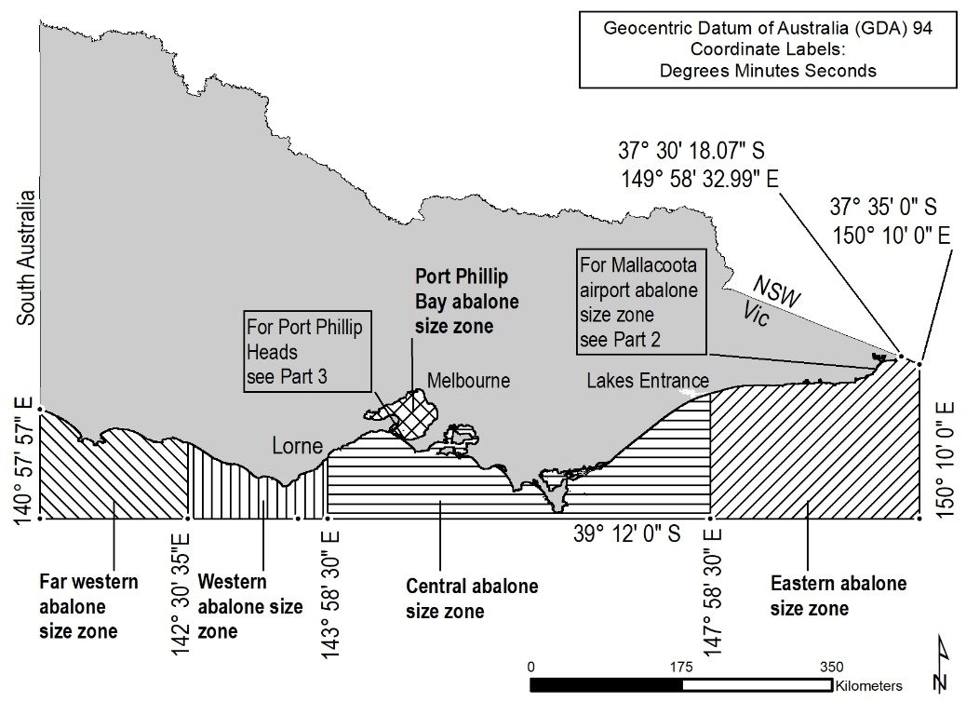
Note
The Port Phillip Bay abalone size zone does not include Swan Bay.

Part 2—Mallacoota airport abalone size zone
Regulation 5
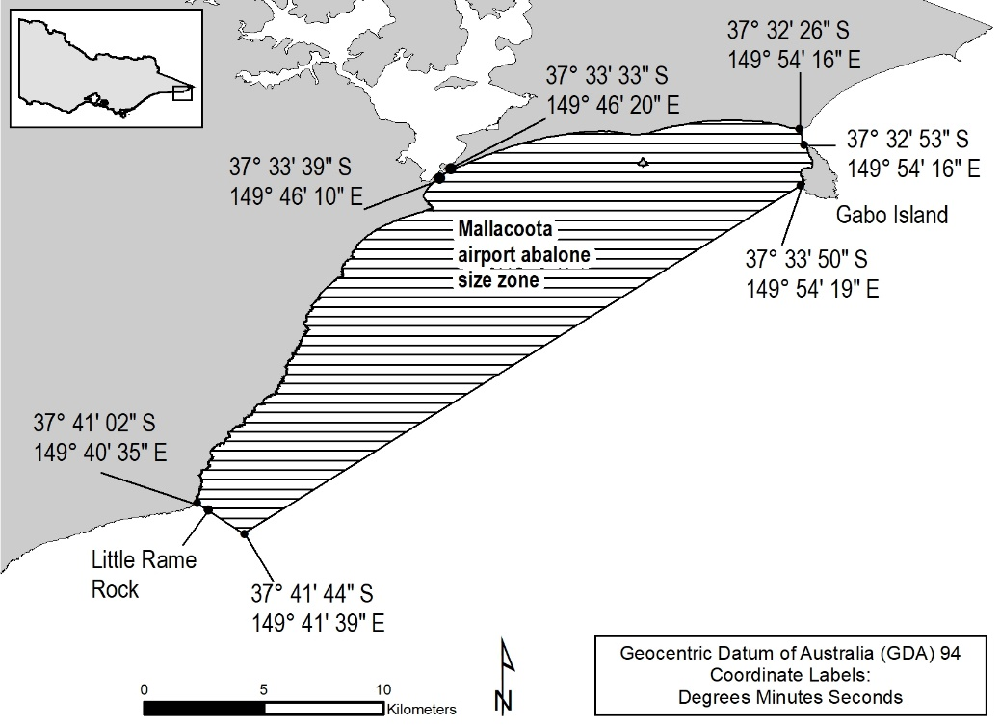
Part 3—Port Phillip Bay abalone size zone boundary near Port Phillip Heads
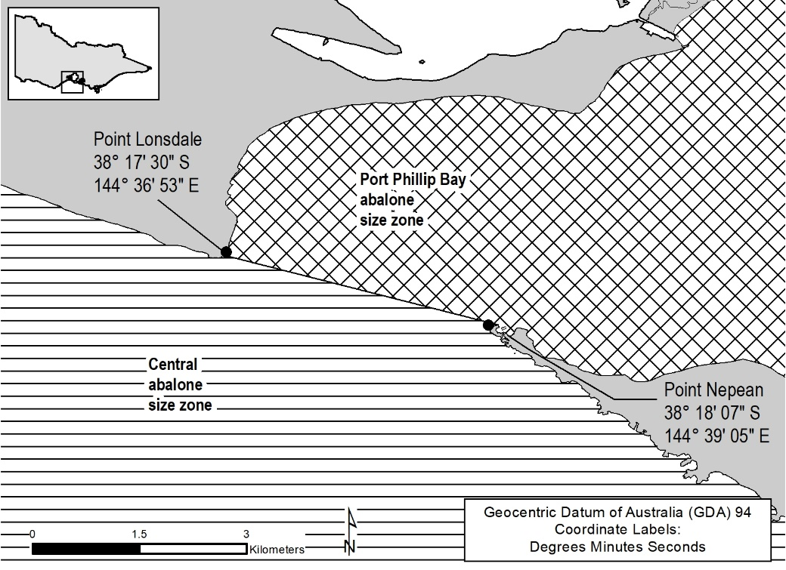

Schedule 4—Abalone zones
Regulation 5
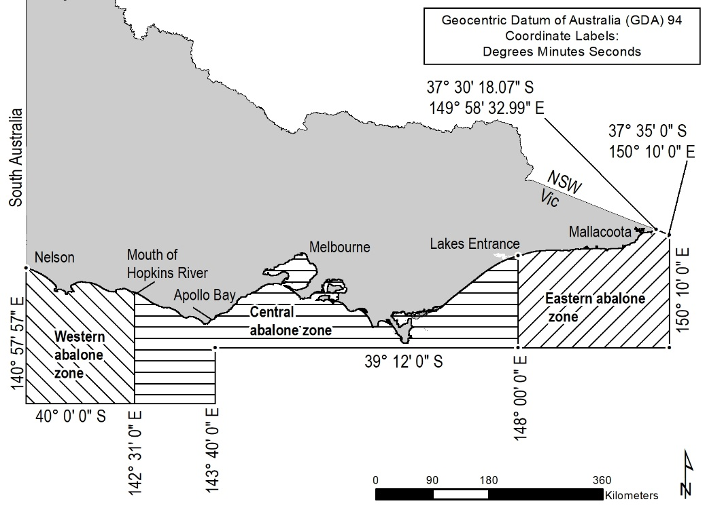

Schedule 5—Octopus commercial fishing management zones
Regulation 5

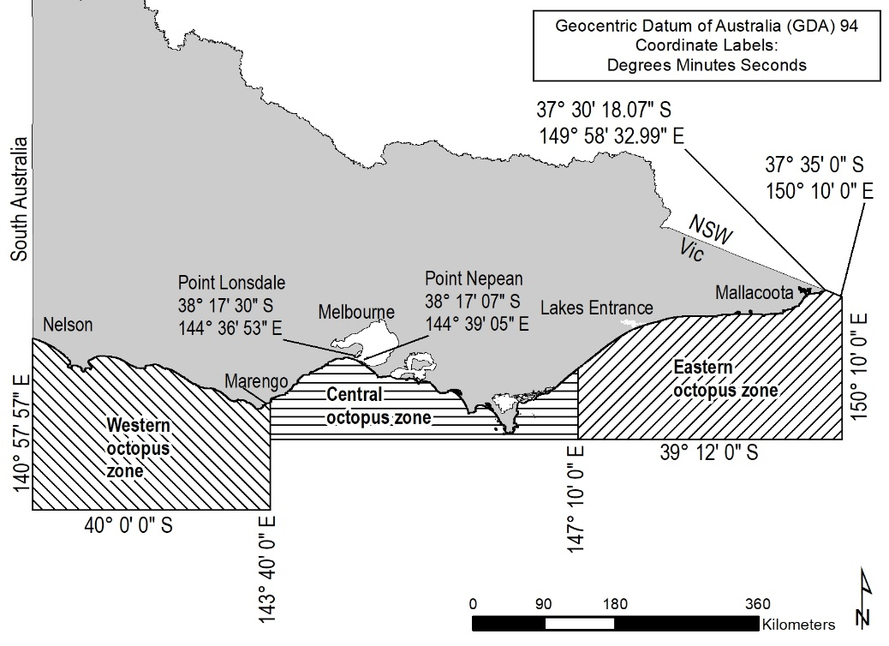

Schedule 6—Sea urchin commercial fishing management zones and ports and mooring areas
Part 1—Sea urchin commercial fishing management zones
Regulation 5
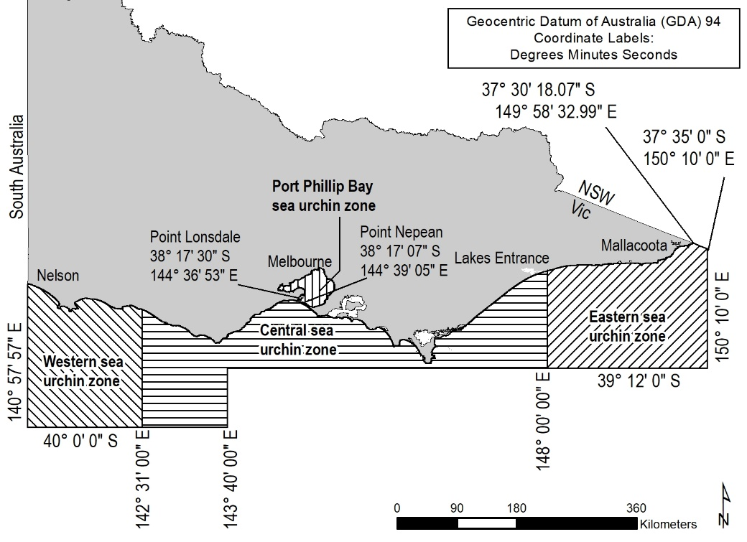
Note
The Port Phillip Bay sea urchin zone does not include Swan Bay.

Part 2— Sea urchin commercial fishing ports and mooring areas
Regulation 81(1)(e)
Altona Boat Ramp Car Park
Apollo Bay Boat Ramp
Avalon Boat Ramp
Bastion Point
Bay of Islands Boat Ramp
Black Rock Boat Ramp
Cape Bridgewater Beach
Cape Conran Boat Ramp
Clifton Springs Boat Ramp
Cowes Jetty
Flinders Boat Ramp
Frankston Boat Ramp
Hastings Boat Ramp
Inverloch Boat Ramp
Killarney Boat Ramp
Kirks Point
Lorne–Grey Point Boat Ramp
Mallacoota Main Wharf
Marlo Jetty
Mornington Boat Ramp (Schnapper Point)
Newhaven Boat Ramp
Ocean Grove Boat Ramp
Patterson River Boat Ramp
Peterborough–Boat Bay Carpark
Pier 35
Port Albert Boat Ramp
Port Campbell Jetty
Port Fairy Boat Ramp
Portland Boat Ramp
Portland Fishermans Wharf
Port Welshpool Boat Ramp
Queenscliff Boat Ramp
Rhyll Boat Ramp
Rye Boat Ramp
St Helens Boat Ramp
St Kilda Marina Carpark
Sandy Point
San Remo Fishermans Wharf
Shallow Inlet Carpark
Sorrento Boat Ramp
Stony Point Boat Ramp
Taylors Bay Boat Ramp
The Basin Carpark (Killarney)
Torquay Boat Ramp
Walkerville North
Walkerville South
Wally's Ramp (Allestree)
Warrnambool Boat Ramp
Werribee South Boat Ramp
West Bank Ramp (Nelson)

Schedule 7—Central Victorian waters
Regulation 5
Part 1—Central Victorian waters
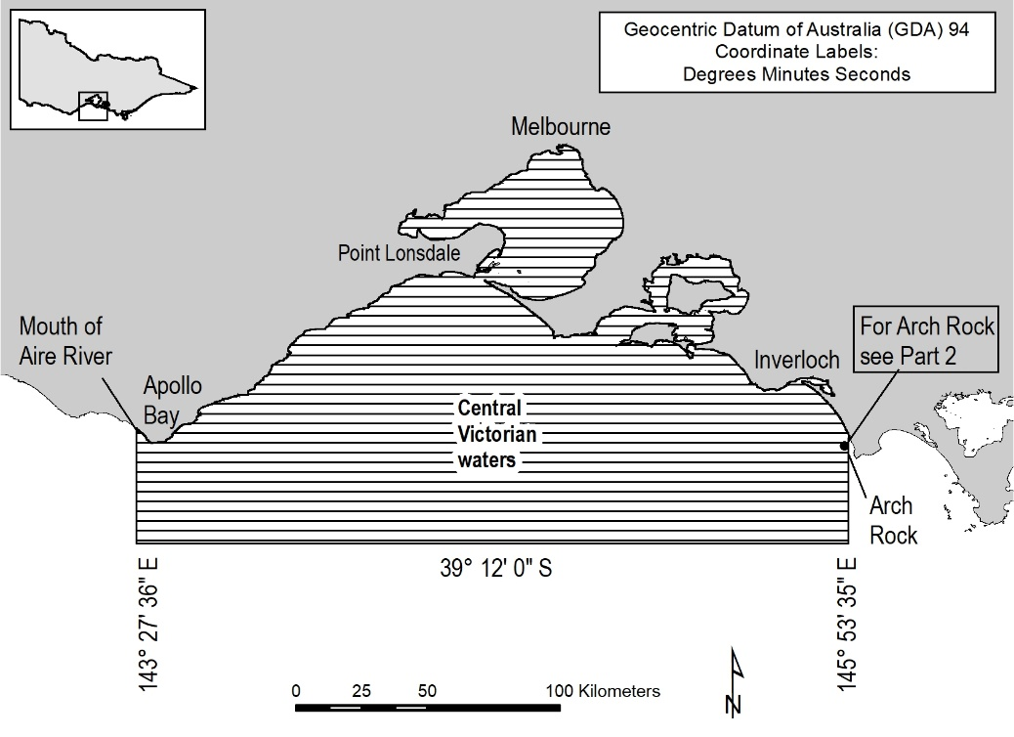

Part 2—Central Victorian waters boundary near Arch Rock
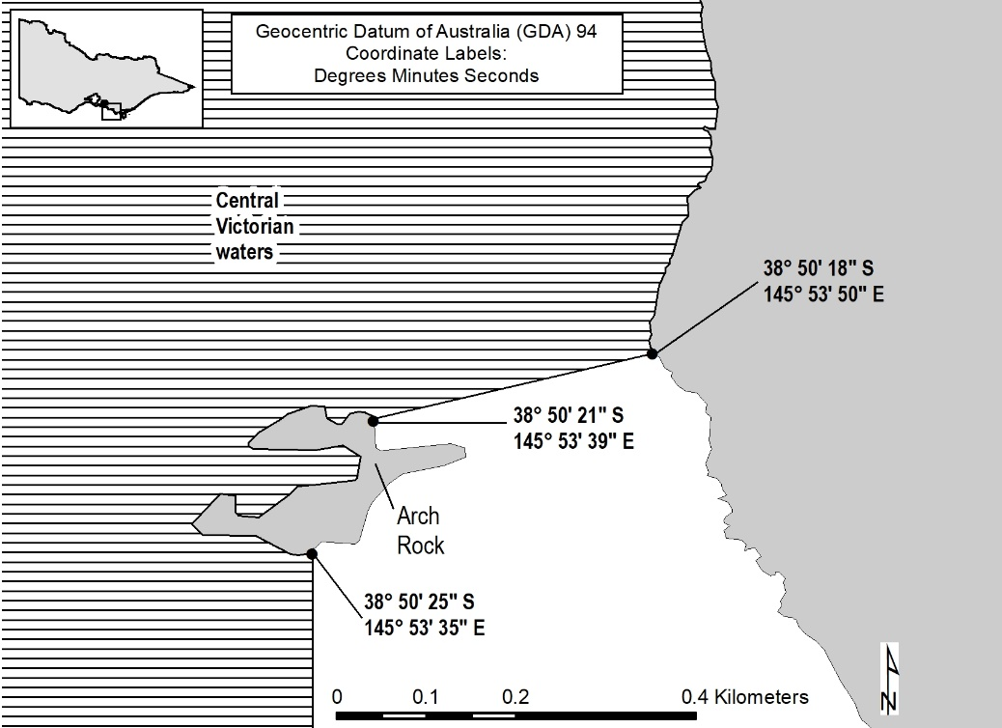

Schedule 8—Pipi fishing zones and designated access points
Part 1—Pipi commercial fishing management zones
Regulation 5
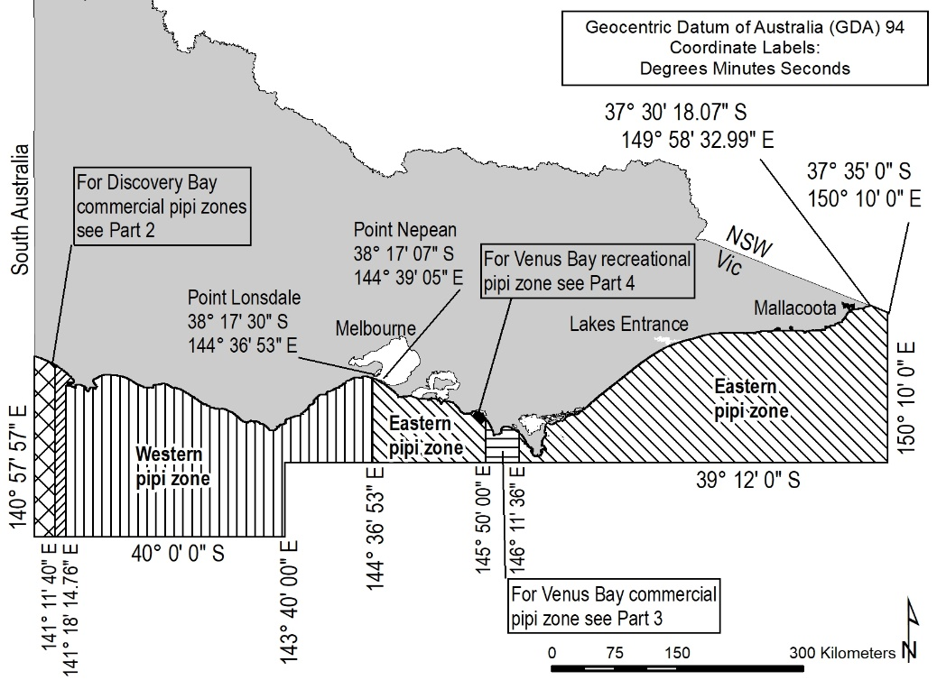

Part 2—Discovery Bay pipi zones
Regulation 5
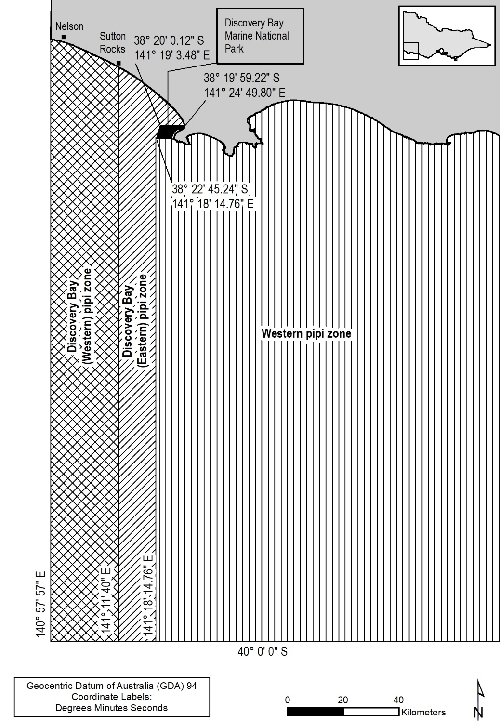

Part 3—Venus Bay commercial pipi zone
Regulation 5
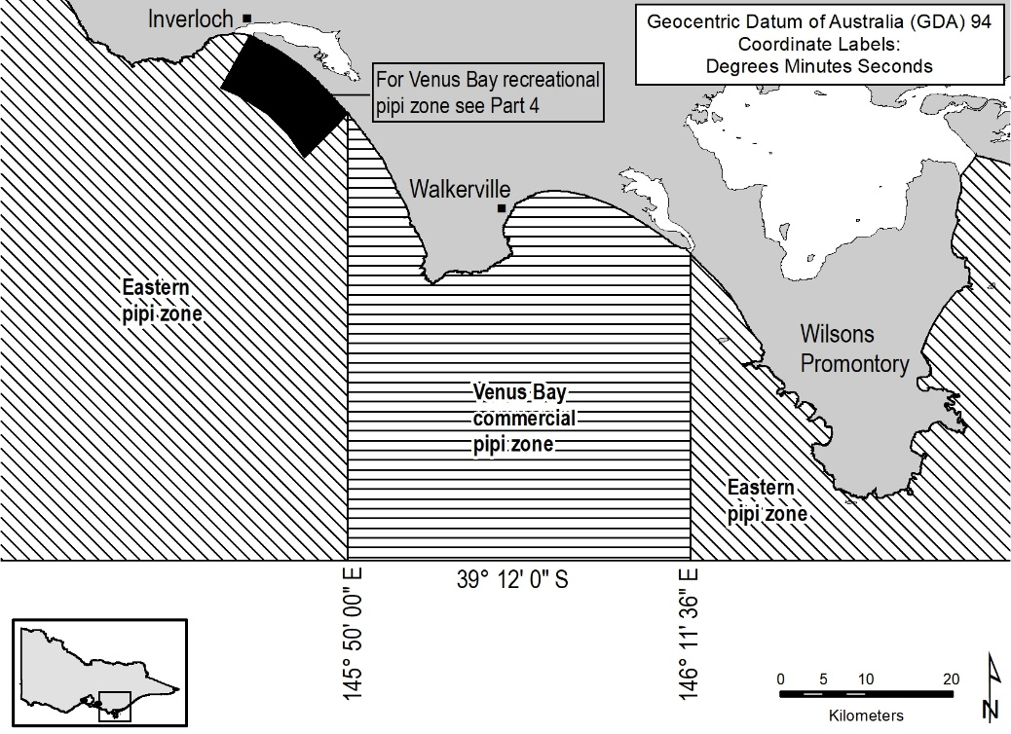

Part 4—Venus Bay recreational pipi zone
Regulation 5
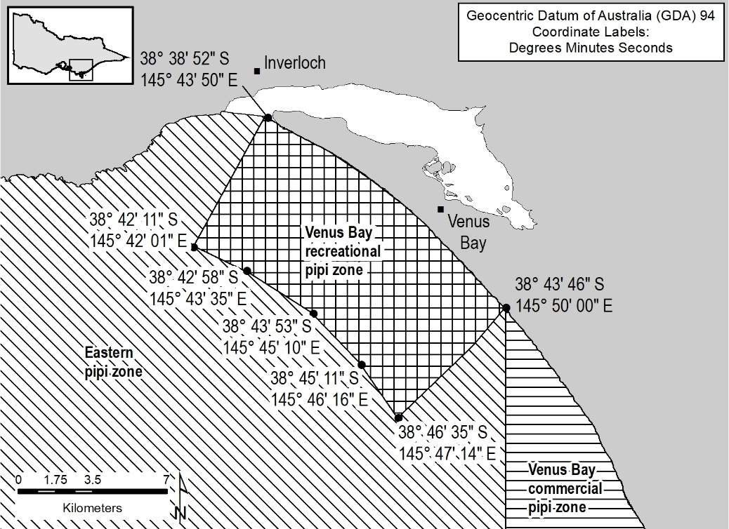

Part 5—Designated access points for commercial fishing in Discovery Bay pipi zone
Regulation 5
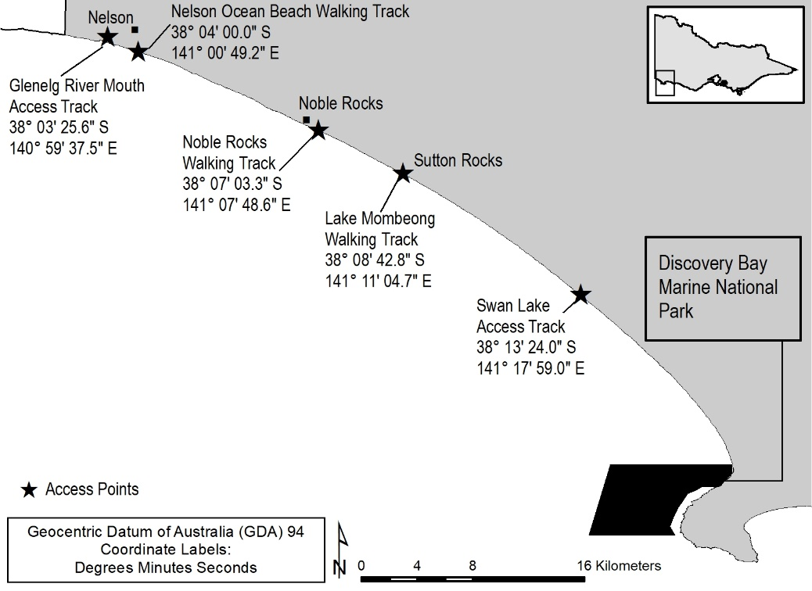

Schedule 9—Rock lobster zones
Regulation 5
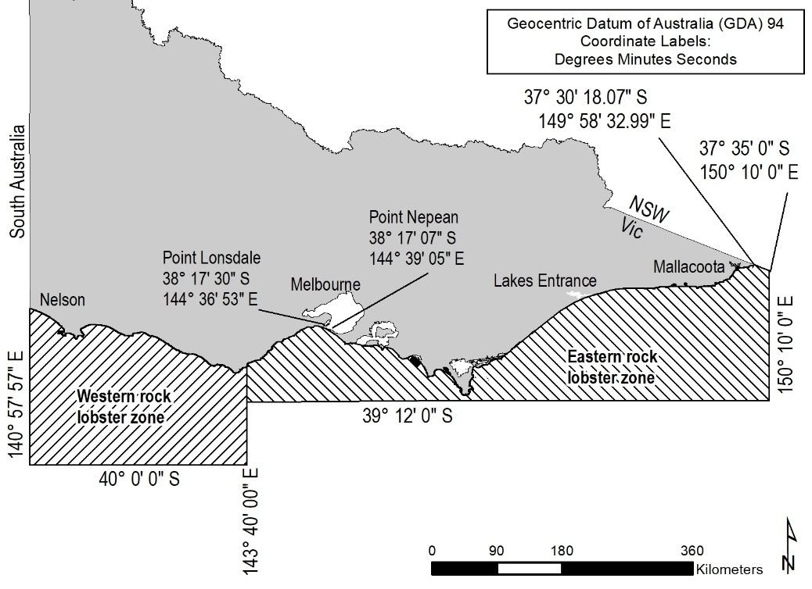

Schedule 10—Snapper zones
Regulation 5
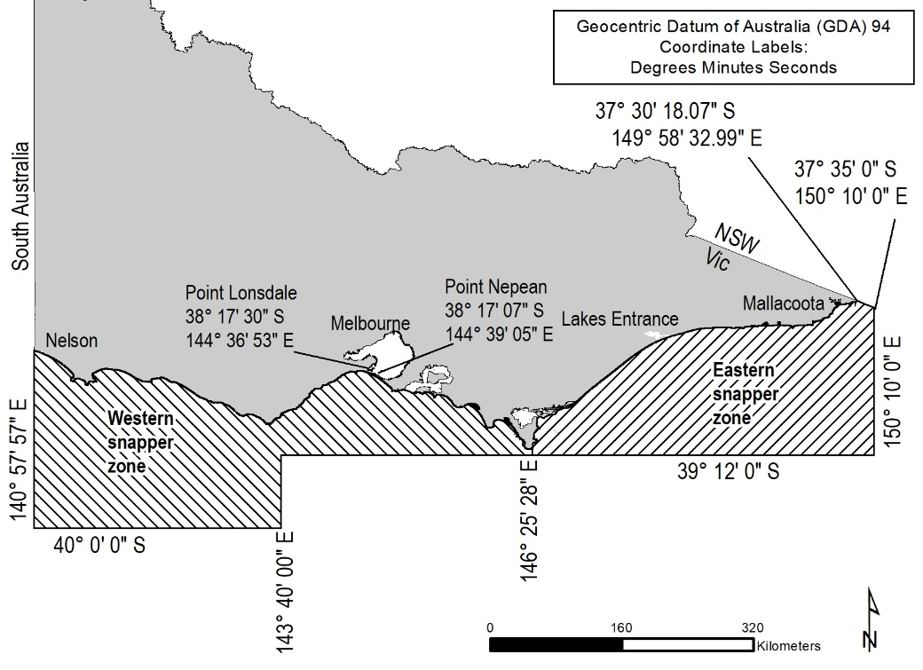

Schedule 11—Family fishing lakes
Regulation 5
Albert Park Lake, Albert Park
Alexandra Lake, Ararat
Allans Flat Dredge Hole, Allans Flat
Anderson Lake, Chiltern
Arboretum Dam, Euroa
Bannockburn Lagoon, Bannockburn
Barge Dam, Stanley (also known as Stanley Ditch Dam)
Bartlett Lake, Tatura
Belvoir Park Lake (also known as Sumsion Gardens Lake), Wodonga
Berwick Springs Estate Lake, Narre Warren South
Boyds Waters, Waurn Ponds
Calembeen Lake, Creswick
Casey Fields Lake, Cranbourne
Cato Lake, Stawell
Caulfield Racecourse Lake, Caulfield
Cobden Lake, Cobden
Coleraine Lagoon, Coleraine
Crusoe Reservoir, Big Hill (Bendigo)
Darlingsford Lake, Melton
Don Lake, Healesville
Donald Caravan Park Lake, Donald (also known as Foletti Caravan Park Lake)
Dunkeld Arboretum, Dunkeld
Eildon Pondage, Eildon
Emerald Lake, Emerald
Esmond Lake, Ballarat
Ess Lagoon, Casterton
Expedition Pass Reservoir, Golden Point (Castlemaine)
Felltimber Creek Wetlands, West Wodonga
Ferntree Gully Quarry Lake, Ferntree Gully
Forest Lake, Kangaroo Flat
Garfield Lake, Garfield
Glenlyon Dam, Glenlyon
Goldfields Reservoir, Maryborough
Golf Course Dam, Longwood
Great Western Recreation Reserve Lake, Great Western
Haddon Reservoir, Haddon
Hanging Rock Lake, Hanging Rock
Harrietville Dredge Hole, Harrietville
Heyfield Racecourse Lake, Heyfield
Hill Lake, Rowville
Hyland Lake, Churchill
Jack Emmett Billabong, Rupanyup (also known as Jack Emmett Lagoon)
Jubilee Lake, Daylesford
Jubilee Lake, Skipton
Karkarook Lake, Moorabbin
Kennington Reservoir, Strathdale
Kerferd Lake, Stanley
Les Stone Park Lake, Wodonga
Lethbridge Lake, Lethbridge
Lilliput Lane Reserve Lake, Pakenham
Lillydale Lake, Lilydale
Lismore Golf Club Dam, Lismore
Marma Lake, Murtoa
Marysville Lake, Marysville
Merriwa Park Lake, Wangaratta
Minyip Wetlands, Minyip
Mooroopna Recreation Reserve Lake, Mooroopna
Morwell Lake, Morwell (also known as Kernot Lake)
Mt Beauty Pondage, Mt Beauty
Navan Park Lake, Harkness
Neanger Lake, Eaglehawk
Nhill Lake, Nhill
Numurkah Lake, Numurkah
Old Hamilton Reservoir, Hamilton
Pakenham Lake, Pakenham
Pertobe Lake, Warrnambool
Police Paddock Dams, Dooen
Quarry Street Reserve Lake, Trentham
Rokewood Reservoir, Rokewood
Roxburgh Park Lakes, Roxburgh Park
St Augustines Water Hole, Highton
Sambell Lake, Beechworth
Sandy Creek Reservoir, Sandy Creek
Simpson Recreation Reserve Lakes, Simpson
Spavin Lake, Sunbury
Sutton Lake, Rowville
Tchum Lake, Narraport
Tea Tree Lake, Mortlake
The Gong, Buninyong
Tom Thumb Lake, Eaglehawk
Victoria Lake, Ballarat
Victoria Lake, Shepparton
Walter J Smith Reserve Lake, Riddells Creek
Yarrambat Park Lake, Yarrambat

Schedule 12—Murray cod waters
Regulation 5
Albert Park Lake
Benalla Lake
Big Meran Lake
Boga Lake
Booroopki Swamp
Buffalo Lake
Cairn Curran Reservoir
Charlegrark Lake
Charm Lake
Cullulleraine Lake
Eildon Lake
Eppalock Lake
First Reedy Lake
Greens Lake
Hume Lake
Kangaroo Lake
Kow Swamp
Laanecoorie Reservoir
Lascelles Lake
Moodemere Lake
Nagambie Weir (including all impounded waters upstream of Nagambie Weir to Chinamans Bridge on the Goulburn River and including Lake Nagambie)
Nillahcootie Lake
Rocklands Reservoir
Taylors Lake
Victoria Lake (Shepparton)
Walkers Lake
Waranga Basin

Schedule 13—Recreational reef zones
Regulation 5
Part 1—Port Phillip Bay
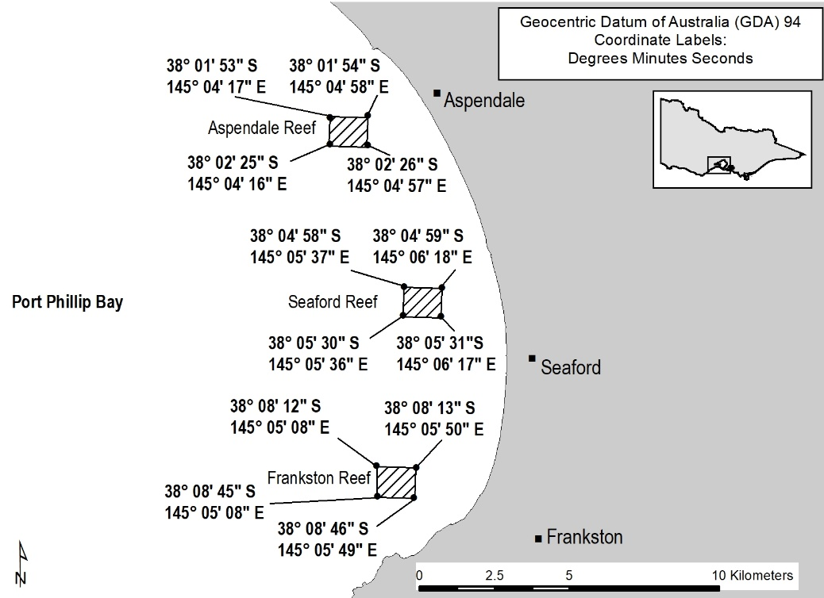

Part 2—Gippsland Lakes
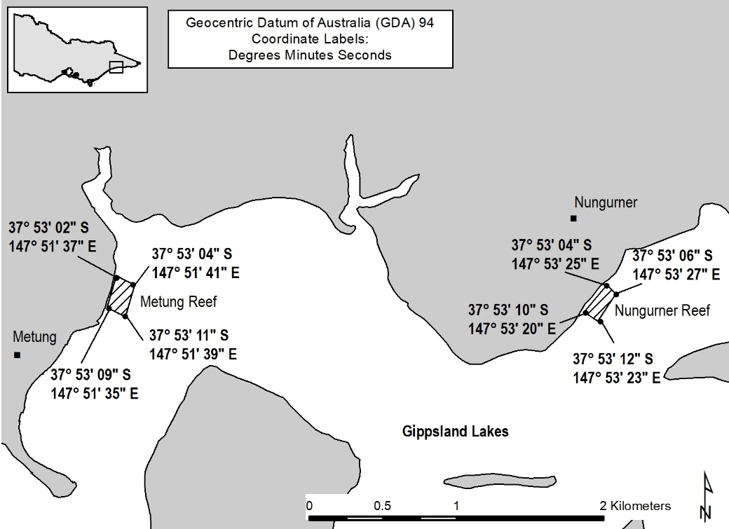

Part 3—Torquay
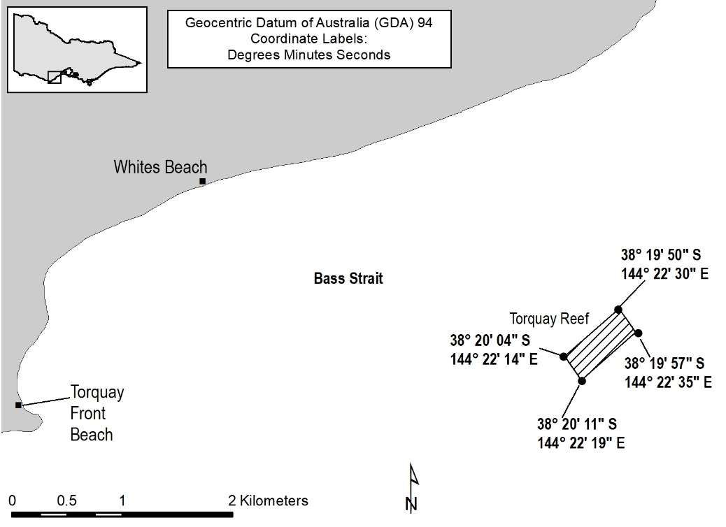

Schedule 14—Scallop Dive (Port Phillip Bay) Fishery Access Licence exclusion zones and ports and mooring areas
Part 1—Scallop commercial fishing exclusion zone at Indented Head
Regulation 5
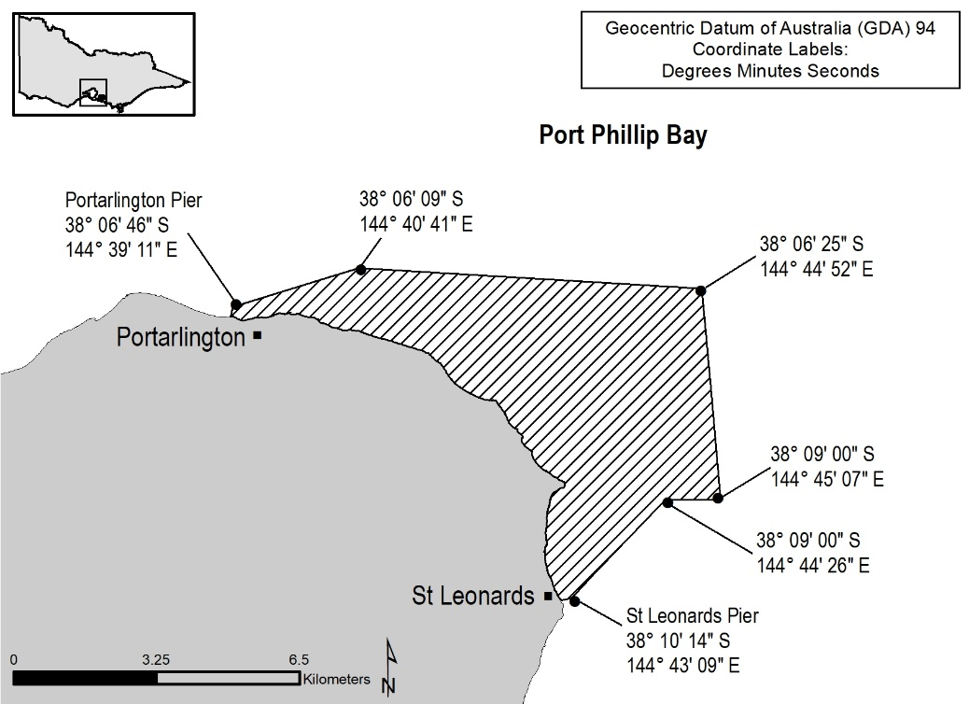

Part 2—Scallop commercial fishing exclusion zone at Rye
Regulation 5
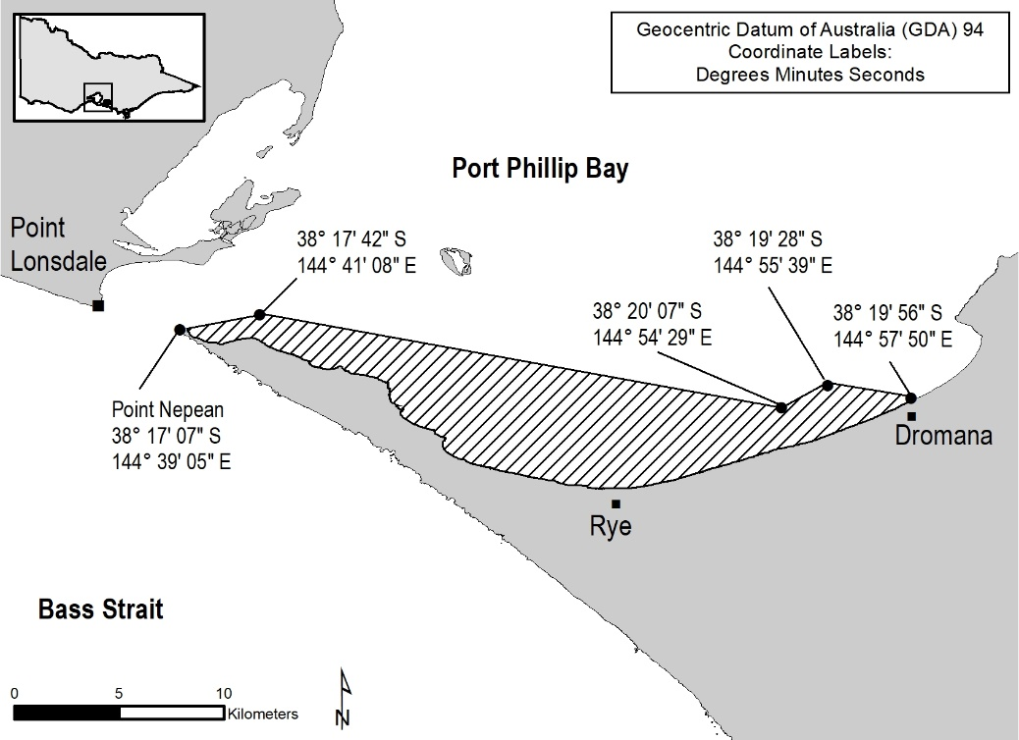

Part 3—Scallop commercial fishing ports and mooring areas
Regulation 81(1)(d)
Altona Boat Ramp
Avalon Boat Ramp
Black Rock Boat Ramp
Clifton Springs Boat Ramp
Frankston Boat Ramp
Kirk Point Boat Ramp
Limeburners Point Boat Ramp
Mordialloc Boat Ramp
Mornington Boat Ramp (Schnapper Point)
Newport (Warmies) Boat Ramp
Patterson River Boat Ramp
Point Richards Boat Ramp
Portarlington Boat Ramp
Queenscliff Boat Ramp
Safety Beach Boat Ramp
St Helens Boat Ramp
St Kilda Marina Carpark
St Leonards Boat Ramp
Werribee South Boat Ramp
Williamstown Boat Ramp
Wyndham Harbour

Schedule 15—Sea-run trout rivers
Regulation 5
Aire River (downstream of the Great Ocean Road)
Avon River (downstream of the Stratford Railway Bridge)
Ford River (downstream of the Great Ocean Road)
Gellibrand River (downstream of the Great Ocean Road)
Hopkins River
Merri River
Mitchell River (downstream of the Princes Highway Bridge at Bairnsdale)
Moyne River
Tambo River (downstream of the Bruthen Road Bridge)

Schedule 16—Definitions of fisheries
Regulation 7
Column 1  Item No. | Column 2  Fishery | Column 3  Species of fish | Column 4  Type of fishing equipment | Column 5  Area of waters
1 | Abalone  (Commercial) | Abalone | — | Marine waters
2 | Bait (General)  (Commercial) | — | As specified in the licence under regulation 43 | Protected waters as specified in the licence under regulation 43
3 | Banded Morwong  (Commercial) | Banded Morwong | — | Marine Waters east of longitude 147° 13' 22'' East (other than the Gippsland Lakes and any inlet of the sea)
4 | Corner Inlet  (Commercial) | — | — | Corner Inlet
5 | Eel  (Commercial) | Eel | Fyke nets | —
6 | Giant Crab  (Commercial) | — | Rock lobster pots | Marine waters west of longitude 143° 40' East
7 | Gippsland Lakes  (Commercial) | — | — | Gippsland Lakes
8 | Gippsland Lakes (Bait)  (Commercial) | — | — | Gippsland Lakes
9 | Gippsland Lakes (Mussel Dive)  (Commercial) | Mussel | Underwater breathing apparatus | Gippsland Lakes
10 | Inland waters  (Recreational) | — | Recreational fishing equipment | Inland waters, including Lake Hume, excluding Lake Mulwala
11 | Lake Tyers (Bait)  (Commercial) | — | — | Lake Tyers
12 | Mallacoota Lower Lake (Bait)  (Commercial) | — | — | Lower Lake at Mallacoota
13 | Marine waters  (Commercial) | — | — | Marine waters
14 | Marine waters  (Recreational) | — | Recreational fishing equipment | Marine waters
15 | Ocean  (Commercial) | — | — | Marine waters (other than Port Phillip Bay, Western Port, Gippsland Lakes and any inlet of the sea)
16 | Octopus  (Commercial) | Octopus | Octopus pots and octopus trigger traps | Marine waters (other than Port Phillip Bay, Western Port, Corner Inlet, Gippsland Lakes and any inlet of the sea)
17 | Pipi  (Commercial) | Pipi | Dip net | Marine waters (including the intertidal zone) other than—  (a) Port Phillip Bay, Western Port, Gippsland Lakes and any inlet of the sea; and  (b) Venus Bay recreational pipi zone
18 | Protected waters  (Commercial) | — | — | Protected waters excluding marine waters
19 | Purse Seine (Ocean)  (Commercial) | — | Purse seine nets, and lampara nets | Marine waters (other than Port Phillip Bay, Western Port, Gippsland Lakes and any inlet of the sea)
20 | Rock lobster  (Commercial) | — | Rock lobster pots | —
21 | Scallop (Ocean)  (Commercial) | Scallop | Scallop dredge | Marine waters (other than Port Phillip Bay, Western Port, Gippsland Lakes and any inlet of the sea)
22 | Scallop Dive (Port Phillip Bay)  (Commercial) | Scallop | Underwater breathing apparatus | Port Phillip Bay other than an area specified in regulation 405
23 | Sea urchin (Commercial) | Sea urchin | Underwater breathing apparatus | Eastern  sea urchin zone  Central  sea urchin zone  Western sea urchin zone  Port Phillip Bay sea urchin zone
24 | Snowy River (Bait)  (Commercial) | — | — | Snowy River
25 | Sydenham Inlet (Bait)  (Commercial) | — | — | Sydenham Inlet
26 | Trawl (Inshore)  (Commercial) | — | Trawl nets | Marine waters (other than Port Phillip Bay, Western Port, Gippsland Lakes and any inlet of the sea)
27 | Western Port/ Port Phillip Bay  (Commercial) | — | — | Western Port and Port Phillip Bay
28 | Wrasse (Ocean)  (Commercial) | Wrasse | — | Marine waters (other than Port Phillip Bay, Western Port, Gippsland Lakes and any inlet of the sea)

Schedule 17—Base number of licences for purposes of calculating maximum number of licences
Regulations 22 and 23
Column 1  Item No. | Column 2  Class of access licence | Column 3  Base number
1 | Abalone Fishery (Central Zone) Access Licence | 34
2 | Abalone Fishery (Eastern Zone) Access Licence | 23
3 | Abalone Fishery (Western Zone) Access Licence | 14
4 | Banded Morwong Fishery Access Licence | 2
5 | Corner Inlet Fishery Access Licence | 18
6 | Eel Fishery Access Licence | 18
7 | Giant Crab Fishery (Western Zone) Access Licence | 34
8 | Gippsland Lakes (Bait) Fishery Access Licence | 10
9 | Gippsland Lakes Fishery Access Licence | 10
10 | Gippsland Lakes (Mussel Dive) Fishery Access Licence | 2
11 | Lake Tyers (Bait) Fishery Access Licence | 2
12 | Mallacoota Lower Lake (Bait) Fishery Access Licence | 2
13 | Ocean Fishery Access Licence | 267
14 | Octopus Fishery Access Licence | 3
15 | Pipi Fishery Access Licence | 9
16 | Purse Seine (Ocean) Fishery Access Licence | 1
17 | Rock Lobster Fishery (Eastern Zone) Access Licence | 46
18 | Rock Lobster Fishery (Western Zone) Access Licence | 85
19 | Scallop (Ocean) Fishery Access Licence | 91
20 | Scallop Dive (Port Phillip Bay) Fishery Access Licence | 1
21 | Snowy River (Bait) Fishery Access Licence | 2
22 | Sydenham Inlet (Bait) Fishery Access Licence | 2
23 | Trawl (Inshore) Fishery Access Licence | 60
24 | Western Port/Port Phillip Bay Fishery Access Licence | 9
25 | Wrasse (Ocean) Fishery Access Licence | 27

Schedule 18—Catch limits for access licence holders
Regulation 72
Table A
Catch limits on certain species of fish when taken by access licence holder
Column 1  Item Number | Column 2  Species of fish | Column 3  Catch limit
1 | Albacore, skipjack tuna and longtail tuna and Ray's bream (Pomfret) combined | 10 fish
2 | Bigeye and yellowfin tuna combined | 2 fish
3 | Blue-eye trevalla and pink ling combined | 50 kilograms
4 | Jackass morwong | 50 kilograms
5 | John dory | 30 kilograms
6 | Mirror dory | 20 kilograms
7 | Ocean perch | 50 kilograms
8 | Redfish | 50 kilograms
9 | Warehou, blue | 100 kilograms
10 | Warehou, silver | 100 kilograms
11 | Yellow eye redfish | 50 kilograms
Note
Some of the species of fish to which catch limits apply under this Schedule are subject to further catch limits under regulation 161 and Schedule 24.

Regulation 73
Table B
Species of fish that may not be taken by access licence holder
Column 1  Item number | Column 2  Species of fish
1 | Bass groper
2 | Marlin (all species)
3 | Black oreodory
4 | Blue grenadier
5 | Gemfish
6 | Hapuku
7 | King dory
8 | Northern bluefin tuna
9 | Orange roughy
10 | Oxeye oreodory
11 | Smooth oreodory
12 | Southern bluefin tuna
13 | Spikey oreodory
14 | Swordfish
15 | Warty oreodory

Schedule 19—Ports and mooring areas at which giant crab and rock lobster may be landed
Regulations 81(1)(b), 81(1)(c),
352 and 379
Anglesea
Apollo Bay
Barwon Heads
Cape Bridgewater
Cape Conran
Cowes
Flinders
Hastings
Inverloch
Lakes Entrance
Lorne
Mallacoota
Marlo Jetty
McLoughlins Beach
Ocean Grove
Port Albert
Port Campbell
Port Fairy
Portland
Portsea Pier
Port Welshpool
Queenscliff
San Remo
Seaworks, Williamstown
Sorrento
Torquay
Ventnor
Walkerville South
Warrnambool

Schedule 20—Banded morwong commercial fishing ports and mooring areas
Regulation 81(1)(a)
Cape Conran Boat Ramp
Lakes Entrance North Arm Boat Ramp on Marine Parade (opposite Laura Street)
Bastion Point
Mallacoota Main Wharf
Marlo Jetty

Schedule 21—Western Port/Port Phillip Bay ports and mooring areas
Regulation 81(1)(f)
Altona Boat Ramp Car Park
Avalon Beach Boat Ramp
Black Rock Boat Ramp
Clifton Springs Boat Ramp
Corinella Boat Ramp
Cowes Jetty
Cowes West Boat Ramp
Dromana Boat Ramp
Fishermans Beach Boat Ramp
Fishermans Wharf Yarra Street
Flinders Boat Ramp
Grammar School Lagoon Boat Ramp
Hastings Boat Ramp
Indented Head Boat Ramp
Kananook Creek Boat Ramp
Kirks Point Boat Ramp
Limeburners Point Boat Ramp
Maddox Road (Williamstown)
Martha Cove
Mordialloc Boat Ramp
Mornington Boat Ramp (Schnapper Point)
Newhaven Boat Ramp
Newport (Warmies) Boat Ramp
North Road Boat Ramp
Patterson River Boat Ramp
Point Richards Boat Ramp
Portarlington Pier
Queenscliff Boat Ramp
Queenscliff Wharf
Rhyll Boat Ramp
Rosebud Boat Ramp
Rye Boat Ramp
Safety Beach Boat Ramp
St Helens Boat Ramp
St Kilda Marina Carpark
St Kilda Pier
St Leonards Boat Ramp
St Leonards Pier
San Remo Fishermans Wharf
Sorrento Boat Ramp
Stoney Point Boat Ramp
Swan Bay Boat Ramp
Tootgarook Boat Ramp
Werribee South Boat Ramp

Schedule 22—Toorloo Arm and Nowa Nowa Arm of Lake Tyers
Regulation 121(4)
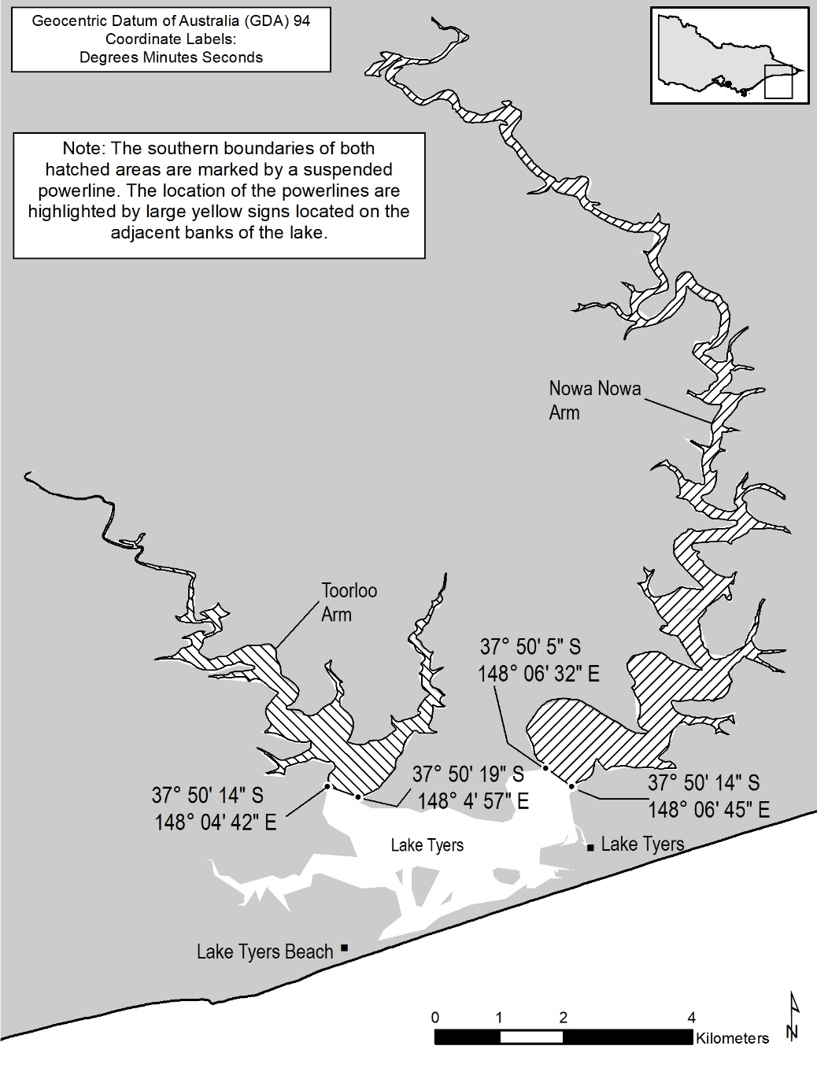

Schedule 23—Areas in the Gippsland Lakes where use of commercial fishing equipment by Gippsland Lakes Fishery Access Licence holders is prohibited
Regulations 144 and 198(1)
Gippsland Lakes River Mouth Exclusions—
Avon River–Perry River
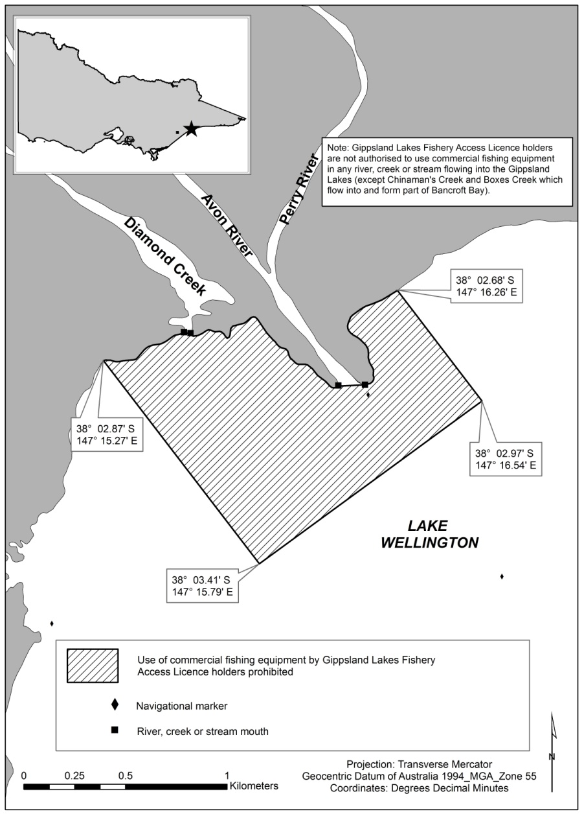
Gippsland Lakes Exclusions—Lake Reeve
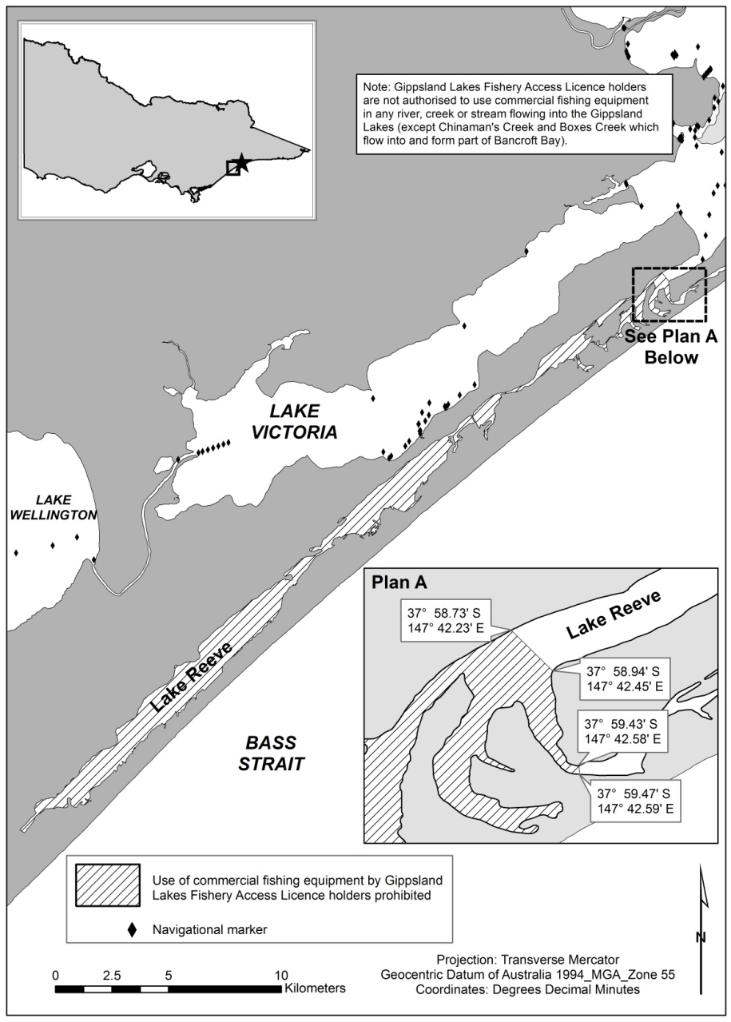

Gippsland Lakes River Mouth Exclusions—Latrobe River
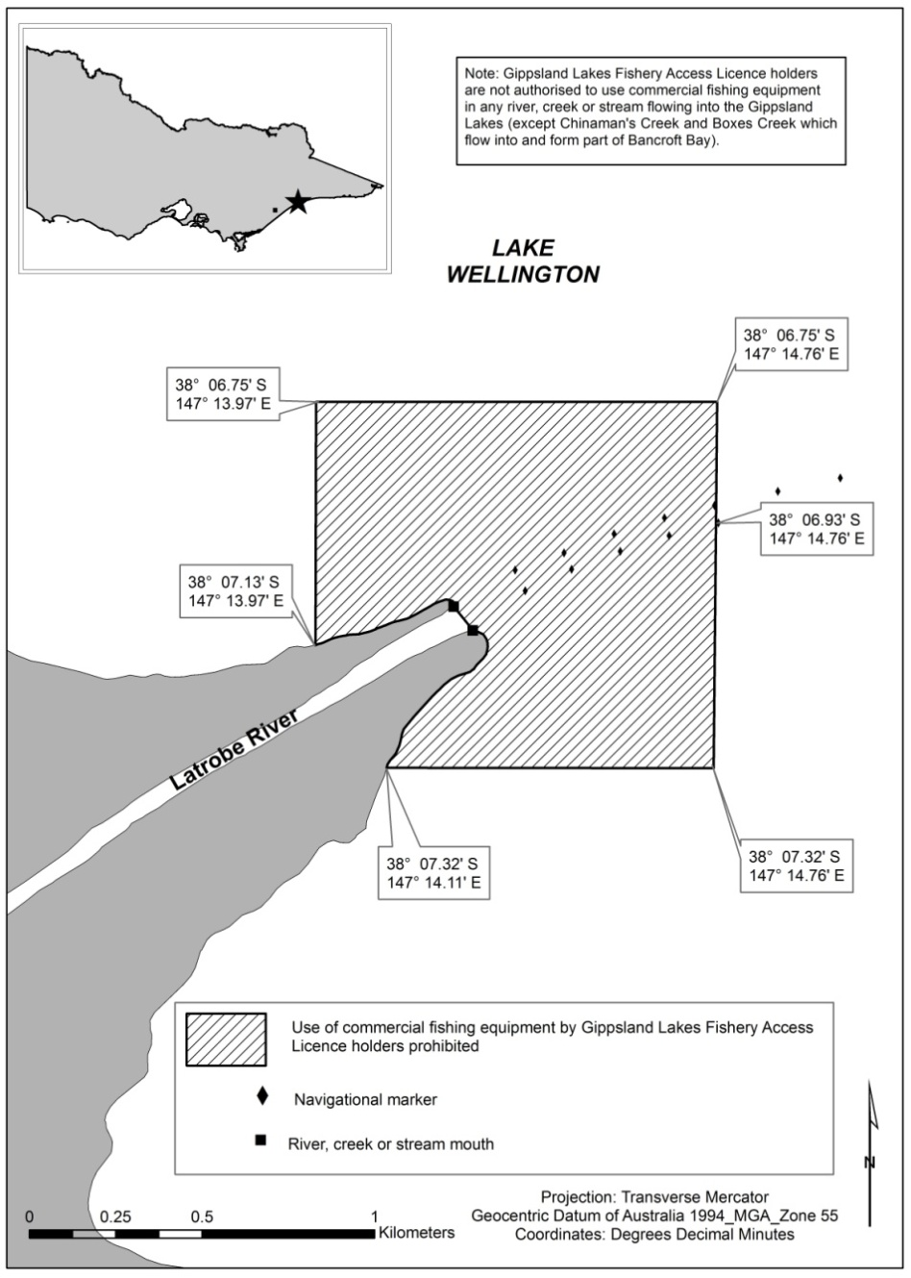

Gippsland Lakes River Mouth Exclusions—Maringa Creek
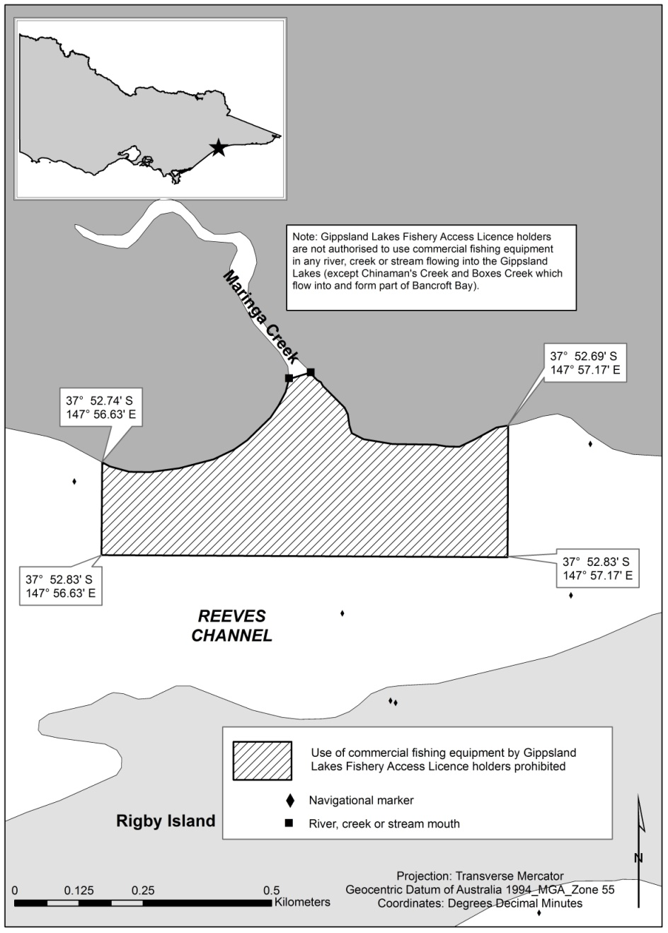

Gippsland Lakes Exclusions—McLennan Straits
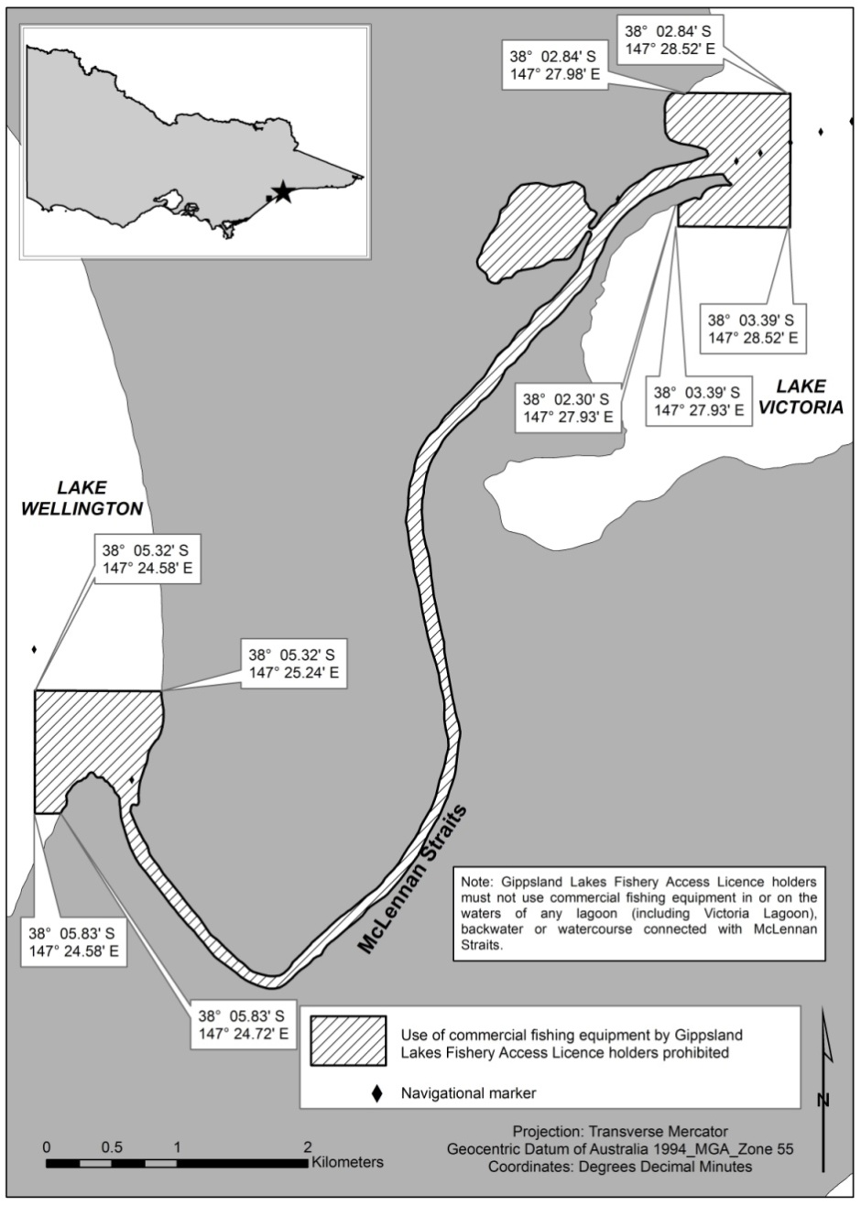

Gippsland Lakes River Mouth Exclusions—Mitchell River
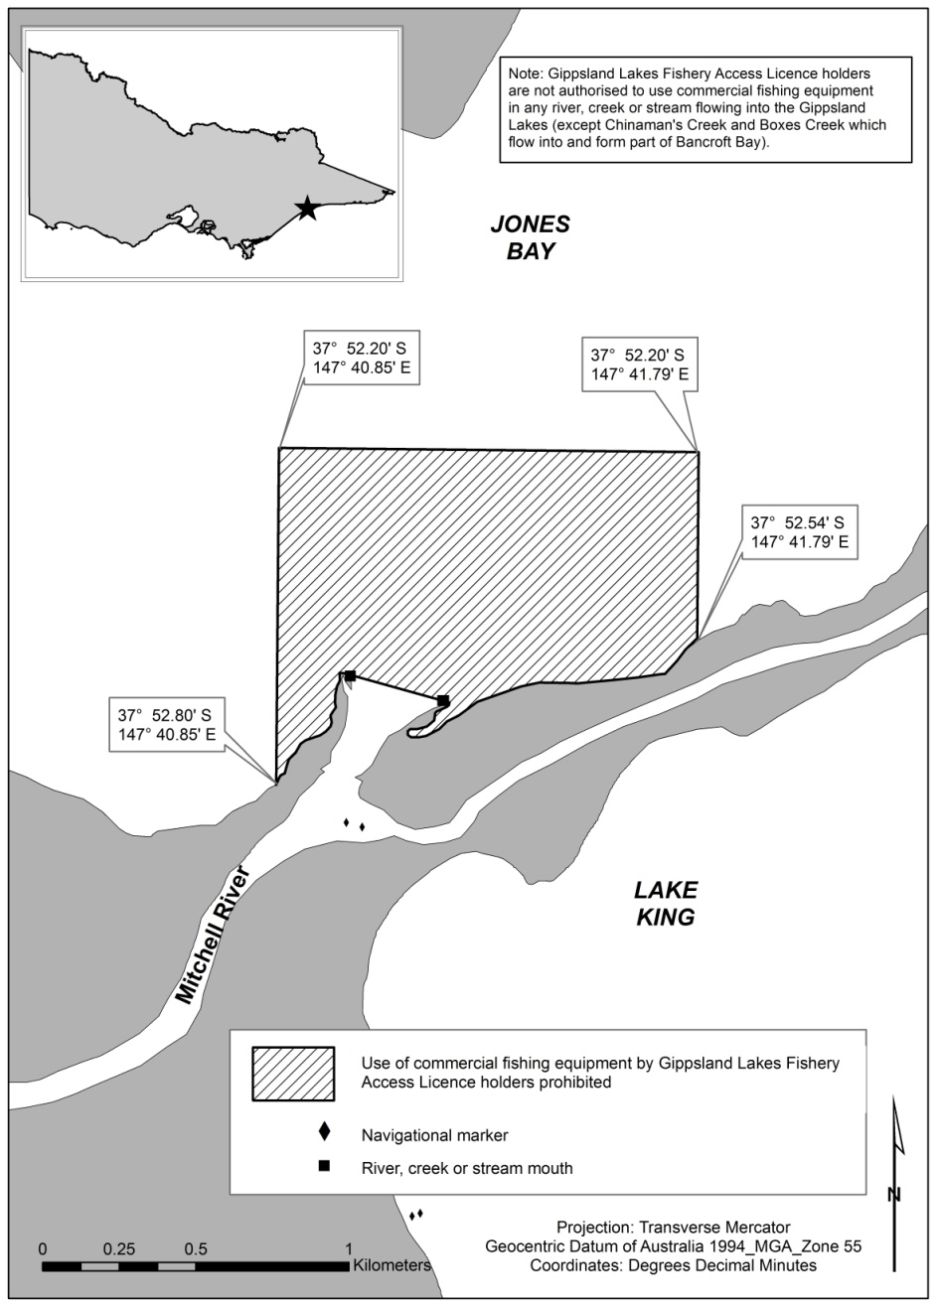

Gippsland Lakes River Mouth Exclusions—Nicholson River and Mitchell River
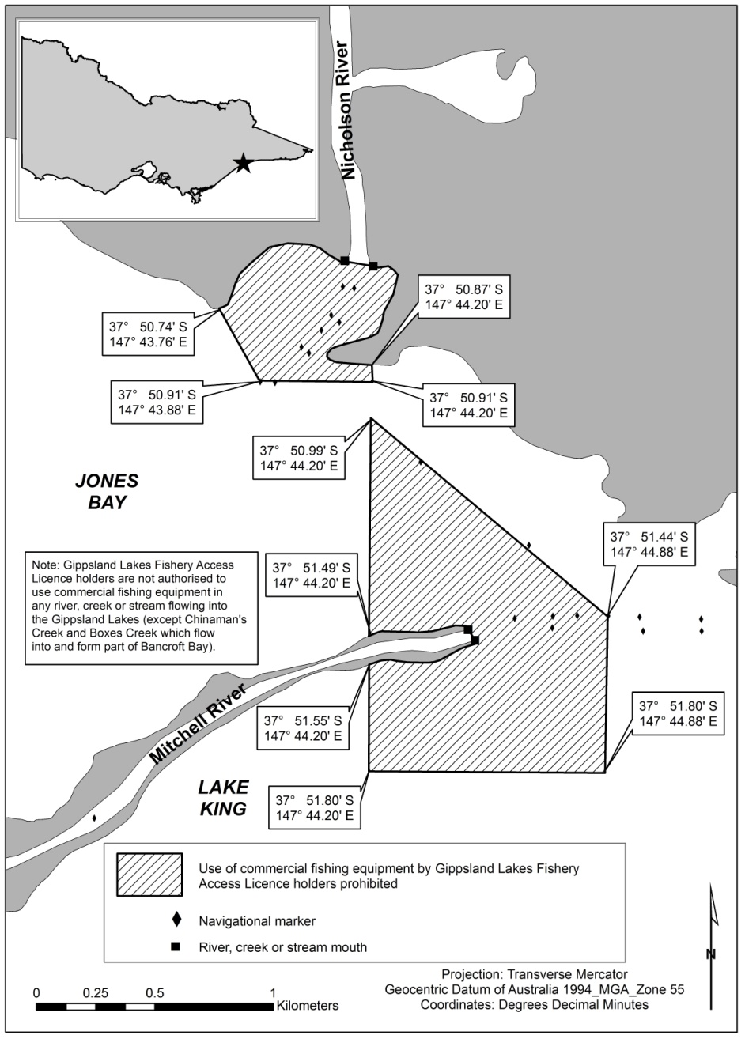

Gippsland Lakes Exclusions—North Arm
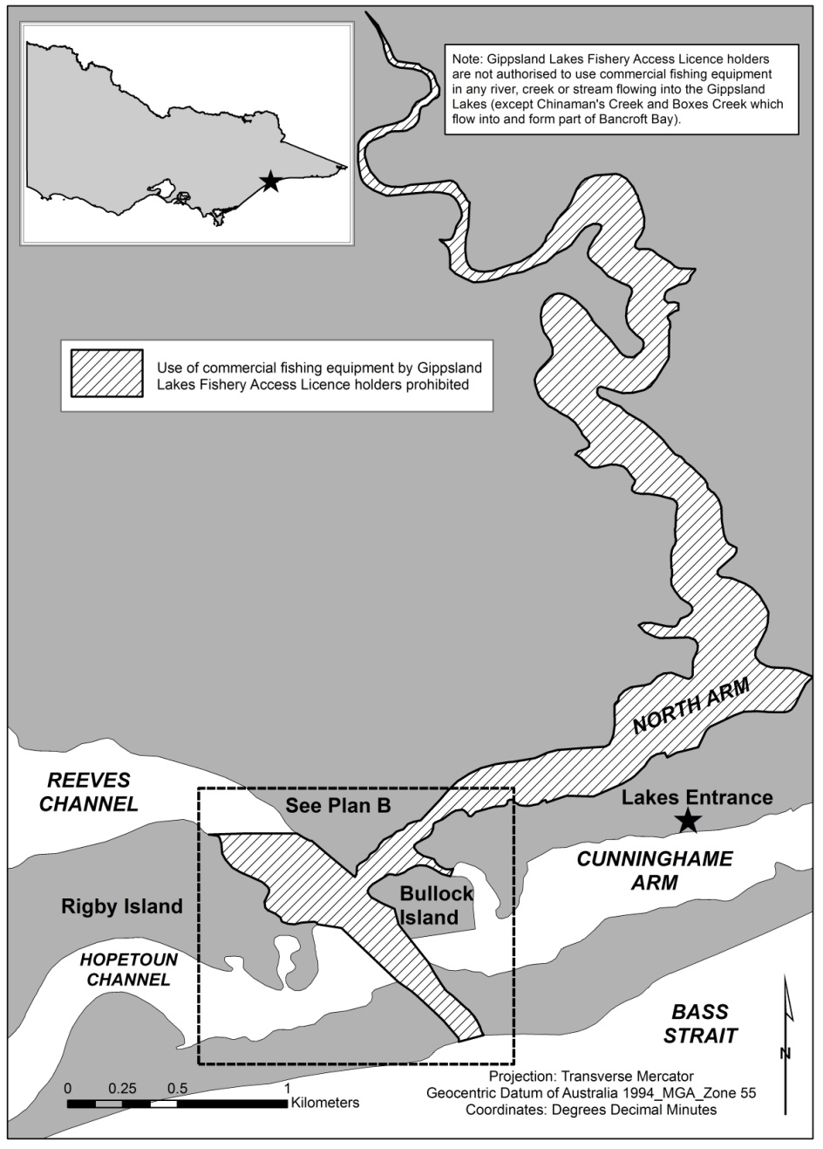

Gippsland Lakes Exclusions—North Arm Plan B
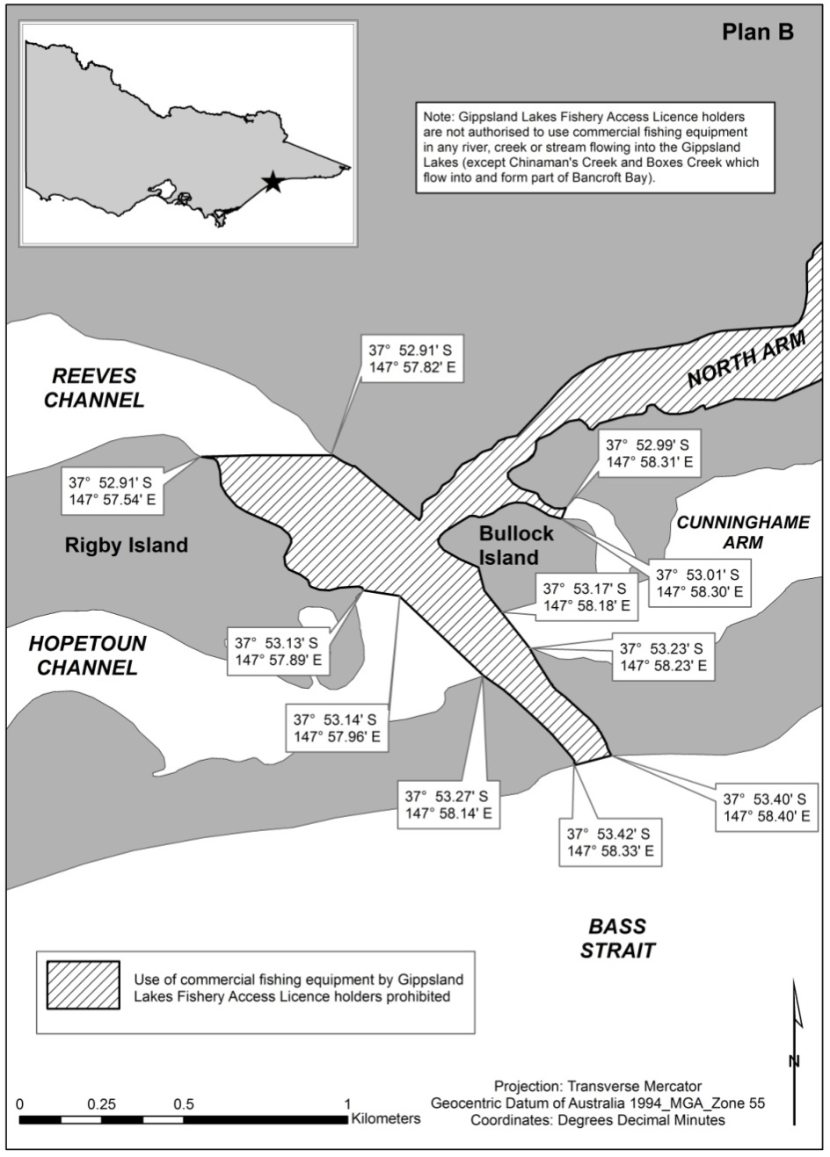

Gippsland Lakes River Mouth Exclusions—Tambo River
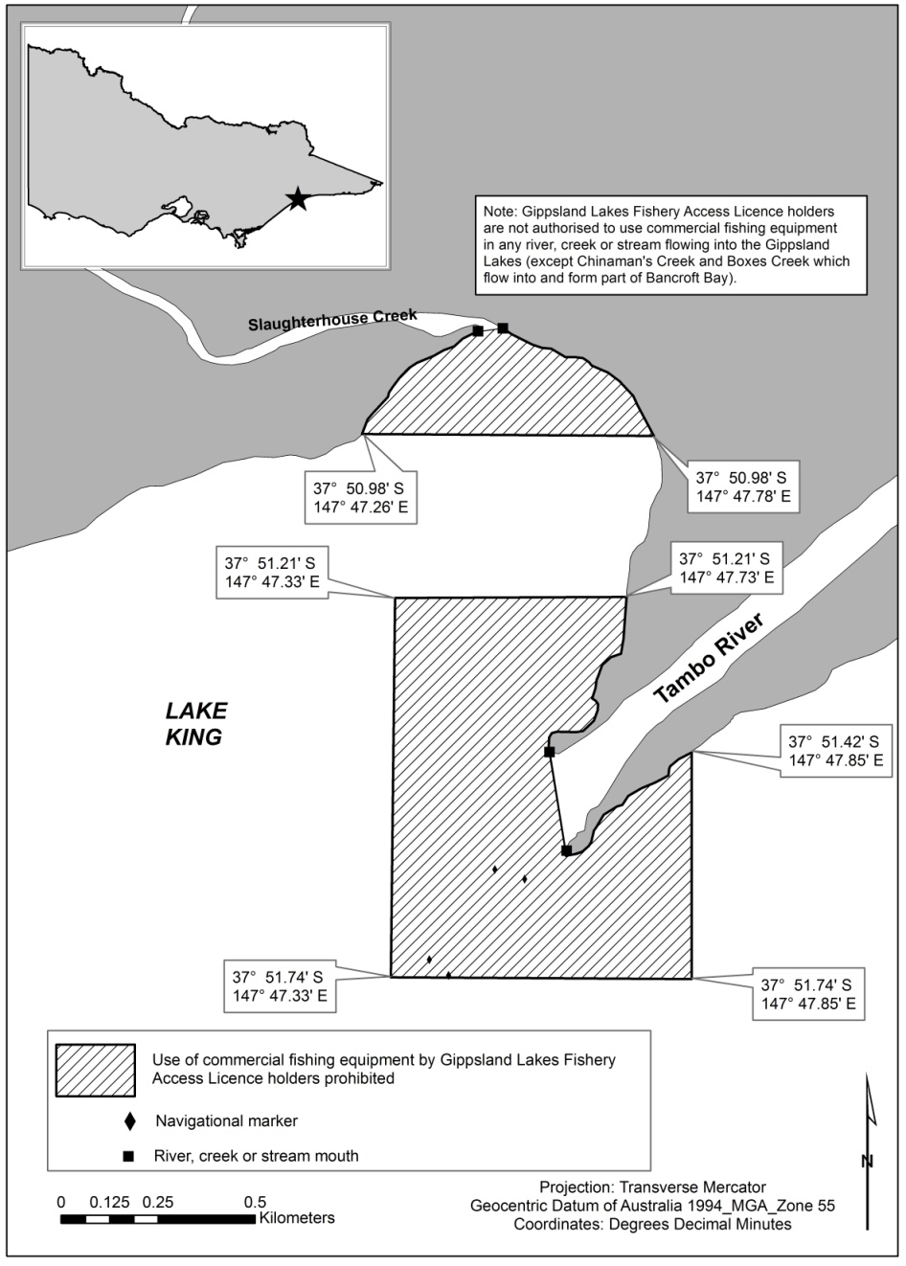

Gippsland Lakes River Mouth Exclusions—Toms Creek
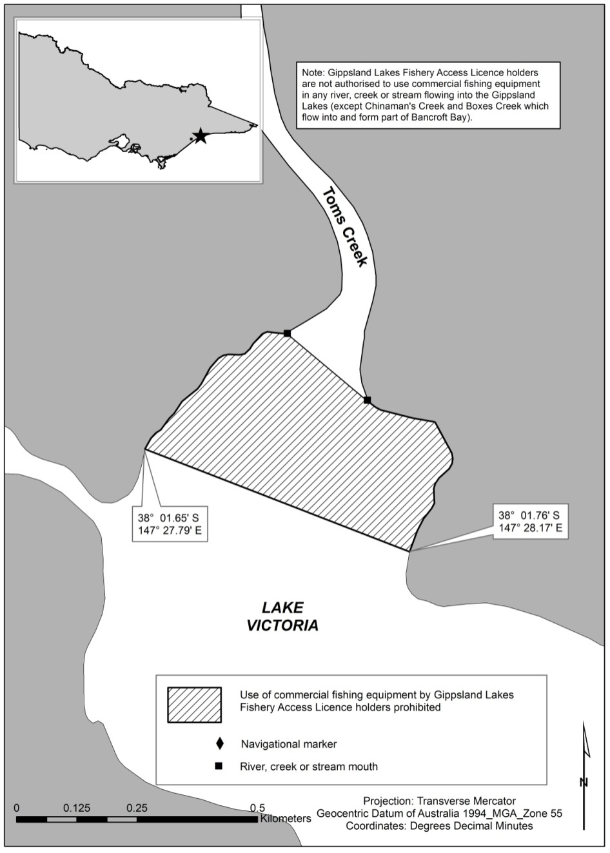

Gippsland Lakes River Mouth Exclusions—
Tom Roberts Creek
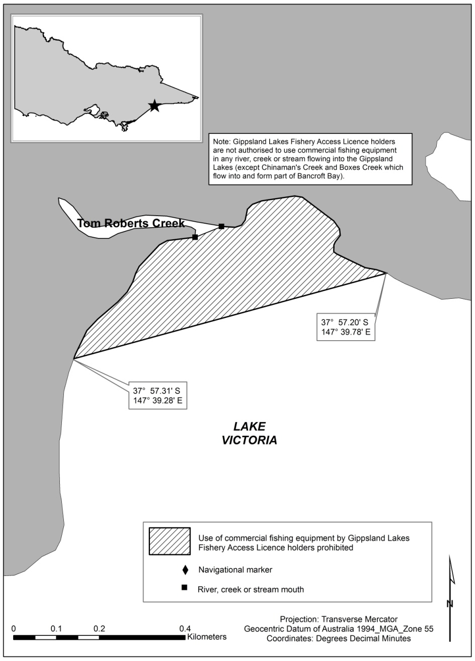

Schedule 24—Minimum and maximum sizes and catch limits for fish (other than abalone, giant crab, noxious aquatic species, rock lobster, salmonids, scallop and sea urchin)
Regulations 157(1), 158(1) and 161
Column 1  Item No. | Column 2  Fish species | Column 3  Minimum size (cm) | Column 4  Maximum size (cm) | Column 5  Area of Victoria in which catch limit specified in column 6 applies | Column 6  Daily limit for fish that may be taken or limit for fish that may be possessed (number of fish unless otherwise specified)
1 | Albacore and skipjack tuna | - | - | All Victorian waters | A total of 5 fish (of one species or a combination of both species)
2 | Anchovy, pilchard and other clupeoids | - | - | All Victorian waters | A total of 40 fish (of one species or a combination of all species)
3 | Australian bass and estuary perch and hybrids | 27 | - | Lake Bullen Merri | A total of 5 fish (of one species or a combination of both species)
 |  |  |  | All other Victorian waters | A total of 5 fish (of which no more than 2 fish may be Australian bass)
4 | Australian salmon and Australian herring (tommy ruff) | 21  (Australian salmon)  -  (Australian herring (tommy ruff)) | - | All Victorian waters | A total of 20 fish (of one species or a combination of both species)
5 | Australian smelt, broad-finned galaxias, common galaxias, flat-headed galaxias, mountain galaxias and spotted galaxias | - | - | All Victorian waters | A total of 40 fish (of one species or a combination of all species)
6 | Australian whitebait | - | - | All Victorian waters | 0
7 | Barracouta | - | - | All Victorian waters | 20
8 | Black cod | - | - | All Victorian waters | 0
9 | Blue groper | - | - | All Victorian waters | 0
10 | Boarfish (all species) | - | - | All Victorian waters | 1
11 | Bream (all species including tarwhine) | 28 | - | All Victorian waters | 10
12 | Crabs (all species except giant crab and European green shore crab) | - | - | All Victorian waters  Note: See regulation 131 for intertidal zone restrictions. | 30 crabs or 1 litre of whole or parts of crabs
13 | Eel, Longfin and Southern shortfin | - | - | All Victorian waters | A total of 10 fish (of one species or a combination of both species)
14 | Elephantfish | - | - | All Victorian waters | 1
15 | European green shore crab | - | - | All Victorian waters | No limit
16 | Flathead (all species except dusky flathead) | 27 | - | All Victorian waters | 20
17 | Flathead, Dusky | 30 | 55 | All Victorian waters | 5 (of which no more than one fish may be equal to or exceed 60 cm in length)
18 | Flounder (all species) | 23 | - | All Victorian waters | 20
19 | Freshwater catfish | 30 | - | Inland waters within the Wimmera Basin | 2
 |  |  |  | All other Victorian waters | 0
20 | Garfish (all species) | - | - | All Victorian waters | 40
21 | Gemfish | - | - | All Victorian waters | 5  Note: Regulation 73 prohibits the holder of an access licence from taking or possessing gemfish.
22 | Glenelg spiny freshwater crayfish | - | - | All Victorian waters | 0
23 | Goatfish | - | - | All Victorian waters | 20
24 | Golden perch | 30 | - | All Victorian waters | 5
25 | Gudgeon, Flat-headed | - | - | All Victorian waters | 40
26 | Gudgeon, Western carp | - | - | All Victorian waters | 40
27 | Gurnard (all species) | - | - | All Victorian waters | 10
28 | Hardyhead (all species of the family Atherinidae other than Murray hardyhead and unspecked hardyhead) | - | - | All Victorian waters | 40
29 | King George whiting | 27 | - | All Victorian waters | 20
30 | Leatherjacket (all species) | - | - | All Victorian waters | 20
31 | Ling (all species) | 30 | - | All Victorian waters | 5
32 | Longfin pike and snook | 30 | - | All Victorian waters | A total of 10 fish (of one species or a combination of both species)
33 | Luderick | 23 | - | All Victorian waters | 10
34 | Mackerel (all species of the genera Trachurus and Scomber other than yellowtail scad) | - | - | All Victorian waters | 40
35 | Macquarie perch | 35 | - | Lake Dartmouth and all its tributaries | 1
 |  |  |  | Upper Coliban Reservoir and all its tributaries | 2
 |  |  |  | All other Victorian waters | 0
36 | Marlin (all species) and swordfish | - | - | All Victorian waters | A total of 1 fish (of one species or a combination of all species)  Note: Regulation 73 prohibits the holder of an access licence from taking or possessing marlin (all species) or swordfish.
37 | Molluscs (all species other than abalone, mussels, pipis, scallop, squid, octopus, oysters and cuttlefish) | - | - | All Victorian waters  Note: See regulations 131 and 132 for intertidal zone restrictions. | 5 litres (or, if shucked or split, 1 litre)
38 | Morwong (all species) | 23 | - | All Victorian waters | 5
39 | Mullet (all species) | - | - | All Victorian waters | 40
40 | Mulloway | 60 | - | All Victorian waters | 5
41 | Murray cod | 55 | 75 | All Victorian waters | 2 (of which no more than one fish may be taken from waters other than Murray cod waters and no more than one fish may be possessed in, on, or next to waters other than Murray cod waters)
42 | Murray spiny freshwater crayfish | 10 | 12 | All Victorian waters | 2
43 | Mussels (all species other than Glenelg freshwater mussel) | - | - | All Victorian waters  Note: See regulation 131 for intertidal zone restrictions. | 10 litres (or, if shucked or split, 1 litre)
44 | Oyster (all species) | - | - | All Victorian waters  Note: See regulation 131 for intertidal zone restrictions. | 50
45 | Pipis | - | - | Cape Liptrap Coastal Park | 2 litres (or, if shucked or split, 0⋅5 litre)
 |  |  |  | All other Victorian waters  Note: See regulation 131 for intertidal zone restrictions. | 5 litres (or, if shucked or split, 1 litre)
46 | Prawn (all species) | - | - | All Victorian waters | 30 litres whole prawns (or 5 litres prawn meats)
47 | Ray | - | 1500 | Victorian waters within 400 metres of any pier, jetty, wharf or breakwater | 0 (does not apply to a person who possesses a ray taken from other waters when that person is in the course of transporting and landing that ray)
 |  |  |  | All other Victorian waters | 1
48 | Redfin | - | - | All Victorian waters | No limit
49 | River blackfish and twospine blackfish | 30 | - | All Victorian waters | A total of 2 fish (of one species or a combination of both species)
50 | Sand worm and other marine worms of the class Polychaeta | - | - | All Victorian waters | 0⋅5 litre (whether whole or in parts)
51 | Scad, Yellowtail | - | - | All Victorian waters | 40
52 | Seahorses, seadragons and pipefish | - | - | All Victorian waters | 0
53 | Shark (all species other than school shark, gummy shark, great white shark, grey nurse shark and elephantfish) | - | - | All Victorian waters | 1 (of each species)
54 | Shark (great white shark and grey nurse shark) | - | - | All Victorian waters | 0
55 | Shark (gummy shark and school shark) | 45 | - | All Victorian waters | A total of 2 fish (of one species or a combination of both species)
56 | Shrimp (burrowing shrimp including Bass yabby) | - | - | All Victorian waters | 0⋅5 litre (whether whole or in parts)
57 | Shrimp (swimming shrimp) | - | - | All Victorian waters  Note: See regulation 131 for intertidal zone restrictions. | 0⋅5 litre
58 | Silver perch | 30 | - | Lakes and impoundments of inland waters north of the Great Dividing Range (excluding the Wimmera Basin) | 5
 |  |  |  | Rivers and streams of inland waters north of the Great Dividing Range (excluding the Wimmera Basin) | 0
 |  |  |  | All inland waters south of the Great Dividing Range (including the Wimmera Basin) | 5
59 | Silver trevally | 20 | - | All Victorian waters | 20
60 | Snapper | 28 | - | All Victorian waters | 10 (of which no more than 3 fish may be equal to or exceed 40 cm in length)
61 | Southern rock cod | 23 | - | All Victorian waters | 20
62 | Spiny freshwater crayfish (other than Glenelg spiny freshwater crayfish and Murray spiny freshwater crayfish) | 9 | - | All Victorian waters | 5 (of which no more than one fish may be equal to or exceed 12 cm in carapace length)
63 | Squid (including calamari), octopus and cuttlefish (all species) | - | - | All Victorian waters | A total of 10 fish (of one species or a combination of all species)
64 | Sweep (all species) | 23 | - | All Victorian waters | 10
65 | Tailor | 23 | - | All Victorian waters | 20
66 | Trout cod | 40 | 50 | Trout cod waters | 1
 |  |  |  | All other Victorian waters | 0
67 | Tuna (other than albacore and skipjack tuna) | - | - | All Victorian waters | 2  Note: Regulation 73 prohibits the holder of an access licence from taking or possessing southern bluefin tuna.
68 | Warehou (haddock) (all species) | - | - | All Victorian waters | 20
69 | Whiting (all species other than King George Whiting) | - | - | All Victorian waters | 20
70 | Wrasse (all species other than blue groper) | 27 | - | All Victorian waters | 5
71 | Yabby | - | - | All Victorian waters | 20 litres of whole yabby or 150 whole yabby or 5 litres of yabby meat in any form not exceeding 150 tails (including claws or other parts)
72 | Yellowtail kingfish | 60 | - | All Victorian waters | 5
73 | Any fish which is a member of a taxon or community of fauna that is listed as threatened under section 10 of the Flora and Fauna Guarantee Act 1988 (unless such a fish is referred to elsewhere in this Table with a different catch limit) | - | - | All Victorian waters | 0
Notes
1. Section 52 of the Flora and Fauna Guarantee Act 1988 provides that a person must not take, trade in or keep any fish which is a member of a listed taxon or community of fauna without a licence under that Act or unless authorised by Order of the Governor in Council published in the Government Gazette.
2. Under section 45A of the National Parks Act 1975, a person must not take, or attempt to take, fish or fishing bait from an area in a marine national park or a marine sanctuary unless authorised to do so by a permit under section 21A of that Act. Section 45A further prohibits a person from using recreational fishing equipment in a marine national park or a marine sanctuary. The prohibitions in section 45A of the National Parks Act 1975 prevail over any licence, permit or other authority issued under the Act.
3. Regulation 73 provides that the taking of a number of fish species referred to in Schedule 24 by the holder of an access licence is prohibited.
4. Further possession limits apply under regulation 154.
5. The minimum and maximum sizes, catch limits and closed seasons for salmonids are set out in Schedule 26.

Schedule 25—Minimum sizes for access licence holders
Regulation 157(2)
Column 1  Item number | Column 2  Fish species | Column 3  Minimum size
1 | Bluethroat wrasse | 30 cm
2 | Dusky flathead | 27 cm
3 | Lakes garfish (Hyporhamphus regularis) | 20 cm
4 | Ling | 33 cm
5 | Longfin pike | 36 cm
6 | Mullet, goldspot | 22 cm
7 | Mullet, sand | 22 cm
8 | Mullet, sea | 25 cm
9 | Mullet, yellow eye | 24 cm
10 | Snook | 36 cm
11 | Tailor | 25 cm

Schedule 26—Minimum and maximum sizes, catch limits and closed seasons for salmonids
Regulations 157(3), 158(2), 161(2) and 163(2)
Column 1  Item No. | Column 2  Area where catch limit, possession limit and size limits apply | Column 3  Daily limit for fish that may be taken or limit for fish that may be possessed | Column 4  Minimum size | Column 5  Maximum size | Column 6  Closed season
1 | Sea-run trout rivers | 5 | - | No more than 2 can exceed 35 cm | -
2 | Mount Emu Creek | 5 | - | No more than 2 can exceed 35 cm | -
2 | Priority rivers and streams | 3 | 25 cm | No more than 2 can exceed 35 cm | From midnight on the Monday of the Queen's birthday weekend in June each year, to midnight on the Friday before the first Saturday in September each year
3 | All other rivers and streams of inland waters | 5 | - | No more than 2 can exceed 35 cm | From midnight on the Monday of the Queen's birthday weekend in June each year, to midnight on the Friday before the first Saturday in September each year
4 | Family fishing lakes | 5 | - | No more than 2 can exceed 35 cm | -
5 | Lake Toolondo | 3 | 30 cm (rainbow trout)  45 cm (brown trout) | - | -
6 | Hepburn Lagoon | 3 | 45 cm | - | -
7 | All other lakes and impoundments of inland waters | 5 | - | - | -
Note
Regulation 128 provides that it is an offence to use or possess a line and hook or handline in certain inland waters during the salmonid closed season.

Schedule 27—Species of fish that may be taken by holders of certain access licences
Regulations 167, 205, 214,
226, 230, 258 and 262
1. Anchovy of the family Engraulidae
2. Cockle of the genus Anadara
3. Any fish of the family Clupeidae including Australian sardine (Sardinops sagax) and Australian sprat (Sprattus novaehollandiae)
4. Bass yabby and other burrowing shrimp of the genus Trypaea
5. Crabs of the infraorder Brachyura including European green shore crab (Carcinus maenas) but excluding giant crab (Pseudocarcinus gigas)
6. Mullet of the family Mugilidae
7. Mussel of the family Mytilidae
8. Prawn of the family Penaeidae
9. Sand worm and other marine worms of the class Polychaeta
10. Yabby

Schedule 28—Ports and mooring areas at which abalone may be landed
Regulation 318
Altona Boat Ramp Car Park
Apollo Bay Boat Ramp
Bastion Point
Bay of Islands Boat Ramp
Black Rock Boat Ramp
Cape Bridgewater Beach
Cape Conran Boat Ramp
Clifton Springs Boat Ramp
Cowes Jetty
Flinders Boat Ramp
Frankston Boat Ramp
Hastings Boat Ramp
Inverloch Boat Ramp
Killarney Boat Ramp
Kirks Point
Lorne–Grey Point Boat Ramp
Mallacoota Main Wharf
Marlo Jetty
Mornington Boat Ramp (Schnapper Point)
Newhaven Boat Ramp
Ocean Grove Boat Ramp
Patterson River Boat Ramp
Peterborough–Boat Bay Carpark
Pier 35
Point Roadknight
Port Albert Boat Ramp
Port Campbell Jetty
Port Fairy Boat Ramp
Portland Boat Ramp
Portland Fishermans Wharf
Port Welshpool Boat Ramp
Queenscliff Boat Ramp
Rhyll Boat Ramp
Rye Boat Ramp
St Helens Boat Ramp
St Kilda Marina Carpark
Sandy Point
San Remo Fishermans Wharf
Shallow Inlet Carpark
Sorrento Boat Ramp
Stony Point Boat Ramp
Taylors Bay Boat Ramp
The Basin Carpark (Killarney)
Torquay Boat Ramp
Walkerville North
Walkerville South
Wally's Ramp (Allestree)
Warrnambool Boat Ramp
Werribee South Boat Ramp
West Bank Ramp (Nelson)

Schedule 29—Commercial quantities of priority species
Regulation 452
Table
Column 1  Item number | Column 2  Priority Species | Column 3  Commercial quantity
1 | Abalone | Either—  (a) 100 or more abalone; or  (b) 2 kilograms or more of dried abalone; or  (c) 10 kilograms or more of canned abalone (including the weight of the cans and anything else in the cans); or  (d) 10 kilograms or more of abalone in any other form (including shells, ice or any other thing that cannot readily be separated from the abalone in the form that it is found)
2 | Murray cod | If the Murray cod are in carcass form, 6 fish or more;  If the Murray cod are in any other form, 30 kilograms or more (including ice or any other thing that cannot be readily separated from the Murray cod in the form that it is found)
3 | Rock lobster | 20 or more rock lobsters
4 | Southern bluefin tuna | If in carcass form, 3 fish or more;  If in any other form, 160 kilograms or more (including ice or any other thing that cannot be readily separated from the southern bluefin tuna in the form that it is found)

Schedule 30—Designated licence conditions subject to higher penalties if breached
(section 53 of the Act)
Regulation 461(c)
Conditions of commercial fishery licences in Part 2
61
66–75
77
79
81
83–87
93
94
Conditions relating to fish other than abalone, giant crab, rock lobster, scallop and sea urchin in Part 7
170
173–178
181–185
187
190–195
198–203
205
206
209
210
213
217
219
222
223
229
233
236–240
243
244
247–254
257
261
265
268–272
275–284
286
287
290
Conditions relating to abalone in Part 8
310–314
316–321
324
325
327–330
Conditions relating to giant crab in Part 9
349–354
356
357
Conditions relating to rock lobster in Part 10
376–381
383–386
Conditions relating to scallop in Part 11
394–397
400
402–405
Conditions relating to sea urchin in Part 12
411
Conditions of aquaculture licences in Part 13
434
438–440
442

Schedule 31—Offences for which time for bringing proceedings is extended
Regulation 463
Column 1  Prescribed offence | Column 2  Prescribed period
Section 36(1)(a) of the Act | 3 years
Section 36(1)(b) of the Act | 3 years
Section 36(1)(c) of the Act | 3 years
Section 37(1)(a) of the Act | 3 years
Section 37(1)(b) of the Act | 3 years
Section 39(1) of the Act | 3 years
Section 39(2) of the Act | 3 years
Section 39(3) of the Act | 3 years
Section 40(1)(a) of the Act | 3 years
Section 40(1)(b) of the Act | 3 years
Section 40(1)(c) of the Act | 3 years
Section 42(1)(a) of the Act | 3 years
Section 42(1)(b) of the Act | 3 years
Section 42(1)(c) of the Act | 3 years
Section 53(1) of the Act | 3 years
Section 53(4) of the Act | 3 years
Section 60A(3) of the Act | 3 years
Section 66(1) of the Act | 3 years
Section 66A(1) of the Act | 3 years
Section 66N of the Act | 3 years
Section 67(3) of the Act | 3 years
Section 68A(1)(a) of the Act | 3 years
Section 68A(1)(b) of the Act | 3 years
Section 68A(2)(a) of the Act | 3 years
Section 68A(2)(b) of the Act | 3 years
Section 68A(4B) of the Act | 3 years
Section 68A(5) of the Act | 3 years
Section 68B(1)(a) of the Act | 3 years
Section 68B(1)(b) of the Act | 3 years
Section 111(1)(f) of the Act | 3 years
Section 111(2) of the Act | 3 years
Section 112(2)(a) of the Act | 3 years
Section 112(2)(b) of the Act | 3 years
Section 114(3) of the Act | 3 years
Section 116(1) of the Act | 3 years
Section 116(2A) of the Act | 3 years
Section 117(1)(a) of the Act | 3 years
Section 117(1)(b) of the Act | 3 years
Section 118(1) of the Act | 3 years
Section 118A of the Act | 3 years
Section 118B(1) of the Act | 3 years
Section 118B(2) of the Act | 3 years
Section 119(1)(a) of the Act | 3 years
Section 119(1)(b) of the Act | 3 years
Section 119(1)(c) of the Act | 3 years
Section 119A(a) of the Act | 3 years
Section 119A(b) of the Act | 3 years
Section 119B(a) of the Act | 3 years
Section 119B(b) of the Act | 3 years
Section 120AA(2) of the Act | 3 years
Section 120AA(3) of the Act | 3 years
Section 120AB(2) of the Act | 3 years
Section 120AC(2) of the Act | 3 years
Section 120B of the Act | 3 years
Section 120C(2) of the Act | 3 years
Section 130(4) of the Act | 3 years
Section 130A(5) of the Act | 3 years
Section 130B(6) of the Act | 3 years
Regulation 305 of these Regulations | 3 years
Regulation 333(1) of these Regulations | 3 years
Regulation 333(2) of these Regulations | 3 years

Schedule 32—Offences in the Act subject to additional penalties
Regulation 464
Section 36(1)(a)
Section 36(1)(b)
Section 36(1)(c)
Section 36(2)
Section 37(1)(a)
Section 37(1)(b)
Section 39(1)
Section 39(2)
Section 39(3)
Section 40(1)(a)
Section 40(1)(b)
Section 40(1)(c)
Section 42(1)(a)
Section 42(1)(b)
Section 42(1)(ba)
Section 42(1)(c)
Section 66A(1)
Section 66M(1)
Section 66N(1)
Section 67(3)
Section 68A(1)(a)
Section 68A(1)(b)
Section 68A(2)(a)
Section 68A(2)(b)
Section 68A(3)(a)
Section 68A(5)
Section 68A(7)(a)
Section 68B(1)(a)
Section 68B(1)(b)
Section 71(1)
Section 76
Section 108(1)
Section 108A(5)
Section 111(1)(a)(i)
Section 111(1)(a)(ii)
Section 111(1)(b)
Section 111(1)(c)
Section 111(1)(d)
Section 111(1)(e)
Section 111(1)(f)
Section 111(1)(g)
Section 111(1)(h)
Section 111(1)(i)
Section 111(2)
Section 111A
Section 111B
Section 111C
Section 112(1)
Section 112(2)(a)
Section 112(2)(b)
Section 113(1)(a)
Section 113(1)(b)
Section 113(1)(c)
Section 114(3)
Section 115(a)
Section 115(b)
Section 116(1)
Section 116(2A)
Section 119(1)(a)
Section 119(1)(b)
Section 119(1)(c)
Section 119A(a)
Section 119A(b)
Section 119B(a)
Section 119B(b)
Section 120A(4)
Section 130(4)
Section 130A(5)
Section 148(7)

Endnotes
¹ Reg. 5 def. of old regulations: S.R. No. 2/2009. Reprint No. 2 incorporating amendments as at 1 July 2017. Reprinted to S.R. No. 58/2017. The Fisheries Regulations 2009 are revoked under regulation 4.

