Owners Corporations Amendment Regulations 2014
Regulatory Impact Statement
not

Disclaimer
Because this publication avoids the use of legal language, information about the law may have been expressed in general statements. This Regulatory Impact Statement should not be relied upon as a substitute for professional legal advice.

© Copyright State of Victoria 2014
No part may be reproduced by any process except in accordance with the provisions of the Copyright Act 1968. For advice on how to reproduce any material from this publication, contact Consumer Affairs Victoria.

Published by Consumer Affairs Victoria
Department of Justice
121 Exhibition Street, Melbourne, Victoria, 3000

Authorised by the Victorian Government
121 Exhibition Street, Melbourne, Victoria. 3000
Owners Corporations Amendment Regulations 2014
Regulatory Impact Statement

This Regulatory Impact Statement has been prepared to fulfil the requirements of the Subordinate Legislation Act 1994 and to facilitate public consultation on the proposed Owners Corporations Amendment Regulations 2014 (the proposed Regulations).
The objective of the proposed Regulations is to prescribe maximum fees charged by owners corporations for owners corporation certificates and copies of the owners corporation register and records, to ensure access and provision of owners corporation information is fair and reasonable, while considering the resources involved in the provision of information.
A copy of the proposed Regulations is provided in the appendix to this Regulatory Impact Statement.
Public comments are invited on the proposed Regulations and Regulatory Impact Statement. All comments must be in writing, preferably in Microsoft Word format.
Written comments should be marked “Owners Corporations RIS”, and forwarded by email or post no later than the close of business on 2 July 2014 to:

cav.consultations@justice.vic.gov.au
or
Owners Corporations Regulatory Impact Statement
Regulation and Policy, Consumer Affairs Victoria
Department of Justice
GPO Box 123
MELBOURNE VIC 3001

All submissions will be treated as public documents, and will be available to other stakeholders, on request, under the Freedom of Information Act 1982 or by being posted on the Consumer Affairs Victoria website at www.consumer.vic.gov.au.

VCEC Advice on the Adequacy of the Regulatory Impact Statement
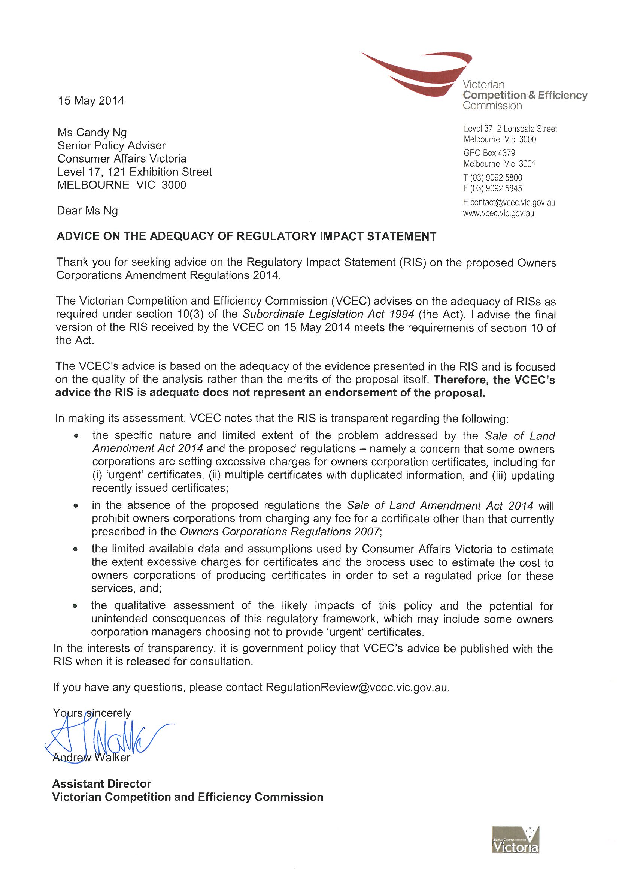

Table of Contents
Executive Summary 8
1 Background 11
1.1 Review of Section 32 of the Sale of Land Act 1962 11
1.1.1 Sale of Land Amendment Act 2014 11
1.2 Owners Corporation Information 12
1.2.1 Owners Corporation Certificate 12
1.2.2 Owners Corporation Register 12
1.2.3 Owners Corporation Records 12
2 Nature and Extent of the Problem 13
2.1 Nature of the Problem 13
2.1.1 Structure and Relationships in the Market 13
2.1.2 Current Observations and Issues 14
2.1.3 Anticipated Issues 15
2.1.4 Practices and Considerations in Providing Owners Corporation Information 15
2.2 Extent of the Problem 17
2.2.1 Certificate Transactions 17
2.2.2 Costs of Certificates 18
3 Objectives of Government Regulation 20
3.1 Main Objective 20
3.2 Other Jurisdictions 20
4 Options to Achieve the Objectives 23
4.1 Assessment of Options 23
4.1.1 Multi-Criteria Analysis 23
4.1.2 Data Collection and Cost Assumptions 24
4.2 Option 1 – Base Case (Current Legislative Framework) 25
4.2.1 Option 1 Proposed Maximum Fees 26
4.3 Option 1 Assessment 26
4.4 Option 2 – Fee Units and Prescribed Maximum Fees 26
4.4.1 Option 2 Proposed Maximum Fees 26
4.5 Option 2 Assessment 27
4.5.1 Fair and Reasonable Access 27
4.5.2 Cost Considerations 27
4.5.3 Complexity and Difficulty 28
4.5.4 Multi-Criteria Analysis 28
4.6 Option 3 – Fee Structure with Urgent Requests 28
4.6.1 Option 3 Proposed Maximum Fees 29
4.7 Option 3 Assessment 29
4.7.1 Fair and Reasonable Access 29
4.7.2 Cost Considerations 30
4.7.3 Complexity and Difficulty 30
4.7.4 Multi-Criteria Analysis 30
4.8 Option 4 – Comprehensive Fee Structure (A) 30
4.8.1 Option 4 Proposed Maximum Fees 32
4.9 Option 4 Assessment 33
4.9.1 Fair and Reasonable Access 33
4.9.2 Cost Considerations 33
4.9.3 Complexity and Difficulty 33
4.9.4 Multi-Criteria Analysis 34
4.10 Option 5 – Comprehensive Fee Structure (B) (Recommended Option) 34
4.10.2 Option 5 Proposed Maximum Fees 35
4.11 Option 5 Assessment 36
4.11.1 Fair and Reasonable Access 36
4.11.2 Cost Considerations 36
4.11.3 Complexity and Difficulty 36
4.11.4 Multi-Criteria Analysis 37
4.12 Other Options Considered 37
5 Small Business and Competition Assessment 38
5.1 Impact on Small Business 38
5.2 Impact on Competition 38
6 Implementation and Evaluation 40
6.1 Implementation 40
6.2 Evaluation 40
7 Consultation 41
Appendix 1 Owners Corporation Certificate, Register and Records – List of Matters 42
Appendix 2 Details of Fees Calculations 44
Appendix 3 Proposed Regulations 48

Acronyms and Abbreviations

Acronyms/Abbreviation | Description
ABS | Australian Bureau of Statistics
AIC | Australian Institute of Conveyancers
Amendment Act | Sale of Land Amendment Act 2014
CAV | Consumer Affairs Victoria
Certificate | Owners corporation certificate
DOJ | Department of Justice
GST | Goods and Services Tax
LIV | Law Institute of Victoria
MCA | Multi-Criteria Analysis
OC Act | Owners Corporations Act 2006
OC Regulations | Owners Corporations Regulations 2007
Proposed Regulations | Owners Corporations Amendment Regulations 2014
REIV | Real Estate Institute of Victoria
Register | Owners corporation register
RIS | Regulatory Impact Statement
SCA | Strata Community Australia (Vic)
SOL Act | Sale of Land Act 1962

Executive Summary
An owners corporation manages the common property of a residential, commercial, industrial or mixed-use property development. An owners corporation is a body corporate that is incorporated by registration of a plan of subdivision, strata subdivision or cluster subdivision under the Subdivision Act 1988. Owners corporations are regulated under the Owners Corporations Act 2006 (the OC Act).
As at the end of 2013, there are estimated to be 60,300 owners corporations in Victoria comprising 498,271 lots. Seventy-five per cent of owners corporations are small, managing fewer than five lots. Just one per cent manage more than 100 lots, however these owners corporations manage more than one-third of the total number of lots. Many small owners corporations are self-managed on a voluntary basis by a committee or individual lot owner who has been endorsed and delegated powers to manage the affairs of the owners corporation. Some owners corporations, typically larger ones, are managed by paid professional owners corporation managers.
Vendors who sell land in Victoria are required under the Sale of Land Act 1962 (SOL Act) to disclose certain information about the land to prospective purchasers through a section 32 statement. As well as the standard disclosure requirements applicable to all vendors, if the land is affected by an owners corporation, the vendor must also disclose certain owners corporation information. The SOL Act requires lot owners to disclose this information to prospective purchasers by obtaining an owners corporation certificate (Certificate) from an owners corporation. The information to be disclosed is prescribed under the Owners Corporation Regulations 2007 (the OC Regulations).
Any person may apply for a Certificate under section 151 of the OC Act. A Certificate can only be obtained from the owners corporation. The owners corporation must issue the Certificate within 10 business days after receiving the application, and may charge a fee not exceeding the fee prescribed under regulation 10 of the OC Regulations. The prescribed fee is currently $150 inclusive of GST.
In 2012, Consumer Affairs Victoria (CAV) began reviewing section 32 of the SOL Act and consulted with the public on the continuing relevance and utility of the disclosure requirements. In the course of this review, issues emerged relating to the provision of Certificates. The Sale of Land Amendment Act 2014 (Amendment Act) seeks to address these issues to a limited extent, however, in the main, Certificate issues were considered through a separate review process, a key component of which is this Regulatory Impact Statement (RIS).
The Amendment Act will commence operation on 1 October 2014 and will have two effects in relation to Certificates. First, the Amendment Act will permit vendors to disclose owners corporation information themselves directly to prospective purchasers, as an alternative to obtaining a Certificate from their owners corporation. An estimated 10 per cent of vendors will have the knowledge and ability to use this alternative. Second, the Amendment Act will apply a penalty to owners corporations that charge fees for Certificates that are not prescribed in the OC Regulations, or that charge a fee in excess of the prescribed maximum fee in the OC Regulations.
To address the issue of Certificate fees more specifically, in early 2014, CAV undertook targeted consultation with stakeholders in relation to fee levels and the options identified in this RIS.
Consultation with owners corporations managers assisted in determining the types of requests they typically receive in relation to Certificates and the costs of fulfilling these requests, such as issuing a Certificate at short notice.
Consultation with stakeholders highlighted specific concerns in relation to excessive charges being made for priority/urgent requests, multiple Certificates, and providing more current information contained in a Certificate. In these contexts, excessive charges can be considered to reduce or prohibit fair and reasonable access to owners corporation information. Furthermore, such charges may not accurately reflect the cost to owners corporations of efficiently providing this information.
There are various circumstances where vendors might require a Certificate more urgently than 10 business days. Fees for urgent requests are currently unregulated. Data from a sample of over 100 owners corporation management companies indicated that the vast majority of owners corporations charge priority fees, ranging from $50 to $450 (in addition to the prescribed fee of $150).
There are also circumstances in which a vendor may require multiple Certificates, such as when a lot is affected by multiple owners corporations, or when multiple lots are being sold, such as a residential lot and a parking lot. In these circumstances, a portion of information contained in the Certificates is likely to be the same. Some stakeholders expressed concern that charging the same fee for each Certificate does not accurately reflect the presumably smaller amount of work required to produce the multiple Certificates.
Vendors may also need or choose to obtain an updated Certificate in instances where some aspect of the information changes loser to the date of sale of their property. Issues were also raised in relation to fees for providing a more current Certificate following previous provision and payment for a Certificate for the same lot. Where this occurs, the current legislative arrangements allow owners corporations to charge the full fee for a new Certificate, even if the information contained in the subsequent Certificate provided is substantially the same.
In relation to fees for urgent requests, CAV estimates that each year in Victoria, between 1,500 and 1,700 vendors request the provision of a Certificate in less than 10 business days. Based on a sample of 114 owners corporation businesses and following consultation with owners corporation managers regarding the costs of preparing a Certificate, CAV estimates that the total cost of excessive fees charged in Victoria is between $184,230 and $208,794 per year. CAV has no data on the number of instances in which multiple Certificates or Certificates with more current information is provided to vendors, nor does CAV have data on any excessive fees charged for such Certificates and so the scale of this aspect of the problem has not been determined.
CAV notes that there is also potential for issues around excessive charges to arise in relation to accessing an owners corporation register or records, as there is currently no prescribed maximum fee for such access.
Given the issues raised, the identified objective of government regulation is to ensure that the provision of owners corporation information is fair and reasonable, and that prices reflects the costs and resources to owners corporation managers of providing such information. Following review and consultation, CAV developed the options in this RIS to meet the objective.
Five options are considered in this RIS. These are:
- Option 1 – the base case. This option represents the scenario in which the Amendment Act has commenced, and the provision of Certificates for any fee exceeding the currently prescribed fee of $150 is prohibited
- Option 2 – fee units and prescribed maximum fees. This option prescribes a new maximum fee for the Certificate based on the assessment in this RIS of the cost of producing a Certificate. The new fee will be expressed in fee units to allow for annual indexation. This option also prescribes maximum fees for copies of an owners corporation register and records
- Option 3 – fee structure with urgent requests. Option 3 comprises of the same elements of Option 2, and also includes prescribed maximum fees for where Certificates are requested urgently.
- Option 4 – comprehensive fee structure A. Option 4 builds on Option 3 by prescribing a fee structure that addresses circumstances where multiple owners corporation certificates are required arising from the sale of land, and where a Certificate is requested within a short period of time from a previous request. This option involves adding two possible definitions, to allow for differential fees for unlimited and limited owners corporations, and ‘service lots’
- Option 5 – comprehensive fee structure B (recommended option). The only difference between this option and Option 4 is the approach to prescribing fees where multiple owners corporation certificates are required. Option 5 provides a simpler approach, where the first Certificate requested attracts a different fee than any subsequent Certificates required
There are three criteria by which the options in the RIS have been assessed –
- the extent to which the option provides fair and reasonable access to owners corporation information
- the extent to which costs to owners corporations of efficiently providing owners corporation information have been accurately reflected in fees charged
- the complexity and difficulty of implementation
Option 5 has been identified as the preferred option. A draft of the proposed Regulations, reflecting this preferred option, is included as Appendix 3. The proposed Regulations would primarily affect owners corporation managers, vendors, legal practitioners who act on their behalf, and property information intermediaries/brokers. The proposed Regulations are not considered to disadvantage small business relative to larger businesses, or to negatively impact on competition.
It is noted that any owners corporation manager that cannot produce Certificates for the proposed maximum fee may decide to no longer offer a priority service. To the extent that this occurs, an unintended consequence of this proposed policy may be to decrease access to information for clients of any such owners corporation managers.
It is intended that the proposed Regulations would commence operation on 1 October 2014 to allow sufficient time for stakeholders to prepare for changes and implement the proposed Regulations.
Public comments and submissions are invited on the proposed Regulations and RIS, including comments on any assumptions that have contributed to analysis of the options.
All submissions will be treated as public documents, and will be available to other stakeholders, on request, under the Freedom of Information Act 1982 or by being posted on the CAV website at www.consumer.vic.gov.au.
Written comments and submission should be in Microsoft Word format and should be forwarded by email or post no later than the close of business on 2 July 2014 to CAV at one of the addresses set out at the front of this RIS.

Background

Key Points
- Submissions to CAV’s review of section 32 of the Sale of Land Act 1962, raised concerns around the costs of disclosing owners corporations information
- As a result of the section 32 review, the Sale of Land Amendment Act 2014 was introduced and seeks to address some of the concerns stakeholders raised regarding owners corporations
- The Owners Corporations Act 2006 provides that owners corporations information can be obtained through purchasing an owners corporation certificate, accessing the owners corporation register, and accessing other records required to be maintained by an owners corporation

Review of Section 32 of the Sale of Land Act 1962
Section 32 of the SOL Act requires those who sell land in Victoria to disclose certain information about the land to prospective purchasers, through the provision of a section 32 statement.
In 2012, CAV began reviewing section 32 of the SOL Act and consulted with the public on the continuing relevance and utility of the disclosure required under section 32. Submissions were made by individuals and organisations including the Consumer Action Law Centre, Law Institute of Victoria (LIV), the Real Estate Institute of Victoria (REIV), Australian Institute of Conveyancers (AIC) and Strata Community Australia (Vic) (SCA).
Stakeholders expressed ongoing support for vendor disclosure and its continuing relevance and utility in property transactions. Submissions expressed that prospective purchasers received benefit from the disclosure and that it led to more effectively informed purchasers.
While most submitters believe that a good balance had been struck between the benefits and costs of disclosure, some stakeholders noted that the current level and form of disclosure could be simplified and refined to reduce red tape and compliance costs, without compromising relevant disclosure.
As an outcome of the review of section 32, the Amendment Act was introduced to amend the SOL Act to streamline and improve information disclosure requirements upon a sale of land.
In the course of the section 32 review and subsequent consultation with the public, issues emerged relating to the disclosure of owners corporation information as part of the sale of land process, particularly the costs of disclosure. These issues were considered through a separate review process, a key component of which is this RIS.

Sale of Land Amendment Act 2014
The Amendment Act seeks to improve information disclosure via the section 32 statement required under the SOL Act. As part of this, the Amendment Act also contains amendments related to owners corporations.
Prior to introduction of the Amendment Act, the SOL Act required that if the land for sale is affected by an owners corporation, the vendor must provide to the purchaser:
  - a copy of the current owners corporation certificate (the Certificate) issued in respect of the land under the OC Act; and
  - a copy of the documents required to accompany the Certificate under section 151(4)(b) of the OC Act,
in addition to standard information disclosure requirements under section 32(1) of the SOL Act.
The OC Act requires additional documents to accompany the Certificate, including a copy of the owners corporation rules and a copy of all resolutions made at the last annual general meeting.
Following commencement of the Amendment Act, vendors selling land affected by an owners corporation will no longer be obligated to purchase a Certificate from the owners corporation, and can choose to disclose owners corporation information themselves by specifying in the section 32 statement the information that would be contained in a Certificate.
Other relevant provisions in the Amendment Act related to owners corporations include the introduction of an offence for an owners corporation to charge more than the relevant prescribed fee for a Certificate, and enabling differential fees for obtaining a Certificate to be prescribed under regulations, for example, based on size, complexity or time considerations.

Owners Corporation Information
There are three main avenues for obtaining owners corporation information – purchasing an owners corporation certificate, accessing the owners corporation register, and accessing owners corporation records.
The OC Act provides for the types of information to be maintained and the circumstances in which information about an owners corporation can be obtained.

Owners Corporation Certificate
The OC Regulations lists 16 key matters that the Certificate must contain, such as current lot fees, repairs and maintenance work that may incur additional charges, insurance details, total funds held by the owners corporation, and minutes of the most recent annual general meeting. This aligns with the matters that the OC Act requires to be prescribed, under section 151(4)(a).
Section 151 of the OC Act provides that any person may apply to an owners corporation for a Certificate. The application must be in writing and accompanied by a fee determined by the owners corporation, which must not exceed the prescribed fee.
The OC Regulations has prescribed the fee at $150, including GST. After receiving an application and the fee, the owners corporation must issue the Certificate within 10 days.

Owners Corporation Register
Section 143(3) of the OC Act requires an owners corporation to maintain an owners corporation register (the Register). Section 148 of the OC Act lists the ten matters that an owners corporation must keep through the Register, including the owners corporation plan number and address, total lot liability and lot entitlements, details of any notices or orders served on the owners corporation, and insurance policy details.
Under section 150, an owners corporation must make the Register available for inspection on request by a lot owner, mortgagee of a lot, purchaser of a lot, or the representative of such persons. Owners corporations must make the Register available for inspection at “any reasonable time”, and access is free of charge.
If a person, entitled to inspect the Register, wishes to obtain a copy of the Register or any part of the Register, they must pay a fee determined by the owners corporation, which must be “reasonable” and not exceed the prescribed maximum fee. The OC Regulations do not currently prescribe a maximum fee for obtaining copies of the Register or any part of the Register.

Owners Corporation Records
Under section 144 of the OC Act, there are 19 types of records that an owners corporation must keep, including records pertaining to minutes of meetings, accounting records, financial statements and leases and licences to and from the owners corporation.
Section 146 requires an owners corporation, on request by a lot owner, mortgagee of a lot, purchaser of a lot or the representative of such persons, to make the records of the owners corporations available to that person for inspection at any reasonable time, free of charge.
The owners corporation may provide a copy of any record of the owners corporation upon the request of a person entitled to inspect the records, and on payment of a “reasonable” fee. This fee is determined by the owners corporation and must not exceed the prescribed maximum fee. The OC Regulations do not currently prescribe a maximum fee.

Nature and Extent of the Problem

Key Points
- The structure and relationships in the market for owners corporations information provides scope for opportunistic behaviour
- Key issues that stakeholders raised regarding fees charged by owners corporations related to urgent requests, sale of land transactions where multiple owners corporation Certificates are required, and requests for a more current Certificate following prior provision of a Certificate
- Owners corporation managers incur resources in preparing and reviewing owners corporation certificates to ensure it meets regulatory requirements and address relevant issues
- The total excessive charges for urgent requests of a Certificate is estimated to range from $184, 230 to $208, 794 per year based on approximately 1,500 to 1,700 urgent requests for a Certificate per year
- The total excessive charges where multiple Certificates are required, and where a more current Certificate is requested, has not been estimated
- The total excessive charges for access to an owners corporations register and records, has not been estimated

Nature of the Problem

Structure and Relationships in the Market
Owners corporations are a separate legal entity comprised of individual lot owners, established to make it easier for owners of common property to make management decisions. A part of their responsibility is to maintain and keep certain information about the owners corporation and the common property they manage. Maintenance of such information is not only integral to the efficacy and efficiency of an owners corporation, but is also important for future purchasers of lots in making decisions about whether to buy property that is part of the owners corporation.
Lot owners typically engage an agent to manage their collective interests in an owners corporation because of the time and complexity involved in managing their funds, the maintenance of common property and meeting administrative requirements. Most large owners corporations do this by employing and paying a professional owners corporation manager. Other owners corporations may be self-managed on a voluntary basis by a committee or individual lot owner who has been endorsed and delegated powers to manage the affairs of the owners corporation.
A problem that arises from such an arrangement is the problem of the monopoly of information that some individuals have about the owners corporation. In many cases, this monopoly power is held by an owners corporation manager (or delegated individual), who as part of their duties, maintains information on behalf of all lot owners, and become the only source of particular information about the owners corporation and associated common property.
In many cases, an owners corporation manager or delegated individual maintains information on behalf of all lot owners. Owners (and prospective purchasers) are freely able to access and view this information. However, when selling a property, prior to introduction of the Amendment Act, section 32(3A) of the SOL Act requires that a copy of the Certificate must be given by a vendor to purchasers of a property affected by an owners corporation. This Certificate could only be issued by the owners corporation. As a result, owners corporation managers, or a delegated individual, wielded significant power in the provision of the Certificate and the information it contains. Similarly, any owner or prospective purchaser wanting a copy of the owners corporation register or other records must go through an owners corporation manager or delegated individual.
In the context of the sale of land, the Amendment Act will allow vendors to disclose information contained in the Certificate themselves without needing to purchase a Certificate from the owners corporation. This introduces an element of competitive pressure with regard to disclosure of owners corporation information during a sale of land process. This pressure may deter some owners corporations from charging excessive prices for the provision of the Certificate and contributes to promoting the objective of fair and reasonable access to owners corporation information.
This effect depends on the willingness and ability of vendors to take responsibility for the disclosure of required owners corporation information. The LIV estimates that around 10 per cent of vendors will have the knowledge and ability to provide the owners corporation information that a Certificate would typically disclose.
In cases where vendors choose to obtain a Certificate, and in the absence of the regulations proposed in this RIS, the Amendment Act would prohibit owners corporations from charging a fee for the Certificate, other than the fee prescribed under the current regulations.

Current Observations and Issues
In recognition that time and resources are required to collate and produce owners corporation information, the OC Act provides that a fee may be charged for obtaining the Certificate, and for obtaining copies of the Register (or part of the Register) and records. These fees are to be prescribed under the OC Regulations.
No systemic issues have been raised regarding self-managed owners corporations where a volunteer may provide services such as preparing a Certificate. However, stakeholders including the LIV, AIC, and REIV, have voiced concerns regarding excessive fees charged by professional and contracted owners corporation managers, for obtaining the Certificate. These concerns primarily relate to excessive charges for:
- priority/urgent requests
- multiple Certificates
- updating information in the Certificate.

Urgent Requests
It should be noted that ‘priority’ fees are not necessarily in themselves the issue for stakeholders, but rather, the excessiveness of such fees. For example, owners corporation management companies have been known to charge up to $450 in addition to the prescribed fee of $150 (total of $600) for a Certificate, when a fast turnaround has been requested.
In certain situations, price discrimination – where different prices are charged to different groups of consumers for the same product – could be appropriate. Where consumers highly value the timely provision of a particular good or service, it may be both efficient and equitable to charge a premium price. The charging of different prices to different types of consumers means that consumers who have varying needs are able to have them better met by paying a premium.
In the case of a sale of land transaction, it may be appropriate for those vendors who have a more urgent need for the Certificate to have the opportunity to pay a premium to obtain the certificate quicker. Whereas those vendors who are able to wait 10 days can choose not to pay a premium because they do not value the faster service.
It has been observed that vendors may not plan for the 10-day maximum statutory period required to obtain a Certificate, due to the nature of property transactions where offers to purchase property may be unexpected. Given the uncertainty, vendors do not want to prepare the Certificate too far in advance so that they avoid the risk of obsolete information and having to purchase a new Certificate. After an expression of interest has been submitted for the property, vendors are then eager to complete the transaction process and meet the demands of a prospective purchaser to close the sale. This contributes to the pressure for a Certificate to be provided within a shorter timeframe than the mandated maximum of 10 days.

Multiple Certificates
There are two main circumstances in which a sale of land may require multiple owners corporation certificates.
A sale of land may involve more than one owners corporation when the land for sale is affected by an unlimited owners corporation and one or more limited owners corporations. The unlimited owners corporation manages common property that affects all lot owners, while the limited owners corporation manages common property that only affects a portion of the lots. For example, where a sale of land involves an apartment that includes access to a gym that not all lot owners have a right to access, there is likely to be an unlimited owners corporation and a limited owners corporation. The unlimited owners corporation manages the common property affecting all apartments in the building (such as gardens and lifts), and the limited owners corporation manages the operation of the gym for the portion of lot owners that have the right to access the gym.
In the above scenario, the vendor would require one certificate from the unlimited owners corporation and one certificate from the limited owners corporation. Stakeholders have observed commonalities between the two Certificates, suggesting that charging full price for each Certificate is not warranted.
The other situation when more than one Certificate may be required is where the sale of land involves multiple titles, for example, the sale of an apartment that includes the title for the residential apartment as well as a title for a parking space. Both lots may be managed by the same owners corporation, but two Certificates may be prepared because there are two titles associated with the sale of land. In these circumstances, the Certificates would be very similar as the two lots are managed by the same owners corporation. Given that there may be a high degree of replication and little difference in information contained in each Certificate, stakeholders have proposed that charging full price for each Certificate is not justified.

Currency of Certificate Information
Situations may arise where a Certificate has been purchased but a change has occurred within a relatively short time-frame that affects information provided in the Certificate. This can arise when a Certificate has been purchased by a vendor when the property was advertised but by the time a prospective purchaser has been found, certain information may no longer be current, for example, it is a new quarter and lot fees have changed. For the most part, the Certificate remains the same, but some items in the Certificate may require amending.
Stakeholders have raised that in these circumstances, the full fee for a Certificate would be charged despite most of the information contained in the Certificate remaining the same. As with the issue above, it has been suggested that payment of the full fee is not reasonable given the level of duplication that occurs.

Anticipated Issues
The Amendment Act allows information contained in the Certificate to be provided by vendors themselves, thus circumventing the necessity to purchase the Certificate from the owners corporation, if the vendors have the relevant information. It is anticipated that a relatively low percentage of vendors would have this information, or would want to provide this information themselves.
In some cases, vendors may be missing several items of information and would require access to the Register, or records kept by the owners corporation, to complete their disclosure obligations. The current legislation provides that access to this information is free. However, for copies of such information, a fee is required which must not exceed the prescribed maximum.
Currently, no maximum fee is prescribed for making copies of the Register or of records kept by the owners corporation. While stakeholders have not raised this as an issue and owners corporation managers have advised that requests for records are rarely received, following commencement of the Amendment Act it is anticipated that there may be greater demand for copies of the Register and owners corporation records.
As demand increases, the scope for opportunistic behaviour is likely to expand, and would be compounded by the absence of a prescribed maximum fee. Equally, the lack of a prescribed maximum fee gives rise to uncertainty as to what is considered a reasonable fee for an owners corporation to charge. Some owners corporation managers have indicated that this ambiguity creates a greater potential for disputes about costs.

Practices and Considerations in Providing Owners Corporation Information

Certificate Preparation
Time and resources are required in order to extract and collate owners corporation information, especially for the preparation of the Certificate. The Certificate is a significant legal document that forms part of the section 32 statement under the SOL Act, and incorrect or missing information from the Certificate could have considerable legal implications. As such, due care must be taken to ensure the accuracy of the document.
The ways in which a Certificate is prepared differs across owners corporation management businesses. Some businesses rely on a custom-developed computerised system that is able to extract skeletal information, which an owners corporation manager reviews and supplements. Other businesses may have less sophisticated computer software, are smaller and more hands-on, relying mostly on the knowledge of their staff members to generate the Certificate.
While a computerised system may be able to quickly generate a basic document, the legal significance of the document means that a lengthy time may be required for quality assurance to ensure the most current information is incorporated, correct attachments are provided, and for information to be reviewed by more experienced and knowledgeable staff. Typically, an administrative or general staff member extracts and compiles information, the relevant owners corporation manager reviews that information to ensure it is current and the appropriate level of information has been disclosed, and other parties may be consulted to double-check the status of issues.
From discussions with owners corporation managers from a cross-section of the sector, the time taken to prepare a Certificate can range from 30 minutes for a simple and straightforward owners corporation, to 12 hours in extreme circumstances where significant issues exist, requiring consultation with multiple parties to address complexities in the preparation of the Certificate. Owners corporation managers have advised that simple Certificates do not correlate to small owners corporations, and conversely, that large owners corporations do not necessarily mean more difficult Certificates and longer preparation times.
The complexity of Certificates, and thus the time taken to prepare them, is subject to a range of factors. These include the number of contracts and level of services that an owners corporation has engaged, the existence of any building defects, title-related matters and whether there are any current disputes. These factors are independent of the size of the owners corporation, and whether they are prescribed or non-prescribed owners corporations.

Urgent Requests
Owners corporation managers have advised that urgent requests are typically received in around 5-10 per cent of cases. Urgency generally arises when someone has expressed interest in purchasing the property and there is pressure to finalise the sale. In addition, urgency can arise when the vendor or their legal practitioner has forgotten about the requirement to prepare a Certificate until it is time to sign the contract.
Where urgent requests are received, approaches to these requests differ. Some owners corporation managers are able to fulfil the request, if resources allow, and deliver the Certificate within a shorter timeframe than 10 days at no extra cost. Other owners corporation managers are able to offer a priority service and deliver the Certificate within a short timeframe if an extra fee is paid.
To meet an urgent request, resources would have to be re-allocated and there is an opportunity cost as other work and activities would need to be postponed in order to complete the Certificate. A fast turnaround is not always feasible and where resources are not able to be re-allocated, an owners corporation manager may not be able to offer a priority service, even if a vendor is willing to pay an additional charge.

Multiple Certificates
Each owners corporation is a separate legal entity with, for example, its own Australian Business Number. Owners corporation managers expressed that as such, they would generally have different sets of information such as financial accounts. Thus, where multiple owners corporations affect a single lot, there may be similarities in certain aspects. However, owners corporation managers advised that each owners corporation would still need to be reviewed separately to determine that all the details are accurate and whether any specific issues exist.
Most of the time, owners corporations within the same building are managed by the same owners corporation management business. Rarely are different owners corporation management businesses engaged, although it does occur. In these cases, vendors whose lot is affected by multiple owners corporations managed by different businesses, would be required to request a Certificate from each owners corporation management business.
Where multiple titles are involved in the sale of land and the lots associated with each title is managed by the same owners corporation, the majority of information contained in each Certificate is likely to be the same. Both lots are affected by the same owners corporation, meaning that the Certificate for both lots would contain the same information for a majority of matters, such as contracts and leases, service agreements, total funds held by the owners corporation, and insurance details.

Currency of Certificate Information
The experiences of the owners corporation managers that CAV engaged with differed regarding requests to provide a more current Certificate (or particular information contained in the Certificate). Following provision of a Certificate, some owners corporation managers receive a request to provide updated information in almost all cases, while others have expressed that it does not occur frequently, for instance in around 10 per cent of Certificates prepared.
Typically, both the vendor and purchaser requests current owners corporation information as settlement date approaches. These requests generally relate to financial information so as to determine the status of fees and therefore expected liabilities. Some businesses charge a fee for providing updated financial information, however most of the owners corporation management businesses that CAV engaged with expressed that their standard practice was to provide updated information regarding fees and levies at no charge. They saw a benefit in doing so, to ensure that the purchaser’s expectations regarding payments and liabilities associated with the lot are accurate when they take ownership of the property. This would likely alleviate the risk of disputes between the new owner and the owners corporation.
One business, upon receiving a request for a more current Certificate, would advise whether a new Certificate was required, or whether the existing Certificate was adequate, as no changes had occurred since it was issued. Another owners corporation management business would not charge a fee if a request for a new Certificate was requested within 60 days.
Providing another more current Certificate can also usually be done with less time and resources than the original Certificate as it would usually be based on the most recent Certificate that was prepared. However, owners corporation managers advised that the information provided must still be carefully reviewed and checked. The length of time required appears to depend on the level of engagement between the particular owners corporation and the owners corporation manager, and thus how readily the owners corporation manager is aware of the activities of the owners corporation.
Despite the different practices, most of the owners corporation managers expressed that given the scope of matters that the Certificate addresses, the accuracy of a Certificate can only be relied upon on the day it is issued. Matters such as the amount of fees owing and paid are likely to have changed, and unforseen issues such as legal proceedings or sudden property damage may have occurred.

Role of Property Information Intermediaries and Brokers
Property information intermediaries and brokers manage systems that allow legal practitioners to place orders for a range of property information. The systems provide a list of the different types of information that may be required as part of a sale of land (including owners corporation certificates) and the costs associated with each piece of information. Legal practitioners identify the items of information they need using these systems, and are advised of total costs. The property information intermediaries then collate the requested information on behalf of the legal practitioner.
Stakeholders have advised that property information intermediaries and brokers have a significant role in the sector. Legal practitioners rely heavily on information brokers to execute requests for a Certificate. Owners corporation managers also indicate that on average, about 50 per cent of requests for a Certificate originate from an information intermediary.

Copies of the Register and Records
All owners corporation managers that CAV spoke with advised that very rarely is a copy of the Register or other owners corporation records requested. Where requests are received, these typically occur when the committee wishes to obtain financial information or when an issue and dispute exists for example, between lot owners or with the committee.
Most owners corporation managers advised that their business did not charge a fee for obtaining copies of information. Some owners corporation management businesses provide an online portal where information can be obtained at no cost. Others may impose a nominal paper and photocopy fee.
Some owners corporation management businesses have computerised systems that can extract the Register as a whole, while others do not have the same function with their computerised systems and so would require individual collation of all the items specified to be maintained on the Register under the OC Act. A few owners corporation managers advised that when a request is received to obtain information, usually time is taken to understand the issue or concern that gave rise to that request and then the relevant information is extracted for the applicant.

Extent of the Problem

Certificate Transactions
In 2013, Land Victoria estimates that the number of owners corporations total 60,300 comprising of 498,271 lots. The majority of owners corporations (75 per cent) are small, with less than five lots. Only one per cent of owners corporations are made up of 100 lots or more. However, 34 per cent of the total number of lots in Victoria are found in owners corporations of 100 lots or more.

Table 1: Size and number of owners corporations in Victoria, 2013

Size of Owners Corporation | Number of Lots | Percentage of Total Lots | Number of Owners Corporations | Percentage of Total Owners Corporations
Less than 5 lots | 117,859 | 24 | 45,075 | 75
5-19 lots | 99,327 | 20 | 11,928 | 20
20-49 lots | 58,363 | 12 | 1,931 | 3
50-99 lots | 48,964 | 10 | 702 | 1
100+ lots | 173,758 | 34 | 664 | 1
TOTAL | 498,271 | 100 | 60,300 | 100

The number of market transfers in 2013 was 156,453 and approximately 37 per cent (57,870 transactions) were affected by an owners corporation. This represents a turnover of almost 12 per cent of total lots in Victoria.
However, based on market assessments, it is estimated that between 15,000 to 17,000 Certificates were prepared commercially by professional owners corporation managers. The difference between the estimated number of ‘commercial’ Certificates prepared and the number of property transactions affected by an owners corporation is assumed to be due to owners corporations that do not employ an owners corporation manager such as owners corporations that are self-managed by volunteers , and inactive owners corporations.

Costs of Certificates
The cost to a vendor of a Certificate ranges from the prescribed fee of $150, to any additional fees that may apply for urgent requests for the supply of the Certificate within a shorter timeframe than the maximum 10 days allowed under the OC Act.
Without considering additional priority fees for urgent requests, the estimated annual cost to vendors of obtaining a Certificate ranges from $2,250,000 to $2,550,000.
Data from a sample of over 100 owners corporation management businesses shows that the vast majority of owners corporations charge a priority fee (approximately 92 per cent) . The Victorian Division of Strata Community Australia (SCA) provides guidelines to owners corporation managers, which suggests that owners corporation managers charge $132 as a priority fee for Certificates to be provided in one to two business days, and $66 for delivery within three to five business days. As an average, this is a priority fee of $99.
Comparing the average of priority fees charged by owners corporation management businesses in the sample with the average priority fee of $99 suggested by SCA, the majority of owners corporations (around 67 per cent) charge a priority fee of higher than an average of $99, and around 21 per cent has adopted the SCA recommendations for priority fees.
In the sample, the maximum fee charged for urgent requests was an extra $450 for provision of the Certificate within 24 hours, and the minimum charge was an additional $50 for provision of the Certificate within two days. In terms of the distribution of fee amounts that are being charged for urgent delivery of the Certificate, this is difficult to observe as fee structures across owners corporation management businesses differ and are not comparable. Some businesses adopt a fee structure based on a one to two-day turnaround and three to five-day turnaround, while others have a fee structure that allows for an immediate/same day turnaround, and still others may simply offer a single option of delivery within three business days.
However, looking only at simple averages, it can be estimated that the average priority fee charged by the sample of owners corporation management businesses is $193, while the median priority fee is $215.
Not all vendors require an urgent turnaround; the majority choose to wait 10 days for the Certificate and do not pay a priority fee. It is estimated that about 10 per cent of Certificates are requested to be provided urgently. Based on an average priority fee of $193, the estimated cost to vendors of priority fees, therefore, ranges from $289,500 to $328,100.
Based on the figures above, the total estimated indicative annual cost to vendors of obtaining owners corporation certificates is therefore between $2.54 million - $2.88 million. It should be noted that this figure excludes Certificates generated by self-managed owners corporations. Issues raised by stakeholders have been solely concerned with professional owners corporation management companies. Owners corporations self-managed by volunteers and inactive owners corporations are likely not to charge any additional urgency fees and may not charge a fee at all for preparing a Certificate.
Using the above information, the potential extent of the problem of excessive charges for urgent requests for Certificates is estimated to range from $184,230 to $208,794 per year.
Regarding the issue of multiple Certificates and requests for updated information contained in the Certificate, the proportion of Certificates prepared relating to these stakeholder concerns is not known and difficult to estimate. The extent of the problem relating to these two matters is thus not measurable. However, where they do occur and there is duplication in information, vendors are paying a fee that could be considered excessive, as fee costs are not commensurate with the amount of time and resources required to deliver the final product.
Likewise, the extent of the problem regarding fees for copies of a Register or record is unknown. As noted above, owners corporation managers have advised that currently, very rarely do they receive requests for obtaining copies of the Register and owners corporation records. Stakeholders have also not raised this as an area of concern; however, CAV anticipates that this will be an issue following commencement of the Amendment Act in the absence of regulation prescribing maximum fees for copies of the Register or records.

Objectives of Government Regulation

Key Points
- The proposed Regulations aim to ensure access and provision of owners corporation information is fair and reasonable, while considering the resources involved in the provision of information
- Current and proposed government regulation seeks to meet this objective
- Government regulation from other jurisdictions provides examples of other approaches to meet the objective

Main Objective
In light of the market dynamics, and the issues raised by stakeholders that can be observed through the sale of land process, the objective of Government regulation is to ensure the fair and reasonable access and provision of owners corporation information, while recognising the resources involved in collating and providing that information.
Without government intervention, there is a risk that Certificates and copies of the Register and records may be excessively costly, with detrimental effects upon owners and prospective purchasers. Conversely, if resource requirements for providing owners corporation information are not considered, costs cannot be adequately recovered and may lead to increases in charges elsewhere that are borne by others who have not obtained any benefit. This is particularly relevant where a professional owners corporation manager has been engaged.
It is envisaged that as a result of effective government regulation, the process in which information about an owners corporation is obtained is fair and the costs of doing so is reasonable. The fees set for obtaining owners corporation information should reflect the resources that an efficient owners corporation would incur to provide the information and charged such that only those who use the service pay a fee.
The way in which government currently aims to meet the objective is by legislating under the OC Act and OC Regulations, the way in which owners corporation information can be obtained, including prescribing fees to be paid. Through introduction of the Amendment Act, allowing vendor’s disclosure of particulars, legislation also seeks to provide choice in disclosure. The relevant legislative provisions are outlined in section 1.

Other Jurisdictions
Most other Australian jurisdictions appear to have identified comparable objectives in relation to owners corporation information. Similar legislative models apply in terms of disclosure via a certificate when a sale of land transaction occurs, and maintenance of owners corporation records. However, the type, and in particular, the quantity of information to be disclosed, differs across jurisdictions, which has likely influenced the fee levels that have been set. This makes it difficult to draw meaningful comparisons; however, it is still beneficial to observe the different approaches in which jurisdictions have addressed the objective of fair and equitable access to owners corporation information, while ensuring cost recovery.
In New South Wales, for example, the fee structure for obtaining an owners corporation certificate has allowed for differences in the length of time between requests by the same person for the same lot, and also considered lots affected by multiple owners corporations.
In South Australia, fees for a certificate have been differentiated based on whether the request for information came from a lot owner or another person. Queensland builds into its fee structure the charging of a priority fee, as well as an additional fee for using fax services. Meanwhile, Western Australia simply charges a flat fee, analogous to the current situation in Victoria.
A summary of the fees for a certificate charged by other jurisdictions, is provided in Table 2.

Table 2: Jurisdictional fees for owners corporation certificate
Fee Type | Fee | Delivery Timeframe
New South Wales
Providing an owners corporation certificate if request is an initial request, or request is made more than 3 months after a previous request by the same person for the same lot | $104, and $52 for any additional certificate related to other owners corporations affected by the lot | No later than 14 days after receipt of an application
Providing an owners corporation certificate if request is made no more than 3 months after a previous request by the same person for the same lot | $90, and $45 for any additional certificate related to other owners corporations affected by the lot | No later than 14 days after receipt of an application
South Australia
Application by owner (for all possible information requests) | $5 | Within 14 days after receiving request
Application by any other person besides lot owner (for all possible information requests) | $65 | Within 14 days after receiving request
Queensland
Providing a body corporate certificate | $53.80 | Within 7 days after receiving request
Priority fee if certificate is required within 24 hours | $20.20 (Fee is refunded if the Certificate is not supplied within 24 hours)
Fee for faxing of Certificate | $13.95
Western Australia
Providing certificate of lot information | $100 | No later than 14 days after receiving application
Tasmania
Providing a certificate | No fee prescribed | No timeframe prescribed
Australian Capital Territory
Fee payable by a person requesting a Certificate | $100 (including GST) maximum | Within 14 days after receiving request
Northern Territory
Fee for supplying a certificate | A fee not exceeding the cost to the corporation of providing the service | Within 14 days after receiving request

The way in which access and information about other owners corporation information and records is obtained appears to differ slightly across the jurisdictions. South Australia and Western Australia do not charge a fee for inspection of records by a lot owner or someone with a notified interest in the property; however, charges are imposed for any other person. Queensland charges both lot owners and non-lot owners, however lot owners are charged a discounted price. New South Wales makes no such distinction, and has implemented a fee structure that does not specifically differentiate between inspection and making copies of documents.

Table 3: Jurisdictional fees for access and copies of owners corporation records
Fee Type | Fee
New South Wales
For making records available for inspection. A person entitled to inspect a document may take extracts from, or make a copy of, the document | $30 and an additional $15 for each half-hour or part of half-hour after the first hour of inspection
South Australia
Inspection of records where applicant is owner | No fee
Inspection of records where applicant is not owner | $5 per application
Queensland
Where applicant is lot owner | $14.50 for inspection, 50c for obtaining copy of a record for each page supplied
Where applicant is not lot owner | $27.90, 50c for obtaining copy of a record for each page supplied
Western Australia
For inspection of records by any proprietor or mortgagee who has notified an interested to the strata company | No fee
For inspection of records by any other person | $40
Tasmania
No fee prescribed
Australian Capital Territory
Fee for inspection of records if the person has also requested a certificate | No fee
Maximum fee for inspection of records if the person has not also requested a certificate | $100 including GST
Northern Territory
Fee for making the books and records of a corporation available | A fee not exceeding the cost to the corporation of providing that service

Options to Achieve the Objectives

Key Points
- A multi-criteria analysis has been used to assess the options in achieving the objectives. Criteria used to assess the option reflect the identified government objective, and implementation costs and burden to the sector
- Fees proposed are calculated using figures and assumptions from a number of sources. This includes the Victorian Guide to Regulation, Australian Bureau of Statistics and discussions with a group of owners corporation managers representing a range of owners corporation management businesses
- The RIS considers 5 different options. Following assessment of the options, the proposed Regulations are considered to be the preferred option

Assessment of Options

Multi-Criteria Analysis
Multi-criteria analysis (MCA) has been used to assess the options to achieving the objective. MCA is a useful tool for making quantitative comparisons between alternative options when it is not possible to quantify and assign monetary values to all the impacts of the options. Given the objective of government regulation and the issues raised by stakeholders, assessing and comparing the extent to which proposed options meet the objective on the basis of dollar figures was not considered meaningful. In addition, while stakeholders were able to advise qualitatively of certain implications of particular options, monetary values were not able to be obtained and thus data limitations and gaps exist. As such, the MCA approach was considered the most suitable way to determine the appropriateness of the proposals below, and make comparisons between each option.
MCA requires an assessment about how each option will contribute to criteria that are chosen to reflect the objectives. A qualitative score is assigned, depending on the impact of the option on each of the criteria, relative to the base case.
In the analysis below, the scores range from -5 to +5. A negative score has been assigned if the option is seen to have an adverse impact compared to the base case, and a positive score has been assigned if the option is considered to provide a better outcome, relative to the base case. The base case has a zero score against all criteria, and when assigned to other proposals, represents no impact or that the effect is neutral, relative to the base case.
There are three criteria by which the options have been assessed –
- the extent to which the option supports fair and reasonable access to owners corporation information
- the extent to which costs to owners corporations of efficiently providing owners corporation information have been accurately reflected in fees charged
- complexity and difficulty of implementation
The Victorian Guide to Regulation stipulates that equal weighting should apply to benefit-related criteria and cost-related criteria, so that anticipated benefits and costs of the particular option can be assessed neutrally.
Out of the three criteria identified above, the first two criteria are benefit-related, and directly reflect the objective of government regulation in this area. They are equally weighted as both are of equal importance and have each been assigned a weight of 0.25.
The third criterion is a cost-related criteria and seeks to assess an option based on the difficulty and cost of implementation. The extent to which an option is difficult to understand or implement, will impact on the effectiveness of the proposed option to addressing the issues identified. In particular, this criteria considers the resource implications on legal practitioners, owners corporation managers and property information intermediaries/brokers in understanding and adapting to the changes under each option. This criterion is assigned a weight of 0.5.
Under each option below, the raw score determined for each criterion has been multiplied by their weighting to obtain a weighted score and then added together to obtain an overall score for the option. Whichever option has the highest overall score is the preferred approach and considered most able to effectively meet the objectives.

Data Collection and Cost Assumptions

General
Government policy is that fees charged by government agencies should be set on a full-cost recovery basis. This means that the value of all the resources being used in the efficient provision of the service or good should be factored into the setting of fees. Costs based on the operations of inefficient provision would not be appropriate, as it would lead to fees calculated on the basis of poor business practices and would remove any incentive to improve operations. In this RIS, CAV applies the same principle on the grounds that the price of Certificates should reflect their efficient provision.
To understand the process and identify the resource requirements of preparing a Certificate and providing copies of the Register and owners corporation records, CAV engaged in discussions with a group of owners corporation managers representing different owners corporation management businesses, ranging from a single-owner managed business to some of the largest businesses in Victoria. In most cases, each owners corporation management business handled small and large owners corporations, with both simple and complex matters. As noted above, the size of an owners corporation was not correlated to the level of complexity.
The group of owners corporation managers that CAV engaged with provided a sample of the average time taken to prepare a Certificate, and this was weighted according to the number of Certificates they typically prepare per year. In addition, a weighted average division of labour between general/administrative staff and managerial staff was also drawn from this sample of owners corporation managers. These figures are discussed below.
Fees below were calculated using figures from a range of sources and based on a number of assumptions. In terms of labour and operational costs (earnings and overheads), figures were drawn from the Strata Community Australia Benchmarking Report (2012), which involved participation of five Victorian owners corporation management businesses through self-selection. The salaries represent direct costs of providing information about owners corporations, and a multiplier was applied to account for on-costs and overhead costs.
Other assumptions used to calculate fees include the number of working weeks per year and the average number of hours worked per week. These figures were drawn from the Victorian Guide to Regulation and the Australian Bureau of Statistics, respectively.
In summary, the following assumptions were used:
- Average salary – General/Administration: $55, 421
- Average salary – Management: $117,250
- Weeks worked per annum: 44
- Average hours worked per week, full-time: 38.8 hours
- On-cost and overhead multiplier: 1.75
The salary costs derived above are estimated costs for 2013, while the proposed Regulations are expected to commence in the 2014 financial year. As such, the fee tables under the proposed options below will provide the estimated cost for 2013 and derive a fee unit based on the 2013-14 value. To generate the proposed fee cost for the 2014 financial year, the value of the fee unit in 2014-15 is then applied.
It should also be noted that the Monetary Units Act 2004 requires that fees fixed in fee units to be no less than one fee unit. As such, in cases where the fees calculated results in a fee unit that is less than one fee unit, the fee will be expressed in dollar amounts.
Detailed calculations of proposed prescribed fees under each of the proposals below can be found in Appendix 2.

Preparation of Certificates – Efficiency and Risk Burden Considerations
As noted above, the setting of fees should be based on the efficient provision of the service or good. In the group of owners corporation managers that CAV engaged with, there was a small portion that indicated times for preparation of Certificates that were outliers, requiring significantly more time relative to the other owners corporation managers.
Efficiency reasons appear to contribute to these significantly lengthier times required to prepare a Certificate, and this may also be associated with the treatment of risk. The main reason for the lengthier times is the thoroughness of the review process that is undertaken to ensure the Certificate is accurate. While all the owners corporation management businesses that CAV talked to include a process of review from senior management as a risk management strategy, these outlier businesses spend a significantly greater time on the review process.
While it is recognised that the lengthiness of time required by these outlier businesses may be due to extensive risk mitigation, it can also be viewed as an inefficient allocation of resources in the treatment of risk. In comparison, the majority of owners corporation management businesses are able to prepare the Certificate using less resources, while managing risk efficiently and appropriately.
Where the assumption is applied, that the outlier businesses represent inefficient provision of a Certificate and therefore are excluded from calculations, then:
- the weighted average time taken to prepare a Certificate is 86 minutes
- the breakdown of staff input in preparing the Certificate is, on average, 54 per cent general/administration staff and 46 per cent managerial staff
Where the efficiency assumption is not applied, and the entire sample was used in calculations, then:
- the weighted average time taken to prepare a Certificate is 128 minutes
- the breakdown of staff input in preparing the Certificate is, on average, 53 per cent general/administration staff and 47 per cent managerial staff
Applying the efficiency assumption is preferred, as it reflects the cost-recovery principle that the value of all the resources being used in the efficient provision of the service or good should be factored into the setting of fees. As such, the options below are based on calculations under the efficiency assumption, representing fees set on a full-cost recovery basis where there has been an efficient use of resources in providing owners corporations information.

Providing the Register and Other Owners Corporations Records
Most owners corporation managers were unable to provide estimations of time and resources used for extracting the Register and other owners corporations records. This is mostly due to the rarity of requests as well as the use by some owners corporation management businesses, of online portals that allowed lot owners to extract such information themselves.
However, overall owners corporation managers indicated that it would not be difficult or resource-intensive to extract the owners corporation information and provide copies upon a request, as information is generally stored and managed electronically. As such, the following estimates are applied following consultation with stakeholders:
- average time to extract the Register: 30 minutes (20 minutes administrative staff, 10 minutes managerial review)
- average time to extract other owners corporation record: 10 minutes for the first item and 5 minutes for subsequent records requested at the same time (resources divided equally between administrative staff and management)
The reason for different fees applied for the first item and subsequent owners corporations records requested is due to the initial time taken to open the system and determine the owners corporation in question to extract the record; subsequent records are assumed to take less time since the system has already been initiated and the particular owners corporation identified.

Option 1 – Base Case (Current Legislative Framework)
Under this option, the legislative framework remains the same with the OC Regulations prescribing a fee of $150 for the Certificate, and no prescribed maximum fee for making copies of the Register or Records, although access is free.
The amendment to the SOL Act would be in place, allowing vendors to have a choice between disclosing owners corporation information themselves or purchasing a Certificate. A penalty would also apply such that owners corporations would be prohibited from charging fees that have not been prescribed and for charging above the prescribed fee for the Certificate.

Option 1 Proposed Maximum Fees
The proposed maximum fees under Option 1 are outlined below.
Table 4: Option 1 – Proposed maximum fees
Fee Type | Estimated Cost  (2013/14) | Fee Unit | Fee Cost  (2014/15) | Including GST
Provision of Certificate | N/A | N/A | N/A | $150

Option 1 Assessment
Option 1, as the base case by which all the other options are measured, is assigned a score of 0 for each of the criteria. This generates a total score of 0.

Criteria | Weighting | Assigned Score | Weighted Score
Fair and reasonable access | 0.25 | 0 | 0
Cost considerations | 0.25 | 0 | 0
Complexity and difficulty | 0.5 | 0 | 0
Total |  |  | 0

Option 2 – Fee Units and Prescribed Maximum Fees
This option involves:
- a single prescribed maximum fee for obtaining a copy of the Certificate, based on current calculations of costs and excluding GST
- setting the fee based on monetary units to recognise inflationary pressures. The value of the fee unit for 2014/15 is $13.24.
- prescribing a maximum fee for obtaining copies of the Register and owners corporation records
Option 2 would remain silent on other types of fees, for example, any additional fees that may apply for urgent requests where a vendor wishes to obtain the Certificate sooner than 10 days. In accordance with the new provisions introduced by the Amendment Act, any additional fees imposed, other than the fees prescribed, would be prohibited.
GST is currently included in the $150 fee, thus owners corporations are effectively receiving approximately $136 for the cost of preparing a Certificate. Under this option, the prescribed fee would not include GST, and the tax would be added to the prescribed fee.

Option 2 Proposed Maximum Fees
The proposed maximum fees under Option 2 are outlined in the tables below.
Table 5: Option 2 - Proposed maximum Certificate fees
Fee Type | Estimated Cost (2013/14) | Fee Unit | Fee Cost  (2014/15) | Including GST
Option 2 – Provision of Certificate | $123.75 | 9.64 | $127.60 | $140.36
Table 6: Option 2 - Proposed maximum fees for obtaining copies of the Register and records
Fee Type | Estimated Cost  (2013/14) | Fee Unit | Fee Cost  (2014/15) | Including GST
Copy of Register | $38.97 | 3.03 | $40.18 | $44.20
Copy of Records – 1st item | $14.75 | 1.15 | $15.21 | $16.73
Copy of Records – Subsequent items (each) | N/A | N/A | $7.60 | $8.37

Under Option 2, an estimation of the cost of preparing a Certificate is $123.75, which equates to 9.64 fee units. This means that the maximum prescribed fee that can be charged by an owners corporation for providing a Certificate in the 2014 financial year is $140.36, including GST.
Similarly, the estimated cost of providing a copy of the Register is $38.97, equating to 3.03 fee units and a maximum fee including GST of $44.20 in the 2014 financial year. The maximum fee for a copy of an owners corporation record is $16.73, and $8.37 for any subsequent record requested.
The Monetary Units Act 2004 requires that fees fixed in fee units to be no less than one fee unit. The fee for a copy of any subsequent record is set at 50 per cent of the first record, corresponding to a fee unit of less than one fee unit. As such, the fee has been expressed in a dollar amount.

Option 2 Assessment

Fair and Reasonable Access
Relative to the base case, this option improves access to owners corporation information by ensuring that the Register and other records can be obtained by paying a reasonable fee.
While the current legislative framework prescribes a fee for obtaining the Certificate, it does not prescribe a maximum fee for obtaining copies of the Register and other owners corporation records. As such, there is limited ability to address behaviour by owners corporations that may make it unfair and unreasonable to obtain copies of such information, such as charging excessive fees.
This absence is likely to be of greater significance when the Amendment Act commences. The ability of vendors to disclose owners corporation information themselves may lead to an increase in demand for owners corporation information. Some vendors may be missing certain information, and will seek to obtain this information from the Register or other records kept by the owners corporation. However, maintaining status quo under Option 1 may negatively affect the feasibility of vendors to disclose owners corporation themselves if excessive fees are charged, and weaken the competitive pressure that this alternative option would provide.
Prescribing a maximum fee would also provide guidance and certainty for what a reasonable fee is, and address expectations from lot owners about an appropriate fee to pay for such records. This may diffuse any complaints received about the costs to obtain copies of the Register and owners corporation records.
A raw score of +1 is therefore assigned to this criterion as prescribing a maximum fee for obtaining copies of the Register and other owners corporation records, would promote fair and reasonable attainment of owners corporation information, relative to the base case where no such fee is prescribed.

Cost Considerations
Prescribing a maximum fee for obtaining a Certificate based on calculations of current resource requirements and costs, provides a better reflection of the costs of providing a Certificate compared to the current legislative framework, which set the fee in 2007. At that time, the legislation regarding Certificates had been amended and the costs were partly determined using assumptions about anticipated practices and resource requirements. Current calculations reflect actual practices in the sector. In addition, overall changes to business practices and efficiencies, as well as the cost of resources (particularly labour costs) are likely to have occurred since 2007, which would impact on the total cost required to prepare the Certificate.
The prescribed fees that are proposed are set at full-cost recovery, based on CAV’s estimate of the efficient cost of providing owners corporation information. If GST was included in the fee, as the current Regulations do, owners corporations would be receiving less than the cost of providing their services, as a proportion of that fee would go towards tax. Prescribing a fee that excludes GST so that the tax would be applied in addition to the prescribed fee, would more accurately reflect the cost of providing owners corporation information.
This option also proposes to prescribe the fee for obtaining a Certificate using monetary units. Adopting monetary units better considers the costs to owners corporations in providing owners corporation information as it recognises increases in costs over time by providing for annual indexation.
As such, Option 2 is considered an improvement relative to the base case and a score of +1 has been assigned.

Complexity and Difficulty
Relative to the base case, Option 2 is considered slightly more complex. The fee structure is very similar to the current structure with one single fee for the Certificate. However, this option requires slightly more effort and resources for stakeholders (such as information intermediaries and owners corporation managers) in identifying and monitoring fee units, which change annually, and adding GST on top of the calculated fee. Information intermediaries have advised that the costs of other property information items they offer also change annually and thus processes currently exist to adjust fees in their systems.
This option also does not propose to provide for fees for urgent requests. As this is a practice that currently exists in the sector, Option 2 would involve changes to the portion of the sector that currently have systems in place to execute such requests.
This option also prescribes fees for a copy of the Register and records, which did not otherwise exist. Some owners corporation managers may already have set an amount for executing these requests and for this portion of the sector, they will need to adjust their figures. However, this option will also mean greater certainty and assist the sector in identifying a reasonable fee to charge when such requests are received.
As a result, a score of - 0.1 has been assigned to represent a slightly more complex option as compared to the base case.

Multi-Criteria Analysis

Criteria | Weighting | Assigned Score | Weighted Score
Fair and reasonable access | 0.25 | +1 | +0.25
Cost considerations | 0.25 | +1 | +0.25
Complexity and difficulty | 0.5 | -0.1 | -0.05
Total |  |  | +0.45
The total weighted score for Option 2 is +0.45.

Option 3 – Fee Structure with Urgent Requests
This option would involve:
- a prescribed maximum fee for obtaining a copy of the Certificate, based on current calculations of costs and excluding GST
- adopting a fee structure for Certificates that allows charges for urgent requests
- setting the fee based on monetary units to recognise inflationary pressures. The fee unit for 2014/15 is $13.24.
- prescribing a maximum fee for obtaining copies of the Register and owners corporation records
Option 3 builds on Option 2 by regulating the fees that can be charged for urgent requests for a Certificate. Queensland is an example of a jurisdiction that has prescribed a fee for urgent requests for owners corporation information. A priority service is also offered in other service areas such as priority processing of passports.
It is proposed that the fees charged for urgent requests be set as follows:
- where a Certificate is requested for delivery within 2 days, an additional maximum fee of 80 per cent of the cost of the Certificate
- where a Certificate is requested for delivery within 5 days, an additional maximum fee of 50 per cent of the cost of the Certificate
Owners corporations would not be obligated to offer a “priority” service, but if they do so, would be required to charge fees no higher than the prescribed maximum.

Option 3 Proposed Maximum Fees
The proposed maximum fees under Option 3 are outlined in the tables below.
Table 7: Option 3 – Proposed maximum Certificate fees
Fee Type | Estimated Cost  (2013/14) | Fee Unit | Fee Cost  (2014/15) | Including GST
Option 3 – Provision of Certificate | $123.75 | 9.64 | $127.60 | $140.36
Option 3 – Additional fee for Certificate within 2 business days | $99 | 7.71 | $102.08 | $112.29
Option 3 – Additional fee for Certificate within 5 business days | $61.87 | 4.82 | $63.80 | $70.18

Table 8: Option 3 – Proposed maximum fees for obtaining copies of the Register and records
Fee Type | Estimated Cost  (2013/14) | Fee Unit | Fee Cost  (2014/15) | Including GST
Copy of Register | $38.97 | 3.03 | $40.18 | $44.20
Coy of Records – 1st item | $14.75 | 1.15 | $15.21 | $16.73
Copy of Records – Subsequent items (each) | N/A | N/A | $7.60 | $8.37

Beginning the 2014 financial year, the maximum cost of a Certificate for an applicant under Option 3 is $140.36. If the applicant wishes to obtain the Certificate within 5 business days, a maximum fee of $210.54 applies; where the Certificate is required within 2 business days, a maximum fee of $252.65 applies.

Option 3 Assessment

Fair and Reasonable Access
As with Option 2, relative to the base case, Option 3 improves access to owners corporation information by prescribing a maximum fee for making copies of the Register and other records.
Where this option differs from Option 2 is the proposal to prescribe a maximum fee for urgent requests for a Certificate. This approach acknowledges current practices in the sector and seeks to ensure that any ‘priority’ fees charged are set at reasonable levels.
Without prescribing a fee for urgent requests, such fees would be prohibited and a penalty imposed pursuant to the provisions introduced under the Amendment Act. While some owners corporations may still accept urgent requests at no extra cost, other owners corporations may not offer a priority service, thus reducing options for vendors who may be willing to pay a premium to obtain the Certificate quicker, rather than wait 10 days.
This Option is considered to be an improvement on Option 2, providing fairer and more reasonable access to a Certificate for the portion of the sector that require one under urgent conditions, and a score of +1.25 has therefore been assigned.
It is noted that any owners corporation manager that cannot produce Certificates for the proposed maximum fee in the time period prescribed may decide to no longer offer a priority service. To the extent that this occurs, an unintended consequence of the proposed policy may be to decrease access to information for clients of any such owners corporation managers.

Cost Considerations
Option 3 is an improvement on Option 2 in terms of cost considerations. This option acknowledges current practice in the market and recognises the opportunity cost of fulfilling urgent requests. This is compared to Option 2, which is silent in such circumstances and therefore any ‘priority’ fees charged would be prohibited. Any urgent demands that are met by owners corporations would not be compensated for, and opportunity costs not recovered.
Option 3 is therefore assigned a score of +1.25 against the cost considerations criterion.

Complexity and Difficulty
While Option 2 would require removal of existing processes around priority fees, Option 3 reflects current practices and systems relating to fees for urgent requests. However, under option 3, the portion of the sector that charges priority fees would need to ensure they adhere to the prescribed maximum, and set their fee structures accordingly. As indicated in section 2 above, fee structures currently differ across owners corporation management businesses.
In addition, as fees units are proposed to be adopted for priority fees, some effort will also be involved in adjusting for annual indexation of these fees, as well as the standard Certificate fees.
Option 3 is considered slightly more complex than Option 2 and a score of -0.15 has therefore been assigned.

Multi-Criteria Analysis

Criteria | Weighting | Assigned Score | Weighted Score
Fair and reasonable access | 0.25 | +1.25 | +0.3125
Cost considerations | 0.25 | +1.25 | +0.3125
Complexity and difficulty | 0.5 | -0.15 | -0.075
Total |  |  | +0.55
The total weighted score for Option 3 is +0.55

Option 4 – Comprehensive Fee Structure (A)
This option would involve:
- adopting a comprehensive fee structure for Certificates involving:
- prescribed maximum fees for obtaining a Certificate for an unlimited owners corporation, a limited owners corporation, and “service lots”, based on current calculations of costs and excluding GST
- prescribed maximum fees for urgent requests (as with Option 3 above)
- prescribed maximum fees where a Certificate is requested within a short period of time from a previous request
- setting fees based on monetary units to recognise inflationary pressures. The fee unit for 2014/15 is $13.24
- prescribing a maximum fee for obtaining copies of the Register and owners corporation records
Option 4 builds on Option 3 by prescribing a fee structure that addresses circumstances where multiple owners corporation certificates are required arising from the sale of land, and where a Certificate is requested within a short period of time from a previous request. This approach draws from examples in New South Wales where differential fees are charged for Certificates that are required for other owners corporations related to the lot, and also where another Certificate for the same lot is requested within a short period of time (3 months in the case of New South Wales).

Urgent Requests
As with Option 3 above, it is proposed that the fees charged for urgent requests be set as follows:
- where a Certificate is requested for delivery within 2 days, an additional maximum fee of 80 per cent of the cost of the relevant Certificate (whether for an unlimited owners corporation, limited owners corporation, or service lot)
- where a Certificate is requested for delivery within 5 days, an additional maximum fee of 50 per cent of the cost of the relevant Certificate (whether for an unlimited owners corporation, limited owners corporation, or service lot)
Owners corporations would not be obligated to offer a “priority” service, but if they do so, would be required to charge fees no higher than the prescribed maximum.

Multiple Certificates
Where multiple owners corporations affect the sale of land, it is proposed that differential fees be set depending on whether the lot for sale is affected by an unlimited or limited owners corporation. It is proposed that copies of the Certificate of limited owners corporations be set at 90 per cent of the cost of the Certificate of the unlimited owners corporation. For urgent requests of limited owners corporation certificates, fees would be set at 80 percent and 50 per cent of the fee for the limited owners corporation Certificate where a 2-day delivery or a 5-day delivery respectively is requested.
An exception would apply where the limited owners corporation is not managed by the same owners corporation manager as the unlimited owners corporation. In these circumstances, the fees for an unlimited owners corporation would apply.
The Amendment Regulations could provide for this by inserting, for example, a definition of “additional application” as follows:
“additional application means an application for an owners corporation certificate for a limited owners corporation if the lot is—
  - affected by an unlimited owners corporation which is managed by the same owners corporation manager as the limited owners corporation which is the subject of the certificate application; and
  - a separate application has been made for an owners corporation certificate for the unlimited owners corporation to the owners corporation manager.”
Regarding a sale of land involving more than one title and a Certificate is required for each lot for sale, it is proposed that any subsequent Certificate managed by the same owners corporation, attract a fee set at 20 per cent of the fee of an unlimited owners corporation Certificate. A definition of ‘service lots’ to define such lots, could be as follows:
“service lot means a lot—
  - which is affected by an owners corporation and is intended to be sold together with another lot which is affected by the same owners corporation; and
  - is to be used as—
    - a stairway, passage or utility space or for a like purpose;
    - a garden, garage, car parking space, storage space, swimming pool or laundry or for a like purpose.”
The fees reflect CAV’s assumption that where a Certificate relating to a limited owners corporation is required, an estimated 10 per cent less resources are required, relative to a Certificate for an unlimited owners corporation, due to some minor duplication (where the owners corporation manager is the same). Where multiple Certificates are required relating to the sale of multiple lots managed by the same owners corporation, CAV estimates that around 80 per cent of information in the Certificate is duplicated, and thus 80 per cent less resources required for generating each additional Certificate.

Currency of Certificate Information
It is proposed that when a request for a Certificate is received within 60 days of a previous request for the Certificate, by the same person, the fees would be set at 50 per cent of the fee of the relevant Certificate (whether for an unlimited owners corporation, limited owners corporation, or service lot).
An exception would apply where an annual general meeting has occurred within the 60 days from the previous issue of the Certificate. In these circumstances, the standard fees for the relevant Certificate would apply.
It is estimated that where another Certificate has been requested within a short period of time, less effort is required to prepare a Certificate, although resources would still be required to review all matters to ensure information is still current. However, where an annual general meeting has occurred within that period of time, a significant proportion of the information covered in the Certificate would likely change, requiring the same level of resources as an initial request for a Certificate.

Option 4 Proposed Maximum Fees
The proposed maximum fees under Option 4 are outlined in the tables below.

Table 9: Option 4 – Proposed maximum Certificate fees
Fee Type | Estimated Cost  (2013/14) | Fee Unit | Fee Cost  (2014/15) | Including GST
Option 4 – Certificate (Unlimited) | $123.75 | 9.64 | $127.60 | $140.36
Option 4 – Additional fee for Certificate within 2 business days (Unlimited) | $99 | 7.71 | $102.08 | $112.29
Option 4 – Additional fee for Certificate within 5 business days (Unlimited) | $61.87 | 4.82 | $63.80 | $70.18
Option 4a – Certificate within 60 days of prior request (unlimited) | $61.87 | 4.82 | $63.80 | $70.18
Option 4 – Certificate (Limited) | $111.37 | 8.67 | $114.84 | $126.33
Option 4 – Additional fee for Certificate within 2 business days (Limited) | $89.10 | 6.94 | $91.87 | $101.06
Option 4 – Additional fee for Certificate within 5 business days (Limited) | $55.69 | 4.34 | $57.42 | $63.16
Option 4a – Certificate within 60 days of prior request (Limited) | $55.69 | 4.34 | $57.42 | $63.16
Option 4 – Certificate (Service Lot) | $24.75 | 1.93 | $25.52 | $28.07
Option 4 – Additional fee for Certificate within 2 business days (Service Lot) | $19.80 | 1.54 | $20.42 | $22.46
Option 4 – Additional fee for Certificate within 5 business days (Service Lot) | N/A | N/A | $12.76 | $14.04
Option 4 – Certificate within 60 days of prior request (Service Lot) | N/A | N/A | $12.76 | $14.04
Table 10: Option 4 – Proposed maximum fees for obtaining copies of the Register and records
Fee Type | Estimated Cost  (2013/14) | Fee Unit | Fee Cost (2014/15) | Including GST
Copy of Register | $38.97 | 3.03 | $40.18 | $44.20
Copy of Records – 1st item | $14.75 | 1.15 | $15.21 | $16.73
Copy of Records – Subsequent items (each) | N/A | N/A | $7.60 | $8.37
Under Option 4, if three Certificates are required from the beginning of the 2014 financial year – one Certificate for an unlimited owners corporation, one Certificate for a limited owners corporation, and one Certificate for a service lot – the maximum total cost of the three Certificates equals to $294.76. If all three Certificates were required within 5 days, the maximum total fee that would apply is $442.14; for a 2-day turnaround, the applicable total maximum fee is $530.57.
If an applicant requested all three Certificates within 60 days of a previous request (where an annual general meeting has not been held), the maximum fee they would have to pay is $147.38.

Option 4 Assessment

Fair and Reasonable Access
Option 4 addresses all the key issues that have been raised by stakeholders. Compared to Option 3, it not only prescribes maximum fees when an urgent request is received, but also proposes to prescribe maximum fees relating to the two circumstances in which multiple Certificates are required for the sale of land, as well as where updates to information contained in the Certificate is requested.
By adopting a comprehensive fee structure, Option 4 is an improvement relative to Option 3 as it provides for differential fees to apply under different circumstances, and sets them at levels commensurate with the level of resources required to deliver the service, accounting for any duplication of information across the Certificates. As such, fairness and reasonableness of access to owners corporation information is greater under this option.
Option 4 is therefore assigned a score of +2 for this criterion, meaning Option 4 is considered twice as fair and reasonable in providing access to owners corporation information as Option 2 (which was assigned a score of +1). This is because this option addresses the two situations where multiple Certificates are required, and where a further Certificate is requested within 60 days of a previous request.
It is noted that any owners corporation manager that cannot produce Certificates for the proposed maximum fee in the time period prescribed may decide to no longer offer a priority service. To the extent that this occurs, an unintended consequence of the proposed policy may be to decrease access to information for clients of any such owners corporation managers.

Cost Considerations
Option 4 is considered to be an improvement on Option 3 in terms of cost considerations as the fees that are proposed to be set better reflects the resources required to deliver the service and product.
Building on Option 3, Option 4 acknowledges, through reduced fees, the lower level of resources required for preparing subsequent Certificates where multiple owners corporations affect the lot for sale, or where multiple lots are involved in the sale of land. Option 4 also recognises the lower level of resources required where a Certificate has been requested within a short period from an initial request.
Option 4 is assigned a score of +2 against this criterion, reflecting the assumption that Option 4 is two times better than Option 2 (which was given a score of +1 for this criterion) at setting fees that accurately reflect the costs of efficiently providing owners corporation information.

Complexity and Difficulty
Option 4 differs greatly from the status quo and Option 3. The complexity of Option 4 is considered significant, corresponding to a high level of difficulty to implement this option.
While a request for another Certificate following a previous request is not a new concept, this Option also proposes to introduce new legal definitions, which would likely require considerable education activity across the sector. Complicated system changes managed by owners corporation managers and information intermediaries would also be required to implement the proposed fee structure.
Further, given the increasingly varied formation of owners corporations, especially in larger complexes, the prescriptive nature of this option could contribute to considerable scope for error and confusion.
Implementation of this option involves ensuring the sector is aware and prepared for the changes, and particularly, for relevant systems of information intermediaries and brokers to be updated. Depending on the extent to which the systems of information intermediaries rely on an applicant’s knowledge or conduct ‘back-end’ work to capture the relevant information to reduce errors in applications for the relevant Certificate, implementation time could require between six months to up to three years.
The score against this criterion for Option 4 is -0.65, reflecting that:
- Option 4 is at least as complex as Option 3
- this option will involve education activities and implementation of system changes to provide for requests for a Certificate within 60 days of a prior request
- owners corporation managers will need to spend time and effort comprehending and implementing system changes to provide for fee differentiations for unlimited and limited owners corporations, and service lots
- the increased complexity brings with it the likelihood of errors and uncertainty

Multi-Criteria Analysis

Criteria | Weighting | Assigned Score | Weighted Score
Fair and reasonable access | 0.25 | +2 | +0.5
Cost considerations | 0.25 | +2 | +0.5
Complexity and difficulty | 0.5 | -0.65 | -0.325
Total |  |  | +0.675
The total weighted score for Option 4 is +0.675.

Option 5 – Comprehensive Fee Structure (B) (Recommended Option)
This option would involve:
- Adopting a comprehensive fee structure for Certificates involving:
- a prescribed maximum fee for obtaining a Certificate, and another prescribed fee for any additional Certificate required from the same owners corporation manager and requested by the same applicant, based on current calculations of costs and excluding GST
- prescribed maximum fees for urgent requests (as with Option 3 above)
- prescribed maximum fees where a Certificate is requested within a short period of time from a previous request (as with Option 4 above)
- setting the fee based on monetary units to recognise inflationary pressures. The fee unit for 2014/15 is $13.24.
- prescribing a maximum fee for obtaining copies of the Register and owners corporation records
Option 5 contains the same elements of Option 4 with the exception of its approach to addressing the issue of multiple Certificates. While Option 4 distinguishes between the two situations where multiple Certificates may be required – unlimited and limited owners corporations, and multiple lots as part of the sale of land – Option 5 proposes to simplify the fee structure in this regard.
Under Option 5, it is proposed that with regard to multiple Certificates, there would be a prescribed maximum fee for a Certificate, and where more than one Certificate is required, any additional Certificate attracts a lower prescribed maximum fee.

Urgent Requests
As with Option 3 above, it is proposed that the fees charged for urgent requests be set as follows:
- where a Certificate is requested for delivery within 2 days, an additional maximum fee of 80 per cent of the cost of the relevant Certificate (whether the first Certificate or any additional Certificate)
- where a Certificate is requested for delivery within 5 days, an additional maximum fee of 50 per cent of the cost of the relevant Certificate (whether the first Certificate or any additional Certificate)
Owners corporations would not be obligated to offer a “priority” service, but if they do so, would be required to charge fees no higher than the prescribed maximum.

Multiple Certificates
It is proposed that where more than one Certificate is required as part of a sale of land, any additional Certificate requested by the same applicant to the same owners corporation manager would attract a maximum fee of 55 per cent of the cost of a Certificate.
It was proposed in Option 4 that a 10 per cent discount apply where a Certificate is required for a limited owners corporation, and an 80 per cent discount apply where a Certificate is required for a ‘service lot’. Assuming an even representation of both scenarios where multiple Certificates are required, an average of 45 per cent discount has been applied for Option 5.

Currency of Certificate Information
As with Option 4 above, it is proposed that when a request is received within 60 days of the previous request for a Certificate, by the same person for the same lot, the fees would be set at 50 per cent of the fee of the relevant Certificate (whether the first Certificate or any additional Certificate).
An exception would apply where an annual general meeting has occurred within the 60 days from the previous issue of the Certificate. In these circumstances, the standard fees for the relevant Certificate would apply.

Option 5 Proposed Maximum Fees

Table 11: Option 5 – Proposed maximum Certificate Fees
Fee Type | Estimated Cost  (2013/14) | Fee Unit | Fee Cost (2014/15) | Including GST
Option 5 – Certificate | $123.75 | 9.64 | $127.60 | $140.36
Option 5 – Additional fee for Certificate within 2 business days | $99 | 7.71 | $102.08 | $112.29
Option 5 – Additional fee for Certificate within 5 business days | $61.87 | 4.82 | $63.80 | $70.18
Option 5 – Certificate within 60 days of prior request | $61.87 | 4.82 | $63.80 | $70.18
Option 5 – Additional Certificate | $68.06 | 5.3 | $70.18 | $77.20
Option 5 – Additional fee for Additional Certificate within 2 business days | $54.45 | 4.24 | $56.15 | $61.76
Option 5 – Additional fee for Additional Certificate within 5 business days | $34.03 | 2.65 | $35.09 | $38.60
Option 5 – Additional Certificate within 60 days of prior request | $34.03 | 2.65 | $35.09 | $38.60

Table 12: Option 5 – Proposed maximum fees for obtaining copies of the Register and records
Fee Type | Estimated Cost  (2013/14) | Nearest Fee Unit | Fee Cost (2014/15) | Including GST
Copy of Register | $38.97 | 3.03 | $40.18 | $44.20
Copy of Records – 1st item | $14.75 | 1.15 | $15.21 | $16.73
Copy of Records – Subsequent items (each) | N/A | N/A | $7.60 | $8.37

Under Option 5, if three Certificates are required in the 2014 financial year, the maximum total cost that would apply is $294.76. Where all three Certificates are required within 5 days, the maximum fee would be $442.14; if required within 2 days, the maximum fee would be $530.57.
If all three Certificates are requested within 60 days of a previous requested (and no annual general meeting has been held), a maximum fee of $147.38.
Note that the above maximum fee amounts are the same as those that would apply in the scenario outlined under Option 4.

Option 5 Assessment

Fair and Reasonable Access
Option 5 addresses all the issues raised by stakeholders and is an improvement on the base case and Option 3. However, due to the simplified approach where multiple Certificates may be required, this option is not considered as fair and reasonable as Option 4.
The averaging of the discount applied where multiple Certificates are requested means that in some instances, some vendors may be paying more than is what considered reasonable, while other vendors may be paying less than what is considered fair. As such this Option is marked down relative to Option 4 by 0.1, and a score of +1.9 assigned.
It is noted that any owners corporation manager that cannot produce Certificates for the proposed maximum fee in the time period prescribed may decide to no longer offer a priority service. To the extent that this occurs, an unintended consequence of the proposed policy may be to decrease access to information for clients of any such owners corporation managers.

Cost Considerations
Option 5 better considers the costs of preparing Certificates under various circumstances, relative to the status quo and Option 3. This option not only recognises the resources incurred where urgency is required, but also reflects the resource efficiencies in preparing Certificates where multiple Certificates are required and when a more current Certificate is requested.
However, in comparison to Option 4, this option is weaker against this criterion as the simplification in fee structure for multiple Certificates means that the fee for an additional Certificate may overcompensate owners corporations under some circumstances, and under compensate in other situations. As such, Option 5 is marked down relative to Option 4, with an allocated score of +1.9.

Complexity and Difficulty
The complexity and difficulty of implementing Option 5 is considered to be greater than status quo and Option 3, but below that of Option 4.
Compared with Option 4, this option does not propose to introduce new legal concepts or differentiate between the two situations in which more than one Certificate may be required. Option 5 provides a more simplified approach so that where more than one Certificate is required as part of a sale of land transaction, any subsequent Certificated requested by the same applicant and to the same owners corporation as the first Certificate, attracts a lower prescribed maximum fee.
Implementation of this option is considered to be significantly easier than Option 4, requiring around four months for education across the sector, and systems of relevant stakeholders to be adapted to align with the proposed regulatory changes.
The score assigned for Option 5 against this criterion is -0.45, reflecting that:
- Option 5 is at least as complex as Option 3, but less complex than Option 4
- this option will involve education activities and implementation of system changes to provide for requests for a Certificate within 60 days of a prior request
- this option will involve education activities and implementation of system changes to provide for a lower fee to subsequent Certificates requested, where more than one Certificated is required. The practice of requesting multiple Certificates already exists in the sector, and affected parties will only need to understand that different fees apply between the first Certificate requested and any additional Certificate needed. Due to this simplification, Option 5 is considered to be less complex than Option 4

Multi-Criteria Analysis

Criteria | Weighting | Assigned Score | Weighted Score
Fair and reasonable access | 0.25 | +1.9 | +0.475
Cost considerations | 0.25 | +1.9 | +0.475
Complexity and difficulty | 0.5 | -0.45 | -0.225
Total |  |  | +0.725
Option 5 has a weighted score of +0.725, the highest weighted score out of all other options. This option best meets the identified objectives of providing for fair and reasonable access to owners corporations information while considering the costs to an owners corporation of efficiently providing owners corporations information. The cost and resources of implementing this option is considered to be well balanced relative to the expected benefits to the sector.

Other Options Considered
CAV considered a number of other options to addressing the issues raised. These included:
- reducing the 10-business day maximum delivery for the Certificate. However, this period of time is legislated under the OC Act, not the OC Regulations and thus was not within the scope of this review and was not considered a feasible option
- a non-regulatory option such as an information and education campaign to inform the sector about the requirement to obtain a Certificate when owners corporations affected land for sale. This was proposed in order to address circumstances where legal practitioners may have forgotten to request a Certificate, contributing to urgent requests for a Certificate. However, this was not considered a systemic issue and legal practitioners are generally well-aware of the need to obtain a Certificate
- prescribing a maximum fee where information regarding the current status of fees is requested. While consultation with stakeholders revealed that this is a common request, the regulation-making powers under the OC Act do not allow fees to be prescribed for a portion of information contained in the Certificate. However, it is anticipated that information related to fees could be charged in accordance with a request for an owners corporation record
- prescribing maximum fees per page of printing and for postage of the Certificate and copies of the Register and other owners corporation records. However, the issuing of a Certificate is subject to both receipt of a request and payment of the relevant fee. This means that the total fee that applies must be paid before an owners corporation prepares the Certificate. Given that the number of pages and, in the case of postage, the weight of the documents, is unknown at the time of making the request, this option was not considered viable. Requests for a printed copy and postage of the Certificate and other owners corporation documents is also considered to occur very rarely as in the majority of cases, electronic provision is relied upon and preferred

Small Business and Competition Assessment

Key Points
- The proposed Regulations do not appear to disadvantage small businesses compared to large businesses.
- The proposed Regulations are not considered to negatively impact on competition.

Impact on Small Business
The absolute impact of these proposed Regulations will be the same regardless of a business’s size (though the relative significance of that effect may be larger for smaller businesses).
The analysis of the size and number of owners corporations in Part 2.2 indicates that 75 per cent of owners corporations manage fewer than five lots, and just five per cent manage 20 lots or more. Some owners corporations, primarily large ones, will employ an owners corporation management company to perform various tasks including issuing Certificates. However, a majority of owners corporations are self-managed on a voluntary basis by a committee or an individual lot owner who has been endorsed and delegated powers to manage the affairs of the owners corporation. These self-managed owners corporations are not operated as a business and would not be employing others.
In terms of professional owners corporation management businesses, there is no data readily available to determine what proportion of these businesses would be considered a small business. However, consultation in the development of this RIS, involved discussions with a group of owners corporation managers representing a range of businesses in terms of size, location and type of clientele.
In discussions with the group about the time required to prepare a Certificate, there did not appear to be a correlation between the size of the business and the time spent preparing a Certificate. Rather, the time taken to gather the prescribed information varies considerably as a function of the complexity of Certificates. For example, if there are disputes or building issues affecting the lot, the Certificate may take longer to prepare.
There is no evidence to suggest that the complexity of Certificates correlates to the size of the owners corporation business managing the owners corporation, hence there is no reason to believe that small businesses spend significantly more (or less) time preparing a Certificate than larger ones.
Given this, the proposed fee levels to be set under the proposed Regulations are expected to be adequate for both small and large businesses. Further, the extent to which processes and systems in place must be changed in order to be consistent with the proposed Regulations, is expected to be similar for both small and large businesses.

Impact on Competition
A ‘competition test’ must be included as part of any RIS whenever a particular legislative option may have the effect of restricting competition. A legislative measure is likely to have an impact on competition if any of the following questions can be answered in the affirmative:
- Is the proposed measure likely to affect the market structure of the affected sector(s) – i.e. will it reduce the number of participants in the market, or increase the size of incumbent firms?
- Will it be more difficult for new firms or individuals to enter the industry after the imposition of the proposed measure?
- Will the costs/benefits associated with the proposed measure affect some firms or individuals substantially more than others (e.g. small firms, part-time participants in occupations etc)?
- Will the proposed measure restrict the ability of businesses to choose the price, quality, range or location of their products?
- Will the proposed measure lead to higher ongoing costs for new entrants that existing firms do not have to meet?
- Is the ability or incentive to innovate or develop new products or services likely to be affected by the proposed measure?
Applying these questions to the proposed Owners Corporations Amendment Regulations 2014, the only questions that can be answered in the affirmative, are questions four and six. The proposed Regulations will restrict the ability of owners corporations to choose a price above the maximum prescribed price, for providing an owners corporation certificate, and copies of the Register and owners corporation records. The proposed Regulations will also restrict the ability of owners corporations to choose to offer a wider range of products that vary in terms of time of provision (for example, a further premium for same-day provision of certificates).
However, the proposed Regulations aims to address the significant market power wielded by owners corporations in the provision of owners corporation information, and as such, address inefficiencies in the market arising from the lack of robust competition in the sector. The proposed Regulations seek to prescribe maximum fees based on the costs to an owners corporation of efficiently providing a Certificate, copies of the Register and other owners corporation records. Given the absence of strong competitive forces, the proposed Regulations specify fees that aim to more accurately reflect a fair market price.
Therefore, while the proposed Regulations are considered to restrict an owners corporation’s ability to choose a price for providing owners corporation information and affect incentives to develop new products or services, this is not considered to negatively impact on competition as the existing market for owners corporation information is not considered competitive and the proposed Regulations seek to address this market weakness.

Implementation and Evaluation

Key Points
- To ensure the sector is made aware of amendments to the OC Regulations, CAV will inform them of regulatory amendments through a number of avenues
- The impact of the proposed Regulations will be monitored through open engagement with key stakeholders.
- The expiry of the OC Regulations expire in 2017, provides for a defined period of time for assessing the impact of the proposed Regulations.

Implementation
It is proposed that the proposed Regulations commence on 1 October 2014. Prior to commencement, CAV intends to inform the sector of any changes to fees via a number of channels—
- direct mail-out
- engaging with peak industry bodies
- CAV website and online mediums
As at the beginning of 2014, there were 599 owners corporation managers registered with CAV. CAV will write to all registered owners corporation managers, advising of the changes to regulation and its impact on their practices. Further, CAV intends to work with industry bodies including the SCA (Vic), REIV and LIV to inform their members of changes to the prescribed maximum fees to be charged by an owners corporation for a Certificate, and copies of the Register and other records. CAV will also engage with information intermediaries and brokers to advise of the implication of the proposed Regulations.
The CAV website will be updated and a news item will be prepared and released through various digital and online mediums to advise the public about the changes.

Evaluation
The objective of the proposed Regulations is to ensure the fair and equitable access and provision of owners corporation information, while recognising the resources involved in collating and providing that information.
The proposed Regulations seek to address potential opportunistic behaviour arising from the market power held by owners corporation managers in the provision of owners corporation information, that could result in excessive fees. The proposed Regulations also provide greater certainty and sets expectations regarding fees that are considered reasonable for obtaining a Certificate and copies of the Register and other owners corporation records.
The impact of the proposed Regulations could be assessed through continual engagement with key stakeholders and monitoring of any concerns around this issue. As the OC Regulations are due to expire on 4 December 2017, they will need to be reviewed in its entirety in two to three years time. This provides a defined period of time to assess the impact of the proposed amendments and determine its effectiveness.

Consultation

Key Points
- The issues raised in this RIS first emerged through consultation from the review of section 32 of the SOL Act
- CAV engaged in discussions with a group of owners corporation managers representing diverse experiences in the sector, to obtain information about the processes involved and the resources required to prepare a Certificate, and provide copies of the Register and owners corporation records
- Peak industry bodies such as the SCA (Vic), REIV and LIV were also consulted in the development of this RIS

As part of the section 32 review and consultation process, submissions were received from a number of stakeholders that raised concerns related to owners corporation fees. These concerns fed into the preliminary thinking around the RIS and its initial development.
CAV consulted with a sample of owners corporation managers representing a cross-section of the sector, to gain a better understanding of the resource implications and processes involved in preparing the Certificate and providing other owners corporation information. Information from this consultation contributed to the development of the proposed fees.
Following development of draft options for the RIS, CAV consulted with peak industry bodies to determine whether the options were adequate and reflected the issues that were raised. Specifically, the following peak industry bodies were consulted prior to the public release of the RIS:
- Australian Institute of Conveyancers
- Strata Community Australia (Vic)
- Real Estate Institute of Victoria
- Law Institute of Victoria
CAV also consulted with a group of owners corporation management businesses and key information intermediaries and brokers, to understand the implementation and practical implementations of the options considered in the RIS.
As part of the public consultation process, this RIS and the proposed Regulations will be published on the CAV website and circulated to industry bodies, including those listed above, and other interested stakeholders for comment. In line with the Subordinate Legislation Act 1994, the RIS will be released for a 28-day public consultation period.

- Owners Corporation Certificate, Register and Records – List of Matters
Owners Corporation Certificate
Regulation 11 of the OC Regulations lists the following matters to be contained in the Certificate:
  - the current fees for the lot for each quarter or annually or other period
  - the date up to which the fees for the lot have been paid
  - the total of any unpaid fees or charges for the lot
  - any special fees or levies which have been struck, and the dates on which they were struck and are payable
  - any repairs, maintenance or other work which has been or is about to be performed which may incur additional charges to those set out in a. to d.
  - in relation to the owners corporation’s insurance cover:
- the name of the company
- the number of the policy
- the kind of policy
- the buildings covered
- the building amount
- the public liability amount
- the renewal date
  - if the owners corporation has resolved that the members may arrange their own insurance under section 63 of the OC Act, the date of this resolution
  - the total funds held by the owners corporation
  - whether the owners corporation has any liabilities (in addition to any such liabilities specified in the first 4 dot points) and if so, the details of those liabilities
  - details of any current contracts, leases, licences or agreements affecting the common property
  - details of any current agreements to provide services to lot owners, occupiers or the public
  - details of any notices or orders served on the owners corporation in the last 12 months that have not been satisfied
  - details of any legal proceedings to which the owners corporation is a party and any circumstances of which the owners corporation is aware that are likely to give rise to proceedings
  - whether the owners corporation has appointed, or has resolved to appoint, a manager and, if so, the name and address of the manager
  - whether an administrator has been appointed for the owners corporation, or whether there has been a proposal for the appointment of an administrator
  - the minutes of the most recent annual general meeting of the owners corporation
Owners Corporation Register
Information to be kept on the Register is listed under section 148 of the OC Act. Section 148 lists the following:
  - the owners corporation plan number and address
  - the name and address of each lot owner
  - the name of the manager, registration number of the manager and contact details of the manager (if any)
  - total lot liability and total lot entitlements
  - lot liability and lot entitlements for each lot affected by the owners corporation
  - the basis for the setting of lot liability and lot entitlements (if available)
  - the date of each amendment to the owners corporation rules and the date of the recording of the consolidated rules (incorporating the amendment) in the Register kept under the Transfer of Land Act 1958
  - details of any notices or orders served on the owners corporation by a court or tribunal or under an Act
  - details of contracts, leases and licences entered into by the owners corporation
  - details of the insurance policies taken out by the owners corporation including:
- the name of the insurance company
- the number of the insurance policy
- the nature of the risk insured
- the amount of insurance
- the due date of the premium
- the date that the premium was last paid
Records of Owners Corporation
Under section 144 of the OC Act, an owners corporation must keep the following records in respect of the owners corporation:
  - the full name and address of each lot owner
  - a consolidated copy of the rules
  - minutes of meetings
  - copies of resolutions
  - records of the results of ballots
  - proxies
  - voting papers or ballots
  - correspondence
  - accounting records
  - records of assets and liabilities
  - financial statements
  - income tax returns of the owners corporation and GST records (if any)
  - insurance policies
  - maintenance plans
  - notices and orders served on the owners corporation by a court or tribunal or under an Act
  - notices served by the owners corporation, including notices under Part 10
  - contracts and agreements entered into by the owners corporation
  - leases and licences to the owners corporation
  - leases and licences from the owners corporation
- Details of Fees Calculations
Assumptions
The fees have been calculated based on the assumptions below:
- Average salary – Administration: $55, 421
- Average salary – Management: $117,250
- Weeks worked per annum: 44
- Average hours worked per week, full-time: 38.8 hours
- On-cost and overhead multiplier: 1.75
- Weighted average time taken to prepare Certificate (A): 86 minutes
- Weighted average time taken to prepare Certificate (B): 128 minutes
- Breakdown of staff input in preparing the Certificate (A): 54 per cent general/administration staff and 46 per cent managerial staff
- Breakdown of staff input in preparing the Certificate (B): 53 per cent general/administration staff and 47 per cent managerial staff
- Average time to extract the Register: 30 minutes (20 minutes administrative staff, 10 minutes managerial review)
- Average time to extract other owners corporation record: 10 minutes for the first item and 5 minutes for subsequent records requested at the same time (resources divided equally between administrative staff and management)
Certificate Preparation
Note: there may be some minor differences with figures stated in the body of the RIS due to rounding.

Hourly rates for general/administration staff
Average annual earnings: $55,421
Average annual earnings including on-costs and overhead costs: $55,421 x 1.75 = $96,986
Average weekly earnings: $96,986/44 = $2,204
Average hourly earnings: $2,204/38.8 = $56.81
Average earnings per minute: $56.81/60 = $0.95

Hourly rates for management staff
Average annual earnings: $117, 250
Average annual earnings including on-costs and overhead costs: $117,250 x 1.75 = $205, 186
Average weekly earnings: $205, 186/44 = $4,663
Average hourly earnings: $4,664/38.8 = $120.19
Average earnings per minute: $120.19/60 = $2

Cost of Certificates (A)
First Certificate / Unlimited Owners Corporation:
= administrative staff cost + management staff cost
= (administrative staff salary rate x Certificate preparation time) + (managerial staff salary rate x Certificate preparation time)
= $0.95 x (0.54 x 86) + $2 x (0.46 x 86) = $0.95 x 46.44 + $2 x 39.56
= 44.12 + 79.12 = $123.24
Priority Fees for First Certificate / Unlimited Owners Corporation Certificate
2-day turnaround:
= 0.8 x cost of first certificate/unlimited owners corporation certificate
= 0.8 x $123.24 = $98.56
5-day turnaround:
= 0.5 x cost of first certificate/unlimited owners corporation certificate
= 0.5 x $123.24 = $61.62
First Certificate / Unlimited Owners Corporation Certificate within 60 days of Prior Request
= 0.5 x cost of first certificate/unlimited owners corporation certificate
= 0.5 x $123.24 = $61.62
Additional Certificate
= 0.55 x cost of first certificate
= 0.55 x $123.24 = $67.78
Priority Fees for Additional Certificate
2-day turnaround
= 0.8 x cost of additional certificate
= 0.8 x $67.78 = $54.22
5-day turnaround
= 0.5 x cost of additional certificate
= 0.5 x $67.78 = $33.89
Additional Certificate within 60 days of Prior Request
= 0.5 x cost of additional certificate
= 0.5 x $67.78 = $33.89
Limited Owners Corporation
= 0.9 x cost of unlimited owners corporation certificate
= 0.9 x $123.24 = $110.92
Priority Fees for Limited Owners Corporation Certificate
2-day turnaround:
= 0.8 x cost of limited owners corporation certificate
= 0.8 x $110.92 = $88.74
5-day turnaround
= 0.5 x cost of limited owners corporation certificate
= 0.5 x $110.92 = $55.45
Limited Owners Corporation Certificate within 60 days of Prior Request
= 0.5 x cost of limited owners corporation certificate
= 0.5 x $110.92 = $55.45
Service Lot:
= 0.2 x cost of unlimited owners corporation certificate
= 0.2 x $123.24 = $24.65
Priority Fees for Service Lot
2-day turnaround:
= 0.8 x cost of service lot certificate
= 0.8 x $24.65 = $19.72
5-day turnaround:
= 0.5 x cost of service lot certificate
= 0.5 x $24.65 = $12.33
Service Lot Certificate within 60 days of Prior Request
= 0.5 x cost of service lot certificate
= 0.5 x $24.65 = $12.33

Cost of Certificates (B)
First Certificate / Unlimited Owners Corporation:
= administrative staff cost + management staff cost
= (administrative staff salary rate x Certificate preparation time) + (managerial staff salary rate x Certificate preparation time)
= $0.95 x (0.53 x 128) + $2 x (0.47 x 128) = $0.95 x 67.84 + $2 x 60.16
= 64.45 + 120.32 = $184.77
Priority Fees for First Certificate / Unlimited Owners Corporation Certificate
2-day turnaround:
= 0.8 x cost of first certificate/unlimited owners corporation certificate
= 0.8 x $184.77 = $147.82
5-day turnaround:
= 0.5 x cost of first certificate/unlimited owners corporation certificate
= 0.5 x $184.77 = $92.39
First Certificate / Unlimited Owners Corporation Certificate within 60 days of Prior Request
= 0.5 x cost of first certificate/unlimited owners corporation certificate
= 0.5 x $184.77 = $92.39
Additional Certificate
= 0.55 x cost of first certificate
= 0.55 x $184.77 = $101.62
Priority Fees for Additional Certificate
2-day turnaround
= 0.8 x cost of additional certificate
= 0.8 x $101.62 = $81.30
5-day turnaround
= 0.5 x cost of additional certificate
= 0.5 x $101.62 = $50.81
Additional Certificate within 60 days of Prior Request
= 0.5 x cost of additional certificate
= 0.5 x $101.62 = $50.81
Limited Owners Corporation
= 0.9 x cost of unlimited owners corporation certificate
= 0.9 x $184.77 = $166.29
Priority Fees for Limited Owners Corporation Certificate
2-day turnaround:
= 0.8 x cost of limited owners corporation certificate
= 0.8 x $166.29 = $133.03
5-day turnaround
= 0.5 x cost of limited owners corporation certificate
= 0.5 x $166.29 = $83.15
Limited Owners Corporation Certificate within 60 days of Prior Request
= 0.5 x cost of limited owners corporation certificate
= 0.5 x $166.29 = $83.15
Service Lot:
= 0.2 x cost of unlimited owners corporation certificate
= 0.2 x $184.77 = $36.94
Priority Fees for Service Lot
2-day turnaround:
= 0.8 x cost of service lot certificate
= 0.8 x $36.94 = $29.55
5-day turnaround:
= 0.5 x cost of service lot certificate
= 0.5 x $36.94 = $18.47
Service Lot Certificate within 60 days of Prior Request
= 0.5 x cost of service lot certificate
= 0.5 x $36.94 = $18.47

Providing copies of Register and Records
Register
= administrative staff cost + management staff cost
= (administrative staff salary rate x Register extraction time) + (managerial staff salary rate x Register review time)
= $0.95 x 20 + $2 x 10 = $19 + $20 = $39
Records
= administrative staff cost + management staff cost
= (administrative staff salary rate x Record) + (managerial staff salary rate x Record review time)
= $0.95 x 5 + $2 x 5 = $4.75 + $10 = $14.75 (First record)
= $0.95 x 2.5 + $2 x 2.5 = $2.38 + $5 = $7.38 (subsequent records)
- Proposed Regulations

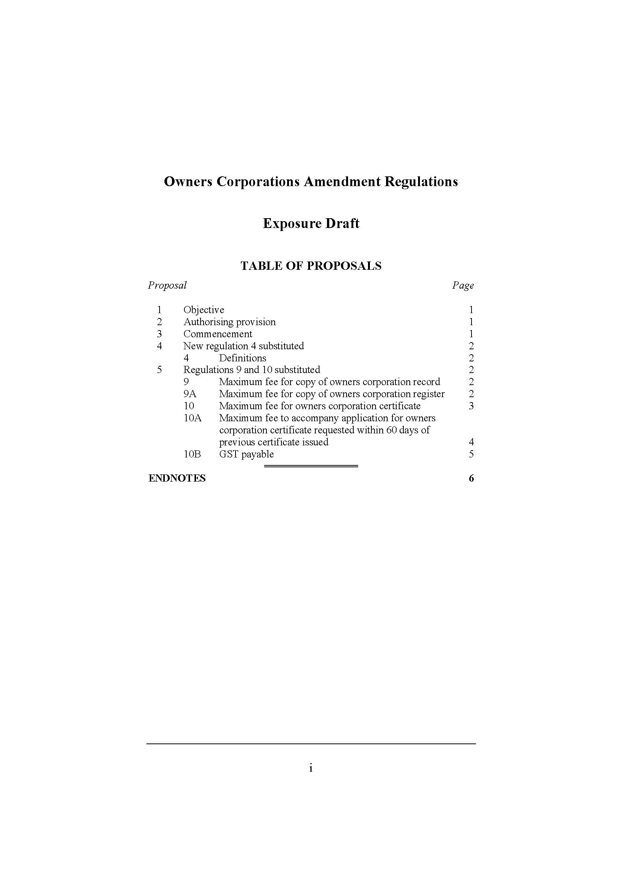

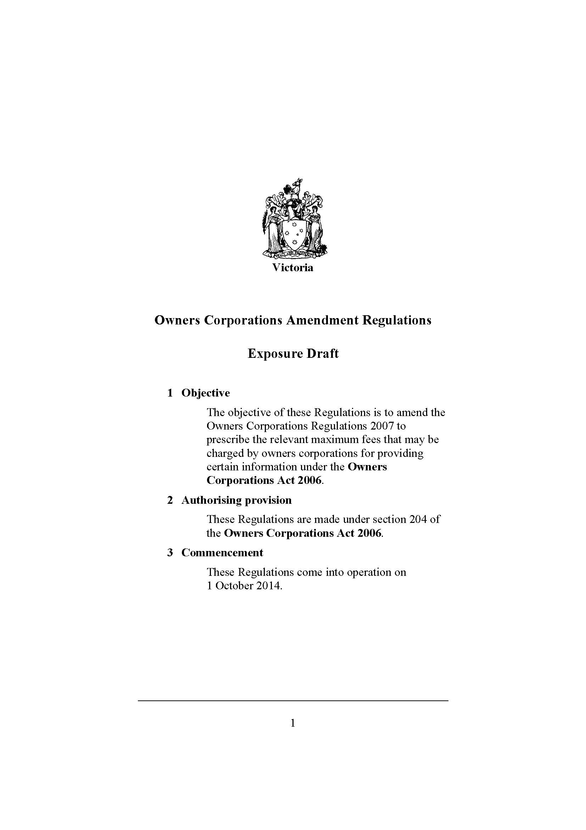

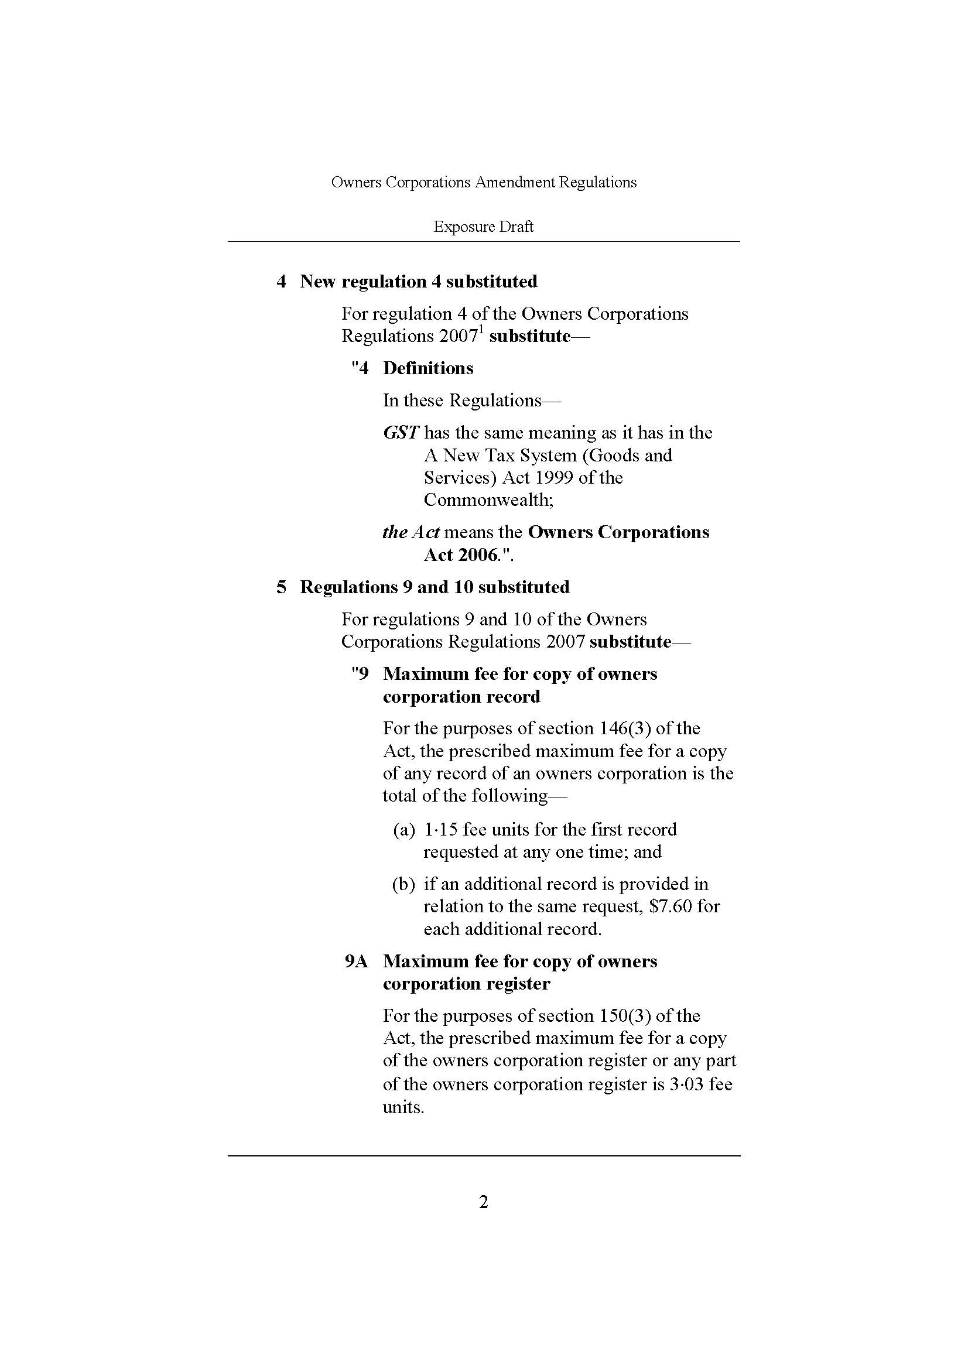

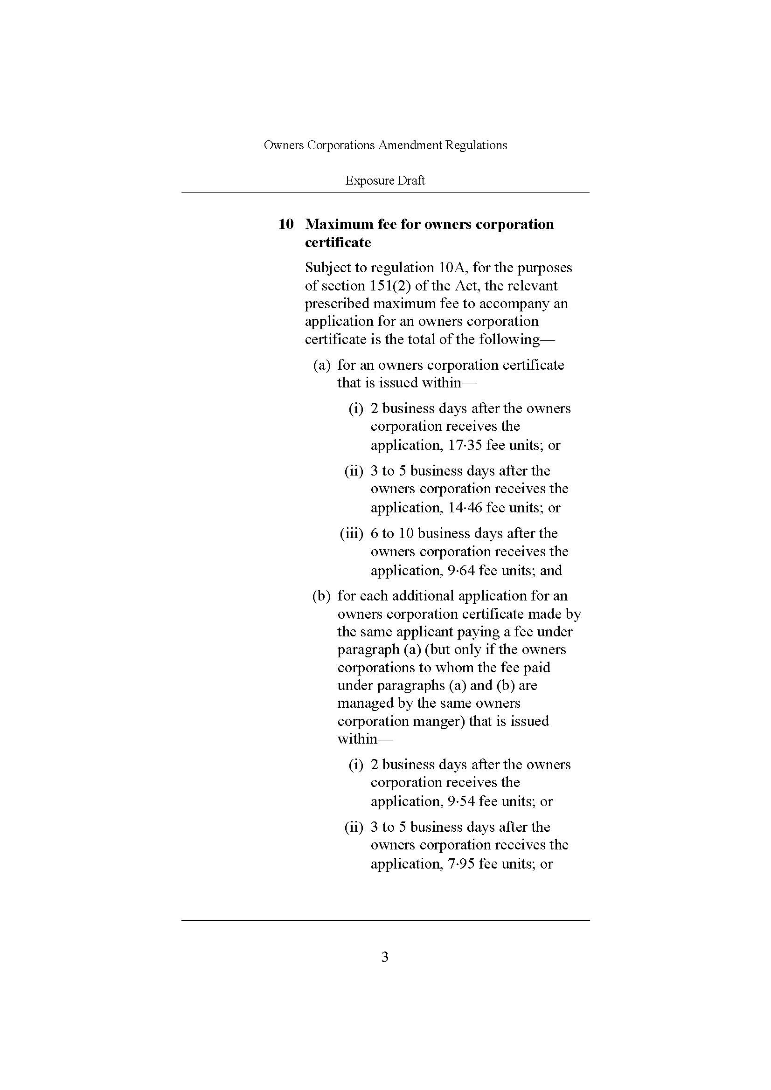

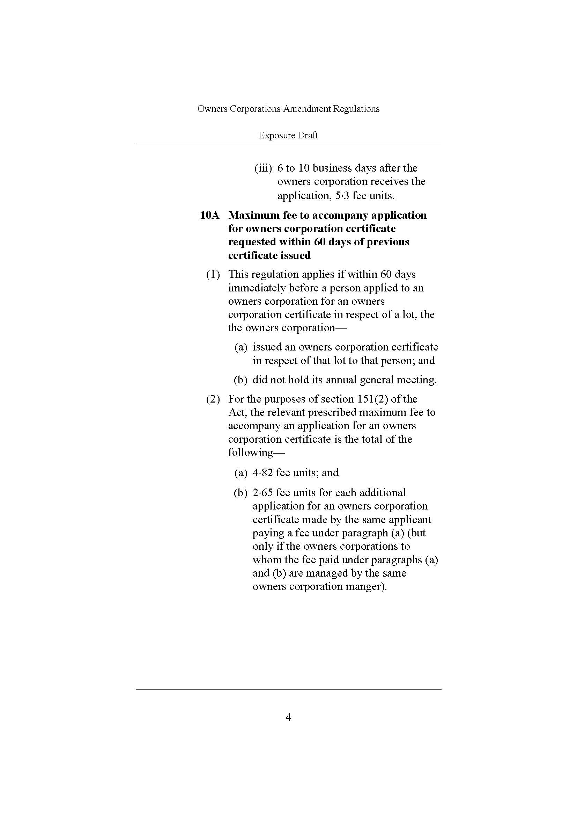

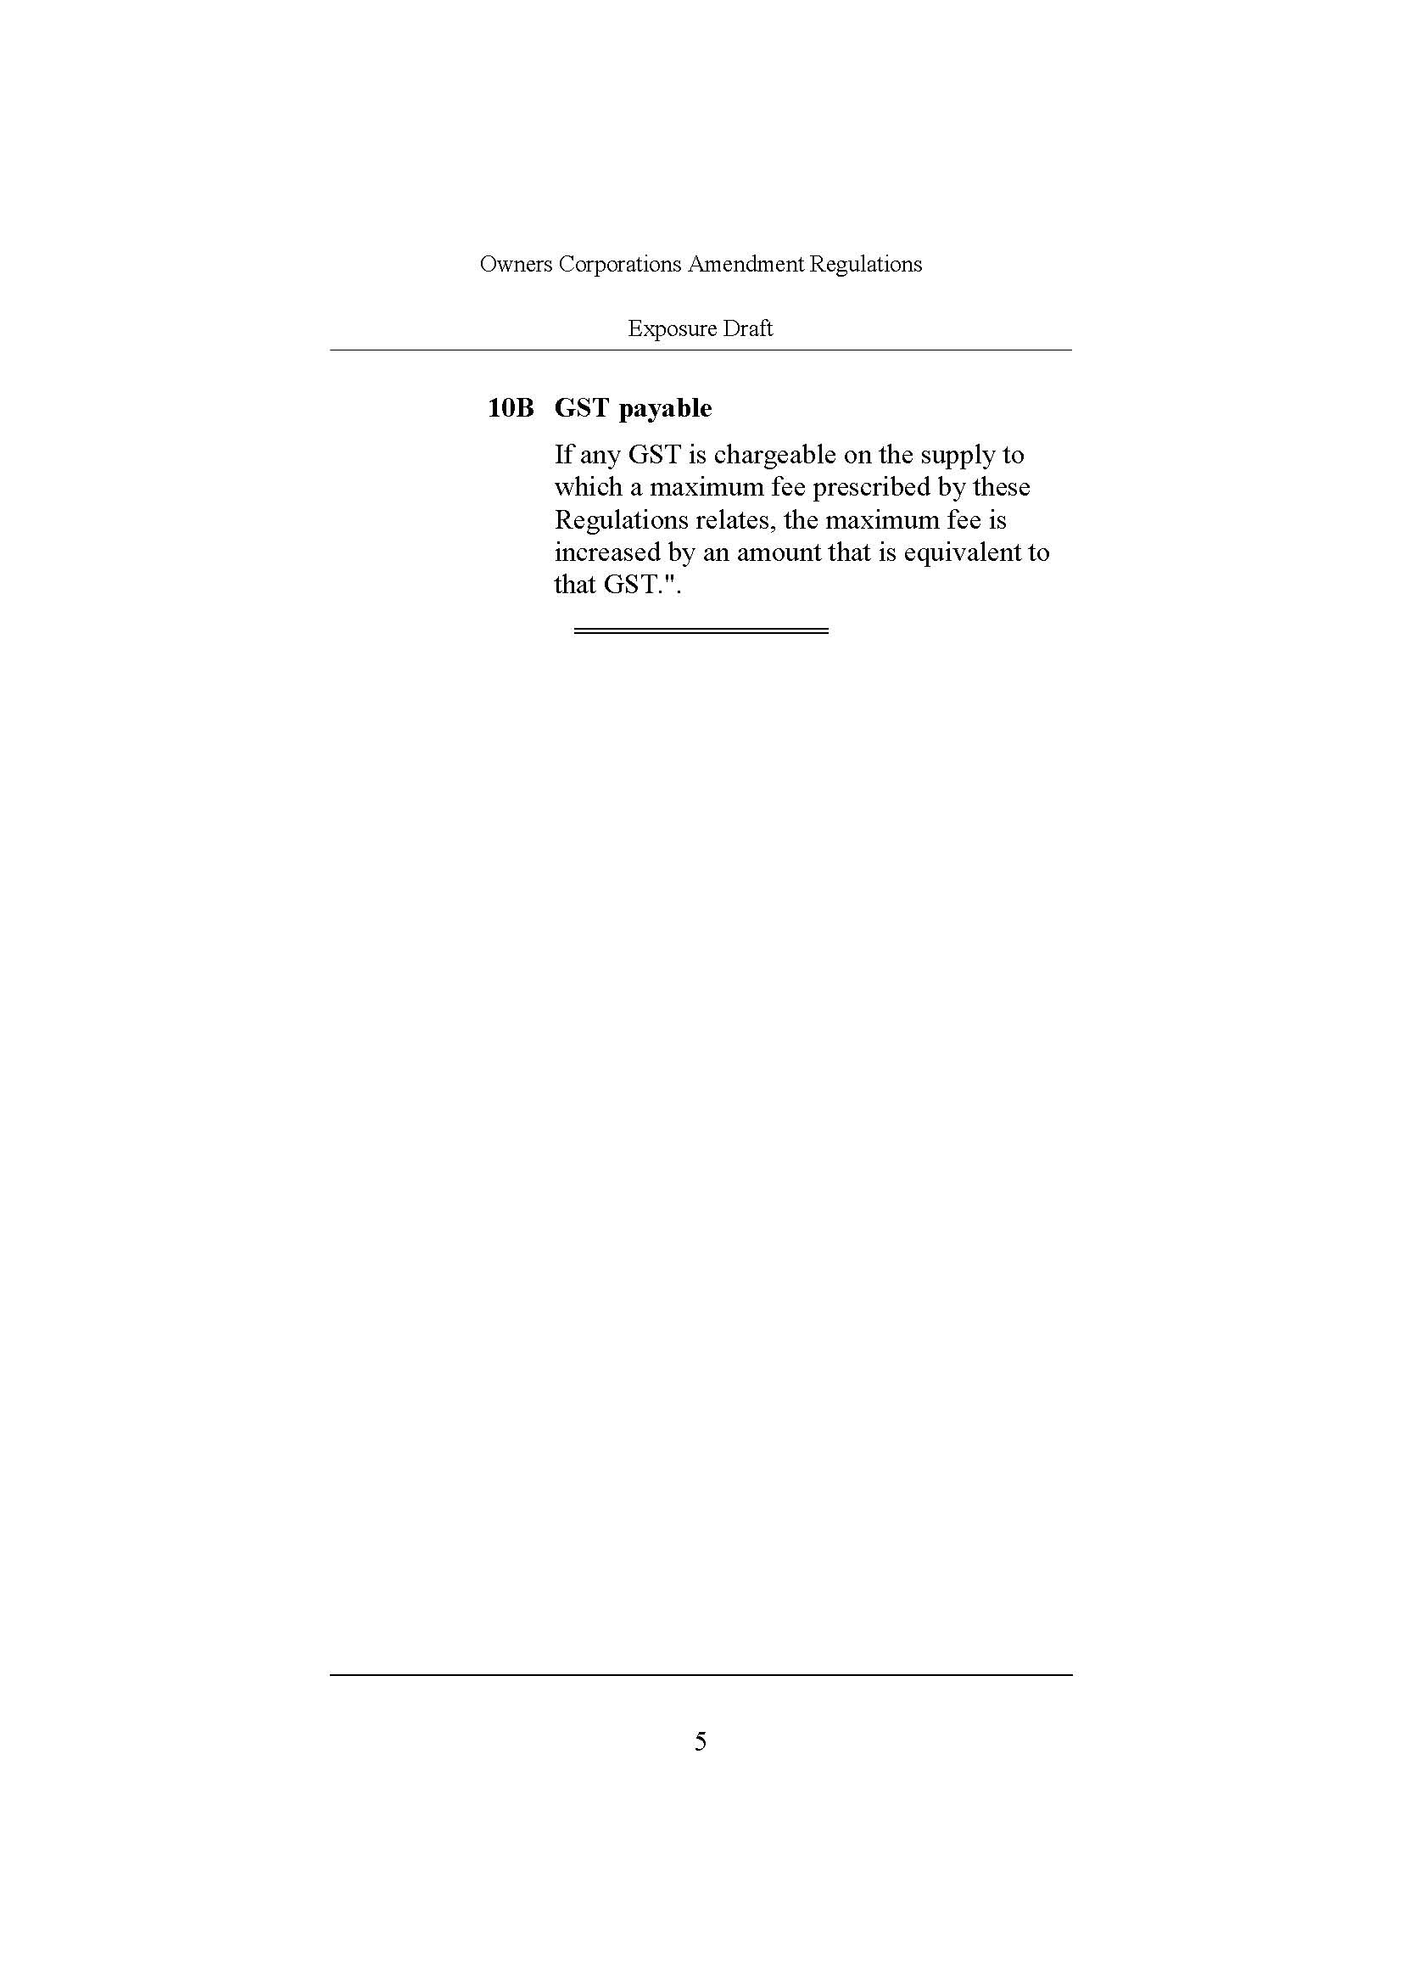



A complete list of matters to be addressed in the Certificate is provided in Appendix 1
Appendix 1 lists all the types of information that must be maintained in the Register
A complete list of all the types of records that an owners corporation must keep is provided in Appendix 1
It is estimated that about 10 per cent of vendors have the capacity to provide owners corporation information themselves.
57,870 transactions as a proportion of 498,271 total lots is 11.61 per cent.
The lower range was calculated by multiplying $150 by 15,000 and the higher range was calculated by multiplying $150 by 17,000.
In a sample of 114 owners corporation companies, only 9 (approximately 8 per cent) did not offer a priority service and therefore did not charge a priority fee.
76 out of the sample of 114 owners corporation companies
The lower range was calculated by multiplying 1,500 by $193, the higher range was calculated by multiplying 1,700 by $193.
The lower range was calculated by adding $2,250,000 and $289,500 assuming 15,000 Certificates prepared per year, while the higher range was calculated by adding $2,550,000 and $328,100 based on 17,000 Certificates per annum.
This estimate is based on a “worst case scenario” assumption in which the estimated 1,500 to 1,700 urgent requests made per year are all charged the average priority fee observed in the sample ($193), and where it is further assumed that each of these requests is for a Certificate issued within five business days. In section 4, the estimated efficient premium for a Certificate issued within five business days is $70.18. The average priority fee of $193 exceeds this efficient premium by $122.82. The estimated maximum range of total excessive charges for urgent requests is then calculated by multiplying $122.81 by 1,500 and 1,700.
In economic terms, fair and reasonable access and provision of owners corporation information means that the price of obtaining owners corporation information is set at efficient levels, representing the value cost of providing the service and information.
Source: SCA Benchmarking Project 2012, indexed at 4.4% (ABS, Average Weekly Ordinary Time Earnings (AWOTE) Index 2013, Publication No. 6302.0)
Source: SCA Benchmarking Project 2012, indexed at 4.4% (ABS, AWOTE index 2013, Publication No. 6302.0)
Appendix C of Victorian Guide to Regulation, Department of Treasury and Finance
Source: ABS catalogue no. 6104.0 – 2013 Labour Statistics in Brief
Default rate under Victorian Guide to Regulation, Department of Treasury and Finance
The value of a fee unit in 2013-14 is $12.84. The value of a fee unit in 2014-15 is $13.23.
Outlined in the Victorian Guide to Regulation, Department of Treasury and Finance
Source: SCA Benchmarking Project 2012, indexed at 4.4% (ABS, Average Weekly Ordinary Time Earnings (AWOTE) Index 2013, Publication No. 6302.0)
Source: SCA Benchmarking Project 2012, indexed at 4.4% (ABS, Average Weekly Ordinary Time Earnings (AWOTE) Index 2013, Publication No. 6302.0)
Appendix C of Victorian Guide to Regulation, Department of Treasury and Finance
Source: ABS catalogue no. 6104.0 – 2013 Labour Statistics in Brief
On-costs include employer superannuation contributions, payroll tax and fringe benefit tax. Overhead costs include building costs (floor space, fixtures and fittings maintenance etc.), equipment, IT and corporate overheads (senior management, human resources, legal services etc.). Multiplier taken from default under Victorian Guide to Regulation, Department of Treasury and Finance

