|  |
| --- |
| Regulatory Impact Statement for proposed Transfer of Land (Fees) Regulations 2015 and Subdivision (Registrar's Fees) Regulations 2015  Land Victoria  4 September 2015 |

Deloitte_blue_RGB_1.tifDeloitte Touche Tohmatsu  
ABN 74 490 121 060  
  
550 Bourke Street  
Melbourne VIC 3000  
GPO Box 78  
Melbourne VIC 3001 Australia  
  
Tel: +61 3 9671 7000  
www.deloitte.com.au

Christopher Shea  
Senior Policy Officer  
Land Victoria  
570 Bourke Street  
Melbourne VIC 3000

4 September2015

Dear Chris

Regulatory Impact Statement for proposed Transfer of Land (Fees) Regulations 2015 and Subdivision (Registrar's Fees) Regulations 2015

Please find attached our Regulatory Impact Statement for the proposed Transfer of Land (Fees) Regulations 2015 and the Subdivision (Registrar's Fees) Regulations 2015.

If you have any queries or would like to discuss the Final Report please feel free to contact me on 9671 6648 or David Floyd on 9671 6305.

Yours sincerely

Paul Liggins  
Partner  
Deloitte Touche Tohmatsu

Contents

[Glossary i](#_Toc429994776)

[Foreword ii](#_Toc429994777)

[Executive summary iii](#_Toc429994778)

[1 Background 1](#_Toc429994779)

[1.1 Land Victoria 1](#_Toc429994780)

[1.2 Legislative framework 2](#_Toc429994781)

[1.3 Purpose and structure of report 4](#_Toc429994782)

[2 The nature and extent of the problem 5](#_Toc429994783)

[2.1 Ensuring cost recovery for regulated activities 5](#_Toc429994784)

[2.2 Funding for government services 6](#_Toc429994785)

[2.3 Problem to be addressed 7](#_Toc429994786)

[2.4 Consequences if regulations are not remade 8](#_Toc429994787)

[2.5 Objectives of intervention 9](#_Toc429994788)

[3 Options to achieve the objectives 10](#_Toc429994789)

[3.1 Introduction 10](#_Toc429994790)

[3.2 Options for cost recovery fees 11](#_Toc429994791)

[3.3 Options for other fees 17](#_Toc429994792)

[4 Determining the preferred option 25](#_Toc429994793)

[4.1 Methodology for assessing the options 25](#_Toc429994794)

[4.2 Assessment of the options 27](#_Toc429994795)

[4.3 Summary of the preferred option 40](#_Toc429994796)

[5 Impacts on small business and competition 44](#_Toc429994797)

[5.1 Impact on small business 44](#_Toc429994798)

[5.2 Competition assessment 44](#_Toc429994799)

[6 Implementation and enforcement considerations 45](#_Toc429994800)

[6.1 Implementation 45](#_Toc429994801)

[6.2 Enforcement 45](#_Toc429994802)

[7 Evaluation strategy 46](#_Toc429994803)

[7.1 Data and Key performance indicators 46](#_Toc429994804)

[7.2 Assessment Timeframe 46](#_Toc429994805)

[Appendix A : Defining cost recoverable activities 47](#_Toc429994806)

[Methodology 47](#_Toc429994807)

[Branches in scope of the analysis 47](#_Toc429994808)

[List of Land Victoria’s functions 48](#_Toc429994809)

[Appropriateness of cost recovery 53](#_Toc429994810)

[Appendix B : Cost recovery and fee analysis 64](#_Toc429994811)

[Methodology 64](#_Toc429994812)

[Estimating the cost base 65](#_Toc429994813)

[Estimating costs per activity 76](#_Toc429994814)

[Calculation of fees 83](#_Toc429994815)

[Fees not included in the cost recovery analysis 84](#_Toc429994816)

[Appendix C : Changes to fees under the preferred option 86](#_Toc429994817)

[Appendix D : Draft Regulations 101](#_Toc429994818)

[Limitation of our work 127](#_Toc429994819)

Charts

[Chart 3.1 : Growth in mean prices of property transactions in Victoria compared to ad valorem ceiling 19](#_Toc429994820)

Tables

[Table ES.1: Summary of proposed options for cost recovery fees (2014-15 prices) iv](#_Toc429994821)

[Table ES.2: Summary of proposed options for the ad valorem component of the land transfer fee and fees for the registration and discharge of mortgages (2014-15 prices) v](#_Toc429994822)

[Table 3.1 : Concordance between branch/business unit and functional area 10](#_Toc429994823)

[Table 3.2 : Change in the structure of fees under Option 2 (by value category)1,2 13](#_Toc429994824)

[Table 3.3 : Proposed fees under Option 2 15](#_Toc429994825)

[Table 3.4 : Proposed fees under Option 3 16](#_Toc429994826)

[Table 3.5 : Estimated revenues under options for cost recovery fees (2014-15 prices) 17](#_Toc429994827)

[Table 3.6 : Summary of changes under Option 2 19](#_Toc429994828)

[Table 3.7 : Summary of changes under Option 3 20](#_Toc429994829)

[Table 3.8 : Summary of changes under Option 4 21](#_Toc429994830)

[Table 3.9 : Estimated revenues under options for the ad valorem component of the Land Transfer Fee (2014-15 prices) 21](#_Toc429994831)

[Table 3.10 : Summary of changes under Option 2 22](#_Toc429994832)

[Table 3.11 : Comparison of current mortgage fees by state 22](#_Toc429994833)

[Table 3.12 : Summary of Option 3 changes 23](#_Toc429994834)

[Table 3.13 : Summary of Option 4 changes 23](#_Toc429994835)

[Table 3.14 : Estimated revenues under options for fees for the registration and discharge of mortgages (2014-15 prices) 24](#_Toc429994836)

[Table 4.1 : Multi-criteria analysis scale 26](#_Toc429994837)

[Table 4.2 : Multi-criteria analysis of cost recovery fee options 28](#_Toc429994838)

[Table 4.3 : Cost recovery fees – assessment of Option 1 against criteria 29](#_Toc429994839)

[Table 4.4 : Cost recovery fees – assessment of Option 2 against criteria 30](#_Toc429994840)

[Table 4.5 : Cost recovery fees – assessment of Option 3 against criteria 31](#_Toc429994841)

[Table 4.6 : Multi-criteria analysis of land transfer fee options 31](#_Toc429994842)

[Table 4.7 : Land transfer fee – Assessment of Option 1 against criteria 32](#_Toc429994843)

[Table 4.8 : Land transfer fee – Assessment of Option 2 against criteria 33](#_Toc429994844)

[Table 4.9 : Land transfer fee - Assessment of Option 3 against criteria 34](#_Toc429994845)

[Table 4.10 : Land transfer fee - Assessment of Option 4 against criteria 36](#_Toc429994846)

[Table 4.11 : Multi-criteria analysis of mortgage fee options 36](#_Toc429994847)

[Table 4.12 : Mortgage fees – Assessment of Option 1 against criteria 37](#_Toc429994848)

[Table 4.13 : Mortgage fees – Assessment of Option 2 against criteria 38](#_Toc429994849)

[Table 4.14 : Mortgage fees – Assessment of Option 3 against criteria 39](#_Toc429994850)

[Table 4.15 : Mortgage fees – Assessment of Option 4 against criteria 40](#_Toc429994851)

[Table 4.16 : Comparison of proposed fee schedule with current fees 41](#_Toc429994852)

[Table 4.17 : Estimated annual revenue under preferred option (2014-15 dollars) 43](#_Toc429994853)

[Table 5.1 : Impacts of proposed fees on competition 44](#_Toc429994854)

[Table A.1 : List of transfer of land and subdivision functions 49](#_Toc429994855)

[Table A.2 : Interstate comparison of select fees with high transaction volumes (2014) 56](#_Toc429994856)

[Table A.3 : Framework for determining the economic characteristics of government outputs or regulation 57](#_Toc429994857)

[Table A.4 : Charging considerations for different types of goods 63](#_Toc429994858)

[Table B.1 : Summary of methodology 64](#_Toc429994859)

[Table B.2 : Concordance between branch/business unit and functional area 65](#_Toc429994860)

[Table B.3 : Land Victoria 2014-15 Budget and projected other costs 66](#_Toc429994861)

[Table B.4 : Allocation of internal costs 67](#_Toc429994862)

[Table B.5 : Proportion of budgeted costs allocated to each functional areas\* 67](#_Toc429994863)

[Table B.6 : Internal costs allocated to function area 69](#_Toc429994864)

[Table B.7 : Corporate overhead staff allocation to function areas (no. FTE staff) 70](#_Toc429994865)

[Table B.8 : Corporate overhead staff allocation to function areas, including agency hire staff (no. FTE staff) 71](#_Toc429994866)

[Table B.9 : Corporate overhead staff allocation to function areas, including agency hire staff (FTE) 72](#_Toc429994867)

[Table B.10 : Allocation of external costs based on resource usage 72](#_Toc429994868)

[Table B.11 : Allocation of external costs based on resource usage 75](#_Toc429994869)

[Table B.12 : Breakdown of the cost base 76](#_Toc429994870)

[Table B.13 : Mapping of fee type consolidation 78](#_Toc429994871)

[Table B.14 : Calculation of cost per activity for registrations 79](#_Toc429994872)

[Table B.15 : Calculation of cost per activity for plans 80](#_Toc429994873)

[Table B.16 : Cost components 81](#_Toc429994874)

[Table B.17 : Average cost calculations 82](#_Toc429994875)

[Table B.18 : Calculation of average transaction costs1,2 82](#_Toc429994876)

[Table B.19 : Summary of cost recovery fees and revenues1,2 83](#_Toc429994877)

[Table C.1 : Transfer of Land Act 1958 Fees – Comparison Table\* 86](#_Toc429994878)

[Table C.2 : Subdivision Act 1988 Fees – Comparison Table\* 96](#_Toc429994879)

Figures and boxes

[Figure 1.1 : Land Victoria – organisational chart 1](#_Toc429994880)

[Box 4.1: Multi Criteria Analysis 25](#_Toc429994881)

[Figure A.1 : Organisational chart – Land Victoria 48](#_Toc429994882)

[Box B.1: Example of cost weighting calculation 77](#_Toc429994883)

Glossary

|  |  |
| --- | --- |
| CAC | Capital Asset Charge |
| DELWP | Department of Environment, Land, Water and Planning |
| FTE | Full-time equivalent |
| GPS | Global positioning system |
| IT | Information Technology |
| LANDATA® | The LANDATA® system delivers Victorian property information including title, survey, valuation and property sales, property certificates and planning certificates through a network of data information brokers |
| MCA | Multi-criteria analysis |
| NSW | New South Wales |
| OSGV | Office of the Surveyor-General Victoria |
| PEXA | Property Exchange Australia |
| PMO | Project Management Office |
| PSV | Property Sales and Valuation |
| RIS | Regulatory Impact Statement |
| SPEAR | Surveying and Planning through Electronic Applications and Referrals system |
| TPI | Titles and Property Information |
| VGV | Valuer-General Victoria |
| VOTS | Victorian Online Titles System |

# Foreword

**Regulatory Impact Statement for the proposed Transfer of Land (Fees) and the Subdivision (Registrar's Fees) Regulations 2015**

This Regulatory Impact Statement (RIS) outlines the details of the proposed Transfer of Land (Fees) Regulations 2015 and the Subdivision (Registrar’s Fees) Regulations 2015.

These proposed Regulations will impose fees for the lodgement of property transactions, the lodgement of plans of subdivision and for searching the Titles Register. It is intended that they commence operation on 1 July 2016 and replace the current Regulations setting out fees for the lodgement of property transactions and plans of subdivision, and for searching the Titles Register.

The RIS process enables members of the public to comment on proposed statutory rules before they have been finalised. This input can provide valuable information and perspectives, and thus improve the overall quality of the regulations. The proposed Regulations are being circulated to key stakeholders and feedback is sought. A copy of the proposed Regulations is provided at Appendix D to this RIS. A comparison table setting out changes from the existing fee to the proposed fee is included at Appendix C.

Public comments and submissions are invited on the proposed Transfer of Land (Fees) Regulations 2015 and the Subdivision (Registrar’s Fees) Regulations 2015.

All submissions will be treated as public documents.

Written comments and submissions should be forwarded by 5:00pm, Monday 16 November via either email or post to:

Via email to: christopher.shea@delwp.vic.gov.au

Via post to:

Chris Shea

Senior Policy Officer

Land Victoria

Department of Environment, Land, Water and Planning

GPO Box 527

MELBOURNE VIC 3001

# Executive summary

This Regulatory Impact Statement (RIS) relates to the proposed Transfer of Land (Fees) Regulations 2015 and the Subdivision (Registrar’s Fees) Regulations 2015. These Regulations will impose fees for the lodgement of property transactions, the lodgement of plans of subdivision and for searching the Titles Register. It is intended that they commence operation on 1 July 2016 and replace the existing Regulations setting out fees for the lodgement of property transactions and plans of subdivision, and for searching the Titles Register.

The existing Regulations (the Transfer of Land (Fees) Interim Regulations 2015 and the Subdivision (Registrar’s Fees) Interim Regulations 2015) impose fees for the same purposes as the proposed Regulations. The existing regulations are interim regulations which set the same fee levels, as the Transfer of Land (Fees) Regulations 2004 and the Subdivision (Registrar’s Fees) Regulations 2004. The Interim Regulations contain no new fees and no fee levels have been amended. Under the provisions of the *Subordinate Legislation Act 1994* the 2004 Regulations would have been automatically revoked in September 2015, however Interim Regulations were made to enable fee collection for a period of 12 months from 19 September 2015. It is Land Victoria’s intention to commence the proposed Regulations on 1 July 2016.

Background

New Regulations are required for fees to be collected from 1 July 2016 associated with the lodgement of property transactions, the lodgement of plans of subdivision and searching the Titles Register. Over the past ten years, with two exceptions (discussed below), fees under these regulations were set to fully recover costs. Given that the purpose of these services remains largely unchanged compared to ten years ago, the rationale of setting fees to recover costs is still appropriate. Consistent with this, a key objective of this RIS is to align fees with cost recovery principles. This objective has been balanced with a number of other objectives, as discussed below.

In many cases, renewing these regulations and setting fees to recover costs will result in lower fees, because the cost of many of those services has decreased due to Land Victoria’s process improvements. Some key drivers of these cost reductions include:

* Automation of the land titles system
* Introduction of optical character recognition to aid the processing of paper documentation
* Launch of electronic conveyancing in Victoria (2006) and subsequent (and ongoing) development of the national system Property Exchange Australia (PEXA) (2010).

Options for cost recovery fees

This RIS estimates the efficient cost of providing transaction lodgement, plan lodgement and title search services and considers different approaches to structuring the fees. These different approaches are articulated as part of a range of options in this RIS. A summary of revenue collected under each option is provided under Table ES.1.

The Department of Environment, Land, Water and Planning’s (DELWP) view is that the proposed fees reflect the estimated efficient cost of each individual service. The total revenue for these fees is estimated to be approximately $60 million per annum. The ongoing collection of these fees is essential to fund the operations of the Office of Titles. Adequate funding of the Office of Titles is essential for the efficient operation in Victoria of the Torrens System of land tenure. An efficiently operated land tenure system is an essential foundation of the wider Victorian economy.

If these fees are not collected then the services would need to be funded from general revenue, with the consequence that users of these services would be subsidised by taxpayers in general who do not directly share in the benefits of these services.

Table ES.1: Summary of proposed options for cost recovery fees (2014-15 prices)

|  |  |
| --- | --- |
| Options | Estimated revenue ($m) |
| **Cost Recovery fees** |  |
| Base case | $0.0 |
| Option 1 – Status quo | $84.3 |
| Option 2 – Aligning with cost recovery principles | $58.6 |
| Option 3 – Significantly reducing complexity | $58.6 |

Source: Land Victoria

Options for the ad valorem component of the land transfer fee and fees for the registration and discharge of mortgages

Two fees charged by Land Victoria over the past ten years were set to over-recover costs. These included the ad valorem component of the transfer of land fee (which has been set to over-recover costs since 1994) and the fee for the registration or discharge of a mortgage (which has been set to over-recover costs since the 2005-06 State Budget).

The revenue raised through these fees contributes to general Victorian Government revenue. For example, fees and charges such as these were included in the “Other Taxes” component of the historical and forecast taxation in the 2015-16 State Budget. As the Government expects and needs to maintain its revenue consistent with the forward estimates to meet its projected expenditure, this RIS assesses options for setting the land transfer fee and the fee for the registration or discharge of a mortgage with an objective of maintaining this level of revenue while minimising any impacts on equity. Another objective considered in assessing options for the land transfer fee is to ensure that the settings of the ad valorem component are consistent with current property prices while maintaining the original policy intent of this fee which was that it would be an equitable tool to raise government revenue, without having a negative impact on large land transactions (e.g. in relation to mines, power plants, and other key infrastructure) which could have implications for investment – noting that DELWP’s current position on the need to avoid negative impacts on large land transactions is consistent with the original policy intent.

Table ES.2 provides a summary of options for these fees.

Table ES.2: Summary of proposed options for the ad valorem component of the land transfer fee and fees for the registration and discharge of mortgages (2014-15 prices)

|  |  |
| --- | --- |
| Options | Estimated revenue ($m) |
| **Ad valorem component of the Land Transfer Fee1** |  |
| Base case | $0.0 |
| Option 1 – Status quo (rate of $2.46 per $1000 up to a ceiling of $500,000) | $147.4 |
| Option 2 – Decrease the rate by 5%, raise the ceiling | $182.2 |
| Option 3 – Maintain the rate, remove the ceiling | $214.7 |
| Option 4 – Decrease the rate by 3%, remove the ceiling | $208.0 |
| **Fees for the registration and discharge of mortgages** |  |
| Base case | $0.0 |
| Option 1 – Status quo | $45.5 |
| Option 2 – Align with NSW | $43.9 |
| Option 3 – Align with all states and territories | $56.6 |
| Option 4 – Full cost recovery | $17.9 |

Source: Land Victoria

Notes: The ad valorem component of the Land Transfer Fee is structured as a rate per $1000 of the value paid for the property (referred to as consideration) subject to the transfer, up to a certain capped amount (referred to as the ceiling).

Under the status quo option, the revenue raised from the ad valorem component of the land transfer fee and the revenue raised from the registration or discharge of a mortgage total $192.9 million per annum. Under the preferred option, which is Option 2 for both, the revenue raised is $226.1 million, an additional $33 million per annum.

Determining the preferred option

Each of the options were assessed using multi criteria analysis to determine the extent to which they meet the efficiency and equity objectives of cost recovery while also meeting the Government’s objective of maintaining revenue consistent with the forward estimates, to meet projected expenditure. On the basis of this analysis, the preferred option was selected as Option 2 across all three areas of fees, as follows:

* Cost recovery fees – aligning with cost recovery principles
* Ad valorem component of the Land Transfer Fee – decrease the rate and raise the ceiling[[1]](#footnote-2)
* Fees for the registration and discharge of mortgages – align with NSW.

DELWP’s view is that the proposed fees materially improve the equity of the fees with a relatively low impact on efficiency. The total amount of revenue generated under the preferred option is $284.7 million in 2014-15 prices.

Option 2 was preferred for both the ad valorem component of the land transfer fee (decrease the rate and increase the ceiling) and the registration or discharge of a mortgage (retain the alignment with NSW fee) as it allows the Government to meet its expenditure commitments. This was preferred to raising the equivalent revenue purely from the ad valorem component of the land transfer fee on the basis that this would require removal of the ad valorem ceiling which would result in large increases in the transaction costs of high-value property transactions.

The preferred option in detail

Fees for registrations and plans of subdivision

Under the preferred option, the range of different fee amounts charged for registrations and plans of subdivision have been consolidated to better reflect the effort and complexities involved in undertaking the underlying activities and, therefore, to better align with the efficiency objective of cost recovery. These groups of fee amounts are referred to as value categories[[2]](#footnote-3). The categories range in dollar value from the more routine transactions taking shorter periods of time to process, to more complex transactions which require longer periods of time and/or more experienced staff to process.

The new grouping reduces the number of fee categories from 21 to eight (not including the two fees for the registration and discharge of mortgages) in the registrations area and from four to two for plans of subdivision. For example, the current fee structure for a plan of subdivision includes a flat plan fee, a fee for every lot in excess of two, a survey fee and an additional owners’ corporation fee. The new fee structure will only include a flat fee for the plan and a fee for every parcel created in the plan. The fee amounts associated with each category reflect the efficient costs of the activities assigned to the category as they are based on true work effort with no averaging of fees within each grouping being applied.

In addition, ancillary fee items such as ‘title made available’ and ‘correspondence fee’ have been removed as they were often forgotten by customers resulting in the incorrect dollar amounts being submitted for payment. The miscalculation of dollar amounts has also been an issue for plan fees, such as the ‘lot fee calculation’. Tendering of incorrect fees results in transactions or plans being postponed or rejected with associated delays until such time as correct fees are submitted – a process that can be time consuming and frustrating for applicants. As such, simplifying the fee structure into categories based on work effort and eliminating most ancillary fees will have the added benefit of reducing the incidence of incorrect calculations and potential double handling of applications and, in so doing, removing or reducing the inconvenience and potential frustration for customers.

Search fees

Under the preferred option, the value categories for search fees remain unchanged. However, it is proposed that the fee values change with some decreasing and some increasing.

The reduction in some search fees reflects the lower cost per unit to deliver the associated services. For example, the cost of the highest volume product – title search through brokers – has fallen 27 per cent. Lower costs per unit have arisen due to greater levels of demand for search products since the current fees were set in 2003 – primarily driven by the maturity of the on-line market – and lower IT costs for hardware and software, noting that online search products do not have a high labour component.

For those fees that are increasing, there are three key explanations, as follows:

* History search is the sum of an image (of the former paper title) and a search of the Victorian Online Titles System (VOTS). The former fee principally reflected the image delivery cost which was generally correct at the time of land titles automation. The history search fee is now the sum of an instrument search fee and a title search fee
* Plan costs have been adversely affected by the need for inclusion of a payment for copyright in survey plans
* Final search is a search of the VOTS system and incurs most title search costs. The 2004 fees adjusted the final search fee to reflect the proportion of title search information that was being delivered. That approach did not accurately reflect costs but encouraged users to undertake a further search at or immediately before settlement.

Summary

Under the preferred option, fees for approximately 75 per cent of transaction types are proposed to decrease.[[3]](#footnote-4) There is a proposed simplification of the fee structure and a number of fees would be removed. This would benefit the majority of customers accessing Land Victoria’s services, especially those customers making registrations and executing plan transactions. As part of the preferred option, some customers would pay higher fees, predominantly as a result of the increase of the ad valorem transfer of land fee ceiling. This change would impact mostly customers transacting in land valued above $500,000.

A summary of the proposed change in the structure and value of fees is provided in Table ES.3. Note that, for the purposes of brevity, the table lists the fee value categories under the current and proposed fee structures, rather than the fee items themselves of which there are over 130. The full list of fee items is outlined in Appendix C.

Table ES.3: Change in the structure and value of fees under the preferred option (by value category)1,2

| Current value category | 2014-15 value | Volume (% total)3 | Proposed new value category | Proposed value4 |
| --- | --- | --- | --- | --- |
| Registrations (Electronic) A1 | $53.50 | 0.7 | Registrations (Electronic) A | $35.89 |
| Registrations (Electronic) A2 | $73.00 | 0.0 |  |  |
| Registrations (Electronic) B | $111.70 | 0.0 | Registrations (Electronic) B | $79.91 |
| Registrations (Electronic) C | $150.54 | 0.0 | Registrations (Electronic) C | $168.01 |
| Registrations (Paper) A1 | $76.90 | 6.6 | Registrations (Paper) A | $44.02 |
| Registrations (Paper) A2 | $77.70 | 0.0 |  |  |
| Registrations (Paper) A3 | $96.40 | 2.9 |  |  |
| Registrations (Paper) B1 | $116.50 | 1.1 | Registrations (Paper) B | $88.04 |
| Registrations (Paper) B2 | $135.20 | 27.4 |
| Survey - Type 1 | $116.50 | 0.1 |
| Survey - Type 2 | $258.40 | 0.0 |
| Registrations (Paper) C1 | $155.30 | 0.1 | Registrations (Paper) C | $176.07 |
| Registrations (Paper) C2 | $174.00 | 0.1 |
| Registrations (Paper) C3 | $233.00 | 0.4 |
| Registrations (Paper) C4 | $310.60 | 0.0 |
| Survey - Type 3 | $362.40 | 0.0 |
| Registrations (Paper) D | $58.30 | 0.3 | Registrations (Paper) D | $27.09 |
| Survey - Type 4 | $517.70 | 0.0 | Survey | $554.45 |
| Survey - Type 5 | $582.40 | 0.0 |  |  |
| Survey - Type 6 | $762.20 | 0.0 |  |  |
| Survey - Type 7 | $776.50 | 0.0 |  |  |
| Subdivision plan-  plus for each lot | $762.20  $166.20 | 1.2 | Subdivision plan-  plus for each parcel | $554.45  $171.38 |
| Cancel a stratum plan and create new subdivision plan - | $116.50 | 0.0 | Other plans- | $88.11 |
| plus for each lot | $64.70 |  | plus for each parcel (relevant only to cancel a stratum plan) | $171.38 |
| Non-subdivision Owners Corporation A5 | $129.50 | 0.0 |  |
| Non-subdivision Owners Corporation B5 | $58.30 | 0.0 |  |  |
| Mortgage and discharge of mortgage fee – paper | $111.00 | 58.6 | Mortgage and discharge of mortgage fee – paper | $107.00 |
| Mortgage and discharge of mortgage fee – electronic | $88.00 | 0.2 | Mortgage and discharge of mortgage fee – electronic | $99.00 |
| **Total** |  | **100** |  |  |
| Title - OTC | $17.25 | 0.1 | Title - OTC | $16.15 |
| Title - FOH | $10.03 | 1.5 | Title - FOH | $8.18 |
| Title - TPI | $16.54 | 3.9 | Title - TPI | $6.84 |
| Title - Broker | $7.65 | 47.9 | Title - Broker | $5.56 |
| Final Search - OTC | $8.75 | 0.3 | Final Search - OTC | $13.34 |
| Final Search - FOH | $2.53 | 0.0 | Final Search - FOH | $5.36 |
| Final Search - TPI | $6.65 | 0.4 | Final Search - TPI | $3.74 |
| Final Search - Broker | $1.85 | 5.9 | Final Search - Broker | $2.74 |
| Plan - OTC | $7.30 | 0.0 | Plan - OTC | $16.09 |
| Plan - FOH | $4.17 | 0.4 | Plan - FOH | $8.12 |
| Plan - TPI | $6.45 | 4.0 | Plan - TPI | $6.50 |
| Plan - Broker | $2.44 | 17.4 | Plan - Broker | $5.50 |
| Instrument - OTC | $6.75 | 0.0 | Instrument - OTC | $14.41 |
| Instrument - FOH | $3.04 | 0.5 | Instrument - FOH | $6.44 |
| Instrument - TPI | $6.45 | 1.5 | Instrument - TPI | $4.82 |
| Instrument - Broker | $2.44 | 15.1 | Instrument - Broker | $3.82 |
| History search - OTC | $10.70 | 0.0 | History search - OTC | $30.56 |
| History search - FOH | $6.93 | 0.1 | History search - FOH | $14.62 |
| History search - TPI | $9.58 | 0.3 | History search - TPI | $11.67 |
| History search - Broker | $6.28 | 0.7 | History search - Broker | $9.38 |
| **Total** |  | **100** |  |  |
| Ad valorem rate of land transfer fee | $2.46 per $1000 up to $500k6 | N/A | Ad valorem rate of land transfer fee | $2.34 per $1000 up to $1.5m6 |

Notes:

1For the purposes of brevity, this table lists the various fee value categories under the current and proposed fee structures, rather than the fee items themselves of which there are over 130. The full list of fee items is outlined in Appendix C.

2OTC – Over the counter; FOH – Front of house (internal government service); TPI – titles and property information (online credit card service).

3The proportion of volume is divided between search and non-search fee value categories. These proportions have been rounded to one decimal place. In doing so, a number of fee value categories with low transaction volumes are zero even though they have transaction volumes associated with them.

4Under the proposed changes, the fees for approximately 75 per cent of transaction types are going down. Some fees are increasing to align those fees with cost recovery principles. Fees have been rounded to the nearest 10 cents.

5Owners Corporation transactions carried out under ‘Other plans’ are only applicable to Owners’ Corporations created outside of the subdivision process. Only three Owners’ Corporations were created outside the subdivision process last financial year. There are approximately 4000 Owners’ Corporations created annually, the cost of which is captured in the subdivision plan fee value category.

6Refers to the rate per $1000 of the value paid for the property (referred to as consideration) subject to the transfer, up to a certain capped amount.

# Background

## Land Victoria

Land Victoria, a division of the Department of Environment, Land, Water and Planning (DELWP), is the key agency for land administration and land information in Victoria. It is responsible for registration of land titles under the Torrens system, General Law titles, and the status of Crown land. In addition, Land Victoria is home to the Valuer-General Victoria (VGV) and the Office of the Surveyor-General Victoria (OSGV). Land Victoria’s operations can be categorised into service delivery units and support units. Support units include the systems, legal, policy and business support units. Service delivery units include the Land Registration Services, VGV and the OSGV (see Figure 1.1).

: Land Victoria – organisational chart

Source: Land Victoria – Efficiency review, Deloitte 2014

Land Victoria has undergone significant changes over the past 20 years. In addition to moving across a number of government departments (most recently from the Department of Transport, Planning and Local Infrastructure to DELWP), Land Victoria has experienced the following changes:

* Automation of the Land Titles Register (2001)
* Conversion of paper-based titles and other reports to electronic format (2001) and introduction of optical character recognition technology to reduce processing time (2010)
* Introduction of the Surveying and Planning through Electronic Applications and Referrals system (SPEAR), allowing for electronic lodgement of planning and subdivision permits (2006)
* Extension of SPEAR via development of ePlan – digital plans of subdivision (ongoing)
* Launch of electronic conveyancing in Victoria (2006) and subsequent (and ongoing) development of the national system ‘PEXA’ (Property Exchange Australia) (2010)
* Establishment of Victoria’s water register (2007)
* Expansion of its services, particularly in relation to provision of information and services via digital channels.

## Legislative framework

### Land Registration Services

The Land Registration Services branch administers statutory land transfer functions and related property information products. This includes registering land transfers, the recording of notifications against land titles and registering plans of subdivision. Key activities that Land Registration Services undertakes are:

* Registration – registers approximately 750,000 transactions in land and water annually, with 25 per cent of transactions performed over-the-counter and the remainder processed within 24 to 48 hours of submission
* Subdivision – registers plans of subdivision, processing approximately 8,000 plans annually. Around 85 per cent of plans are lodged online via SPEAR
* Application and Survey – registers complex survey and plan based dealings and applications, maintains the status of crown land and undertakes data quality assurance, conversion of General Law land to the Torrens title system and establishing a Crown Land Register.
* Land Records and Information Services – delivers information to brokers and the public via online services (LANDATA, Titles and Property Information (TPI) and Property Sales and Valuation (PSV)) and undertakes projects to improve the accuracy and accessibility of land information.
* Business Services – supports Land Registration Services in the following areas; initiatives, statistics, business reports, website updates, forms building and QA/business improvement.

### Regulation of fees

Land Victoria collects a range of statutory fees through the conduct of its mandated service delivery responsibilities. These fees form part of Victoria’s consolidated revenue and provide for funding of Land Victoria’s costs via once off and annual appropriations as well as appropriations under section 29 of the *Financial Management Act 1994*. The majority of statutory fees collected by Land Victoria were set in 2004 following a regulatory impact statement (RIS), although some subsequent amendments have been made to reflect changes in activity following introduction of electronic conveyancing and SPEAR and to align mortgage and discharge of mortgage fees with their NSW equivalent.

Currently, two sets of Regulations set out the statutory fees payable to the Registrar of Titles under the *Transfer of Land Act 1958* and the *Subdivision Act 1988*. These Regulations are as follows:

* Transfer of Land (Fees) Interim Regulations 2015
* Subdivision (Registrar’s Fees) Interim Regulations 2015.

The existing regulations are Interim Regulations which set the same fee levels, as the Transfer of Land (Fees) Regulations 2004 and the Subdivision (Registrar’s Fees) Regulations 2004. Under the provisions of the *Subordinate Legislation Act 1994* the 2004 Regulations were to be automatically revoked in September 2015. However, Interim Regulations were made to enable fee collection consistent with the fee levels set by the 2004 Regulations from 19 September 2015. Since the 2004 Regulations were introduced, there have been a series of amendments to the level of fees. These changes reflect technological changes and the reduction in cost of delivery for some of the services that Land Victoria is responsible for. These changes were reflected in a series of amending Regulations, as follows:

* Transfer of Land (Fees) (Amendments) Regulations 2006
* Transfer of Land (Fees) (Further Amendments) Regulations 2007
* Subdivision (Registrar’s Fees) (Amendments) Regulations 2007
* Subdivision (Registrar’s Fees) (Amendments) Regulations 2011.

The existing Regulations will expire on 18 September 2016 unless revoked earlier. It is Land Victoria’s intention to have the new regulations commence on 1 July 2016. Land Victoria wishes to make new Regulations with amendments to fee levels and the structure of fees to reflect changes in the relevant cost bases and changes in Land Victoria and industry practices.

### Land Victoria fees and cost recovery

There are a large number of statutory fees specified under the existing Regulations, including over 90 fees (a number of which have the same value) under the Transfer of Land (Fees) Interim Regulations 2015 and over 30 under the Subdivision (Registrar’s Fees) Interim Regulations 2015. The majority of these fees are set using principles outlined in the Department of Treasury and Finance’s *Cost Recovery Guidelines*[[4]](#footnote-5). However, there are two exceptions to this. Consistent with Victorian Government policy, fees for registration and discharge of mortgages are made to achieve alternative objectives of the Government. This is permitted under *Transfer of Land Act 1958* section 108(1). The ad valorem component of the Land Transfer fee is also made to achieve alternative objectives of the Government. This is permitted under Section 120(2)(b) of the *Transfer of Land Act 1958*. These fees are discussed separately in this RIS.

## Purpose and structure of report

Deloitte Touche Tohmatsu (Deloitte) has been engaged by DELWP to prepare the RIS report consistent with requirements outlined in the *Victorian Guide to Regulation*. This RIS draws upon cost recovery and fee analysis conducted by Land Victoria for the purposes of this RIS.

Land Victoria is seeking to align fees for land registration and information services with best practice policy principles, specifically those outlined in the *Cost Recovery Guidelines*. In accordance with the requirements of the *Subordinate Legislation Act 1994*, a RIS is required to determine the burden imposed on sectors of Victorian society by the proposed fee changes. This RIS has been developed to articulate the need to set cost recovery fees in Victoria for use of government provided land registration and information services. The remainder of this report is structured as follows:

* Chapter 2 – Nature and extent of the problem
* Chapter 3 – Options to achieve the objectives
* Chapter 4 – Determining the preferred option
* Chapter 5 – Impacts on small business and competition
* Chapter 6 – Implementation and enforcement considerations
* Chapter 7 – Evaluation strategy
* Appendix A – Defining cost recoverable activities
* Appendix B – Cost recovery and fee analysis
* Appendix C – Changes to fees under the preferred option
* Appendix D – Draft Regulations.

# The nature and extent of the problem

*This chapter outlines the nature and extent of the problem, the risk of non-intervention and the objectives of intervention*

## Ensuring cost recovery for regulated activities

Cost recovery through fees occurs on the basis of a user-pays system, whereby those who utilise services are obliged to pay for the cost of those services, rather than having them funded from general taxation revenues. Under full cost recovery, taxpayers in general are not subsidising those who use the service for which costs are being recovered.

Land Victoria conducts various administrative activities set out under the *Transfer of Land Act 1958* and the *Subdivision Act 1988* and associated Regulations that support the ownership of land and the use of that land in Victoria, including activities relating to the transfer of land and subdivision of land. Land Victoria currently charges fees for various activities including those in relation to:

* The lodgement of transactions for the registration of rights and interests in land
* Plan and instrument searches
* The lodgement of various plans and documents associated with the registration of plans of subdivisions
* The lodgement of various plans and documents connected with the consolidations of land, creating, amending or removing easements and restrictions.

Through these fees and charges, Land Victoria is able to recoup the cost of government-provided activities that reflect the costs incurred to service the needs of Land Victoria’s customers.

Cost recovery has the potential of advancing both equity and efficiency objectives, although in some cases these objectives may need to be balanced against each other. A requirement outlined in the *Victorian Guide to Regulation* and general government policy is that regulatory fees and user charges should be set on a full cost recovery basis to ensure that both efficiency and equity objectives are met.[[5]](#footnote-6) Full cost represents the value of all the resources used or consumed in the provision of an output or activity. In particular:

* Full cost recovery promotes the efficient allocation of resources by sending the appropriate price signals about the value of all the resources being used in the provision of government goods, services and/or regulatory activity
* From a horizontal equity point of view, full cost recovery ensures that those that have benefited from government-provided goods and services, or those that give rise to the need for government regulation, pay the associated cost. Those parties that do not benefit or take part in a regulated activity do not have to bear the costs.

## Funding for government services

Land Victoria collects a range of statutory fees through the conduct of its mandated service delivery responsibilities. A small number of fees charged under the Transfer of Land (Fees) Interim Regulations 2015[[6]](#footnote-7) (specifically the ad valorem component of the Land Transfer Fee and fees for the registration and discharge of mortgages) are set at a level higher than cost recovery. As outlined in Chapter 1, this is permitted under *Transfer of Land Act 1958* section 108(1) and section 120(2)(b).

The revenue raised through these fees contributes to general revenue. For example, fees and charges such as these were included in the “Other Taxes” component of the historical and forecast taxation in the 2015-16 State Budget. As the Government expects and needs to maintain its revenue consistent with the forward estimates to meet its projected expenditure, this RIS assesses options for setting the land transfer fee and the fee for the registration or discharge of a mortgage with an overarching objective of maintaining this level of revenue while minimising any impacts on equity.

These fees are referred to as non-cost recovery fees for the remainder of this report. Further discussion is provided below to highlight the government’s authority for setting non-cost recovery fees and the rationale for doing so.

### Land Transfer Fee

Fees for Land Transfer are made according to a separate legislative power under Section 120(2)(b) of the *Transfer of Land Act 1958*. Section 120(2)(b) states:

Without limiting the generality of subsection (1), the Governor in Council may make regulations for or with respect to the amount to be paid for lodging an instrument of transfer of land, whether fixed by reference to the consideration expressed in the transfer or otherwise and whether or not bearing relation to the cost of providing the service.

Note that the land transfer fee has two components, a fixed fee which is based on cost recovery principles, and an ad valorem component which is set under Section 120(2)(b) of the *Transfer of Land Act 1958*.

In addition to the objective of maintaining revenue consistent with the forward estimates, another objective considered in assessing options for the land transfer fee is to ensure that the settings of the ad valorem component are consistent with current property prices while maintaining the original policy intent of this fee which was that it would be an equitable tool to raise government revenue, without having a negative impact on large land transactions (e.g. in relation to mines, power plants, and other key infrastructure) which could have implications for investment – noting that DELWP’s current position on the need to avoid negative impacts on large land transactions is consistent with the original policy intent.

### Registration and discharge of mortgages

In 2005-06, the Victorian Government adopted a new approach to making fees relating to the registration and discharge of mortgages. As part of the 2005-06 changes, the Treasurer announced that these fees would be brought more into line with amounts charged in other jurisdictions by aligning the fees with amounts charged in New South Wales. This resulted in an increase in these fees beyond the cost recovery level.

## Problem to be addressed

There are two key problems to address through the proposed Regulations:

* Funding of Land Victoria services
* Over-recovery of costs for certain Land Victoria services under the current Regulations.

These are discussed below.

### Funding of Land Victoria services

Best practice regulation aims to address failures pertaining to market outcomes at minimum cost to consumers and industry.

In order to make a case for government intervention, it must first be established what problem the proposed Regulations are seeking to address. In the case where regulations are due to sunset, the role of the RIS is to determine whether there remains a case for government intervention (as represented by the sunsetting regulations). That is, whether the problem for which the sunsetting regulations were established still applies. In this context, assessing the nature and extent of the problem should consider the need for regulations on a ‘first principles’ basis (rather than assessing whether current Regulations should be amended).

If the existing regulations setting out fees for the lodgement of property transactions and plans of subdivision, and for searching the Titles Register were not replaced with new fees Regulations, owners of land would still be permitted to sell, subdivide and change details of their land interests as required under the *Transfer of Land Act 1958*, and the *Subdivision Act 1988*. However, Land Victoria would not have the power to charge fees for the provision of services in support of these activities, thus requiring an alternative, less efficient, and general taxpayer funded source in order to remain operational.

Further, in light of the fact that other government services are also funded through the fees charged in the Transfer of Land (Fees) Interim Regulations 2015,[[7]](#footnote-8) the lapsing of these Regulations would impact the Victorian Government’s ability to maintain its revenue consistent with the forward estimates.

### Over-recovery of costs

The cost recovery analysis undertaken by Land Victoria as part of this RIS found that the total projected annual cost base[[8]](#footnote-9) for activities performed by Land Victoria under the Transfer of Land (Fees) Interim Regulations 2015 and the Subdivision (Registrar’s Fees) Interim Regulations 2015[[9]](#footnote-10) is $59 million per annum.[[10]](#footnote-11) However, in 2013‑14, revenue from cost recovery fees charged under these Regulations was approximately $84.3 million. This over-recovery is largely due to the growing efficiency in Land Victoria’s activities, and the annual indexation of fee levels. Therefore, if Land Victoria’s current schedule of fees was to remain unchanged, costs would be over recovered by approximately $25.3 million, or 43 per cent.

Further analysis shows an inconsistency in the level of cost recovery across different activities, as some fees are over-recovering cost and some fees are under-recovering cost. The existence of this inconsistency is counter to Victorian Government policy and requirements in the *Victorian Guide to Regulation* that cost recovery charges be set at a level that recover the ‘efficient’ (i.e. minimum) costs of providing the good/service at the required quality.

## Consequences if regulations are not remade

The key risk of not replacing the existing Regulations is the inability of the Victorian Government under such a scenario to maintain its revenue consistent with the forward estimates, with implications for the funding of Land Victoria and other government services.

## Objectives of intervention

The objective of the proposed Transfer of Land (Fees) Regulations 2015 and the Subdivision (Registrar’s Fees) Regulations 2015 is to prescribe fees to recover the costs of regulating the transfer of land and subdivisions, in alignment with general government policy and cost recovery principles.

Where the Regulations are setting fees using principles other than cost recovery, the Victorian Government has identified separate objectives for the Regulations. The Victorian Government has a program of projected expenditure to provide delivery of its services. As projected expenditure is based on forward estimates of revenue raised, government expects and needs to maintain its revenue consistent with the forward estimates. If the fees are not reset to meet this, Government’s projected expenditure will be negatively impacted. As such, the Victorian Government’s objectives in setting non-cost recovery fees as part of this RIS is to ensure the feasibility of Government’s fiscal policies is consistent with historical practice, doing so in the most equitable way possible. Another objective considered in assessing options for the land transfer fee is to ensure that its settings are consistent with current property prices while maintaining the original policy intent of this fee which was that it would be an equitable tool to raise government revenue, without having a negative impact on large land transactions (e.g. in relation to mines, power plants, and other key infrastructure) which could have implications for investment – noting that DELWP’s current position on the need to avoid negative impacts on large land transactions is consistent with the original policy intent.

# Options to achieve the objectives

*This chapter outlines the different options for fees made under the Transfer of Land (Fees) Regulations 2015 and the Subdivision (Registrar’s Fees) Regulations 2015*

## Introduction

As outlined in the *Victorian Guide to Regulation*, in the case of RISs prepared for fees and charges, the range of different options required to be considered is narrower than for other types of regulations and is likely to include consideration of the following:

* Different levels of regulatory activity that are to be funded through fees and charges
* Different types of fee structures
* Different levels of cost recovery (including 100 per cent cost recovery).[[11]](#footnote-12)

For the purposes of this RIS, the fee options focus predominantly on different fee structures. There is no strong economic rationale for anything less than 100 per cent cost recovery for fees under the Transfer of Land (Fees) Regulations 2015 and the Subdivision (Registrar’s Fees) Regulations 2015, so options for different levels of cost recovery are not explored.

As discussed in the previous chapter, the land transfer fee and fees for registration and discharge of mortgages are made to achieve alternative, non-cost recovery, objectives of the Government. As such, the options for these fees reflect different considerations. Options for cost recovery fees, the transfer of land fee and fees for registration and discharge of mortgages are discussed in Section 3.2.1.5.

For the purposes of the cost recovery analysis and the description of the options, Land Victoria has identified three areas of service delivery (or ‘functional areas’) that broadly align with the various business units within the Land Registration Services branch. These three functional areas are registrations, plans and search. The analysis outlined in this RIS has been undertaken from the perspective of these three functional areas. A concordance is provided in Table 3.1 to clarify the relationship between the functional areas discussed in this report and the business units and branches discussed in Chapter 1.

: Concordance between branch/business unit and functional area

|  |  |
| --- | --- |
| **Branch/business unit** | **Functional area** |
| Land Registration Services / Registrations | Registrations |
| Land Registration Services / Application and Survey | Registrations |
| Land Registration Services / Subdivision | Plans |
| Land Registration Services / Land Records and Information Services | Search |

## Options for cost recovery fees

The guiding principle in determining the options for the registrations, plans and search fees was that the fee structure should accurately reflect the cost of providing the relevant services. Another consideration was simplicity as Land Victoria believes the current fee structure is overly complex with too many different fee amounts reflected in the regulations.

Fees for cost recoverable activities incorporate fees for registration, plans and search activities that will be made under the Transfer of Land (Fees) Regulations 2015 and the Subdivision (Registrar’s Fees) Regulations 2015.

Activities for some fees that will be set under the Transfer of Land (Fees) Regulations 2015 and Subdivision (Registrar’s Fees) Regulations 2015 have a negligible impact on Land Victoria’s costs. These particular fees have less than four hundred transactions at a total cost of less than $5,000. In light of this, there is no proposal to change these fees (except for the fee for obtaining general law plans which will be aligned with the equivalent search fee for obtaining other plans) and, as such, options are not included in this chapter. Further detail is provided in Appendix B. and proposed fees are outlined in Appendix C.

Options for cost recovery fees set under the Transfer of Land (Fees) Regulations 2015 and the Subdivision (Registrar’s Fees) Regulations 2015 are outlined in this chapter. There are three options proposed for recovering the costs of the registrations, plans and search functions, as follows:

* The base case
* Option 1 – Status quo
* Option 2 – Aligning with cost recovery principles
* Option 3 – Significantly reducing complexity.

These are described in more detail below.

#### The base case

As required by the Victorian Guide to Regulation, any analysis of options in a RIS for sunsetting regulations should be done relative to a base case of having no regulation. Practically speaking, the base case represents a situation where no fees would be collected at all for services provided under the *Transfer of Land Act 1958* and the *Subdivision Act 1988* and the activities of Land Victoria would have to be funded through alternate, less efficient, sources. This would have implications for funding elsewhere across the government given finite public resources.

#### Option 1 – Status quo

Option 1 reflects the continuance of the existing structure and level of fees. As discussed in Chapter 2, the current schedule of fees is over-recovering costs from users of the land titles system. The level of revenue generated from these fees (excluding the land transfer fee and the mortgage fee) was approximately $84.3 million in 2014-15, whereas the projected cost base is $59 million.[[12]](#footnote-13) This suggests over recovery of 43 per cent.

#### Option 2 – Aligning with cost recovery principles

Option 2 involves restructuring fee amounts to adhere to the principles of cost recovery. Under this option, the range of different fee amounts charged for registrations and plans of subdivision would be consolidated into a smaller number to better reflect the effort and complexities involved in undertaking the underlying activities. These groups of fee amounts are referred to as value categories[[13]](#footnote-14). The categories range in dollar value from the more routine type transactions taking shorter periods of time to process, to more complex transactions which require longer periods of time and/or more experienced staff to process.

Land Victoria anticipates that this change will also improve simplicity and reduce costs for customers who may have difficulty understanding the different types of fees. The two key components of Option 2 are as follows:

* A decrease in the number of fee items
* Decreasing from 21 to 8 in the registrations area
* Decreasing from 4 to 2 in the plans area.
* A decrease in the level of fees in the registrations and plans area and an increase in the level of fees in the search area to better match costs. This will bring cost recovery to 100 per cent (excluding part of the mortgage fee and the ad valorem component of the land transfer fee).

Note that reducing the number of value categories will not, in most cases, involve reducing the number of fees. There are currently over 130 fees made under the Transfer of Land (Fees) Interim Regulations 2015 and the Subdivision (Registrar’s Fees) Interim Regulations 2015 (see Appendix C), and the majority of these fees will remain under Option 2.[[14]](#footnote-15) However, the range of different amounts will be consolidated to reduce complexity.

A summary of value categories – where each represents a different amount not an actual fee – under the base case and Option 1 is provided in Table 3.2. For the purposes of brevity, this table lists the various fee value categories under the current and Option 2 fee structures, rather than the fee items themselves of which there are over 130. The full list of fee items is outlined in Appendix C.

: Change in the structure of fees under Option 2 (by value category)1,2

| Current value category | Proposed value category |
| --- | --- |
| **Registrations** |  |
| Registrations (Electronic) A1 | Registrations (Electronic) A |
| Registrations (Electronic) A2 |  |
| Registrations (Electronic) B | Registrations (Electronic) B |
| Registrations (Electronic) C | Registrations (Electronic) C |
| Registrations (Paper) A1 | Registrations (Paper) A |
| Registrations (Paper) A2 |  |
| Registrations (Paper) A3 |  |
| Registrations (Paper) B1 | Registrations (Paper) B |
| Registrations (Paper) B2 |
| Survey – Type 1 |  |
| Survey – Type 2 |  |
| Registrations (Paper) C1 | Registrations (Paper) C |
| Registrations (Paper) C2 |
| Registrations (Paper) C3 |
| Registrations (Paper) C4 |
| Survey – Type 3 |
| Registrations (Paper) D | Registrations (Paper) D |
| Survey - Type 4 | Survey |
| Survey - Type 5 |  |
| Survey - Type 6 |  |
| Survey - Type 7 |  |
| **Plans** |  |
| Subdivision plan-  plus for each lot | Subdivision plan-  plus for each parcel |
| Cancel a stratum plan and create new subdivision plan -  plus for each lot | Other plans-  plus for each parcel |
| Non-subdivision Owners Corporation A | Other plans |
| Non-subdivision Owners Corporation B |
| **Search** |  |
| Title - OTC | Title - OTC |
| Title - FOH | Title - FOH |
| Title - TPI | Title - TPI |
| Title - Broker | Title - Broker |
| Final Search - OTC | Final Search - OTC |
| Final Search - FOH | Final Search - FOH |
| Final Search - TPI | Final Search - TPI |
| Final Search - Broker | Final Search - Broker |
| Plan - OTC | Plan - OTC |
| Plan - FOH | Plan - FOH |
| Plan - TPI | Plan - TPI |
| Plan - Broker | Plan - Broker |
| Instrument - OTC | Instrument - OTC |
| Instrument - FOH | Instrument - FOH |
| Instrument - TPI | Instrument - TPI |
| Instrument - Broker | Instrument - Broker |
| History search - OTC | History search - OTC |
| History search - FOH | History search - FOH |
| History search - TPI | History search - TPI |
| History search - Broker | History search - Broker |

Notes: 1For the purposes of brevity, this table lists the various fee value categories under the current and proposed fee structures, rather than the fee items themselves of which there are over 130. The full list of fee items is outlined in Appendix C.

2OTC – Over the counter; FOH – Front of house (internal government service); TPI – titles and property information (online credit card service).

Improved cost recovery

As discussed above, current fee levels do not accurately portray the effort in the underlying transactions and over-recover approximately $25 million per annum. Option 2 aims to address this by adjusting the fees to a level that reflects 100 per cent cost recovery of the projected cost base.[[15]](#footnote-16)

Proposed fees

Proposed fee amounts under Option 2 are shown in Table 3.3 below. The fee amounts in Option 2 accurately reflect the cost of providing the relevant services. The fee amounts associated with each category reflect the efficient costs of the activities assigned to the category as they are based on true work effort with no averaging of fees within each grouping being applied.

: Proposed fees under Option 2

| **Proposed new fee amount type** | **Amount** |
| --- | --- |
| Registrations |  |
| Registrations (Electronic) A | $35.89 |
| Registrations (Electronic) B | $79.91 |
| Registrations (Electronic) C | $168.01 |
| Registrations (Paper) A | $44.02 |
| Registrations (Paper) B | $88.04 |
| Registrations (Paper) C | $176.07 |
| Registrations (Paper) D | $27.09 |
| Survey | $554.45 |
| Plans |  |
| Subdivision plan-  plus for each parcel | $554.45  $171.38 |
| Other plans- | $88.11 |
| plus for each parcel (where relevant) | $171.38 |
| Search |  |
| Title - OTC | $16.15 |
| Title – FOH | $8.18 |
| Title – TPI | $6.84 |
| Title - Broker | $5.56 |
| Final Search - OTC | $13.34 |
| Final Search - FOH | $5.36 |
| Final Search - TPI | $3.74 |
| Final Search - Broker | $2.74 |
| Plan - OTC | $16.09 |
| Plan - FOH | $8.12 |
| Plan - TPI | $6.50 |
| Plan - Broker | $5.50 |
| Instrument - OTC | $14.41 |
| Instrument - FOH | $6.44 |
| Instrument - TPI | $4.82 |
| Instrument - Broker | $3.82 |
| History search - OTC | $30.56 |
| History search - FOH | $14.62 |
| History search - TPI | $11.67 |
| History search - Broker | $9.38 |

#### Option 3 – Significantly reducing complexity

In consideration of Land Victoria’s secondary objective of improving simplicity in the fee structure, Option 3 involves a simple three-tiered approach for registration and plan fees. Under Option 3, search fees are proposed to be the same as under Option 2. Proposed value categories under Option 3 are as follows:

* Registration fees
* Registration fee – paper
* Registration fee – electronic
* Survey fee
* Plan fees
* Simple subdivision plan fee (less than or equal to five parcels of land)
* Complex subdivision plan fee (greater than five parcels of land).

Option 2 and Option 3 share a common focus of simplification. However, Option 3 exclusively focuses on simplification and does so to the detriment of cost reflectivity in amounts charged. As a result of the further consolidation of amounts, a high degree of cross-subsidisation is introduced.

Proposed fee amounts under Option 3 are shown in Table 3.4 below. As with Option 2, Option 3 recovers 100 per cent of the cost base (excluding the ad valorem component of the transfer of land fee and the mortgage fee). The proposed fee amounts in Option 3 were determined by dividing the various transaction types into five categories based on similarity of transaction type. A fee was then assigned to each of the five categories to reflect the average cost of the transaction types assigned to that category. This means there is cross-subsidisation within each of the categories.

: Proposed fees under Option 3

| Fee type | Amount |
| --- | --- |
| Registration fee – paper | $77 |
| Registration fee – electronic | $69 |
| Survey | $558 |
| Simple subdivision plan fee | $1,543 |
| Complex subdivision plan fee | $5,542 |

#### Estimated revenues

Table 3.5 provides a summary of estimated revenues under options for cost recovery fees.

: Estimated revenues under options for cost recovery fees (2014-15 prices)

|  |  |
| --- | --- |
| Options | Estimated revenue ($m) |
| Base case | $0.0 |
| Option 1 – Status quo | $84.3 |
| Option 2 – Aligning with cost recovery principles | $58.6 |
| Option 3 – Significantly reducing complexity | $58.6 |

Source: Land Victoria

## Options for other fees

In addition to options for the cost recovery fees, options have also been identified for the non-cost recovery fees – the ad valorem component of the land transfer fee and the fees for registration and discharge of mortgages. These are outlined below.

### Land transfer fee ad valorem component

Five options are proposed for the structure and level of the ad valorem component of the land transfer fee, as follows[[16]](#footnote-17):

* Base case – no regulations authorising ad valorem fee component
* Option 1 – status quo, the existing structure with a rate of $2.46 per $1,000 of consideration and ceiling of $500,000 consideration to which the rate applies
* Option 2 – decrease the ad valorem rate to $2.34 per $1,000 of consideration and increase the ceiling to $1.5 million consideration to which the rate applies
* Option 3 – retain the current ad valorem rate at $2.46 and remove the ceiling
* Option 4 – decrease the ad valorem rate to $2.39 per $1,000 of consideration and remove the ceiling.

Note that the land transfer fee has two components, a fixed fee which is based on cost recovery principles, and an ad valorem component which is set under Section 120(2)(b) of the *Transfer of Land Act 1958*. This section presents options for the ad valorem component, not the fixed component. As the fixed component is based on cost recovery principles, options for the fixed component are explored in Section 3.2 (the cost of the fixed component of the land transfer fee is estimated to be $79.91 for electronic transactions (Registrations (Electronic) B) or $88.04 for paper lodgements (Registrations (Paper) B)).

#### The base case – no regulations authorising the ad valorem fee component

As required by the Victorian Guide to Regulation, any analysis of options in an RIS for sunsetting regulations should be done relative to a base case of having no regulation. Practically speaking, the base case represents a situation where revenue would no longer be collected for the ad valorem component of the land transfer fee. This would impact the Government’s ability to maintain its revenue consistent with the forward estimates, with implications for the funding of general government services.

#### Option 1 – status quo

The status quo reflects continuance of the existing structure and level of the ad valorem component of the land transfer fee.

#### Option 2 – decrease the rate and increase the ceiling

The ad valorem component of the land transfer fee has not been altered since 1994. DELWP’s understands that the original intent of this policy was that it would be an equitable tool to raise government revenue, without having a negative impact on large land transactions which could have implications for investment. This was evident in the initial ceiling of $500,000 set for the value to which the ad valorem rate would apply. At the time, the majority of residential land transactions were well beneath this ceiling (the mean housing price in Victoria at the time was approximately $142,348[[17]](#footnote-18)), however, over time this has changed. DELWP’s current position on the need to avoid negative impacts on large land transactions is consistent with the original policy intent.

Chart 3.1 shows the growth in mean housing prices compared to the ad valorem rate ceiling. In 2010, the mean housing price in Victoria increased above the ad valorem ceiling. This has significant implications for the equity of this fee, as more than 35 per cent of properties sold are valued higher than the ad valorem ceiling[[18]](#footnote-19), and those properties currently only pay the ad valorem rate on the first $500,000. This means that many property buyers effectively end up paying the same amount regardless of the value of the property purchased. Generally speaking, the price of a property is reflective of the purchaser’s capacity to pay. As such, as the fee is currently structured, purchasers pay proportionally less as their capacity to pay increases.

Option 2 would have the effect of greatly increasing the equity of this fee, as those at the lower end of the market, presumably with a lower capacity to pay, would pay a lower land transfer fee and those at the upper end of the market, with a higher capacity to pay, would pay a higher fee.

: Growth in mean prices of property transactions in Victoria compared to ad valorem ceiling



Source: Valuer-General Victoria (July 2014), *A guide to property values – Annual data and analysis from Valuer-General Victoria 2013*. Note, as data for 2014 is incomplete, it has been omitted.

Option 2 would have the effect of increasing revenue from the ad valorem component of the transfer of land fee by approximately $34.8 million.[[19]](#footnote-20) Setting the ad valorem rate at $2.34 and increasing the ceiling to $1,500,000 while retaining the registration and discharge of mortgage fee the same as New South Wales will enable the proposed regulations to raise the required revenue to offset the reduction in revenue due to the reductions in the other fees that have been set at cost recovery. Changes in the ad valorem component of the land transfer fee and associated revenue impacts are summarised in Table 3.6.

: Summary of changes under Option 2

|  | Current fee structure | Option 2 | Change |
| --- | --- | --- | --- |
| Ad valorem rate | $2.46 | $2.34 | -$0.12 |
| Ceiling | $500,000 | $1,500,000 | +$1,000,000 |
| Estimated revenue | $147,437,572 | $182,228,596 | +$34,791,024 |

#### Option 3 – retain the rate and remove the ceiling

An alternative option to achieve greater equity in the setting of the ad valorem component of the land transfer fee is to retain the current rate and remove the ceiling altogether. By removing the ceiling on the ad valorem component, high value purchasers would pay the same fee proportionally as low value purchasers.

The removal of the ceiling would bring similar improvements in vertical equity as under Option 2. However, it may also act against the initial policy intent of setting the ceiling. As discussed above, DELWP understands that the ceiling was initially implemented to limit the effect on non-residential transactions which would typically be valued much higher than residential transactions and thus be above the ad valorem ceiling. Removing the ceiling would mean that high value transactions (e.g. mines, power plants, and other key infrastructure as well as high value residential transactions) would incur greatly increased transaction costs, and investors would possibly be deterred from investing in key infrastructure projects in Victoria.

: Summary of changes under Option 3

|  | Current fee structure | Option 3 | Change |
| --- | --- | --- | --- |
| Ad valorem rate | $2.46 | $2.46 | No change |
| Ceiling | $500,000 | No ceiling | Removed |
| Estimated revenue | $147,437,572 | $214,737,572 | +$67,300,000 |

#### Option 4 – small rate decrease, remove the ceiling

Similar to Option 3 above, an alternative option to achieve greater equity in the setting of the ad valorem component of the land transfer fee is to remove the ceiling, and instead of retaining the ad valorem rate, to reduce the ad valorem rate to $2.39 per $1,000 of consideration. By removing the ceiling on the ad valorem component, high value purchasers would pay the same fee proportionally as low value purchasers. Setting the ad valorem rate at $2.39 and removing the ceiling together with setting the registration and discharge of mortgage fee at cost recovery will enable the proposed regulations to raise the required revenue to offset the reduction in revenue due to the reductions in the other fees that have been set at cost recovery. However, consistent with Option 3, it would mean that high value transactions would incur greatly increased transaction costs, and investors would possibly be deterred from investing in key infrastructure projects in Victoria.

The removal of the ceiling would bring similar improvements in vertical equity as under Option 3.

: Summary of changes under Option 4

|  | Current fee structure | Option 4 | Change |
| --- | --- | --- | --- |
| Ad valorem rate | $2.46 | $2.39 | No change |
| Ceiling | $500,000 | No ceiling | Removed |
| Estimated revenue | $147,438,000 | $207,995,000 | +$60,557,000 |

#### Estimated revenues

Table 3.9 provides a summary of estimated revenues under options for the ad valorem component of the Land Transfer Fee.

: Estimated revenues under options for the ad valorem component of the Land Transfer Fee (2014-15 prices)

|  |  |
| --- | --- |
| Options | Estimated revenue ($m) |
| Base case | $0.0 |
| Option 1 – Status quo | $147.4 |
| Option 2 – 5% decrease in the rate, raise the ceiling | $182.2 |
| Option 3 – Maintain the rate, remove the ceiling | $214.7 |
| Option 4 – 3% decrease in the rate, remove the ceiling | $208.0 |

Source: Land Victoria

### Fees for registration and discharge of mortgages

Four options are considered for fees for the registration and discharge of mortgages, as follows:

* Base case – no regulations
* Option 1 – status quo, the existing fees
* Option 2 – lower the fee to the current New South Wales fee amount
* Option 3 – set the fee as an average of comparable fees in other states
* Option 4 – full cost recovery.

As described in Chapter 2, the intent of the fees for registration and discharge of mortgages has been to bring Victoria’s fees into line with other jurisdictions. As part of this RIS, Land Victoria has reviewed the fees for registration and discharge of mortgages and analysis indicates that the Victorian fees for the registration and discharge of mortgages has since increased to a level above the New South Wales fee due to a higher rate of indexation in Victoria than New South Wales over the period since 2006 when the fee was introduced.

#### Base case

As required by the Victorian Guide to Regulation, any analysis of options in an RIS for sunsetting regulations should be done relative to a base case of having no regulation. Practically speaking, the base case represents a situation where fees for the registration and discharge of mortgages would no longer be charged. This would impact the Government’s ability to maintain its revenue consistent with the forward estimates, with implications for the funding of Land Victoria and general government services.

#### Option 1 – status quo

The status quo reflects continuance of the existing structure and level of fees. The current level of revenue generated from the fees for registration and discharge of mortgages is approximately $45.5 million.

#### Option 2 – align with NSW

Under Option 2, fees for registration and discharge of mortgages would be re-aligned with the amounts charged for these fees in the jurisdiction with the lowest such fees, in this case New South Wales. Although this may not represent a perfect alignment of the Victorian fee with other states, this option takes into account housing affordability.

Changes in fees for the registration and discharge of mortgages proposed under Option 2 are summarised in Table 3.10.

: Summary of changes under Option 2

|  | Current fee structure | Option 2 | Change |
| --- | --- | --- | --- |
| Registration and discharge of mortgage – paper | $111 | $107 | -$4 |
| Registration and discharge of mortgage – electronic | $88 | $99 | +$11 |
| Estimated revenue – paper | $45,337,009 | $43,703,243 | -$1,633,766 |
| Estimated revenue – electronic | $135,666 | $153,228 | +$17,562 |

#### Option 3 – align with all States/Territories

An alternative interpretation of the intent of the decision to bring the fee for registration and discharge of mortgages into line with other jurisdictions is that it should be the average of the fees charged in all jurisdictions. Option 3 proposes to increase the fee for the registration and discharge of mortgages to the average of other jurisdictions.

A comparison of fees charged for the registration and discharge of mortgages is shown for each state in Table 3.11.

: Comparison of current mortgage fees by state

|  | NSW | NT | QLD | SA | TAS | VIC | WA |
| --- | --- | --- | --- | --- | --- | --- | --- |
| **Mortgage fee** | $107.00 | $133.00 | $157.40 | $148 | $124.83 | $111.00(paper)  $87.60(electronic) | $160.00 |

Source: Land Victoria

The average mortgage fee across all states and territories other than Victoria is approximately $138. Using this as the value for the Victorian fee would significantly increase the associated revenue.

Changes in fees for the registration and discharge of mortgages proposed under Option 3 are summarised in Table 3.12. Note it is assumed that the electronic fee is $8 less than the paper fee, reflecting the cost difference between the two channels.[[20]](#footnote-21)

: Summary of Option 3 changes

|  | Current fee structure | Option 3 | Change |
| --- | --- | --- | --- |
| Registration and discharge of mortgage – paper | $111 | $138 | +$27 |
| Registration and discharge of mortgage – electronic | $88 | $130 | +$42 |
| Revenue – paper | $45,337,009 | $56,364,391 | +$11,027,382 |
| Revenue – electronic | $135,666 | $201,238 | +$65,572 |

#### Option 4 – full cost recovery

Under the Victorian Guide to Regulation, a RIS is required to consider a full cost recovery option when setting fees. As described in Appendix B, the cost of processing a registration or discharge of mortgage is the same as Registration (Paper) A fee for the paper transaction and Registration (Electronic) A fee for the electronic transaction. However, the current fees for the registration and discharge of mortgages are charged at a rate higher than those amounts as they are made to achieve alternative non-cost recovery objectives. Essentially, part of the revenue from these fees reflects cost recovery and the other part reflects non-cost recovery. Under a full cost recovery option, these fees would be reduced from their current levels so that they reflect only the costs of processing the registration and discharge of mortgages. The summary of fees and revenue under Option 4 is provided in Table 3.13.

: Summary of Option 4 changes

|  | Current fee structure | Option 4 | Change |
| --- | --- | --- | --- |
| Registration and discharge of mortgage – paper | $111 | $44 | -$67 |
| Registration and discharge of mortgage – electronic | $88 | $36 | -$52 |
| Estimated revenue – paper | $45,337,009 | $17,838,714 | -$27,498,295 |
| Estimated revenue – electronic | $135,666 | $55,157 | -$80,509 |

#### Estimated revenues

Table 3.14 provides a summary of estimated revenues under options for fees for the registration and discharge of mortgages.

: Estimated revenues under options for fees for the registration and discharge of mortgages (2014-15 prices)

|  |  |
| --- | --- |
| Options | Estimated revenue ($m) |
| Base case | $0.0 |
| Option 1 – Status quo | $45.5 |
| Option 2 – Align with NSW | $43.9 |
| Option 3 – Align with all states and territories | $56.6 |
| Option 4 – Full cost recovery | $17.9 |

Source: Land Victoria

# Determining the preferred option

*This chapter outlines the methodology for assessing the various fee options and weighs up the different options according to common criteria.*

## Methodology for assessing the options

Consistent with standard practice for fees RISs, options for the fees are assessed using multi criteria analysis (MCA). MCA is one of a number of techniques outlined in the Victorian Guide to Regulation for assessing options in a RIS. MCA is typically used for the purposes of assessing options in fees RISs. The MCA technique is outlined in Box 4.1.

Box 4.1: Multi Criteria Analysis

MCA refers to a range of techniques to assess policy options against decision criteria. MCA enables options to be compared in a way that utilises quantitative and qualitative evidence fully. The approach enables the inclusion of a wider range of criteria — including social and environmental considerations for example — than used in a typical financial analysis. In addition, the approach is transparent — necessarily subjective judgements and assumptions made to determine options and criteria, and to assign scores and weights are made explicitly. The preferences of the decision maker reflected in these judgements and assumptions can be readily changed in a sensitivity analysis or to incorporate more robust indicators of community preferences.

The approach adopted for the MCA differs for the assessment of options for the cost recovery fees versus the non-cost recovery fees, as outlined below.

* + 1. Cost recovery fees

#### Criteria

Consistent with the objectives of cost recovery and effectiveness objectives more broadly, the following criteria are used to assess options for the cost recovery fees:

* Efficiency ­– Assesses the degree to which the option is consistent with the efficiency objective of cost recovery. Includes consideration of:
* the level of cost recovery
* whether the fees send the right signals to Land Victoria customers regarding the resources used to allow the services to be provided
* Equity – Assesses the degree to which the option is consistent with the ‘vertical equity’ objective of cost recovery, that those with greater means might contribute proportionately more than those with lesser means[[21]](#footnote-22)
* Effectiveness – Assesses the degree to which the option addresses other issues. Includes consideration of compliance and implementation issues (e.g. simplicity, transactions costs, appropriate legal authority and levels of evasion etc.).

#### Weightings

The criteria are weighted as follows:

* Efficiency – 33.3 per cent
* Equity – 33.3 per cent
* Effectiveness – 33.3 per cent.

The criteria are weighted evenly, consistent with standard practice for assessing cost recovery fees.

#### Scale

The criterion rating scale has a range of –10 to +10, where a score of zero represents no change from the base case. A scale from -10 to +10 is preferred as it is easier to include more information on the choices made, thus resulting in a greater understanding of the proposal. The scale is shown in Table 4.1.

: Multi-criteria analysis scale

| **Score** | **Description** |
| --- | --- |
| -10 | Much worse than the base case |
| -5 | Somewhat worse than the base case |
| 0 | No change from the base case |
| +5 | Somewhat better than the base case |
| +10 | Much better than the base case |

### Non-cost recovery fees

As these fees are made to achieve alternative, non-cost recovery, objectives of the Government, alternative criteria and weightings are used, as outlined below.

#### Criteria

Consistent with the Government’s objectives of ensuring the feasibility of its fiscal policies consistent with historical practice, and doing so in the most equitable way possible, the following criteria are used to assess the options for the non-cost recovery fees:

* Efficiency ­– Assesses the degree to which the option is consistent with principles of efficiency. Includes consideration of:
* the extent of administrative costs associated with collecting the revenue
* the scale and scope of any distortions induced by fees
* Consistency with fiscal commitments– Assesses the degree to which the option will allow the Government to maintain its existing fiscal program
* Equity – Assesses the degree to which the option is consistent with equity principles, including that:
* those who benefit from government activities should pay the associated cost (‘horizontal equity’)
* those with greater means might contribute proportionately more than those with lesser means (‘vertical equity’).

#### Weightings

The criteria for non-cost recovery fees are weighted as follows:

* Efficiency – 15 per cent
* Consistency with fiscal commitments – 65 per cent
* Equity – 20 per cent.

Consistency with fiscal commitments is weighted higher than equity as this is the primary objective to be considered in selecting between options for the non-cost recovery fees. Efficiency is weighted the lowest as aspects relating to efficiency were secondary to considerations around the other criteria.

#### Scale

The rating scale adopted for the assessment of options for the non-cost cost recovery fees is consistent with that outlined above for the assessment of options for the cost recovery fees.

All options have been chosen such that, in combination with a corresponding option for the mortgage fee, they raise at least as much revenue as is required. Each option therefore scores a 10 in terms of being consistent with the Government's fiscal commitments, even though some options raise more revenue than others. Options that raise more revenue than others are penalised for the larger scale of the distortion under the efficiency criterion.

## Assessment of the options

An assessment of the options for cost recovery fees and other fees is provided below. As this assessment is made relative to the base case, the base case for each set of options scores zero against all of the criteria.

### Cost recovery fees

Using the MCA framework to assess options for the cost recovery fees, it was found that Option 2, aligning with cost recovery, scored the highest and, as such, is the preferred option. The results are summarised in Table 4.2 and discussed in more detail below.

: Multi-criteria analysis of cost recovery fee options

| Criterion | Option 1 | Option 2 | Option 3 |
| --- | --- | --- | --- |
| Efficiency weighted score | 0.8 | 3.3 | 1.7 |
| Equity weighted score | 1.7 | 1.7 | 1.7 |
| Effectiveness weighted score | 0.8 | 2.5 | 2.8 |
| Total weighted score | **3.3** | **7.5** | **6.2** |

Source: Deloitte analysis

#### Option 1 – status quo

Efficiency

Though initially designed under principals of cost recovery, the status quo schedule of fees is outdated and does not accurately reflect costs. This schedule of fees would over-recover approximately $25 million of costs from users of the Victorian land registration system. This represents a situation where these users are cross subsidising the general taxpayer. Over-recovery of costs is scored negatively under the efficiency criteria as the excessively high fees send incorrect price signals to users of Land Victoria’s services. However, given that under the base case there are no prices signals at all, Option 1 is still considered to be more efficient than the base case. On this basis, efficiency is scored at +2.5 under this option relative to the base case.

Equity

From a vertical equity perspective, Option 1 does not have any specific features whereby those with greater means might contribute proportionately more than those with lesser means. Nonetheless, when compared with the base case, Option 1 is considered to be more vertically equitable as users of Land Victoria’s services (i.e. those transacting and subdividing land) have a greater capacity to pay for those services than the general taxpayer, which includes individuals on low incomes. On this basis, equity is scored at +5 under this option relative to the base case.

Effectiveness

From a general perspective, the status quo option is considered to be more effective than the base case as it involves charging fees to collect revenue to cover the cost of providing the relevant Land Victoria services, rather than charging no fees at all and relying on an alternative, less efficient, funding source. However, this option also involves a high level of over-recovery of costs and is therefore ineffective to a certain extent. On this basis, effectiveness is scored at +2.5 under this option relative to the base case.

Calculation of scores

Using the scores assigned for the assessment criteria in each section above and the weightings discussed in Section 4.1, the weighted scores for Option 1 are calculated in Table 4.3.

: Cost recovery fees – assessment of Option 1 against criteria

| Criterion | Score | Weighting (%) | Weighted score |
| --- | --- | --- | --- |
| Efficiency | 2.5 | 33 | 0.83 |
| Equity | 5.0 | 33 | 1.67 |
| Effectiveness | 2.5 | 33 | 0.83 |
|  |  | **Total** | **3.33** |

#### Option 2 – Aligning with cost recovery

Efficiency

Option 2 scores well relative to the base case as it involves 100 per cent cost recovery. Further, individual fees under this option reflect the effort involved in each transaction and, as such, send the right price signals to Land Victoria’s customers. On this basis, efficiency is scored at +10 under this option relative to the base case.

Equity

As with Option 1, Option 2 does not have any specific features whereby those with greater means might contribute proportionately more than those with lesser means. Nonetheless, when compared with the base case, Option 2 is considered to be more vertically equitable for the same reasons as for Option 1. On this basis, equity is scored at +5 under this option relative to the base case.

Effectiveness

From a general perspective, Option 2 is considered to be much more effective than the base case as it involves charging fees to collect revenue to cover 100 per cent of the cost of providing the relevant Land Victoria services, rather than charging no fees at all and relying on an alternative, less efficient, funding source.

The proposed fee structure under Option 2 is also effective from a simplicity perspective is it involves charging only 32 separate fee amounts across a wide range of services. Further, a number of ancillary fees (including the made available fee and correspondence fee), which were added to the standard fee for transaction lodgement, are being eliminated, which will simplify fee calculation and payment for Land Victoria customers and significantly reduce fee payment errors. As Land Victoria has experienced issues in the past with customers paying incorrect fee amounts, it is expected that this option will bring about benefits for customers in minimising the administrative cost of interacting with Land Victoria and reducing costs for Land Victoria. In light of the above considerations, effectiveness is scored at +7.5 under this option relative to the base case.

Calculation of scores

Using the scores assigned for the assessment criteria in each section above and the weightings discussed in Section 4.1, the weighted scores for Option 2 are calculated in Table 4.4.

: Cost recovery fees – assessment of Option 2 against criteria

| Criterion | Score | Weighting (%) | Weighted score |
| --- | --- | --- | --- |
| Efficiency | 10 | 33 | 3.3 |
| Equity | 5 | 33 | 1.7 |
| Effectiveness | 7.5 | 33 | 2.5 |
|  |  | **Total** | **7.5** |

#### Option 3 – Significant simplification

Efficiency

Option 3 scores well relative to the base case as it involves 100 per cent cost recovery. However, this option involves trading off efficiency for simplicity as the fee amounts have been significantly consolidated from what they would be under perfect cost reflective pricing approach. It is considered that, relative to Option 2, this oversimplification may send incorrect pricing signals to Land Victoria’s customers; resulting in some degree of inefficient use of Land Victoria’s services. On this basis, efficiency is scored at +5 under this option relative to the base case.

Equity

As with Options 1 and 2, Option 3 does not have any specific features whereby those with greater means might contribute proportionately more than those with lesser means. Nonetheless, when compared with the base case, Option 3 is considered to be more vertically equitable for the same reasons as for Options 1 and 2. On this basis, equity is scored at +5 under this option relative to the base case.

Effectiveness

From a general perspective, Option 3 is considered to be much more effective than the base case as it involves charging fees to collect revenue to cover 100 per cent of the cost of providing the relevant Land Victoria services, rather than charging no fees at all and relying on an alternative, less efficient, funding source.

The proposed fee structure under Option 3 is also effective from a simplicity perspective is it involves charging only 25 separate fee amounts across a wide range of services, for the same reasons discussed above for Option 2. As this option involves a high degree of simplification, it is somewhat more effective than Option 2. Note, however, that effectiveness might be negatively impacted under this option if certain Land Victoria customers perceive the fee structure as unfair, potentially resulting in complaints. In light of the above considerations, effectiveness is scored at +8.5 under this option relative to the base case.

Calculation of scores

Using the scores assigned for the assessment criteria in each section above, and the weightings discussed in Section 4.1, the weighted scores for Option 2 are calculated in Table 4.5.

: Cost recovery fees – assessment of Option 3 against criteria

| Criterion | Score | Weighting (%) | Weighted score |
| --- | --- | --- | --- |
| Efficiency | 5 | 33 | 1.7 |
| Equity | 5 | 33 | 1.7 |
| Effectiveness | 8.5 | 33 | 2.8 |
|  |  | **Total** | **6.2** |

### Other fees – ad valorem component of the transfer of land fee

Using the MCA framework to assess the options for the ad valorem component of the transfer of land fee, it was found that Option 2, reducing the ad valorem rate and increasing the ceiling, scored the highest and, as such, is the preferred option. The results are summarised in Table 4.6 and discussed in more detail below.

Note also that the preferred option is consistent with the original intent of this fee which was that it would be an equitable tool to raise government revenue, without having a negative impact on large land transactions (e.g. in relation to mines, power plants, and other key infrastructure) which could have implications for investment – noting that DELWP’s current position on the need to avoid negative impacts on large land transactions is consistent with the original intent.

: Multi-criteria analysis of land transfer fee options

| Criterion | Option 1 | Option 2 | Option 3 | Option 4 |
| --- | --- | --- | --- | --- |
| Efficiency weighted score | -0.3 | -0.45 | -0.6 | -0.6 |
| Fiscal weighted score | 6.5 | 6.5 | 6.5 | 6.5 |
| Equity weighted score | -1.6 | -0.6 | -1.2 | -0.6 |
| Total weighted score | **4.6** | **5.45** | **4.7** | **5.3** |

Source: Deloitte analysis

#### Option 1 – status quo

Efficiency

From a general perspective, the ad valorem component of the land transfer fee can technically be regarded as distortionary as it is levied on a financial transaction. As such, efficiency under this option should be scored lower than the base case. However, as the amount of the ad valorem component of the land transfer fee is small relative to the total value of those transactions, the degree of distortion is not regarded as being significant. In light of the above, efficiency is scored at -2 under this option relative to the base case.

Consistency with fiscal commitments

The status quo option would retain the current level of revenue generated (approximately $147 million) from the ad valorem component of the land transfer fee, and would support the Government’s existing fiscal program, assuming it would also be in place with the status quo options for the cost recovery fees and fees for the registration and discharge of mortgage. On this basis, the fiscal criterion is scored at +10 under this option relative to the base case, which would generate no revenue at all.

Equity

From a horizontal equity perspective, Option 1 is considered to be far less equitable than the base case as it involves individuals who transact in land effectively cross-subsidising taxpayers generally.

From a vertical equity perspective, Option 1 is considered to be somewhat inequitable as the fee ceiling of $500,000 does not provide scope for charging higher fees to those transacting in high value properties, noting that such people would typically have a greater capacity to pay. In other words, as a result of growth in housing prices since the ad valorem fee was first developed, the fee ceiling is no longer effective at addressing vertical equity considerations. On the basis of the above considerations, equity is scored at -8 under this option relative to the base case.

Calculation of scores

Using the scores assigned for the assessment criteria in each section above, and the weightings discussed in Section 4.1, the weighted scores for Option 1 are calculated in Table 4.7.

: Land transfer fee – Assessment of Option 1 against criteria

| Criterion | Score | Weighting (%) | Weighted score |
| --- | --- | --- | --- |
| Efficiency | -2 | 15 | -0.3 |
| Consistency with fiscal commitments | 10 | 65 | 6.5 |
| Equity | -8 | 20 | -1.6 |
|  |  | **Total** | **4.6** |

#### Option 2 – reducing the ad valorem rate and increasing the ceiling

Efficiency

As discussed above, the ad valorem component of the land transfer fee can technically be regarded as distortionary as it is levied on a financial transaction. However, the degree of distortion is not regarded as being significant. Under this option, the amount of revenue raised through the ad valorem component is higher than under Option 1. As such, the scale of the distortion under this option would be slightly larger than under Option 1. In light of the above, efficiency is scored at -3 under this option relative to the base case.

Consistency with fiscal commitments

Option 2 would generate approximately $182 million in revenue from the ad valorem component of the land transfer fee. Although this is approximately $35 million more than the status quo option, it would generate a similar amount of revenue as under the status quo overall based on the assumption that it would also be in place with the preferred options for the cost recovery fees and fees for the registration and discharge of mortgage. It would therefore support the Victorian Government’s existing fiscal program, as under Option 1. On the basis of this, the fiscal criterion is scored at +10 under this option relative to the base case, which would generate no revenue at all.

Equity

From a horizontal equity perspective, Option 2 is considered to be far less equitable than the base case as it involves individuals who transact in land effectively cross-subsidising taxpayers generally.

From a vertical equity perspective, Option 2 is considered to be equitable as the fee ceiling of $1.5 million provides adequate scope for charging higher fees to those transacting in high value properties, noting that such people would typically have a greater capacity to pay. Moreover, the ad valorem rate of $2.34 per $1000 of consideration is more equitable than under Options 1 and 3 as it involves a lower rate and would, therefore, allow those with a lower capacity to pay to pay less. In other words, those purchasing properties at the lower end of the price range would pay lower Land Transfer fees relative to Options 1 and 3. On the basis of the above considerations, equity is scored at -3 under this option relative to the base case.

Calculation of scores

Using the scores assigned for the assessment criteria in each section above, and the weightings discussed in Section 4.1, the weighted scores for Option 2 are calculated in Table 4.8.

: Land transfer fee – Assessment of Option 2 against criteria

| Criterion | Score | Weighting (%) | Weighted score |
| --- | --- | --- | --- |
| Efficiency | -3 | 15 | -0.45 |
| Consistency with fiscal commitments | 10 | 65 | 6.5 |
| Equity | -3 | 20 | -0.6 |
|  |  | **Total** | **5.45** |

#### Option 3 – retain the rate, remove the ceiling

Efficiency

As discussed above, the ad valorem component of the land transfer fee can technically be regarded as distortionary as it is levied on a financial transaction. However, the degree of distortion is not regarded as being significant. Under this option, the amount of revenue raised through the ad valorem component is higher than under options 1 and 2. As such, the scale of the distortion under this option would be slightly larger than under options 1 and 2. In light of the above, efficiency is scored at -4 under this option relative to the base case.

Consistency with fiscal commitments

Option 3 would generate approximately $215 million in revenue from the ad valorem component of the land transfer fee. This would generate approximately $67 million more than the status quo option on the assumption that it would also be in place with the preferred options for the cost recovery fees and fees for the registration and discharge of mortgage. As such, it would support the Victorian Government’s existing fiscal program. On the basis of this, the fiscal criterion is scored at +10 under this option relative to the base case, which would generate no revenue at all.

Note that the existence of additional revenue under Option 3 has not resulted in this option being scored higher than options 1 and 2 as this criterion is reflects consistency with current fiscal commitments, not greater than current commitments.

Equity

From a horizontal equity perspective, Option 3 is considered to be far less equitable than the base case as it involves individuals who transact in land effectively cross-subsidising taxpayers generally. The level of horizontal inequity is considered to be more extreme than under Options 1 and 2 as this option generates more revenue overall.

From a vertical equity perspective, Option 3 is considered to be equitable as the lack of fee ceiling provides significant scope for charging higher fees to those transacting in high value properties, noting that such people would typically have a greater capacity to pay. However, despite the fact that the complete removal of the ceiling marginally improves vertical equity relative to Option 2, Option 3 includes a higher ad valorem rate than Option 2 so is less equitable for those with a lower capacity to pay. On the basis of the above considerations, equity is scored at -6 under this option relative to the base case.

Calculation of scores

Using the scores assigned for the assessment criteria in each section above, and the weightings discussed in Section 4.1, the weighted scores for Option 3 are calculated in Table 4.9.

: Land transfer fee - Assessment of Option 3 against criteria

| Criterion | Score | Weighting (%) | Weighted score |
| --- | --- | --- | --- |
| Efficiency | -4 | 15 | -0.6 |
| Consistency with fiscal commitments | 10 | 65 | 6.5 |
| Equity | -6 | 20 | -1.2 |
|  |  | **Total** | **4.7** |

#### Option 4 – small rate decrease, remove the ceiling

Efficiency

As discussed above, the ad valorem component of the land transfer fee can technically be regarded as distortionary as it is levied on a financial transaction. However, the degree of distortion is not regarded as being significant. Under this option, the amount of revenue raised through the ad valorem component is higher than under options 1 and 2, and about the same as Option 3. As such, the scale of the distortion under this option would be slightly larger than under options 1 and 2, and about the same as Option 3. In light of the above, efficiency is scored at -4 under this option relative to the base case.

Consistency with fiscal commitments

Option 4 would generate approximately $208 million in revenue from the ad valorem component of the land transfer fee. Assuming this option would be in place with Option 4 for the registration and discharge of mortgage fees (the full cost recovery option) and the preferred option for the cost recovery fees (also a full cost recovery option) – noting that the intention when designing this option was that it would be considered in combination with these options for the other fees – this would generate a similar amount of revenue as under the status quo overall. On the basis of this, the fiscal criterion is scored at +10 under this option relative to the base case, which would generate no revenue at all.

Equity

From a horizontal equity perspective, Option 3 is considered to be far less equitable than the base case as it involves individuals who transact in land effectively cross-subsidising taxpayers generally.

From a vertical equity perspective, Option 3 is considered to be equitable as the lack of fee ceiling provides significant scope for charging higher fees to those transacting in high value properties, noting that such people would typically have a greater capacity to pay. Moreover, the ad valorem rate of $2.39 per $1000 of consideration is more equitable than under Options 1 and 3 as it involves a lower rate and would, therefore, allow those with a lower capacity to pay to pay less. In other words, those purchasing properties at the lower end of the price range would pay lower Land Transfer fees relative to Options 1 and 3. On the basis of the above considerations, equity is scored at -3 under this option relative to the base case.

Note that this option is scored the same as Option 2 in relation to equity. Although, on the one hand this option is superior to Option 2 as it involves no ceiling at all (whereas Option 2 has a $1.5 million ceiling), on the other hand it is inferior to Option 2 as it involves a higher rate of $2.39 (whereas Option 2 has a rate of $2.34). On balance, these are considered to cancel each other out.

Calculation of scores

Using the scores assigned for the assessment criteria in each section above, and the weightings discussed in Section 4.1, the weighted scores for Option 4 are calculated in Table 4.10.

: Land transfer fee - Assessment of Option 4 against criteria

| Criterion | Score | Weighting (%) | Weighted score |
| --- | --- | --- | --- |
| Efficiency | -4 | 15 | -0.6 |
| Consistency with fiscal commitments | 10 | 65 | 6.5 |
| Equity | -3 | 20 | -0.6 |
|  |  | **Total** | **5.3** |

### Other fees – mortgage fees

Using the MCA framework to assess options for the mortgage registration and discharge fees, options 1 and 2 rate equally highest in the MCA. The results are summarised in Table 4.11 and discussed in more detail below.

In choosing between options 1 and 2, Land Victoria has selected Option 2. This option has been selected as it would involve charging a lower fee to users of Land Victoria’s services while still providing enough revenue to allow the Government to maintain its existing fiscal program.

: Multi-criteria analysis of mortgage fee options

| Criterion | Option 1 | Option 2 | Option 3 | Option 4 |
| --- | --- | --- | --- | --- |
| Efficiency weighted score | -0.1 | -0.1 | -0.1 | 0.0 |
| Fiscal weighted score | 6.5 | 6.5 | 6.5 | 1.3 |
| Equity weighted score | -1.6 | -1.6 | -1.8 | 0.8 |
| Total weighted score | **4.8** | **4.8** | **4.6** | **2.1** |

Source: Deloitte analysis

Note that a separate discussion is not included below in relation to efficiency as considerations relating to the administrative costs of collecting revenue and the scale and scope of distortions induced by the fees are not considered to vary between most of the options. However, from a general perspective, to the extent that mortgage registration and discharge fees generate revenues above cost recovery levels, and in light of the fact they can technically be regarded as distortionary as they are levied on financial transactions, efficiency is scored lower than the base case across all options that involve over recovery of this fee. Notwithstanding this, as the over-recovered amount is minute relative to the total value of those transactions, the degree of distortion is regarded as close to negligible. In light of the above, efficiency is scored at ‑0.5 under all options relative to the base case other than Option 4.

#### Option 1 – status quo

Consistency with fiscal commitments

The status quo option would retain the current level of revenue generated (approximately $46 million) from fees for the registration and discharge of mortgages, and would support government’s existing fiscal program, assuming it would also be in place with the status quo options for cost recovery fees and the ad valorem component of the Land Transfer Fee. On the basis of this, the fiscal criterion is scored at +10 under this option relative to the base case, which would generate no revenue at all.

Equity

Option 1 is considered to be less equitable than the base case as it involves individuals who take out mortgages effectively cross-subsidising taxpayers generally as the fees are higher than the cost recovery level under this option. It is important to highlight, however, that only part of the revenue results in this cross subsidy. On the basis of this, equity is scored at -8 under this option relative to the base case.

Calculation of scores

Using the scores assigned for the assessment criteria in each section above, and the weightings discussed in Section 4.1, the weighted scores for Option 1 are calculated in Table 4.12.

: Mortgage fees – Assessment of Option 1 against criteria

| Criterion | Score | Weighting (%) | Weighted score |
| --- | --- | --- | --- |
| Efficiency | -0.5 | 15 | -0.1 |
| Consistency with fiscal commitments | 10 | 65 | 6.5 |
| Equity | -8 | 20 | -1.6 |
|  |  | **Total** | 4.8 |

#### Option 2 – align with New South Wales

Consistency with fiscal commitments

Under Option 2, approximately $44 million in revenue per annum would be generated from the registration and discharge of mortgage fees. Although this is approximately $2 million less than the status quo option, it would generate a similar amount of revenue as under the status quo overall based on the assumption that it would also be in place with the preferred options for cost recovery fees and the ad valorem component of the Land Transfer Fee. It would therefore support the Victorian Government’s existing fiscal program, as under Option 1. On the basis of this, the fiscal criterion is scored at +10 under this option relative to the base case, which would generate no revenue at all.

Equity

Option 2 is considered to be less equitable than the base case as it involves individuals who take out mortgages effectively cross-subsidising taxpayers generally as the fees are higher than the cost recovery level under this option. It is important to highlight, however, that only part of the revenue results in this cross subsidy. On the basis of this, equity is scored at -8 under this option relative to the base case.

Calculation of scores

Using the scores assigned for the assessment criteria in each section above, and the weightings discussed in Section 4.1, the weighted scores for Option 2 are calculated in Table 4.13.

: Mortgage fees – Assessment of Option 2 against criteria

| Criterion | Score | Weighting (%) | Weighted score |
| --- | --- | --- | --- |
| Efficiency | -0.5 | 15 | -0.1 |
| Consistency with fiscal commitments | 10 | 65 | 6.5 |
| Equity | -8 | 20 | -1.6 |
|  |  | **Total** | 4.8 |

#### Option 3 – align with states and territories

Consistency with fiscal commitments

Under Option 3, approximately $57 million in revenue per annum would be generated from the registration and discharge of mortgage fees. This would generate approximately $20 million more than the status quo option on the assumption that it would also be in place with the preferred options for the cost recovery fees and the ad valorem component of the land transfer fee. As such, it would support the Victorian Government’s existing fiscal program. On the basis of this, the fiscal criterion is scored at +10 under this option relative to the base case, which would generate no revenue at all.

Note that the existence of additional revenue under Option 3 has not resulted in this option being scored higher than options 1 and 2 as this criterion is reflects consistency with current fiscal commitments, not greater than current commitments.

Equity

Option 2 is considered to be less equitable than the base case as it involves individuals who take out mortgages effectively cross-subsidising taxpayers generally as the fees are higher than the cost recovery level under this option. It is important to highlight, however, that only part of the revenue results in this cross subsidy.

The level of horizontal inequity is considered to be more extreme than under options 1 and 2 as this option generates more revenue overall. On the basis of this, equity is scored at -9 under this option relative to the base case.

Calculation of scores

Using the scores assigned for the assessment criteria in each section above, and the weightings discussed in Section 4.1, the weighted scores for Option 3 are calculated in Table 4.14.

: Mortgage fees ­– Assessment of Option 3 against criteria

| Criterion | Score | Weighting (%) | Weighted score |
| --- | --- | --- | --- |
| Efficiency | -0.5 | 15 | -0.1 |
| Consistency with fiscal commitments | 10 | 65 | 6.5 |
| Equity | -9 | 20 | -1.8 |
|  |  | **Total** | 4.6 |

#### Option 4 – full cost recovery

Consistency with fiscal commitments

Under Option 4, approximately $17 million in revenue per annum would be generated from the registration and discharge of mortgage fees.

This would generate approximately $200 million less than the status quo option on the assumption that it would also be in place with the preferred option for the cost recovery fees and the full cost recovery option for the ad valorem component of the land transfer fee. As such, it would not support the Victorian Government’s existing fiscal program. On the basis of this, the fiscal criterion is scored at +2 under this option relative to the base case, which would generate no revenue at all.

Note that, if this option was also in place with Option 4 for the ad valorem component of the land transfer fee (rate of $2.39 per $1000 of consideration with no ceiling) and the preferred option for the cost recovery fees (full cost recovery option), this would generate a similar amount of revenue as under the status quo overall and would therefore be scored favourably in relation to this criterion. The overall result of this is that this option would score the highest among all options for the registration and discharge of mortgage fees. However, this combination is not reflected in the above scoring due to the potential negative impact it would have on large land transactions and therefore investment, as discussed above.

Equity

Unlike the other options and the base case, under Option 4 there would be no cross subsidisation resulting in a high degree of equity. On this basis, equity is scored at +4 under this option relative to the base case.

Calculation of scores

Using the scores assigned for the assessment criteria in each section above, and the weightings discussed in Section 4.1, the weighted scores for Option 2 are calculated in Table 4.15.

: Mortgage fees ­– Assessment of Option 4 against criteria

| Criterion | Score | Weighting (%) | Weighted score |
| --- | --- | --- | --- |
| Efficiency | 0 | 15 | 0.0 |
| Consistency with fiscal commitments | 2 | 65 | 1.3 |
| Equity | 4 | 20 | 0.8 |
|  |  | **Total** | **2.1** |

## Summary of the preferred option

Based on the above analysis, the preferred options are as follows:

* Cost recovery fees – Option 2 (aligning with cost recovery)
* Ad valorem component of transfer of land fee – Option 2 (reduce ad valorem rate and increase the ceiling)
* Mortgage fees – Option 2 (align with New South Wales).

### Comparison of proposed fees and existing fees

The fee estimates resulting from the analysis outlined in Appendices A and B are provided in Table 4.16, noting that the amounts are expressed in 2014-15 prices – consistent with the costs determined in the cost recovery analysis. The table also provides a comparison with existing fees charged in 2014-15. The projected level of revenue under the preferred option is as follows:

* $58.6 million for the cost recovery fees
* $182.2 million for the ad valorem component of the transfer of land fee
* $43.9 million for the mortgage fee.

The proposed fee schedule under the preferred option, expressed in 2014-15 prices, is provided in Table 4.16 and includes a comparison with current fees. The fees for approximately 75 per cent of transaction types are going down under the preferred option.[[22]](#footnote-23) There has also been a simplification of the fee structure and a number of fees removed.

: Comparison of proposed fee schedule with current fees

| Current fee | Proposed fee | 2014-15 fee value | Proposed fee value | Change (%)1 | Volume (% total)2 |
| --- | --- | --- | --- | --- | --- |
| **Cost recovery fees** |  |  |  |  |  |
| Registrations (Electronic) A1 | Registrations (Electronic) A | $53.50 | $35.89 | -33 | 0.7 |
| Registrations (Electronic) A2 | Registrations (Electronic) A | $73.00 | $35.89 | -51 | 0.0 |
| Registrations (Electronic) B | Registrations (Electronic) B | $111.70 | $79.91 | -28 | 0.0 |
| Registrations (Electronic) C | Registrations (Electronic) C | $150.54 | $168.01 | 13 | 0.0 |
| Registrations (Paper) A1 | Registrations (Paper) A | $76.90 | $44.02 | -43 | 6.6 |
| Registrations (Paper) A2 | Registrations (Paper) A | $77.70 | $44.02 | -43 | 0.0 |
| Registrations (Paper) A3 | Registrations (Paper) A | $96.40 | $44.02 | -54 | 2.9 |
| Registrations (Paper) B1 | Registrations (Paper) B | $116.50 | $88.04 | -24 | 1.1 |
| Registrations (Paper) B2 | Registrations (Paper) B | $135.20 | $88.04 | -35 | 27.0 |
| Registrations (Paper) C1 | Registrations (Paper) C | $155.30 | $176.07 | 13 | 0.1 |
| Registrations (Paper) C2 | Registrations (Paper) C | $174.00 | $176.07 | 1 | 0.1 |
| Registrations (Paper) C3 | Registrations (Paper) C | $233.00 | $176.07 | -24 | 0.4 |
| Registrations (Paper) C4 | Registrations (Paper) C | $310.60 | $176.07 | -43 | 0.0 |
| Registrations (Paper) D | Registrations (Paper) D | $58.30 | $27.09 | -54 | 0.3 |
| Survey - Type 1 | Registrations (Paper) B | $116.50 | $88.04 | -24 | 0.1 |
| Survey - Type 2 | Registrations (Paper) B | $258.40 | $88.04 | -66 | 0.1 |
| Survey - Type 3 | Registrations (Paper) C | $362.40 | $176.07 | -51 | 0.0 |
| Survey - Type 4 | Survey | $517.70 | $554.45 | 7 | 0.0 |
| Survey - Type 5 | Survey | $582.40 | $554.45 | -5 | 0.1 |
| Survey - Type 6 | Survey | $762.20 | $554.45 | -27 | 0.0 |
| Survey - Type 7 | Survey | $776.50 | $554.45 | -29 | 0.0 |
| Subdivision plan- | Subdivision plan- | $762.20 | $554.45 | -27 | 1.2 |
| plus for each lot | plus for each parcel | $166.20 | $171.38 | 3 |  |
| Cancel a stratum plan and create new subdivision plan - | Other plan- | $116.50 | $88.11 | -24 | 0.0 |
| plus for each lot | plus for each parcel | $64.70 | $171.38 | 165 |  |
| Non-subdivision Owners Corporation A3 | Other plan3 | $129.50 | $88.11 | -32 | 0.0 |
| Non-subdivision Owners Corporation B3 | Other plan3 | $58.30 | $88.11 | 51 | 0.0 |
| Mortgage and discharge of mortgage fee – paper | Mortgage and discharge of mortgage fee – paper | $111.00 | $107.00 | -4 | 58.6 |
| Mortgage and discharge of mortgage fee – electronic | Mortgage and discharge of mortgage fee – electronic | $88.00 | $99.00 | 13 | 0.2 |
| Total |  |  |  |  | 100 |
| Title - OTC | Title - OTC | $17.25 | $16.15 | -6 | 0.1 |
| Title - FOH | Title – FOH | $10.03 | $8.18 | -18 | 1.5 |
| Title - TPI | Title – TPI | $16.54 | $6.84 | -59 | 3.9 |
| Title - Broker | Title - Broker | $7.65 | $5.56 | -27 | 47.9 |
| Final Search - OTC | Final Search - OTC | $8.75 | $13.34 | 52 | 0.3 |
| Final Search - FOH | Final Search - FOH | $2.53 | $5.36 | 112 | 0.0 |
| Final Search - TPI | Final Search - TPI | $6.65 | $3.74 | -44 | 0.4 |
| Final Search - Broker | Final Search - Broker | $1.85 | $2.74 | 48 | 5.9 |
| Plan - OTC | Plan - OTC | $7.30 | $16.09 | 120 | 0.0 |
| Plan - FOH | Plan - FOH | $4.17 | $8.12 | 95 | 0.4 |
| Plan - TPI | Plan - TPI | $6.45 | $6.50 | 1 | 4.0 |
| Plan - Broker | Plan - Broker | $2.44 | $5.50 | 125 | 17.4 |
| Instrument - OTC | Instrument - OTC | $6.75 | $14.41 | 113 | 0.0 |
| Instrument - FOH | Instrument - FOH | $3.04 | $6.44 | 112 | 0.5 |
| Instrument - TPI | Instrument - TPI | $6.45 | $4.82 | -25 | 1.5 |
| Instrument - Broker | Instrument - Broker | $2.44 | $3.82 | 57 | 15.1 |
| History search - OTC | History search - OTC | $10.70 | $30.56 | 186 | 0.0 |
| History search - FOH | History search - FOH | $6.93 | $14.62 | 111 | 0.1 |
| History search - TPI | History search - TPI | $9.58 | $11.67 | 22 | 0.3 |
| History search - Broker | History search - Broker | $6.28 | $9.38 | 49 | 0.7 |
| Total |  |  |  |  | 100 |
| Ad valorem rate of land transfer fee | Ad valorem rate of land transfer fee | $2.46 per $1000 up to $500k | $2.34 per $1000 up to $1.5m | N/A | N/A |

Note: 1The fees for approximately 75 per cent of transaction types are going down under the preferred option. There has also been a simplification of the fee structure and a number of fees removed. Some fees are increasing to align those fees.

2The proportion of volume is split up into search and non-search fee value categories. These proportions have been rounded to one decimal place. In doing so, a number of fee value categories with low transaction volumes are shown to be zero even though they have transaction volumes associated with them.

3This Owners Corporation fee is only applicable to Owners Corporation’s created outside of the subdivision process. Only 3 Owners Corporations were created outside the subdivision process last financial year. There are approximately 4000 Owners Corporations created annually, the cost of which is captured in the subdivision plan fee value category.

### Revenue impact

The overall annual revenue (including in net present value terms, over 10 years) under the proposed option is provided in Table 4.17. These revenue streams are calculated in real terms, so do not include the effects of annual indexation.

: Estimated annual revenue under preferred option (2014-15 dollars)

|  |  |  |  |  |
| --- | --- | --- | --- | --- |
| **Year** | **Cost recovery fees** | **Transfer of Land, Ad valorem-** | **Mortgage fees** | **Total** |
| 2015-16 | $59,690,679 | $190,973,720 | $44,645,983 | $295,310,382 |
| 2016-17 | $60,765,111 | $194,411,247 | $45,449,610 | $300,625,969 |
| 2017-18 | $61,858,883 | $197,910,650 | $46,267,703 | $306,037,236 |
| 2018-19 | $62,972,343 | $201,473,041 | $47,100,522 | $311,545,907 |
| 2019-20 | $64,042,873 | $204,898,083 | $47,901,231 | $316,842,187 |
| 2020-21 | $65,131,602 | $208,381,350 | $48,715,552 | $322,228,504 |
| 2021-22 | $66,238,839 | $211,923,833 | $49,543,716 | $327,706,389 |
| 2022-23 | $67,364,900 | $215,526,538 | $50,385,959 | $333,277,397 |
| 2023-24 | $68,442,738 | $218,974,963 | $51,192,135 | $338,609,836 |
| 2024-25 | $69,537,822 | $222,478,563 | $52,011,209 | $344,027,593 |
| **Net present value (4% real discount rate)** | $567,026,352 | $1,814,138,040 | $424,110,582 | $2,805,274,974 |

Source: Deloitte analysis. Note: future projections of volumes used in this analysis have been calculated by applying the Victorian population growth rate to 2013-14 volumes. Population growth data was taken from the 2014 Victoria in Future projections produced by the former Department of Transport, Planning and Local Infrastructure.

It is important to note that the fees outlined in this RIS are for the year 2015-16 expressed in 2014-15 prices (i.e. without indexation). Fees in subsequent years would also be higher due to indexation. In particular, the Government, through the expression of fees in fee units within the Transfer of Land (Fees) Regulations and the Subdivision (Registrar’s Fees) Regulations has the authority to increase fees on an annual basis according to the Treasurer’s rate or higher to ensure fees are consistent with general price inflation and continue to achieve full *revenue yield* recovery. Increases above the Treasurer’s rate need to be approved by the Treasurer.

# Impacts on small business and competition

## Impact on small business

It is Victorian Government policy to specifically consider the impact of proposed amendments to legislative proposals on small business in RISs. Where the costs of compliance with regulations comprise a significant proportion of business costs, small business may be affected disproportionately by such costs compared to large businesses.

The proposed Regulations will have a minimal impact on small businesses. They may have a positive effect on small business as fees for 75 per cent of transaction types are proposed to decrease. In particular, the changes may have impacts on conveyancers and conveyancing lawyers.

## Competition assessment

It is Victorian Government policy that legislation which restricts competition will not be passed unless it can be demonstrated that:

* The benefits of the restriction, as a whole, outweighs the costs
* The objectives of the legislation can only be achieved by restricting competition.

In order to assess whether the proposed fee structure will restrict competition, and if so, if the above principles have been met, the following ‘competition test’ has been applied.

: Impacts of proposed fees on competition

| Question | Assessment |
| --- | --- |
| Is the proposed measure likely to affect the market structure of the affected sector(s) – i.e. will it reduce the number of participants in the market, or increase the size of incumbent firms? | No |
| Will it be more difficult for new firms or individuals to enter the industry after the imposition of the proposed measure? | No |
| Will the costs/benefits associated with the proposed measure affect some firms or individuals substantially more than others (e.g. small firms, part-time participants in occupations etc.)? | No |
| Will the proposed measure restrict the ability of businesses to choose the price, quality, range or location of their products? | No |
| Will the proposed measure lead to higher ongoing costs for new entrants that existing firms do not have to meet? | No |
| Is the ability or incentive to innovate or develop new products or services likely to be affected by the proposed measure? | No |

# Implementation and enforcement considerations

## Implementation

Under the proposed new fee structure, the collection method is consistent with the existing arrangements. That is, fees are collected on a per transaction basis, which is regarded as the most efficient as fees can be collected at key stages as costs are incurred.

As is usual practice, Land Victoria will place guides to the new fees on the Land Victoria website. Customer Service liaison group meetings will also be used to advise stakeholders.

## Enforcement

Fees are paid at the time of lodgement. Thus, there is a high level of certainty that fee liabilities are actually met. It is not expected that there will be any other significant considerations in the enforcement of the Transfer of Land (Fees) Regulations 2015 and the Subdivision (Registrar’s Fees) Regulations 2015 . The need for fees is widely accepted by stakeholders and affected stakeholders are used to paying fees.

# Evaluation strategy

*An evaluation strategy will be established to regularly review the Regulations to ensure they are meeting their specified objectives.*

## Data and Key performance indicators

To ensure that the quantum of fees remains appropriate into future years – including that any future efficiency gains arising through continued productivity gains are taken into consideration, Land Victoria will continue monitoring of the level of effort required to administer the Transfer of Land (Fees) Regulations 2015 and the Subdivision (Registrar’s Fees) Regulations 2015. Land Victoria will collect information in relation to:

* Fees collected under the Regulations
* The number of registrations, plan and search transactions processed
* Changing patterns in usage of Land Victoria’s services.

The existing business reporting systems in Land Victoria, namely the Victorian Online Titles System and the financial reporting system, will be used to collect information on transaction volumes and revenues. These results will be used to compare against the projected transaction volumes and revenues. This information is currently, and will continue to be, collected and reported on a monthly basis. The appropriateness of the fees will be reviewed on a continuing basis.

Land Victoria will use the following key performance indicators to measure the effectiveness of the fee amendments:

* Total fees recovered (and whether these are commensurate with costs incurred, subject to principles outlined in the Cost Recovery Guidelines)
* Feedback from Land Victoria customers regarding the level of complexity in fees
* Ongoing costs of administering the fees.

## Assessment Timeframe

To ensure that the fees proposed in this RIS remain suitable, in addition to ongoing monitoring of the level of cost recovery, Land Victoria will conduct another cost recovery and fee analysis review after a five year period. If this review suggests that significant changes are needed to the fees proposed in this RIS, an amendment RIS can be developed to articulate any proposed changes.

In alignment with the *Subordinated Legislation Act 1994*, the Transfer of Land (Fees) Regulations 2015 and the Subdivision (Registrar’s Fees) Regulations 2015 will sunset after a ten year period of their making (2026), and at that time, a cost recovery review will again be carried out to evaluate the suitability of the fee structures and levels.

1. : Defining cost recoverable activities

*This Appendix outlines the methodology for defining cost recoverable activities, the Land Victoria business units in scope of the RIS, the list of functions included in the analysis and an analysis of the appropriateness of recovering the associated costs*

## Methodology

Land Victoria undertook an internal cost recovery review and fee analysis as a precursor to this RIS. The outputs of that work formed the basis for this report. This work included a review of activities that are performed under the *Transfer of Land Act 1958* and the *Subdivision Act 1988*. The list of activities was then assessed to determine the appropriateness of recovering costs associated with each of these activities. Consistent with the Cost Recovery Guidelines, this involved consideration of the following questions:

* Is the provision of the output or level of regulation appropriate?
* What is the nature of the output or regulation (including economic characteristics and key beneficiaries)?
* Who could be charged?
* Is charging feasible, practical and legal?
* Is full cost recovery appropriate?[[23]](#footnote-24)

The outcomes of the activity analysis are outlined below, including an assessment of the branches of Land Victoria in scope of the analysis, a list of Land Victoria’s functions and an assessment of the appropriateness of recovering the costs of these functions.

## Branches in scope of the analysis

The first step of the analysis was to determine the parts of Land Victoria’s operations that carry out activities that are cost recoverable through fees made under the Transfer of Land (Fees) Regulations 2015 and the Subdivision (Registrar’s Fees) Regulations 2015 . Branches and business units were deemed to be out of scope of this analysis if it was clear that they do not undertake functions that relate to activities performed under the *Transfer of Land Act 1958* and the *Subdivision Act 1988*. Branches that were excluded are highlighted in orange in Figure A.1.

* + - 1. : Organisational chart – Land Victoria

Based on the outcomes of this assessment, it was determined that the Valuer General Victoria (VGV) is out of scope as the branch does not provide services relating to the transfer of land and subdivisions. Rather, the VGV provides land valuation services under the *Valuation of Land Act 1960* and the *Fire Services Property Levy Act 2012*. This includes government valuations, ratings authority valuations and the capture and provision of property and valuation information.

All other branches, including Land Registration Services, the Surveyor General Victoria, Land Victoria Systems, Land Victoria Legal, Land Victoria Policy and Land Victoria Business Support were determined to either solely or partly perform functions that relate to the transfer of land and subdivisions.

## List of Land Victoria’s functions

The next step of the analysis was to compile a list of functions that each of the remaining branches and business units perform. The list of these functions is provided in Table A.1, broken down by the relevant branch of Land Victoria.

The three support branches of Land Victoria, Land Victoria Systems, Land Victoria Legal and Executive are included in the below analysis for descriptive purposes only. The cost of these branches is allocated to the service delivery branches (including non-recoverable service delivery branches) and, as such, is accounted for in the cost recovery analysis.

* 1. : List of transfer of land and subdivision functions

| **Branch** | **Functions** |
| --- | --- |
| Land Registration Services | Land Registration Services is the main service delivery business unit of Land Victoria. Sitting within Land Registration Services are five teams which carry out most of the statutory services under the *Transfer of Land Act 1958* and the *Subdivision Act 1988*. These teams are:   * Registrations * Application and Survey * Land Records and Information Services * Subdivision * Business services |
| Office of the Surveyor-General Victoria | The Office of the Surveyor-General Victoria (OSGV) is the primary government authority for surveying and the cadastre. Key activities include:   * Audit and regulation of surveys * Surveying and drafting supervision * Verification of geodetic survey and maintenance of geodetic survey infrastructure |
| Land Victoria Systems | Systems is responsible for supporting the IT requirements of Land Victoria. Key activities include:   * Client services – helpdesk support, system administration and procurement * Application services – technical support, patches/releases and application testing * Infrastructure and technology services – technical support, disaster recovery and security * Contract management and project management Office (PMO) – performance monitoring against SLAs, procurement, management of change requests and project management |
| Land Victoria Legal | Legal is responsible for providing advice and determinations on legal matters across Land Victoria. Key activities include:   * Complex transaction legal advice * General correspondence advice * General litigation advice * VGV litigation advice * OSGV disciplinary hearing cases * General legal advice on Land Victoria projects * Legal advice on internal contractual matters |
| Land Victoria Policy | Policy is primarily responsible for the preparation and review of formal advice to the Registrar of Titles to assist him in meeting his statutory responsibilities. Key activities include:   * Ministerial briefs and correspondence * FOI requests |
| Land Victoria Business Support | Business Support is responsible for providing day-to-day administrative support to other Land Victoria branches. Key activities include:   * Communications * Finance * Strategy * Budgeting |

Source: Land Victoria

A brief description of the branches and their purpose is provided below, noting that more detail is provided for Land Registration Services as it forms the main cost of delivering services under the *Transfer of Land Act 1958* and the *Subdivision Act 1988*.

Land Registration Services

The Land Registration Services branch of Land Victoria has five business units, as discussed below.

**Registrations**

The Registrations unit performs a number of statutory registration functions under the *Transfer of Land Act 1958* and other legislation[[24]](#footnote-25). This includes a wide range of land and water registration activities. The vast majority of this activity is in the registration and discharge of mortgages (28 per cent and 29 per cent respectively) and the transfer of land (26 per cent).

It should be noted that, although the Registrations unit is responsible for statutory activities outside of the *Transfer of Land Act 1958*, the Transfer of Land (Fees) Regulations enables fees to be set to recover the costs of these activities. The full list of activities performed by the registrations unit is reflected in the fee schedule included in Appendix D.

**Application and Survey**

The Application and Survey unit performs a range of functions under the *Transfer of Land Act 1958*. Its functions primarily relate to:

* Complex survey and plan based dealings and applications
* Maintenance of the status of Crown land (keeping Crown land records up to date with the number of transactions)
* Project work.

A key difference between work performed by the Application and Survey unit and the Registrations unit is that it is also responsible for quality checking of cadastral surveys that are attached to documents registering and altering claims to land. Application and Survey is assisted in the checking of cadastral surveys by the OSGV.

The Application and Survey unit also has responsibility for the provision of information in relation to land covered by the old common law system, as opposed to land covered under the Torrens system.

**Land Records and Information Services**

The Land Records and Information Services unit delivers information to brokers and the public via online services (LANDATA, TPI and PSV) and undertakes projects to improve the accuracy and accessibility of land information. Through the LANDATA system, the Land Records and Information Services team provides both statutory (as required by the *Transfer of Land Act 1958*) and non-statutory services. These services are listed as follows:

| Non-statutory services | Statutory services |
| --- | --- |
| * Land Index Search * Owners Corporation Premium Report * Property Transaction Alert Service * Cancelled Title Search * Crown Land Status Report * Dealing Search * Dealing Activity on Title * Vendor Statement Certificate Delivery * Catchment and Land Protection Certificate * Sales History Report * Aerial Photography | * Pre-population search * Title activity check * Title search * Final Search * Instrument Search * Plan Search * Historical Search * Provision of certified copies of various land title documents. |

**Subdivision**

The Subdivision unit processes and registers plans of subdivision, and ensures that claims made to land are within the claimant’s rights. This unit has responsibility for the processing and quality assurance of cadastral surveys that are attached to subdivision applications. Subdivision is assisted in the checking of cadastral surveys by OSGV.

**Business services**

Business Services provides business units within Land Registration Services with support in the following areas:

* Initiatives
* Statistics
* Business reports
* Website updates
* Forms building
* QA/Business Improvement

Office of the Surveyor-General Victoria

OSGV is the primary government authority for surveying and the Cadastre. OSGV has three main functions performed by the cadastral infrastructure and standards, crown survey approval, and geodetic survey units. These are outlined as follows:

* Cadastral infrastructure and standards – responsible for auditing surveys lodged with Land Registration Services and maintaining standards through surveyor registration (SRBV) and Practice Directives
* Crown Survey Approval – responsible for the supervision of surveys on behalf of government departments and authorities and certification of all public land surveys
* Geodetic Survey – responsible for the verification of length and maintaining the geodetic infrastructure and survey control network. This unit also undertakes data capture and analysis activities to maintain and update Land Victoria’s spatial applications, including SMES, LASSI and VICNAMES.

Additionally, the Surveyor-General is the Registrar of Geographic Names and Chairman of the Surveyors Registration Board of Victoria.

Systems

The Systems branch manages Land Victoria’s IT systems. The key systems relevant for statutory services are the Victorian Online Titles System (VOTS), Imaging (titles and plan imaging system), and the Survey and Planning through Electronic Applications and Referrals system (SPEAR). The various functions of Land Victoria’s systems are performed through the client services, technology and infrastructure, application services and contracts and PMO management units. These are outlined as follows:

* Client services business unit – provides helpdesk support, system and administration and procurement services of Land Victoria
* Technology and infrastructure business unit – provides technical support, disaster recovery and IT security for Land Victoria
* Application services business unit – provides application-specific technical support, is responsible for patching and updating of software, and also provides application testing services
* Contracts and PMO management business unit – responsible for performance management against service license agreements, procurement of IT, management of change requests and project management.

Legal

The Legal branch is responsible for providing advice and determinations on legal matters across Land Registration Services, the VGV and OSGV, mostly relating to the *Transfer of Land Act 1958* and the *Subdivision Act 1988*. The various functions of this branch are in litigation, policy, administrative support and assistance with complex transactions. These are outlined as follows:

* Litigation – engages in general litigation on behalf of Land Victoria to enforce aspects of the *Transfer of Land Act 1958,* the *Subdivision Act 1988* and other relevant legislation. There is also litigation on behalf of the Valuer-General.
* Policy – reviews legislation from other government departments to assess the impact on Land Registration Services business processes and the impact on the Registrar of Titles in meeting his statutory responsibilities
* Administrative support – provides support to the legal team, including telephone support, customer services, copying papers, correspondence tracking, filing, purchasing and other support-related duties
* Complex transactions – processes complex land transactions for Land Registration Services (e.g. vesting orders, foreclosures and other land transactions of an unusual nature). Also provides advice to Land Registration Services staff on specific transactions including court orders, warrants, confiscation orders and a range of other land transactions that have some complexity to them.

Executive

The Executive branch comprises the Executive Director, Land Victoria Business Support Group and Land Victoria Policy and Projects Group. The key functions of the Executive include the Registrar of Titles, financial management, communications, occupational health and safety, workforce planning and development, ministerial correspondence and briefings and legislation for Land Victoria operations. These are outlined as follows:

* Executive director – overall responsibility for strategic direction and management of Land Victoria
* Land Victoria Business Support – provides services to the business areas of Land Victoria in a number of areas, including budget and financial management, accounts payable, procurement, facilities management, risk management, occupational health and safety and communication (incl. customer bulletins, user guides and website management)
* Land Victoria Policy – comprises six staff whose primary role is to provide support to Registrar of Titles to assist him in meeting his statutory responsibilities. The group responds to correspondence, freedom of information requests, privacy complaints and Ombudsman requests to the Registrar of Titles and Minister that primarily relate to land transaction and search services provided by Land Victoria. The group also provides workforce and development services and assists business areas by co-ordinating legislation review, the impact of the legislation on business processes and services and Regulations for them to meet their statutory responsibilities.

## Appropriateness of cost recovery

The appropriateness of cost recovery is assessed according to the framework outlined in the Cost Recovery Guidelines.[[25]](#footnote-26) This framework requires consideration of five key questions to determine the overall appropriateness of cost recovery, as follows:

* Is the provision of the output or level of regulation the minimum necessary to meet the objective?
* What is the nature of the output or regulation?
* Who could be charged?
* Is charging feasible, practical and legal?
* Is full cost recovery appropriate?

These questions are addressed below.

Is the provision of the output or level of regulation the minimum necessary to meet the objective?

It is important to ensure that the level and standard of provision of government goods and services, and the nature of any regulation imposed by government, are the minimum necessary to meet the needs of the community and achieve the Government’s objectives. That is, cost recovery should be based on the ‘efficient costs’ of the activity and should avoid:

* Gold plating – where unnecessarily high standards of facilities are adopted in the provision of goods and services, with government agencies imposing their own preferred levels of service, rather than the lower levels that would be sufficient to meet client needs or achieve government objectives
* Cost padding – where costs are inflated above efficient levels, motivated by the knowledge that all costs can be recovered
* Regulatory creep or over-regulation – where additional or unnecessary regulation is imposed without adequate scrutiny.

Given that the level of regulation of the sector under the proposed Regulations will be in line with existing levels, it is useful to consider if there are any historical indications of any of the inefficiencies identified above.

In 2004-05, the cost base of Land Victoria was estimated to be $64.1 million in 2003-04 dollars. Adjusting this to 2014-15 dollars for the provision of services relevant to these Regulations, and assuming the same level of expenditure was maintained, the comparable 2014-15 expenditure would be expected to be approximately $84.8m. However, the relevant estimated cost base in 2014-15 was $59 million.[[26]](#footnote-27) This provides evidence against the existence of regulatory creep or gold plating in the relevant areas of Land Victoria. In addition, upgrades to IT capabilities and the digitisation of much of Land Victoria’s records in recent years indicate that Land Victoria has significantly improved administrative efficiencies over time.

To further analyse the efficiency of Land Victoria’s cost base, a fee benchmarking exercise was conducted. In particular, an interstate fee comparison of the major transaction types was developed by Land Victoria as a precursor to this RIS (see Table A.2). Generally speaking, the land title system and the services provided and fee structures for transfer of land and subdivision related transactions do not differ greatly from state to state in Australia. As such, an interstate fee comparison is a useful tool for assessing the relative efficiency of Land Victoria’s cost base.

The interstate fee analysis suggests that Victoria has the lowest fees for four of the eight major transaction types, and is very close to having the lowest fees for the other fee types. Considering that, and the fact Land Victoria is proposing to reduce most fees to reflect a reduced cost base, there is strong evidence to suggest that Land Victoria’s cost base is efficient for the purposes of this RIS. There is no evidence to suggest that Land Victoria is providing a level of service that is beyond the minimum required to meet its objective of delivering land administration and property information services in Victoria.

* 1. : Interstate comparison of select fees with high transaction volumes (2014)

|  | **NSW** | **NT** | **QLD** | **SA** | **TAS** | **VIC** | **WA** |
| --- | --- | --- | --- | --- | --- | --- | --- |
| **Title search fee** | $14.00 (over the counter), $12.40 (LPI Online and website), $7.35 (to information brokers) | $21 (account client)  $31 (at counter) | Current title - $16.45; Historical details of title - $24.15; | $26.50 | $29.00 | $17.25 staff assisted; $10.03 accounts assisted; $7.65 to information brokers; $16.54 govt. internet | $24.00 |
| **Instrument search fee** | $14.00 (over the counter), $12.40 (LPI Online and website), $7.35 (to information brokers) | $21 (account client)  $31 (at counter) | $31.95 | $8.90 | $29.00 | $6.75 staff assisted; $3.04 accounts; $2.44 to information brokers; $6.45 govt. internet | $24.00 |
| **Plan search fee** | $14.00 (over the counter), $13.25 (LPI Online and website), $7.35 (to information brokers) | Unit Plan only $21 & $31 | $16.45 | $8.90 | $29.00 | $7.30 staff assisted; $4.17 accounts; $2.44 to information brokers; $6.45 govt. internet | $24.00 |
| **Mortgage fee** | $107.00 | $133.00 | $157.40 | $148 | $124.83 | $111.00(paper); $87.60(electronic) | $160.00 |
| **Discharge of Mortgage fee** | $107.00 | $133.00 | $157.40 | $148 | $154.76 | $111.00(paper); $87.60(electronic) | $160.00 |
| **Transfer base fee** | $214.00 | $133.00 | $157.40 | $148 | $191.26 | $135.20(paper); or $111.70(electronic) | $160.00 |
| **Caveat fee** | $107.00 | $214.00 | $157.40 plus $30.40 per notice | $148 | $154.76 | $76.90(paper); or $53.50(electronic) | $160.00 |

Source: Internal analysis conducted by Land Victoria

What is the nature of the output or regulation?

The nature of Land Victoria’s output is discussed separately for each of the business units below. Consistent with requirements outlined in the Cost Recovery Guidelines, the nature of the output is assessed according to the purpose, context, other policy objectives, economic characteristics and beneficiaries of each of Land Victoria’s functions.[[27]](#footnote-28)

In assessing the economic characteristics, the framework and definitions outlined in the Cost Recovery Guidelines were used. These definitions are outlined in Table A.3.

* 1. : Framework for determining the economic characteristics of government outputs or regulation

| **Type of good** | **Description** |
| --- | --- |
| Pure public good | Pure public goods display the following characteristics:   * they are non-excludable, which means that anyone can have access to them once they are provided; and * they are non-rivalrous, which means that any person can benefit from them, without diminishing anyone else’s enjoyment.   Examples include national defence and street-lighting. |
| Selective public good | Selective public good are public goods that benefit specific groups.  For example, the groups may be differentiated by:   * area of interest (e.g. all Victorian beef producers); or * geographical region (e.g. wine grape growers in the Yarra Valley).   Examples include basic strategic research and development of new crop  Varieties. |
| Club goods | Club goods are those where people can be excluded from its benefits at low cost (unlike a public good) but its use by one person (within the ‘club’) does not detract from its use by another (at least until congestion becomes an issue). The key difference between club good and (selective) public goods is that the ability to exclude implies the feasibility of charging for use.  Examples include cable television, private schools and national parks (where entrance fees can be charged) |
| Private goods | Private goods display the following characteristics:   * they are excludable – it is physically, technically and/or legally possible to prevent use by another party; and * they are rivalrous, which means consumption/benefit by one party rules out consumption/benefit by another. * Examples include birth certificates and research and development tailored to a specific party |
| Merit goods | Merit goods have the property that the community as a whole desires a higher use of the output than would be likely than if they were charged at full cost. Similarly, some goods display positive externalities because they also benefit unrelated third parties.  Examples include education, healthcare, exercise and the arts |
| Government regulation | There is often a need for ‘government regulation’ in order to reduce the risk of harm or damage that may arise to consumers, the whole community or the environment.  Regulation can be justified on the basis that it address market failures such as negative externalities, inadequate information and market power. |

Source: Department of Treasury and Finance, (2010), *Cost Recovery Guidelines*, Melbourne, p.15.

#### Land Registration Services

***Registrations***

The purpose of the Registrations business unit is primarily to process and register applications relating to changes of ownership, mortgages, caveats and easement of Victorian land titles. These functions are provided in the context of the Government’s commitment to both land rights and the maintenance of the Torrens system, and the provision of these services as is required in the *Transfer of Land Act 1958*.

Broadly speaking, these functions do not contribute to achieving other policy objectives or desired outcomes beyond those they are intended to achieve. The same can be said for the other business units discussed below.

The economic characteristics of the functions of the Registrations business unit can be classed as a private good. That is, services provided by this business unit are rivalrous in use (cannot be used by more than one party) and it is legally and physically possible to restrict the usage of a particular registration activity to one party. Additionally, the key beneficiary of any registration service is the party lodging the registration application for a transfer of ownership/mortgage/caveat/easement.

The registration of water titles function of the Registration business unit relates to other legislation and, as such, is outside the scope of this cost recovery review and RIS. Accordingly, the cost of providing this service should not be recovered through the fees that are the subject of this RIS. This has been accounted for in the cost recovery review. In addition to the registration of water titles, the registration business unit is also responsible for the processing of a number of other small volume transactions where the authority for fee-setting is contained in other legislation. As with water titles registrations, the cost of these transactions was removed from the cost base.

***Application and Survey***

The majority of work conducted by the Application and Survey business unit relates to complex survey and plan based dealing applications, such as the creation of easements, amendment of boundaries and applications for removal of encumbrance to name but a few. In addition to this, the application and survey unit provides ongoing support for the maintenance of crown land and also conducts project work. The Application and Survey unit works closely with the Registrations business unit to provide these services in the context of the Government’s commitment to the provision and maintenance of the Torrens land rights system as articulated through the *Transfer of Land Act 1958*.

The economic characteristics and key beneficiaries of the Application and Survey unit are broadly consistent with those discussed above for the land titles registration function of the Registrations unit[[28]](#footnote-29). It should be noted that the function relating to the maintenance of the status of Crown land is classed as a private good as it ultimately benefits private individuals who have an interest in knowing what Crown land is available for sale or lease. Consistent with this, the associated cost was not removed from the cost base. Regardless, it is understood that the cost of providing this function is relatively minor.

***Land Records and Information Services***

The Land Records and Information Services unit has three primary functions: the provision of statutory search services of land records and information (titles and plans), the provision of non-statutory search services, and the maintenance of the land records and information database. All three of the above functions are delivered to uphold the government’s commitment to providing a modern land information search capability.

The economic characteristics of the functions performed by this business unit can be classed as club goods. That is, similarly to the Registrations business unit, it is possible to restrict the usage of a service to an individual and each individual in the community benefits without diminishing the benefit to others. The key difference however, is that the functions provided by Land Records and Information Services are non-rivalrous, i.e. the use of the service by one person does not prevent another person from using that service[[29]](#footnote-30). Key beneficiaries of these services are individuals who search for land title information including prospective purchasers of property, individuals examining land title details of their own property, conveyancers, solicitors and individuals conducting credit checks.

The cost of providing non-statutory search services is recovered through a separate system of user charges and, as such, this cost was removed from the cost base.

***Subdivision***

The functions carried out by the Subdivision unit primarily relate to the processing and registration of plans for subdivision. These functions are provided in the context of the Government’s commitment to both land rights and the maintenance of the Torrens system, and the provision of these services is stipulated in the *Subdivision Act 1988*.

The economic characteristics of the Subdivision business unit are consistent with those discussed above for the land titles registration function of the Registrations unit, and hence considered to be private goods. The key beneficiary of this service is the party lodging the registration application for plans of subdivision.

***Business Services***

The Business Services area provides other business units within Land Registration Services with administrative support in areas such as budget and financial management, accounts payable, procurement and facilities management. All these activities are indirect and integral inputs to the broader function of proving land registration and search services. These functions are provided in the context of the Government’s commitment to both land rights and the maintenance of the Torrens system, and the provision of these services is stipulated in the *Transfer of Land Act 1958* and the *Subdivision Act 1988*.

The economic characteristics and key beneficiaries of the Business Services unit are consistent with those discussed above for the land titles and subdivision registration functions, and hence considered to ultimately be private goods in an indirect sense.

#### Office of the Surveyor-General Victoria

The three business units of OSGV, Cadastral Infrastructure and Standards, Crown Survey Approval and Geodetic Survey, predominantly uphold the standard of the cadastre and geodetic survey in Victoria. This supports land rights in Victoria, which in turn supports broader government objectives of property rights and economic development.

The economic characteristics of the OSGV’s functions can be classed as a mix of selective public goods and public goods. Oversight of cadastral infrastructure (incl. standards) and the geodetic survey can be classed as selective public goods as they benefit specific groups, including prospective purchasers of property and land owners. It is not possible to restrict the usage of these services to an individual and each land owner benefits without diminishing the benefit to others. In addition, these services are non-rivalrous, i.e. the use of the service by one person does not prevent another person from using that service. In light of the fact that these functions can be classed as selective public goods, it is reasonable to recover the costs from the specific groups who benefit – namely, users of Land Victoria’s services. As such, the associated costs are included in the cost base.

The Crown survey approval function can be classed as a public good as it benefits the Victorian Government and, therefore, the public more broadly. Accordingly, these costs are funded by a separate trust account. For the purposes of this analysis, these costs have been removed from the cost base.

#### Systems, Legal and Executive

The Systems, Legal and Executive teams provide IT systems support, legal advice, executive oversight, business support and policy support to Land Registration Services, the VGV, OSGV and the Registrar of Titles. All these activities are indirect and integral inputs to the broader function of proving land registration and search services. As outlined above, these functions are provided in the context of the Government’s commitment to both land rights and the maintenance of the Torrens system, and the provision of these services is stipulated in the *Transfer of Land Act 1958* and the *Subdivision Act 1988*.

The economic characteristics and key beneficiaries of these business units are consistent with those discussed above for the land titles and subdivision registration functions, and hence considered to ultimately be private goods in an indirect sense.

This includes internal services provided by the Land Victoria Policy unit within the Executive team. Although many of the activities undertaken by this business unit are consistent with the general role of government, including responding to correspondence and other requests, preparing briefs and co-ordinating legislative and regulatory review, these are done so to provide support to Registrar of Titles to assist him in meeting his statutory responsibilities as they relate to land transaction and search services provided by Land Registration Services. This includes servicing the Minister as required to fulfil these statutory responsibilities and assist in responding to requests and complaints. These activities are considered to be integral to the overall provision of services by statutory service delivery agencies and are, therefore, cost recoverable through fees charged to users of the statutory service. In this case, the key beneficiaries of these services are ultimately users of Land Victoria’s services.

To the extent that the Systems, Legal and Executive team’s services are provided to the VGV and other parts of Land Victoria for which the costs are not recoverable through fees that are the subject of this RIS, these costs were removed from the cost base.

Who could be charged?

Potential parties to be charged are those individuals/businesses that benefit directly from use of the services provided by Land Victoria, i.e. those submitting registration applications, plans of subdivision, and conducting searches of land title information.

Under the Victorian Cost Recovery Guidelines it is suggested that the possible types of parties to recover the cost of service provision from include:

* Private parties
* Collectives
* Those whose actions place the governments objectives at risk
* Related parties
* General population (i.e. through taxation).

As the provision of services by Land Victoria is primarily a provision of various private, or club goods, and the party to which the benefit of these services accrues is clear, it is considered appropriate to charge private parties for the use of Land Victoria’s services.

Is charging feasible, practical and legal?

The charging of fees for Land Victoria services is feasible and practical, noting that such fees are already charged in Victoria and that the application process provides an opportunity for the charging of such fees.

The appropriate legal authority to charge regulatory fees exists under the *Transfer of Land Act 1958* and the *Subdivision Act 1988*. For example, this authority is articulated in the following extracts:

* *Transfer of Land Act 1958*

Subject to this Act there shall be fees paid such as are prescribed. (section 108(1))

Without limiting the generality of subsection (1), the Governor in Council may make regulations for or with respect to the fees, charges and expenses recoverable by the Registrar in the administration of this Act or in performing any function or duty under any other Act; the amount to be paid for lodging an instrument of transfer of land, whether fixed by reference to the consideration expressed in the transfer or otherwise and whether or not bearing relation to the cost of providing the service; the amount to be paid for lodging any other instrument or document, for making an application or search, or for the doing of any act by the Registrar. (section 120(2)(a–c))

Regulations made under subsection (2)(a), (2)(aa) or (2)(c) may vary according to differences in time, place or circumstance; and provide for different amounts, fees, charges and expenses for different activities or classes of activities; or different cases or classes of cases; or different modes of providing any service in respect of which those amounts, fees, charges or expenses apply. (section120(3))

* Subdivision Act 1988

The Governor in Council may make regulations prescribing the powers and duties of the Registrar in connection with plans and other matters arising under this Act or the regulations including authorising the Registrar to charge fees for supplying a copy of any document; and to charge fees for lodging or sending any document by post; and to supply information concerning existing registered easements for the purposes of section 12 and to charge fees for doing so – (section 43(1)(ib)(iii–v))

The Governor in Council may make regulations prescribing fees for any thing done under this Act (section 43(1)(j))

Fees currently prescribed under the Transfer of Land (Fees) Regulations and the Subdivision (Registrar’s Fees) Regulations are outlined in Appendix C and discussed in this report. The introduction of any new fees would require amendments to these Regulations.

Is full cost recovery appropriate?

The appropriateness of full cost recovery is discussed below. This assessment was based on charging considerations for outputs with different economic characteristics, as outlined in the Cost Recovery Guidelines. These are summarised in Table A.4.

* 1. : Charging considerations for different types of goods

| **Type of good** | **Charging considerations** |
| --- | --- |
| Pure public good | Given the wide-ranging and nonexclusive nature of the benefits, there is a strong case for funding pure public goods from the community as a whole through general taxation |
| Selective public good | A number of policy initiatives have been introduced to enable these type of public goods to be funded by the beneficiaries – e.g. legislation that allows compulsory levies to be introduced on identifiable groups that benefit from research and development  Funds may also come from the budgets of the government departments responsible for the relevant activity/benefit group, where there are external benefits to society |
| Club goods | Club goods may be provided (and funded) by member-owned collectives (such as an industry organisation). In some cases, the public sector may also provide club goods, in which case charging the members of the ‘club’ can be an efficient way of recovering costs. |
| Private goods | There is a strong case for recovering the costs of a private good from those who benefit from it. |
| Government regulation | On economic efficiency grounds, there is a case for the administrative costs of regulation to be internalised into the cost structure of the regulated industry.  Practical considerations normally mean charges are imposed on businesses (but may ultimately be shared with consumers with costs shifting along the production line) |

Source: Adapted from Department of Treasury and Finance, (2010), *Cost Recovery Guidelines*, Melbourne, p.15 and p.29.

As outlined above, the services provided by Land Victoria that are the subject of this RIS can predominantly be classed as private goods. As such, it is appropriate that the costs of providing these services are fully recovered through the individuals or groups of individuals who benefit from these services. Further, given that these beneficiaries (either as individuals or groups or individuals) can be readily identified through the property transaction and information search process, it is considered practical and appropriate to recover these costs directly via fees charged to users of Land Victoria’s land registration and search services, rather than indirectly via some sort of separate levy or member subscription fee to recover the costs of the selective public goods and club goods.

1. : Cost recovery and fee analysis

*This Appendix outlines the methodology for the cost recovery and fee analysis, the estimated cost base, the allocation of those costs to activities and the calculations of fees.*

## Methodology

Land Victoria undertook an internal cost recovery review and fee analysis as a precursor to this RIS. As outlined above, the outputs of that work formed the basis for this report. The approach taken for the cost recovery and fee analysis is outlined in Table B.1.

* 1. : Summary of methodology

| **Stage** | **Approach** |
| --- | --- |
| Defining activities that are cost recoverable under the relevant Acts | Land Victoria undertook an internal review to determine which activities are undertaken by the various functions of Land Victoria (Registrations, Plans, Search), and which of these were cost recoverable. The results of that analysis are outlined in Appendix A. |
| Estimating and allocating costs | The broad costing methodology adopted for the Review was the ‘fully distributed costs’ approach, which allocates all costs (direct and indirect) to the activities.  Land Victoria utilised a top down approach by allocating its budget and other costs that form part of the cost base to either the ‘registrations’, ‘plans’ or ‘search’ functions if they were considered to be recoverable under the Cost Recovery Guidelines, and to a ‘non-recoverable’ cost base if they were considered not to be recoverable under the guidelines.  Further analysis was then conducted for each of the functional areas which involved distributing the costs allocated to their functional area to different cost recoverable activities within each area.  The distribution of these costs to activities within the ‘registrations’ and ‘plans’ functional areas was calculated using a cost weighting approach which took into account the relative effort required to complete each activity. Calculations of relative effort across different cost recoverable activities are based on the results of an internal review.  For the ‘search’ functional area, a ‘quasi bottom-up’ approach was adopted in which costs were further disaggregated from the initial top down analysis into four cost components (IT, operational costs, project costs and overheads). The different cost components were distributed to activities based on system requirements of different search activity types and activity volumes.  Information on direct costs of Land Victoria staff such as salaries, non-wage labour costs and office expenses, and indirect costs such as capital costs and overheads was gathered from Land Victoria’s budget. |
| Determining options for the structure of fees | Once the estimates of costs for each activity were developed, consideration was given to different options for the structure of fees. Options were developed with consideration of any limitations of the current fee structure and key principles of appropriate fee design (e.g. that the structure of fees should be simple and reflect the effort involved in the associated regulatory activity). Discussion around the structure of fees and options is contained in the main body of the RIS. |

Under the *Transfer of Land Act 1958* and the *Subdivision Act 1988* Land Victoria has three areas of service delivery (or ‘functional areas’) that broadly align with the various business units of the Land Registration Services branch of Land Victoria. These three functional areas are registrations, plans and search. The analysis outlined in this appendix has been undertaken from the perspective of these three functional areas. Appendix A discussed the appropriateness of recovering costs from the perspective of various branches and business units. A concordance is provided in Table B.2 to clarify the relationship between the functional areas discussed in this appendix and the business units and branches discussed in Appendix A.

* 1. : Concordance between branch/business unit and functional area

|  |  |
| --- | --- |
| **Branch/business unit** | **Functional area** |
| Land Registration Services / Registrations | Registration |
| Land Registration Services / Application and Survey | Registration |
| Land Registration Services / Subdivision | Plan |
| Land Registration Services / Land Records and Information Services | Search |

## Estimating the cost base

Based on the outcomes of the activity analysis outlined in Appendix A, it was determined that all activities undertaken by the Land Registration Services branch and the OSGV are cost recoverable. Further, to the extent that the Systems, Legal and Executive team’s services are provided internally to Land Registration Services and OSGV, these costs are also recoverable.

Estimates of the costs associated with activities undertaken in these areas are outlined below.

Total costs

As part of this cost recovery review, Land Victoria provided information for its 2014-15 budget which was used as a starting point to calculate the cost base. In addition to these budgeted costs, Land Victoria will also incur other costs relating to the provision of statutory services under the *Transfer of Land Act 1958* and the *Subdivision Act 1988*, which have been added to calculate the cost base. A breakdown of the projected budget is provided in Table B.3. Note that the total cost shown in Table B.3 reflects Land Victoria’s total costs, not just those recoverable under the Regulations.

* 1. : Land Victoria 2014-15 Budget and projected other costs

| Cost item | Budgeted Cost | |
| --- | --- | --- |
| Staff and Labour (incl. on-costs) | $30,261,543 |
| Training and Development | $496,168 |
| Communications | $120,082 |
| Office expenses | $339,539 |
| IT | $11,059,497 |
| Contract services | $2,260,839 |
| Legal fees | $21,000 |
| Travel | $384,737 |
| Other operating expenses | $14,455,189 |
| Land Victoria Corporate Services | $5,468,430 |
| Total internal budgeted costs | $64,867,025 |
| CAC/Depreciation | $1,451,000 |
| GPS Net | $500,000 |
| VicMap | $4,000,000 |
| Integrity and enhancement responsibilities | $13,719,000 |
| Accommodation | $3,900,000 |
| Departmental Allocated Overhead | $6,821,000 |
| Total other costs | $30,391,000 |
| **Total projected costs** | **$95,258,024** |

Source: Internal Land Victoria financial data

**Breakdown of internal costs**

The total budgeted cost of Land Victoria was broken down into lower level categories to facilitate the allocation of costs to functional areas. These costs are shown in Table B.4, and include both direct and indirect costs.

* 1. : Allocation of internal costs

| Cost category | Budgeted cost in 2014-15 | Direct/indirect/capital |
| --- | --- | --- |
| Land Registration Services | $33,116,070 | Direct |
| LANDATA (within Land Registration Services) | $17,028,748 | Direct |
| VGV | $6,009,727 | Direct |
| Office of the Surveyor-General Victoria | $3,244,050 | Indirect |
| Executive | $2,120,687 | Indirect |
| Land Victoria Systems | $2,267,168 | Indirect |
| Land Victoria Legal | $1,080,575 | Indirect |
| **Total** | **$64,867,025** |  |

From these branch-level cost categories, Land Victoria’s budgeted costs were allocated to functional areas based on the approximate proportion of work that each branch performs that is related to the relevant functional area. The allocation of costs from each of the categories, except Land Registration Services, was based on the extensive experience of Land Victoria’s management team and representatives from each functional area. In the case of Land Registration Services, the allocation of costs to each functional area was based on lower level cost centres for the business units within Land Registration Services – this was feasible as these business units closely align with the functional areas.

Top down cost allocation – internal budgeted costs

The approach to allocating internal budgeted costs to each functional area is discussed below and summarised in Table B.5. For the purposes of this analysis, three additional functional areas are also shown. These functional areas – VGV, LANDATA and Water – perform some tasks which are not deemed to be recoverable through fees made under the Transfer of Land (Fees) Regulations and the Subdivision (Registrar’s Fees) Regulations. As such, any costs allocated to these functional areas are removed from the cost base.

* 1. : Proportion of budgeted costs allocated to each functional areas\*

| Cost category | Functional area | | | | | |
| --- | --- | --- | --- | --- | --- | --- |
| Registration  (%) | Plan  (%) | Search  (%) | VGV  (%) | LANDATA (non-statutory)  (%) | Water  (%) |
| Land Registration Services | 73 | 26 | 0 | 0 | 0 | 1 |
| LANDATA (within LRS) | 0 | 0 | 45 | 0 | 55 | 0 |
| VGV | 0 | 0 | 0 | 100 | 0 | 0 |
| OSGV | 19 | 60 | 16 | 0 | 5 | 0 |
| Executive | 56 | 21 | 8 | 13 | 3 | 0 |
| Systems | 80 | 10 | 5 | 0 | 5 | 0 |
| Legal | 65 | 10 | 5 | 15 | 5 | 0 |

Source: Land Victoria. \* May not sum due to rounding.

**Land Registration Services**

Land Registration Services comprises the Registration Branch, Application and Survey Branch, Subdivision Branch, Records Maintenance and Business Services. For purposes of this RIS, all activities other than those undertaken by the Subdivision Branch have been grouped under the registration functional area. The subdivision branch activities are under the plan functional area. The split of costs across the functional areas is based on staff resources devoted to each.

LANDATA

LANDATA refers to an area within the Land Records and Information Services unit of Land Registration Services that provides a wide range of property information services both statutory (for the purposes of the search functional area) and non-statutory to industry. This includes title searches, plan searches, planning certificates, property certificates, land index searches, property sales information and a range of other property information services. The split of costs between the search and non-statutory LANDATA functional areas is based on staff resources devoted to each.

**Valuer-General Victoria**

As outlined in the Appendix A, the costs associated with the provision of services by the VGV are out of scope of this RIS and, as such, are removed from the cost base.

**Office of the Surveyor-General Victoria**

OSGV comprises the Cadastral Infrastructure and Standards, Crown Survey Approval, and Geodetic Survey business units. The majority of OSGV’s costs have been allocated to the plans functional area due to the activities associated with the audit program, setting standards for cadastral surveys and regulating the surveying profession who undertake the plan surveys. The remaining costs have been allocated to the other plan-based applications processed within the registration functional area and between the search and LANDATA functional areas on the basis of naming registration and standards.

**Executive**

The Land Victoria Executive comprises the Executive Director, Land Victoria Business Support Group and Land Victoria Policy and Projects Group. The split of costs across the functional areas is based on staff resources devoted to each.

**Systems**

The Systems group manages Land Victoria’s IT systems. The key systems grouped under the registration functional area are the Victorian Online Titles System (VOTS) and the Imaging system. The Systems group also provide support activities for the development and implementation of the national electronic conveyancing system and associated interfaces with Land Victoria systems. The plan functional area also uses VOTS and the Electronic Applications and Referrals system (SPEAR). The Systems group also provide support for the LANDATA statutory search systems and user charge search systems. The VGV uses an external service provider to manage the valuation business systems. The split of costs across the four areas is based on an estimate of the resource allocation by the Systems group for the management of each of these systems.

**Legal**

The Legal branch provide legal services to the three key business areas of Land Victoria being Land Registration Services, OSGV and VGV. The split of costs across the functional areas is based on staff resources devoted to each.

**Summary**

The proportion of internal Land Victoria costs which are recoverable from each the registration, plan and search functional areas is calculated by applying the allocation proportions in Table B.5 to the cost areas in Table B.4, as shown in Table B.6. Note that the cost of the non-recoverable functional areas – VGV, LANDATA (non-statutory) and Water – is shown in the ‘Total not recoverable’ column.

* 1. : Internal costs allocated to function area

| Cost category | Functional area | | | Total recoverable | Total not recoverable |
| --- | --- | --- | --- | --- | --- |
| Registration | Plan | Search |
| Land Registration Services | $24,274,079 | $8,610,178 | $0 | $32,884,257 | $231,812 |
| LANDATA (within LRS) | $0 | $0 | $7,674,857 | $7,674,857 | $9,353,891 |
| VGV | $0 | $0 | $0 | $0 | $6,009,727 |
| OSGV | $616,370 | $1,946,430 | $519,048 | $3,081,848 | $162,203 |
| Executive | $1,187,585 | $445,344 | $159,052 | $1,791,981 | $328,706 |
| Systems | $1,813,734 | $226,717 | $113,358 | $2,153,809 | $113,358 |
| Legal | $702,374 | $108,058 | $54,029 | $864,461 | $216,115 |
| **Total** | **$28,594,142** | **$11,336,727** | **$8,520,343** | **$48,451,212** | **$16,415,813** |

Source: Land Victoria

Top down cost allocation – external costs

In addition to Land Victoria’s budgeted costs, there are also costs outside of Land Victoria which are associated with the statutory provision of services under the *Transfer of Land Act 1958* and the *Subdivision Act 1988*. These external costs are comprised of the following items:

* CAC/Depreciation
* GPSnet
* VicMap maintenance
* Integrity and enhancement responsibilities
* Integrity of Victoria’s property administration
* Maintaining contemporary property administration systems
* All property to be transacted electronically
* Copyright
* Accommodation
* Departmental allocated overhead.

These cost items are defined below.

Land Victoria has employed two different methodologies for allocating these costs to functional areas:

* Pro-rata allocation based on staffing levels – a pro-rata methodology was used based on the number of full time equivalent (FTE) staff for the allocation of accommodation costs and the departmental allocated overhead
* Allocation based on resource usage – resources such as GPS Net, VicMap and a variety of Integrity and enhancement responsibilities are used differently by each functional area. These costs have been allocated to each functional area according to their respective intensity of usage.

**Pro-rata allocation of select external costs**

***Departmental allocated overhead***

Departmental allocated overhead includes finance, human resources, communication and ICT services delivered by DELWP for Land Victoria. These include accounts management, accounts payable, accounts receivable, asset accounting, building and facilities management, recruitment, leave management, payroll, safety and wellbeing, training, printing, website management, ICT corporate services, information and records services, freedom of information, privacy, and mail services.

The DELWP overhead has been allocated to functional areas on the basis of the number of FTE staff in each. The number of FTE staff assigned to each functional area was calculated internally by Land Victoria. The results are shown in Table B.7.

* 1. : Corporate overhead staff allocation to function areas (no. FTE staff)

| Staff groupings | Total  staff | Registration | Plan | Search | VGV | LANDATA | Water |
| --- | --- | --- | --- | --- | --- | --- | --- |
| Executive | 13.2 | 6.9 | 2.6 | 1.3 | 1.6 | 0.8 | 0.0 |
| Registrations | 88.1 | 86.2 | 0.0 | 0.0 | 0.0 | 0.0 | 1.9 |
| Subdivision | 56.2 | 0.0 | 56.2 | 0.0 | 0.0 | 0.0 | 0.0 |
| Application and Survey | 49.2 | 49.2 | 0.0 | 0.0 | 0.0 | 0.0 | 0.0 |
| Business Services | 10.8 | 8.6 | 2.2 | 0.0 | 0.0 | 0.0 | 0.0 |
| Search | 19.5 | 0.0 | 0.0 | 19.5 | 0.0 | 0.0 | 0.0 |
| Systems | 58.3 | 40.8 | 5.8 | 8.7 | 0.0 | 2.9 | 0.0 |
| VGV | 44.2 | 0.0 | 0.0 | 0.0 | 44.2 | 0.0 | 0.0 |
| Legal | 6.4 | 4.8 | 0.6 | 0.6 | 0.3 | 0.0 | 0.0 |
| OSGV | 20.7 | 4.1 | 12.4 | 4.1 | 0.0 | 0.0 | 0.0 |
| LANDATA | 6.0 | 0.0 | 0.0 | 0.0 | 0.0 | 6.0 | 0.0 |
| **Total** | **372.6** | **200.6** | **79.9** | **34.3** | **46.1** | **9.7** | **1.9** |

Source: Land Victoria

On the basis of the allocation presented in Table B.7, the number of FTE staff in each functional area can be summarised as follows:

* Registrations – 200.6 FTE, which is approximately 54 per cent of Land Victoria staff
* Plans – 79.9 FTE, which is approximately 21 per cent of Land Victoria staff
* Search – 34.3 FTE, which is approximately 9 per cent of Land Victoria staff
* Non-recoverable function areas – 57.7 FTE, which is approximately 15 per cent of Land Victoria staff.

***Accommodation***

Accommodation includes costs associated with property rent of Land Victoria’s accommodation, property maintenance, security services, cleaning services, electricity and water charges.

Office rental and accommodation expenses, similarly to overheads, are allocated across functional areas on the basis of staffing numbers. Land Victoria also employs a number of agency hire staff (for which Land Victoria does not bear an overhead cost), who require desk space within the Land Victoria office. The analysis of employees presented in Table B.7 has been reproduced in Table B.8 to account for agency hire staff.

* 1. : Corporate overhead staff allocation to function areas, including agency hire staff (no. FTE staff)

| Staff groupings | Total  staff | Registration | Plan | Search | VGV | LANDATA | Water |
| --- | --- | --- | --- | --- | --- | --- | --- |
| Executive | 13.2 | 6.9 | 2.6 | 1.3 | 1.6 | 0.8 | 0.0 |
| Registration | 89.1 | 87.1 | 0.0 | 0.0 | 0.0 | 0.0 | 2.0 |
| Subdivision | 60.2 | 0.0 | 60.2 | 0.0 | 0.0 | 0.0 | 0.0 |
| Application and Survey | 60.2 | 60.2 | 0.0 | 0.0 | 0.0 | 0.0 | 0.0 |
| Business Services | 10.8 | 8.6 | 2.2 | 0.0 | 0.0 | 0.0 | 0.0 |
| Search | 29.6 | 0.0 | 0.0 | 29.6 | 0.0 | 0.0 | 0.0 |
| Systems | 131.3 | 91.9 | 13.1 | 19.7 | 0.0 | 6.6 | 0.0 |
| VGV | 58.2 | 0.0 | 0.0 | 0.0 | 58.2 | 0.0 | 0.0 |
| Legal | 7.4 | 5.6 | 0.7 | 0.7 | 0.4 | 0.0 | 0.0 |
| OSGV | 20.7 | 4.1 | 12.4 | 4.1 | 0.0 | 0.0 | 0.0 |
| LANDATA | 13.0 | 0.0 | 0.0 | 0.0 | 0.0 | 13.0 | 0.0 |
| **Total** | **493.7** | **264.4** | **91.3** | **55.5** | **60.2** | **20.4** | **2.0** |

Source: Land Victoria

On the basis of the allocation presented in Table B.8, the number of FTE staff in each functional area can be summarised as follows:

* Registrations – 264.4 FTE, which is approximately 54 per cent of Land Victoria staff
* Plans – 91.3 FTE, which is approximately 19 per cent of Land Victoria staff
* Search – 55.5 FTE, which is approximately 11 per cent of Land Victoria staff
* Non-recoverable function areas – 82.5 FTE, which is approximately 16 per cent of Land Victoria staff.

***Allocation across functional areas***

Using the proportions calculated in Table B.7 and Table B.8, total overhead and accommodation costs are distributed to the registrations, plans and search functional areas, as shown in Table B.9.

* 1. : Corporate overhead staff allocation to function areas, including agency hire staff (FTE)

| Cost category | Function area | Proportion of cost allocated (%) | Allocated cost |
| --- | --- | --- | --- |
| Departmental overhead | Registration | 54 | $3,696,982 |
|  | Plans | 21 | $1,459,694 |
|  | Search | 9 | $634,353 |
|  | Total | 85 | $5,791,029 |
| Accommodation expense | Registration | 54 | $2,088,450 |
|  | Plans | 19 | $721,500 |
|  | Search | 11 | $436,800 |
|  | Total | 83 | $3,246,750 |

Source: Land Victoria.

**Allocation of select external costs based on resource usage**

For the remaining external costs, Land Victoria conducted an internal analysis to assess resource usage by functional area to determine how these costs should be allocated to each. The results are summarised in Table B.10.

* 1. : Allocation of external costs based on resource usage

| Cost category | Registration  (%) | Plan  (%) | Search  (%) | Non-recoverable  (%) |
| --- | --- | --- | --- | --- |
| CAC/Depreciation | 40 | 10 | 30 | 20 |
| GPSnet | 10 | 65 | 25 | 0 |
| VicMap maintenance | 0 | 0 | 100 | 0 |
| Integrity and enhancement responsibilities: |  |  |  |  |
| Integrity of Victoria’s property administration | 85 | 5 | 10 | 0 |
| Maintaining contemporary property administration systems | 40 | 10 | 50 | 0 |
| All property to be transacted electronically | 10 | 0 | 90 | 0 |
| Copyright | 0 | 0 | 100 | 0 |

Source: Land Victoria

These cost items are outlined in more detail below.

***CAC/Depreciation***

Land Victoria does not incur any Capital Asset Charges (CAC). Depreciation costs are for Land Victoria’s assets which include an archival storage facility, office refurbishment and improvements to customer services areas, GPS base stations and IT equipment for VOTS and Imaging equipment and DELWP’s corporate assets. The costs have been allocated based on usage of the capital across the different functional areas.

***GPSnet***

GPSnet is a positioning and navigation correction service for Global Navigation Satellite System users. It is a contemporary and widely accessible means of determining positions and heights relative to nationally defined datum to a high degree of absolute accuracy. It augments the State's network of traditional geodetic and survey ground marks used by surveyors for cadastral surveys including plans of subdivision, boundary amendments, boundary remark and survey plans to support leases, easements and agreements. This cost reflects a proportion of the overall cost of GPSnet consistent with the level of usage by Land Registration Services. GPSnet is used by Land Registration Services, mostly for plans of subdivision. As such, the majority of these costs are allocated to the plans functional area.

***VicMap maintenance***

VicMap Property is the authoritative cadastral map base of Victoria providing information about land parcels and property details. The database is continuously maintained by obtaining maintenance information of newly registered plans of subdivision, property boundary and land description changes from Land Registration Services. VicMap Property includes parcel and property details, address information and changes to administrative boundaries. Fully maintained and accurate VicMap property, address and administrative boundary information is vital to support the activities undertaken within the search functional area.

***Integrity of Victoria’s property administration***

Land Victoria has a critical responsibility to support the property industry as the authoritative expert and holder of property related information. This includes discharging the government’s property-related statutory obligations, as well as providing a range of non-statutory property information products. Land Victoria provides a number of land administration services that are critical to a well-functioning property market. A key aspect involves providing a guarantee associated with ownership of registered land, as well as ensuring the land surveying profession operates in a robust, well regulated market.

Under the Torrens land title system, victims of property fraud are entitled to compensation, which is a fundamental basis for community and business confidence in the property industry.

This resource enables Land Victoria to:

* Fund obligations for compensation associated with the statutory guarantee of land title
* Continue supporting the activities of OSGV and the Surveyors Registration Board of Victoria to provide valuable oversight of the land surveying profession
* Increase the level of survey audits undertaken which is a critical aspect of ensuring high quality cadastral surveys are performed by licensed surveyors.

This resource provides safeguards for market participants, promotes the delivery of high quality and reliable survey products to reduce the burden of transaction costs on the market, and boosts consumer confidence to drive a more efficient property market.

The majority of these costs are allocated to the registrations functional area as the activity is integral to the government guarantee of title.

***Contemporary property administration systems***

Land Victoria operates multiple business-critical IT systems which underpin its function to provide land registration, property information and search services. IT Systems which support Land Victoria’s statutory functions and services have grown in functionality and complexity over the years to support many industry reform initiatives, ongoing legislative programs and customer demands. They are increasingly being required to match the reliability and responsiveness of national commercial systems operating in the property industry, managed by financial institutions and data providers. Two key elements comprise:

* Land titles system – This system, also referred to as VOTS, holds all of the ownership and property details for Victoria’s 3.3 million land titles
* Search system – This system provides integrated online property information and search services through a range of channels including national information brokers.

The land administration business in Australia is undergoing major structural change with the commencement of implementation of a national e-Conveyancing system in mid-2013. E-Conveyancing is expected to be the catalyst to create an entirely paperless origination and property conveyancing process, including the introduction of electronic mortgages and certificates of title.

The existing Land Victoria IT systems are unable to meet such demands due to systems having aged beyond the expected application life span, outdated architecture, unsupported technologies and inadequate hosting arrangements. There is also a need to resource enhanced support levels to manage upgraded systems and to ensure adequate responsiveness in a more commercially oriented and challenging environment.

This resource provides for an IT system that delivers more reliable and responsive registration and search systems. It will also addresses the costly problem of obsolescence with the existing systems, and provides for a significant element of future proofing as innovation within industry drives changing system requirements. It will reduce administrative costs and risks to property market participants which currently act as an impediment to progress, as well as provide greater information flows to facilitate more effective decision making. The costs have largely been split between the registration and search functional areas (the two key areas of change) with a small component allocated against the plans functional area.

***All property to be transacted electronically***

Electronic record keeping is a key aspect of Land Victoria’s strategy to enable government to fulfil its function as the authoritative expert and holder of property related information. The community now expects to be able to obtain authoritative information online whenever required.

Currently, there are key areas of land information which are not captured by this electronic system, and a number of existing electronic records are out of date. This means that, for those records, experts are engaged to investigate the paper records to determine the status and advise the client within a week.

This resource will convert the existing General law land and other paper records to electronic records and enhance out of date electronic records. It will greatly enhance the quality and reliability of electronic records and reduce costs and the administrative burden to property market participants. It will also provide improved information for decision makers. The majority of costs have been allocated to the search functional area as it will eliminate the need for searching paper records and improve search results.

***Copyright***

In July 2013, the Copyright Tribunal of Australia determined a rate of remuneration to be paid by the State of NSW for copies made of survey plans. The Copyright Agency Limited, who led the case in NSW, has made a similar claim on behalf of surveyors in Victoria. This cost has been included to cover the remuneration to be paid for copies of plans and system and business process changes to support the administrative arrangements to support the payments. The costs have been fully allocated to the search functional area.

***Summary***

Using the percentages outlined in Table B.10, the remaining external costs are distributed to the functional areas, as shown in Table B.11.

* 1. : Allocation of external costs based on resource usage

| Cost category | Total cost | Registration | Plan | Search | Non-recoverable |
| --- | --- | --- | --- | --- | --- |
| CAC/Depreciation | $1,451,000 | $580,400 | $145,100 | $435,300 | $290,200 |
| GPSnet | $500,000 | $50,000 | $325,000 | $125,000 | $0 |
| VicMap maintenance | $4,000,000 | $0 | $0 | $4,000,000 | $0 |
| Integrity and enhancement responsibilities: |  |  |  |  |  |
| Integrity of Victoria’s property administration | $2,620,000 | $2,227,000 | $131,000 | $262,000 | $0 |
| Maintaining contemporary property administration systems | $6,500,000 | $2,600,000 | $650,000 | $3,250,000 | $0 |
| All property to be transacted electronically | $3,099,000 | $309,900 | $0 | $2,789,100 | $0 |
| Copyright | $1,500,00 | $0 | $0 | $1,500,000 | $0 |

Source: Land Victoria

The cost base

The cost base is calculated by adding the various internal and external costs that have been allocated to the three functional areas, as shown in Table B.12.

* 1. : Breakdown of the cost base

| Cost category | Registration | Plan | Search | Total |
| --- | --- | --- | --- | --- |
| **Internal costs** |  |  |  |  |
| Land Registration Services | $24,274,079 | $8,610,178 | $0 | $32,884,258 |
| VGV | $0 | $0 | $0 | $0 |
| OSGV | $616,370 | $1,946,430 | $519,048 | $3,081,848 |
| LANDATA | $0 | $0 | $7,674,857 | $7,674,857 |
| Executive | $1,187,585 | $445,344 | $159,052 | $1,791,981 |
| Land Victoria Systems | $1,813,734 | $226,717 | $113,358 | $2,153,810 |
| Land Victoria Legal | $702,374 | $108,058 | $54,029 | $864,460 |
| **External costs** |  |  |  |  |
| Departmental overhead allocation | $3,696,982 | $1,459,694 | $634,353 | $5,791,029 |
| Accommodation | $2,088,450 | $721,500 | $436,800 | $3,246,750 |
| CAC/Depreciation | $580,400 | $145,100 | $435,300 | $1,160,800 |
| GPSnet | $50,000 | $325,000 | $125,000 | $500,000 |
| VicMap maintenance | $0 | $0 | $4,000,000 | $4,000,000 |
| Integrity and enhancement responsibilities |  |  |  |  |
| Integrity of Victoria’s property administration | $2,227,000 | $131,000 | $262,000 | $2,620,000 |
| Contemporary property administration systems | $2,600,000 | $650,000 | $3,250,000 | $6,500,000 |
| All property to be transacted electronically | $309,900 | $0 | $2,789,100 | $3,099,000 |
| Copyright | $0 | $0 | $1,500,000 | $1,500,000 |
| **Cost base** | **$40,146,874** | **$14,769,021** | **$21,952,896** | **$76,868,791** |

Source: Land Victoria

The total cost base for activities recoverable under the Transfer of Land (Fees) Regulations and the Subdivision (Registrar’s Fees) Regulations is $76,868,791. The cost bases for each of the functional areas are as follows:

* Registrations – $40,146,874
* Plans – $14,769,021
* Search – $21,952,896.

## Estimating costs per activity

As the cost recovery analysis is based on a top down approach, the next step is to assign costs to individual activities. The methodology applied by Land Victoria in arriving at the estimated costs of each activity differs slightly by functional area and, as such, is discussed separately for each below.

Note that transaction volumes used as part of the below analysis have been calculated by applying the distribution of different transaction type volumes in 2013-14 to the five year average (2009-10 to 2013-14) total volume of transactions. This approach has been used to remove year to year volatility of total transactions, while still retaining up-to-date information regarding customer behaviour captured in the distribution of different transaction types in 2013-14. Despite use of this approach, actual transaction volumes will likely differ from those projected, at least on a year-on-year basis. In light of this, a degree of risk remains that costs will be over- or under-recovered over the 10 year period of the proposed Regulations.

Registrations

**Cost weighting**

Land Victoria has estimated the cost of different types of activity, or transactions, using a cost weighting analysis. This analysis takes into account the relative effort required to complete different types of transactions, as well as the total number of each type of transaction, to develop a cost weighting. Using these cost weightings, the cost base for the registrations functional area has been split into separate costs for completing each type of transaction. The costs of completing each type of transaction are then divided by the number of each type of transaction to calculate an average cost per transaction. An example of this calculation is shown in Box B.1.

Box B.1: Example of cost weighting calculation

Annual cost base: $100

There are two types of transactions – transaction A and transaction B.

Completing transaction B requires twice the amount of effort required to complete Transaction A.

Annually, there are 10 transactions of A and 20 transactions of B.

Cost weight of Transaction A = (Relative effort of Transaction A x number of transaction of A) / (Relative Effort of Transaction A x Number of transactions of A + Relative Effort of Transaction B x Number of transactions of B)

Cost weight for Transaction A = 1x 10 / (1x10+2x20) = 0.2

Total cost of Transaction A = 0.2 x $100 = $20

Average cost of Transaction A = $20/10 = $2 per transaction

Cost weight for Transaction B = 2 x 20/(1x10 + 2x20) = 0.8

Total cost of Transaction B = 0.8 x $100 = $80

Average cost of Transaction B = $80/20 = $4 per transaction.

Calculations of relative effort across different cost recoverable activities are based on the results of an internal review. As a result of this review, the range of different fee amounts charged for registrations and plans of subdivision have been consolidated into a smaller number to better reflect the effort and complexities involved in undertaking the underlying activities and, therefore, to better align with the efficiency objective of cost recovery. These groups of fee amounts are referred to as value categories. The categories range in dollar value from the more routine type transactions taking shorter periods of time to process, to more complex transactions which require longer periods of time and/or more experienced staff to process.

Currently, including electronic transactions, there are 22 different value categories for the various fees charged for the different services provided by the registrations functional area. As part of this RIS, the preferred option is to reduce this number down to eight value categories. As such, eight different fee amounts have been considered in this cost recovery analysis.[[30]](#footnote-31) The mapping of these fee amounts (expressed in fee units) from the current level to the new level is shown in Table B.13. Note that this table shows the name of the new fee amount type, and the new amount is calculated in the analysis following this section.

* 1. **: Mapping of fee type consolidation**

| Current fee (fee units) | Proposed fee type | Relative effort under proposed approach |
| --- | --- | --- |
| 4.04 | Registrations (Electronic) A | 2.65 |
| 4.40 | Registrations (Paper) D | 2.00 |
| 5.51 | Registrations (Electronic) A | 2.65 |
| 5.81 | Registrations (Paper) A | 3.25 |
| 5.87 | Registrations (Paper) A | 3.25 |
| 6.62 | Mortgage (Electronic) | 2.65\* |
| 7.28 | Registrations (Paper) A | 3.25 |
| 8.38 | Mortgage (Paper) | 3.25\* |
| 8.44 | Registrations (Electronic) B | 5.90 |
| 8.80 | Registrations (Paper) B | 6.50 |
| 10.21 | Registrations (Paper) B | 6.50 |
| 11.37 | Registrations (Electronic) C | 12.40 |
| 11.73 | Registrations (Paper) C | 13.00 |
| 13.14 | Registrations (Paper) C | 13.00 |
| 17.60 | Registrations (Paper) C | 13.00 |
| 23.46 | Registrations (Paper) C | 13.00 |
| 19.55 | Registrations (Paper) B | 6.50 |
| 27.37 | Registrations (Paper) C | 13.00 |
| 39.10 | Survey | 41.54 |
| 43.99 | Survey | 41.54 |
| 57.57 | Survey | 41.54 |
| 58.65 | Survey | 41.54 |

Source: Land Victoria. \*Note that, although the mortgage fees are shown as a separate fee type, they require the same effort as the Registrations A fee.

**Calculation of cost weights**

Using the estimates of relative effort under the consolidated approach, Land Victoria calculated cost weights and then calculated average cost per each type of transaction on the basis of those cost weights. The resulting calculations are shown in Table B.14.

* 1. : Calculation of cost per activity for registrations

| Transaction Type | Relative effort | Volume1 | Cost weighting  (%) | Total cost | Average cost |
| --- | --- | --- | --- | --- | --- |
| Registrations (Paper) A | 3.25 | 476,8022 | 53.10 | $20,992,649 | $44.02 |
| Registrations (Electronic) A | 2.65 | 6,6942 | 0.61 | $240,312 | $35.89 |
| Registrations (Paper) B | 6.50 | 199,428 | 44.42 | $17,560,828 | $88.04 |
| Registrations (Electronic) B | 5.90 | 4 | 0.00 | $307 | $79.91 |
| Registrations (Paper) C | 13.00 | 4,041 | 1.80 | $711,599 | $176.07 |
| Registrations (Electronic) C | 12.40 | 0 | 0 | $0 | N/A |
| Registrations (Paper) D | 2.00 | 1,113 | 1.57 | $30,163 | $27.09 |
| Survey | 41.54 | 1,740 | 2.42 | $611,016 | $554.45 |
| **Total** |  | **689,185** |  | **$40,146,874** |  |

Source: Land Victoria.

1Transaction volumes used as part of this cost recovery analysis have been calculated by applying the distribution of different transaction type volumes in 2013-14 to the five year average (2009-10 to 2013-14) total volume of transactions. This approach has been used to remove year to year volatility of total transactions, while still retaining up-to-date information regarding customer behaviour captured in the distribution of different transaction types in 2013-14.

2Mortgage fees are incorporated into the Registrations A transaction types for the purpose of the cost recovery analysis as the associated effort is consistent with this. However, final fees for the registration and discharge of mortgages are made to achieve alternative non-cost recovery objectives as outlined in the body of this RIS.

Note that as Survey transactions are similar in effort to transactions carried out in the Plans areas, the average cost for survey transactions has been calculated using the average cost of subdivision plan transactions. This average cost is then multiplied by the volume of survey transactions to calculate a total cost which is removed from the total registration area cost before performing calculations for other registration area transactions.

Also for Registrations (Electronic) C transactions, there were no transactions over the period and, as a result, no average cost can be calculated. Land Victoria analysis indicates that the average cost saving from an electronic application over a paper application is approximately $8, a result which is corroborated by this cost recovery analysis. In the setting of the fee for Registrations (Electronic) C, the average cost is assumed to be $8 less than the cost of Registrations (Paper) C, approximately $176.

Plans

The estimation of transaction level costs for the plans functional area were calculated using a similar methodology to that applied for the registrations area. The activities associated with this area are limited to the following:

* Assessment of a subdivision plan
* Assessment of individual parcels as part of the subdivision plan. Note that this is not a separate additional activity to a subdivision plan, but indicates the level of difficulty and effort required.
* Other plans (this includes the creation of, merging of and dissolution of non-subdivision Owners Corporation).

Cost weightings under the preferred option were calculated using estimates of relative effort derived as part of the Land Victoria cost recovery review undertaken as a precursor to this RIS. The cost weighting calculations are shown in Table B.15 below.

* 1. : Calculation of cost per activity for plans

| Activity type | Relative effort | Volume | Cost weighting | Total cost | Average cost |
| --- | --- | --- | --- | --- | --- |
| Subdivision plan | 1.00 | 8,432 | 0.32 | $4,672,315 | $554 |
| Additional parcel\* | 0.31 | 58,947 | 0.68 | $10,096,002 | $171 |
| Other plans | 0.16 | 8 | <0.01 | $704 | $88 |
| **Total** |  | **67,387** |  | **$14,769,021** |  |

Source: Land Victoria. \* Note that this is not a separate activity to a subdivision plan, but indicates the level of difficulty and effort required. The volume of parcels represents the total number of parcels that were created from all subdivision plans.

Search

The calculation of costs per activity for the search functional area was based on a different methodology than that used for the registrations and plans areas. In particular, a ‘quasi-bottom up’ approach was used to calculate the cost per transaction for each search activity. This ‘quasi-bottom up’ approach involved the following steps:

* Identify the types of search transactions
* Identify the cost components that apply to each type of transaction and the total cost for these cost components
* Calculate the average cost of each cost component using volume numbers from the different types of search transactions
* Combine the average costs of the cost components to form average costs for each transaction type.

This methodology is referred to as ‘quasi-bottom up’ as, although it uses a bottom up approach in identifying the component costs of each transaction type and building up the average transaction costs from these components, the component costs are calculated using a top down approach and therefore the activity costs are still ultimately top down costs. Further detail on the methodology is provided below.

**Identify the types of search transactions**

There are four types of search transactions[[31]](#footnote-32), each of which can be carried out through four different channels, resulting in effectively 16 different transactions. The transaction types are as follows:

* Title search
* Final search
* Plan search
* Instrument search.

The channel types are as follows:

* Over the counter (OTC) – customers can come to a Land Victoria office and conduct the search from the office with the assistance of a staff member
* Front of house (FOH) – front of house refers to the internal internet service that is made available to other parts of the Victorian Government
* Titles and Planning Internet (TPI) – Land Victoria’s public internet service that allows users to conduct searches remotely and pay via credit card
* Broker – Land Victoria offers wholesale access to a number of brokers who can directly access the search databases.

**Identify the main cost components**

The main cost components were identified to be IT costs, operational costs, overhead costs and project costs. Each of these cost components also has sub-cost components which are more specific to each transaction type. An example of this is IT costs. As search transactions can use one of two IT systems (Imaging or LANDATA), of which one system (LANDATA) has different costs for different channels, in total there were five different specific IT costs. The full range of cost components and associated total costs are shown in Table B.16. Note that the total costs in the right hand column are calculated from the total cost base for the search functional area.

* 1. : Cost components

| Cost component | Transaction types | Channel types | Total cost |
| --- | --- | --- | --- |
| IT – imaging costs | Plan search, Instrument search | All channel types | $1,771,974 |
| IT – LANDATA costs (FOH/OTC) | All transaction types | OTC, FOH | $394,809 |
| IT – LANDATA costs (TPI) | All transaction types | TPI | $394,809 |
| IT – LANDATA costs (Brokers) | All transaction types | Broker | $1,842,444 |
| Operational costs (general) | All transaction types | All channel types | $2,797,961 |
| Operational costs (OTC specific) | All transaction types | OTC | $178,649 |
| Operational costs (TPI specific) | All transaction types | TPI | $244,210 |
| Operational costs (TPI credit card costs) | Title search | TPI | $50,000 |
| Overhead costs | All transaction types | All channel types | $6,476,940 |
| Project costs – title searches | Title search | All channel types | $6,301,100 |
| Project costs – plan searches | Plan search | All channel types | $1,500,000 |
| **Total** |  |  | **$21,952,896** |

Source: Land Victoria

**Calculate the average cost of each cost component**

The average cost of each cost component has been calculated by dividing the total cost by the volume of relevant transactions. This analysis is presented in Table B.17.

* 1. : Average cost calculations

| Cost component | Total cost | Volume | Average cost |
| --- | --- | --- | --- |
| IT – imaging costs | $1,771,974 | 1,643,233 | $1.08 |
| IT – LANDATA costs (FOH/OTC) | $394,809 | 126,118 | $3.13 |
| IT – LANDATA costs (TPI) | $394,809 | 423,323 | $0.93 |
| IT – LANDATA costs (Brokers) | $1,842,444 | 3,602,991 | $0.51 |
| Operational costs (general) | $2,797,961 | 4,152,431 | $0.67 |
| Operational costs (OTC specific) | $178,649 | 22,410 | $7.97 |
| Operational costs (TPI specific) | $244,210 | 423,323 | $0.58 |
| Operational costs (TPI credit card costs) | $50,000 | 173,507 | $0.29 |
| Overhead costs | $6,476,940 | 4,152,431 | $1.56 |
| Project costs – title searches | $6,301,100 | 2,239,550 | $2.81 |
| Project costs – plan searches | $1,500,000 | 894,280 | $1.68 |
| **Total** | **$21,952,896** | **16,210,363** |  |

Source: Land Victoria

**Combine the cost components to calculate average transaction cost**

The cost components are combined to calculate an average cost for each type of transaction and each channel. These calculations are presented in Table B.18.

* 1. : Calculation of average transaction costs1,2

| Transaction type | Channel | Average cost | Volume | Total cost |
| --- | --- | --- | --- | --- |
| Title | OTC | $16.15 | 5,780 | $93,339 |
| Title | FOH | $8.18 | 63,654 | $520,537 |
| Title | TPI | $6.84 | 173,507 | $1,187,632 |
| Title | Broker | $5.56 | 1,996,610 | $11,098,212 |
| Final Search | OTC | $13.34 | 13,556 | $180,785 |
| Final Search | FOH | $5.36 | 2 | $10 |
| Final Search | TPI | $3.74 | 15,222 | $56,978 |
| Final Search | Broker | $2.74 | 240,868 | $661,176 |
| Plan | OTC | $16.09 | 189 | $3,041 |
| Plan | FOH | $8.12 | 17,074 | $138,639 |
| Plan | TPI | $6.50 | 162,358 | $1,055,132 |
| Plan | Broker | $5.50 | 714,659 | $3,931,087 |
| Instrument | OTC | $14.41 | 2,885 | $41,586 |
| Instrument | FOH | $6.44 | 22,978 | $148,035 |
| Instrument | TPI | $4.82 | 72,236 | $348,286 |
| Instrument | Broker | $3.82 | 650,854 | $2,488,421 |
| **Total** |  |  | **4,152,432** | **$21,952,896** |

Source: Land Victoria

Notes: 1Total costs may not sum due to rounding. 2As a history search is a combination of a title search and instrument search, the fees for a history search are calculated by adding the average costs of title searches and instrument searches together. As such, history searches are excluded from this table.

## Calculation of fees

Fees under the preferred option are equivalent to the average cost estimates outlined above for each functional area. The average costs, fees and associated revenues are summarised in Table B.19.

Note that, consistent with Victorian Government policy, the ad-valorem component of the Land Transfer fee and a portion of the fees for registration and discharge of mortgages are made to achieve alternative, non-cost recovery, objectives of the Government. These fees and the associated revenues are outlined in the body of this RIS. The revenues outlined in Table B.19 include the cost recovery component of those fees only.

* 1. : Summary of cost recovery fees and revenues1,2

| Functional area | Transaction type | Average cost | Fee amount | Volume | Total revenue from cost recovery fees |
| --- | --- | --- | --- | --- | --- |
| Registrations | Registrations (Paper) A | $44.02 | $44.02 | 68,092 | $2,997,970 |
| Registrations | Registrations (Electronic) A | $35.89 | $35.89 | 5,144 | $184,677 |
| Registrations | Registrations (Paper) B | $88.04 | $88.04 | 199,428 | $17,560,828 |
| Registrations | Registrations (Electronic) B | $79.91 | $79.91 | 4 | $307 |
| Registrations | Registrations (Paper) C | $176.07 | $176.07 | 4,041 | $711,599 |
| Registrations | Registrations (Electronic) C | N/A | $168.01 | 0 | $0 |
| Registrations | Registrations (Paper) D | $27.09 | $27.09 | 1,113 | $30,163 |
| Registrations | Survey | $554.45 | $554.45 | 1,103 | $611,016 |
| Registrations | Mortgage (Paper) | $44.03 | N/A\* | 408,710 | $17,994,678 |
| Registrations | Mortgage (Electronic) | $35.90 | N/A\* | 1,550 | $55,634 |
| Total |  |  |  |  | $40,146,874 |
| Plans | Subdivision plan - | $554.45 | $554.45 | 8,432 | $4,672,315 |
|  | plus for each parcel | $171.38 | $171.38 | 58,947 | $10,096,002 |
| Plans | Other plans | $88.11 | $88.11 | 8 | $704 |
| Total |  |  |  |  | $14,769,021 |
| Search | Title - OTC | $16.15 | $16.15 | 4,364 | $70,470 |
| Search | Title - FOH | $8.18 | $8.18 | 61,390 | $502,029 |
| Search | Title - TPI | $6.84 | $6.84 | 161,349 | $1,104,412 |
| Search | Title - Broker | $5.56 | $5.56 | 1,967,283 | $10,935,200 |
| Search | Final Search - OTC | $13.34 | $13.34 | 13,556 | $180,785 |
| Search | Final Search - FOH | $5.36 | $5.36 | 2 | $10 |
| Search | Final Search - TPI | $3.74 | $3.74 | 15,222 | $56,978 |
| Search | Final Search - Broker | $2.74 | $2.74 | 240,868 | $661,176 |
| Search | Plan - OTC | $16.09 | $16.09 | 189 | $3,041 |
| Search | Plan - FOH | $8.12 | $8.12 | 17,074 | $138,639 |
| Search | Plan - TPI | $6.50 | $6.50 | 162,358 | $1,055,132 |
| Search | Plan - Broker | $5.50 | $5.50 | 714,659 | $3,931,087 |
| Search | Instrument - OTC | $14.41 | $14.41 | 1,469 | $21,174 |
| Search | Instrument - FOH | $6.44 | $6.44 | 20,715 | $133,454 |
| Search | Instrument - TPI | $4.82 | $4.82 | 60,078 | $289,667 |
| Search | Instrument - Broker | $3.82 | $3.82 | 621,527 | $2,376,296 |
| Search | History search - OTC3 | $30.56 | $30.56 | 1,416 | $43,280 |
| Search | History search - FOH3 | $14.62 | $14.62 | 2,263 | $33,089 |
| Search | History search - TPI3 | $11.67 | $11.67 | 12,158 | $141,839 |
| Search | History search - Broker3 | $9.38 | $9.38 | 29,327 | $275,137 |
| Total |  |  |  |  | $21,952,896 |
| **Grand total** |  |  |  |  | **$76,868,791** |

Source: Land Victoria

Notes: 1Total costs not sum due to rounding. 2Final fees for the registration and discharge of mortgages are made to achieve alternative non-cost recovery objectives as outlined in the body of this RIS. The associated revenues outlined in this table reflect the projected revenues for the cost recovery component of these fees. 3As a history search is a combination of a title search and instrument search, the fees for a history search are calculated by adding the average costs of title searches and instrument searches together.

## Fees not included in the cost recovery analysis

There are a small number of other fee items in the draft Regulations which relate to transactions that are relatively rare. These were excluded from Land Victoria’s cost recovery and fee analysis. Land Victoria has advised that the revenue from these fees and cost of associated activities is insignificant.

For example, there are an average of 300 requests per year for certified copies raising approximately $30 per request. There are approximately 8,000 subdivision plan numbers sold a year for a total of $80,000 revenue.

These fees from the Transfer of Land (Fees) Regulations and the Subdivision (Fees) Regulations are listed in the table below.

| Regulations | Item | Section | Description | Fee |
| --- | --- | --- | --- | --- |
| Transfer of Land | 13 | 27D(1) | A certified copy of a search of an automated folio of the Register | 2.39 fee units |
| Transfer of Land | 15 | 27G(7) | A certified copy of a reproduction of a document that defines the boundaries of land by way of graphical and textual information (Certified plan search) | 1.64 fee units |
| Transfer of Land | 84 | 114(2) | Certified reproduction of any manual folio of the Register | 3·36 fee units |
| Transfer of Land | 85 | 114(2) | Certified reproduction of any registered instrument | 2·56 fee units |
| Subdivision | 1 |  | Plan number to be used on plans submitted to Councils and Referral Authorities | $10.00 |

1. : Changes to fees under the preferred option

A comparison of 2014-15 fees with the proposed fees is provided in Table C.1 for fees under the *Transfer of Land Act 1958* and Table C.2 for fees under the *Subdivision Act 1988*.

Note that the proposed fees in the below table are calculated using the Fee Unit value for 2014-15 and are compared to 2014-15 fee levels as costs in this RIS are based on costs for the 2014-15 financial year. This facilitates an accurate comparison when comparing changes in the dollar level of fees. Costings are based on the 2014-15 figures as these are the most recent costings available to Land Victoria. Dollar values of fees are determined by multiplying the Fee Unit figure in the Regulations (see Appendix D) by the Fee Unit value for the relevant financial year. For example, 6.65 Fee Units when multiplied by the 2014-15 Fee Unit value of $13.24 produces a proposed fee of $88 ($88.04 before rounding) to the nearest 10 cents as required by the *Monetary Units Act 2004*.

The actual dollar fee amount that will apply from 1 July 2016 (when the new fee levels are expected to commence operation) will reflect the Fee Unit value for 2016-17 which will likely be determined in April/May 2016. The value of a Fee Unit increased from $13.24 to $13.60 from 2014-15 to 2015-16 and it is likely that the Fee Unit value for 2016-17 will be slightly higher than the value for 2015-16. These changes from year to year are to account for inflation. This means that fee levels will continue to reflect cost recovery as increased costs due to inflation will be accounted for.

* 1. : Transfer of Land Act 1958 Fees – Comparison Table\*

| Section of Act | Description | Fee  (from 1 July 2014)  ($) | Proposed Fee[[32]](#footnote-33)  ($) | Percentage Change  (%) |
| --- | --- | --- | --- | --- |
| 14(1) | Making of an application to the Registrar to bring land under the Act not based on survey | 116.50 | 88.00 | -24.4 |
| 15(1) | Making of an application to the Registrar to bring land under the Act based on survey or any other document describing the land | 116.50 | 88.00 | -24.4 |
| 15(2)(a) | Making of an application to the Registrar to accept documentation describing the land, other than a survey, for an application under item 2 | n/a | 88.00 | – |
| 22(1) | Lodgement with the Registrar of a specified dealing (excluding a transfer of the freehold) | 116.50 | 88.00 | -24.4 |
| 22(1) | Lodgement with the Registrar of a specified dealing being a transfer of the freehold  *Notes:*  *Fee is calculated using the highest consideration if there is more than one*  *Total fee is rounded up to the next whole dollar* | $2.46 per whole $1000 of consideration (to a maximum of $1230) plus $135.20 | $2.34 per whole $1000 of consideration (to a maximum of $3510) plus $88.00 | -4.8 (rate per $1000)  -34.9 (Fixed fee) |
| 23(1) | Making of an application to the Registrar to bring land under the Act by the creation of a provisional folio | 116.50 | 88.00 | -24.4 |
| 26D(1) | Making of an application to the Registrar to give notice for the deletion of a warning as to subsisting interests from a provisional folio | 155.30 | 176.10 | +13.3 |
| 26F(1) | Lodgement with the Registrar of a notice claiming an interest in land in an identified folio | 58.30 | 44.00 | -24.5 |
| 26N(1) | Making of an application to the Registrar to give notice to a person claiming an interest recorded on an identified folio | 155.30 | 176.10 | +13.3 |
| 26P(1) | Making of an application to the Registrar to remove a warning as to title dimensions from a provisional folio | 517.70 | 554.50 | +7.1 |
| 26R(1) | Lodgement with the Registrar of a caveat against creation of a folio or removal of a warning or withdrawal of such caveat | 58.30 | 44.00 | -24.5 |
| 27C(3) | Making of an application to the Registrar for a folio history search statement |  |  |  |
|  | (a) information broker search | 6.28 | 9.38 | +49.3 |
|  | (b) regular online search | 6.93 | 14.62 | +110.9 |
|  | (c) online search | 9.58 | 11.67 | +21.8 |
|  | (d) in person search | 10.70 | 30.60 | +185.9 |
| 27D(1) | Making of an application to the Registrar to certify a folio search statement or a folio history search statement | 31.60 | 10.00 | -68.3 |
| 27G(3) | Making of an application to the Registrar for a plan search |  |  |  |
|  | (a) information broker search | 2.44 | 5.50 | +125 |
|  | (b) regular online search | 4.17 | 8.12 | +94.7 |
|  | (c) online search | 6.45 | 6.50 | +0.7 |
|  | (d) in person search | 7.30 | 16.10 | +120.5 |
| 27G(7) | Making of an application to the Registrar to certify a plan search | 21.70 | 10.00 | -53.9 |
| 28 | Lodgement with the Registrar of a Crown grant or a Crown lease | n/a | 88.00 | – |
| 31(1) | Making of an application to the Registrar to replace a certificate of title lost, destroyed or obliterated  Plus for each additional certificate of title | 233.00  26.00 | 176.10  n/a | -24.4  – |
| 32(1) | Making of an application to the Registrar to produce a new folio of the Register  Plus for each additional folio of the Register | 116.50  26.00 | 88.00  n/a | -24.4  – |
| 35(4) | Application to issue a certificate in place of duplicate instrument lost or destroyed  Plus for each additional instrument | 116.50  26.00 | n/a  n/a | –  – |
| 38 | Application for order to deal with folios of the Registrar recorded ‘no survivorship’ | 233.00 | n/a | – |
| 45(1) | Lodgement with the Registrar of a transfer in which the consideration is monetary (excluding a creation or surrender of easement and a transfer of mortgage)—   1. lodged in paper   *Notes:*  *Fee is calculated using the highest consideration if there is more than one*  *Total fee is rounded up to the next whole dollar*  (b) lodged electronically  *Notes:*  *Fee is calculated using the highest consideration if there is more than one*  *Total fee is rounded up to the next whole dollar* | (a) $2.46 per whole $1000 of consideration (to a maximum of $1230.00) plus $135.20  (b) $2.46 per whole $1000 of consideration. (to a maximum of $1230.00) plus $111.70 | (a) $2.34 per whole $1000 of consideration (to a maximum of $3510), plus $88.00  (b) $2.34 per whole $1000 of consideration (to a maximum of $3510), plus $79.90 | (a) -4.8 (Rate per $1000) -34.9 (Fixed fee)  (b) -4.8 (Rate per $1000)  -28.4 (Fixed fee) |
| 45(1) | Lodgement with the Registrar of a transfer in which the consideration is non-monetary (excluding a creation or surrender of an easement and a transfer of a mortgage)—  (a) lodged in paper  (b) lodged electronically | 135.20  111.70 | 88.00  79.90 | -34.9  -28.4 |
| 45(1) | Lodgement with the Registrar of a creation or surrender of an easement in which the consideration is monetary  *Notes:*  *Fee is calculated using the highest consideration if there is more than one*  *Total fee is rounded up to the next whole dollar* | $2.46 per whole $1000 of consideration (to a maximum of $870.00) plus $582.40 | $2.34 per whole $1000 of consideration plus $554.50, maximum fee not to exceed $3510 plus $88.00 | -4.9 (Rate per $1000)  -4.8 (Fixed fee) |
| 45(1) | Lodgement with the Registrar of the creation or surrender of an easement in which the consideration is non-monetary | 582.40 | 554.50 | -4.8 |
| 45(1) | Lodgement with the Registrar of a transfer of a mortgage—   1. lodged in paper 2. lodged electronically | 76.90  53.50 | 44.00  35.90 | -42.8  -32.9 |
| 47 | Making of an application to the Registrar for a vesting order for a completed purchase | 233 | 176.10 | -24.4 |
| 49(1) | Making of an application to the Registrar by legal personal representative) to be registered as proprietor—  (a) Lodged in paper  (b) lodged electronically | 96.40  73.00 | 44.00  35.90 | -54.4  -50.8 |
| 50 | Making of an application to the Registrar by surviving joint proprietor to be registered as proprietor—  (a) lodged in paper  (b) lodged electronically | 96.40  73.00 | 44.00  35.90 | -54.3  -50.8 |
| 51(1) | Making of an application to the Registrar by trustee in bankruptcy to be registered as proprietor | 77.70 | 44.00 | -43.4 |
| 52(2) | Making of an application to the Registrar to record a judgment, decree, order or process of execution of a court | 155.30 | 176.10 | +13.4 |
| 52(6) | Making of an application to the Registrar to record the satisfaction of any judgment, decree, order or process of execution | 116.50 | 88.00 | -24.4 |
| 54 | Making of an application by an acquiring authority for creation of a folio of the Register | 116.50 | 88.00 | -24.4 |
| 57(1) | Making of an application to the Registrar to record notice of intention to acquire land compulsorily or withdrawal of such notice | 58.30 | 44.00 | -24.5 |
| 58(1) | Making of an application to the Registrar by a trustee or beneficiary for a vesting order or to record a vesting order | 233 | 176.10 | -24.4 |
| 59(2) | Making of an application to the Registrar to record a disposition | 233 | 176.10 | -24.4 |
| 59A(1) | Making of an application to the Registrar to register a successor in law | 233 | 176.10 | -24.4 |
| 60(1) | Making of an application to the Registrar for a vesting order based on title by possession to land   1. Supported by a survey 2. Survey not required by Registrar | 1035.40  776.50 | 554.50  554.50 | -46.4  -28.6 |
| 60(1) | Making of an application to the Registrar to accept documentation describing the land other than a survey for an application under item 35 | n/a | 88.00 | – |
| 61(1) | Lodgement with the Registrar of a caveat forbidding making of a vesting order under section 60 or withdrawal of such caveat | 58.30 | 44.00 | -24.5 |
| 66(1) | Lodgement with the Registrar of a lease | 116.50 | 88.00 | -24.4 |
| 67A(1) | Lodgement with the Registrar of a variation of lease | 116.50 | 88.00 | -24.4 |
| 68(1) | Making of an application to the Registrar to record a disclaimer of lease by trustee in bankruptcy | 58.30 | 88.00 | +50.9 |
| 69(1) | Lodgement with the Registrar of a surrender of lease | 58.30 | 44.00 | -24.5 |
| 70 | Making of an application to the Registrar to record a determination of lease | 310.60 | 176.10 | -43.3 |
| 71(1) | Lodgement with the Registrar of a sub-lease | 58.30 | 44.00 | -24.5 |
| 72(2) | Making of an application to the Registrar to record an easement | 582.40 | 554.50 | -4.8 |
| 73(1) | Making of an application to the Registrar to delete an easement | 582.40 | 554.50 | -4.8 |
| 73(1B) | Application for declaration that easement has been abandoned or extinguished | 582.40 | n/a | – |
| 73(4) | Lodgement with the Registrar of a caveat forbidding the deletion of an easement or withdrawal of such caveat | 58.30 | 44.00 | -24.5 |
| 74(1) | Lodgement with the Registrar of a mortgage or annuity—  (a) lodged in paper  (b) lodged electronically | 111.00  87.60 | 107.00  99.00 | -3.6  +13 |
| 75A(1) | Lodgement with the Registrar of a variation of mortgage or annuity—  (a) lodged in paper  (b) lodged electronically | 76.90  53.50 | 44.00  35.90 | -42.7  -32.9 |
| 75B(1) | Lodgement with the Registrar of a variation of priority of mortgage or annuity—  (a) lodged in paper  (b) lodged electronically | 135.20  111.70 | 88.00  79.90 | -34.9  -28.5 |
| 79(1) | Making of an application to the Registrar for order for foreclosure | 582.40 | 176.10 | -69.8 |
| 84(1) | Lodgement with the Registrar of a discharge of mortgage or annuity—  (a) lodged in paper  (b) lodged electronically | 111.00  87.60 | 107.00  99.00 | -3.6  +13 |
| 84(2) | Making of an application to the Registrar to record a discharge of mortgage on proof of payment | 233.00 | 176.10 | -24.4 |
| 84(3) | Making of an application to the Registrar to record a satisfaction of annuity   1. lodged in Paper 2. lodged electronically | 135.20  87.60 | 176.10  n/a | +30.2  – |
| 84(4) | Making of an application to the Registrar to record a discharge of General Law mortgage or charge   1. lodged in Paper 2. lodged electronically | 111  87.70 | n/a  n/a | –  – |
| 85(1) | Making of an application to the Registrar to record a discharge of mortgage on production of a receipt of the Treasurer | 58.30 | 44.00 | -24.5 |
| 88(1) | Making of an application to the Registrar to record a creation, variation or removal of a restrictive covenant | 155.30 | 176.10 | +13.3 |
| 88(1B) | Application for a written declaration that restrictive covenant is released, varied or modified | 155.30 | n/a | – |
| 88(2) | Making of an application to the Registrar to record an acquisition of an easement | 582.40 | 554.50 | -4.8 |
| 88(2) | Making of an application to the Registrar to record an acquisition of a charge or right | 116.50 | 88.00 | -24.4 |
| 88A(1) | Making of an application to the Registrar to remove a lease, remove a variation of a lease or reinstate a lease | n/a | 44.00 | – |
| 88B(1) | Making of an application to the Registrar to remove an easement or restrictive covenant, or remove a variation of an easement or restrictive covenant | n/a | 176.10 | – |
| 89(1) | Lodgement with the Registrar of a caveat forbidding dealings with land or withdrawal of such caveat—  (a) lodged in paper  (b) lodged electronically | 76.90  53.50 | 44.00  35.90 | -42.8  -32.9 |
| 89A(1) | Making of an application to the Registrar for service of a notice (for each caveat affected)—  (a) lodged in paper  (b) lodged electronically | 174  150.50 | 176.10  168.00 | +1.2  +11.6 |
| 91A(1) | Lodgement with the Registrar of a memorandum of common provisions | 58.30 | 88.00 | +50.9 |
| 91D(1) | Lodgement with the Registrar of a priority notice | n/a | 27.10 | – |
| 91G(2) | Lodgement with the Registrar of a withdrawal of a priority notice | n/a | 27.10 | – |
| 98A(2) | Making of an application to the Registrar to include shares or other like interests in a stratum estate | 58.30 | 44.00 | -24.5 |
| 98C(1) | Lodgement with the Registrar of a service agreement for a stratum estate | 58.30 | 44.00 | -24.5 |
| 98C(2) | Lodgement with the Registrar of a cancelation or variation of a service agreement for a stratum estate | 58.30 | 44.00 | -24.5 |
| 98CA(1) | Making of an application to the Registrar to cancel a plan of building subdivision and register a new plan of subdivision  Plus for each lot in excess of two comprised in the plan of subdivision  plus for each and every parcel created | 116.50  64.70  n/a | 88.00  n/a  171.40 | -24.4  –  – |
| 99(1) | Making of an application to the Registrar to amend boundaries, area or position of land in a folio of the Register | 517.70 | 554.50 | +7.1 |
| 100 | Lodgement with the Registrar of a caveat forbidding granting of an application under section 99 of the Act or withdrawal of such caveat | 58.30 | 44.00 | -24.5 |
| 103(1) | Making of an application to the Registrar to amend a folio of the Register pursuant to an order of a court | 116.50 | 88.00 | -24.4 |
| 103(1AA) | Making of an application to the Registrar to amend a folio of the Registrar pursuant to an order of VCAT | 116.50 | 88.00 | -24.4 |
| 103(2) | Making of an application to the Registrar to correct a folio of the Register as to description of the land   1. Supported by a survey 2. Survey not required by Registrar | 517.70  258.80 | 554.50  554.50 | +7.1  +114.2 |
| 103(2) | Making of an application to the Registrar to correct a folio of the Register (other than as to description of the land) | 116.50 | 88.00 | -24.4 |
| 103(2) | Making of an application to the Registrar to correct a plan of subdivision | 116.50 | 88.00 | -24.4 |
| 104(5) | Application to dispense with the submission of a certificate of title | 58.30 | n/a | – |
| 106(1)(c) | Making of an application to the Registrar to remove an encumbrance | 58.30 | 88.00 | +50.9 |
| 106(1)(c) | Application for recording on folio of the Registrar that the folio is no longer affected by an easement | 582.40 | n/a | – |
| 113(5) | Making of an application to the Registrar to amend the address for service of notice of a registered proprietor | 58.30 | 27.10 | -53.5 |
| 113(6) | Making of an application to the Registrar to amend the address for service of notice of a caveator | 58.30 | 27.10 | -53.5 |
| 113(6A) | Making of an application to the Registrar to amend the address for service of notice of a person who lodged a notice under section 26F(1) of the Act | 58.30 | 27.10 | -53.5 |
| 114(1) | Making of an application to the Registrar for a folio search statement— |  |  |  |
|  | (a) information broker search | 7.65 | 5.56 | -27.3 |
|  | (b) regular online search | 10.03 | 8.18 | -18.4 |
|  | (c) online search | 16.54 | 6.84 | -58.6 |
|  | (d) in person search | 17.25 | 16.20 | -6.1 |
| 114(1) | Making of an application to the Registrar for a registry information supply | 10.30 | 5.56 | -46 |
| 114(1) | Making of an application to the Registrar for an instrument search— |  |  |  |
|  | (a) information broker search | 2.44 | 3.82 | +56.5 |
|  | (b) regular online search | 3.04 | 6.44 | +111.8 |
|  | (c) online search | 6.45 | 4.82 | -25.2 |
|  | (d) in person search | 6.75 | 14.40 | +113.3 |
| 114(1) | Making of an application to the Registrar for a final search statement— |  |  |  |
|  | (a) information broker | 1.85 | 2.74 | +48.1 |
|  | (b) regular online search | 2.53 | 5.36 | +111.8 |
|  | (c) online search | 6.65 | 3.74 | \_-43.8 |
|  | (d) in person search | 8.75 | 13.30 | +52 |
| 114(2) | Making of an application to the Registrar to certify a folio search statement | 31.60 | 10.00 | -68.4 |
| 114(2) | Making of an application to the Registrar to certify an instrument search | 33.90 | 10.00 | -70.50 |
| 114(2) | Making of an application to the Registrar to certify a copy of the manual folio of the Register | 44.50 | n/a | – |
| 116(1) | Making of an application to the Registrar for statement of grounds for a Registrar’s refusal of an application | 582.40 | 176.10 | -69.8 |
| 121(2)(c) | Making of an application to the Registrar for a licence to print and sell an approved form | 116.50 | 88.00 | -24.4 |
| 121(4) | Making of an application to the Registrar for the approval of a form and a licence to print and sell the approved form | 116.50 | 88.00 | -24.4 |
| 121(7) | Making of an application to the Registrar for approval of a form for use by that person | 58.30 | 88.00 | +50.9 |
| 121(10) | Making of an application to the Registrar to use an instrument not in an approved form | 58.30 | 44.00 | -24.5 |
| Miscellaneous | The prescribed fee for lodgement with the Registrar of an instrument or application for which a fee is not specified in the Regulations or any other Act or Regulation | 116.50 | 88.00 | -24.4 |
| *Religious and Successory Trusts Act 1958* | The prescribed fee for lodgement with the Registrar of an application under the Religious and Successory Trusts Act 1958 | 116.50 | 88.00 | -24.4 |

Source: Land Victoria

Notes: \*Fees are compared to 2014-15 fee levels as costs in this RIS are based upon costs for the 2014-15 financial year

* 1. : Subdivision Act 1988 Fees – Comparison Table\*

| Section of Act | Description | Fee  (from 1 July 2014) ($) | Proposed Fee[[33]](#footnote-34)  ($) | Percentage Change (%) |
| --- | --- | --- | --- | --- |
| 22(1) | Lodgement by the applicant of a certified plan of subdivision (excluding a staged plan of subdivision) for registration by the Registrar  Plus for each lot in excess of two  Plus for each owners corporation in excess of one  Plus for every plan supported by a survey  Plus for each parcel of land created | 762.20  166.20  129.50  375.10  n/a | 554.50  n/a  n/a  n/a  171.40 | -27.3  –  –  –  – |
| 22(1) | Lodgement by the applicant of a staged plan of subdivision for registration by the Registrar—  (a) for the master plan  Plus for each lot in excess of two  Plus for each owners corporation in excess of one  Plus for every plan supported by a survey  Plus for each parcel of land created  (b) for the second or a subsequent stage  Plus for each lot in excess of two  Plus for each owners corporation in excess of one  Plus for every plan supported by a survey  Plus for each parcel of land created | 762.20  166.20  129.50  375.10  n/a  762.20  166.20  129.50  375.10  n/a | 554.50  n/a  n/a  n/a  171.40  554.50  n/a  n/a  n/a  171.40 | -27.3  –  –  –  –  -27.3  –  –  –  – |
| 22(1) | Lodgement by the applicant of a plan of consolidation for registration by the Registrar  Plus for every plan supported by a survey | 762.20  375.10 | 554.50  n/a | -27.3  – |
| 22(1B) | Application to the Registrar for service of a notice on each mortgagee, chargee, lessee, sub-lessee, annuitant or caveator who has not consented to the registration of a plan | 58.30 | 88.00 | +50.9 |
| 23(1) | Lodgement by the applicant of a certified plan to create, remove or vary an easement or condition in the nature of an easement in a Crown grant for registration by the Registrar  Plus for each lot in excess of two over which the easement or condition is created, varied or removed | 762.20  166.20 | 554.50  n/a | -27.3  – |
| 23(1) | Lodgement by the applicant of a certified plan to create, remove or vary a restriction for registration by the Registrar  Plus for each lot in excess of two over which the restriction is to be created, varied or removed | 116.50  166.20 | 88.00  n/a | -24.5  – |
| 24A(1) | Lodgement by the applicant of a certified plan to vest land (other than under item 8)) for registration by the Registrar  Plus for each reserve in excess of two vested | 233.00  64.70 | 176.10  n/a | -24.4  – |
| 24A(1) | Lodgement by the applicant of a certified plan to remove, or vest and remove, a reservation for registration by the Registrar  Plus for each reserve in excess of two affected  Plus for every plan supported by a survey  Plus for each parcel of land created | 762.20  166.20  375.10  n/a | 554.50  n/a  n/a  171.40 | -27.3  –  –  – |
| 26(1) | Application for approval of a boundary plan by the Registrar | 362.40 | 176.10 | -51.4 |
| 27E(1) | Lodgement of any owners corporation rules that accompany a plan creating an owners corporation or that merges owners corporations, for recording by the Registrar | 58.30 | 44.00 | -24.5 |
| 27H(2) | Application by an owners corporation to the Registrar to record the alteration of the purposes of the owners corporation | 116.50 | 88.00 | -24.5 |
| 27H(3) | Application by the owners corporation to the Registrar to record the alteration of the functions or obligations of the limited owners corporations that are to be complied with by the unlimited owners corporation | 116.50 | 88.00 | -24.5 |
| 32AD(1) | Lodgement by an owners corporation of a plan for registration by the Registrar to alter the boundaries of any land under section 32(c) of the Act  Plus for each lot in excess of two  Plus for each owners corporation in excess of one  Plus for every plan supported by a survey  Plus for each parcel of land created | 762.20  166.20  129.50  375.10  n/a | 554.50  n/a  n/a  n/a  171.40 | -27.3  –  –  –  – |
| 32AD(1) | Lodgement by an owners corporation of a plan for registration by the Registrar to increase or reduce the number of lots under section 32(d) of the Act | 116.50 | 88.00 | -24.5 |
| 32AD(1) | Lodgement by an owners corporation of a plan for registration by the Registrar to create new lots or new common property under section 32(e) of the Act  Plus for each lot in excess of two  Plus for each owners corporation in excess of one  Plus for every plan supported by a survey  Plus for each parcel of land created | 762.20  166.20  129.50  375.10  n/a | 554.50  n/a  n/a  n/a  171.40 | -27.3  –  –  –  – |
| 32AD(1) | Lodgement by an owners corporation of a plan for registration by the Registrar to create a new owners corporation under section 32(f) of the Act  Plus for each owners corporation in excess of one comprised in the plan | 129.50  129.50 | 88.00  n/a | -32.0  – |
| 32AD(1) | Lodgement by an owners corporation of a plan for registration by the Registrar to dissolve itself under section 32(g) of the Act  Plus for each owners corporation in excess of one comprised in the plan | 58.30  58.30 | 88.00  n/a | +50.9  – |
| 32AD(1) | Lodgement by an owners corporation of a plan for registration by the Registrar to merge with another owners corporation under section 32(h) of the Act | 58.30 | 88.00 | +50.9 |
| 32AD(1) | Lodgement by an owners corporation of a plan for registration by the Registrar to create, vary or remove an easement under section 32(i) of the Act  Plus for each lot in excess of two over which the easement or conditions is to be created, varied or removed | 762.20  166.20 | 554.50  n/a | -27.3  – |
| 32AD(1) | Lodgement by an owners corporation of a plan for registration by the Registrar to create, vary or remove a restriction under section 32(i) of the Act  Plus for each lot in excess of two over which the restriction is to be created, varied or removed | 116.50  166.20 | 88.00  n/a | -24.5  – |
| 32AD(1) | Lodgement by an owners corporation of a plan of consolidation for registration by the Registrar under section 32(j) of the Act  Plus for every plan supported by a survey | 762.20  375.10 | 554.50  n/a | -27.3  – |
| 32AD(1) | Lodgement by an owners corporation of a plan for registration by the Registrar to create, alter or extinguish lot entitlement or lot liability under section 32(k) of the Act | 116.50 | 88.00 | -24.5 |
| 32AD(1) | Lodgement by an owners corporation of a plan for registration by the Registrar to amend or cancel a scheme of development under the **Cluster Titles Act 1974** under section 32(l) of the Act | 116.50 | 88.00 | -24.5 |
| 32AD(1) | Lodgement by an owners corporation of a plan for registration by the Registrar to make more than one alteration under section 32(a) to (l) of the Act  Plus for each lot in excess of two comprised in the plan  Plus for each owners corporation in excess of one created by the plan  Plus for every plan supported by a survey  Plus for each parcel of land created | 762.20  166.20  129.50  375.10  n/a | 554.50  n/a  n/a  n/a  171.40 | -27.2  –  –  –  – |
| 32AI(2) | Lodgement by the applicant of a plan of subdivision, consolidation, or alteration for registration by the Registrar  Plus for each lot in excess of two  Plus for each owners corporation in excess of one  Plus for every plan supported by a survey  Plus for each parcel of land created | 762.20  166.20  129.50  375.10  n/a | 554.50  n/a  n/a  n/a  171.40 | -27.3  –  –  –  – |
| 32A(1) | Lodgement by the applicant of a plan of consolidation or re-subdivision for registration by the Registrar  Plus for each lot in excess of two  Plus for each owners corporation in excess of one  Plus for every plan supported by a survey  Plus for each parcel of land created | 762.20  166.20  129.50  375.10  n/a | 554.50  n/a  n/a  n/a  171.40 | -27.3  –  –  –  – |
| 32B(1) | Lodgement by the applicant of a plan to create an owners corporation for registration by the Registrar  Plus for each owners corporation in excess of one created by the plan | 129.50  129.50 | 88.00  n/a | -32.0  – |
| 33(1) | Application by an owners corporation to the Registrar to alter lot entitlement or lot liability | 116.50 | 88.00 | -24.5 |
| 34(2) | Application by an owners corporation to inform the Registrar of a change of address | 58.30 | 27.10 | -53.5 |
| 34G(4) | Notice to the Registrar to record the application to the Victorian Civil and Administrative Tribunal for an order that the owners corporation be wound up | 58.30 | 44.00 | -24.5 |
| 34H(1) | Application to the Registrar to amend or cancel a plan in accordance with an order of the Victorian Civil and Administrative Tribunal made under section 34G | 582.40 | 176.10 | -69.8 |
| 35(1) | Lodgement by an acquiring authority of a plan for registration by the Registrar  Plus for each lot in excess of two  Plus for each owners corporation in excess of one  Plus for every plan supported by a survey  Plus for each parcel of land created | 762.20  166.20  129.50  375.10  n/a | 554.50  n/a  n/a  n/a  171.40 | -27.3  –  –  –  – |
| 44(4A) | Application by an owner to the Registrar to amend a plan to show a lot as no longer being an accessory lot-for each lot | 58.30 | 44.00 | -24.5 |
| 44(5) | Application by an owner to the Registrar to amend a plan to show a lot as no longer being a restricted lot-for each lot | 58.30 | 44.00 | -24.5 |
| 44(5A) | Application by an owners corporation to the Registrar to cancel or alter a scheme of development accompanying a plan of cluster subdivision | 116.50 | 88.00 | -24.5 |
| *Owners Corporation Act 2006* | The prescribed fee for the lodgement of any owners corporation rules made or amended in accordance with Part 8 of the **Owners Corporation Act 2006** for recording by the Registrar | 58.30 | 44.00 | -24.5 |
| *Regulation 7(2)* | The prescribed fee for the allocation by the Registrar of a plan number | 10.00 | 10.00 | – |

Source: Land Victoria

Notes: \*Fees are compared to 2014-15 fee levels as costs in this RIS are based upon costs for the 2014-15 financial year

1. : Draft Regulations

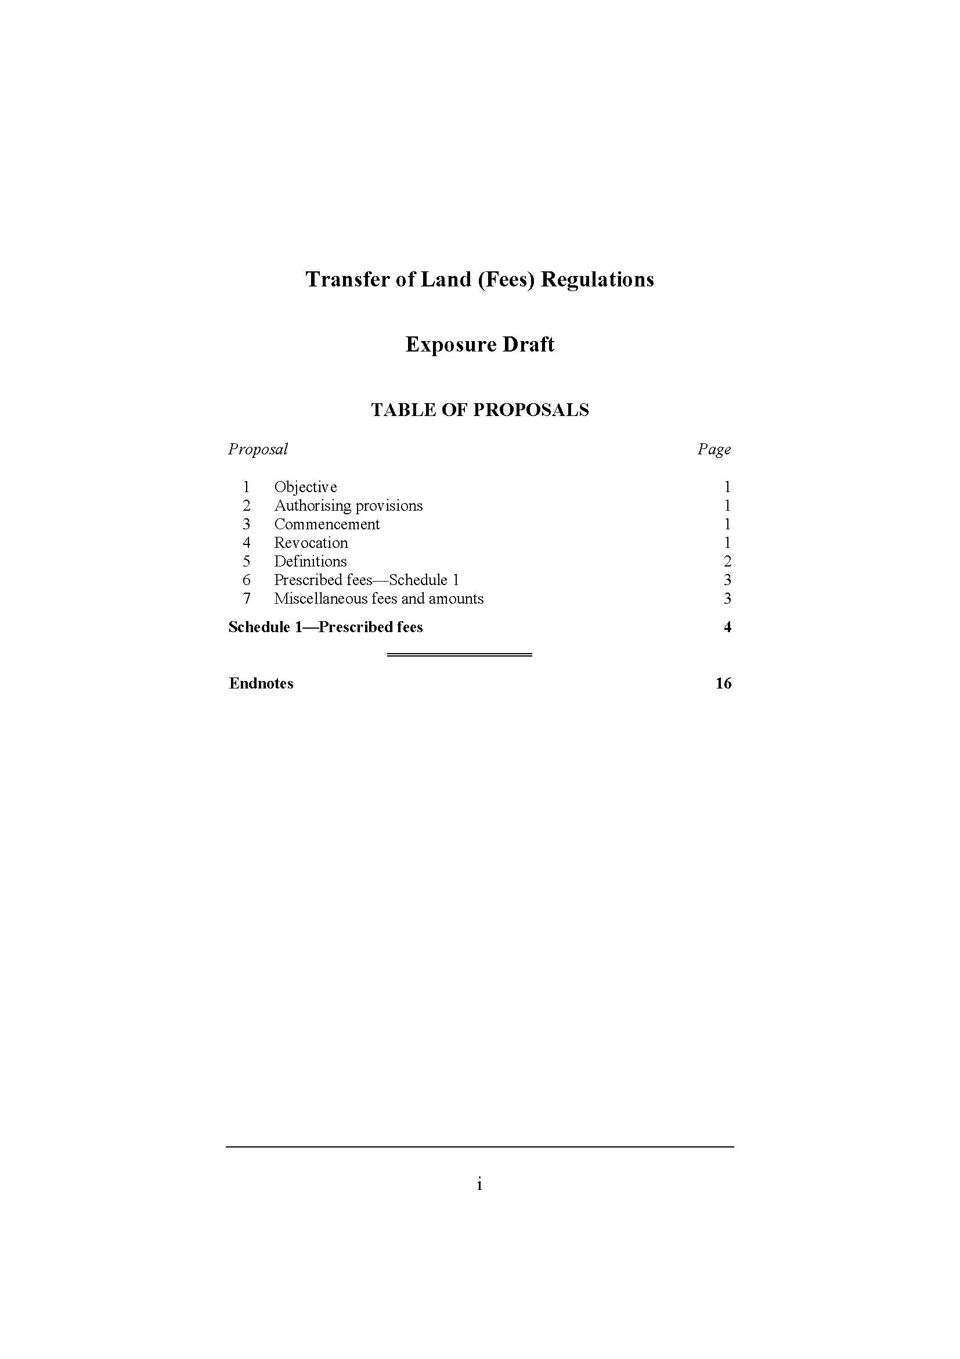

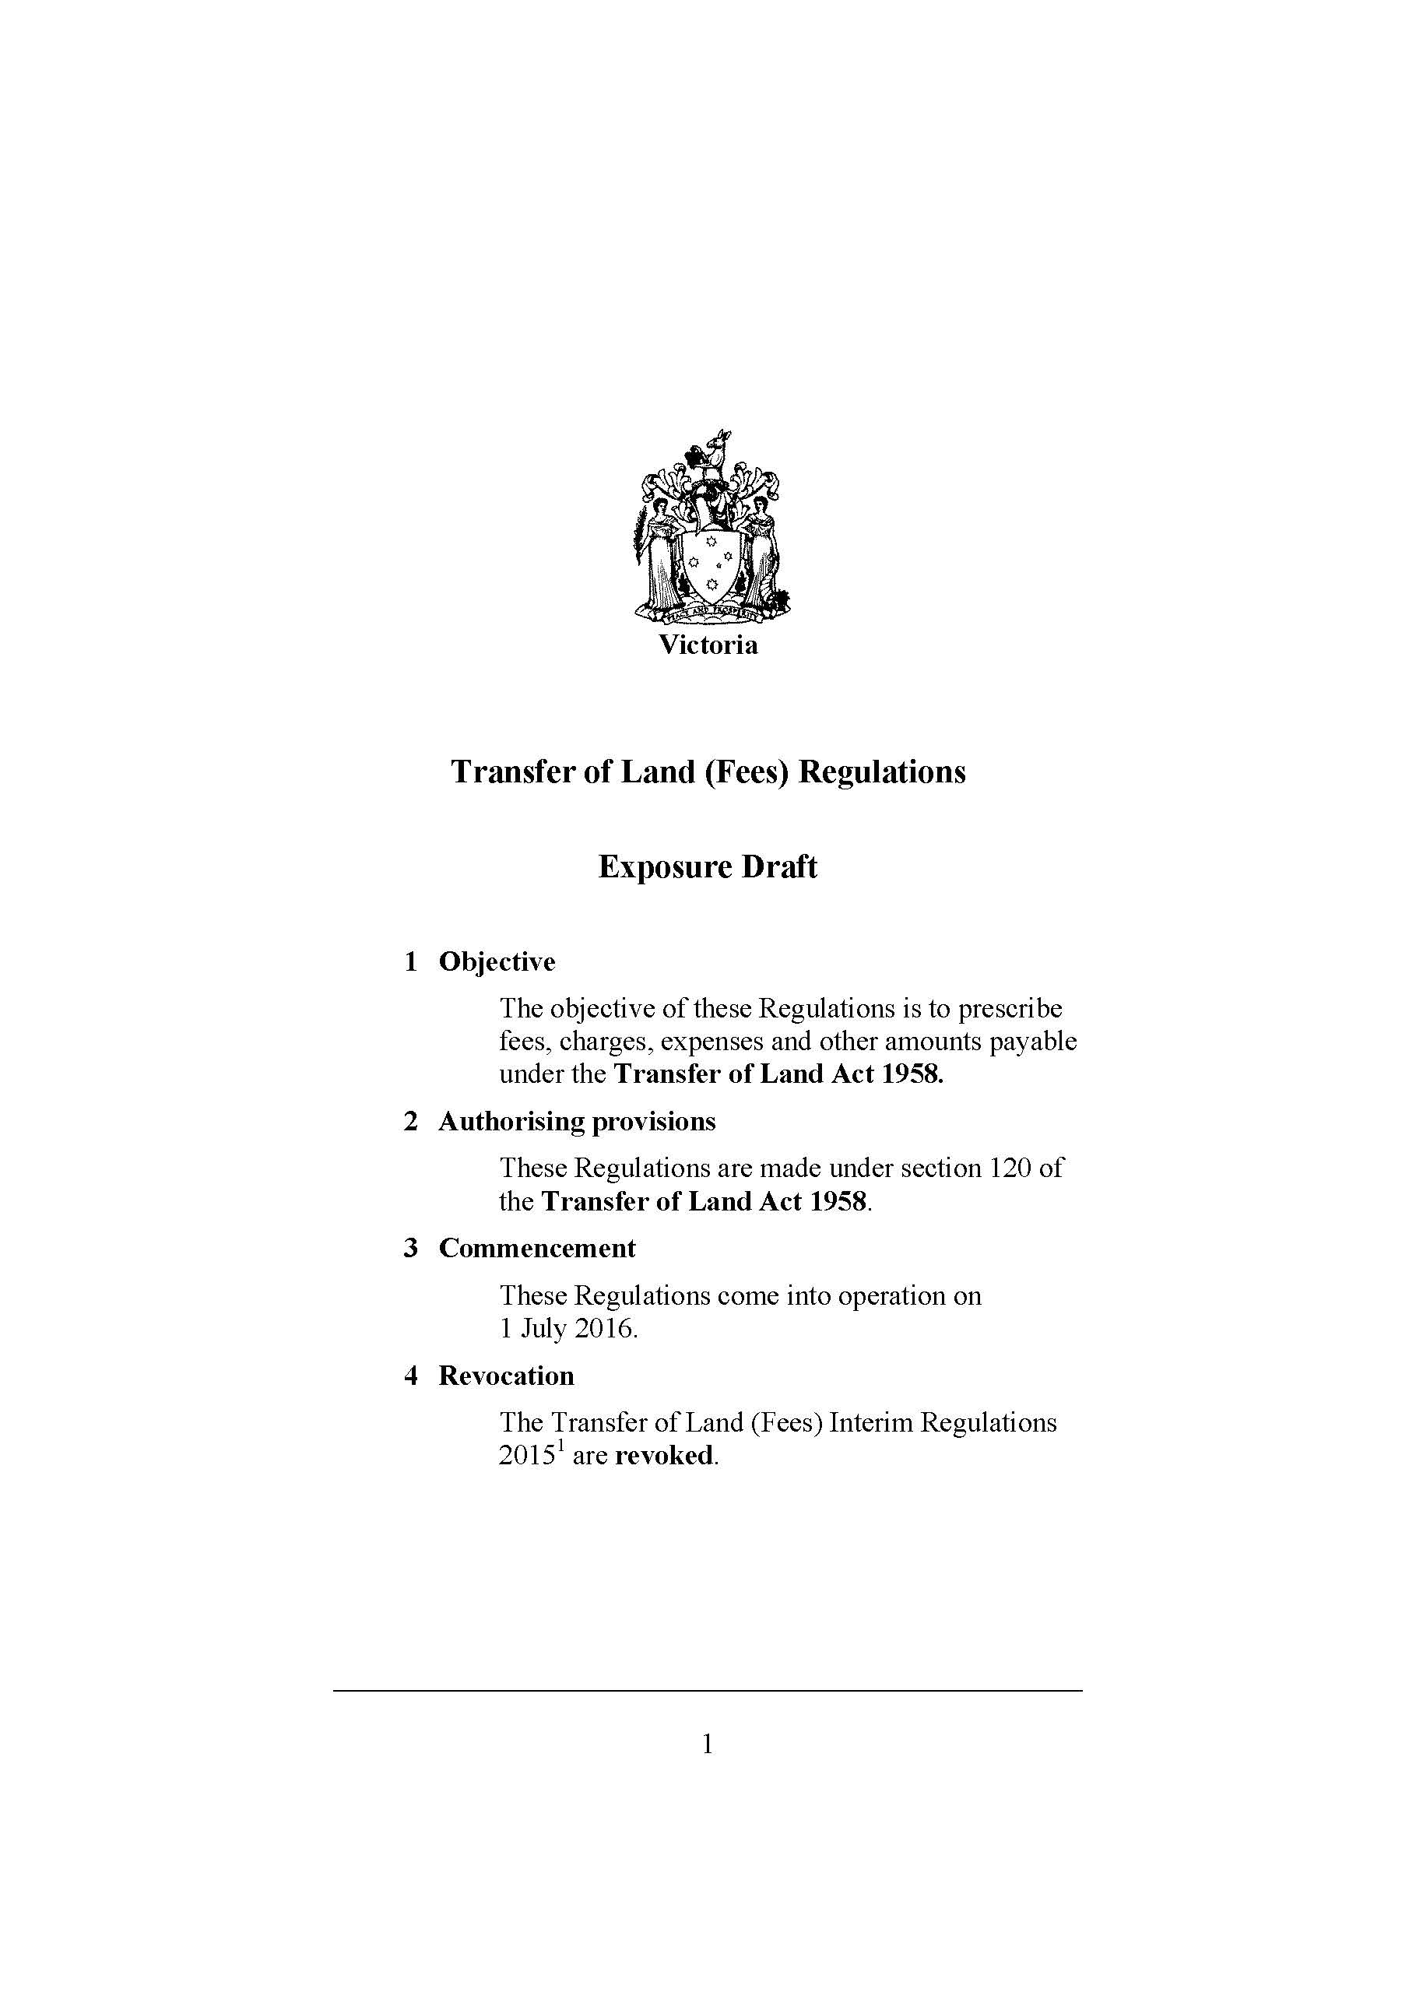

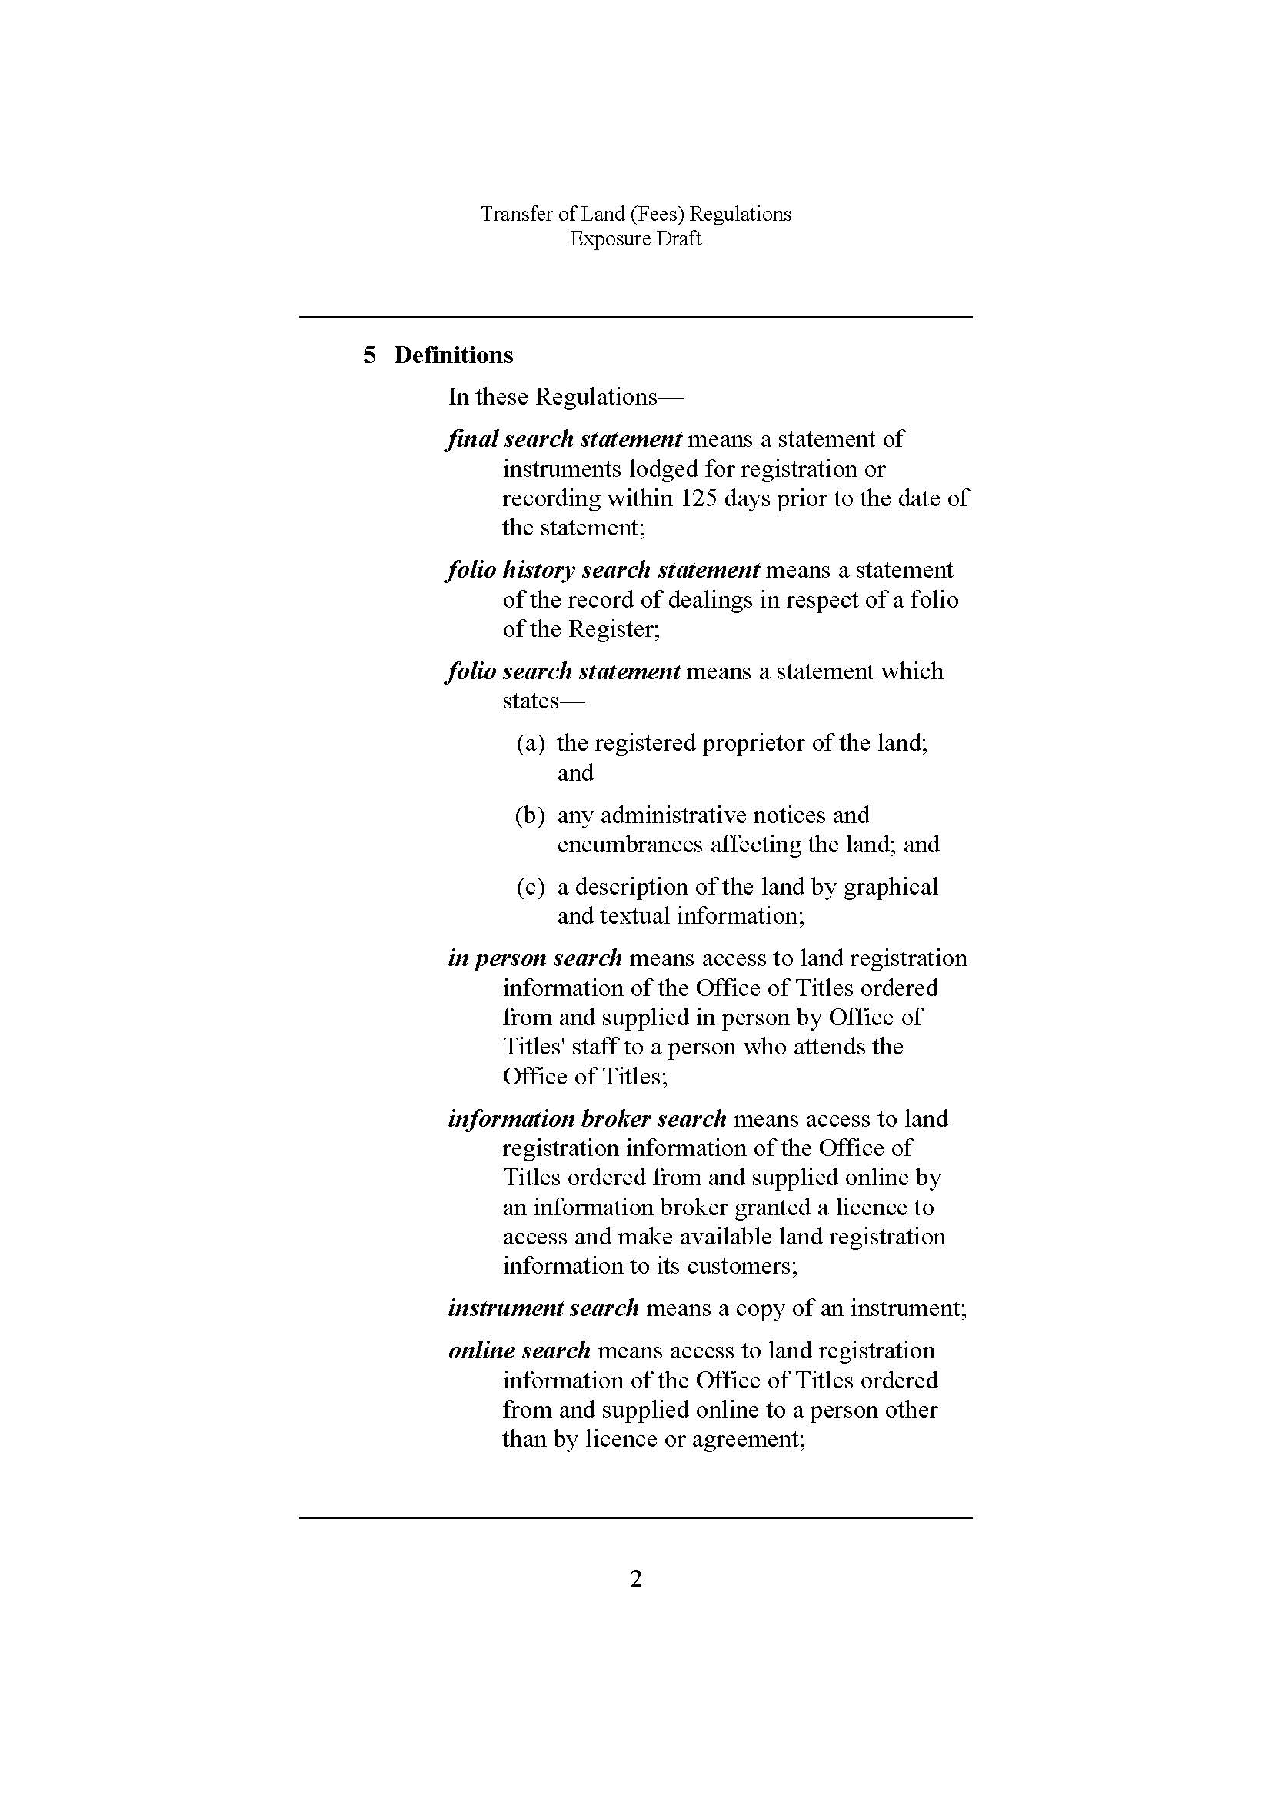

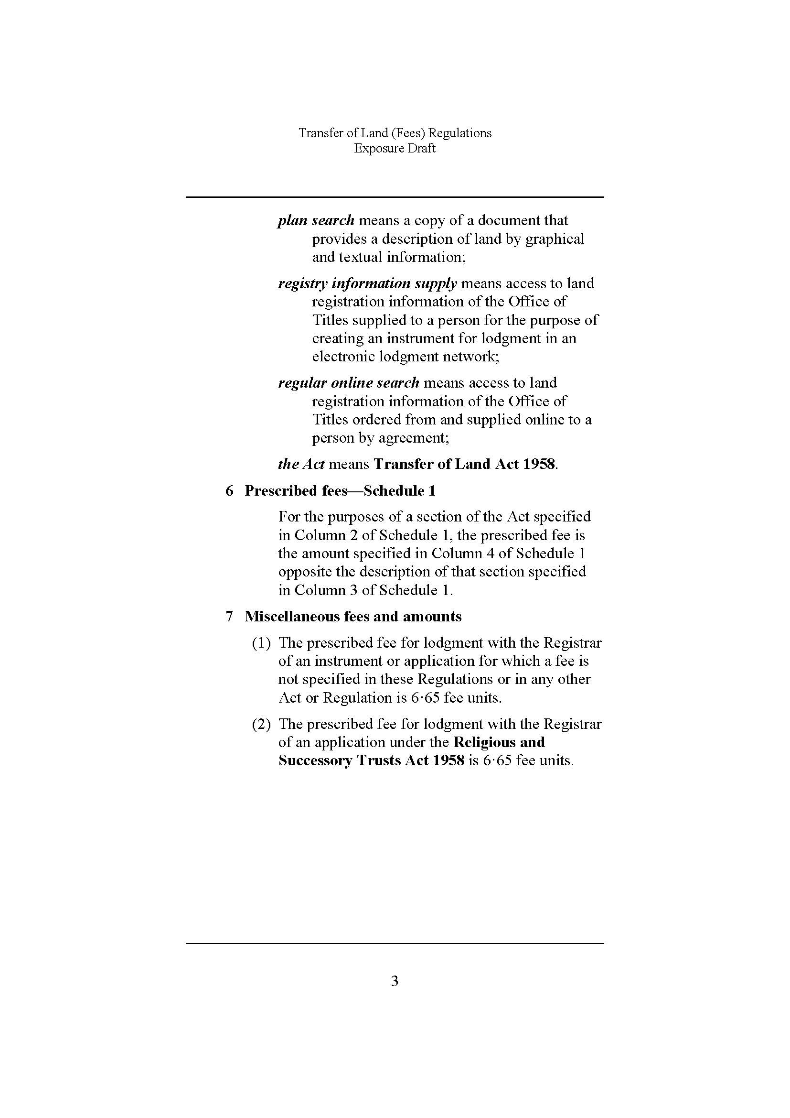

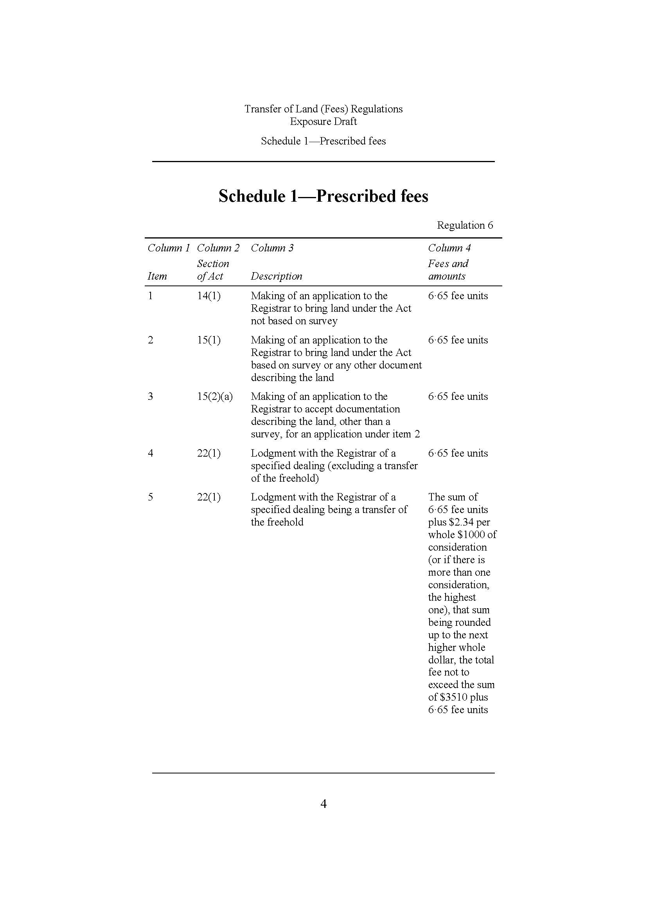

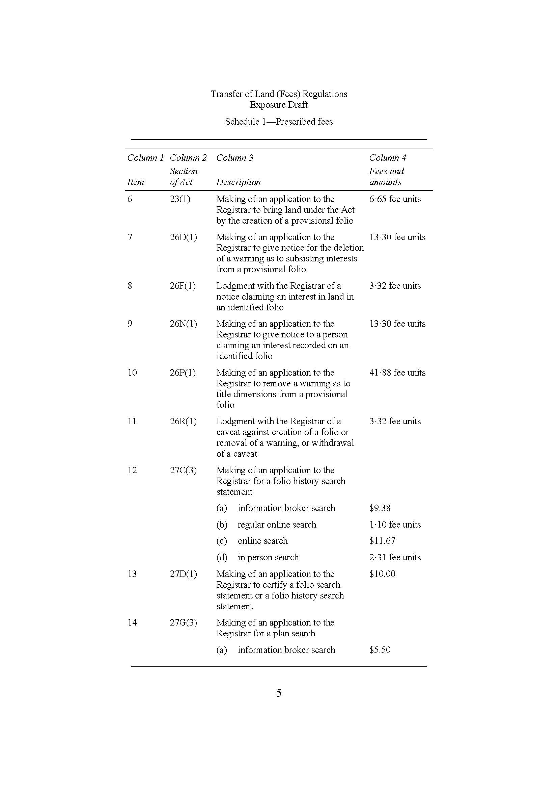

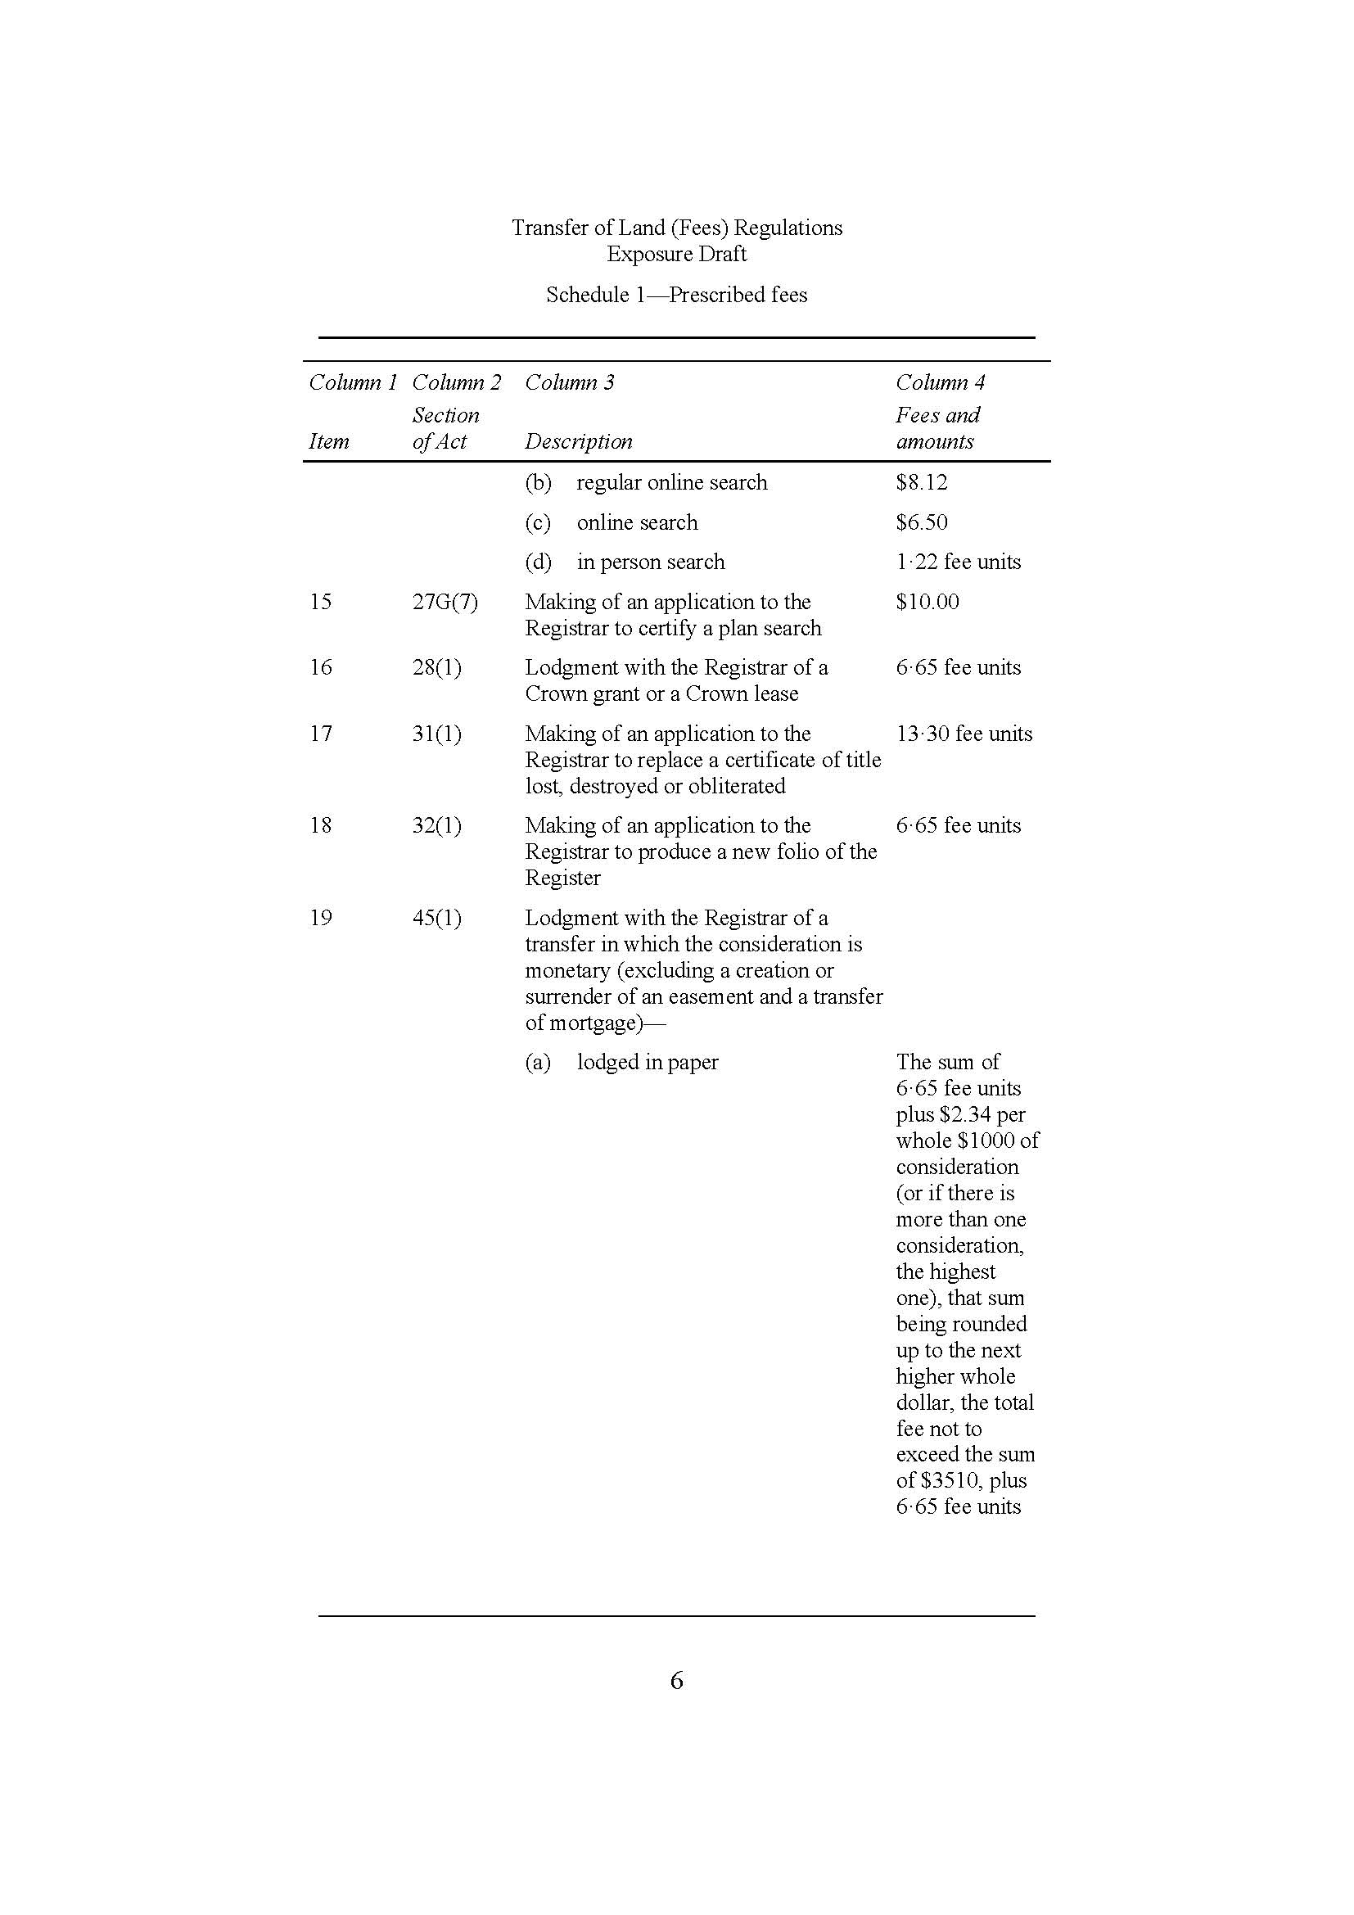

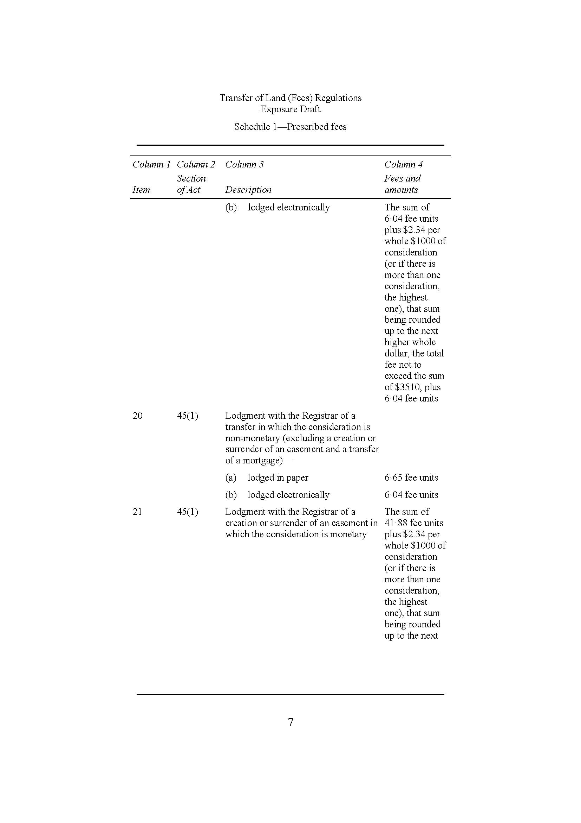

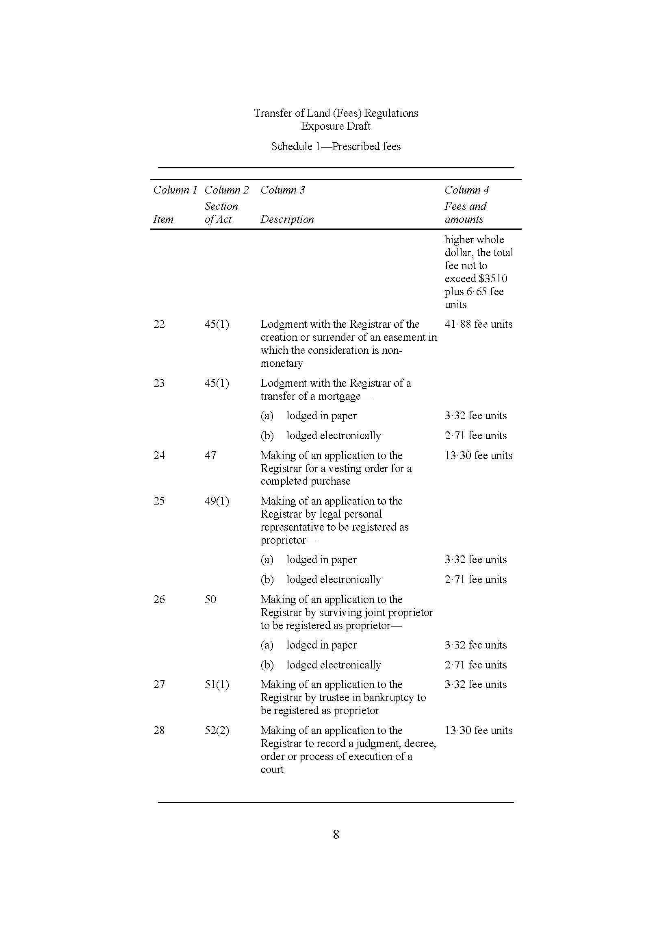

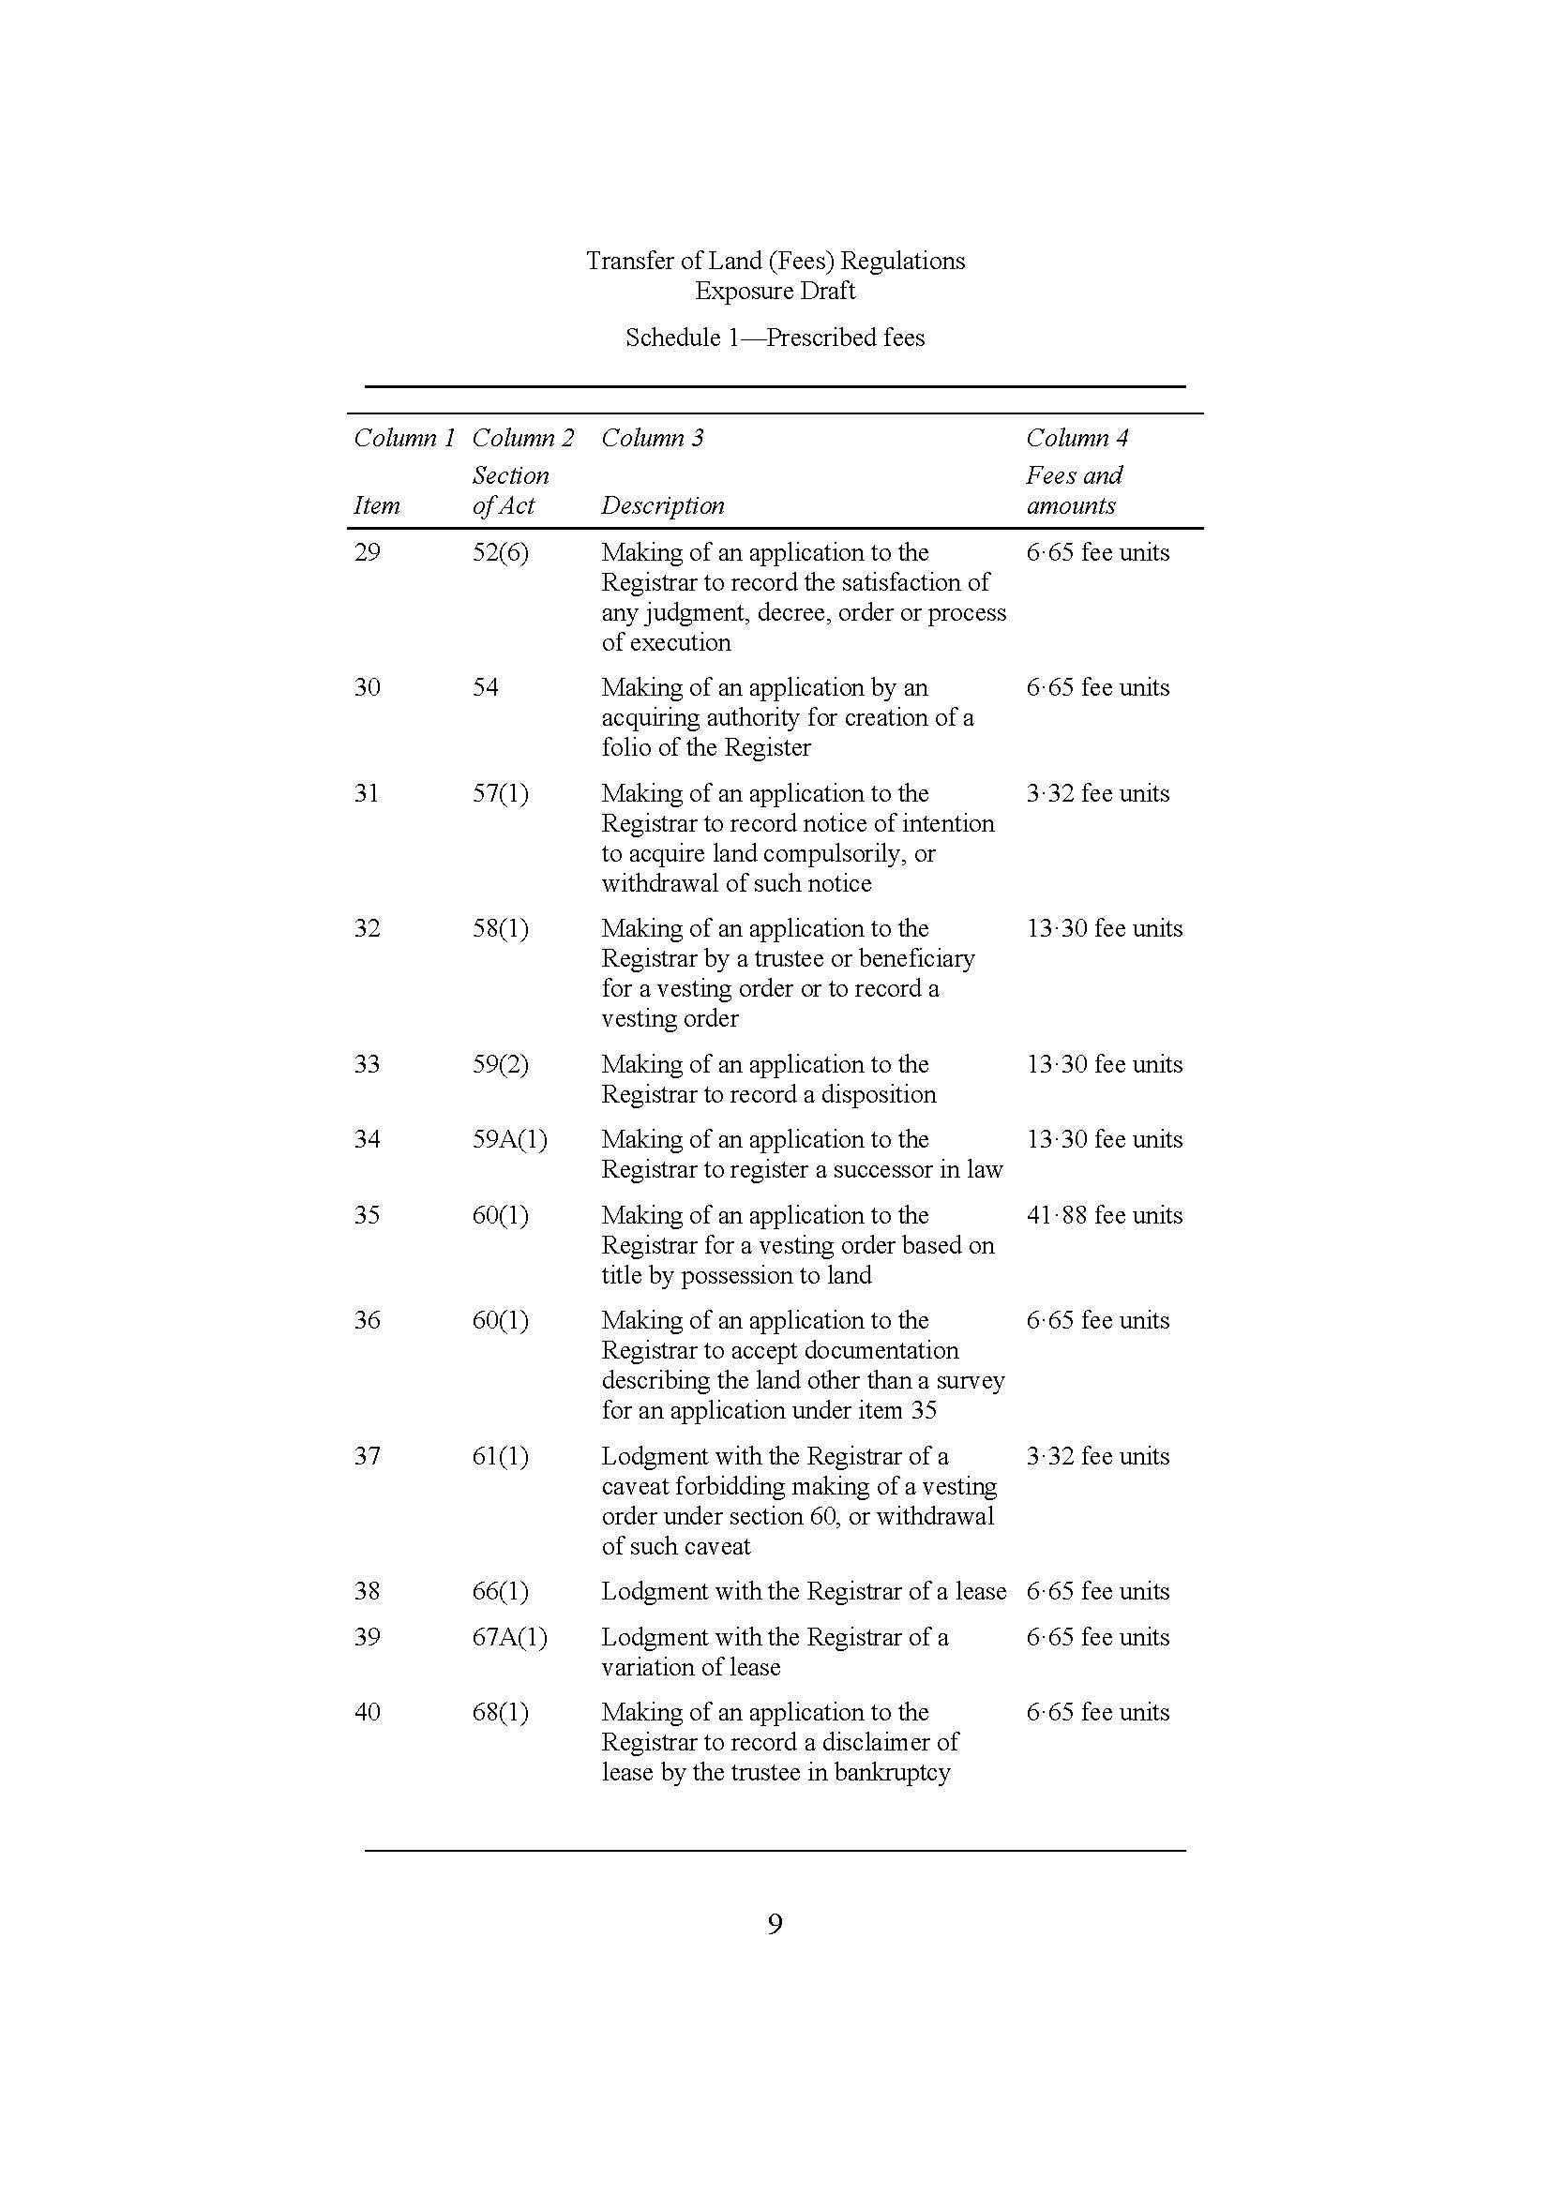

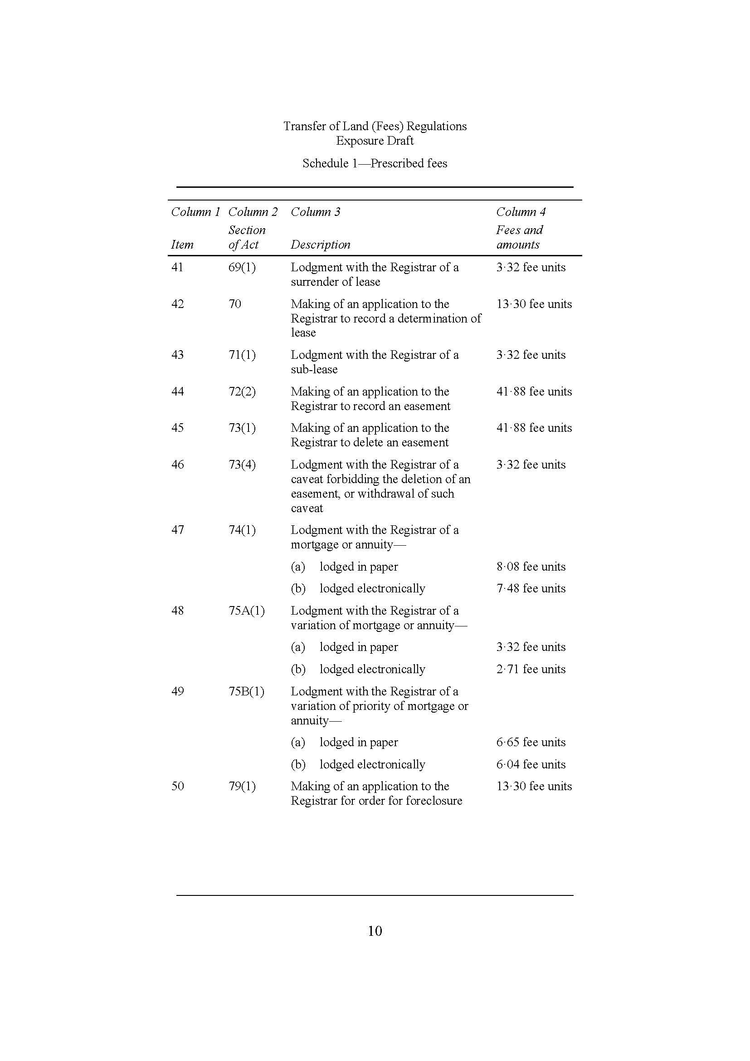

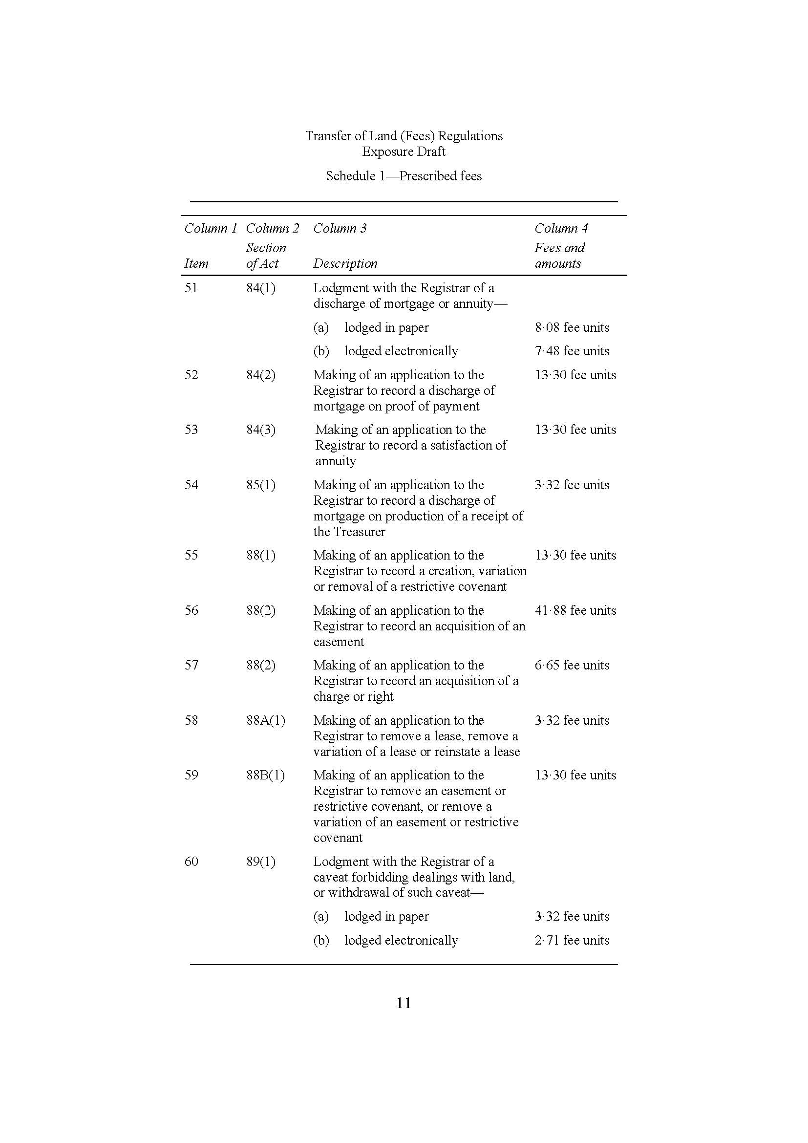

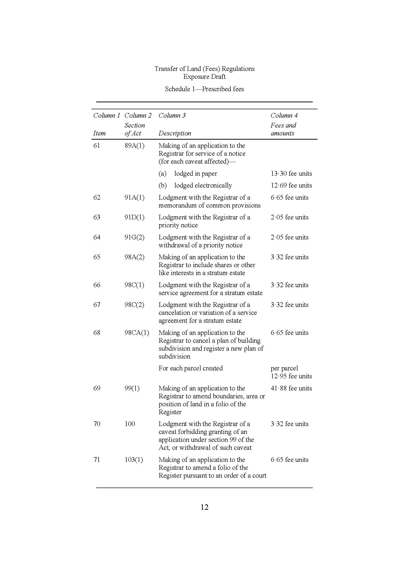

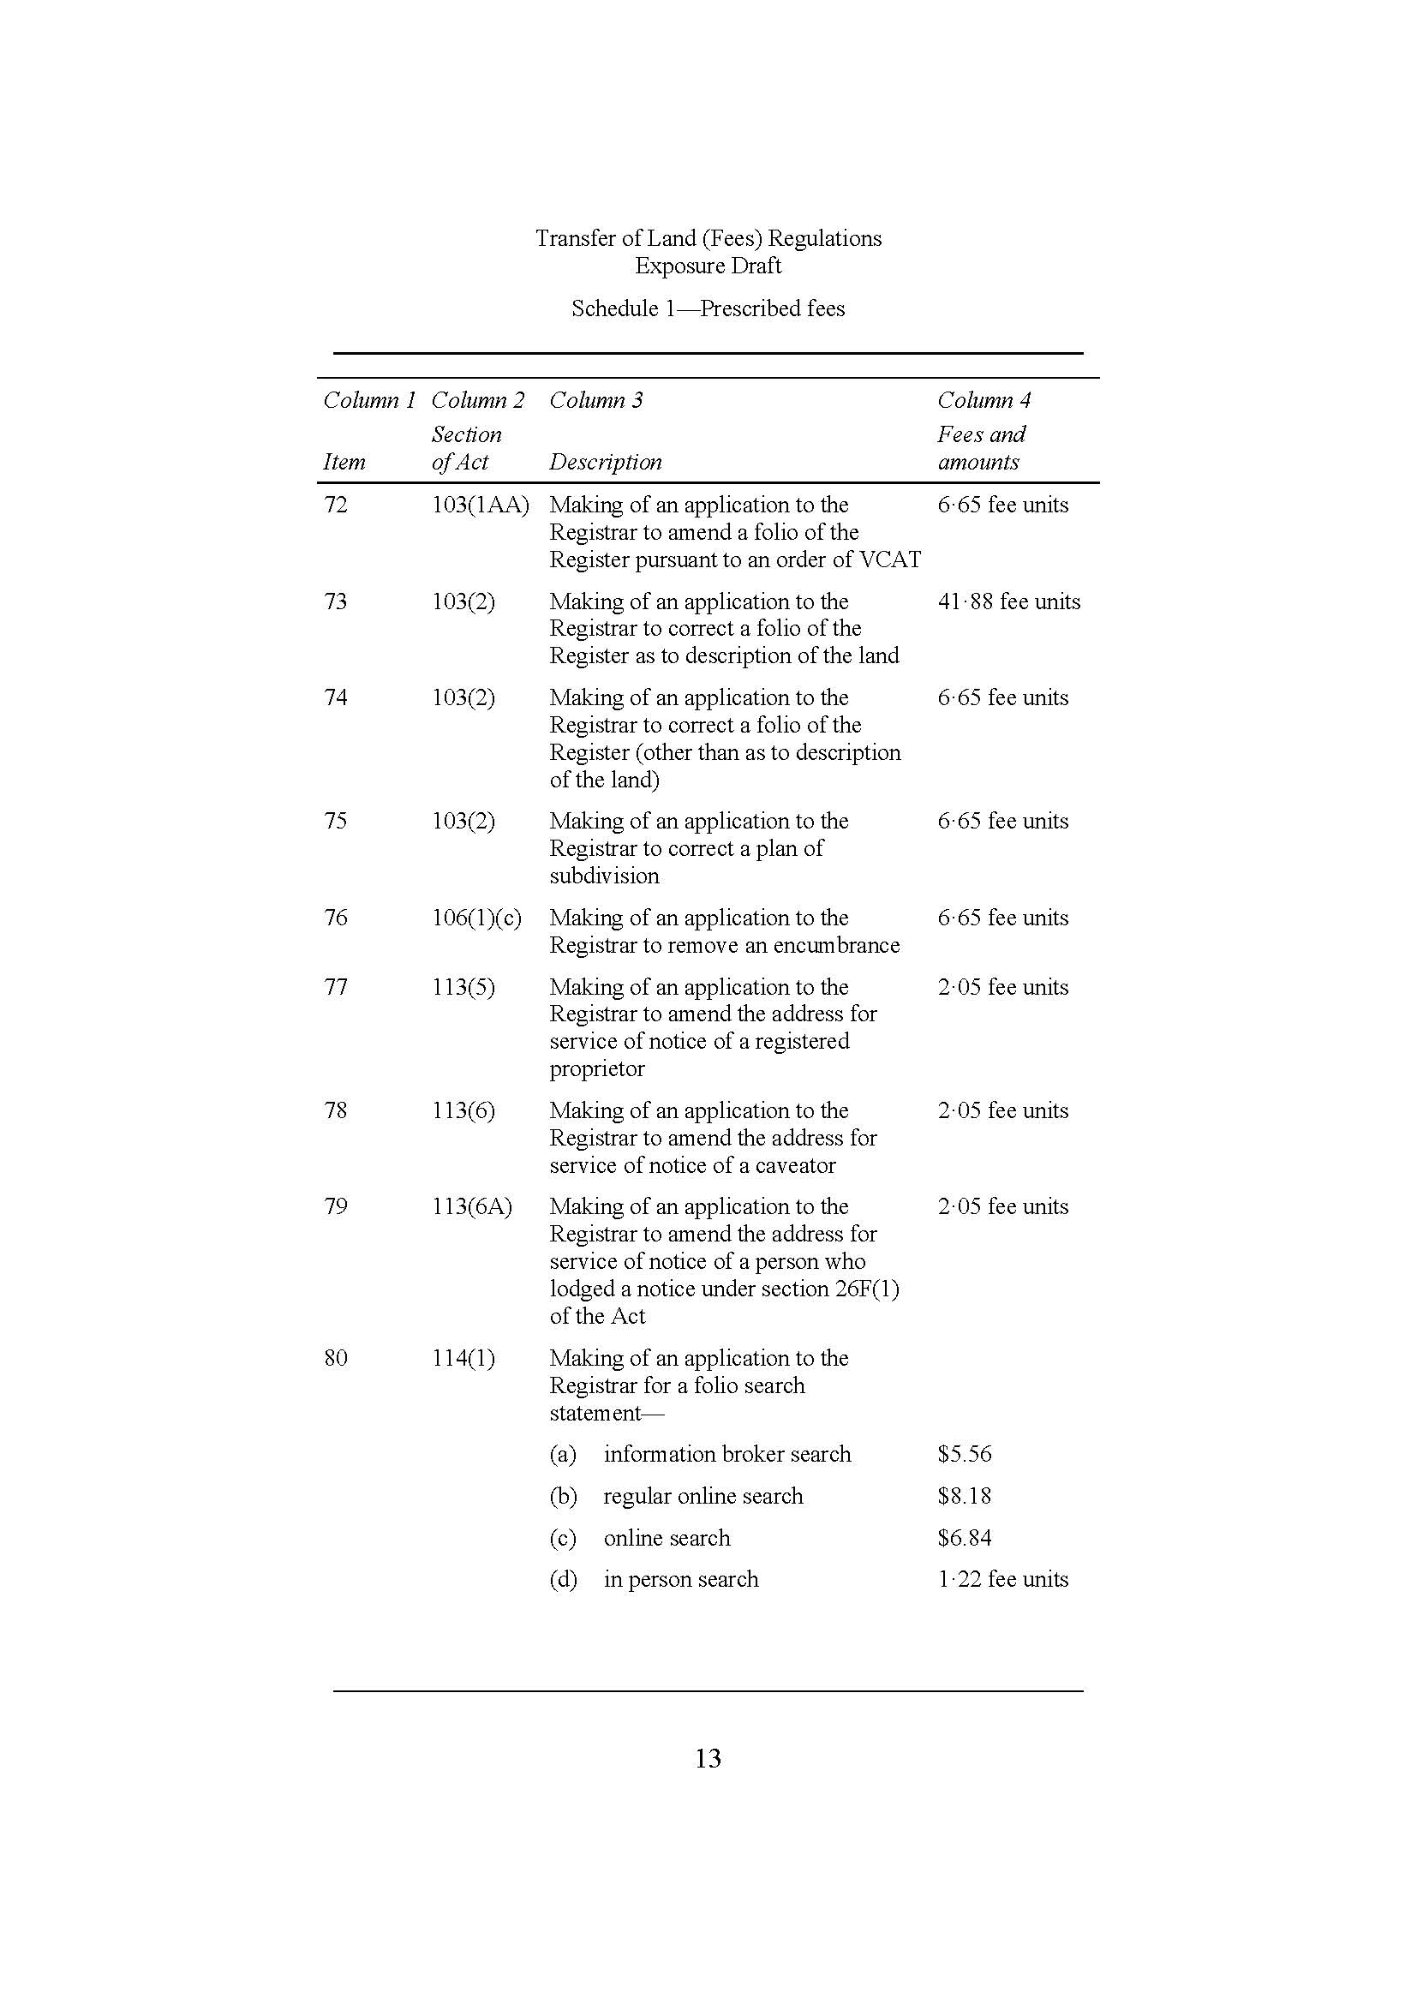

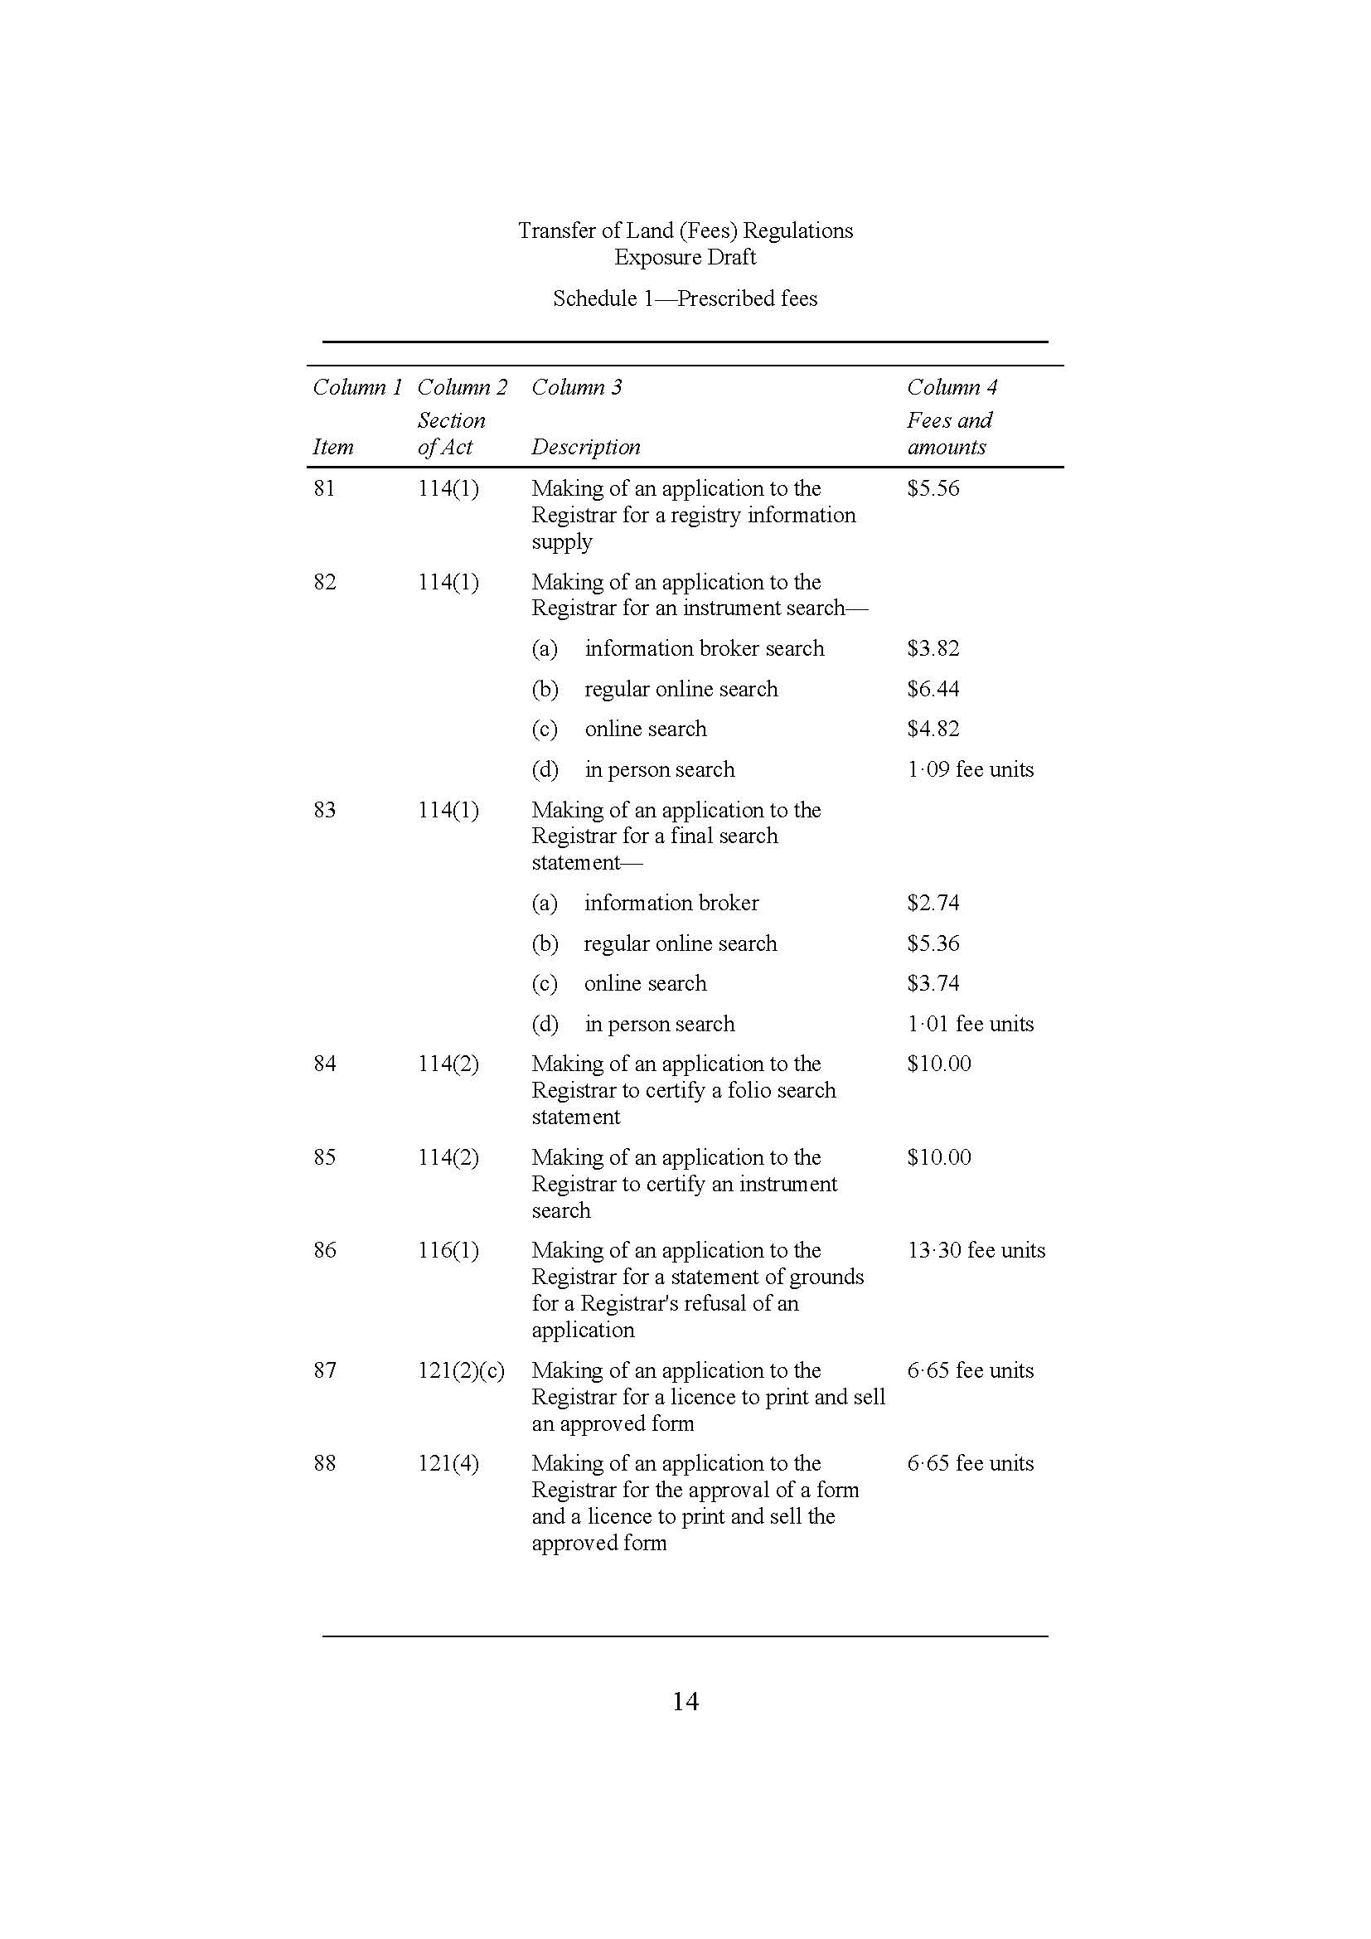

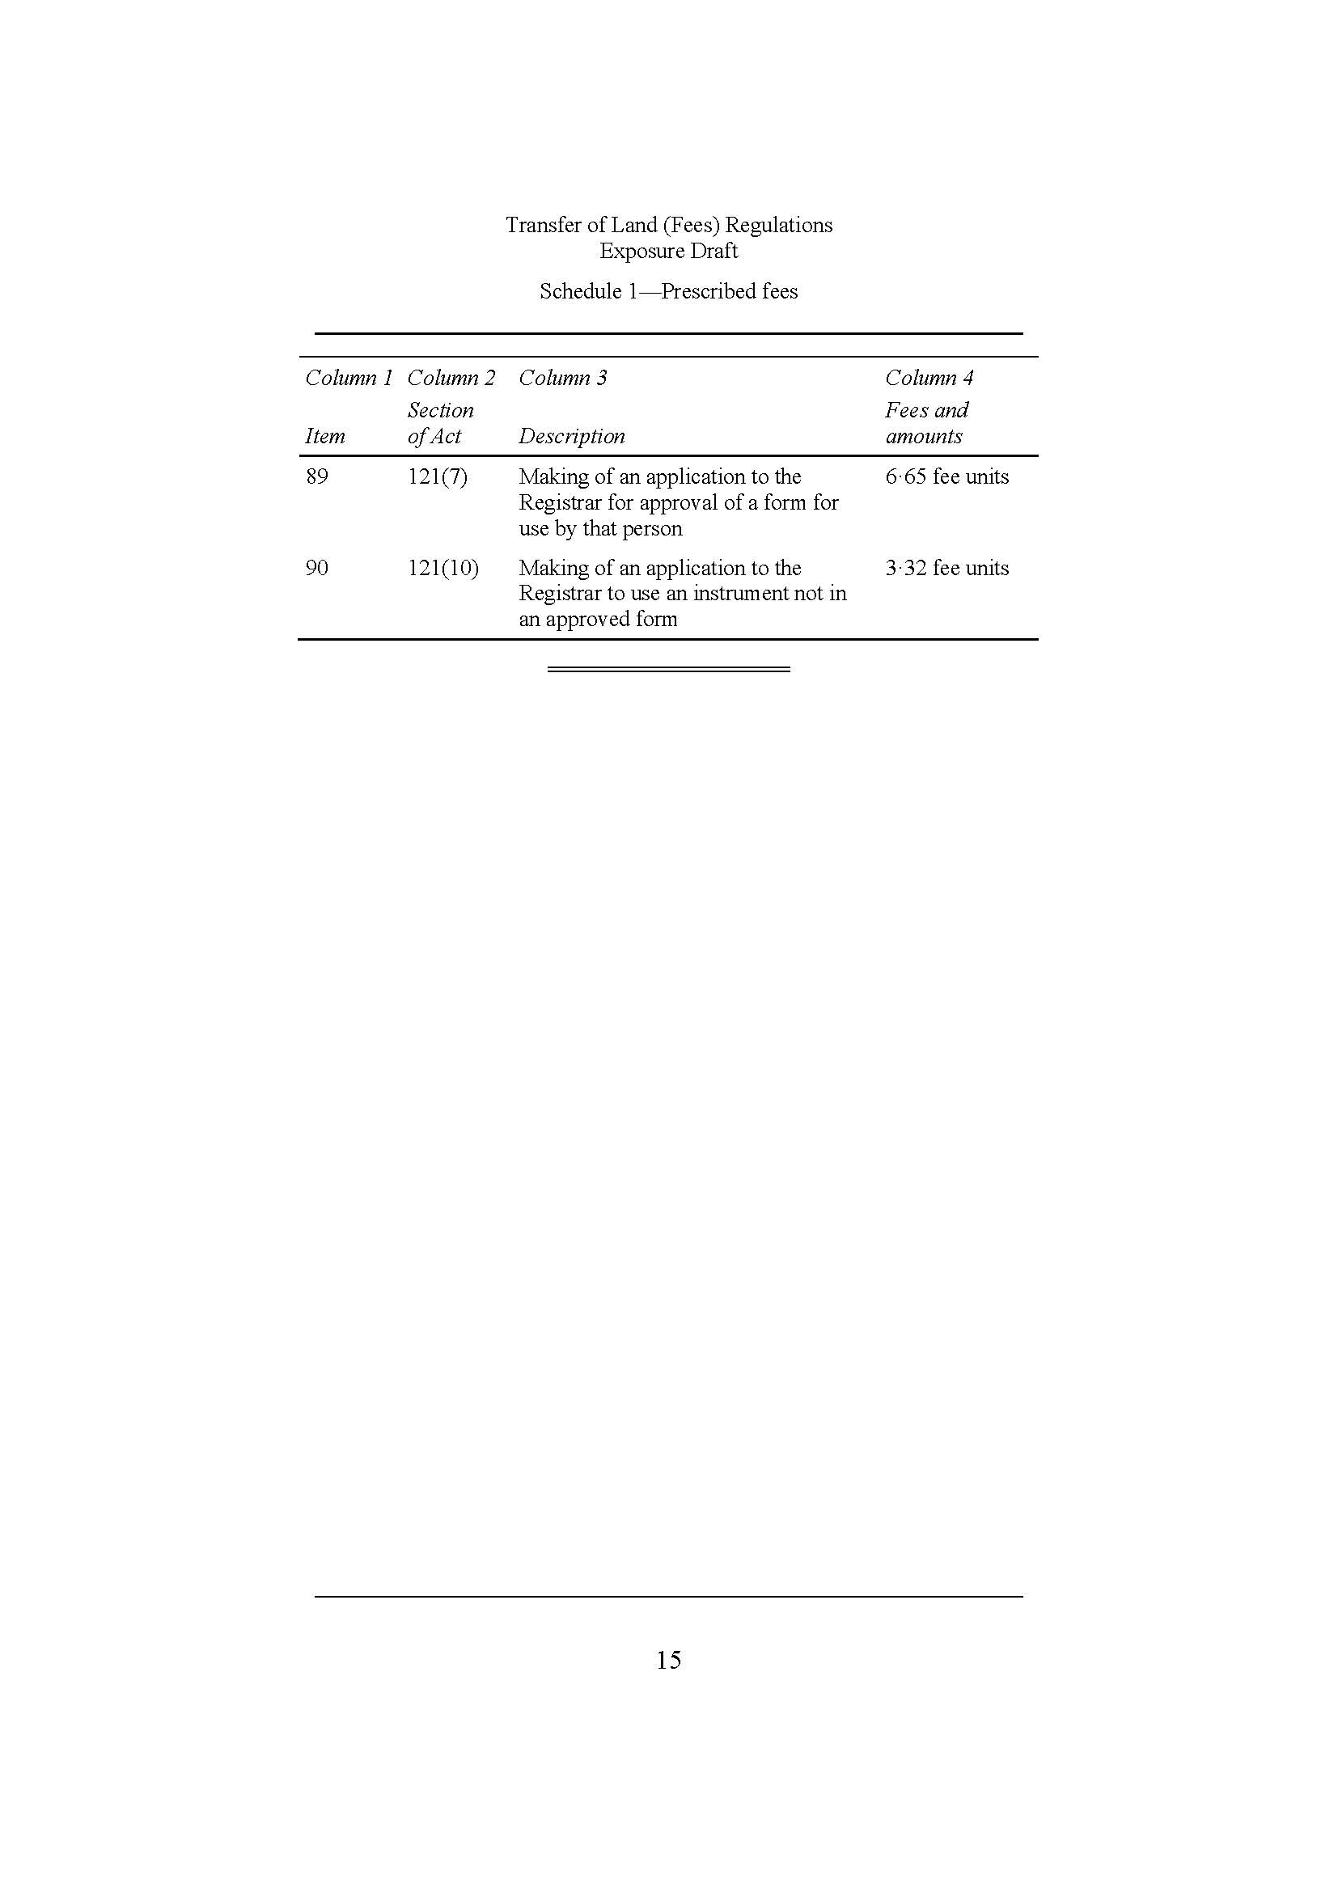



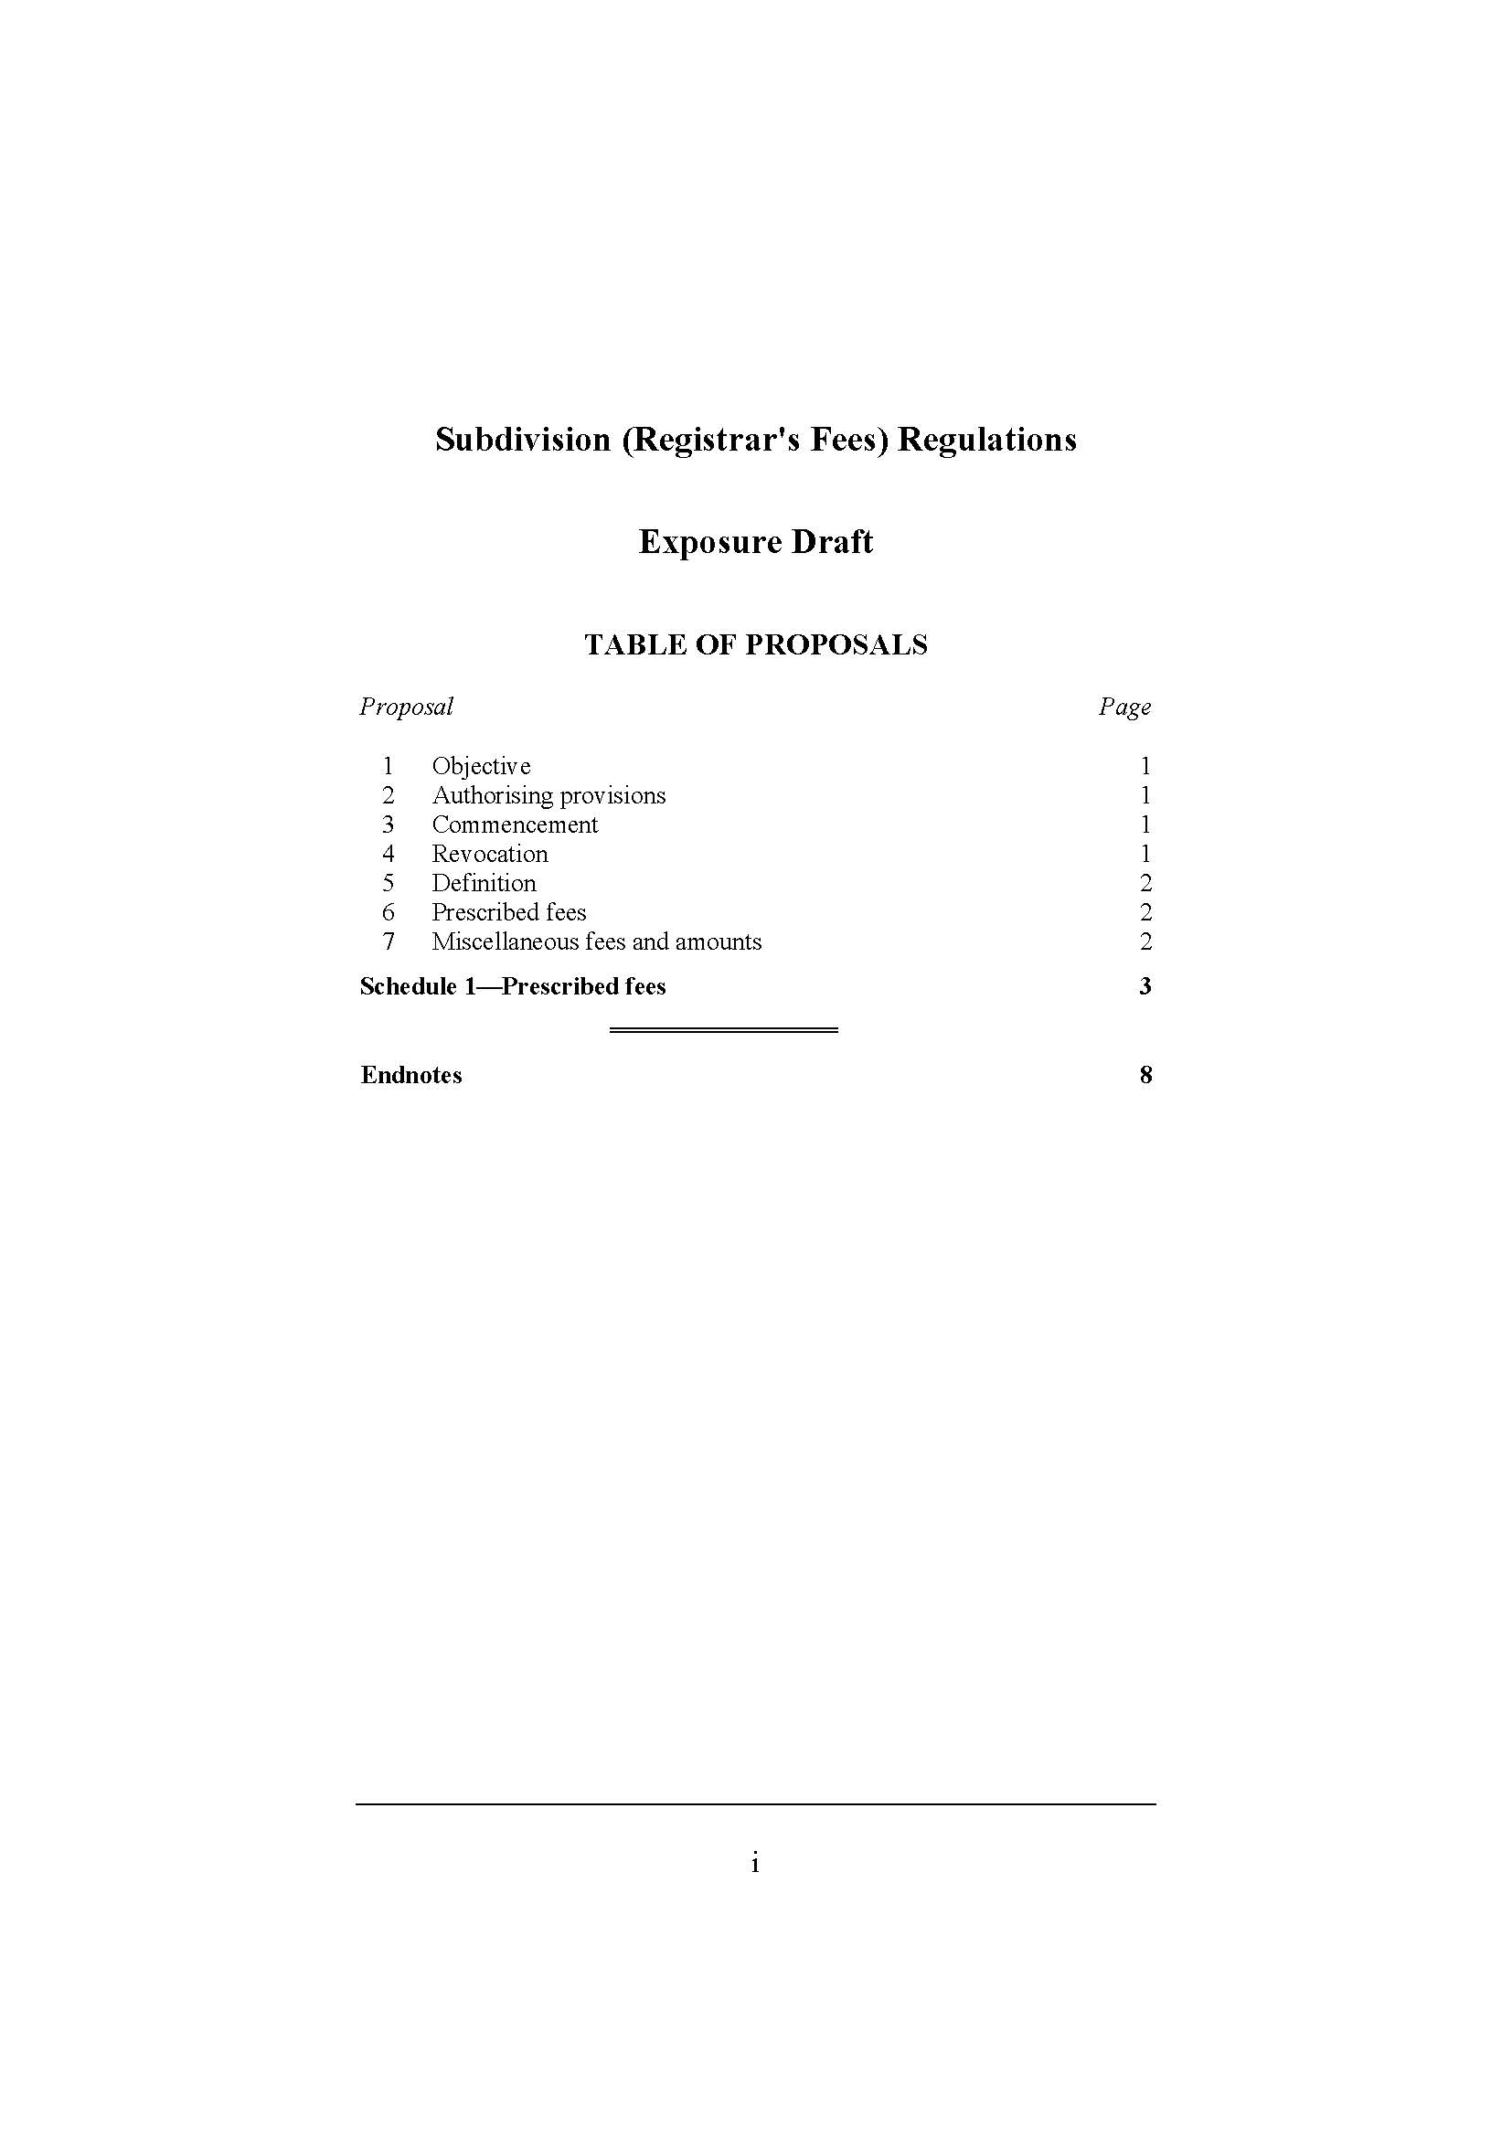

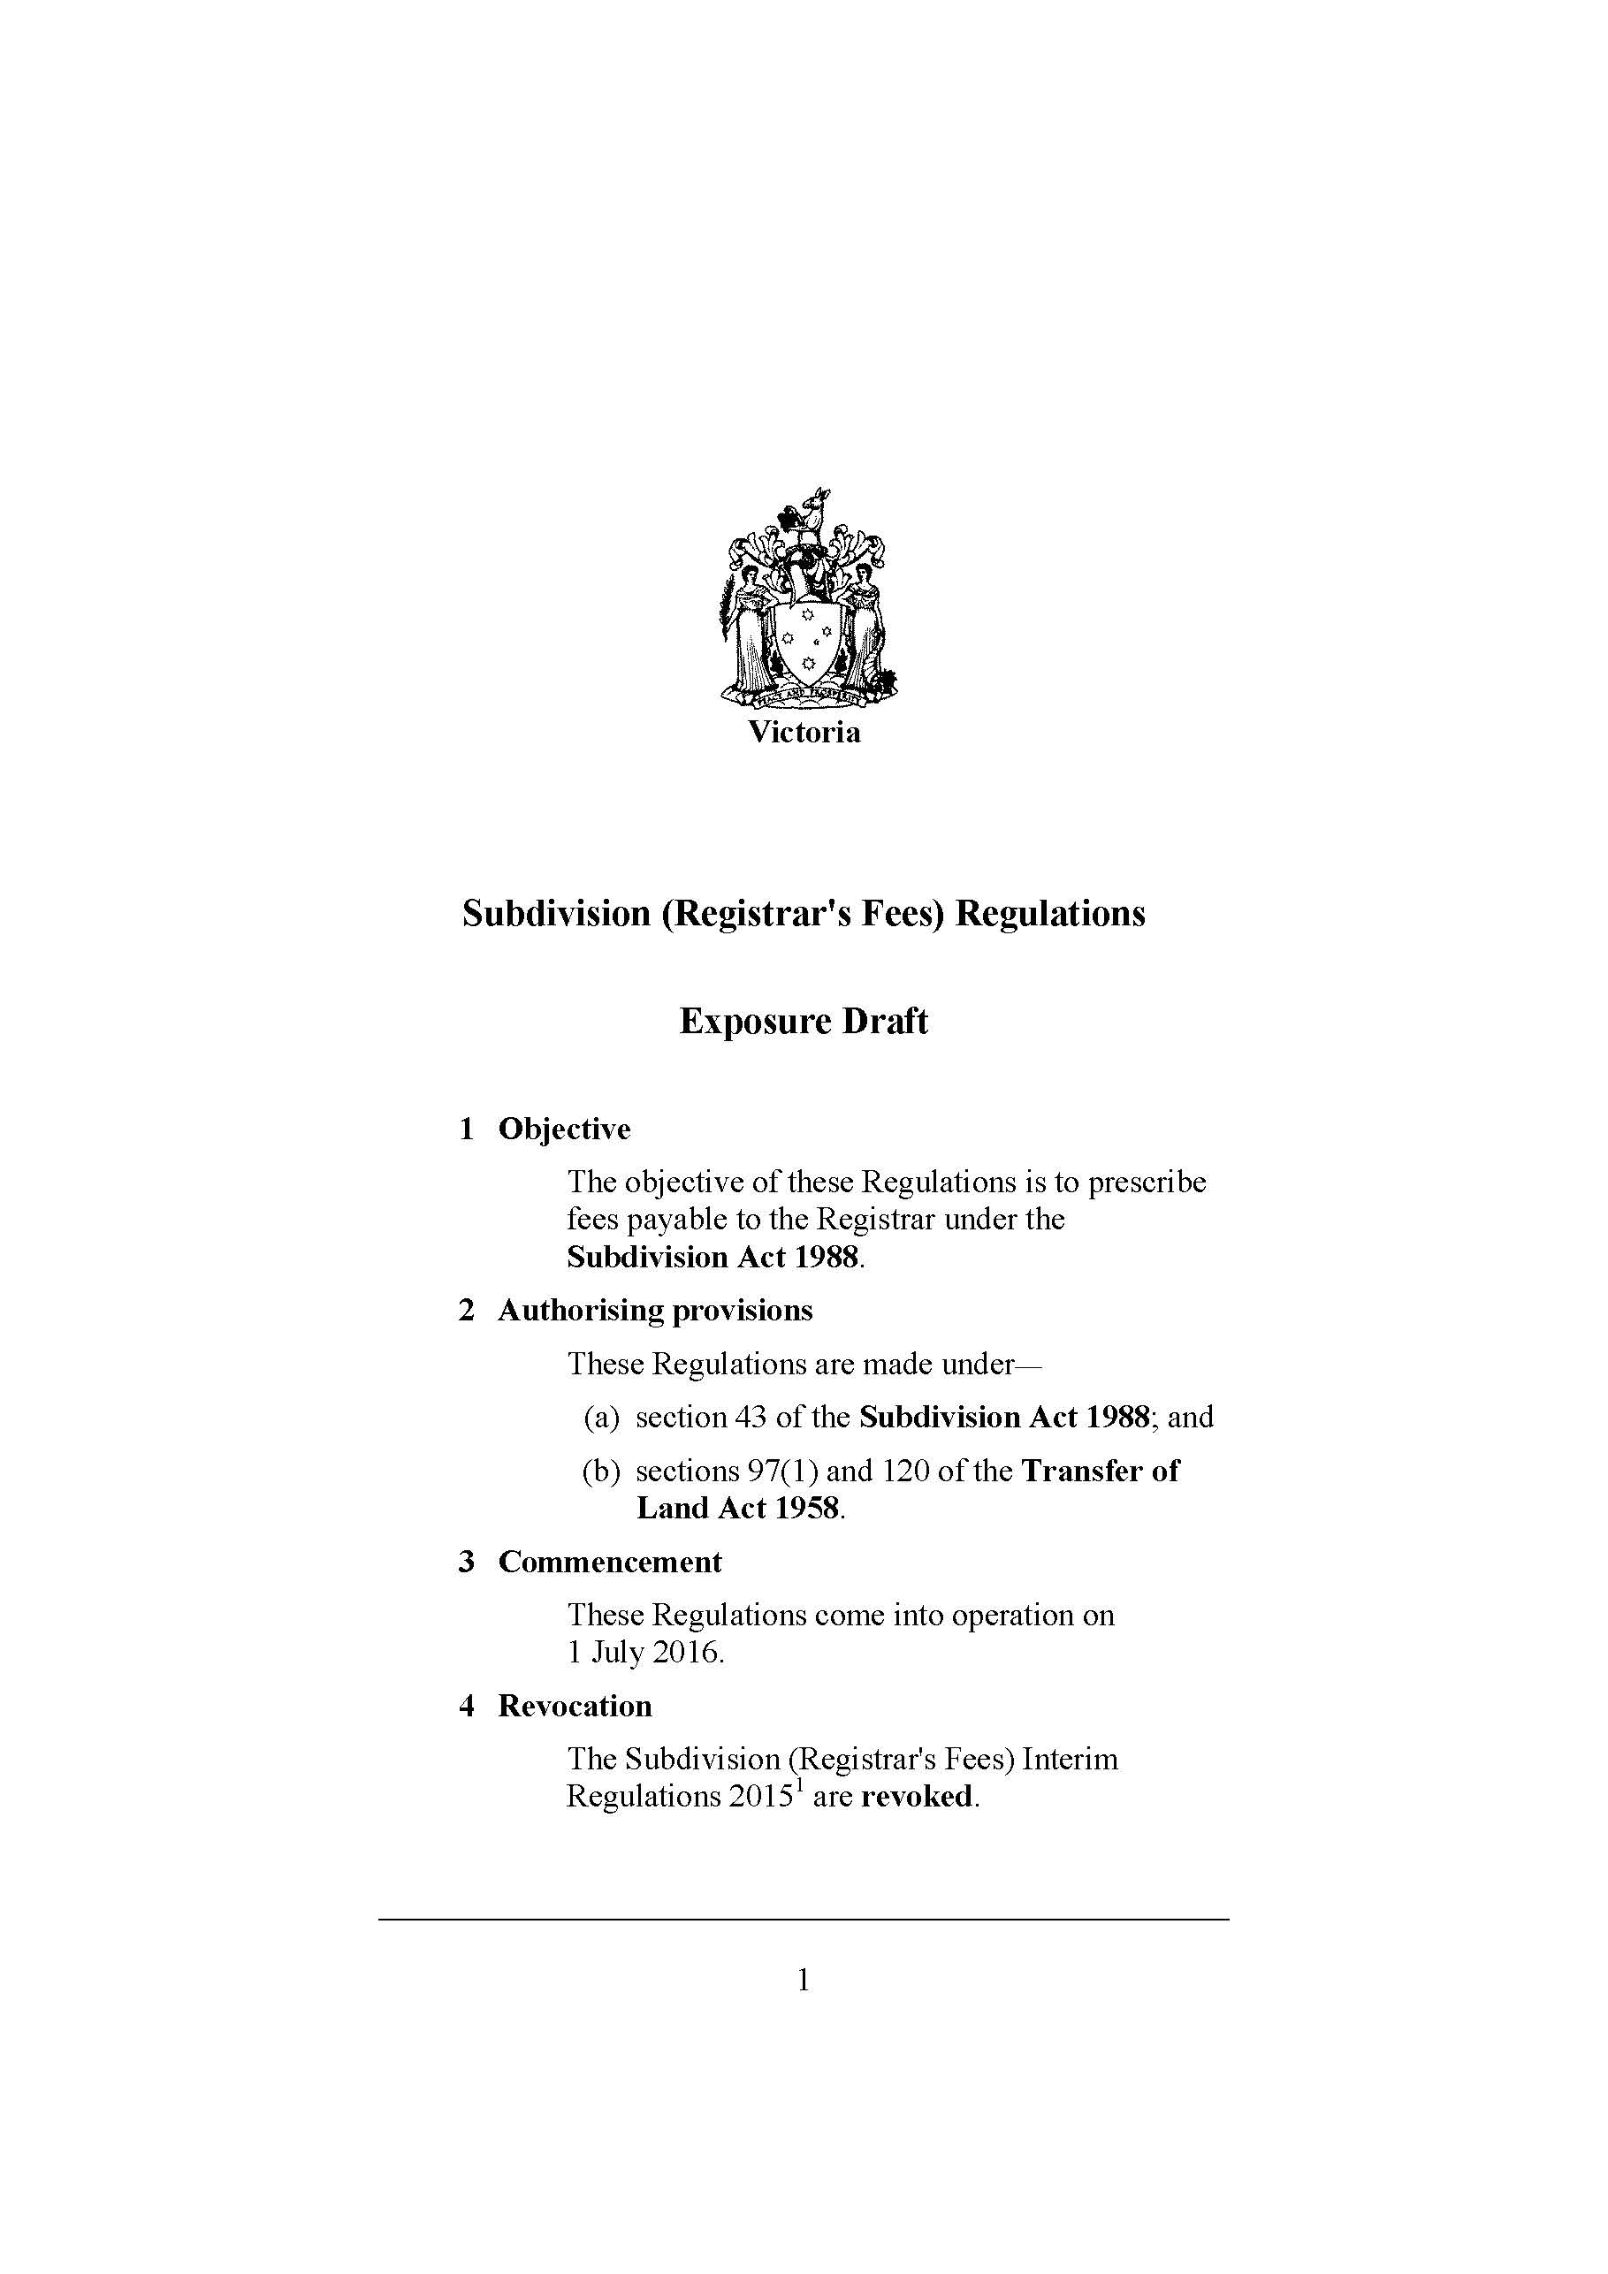

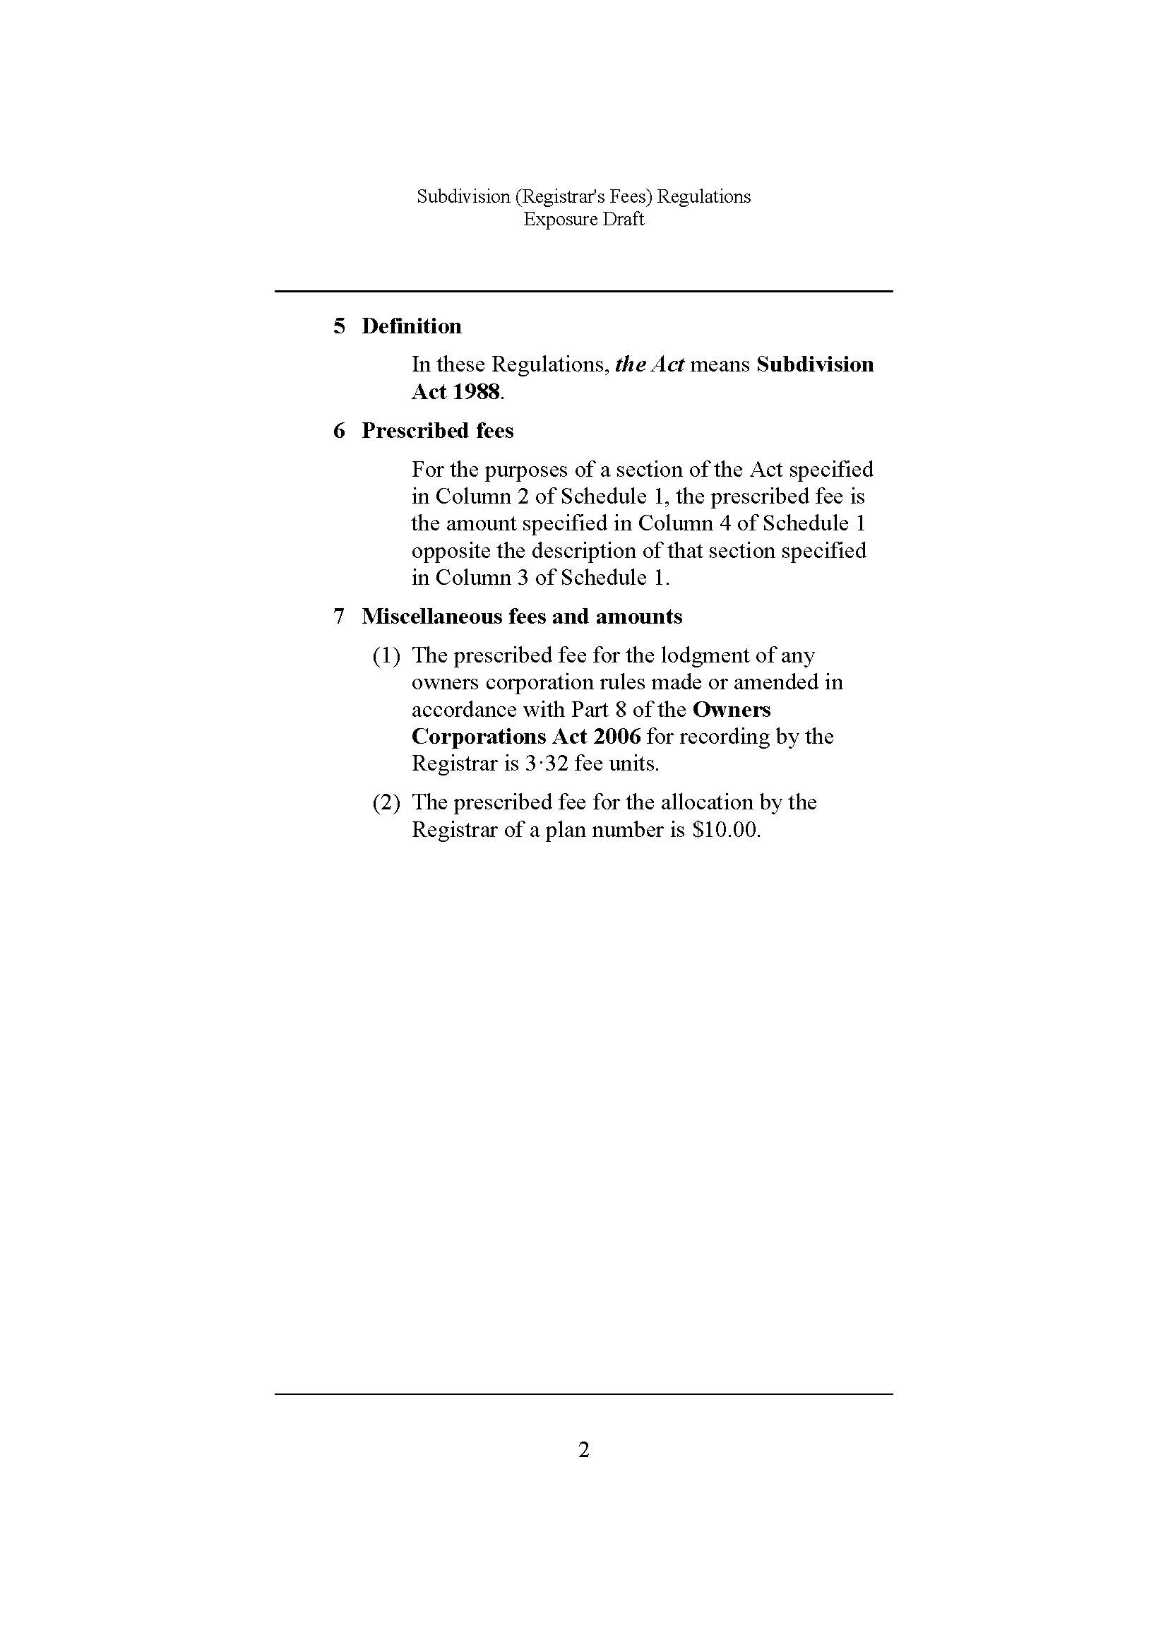

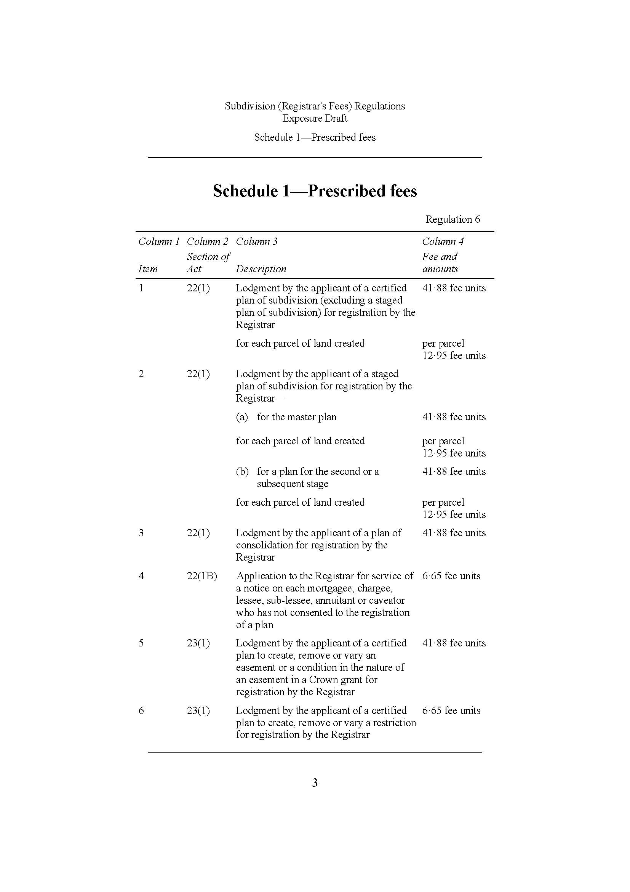

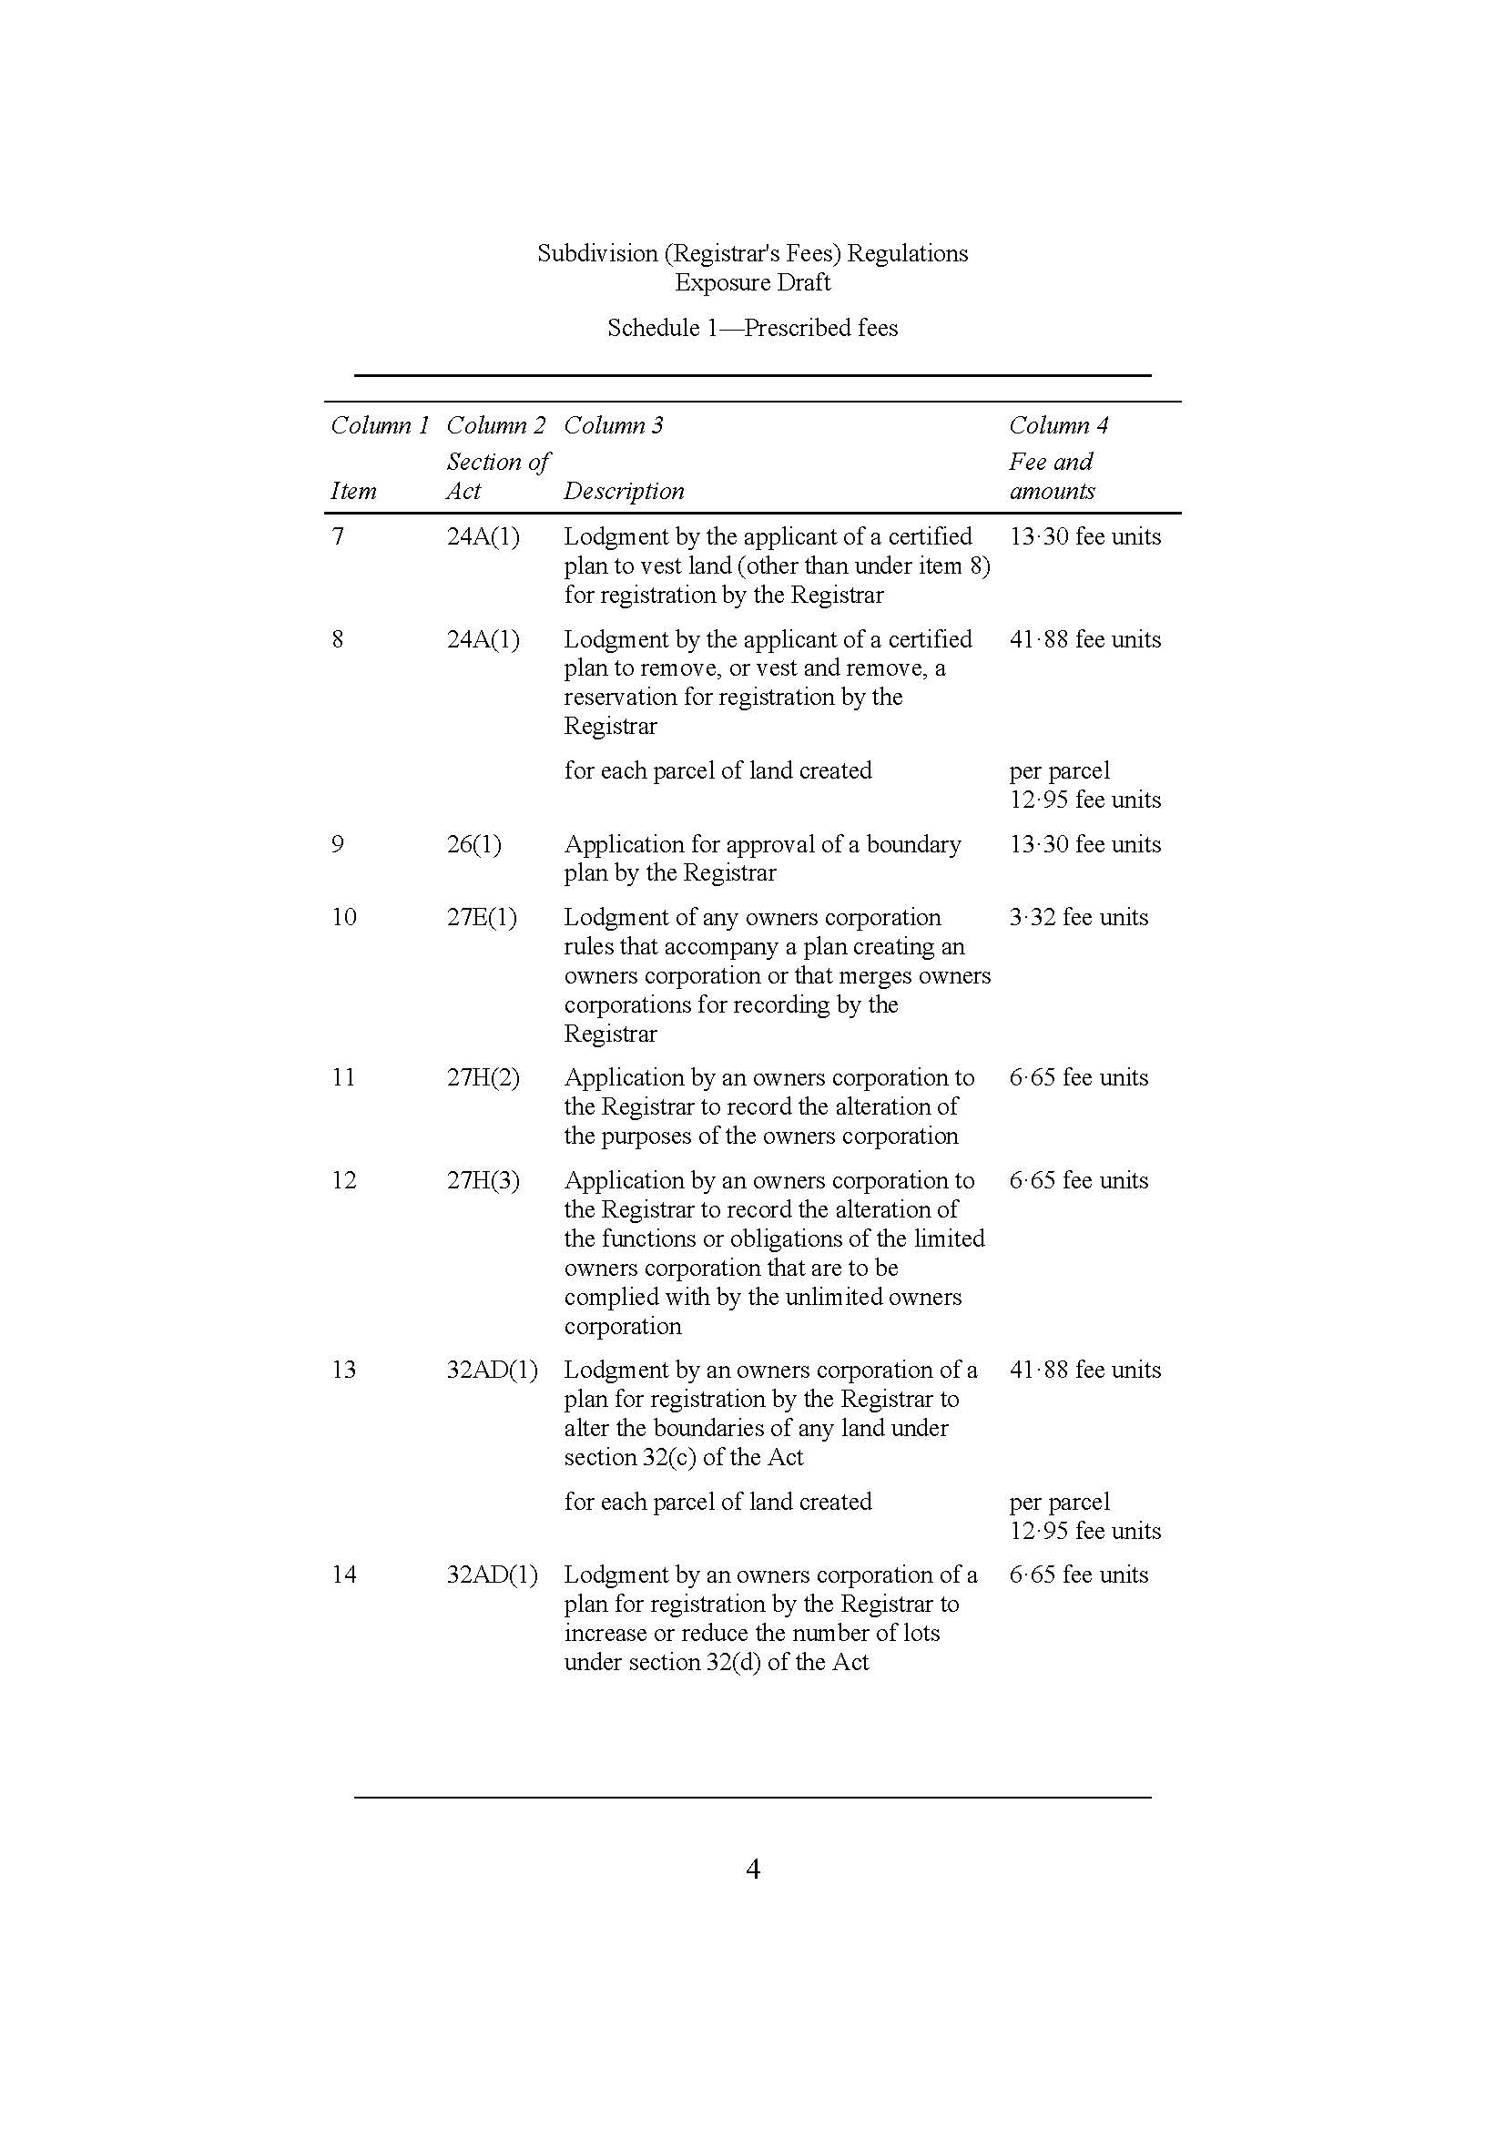

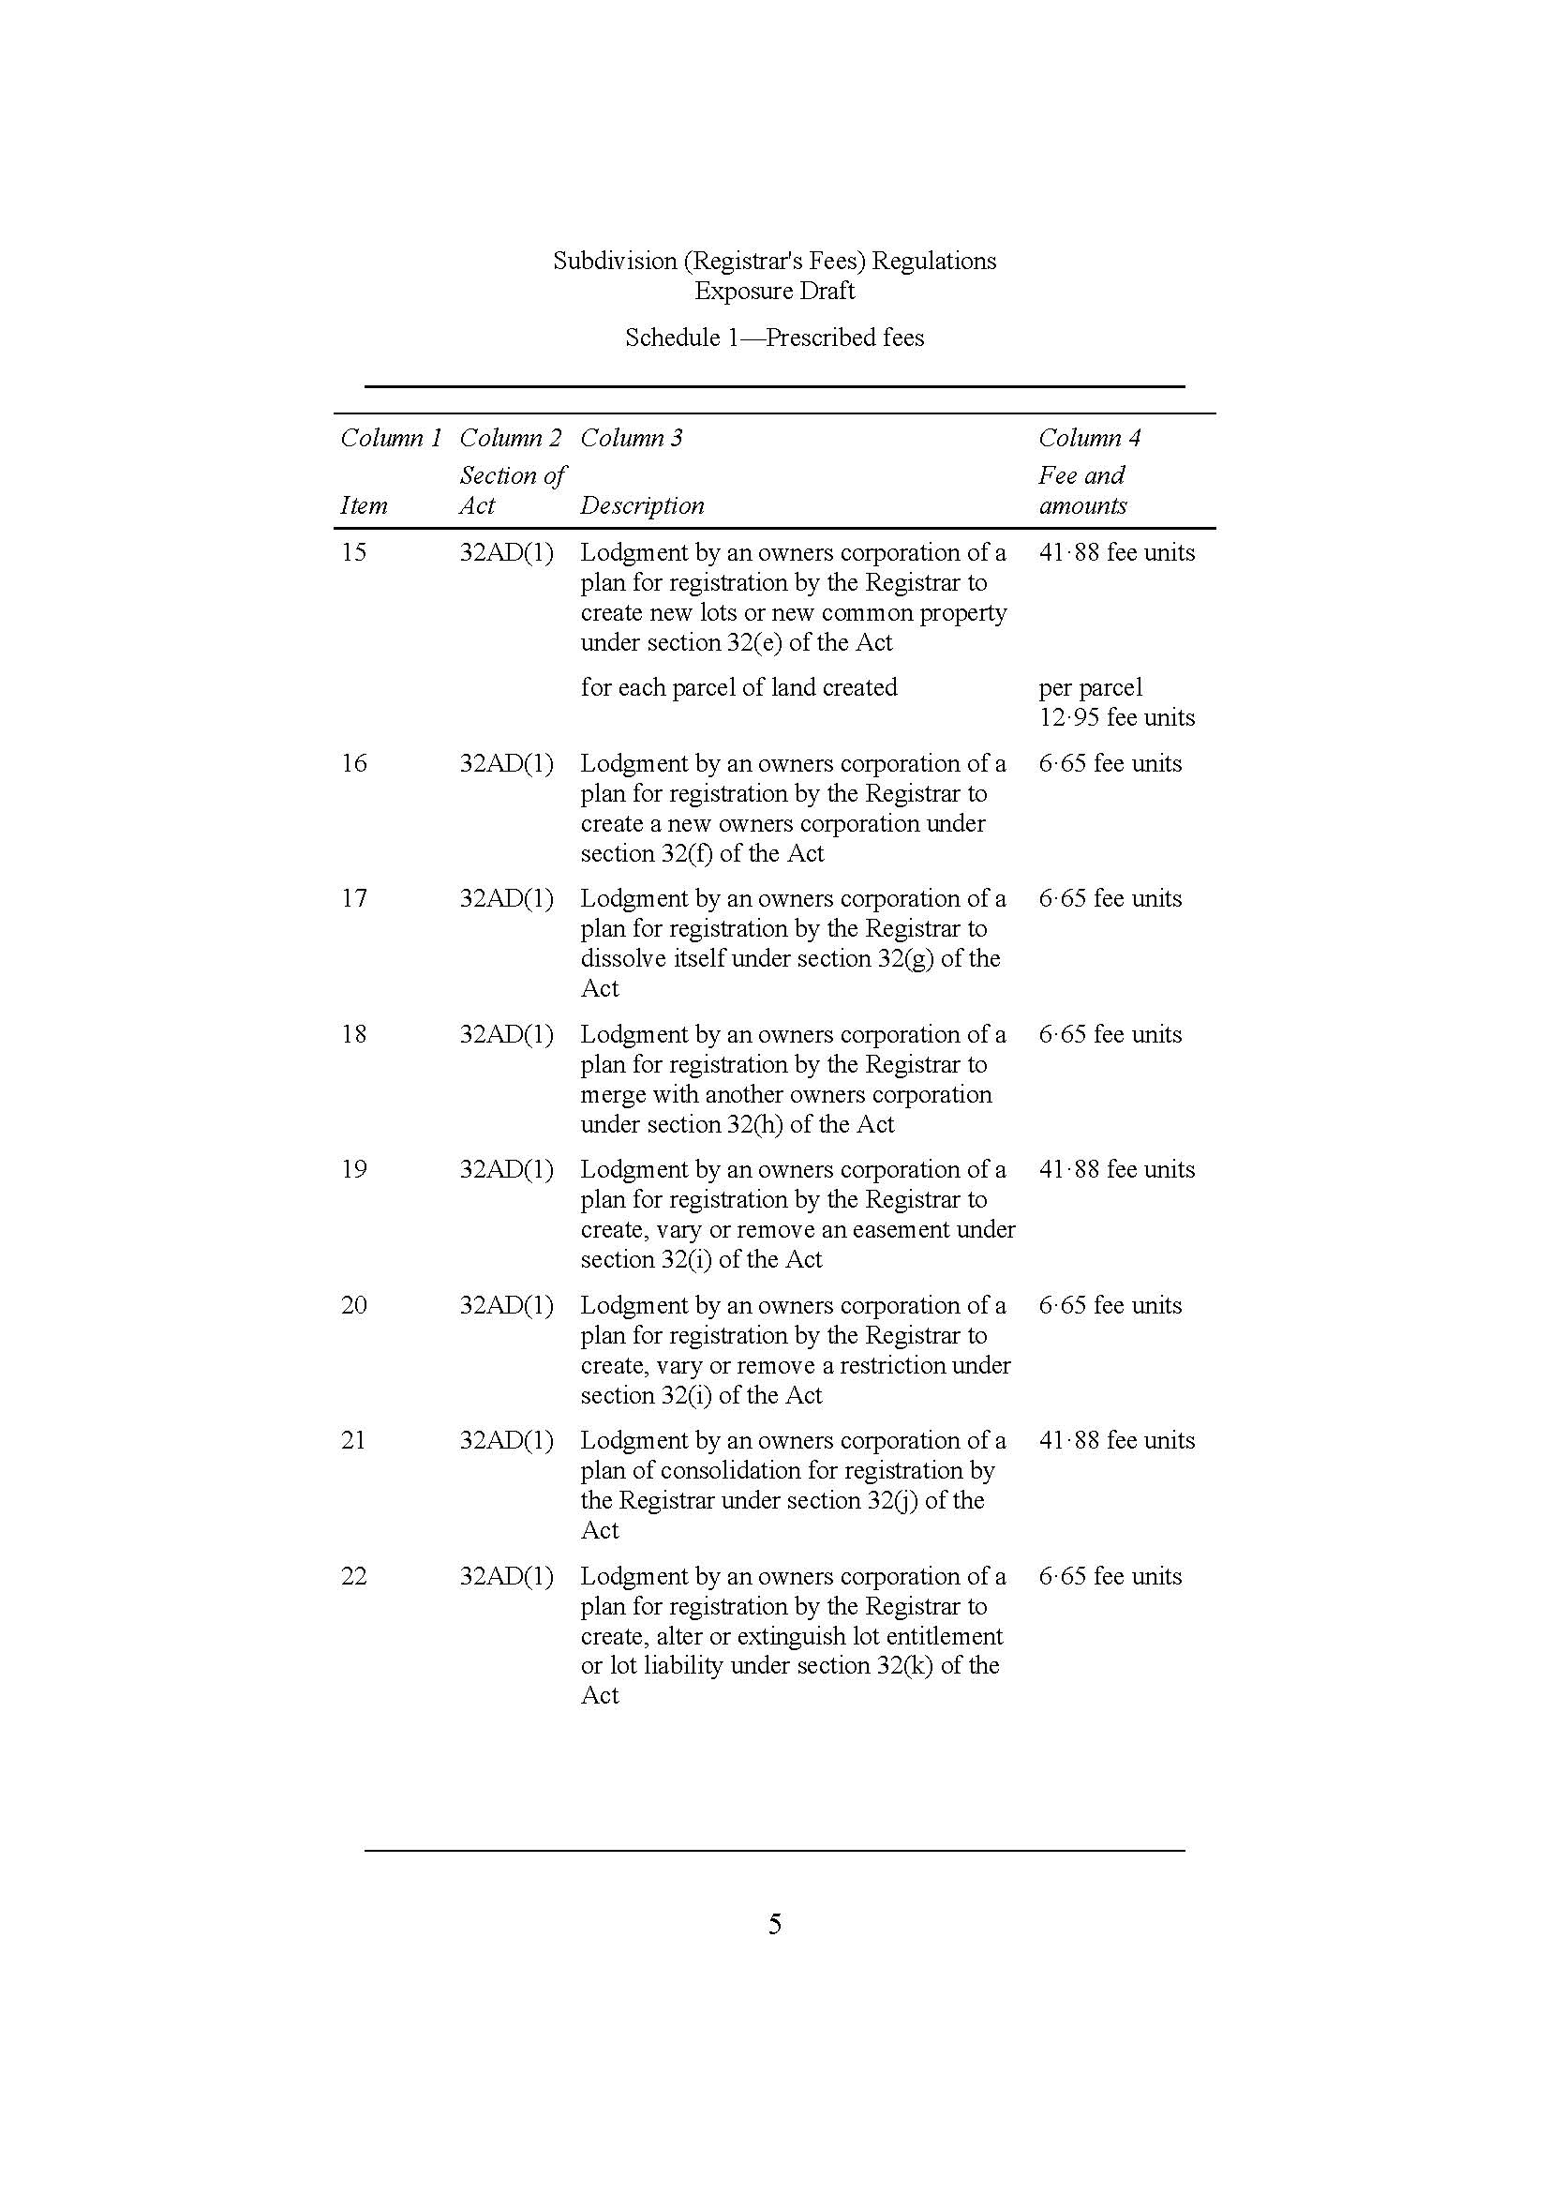

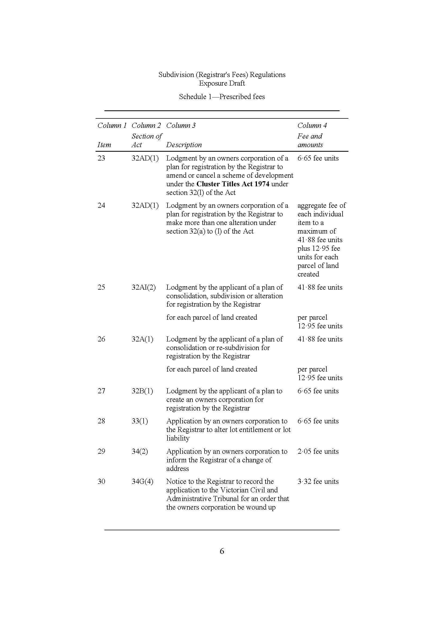

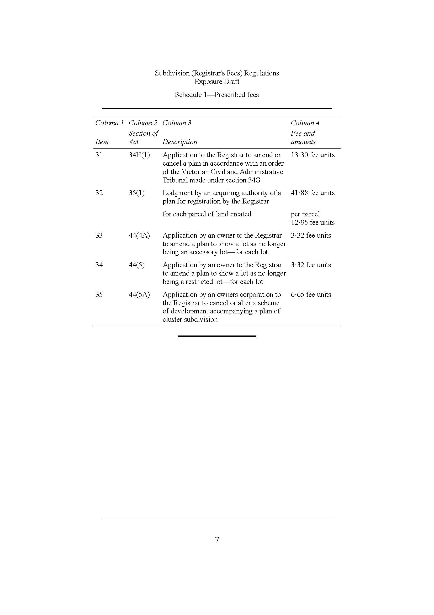



Limitation of our work

General use restriction

This Regulatory Impact Statement was prepared for Land Victoria as set out in the engagement letter with Land Victoria dated 18 March 2015 to undertake a Regulatory Impact Statement for proposed amendments to the Transfer of Land (Fees) Regulations, and the Subdivision (Registrar’s Fees) Regulations. In preparing this Report we have relied on the accuracy and completeness of the information provided to us by Land Victoria and from publicly available sources. The cost recovery and fee analysis contained in the report was conducted by Land Victoria.

We have not audited or otherwise verified the accuracy or completeness of the information. We have not contemplated the requirements or circumstances of anyone other than the Land Victoria. The information contained in this Report is general in nature and is not intended to be applied to anyone’s particular circumstances. This Report may not be sufficient or appropriate for your purposes. It may not address or reflect matters in which you may be interested or which may be material to you. Events may have occurred since we prepared this Report which may impact on it and its conclusions. We do not accept or assume any responsibility to anyone other than Land Victoria in respect of our work or this Report.

**Contact us**

Deloitte Touche Tohmatsu

ABN 74 490 121 060

550 Bourke Street

Melbourne VIC 3000

GPO Box 78

Melbourne VIC 3001 Australia

Tel: +61 3 9671 7000

www.deloitte.com.au

About Deloitte

Deloitte provides audit, tax, consulting, and financial advisory services to public and private clients spanning multiple industries. With a globally connected network of member firms in more than 150 countries, Deloitte brings world-class capabilities and deep local expertise to help clients succeed wherever they operate. Deloitte's approximately 170,000 professionals are committed to becoming the standard of excellence.

About Deloitte Australia

In Australia, the member firm is the Australian partnership of Deloitte Touche Tohmatsu. As one of Australia’s leading professional services firms. Deloitte Touche Tohmatsu and its affiliates provide audit, tax, consulting, and financial advisory services through approximately 5,400 people across the country. Focused on the creation of value and growth, and known as an employer of choice for innovative human resources programs, we are dedicated to helping our clients and our people excel. For more information, please visit our web site at [www.deloitte.com.au](http://www.deloitte.com/dtt/home/0%2C1044%2Csid%25253D5518%2C00.html).

Liability limited by a scheme approved under Professional Standards Legislation.

Member of Deloitte Touche Tohmatsu Limited

© 2015 Deloitte Touche Tohmatsu

1. The ad valorem component of the Land Transfer Fee is structured as a rate per $1000 of the value paid for the property (referred to as consideration) subject to the transfer, up to a certain capped amount (referred to as the ceiling). [↑](#footnote-ref-2)
2. The Regulations contain over 130 fee items, many of which are set at the same value. For the purposes of this RIS, fee items with the same value are grouped together under value categories. The full list of fee items is outlined in Appendix C. [↑](#footnote-ref-3)
3. The proposed Regulations contain over 130 fees. These fees relate to 241 different transaction types, noting that some fees cover multiple transaction types. Of the 241 transaction types, 194 of them have fees that would decrease under the proposed Regulations. [↑](#footnote-ref-4)
4. Department of Treasury and Finance, (2013), *Cost Recovery Guidelines*, January. [↑](#footnote-ref-5)
5. Government of Victoria, 2014, *Victorian Guide to Regulation,* Department of Treasury and Finance, Melbourne. [↑](#footnote-ref-6)
6. The existing Regulations are Interim Regulations which set the same fee levels as the Transfer of Land (Fees) Regulations 2004 and the Subdivision (Registrar’s Fees) Regulations 2004. The 2004 Regulations would have automatically sunset in September 2015, however Interim Regulations have been made using 2004 fee levels to enable fee collection from 19 September 2015. [↑](#footnote-ref-7)
7. The existing Regulations are Interim Regulations which set the same fee levels as the Transfer of Land (Fees) Regulations 2004 and the Subdivision (Registrar’s Fees) Regulations 2004. The 2004 Regulations would have automatically sunset in September 2015, however Interim Regulations have been made using 2004 fee levels to enable fee collection from 19 September 2015. [↑](#footnote-ref-8)
8. The cost base has been calculated using a forward looking approach. This involved looking at what the current costs are of providing the relevant services and adding in some additional ongoing costs to improve Land Victoria’s service delivery (see integrity and enhancement responsibilities cost items in Appendix B). [↑](#footnote-ref-9)
9. The existing Regulations are Interim Regulations which set the same fee levels, as the Transfer of Land (Fees) Regulations 2004 and the Subdivision (Registrar’s Fees) Regulations 2004. The 2004 Regulations would have automatically sunset in September 2015, however Interim Regulations have been made using 2004 fee levels to enable fee collection from 19 September 2015. [↑](#footnote-ref-10)
10. Note that this excludes the costs of processing registrations and discharges of mortgages as the associated fees are made to achieve alternative, non-cost recovery objectives. [↑](#footnote-ref-11)
11. Department of Treasury and Finance, (2013), Op cit. [↑](#footnote-ref-12)
12. Note that this excludes the costs of processing registrations and discharges of mortgages as the associated fees are made to achieve alternative, non-cost recovery objectives. [↑](#footnote-ref-13)
13. The Regulations contain over 130 fee items, many of which are set at the same value. For the purposes of this RIS, fee items with the same value are grouped together under value categories. The full list of fee items is outlined in Appendix C. [↑](#footnote-ref-14)
14. The existing Regulations are Interim Regulations which set the same fee levels, as the Transfer of Land (Fees) Regulations 2004 and the Subdivision (Registrar’s Fees) Regulations 2004. The 2004 Regulations would have automatically sunset in September 2015, however Interim Regulations have been made using 2004 fee levels to enable fee collection from 19 September 2015. [↑](#footnote-ref-15)
15. Note that this level of cost recovery excludes both costs and fee revenues associated with the ad valorem component of the transfer of land fee and the fee for registration and discharge of mortgages. [↑](#footnote-ref-16)
16. The ad valorem component of the Land Transfer Fee is structured as a rate per $1000 of the value paid for the property (referred to as consideration) subject to the transfer, up to a certain capped amount (referred to as the ceiling). [↑](#footnote-ref-17)
17. Valuer-General Victoria (July 2014), *A guide to property values – Annual data and analysis from Valuer-General Victoria 2013*. [↑](#footnote-ref-18)
18. Internal Land Victoria analysis. [↑](#footnote-ref-19)
19. This calculation is based on an estimate provided by Land Victoria. [↑](#footnote-ref-20)
20. This is discussed in Appendix B. [↑](#footnote-ref-21)
21. Note that the principle of horizontal equity (that those who benefit from government activities should pay the associated cost) is largely dealt with through the efficiency criterion so is excluded from the equity criterion to avoid double counting. [↑](#footnote-ref-22)
22. The proposed Regulations contain approximately 130 fees in total. These fees relate to 241 different transaction types, noting that some fees cover multiple transaction types. Of the 241 transaction types, 186 of them have fees that would decrease under the proposed Regulations. [↑](#footnote-ref-23)
23. Department of Treasury and Finance, (2013), Op. cit. [↑](#footnote-ref-24)
24. *Electronic Conveyancing National Law (Victoria), Instruments Act 1958, Surveying Act 2004, Survey Co-ordination Act 1958, Geographic Place Names Act 1998, Valuation of Land Act 1960.* [↑](#footnote-ref-25)
25. Ibid. [↑](#footnote-ref-26)
26. This differs from the cost base used for the purposes of calculating proposed fees in this RIS as the proposed fees are based on projected future costs – not costs in 2014-15 – which include the costs of VicMap maintenance and costs of meeting integrity and enhancement responsibilities (see Appendix B). [↑](#footnote-ref-27)
27. Ibid. [↑](#footnote-ref-28)
28. The Registrations unit processes the bulk of more basic transactions, whereas the Application and Survey unit complete the more complex land title registration transactions. It should be noted that Land Victoria has grouped these two business units together for the purposes of the cost recovery review exercise. [↑](#footnote-ref-29)
29. Note that this is within a limited capacity. If the use of the Land Records and Information Services system exceeds a certain level of ‘traffic’, congestion can occur and the service can become ‘rivalrous’. [↑](#footnote-ref-30)
30. The Includes the mortgage fees, but excludes the ad valorem component of the land transfer fee. [↑](#footnote-ref-31)
31. In reality there are six types of transactions. However, there has been no pre-population searches performed recently and title history transactions were found to be a composite of two other types of transactions. As a result, pre-population searches were removed for the cost recovery analysis and the title history transactions were consolidated into title searches and instrument searches. [↑](#footnote-ref-32)
32. Proposed fees are shown as rounded in accordance with the *Monetary Units Act 2004* (for example, $88.04 is rounded to $88.00 and $176.07 is rounded to $176.10). Note that some search fees are not rounded. [↑](#footnote-ref-33)
33. Proposed fees are shown as rounded in accordance with the *Monetary Units Act 2004* (for example, $88.04 is rounded to $88.00 and $176.07 is rounded to $176.10). [↑](#footnote-ref-34)