Cladding Safety Victoria

Annual Report 2023–2024

Responsible body declaration
In accordance with the Financial Management Act 1994 (Vic), I am pleased to present the Cladding Safety Victoria (CSV) Annual Report for the year ending 30 June 2024.

Rodney Fehring
Board Chair
Cladding Safety Victoria
12 September 2024

Aboriginal acknowledgement
CSV respectfully acknowledges the Traditional Owners and custodians of the land and water upon which we rely. We pay our respects to their Elders past, present and emerging. We recognise and value the ongoing contribution of Aboriginal people and communities to Victorian life. We embrace the spirit of reconciliation, working towards equality of outcomes and an equal voice.
ISSN 2653-2808
© State of Victoria
The 2023–24 CSV Annual Report is licensed under a Creative Commons Attribution 4.0 International licence. You may share and adapt the work under the terms of the license on the condition that you attribute the State of Victoria as the creator. The licence does not apply to any images, photographs or branding, including the Victorian Coat of Arms, the Victorian Government logo and the Cladding Safety Victoria logo.
Copyright queries may be directed to IPpolicy@dtf.vic.gov.au.
Available online at vic.gov.au/cladding-safety.

2023–24 – Year at a glance

Risk reduction on residential buildings
1,000+ buildings in CSV’s program have now either been resolved or have a pathway for resolution in place
Works are complete on 330 buildings resulting in the removal of 257,750m² of combustible cladding, which equates to 12.5 times the playing surface of the Melbourne Cricket Ground
31,000+ residents in approximately 16,500 individual homes are now safer

Risk reduction on government-owned buildings
Cladding has been removed on all 130 funded buildings
50,000m2+ of combustible cladding has been removed, protecting tens of thousands of Victorians in the community

Contents

Board Chair’s statement 6
Chief Executive Officer’s statement 7
About Cladding Safety Victoria 8
Manner of establishment 8
Responsible Minister 8
Purpose and functions 8
Vision, mission and outcomes 9
Culture and values 9
Nature and range of services provided 11
Financial summary 13
Year in review 15
Defining the way forward 15
Building sector reform 20
Residential Cladding Rectification Program 21
Cladding Rectification Program 22
Cladding Remediation Partnership Program 28
Government-owned Buildings Cladding Rectification Program 32
Performance against outcomes and outputs 34
2023–24 State Budget and service delivery 34
2023–24 Annual Work Program outcomes and measures 35
Organisation and people 37
Organisational structure 37
Minister for Planning 38
Department of Transport and Planning 38
Cladding Safety Victoria’s Board 39
Board Sub-committee 40
CEO and Senior Executives 41
Our people 41
Public sector values, employment and conduct principles 42
Comparative workforce data 42
Senior employees 46
Workforce inclusion policy 47
Occupational health and safety 47
Financial statements 49
Disclosures 104
Financial Management Compliance 104
Attestation Statement 104
Local jobs first 104
Social procurement framework 105
Emergency procurement 107
Disclosure of procurement complaints 107
Disclosure of major contracts 107
Consultancy expenditure 107
Government advertising expenditure 108
Information and communication technology expenditure 108
Reviews and studies expenditure 110
Asset Management Accountability Framework maturity assessment 112
Competitive Neutrality Policy 113
Freedom of information 113
Compliance with the Building Act 1993 (Vic) 115
Compliance with Public Interest Disclosures Act 2012 (Vic) 115
Compliance with Carers Recognition Act 2012 (Vic) 115
Compliance with Disability Act 2006 (Vic) 115
Compliance with DataVic Access Policy 116
Environmental reporting 116
Additional information on request 117
Disclosure index 118
Acronyms and abbreviations 122

Board Chair’s statement
During the 2023–24 financial year, CSV continued to deliver on its key objective to reduce the risk to Victorians posed by combustible cladding.
The end of this large and complex task is now in sight.
The substantial progress achieved can be attributed largely to the development by CSV of a world-leading approach which has enabled more accurate assessment of cladding risk and through this, more proportionate and achievable solutions.
It is hard to overstate the positive practical effect of this new approach for the people who own, live in or visit these buildings. As of 30 June 2024, works to remove and replace cladding was complete on 330 funded projects for the most dangerous Class 2 (residential apartment) buildings. Works were underway on another 85 funded projects in this class and 613 lower-risk buildings have been provided with advice to mitigate any issues or discharged because no further action was required. In total, that is more than one thousand buildings provided with an outcome.
Of course CSV’s technical innovations would have borne little fruit had it not been for the collaboration with the Department of Transport and Planning in the establishment of the Cladding Risk Mitigation Framework and the backing of The Minister for Planning, Sonya Kilkenny, with Minister’s Guideline 15. The Minister’s Guideline in essence requires all building surveyors in Victoria to have regard to CSV’s advice. These initiatives gave substance to the Victorian Government’s adoption of a risk-based approach to combustible cladding.
To facilitate the practical application of the Minister’s Guideline, a Partnership Program was introduced through which CSV, the Department of Transport and Planning and local councils are working together to help building owners and tenants. The measurable objective of this program has been to reach agreement on a pathway for each affected building and then provide this in documented form to the owners. This approach has not only taken the guesswork out of what can be a very difficult regulatory road for owners to navigate, but has greatly reduced the need for them to spend large sums on private consultants or to undertake unnecessary removal of cladding.
In addition to the residential program, the program to tackle cladding risk on 130 public buildings including healthcare facilities, educational facilities such as schools and TAFE buildings, sporting and recreational facilities and other public buildings across Victoria has concluded. This is a huge achievement.
While there is still much to do, we can now confidently expect the conclusion of the residential program by of the end of the next calendar year. We are confident the partnership approach that has yielded so much to date will see Victoria become the first jurisdiction in the world to comprehensively deal with this challenge.
I would like to acknowledge the contribution of Roger Teale, who concluded his term as a member of the CSV Board in late 2023. The Board has benefited greatly from Roger’s expertise, in particular from his leadership of the Board’s Risk Committee during CSV’s establishment phase.
On behalf of the Board, I also want to thank Chief Executive Dan O’Brien and the whole CSV team for their hard work, high standards and commitment to the Victorian community. In addition, I thank the Victorian Government for making this work possible.
Finally, we all recognise that none of this would be possible without the collaboration of building owners and residents, industry experts, local councils, Municipal Building Surveyors, the insurance industry and the building industry more generally, and on behalf of the Board, I wish to send my thanks to each and every one of these entities for making our success possible.
Rod Fehring
Board Chair
Cladding Safety Victoria

Chief Executive Officer’s statement
Five years ago, Cladding Safety Victoria was set a challenge to address the uncertain risk of combustible cladding on an unknown number of buildings, at pace.
Since that time, through our research, the methodical collection of data, the conducting of materials testing while working on hundreds of residential apartments and government buildings, CSV is now able to answer two key questions: How many apartment buildings are exposed to flammable cladding in Victoria? And how significant is the risk?
The recent release of the Phase 2 Report of the Public Inquiry into the Fire at Grenfell Tower in September 2024 has highlighted how critical it is to create clarity about the degree of combustible cladding risk in the community – as well as taking appropriate and timely action to mitigate this risk – which in the worst case scenario, has the potential to result in significant and devastating loss of life.
As of 30 June 2024, 1619 Class 2 apartment buildings have been identified as having some form of cladding risk. Twenty-six per cent of these buildings have been categorised as having an unacceptable risk. Works are now complete on 330 of these residential buildings. A further 90 buildings are either underway or in negotiation with owners. We are on track to close out this part of the program next year. When these buildings are finished, it will mean that approximately 90 per cent of the cladding risk in Class 2 buildings will be retired in Victoria. For the tens of thousands of people who own or live in affected buildings, this is both an emotional as well as a financial relief.
During 2023–24, the Protocols for Mitigating Cladding Risk were published. This approach enables owners to adopt less costly interventions commensurate with the lower risk cladding on their buildings, without compromising safety. There are many buildings in CSV’s program where a cladding risk exists, but the risk of fire spread is low because of the type of cladding and where it is present on the external walls. Our improved understanding of cladding risk has enabled CSV to extend support to owners of these buildings.
CSV’s evolved approach was backed on 21 September 2023 when the Victorian Government, through the Minister for Planning, Sonya Kilkenny, issued Minister’s Guideline 15 and the Cladding Risk Mitigation Framework under section 188(1)(c) of the Building Act 1993 (Vic). Following that publication, we engaged extensively with regulators, insurers, fire engineers and a range of other professional and representative organisations within the sector to educate them about this approach and its implications.
In conjunction with the Department of Transport and Planning, we launched the Cladding Remediation Partnership Program for local government Municipal Building Surveyors. The aim of this is to assist Municipal Building Surveyors understand the risk and the potential interventions available to guide their enforcement actions.
In relation to government-owned buildings, of the 130 buildings that were nominated by government agencies and assessed by CSV as requiring cladding works, all have had their cladding removed. I thank those government agencies that made this program a priority.
Over the course of CSV’s lifespan, much consideration has also been given to ensuring we have a team that can deliver the program not just now, but to completion. This did not falter in 2023–24. The diversity of our people continues to be a strength, while the high rate of job satisfaction continues across all work areas at CSV.
Finally, CSV concluded the year in a robust financial position, with a commitment to maintaining low operational costs relative to the funds dedicated to risk reduction. This approach has been consistently applied and successfully upheld over the past 12 months, ensuring that we maximise our resources, achieve our goals, and maintain financial stability.
Dan O’Brien
Chief Executive Officer
Cladding Safety Victoria

About Cladding Safety Victoria

Manner of establishment
On 16 July 2019, the then Premier of Victoria and Minister for Planning announced the establishment of CSV, within the Victorian Building Authority (VBA). The Cladding Safety Victoria Act 2020 (Vic) (CSV Act) commenced on 1 December 2020 and established CSV as the world’s first stand-alone cladding rectification agency, formally separating CSV from the VBA.
The CSV Act underwent its legislated review during the year, which was tabled in Parliament on 7 March 2024. The review concluded there is a need for CSV to continue operating under the CSV Act to complete its existing cladding programs, with no changes required to the legislation.

Responsible Minister
The Minister for Planning is the responsible Minister for CSV. The Hon. Sonya Kilkenny MP was appointed as Minister for Planning on 5 December 2022.

Purpose and functions
Section 6 of the CSV Act provides that the object of CSV is to support Victorians to rectify non-compliant or non-conforming external wall cladding products on buildings to improve the safety of those buildings.
CSV does this through administering the Cladding Rectification Program.
To achieve this purpose, CSV has the following functions under the CSV Act:
- prioritising buildings for potential financial assistance for cladding rectification work
- deciding whether to grant or refuse to grant financial assistance to owners and owners corporations of buildings
- determining the amounts of financial assistance to owners and owners corporations of buildings for cladding rectification work
- monitoring cladding rectification work where financial assistance has been given
- supporting owners and owners corporations of buildings by procuring building practitioners and engaging technical design and project management services to undertake cladding rectification work
- facilitating cladding rectification work for government-owned buildings
- providing information, advice and support to owners and owners corporations of buildings and other persons and bodies in relation to cladding rectification work
- notifying the appropriate regulators, Municipal Building Surveyors, persons and bodies about matters relating to compliance and enforcement under the CSV Act, the Building Act 1993 (Vic) or any other Act
- advising the Minister on the performance of its functions
- performing any other function conferred on CSV, including under any agreement to which the State is a party.

Vision, mission and outcomes
CSV’s Strategic Plan 2021–25 outlines 3 core outcomes that provide the focus for performance monitoring and reporting. These are delivered within the context of CSV’s vision and mission.
Vision: Making the community safer by reducing combustible cladding risk.
Mission: We will improve the safety of buildings impacted by cladding issues by working in partnership with industry and the community.
Outcomes:
- CSV actions are undertaken safely and improve the safety of buildings within the scope of the program.
- Owners corporations of buildings referred to CSV are provided with information and support to address the cladding risk for their building.
- Robust financial and resource management optimises the value of CSV’s delivery outcomes.
Each of the 3 outcomes has outputs and measures attached to it that allow CSV to track progress against key activities during the year. More information about 2023–24 results is available on pages 35–36.

Culture and values
A positive workplace experience that attracts talent, drives engagement, enhances staff satisfaction and improves performance is critical to the successful delivery of CSV’s strategic objectives. To achieve CSV’s organisational outcomes, CSV’s values are brought to life in a way that is meaningful to all staff. CSV’s strong workplace culture is evidenced by the overwhelmingly positive responses from staff to the 2024 People Matter Survey, about which further information is provided on pages 41 and 47.
Developing and growing a values-based culture begins with understanding that all staff take responsibility for how they interact and work together. CSV is guided by the Code of Conduct for Victorian Public Sector Employees and in particular the values of leadership, respect, accountability and integrity. These values speak to the way staff work as individuals and team members. In addition, CSV holds safety, health and wellbeing at the forefront of all of its activities and processes.

We are all leaders
This means:
- We set the tone for workplace culture and have a huge influence over how our workplace is shaped.
- We are committed to building a positive and constructive workplace culture.
- We empower staff to show leadership at every level of the organisation.
- We promote and role model physically and psychologically safe work practices.

We are respectful
This means:
- We treat each other fairly, objectively and with civility.
- We recognise and value diversity, equality and human rights.
- We value each other’s contribution and are committed to listen and communicate honestly and clearly.
- We give and seek feedback and encourage reporting of behaviour outside of these values.

We are accountable
This means:
- We are comfortable with being held accountable and working to clear objectives in a transparent manner.
- We accept responsibility for our decisions and we take this seriously.
- We take ownership of the quality and demonstratable impact of our work.
- We are accountable for the responsible spending of public money.
- We ensure that our decisions and actions are evidence based and outcomes focused.

We have integrity
This means:
- We are honest, open and transparent with each other and in all of our dealings.
- We show a consistent and uncompromising adherence to compliance, decisions and our values.
- We strive to build and sustain community trust.
- Our interactions with people always demonstrate that we are concerned about how they experience the service we deliver.

Nature and range of services provided
CSV was established to reduce the risk posed by combustible cladding in Victoria’s built environment. Cladding is the outside skin of a building. It is used to provide thermal insulation, weather resistance, noise reduction, and to improve the appearance of buildings.
While there are numerous types and brands of cladding available, there are two types of combustible cladding that pose a particular risk for building occupants, as well as the community more broadly. This is because in the event of a fire, these materials may increase the rate at which a fire spreads. These cladding types are aluminium composite panels with a polyethylene core (ACP) and expanded polystyrene (EPS).
CSV runs two programs that aim to reduce cladding risk across Victoria by targeting combustible ACP and EPS cladding – one focuses on privately-owned residential apartment buildings and the other addresses government-owned buildings and facilities.
Through these programs, CSV delivers a number of community services where the primary customers are the owners, occupants and users of buildings with combustible cladding.

Services for residential apartment buildings
The CSV delivery process for the rectification of residential buildings is founded on the following core services to support building owners.
Cladding risk assessment and rectification funding services | The risk assessments performed by CSV help owners and Municipal Building Surveyors (MBSs) examine the level of fire spread risk that cladding adds to a building and what risk mitigation actions, if any, may need to be taken. Buildings assessed at a risk rating of ‘unacceptable’ are eligible to be considered for funding of cladding rectification works.
Case management services | Senior Customer Liaison Officers provide a dedicated one-to-one case management service for owners to support them in navigating a complex range of issues that they need to contend with to make their buildings safer.
Due diligence inspection services | A multi-disciplinary expert team of building and fire safety practitioners is provided by CSV to inspect buildings, guide the development of Remediation Work Proposals and provide an initial appraisal of rectification costs.
Remediation solutions services | CSV technical experts review building information – including the outcomes of any testing – to develop Remediation Works Proposals that outline the interventions to be implemented that will reduce cladding risk to an acceptable level.
Project management services | CSV-appointed Independent Project Managers represent the mutual interests of building owners and CSV in cladding rectification work, overseeing all aspects of contract management and delivery progress for buildings in the funded program.
Quality control services | Clerks of Works and CSV staff undertake on-site inspections during the construction period to ensure that work practices comply with quality standards and that building residents, visitors and workers are safe on-site.

Services for government-owned buildings
The rectification process for government-owned buildings is managed by the relevant individual government departments, using funds allocated by CSV. The CSV services that support the rectification of government-owned buildings are as follows.
Risk assessment services | CSV assesses a diverse range of government-owned buildings (including schools, hospitals, police stations and sports venues), helping government departments to understand the cladding risk profile of their respective buildings and the associated rectification priorities.
Rectification solution services | Drawing on several years of experience in designing rectification solutions for different types of government-owned buildings, CSV, with the support of external design practitioners, develops costed rectification solution proposals that reduce cladding risk to an acceptable level.
Advisory services | CSV provides a vital advisory service to each government department to ensure they are appropriately supported throughout the process and rectification priorities are understood and agreed.
Project oversight services | CSV monitors the implementation of construction works to ensure compliance with the approved solution design and quality standards and that delivery occurs within project budget and schedule tolerances.

Financial summary

Overview
CSV considers the net result from transactions to be the appropriate measure of financial management that can be directly attributed to the Cladding Rectification Program (CRP). In 2023–24, CSV achieved a net deficit from transactions of $6.13 million, which is $28.64 million lower than in 2022–23. This decrease is mainly attributed a reduction in grant income of $56.63 million, as CSV had received its full grant appropriations for the CRP in the prior year. However, this was partially offset by a $17.11 million decrease in grants paid to owners corporations and a $7.93 million increase in collected Cladding Rectification Levy compared to the previous period.
Total net assets decreased from $119.14 million in 2022–23 to $113.02 million, primarily due to a decrease in the cash and receivables balance. CSV has a cash balance of $115.31 million, reflecting a decrease of $2.88 million from 2022–23 to 2023–24. The change in cash balance indicates a reduction in CSV’s cash reserves over the year.
Four-year performance summary ($‘000s)
 | 2023–24 | 2022–23 | 2021–22 | 2020-21¹
Total income from transactions | 108,557 | 156,311 | 145,312 | 98,002
Total expenses from transactions | (114,682) | (133,797) | (168,973) | (61,220)
Net result from transactions | (6,125) | 22,514 | (23,661) | 36,782
Net result for the period | (6,125) | 22,514 | (23,661) | 36,677
Net cash flows from operating activities | (2,251) | 17,895 | (21,138) | 34,332
Total assets | 127,003 | 132,494 | 111,429 | 134,753
Total liabilities | 13,988 | 13,354 | 14,803 | 14,466
Net assets | 113,015 | 119,140 | 96,626 | 120,287

¹ CSV was established as an entity on 1 December 2020 and therefore the figures for 2020–21 represent a period of 7 months.

Financial performance and business review
The main budgetary objectives of the organisation in 2023–24 were to oversee and coordinate the rectification of buildings while managing the financial resources efficiently, which included:
- timely rectification of building prioritised on a risk basis
- defined pathways in place for all buildings referred to CSV
- facilitation of timely rectification of government-owned buildings
- enhanced awareness of the Victorian community and participating owners corporations about cladding fire safety risk by providing information and guidance
- enhancement of the effectiveness of CSV’s financial, risk and resource planning and systems.
CSV’s funding was applied to achieve the main strategic outcomes as outlined in the 2023–24 Annual Work Program.
CSV achieved a net deficit result from transactions in 2023–24 of $6.13 million. Income decreased from 2022–23 due to a reduction of grant funding received, as outlined above.
Expenses from transactions decreased by $19.12 million from the prior year. Grants payments to owners corporations for cladding rectification totalled $87.62 million, a decrease of $17.11 million. Payments to employees, consultants and professional services of $23.88 million represented a decrease of $2.07 million.
The total number of active grants in 2023–24 was 171, compared to 200 in 2022–23. The decrease in expenses from transactions and grant payments was mainly due to the practical completion of 139 projects during the year, compared to 87 projects that reached practical completion in the previous year.
CSV has been able to maintain fiscal responsibility in managing project budgets and commitments despite the challenges faced by the construction industry. The industry has experienced increased volatility in recent years, which can be attributed to factors such as economic fluctuations including the rising costs of building materials.

Financial position – balance sheet
Net assets decreased by $6.13 million over the year to $113.02 million, mainly due to a decrease in total assets of $5.49 million, comprising a $5.02 million reduction in financial assets, and a reduction of $0.47 million in non-financial assets. The decrease in financial assets is mainly due to decreases in cash and deposits of $2.88 million and receivables of $2.14 million.
Total liabilities have remained steady over the last three years and has been relatively consistent during these periods. Total liabilities are $13.99 million, predominately made up of $11.80 million in grant payables to owners corporations and payables to suppliers.

Cash flows
The overall cash surplus of $115.31 million for the 2023–24 financial year was a decrease of $2.89 million compared to the previous year.
The net cash outflows from operating activities was $2.25 million, a decrease of $20.15 million from 2022–23 due to a reduction of grants received from the Department of Transport and Planning (DTP) offset by an increase in Cladding Rectification Levy collected and reduced payments of grants to owners corporations and payments to suppliers and employees.

Disclosure of grants and transfer payments
CSV makes grant payments to owners corporations to rectify the highest-risk privately-owned multi-storey residential buildings with combustible cladding.
Up to 30 June 2024, CSV has entered into funding agreements with 387 owners corporations. During 2023–24, CSV made a total of $87.62 million of grant payments.

Subsequent events
CSV had no material subsequent events that occurred after 30 June 2024. See Note 8.6 in the financial statements for further details.

Year in review
In July 2019, the State Government established a world-first program to address high-risk cladding, in order to keep Victorians safe from the impacts of events such as the Neo 200 fire in Melbourne and the Grenfell fire in London.
A $600 million package was allocated to fund rectification works on hundreds of buildings assessed to have a high level of risk associated with combustible cladding. At the same time, Cladding Safety Victoria was established to oversee the program and to work with government departments and owners corporations to ensure the effective delivery of risk reduction outcomes.
To date, this significant investment by the government has yielded major results for the Victorian community, including:
- the completion of cladding removal on all 130 buildings identified as being eligible for funding under the Government-owned Buildings Cladding Rectification Program
- the development and publication of a world-leading evidence-based methodology for the assessment and treatment of cladding risk: the Protocols for Mitigating Cladding Risk (PMCR)
- the remediation of more than 75% of the highest-risk buildings in the Residential Cladding Rectification Program to an acceptable level of combustible cladding risk
- the provision of works proposals to owners corporations for the mitigation of cladding risk on elevated-risk and low-risk residential buildings.

Defining the way forward
Developing a consistent understanding of and approach to the identification, assessment, classification and treatment of combustible cladding risk is a challenge with which many jurisdictions in Australia and around the world are grappling. However, applying a consistent approach to cladding risk is critical to the effective deployment of government funding and to provide certainty to the owners of buildings with combustible cladding.
CSV has worked extensively with its government, sector and research partners to establish a multi-layered evidence-based framework for combustible cladding risk that has not only become the foundation for CSV’s program, but which forms part of the future legacy of the government’s investment, which will endure well beyond the life of CSV and its rectification program.

Minister’s Guideline 15
In September 2023, Minister’s Guideline 15 was published in the Victoria Government Gazette. This guideline is supported by the Cladding Risk Mitigation Framework (CRMF), which was developed by CSV. The guideline and framework provide councils, MBSs and owners with clear policy for understanding combustible cladding risk, how it is assessed and a procedure for how risk can be addressed.
Under the Minister’s Guideline, when MBSs and private building surveyors are undertaking their functions in relation to buildings with combustible cladding, they must have regard to:
- the CRMF
- advice, support and information provided by CSV and DTP
- Remediation Work Proposals prepared by CSV.
In April 2024, additional direction was released by the VBA on the requirement for MBSs and private building surveyors to ‘have regard’ in Minister’s Guideline 15. The industry alert clarified that building surveyors and other practitioners advising on cladding risk must consider guidance provided under Minister’s Guideline 15. Should these practitioners decide to deviate from it, they must document the decision and the reason for implementing an alternate approach. This statement cements CSV’s approach and methodologies as the key considerations in addressing combustible cladding risk in Victoria.

PMCR model
The PMCR is an evidence-led and scientifically supported methodology that has been internationally recognised as the most comprehensive research undertaken into addressing cladding risk in the world. It was developed through a partnership between CSV, CSIRO (Data 61) and RMIT University.
The PMCR aims to identify a risk-proportionate response for buildings of all risk levels, with a primary focus on buildings with a cladding risk rating of ‘elevated’ and ‘low’. The suite of PMCR documents comprises the supporting prescriptive standards, rules and procedures that underpin Victoria’s risk-based approach to combustible cladding interventions. The PMCR works in conjunction with Minister’s Guideline 15 and the CRMF to provide a complete guide to addressing combustible cladding risk.
CSV is committed to being transparent about the approaches applied to its cladding risk reduction projects, both with program partners and the general public. CSV is also eager to share its research outcomes and innovative risk-mitigation methodologies with other government entities, the broader building and construction sector, insurance providers and other jurisdictions – nationally and internationally. To this end, CSV publicly published the full set of PMCR documents during the year, which includes the research and analysis that informed the PMCR design, on its website: vic.gov.au/cladding-risk-prioritisation-model-policy-and-methodology.
The PMCR was primarily designed to support MBSs in approving work proposals that enable enforcement actions relating to cladding risk to be removed from buildings. This is in recognition that MBSs are the key decision-maker in relation to the formal obligations placed on building owners to address cladding-related issues.
To support effective implementation of the PMCR across the program, CSV worked closely with MBSs and held workshops to communicate the purpose, design and intended application of the PMCR. Through this process, the design of the PMCR was continuously tested and targeted revisions were made to enhance implementability. Further technical workshops with MBSs in early 2024 demonstrated the detail of the science and evidence behind the PMCR methodology. CSV, in partnership with DTP, also rolled out an intensive program of engagement with the Chief Executive Officers of all impacted councils to explain CSV’s role, Minister’s Guideline 15, roll-out of the PMCR and resourcing requirements. In addition, all affected councils were provided with a printed version of the suite of technical documents that describe and underpin the PMCR.
As CSV’s materials testing regime and research program provide new insights about the identification, assessment, classification and management of combustible cladding risk, the PMCR will be updated to ensure that it continues to act as a valuable and cutting-edge source of information about cladding risk reduction approaches.

Materials testing and research
For the last couple of years, CSV has been undertaking a robust program of cladding product testing. This involves the construction of cladded wall test specimens that replicate forms of cladding installation found on buildings in CSV’s program. The testing regime assesses the fire spread potential of different cladding products, which has allowed CSV to create a knowledge base that details various cladding types and their reaction to particular fire scenarios.
In 2023–24, CSV’s material testing program focused on developing a deeper knowledge of the behaviour of ACP products, and ACP-FR (ACP with Flame Retardant) in particular. Through this testing program, CSV is leading the industry’s understanding of ACP and
re-defining the perception of ACP-FR. As with the PMCR, all of CSV’s test parameters, data and results are published publicly, to contribute to a better-informed sector: vic.gov.au/cladding-testing.
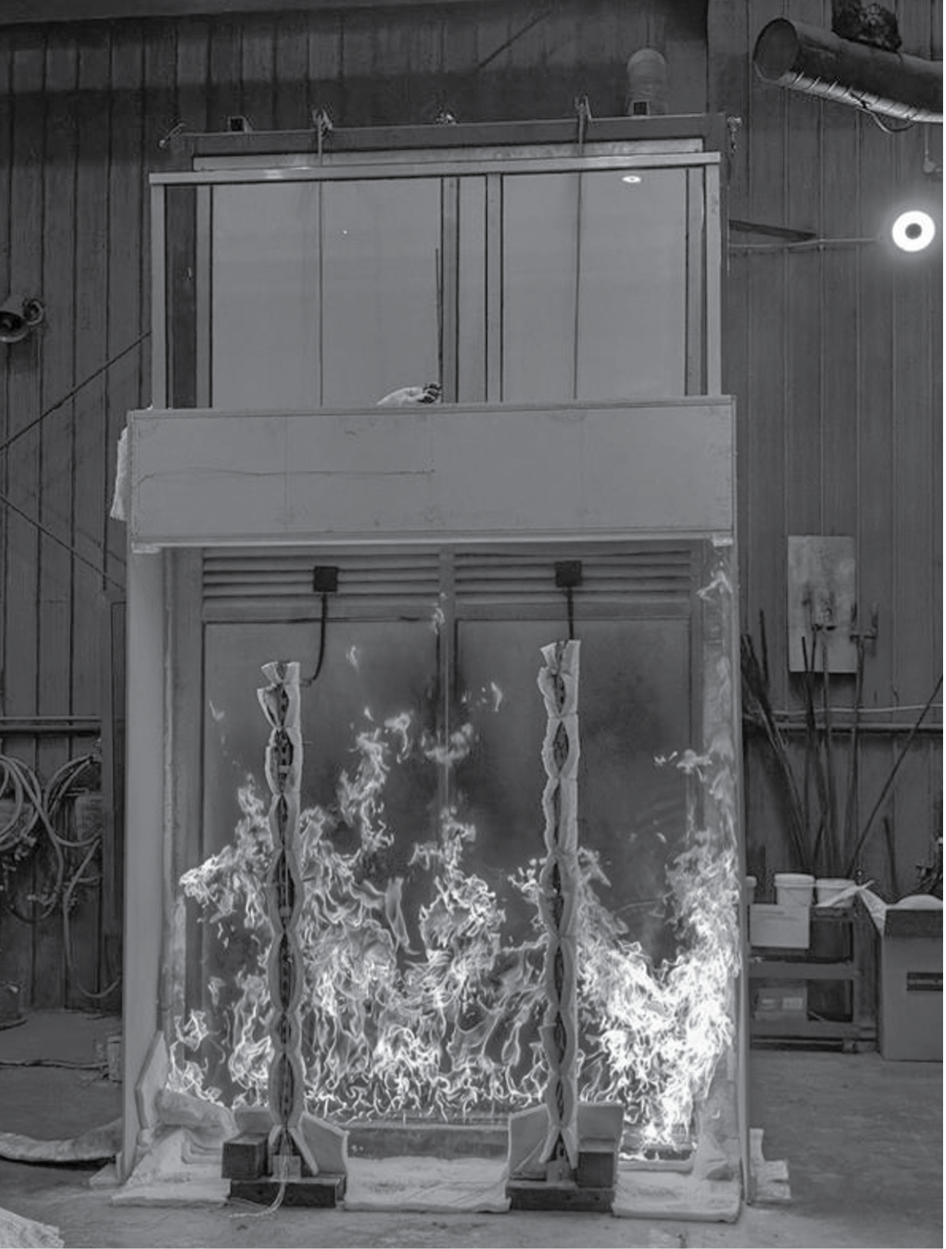
Image: This test explored vertical fire spread where a balcony fire starts on the floor below and examined its ability to leap past the slab, break the glass balustrade and to ignite the cladding on the balcony above (ACP panels with 100% polyethylene core).
To further disseminate CSV’s learnings and to provide clear guidance for industry practitioners, CSV and the VBA jointly published the Guide for Aluminium Composite Panels with Flame Retardant on Existing Buildings in May 2024. This advice provides a framework for MBSs when reviewing the applicability of enforcement notices for existing buildings with ACP-FR cladding.
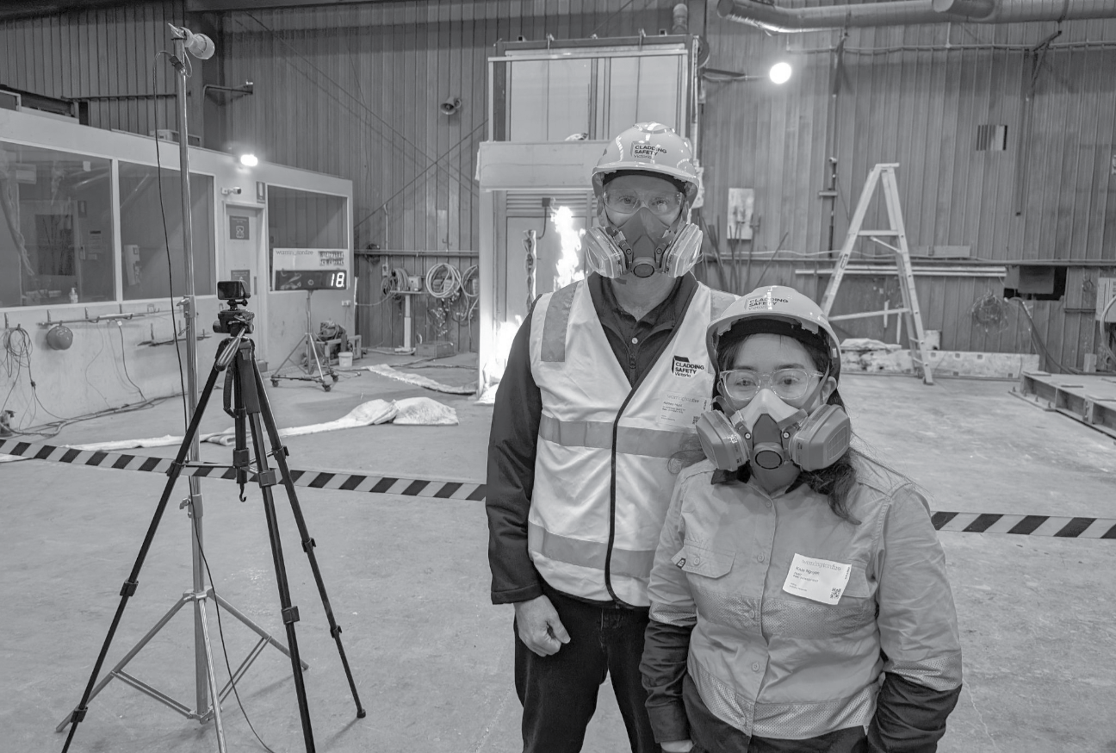
Image: Staff attend cladding product fire testing.
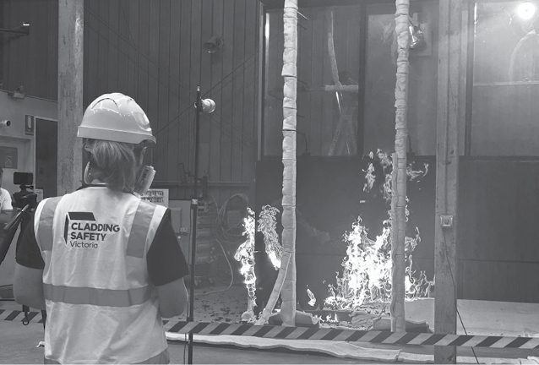
Image: Cladding product fire testing underway.

Spreading the word
During 2023–24, CSV engaged with a range of industry bodies and professional associations to present the PMCR and to provide an update on progress and future areas of focus for the rectification program. This included forums, webinars and sessions with the Victorian Municipal Building Surveyors Group Inc., Engineers Australia, the International Fire Safety Standards Coalition, the National Fire Industry Association of Australia and with Owners Corporation Managers through the Strata Community Association (Vic).
CSV is committed to ensuring owners receive the full benefits of cladding remediation, including through the re-consideration of building insurance premiums and policy availability by providers, to reflect reduced combustible cladding risk. Extensive engagement occurred throughout the year with the insurance industry, in particular with the largest underwriter of strata-owned residential buildings in Victoria, CHU Underwriting Agencies Pty Ltd.
Jurisdictions around the world are coming to terms with many of the same issues faced by Victoria in relation to the building and construction sector. There is significant commonality in this shared experience that benefits from the exchange of information, approaches and ideas. CSV has liaised especially closely with government bodies in England, Scotland and Ireland. These entities have been focusing on matters such as mitigating building insurance impacts, providing loans to owners of cladding-affected buildings and establishing programs for defects remediation.
These governments have all expressed deep interest in CSV’s work and the way in which the PMCR methodology is facilitating the resolution of cladding risk for government in Victoria. Online discussions were held throughout the year and in May 2024, Chief Executive Officer, Dan O’Brien, and Executive Director Program Delivery, Ashley Hunt, visited the UK and Ireland to present the details of CSV’s risk-based approach and to provide advice on its potential applicability to those jurisdictions.

Building sector reform
CSV’s research, testing and cladding rectification programs operate within the context of a broader system of building reform being undertaken by the Victorian Government. In December 2023, Dan O’Brien was appointed as the Chairperson of the Expert Panel on Building Reform to undertake the final stage of its three-part review of the building legislative and regulatory system.
The Victorian Government established the Expert Panel in 2019 to lead the review, which covers:
- examination of the permitting system, regulatory oversight and consumer protection
- identification of opportunities for improving building information, regulator tools and powers, insurance coverage and dispute resolution processes
- the provision of advice on a framework for a new Building Act.
Key CSV staff members supported the Expert Panel in the development of its Stage 3 Report. The report draws on a broad range of input, including data, observations and learnings from CSV’s program. The Stage 3 Report was submitted to the Minister for Planning on 30 April 2024.

Residential Cladding Rectification Program
As at 30 June 2024, there are 1,619 Class 2 buildings within Victoria that have been identified for consideration under CSV’s residential program.
This is an increase of 31 from 2022–23, which is a result of Section 27 referrals of buildings from councils and the assessment of some buildings from CSV’s database of referred buildings as being in-scope for the program.
The application of the PMCR model categorises residential buildings deemed eligible for CSV’s program as either ‘unacceptable risk’, ‘elevated risk’ or ‘low risk’. These categories reflect the extent to which cladding can spread fire across a facade by estimating the number of apartments that would be directly impacted under a worst-case scenario.
- Unacceptable risk means the amount, type and configuration of the cladding on a building could lead to rapid acceleration of a fire. For these buildings, the primary means of reducing cladding risk to an acceptable level is to undertake works that substantially remove and replace external combustible cladding.
- Elevated risk means a range of interventions are available to limit potential fire spread on a building. CSV works with MBSs and owners corporations to develop Remediation Work Proposals that reduce cladding fire risk to an acceptable level for these buildings.
- Low risk means well-maintained essential safety measures are sufficient to address any cladding risk on a building and no further intervention is required.
Buildings in the program may fall outside these risk categories and an associated CSV-identified pathway for the following reasons:
- they are subsequently deemed to be out-of-scope for a range of possible reasons, such as an ineligible ownership structure or the building being less than 3 storeys high
- the combustible cladding risk has already been resolved in another manner, for example by the owners corporation or the MBS directly.
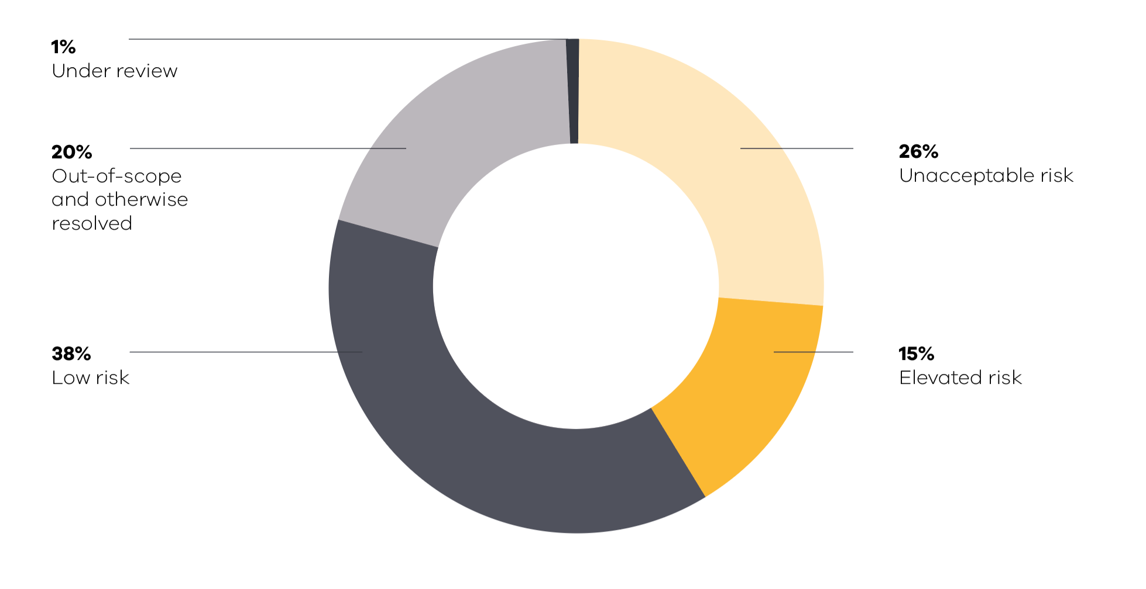
This chart illustrates the categorisation of residential buildings that have been identified for consideration under CSV’s residential program as at the end of 2023–24.
More than 1,000 buildings, or approximately two-thirds of buildings in CSV’s program, have now either been resolved or have a pathway for resolution in place. This includes buildings that have been discharged and more than 400 buildings that have been approved for rectification funding.
The following sections outline progress made during 2023–24 under the 2 main streams of the residential program, which address the different risk categories for buildings with combustible cladding.

Cladding Rectification Program
The funded program is designed to finance rectification works and support building owners in remediating unacceptable cladding fire risk on Class 2 residential buildings that are three storeys or higher.
The portfolio of buildings in the funded program varies significantly in scale and complexity, with not all buildings requiring full removal of cladding to appropriately mitigate the risk. To ensure that the most efficient remediation solution is developed for each building, an up-front due diligence process is undertaken that involves a physical inspection and in many cases, sampling of the cladding and other materials from the building.
This allows a rectification proposal to be developed, which forms the basis of the funding agreement that is signed between CSV and the owners corporation. In 2023–24, 65 funding agreements were signed and works commenced on 52 buildings.

Delivery achievements
During 2023–24, CSV completed rectification works on 80 residential buildings, bringing the total number of buildings rectified under the funded program to 330 from commencement of the program to 30 June 2024. This equates to 257,750 square metres of cladding removed and more than 16,500 homes made safer.
Although unacceptable-risk buildings only represent approximately one-quarter of the total building cohort, remediation of these buildings is estimated to mitigate approximately 90% of the cladding risk across Victoria. This is the basis on which CSV has focused on the rectification of unacceptable-risk buildings as the priority during the first half of its program. With the completion of works on 330 unacceptable-risk buildings to the end of 2023–24, 70% of residential building cladding risk across the state has now been addressed.
The following table details the number of buildings rectified during 2023–24 by local government area.
Council | Works completed during 2023–24 | Works completed to 30 June 2024
Banyule | 1 | 7
Bass Coast | 0 | 1
Bayside | 1 | 6
Boroondara | 3 | 24
Darebin | 1 | 8
Frankston | 0 | 1
Glen Eira | 9 | 29
Greater Dandenong | 2 | 9
Greater Geelong | 0 | 2
Hobsons Bay | 1 | 1
Hume | 1 | 1
Kingston | 1 | 7
Knox | 3 | 10
Manningham | 1 | 10
Maribyrnong | 4 | 13
Maroondah | 1 | 9
Melbourne | 16 | 38
Melton | 0 | 2
Merri-bek | 4 | 35
Monash | 1 | 14
Moonee Valley | 0 | 7
Port Phillip | 3 | 37
Stonnington | 7 | 27
Surf Coast | 0 | 1
Whitehorse | 4 | 5
Yarra | 16 | 26
Total | 80 | 330

The remaining unacceptable-risk buildings in the program are forecast to have works completed by mid to late 2025.

Challenges to delivery
The rectification projects undertaken during 2023–24 have been delivered in the context of a continually changing and evolving construction sector. Along with the rest of the industry, CSV has experienced challenges relating to a shortage of skilled trades and the spread of key contractors across a large program of government projects and domestic builds. Throughout the program, CSV has focused on developing strong collaborative relationships with cladding rectification contractors and consultants. This has enabled CSV to maintain a group of high-performing builders and practitioners to deliver its projects.
However, the primary issue for CSV’s program remains the presence of non-cladding defects discovered in a significant number of buildings that can create both project delays and considerable challenges for owners and owners corporations.

Non-cladding building defects
In 2022–23, CSV reported that 49% of the buildings in its funded program had been identified with defects unrelated to cladding. This observation has continued into 2023–24, with non-cladding defects found on approximately half of the buildings subject to rectification projects. Defects associated with water ingress remain the most commonly detected issue.
During the year, CSV published 2 case study videos on its website that show the impact of various defects on building structures, including apartment balconies. The videos highlight the common types of defects that have been revealed through the removal of combustible cladding during rectification projects (vic.gov.au/other-building-defects).
Although CSV’s program does not cover the remediation of non-cladding building defects, owners are able to partner with CSV to facilitate the smooth completion of works by accessing project management support and the use of infrastructure in place for cladding removal and reinstatement. In addition, CSV’s experience developed through delivery of the program now facilitates early identification of the presence of defects, allowing CSV to plan with owners corporations to mitigate the impacts of defect remediation in the initial stages of rectification projects.
CSV continues to gather data and observations about the state of building infrastructure and to feed information to other government bodies and review processes. During the year, CSV collaborated with the VBA and the Department of Premier and Cabinet to develop a submission that was presented to the Building Reform Steering Committee. The submission highlighted research undertaken by CSV and the VBA into the impacts of defects on Victorian residential buildings. Data, observations and suggestions for improvements were also provided to the Expert Panel on Building Reform for consideration as part of their Stage 3 Report.
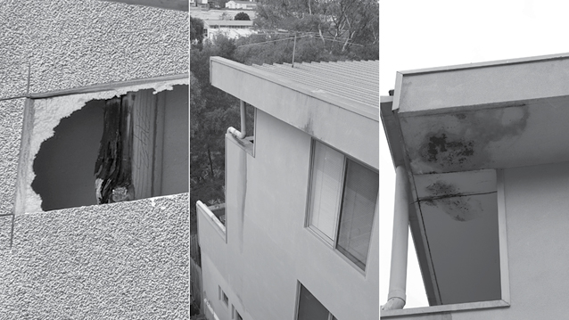
Building A: Evidence of water ingress and other defects. Rectification works have not yet commenced.
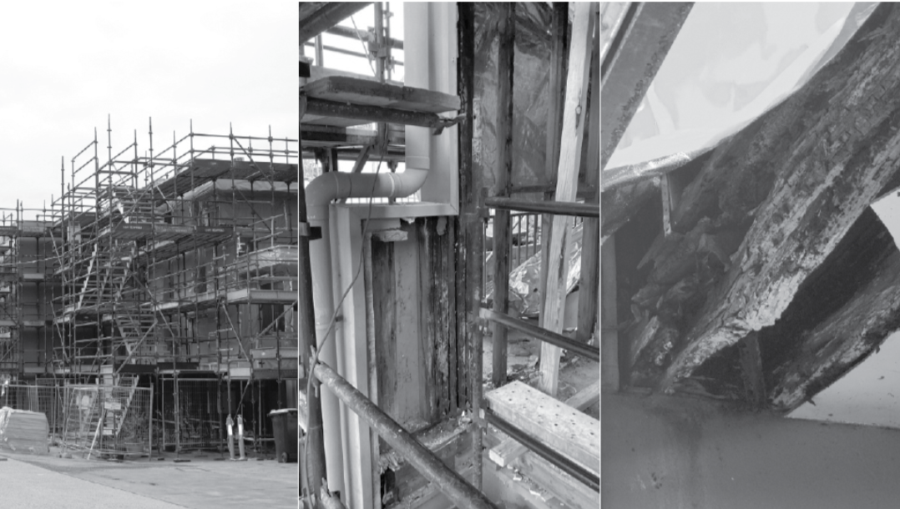
Building B: Cladding rectification underway in conjunction with full balcony reconstructions.
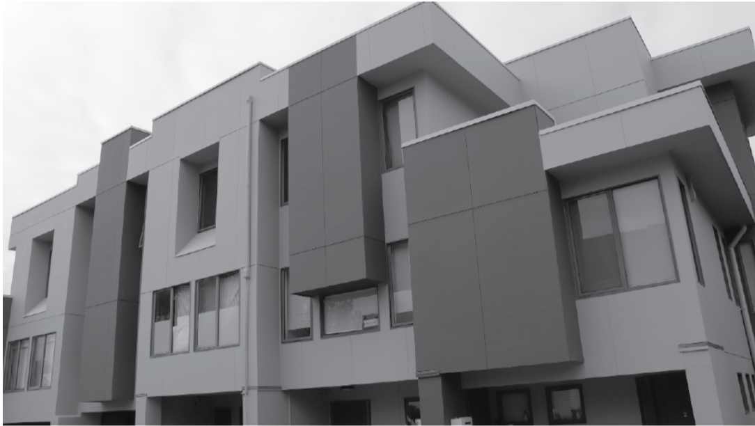
Building C: Rectification complete.
Images: Stages of rectification for three buildings on a site in Coburg, showing evidence of pre-rectification non-cladding defects.

Support for building owners
CSV is committed to supporting owners and owners corporations during rectification projects to minimise adverse impacts on building occupants, to safeguard the delivery of quality outcomes and to ensure project stakeholders are kept fully informed about their project throughout each stage.

Engagement with owners corporations
Cladding rectification projects can be complex and challenging for owners corporations to navigate through to a successful outcome. CSV has placed a high priority on establishing effective engagement with owners corporations, owners and residents to ensure every owners corporation is provided with clear and useful information, advice and support.
Each building assessed as being eligible for funding has a dedicated CSV staff member who works with the owners corporation from the beginning of the project through to the completion of works and acquittal of the building from the rectification program. This takes the form of project milestone meetings, the provision of information about the rectification process and timely response to queries and issues raised. In 2023–24, CSV had 14,533 engagements with owners corporations.
Type of engagement | Number
Meetings | 452
Phone | 3,347
Email | 9,816
Enquiries via Cladding Support Line | 918
Total | 14,533

During the year, CSV also issued fire safety information to owners. A printed fire safety flyer was distributed in December 2023 to 7,656 individual apartments located in 141 buildings in the program. These flyers were developed in consultation with Fire Rescue Victoria.

Project management and assurance
Although CSV does not directly undertake or project manage rectification works, the program has been designed to incorporate a number of processes that support owners corporations and ensure the safe delivery of works that meet relevant quality standards.
Independent Project Managers are appointed by CSV to work with owners corporations to oversee the delivery of project milestones and to ensure the builders’ contractual obligations are met. In addition, these project managers act as a point of contact to resolve any on-site issues.
A Clerk of Works is also engaged by CSV for each project. These contractors visit building sites regularly to undertake inspections, providing independent oversight for construction works that ensures adherence to quality and safety standards. This approach delivers peace-of-mind for owners and allows CSV to maximise quality, safety and value-for-money outcomes, thereby reducing risk for the community and government.
During 2023–24, Clerks of Works carried out 4,445 inspections and submitted quality and safety observations to CSV for monitoring and resolution. Issues raised and any associated trends are presented to the CSV Board for their consideration as part of regular safety reporting.
In addition to the Clerk of Works program, CSV Quality and Safety Officers and Program Managers undertake regular site inspections, covering on average 35 sites per week. CSV staff are also involved in running on-site toolbox talks as required, based on reported observations and incidents.
The following graphs outline the three most frequently reported categories of observations for quality and safety in 2023–24 across the 107 buildings that were under construction during the year.

Quality observations
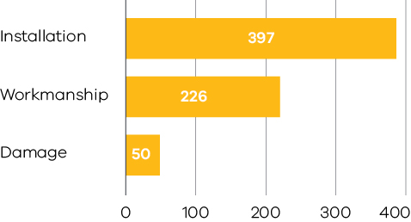

Safety observations
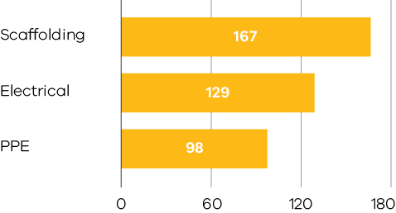

Cladding Remediation Partnership Program
Although lower-risk buildings (elevated-risk and low-risk buildings) only account for approximately 10% of residential cladding risk across the state, providing certainty for owners about whether any actions are required to address cladding risk on their building is important. A significant focus for CSV during 2023–24 has therefore been rolling out and embedding processes to support owners corporations and MBSs to apply a proportionate risk response to buildings with lower levels of cladding risk, which are not eligible for funding through CSV’s program.
Under the umbrella of Minister’s Guideline 15 and the CRMF, the PMCR (outlined on page 16) provides a methodology for examining the critical aspects of a cladded building that would contribute to the risk of fire spread and, based on that level of risk, identifies the level of intervention required for mitigation. In the case of elevated-risk buildings, minimal or no cladding removal may be required to reduce the risk to an acceptable level. The implementation of other actions, such as upgrades to a building’s essential safety measures, are sufficient in many cases. Based on the PMCR, ‘low’ represents an acceptable level of risk and low-risk buildings do not require any further interventions to mitigate cladding risk.
The Cladding Remediation Partnership Program (CRPP) brings together CSV, DTP, councils and building owners to address cladding risk on these lower-risk buildings through the approaches outlined in the PMCR. The CRPP is designed to empower councils, and MBSs in particular, to make decisions about buildings with cladding risk within their municipality using a clearly articulated and evidence-based risk-reduction policy. Councils are eligible for funding through DTP to support their resource requirements to apply this risk-based method. Through this cross-government approach, the CRPP provides owners with an agreed pathway for the mitigation of cladding risk to an acceptable level that can be implemented by them at a lower cost than the full removal of cladding.

Elevated-risk buildings
For buildings identified with an ‘elevated’ risk rating, CSV develops Remediation Work Proposals (RWPs) collaboratively with councils. RWPs identify interventions to be undertaken by owners corporations to reduce cladding risk on their building to an acceptable level, in accordance with the PMCR principles. These RWPs are then provided to owners corporations as a proposed method for mitigating cladding risk and for obtaining the removal of any enforcement notices relating to combustible cladding risk. To provide clarity for MBSs, owners and the broader community, an animated video has been published on CSV’s website that details the process: vic.gov.au/cladding-remediation-partnership-program.
In total, 68 RWPs for elevated-risk buildings were developed in 2023–24 by CSV for consultation with councils. As these are agreed with MBSs, they are being presented to owners corporations. Initial anecdotal feedback from owners corporations has been positive, with appreciation expressed for the time taken by CSV staff in explaining to owners how the PMCR has been applied to their building and for ensuring RWPs provide the information required to meet building insurance requirements.

Low-risk buildings
In parallel with the council engagement on elevated-risk buildings, CSV is also working with MBSs on reaching agreement on the rating for those buildings identified by CSV as low-risk. Based on the PMCR, ‘low’ represents an acceptable level of risk and low-risk buildings do not require any further interventions to mitigate cladding risk.
In 2023–24, CSV enhanced its internal capability to assess low-risk buildings and to produce reports that detail the risk assessment process and outcome, provide data and images to illustrate the presence and type/s of cladding and incorporate any other relevant building information. These reports are discussed with the appropriate MBS and provided to the council for further review and consideration, with a view to reaching agreement about the level of risk and subsequent removal of any cladding enforcement notices (where relevant). More than 200 low-risk building reports have now been produced by CSV and provided to the relevant council MBS for review.
Once agreement has been reached with the MBS on low-risk buildings, they are discharged from the CSV program. Buildings may be discharged by CSV based on their low-risk rating or for other reasons, such as having an ineligible type of cladding or having been resolved in another manner (e.g. directly by the MBS or owners corporation). As at 30 June 2024, 598 buildings have been discharged from the program, representing 37% of the total building cohort.

Resolution of buildings under the CRPP
Different councils are at various stages of progression with the buildings in their municipality that are subject to the CRPP; however, some councils are leading the way with their responsiveness and support for the PMCR methodology as a robust approach for addressing residential cladding risk. Many councils welcomed the certainty and support made available through the CRPP, and some MBSs have become strong advocates for the PMCR and are seeking to move the buildings in their municipality through the process as quickly as possible.
The table below details progress made by councils in reaching agreement on elevated-risk and low-risk-buildings to 30 June 2024.
CSV will continue to work with those councils that are yet to make progress, on buildings for which the risk associated with combustible cladding requires resolution.
Council | Number of RWPs and low-risk reports provided by CSV | Number of RWPs and low-risk reports endorsed by council | Percentage of RWPs and low-risk reports endorsed by council
Banyule | 3 | 2 | 67%
Bayside | 8 | 0 | 0%
Boroondara | 16 | 12 | 75%
Darebin | 16 | 11 | 69%
Frankston | 1 | 1 | 100%
East Gippsland | 1 | 1 | 100%
Glen Eira | 17 | 14 | 82%
Greater Dandenong | 2 | 0 | 0%
Greater Geelong | 2 | 1 | 50%
Hobsons Bay | 1 | 0 | 0%
Kingston | 3 | 3 | 100%
Knox | 2 | 2 | 100%
Manningham | 15 | 15 | 100%
Maribyrnong | 17 | 10 | 59%
Maroondah | 6 | 2 | 33%
Melbourne | 3 | 0 | 0%
Melton | 2 | 1 | 50%
Merri-bek | 36 | 29 | 81%
Monash | 4 | 1 | 25%
Moonee Valley | 14 | 13 | 93%
Port Phillip | 38 | 24 | 63%
Stonnington | 28 | 26 | 93%
Whitehorse | 5 | 1 | 20%
Yarra | 17 | 10 | 59%

Looking ahead
The CRPP will remain a significant focus for CSV in 2024–25. CSV aims to have RWPs presented to owners corporations for all elevated-risk buildings by the end of 2024–25 and will work with councils to address the remaining low-risk buildings so that owners corporations have clarity about whether action is required to reduce the cladding risk for their buildings.
During 2024–25, CSV will also be addressing Class 3 buildings that have been referred for consideration under the program. These include properties such as boarding houses, student accommodation and residential care facilities. In addition, CSV will be adapting the PMCR to assess and provide risk-mitigation advice for Class 9 buildings with combustible cladding, which includes universities, aged care homes and sports facilities.

Government-owned Buildings Cladding Rectification Program
Through the Government-owned Buildings Cladding Rectification Program, CSV works with government departments and agencies that are responsible for managing community and public facilities to mitigate the risk of combustible cladding on those buildings.
In total, 249 government-owned buildings were identified with combustible cladding through the program, of which 130 were approved for rectification funding due to the high risk posed by cladding.
Under the program, the design and implementation of projects is primarily the responsibility of the relevant department, based on CSV’s recommendation for rectification. CSV oversees these projects to facilitate consistency of the risk assessment and prioritisation process, efficient use of allocated funding and early resolution of issues that may create delays.

Performance outcomes
During 2023–24, cladding removal works for 15 buildings reached completion, bringing the total number of government-owned buildings with cladding risk addressed to 130. This represents full cladding risk mitigation for the portfolio of buildings deemed to be eligible for the program, which are the highest‑risk buildings identified by government departments for funding. The table below details the number of buildings with cladding risk addressed from the beginning of the program to 30 June 2024.
Building type | Number of buildings
Portable school buildings | 40
TAFE colleges | 15
Police and fire stations | 11
Justice facilities | 2
Hospitals and health care facilities | 19
Law courts | 3
Sporting venues and tourism facilities | 12
Government-owned residential housing | 1
Public and community housing | 27
Total | 130

More than 50,000 square metres of combustible cladding has been removed from government-owned buildings since the commencement of the program in 2020. Every square metre of combustible cladding removed enhances the safety of people attending events, accessing services, and working in government-owned buildings.
CSV adopted a risk reduction approach from the start of the program. By undertaking cladding testing and identifying potential ignition sources, CSV was able to work with departments to develop partial cladding removal solutions for many buildings that would reduce cladding risk to an acceptable level. This approach facilitated timely completion for many projects and also introduced savings that were able to be applied to addressing combustible cladding risk for additional government-owned buildings, such as the 16 community housing buildings added to the program in March 2022.
The application of a risk reduction methodology from the start of the program and the different type of occupancy for most buildings is also the reason that the overall square meterage of cladding removed for the government-owned buildings program is proportionately lower than that for the residential program.

Working in partnership
Government departments and agencies, as the owners of the buildings in the program and the organisations with the most in-depth knowledge of their operating needs and individual complexities, are ultimately responsible for the delivery of cladding remediation works. The table below identifies the number of building projects that each entity has overseen throughout the course of the program.
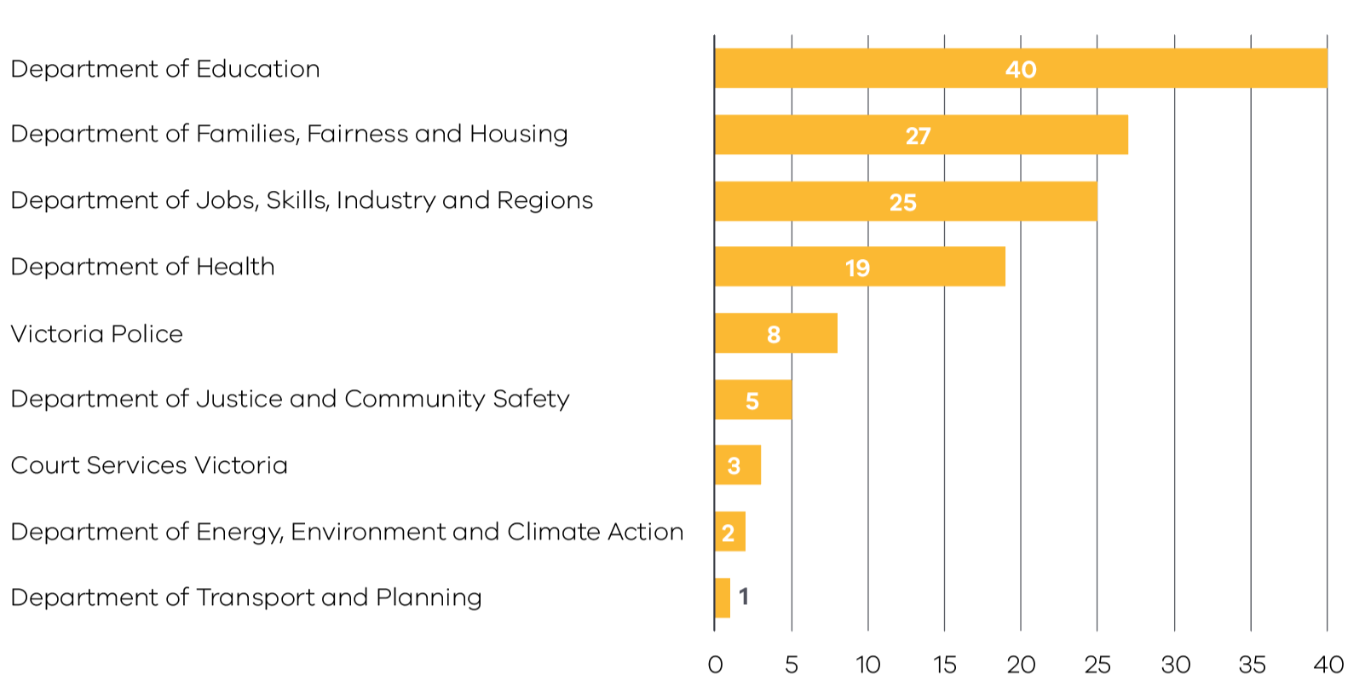
CSV’s experience, built through the delivery of hundreds of rectification projects and the development of specialised technical expertise, has allowed it to work with and support departments throughout the program. An example of this is illustrated through one of the biggest projects in the program – rectification of combustible cladding on the Austin and Mercy Tower Hospital in Heidelberg.
Hospital projects have been some of the most complex in the program, each with unique operating needs, overlaid with coronavirus directions that have placed restrictions on access to hospital buildings at various times during the program.
For the Austin and Mercy Tower Hospital project, the Department of Health sought multiple expert consultant reports for remediation of the building, which recommended cladding removal solutions that were considered to be an overreach and costly. To address this, the department worked with CSV’s technical experts, including fire engineers, to seek a lower-cost solution that reduced cladding risk to an acceptable level. The development and agreement of this solution brought to an end a delay of more than 12 months and allowed the project to be completed within 7 months and under budget.

Looking ahead
While all 130 buildings originally identified to be part of the government building program have their cladding removal works complete, during the course of 2023–24, 2 additional buildings with combustible cladding were identified by departments. Proposals for works on these buildings are currently being developed and cladding remediation will be completed during 2024–25.

Performance against outcomes and outputs

2023–24 State Budget and service delivery
CSV is accountable for the delivery of 2 output performance measures that form part of the government’s priorities for service delivery as outlined in Budget Paper No.3. One performance target relates to the Residential Cladding Rectification Program and one relates to the Government-owned Buildings Cladding Rectification Program.

Residential Cladding Rectification Program
Performance measures | Unit of measure | 2023–24 target | 2023–24 actual | Performance variation (%) | Result
In-scope privately-owned residential buildings that have completed cladding rectification works | number | 80 | 80 | 0% | ü
ü Performance target achieved or exceeded
* Performance target not achieved – exceeds 5 per cent
# Performance target not achieved – within 5 per cent

Government-owned Buildings Cladding Rectification Program
Performance measures | Unit of measure | 2023–24 target | 2023–24 actual | Performance variation (%) | Result
In-scope government buildings that have completed cladding rectification works | number | 2 | 15 | 650% | ü
The result is favourably higher than the target due to delivery of an additional 13 projects, which were deferred from 2022–23.
ü Performance target achieved or exceeded
* Performance target not achieved – exceeds 5 per cent
# Performance target not achieved – within 5 per cent

2023–24 Annual Work Program outcomes and measures
CSV’s 2021–25 Strategic Plan defines the three core outcomes that provide the focus for CSV performance monitoring and reporting.

Outcome 1: CSV actions are undertaken safely and improve the safety of buildings within the scope of the program
The focus of CSV’s rectification program is to efficiently reduce the risks associated with combustible cladding on residential properties, thereby protecting occupants and building assets from the serious impacts of fire that can spread through building cladding. CSV works intensively with owners corporations to develop high-quality and cost-effective solutions that effectively address cladding risk for buildings that are eligible for the rectification program and ensure these are implemented to the highest safety standards.
Timely rectification of buildings prioritised on a risk basis | 2023–24 target | 2023–24 actual
Percentage total risk reduction realised from the rectification of buildings with a risk rating of ‘unacceptable’ | 80% | 70%*

* 350 buildings were initially forecast for completion by the end of 2023–24; however, due to the complexity of some projects, including the presence of latent defects, 330 buildings were completed. This resulted in a lower risk reduction for the year overall.

Outcome 2: Owners corporations of buildings referred to CSV are provided with information and support to address the cladding risk for their building
CSV is committed to providing clear pathways for all buildings referred to it, whether they are deemed eligible for funding or not. These pathways are determined by a comprehensive assessment of the degree of risk presented by the amount and type of cladding on each building. Cladding removal is not required in all circumstances to reduce risk to an acceptable level and CSV provides information, advice and support to all owners corporations about the most appropriate solution for their building.
Defined pathways are in place for all buildings referred to CSV | 2023–24 target | 2023–24 actual
Number of referred buildings with low combustible cladding risk with an agreed pathway | 275 | 366

Outcome 3: Robust financial and resource management optimises the value of CSV’s delivery outcomes
CSV’s success is underpinned by the processes and controls that work to build and sustain a high level of organisational performance through effective resource management, comprehensive risk and safety systems, and strong financial governance. CSV is continually striving to improve the operational practices that provide a strong foundation for the achievement of its objectives. This is realised through benchmarking against better-practice organisations, sound oversight and the external review of our processes by independent bodies.
Enhance the effectiveness of CSV’s financial, risk and resource planning and systems | 2023–24 target | 2023–24 actual
Variance between actual and budgeted cost for CSV’s overall budget | ≤+/-10% | -28%*
Internal CSV operating costs as a percentage of overall costs | <15% | 8%
Percentage of extreme and high risks managed within tolerance levels | ≥85% | 92%
* Underspends occurred across the residential program due to delays with challenging buildings and savings realised for buildings that have reached practical completion. Additionally, budget adjustments and the project commencement date associated with additional funding approved in December 2023 contributed to the variance.

Organisation and people

Organisational structure

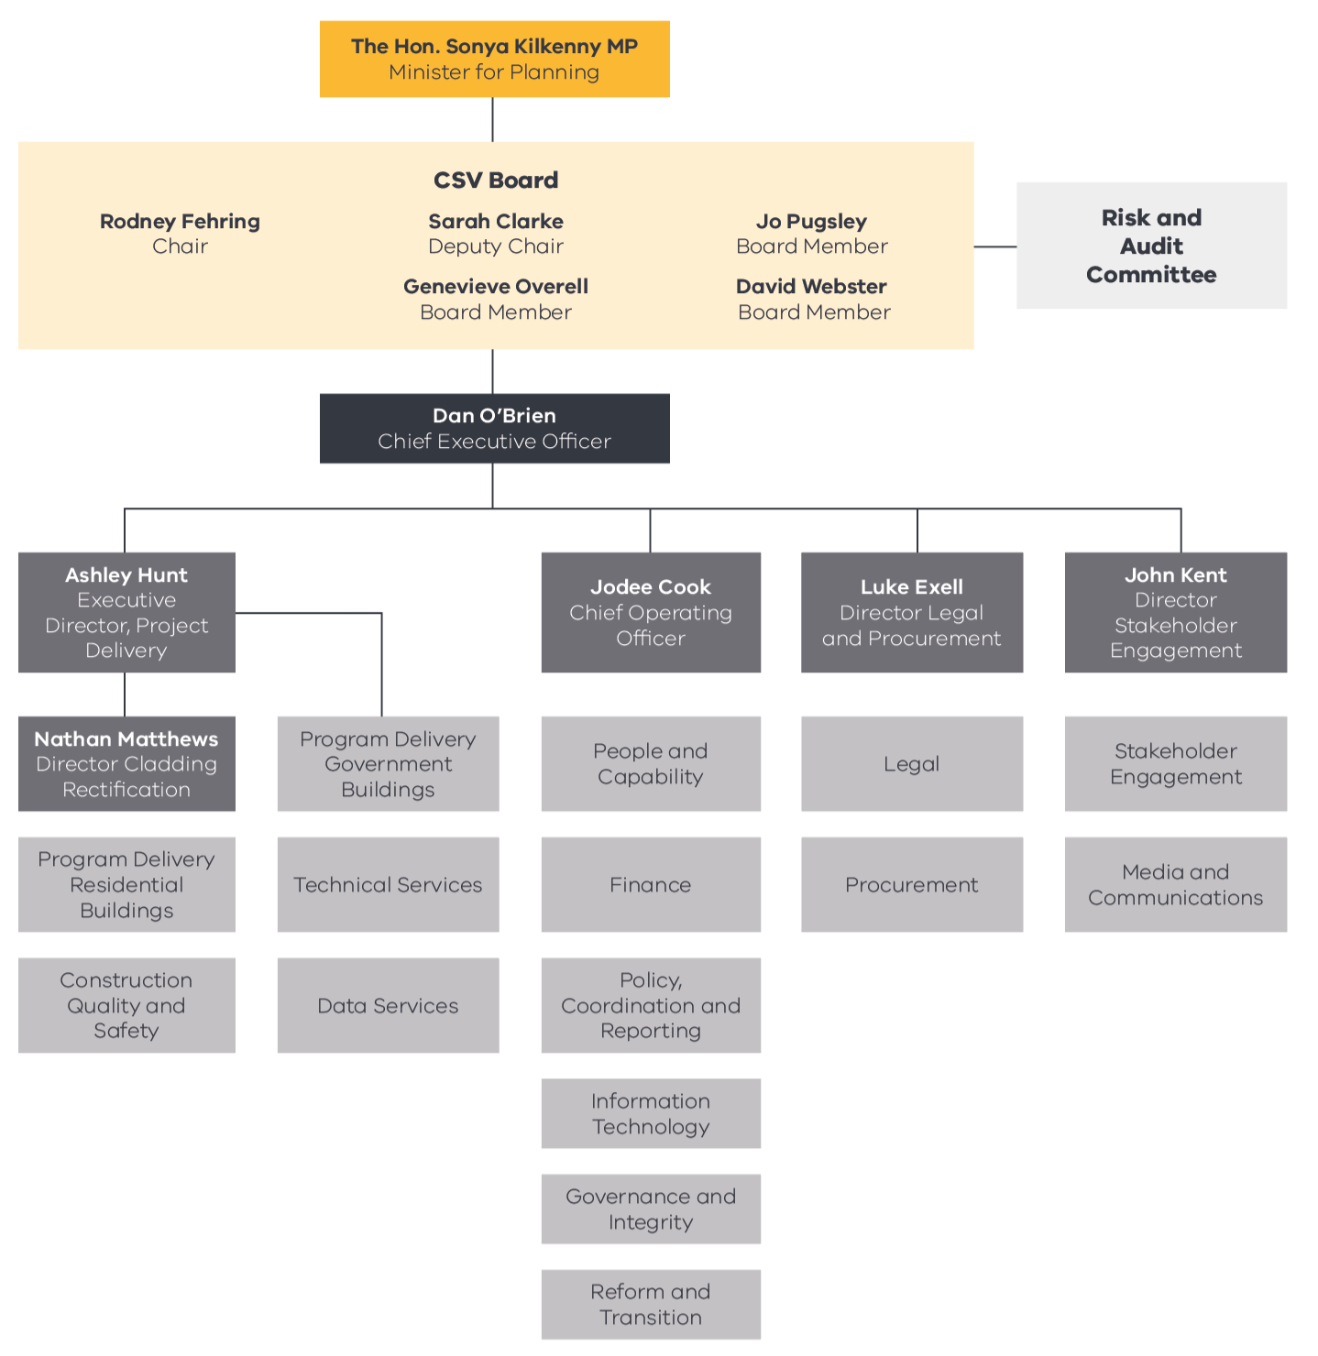
Note: The above chart represents CSV’s organisational structure as at 30 June 2024.

Minister for Planning
CSV is subject to the general direction and control of the Minister for Planning. From 5 December 2022, this has been the
Hon. Sonya Kilkenny MP, who is also the Minister for Suburbs.

Department of Transport and Planning
DTP is the portfolio department for CSV.
The DTP-led Project Control Board (PCB) is responsible for strategic oversight of the overarching Cladding Rectification Program, including:
- state-wide audit activity and associated disciplinary action by the VBA
- implementation of the Cladding Rectification Program for in-scope privately owned buildings overseen by CSV
- establishment and implementation of the rectification program for government-owned buildings, including authorising the release of funds
- cost recovery activity by DTP
- development and implementation of immediate reform priorities and scoping and development of longer-term policy reform options.
PCB comprises senior representation from CSV, VBA, DTP, the Department of Treasury and Finance, and the Department of Premier and Cabinet.

Cladding Safety Victoria’s Board
The role and responsibilities of the CSV Board are defined under the Cladding Safety Victoria Act 2020 (Vic). In addition to monitoring the performance of CSV against its duties under the CSV Act, the CSV Board is responsible for:
- setting the goals and overall strategy for CSV and monitoring deliverables
- establishing appropriate and effective financial governance and oversight arrangements, including the regular review of the effectiveness of those arrangements
- overseeing CSV’s systems for internal control, risk management, auditing and legal compliance
- selecting and appointing the CEO.
CSV Board Members completed their first term on 22 November 2023. Five of the initial 6 Board Members were reappointed for another term until 30 June 2026. Details about Board members can be found on the CSV website at vic.gov.au/our-ceo-and-governing-board.

Meeting attendance
Six Board meetings were held during 2023–24. The record of attendance for Board Members is shown below.
Name | Position | Attended
Rod Fehring | Chair | 6
Sarah Clarke | Deputy Chair | 5
Genevieve Overell | Board Member | 6
Jo Pugsley | Board Member | 6
Roger Teale | Board Member | 2*
David Webster | Board Member | 4
* Roger Teale’s tenure as a member of the CSV Board concluded in November 2023. Roger attended 2 out of a possible 3 meetings during the year.

Board Sub-committee
In November 2023, the CSV Board’s Finance and Audit Committee and Risk Committee were merged into one committee, the Risk and Audit Committee.

Finance and Audit Committee
Two Finance and Audit Committee meetings were held during 2023–24. The record of attendance for Committee Members is shown below.
Name | Position | Attended
David Webster | Chair | 2
Rod Fehring | Member | 2
Genevieve Overell | Member | 2

Risk Committee
One Risk Committee meeting was held during 2023–24. The record of attendance for Committee Members is shown below.
Name | Position | Attended
Roger Teale | Chair | 1
Sarah Clarke | Member | 1
Jo Pugsley | Member | 1

Risk and Audit Committee
The Risk and Audit Committee provides assurance and advice to the Board on the effectiveness of the organisation’s financial and risk management systems and internal controls, including performance and sustainability, and compliance with laws and regulations.
Two Risk and Audit Committee meetings were held during 2023–24. The record of attendance for Committee Members is shown below.
Name | Position | Attended
David Webster | Chair | 2
Rod Fehring | Member | 2
Genevieve Overell | Member | 2

CEO and Senior Executives
CSV is led by Dan O’Brien, Chief Executive Officer, who reports to the Chair of the CSV Board. CSV is managed by a senior executive group comprising the Chief Executive Officer, the heads of 3 of CSV’s divisions and the 2 executives who oversee delivery of the cladding rectification program. Details about CSV’s Chief Executive Officer and senior executives can be found on the CSV website: vic.gov.au/our-ceo-and-governing-board.

Our people
CSV continues to foster a culture that puts the Cladding Rectification Program at the heart of everything it does. In response to challenges experienced in attracting skilled staff to fixed-term roles (due to CSV’s establishment as a timebound entity), CSV is committed to creating an engaged workforce, actively supporting staff retention. By investing in comprehensive training programs and offering continuous learning opportunities, CSV ensures that employees are well-equipped to adapt to new capability requirements. Additionally, CSV emphasises career development, diversity and inclusion, and health and well-being programs, which support a positive and inclusive work environment. These efforts have enabled CSV to build a stable and motivated workforce, essential for its success in a competitive labour market.
With its significant pipeline of projects, CSV committed to continuing the enhancement of technical and delivery capabilities in recognition of the fact that staff are critical to building and navigating its key partnerships, including those with owners corporations, government, the construction industry, the broader community and other stakeholders.
The effectiveness of CSV’s approach is supported by its 2024 People Matter Survey results, which are based on a very high staff participation rate (97%). CSV’s employee engagement index remains high at 77%, compared to 65% for the public sector more broadly. Employees reported experiencing a strong affinity with CSV and its objectives, feeling that they are engaged in meaningful work and being highly motivated. The overall results for inclusion, satisfaction, organisational integrity and collaboration were all well above the comparator organisation average. Significant improvements were also returned for learning and development, reflecting a strong focus from CSV over the last year.

Public sector values, employment and conduct principles
The Public Administration Act 2004 (Vic) established the Victorian Public Sector Commission (VPSC). The VPSC’s role is to strengthen public sector efficiency, effectiveness and capability, and advocate for public sector professionalism and integrity.
CSV maintains policies and practices that are consistent with the VPSC’s employment standards and provide for fair treatment, career opportunities and the early resolution of workplace issues. CSV regularly communicates to employees about how to avoid and manage conflicts of interest; how to respond to offers of gifts, benefits and hospitality; and how misconduct is addressed.
CSV is committed to applying merit and equity principles when appointing staff. Selection processes ensure applicants are assessed and evaluated fairly and equitably based on key selection criteria and other accountabilities, without discrimination. Employees have been correctly classified in workforce data collections.

Comparative workforce data
The following table details the head count and full-time staff equivalent (FTE) of all active public sector employees of CSV who were employed in the last full pay period in June of the current reporting period and in the last full pay period in June of the previous reporting period.

 | June 2023 |  |  |  |  |  |  | June 2024
 | All employees |  | Ongoing |  |  | Fixed Term & Casual |  | All employees |  | Ongoing |  |  | Fixed Term & Casual
 | No. HC* | FTE# | F/T~ HC* | P/T ^ HC* | FTE# | No. HC* | FTE# | No. HC* | FTE# | F/T~ HC* | P/T ^ HC* | FTE# | No. HC* | FTE#
Gender
Female | 40 | 38 | 17 | 1 | 17 | 22 | 20 | 36 | 36 | 20 | - | 20 | 16 | 16
Male | 44 | 41 | 16 | 1 | 16 | 27 | 25 | 39 | 38.6 | 17 | 1 | 17.6 | 21 | 21
Self-described | - | - | - | - | - | - | - | - | - | - | - | - | - | -
Age
20-24 | - | - | - | - | - | - | - | 2 | 2 | - | - | - | 2 | 2
25–34 | 25 | 23 | 8 | - | 8 | 17 | 15 | 17 | 17 | 7 | - | 7 | 10 | 10
35–44 | 28 | 26 | 11 | 1 | 11 | 16 | 14 | 25 | 25 | 14 | - | 14 | 11 | 11
45–54 | 19 | 19 | 10 | - | 10 | 9 | 9 | 17 | 17 | 10 | - | 10 | 7 | 7
55–64 | 11 | 11 | 4 | - | 4 | 7 | 7 | 12 | 12 | 6 | - | 6 | 6 | 6
65+ | 1 | 1 | - | 1 | 1 | - | - | 2 | 1.6 | - | 1 | 0.6 | 1 | 1
Band 1–6 | 73 | 70 | 29 | 2 | 30 | 42 | 39 | 65 | 64.6 | 33 | 1 | 33.6 | 31 | 31
3 | 8 | 5 | 2 | - | 2 | 6 | 3 | 2 | 2 | 1 | - | 1 | 1 | 1
4 | 21 | 21 | 3 | - | 3 | 18 | 18 | 19 | 19 | 4 | - | 4 | 15 | 15
5 | 26 | 26 | 16 | - | 16 | 10 | 10 | 24 | 24 | 13 | - | 1 | 11 | 11
6 | 18 | 17 | 8 | 2 | 9 | 8 | 8 | 20 | 19.6 | 15 | 1 | 15.6 | 4 | 4
Senior employees | 11 | 10 | 4 | - | 4 | 7 | 6 | 10 | 10 | 4 | - | 4 | 6 | 6
Senior Technical Specialist (STS) | 5 | 4 | 4 | - | 4 | 1 | 1 | 4 | 4 | 4 | - | 4 | - | -
Senior Executive Service (SES) | 6 | 6 | - | - | - | 6 | 6 | 6 | 6 |  | - |  | 6 | 6
Total employees | 84 | 80 | 33 | 2 | 34 | 49 | 46 | 75 | 74.6 | 37 | 1 | 37.6 | 37 | 37

* HC = headcount
# There may be some variation in totals due to rounding of FTE figures.
~ F/T = full-time
^ P/T = part-time

Senior employees
The following table discloses the annualised total remuneration for senior employees of CSV, categorised by classification. The remuneration amount is reported as the full-time equivalent.

Annualised total remunerations by $20,000 bands for executives and senior non-executive staff as at 30 June 2024
Income band | Executives | Senior Technical Specialist
$190,000–209,999 |  | 1
$210,000–229,999 |  | 3
$230,000–249,999 |  | 1
$250,000–269,999 | 2 | 1
$270,000–289,999 | 2
$290,000–349,999 | 1
$450,000–509,999 | 1

The following table provides further information about the number of executive officers by classification and gender, including variations (‘Var.’) to the previous reporting period.

Number of executive officers by classification and gender as at 30 June 2024
Classification | Total |  | Female |  | Male
 | No. | Var. | No. | Var. | No. | Var.
SES 3 | 1 | 0 | 0 | 0 | 1 | 0
SES 2 | 1 | 0 | 0 | 0 | 1 | 0
SES 1 | 4 | 0 | 1 | 0 | 3 | 0

The following table provides a reconciliation of executive numbers presented in the report of operations and Note 8.2 in the financial statements.

Reconciliation of executive numbers
 |  | 2022–23 | 2023–24
 | Executives (Financial Statements Note 8.2) | 6 | 5
 | Accountable Officer | 1 | 1
Less | Separations | (1) | 0
 | Total executive numbers at 30 June | 6 | 6

Workforce inclusion policy
CSV is committed to creating a place where opportunities are created and diversity is celebrated to enable the industry to sustainably develop an inclusive and skilled workforce to deliver on current and future infrastructure projects. This work continues to yield organisation-wide recognition and growing capability and capacity for the industry. Importantly, CSV acknowledges diversity in its workforce and is committed to continuing to build and grow a diverse and inclusive workplace culture, including through the initiatives outlined in its Gender Diversity and Inclusion Strategy.
Activities undertaken during the year to support CSV’s commitment to creating a more inclusive and culturally safe workplace include:
- mandatory in-person unconscious bias training sessions for all staff that assessed the influence of unconscious biases in the workplace and offered strategies for intervention
- attendance by CSV representatives at the annual International Women’s Day High Tea hosted by the National Association for Women in Construction
- celebrations for Cultural Diversity Week, with a cultural lunch featuring a variety of foods from different cultures.
The 2024 People Matter Survey indicated that 92% of staff felt culturally safe at work, compared to the average response for our comparator group of 82%.

Occupational health and safety
CSV actively demonstrates a strong commitment to workplace safety and wellbeing, to ensure that it remains at the forefront of all activities and projects. This commitment is shared by staff, as shown by the 2024 People Matter Survey results for safety climate, where CSV scored higher than the average for comparator organisations for all questions.
During 2023–24, CSV continued to implement a number of initiatives to support the health and safety of staff, including:
- promotion of health and wellbeing awareness days through staff newsletters
- provision of advice and counselling for staff in relation to work and personal matters through the Employee Assistance Program, including a presentation to all staff about services available in the program
- roll-out of the 2024 flu vaccination program
- regular meetings of the Occupational Health, Safety and Wellness Committee
- delivery of mandatory training for managers, wardens, first aiders and health and safety representatives
- provision of mental health support through trained mental health first aiders
- targeted training to address identified hazards, such as sessions on courageous conversations to provide CSV staff with strategies and tools to manage the dynamics of difficult interactions.

Performance against OH&S management measures
Measure | Performance indicator | 2021–22 | 2022–23 | 2023–24
Incidents | Number of incidents | 1 | 0 | 2
 | Rate per 100 FTE | 1.2 | 0 | 1.78
Corrective actions | Percentage completed within agreed timeframes | 100% | N/A* | 100%
Claims | Number of standard claims | 0 | 0 | 0
 | Rate per 100 FTE | 0 | 0 | 0
 | Number of lost time claims | 0 | 0 | 0
Claim costs | Average cost per standard claim | N/A** | N/A** | N/A**
Fatalities | Fatality claims | 0 | 0 | 0
* No incidents were reported during the period and therefore there were no corrective actions.
** No relevant claims were made during the period.

Incident management
CSV is committed to creating and maintaining a physically and psychologically safe environment for all its staff and communities. During the 2023–24 financial year, 2 workplace incidents were reported, compared with zero for the previous financial year. None of the incidents reported were notifiable and corrective actions for each incident were implemented.

Financial statements

How this report is structured
The Board of Directors of Cladding Safety Victoria (CSV) has the pleasure of presenting its audited general-purpose financial statements for the financial year ended 30 June 2024, providing users with information about the authority’s stewardship of resources entrusted to it.
Declaration in the Financial Statements 53
Independent Auditor’s Report 54
Comprehensive operating statement 56
Balance sheet 57
Cash flow statement 58
Statement of changes in equity 59
Note 1: About this report 60
1.1. Basis of preparation 60
1.2. Compliance information 61
1.3. Rounding of amounts 61
Note 2: Funding delivery of our services 61
2.1. Levy income 61
2.2. Grant income 62
2.3. Other income 63
Note 3: The cost of delivering services 63
3.1. Employee benefits 63
3.2. Grant expense 67
3.3. Other operating expenses 68
Note 4: Key assets available to support output delivery 68
4.1. Total property, plant and equipment 69
4.2. Depreciation and amortisation 71
Note 5: Other assets and liabilities 72
5.1. Receivables 72
5.2. Payables 73
5.3. Other non-financial assets 74
Note 6: How we financed our operations 74
6.1. Borrowings 75
6.2. Leases 76
6.3. Cash flow information and balances 78
6.4. Commitments for expenditure 79
Note 7: Risks, contingencies and valuation judgements 80
7.1. Financial instruments specific disclosures 81
7.2. Contingent assets and contingent liabilities 88
7.3. Fair value determination 89
Note 8: Other disclosures 92
8.1. Ex gratia expenses 93
8.2. Responsible persons 93
8.3. Remuneration of executives 94
8.4. Related parties 95
8.5. Remuneration of auditors 97
8.6. Subsequent events 98
8.7. Other accounting policies 98
8.8. Australian Accounting Standards issued that are not yet effective 98
8.9. Glossary of technical terms 99
8.10. Style conventions 104
Financial Management Compliance Attestation Statement 104
Local jobs first 104
Projects commenced (standard) 105
Projects completed (standard) 105
Projects commenced and completed (strategic) 105
Reporting requirements – grants 105
Social procurement framework 105
Emergency procurement 107
Disclosure of procurement complaints 107
Disclosure of major contracts 107
Consultancy expenditure 107
Details of consultancies (valued at $10,000 or greater) 107
Details of consultancies less than $10,000 108
Government advertising expenditure 108
Information and communication technology expenditure 108
Reviews and studies expenditure 110
Details of reviews and studies 110
Asset Management Accountability Framework maturity assessment 112
Leadership and Accountability (requirements 1–19) 113
Planning (requirements 20–23) 113
Acquisition (requirements 24 and 25) 113
Operation (requirements 26–40) 113
Disposal (requirement 41) 113
Competitive Neutrality Policy 113
Freedom of information 113
Making a request 114
Freedom of information statistics 114
Further information 114
Compliance with the Building Act 1993 (Vic) 115
Compliance with Public Interest Disclosures Act 2012 (Vic) 115
Reporting procedures 115
Compliance with Carers Recognition Act 2012 (Vic) 115
Compliance with Disability Act 2006 (Vic) 115
Compliance with DataVic Access Policy 116
Environmental reporting 116
Organisational boundary 116
Electricity production and consumption 116
Transportation 117
Sustainable buildings and infrastructure 117
Additional information on request 117
Information that is not applicable to CSV 118
Disclosure index 118

Declaration in the Financial Statements
The attached financial statements for Cladding Safety Victoria (CSV) have been prepared in accordance with Direction 5.2 of the Standing Directions of the Assistant Treasurer under the Financial Management Act 1994, applicable Financial Reporting Directions, Australian Accounting Standards including interpretations, and other mandatory professional reporting requirements.
We further state that, in our opinion, the information set out in the comprehensive operating statement, balance sheet, statement of changes in equity, cash flow statement and accompanying notes, presents fairly the financial transactions during the year ended 30 June 2024 and the financial position of CSV at 30 June 2024.
At the time of signing, we are not aware of any circumstances which would render any particulars included in the financial statements to be misleading or inaccurate.
We authorise the attached financial statements for issue on 12 September 2024.
Rodney Fehring  Board Chair  Cladding Safety Victoria  12 September 2024 | Dan O’Brien  Chief Executive Officer  Cladding Safety Victoria  12 September 2024 | Rose Scasni  Chief Financial Officer  Cladding Safety Victoria  12 September 2024

Independent Auditor’s Report
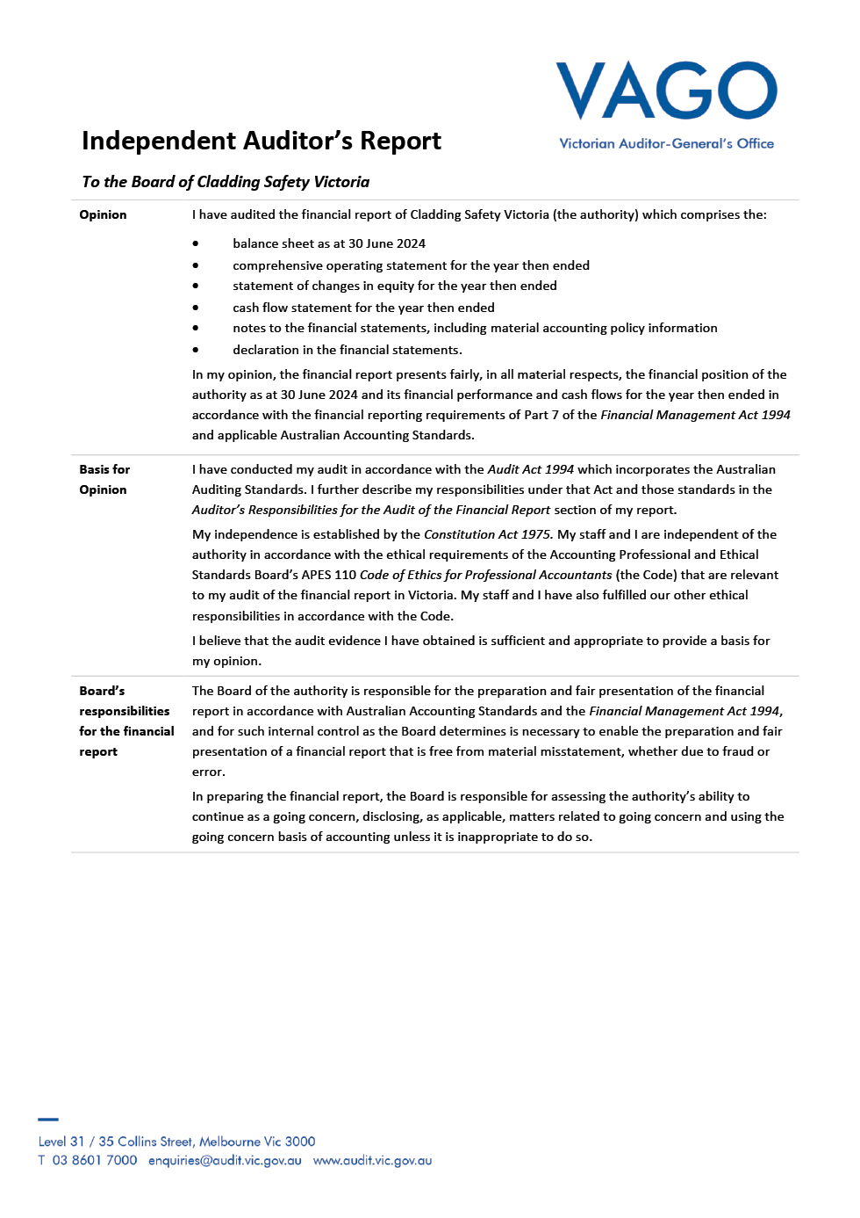

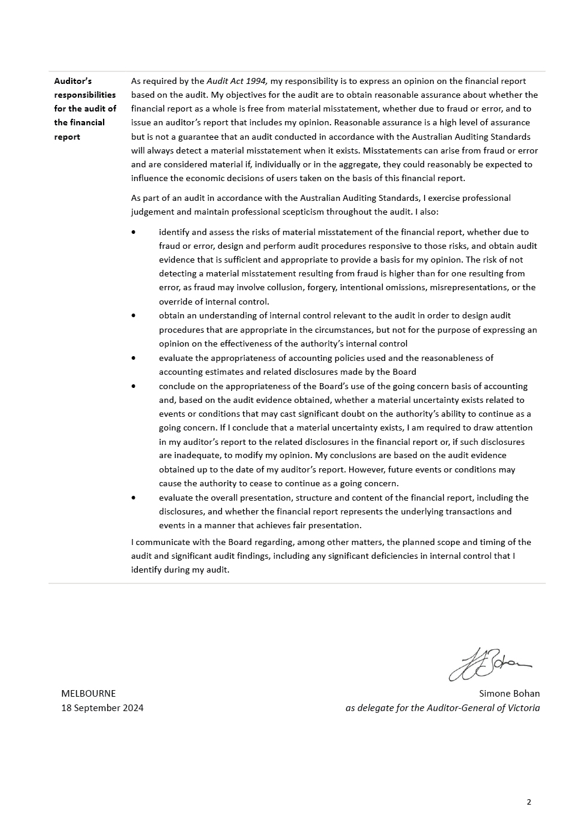

Comprehensive operating statement
for the financial year ended 30 June 2024
 |  | ($ thousand)
 | Notes | June 2024 | June 2023
Continuing operations
Revenue and income from transactions
Levy income | 2.1 | 103,608 | 95,675
Grant income | 2.2 | 38 | 56,669
Other income | 2.3 | 4,911 | 3,967
Total revenue and income from transactions |  | 108,557 | 156,311
Expenses from transactions
Employee costs | 3.1 | (13,823) | (12,267)
Grant expense | 3.2 | (87,618) | (104,728)
Other operating expenses | 3.3 | (12,671) | (16,209)
Depreciation and amortisation | 4.2 | (546) | (548)
Interest expense | 6.1.2 | (24) | (45)
Total expenses from transactions |  | (114,682) | (133,797)
Net result from transactions (Net operating balance) |  | (6,125) | 22,514
Other economic flows included in net result
Total other economic flows included in net result |  | - | -
Comprehensive result |  | (6,125) | 22,514

The comprehensive operating statement should be read in conjunction with the accompanying notes.

Balance sheet
as at 30 June 2024
 |  | ($ thousand)
 | Notes | June 2024 | June 2023
Assets
Financial assets
Cash and deposits | 6.3 | 115,312 | 118,196
Receivables | 5.1 | 10,831 | 12,966
Total financial assets |  | 126,143 | 131,162
Non-financial assets
Property, plant and equipment | 4.1 | 378 | 840
Intangible assets |  | 4 | 11
Other non-financial assets | 5.3 | 478 | 481
Total non-financial assets |  | 860 | 1,332
Total assets |  | 127,003 | 132,494
Liabilities
Payables | 5.2 | 11,796 | 10,826
Borrowings | 6.1 | 343 | 899
Employee benefits provision | 3.1.2 | 1,849 | 1,629
Total liabilities |  | 13,988 | 13,354
Net assets |  | 113,015 | 119,140
Equity
Contributed capital |  | 83,610 | 83,610
Accumulated surplus/(deficit) |  | 29,405 | 35,530
Net worth |  | 113,015 | 119,140

The balance sheet should be read in conjunction with the accompanying notes.

Cash flow statement
for the financial year ended 30 June 2024
 |  | ($ thousand)
 | Notes | June 2024 | June 2023
Cash flows from operating activities
Receipts
Receipts from customers |  | 105,338 | 91,519
Grants received from State Government |  | 38 | 56,669
Goods and services tax recovered from the ATO |  | 10,413 | 8,839
Interest received |  | 4,904 | 3,962
Total receipts |  | 120,693 | 160,989
Payments
Payments of grants |  | (95,957) | (115,886)
Payments to suppliers and employees |  | (26,963) | (27,163)
Payments of lease interest | 6.2.2 | (24) | (45)
Total payments |  | (122,944) | (143,094)
Net cash flows from/ (used in) operating activities | 6.3.1 | (2,251) | 17,895
Cash flows from investing activities
Payments
Payments for property, plant and equipment |  | (77) | (16)
Total payments |  | (77) | (16)
Net cash flows from/ (used in) investing activities |  | (77) | (16)
Cash flows from financing activities
Payments
Repayment of leases |  | (556) | (514)
Net cash flows from/ (used in) financing activities | 6.2.3 | (556) | (514)
Net increase in cash and cash equivalents |  | (2,884) | 17,365
Cash and cash equivalents at the beginning of the financial year |  | 118,196 | 100,831
Cash and cash equivalents at the end of the financial year | 6.3 | 115,312 | 118,196

The cash flow statement should be read in conjunction with the accompanying notes.

Statement of changes in equity
for the financial year ended 30 June 2024
 | ($ thousand)
 | Contributed  capital | Accumulated  surplus | Total
Balance at 30 June 2022 | 83,610 | 13,016 | 96,626
Net result for the year | - | 22,514 | 22,514
Balance at 30 June 2023 | 83,610 | 35,530 | 119,140
Net result for the year | - | (6,125) | (6,125)
Balance at 30 June 2024 | 83,610 | 29,405 | 113,015
The statement of changes in equity should be read in conjunction with the accompanying notes.

Note 1: About this report
Cladding Safety Victoria (CSV) was established on 1 December 2020 as a statutory authority by the State of Victoria, under the Cladding Safety Victoria Act 2020. CSV was established to deliver a program that is a world-first initiative, making Victorians safer by reducing the risk associated with combustible cladding on residential apartments and government-owned buildings.
Its principal address is:
Cladding Safety Victoria
Level 4
717 Bourke Street
Docklands VIC 3008
A description of the nature of CSV’s operations and its principal activities is included in the Report of Operations which does not form part of these financial statements.

1.1. Basis of preparation
These financial statements are in Australian dollars and the historical cost convention is used unless a different measurement basis is specifically disclosed in the note associated with the item measured on a different basis.
The accrual basis of accounting has been applied in the preparation of these financial statements whereby assets, liabilities, equity, income and expenses are recognised in the reporting period to which they relate, regardless of when cash is received or paid.
Consistent with the requirements of AASB 1004 Contributions, contributions by owners (that is, contributed capital and its repayment) are treated as equity transactions and, therefore, do not form part of the income and expenses of CSV.
Additions to net assets which have been designated as contributions by owners are recognised as contributed capital. Other transfers that are in the nature of contributions to or distributions by owners have also been designated as contributions by owners.
Transfers of net assets arising from administrative restructurings are treated as distributions to or contributions by owners. Transfers of net liabilities arising from administrative restructurings are treated as distributions to owners.
Judgements, estimates and assumptions are required to be made about financial information being presented. The significant judgements made in the preparation of these financial statements are disclosed in the notes where amounts affected by those judgements are disclosed. Estimates and associated assumptions are based on professional judgements derived from historical experience and various other factors that are believed to be reasonable under the circumstances. Actual results may differ from these estimates.
Revisions to accounting estimates are recognised in the period in which the estimate is revised and also in future periods that are affected by the revision. Judgements and assumptions made by management in applying AAS that have significant effects on the financial statements and estimates are disclosed in the notes.
In addition to the Cladding Rectification Levy collected by the Victorian Building Authority (VBA) and subject to fluctuations due to activity levels in the construction sector, CSV is dependent on the Department of Transport and Planning (DTP) for a substantial portion of its revenue used to operate. At the date of this report, the Board of Directors has no reason to believe the DTP will not continue to support CSV. The CSV Act underwent its legislated review during the year, concluding that there is a need to continue operating into the foreseeable future to complete its existing cladding programs. As such, these financial statements have been prepared on a going concern basis.

1.2. Compliance information
These general-purpose financial statements have been prepared in accordance with the Financial Management Act 1994 (FMA) and applicable Australian Accounting Standards (AAS) which include Interpretations issued by the Australian Accounting Standards Board (AASB). In particular, the statements are presented in a manner consistent with the requirements of AASB 1049 Whole of Government and General Government Sector Financial Reporting.
Where appropriate, those AAS paragraphs applicable to not-for-profit entities have been applied. Accounting policies selected and applied in these financial statements ensure that the resulting financial information satisfies the concepts of relevance and reliability, thereby ensuring that the substance of the underlying transactions or other events is reported.

1.3. Rounding of amounts
Amounts in the financial statements have been rounded to the nearest $1,000 unless otherwise stated. Figures in the financial statements may not equate due to rounding (Note 8.10. Style conventions).

Note 2: Funding delivery of our services
CSV’s mission is to improve the safety of buildings impacted by cladding issues by working in partnership with industry, government partners and the community.
To enable CSV to fulfil its mission, it is funded predominantly through the distribution of the Cladding Rectification Levy (CRL) under the Building Act 1993 (Vic).
This section of the financial statements identifies the funding sources that enable CSV to achieve these objectives.

Structure
2.1. Levy income
2.2. Grant income
2.3. Other income

2.1. Levy income
The CRL came into effect on 1 January 2020 and is calculated based on the rates and cost of building works for which a building permit number is sought. The CRL applies to Building Code of Australia classes 2 to 8 building works located in the metropolitan area that are $0.8 million or more. The CRL is brought to account upon issue of the building permit number and is recognised at a point in time. Building works on Commonwealth Crown Land retain the current exemption from any building permit levy, including the CRL.
 | ($ thousand)
 | June 2024 | June 2023
Cladding Rectification Levy | 103,608 | 95,675
Total levy income | 103,608 | 95,675

Income recognised under AASB 1058
AASB 1058 Income of not-for-profit entities clarifies the income recognition requirements that apply to not-for-profit entities. Under the AASB 1058 income recognition model, the entity first determines whether an enforceable agreement exists and whether the promises to transfer goods or services to the customer are “sufficiently specific”. This occurred where grants and contracts do not contain performance obligations that are sufficiently specific. As a result, income is recognised when CSV has an unconditional right to receive cash, in accordance with AASB 1058.
CSV has determined that the CRL is recognised as income of not-for-profit entities in accordance with AASB 1058, as there is no performance obligation that are sufficiently specific. CRL is recognised when the amounts become receivable.

2.2. Grant income
In the financial year ended 30 June 2024, CSV did not receive any grant funding from the Department of Transport and Planning for the Cladding Rectification Program (2023: $56.63 million).
 | ($ thousand)
 | June 2024 | June 2023
Income recognised as income
of not-for-profit entities
Private Building Rectification Grant | - | 55,445
Government Building Rectification Grant (i) | - | 1,187
Mental Health Levy Grant | 38 | 37
Total grant income | 38 | 56,669
Note: (i) this grant is only for technical and operational functions of the Cladding Rectification Program and the Department of Transport and Planning holds the funds for the rectification of government buildings.
CSV has determined that the grant income included in the table above under AASB 1058 has been earned under arrangements that are either not enforceable and/or linked to sufficiently specific performance obligations.
Income from grants without any sufficiently specific performance obligations, or that are not enforceable, is recognised when CSV has an unconditional right to receive cash which usually coincides with receipt of cash. On initial recognition of the asset, CSV recognises any related contributions by owners, increases in liabilities, decreases in assets, and revenue (‘related amounts’) in accordance with other Australian Accounting Standards.

2.3. Other income
 | ($ thousand)
 | June 2024 | June 2023
Interest income | 4,904 | 3,962
Miscellaneous income | 7 | 5
Total other income | 4,911 | 3,967

Interest income includes interest received on bank deposits and Central Banking System deposits. Interest income is recognised using the effective interest method, which allocates the interest over the relevant period.

Note 3: The cost of delivering services
This section provides an account of the expenses incurred by CSV in delivering services. In Note 2, the funds that enable the provision of services were disclosed and in this note the costs associated with provision of services are recorded.

Structure
3.1. Employee benefits
3.2. Grant expense
3.3. Other operating expenses

3.1. Employee benefits

3.1.1. Employee benefits in the comprehensive operating statement
 | ($ thousand)
Employee benefits | June 2024 | June 2023
Salaries and wages, annual leave, long service leave and on-costs | 12,560 | 11,060
Defined contribution superannuation expense | 1,180 | 1,034
Defined benefit superannuation expense | 17 | 23
Termination benefits | 66 | 150
Total employee benefits expense | 13,823 | 12,267

Employee expenses include all costs related to employment including wages and salaries, fringe benefits tax, leave entitlements, termination payments and Workcover premiums.
The amount recognised in the comprehensive operating statement in relation to superannuation is employer contributions for members of both defined benefit and defined contribution superannuation plans that are paid or payable during the reporting period.
The amount recognised in the comprehensive operating statement in relation to superannuation is employer contributions for members of both defined benefit and defined contribution superannuation plans that are paid or payable during the reporting period. CSV does not recognise any defined benefit liabilities because it has no legal or constructive obligation to pay future benefits relating to its employees. Instead, the Department of Treasury and Finance (DTF) discloses in its annual financial statements the net defined benefit cost related to the members of these plans as an administered liability (on behalf of the State as the sponsoring employer).
Termination benefits are payable when employment is terminated before normal retirement date, or when an employee accepts an offer of benefits in exchange for the termination of employment. Termination benefits are recognised when CSV is demonstrably committed to terminating the employment of current employees according to a detailed formal plan without possibility of withdrawal or providing termination benefits as a result of an offer made to encourage voluntary redundancy.

3.1.2. Employee benefits in the balance sheet
Provision is made for benefits accruing to employees in respect of wages and salaries, annual leave and long service leave (LSL) for services rendered to the reporting date and recorded as an expense during the period the services are delivered.
 | ($ thousand)
 | June 2024 | June 2023
Current provisions
Annual leave
Unconditional and expected to wholly settle within 12 months | 837 | 832
Unconditional and expected to wholly settle after 12 months | - | -
Long service leave
Unconditional and expected to wholly settle within 12 months | 185 | 95
Unconditional and expected to wholly settle after 12 months | 401 | 304
Provisions for on-costs
Unconditional and expected to wholly settle within 12 months | 201 | 176
Unconditional and expected to wholly settle after 12 months | 78 | 56
Total current provisions | 1,702 | 1,463
Non-current provisions
Employee benefits | 123 | 140
Provisions for on-costs | 24 | 26
Total non-current provisions | 147 | 166
Total provisions for employee benefits | 1,849 | 1,629

Reconciliation of movement in on-cost provision
 | ($ thousand)
 | June 2024 | June 2023
Opening balance | 258 | 299
Additions/(reductions) due to transfers | 1 | (23)
Additional provisions recognised | 182 | 139
Reductions arising from payments/other sacrifices of future economic benefits | (145) | (159)
Reductions resulting from remeasurement or settlement without cost | (5) | -
Unwind of discount and effect of changes in the discount rate | 12 | 2
Closing balance | 303 | 258
Current | 279 | 232
Non-current | 24 | 26

Wages and salaries, annual leave and sick leave: Liabilities for wages and salaries (including non-monetary benefits, annual leave and on-costs) are recognised as part of the employee benefit provision as current liabilities, given CSV does not have an unconditional right to defer settlements of these liabilities.
The liability for salaries and wages are recognised in the balance sheet at remuneration rates which are current at the reporting date. As CSV expects the liabilities to be wholly settled within 12 months of the reporting date, they are measured at undiscounted amounts.
The annual leave liability is classified as a current liability and measured at the undiscounted amount expected to be paid, as CSV does not have an unconditional right to defer settlement of the liability for at least 12 months after the end of the reporting period.
No provision has been made for sick leave as all sick leave is non-vesting and it is not considered probable that the average sick leave taken in the future will be greater than the benefits accrued in the future. As sick leave is non-vesting, an expense is recognised in the Statement of Comprehensive Income as it is taken.
Employment on-costs such as payroll tax, workers compensation and superannuation are not employee benefits. They are disclosed separately as a component of the provision for employee benefits when the employment to which they relate has occurred.
Unconditional LSL is disclosed as a current liability; even where CSV does not expect to settle the liability within 12 months, it will not have the unconditional right to defer the settlement of the entitlement should an employee take leave within 12 months.
The components of this current LSL liability are measured at:
- undiscounted value – if CSV expects to wholly settle within 12 months; or
- present value – if CSV does not expect to wholly settle within 12 months.
Conditional LSL is disclosed as a non-current liability. There is a conditional right to defer the settlement of the entitlement until the employee has completed the requisite years of service. This non-current LSL is measured at present value.
Any gain or loss following revaluation of the present value of non-current LSL liability is recognised as a transaction, except to the extent that a gain or loss arises due to changes in bond interest rates for which it is then recognised as ‘other economic flow’ in the net result.

3.1.3. Superannuation contributions
Employees of CSV are entitled to receive superannuation benefits and CSV contributes to both defined benefit and defined contribution plans. The defined benefit plan(s) provide benefits based on years of service and final average salary.
 | ($ thousand)
 | Paid contribution for the year
 | June 2024 | June 2023
Defined benefit plans
State Superannuation Fund | 17 | 23
Defined contribution plans
Aware Super | 411 | 95
Australian Super | 179 | 152
Uni Super | 73 | 65
Hostplus Super | 67 | 61
Vic Super | - | 288
Other | 450 | 373
Total | 1,197 | 1,057
Note: The basis for determining the level of contributions is determined by the various actuaries of the defined benefit superannuation plans.

3.2. Grant expense
 | ($ thousand)
 | June 2024 | June 2023
Grants payments to owners corporations | 87,618 | 104,728
Total grant expenses | 87,618 | 104,728

Grant payments are contributions of CSV’s resources to another party for specific purposes where there is no expectation that the amount will be repaid in equal value (either by money, goods or services).
Grant payments are paid for a particular purpose and have conditions attached regarding their use. CSV makes grant payments under funding agreements to rectify the highest risk privately owned buildings with combustible cladding.
Grant payments are in the form of cash and are recognised as an expense when they are paid or become payable.

3.3. Other operating expenses
 | ($ thousand)
 | June 2024 | June 2023
Consultants and professional services | 10,053 | 13,679
Computer services and equipment | 834 | 731
Accommodation | 187 | 172
Insurance expense | 910 | 1,236
Administrative expenses | 687 | 391
Total other operating expenses | 12,671 | 16,209

Other operating expenses generally represent the day-to-day running costs incurred in normal operations. Other operating expenses are recognised as an expense in the reporting period in which they are incurred.
Consultants and professional services relate to the expenses paid for operational services, specialist professional services, expert analysis and advice.
Insurance expense relate to the costs associated with insurance policies procured to safeguard against potential risks and liabilities.

Note 4: Key assets available to support output delivery
CSV controls property, plant and equipment that are utilised in fulfilling its objectives and conducting its activities. They represent the resources that have been entrusted to CSV to be utilised for delivery of those outputs.

Fair value measurement
Where the assets included in this section are carried at fair value, additional information is disclosed in Note 7.3 in connection with how those fair values were determined.

Structure
4.1. Total property, plant and equipment
4.2. Depreciation and amortisation

4.1. Total property, plant and equipment
 | ($ thousand)
 | Gross carrying amount |  | Accumulated depreciation |  | Net carrying amount
 | June 2024 | June 2023 | June 2024 | June 2023 | June 2024 | June 2023
Right-of-use buildings | 1,681 | 1,681 | (1,446) | (1,042) | 235 | 639
Plant, equipment and vehicles at fair value | 314 | 277 | (209) | (180) | 105 | 97
Leasehold improvements | 274 | 274 | (236) | (170) | 38 | 104
Net carrying amount | 2,269 | 2,232 | (1,891) | (1,392) | 378 | 840

4.1.1. Total right-of-use assets
 | ($ thousand)
 | Gross carrying amount |  | Accumulated depreciation |  | Net carrying amount
 | June 2024 | June 2023 | June 2024 | June 2023 | June 2024 | June 2023
Right-of-use buildings | 1,681 | 1,681 | (1,446) | (1,042) | 235 | 639
Net carrying amount | 1,681 | 1,681 | (1,446) | (1,042) | 235 | 639

Initial recognition
Items of property, plant and equipment, including right-of-use (RoU) assets, are measured initially at cost and subsequently revalued at fair value less accumulated depreciation and impairment. Where an asset is acquired for no or nominal cost, the cost is its fair value at the date of acquisition. Assets transferred as part of a machinery of government change are transferred at their carrying amount.
The cost of a leasehold improvement is capitalised and depreciated over the shorter of the remaining term of the lease or their estimated useful lives.

Right-of-use asset acquired by lessees – initial measurement
CSV recognises a right-of-use asset and a lease liability at the lease commencement date. The right-of-use asset is initially measured at cost which comprises the initial amount of the lease liability adjusted for:
- any lease payments made at or before the commencement date less any lease incentive received
- any initial direct costs incurred
- an estimate of costs to dismantle and remove the underlying asset or to restore the underlying asset or the site on which it is located.

Right-of-use asset - Subsequent measurement
CSV depreciates the RoU assets on a straight-line basis from the lease commencement date to the earlier of the end of the useful life of the RoU asset or the end of the lease term. The right-of-use assets are also subject to revaluation.
In addition, the RoU asset is periodically reduced by impairment losses, if any and adjusted for certain remeasurements of the lease liability.

4.1.2. Reconciliation of movements in carrying amount of property, plant and equipment
 | ($ thousand)
 | Right-of-use buildings | Plant, equipment and vehicles at fair value | Leasehold improvements | Total
Opening balance - 1 July 2023 | 639 | 97 | 104 | 840
Additions | - | 77 | - | 77
Depreciation expense | (404) | (69) | (66) | (539)
Closing balance - 30 June 2024 | 235 | 105 | 38 | 378
Opening balance - 1 July 2022 | 1,043 | 154 | 169 | 1,366
Additions | - | 16 | - | 16
Depreciation expense | (404) | (73) | (65) | (542)
Closing balance - 30 June 2023 | 639 | 97 | 104 | 840

4.2. Depreciation and amortisation
 |  | ($ thousand)
 | Note | June 2024 | June 2023
Right-of-use buildings | 4.1.2 | (404) | (404)
Plant, equipment and vehicles at fair value | 4.1.2 | (69) | (73)
Leasehold improvements | 4.1.2 | (66) | (65)
Intangible assets (amortisation) |  | (7) | (6)
Total depreciation and amortisation |  | (546) | (548)

All buildings, plant and equipment and other non-financial physical assets that have finite useful lives, are depreciated.
Depreciation is generally calculated on a straight-line basis, at rates that allocate the asset’s value, less any estimated residual value, over its estimated useful life. Typical estimated useful lives for the different asset classes for current and prior years are included in the table below:
Asset | Useful life
Right-of-use buildings | 5 years
Leasehold improvements | 5 years
Motor vehicles owned | 3 to 5 years
IT equipment | 3 to 5 years
Furniture and fittings | 5 to 10 years
Software and intangibles | 3 to 7 years

The estimated useful lives, residual values and depreciation method are reviewed at the end of each annual reporting period, and adjustments made where appropriate. The useful lives of some assets are longer than the expected operating period of CSV.
Right-of-use assets are depreciated over the shorter of the asset’s useful life and the lease term.
Leasehold improvements are depreciated over the shorter of the lease term and their useful lives.

Note 5: Other assets and liabilities
This section sets out those assets and liabilities that arose from CSV’s operations.

Structure
5.1. Receivables
5.2. Payables
5.3. Other non-financial assets

5.1. Receivables
 | ($ thousand)
Current receivables | June 2024 | June 2023
Contractual
Other sundry receivables | 4 | -
Statutory
Cladding Rectification Levy receivables | 9,618 | 11,339
GST input tax credit recoverable from the ATO | 1,209 | 1,627
Total current receivables | 10,831 | 12,966
Total receivables | 10,831 | 12,966

Receivables consist of:
- Contractual receivables are classified as financial instruments and categorised as financial assets at amortised costs. They are initially recognised at fair value plus any directly attributable transaction costs. CSV holds the contractual receivables with the objective to collect the contractual cash flows and therefore subsequently measured at amortised cost using the effective interest method less any impairment.
- Statutory receivables do not arise from contracts and are recognised and measured similarly to contractual receivables (except for impairment) but are not classified as financial instruments. The Cladding Rectification Levy is a component of the Building Permit Levy under the Amendments to the Building Act 1993 in the Building Amendment (Cladding Rectification) Act 2019 (Vic).

5.2. Payables
 | ($ thousand)
 | June 2024 | June 2023
Current payables
Contractual
Grants payables | 3,932 | 3,672
Supplies and services | 221 | 333
Accrued grants payables | 6,359 | 6,235
Accrued supplies and services | 1,224 | 523
Statutory
Other tax payables | 60 | 63
Total current payables | 11,796 | 10,826
Total payables | 11,796 | 10,826

Payables consist of:
- Contractual payables: Classified as financial instruments and measured at amortised cost. Accounts payable represent liabilities for goods and services provided to CSV prior to the end of the financial year that are unpaid; and
- Statutory payables: Recognised and measured similarly to contractual payables, but are not classified as financial instruments and not included in the category of financial liabilities at amortised cost, because they do not arise from contracts.
Payables for supplies and services have an average credit period of 30 days.
Payables for grants have an average credit period of ten days.
The terms and conditions of amounts payable to the government and agencies vary according to the particular agreements. As they are not legislative payables, they are not classified as financial instruments.

5.2.1. Maturity analysis of contractual payables
 | ($ thousand)
 |  |  | Maturity dates
 | Carrying  amount | Nominal  amount | Less than 1 month | 1–3  months | 3–12  months | 1–5  years
June 2024
Payables | 11,736 | 11,736 | 11,736 | - | - | -
Total | 11,736 | 11,736 | 11,736 | - | - | -
June 2023
Payables | 10,763 | 10,763 | 10,763 | - | - | -
Total | 10,763 | 10,763 | 10,763 | - | - | -

Note: Maturity analysis is presented using the contractual undiscounted cash flows.

5.3. Other non-financial assets
 | ($ thousand)
 | June 2024 | June 2023
Current
Prepayments | 478 | 481
Total other non-financial assets | 478 | 481
Other non-financial assets include prepayments, which represent payments in advance of receipt of goods or services, or the payments made for services covering a term extending beyond that financial accounting period.

Note 6: How we financed our operations
This section provides information on the sources of finance utilised by CSV during its operations, along with interest expenses and other information related to financing activities of CSV.
This section includes disclosures of balances that are financial instruments (such as interest-bearing liabilities and cash balances). Note 7.1 and Note 7.3 provide additional, specific financial instrument disclosures.

Structure
6.1. Borrowings
6.2. Leases
6.3. Cash flow information and balances
6.4. Commitments for expenditure

6.1. Borrowings
 | ($ thousand)
Current borrowings | June 2024 | June 2023
Lease liabilities | 343 | 556
Total current borrowings | 343 | 556
Non-current borrowings
Lease liabilities | - | 343
Total non-current borrowings | - | 343
Total borrowings | 343 | 899

Borrowings refer to interest bearing liabilities entirely made up of lease liabilities in CSV.
Borrowings are classified as financial instruments. The measurement basis depends on whether CSV has categorised its interest-bearing liabilities as financial liabilities at amortised cost. Borrowings are initially recognised at the fair value of the consideration received less directly attributable transaction costs and subsequently measured at amortised cost using the effective interest method.

6.1.1. Maturity analysis of borrowings
 | ($ thousand)
 |  |  | Maturity dates
 | Carrying amount | Nominal  amount | Less than 1 month | 1–3  months | 3–12  months | 1–5  years | 5+  years
June 2024
Lease liabilities | 343 | 346 | 49 | 99 | 198 | - | -
Total | 343 | 346 | 49 | 99 | 198 | - | -
June 2023
Lease liabilities | 899 | 927 | 48 | 95 | 438 | 346 | -
Total | 899 | 927 | 48 | 95 | 438 | 346 | -

6.1.2. Interest expense
 | ($ thousand)
 | June 2024 | June 2023
Interest on lease liabilities | 24 | 45
Total interest expense | 24 | 45

Interest expense represents costs incurred in connection with the interest component of lease repayments. Interest expense is recognised in the period in which it is incurred.
CSV recognises borrowing costs immediately as an expense, even where they are directly attributable to the acquisition, construction or production of a qualifying asset.

6.2. Leases
CSV leases a property, comprising of space for its head office. The lease contract is made for fixed periods of five years with an option to renew the lease after that date. Lease payments for properties are renegotiated every five years to reflect market rentals.

6.2.1. Right-of-use assets
Right-of-use assets are presented in Note 4.1.1.

6.2.2. Amounts recognised in the Comprehensive Operating Statement
The following amounts are recognised in the Comprehensive Operating Statement relating to leases:
 | ($ thousand)
 | June 2024 | June 2023
Total cash outflow for leases | 24 | 45

6.2.3. Amounts recognised in the Statement of Cashflows
The following amounts are recognised in the Statement of Cashflows for the year ending 30 June 2024 relating to leases.
 | ($ thousand)
 | June 2024 | June 2023
Total cash outflow for leases | 556 | 514

For any new contracts entered into during the financial year, CSV considers whether a contract is, or contains a lease.
A lease is defined as ‘a contract, or part of a contract, that conveys the right to use an asset (the underlying asset) for a period of time in exchange for consideration’. To apply this definition, CSV assesses whether the contract meets three key evaluations:
- whether the contract contains an identified asset, which is either explicitly identified in the contract or implicitly specified by being identified at the time the asset is made available to CSV and for which the supplier does not have substantive substitution rights
- whether CSV has the right to obtain substantially all of the economic benefits from use of the identified asset throughout the period of use, considering its rights within the defined scope of the contract and CSV has the right to direct the use of the identified asset throughout the period of use
- whether CSV has the right to take decisions in respect of ‘how and for what purpose’ the asset is used throughout the period of use.
This policy is applied to contracts entered into, or changed, on or after 1 July 2019.

Separation of lease and non-lease components
At inception or on reassessment of a contract that contains a lease component, CSV separates out and accounts separately for non-lease components and excludes these amounts when determining the lease liability and right-of-use asset amount.

Recognition and measurement of lease as a lessee
Initial measurement: The lease liability is initially measured at the present value of the lease payments unpaid at the commencement date, discounted using the interest rate implicit in the lease if that rate is readily determinable; or otherwise, CSV’s incremental borrowing rate is used.
Lease payments included in the measurement of the lease liability comprise the following:
- fixed payments (including in-substance fixed payments)
- variable payments based on an index or rate, initially measured using the index or rate as at the commencement date
- amounts expected to be payable under a residual value guarantee; and
- payments arising from purchase and termination options reasonably certain to be exercised.
Subsequent measurement: Subsequent to initial measurement, the liability will be reduced for payments made and increased for interest. It is remeasured to reflect any reassessment or modification, or if there are changes in the substance of fixed payments. When the lease liability is remeasured, the corresponding adjustment is reflected in the right-of-use asset, or profit and loss if the right-of-use asset is already reduced to zero.

Short-term leases and leases of low value assets
CSV has elected to account for short-term leases and leases of low value assets using the practical expedients. Instead of recognising a right-of-use asset and lease liability, the payments made are recognised as an expense in profit or loss on a straight-line basis over the lease term.

Presentation of right-of-use assets and lease liabilities
CSV presents right-of-use assets as ‘property, plant and equipment’ in the balance sheet. Lease liabilities are presented as ‘borrowings’ in the balance sheet.

6.3. Cash flow information and balances
Cash and deposits, including cash equivalents, comprise cash on hand and cash at bank, deposits at call and those highly liquid investments with an original maturity of three months or less, which are held for the purpose of meeting short-term cash commitments rather than for investment purposes, and which are readily convertible to known amounts of cash and are subject to an insignificant risk of changes in value.
 | ($ thousand)
 | June 2024 | June 2023
Total cash and deposits disclosed in balance sheet | 115,312 | 118,196
Balance as per cash flow statement | 115,312 | 118,196

6.3.1. Reconciliation of net result for the period to cash flow from operating activities
 | ($ thousand)
 | June 2024 | June 2023
Net result for the period | (6,125) | 22,514
Non-cash movements
Depreciation and amortisation | 546 | 548
Movements in assets and liabilities
(Increase) decrease in receivables | 2,135 | (4,166)
(increase) decrease in other non-financial assets | 3 | (66)
Increase (decrease) in payables | 970 | (628)
Increase (decrease) in provisions | 220 | (307)
Net cash flows from/(used) in operating activities | (2,251) | 17,895

6.4. Commitments for expenditure
Commitments for future expenditure include operating and capital commitments arising from contracts. These commitments are recorded below at their nominal value and inclusive of GST. Where it is considered appropriate and provides additional relevant information to users, the net present values of significant individual projects are stated. These future expenditures cease to be disclosed as commitments once the related liabilities are recognised in the balance sheet.
 | ($ thousand)
Nominal amounts: as at 30 June 2024 | Less than 1 year | Between 1 and 5 years | 5+  years | Total
Grants commitments | 42,609 | - | - | 42,609
Cladding Rectification Program commitments | 8,102 | - | - | 8,102
Total commitment (inclusive of GST) | 50,711 | - | - | 50,711
Less GST recoverable | (4,610) | - | - | (4,610)
Total commitment (exclusive of GST) | 46,101 | - | - | 46,101
Nominal amounts: as at 30 June 2023
Grants commitments | 121,726 | - | - | 121,726
Cladding Rectification Program commitments | 8,756 | - | - | 8,756
Total commitment (inclusive of GST) | 130,482 | - | - | 130,482
Less GST recoverable | (11,862) | - | - | (11,862)
Total commitment (exclusive of GST) | 118,620 | - | - | 118,620

Grant commitments include funding agreements executed for cladding rectification work.
Cladding Rectification Program commitments include contractors who work on the delivery of the Cladding Rectification Program including independent project managers, fire safety engineers, architects, and quantity surveyors, for which contracts have been executed.
Other commitments include agreements entered into for provision of financial information technology, human resource services and other expenditure commitments.

Note 7: Risks, contingencies and valuation judgements
CSV is exposed to risk from its activities and outside factors. In addition, it is often necessary to make judgements and estimates associated with recognition and measurement of items in the financial statements. This section sets out financial instrument specific information (including exposures to financial risks), as well as those items that are contingent in nature or require a higher level of judgement to be applied, which for CSV relate mainly to fair value determination.

Structure
7.1. Financial instruments specific disclosures
7.2. Contingent assets and contingent liabilities
7.3. Fair value determination

7.1. Financial instruments specific disclosures
Financial instruments arise out of contractual agreements that give rise to a financial asset of one entity and a financial liability or equity instrument of another entity. Due to the nature of CSV’s activities, certain financial assets and financial liabilities arise under statute rather than a contract (for example taxes, fines and penalties). Such assets and liabilities do not meet the definition of financial instruments in AASB 132 Financial Instruments: Presentation.

Categories of financial assets

Financial assets at amortised cost
Financial assets are measured at amortised cost if both of the following criteria are met and the assets are not designated as fair value through net result:
- the assets are held by CSV to collect the contractual cash flows
- the assets’ contractual terms give rise to cash flows that are principal and interest payments.
These assets are initially recognised at fair value plus any directly attributable transaction costs and subsequently measured at amortised cost using the effective interest method less any impairment.
CSV recognises the following assets in this category:
- cash and cash equivalent
- receivables (excluding statutory receivables).

Categories of financial liabilities
Financial liabilities at amortised cost are initially recognised on the date they are originated. They are initially recognised at fair value plus any directly attributable transaction costs. Subsequent to initial recognition, these financial instruments are measured at amortised cost with any difference between the initial recognised amount and the redemption value being recognised in profit and loss over the period of the interest-bearing liability, using the weighted average interest rate method.
Financial instrument liabilities measured at amortised cost include borrowings (including lease liabilities) and contractual payables.

Derecognition of financial assets
A financial asset (or, where applicable, a part of a financial asset or part of a group of similar financial assets) is derecognised when:
- the rights to receive cash flows from the asset have expired
- CSV retains the right to receive cash flows from the asset, but has assumed an obligation to pay them in full without material delay to a third party under a ‘pass through’ arrangement; or
- CSV has transferred its rights to receive cash flows from the asset and either:
  - has transferred substantially all the risks and rewards of the asset; or
  - has neither transferred nor retained substantially all the risks and rewards of the asset, but has transferred control of the asset.
Where CSV has neither transferred nor retained substantially all the risks and rewards or transferred control, the asset is recognised to the extent of CSV’s continuing involvement in the asset.

Derecognition of financial liabilities
A financial liability is derecognised when the obligation under the liability is discharged, cancelled or expires. When an existing financial liability is replaced by another from the same lender on substantially different terms, or the terms of an existing liability are substantially modified, such an exchange or modification is treated as a derecognition of the original liability and the recognition of a new liability. The difference in the respective carrying amounts is recognised as an ‘other economic flow’ in the estimated consolidated comprehensive operating statement.

7.1.1. Financial instruments: Categorisation
 | ($ thousand)
 | Cash and cash equivalents | Financial assets at amortised cost (AC) | Financial liabilities at amortised cost (AC) | Total
June 2024
Contractual financial assets
Cash and cash equivalents | 115,312 | - | - | 115,312
Total contractual financial assets | 115,312 | - | - | 115,312
Contractual financial liabilities
Payables | - | - | 11,736 | 11,736
Borrowings | - | - | 343 | 343
Total contractual financial liabilities | - | - | 12,079 | 12,079
June 2023
Contractual financial assets
Cash and cash equivalents | 118,196 | - | - | 118,196
Total contractual financial assets | 118,196 | - | - | 118,196
Contractual financial liabilities
Payables | - | - | 10,763 | 10,763
Borrowings | - | - | 899 | 899
Total contractual financial liabilities | - | - | 11,662 | 11,662

7.1.2. Financial instruments: Net holding gain/(loss) on financial instruments by category
 | ($ thousand)
 | Interest income/  (expense) | Total
June 2024
Contractual financial assets
Cash and cash equivalents | 4,904 | 4,904
Total contractual financial assets | 4,904 | 4,904
Contractual financial liabilities
Financial liabilities at amortised cost | (24) | (24)
Total contractual financial liabilities | (24) | (24)
 | Interest income/  (expense) | Total
June 2023
Contractual financial assets
Cash and cash equivalents | 3,962 | 3,962
Total contractual financial assets | 3,962 | 3,962
Contractual financial liabilities
Financial liabilities at amortised cost | (45) | (45)
Total contractual financial liabilities | (45) | (45)

7.1.3. Financial risk management objectives and policies
CSV does not enter into derivative financial instruments to manage its exposure to interest rates.
CSV does not enter into or trade financial instruments, including derivative financial instruments, for speculative purposes.
CSV’s principal financial instruments comprise:
- cash assets
- receivables (excluding statutory receivables)
- payables (excluding statutory payables)
- borrowings (including lease liabilities).
Details of the significant accounting policies and methods adopted, including the criteria for recognition, the basis of measurement, and the basis on which income and expenses are recognised, with respect to each class of financial asset, financial liability and equity instrument above are disclosed in Note 7.
The main purpose in holding financial instruments is to prudentially manage CSV’s financial risks within the government policy parameters. CSV uses different methods to measure and manage the different risks to which it is exposed.
The carrying amounts of CSV’s contractual financial assets and financial liabilities by category are disclosed in Note 7.1.1. Financial instruments: Categorisation.
CSV’s main financial risks include credit risk, liquidity risk, market risk and interest rate risk. CSV manages these financial risks in accordance with its financial risk management policy.
CSV uses different methods to measure and manage the different risks to which it is exposed. Primary responsibility for the identification and management of financial risks rests with the Accountable Officer of CSV.

Financial instruments: Credit risk
Credit risk arises from the contractual financial assets of CSV, which comprise cash and cash equivalents, non-statutory receivables and available-for-sale contractual financial assets. CSV’s exposure to credit risk arises from the potential default of the counter party on their contractual obligations resulting in financial loss to CSV. Credit risk is measured at fair value and is monitored on a regular basis. Credit risk refers to the possibility that a borrower will default on its financial obligations as and when they fall due.
Credit risk associated with CSV’s financial assets is minimal because its main debtor is the Victorian Government.
Currently, CSV does not hold any collateral as security, nor credit enhancements relating to any of its financial assets. As at the reporting date, there is no event to indicate that any of the financial assets were impaired. There are no financial assets that have had their terms renegotiated so as to prevent them from being past due or impaired, and they are stated at the carrying amounts as indicated.

Credit quality of contractual financial assets are neither past due nor impaired
 | ($ thousand)
June 2024 | Government agencies  (AA credit rating) | Financial institutions (minimum BBB  credit rating) | Other | Total
Cash and cash equivalents | 115,312 | - | - | 115,312
Total contractual financial assets | 115,312 | - | - | 115,312
June 2023
Cash and cash equivalents | 118,196 | - | - | 118,196
Total contractual financial assets | 118,196 | - | - | 118,196

Note: The total amounts disclosed here exclude statutory amounts (e.g. amounts owing from the Victorian Government and GST input tax credit recoverable).

Impairment of financial assets under AASB 9
CSV records the allowance for expected credit loss for the relevant financial instruments applying AASB 9’s Expected Credit Loss approach. Subject to AASB 9, impairment assessment include CSV’s contractual receivables, statutory receivables and its investment in debt instruments.
Equity instruments are not subject to impairment under AASB 9. Other financial assets mandatorily measured or designated at fair value through net result are not subject to impairment assessment under AASB 9. While cash and cash equivalents are also subject to the impairment requirements of AASB 9, the identified impairment loss was immaterial.

Contractual receivables at amortised cost
CSV applies AASB 9 simplified approach for all contractual receivables to measure expected credit losses using a lifetime expected loss allowance based on the assumptions about the risk of default and expected loss rates. CSV has grouped contractual receivables on shared credit risk characteristics and days past due and selected the expected credit loss rate based on CSV’s history, existing market conditions, as well as forward-looking estimates at the end of the financial year.
CSV has not recorded any allowance for expected credit loss. As at 30 June 2024, no expected credit loss has been identified across CSV.

Statutory receivables and debt investments at amortised cost
CSV’s non-contractual receivables arising from statutory requirements are not financial instruments. However, they are nevertheless recognised and measured in accordance with AASB 9 requirements as if those receivables are financial instruments.
Statutory receivables are considered to have low credit risk, taking into account the counterparty’s credit rating, risk of default and capacity to meet contractual cash flow obligations in the near term. As the result, the loss allowance recognised for these financial assets during the period was limited to 12 months of expected losses. No loss allowance has been recognised.

Financial instruments – Liquidity risk
Liquidity risk arises when CSV would be unable to meet its financial obligations as they fall due. CSV operates under the government’s fair payments policy of settling financial obligations within 30 days and, in the event of a dispute, makes payments within 30 days from the date of resolution.
CSV’s maximum exposure to liquidity risk is the carrying amount of financial liabilities as disclosed in the face of the balance sheet.
CSV manages its liquidity risk by close monitoring of its short-term and long-term borrowings by senior management including monthly reviews on current and future borrowings levels and requirements, maintaining an adequate level of uncommitted funds, careful maturity planning of its financial obligations based on forecasts and future cash flows.
CSV’s exposure to liquidity risk is deemed insignificant based on its significant cash investments.

Financial instruments – Market risk
CSV’s exposure to market risk is primarily through interest rate risk. Exposure to interest rate risk is insignificant and might arise primarily through CSV’s cash and cash equivalents and other financial assets. Minimisation of risk is achieved by mainly undertaking fixed rate or non-interest-bearing financial instruments.
The carrying amount of financial assets and financial liabilities that are exposed to interest rates are disclosed under Note 7.1.3.1. Interest rate exposure of financial instruments.

Financial instruments – Interest rate risk
Fair value interest rate risk is the risk that the fair value of a financial instrument will fluctuate because of changes in market interest rates. CSV does not hold any interest-bearing financial instruments that are measured at fair value, and therefore has no exposure to fair value interest rate risk.
Cash flow interest rate risk is the risk that the future cash flows of a financial instrument will fluctuate because of changes in market interest rates. CSV has minimal exposure to cash flow interest rate risks through cash and deposits and term deposits that are at floating rate.
CSV manages interest rate risk by holding floating rate financial instruments, such as cash at bank.
The carrying amounts of financial assets and financial liabilities that are exposed to interest rates and CSV’s sensitivity to interest rate risk are set out below.

7.1.3.1. Interest rate exposure of financial instruments
 |  | ($ thousand)
 | Weighted average interest rate | Interest rate exposure
 |  | Carrying amount | Fixed interest rate | Variable interest rate | Non-interest bearing
June 2024
Financial assets
Cash and cash equivalents | 4.37% | 115,312 | - | 115,312 | -
Total financial assets |  | 115,312 | - | 115,312 | -
Financial liabilities
Payables | - | 11,736 | - | - | 11,736
Borrowings | 4.00% | 343 | 343 | - | -
Total financial liabilities |  | 12,079 | 343 | - | 11,736
June 2023
Financial assets
Cash and cash equivalents | 3.05% | 118,196 | - | 118,196 | -
Total financial assets |  | 118,196 | - | 118,196 | -
Financial liabilities
Payables | - | 10,763 | - | - | 10,763
Borrowings | 4.00% | 899 | 899 | - | -
Total financial liabilities |  | 11,662 | 899 | - | 10,763

Note: Amounts disclosed in this table exclude holding gains and losses related to statutory financial assets and liabilities.

Interest rate risk sensitivity
 | ($ thousand)
 |  | Interest rate
 |  | -100 basis points | +100 basis points
 | Carrying amount | Net result | Net result
June 2024
Contractual financial assets
Cash and deposits | 115,312 | (1,153) | 1,153
Total impact |  | (1,153) | 1,153
June 2023
Contractual financial assets
Cash and deposits | 118,196 | (1,182) | 1,182
Total impact |  | (1,182) | 1,182

7.2. Contingent assets and contingent liabilities
Contingent assets and contingent liabilities are not recognised in the balance sheet, but are disclosed by way of a note and, if quantifiable, are measured at nominal value. Contingent assets and liabilities are presented inclusive of GST receivable or payable respectively.

Contingent assets
Contingent assets are possible assets that arise from past events, whose existence will be confirmed only by the occurrence or non-occurrence of one or more uncertain future events not wholly within the control of the entity.
These are classified as either quantifiable, where the potential economic benefit is known, or non‑quantifiable.
CSV does not have any contingent assets as at 30 June 2024.

Contingent liabilities
Contingent liabilities are:
- possible obligations that arise from past events, whose existence will be confirmed only by the occurrence or non-occurrence of one or more uncertain future events not wholly within the control of the entity; or
- present obligations that arise from past events but are not recognised because:
  - it is not probable that an outflow of resources embodying economic benefits will be required to settle the obligations; or
  - the amount of the obligations cannot be measured with sufficient reliability.
Contingent liabilities are also classified as either quantifiable or non-quantifiable.

Quantifiable contingent liabilities
For buildings that are currently in construction or have yet to start construction, CSV has allocated a budget of $43.48 million, of which $2.70 million has been contractually committed. Out of the total budget allocation, $40.78 million has not been contractually committed. No present obligation exists for this uncommitted funding, until agreements are executed.

7.3. Fair value determination
This section sets out information about how CSV determined fair value for financial reporting purposes. Fair value is the price that would be received to sell an asset or paid to transfer a liability in an orderly transaction between market participants at the measurement date.
The following assets and liabilities are carried at fair value:
- buildings
- plant, equipment and vehicles.
In addition, the fair values of other assets and liabilities that are carried at amortised cost, also need to be determined for disclosure purposes.
CSV determines the policies and procedures for determining fair values for both financial and non‑financial assets and liabilities as required.

Fair value hierarchy
In determining fair values, a number of inputs are used. To increase consistency and comparability in the financial statements, these inputs are categorised into three levels, also known as the fair value hierarchy. The levels are as follows:
- Level 1 – quoted (unadjusted) market prices in active markets for identical assets or liabilities
- Level 2 – valuation techniques for which the lowest level input that is significant to the fair value measurement is directly or indirectly observable; and
- Level 3 – valuation techniques for which the lowest level input that is significant to the fair value measurement is unobservable.
CSV determines whether transfers have occurred between levels in the hierarchy by reassessing categorisation (based on the lowest level input that is significant to the fair value measurement as a whole) at the end of each reporting period.
The Valuer-General Victoria (VGV) is CSV’s independent valuation agency and CSV will engage them to monitor changes in the fair value of each asset and liability through relevant data sources to determine revaluations when it is required.

7.3.1. Fair value determination of financial assets and liabilities
The fair values and net fair values of financial assets and liabilities are determined as follows:
- Level 1 – the fair value of financial instruments with standard terms and conditions and traded in active liquid markets are determined with reference to quoted market prices
- Level 2 – the fair value is determined using inputs other than quoted prices that are observable for the financial asset or liability, either directly or indirectly; and
- Level 3 – the fair value is determined in accordance with generally accepted pricing models based on discounted cash flow analysis using unobservable market inputs.
CSV currently holds a range of financial instruments that are recorded in the financial statements where the carrying amounts approximate to fair value, due to their short-term nature or with the expectation that they will be paid in full by the end of the 2023-24 reporting period.
These financial instruments include:
Financial assets | Financial liabilities
Cash and deposits | Payables
Other sundry receivables | Borrowings

None of CSV’s financial instruments are recorded at fair value post initial recognition.
The carrying value of those financial instruments measured at amortised cost approximate their fair value.

7.3.2. Fair value determination: Non-financial physical assets

Fair value measurement hierarchy
 |  | ($ thousand)
 |  | Fair value measurement at end of reporting period using:
 | Carrying amount | Level 1 | Level 2 | Level 3
June 2024
Buildings at fair value | 235 | - | 235 | -
Plant, equipment and vehicles at fair value | 105 | - | - | 105
Leasehold improvements | 38 | - | - | 38
Net carrying amount | 378 | - | 235 | 143
June 2023
Buildings at fair value | 639 | - | 639 | -
Plant, equipment and vehicles at fair value | 97 | - | - | 97
Leasehold improvements | 104 | - | - | 104
Net carrying amount | 840 | - | 639 | 201

Reconciliation of Level 3 fair value movements
 | ($ thousand)
 | Buildings at fair value | Plant, equipment and vehicles at fair value | Leasehold improvements | Total
June 2024
Opening balance | - | 97 | 104 | 201
Additions | - | 77 | - | 77
Depreciation expense | - | (69) | (66) | (135)
Closing balance | - | 105 | 38 | 143
June 2023
Opening balance | 1,043 | 154 | 169 | 1,366
Transfers in/(out) of Level 3 | (639) | - | - | (639)
Additions | - | 16 | - | 16
Depreciation expense | (404) | (73) | (65) | (542)
Closing balance | - | 97 | 104 | 201

Description of significant unobservable inputs to Level 3 valuations
June 2024 and June 2023 | Valuation technique | Significant unobservable inputs
Plant, equipment and vehicles | Current replacement cost method | Useful life of plant, equipment and vehicles
Leasehold improvements | Current replacement cost method | Useful life of leasehold improvements

Note 8: Other disclosures
This section includes additional material disclosures required by accounting standards or otherwise, for the understanding of this financial report.

Structure
8.1. Ex gratia expenses
8.2. Responsible persons
8.3. Remuneration of executives
8.4. Related parties
8.5. Remuneration of auditors
8.6. Subsequent events
8.7. Other accounting policies
8.8. Australian Accounting Standards issued that are not yet effective
8.9. Glossary of technical terms
8.10. Style conventions

8.1. Ex gratia expenses
Ex gratia expenses are the voluntary payments of money or other non-monetary benefit (e.g. a write off) that are not made either to acquire goods, services or other benefits for the entity or to meet a legal liability, or to settle or resolve a possible legal liability of or claim against the entity.
No ex gratia payments were made for the year ended 30 June 2024 (2023: Nil).

8.2. Responsible persons
In accordance with the Ministerial Directions issued by the Assistant Treasurer under the Financial Management Act 1994, the following disclosures are made regarding responsible persons for the reporting period.
Minister
Hon Sonya Kilkenny MP, Minister for Planning | 1/07/2023–30/06/2024
Governing Board
Rodney Fehring, Board Chair | 1/07/2023–30/06/2024
Sarah Clarke, Deputy Board Chair | 1/07/2023–30/06/2024
Genevieve Overell, Board Member | 1/07/2023–30/06/2024
Jo Pugsley, Board Member | 1/07/2023–30/06/2024
Roger Teale, Board Member | 1/07/2023–21/11/2023
David Webster, Board Member | 1/07/2023–30/06/2024
Accountable Officer
Dan O’Brien, Chief Executive Officer | 1/07/2023–30/06/2024

Remuneration of responsible persons
Remuneration received or receivable by the Accountable Officer in connection with the management of CSV during the reporting period was in the range of $540,000–$549,999 (2023: $490,000–$499,999).
The number of Responsible Persons, excluding the Minister, whose total remuneration in connection with the affairs of CSV as shown in the following bands, were:
 | June 2024 | June 2023
Income band ($) | no. | no.
0–9,999 | 1 | -
10,000–19,999 | 2 | -
20,000–29,999 | 2 | 5
40,000–49,999 | - | 1
50,000–59,999 | 1 | -
490,000–499,999 | - | 1
540,000–549,999 | 1 | -
Total number of responsible persons | 7 | 7

8.3. Remuneration of executives
The number of executive officers, other than ministers, governing board and accountable officers, and their total remuneration during the reporting period are shown in the table below. Total annualised employee equivalents provide a measure of full-time equivalent executive officers over the reporting period.
Remuneration comprises employee benefits (as defined in AASB 119 Employee Benefits) in all forms of consideration paid, payable or provided by the entity, or on behalf of the entity, in exchange for services rendered. Accordingly, remuneration is determined on an accrual basis, and is disclosed in the following categories.
- Short-term employee benefits include amounts such as wages, salaries, annual leave or sick leave that are usually paid or payable on a regular basis, as well as non-monetary benefits such as allowances and free or subsidised goods or services.
- Post-employment benefits include pensions and other retirement benefits paid or payable on a discrete basis when employment has ceased.
- Other long-term benefits include long service leave, other long service benefits or deferred compensation.
- Termination benefits include termination of employee payments, such as severance packages.

Remuneration of executive officers
 | ($ thousand)
 | June 2024 | June 2023
Short-term employee benefits | 1,385 | 1,327
Post-employment benefits | 132 | 128
Other long-term benefits | 32 | 29
Termination benefits | - | 66
Total remuneration (i) | 1,549 | 1,550
Total number of executives | 5 | 6
Total annualised employee equivalent (AEE) (ii) | 5.0 | 5.2

Notes:
i. The total number of executive officers includes persons who meet the definition of Key Management Personnel (KMP) of the entity under AASB 124 Related Party Disclosures and are also reported within the related parties note disclosure (Note 8.4).
ii. Annualised employee equivalent is based on the time fraction worked over the reporting period.

8.4. Related parties
CSV is a wholly owned and controlled entity of the State of Victoria.
Related parties of CSV include:
- all key management personnel and their close family members and personal business interests (controlled entities, joint ventures and entities they have significant influence over);
- the Minister and their close family members; and
- all departments and public sector entities that are controlled and consolidated into the whole of state consolidated financial statements.
All related party transactions have been entered into on an arm’s length basis.

Significant transactions with government-related entities
During the financial year, CSV had transactions with other government-controlled entities and these transactions were undertaken in the ordinary course of operations, as listed in the following table.
 | ($ thousand)
Government-related entities | June 2024 | June 2023
Victorian Building Authority(i) - receipt | 103,608 | 95,675
Department of Energy, Environment and Climate Action(ii) - receipt | 38 | 56,669
Department of Treasury and Finance(iii)- receipt | 4,904 | 3,962
State Revenue Office(iv) - payment | (857) | (681)
Total aggregate transactions | 107,693 | 155,625

Notes:
i. Cladding Rectification Levy income.
ii. Grants for private and government buildings rectification.
iii. Interest on CBS bank account.
iv. Payroll tax, mental health levy and COVID levy.
Key management personnel (KMP) of CSV include responsible persons as outlined in Note 8.2 and senior executives of CSV as indicated below.
Position identified as KMPs | Personnel movements
Jodee Cook, Chief Operating Officer | 1/07/2023–30/06/2024
Luke Exell, Director Legal and Procurement | 1/07/2023–30/06/2024
Ashley Hunt, Executive Director Project Delivery | 1/07/2023–30/06/2024
John Kent, Director Stakeholder Engagement | 1/07/2023–30/06/2024
Nathan Matthews, Director Cladding Rectification | 1/07/2023–30/06/2024
Rose Scasni, Chief Financial Officer | 1/07/2023–30/06/2024

The compensation detailed below excludes the salaries and benefits the Portfolio Ministers receive. The Minister’s remuneration and allowances are set by the Parliamentary Salaries and Superannuation Act 1968 (Vic) and is reported within the State’s Annual Financial Report.

Compensation of key management personnel
 | ($ thousand)
 | June 2024 | June 2023
Short-term employee benefits | 2,246 | 2,033
Post-employment benefits | 181 | 174
Other long-term benefits | 49 | 45
Termination benefits | - | 66
Total compensation | 2,476 | 2,318

Outside of normal citizen type transactions with the CSV, there were no related party transactions that involved key management personnel, their close family members and their personal business interests. No provision has been required, nor any expense recognised, for impairment of receivables from related parties.

8.5. Remuneration of auditors
 | ($ thousand)
 | June 2024 | June 2023
Victorian Auditor-General’s Office
Audit of the financial statements | 43 | 41
Other non‑audit services (a) | - | -
Total remuneration of auditors | 43 | 41

Note:
(a) The Victorian Auditor-General’s Office is prohibited from providing non-audit services.

8.6. Subsequent events
No matters or circumstances have arisen since the end of the financial year that significantly affected or may affect the operations of CSV, its operations or the state of affairs of CSV in future financial years.

8.7. Other accounting policies

Contributions by owners
Consistent with the requirements of AASB 1004 Contributions, contributions by owners, contributed capital and its repayment are treated as equity transactions, and therefore do not form part of the income and expenses of CSV.
Additions to net assets that have been designated as contributions by owners are recognised as contributed capital. Other transfers that are in the nature of contributions to or distributions by owners have also been designated as contributions by owners.
Transfers of net assets arising from administrative restructurings are treated as distributions to or contributions by owners. Transfers of net liabilities arising from administrative restructurings are treated as distributions to owners.

8.8. Australian Accounting Standards issued that are not yet effective
Certain new and revised accounting standards have been issued but are not effective for the 2023–24 reporting period. These accounting standards have not been applied to the Model Financial Statements.
AASB 2022-10 Amendments to Australian Accounting Standards – Fair Value Measurement of Non-Financial Assets of Not-for-Profit Public Sector Entities.
AASB 2022-10 amends AASB 13 Fair Value Measurement by adding authoritative implementation guidance and illustrative examples for fair value measurements of non-financial assets of not-for-profit public sector entities not held primarily for their ability to generate net cash inflows.
Among other things, the Standard:
- specifies that an entity needs to consider whether an asset’s highest and best use differs from its current use only when it is held for sale or held for distributions to owners under AASB 5 Non-current Assets Held for Sale and Discontinued Operations or if it is highly probable that it will be used for an alternative purpose;
- clarifies that an asset’s use is ‘financially feasible’ if market participants would be willing to invest in the asset’s service capacity, considering both the capacity to provide needed goods or services and the resulting costs of those goods and services;
- specifies that if both market selling price and some market participant data required to fair value the asset are not observable, an entity needs to start with its own assumptions and adjust them to the extent that reasonably available information indicates that other market participants would use different data; and
- provides guidance on the application of the cost approach to fair value, including the nature of costs to be included in a reference asset and identification of economic obsolescence.
This Standard applies prospectively to annual periods beginning on or after 1 January 2024, with earlier application permitted.
AASB 17 Insurance Contracts, AASB 2022-8 Amendments to Australian Accounting Standards – Insurance Contracts: Consequential Amendments and AASB 2022-9 Amendments to Australian Accounting Standards – Insurance Contracts in the Public Sector
AASB 17 replaces AASB 4 Insurance Contracts, AASB 1023 General Insurance Contracts and AASB 1038 Life Insurance Contracts for not-for-profit public sector entities for annual reporting periods beginning on or after 1 July 2026.
AASB 2022-9 amends AASB 17 to make public sector-related modifications (for example, it specifies the pre-requisites, indicators and other considerations in identifying arrangements that fall within the scope of AASB 17 in a public sector context). This Standard applies for annual reporting periods beginning on or after 1 July 2026.
AASB 2022-8 makes consequential amendments to other Australian Accounting Standards so that public sector entities are permitted to continue to apply AASB 4 and AASB 1023 to annual periods before 1 July 2026. This Standard applies for annual reporting periods beginning on or after 1 January 2023.
CSV is currently in the process of assessing the potential impact of these standards and amendments.
A number of other standards and amendments have also been issued that apply to future reporting periods, however they are not expected to have any significant impact on the financial statements in the period of initial application.

8.9. Glossary of technical terms
The following is a summary of the major technical terms used in this report.
Actuarial gains or losses on superannuation defined benefit plans are changes in the present value of the superannuation defined benefit liability resulting from:
- experience adjustments (the effects of differences between the previous actuarial assumptions and what has actually occurred); and
- the effects of changes in actuarial assumptions.
Amortisation is the expense that results from the consumption, extraction or use over time of a non-produced physical or intangible asset. This expense is classified as an ‘other economic flow’.
Borrowings refers to interest-bearing liabilities mainly raised from public borrowings raised through the Treasury Corporation of Victoria, lease liabilities, service concession arrangements and other interest-bearing arrangements. Borrowings also include non-interest-bearing advances from government that are acquired for policy purposes.
Commitments include those operating, capital and other outsourcing commitments arising from non-cancellable contractual or statutory sources.
Comprehensive result is the amount included in the operating statement representing total change in net worth other than transactions with owners as owners.
Controlled item generally refers to the capacity of a department to benefit from that item in the pursuit of the entity’s objectives and to deny or regulate the access of others to that benefit.
Current grants are amounts payable or receivable for current purposes for which no economic benefits of equal value are receivable or payable in return.
Depreciation is an expense that arises from the consumption through wear or time of a produced physical or intangible asset. This expense is classified as a ‘transaction’ and so reduces the ‘net result from transaction’.
Effective interest method is the method used to calculate the amortised cost of a financial asset and of allocating interest income over the relevant period. The effective interest rate is the rate that exactly discounts estimated future cash receipts through the expected life of the financial asset or, where appropriate, a shorter period.
Employee benefits expenses include all costs related to employment including wages and salaries, fringe benefits tax, leave entitlements, redundancy payments, defined benefits superannuation plans, and defined contribution superannuation plans.
Ex gratia expenses mean the voluntary payment of money or other non-monetary benefit (e.g. a write off) that is not made either to acquire goods, services or other benefits for the entity or to meet a legal liability, or to settle or resolve a possible legal liability or claim against the entity.
Finance lease is a lease that transfers substantially all the risks and rewards incidental to ownership of an underlying asset.
Financial asset is any asset that is:
- cash
- an equity instrument of another entity
- a contractual right:
  - to receive cash or another financial asset from another entity; or
  - to exchange financial assets or financial liabilities with another entity under conditions that are potentially favourable to the entity; or
- a contract that will or may be settled in the entity’s own equity instruments and is:
  - a non-derivative for which the entity is or may be obliged to receive a variable number of the entity’s own equity instruments; or
  - a derivative that will or may be settled other than by the exchange of a fixed amount of cash or another financial asset for a fixed number of the entity’s own equity instruments.
Financial instrument is any contract that gives rise to a financial asset of one entity and a financial liability or equity instrument of another entity.
Financial liability is any liability that is:
- a contractual obligation:
  - to deliver cash or another financial asset to another entity
  - to exchange financial assets or financial liabilities with another entity under conditions that are potentially unfavourable to the entity; or
- a contract that will or may be settled in the entity’s own equity instruments and is:
  - a non-derivative for which the entity is or may be obliged to deliver a variable number of the entity’s own equity instruments; or
  - a derivative that will or may be settled other than by the exchange of a fixed amount of cash or another financial asset for a fixed number of the entity’s own equity instruments. For this purpose, the entity’s own equity instruments do not include instruments that are themselves contracts for the future receipt or delivery of the entity’s own equity instruments.
Financial statements in the Model Report comprises:
- a balance sheet as at the end of the period
- a comprehensive operating statement for the period
- a statement of changes in equity for the period
- a cash flow statement for the period
- notes, comprising a summary of significant accounting policies and other explanatory information
- comparative information in respect of the preceding period as specified in paragraph 38 of AASB 101 Presentation of Financial Statements; and
- a statement of financial position as at the beginning of the preceding period when an entity applies an accounting policy retrospectively or makes a retrospective restatement of items in its financial statements, or when it reclassifies items in its financial statements in accordance with paragraphs 41 of AASB 101.
General government sector comprises all government departments, offices and other bodies engaged in providing services free of charge or at prices significantly below their cost of production. General government services include those that are mainly non-market in nature, those that are largely for collective consumption by the community and those that involve the transfer or redistribution of income. These services are financed mainly through taxes, or other compulsory levies and user charges.
Grant expenses and other transfers are transactions in which one unit provides goods, services, assets (or extinguishes a liability) or labour to another unit without receiving approximately equal value in return. Grants can either be operating or capital in nature.
While grants to governments may result in the provision of some goods or services to the transferor, they do not give the transferor a claim to receive directly benefits of approximately equal value. For this reason, grants are referred to by the AASB as involuntary transfers and are termed non-reciprocal transfers. Receipt and sacrifice of approximately equal value may occur, but only by coincidence. For example, governments are not obliged to provide commensurate benefits, in the form of goods or services, to particular taxpayers in return for their taxes.
Grants can be paid as general-purpose grants, which refer to grants that are not subject to conditions regarding their use. Alternatively, they may be paid as specific purpose grants, which are paid for a particular purpose and/or have conditions attached regarding their use.
Interest expense represents costs incurred in connection with borrowings. It includes interest on advances, loans, overdrafts, bonds and bills, deposits, interest components of lease repayments, service concession financial liabilities and amortisation of discounts or premiums in relation to borrowings.
Interest income includes unwinding over time of discounts on financial assets and interest received on bank term deposits and other investments.
Leases are rights conveyed in a contract, or part of a contract, the right to use an asset (the underlying asset) for a period of time in exchange for consideration.
Net financial liabilities is calculated as liabilities less financial assets, other than equity in public non-financial corporations (PNFC) and public financial corporations (PFC). This measure is broader than net debt as it includes significant liabilities, other than borrowings (e.g. accrued employee liabilities such as superannuation and long service leave entitlements). For the PNFC and PFC sectors, it is equal to negative net financial worth.
Net financial worth is equal to financial assets minus liabilities. It is a broader measure than net debt as it incorporates provisions made (such as superannuation but excluding depreciation and bad debts) as well as holdings of equity. Net financial worth includes all classes of financial assets and liabilities, only some of which are included in net debt.
Net lending/borrowing is the financing requirement of government, calculated as the net operating balance less the net acquisition of non-financial assets. It also equals transactions in financial assets less transactions in liabilities. A positive result reflects a net lending position and a negative result reflects a net borrowing position.
Net operating balance or net result from transactions is a key fiscal aggregate and is revenue from transactions minus expenses from transactions. It is a summary measure of the ongoing sustainability of operations. It excludes gains and losses resulting from changes in price levels and other changes in the volume of assets. It is the component of the change in net worth that is due to transactions and can be attributed directly to government policies.
Net result is a measure of financial performance of the operations for the period. It is the net result of items of revenue, gains and expenses (including losses) recognised for the period, excluding those classified as ‘other non-owner movements in equity’.
Net worth is calculated as assets less liabilities, which is an economic measure of wealth.
Non-financial assets are all assets that are not financial assets. It includes inventories, land, buildings, infrastructure, road networks, land under roads, plant and equipment, cultural and heritage assets, intangibles and biological assets such as commercial forests.
Non-financial public sector represents the consolidated transactions and assets and liabilities of the general government and PNFC sectors. In compiling statistics for the non-financial public sector, transactions and debtor/creditor relationships between sub-sectors are eliminated to avoid double counting.
Operating result is a measure of financial performance of the operations for the period. It is the net result of items of revenue, gains and expenses (including losses) recognised for the period, excluding those that are classified as ‘other non-owner movements in equity’. Refer also to ‘net result’.
Other economic flows included in net result are changes in the volume or value of an asset or liability that do not result from transactions. In simple terms, other economic flows are changes arising from market remeasurements. They include gains and losses from disposals, revaluations and impairments of non-current physical and intangible assets; fair value changes of financial instruments and agricultural assets; and depletion of natural assets (non-produced) from their use or removal.
Other economic flows – other comprehensive income comprises items (including reclassification adjustments) that are not recognised in net result as required or permitted by other Australian Accounting Standards. They include changes in physical asset revaluation surplus; share of net movement in revaluation surplus of associates and joint ventures; and gains and losses on remeasuring available-for-sale financial assets.
Payables includes short and long-term trade debt and accounts payable, grants, taxes and interest payable.
Receivables include amounts owing from government through appropriation receivable, short and long-term trade credit and accounts receivable, accrued investment income, grants, taxes and interest receivable.
Sales of goods and services refers to income from the direct provision of goods and services and includes fees and charges for services rendered, sales of goods and services, fees from regulatory services and work done as an agent for private enterprises. It also includes rental income under leases and on produced assets such as buildings and entertainment, but excludes rent income from the use of non-produced assets such as land. User charges includes sale of goods and services income.
Service concession arrangement is a contract effective during the reporting period between a grantor and an operator in which:
- the operator has the right of access to the service concession asset (or assets) to provide public services on behalf of the grantor for a specified period of time
- the operator is responsible for at least some of the management of the public services provided through the asset and does not act merely as an agent on behalf of the grantor
- the operator is compensated for its services over the period of the service concession arrangement.
Supplies and services generally represent cost of goods sold and the day-to-day running costs, including maintenance costs, incurred in the normal operations of CSV.
Transactions are those economic flows that are considered to arise as a result of policy decisions, usually an interaction between two entities by mutual agreement. They also include flows into an entity such as depreciation, where the owner is simultaneously acting as the owner of the depreciating asset and as the consumer of the service provided by the asset. Taxation is regarded as mutually agreed interactions between the government and taxpayers. Transactions can be in kind (e.g. assets provided/given free of charge or for nominal consideration) or where the final consideration is cash. In simple terms, transactions arise from the policy decisions of the Government.

8.10. Style conventions
Figures in the tables and in the text have been rounded. Discrepancies in tables between totals and sums of components reflect rounding. Percentage variations in all tables are based on the underlying unrounded amounts.
The notation used in the tables is as follows:
- | zero, or rounded to zero
(xxx.x) | negative numbers
20xx | year period
20xx‑xx | year period

The financial statements and notes are presented based on the illustration for a government agency in the 2023–24 Model Report for Victorian Government Departments.

Disclosures

Financial Management Compliance Attestation Statement
I, Rodney Fehring, on behalf of the Responsible Body, certify that Cladding Safety Victoria has no Material Compliance Deficiency with respect to the applicable Standing Directions under the Financial Management Act 1994 (Vic) and Instructions.
Rod Fehring
Board Chair
Cladding Safety Victoria
12 September 2024

Local jobs first
The Local Jobs First Act 2003 (Vic) introduced in August 2018 brings together the Victorian Industry Participation Policy (VIPP) and Major Project Skills Guarantee (MPSG) policy, which were previously administered separately.
Departments and public sector bodies are required to apply the Local Jobs First policy in all projects valued at $3 million or more in Metropolitan Melbourne or for state-wide projects, or $1 million or more for projects in regional Victoria.
MPSG applies to all construction projects valued at $20 million or more.

Projects commenced (standard)
During 2023–24, CSV funded the commencement of 4 Local Jobs First standard projects, which were for the rectification of residential buildings, totalling $17.4 million. Of those projects, all 4 were in metropolitan Melbourne, with an average commitment of 94 per cent of local content. The MPSG did not apply to any of these projects.

Projects completed (standard)
During 2023–24, 13 Local Jobs First standard projects funded by CSV for the rectification of residential buildings reached completion, totalling $58.48 million. Of those projects, all 13 were in metropolitan Melbourne, with an average commitment of 96 per cent of local content. MPSG did not apply to these projects.
The outcomes expected from the implementation of the Local Jobs First policy to both commenced and completed projects where information was provided are as follows:
- an average of 95 per cent of local content commitment was made
- a total of 229 positions were committed, including the creation of 98 new jobs and the retention of 101 existing jobs (AEE)
- a total of 21 positions for apprentices, trainees and cadets were committed – including the creation of 9 new apprenticeships, traineeships and cadets – and the retention of the remaining 12 existing apprenticeships, traineeships and cadets
- 307 small-to-medium businesses were engaged through the supply chain on commenced standard projects.

Projects commenced and completed (strategic)
Not relevant to CSV for 2023–24.

Reporting requirements – grants
Not relevant to CSV for 2023–24.

Social procurement framework
The Victorian Government’s Social Procurement Framework outlines the Victorian Government’s commitment to using its purchasing power to generate social value above and beyond the value of the goods and services it procures. CSV seeks to engage with suppliers with the capability to deliver critical requirements, while also delivering social benefit to the Victorian community in key areas.
CSV updated its social procurement objectives in its Social Procurement Strategy in March 2024. The strategy applies to all procurement activities undertaken by CSV, along with procurements managed by the Independent Project Managers on behalf of building owners in the delivery of the Cladding Rectification Program.
The following table outlines CSV’s social procurement objectives and the outcomes sought against each objective.
Social procurement objectives | Outcomes sought by CSV
Opportunities for Victorian Aboriginal people | - Purchasing from Victorian Aboriginal businesses  - Employment of Victorian Aboriginal people by suppliers to the Victorian Government
Opportunities for Victorians with disability | - Purchasing from Victorian social enterprises and Australian Disability Enterprises  - Employment of Victorians with disability by suppliers to the Victorian Government
Women’s equality and safety | - Gender-equitable employment practices, including leadership at senior levels and equal remuneration  - Support for female workers’ inclusion and safety in the construction sector  - Adoption of family violence leave by Victorian Government suppliers  - Gender equality within Victorian Government suppliers
Opportunities for Victorian priority jobseekers | - Purchasing from Victorian social enterprises  - Job readiness and employment for Victorian priority jobseekers by suppliers to the Victorian Government
Supporting safe and fair workplaces | - Purchasing from suppliers that comply with industrial relations laws and promote secure employment
Sustainable Victorian social enterprise and Aboriginal business sectors | - Purchasing from Victorian social enterprises and Aboriginal businesses
Sustainable Victorian regions | - Job readiness and employment for people in regions with entrenched disadvantage
Environmentally sustainable business practices | - Resource usage optimisation and sustainable waste management practices

In 2023–24, social procurement objectives were mandatory weighted criteria for procurements valued at more than $1 million (excluding GST) and recommended for lower-value procurements, in particular consultancy and other services.
The defined objectives have been included as required weighted evaluation criteria of 5% to 10% on procurements valued at $1 million to $20 million (regional) and $3 million to $20 million (metro), and optional weighted criteria depending on the nature of the required goods and services.
In 2023–24, to support CSV’s social procurement initiatives, two suppliers were engaged to provide kitchen supplies delivery and organisational transition training. The kitchen supplies provider is a registered charity, operating as a not-for-profit social enterprise, and a certified member of Social Traders. The training provider supports gender equality and promotes diversity, aligning with CSV’s social procurement objective of ‘Women’s equality and safety’.
While the prioritised social procurement framework objectives guide procurement activities, CSV is committed to pursuing any other opportunities to advance social and sustainable outcomes for Victorians.

Emergency procurement
No emergency procurement arrangements were activated during 2023–24.

Disclosure of procurement complaints
CSV did not receive any formal complaints through its procurement complaints management system in 2023–24.

Disclosure of major contracts
CSV did not enter into any contracts greater than $10 million in value in 2023–24.

Consultancy expenditure

Details of consultancies (valued at $10,000 or greater)
In 2023–24, there were 5 contracts where the total fees payable to consultants were $10,000 or greater. The total expenditure incurred during 2023–24 in relation to these consultancies was $0.65 million (excluding GST). Details of individual consultancies are outlined below.
$ (thousand)
Consultant | Purpose of consultancy | Total approved project fee (excl. GST) | Expenditure 2023–24 (excl. GST) | Estimated future expenditure (excl. GST)
CSIRO | Risk modelling and measurement | 275 | 37 | 125
Nous Group Pty Ltd | Executive expert support panel | 248 | 239 | nil
PricewaterhouseCoopers  and Scyne Advisory | Internal audit services | 910 | 126 | 210
Maddocks | 2023–24 Legal policy consultancy services | 135 | 135 | nil
RMIT University | Research input into the PMCR | 362 | 116 | 171

Details of consultancies less than $10,000
In 2023–24, no consultants where the total fees payable to the individual firm was less than $10,000 were engaged by CSV.

Government advertising expenditure
There is no government advertising expenditure to report for 2023–24.

Information and communication technology expenditure
For the 2023–24 reporting period, CSV had a total ICT expenditure of $0.87 million, with details outlined in the table below.
 | $ (thousand)
All operational ICT expenditure | ICT expenditure related to projects to create or enhance  ICT capabilities
Business as Usual (BAU) ICT expenditure | Non-Business as Usual  (non-BAU) ICT expenditure | Operational expenditure | Capital expenditure
(Total) | (Total = Operational expenditure and capital expenditure)
849 | 22 | 22 | nil

ICT expenditure refers to CSV’s costs in providing business enabling ICT services within the current reporting period. It comprises Business as Usual (BAU) ICT expenditure and non-Business as Usual (non-BAU) ICT expenditure. Non-BAU ICT expenditure relates to extending or enhancing CSV’s current ICT capabilities. BAU ICT expenditure is all remaining ICT expenditure that primarily relates to ongoing activities to operate and maintain the current ICT capability.

Reviews and studies expenditure

Details of reviews and studies
During 2023–24, there were 4 reviews and studies undertaken with the total cost of $1.83 million. Details of individual reviews and studies are outlined below. All amounts are exclusive of GST.
$ (thousand)
Name of the review | Reasons for review | Scope | Anticipated outcomes | Estimated cost 2023–24 | Final cost if completed | Public availability (Y/N) and URL
Material sample testing | To evaluate cladding fire spread under various scenarios | Determine how the products react, contribute to, and withstand fire exposure | More informed decision-making about the use of cladding products | 1,298 | N/A | Y  vic.gov.au/cladding-testing
Research services | To provide independent research input into the PMCR | Contribute to currency and completeness of evidence underpinning the PMCR | Effective and value-for-investment cladding risk reduction | 133 | N/A | N
Expert Panel on Building Reform Stage 3 Report | To complete the final stage of the government’s building reform review | Produce the Stage 3 Report with advice on a framework for a new Victorian Building Act | Provision of recommendations to the Minister for Planning | 342 | 342 | N
Compliance in building design | To better understand practices that led to the need for the Cladding Rectification Program | Review of buildings in CSV’s program to determine how original design development and approvals occurred with regard to cladded facades | Better informed building policy and reform | 54 | 54 | Y  vic.gov.au/compliance-building-design

Asset Management Accountability Framework maturity assessment
The following sections summarise CSV’s assessment of maturity against the requirements of the Asset Management Accountability Framework (AMAF). The AMAF is a non-prescriptive, devolved accountability model of asset management that requires compliance with 41 mandatory requirements. These requirements can be found at dtf.vic.gov.au/infrastructure-investment/asset-management-accountability-framework.
CSV’s target maturity rating is ‘competence’, which means systems and processes are fully in place, consistently applied and systematically meeting the AMAF requirement, including a continuous improvement process to expand system performance above AMAF minimum requirements.

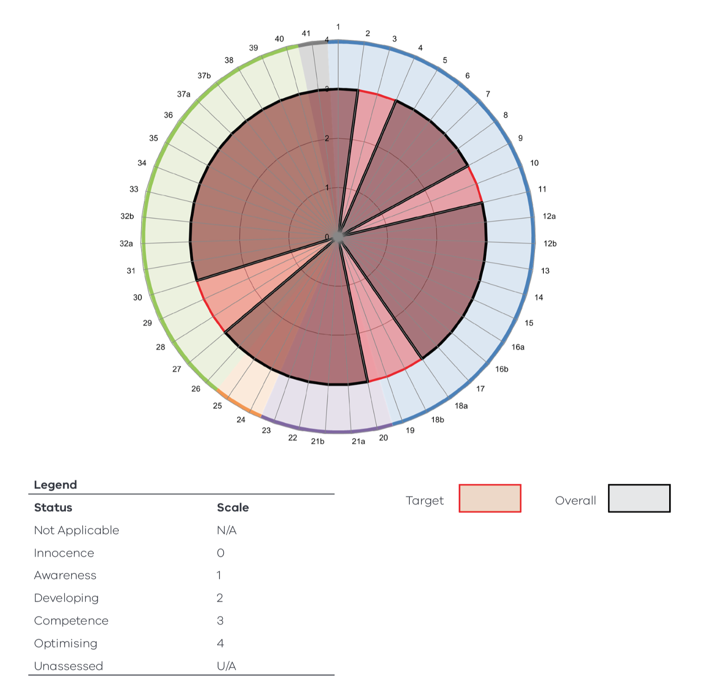

Leadership and Accountability (requirements 1–19)
The target maturity level has been met for this category, with some elements being not applicable to CSV.

Planning (requirements 20–23)
The target maturity level has been met for this category.

Acquisition (requirements 24 and 25)
The target maturity level has been met for this category.

Operation (requirements 26–40)
The target maturity level has been met for this category, with some elements being not applicable to CSV.

Disposal (requirement 41)
The target maturity level has been met for this category.

Competitive Neutrality Policy
Competitive neutrality requires government businesses to ensure that where services compete, or potentially compete, with the private sector, any net advantage arising from government ownership is accounted for if it is not in the public interest. Government businesses are required to set a competitively neutral price, which accounts for any net advantage that comes from public ownership. Competitive neutrality policy supports fair competition between public and private businesses and provides government businesses with a tool to enhance decisions on resource allocation. This policy does not override other policy objectives of government and focuses on efficiency in the provision of service.
CSV complies with the National Competition Policy and with the requirements of the Competitive Neutrality Policy Victoria policy statement and any subsequent reforms. The Commissioner for Better Regulation is responsible for considering competitive neutrality complaints by individuals and businesses against government entities. No competitive neutrality complaints were lodged in 2023–24 relating to business activities operated by CSV.

Freedom of information
The Freedom of Information Act 1982 (Vic) (FOI Act) allows the public a right of access to documents held by CSV. The purpose of the FOI Act is to extend as far as possible the right of the community to access information held by government departments, local councils, Ministers and other bodies subject to the FOI Act.
An applicant has a right to apply for access to documents held by CSV. This comprises documents both created by CSV or supplied to CSV by an external organisation or individual, and may also include maps, films, microfiche, photographs, computer printouts, computer discs, tape recordings and videotapes.
The FOI Act allows CSV to refuse access, either fully or partially, to certain documents or information. Examples of documents that may not be accessed include cabinet documents; some internal working documents; law enforcement documents; documents covered by legal professional privilege, such as legal advice; personal information about other people; and information provided in-confidence and information that is confidential under another Act.
Under the FOI Act, the processing time for requests received is 30 calendar days. However, when external consultation is required under ss29, 29A, 31, 31A, 33, 34 or 35, the processing time is 45 days. Processing time may also be extended by periods of 30 days, in consultation with the applicant. With the applicant’s agreement this may occur any number of times. However, obtaining an applicant’s agreement for an extension cannot occur after the expiry of the timeframe for deciding a request.
If an applicant is not satisfied by a decision made by CSV, under section 49A of the FOI Act they have the right to seek a review by the Office of the Victorian Information Commissioner within 28 days of receiving a decision letter.

Making a request
Freedom of information requests can be made by filling out the form located on CSV’s website vic.gov.au/freedom-information-and-cladding-safety-victoria and paying the application fee of $32.70. Access charges may also be payable if the document pool is large, and the search for material is time consuming.
Access to documents can also be obtained through a written request to CSV’s Freedom of Information team, as detailed in s17 of the FOI Act. When making a request, applicants should ensure requests are in writing, and clearly identify what types of material/documents are being sought.
Requests for documents held by CSV should be sent by email to foicsv@claddingsafety.vic.gov.au or posted to:
Freedom of Information Officer
Cladding Safety Victoria
PO Box 23392
Docklands VIC 8012

Freedom of information statistics
During 2023–24, CSV received 2 freedom of information requests. The requests were made by a building owner and an architect.
CSV responded to one of these requests within the required timeframes. As at 30 June 2024, the remaining request was being processed.

Further information
Further information regarding the operation and scope of freedom of information can be obtained from the FOI Act, regulations made under the FOI Act and ovic.vic.gov.au.

Compliance with the Building Act 1993 (Vic)
CSV does not own or control any government buildings and consequently is exempt from notifying its compliance with the building and maintenance provisions of the Building Act 1993 (Vic).

Compliance with Public Interest Disclosures Act 2012 (Vic)
The Public Interest Disclosures Act 2012 (Vic) (PID Act) encourages and assists people in making disclosures of improper conduct by public officers and public bodies. The PID Act provides protection to people who make disclosures in accordance with the Act and establishes a system for the matters disclosed to be investigated and rectifying action to be taken.
CSV does not tolerate improper conduct by employees, nor the taking of reprisals against those who come forward to disclose such conduct. CSV is committed to ensuring transparency and accountability in its administrative and management practices and supports the making of disclosures that reveal corrupt conduct, conduct involving a substantial mismanagement of public resources, or conduct involving a substantial risk to public health and safety or the environment.
CSV will take all reasonable steps to protect people who make such disclosures from any detrimental action in reprisal for making the disclosure. It will also afford natural justice to the person who is the subject of the disclosure to the extent it is legally possible.

Reporting procedures
CSV is not an entity that can receive public interest disclosures. Disclosures of improper conduct or detrimental action by CSV or any of its employees may be made directly to the Independent Broad-based Anti-corruption Commission (IBAC):
Level 1, North Tower, 459 Collins Street
Melbourne VIC 3000
Phone: 1300 735 135
Internet: ibac.vic.gov.au

Compliance with Carers Recognition Act 2012 (Vic)
CSV recognises that the Carers Recognition Act 2012 (Vic) sets a default position for CSV and we continue to offer a range of work arrangements and leave options to help staff balance the demands of work with personal and carer commitments. CSV promotes flexible work options for staff and aims to reduce the barriers to workforce participation for carers and ensures carers can make choices about work and their care role, to participate socially and economically and maintain their health and wellbeing.

Compliance with Disability Act 2006 (Vic)
In 2022, CSV implemented the 2022–24 Gender, Diversity and Inclusion Strategy, which considers both broader workforce diversity and employees that provide care for people with disability. The strategy was developed in consultation with all CSV staff. The associated action plan defines how CSV works to build a diverse and inclusive workforce for people with disability, which includes:
- ensuring an accessible workplace
- providing reasonable workplace adjustments
- attracting, recruiting, developing and retaining a diverse workforce from a variety of backgrounds
- enhancing workforce knowledge on diversity and inclusion principles and practices to create an inclusive environment.
To increase awareness and understanding of CSV’s diversity profile, a training program to address unconscious bias and promote disability awareness was rolled out to all staff during 2023–24.
CSV’s recruitment and selection process has been reviewed to ensure it is fair and does not present barriers to people with disability.

Compliance with DataVic Access Policy
The Victorian Government issued the DataVic Access Policy in 2012. Consistent with this policy, information included in this annual report will be available at data.vic.gov.au in electronic readable format. CSV was established as an independent entity in December 2020 and considers opportunities to publish other datasets as work progresses throughout its program.

Environmental reporting

Organisational boundary
CSV’s head office is located at Level 4, 717 Bourke Street in Docklands.
This premises was leased in March 2020.

Electricity production and consumption
CSV consumes energy predominantly through office facilities. Electricity consumption was lower than average during 2021–22 due to employees working remotely in line with government directions and a transition back to the office from early 2022.
Total electricity consumption (MJ) | 2023–24 | 2022–23 | 2021–22
Purchased electricity – consolidated | 145,262 | 137,866.5 | 113,979.5
Not directly purchased but from outside the organisation | 0 | 0 | 0
Self-generated | 0 | 0 | 0

Total electricity offsets (MWh) | 2023–24 | 2022–23 | 2021–22
LGCs retired | 39.79 | 28.2 | 0
Greenpower or certified carbon neutral electricity purchased | 0 | 0 | 0

Transportation
CSV has a fleet of 3 hybrid vehicles, which are predominantly used for CSV building site visits.

Number and proportion of vehicles | 2023–24 |  | 2022–23 |  | 2021–22
 | No. | % | No. | % | No. | %
Passenger vehicles: Hybrid | 3 | 100 | 3 | 100 | 3 | 100

Sustainable buildings and infrastructure
No substantial office fit-outs were done in 2023–24.

Additional information on request
In compliance with the requirements of the Standing Directions 2018 under the Financial Management Act 1994 (Vic), details in respect of the items listed below have been retained by CSV and are available on request, subject to the provisions of the Freedom of Information Act 1982 (Vic):
- a statement that declarations of pecuniary interests have been duly completed by all relevant officers
- details of shares held by senior officers as nominee or held beneficially in a statutory authority or subsidiary
- details of publications produced by CSV about itself and how these can be obtained
- details of any major external reviews carried out on CSV
- details of major research and development activities undertaken by CSV
- details of overseas visits undertaken, including a summary of the objectives and outcomes of each visit
- details of major promotional, public relations and marketing activities undertaken by CSV to develop community awareness of CSV and its services
- details of assessments and measures undertaken to improve the occupational health and safety of employees
- a general statement on industrial relations within CSV and details of time lost through industrial accidents and disputes
- a list of major committees sponsored by CSV, the purpose of each committee and the extent to which the purposes have been achieved
- details of all consultancies and contractors, including:
- consultants/contractors engaged
- services provided
- expenditure committed to each engagement.
The information is available on request from the CSV telephone support line on 1300 456 542 or via email at support@claddingsafety.vic.gov.au.

Information that is not applicable to CSV
Details of changes in prices, fees, charges, rates and levies charged by CSV is not available because CSV does not charge for its services.

Disclosure index
CSV’s annual report is prepared in accordance with all relevant Victorian legislation and pronouncements. This index has been prepared to facilitate identification of CSV’s compliance with statutory disclosure requirements.
Click on a page reference number to refer to the relevant requirements for the corresponding disclosure requirements, or alternatively, refer to the corresponding page references.
Legislation | Requirement | Page reference
Standing Directions and Financial Reporting Directions
Report of Operations
Charter and purpose
FRD 22 | Manner of establishment and the relevant Ministers | page 8
FRD 22 | Purpose, functions, powers and duties | page 8–9
FRD 22 | Key initiatives and projects | page 15–37
FRD 22 | Nature and range of services provided | page 11–12
Management and structure
FRD 22 | Organisational structure | page 37–38
FRD 22 | Board committee membership | page 40–41
Financial and other information
FRD 10 | Disclosure index | page 118–121
FRD 12 | Disclosure of major contracts | page 107
FRD 15 | Executive disclosures | page 95
FRD 22 | Employment and conduct principles | page 42
FRD 22 | Occupational health and safety policy | page 47–49
FRD 22 | Summary of the financial results for the year | page 13–15
FRD 22 | Significant changes in financial position during the year | page 13
FRD 22 | Major changes or factors affecting performance | page 13–14
FRD 22 | Subsequent events | page 15
FRD 22 | Application and operation of the Freedom of Information Act 1982 (Vic) | page 113–114
FRD 22 | Compliance with building and maintenance provisions of the Building Act 1993 (Vic) | page 115
FRD 22 | Statement on National Competition Policy | page 113
FRD 22 | Application and operation of the Public Interest Disclosures Act 2012 (Vic) | page 115
FRD 22 | Application and operation of the Carers Recognition Act 2012 (Vic) | page 115
FRD 22 | Details of consultancies over $10,000 | page 107–108
FRD 22 | Details of consultancies under $10,000 | page 108
FRD 22 | Disclosure of government advertising expenditure | page 108
FRD 22 | Disclosure of ICT expenditure | page 108–109
FRD 22 | Reviews and studies expenditure | page 110–111
FRD 22 | Statement of availability of other information | page 117–118
FRD 22 | AMAF maturity assessment | page 112–113
FRD 22 | Disclosure of emergency procurement | page 107
FRD 22 | Disclosure of procurement complaints | page 107
FRD 24 | Environmental reporting | page 116–117
FRD 25 | Local jobs first | page 104–105
FRD 29 | Workforce data disclosures | page 42–47
SD 5.2 | Specific requirements under Standing Direction 5.2 | page 2 and 104
SPF Reporting Guidelines | Social Procurement Framework | page 105–107
Compliance attestation and declaration
SD 5.1.4 | Attestation for compliance with Ministerial Standing Direction | page 104
SD 5.2.3 | Declaration in report of operations | page 2
Financial Statements
Declaration
SD 5.2.2 | Declaration in financial statements | page 53
Other requirements under Standing Direction 5.2
SD 5.2.1(a) | Compliance with Australian accounting standards and other authoritative pronouncements | page 61
SD 5.2.1(a) | Compliance with Standing Directions | page 104
SD 5.2.1(b) | Compliance with Model Financial Report | page 104
Other disclosures as required by FRDs in notes to financial statements (a)
FRD 11 | Disclosure of Ex gratia Expenses | page 93
FRD 21 | Disclosures of Responsible Persons, Executive Officers and other Personnel (Contractors with Significant Management Responsibilities) in the Financial Report | page 93–94
FRD 103 | Non-Financial Physical Assets | page 91
FRD 110 | Cash Flow Statements | page 58
FRD 112 | Defined Benefit Superannuation Obligations | page 63–64
FRD 114 | Financial Instruments – general government entities and public non-financial corporations | page 81
Note: (a) References to FRDs have been removed from the Disclosure Index if the specific FRDs do not contain requirements that are in the nature of disclosure.
Legislation
Freedom of Information Act 1982 (Vic) |  | page 113–114
Building Act 1993 (Vic) |  | page 115
Public Interest Disclosures Act 2012 (Vic) |  | page 115
Carers Recognition Act 2012 (Vic) |  | page 115
Disability Act 2006 (Vic) |  | page 115–116
Local Jobs Act 2003 (Vic) |  | page 104–105
Financial Management Act 1994 (Vic) |  | page 2, 53 and 104

Acronyms and abbreviations
AAS | Australian Accounting Standards
AASB | Australian Accounting Standards Board
AC | amortised cost
ACP | aluminium composite panels
ACP-FR | aluminium composite panels (fire retardant)
AEE | annualised employee equivalent
AMAF | Asset Management Accountability Framework
ATO | Australian Taxation Office
BAU | business as usual
CEO | Chief Executive Officer
CRL | Cladding Rectification Levy
CRPP | Cladding Remediation Partnership Program
CRPM | Cladding Risk Prioritisation Model
CSIRO | Commonwealth Scientific and Industrial Research Organisation
CSV | Cladding Safety Victoria
DTF | Department of Treasury and Finance
DTP | Department of Transport and Planning
EPS | expanded polystyrene
FMA | Financial Management Act 1994 (Vic.)
FOI | freedom of information
FRD | Financial Reporting Direction
FT | full-time
FTE | full-time equivalent
GST | Goods and Services Tax
HC | head count
IBAC | Independent Broad-based Anti-corruption Commission
ICT | information and communications technology
IT | information technology
KMP | key management personnel
LGC | large-scale generation certificate
LSL | long service leave
MBS | Municipal Building Surveyor
MCG | Melbourne Cricket Ground
MJ | megajoule
MPSG | Major Project Skills Guarantee
MWh | megawatt hour
OH&S | occupational health and safety
PCB | Project Control Board
PFC | public financial corporations
PID | Public Interest Disclosures
PMCR | Protocols for Mitigating Cladding Risk
PNFC | public non-financial corporations
PT | part-time
RMIT | Royal Melbourne Institute of Technology
RoU | right-of-use
RWP | Remediation Work Proposal
SES | Senior Executive Service
STS | Senior Technical Specialist
TAFE college | Technical and Further Education college
VBA | Victorian Building Authority
VGV | Valuer-General Victoria
VIPP | Victorian Industry Participation Policy
VPSC | Victorian Public Service Commission

Website
vic.gov.au/cladding-safety
Email
support@claddingsafety.vic.gov.au
Postal address
PO Box 23392, Docklands VIC 8012
Telephone
1300 456 542
For enquiries in languages other than English, contact the Translating and Interpreting Service on 131 450.
If you are deaf, or have a hearing or speech impairment, contact us through the National Relay Service.
For more information:
Voice Relay number 1300 555 727
TTY number 133 677
SMS relay number 0423 677 767

The MCG has dimensions of 173.6 metres x 148.4 metres fence to fence (austadiums.com/stadiums/mcg) equating to a surface area of 20,370 square metres.

