**SOUTHERN GRAMPIANS SHIRE LIQUOR ACCORD**

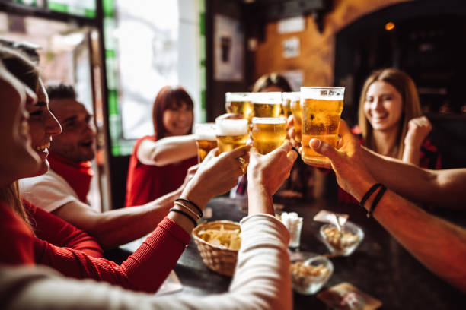2024 - 2030

**Responsible Service of Alcohol**



**Working Together for a Safer Community**

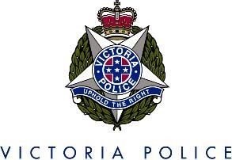

Date: Oct 2024

Version: No 1

**Table of contents**

1. AIM 3

2. BACKGROUND 3

3. INTRODUCTION 3

5. BEST PRACTICE PRINCIPLES 5

5.2 SIGNAGE 8

6. CROWD CONTROLLERS 8

7. IMPROVE SAFETY AND SECURITY 8

8. COMMITMENT TO ‘BEING GOOD NEIGHBOURS’ 11

9. ACCORD BANNING GUIDELINES 11

10. VICTORIA POLICE 12

11. ACKNOWLEDGEMENT OF COMMITMENT 12

12. MEMBERSHIP 13

# 1. AIM

*‘To improve public safety and amenity by reducing alcohol related crime and harm, and promote a responsible liquor industry in the Southern Grampians Shire’.*

# 2. BACKGROUND

The purpose of the Southern Grampians Shire Liquor Accord (the Accord) is to draw together representatives of key licensed venues to recognise and address issues of excessive alcohol consumption and unacceptable practices that contribute to community and social problems.

Licensees give a written commitment to uphold the codes of conduct outlined within the Accord document, including the support of measures to reduce levels of alcohol related crime, disorder and nuisance within the Southern Grampians Shire.

# 3. INTRODUCTION

The Accord provides partnership opportunities for developing collaborative and proactive approaches to minimising the harms associated with alcohol, improving safety and amenity, and reducing alcohol related violence and anti-social behaviour.

The Accord involves a variety of partners including Victoria Police, Southern Grampians Shire Council, liquor licensees, Liquor Control Victoria (LCV) and community stakeholders.

The Accord is committed to strategies, which promote positive and effective outcomes through:

* minimising the harms associated with the excessive alcohol consumption
* improving safety and amenity
* reducing alcohol related harm and anti-social behaviour.

Benefits include:

* Keeping up-to-date with changes to liquor laws
* Contributing and making a difference in your local community
* Getting to know your local police, council and LCV representatives
* Enhancing your business and making your venue welcoming and safe for everyone
* Networking with colleagues and stakeholders.

**4. PRIORITY AREAS, OBJECTIVES AND STRATEGIES**

|  |  |
| --- | --- |
| **Priority Area:** | Addressing contributors to alcohol related crime and harm |
| **Objective:** | To reduce factors that contribute to alcohol related crime and violence in and around licensed venues |
| **Strategies:** | * Adhere to Responsible Service of Alcohol (RSA); * Eliminate practices that lead to harm from use of alcohol; * Eliminate illegal underage patronage at all licensed premises; * Eliminate false identification used by underage persons; * Eliminate promotions and practices that encourage the irresponsible service and consumption of alcohol; |
| **Priority Area:** | Creating a safe environment in and around licensed premises. |
| **Objective:** | To improve safety in and around licensed venues |
|  |  |
| **Strategies*:*** | * Maintain a high standard of public amenity within the central business districts; * Work collaboratively with responsible regulator to protect physical amenity; * Adhere to best practice in the management of licensed premises; * Identify and report issues of public safety to the responsible regulator; * Actively contribute to the development of projects and programs that improve safety around licensed venues. |
| **Priority Area:** | Positively contributing to public health, wellbeing and safety. |
| **Objective:** | Tocontribute to the health, wellbeing and safety of residents and visitors to the Southern Grampians Shire. |
| **Strategies:** | * Encouraging positive health and social behaviours by the community, in relation to the consumption of alcohol; * Promote and encourage the use of ‘Designated Driver’ programs; * Support and promote best practice programs which improve the health, wellbeing and safety of residents and visitors to the precinct. |
|  |  |

# 5. BEST PRACTICE PRINCIPLES

This section outlines industry accepted best practice principles for licensees. It is expected that licensees committed to the Accord adhere to these principles in order to operate a business within a best practice framework.

The Southern Grampians Shire Accord – Best Practice Principles are founded on a harm minimisation approach that aims to minimise and reduce harm to individuals, families and the broader community as a result of alcohol and other drugs.

In applying these principles, it is recognised that some aspects outlined may only apply to a certain types of liquor licence. For example *‘Ensure that the maximum capacity numbers of patrons are adhered to at all times’* would not apply to packaged liquor outlets. However, most of the recommendations contained in this section have been modified to apply to all licence types.

## 5.1. Responsible Service of Alcohol

* Refuse service of alcohol to any patron showing signs of [intoxication](https://www.vic.gov.au/managing-intoxicated-patrons).
* Refuse entry to all intoxicated patrons.
* Encourage patrons to drink responsibly and let them know they will be asked to leave if they become intoxicated, disorderly, violent or quarrelsome.
* Notify crowd controllers of patrons who are showing signs of intoxication so that crowd controllers can monitor and manage the situation.
* Ensure staff are adequately trained to identify intoxicated patrons.

A responsible service of alcohol checklist is provided in **Appendix. A**

### 5.1.2. Minors

[**Minors on licensed premises**](https://www.vic.gov.au/under-18-patrons-licensed-premises)

Anyone under the age of 18 years is considered a minor.

The legal drinking age in Victoria is 18 years. **It's illegal for any person to supply alcohol to a minor on licensed premises.** It's also illegal for a minor to be on licensed premises to purchase, receive or consume alcohol.

**Minors are not permitted to drink alcohol on licensed premises under any circumstances.**

Depending on the situation, a minor may be allowed on licensed premises. A minor may be on licensed premises if they are in the company of a *responsible adult*.

A *responsible adult* is defined as a person who is 18 years or older and is:

* the minor's parent, step-parent, guardian, grandparent, or
* the minor's spouse who is over the age of 18 years, or
* a person who is acting in place of a parent and who could reasonably be expected to exercise responsible supervision of the minor – for example, a sporting coach.

An unaccompanied minor cannot be on licensed premises unless:

* there is a condition allowing them on the licence (for example, a junior sports club)
* it holds a restaurant and cafe licence (until 11pm)
* it holds an on-premises licence with restaurant conditions (until 11pm).

Other circumstances that permit minors on licensed premises are if the minor is:

* having a meal, or
* is a resident of the premises if accommodation is supplied, or
* employed by the licensee but not involved in the supply of alcohol, or
* completing an LCV approved training program in hospitality.

### 5.1.3. Checking Identification

One of the key aims of this Accord is to actively discourage illegal underage patronage and with that, illegal underage drinking on/or from licensed premises of all kinds.

To achieve this:

* Insist on sighting an [acceptable form of ID](https://www.vic.gov.au/acceptable-forms-identification-for-licensed-premises) as specified in the *Liquor Control Reform Act 1998 (the Act)*, for entry to all licensed venues/point of sale where appropriate.
* Prominently display LCV signage about restrictions on minors.
* When checking ID, ask customer to remove ID from their wallet/purse and pass to a staff member, so they can hold and inspect it.
* If checking digital ID, don’t touch the customer’s phone.
* Check date of birth is accurate and hasn’t been tampered with (check the back of the ID too).
* Ensure photo matches the person presenting the ID, paying close attention to physical features.
* Ensure photo has not been substituted or tampered with.
* If staff believe an ID is false, defaced or not the person presenting the ID, confiscate it and forward to police ASAP (excluding a driver licence).
* If an approved form of ID is not produced, refuse entry or supply of alcohol unless the patron is obviously over the age of 18 years. This will be at the discretion of the venue operator or delegate.

Acceptable evidence of age documents under the Actare:

* Australian driver licence (including digital driver licence[)](https://www.vcglr.vic.gov.au/news/accepting-digital-identification-id-documents)
* Victorian learner permit
* Foreign driver licence in the English language or if not in the English language, must be accompanied by an official English translation or an International Driving Permit
* [Victorian proof of age card](https://www.vic.gov.au/proof-of-age-card)or an equivalent from another state or territory of
* Australia
* Keypass card (including [digital keypass](https://www.digitalid.com/personal))
* Australian or foreign passport
* Victorian marine licence.

### 5.1.4 Discourage activities that encourage drinking alcohol excessively

Actively discourage irresponsible alcohol consumption practices such as:

* free or heavily discounted drinks on entry or during the night at licensed venues
* lay backs, two for one drinks, short term price reductions
* all-inclusive events which have the potential for alcohol harm
* serving of ‘shots’ after 12:00AM
* practices or promotions which encourage rapid consumption of alcohol such as drinking games, skolling competitions, dares or challenges and pouring straight alcohol into patrons mouths
* advertising of events that encourage excessive consumption of alcohol e.g., sporting clubs end of season celebrations (Mad Monday), end of school celebrations (schoolies week), start of university celebrations (O-Week)
* Happy Hours will be kept to a maximum of two hours per day, per venue operation and will be completed by 11:00pm on any operating night.

All licensees (members) of the Southern Grampians Shire Liquor Accord are to become familiar with LCV’s [Responsible Alcohol Advertising and Promotions Guidelines](https://www.vic.gov.au/responsible-alcohol-advertising-and-promotions) **Appendix. B**

*Standard Drinks*

The following amounts are a guide for 1 standard drink based on the alcohol content.

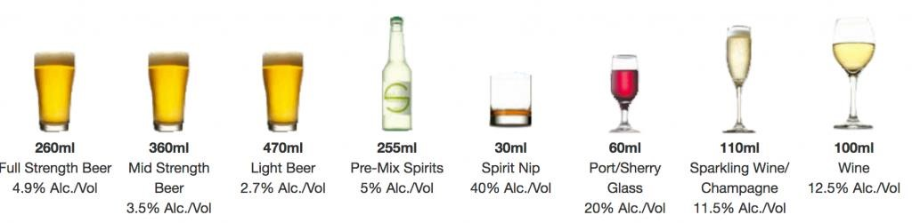

### 5.1.5 Promote non-alcoholic or low alcoholic beverages and snacks

* At all times, offer and promote the availability of low and non-alcoholic drinks.
* Ensure bottled water is available for purchase and free tap water is available to all patrons; (legal requirement under section 99A of the Act*).*
* Ensure refreshments (food) are readily available for purchase on request at any time *(*legal requirement under section 99 of the Act*).*

**5.1.6 Ensure all staff are adequately trained.**

* RSA training is mandatory for licensees and staff selling, offering or serving alcohol for general, on-premises, late night and packaged liquor licences.
* Licensees and staff who are subject to mandatory RSA requirements have one month from the date they first sell, offer for sale or serve liquor on a licensed premise to complete an [approved RSA training course](https://www.vic.gov.au/approved-training-providers).
* Once you have completed the initial Victorian RSA course, you must complete [LCV’s free online refresher course](https://liquorportal.vcglr.vic.gov.au/rsa_refresher/) every three years.
* A list/register of minors employed on the premises (which may be the business time and wages record book) is maintained by the licensee and is available upon request for viewing by LCV inspectors or Victoria Police.
* Have a copy of every staff member’s most recent RSA certificate available on request. Ensure staff know where to access them.
* Display LCV’s [RSA Principles poster](https://content.vic.gov.au/sites/default/files/2023-07/RSA-Principles.pdf) in staff room/back of house.
* Provide regular updates to all staff regarding the Accord and related responsible service of alcohol and harm minimisation policies and practices.

# 5.2 SIGNAGE

Under the Act, licensees are required to display certain signage (also referred to as posters or notices) in a prominent location around their licensed premises. [*Mandatory signage was updated on 21 July 2023.*](https://www.vic.gov.au/print-my-liquor-signage)

Ensure mandatory signage is printed and displayed correctly. **Appendix C**

# 6. CROWD CONTROLLERS

If licensees have a crowd controller condition on their licence, they must abide by certain requirements.

* Ensure crowd controllers have a current licence under the *Private Security Act 2004* – status can be checked online.
* Maintain a crowd controller’s incident register book (this is separate to an in-house incident book).
* Brief security before their shift about expectations, including conflict resolution and communicating with stakeholders.
* Ensure security maintain queues in an orderly fashion.
* Check ID of all patrons who [look under 25 years old](https://content.vic.gov.au/sites/default/files/2023-09/Optional-signage-if-you-look-under-25-ask-id.pdf).
* Walk around the outside perimeter of the venue to look for potential risks e.g. patrons pre-loading, minors trying to access venue.
* Employ two crowd controllers for the first 100 patrons and one for every additional 100 or part of, as per licence conditions

# 7. IMPROVE SAFETY AND SECURITY

Actively monitor the behaviour of patrons to detect early signs of intoxication or inappropriate behaviour.

* Clearly display a house policy that details acceptable and unacceptable behaviour on premises, including non-acceptance of excessive consumption of alcohol or illicit drug use.
* Signage that educates patrons and explains the harms associated with drug use, including drink spiking, drink/drug driving and tobacco smoking, is displayed throughout the premises.
* Discourage glass in toilets or dance floor, to reduce both intentional and accidental injuries.
* Ensure internal and external security procedures are well maintained and functioning effectively.
* Encourage phased and orderly exit of patrons from premises when closing.

## 7.1 Maintain safety and security throughout the premises

* An Emergency Procedures Management Plan is maintained and available to Victoria Police. All staff are trained in emergency procedures and the use of emergency equipment.
* Conduct regular WorkSafe crowd control safety and security risk assessment of premises and immediate surrounds.
* Ensure entrances and exits are well lit and that immediate surrounds are safe and allow good visibility.
* Implement good surveillance systems, such as closed-circuit television systems
* [(CCTV),](https://www.vic.gov.au/security-licensed-venues) where appropriate.
* Ensure staff, including security, are clearly identifiable (for example, distinctive t-shirts, uniforms, name tags etc).
* Serve alcohol in containers selected to minimise possible harm to patrons. Where possible, glasses are made of shatter proof glass.
* Where possible stock liquor in unbreakable containers, such as cans or plastic bottles, instead of glass bottles.
* Fully cooperate with police and other Accord members on ways to improve public safety.
* Prevent criminal activity and disorderly conduct from occurring on premises. Notify police immediately if something illegal or suspicious does occur.
* When required, agree to implement additional or local strategies that relate to specific safety and security issues in and around the premises. These strategies will be negotiated as part of the Accord.
* Door/security or reception personnel will:
  + Wear clear ID at all times.
  + Not harass or intimidate passers-by or potential customers.
  + Record incidents of false ID and fraudulent use of ID into the incident book.
  + Monitor and discourage anti-social behaviour when patrons leave the premises, both near and immediately surrounding the premises, and call police if necessary.
  + Not let people back into premises who have caused a disturbance – immediately contact police and other premises to inform them of patrons that have been ejected and/or problem patrons in the vicinity.
  + Abide by privacy laws during group chats or other communication between neighbouring venues (used in the event of ejecting or refusing entry to patrons).
  + Assist patrons in accessing safe transportation out of the area.
  + Uphold any statutory requirements relating to security personnel and enter details of any incidents in the incident book.

## 7.2 Maintain records of incidents and have regular communication with police

* Maintain a register of all types of incidents that occur in and around the premises that includes the time, date and nature of the incident and the response taken by staff and management.
* Ensure all staff are familiar with the incident register book and are aware of how to use it when required.
* Notify the police of any special events likely to significantly increase the number of people in the area, in advance of the event.
* Ensure close liaison and open communication with all Southern Grampians Liquor Accord stakeholders.

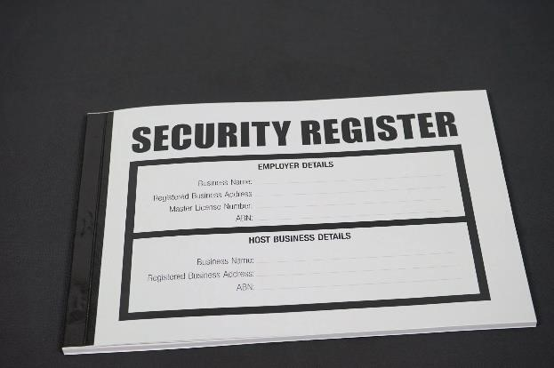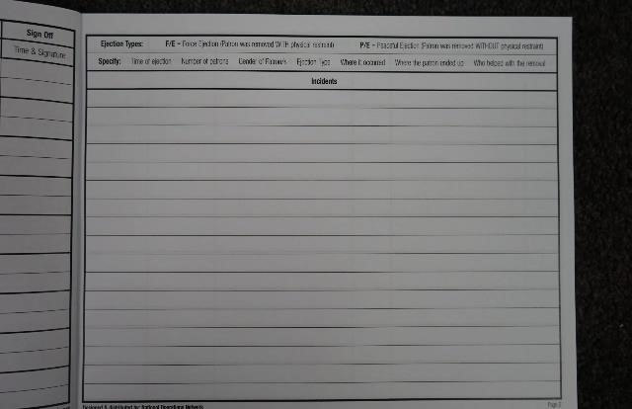

## 7.3 Patron and premises safety

* Maintain a current list of emergency phone numbers and security at other venues for all staff to access.
* Ensure maximum capacity numbers of patrons are adhered to at all times, if applicable.
* Encourage a policy of no pass-outs after midnight, if applicable.
* Encourage all staff members to undertake first aid courses and ensure one staff member with a first aid certificate is rostered on for each shift.

A Safety and Security Self-Audit checklist is provided in **Appendix. D**

# 8. COMMITMENT TO ‘BEING GOOD NEIGHBOURS’

# 8.1 Improve the local amenity

* Minimise noise generated from the premises, wherever possible, keep doors closed.
* Educate patrons, including through signage, about the need to respect the local amenity and to arrive and depart the area in a quiet and orderly manner.
* Prevent removal of alcohol (other than packaged liquor where permitted) from licensed premises.
* Ensure door and security staff, are briefed on local environment issues, including potential traffic, noise or security problems.
* Record all legitimate complaints in the incident book, respond to resident concerns and take all reasonable steps to ensure the premise is functioning as a ‘good neighbour’.
* Communicate with neighbouring premises to discuss any common issues surrounding the premises.

## A Self-Audit Checklist designed to assess the effectiveness of the licensee can be found in Appendix. E

# 9. ACCORD BANNING GUIDELINES

The *Liquor Control Reform Act 1998* (**the Act**) provides that two or more licensees or permittees may enter into a liquor accord with the approval of the Chief Commissioner of Victoria Police and LCV. They may enter into such an agreement for the purpose of minimising harm arising from the misuse or abuse of alcohol at their licensed premises.

The terms of a liquor accord may make provision for licensees or permittees to stop supplying liquor or allowing the consumption of liquor at their licensed premises. The terms may also make provisions for banning a person or the public access to licensed premises.

Liquor accord bans should be implemented only for the purpose of minimising harm arising from the misuse and abuse of alcohol in relation to behaviour that has occurred in or around licensed premises. It is recommended that parties to an accord:

* ensure a decision to ban is fair and reasonable, including providing the banned person with an opportunity to respond to or request review of the decision to ban them
* ensure a ban is made for a clear harm minimisation purpose
* ensure the privacy of personal information in relation to banned persons is maintained
* ensure a ban is non-discriminatory and complies with the provisions of the [Charter of Human Rights and Responsibilities Act 2006 (Vic)](https://www.legislation.vic.gov.au/in-force/acts/charter-human-rights-and-responsibilities-act-2006/014)
* do not ban persons for unreasonable periods of time (maximum 12 months) unless clearly justified by the circumstances and
* appropriately notify the patron that a decision has been made to exclude them.

From 31 January 2022, the maximum period for which a person may be banned under a liquor accord is 12 months.

A licensee or permittee may consult with Victoria Police in developing or enforcing a liquor accord.

## Release of information for the purpose of enforcing an accord ban

Section 146D of the Act allows for LCV or Victoria Police to disclose specific information about a banned person to a licensee or permittee who are party to a liquor accord which contains a liquor accord ban. It is an offence under section 146DA of the Act for a person to use or disclose any information received from LCV or Victoria Police regarding banned persons except for the purposes of enforcing a liquor accord ban or otherwise as required by law.

Information will only be disclosed by LCV wherenecessary for the purposes of the effective and efficient enforcement of the liquor accord ban. When determining whether to disclose information, LCV or Victoria Police may require a licensee or permittee who are a party to an accord to provide further details.

# 10. VICTORIA POLICE

In addition to licensees adopting and implementing the principles and practices of the Accord, Victoria Police will use reasonable endeavours to:

* maintain a visible police presence in and around licensed premises
* work with all stakeholders to implement the accord and improve community safety
* work collaboratively with the Southern Grampians Shire Liquor Accord members to develop solutions for identified problems/issues.

# 11. ACKNOWLEDGEMENT OF COMMITMENT

Licensees adopting this Code of Practice will be invited to sign a standardised Certificate of Commitment to adhere to the objectives of the code.

The Local Police Service Area Licensing Inspector will also endorse the certificate.

The licensee should ensure the Certificate of Commitment is displayed in a conspicuous place on the licensed premises in a manner that invites public attention.

Current members of the Southern Grampians Shire Liquor Accord are:

|  |  |  |
| --- | --- | --- |
| **ALEXANDRA HOUSE SPORTS CLUB** | **GRANGEBURN BOWLING CLUB** | **HAMILTON RACING CLUB** |
| **BANDICOOT MOTOR INN** | **HAMILTON BOWLING CLUB** | **JACK AND JUDE** |
| **CALEDONIAN HOTEL MOTEL** | **HAMILTON CLUB** | **LITTLE KOI** |
| **COMFORT INN BOTANICAL** | **HAMILTON CURRY BOWL** | **ROXBURGH HOUSE** |
| **COMMERCIAL HOTEL** | **HAMILTON GOLF CLUB** | **THE SPECKLED FROG** |
| **GRAND CENTRAL HOTEL** | **HAMILTON KANGAROOS FOOTBALL NETBALL CLUB** | **WILFRED'S RESTAURANT AND CAFE** |

# 12. MEMBERSHIP

* Membership will include representation from the Council and Victoria Police.
* Membership will be available to agencies with interest and expertise in liquor licensing and the reduction of harm within the accord area and at licensed venues.
* Membership is voluntary and open to all liquor licensees within the accord area.
* Membership requires attendance and participation at quarterly meetings, communication with other stakeholders and commitment to implementing any agreed changes within your own agency/premises.
* By agreement of Accord members at any Accord meeting, membership may be extended to any agency with an interest, expertise, or commitment to the reduction of harm.
* All meetings will invite a representative from Liquor Control Victoria.
* Licensees who agree to and sign the statement of commitment certificate will become members.
* A member may resign by written notice to the liquor forum chairperson/administrator or Victoria Police.
* A member is taken to have resigned if:
  + the liquor forum chairperson/administrator or Victoria Police has made a written request to the member to confirm that they wish to remain a member and
  + the member has not, within 14 days after receiving that request, confirmed in writing that they wish to remain a member.
* If the liquor forum chairperson/administrator or Victoria Police is satisfied that a licensee member (**relevant member**) has failed to comply with the Accord or refuses to support the purposes of the Accord, disciplinary action may be taken against the relevant member as follows:
  + A letter will be sent to the relevant member stating:
    - that it is proposed to take disciplinary action against the relevant member
    - the grounds for the proposed disciplinary action and
    - that the relevant member will be allowed to make submissions in writing or at the next Accord meeting.
  + The relevant member must confirm in writing within 14 days of receiving the letter if they wish to make any submissions in writing or at the meeting.
  + At the next Accord meeting, if the relevant member is in attendance, they will be given time to speak. If a written submission has been sent, then that will be read. The members present at the meeting (other than the relevant member) may decide to:
    - take no further action against the relevant member
    - reprimand the relevant member, or
    - cancel the relevant member’s membership of the Accord.
  + The discussion and any outcome will be recorded in the meeting minutes.
* If a licensee’s membership of the Accord is cancelled, they may apply to become a member again after 12 months. The application may only be accepted by agreement of Accord members at an Accord meeting.

**Appendix. A**

The attached Self-Audit Checklist is designed to assess the effectiveness of the licensee’s commitment to Responsible Service of Alcohol.

|  |  |  |  |
| --- | --- | --- | --- |
| **Requirement** | **Yes** | **No** | **Action Required** |
| Licensees have completed and are trained in the Licensees ‘New Entrant Training’ course. |  |  |  |
| Licensees and staff have read and understood their liquor licence. The current liquor licence is prominently displayed. |  |  |  |
| All liquor service staff have completed and are trained in ‘RSA’ within one month of commencing employment or are the holder of an approved RSA certificate. Complete the RSA Refresher program every three years |  |  |  |
| The current red line plan of the premises is available for inspection by Victoria Police or LCV inspectors. |  |  |  |
| Required signage is prominently displayed. |  |  |  |
| Minors employed in the licensed premises are not involved in the sale or supply of alcohol and their employment is registered and available to Victoria Police or LCV inspectors when requested. |  |  |  |
| Patrons’ identification is actively monitored at the door to ensure they are not underage. |  |  |  |
| Promotions and advertising do not encourage the rapid consumption of alcohol. |  |  |  |
| Low and non-alcoholic drinks are readily available. Water is available free, in line with legislation. |  |  |  |

**Appendix. B**

Below is the unacceptable practices section of the Responsible Alcohol Advertising and Promotion Guidelines. The full document can be found at [www.vic.gov.au/responsible-alcohol-advertising-and-promotions](http://www.vic.gov.au/responsible-alcohol-advertising-and-promotions).

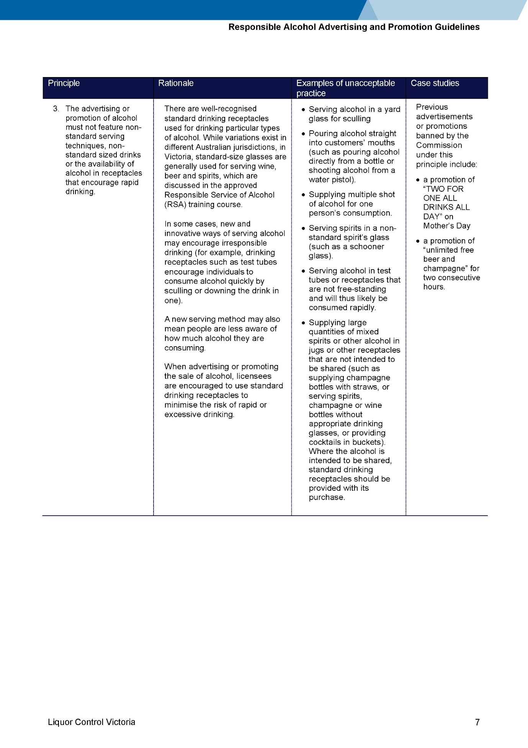

**Appendix. C**

**Appendix. D**

Self-audit checklist designed to assess the effectiveness of the licensee’s commitment to safety and security.

|  |  |  |  |
| --- | --- | --- | --- |
| **Requirement** | **Yes** | **No** | **Action Required** |
| All crowd controllers are trained and hold a current Private Security Licence. |  |  |  |
| The crowd controllers register is properly maintained. |  |  |  |
| A house policy has been developed and is displayed for patrons’ information. |  |  |  |
| An Emergency Procedure  Management Plan is in place. |  |  |  |
| Staff are informed and trained in emergency procedures. |  |  |  |
| A Patron Management Plan is in place and all staff are trained in implementing the plan. |  |  |  |
| Where applicable, video surveillance cameras are installed and placed in the appropriate locations. |  |  |  |
| Surveillance footage is retained in  accordance with licence requirements. |  |  |  |
| Where possible, glasses are shatter glass and preference given to stock liquor in unbreakable containers. |  |  |  |
| Security and reception staff are aware of the closest taxi and public transport options. |  |  |  |
| An employee is present who holds a current accredited first-aid certificate during operating hours. |  |  |  |
| All relevant staff are aware of maximum numbers permitted on the premises. This includes relevant management and security personnel. |  |  |  |
| Staff will monitor and discourage anti-social behaviour both in and near licensed premises. |  |  |  |
| All staff understand the procedures of recording an incident in the incident book. |  |  |  |

**Appendix. E**

Licensee effectiveness self-audit checklist

|  |  |  |  |
| --- | --- | --- | --- |
| **Requirement** | **Yes** | **No** | **Action Required** |
| Queues are managed to be orderly and do not obstruct access to footpaths for other users. |  |  |  |
| Management and security staff will work cooperatively with other venues and authorities to protect the amenity of other people. |  |  |  |
| Staff and management will encourage people to leave the premises in a quiet and orderly manner. |  |  |  |
| All staff are aware of the process of recording complaints. |  |  |  |