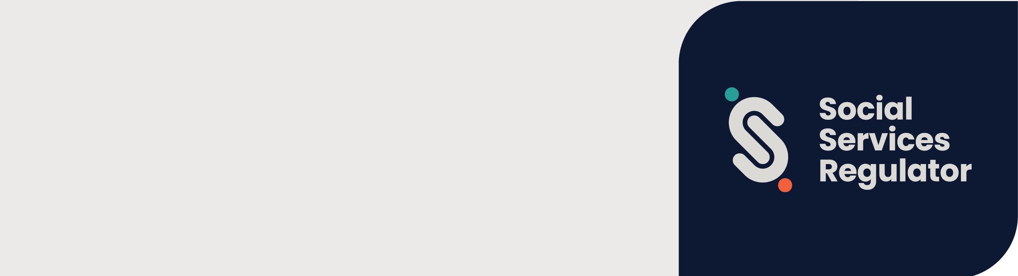

Child Safe Standards self-assessment

evidence guide
OFFICIAL

Contents
Introduction 2
Purpose of the evidence guide 2
Entities that must comply with the Standards 2
Complying with the Standards 3
Categories of evidence 3
Documented approach 3
Knowledge and actions 4
Assessing compliance with the Child Safe Standards 4
Completing a self-assessment 5
Step 1 – Start here 6
Step 2 – Review definitions 7
Step 3 – Compliance indicators 7
Step 4 – Organisational overview 9
Step 5 – Document mapping 10
Step 6 – Self-assessment template 10
Recording assessor evidence and comments 10
Recording assessor recommendations 11
Step 7 – Action plan 12
Step 8 – Opportunities for improvement 13
Step 9 – Performance summary 14
Further information 16
Appendix 1 – Definitions 17
Appendix 2 – Organisations regulated by the Social Services Regulator 18

Introduction
To meet the requirements of the Child Safe Standards (Standards) organisations must have strategies, policies and practices that are relevant to the type of services or facilities they provide to children.
The Standards are made under the Child Wellbeing and Safety Act 2005 (the Act) and by the Minister for Families and Children through publication of the Standards in the Victorian Government Gazette.
The Standards are outcomes-based. This means they don’t set out specific methods organisations must use to comply. This gives organisations flexibility to determine the most appropriate – or innovative – ways to comply and create a child-safe organisation.
Under the Act, the Social Services Regulator (Regulator) is an integrated sector regulator. Its role is to monitor the organisations it regulates and ensure they comply with the Standards.

Purpose of the evidence guide
This evidence guide has been developed by the Regulator to support the Child Safe Standards all-in-one assessment tool. It shows you how to self-assess and what to consider when gathering evidence to show how your organisation is complying with the Standards.
The Excel tool and accessible versions of the tool can be downloaded from the Regulator’s Child Safe Standards webpage.
The evidence guide can also help organisations prepare for and participate in compliance assessments initiated by the Regulator.

Entities that must comply with the Standards
Many types of organisations and individuals work with children and young people throughout Victoria. Relevant entities (i.e., organisations and individuals) that must comply with the Standards are entities that:
- provide any services specifically for children
- provide any facilities specifically for use by children under the organisation’s supervision
- engage a child as a contractor, employee, or volunteer to assist the organisation in providing services, facilities or goods.
For example, small community-based organisations must comply with the Standards. This includes but is not limited to sports clubs, youth organisations or playgroups where families and community members volunteer to deliver services.
Highly organised and regulated organisations such as schools, hospitals, child protection services or religious bodies, including churches, must also comply with the Standards.
The Standards apply to the organisation as a whole and not solely to programs or activities that involve children or services delivered as part of a consortia arrangement.
Schedule 1 of the Act prescribes all entities that are required to comply with the Standards. Legislative definitions for relevant and applicable entities are detailed in Appendix 1.
There is a full list of entities subject to the Standards regulated by the Regulator in Appendix 2.

Complying with the Standards
The Commission for Children and Young People (the Commission) has published a guide for creating a Child Safe Organisation. The guide outlines each of the 11 Standards and the minimum requirements organisations must meet to comply with the Standards. It also identifies compliance indicators – a list of documents and actions that regulators may look for when assessing compliance.
Organisations will generally comply with the Standards if they produce the recommended documents and implement the actions detailed as compliance indicators.
The compliance indicators are a general guide and must be considered in the context of your organisation. How best to comply with the Standards should be considered in relation to your organisation’s:
- size and complexity profile
- risks to child safety and
- service delivery, operations, or other relevant circumstances.
If your organisation takes a different approach you may need to explain how the outcome and the minimum requirements of the Standards are met.
The Regulator has used the Commission’s guide and the compliance indicators to develop its self-assessment tool. This is to ensure the Standards are regulated consistently.

Categories of evidence
To help organisations demonstrate compliance with the Standards, examples of evidence have been broken down into two categories:
- a documented approach
- knowledge and actions.
To demonstrate compliance with each of the Standards, organisations must show that processes and/or systems in place are understood and used by relevant staff, volunteers or people accessing services.

Documented approach
When an organisation is assessed by the Regulator, it must provide documented evidence to demonstrate its compliance with the Standards.
The documented approach includes a wide range of written material that demonstrates the systems and processes in place to meet the Standards and address other relevant external requirements. For example, legislation and program-specific requirements are captured in business policies and procedures.
Documentation should include:
- policies, procedures, protocols or work instructions that describe the organisation’s processes and practices, including in the interface between the Board/Managing Director and the operational staff
- information available and/or provided to people or displayed, such as brochures, pamphlets, newsletters, photographs, posters, employment advertising material or other written material given to people who use the service or other stakeholders
- plans, reports, records and other tools used by staff or people who use the service. Examples may include referrals, intake and assessment tools, care plans, attendance records, risk management plans and reports, feedback and complaint forms, improvement forms, personnel files, meeting minutes, memoranda, and emails

Knowledge and actions
To prove knowledge and actions, organisations must provide information about how they implement their processes and systems. This includes the ways an organisation reviews, monitors and evaluates processes and systems to ensure the outcomes of the Standards are being met. Organisations must also provide evidence of the actions they take to comply with the Standards.
Knowledge and actions should include training board members, management, staff, carers, volunteers and other stakeholders on the processes and systems developed for the service and service delivery. This might include:
- training plans/records (mandatory training, planned training, orientation)
- having agenda items in meetings
- providing manuals/guidelines/memos.
For people who use the service, this may include:
- when, how and what information is provided
- providing information in various formats to meet the language, cultural and communication needs of individuals
- using interpreters.
The way an organisation monitors and evaluates itself shows its approach to continuous improvement. And it demonstrates the way an organisation measures how effective its processes and systems are in the day-to-day of delivering its service.
Evidence should show that monitoring and evaluation has resulted in improvements to systems and processes. This might include:
- complaints and/or incident reports and registers
- reports, including management reports, financial reports, annual reports, and audit reports
- feedback mechanisms, for example focus groups, surveys, complaints, incidents
- documentation audits, for example client files/records, personnel files/records
- internal and/or external audits and document reviews
- risk management plans
- meeting minutes
- observations including identifying hazards and personnel supervision and performance.

Assessing compliance with the Child Safe Standards
For organisations it regulates, the Regulator may request information or documents to determine whether an organisation is complying, has complied or is required to comply with the Standards. As part of this process, the Regulator may request that an organisation completes the assessment tool.

Completing a self-assessment
The Child Safe Standards all-in-one assessment tool is self-directed and designed to be user friendly. It helps organisations identify and reflect on child-safe strategies, systems and areas of compliance. It automatically creates plans for actioning remedial activities and opportunities for improvement.
Accessible versions of the tool are available on the Regulator’s Child Safe Standards webpage.
The steps below outline how to use the tool:
Step 1 – fill out details in ‘start here’
Step 2 – review definitions
Step 3 – review relevant Standards and associated minimum requirements being assessed
Step 4 – fill out details in ‘organisational overview’
Step 5 – complete ‘document mapping’
Step 6 – complete ‘self-assessment template’
Step 7 & 8 – if required, complete ‘action plan’ and ‘opportunities for improvement’ plan
Step 9 – review ‘performance summary’
Note: if you have downloaded the excel version of the tool, you will need to ensure macro’s have been enabled so the tool works properly.

Step 1 – Start here
Enter relevant organisation and assessor details under ‘start here’. This will auto-populate the same fields replicated in other worksheets throughout the assessment tool.
Figure 1 below shows the fields that need to be completed in the ‘start here’ worksheet. The fields required are:
- Organisation name
- Sector/programs
- Assessment date(s)
- Assessor names (s) and position(s)
Figure 1. Details required in the 'start here' worksheet
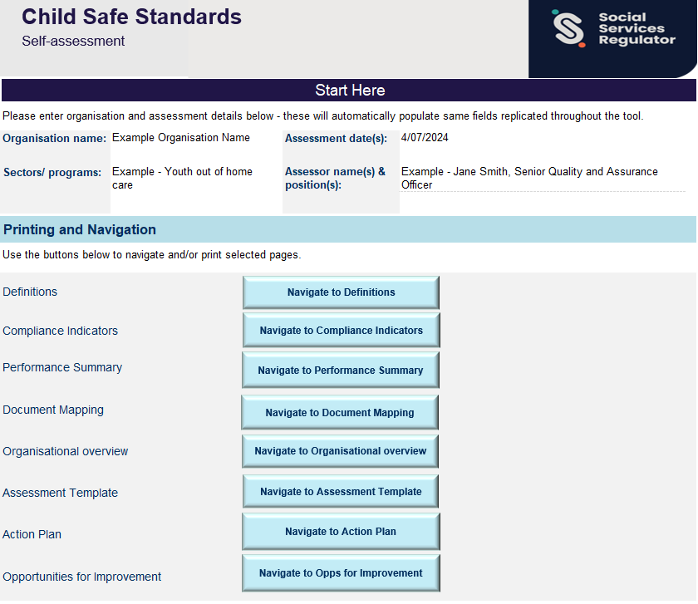

Step 2 – Review definitions
Table 2 lists the definitions used in an assessment to record a result to against minimum requirements in the ‘assessment template’ worksheet.
Table 2. Definitions used to assess compliance
Definitions | Reported as
Not assessed: Rating applied if the Standard/minimum requirement is not being assessed | Not assessed
Met: Rating applied when an aspect of the implemented system being assessed fully meets the requirements of the compliance minimum, demonstrating implementation of a system and the system is being maintained | Met
Partially met: Some aspects or parts of the compliance minimum are met/evidenced while others are not. The interpretation of the Standard/compliance minimum is correct, but the manner of implementation is not effective enough | Partially met
Not met: Rating applied when an aspect of the system being assessed does not meet the requirements of the compliance minimum, due to an absence of a system and/or strategy, or the failure to implement or maintain the system/strategy | Not met
Opportunity for improvement: rating applied to a minimum compliance requirement (document or activity) as a proactive comment where:  - The assessor identifies an aspect (document or action) that meets minimum compliance however the organisation has the capacity to meet the compliance requirement more effectively;  - The assessor identifies an aspect (document or action) that mostly meets minimum compliance, though some minor evidential gaps/non-compliance were observed which would not lead to a systems/process failure. (e.g. X out of 10 staff training records were available at time of assessment). | Opportunity for improvement

Step 3 – Compliance indicators
On the ‘compliance indicators’ worksheet, each Standard, associated compliance indicators and suggested documentation and actions have been described in full.
Compliance indicators show you the type of policies, procedures, processes and actions that you can use to keep young people safe. Compliance indicators can also help you identify potential gaps or opportunities for improvement.
Each Standard in the ‘assessment template’ worksheet is hyperlinked to the relevant Standard in the ‘compliance indicator’ worksheet. Figure 2 shows you where to find the hyperlink to a Standard in the ‘assessment template’ worksheet.
The hyperlink to the ‘compliance indicators’ worksheet is in the top left-hand corner of the in the ‘assessment template worksheet’, as shown in Figure 2. It will be labelled with ‘Standard’ and then the number of the standard it links to.
Figure 2. Hyperlink to 'compliance indicator' worksheet
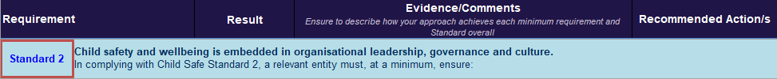
Figure 3 identifies the hyperlinked text to jump from the ‘Assessment Template’ worksheet to the ‘Compliance Indicators’ worksheet.
Figure 3. Standard 2 minimum requirements, documents and actions
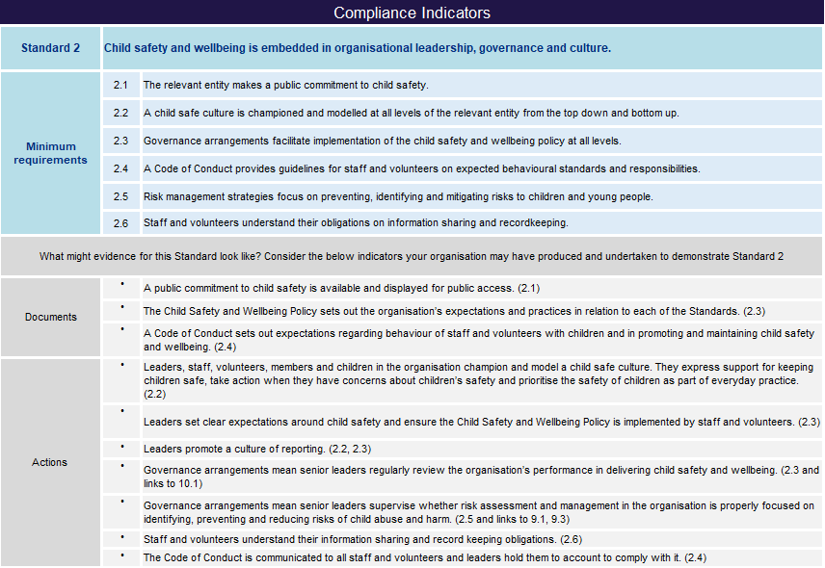
Figure 3 is a screenshot from the assessment tool. Table 3 shows all the text recorded in Figure 3.

Table 3. Standard 2 minimum requirements, documentation and actions
Standard 2 | Child safety and wellbeing is embedded in organisational leadership, governance and culture
Minimum requirements | - 2.1 The relevant entity makes a public commitment to child safety  - 2.2 A child safe culture is championed and modelled at all levels of the relevant entity from the top down to the bottom up.  - 2.3 Governance arrangements facilitate implementation of child safety and wellbeing at all levels  - 2.4 A code of conduct provides guidelines for staff and volunteers on expected behavioural standards and responsibilities  - 2.5 Risk management strategies focus on preventing, identifying and mitigating risks to children and young people  - 2.6 Staff and volunteers understand their obligations on information sharing and recordkeeping.
Documents | - 2.1 A public commitment to child safety is available and displayed for public assessment  - 2.3 The Child Safety and Wellbeing Policy sets out the organisation’s expectations and practices in relation to each of the Standards  - 2.4 A Code of Conduct sets out expectations regarding behaviour of staff and volunteers with children and in promoting and maintaining child safety and wellbeing
Actions | - 2.2 Leaders, staff, volunteers, members and children in the organisation champion and model a child safe culture. They express support for keeping children safe, take action when they have concerns about children’s safety and prioritise the safety of children as part of everyday practice  - 2.3 Leaders set clear expectations around child safety and ensure the Child Safety and Wellbeing Policy is implemented by staff and volunteers  - 2.2 and 2.3 Leaders promote a culture of reporting  - 2.3 Governance arrangements mean senior leaders regularly review the organisation’s performance in delivering child safety and wellbeing  - 2.5 Governance arrangements mean senior leaders supervise whether risk assessment and management in the organisation is properly focused on identifying, preventing and reducing risks of child abuse and harm  - 2.6 Staff and volunteers understand their information-sharing and record-keeping obligations  - 2.4 The Code of Conduct is communicated to all staff and volunteers and leaders hold them to account to comply with it

Step 4 – Organisational overview
The organisational overview helps you to identify your organisational context. The organisational overview is a mix of tick boxes and free text fields. It asks you to:
- provide an overview of your organisation’s service delivery and
- provide details on how your organisation interacts and works with children and young people.
This step can be used as a reflective process to identify activities or services for children and young people that are relevant to a Standards assessment. It can help your organisation identify areas to focus on during an assessment. It can also help your organisation understand where consideration and action may be needed to address potential risks for children and young people.

Step 5 – Document mapping
Document mapping helps you identify and communicate how your organisation is meeting the minimum requirements of the Standards. It’s a tool to identify the gaps in your compliance and opportunities to improve.
Record all relevant documents and information that demonstrates compliance with the Standards in the ‘documented evidence mapping’ table. Each Standard includes minimum requirements that organisations must meet. Organisations may have documents or activities that individually meet more than one minimum requirement. Detail all minimum requirements covered by each document. Figure 4 shows how to map documentation or evidence.
Note: If your organisation has been asked to complete a self-assessment by the Regulator, you must complete the document mapping as part of your submission of evidence.
Figure 4. Mapping evidence against the Standards
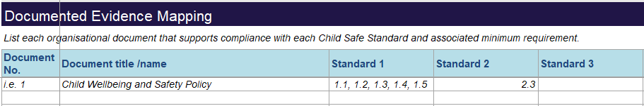
Figure 4 shows an example of text that may be recorded, including document number, document title/name and what minimum requirements this document meets.
For example, you have identified your organisation has a Child Safety and Wellbeing Policy that meets minimum requirements 1.1, 1.2, 1.3, 1.4 and 1.5 that also meets minimum requirement 2.3. This should be recorded as part of the evidence mapping exercise.

Step 6 – Self-assessment template
This part of an assessment requires you to select a result and write evidence, comments or recommended actions against a minimum requirement. The results selected will auto-populate fields in the ‘performance summary’ worksheet.
‘Evidence/comments’ and ‘recommended action/s’ are free-text fields where you can write about the documents and actions that you have in place to prove compliance, and any recommended action/s that would improve compliance with the Standards or remedy non-compliance.
Note: If your organisation has been asked to complete a self-assessment by the Regulator you must select a result and provide supporting commentary in the ‘evidence/comments’ field. Organisations may choose to record recommended action/s, but this is not a requirement.

Recording assessor evidence and comments
When assessing minimum requirements, all evidence and comments should clearly describe what documents have been used and what actions have been implemented, and how these show your organisation’s compliance with the Standards. Regulatory bodies expect that any actions are proportionate to the size and complexity of your organisation, the nature of the services provided, and the people accessing the services.
For example, minimum requirement 2.4 is: a Code of Conduct that provides guidelines for staff and volunteers on expected behavioural standards and responsibilities.
In this scenario, the assessor may observe that the code of conduct outlines clear expectations for staff and volunteer behaviour. It specifically describes acceptable and unacceptable behaviour in relation to children and young people, and links to the policy and/or procedure for disciplinary action if there is a breach. To demonstrate how the code of conduct is embedded into practice, the assessor might note that the code of conduct is given to all new staff members and volunteers, and that it’s incorporated into induction processes and training.
Figure 5. Example of how to record evidence/comments in the assessment tool
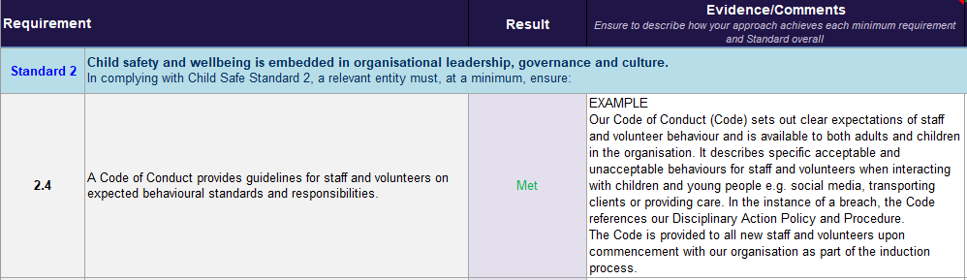
Figure 5 shows the result for minimum requirement 2.4 is ‘met’.
Evidence/comments example:
“Our Code of Conduct (Code) sets out clear expectations of staff and volunteer behaviour and is available to both adults and children in the organisation. It describes specific acceptable and unacceptable behaviours for staff and volunteers when interacting with children and young people e.g. social media, transporting clients or providing care. In the instance of a breech, the Code references our Disciplinary Action Policy and Procedure. The Code is provided to all new staff and volunteers upon commencement with our organisation as part of the induction process.”

Recording assessor recommendations
If your organisation cannot demonstrate compliance, the result should be recorded as ‘not met’ or ‘partially met’ against the relevant minimum requirement. This should be accompanied by recommended action/s to become compliant.
Using the previous example, if the assessor has observed that the Code of Conduct did not outline many unacceptable behaviours or reflect a new organisational policy, they would record any recommended action/s to fix the problem or gap.
Figure 6 shows you how you might record recommended action/s in the assessment tool.
Figure 6. Example of how to record recommended action/s
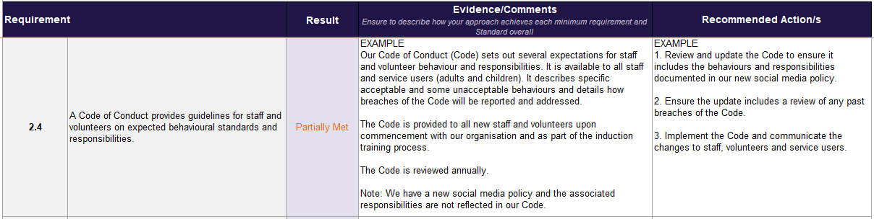
Figure 6 shows that minimum requirement 2.4 is recorded as ‘partially met’.
Evidence/comments example:
“Our code of conduct (Code) sets out several expectations for staff and volunteer behaviour and responsibilities. It is available to all staff and service users (adults and children). It describes specific acceptable and some unacceptable behaviours and details how breaches of the Code will be reported and addressed.
The Code is provided to all new staff and volunteers upon commencement with our organisation and as part of the induction training process. The Code is reviewed annually.
Note: We have a new social media policy and the associated responsibilities are not reflected in our Code.”
Recommended action example:
- Review and update the Code to ensure it includes the behaviours and responsibilities documented in our new social media policy
- Ensure the update includes a review of any past breaches of the Code
- Implement the Code and communicate the changes to staff, volunteers and service users.

Step 7 – Action plan
When the result against a minimum requirement is selected as ‘not met’ or ‘partially met’ in the tool, any recommended action/s, will automatically populate in the ‘action plan’ worksheet.
Agreed actions and the people responsible for them can then be recorded against the action plan. This will help you to address areas of non-compliance. Figure 7 and Figure 8 below show this process.
Figure 7. Example of a minimum requirement recorded as 'not met'
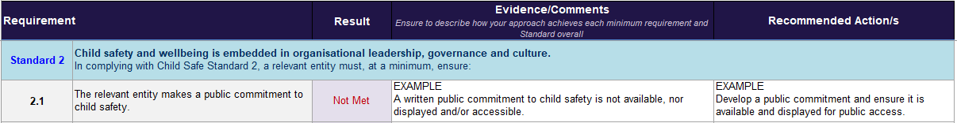
Figure 7 shows that compliance indicator 2.1 (the relevant entity makes a public commitment to child safety) as ‘not met’.
Evidence/comments example:
“A written public commitment to child safety is not available, nor displayed and/or accessible.”
Recommended action example:
“Develop a public commitment and ensure it is available and displayed for public access”
The recommended action recorded by the assessor will then auto populate in the ‘Action Plan’ worksheet.
Figure 8. Example of a recommended action in the 'action plan' worksheet
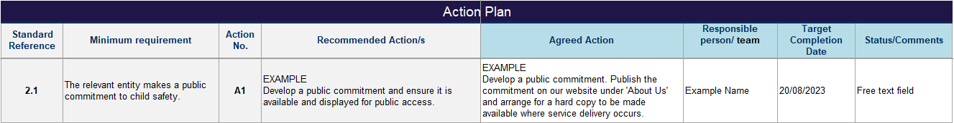
Figure 8 gives an example of minimum requirement 2.1 (the relevant entity makes a public commitment to child safety) as action reference number ‘A1’. The assessor recommendations to develop a public commitment are auto populated from the ‘assessment template’ worksheet.
Recommended action example:
“Develop a public commitment and ensure it is available and displayed for public access”
Agreed action example:
“Develop a public commitment. Publish the commitment on our website under ‘about us’ and arrange for a hard copy to be made available where service delivery occurs.”

Step 8 – Opportunities for improvement
An ‘opportunity for improvement’ result is the equivalent of ‘met’ for compliance purposes. But it also means the assessor found that a document or activity could meet the minimum requirement more effectively.
Where a minimum requirement has been assessed as an opportunity for improvement in the ‘assessment template’ worksheet, it will automatically populate in the ‘opportunities for improvement’ worksheet along with any recommended action/s recorded by the assessor. Figure 9 and Figure 10 show this process.
Figure 9. Example of a minimum requirement recorded as 'opportunity for improvement'
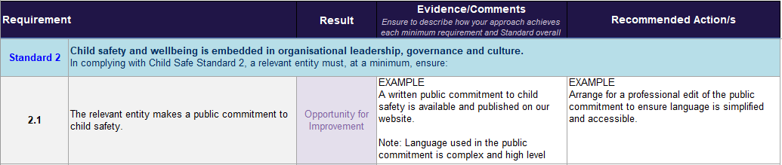
Figure 9 shows examples of text in the ‘evidence/comments’ and ‘recommended actions’ fields when the result is ‘opportunity for improvement’.
Evidence/comments example:
“A written public commitment to child safety is available and published on our website. Note: Language used in the public commitment is complex and high level.”
Recommended actions example:
“Arrange for a professional edit of public commitment to ensure language is simplified and accessible.”
Figure 10. Example of an opportunity for improvement recorded in the 'opportunities for improvement' worksheet
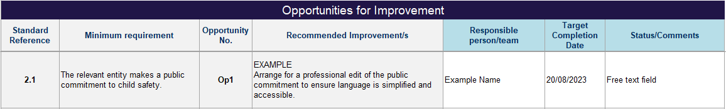
Figure 10 shows examples of text in the ‘recommended improvements’ fields, as well as in the ‘responsible person/team’, ‘target completion date’ and ‘status/comments’ fields.
Recommended improvements example:
“Arrange for a professional edit of the public commitment to ensure language is simplified and accessible.”

Step 9 – Performance summary
The assessment results fields in the ‘performance summary’ worksheet populate based on the result recorded against a minimum requirement in the ‘assessment template’ worksheet.
The ‘assessment results’ table will appear blank as ‘not assessed’ until a minimum requirement has been marked. Figure 11 and Figure 12 show this process.
Figure 11. Assessment results table before assessment
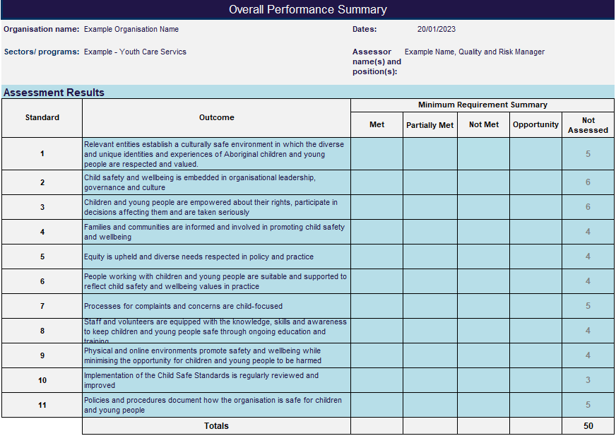
The text in Figure 11 shows a table with all 11 Standards. All Standards are marked as ‘not assessed’ and the total is 50. Once a result has been recorded against a minimum requirement in the ‘assessment template’ worksheet, the table will populate automatically.

Figure 12. Assessment table where a result has been recorded against some minimum requirements
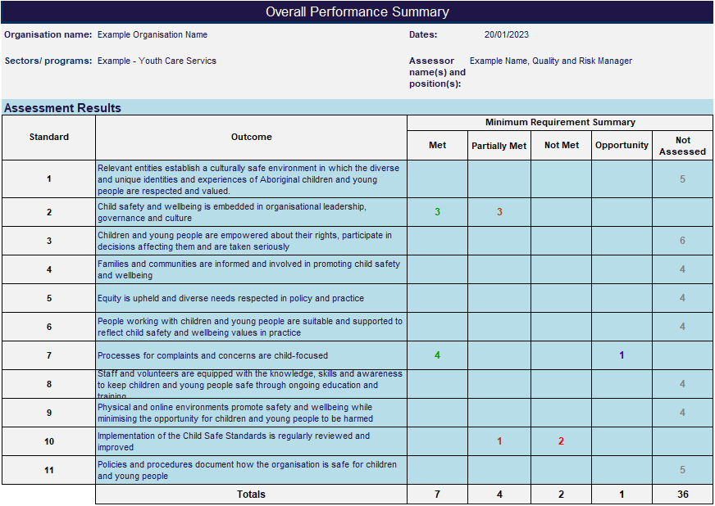
The text in Figure 12 shows the same table with 11 Standards. Some of the Standards have had a result recorded. For example:
- Standard 2 shows that 3 minimum requirements have been marked as ‘met’ and 3 have been marked as ‘partially met’
- Standard 7 shows that 4 minimum requirements have been marked as ‘met’ and one marked as ‘Opportunity’
- Standard 10 shows that one minimum requirement has been marked as ‘partially met’ and 2 marked as ‘not met’.
Totals at the bottom of the table show 7 minimum requirements are met, 4 are partially met, 2 are not met and one is an opportunity for improvement.
During an assessment, or after an assessment has been completed, you can record a summary of the self-assessment in the ‘performance summary’ worksheet. The summary section is located below the assessment results table and can be used to highlight key or broad findings from the assessment.
Figure 13. Summary comments
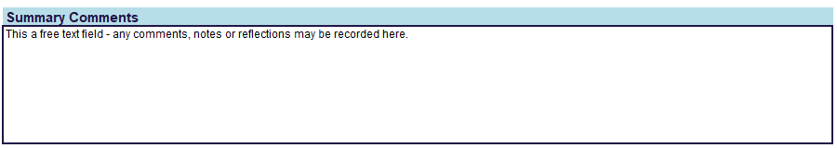
The text in Figure 13 describes that the ‘summary comments’ text box is a free text field – that any comments, notes or reflections on the assessment can be recorded here.

Further information
There is more information about the Child Safe Standards on the Social Services Regulator website. This includes additional resources for organisations regulated by the Social Services Regulator.
Organisations can also find information and resources on the on the Commission for Children and Young People’s website.

Appendix 1 – Definitions
Definitions used throughout this document.
Table 1: Definitions Child Wellbeing and Safety Act 2005
Term | Definition
Applicable entity Section 3(1) | applicable entity means—  (a) an incorporated body or association; or  (b) an unincorporated body or association (however structured); or  (c) an individual who—  (i) carries on a business; and  (ii) engages contractors, employees or volunteers to assist the business in providing services or facilities or in producing or providing goods.
Relevant entity Section 3(1) | relevant entity means—  (a) an entity that is required under section 19, 20 or 21 to comply with the Child Safe Standards; or  (b) an individual who is required under section 23 to comply with the Child Safe Standards.
Integrated Sector Regulator  Section 25F and section 25G | An integrated sector regulator may also perform functions or exercise powers that relate to the Child Safe Standards if it has such functions or powers under another authorising Act. The Social Services Regulator has such functions and powers under the Social Services Regulation Act 2021.
Sector regulators Section 25B (1) | (1) Subject to section 25C, sector regulator means—  (a) in relation to a relevant entity referred to in an item in Schedule 1 (other than a relevant entity that has an integrated sector regulator)—  (i) the prescribed sector regulator for that relevant entity; or  (ii) if no person or body is prescribed to be the sector regulator, or the person or body prescribed to be the sector regulator for the relevant entity no longer exists, the Commission; or  (b) in relation to a relevant entity that has an integrated sector regulator and that integrated sector regulator no longer exists, the Commission; or  (c) in relation to any other relevant entity, the prescribed sector regulator for that relevant entity.

Appendix 2 – Organisations regulated by the Social Services Regulator
Schedule 1 entities that are regulated by the Social Services Regulator are listed below:
- An applicable entity that receives funding under a State contract to provide early therapeutic intervention specifically for children with a disability, additional needs, or developmental delay
- A disability service provider within the meaning of the Disability Act 2006
- An applicable entity, other than a disability service provider within the meaning of the Disability Act 2006, that providers disability services
- An applicable entity that receives funding under a State contract to provide services in relation to family violence or sexual assault
- An applicable entity that receives funding under a State contract to provide support services for parents and families
- An applicable entity that receives funding under a State contract to provide housing services or other assistance to homeless persons
- An applicable entity that receives funding under a State contract to provide child protection services
- An out of home care service within the meaning of the Children, Youth and Families Act 2005
Refer to Schedule 1 of the Child Wellbeing and Safety Act 2005 for a full list of entities required to comply with the Standards.

To receive this document in another format, phone 1300 310 778 using the National Relay Service 13 36 77 if required, or email child safe orgs <childsafeorgs@ssr.vic.gov.au>
Authorised and published by the Victorian Government, 1 Treasury Place, Melbourne.
© State of Victoria, Australia, Social Services Regulator, November 2024
In this document, ‘Aboriginal’ refers to both Aboriginal and Torres Strait Islander people. ‘Indigenous’ or ‘Koori/Koorie’ is retained when part of the title of a report, program or quotation.
ISBN 978-1-76130-717-1 (pdf/online/MS word)

Available at Child Safe Standards <https://www.vic.gov.au/changes-regulation-child-safe-standards>

Child Wellbeing and Safety Act 2005
Child Wellbeing and Safety Act 2005, Gazette No. G 26 Thursday 1 July 2021
Child Wellbeing and Safety Act 2005, s.19(1)
Child Wellbeing and Safety Act 2005, s.19-21 and s.23
Child Wellbeing and Safety Act 2005, s30(1)
Child Wellbeing and Safety Act 2005, s40A(1)

