# Completing your Arrival Registration

## Information for users

A guide to support new users to create their account in Arrival.

To access Arrival, all users will need to complete an initial validation process that will involve:

1. Receiving your email invitation
2. Creating your user password
3. Setting up your method of two-factor authentication
4. Accepting the Arrival terms of use
5. Completing your registration.

### Steps to complete Arrival access

1. **Receiving your email invitation**

All new users will receive an email invitation from Arrival with a link to validate their access. This invitation link will come from [DoNotReply@arrival.educationapps.vic.gov.au](mailto:DoNotReply@arrival.educationapps.vic.gov.au) and is valid for 7 days from receipt of the email.

Click on ‘Validate access to Arrival’.

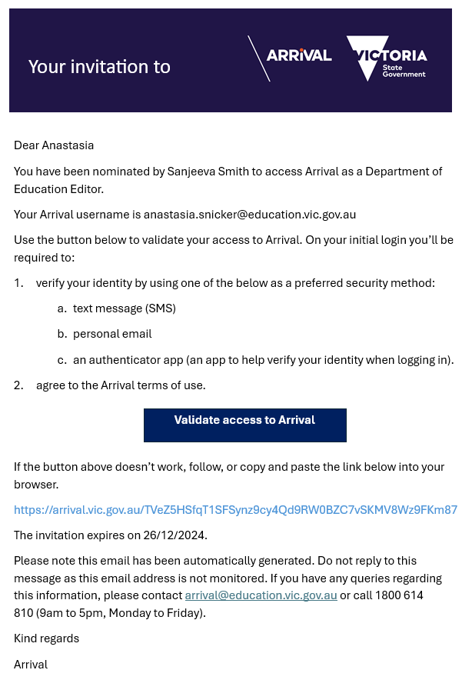

1. **Creating your user password**

Create a new password following the password requirements displayed on the right side of the page. Click ‘Continue’.

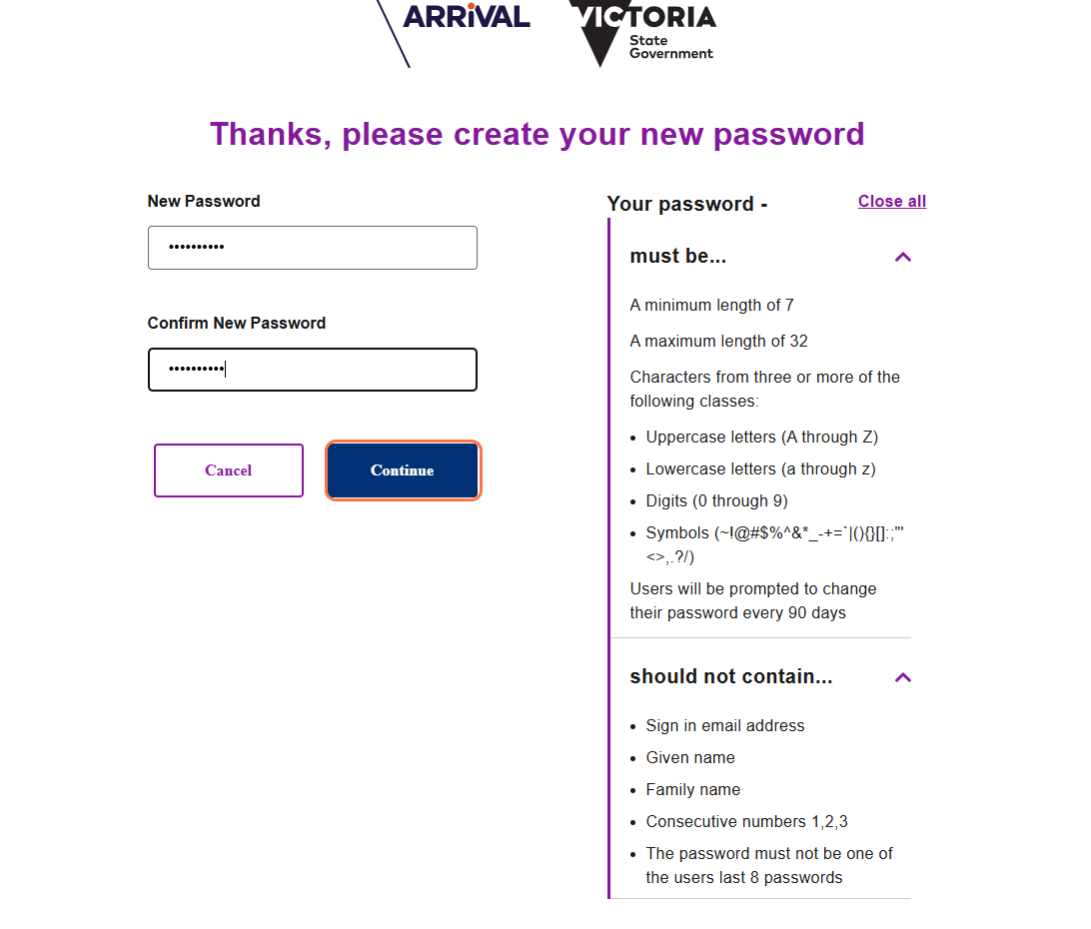

1. **Setting up your method of two-factor authentication**

Select your method of two-factor authentication from the displayed options. If selecting email, a home/private email address will be needed. Click ‘Continue’ and follow the steps to verify your selected method.

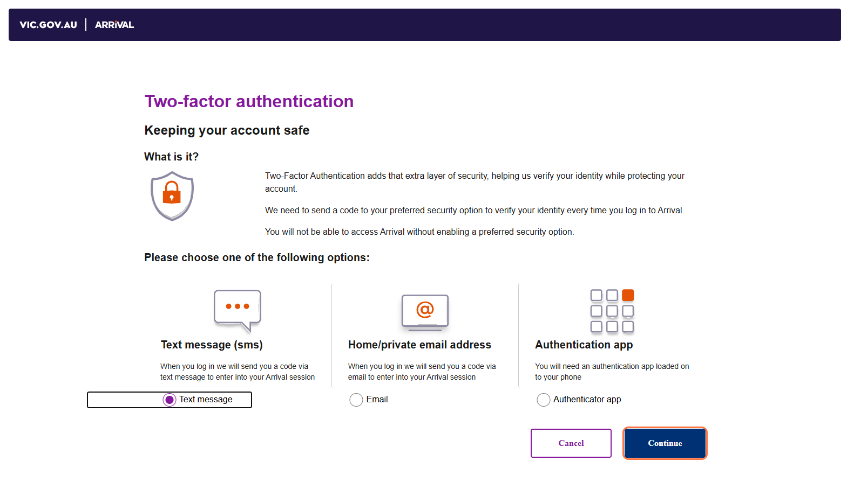

1. **Accepting the Arrival terms of use**

You must read through the Arrival terms of use and click the ‘I agree to the Arrival terms of use’ check box’ at the bottom of the screen. You may need to complete this process again in the future if the terms of use are updated. Click ‘Continue’.

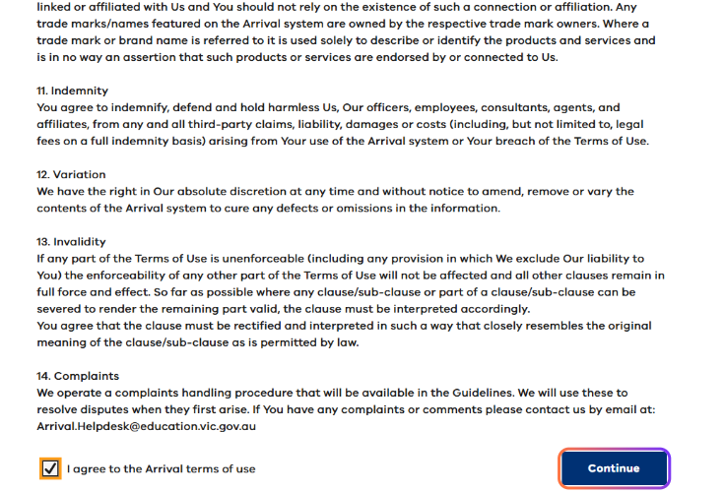

1. **Registration complete**

The service provider ‘Welcome Dashboard’ page will be displayed. Your access to Arrival is now complete. Next time you access the system you will be able to log in using your individual provider/service user email and password.

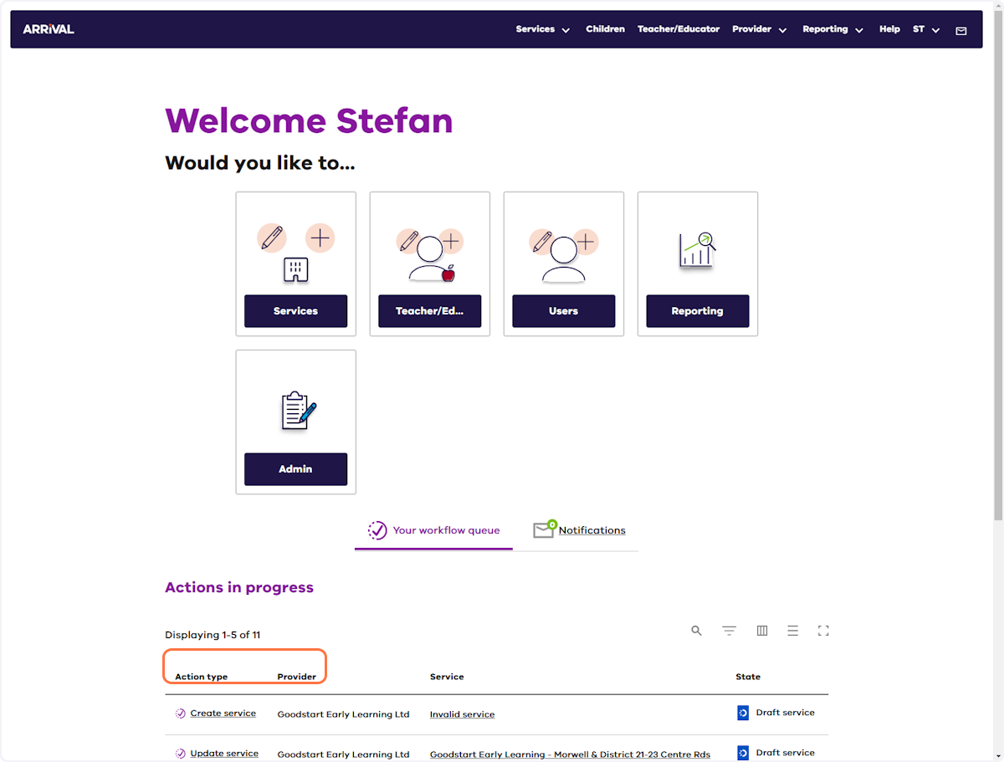

**N.B**: it is recommended you bookmark the Arrival page in your preferred browser for quick ongoing access - [**https://arrival.educationapps.vic.gov.au**](https://arrival.educationapps.vic.gov.au/)

### Further information

For further support contact the Arrival Helpdesk on 1800 614 810 or email [**Arrival.Helpdesk@education.vic.gov.au**](mailto:Arrival.Helpdesk@education.vic.gov.au)**.**