Circular Economy   
Market Report 2025

Table of Contents

Executive summary 1

Circularity rate 2

Material footprint 2

Material productivity 2

Overview 5

Measuring the circular economy 8

What is the circular economy? 8

Circular economy and economic growth 10

Circular economy measurement 12

Victorian metrics overview 14

Market overview and performance 2022–23 20

Market overview 21

Performance by activity 25

Right to repair 31

Case Study: Repair cafes 32

Performance by material 38

Aggregates, masonry and soil 38

Glass 44

Metals 49

Organics 55

Case study: Tackling barriers to food waste reduction 61

Case Study: Tackling barriers to food re-use 63

Paper and cardboard 66

Plastics 73

Tyres 81

Textiles 86

Emerging materials 93

Government policy and action 103

National action towards a circular economy 104

Victorian Government actions towards a circular economy 107

Conclusion 112

References 114

Appendix 1: Data method and quality 123

1.1 Data rounding 123

1.2 Data sources 123

1.3 Data quality and updates 124

1.4 Circular economy metric methods 125

Publication information 128

Acknowledgements 128

Copyright 128

Creative Commons 128

Disclaimer 129

Accessibility 129

# Executive summary

Recycling Victoria’s vision is for a world class circular economy system that helps build a sustainable future for all Victorians. The role of Recycling Victoria is to provide leadership, stewardship and oversight of Victoria’s waste and resource recovery services, to support a strong and resilient circular economy with robust market investment and growth.

The preparation of an annual Circular Economy Market Report is a legislative requirement under the *Circular Economy (Waste Reduction and Recycling) Act 2021* (CE Act). A circular economy market is defined in the CE Act as “the market for waste, recycling or resource recovery services within the circular economy.”

The Circular Economy Market Report 2025 (CEMR 2025) delivers against Recycling Victoria’s Strategic Plan 2023−2026 (Recycling Victoria 2023), through the provision of regular, timely and quality market data and insights. These insights help to identify key investment opportunities, gaps, and issues, with a view to enabling stronger circular economy interventions, as well as recommended focus areas for further investigation to improve circularity within the major material streams.

**The CEMR 2025 is informed by Victorian market sector data collected for the 2022–23 financial year and provides best available information about performance relating to the generation, collection, sorting, re-processing or re-manufacturing of waste within Victoria’s circular economy market.**

Recycling Victoria remains committed to expanding Victoria’s waste data systems to inform better decision-making that allow the government to monitor progress towards a circular economy.

The CEMR 2025 introduces 3 new metrics to measure circular economy performance for the whole state. This fulfils a commitment in *Recycling Victoria – a new economy policy* for the Victorian Government to establish a framework for monitoring progress towards the circular economy, including the identification of indicators and metrics.

The new metrics: circularity rate, material footprint and material productivity, align with the Circular Economy Ministerial Advisory Group final report [The Circular Advantage](https://www.dcceew.gov.au/sites/default/files/documents/circular-advantage-final-report-cemag.pdf) recommending these metrics serve as the foundation for Australia’s circular economy targets, and [Australia’s Circular Economy Framework](https://www.dcceew.gov.au/sites/default/files/documents/australias-circular-economy-framework.pdf).

## Circularity rate

**Circularity rate** measures the percentage of all consumed materials that are recycled, serving as an indicator of material reuse. **Victoria’s circularity rate is 7.5%** which is higher (better) than the National circularity rate (4.4%) which is calculated using the same formula, and higher than the global average (7.2%).

## Material footprint

**Material footprint** is a key indicator of overall environmental sustainability. It measures virgin (raw) material demand per capita within an economy. **The material footprint for Victoria is 28.1 tonnes per person** which is lower (better) than the national material footprint figure of 31.0 tonnes per person.

## Material productivity

**Material productivity** quantifies the economic output or value added per unit of materials consumed. Higher material productivity helps to mitigate environmental impacts associated with virgin material consumption. **The material productivity for Victoria is $3.49 per kilogram of materials consumed**, which is higher (better) than the national material productivity figure of $2.04 per kilogram.

The CEMR 2025 continues to report on waste generation per capita and recovery rate, as relevant for tracking against state targets.

Victoria generated 14.5 million tonnes of material in 2022–23, with 9.9 million tonnes recovered for reprocessing, which resulted in a state-wide recovery rate of 69%.

Per capita, **Victoria generated 2.2 tonnes of waste per person**.

Key insights from analysing the 2022–23 Victorian market sector data indicate a mix of steady performance in the construction and demolition (C&D) sector, a positive trend in municipal solid waste (MSW) recovery and challenges in maintaining or improving recovery rates in the commercial and industrial (C&I) sector.

Total material generation has decreased by over 1 million tonnes since 2020–21 but is relatively consistent with total material generation for the following financial year (2021–22). This decline is primarily driven by reductions in material generation within the C&D sector.

Victoria recovered and circulated an estimated $1.8 billion worth of materials back into the economy in the 2022–23 financial year. Materials with the potential value of $1.3 billion were lost to landfill, indicating more can be done to support markets in capturing this unrealised economic contribution. Plastics and textiles continue to have low recovery rates.

Organics, food waste in particular, across the C&I sector, has potential to achieve significant gains in improving circular economy outcomes. The roll out of kerbside food organics and garden organics (FOGO) services addresses the issue with households. The opportunity remains to drive investment and reform effort to strengthen the systems for collection and processing in the C&I sector as well dealing with contamination.

The C&D sector remains the largest contributor to material generation by weight across the 3 sectors, accounting for nearly 50% of the total tonnes. This is largely due to the significant quantities of heavy materials, such as aggregates, masonry and soils, generated by the sector.

The CEMR 2025 market insights and application of the new circular economy metrics for the first time, provide an important benchmark to inform future policy decision making, and investment choices, that will help accelerate Victoria toward its circular economy goals.

# Overview

**Recycling Victoria’s vision is for a world-class circular economy system that helps build a more sustainable future for all Victorians.**

Recycling Victoria commenced in July 2022 to provide leadership, stewardship and oversight of Victoria’s waste and resource recovery services to support a strong and resilient circular economy with robust market investment and growth.

Its strategic priorities for 2023 to 2026 include providing strategic market information for greater market transparency, and confidence to enable stronger circular economy opportunities.

Victoria is developing a waste and resource recovery system that minimises waste generation and maximises resource recovery. Everyone has a part to play – without collaboration between industry, community and local, state and national governments, we cannot achieve the required transition to a new system of resource management and move closer to a circular economy.

The cornerstones of the Victorian transition to a circular economy are the *Recycling Victoria – a new economy* policy and the *Circular Economy (Waste Reduction and Recycling) Act 2021* (CE Act).

The CE Act provides the foundation for Victoria’s transition to a sustainable and thriving circular economy, including enabling laws for the Container Deposit Scheme and state-wide standardised 4 stream household waste and recycling system. A circular economy market is defined by the CE Act as “the market for waste, recycling or resource recovery services within the circular economy.”

Along with the alignment between the policy preparation and delivery at national, state and local government levels, there are synergies between the CE Act, the Recycling Victoria policy and the United Nations (n.d.a) Sustainable Development Goals.

The Sustainable Development Goals, amongst other things, aim to make cities and human settlements sustainable, ensuring sustainable consumption and production patterns. The transition to a circular economy is most strongly aligned with goal 12 (Responsible Consumption and Production), which has targets on waste generation, food waste, champions sustainable management and promotes the use of natural resources amongst other aims (Figure 1).

Figure 1: The 12 Sustainable Development Goals aligned with Recycling Victoria’s objectives and actions (United Nations n.d.)

The 12 Sustainable Development Goals aligned with Recycling Victoria’s objectives and actions (United Nations n.d.)

The Recycling Victoria: a new economy policy sets 4 key targets:

* Divert 80% of waste from landfill by 2030, with an interim target of 72% by 2025.
* Cut total waste generation by 15% per capita by 2030.
* Halve the volume of organic materials going to landfill between 2020–2030, with an interim target of 20% reduction by 2025.
* Ensure every household has access to food and garden organic waste recycling services or local composting by 2030.

Recycling Victoria’s vision and strategic objectives each support the *Recycling Victoria: a new economy* policy for the management of waste and recycling in Victoria, which sets a plan to transition Victoria to a circular economy through the following goals:

* Design to last, repair and recycle.
* Use products to create more value.
* Recycle more resources.

Reduce harm from waste and pollution.

The CEMR 2025 relates to these goals by:

* measuring material stream waste generated in Victoria
* identifying barriers and opportunities in each stream to achieve circularity

identifying emerging new material streams entering the Victorian market.

The CEMR 2025 also provides an overview of the current circular economy market in Victoria, using a combination of sector survey data from activities during 2022–23 and publicly available information from 2024, including export data for each material stream.

The Victorian Government aims to be a national leader in the way the circular economy and material circularity is measured. The *Recycling Victoria – a new economy* policy includes a commitment to develop new Victorian circular economy metrics.

The CEMR 2025 delivers on this objective, providing improved ways to understand, measure and track Victoria’s circular economy.

# Measuring the circular economy

## What is the circular economy?

A circular economy aims to keep products and materials at their highest value for as long as possible to reduce the need for virgin materials and keep overall material use within the planetary boundaries.

The circular economy is an economic model that seeks to address these challenges (Figure 2). It is a system where products are designed, marketed and delivered with a reduced reliance on raw or virgin materials, and are made to be reusable, durable, repairable and shareable, to achieve an extended life cycle (The State of Victoria 2021). A circular economy emphasises the design of products and systems for reuse and recovery, aiming to establish business models, production and consumption practices that create a closed-loop system for resource utilisation.

Governments around the world are making the shift to a more circular global economy and many businesses are employing circular economy principles. Progressing a circular economy will allow Victoria to strengthen and future proof its economy by fostering innovation, attracting investment and creating new jobs in recycling and remanufacturing. This will ensure future generations benefit from a cleaner, more sustainable environment.

A circular economy focuses on 3 key economic and industrial goals (Ellen Macarthur Foundation n.d.). Eliminating waste, maintaining and increasing the value of materials and products through repeated use and conserving natural resources.

Figure 2: Resource flows in a circular economy (Recycling Victoria 2020)

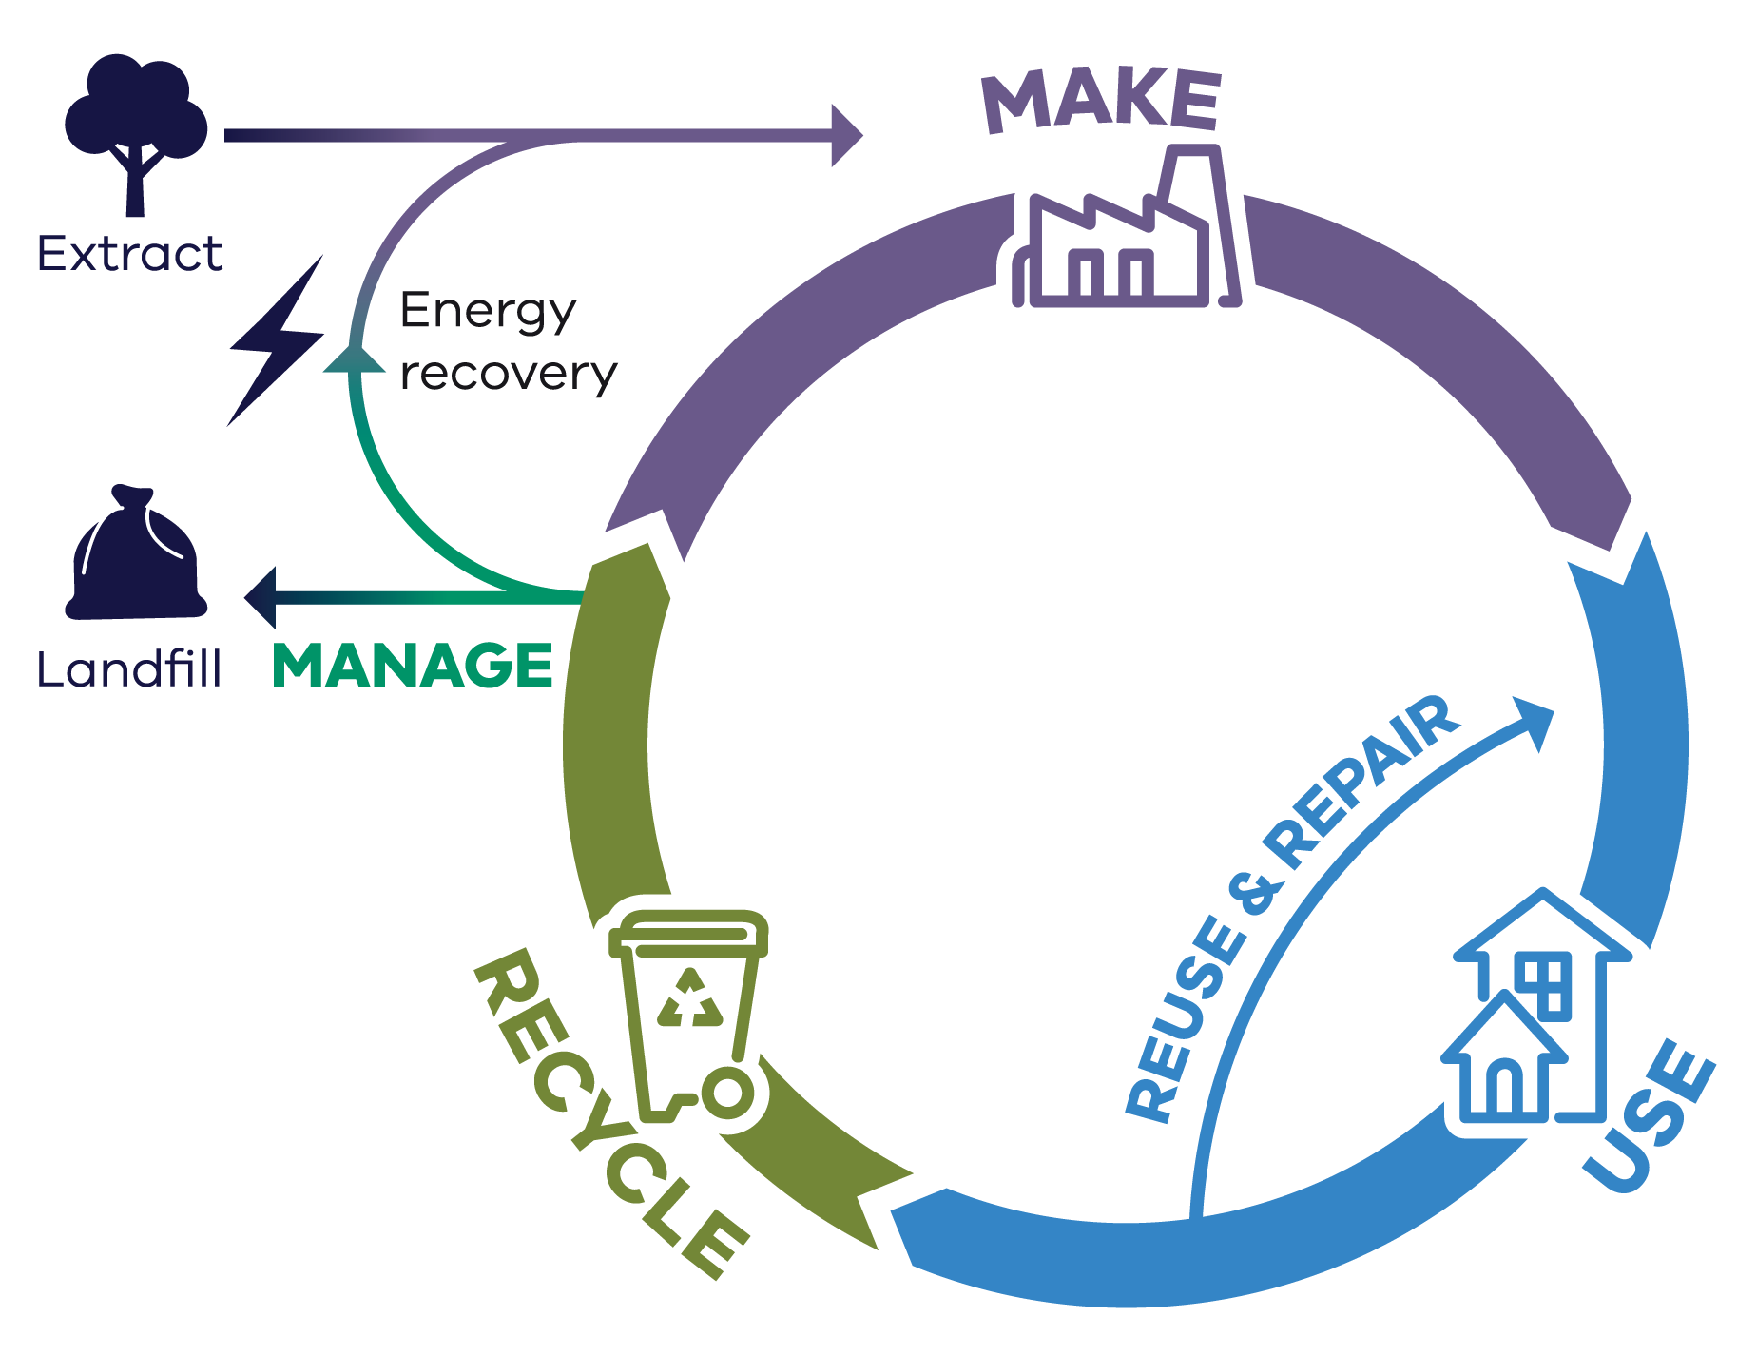

A more circular economy is consistent with economic growth and higher living standards. It drives sustainable growth by focusing on resource efficiency, avoiding and reducing waste, and promoting recycling and reuse.

The circular economy has become a mainstream focus for industry development, resource security and waste and resource recovery policies around the world. The European Union (EU) has taken a strong lead with *Closing the loop* – an EU action plan for a circular economy, supported by national strategies in Denmark (Danish Ministry of Environment and Gender Quality 2018), Finland (Laita 2019), France (French Government 2018), Germany (Circular Economy Initiative n.d.), the Netherlands (Government of the Netherlands n.d.) and Slovenia (Republic of Slovenia 2023), among others.

There are also non-government actors who focus on intervention points in global production systems, such as PACE (Platform for Accelerating the Circular Economy) (PACE n.d.), a neutral, public/private collaboration supported by the World Economic and the World Resources Institute.

Several key industry sectors in Australia (including mining, construction, manufacturing, agriculture, waste management and resource recovery) have core roles to play in the transition to a circular economy (Schandl et al. 2023).

This report focuses on measuring the potential of the Victorian waste, recycling and resource recovery industry.

## Circular economy and economic growth

Businesses and governments around the world are increasingly recognising the value of ‘going circular’. A global economy that minimises waste, has the potential to unlock $4.5 trillion dollars in value by 2030 (Accenture 2015). The economic benefit expected for Australia from adopting a circular economy has been estimated to be $210 billion by 2048. This equates to 11.4% of GDP and would lead to an additional 17,000 (FTE) jobs. (Schandl et al. 2023).

Victoria has a vibrant, diverse and growing economy. Victoria’s population is expected to exceed 10 million within the next 25 years. This growth will require more than 1.6 million new dwellings, requiring significant material resources for housing and infrastructure to accommodate this growth (DTP 2023).

The current economic climate has witnessed a sustained period of inflation, pushing up the price of groceries, household costs and other daily expenses. The costs of construction materials have significantly increased, elevating the overall costs of infrastructure projects across the state. The combination of historically low unemployment, high inflation and the continued impact of COVID-19 has created challenges in obtaining sufficient resources to deploy the workforce and materials for this work (DTF 2024). These factors underscore the need to transition to a circular economy that is resourceful and efficient in its use of materials to generate economic productivity.

Accompanying these challenges, Victoria continues to respond to the need to combat climate change. The transition to net zero emissions and to a more circular economy are complementary policies. Creating more efficient products with less waste and lower energy consumption reduces emissions and aligns with Victoria’s target of net zero emissions by 2045, and Victoria’s targets of maximising landfill diversion and minimising waste generation.

A transition to a circular economy will be a catalyst for Victoria’s future economic growth in the following ways:

* **Resource efficiency** – maximising the use of resources that can lower costs and increase productivity, leading to economic growth without the need for extra raw materials.
* **Innovation** – in product design and business models, creating new markets and jobs.
* **Sustainability and resilience** – reducing environmental impacts and protecting natural resources, thereby enhancing the long-term viability of industries and communities.
* **Decarbonisation and resilience** – achieving emissions targets and future-proofing Victoria in a rapidly decarbonising world.
* **Consumer demand** – promoting demand for circular products and services, fuelling economic activity.

**Investment opportunities** – attracting investment in green technologies, renewable energy and sustainable practices.

A circular economy values Victoria’s goals of sustainability, reduced emissions and efficient resource usage.

**Moving toward a circular economy will contribute to placing Victoria on the path to achieving net zero emissions by 2045 and aligning economic growth with Victoria’s environment.**

## Circular economy measurement

### Global context

International initiatives, such as the EU’s Circular Economy Action Plan and the UN’s Sustainable Development Goals, have inspired efforts to develop metrics that can track circularity at the global level. These initiatives focus on key indicators such as resource productivity, recycling rates, waste reduction and material efficiency. Despite these developments, challenges remain in establishing universally accepted measurement frameworks that account for differences in industrial practices, economic development and social contexts across countries (European Commission 2020).

The Circularity Gap Report, published annually by the Circular Economy Institute, is one example of a global effort to assess circularity. It uses indicators such as the share of recycled materials in global production and the percentage of resources reused or recycled within a given economy. While useful, these indicators are difficult to apply to certain industries or regions.

Recently, the Organisation for Economic Co-operation and Development (OECD) published a conceptual framework and indicator set to monitor progress in the transition towards a more circular economy and inform international circular economy policies at national levels (OECD 2024).

The purpose of the OECD report is to provide a clear, consistent and data-driven approach to measuring the circular economy, which will support informed decision making and policy development. By establishing common definitions, indicators and measurement approaches, it ensures progress towards a circular economy can be effectively tracked.

While the OECD report has progressed the thinking and approach to measuring circularity, it does highlight challenges in the measurement of boundaries and classifications, as well as data availability and quality.

With new international standards (ISO) recently released, (ISO 59020:2024) we can expect that measuring and assessing circularity performance will continue to evolve as global understanding and maturity in circular economy practices evolves.

While the work of international bodies and agencies in the creation and sharing of frameworks, data and reports is important, each nation needs to have a detailed understanding of local context and opportunities.

This is demonstrated by the findings of the United Nations Department of Economic and Social Affairs (United Nations n.d.b) that the material footprint per capita in high-income countries is 10 times the level of low-income countries, highlighting unequal responsibilities and consumption disparities between import oriented and export oriented and high income and low income countries.

### National context

The Australian Government plays a key role in partnering with the states and territories in the harmonisation of data collection and analysis. To provide specific advice to the Australian Government on the transition to a more circular economy, the Circular Economy Ministerial Advisory Group (Advisory Group) was created in February 2023.

An interim report was released by the Advisory Group in April 2024 (DCCEEW 2024a) recommending the development of the National Circular Economy Framework. The report recommended to set national and sector-based circular economy targets and routinely measure and report progress against the following upstream indicators of circularity in the Measuring What Matters framework (DCCEEW 2024a):

* National extent of circularity.
* Material footprint.
* Domestic material consumption.
* Resource productivity.
* Waste generated per person.

Resource recovery rate – portion of waste recovered for reuse, recycling or energy.

In December 2024, the Advisory Group released a final report, The Circular Advantage, (DCCEEW 2024b) recommending that 3 indicators (material footprint, material productivity and resource recovery rates) serve as the foundation for Australia’s circular economy targets.

## Victorian metrics overview

Effective measurement of the circular economy in Victoria will inform better decision making, allow government to monitor progress, highlight areas and opportunities for circularity improvement and help direct investment.

Recovery rates of individual material streams have historically been used as the best available proxy to provide insights into Victoria’s circular economy. While it provides a good representation of the performance of each material stream, it is limited in its ability to measure, monitor and progress Victoria’s circular economy transition.

This CEMR 2025 outlines the circular economy metrics to monitor and measure Victoria’s progress towards a circular economy. The metrics have been selected with a focus on what can be measured with the data available today, and to ensure alignment where possible with Australia’s Circular Economy Framework released in December 2024 (DCCEEW 2024j).

The new state-based metrics will add to the existing waste reporting metrics. Refer to Appendix 1: Data method and quality for calculations.

### Circularity rate

**Circularity rate:** This metric measures the percentage of all consumed materials that are recycled, serving as an indicator of material reuse. It includes materials recycled within Victoria as well as recycled material within imported products. In other words, it reflects the percentage of recycled materials within the total materials used in the national or state economy. A higher circularity rate means that a country or region uses a larger proportion of recycled materials. (DCCEEW 2024b).

### Material footprint

**Material footprint:** A key indicator of overall environmental sustainability, this metric measures the virgin (raw) material demand per capita within an economy, regardless of the source of those raw materials. Material footprint is a consumption-based indicator of the material requirements for final demand and provides a proxy for assessing the environmental pressures and impacts associated with material living standards. It can be described as how much material is used to create the products consumed or services provided in Victoria. It is measured in tonnes per capita. A lower material footprint means that a country or region is efficient in its use of raw materials to service the needs of the population.

### Material productivity

**Material productivity:** This metric measures the efficiency of raw material use in production processes, expressed as a ratio of economic output to the amount of material consumed. A higher material productivity means that the economy is generating more output with equal or less material input, reducing material waste and therefore environmental impact (DCCEEW 2024g). It is measured in Australian dollars (AU$) per kilogram (kg). The measure will increase as materials are used more than once, since reuse does not add to consumption, but it does contribute to the economy.

These 3 metrics have been informed by CSIRO research and modelling. They are also used in the Measuring What Matters Framework (Treasury 2023) for the circular economy domain. While the modelling was originally developed to measure these metrics at a national level, CSIRO has provided support and data to enable the calculation at a state level.

Table 1: New circular economy metrics for Australia and Victoria

| Circular metric | Unit | Australian comparator (2023) | Victoria (2022–23)# |
| --- | --- | --- | --- |
| Circularity rate | % | 4.4%* | 7.5%^ |
| Material footprint | Tonnes per capita | 31.0* | 28.1^ |
| Material productivity | AUD/kg | 2.04† | 3.49^ |

**\*** from “[Measuring What Matters](https://www.abs.gov.au/statistics/measuring-what-matters/measuring-what-matters-themes-and-indicators/sustainable/circular-economy)”, DCCEEW and ABS 2024

**†** calculated using Australia’s gross domestic product (GDP) in current prices. Australia’s 2023 value reported in “Measuring What Matters” is $1.58 AUD/kg, which was calculated using constant 2015 prices. DCCEEW and ABS 2024, CSIRO 2024.

**^** calculated using datasets maintained by Recycling Victoria, as well as data sourced from or provided by National Waste Database (Blue Environment 2024), CSIRO, ABS, and UNEP IRP (2024) Global Material Flow and Resource Productivity Database.

**#** at time of writing, no up-to-date values for domestic material consumption or material footprint in Victoria were available. A value has therefore been calculated by applying assumptions based on 2019 data (provided by CSIRO) to 2022–23 national material flow values to estimate values for Victoria in 2022–23.

Recycling Victoria acknowledges that, as the application of these metrics is new, future adjustments to the reported calculations may be required.

Image 1: Circularity rate, Material footprint and Material productivity

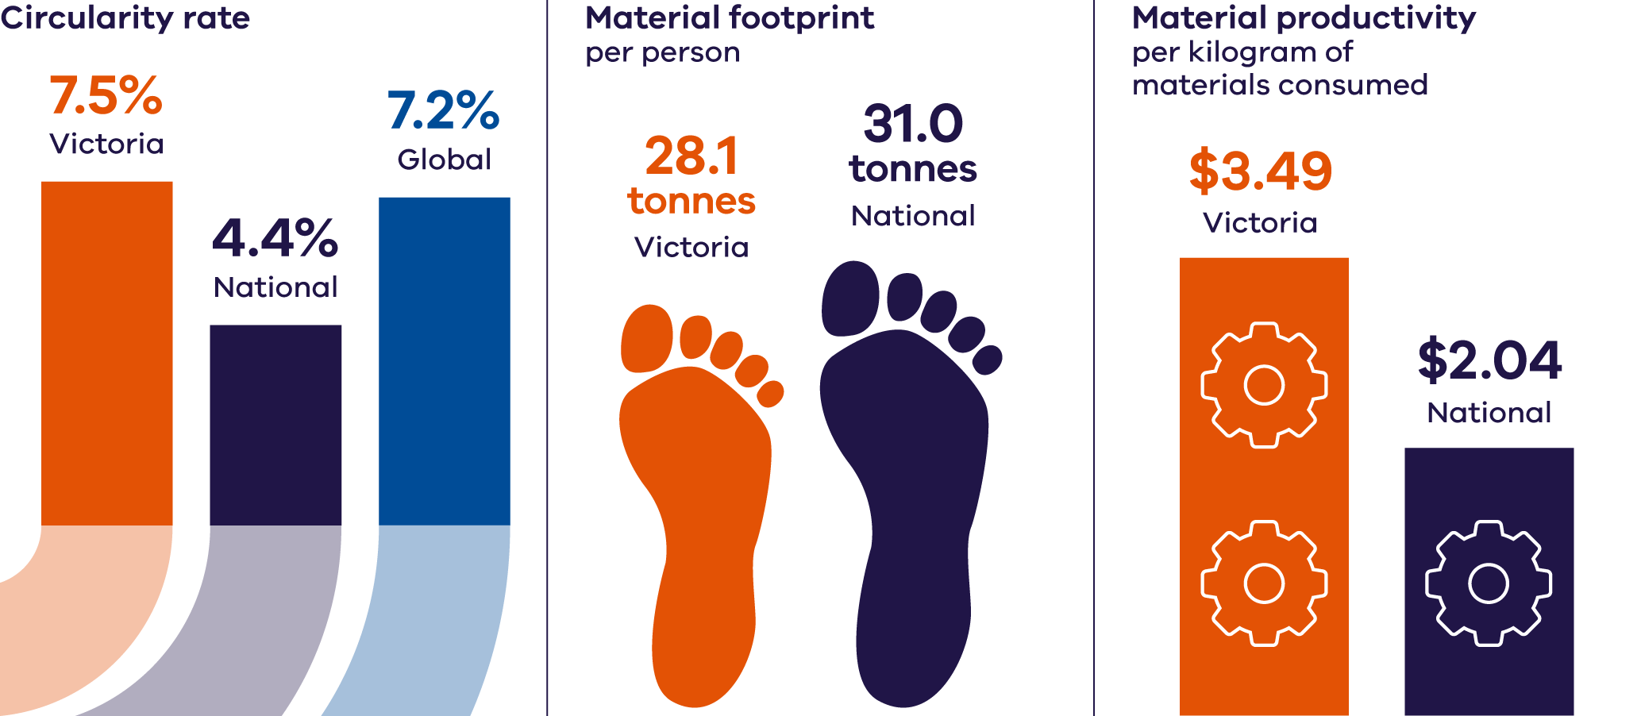

### Circularity rate

The rate for Victoria was calculated using secondary material consumption (SMC) in tonnes divided by domestic material consumption (DMC) in tonnes. Victoria’s SMC in 2022–23 is estimated to be 11.8 million tonnes and the DMC is estimated to be 156.8 million tonnes (for more detail on how these values are estimated see 1.4 circular economy metric methods).

**Victoria’s 2022–23 circularity rate is approximately 7.5%.**

That is, of all materials that Victoria consumed in 2022–23, 7.5% came from recycled material. Victoria has a higher circularity rate compared with the overall rate for Australia (4.4%) which is calculated using the same formula. The Victorian result also appears better than the global average (7.2%) but lower than the EU average (11.5%).

The best performing country internationally is the Netherlands with a circularity rate of 27.5% (DCCEEW 2024b). While a higher circularity rate is preferable, a 100% circularity rate is not achievable. The Australian Material Flow Analysis to Progress to a Circular Economy Report (CSIRO 2024) notes:

“a circularity rate of 100% is not achievable because several materials are irreversibly transformed during use, such as biomass used as food or fossil fuels used for energy. We measure the theoretical circularity maximum as the highest possible circularity rate under today’s economic and technical structure. At most, Australia could supply its economy with 32.5% of secondary materials, which are all the materials that are used for non-energetic purposes.”

### Material footprint

The result for Victoria was calculated using total material footprint (TMF) in tonnes divided by the estimated residential population (ERP). Victoria’s TMF in 2022–23 is estimated to be 189.7 million tonnes and the ERP is estimated to be 6.7 million people (for more detail on how these values are estimated see Appendix 1.4 Circular economy metric methods).

**Victoria’s 2022–23 material footprint is approximately 28.1 tonnes per person.**

This is lower than the Australian figure of 31.0 tonnes per person.

Reduced footprint could be achieved through improved product design, greater use of recycled materials in the built environment and preference for longer lasting and recycled materials in manufacturing.

### Material productivity

The result for Victoria was calculated using gross state product (GSP) in AUD divided by the DMC in kilograms. Victoria’s GSP in 2022–23 is estimated to be AUD $547.4 billion and the DMC is estimated to be 156.8 billion kilograms (for more detail on how these values are estimated see 1.4 Circulareconomy metric methods).

**Victoria’s 2022–23 Material Productivity is approximately $3.49 AUD/kg.**

This compares to the value for Australia of $2.04 AUD/kg indicating that Victoria is more efficient with its use of raw materials in generating economic value compared with the national result.

# Market overview and performance 2022–23

Victoria generated a total of 14.5 million tonnes of material in 2022–23, with 9.9 million tonnes recovered for reprocessing.

This resulted in a Victorian recovery rate of 69% (Figure 3). (For clarity, the soils component in this figure has been split out from other materials in the aggregate/masonry/soils section of this chart.)

Figure 3: Materials generated, recovered for processing, and disposed of in 2022–23 (tonnes) (Recycling Victoria 2024b)

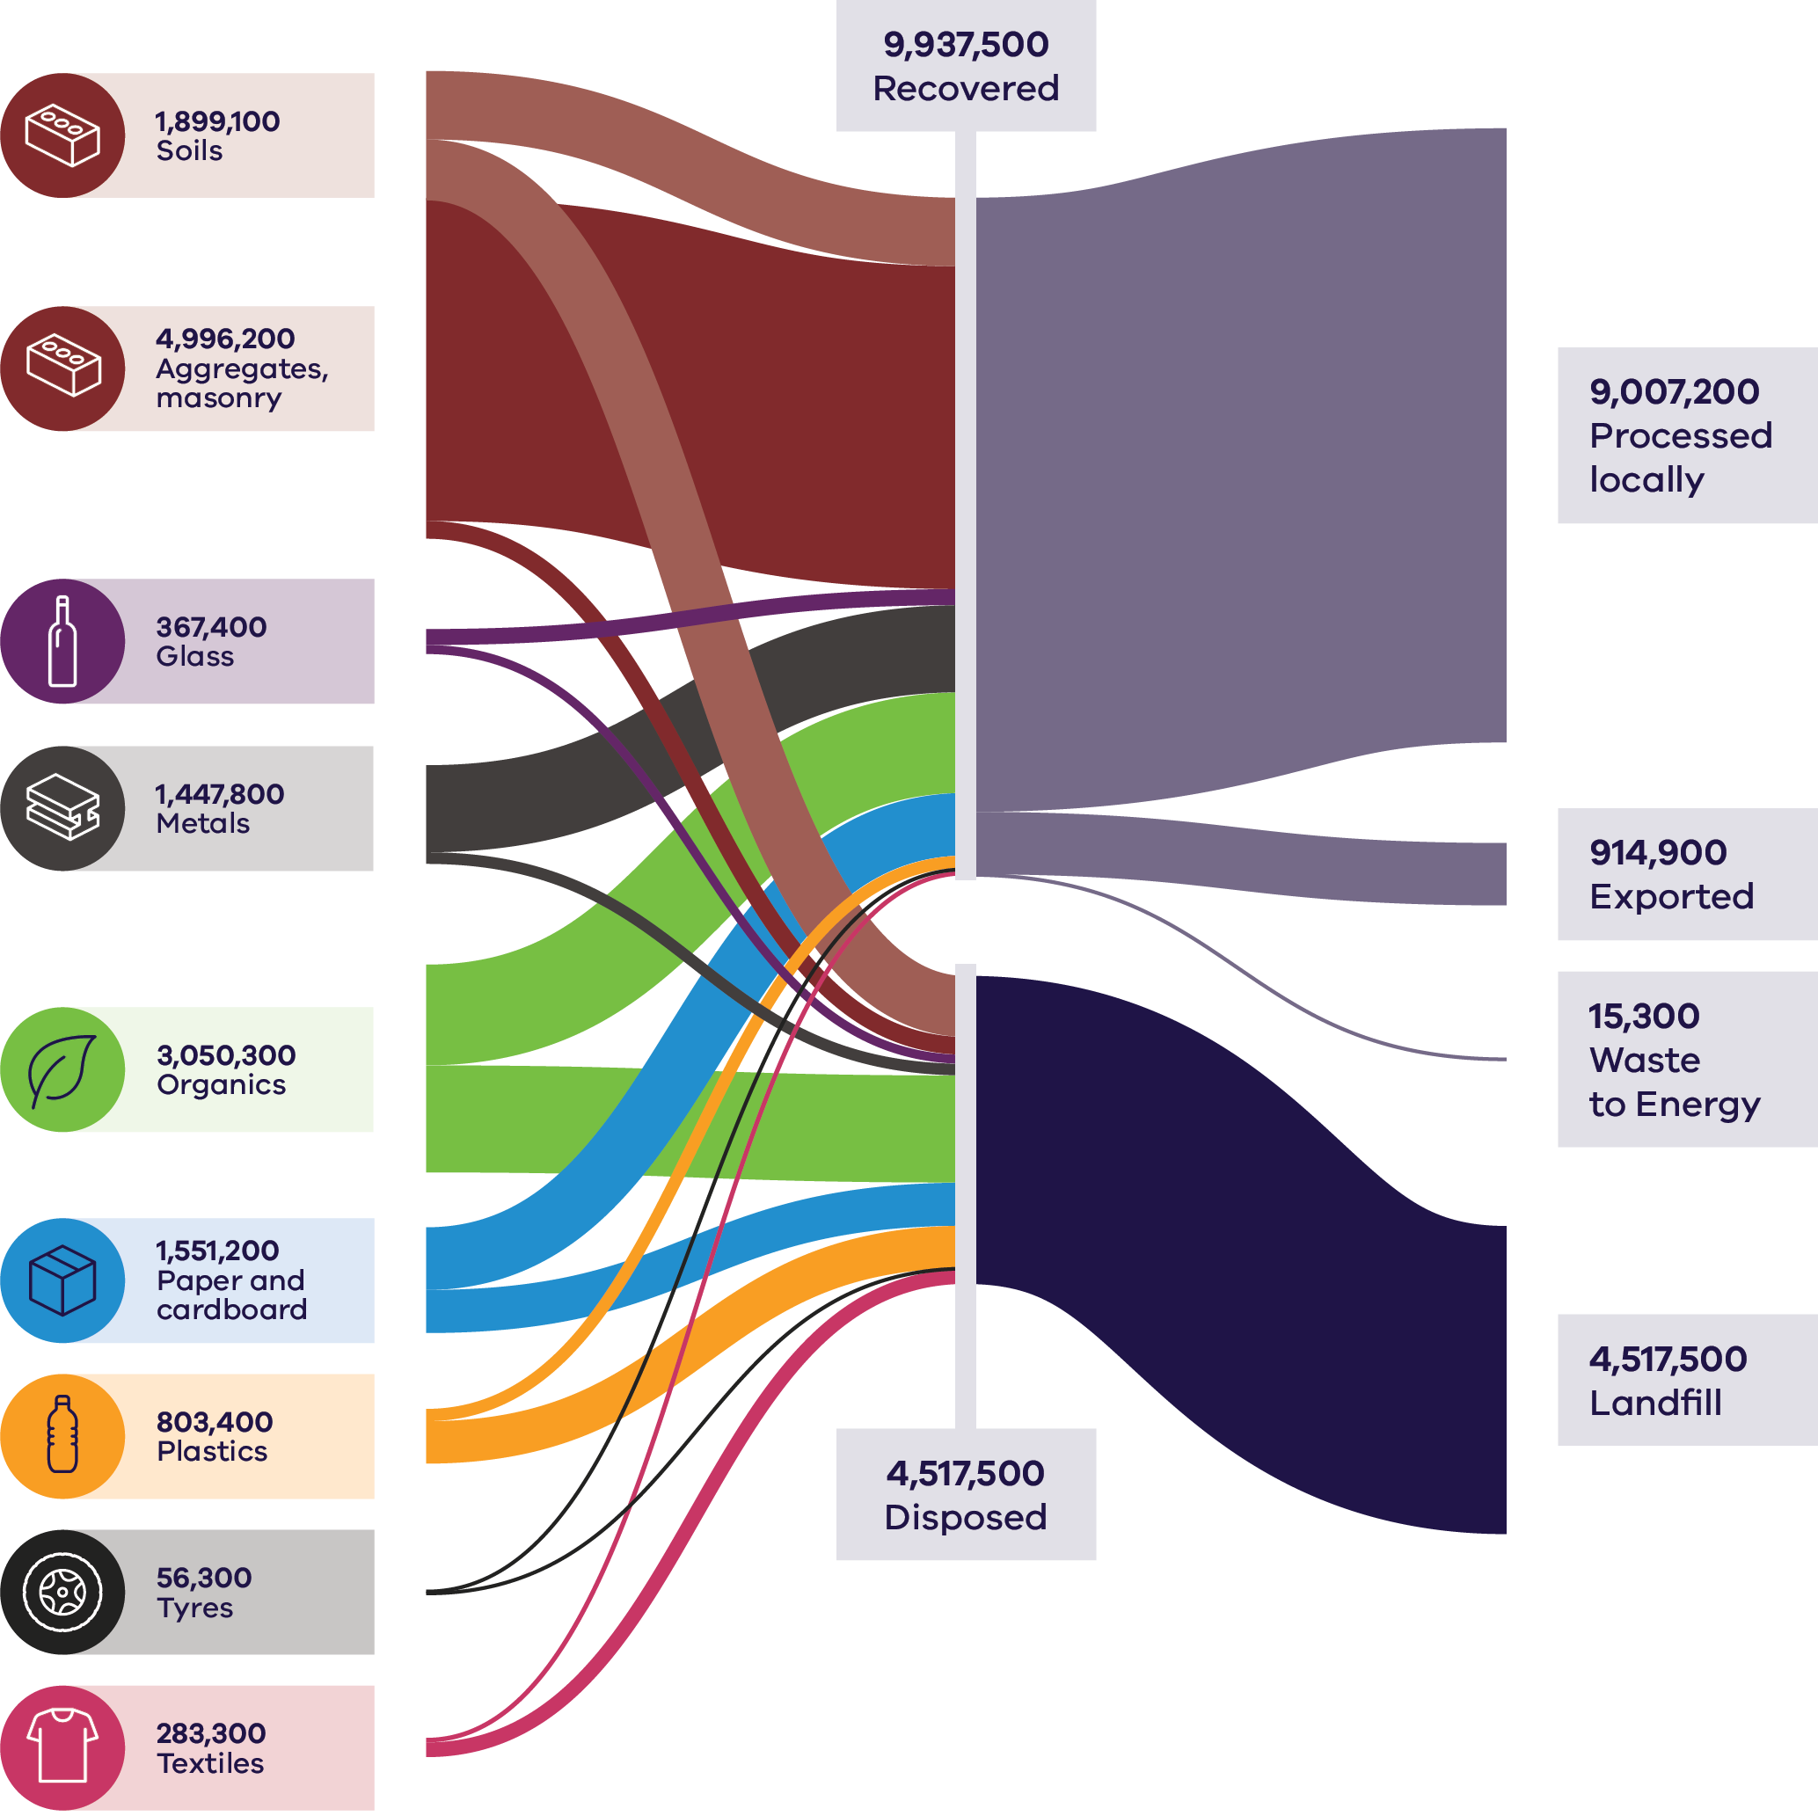

Table 2: Materials generated, recovered for processing, and disposed of in 2022–23 (tonnes) (Recycling Victoria 2024b)

| Materials (Tonnes) | Generated | Recovered | Disposed |
| --- | --- | --- | --- |
| **Soils** | 1899100 | 1005400 | 893700 |
| **Aggregates, masonry** | 4996200 | 4733800 | 262400 |
| **Glass** | 367400 | 233900 | 133500 |
| **Metals** | 1447800 | 1277900 | 169900 |
| **Organics** | 3050300 | 1478600 | 1571700 |
| **Paper and cardboard** | 1551200 | 918200 | 633000 |
| **Plastic** | 803400 | 181100 | 622300 |
| **Tyres** | 56300 | 41900 | 14400 |
| **Textiles** | 283300 | 66800 | 216500 |

| Totals (tonnes) |  |
| --- | --- |
| Recovered – Processed locally | 9007200 |
| Recovered – Exported | 914900 |
| Recovered – Waste to Energy | 15300 |
| Disposed – Landfill | 4517500 |

## Market overview

The value of the Victorian waste, recycling and resource recovery sector has been estimated at over $4.4 billion (ABS 2020). This value will continue to grow as Victoria transitions to a stronger circular economy.

Victoria remains the fastest growing state in the country with the population expected to reach 10.3 million by 2051 (DTP 2023). This growth will place greater pressure on the environment including through higher levels of waste generation.

Despite increasing population, Victoria’s recovery rate has been relatively consistent (69–70%) since 2016–17. There is still a need for improvement to transition to a circular economy and meet Victoria’s target to divert 80% of non-hazardous waste from landfill by 2030. Victoria needs to continue efforts to develop a reliable and robust circular economy market to avoid valuable material and embodied energy being lost to landfill.

Analysis of trends in resource recovery between 2020–21 and 2022–23 shows a mix of steady performance in the C&D sector, a positive trend in household MSW recovery and challenges in maintaining or improving recovery rates of specific material streams in the C&I sector. Increased focus on waste management systems for businesses, such as through improved separation and collection of materials, could further improve recovery rates.

A key opportunity for C&I to achieve significant gains in overall circularity is in food organics. While households are benefiting from the rollout of kerbside FOGO services, businesses such as those in food manufacturing and hospitality would benefit from improved investment and systems of waste separation and collection.

Key barriers to circularity include the following:

* **Contamination** – high processing costs associated with sorting, decontaminating and cleaning material streams.
* **Limited end markets** – weak local demand for reusing, reprocessing or recycling some material streams.
* **Product design** – products are not designed for circularity or end-of-life. Complex product designs, the use of mixed materials, and the difficulty of disassembling products hinder effective recycling.

**Competition with international jurisdictions** – Victorian recyclers and re-manufacturers compete with international jurisdictions that have lower costs and stronger manufacturing bases.

Competition with virgin materials – cheaper virgin materials, particularly those derived from fossil fuels, often undermine the competitiveness of recycled alternatives.

Recent government policy has been introduced to support a stronger and more reliable and transparent waste and recycling sector by measures such as:

* improving the way waste is collected through a new standardised 4 stream household waste and recycling system, which reduces contamination and increases the value and opportunity of the materials collected
* implementing a product stewardship scheme for the recovery of recyclable containers through Victoria’s Container Deposit Scheme (CDS Vic) to incentivise increased participation in the collection and deposit of containers, reducing contamination and increasing the value and opportunity of the materials collected
* increasing waste levies to incentivise circular economy opportunities and making them more cost effective when compared to disposal
* regulation and planning to ensure that collection and recycling services remain reliable and transparent
* driving investment through long term recycling infrastructure planning, outlining where improved capacity and capability are required to meet Victoria’s needs

new government procurement policies for major transport projects to optimise the use of recycled and reused Victorian material within allowable limits under existing specifications.

Victoria has the conditions to support further investment in the waste, resource recovery and recycling sector, including continuing strong government policy to enable and encourage growth, strong domestic demand and facilitating a collaborative research and development environment to support innovation.

Commodity values of recycled material evolve with markets. Commodity values for recycled materials are influenced by multiple factors including:

* international and domestic market demand
* virgin material alternatives
* landfill gate fees and waste levies

product stewardship arrangements (CDS Vic, e-waste)

A material’s commodity value (the price the market is willing to pay) relative to its processing costs and the virgin material alternative, provides insight into the commercial incentives for circularity. Strong commodity values can justify higher processing costs, enabling more complex recycling processes. For example, metals have high commodity values due to strong market demand, which helps overcome transport and processing costs, resulting in higher recovery rates.

Some materials such as aggregates, masonry and soil, have relatively low commodity values but still enjoy high rates of recovery, due to simpler and more cost-efficient processing requirements, and with strong financial incentive for the otherwise high costs associated with disposal fees.

Recycled plastics, on the other hand, are costly to recover and process and are lightweight; therefore, cannot commercially compete with virgin fossil-fuel derived plastics which are priced attractively low. However, the price of virgin plastics does not reflect the environmental and social harms of extracting finite natural resources, distorting the true economic comparison between virgin and recycled plastics.

In 2022–23 Victoria recovered and circulated an estimated $1.8 billion worth of materials back into the economy. However, material with potential value of $1.3 billion was lost to landfill, indicating more can be done to support markets in capturing this potential value (Figure 4).

Figure 4: Realised market value, Potential market value, and Commodity value for 2022–23

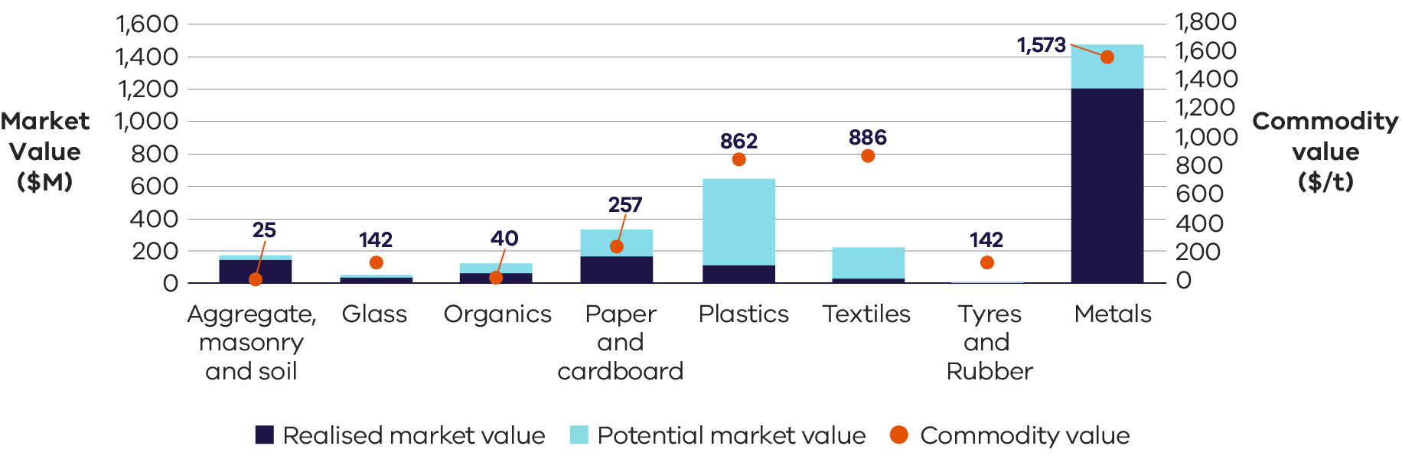

## Performance by activity

### Material generation

In 2022–23 Victoria’s generation of waste materials totalled 14.5 million tonnes. The C&I sector represents the second largest contributor, accounting for just under one third of total material generation by weight. The largest material stream contributors to this are:

* aggregates, masonry and soils
* organics
* paper and cardboard
* metals.

Table 3: Comparison of material generation, recovery and disposal between financial years (Recycling Victoria 2024b)

| Source sector | Total generation (tonnes) | | | | Recovered (tonnes) | | | | Disposed (tonnes) | | | | Recovery rate (%) | | | |
| --- | --- | --- | --- | --- | --- | --- | --- | --- | --- | --- | --- | --- | --- | --- | --- | --- |
| **FY** | **20–21** | **21–22** | **22–23** |  | **20–21** | **21–22** | **22–23** |  | **20–21** | **21–22** | **22–23** |  | **20–21** | **21–22** | **22–23** |  |
| MSW | 3.3 | 3.5 | 3.6 | **↑** | 1.6 | 2.0 | 2.0 | ↑ | 1.7 | 1.5 | 1.6 | ↓ | 49% | 57% | 56% | ↑ |
| C&I | 4.9 | 4.3 | 4.2 | **↓** | 2.9 | 2.3 | 2.3 | ↓ | 2.0 | 2.0 | 1.9 | ↓ | 60% | 54% | 54% | ↓ |
| C&D | 7.7 | 6.6 | 6.7 | **↓** | 6.6 | 5.6 | 5.6 | ↓ | 1.1 | 1.1 | 1.0 | ↓ | 86% | 84% | 84% | ↓ |
| **Total** | **15.8** | **14.4** | **14.5** | **↓** | **11.1** | **9.9** | **9.9** | **↓** | **4.7** | **4.5** | **4.5** | **↓** | **70%** | **69%** | **69%** | **↓** |

**Note:** the arrows in 2022–23 represent the change compared to the 2020–21 financial year.

Total material generation in 2022–23 decreased by over 1 million tonnes in the last 2 years since 2020–21. This decline is likely driven by a reduction in material generation within the C&D sector, possibly reflecting the sector’s improvements of in-situ material re-use which occurs before it is classified as waste.

The C&D sector remains the largest contributor to material generation by weight across the 3 sectors, accounting for nearly 50% of the total tonnes. This is largely due to the significant relative weight of materials such as aggregates, masonry and soils generated by this sector.

The key trends in C&D material generation over the past 3 financial years show:

* a 1 million tonne decrease in material generation from 2020–21 to 2021–22, likely caused by efficiencies in material use, as well as reduced sector activity

a subsequent increase of approximately 100,000 tonnes from 2021–22 to 2022–23, likely reflecting a return to sector activity, particularly linked to transport infrastructure projects.

Material generation trends for C&I over the recent years show:

* a 600,000 tonne decrease from 2020–21 to 2021–22, possibly influenced by COVID-19 which disrupted typical waste generation patterns as workplaces shifted to home-based activity

a smaller subsequent drop of 100,000 tonnes from 2021–22 to 2022–23.

MSW accounted for the remaining 25% of material generation by weight. The observed increase in MSW generation is possibly attributed to post COVID-19 population growth and the shift toward remote working.

Over the next 30 years total material generation is projected to increase by about 93%, increasing the state-wide generation to an estimated 28 million tonnes by 2053 (Recycling Victoria 2024b). The largest contributor to material generation, C&D, is projected to grow and contribute 55% of the total material generation in 2053. The C&I and MSW sectors are expected to decrease contribution to 26% and 18% respectively (Recycling Victoria 2024b).

### Material generation per capita and Gross State Product

Gross State Product (GSP) is an aggregate measure which details the total economic production of a state economy and is the state equivalent to the national Gross Domestic Product (GDP).

The amount of waste material generated by the 3 source sectors is shown compared with population (Figure 5). The flattening of population growth in 2020–21 and 2021–22 correspond to COVID-19 impacts, when there was reduced domestic population in Victoria. The source sector show that C&D waste generation has fallen by about 1 Mt since 2021, while C&I generation has risen to a peak of just under 5 Mt before falling to around 4.3 Mt. Generation of MSW fell to just over 3 Mt in 2020–21, noting that the amount generated increased as population began to rise again.

Figure 5: Material waste generation by source compared with Victorian population

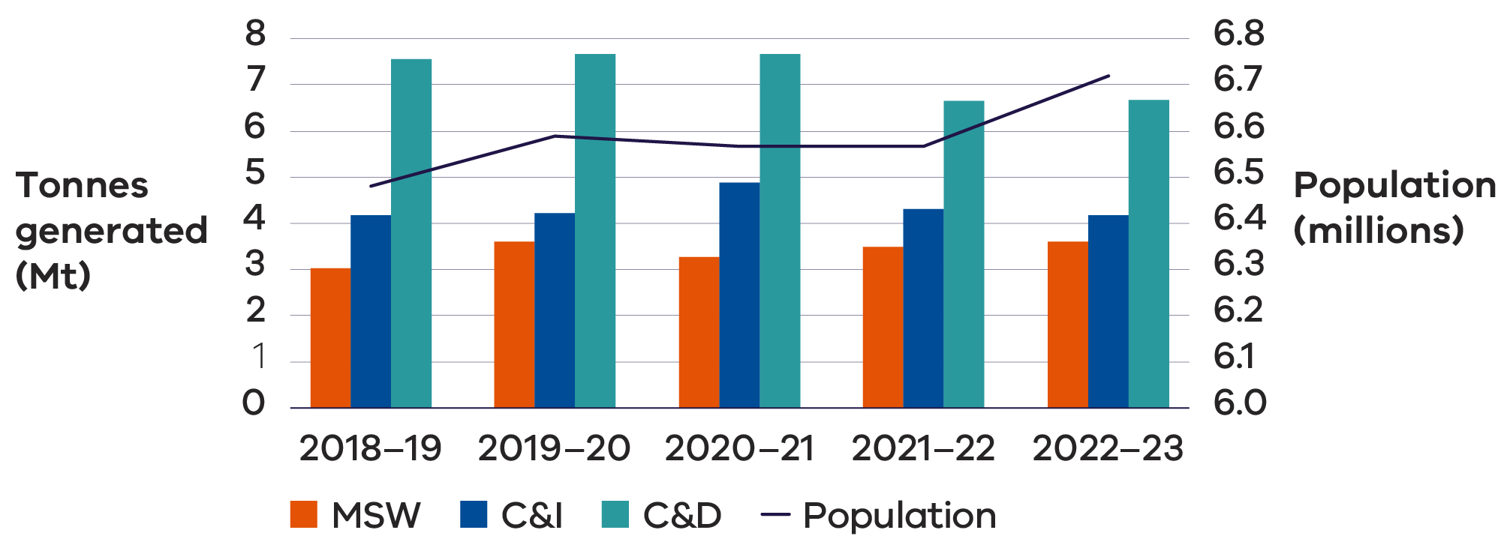

Generally, as a country’s GDP (or GSP in Victoria’s case) increases, so too does its consumption, which can lead to higher levels of waste generation. This relationship can be attributed to several factors:

* Increased consumption – higher GDP (or GSP) typically indicates greater wealth, leading to increased consumption of goods and services, which can generate more waste.
* Industrial activity – countries with higher GDP often have more industrial activity, which can produce significant amounts of waste.

Urbanisation – economic growth frequently drives urbanisation, resulting in concentrated waste generation in cities.

There are cases where GDP (or GSP) trends do not directly correlate with consumption, often due to improved waste management practices and technologies, introduction of price signals or economic incentives to encourage circularity of materials, recycling and waste reduction initiatives, and public policies. Figure 6 illustrates the relationship between waste generation and GSP in recent years.

Figure 6: Waste generation by source compared with Victorian GSP

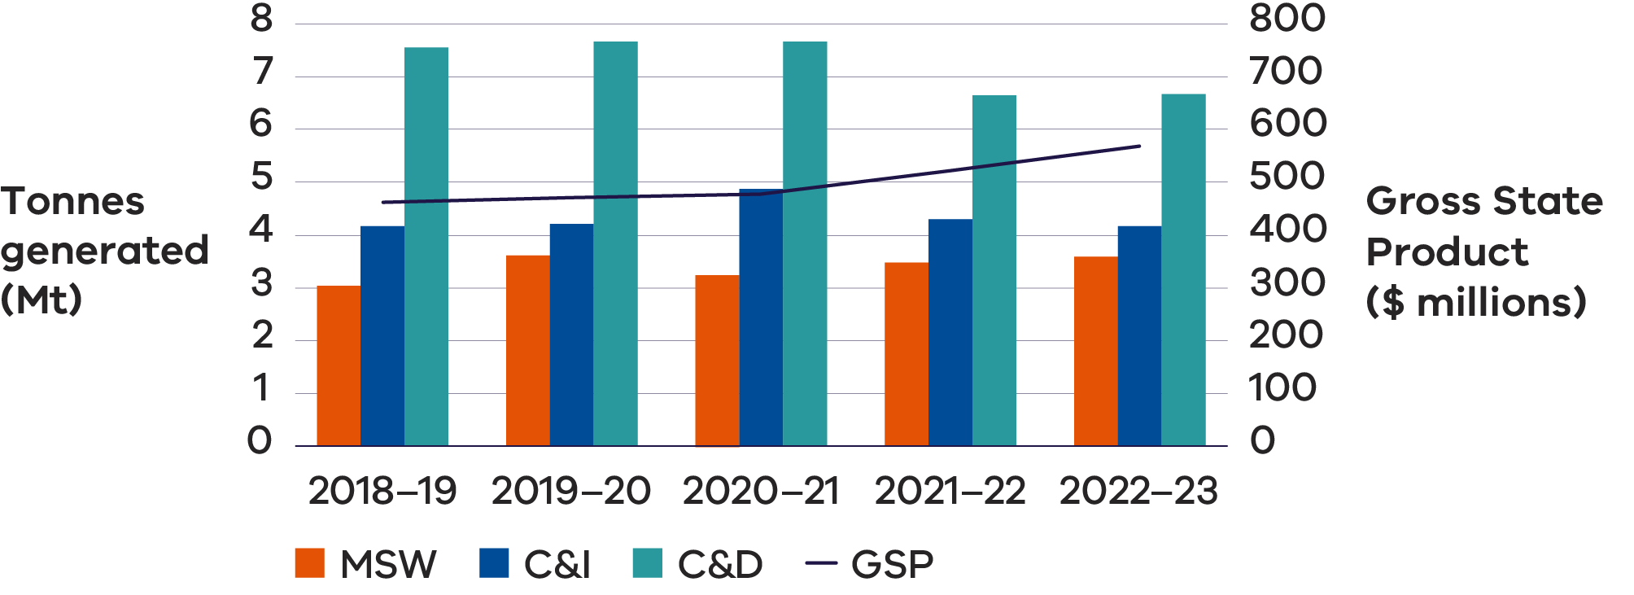

Waste generation has not followed the same trends as GSP growth in Victoria in the last few years. This is possibly attributed to:

* 1 million tonne decrease in material generation from C&D from 2020–21 to 2021–22, driven by efficiencies in material use and reduced infrastructure sector activity

600,000 tonne decrease from 2020–21 to 2021–22 in C&I waste, largely influenced by COVID-19 impact, which disrupted typical waste generation patterns as workplaces shifted to home-based activity and a smaller subsequent drop of 100,000 tonnes from 2021–22 to 2022–23.

### Material reuse and repair

Community leadership and state government funding has supported continued progress in the development of new repair and reuse projects. These programs include repairing and sharing of toys, clothes, nursery items and establishing repair cafes.

Many schools have established second-hand uniform and textbook shops run by volunteers associated with the schools. These allow families more affordable access to school essentials. There are also a number of online platforms and market places that enable people to sell and buy second hand goods privately.

Charitable recycling enterprises are widespread with nearly 650 shops and outlets throughout Victoria, enabling customers to purchase goods including clothes and household items. This network enables people to support not-for-profit organisations and provides environmental benefits by extending the life of unwanted clothing and household goods and contributing to emissions reduction.

# Right to repair

One development in the European market that may have implications for other jurisdictions is the adoption of “right to repair’ rules in April 2024 (European Parliament 2024). The European Commission (2020) calculates premature disposal of consumer goods produces 261 million tons of CO2-equivalent emissions, consumes 30 million tonnes of resources, and generates 35 million tonnes of waste in the EU each year.

Under the new “right to repair” rules, manufacturers have obligations to repair goods, inform consumers about their rights to repair and provide timely and cost-effective repair services. If the item to be repaired is under warranty, the repair triggers an extra year on the warranty.

The list of household goods that are considered repairable include washing machines, vacuum cleaners and smartphones. Consumers may also borrow a device while theirs is being repaired or, if it cannot be fixed, opt for a refurbished unit as an alternative.

Similar programs and policies are emerging in the United States, where right to repair legislation has passed in the last year in California, Colorado, Minnesota and New York (The White House, 2023). California’s new law requires manufacturers to make the parts, tools and documentation needed to diagnose, maintain and repair consumer electronic devices and appliances available to independent repair shops and consumers at fair and reasonable price.

Laws and economic incentives are useful to enable consumers and businesses to support these emerging circular economy opportunities.

Much of Victoria’s material reuse and repair is unrecorded. To support improved information, Charitable Reuse Australia developed the National Reuse Measurement Guidelines, published in October 2024 (Allen et al. 2024). The intent of the guidelines is to provide an overarching reporting framework with organisational level data on environmental, social and economic impacts to be collected from individual reuse organisations and annually provided to Charitable Reuse Australia, who will collate, harmonise, interpret and report on the data.

## Case Study: Repair cafes

The repair cafe movement started in the Netherlands in 2009 and has since grown to a network in over 3000 locations around the world, including in Victoria. There are numerous other organisations providing equivalent services to their community, but with different brands or names. Repair cafes are not repair services as such and are not there to do house calls to repair large appliances or furniture. Volunteer fixers and menders offer their time and skills to help make possible repairs free of charge. People visiting the repair cafe bring broken or damaged items from home – toasters, lamps, hair dryers, clothes, bikes, toys, crockery – anything that is broken is welcome. This helps reduce waste and save money and resources. The volunteers offer their time and skills to members of the community, providing a teaching experience by showing how to do the repairs and encouraging visitors to the café to acquire new skills by using the equipment under supervision.

There is a strong economic case for encouraging the repair of goods. Australian economist Richard Denniss wrote in his book Curing Affluenza: How to Buy Less Stuff and Save the World, that a community that repairs its goods “would employ more people, per dollar spent, than a community that instinctively disposes of them” (Wilson 2019). It would create more high skill jobs and reduce the cost of living.

Victorian Government Circular Economy Communities Fund, has provided almost $5.4 million for social enterprises, including repair cafes. A network of repair cafes exists across Victoria. Different locations measure success in different ways – the number of visitors, the number of items fixed, and the mass of material getting an extended life rather than being destined for landfill.

### Material recovery

Below are the recovery rates per material in Victoria for 2022–23. Acknowledging the limitations of understanding circularity by using resource recovery rates across material streams, they do serve as a good measure in determining which streams are performing better than others in the Victorian market.

Figure 7: Resource recovery rates for key materials in Victoria 2022–23 (Recycling Victoria 1014b)

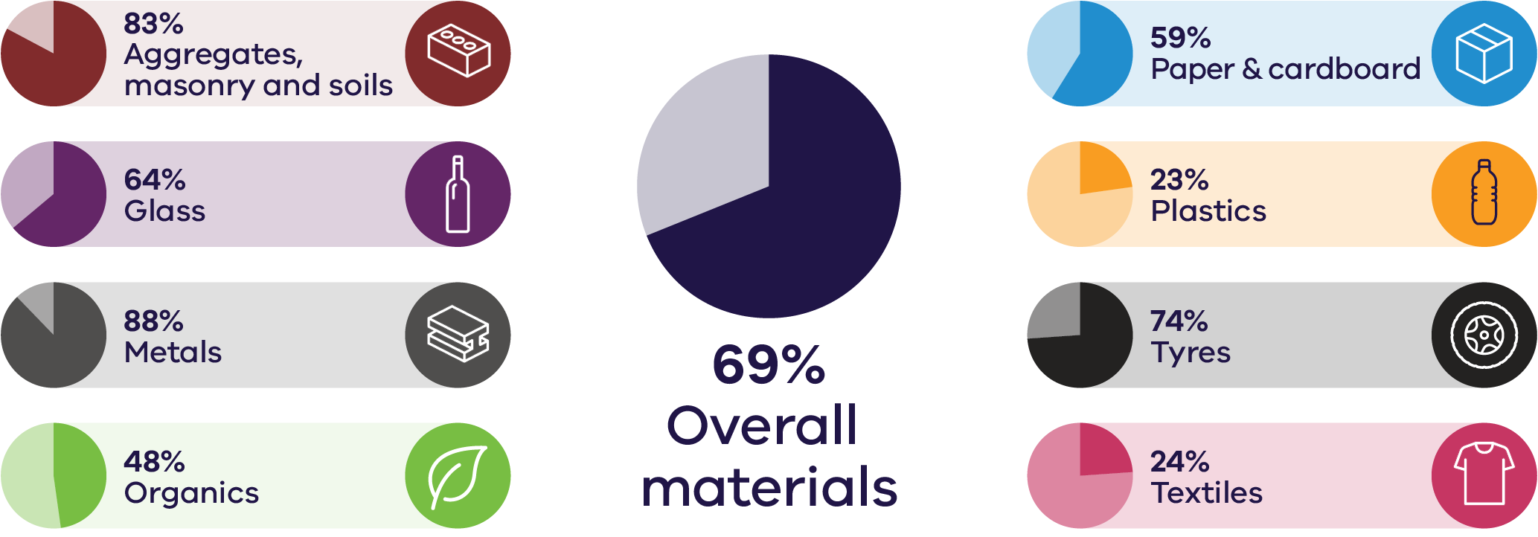

Across recent years, metals, and aggregates, masonry and soils, have had the highest recovery rates within Victoria, with textiles, plastics and organics having the lowest recovery rates.

Table 4: Comparison of the overall recovery rates for the eight key material streams (Recycling Victoria 2024b)

| Material | 2020–21 | 2021–22 | 2022–23 |
| --- | --- | --- | --- |
| Aggregate, masonry and soils | 85% | 83% | 83% |
| Glass | 71% | 63% | 64% |
| Metals | 89% | 89% | 88% |
| Organics | 50% | 47% | 48% |
| Paper and cardboard | 57% | 60% | 59% |
| Plastic | 18% | 23% | 23% |
| Tyres and rubber | 86% | 76% | 74% |
| Textiles | 23% | 21% | 24% |

The recovery rate data indicates a mix of steady performance in the C&D sector, a positive trend in MSW recovery, and challenges in maintaining or improving recovery in the C&I sector and specific material streams. Increased focus on improving waste management strategies for materials like plastics, textiles and organics could further improve recovery rates across all sectors.

The C&D sector continues to report the highest recovery rate among the 3 sectors at 84%. This strong performance is primarily driven by effective recovery in metals, glass and aggregates, masonry, and soils.

The MSW sector has a recovery rate of 56%, showing an increase compared to 2020–21. This improvement is likely a result of the continuing rollout of additional kerbside collection services, specifically FOGO. The changes are also linked to post COVID-19 behavioural shifts, with more people working from home, leading to increased waste being captured by household collection services.

The C&I sector has a recovery rate of 54%, with a small decrease recorded compared to the 2020–21 financial year.

Table 5: Recovery rate for the eight key material streams across the 3 sectors for 2020–21, 2021–22 and 2022–23 (Recycling Victoria 2024b)

|  |  |  |  |  |  |  |  |  |  |
| --- | --- | --- | --- | --- | --- | --- | --- | --- | --- |
| Material | MSW | | | C&I | | | C&D | | |
|  | **2020-21** | **2021-22** | **2022-23** | **2020-21** | **2021-22** | **2022-23** | **2020-21** | **2021-22** | **2022-23** |
| Aggregate, masonry and soils | 13% | 38% | 21% | 11% | 36% | 41% | 89% | 87% | 87% |
| Glass | 69% | 66% | 66% | 75% | 58% | 59% | – | 67% | 67% |
| Metals | 79% | 87% | 85% | 92% | 91% | 91% | 72% | 77% | 76% |
| Organics | 52% | 60% | 60% | 53% | 35% | 36% | – | 12% | 12% |
| Paper and cardboard | 45% | 53% | 52% | 63% | 64% | 64% | 56% | – | – |
| Plastic | 21% | 24% | 31% | 15% | 23% | 12% | 14% | 13% | 16% |
| Tyres and rubber | 57% | 61% | 53% | 88% | 79% | 77% | – | – | – |
| Textiles | 37% | 42% | 44% | 11% | – | 1% | – | – | – |
| **Total** | **49%** | **57%** | **56%** | **60%** | **54%** | **54%** | **86%** | **84%** | **84%** |

**Note:** values indicate that no material was reported as recovered for that material in that year. This is likely due to variations in reporting or the material not being present in those recovery streams for the source sector.

### Residual management

The C&I sector was the largest contributor to total waste material disposed across the 3 sectors in 2022–23, accounting for just over 40%. MSW was the next highest contributor accounting for just over 35% of total disposed material. The C&D sector was the lowest contributor accounting for almost 25% of all waste.

In 2022–23, the waste levy and other economic incentives played a crucial role in reducing waste sent to landfill and promoting higher recovery rates. By imposing a fee on landfilling, the waste levy provided a financial disincentive for businesses and individuals to dispose of waste in landfills, encouraging them to explore alternative waste management options such as recycling, reuse or composting. In 2022–23, the amount payable for each tonne of municipal or industrial waste was $110.79 ($/tonne) in the Melbourne metropolitan area. In rural areas it is $62.95($/tonne) for municipal waste and $116.76 for ($/tonne) industrial waste (EPA n.d.).

### Case Study: Waste levy

The Victorian Waste Levy incentivises waste reduction and resource recovery in Victoria’s waste management through the following means:

**Economic incentives** – The waste levy amount has increased over time, from around $2 a tonne in 1992, under $20 a tonne in 2009–10, to $63.28 a tonne in 2017–18 and $129.27 in 2023–24. A further increase in the waste levy to $167.9 from 1 July 2025, announced in the 2024–25 Victorian Budget (EPA n.d.), will bring the levy more in line with neighbouring jurisdictions and increase waste disposal costs, encouraging businesses and consumers to reduce waste and seek recycling or recovery options.

**Investment in infrastructure** – Revenues from the waste levy are used to promote recycling facilities and technology, enhancing recovery capabilities and efficiency. In 2022–23 $53.1M of public and private investment was leveraged to support investment in the waste management and recovery sector.

**Cost of alternatives** – When the cost of waste disposal rises, the relative cost of recycling and recovery processes becomes more commercially attractive, leading to higher recovery rates. This is underpinned with Environment Protection Authority Victoria (EPA) compliance activities to ensure waste is not diverted and dumped illegally, with $44 million allocated in 2024–25.

**Awareness and education** – Increased waste levies provide a price signal that shifts consumer and business behaviour toward more sustainable and relatively lower cost products with better recyclability. Victoria’s waste levy contributes to the Sustainability Fund which funds activities which promote greater community awareness of recycling. For example, in 2022–23 the $26.6 million Victorian Government Household Education and Behaviour Change Program aligned statewide and local government level communications to educate Victorians to better manage and reduce their household waste.

# Performance by material

## Aggregates, masonry and soil

Aggregate is a granular material used in construction. The most common natural aggregates include sand, gravel and crushed rock. Aggregates are used in a wide variety of applications including the construction of roads, pavements, building foundations and agricultural applications. When combined with other materials, aggregates enable the construction of essential infrastructure such as houses, roads, bridges, schools and hospitals – all critical components in maintaining living standards. Recycled concrete aggregate is highly effective for use in road bases and hardstand areas due to its compaction properties, which result in stronger and more durable surfaces compared to virgin aggregate.

Masonry materials include heavy waste types such as concrete, bricks, asphalt and rubble (O’Sullivan 2021). These are the primary materials generated by the construction industry, which is one of the highest contributors to Australia’s total waste generation.

Soil, as discussed in this material stream, focuses exclusively on non-contaminated soil. Soil with contaminants above specified thresholds or containing asbestos is classified as contaminated soil (a reportable priority waste). Soil discussed here predominantly originates from industrial processes but is classified as non-priority waste as it does not pose significant environmental or health risks. This material is commonly reused as fill material and utilised for leveling land or filling pits (EPA 2024). It is noted that most fill material does not enter the formal waste management system as it is reused onsite or transported directly to fill sites.

Waste generation is positively correlated with the amount of C&D activity each year due to the weight of the material.

Asphalt, bricks and concrete have a very high recovery rate reflective of valuable application in built environment. Soils, natural materials and plaster have a much lower recovery rate and they are more challenging to recycle (Recycling Victoria 2024c).

With the construction industry being one of the largest employers in Victoria, there are strong and viable local end markets for recycled materials across the state (Recycling Victoria, 2024c). Because of factors such as transport costs and carbon emissions, the uptake of recycled / reused materials in these projects is higher in Metropolitan Melbourne than in regional areas.

The recovery and reuse of materials like aggregates and masonry in the construction sector have become well-established practices. The processing of these materials locally has proven to be highly efficient, with substantial potential for regional investment. Due to the high transport costs associated with moving materials over long distances and the relatively low technological requirements for reprocessing, local reprocessing capacity is well-positioned to meet growing demand across the state (Recycling Victoria 2024c).

### Market performance

The overall recovery rate for aggregates, masonry and soil in Victoria in 2022–23 was 83%, which is similar to the recovery rate of 85% observed in both 2020–21 and 2021–22.

Figure 8: Aggregates, masonry and soil generated, recovered for processing, and disposed of in Victoria in 2022–23 (tonnes) (Recycling Victoria 2024b)

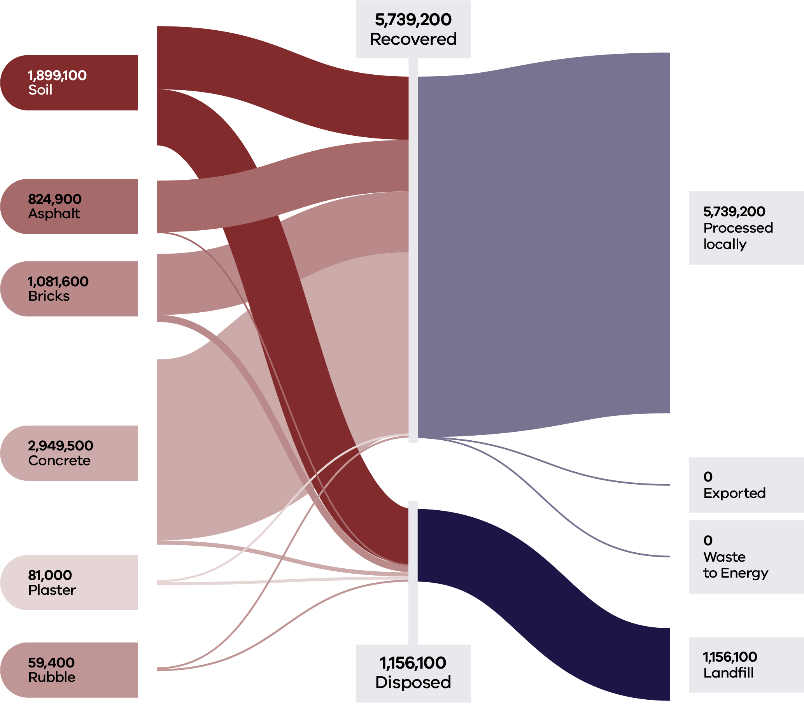

This was largely driven by the C&D sector, with the MSW and C&I sectors generating a low volume of material and lower recovery rates (21% and 41% respectively).

As in 2020–21, there was no export of aggregates, masonry and soil from Victoria in 2022–23. All processing is carried out in Victoria, ensuring that the investment and full value of resource recovery activity is captured locally.

Aggregates, masonry and soil combined, are Victoria’s largest waste stream by mass (6.9M tonnes in 2022–23), representing 47% of all state-wide waste generation. Most (93%) of this material was generated and managed by the C&D sector (Table 6).

Table 6: Source streams and recovery rates for aggregates, masonry and soils in Victoria in 2022–23 (Recycling Victoria 2024b)

| Stream | Generated | | Recovered for reprocessing | | | Disposed | Recovery rate |
| --- | --- | --- | --- | --- | --- | --- | --- |
|  |  |  | **Processed locally** | **Exported** | **Total** |  |  |
|  | **Tonnes** | **Proportion** | **Tonnes** | **Tonnes** | **Tonnes** | **Tonnes** | **%** |
| MSW | 91,100 | 1% | 18,800 | 0 | 18,800 | 72,200 | 21% |
| C&I | 438,400 | 6% | 180,600 | 0 | 180,600 | 257,800 | 41% |
| C&D | 6,365,800 | 93% | 5,539,800 | 0 | 5,539,800 | 826,100 | 87% |
| **Total** | **6,895,300** |  | **5,739,200** | **0** | **5,739,200** | **1,156,100** | **83%** |

| Stream | Generated | | Recovered for reprocessing | | | Disposed | Recovery rate |
| --- | --- | --- | --- | --- | --- | --- | --- |
|  |  |  | Processed locally | Exported | Total |  |  |
|  | Tonnes | Proportion | Tonnes | Tonnes | Tonnes | Tonnes | % |
| Asphalt | 824,900 | 12% | 819,100 | 0 | 819,100 | 5,700 | 99% |
| Bricks | 1,081,600 | 16% | 970,300 | 0 | 970,300 | 111,300 | 90% |
| Concrete | 2,949,500 | 43% | 2,882,700 | 0 | 2,882,700 | 66,800 | 98% |
| Plaster | 81,000 | 1% | 33,000 | 0 | 33,000 | 48,000 | 41% |
| Rubble | 59,400 | 1% | 28,800 | 0 | 28,800 | 30,600 | 48% |
| Soil | 1,899,100 | 28% | 1,005,300 | 0 | 1,005,300 | 893,700 | 53% |
| **Total** | **6,895,300** |  | **5,739,200** | **0** | **5,739,200** | **1,156,100** | **83%** |

### Developments and changes

Victoria’s rapid growth and investment in major infrastructure projects continue to increase demand for quarry products such as soil, sand and rock consistent with projections of demand doubling between 2015 and 2050 (Resources Victoria 2023).

The Victorian Government’s ecologiQ initiative, supported by the Recycled First policy, has continued to provide end market pull-through of aggregates and masonry into large government infrastructure projects (ecologIQ 2024).

The Recycled First Summary Report on progress from 2020 to 2023 (ecologIQ 2024) shows some of the benefits realised through the policy. There are 16 Recycled First road and rail projects that have been completed, with a further 36 in procurement and delivery. There is 3.4M tonnes of recycled or reused material committed for future projects, with 90% of that amount being road projects.

### Market issues and challenges

The waste stream from C&D activities is projected to grow to over 16 million tonnes annually over the next 30 years.

The reuse of materials, particularly soil, can sometimes be hindered by lack of space to sort and temporarily store material.

In smaller construction projects, mixed material loads are frequently sent directly to landfill, perpetuating reliance on virgin materials. These projects often face higher costs per unit for using recycled materials, in addition to navigating regulatory challenges and market resistance. Compared to large-scale projects, smaller projects are more likely to encounter barriers to adopting recycled materials due to these economic and regulatory constraints.

Another major logistical challenge for the soil reuse market is the need to ensure that contamination is not present in recycled quarry products including soil. Australian soil has been contaminated with conventional and emerging contaminants for decades, including heavy metals, hydrocarbons, organic matter and man-made chemicals (Quarry 2020).

Contaminated soil wastes are a major component of hazardous waste in Australia, but little national data is available on these wastes (Plant et al. 2014). This is due, in part, to the diverse ways in which jurisdictions define, classify and regulate waste. Historically this has led to hazardous waste tracking that has been irreconcilable at the national level, making systematic and coherent national assessment and tracking challenging.

### Focus areas for greater circularity – aggregates, masonry and soils

The analysis highlights the following opportunities for improvements to this material stream:

* Identification and promotion of best practice management techniques to recover, treat and store soil to increase reuse options and recovery rate.
* Investigation and promotion of end markets for recycled plaster and rubble.
* Improved site design and planning to make space for the sorting and storage of recovered materials.

## Glass

Glass is a key material used in a wide range of applications including windows, food and beverage packaging, solar panels, electronics (such as device screens), medical technologies and in fibre optic cables that enable faster internet connections. One of the unique qualities of glass is its ability to be endlessly recycled – melted down and reshaped without losing its structural integrity.

The market demand for glass based construction materials remains high. The glass recovery sector is serviced by beneficiation plants, glass crushing processors and a packaging manufacturing plant.

Recovered glass packaging markets in Victoria are stable and improving but current glass generation exceeds the demand for recycled into new glass packaging. This is expected to improve over the next few years as the recycled content in glass manufacturing increases. All recovered glass is processed in Victoria into glass cullet, then back into glass packaging, or otherwise crushed glass/glass fines into construction materials. Recovering used glass for production of glass sand is growing in Victoria, supported by changes to construction specifications that have increased how much recycled glass sand can be used in road and rail construction (Recycling Victoria 2024c).

### Market performance

The overall recovery rate for glass in Victoria in 2022–23 was 64%. This is consistent with the recovery rate of 63% observed in 2021–22, but less than the recovery rate of 71% observed in 2020–21.

Glass continues to have a high circularity opportunity, with the ability to remanufacture glass packaging into new glass packaging, using around 20–30% less energy compared to glass from virgin silica sand (Recycling Victoria 2024a).

Figure 9: Glass generated, recovered for processing, and disposed of in 2022–23 (tonnes) (Recycling Victoria 2024b)

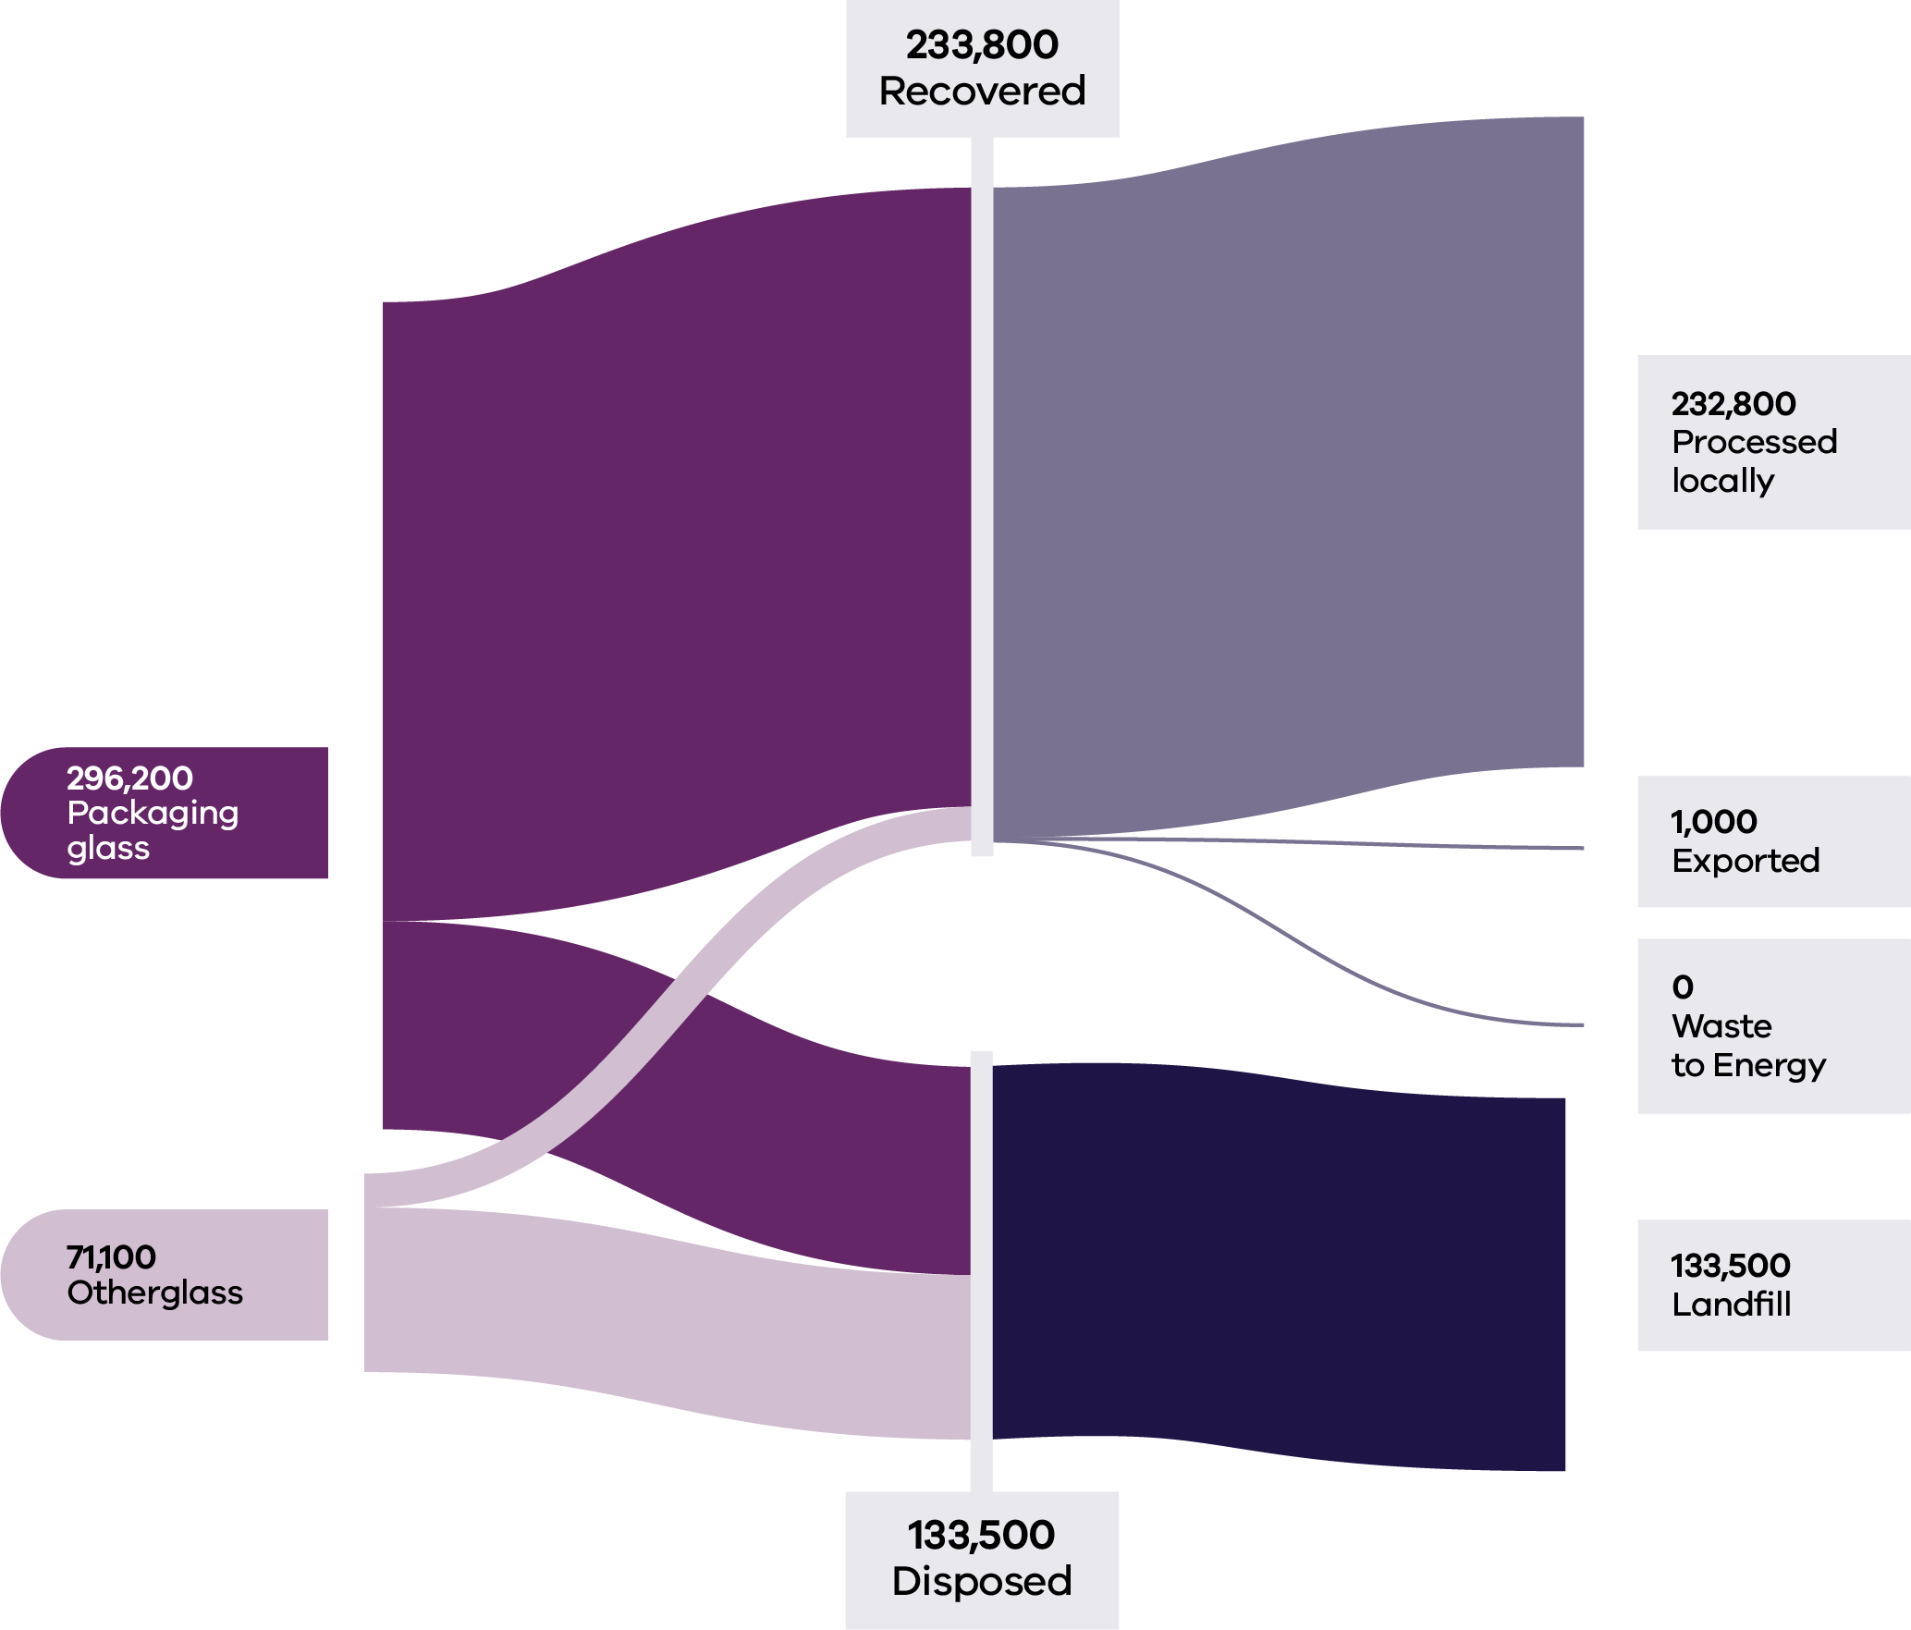

Households (MSW) were the largest contributors to the generation of glass waste (62%) and maintained a similar recovery rate to 2020–21 (66%) and 2021–22 (66%). The recovery rate for ‘Packaging glass’ (75%) is significantly higher than that observed for ‘Other glass’ (17%).

Based on 2021–22 commodity values, it is estimated that almost $17M was lost in landfill from the glass sector in 2022–23, as compared to approximately $25M of lost value for this material type in Victoria in 2021–22.

There was some very limited export of glass materials out of Victoria in 2022–23. Export tonnages are a very minor component (<0.1%) of all recovered glass with almost all material reprocessed locally.

Table 7: Source streams and recovery rates for glass in Victoria in 2022–23 (Recycling Victoria 2024b)

| Stream | Generated | | Recovered for reprocessing | | | Disposed | Recovery rate |
| --- | --- | --- | --- | --- | --- | --- | --- |
|  |  |  | **Processed locally** | **Exported** | **Total** |  |  |
|  | **Tonnes** | **Proportion** | **Tonnes** | **Tonnes** | **Tonnes** | **Tonnes** | **%** |
| MSW | 227,800 | 62% | 150,200 | 700 | 150,900 | 76,900 | 66% |
| C&I | 127,400 | 35% | 74,600 | 300 | 74,900 | 52,600 | 59% |
| C&D | 12,100 | 3% | 8,100 | 0 | 8,100 | 4,100 | 67% |
| **Total** | **367,400** |  | **232,800** | **1,000** | **233,800** | **133,500** | **64%** |

| Stream | Generated | | Recovered for reprocessing | | | Disposed | Recovery rate |
| --- | --- | --- | --- | --- | --- | --- | --- |
|  |  |  | **Processed locally** | **Exported** | **Total** |  |  |
|  | **Tonnes** | **Proportion** | **Tonnes** | **Tonnes** | **Tonnes** | **Tonnes** | **%** |
| Packag-ing Glass | 296,200 | 81% | 220,600 | 1,000 | 221,600 | 74,600 | 75% |
| Other  Glass | 71,100 | 19% | 12,200 | 0 | 12,200 | 58,900 | 17% |
| **Total** | **367,400** |  | **232,800** | **1,000** | **233,800** | **133,500** | **64%** |

### Developments and changes

There is a current strong market emphasis on increasing the recycled glass content in glass packaging manufacture, from the current average of 30–35% to a target range of 60–70%, increasing circularity benefits.

This market trend appears to be driven by consumer expectations. National Government policy is also proposing increases in a minimum post-consumer recycled content threshold for glass of 50% by 2025. This minimum threshold is proposed to increase to 75% by 2040 (DCCEEW 2024d).

In its first year of operation, CDS Vic has collected more than 1 billion eligible containers, which continues to secure a cleaner stream of glass material.

Twenty local government authorities have now introduced a glass-only kerbside bin service (representing 25% of all councils), with a further 16 introducing a new separated glass drop-off service (DEECA 2024).

Both above developments have resulted in an increase in the supply of clean glass to the sector, suitable for glass-to-glass remanufacture

### Market issues and challenges

The glass waste stream is expected to grow by over 50% over the next 30 years, with Victoria projected to generate over 500,000 tonnes by 2053.

Contamination from materials like food residues, bottle caps or ceramics makes it difficult to separate and recycle glass effectively.

Broken glass is also challenging to handle and often not recycled if it’s in small shards or heavily damaged. Limited recycling infrastructure in some areas, along with improper disposal and the economic cost of processing heavily contaminated or broken glass contributes to this issue. Addressing these challenges requires improved recycling facilities, better public awareness and better contamination control.

Many countries are nearing 100% glass recycling rates. In Australia, more than 80% of glass usage is attributed to food and beverage packaging (Dalla Costa and De Meillon, 2022) and more than a quarter of the glass used ends up in landfill. Even when disposed of correctly, broken glass and contamination can render the material unrecyclable.

### Focus areas for greater circularity – glass

The analysis highlights the following opportunities for improvements to this material stream:

Ongoing investigation into opportunities to maximise bottle-to-bottle recycling from opportunities presented by CDS Vic and glass-only kerbside collection.

Support opportunities to increase Victorian glass beneficiation capacity, including regionally.

Investigate opportunities to increase the use of lower grade recovered glass in construction materials, supporting the market for lower grade glass that is not suitable for glass-to-glass recycling.

## Metals

Sources of waste metals in Victoria include:

* packaging from households
* commercial businesses and the hospitality industry
* components from discarded furniture, household appliances and e-waste
* scrap generated by industrial manufacturing processes

materials from end-of-life vehicles.

Additionally, construction and demolition activities contribute significantly to waste metal, with metals like steel, copper and aluminium being recovered from building materials, infrastructure and machinery.

Recovered metals in Victoria are predominantly non-packaging types such as structural steel and aluminium (Recycling Victoria 2024d). Packaging metals, particularly those from food and beverage containers, make up a small portion of the total recovery, typically making up 3–4% of household recycling bin contents.

The waste metals recovery and reprocessing system is well established, and the industry is mature. There is strong dependence on exporting processed metals to fill that need. Increasing the local metal processing market is an opportunity to protect against export bans or other changes, increase the circularity and reduce embodied emissions, particularly if renewable energy is used.

The domestic metal recycling market is based on many small scrap metal collectors who collect material so that it can be aggregated into sufficient volumes to be managed. Waste generation and management levels have been relatively stable for several years. Generally, steel and aluminium packaging is recycled back into post-consumer metal pools to manufacture durable applications such as vehicles, building materials and many other products.

Exported steel and aluminium packaging are sold into large markets with most metal coming from non-packaging sources. The material flows from all countries are destined for wherever the demand requires material for production. Unlike some other materials, the origin of the steel or aluminium in new product is often unknown. Demand and pricing can increase or decrease based on worldwide supply and demand conditions.

### Market performance

The overall recovery rate for metals in Victoria in 2022–23 was 88% which is consistent with the recovery rate of 89% observed in 2020–21 and 2021–22.

More than 35% of all scrap metal generated was exported in 2022–23, making it the biggest export component of recyclable materials. Over 70% of all recovered aluminium was exported for processing in 2022–23. Victoria does not have local aluminium reprocessing capacity, so relies on the export market for managing this material stream. A total of 606,849 tonnes of metals were exported internationally in 2021–22 compared to 512,200 tonnes in 2022–23.

Figure 10: Source streams and recovery rates for glass in Victoria in 2022–23 (Recycling Victoria 2024b)

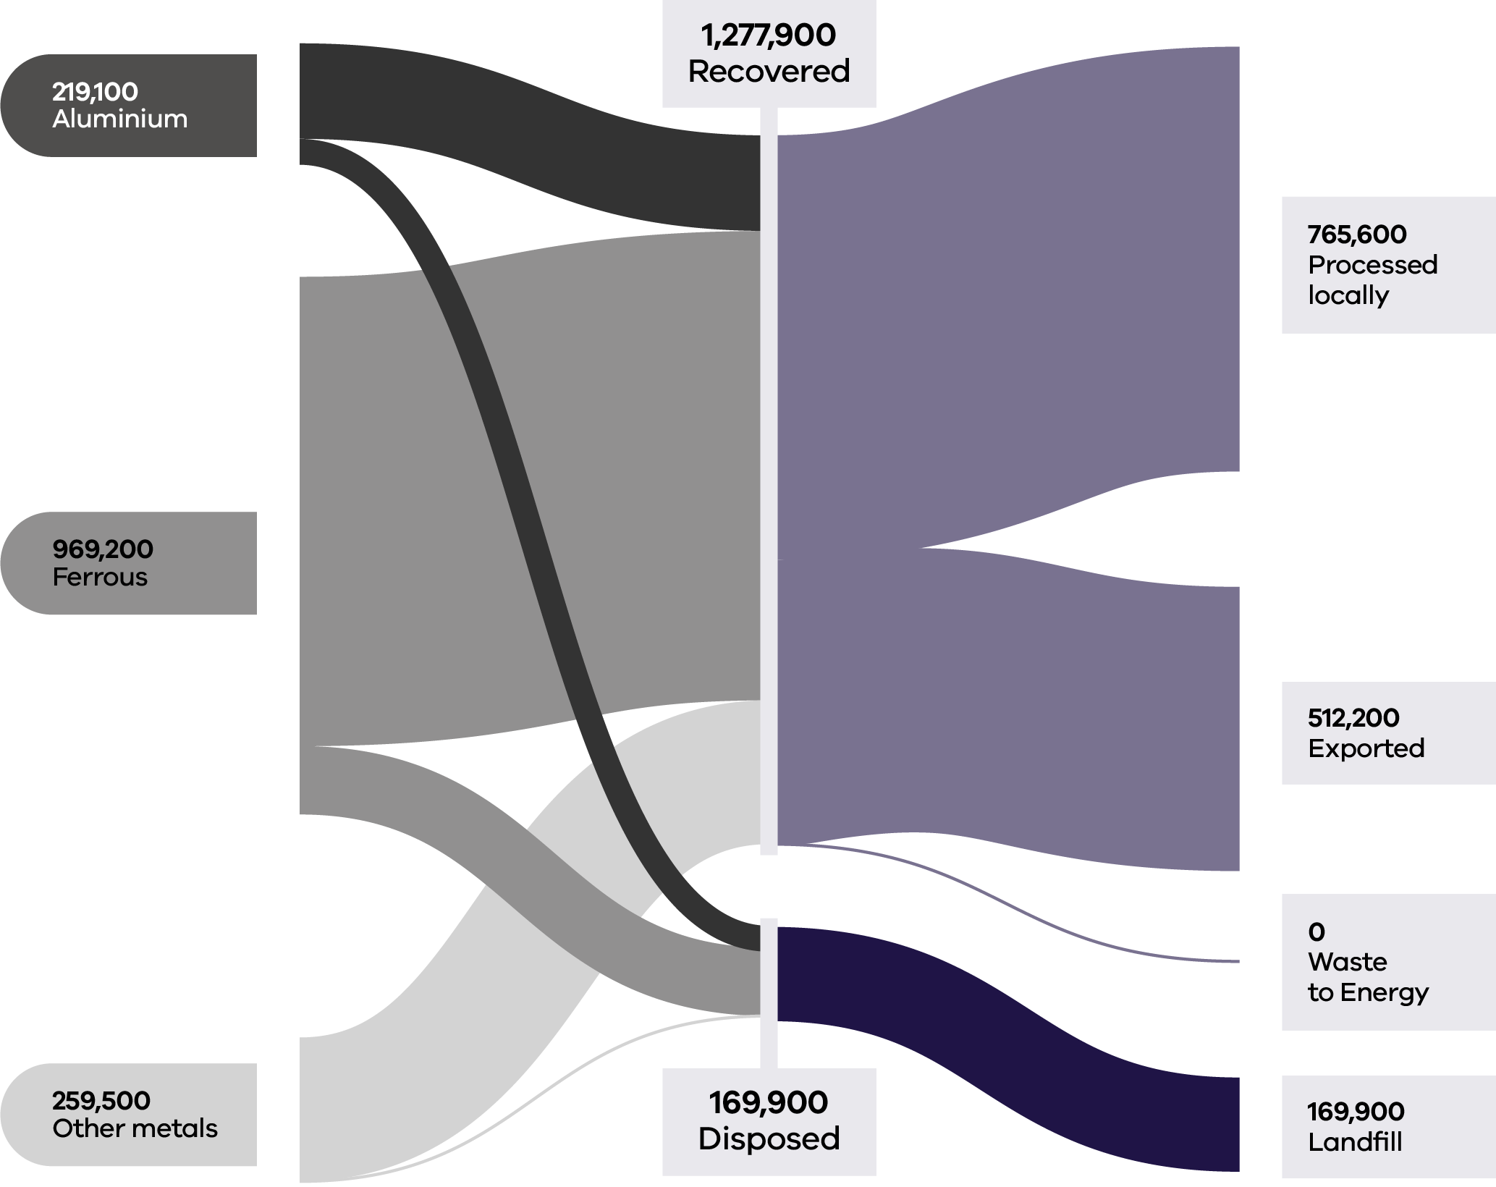

C&I was the largest contributor to the generation of metal (68%) and maintained a similar recovery rate (91%) to 2020–21 (92%) and 2021–22 (91%). A key driver of the high recovery rate for metal waste is the high commodity prices that can be achieved (Recycling Victoria 2024c). The rate of recovery exceeded 75% across all sectors in 2022–23. Similarly high rates were observed in 2020–21.

Around 60% of recovered metal waste was processed locally in 2022–23, with the remainder being processed outside of Victoria (Table 8)

The majority (~90%) of ‘other metals’ were processed locally in 2022–23, with similarly high processing rates reported in 2021–22.

Table 8: Metal flows by stream and material sub-groups for 2022–23 (Recycling Victoria 2024b)

| Stream | Generated | | Recovered for reprocessing | | | Disposed | Recovery rate |
| --- | --- | --- | --- | --- | --- | --- | --- |
|  |  |  | **Processed locally** | **Exported** | **Total** |  |  |
|  | **Tonnes** | **Proportion** | **Tonnes** | **Tonnes** | **Tonnes** | **Tonnes** | **%** |
| MSW | 374,800 | 26% | 182,200 | 136,600 | 318,900 | 55,900 | 85% |
| C&I | 985,400 | 68% | 551,100 | 341,300 | 892,400 | 93,000 | 91% |
| C&D | 87,600 | 6% | 32,400 | 34,300 | 66,600 | 21,000 | 76% |
| **Total** | **1,447,800** |  | **765,600** | **512,200** | **1,277,900** | **169,900** | **88%** |

| Stream | Generated | | Recovered for reprocessing | | | Disposed | Recovery rate |
| --- | --- | --- | --- | --- | --- | --- | --- |
|  |  |  | **Processed locally** | **Exported** | **Total** |  |  |
|  | **Tonnes** | **Proportion** | **Tonnes** | **Tonnes** | **Tonnes** | **Tonnes** | **%** |
| Aluminium | 219,100 | 15% | 50,500 | 121,900 | 172,400 | 46,700 | 79% |
| Ferrous | 969,200 | 67% | 483,500 | 362,500 | 846,000 | 123,200 | 87% |
| Other metals | 259,500 | 18% | 231,700 | 27,800 | 259,500 | 0 | 100% |
| **Total** | **1,447,800** |  | **765,600** | **512,200** | **1,277,900** | **169,900** | **88%** |

It is estimated that material with a potential value of $208M was lost to landfill in 2022–23 in Victoria indicating an opportunity for improved recovery.

The pricing for recycled steel and aluminium reflect that these feedstocks are highly integrated into global markets for virgin commodities. Hence these prices tend to reflect global influences on demand and supply, including perceptions of future global growth.

### Developments and changes

The metal waste stream is projected to grow by around 50% in the next 30 years, generating over 2.6 million tonnes of waste annually in 2053. Metal markets are well established with high value materials. There have been commercial developments in Australia with Sims Resource Renewal in Queensland testing plasma gasification of automotive floc to convert the waste into a synthetic gas, but this is still several years from reaching its potential (Recycling Victoria 2024c).

Operating for over one year now, CDS Vic has created a new collection pathway for metal beverage containers, presenting opportunities for reprocessing to capitalise on this new high value material stream.

### Market issues and challenges

Shredder floc continues to represent a challenge. Floc consists of glass, rubber, plastics, fibres, dirt and fines that remain after ferrous and nonferrous metals have been removed. Floc is highly combustible and poses a fire risk when inappropriately stored in stockpiles.

Ongoing action is required to increase capacity to meet future demand and, where economically viable, to replace exports with local reprocessing. Ongoing actions are also needed to increase capability relating to shredder floc and metals from e-waste (Recycling Victoria 2024c).

### Focus areas for greater circularity – metals

The analysis highlights the following opportunities for improvements to this material stream:

* Explore options to increase local reprocessing capacity to meet future demand and, where economically viable, to replace exports with local reprocessing.
* Investigate improved methods for managing and processing shredder floc to limit stockpiling.
* Investigate options to increase local end markets for steel and aluminium packaging.
* Investigate opportunities to recover precious and rare earth metals in e-waste.

## Organics

Organic waste includes biodegradable material such as:

* food scraps
* garden waste and other plant-based materials
* biodegradable packaging materials
* by-products from food processing and manufacturing

biosolids from water treatment processes.

These materials can be recovered, composted or used for bioenergy production to reduce disposal to landfill.

Organics are the most potent source of greenhouse gas emissions in landfill (DCCEEW 2024c). Recovering organics into compost and fertiliser products reduces greenhouse gas emissions, regenerates landscapes and builds healthier soils.

### Market performance

Victoria recovered just under half (48%) of all organic material generated in 2022–23. Of the 3 contributing sectors, households (MSW) contributed the most to the total tonnes generated (56%) and had the highest recovery rate (59%). This is an improvement from the recovery rate observed for households in 2020–21 (52%) and reflects the benefits realised from the ongoing roll out of FOGO collection services across this state. C&I is the next largest contributor to total tonnes generated (38%) although has a less optimal recovery rate than that for households (37%) (Table 9).

Food organics and garden organics each contribute approximately a third to the total material generation by weight. The recovery rate is markedly better for garden organics (82%) than for food organics (23%). It is estimated that the average Australian household loses $890 every year to food waste and the cost to the Australian economy is $20 billion (KPMG 2020).

Figure 11: Organics generated, recovered for processing, and disposed of in 2022–23 (tonnes) (Recycling Victoria 2024b)

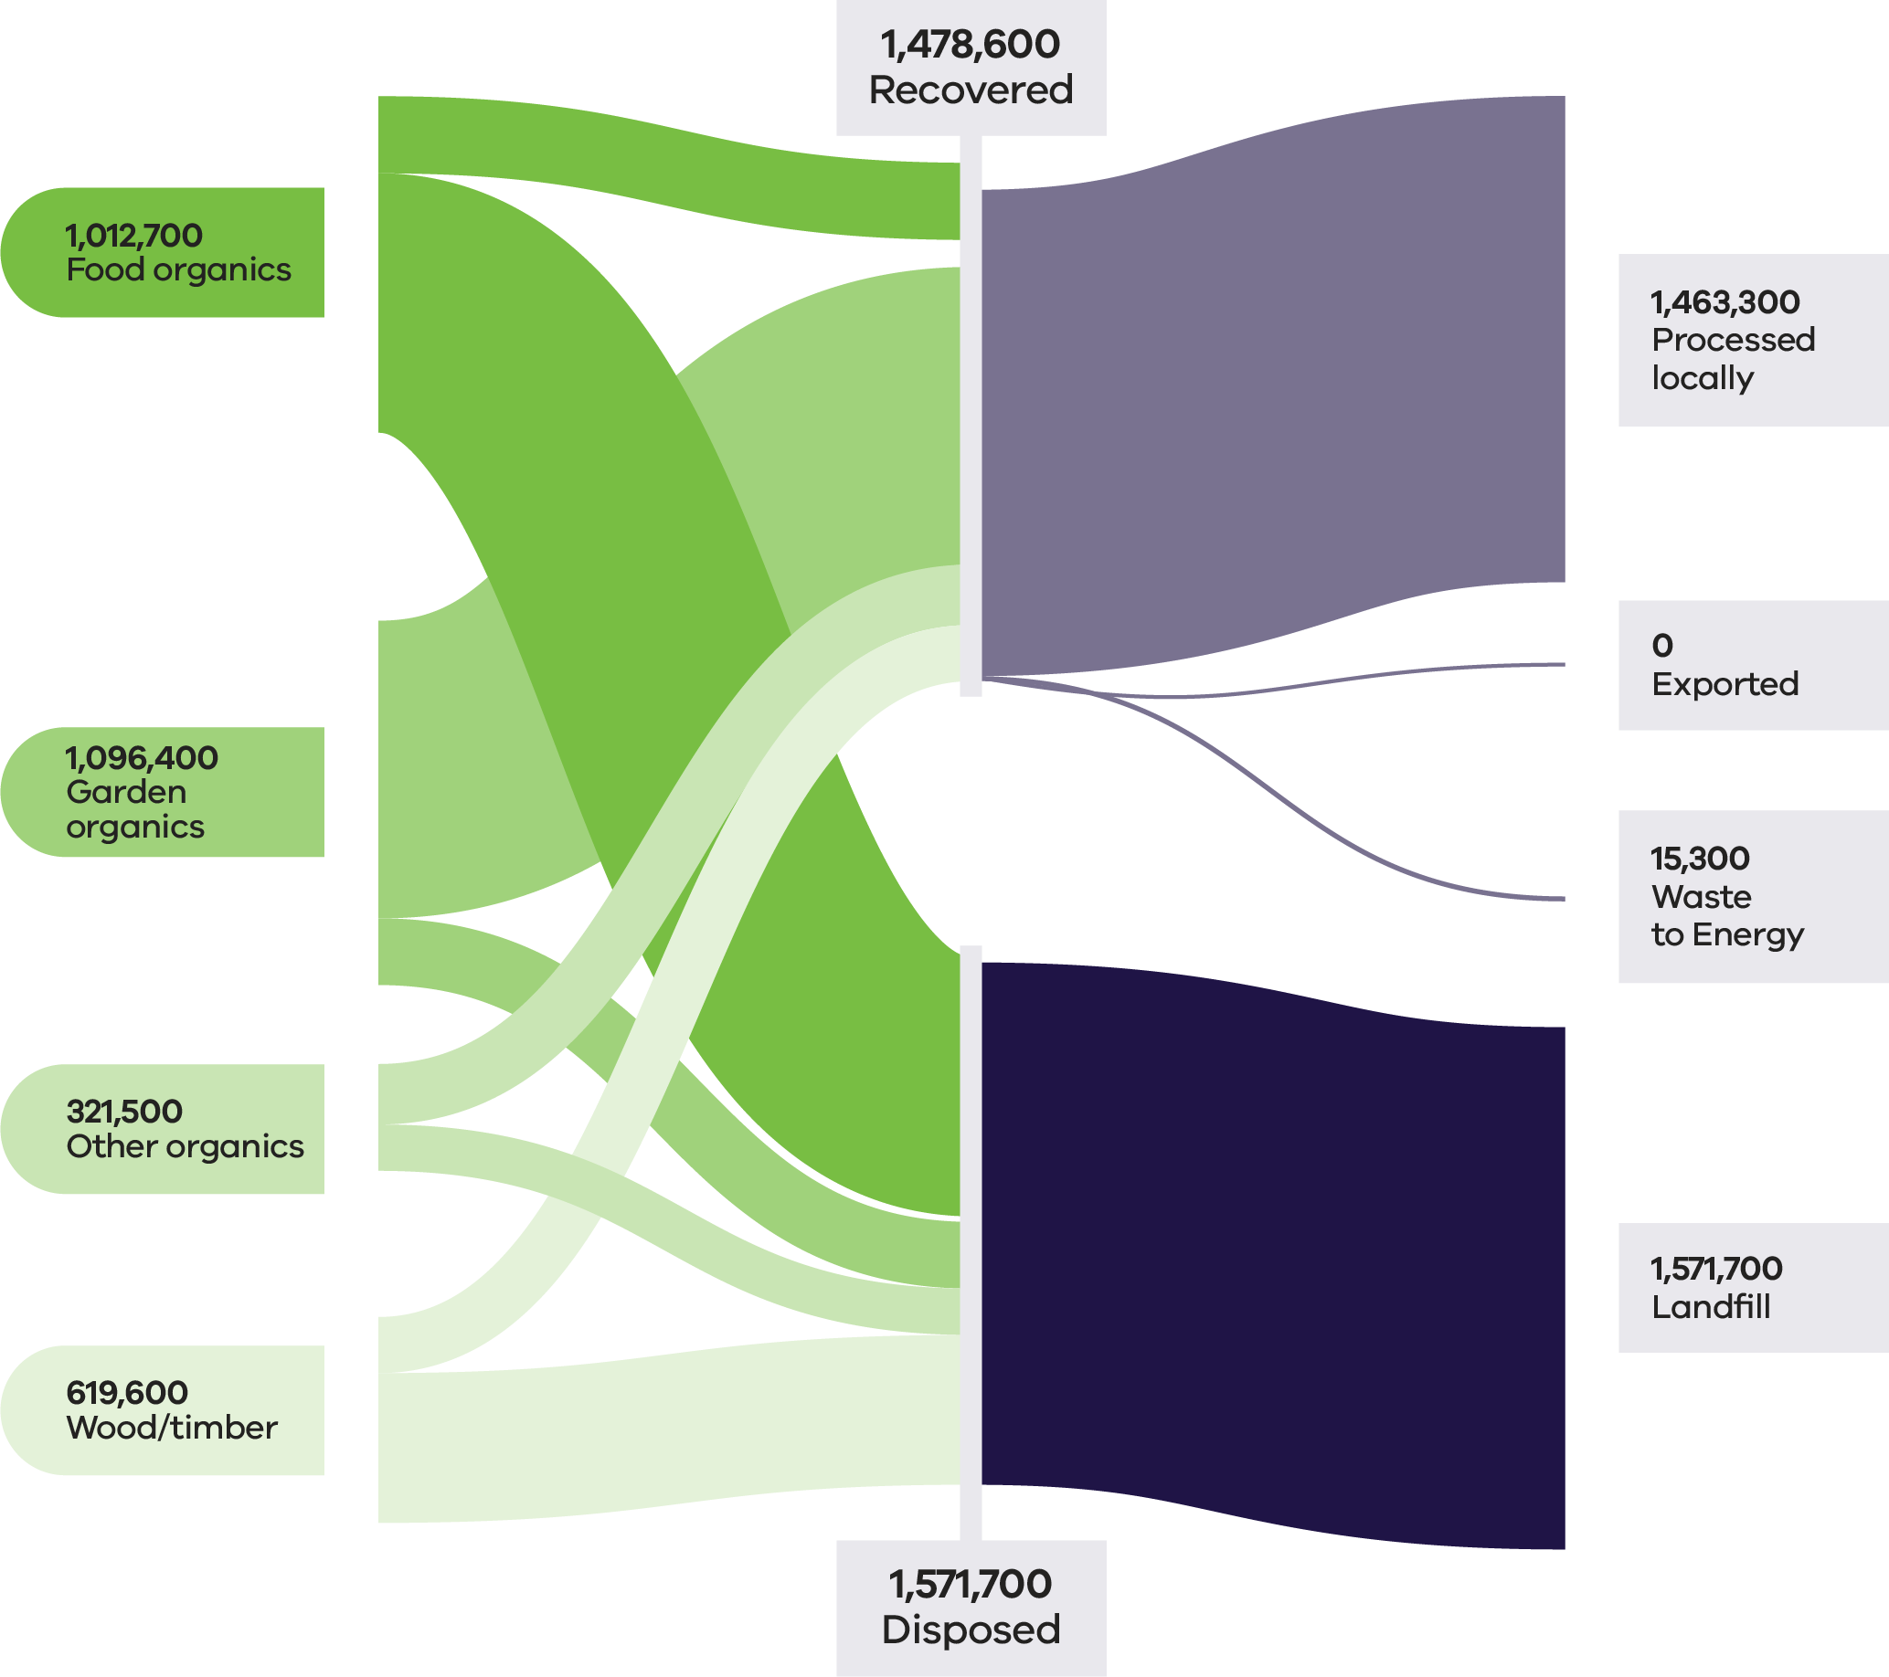

Table 9: Organics flows by stream and material sub-groups for 2022–23 (Recycling Victoria 2024b)

| Stream | Generated | | Recovered for reprocessing | | | Disposed | Recovery rate |
| --- | --- | --- | --- | --- | --- | --- | --- |
|  |  |  | **Processed locally** | **Exported** | **Total** |  |  |
|  | **Tonnes** | **Proportion** | **Tonnes** | **Tonnes** | **Tonnes** | **Tonnes** | **%** |
| MSW | 1,712,800 | 56% | 1,017,100 | 0 | 1,017,100 | 695,700 | 59% |
| C&I | 1,153,900 | 38% | 409,100 | 15,300 | 424,400 | 729,500 | 37% |
| C&D | 183,600 | 6% | 37,100 | 0 | 37,100 | 146,500 | 20% |
| **Total** | **3,050,300** |  | **1, 463,300** | **15,300** | **1,478,600** | **1,571,700** | **48%** |

| Stream | Generated | | Recovered for reprocessing | | | Disposed | Recovery rate |
| --- | --- | --- | --- | --- | --- | --- | --- |
|  |  |  | **Processed locally** | **Exported** | **Total** |  |  |
|  | **Tonnes** | **Proportion** | **Tonnes** | **Tonnes** | **Tonnes** | **Tonnes** | **%** |
| Food Organics | 1,012,700 | 33% | 216,700 | 15,300 | 232,700 | 780,700 | 23% |
| Garden Organics | 1,096,400 | 36% | 895,600 | 0 | 895,600 | 200,900 | 82% |
| Other Organics | 321,500 | 11% | 182,200 | 0 | 182,200 | 139,400 | 57% |
| Wood/ Timber | 619,600 | 20% | 168,900 | 0 | 168,900 | 450,700 | 27% |
| **Total** | **3,050,300** |  | **1,463,300** | **15,300** | **1,478,600** | **1,571,700** | **48%** |

Over the last 5 years, the amount of garden organics collected has increased by approximately 80% while retaining a recovery rate of over 80%. The volume of food organics collected is also expected to steadily increase as councils across the state expand green bin services to include food organics (Recycling Victoria 2024b).

Figure 12 shows the amount of food and garden organics generated and recovered from households (MSW). (Recycling Victoria 2024b)

Figure 12: Changes in MSW food and garden organics recovery over 5 years (Recycling Victoria 2024b)

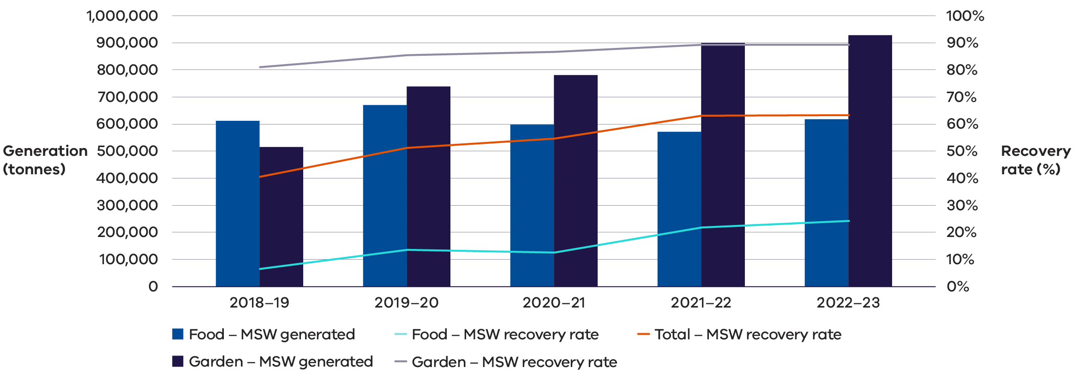

### Commercial and Industrial food waste

Victoria produces 25% of all fresh food in Australia, processes over 50% of all Australian made foods and is responsible for around 25% of Australia’s total food waste (Sustainability Victoria, 2024).

Food waste is a global issue. Each year around the world 1.3 billion tonnes of food is wasted. About one third of all the food produced for human consumption becomes waste. This is a financial concern as well as a major contributor to global warming (Reset 2024). Trends in Australian C&I food organics management as reported in the National Waste Report 2024 (DCCEEW 2024d) show that across all jurisdictions and time periods of available data, the disposal of C&I food organics to landfill is the most common fate.

Organics have high potential for circularity but currently have a low to medium recovery rate nationally. The C&I sector has a poor recovery rate for organics relative to MSW. The national target is to halve food waste by 2030, with the baseline set in 2016–17, and most jurisdictions have adopted targets consistent with the national targets. Victoria has an additional interim target of a 20% reduction in food waste to landfill by 2025.

Opportunities exist at each stage of the lifecycle to reduce C&I food waste and increase recovery including generation, collection, processing and end uses. Opportunities include the following:

* **Avoidance** – Awareness for businesses on the importance of food waste avoidance and education/support for hospitality and food service operators on ways to reduce food waste.
* **Re-use** – Promotion of food reuse via food rescue organisations or business connection platforms.
* **Sorting and collecting** – Collection services through local networks and promote/education on incentivise onsite commercial food recovery systems.
* **Contamination / Recycling** – Decontamination technology (such as depackaging) and ways to improve contamination tolerance in organics recycling facilities.
* **Alternative technology** – Viability assessments of business onsite maceration equipment designed to work with anaerobic digestion and in-sink macerators in collaboration with water industry, as well as the exploration of insect processing as an alternative treatment process and viability for residual C&I timber to be used for refuse derived fuel.

### Development and changes

Household recovery of garden organics continues to develop with the rollout of kerbside FOGO. This is in line with the Victorian Government target to ensure 100% of households have access to food and organic waste services or composting by 2030 (Recycling Victoria 2024f).

The development of small-scale composting infrastructure for regional councils is a relatively recent advancement.

There is increasing uptake from industry and regional communities in advanced recycling methods beyond composting. Water authorities and regional municipalities are also exploring anaerobic digestion and pyrolysis, which present emerging pathways for organic waste into energy, biogas digestate and biochar.

### Market issues and challenges

It is estimated that the average Australian household loses $890 every year to food waste and the cost to the Australian economy is $20 billion (KPMG 2020).

Opportunities remain to reduce food waste generation across the entire value chain, from cultivation and harvesting to retail, households, and the hospitality sector.

Compost and fertiliser products typically attract a modest per-tonne market value and are traded in bulk. These factors, along with transport costs and the perishable nature of organics, impose geographical limitations on supply chains and market reach. As a result, organics markets operate locally, with materials recovered, processed and sold entirely within Victoria.

There is an ongoing opportunity for further development of recycled organics markets in Victoria. Opportunities exist to enable investment and policy reform to improve the recovery rates for the C&I sector noting that this sector contributes 40% of the total organic materials generated but only has a recovery rate of 36% (Table 9). Opportunity also exists for the improved recovery of food organics which comprises a third of total organic materials generated but only has a recovery rate of 23% (Table 9).

### Key focus areas for greater circularity – organics

The analysis highlights the following opportunities for improvements to this material stream:

* Investigate opportunities to reduce contamination across all organic material types.
* Investigate opportunities to enable investment and reduce barriers to food waste collection in the C&I sector.

## Case study: Tackling barriers to food waste reduction

Too Good To Go, a certified B Corp social impact company and the world’s largest business to consumer marketplace for surplus food was founded in Copenhagen in 2015. Too Good To Go connects food businesses to consumers as a way to help them unlock value from surplus food and reduce food waste through its free to use mobile app. The business has accumulated over 100 million registered users and 170,000 active partners, in 19 countries across Europe, North America and Australia.

### Problem

Forty percent of all the food produced around the world is wasted, this is as much as 2.5 billion tonnes each year (WWF 2021), with this wastage accounting for 10% of all greenhouse gas emissions worldwide (WWF 2024). Economically, the cost of global food waste amounts to about $1.1 trillion annually (WWF 2024). In Australia, food waste is a multi-billion-dollar problem, with over 7.6 million tonnes of food wasted annually, despite 70% of this food still being edible. Reducing food waste tackles climate change by limiting the temperature rise to 2˚C by 2100 (Project Drawdown 2020).

### Approach

Too Good To Go aims to help households and businesses halve Australia’s annual food waste by 2030 in line with the National Food Waste Strategy. In order to help combat the food wastage problem at a retail level, the Too Good To Go marketplace partners with food businesses, giving them the opportunity to use “Surprise Bags” as a simple solution to unlock value from surplus food and reduce food waste. As surplus varies on a day-to-day basis, retailers have the flexibility to include genuine surplus in Surprise Bags that are advertised on the Too Good To Go app for purchase, direct to consumers.

Too Good To Go officially launched in Melbourne on the 29th of August 2024 with over 80 innovative and pioneering businesses who understand the importance and benefits of moving to a circular economy to reduce waste from both a cost perspective and environmental perspective. Since August, Too Good To Go has scaled to expand into Sydney as of mid-November 2024, and amassed over 400 businesses and 250,000 registered users in 4 months. Since the launch, consumers have saved over 70,000 meals from going to waste, the equivalent of 189,000 Kg CO2e, 196,000 m2 of land use and 56.7 million litres of unnecessary water use.

Too Good To Go quantifies the environmental impact of the food that users help to save in ‘Surprise Bags’ from going to waste. It is estimated that saving a meal from being wasted (1 ‘Surprise Bag’ = 1 kg) through the app is equivalent to avoiding 2.7 kg of CO2e emissions, 810 litres of water use and 2.8 m2 of unnecessary land use per year. (The quantities of each measure are based on independent research conducted in 2023 by Mérieux Nutrisciences | Blonk and validated by researchers from Oxford University and WRAP. The research is concluded in a bespoke measurement framework based on Life Cycle Index data of the food from going to waste.)

### Lessons

While the positive environmental impact is the primary focus of Too Good To Go, there is also a positive economic impact for its partners, aiding them in the recovery of costs on food items that would otherwise go to landfill by selling them through the app. These costs not only involve the cost of ingredients, production and labour, it also includes council and landfill fees associated with the disposal of this surplus food.

Selling surplus food on Too Good To Go also attracts new customers to these businesses. Across all segments, over one in 3 (Sources: Too Good To Go Internal Data; Too Good To Go 2024 Survey across 20 million users in 19 markets who bought a Surprise Bag in 2024.) customers collecting their Too Good To Go Surprise Bag had never purchased from these businesses before. The new traffic allows partners to showcase their products and foster brand loyalty to a new audience.

There is a link to improved brand perception, with 83% of Too Good To Go customers saying they will favour a brand over competition because they are on the app. Too Good To Go’s model shows that tackling food waste can be an environmental imperative and a viable economic opportunity with measurable societal benefits.

## Case Study: Tackling barriers to food re-use

Hospitality businesses in Melbourne’s CBD overcoming barriers to improved food waste collection

### Problem

In Australia 5 million tonnes of food waste ends up in landfill each year. (ABC 2022). To address food waste volumes generated by Melbourne’s dining precincts, the City of Melbourne partnered with hospitality businesses to trial a ‘butler’ style food waste collection service in 2022. The goal was to divert a large proportion of the city’s hospitality food waste from ending up in landfill.

### Approach

Businesses were provided with 22 litre tubs for food waste, which were collected directly from the business using e-bikes with a trailer. The e-bike and trailer were a practical option to avoid the congestion caused by larger vans or trucks in narrow city laneways.

The tubs were taken to Degraves Street Recycling Facility to be inspected, sorted for contamination and weighed prior to processing in food waste digesters. Tubs were then cleaned by the facility and returned to businesses for ongoing service collection. The service diverted tonnes of biodegradable waste from ending up in landfill and instead the food waste was processed into compost.

### Lessons

The trial of the ‘butler’ style service led to the collection of valuable data on how food waste services can operate.

The key constraints to effective participation were resistance to changing practices, lack of space within the kitchen for tubs, poor communication between managers and kitchen staff, confusion that businesses could request more tubs/collection times and misunderstanding that all organics can be collected (businesses were often only collecting kitchen organic waste and not including plate scrapings).

Recurring engagement by council staff was necessary to maintain high diversion rates. Additionally, in-person interaction with collection staff had assisted with managing contamination and ongoing recycling education. Multi-lingual printed material such as letter, flyers and signage were required to support in-person engagement, but distribution of printed material alone did not prove effective.

There were varied diversion rates between businesses, but higher diversion rates were often found in businesses with previous experience in source separation as normal practice.

City of Melbourne derived 3 conditions that need to be met to drive behaviour change with the introduction of a new waste service:

1. It must be cost effective for the business or be proven to reduce costs.
2. The service must be easy and convenient.
3. The business must legally be required to participate.

By collecting organics directly from businesses, staff did not need to wash containers/bins themselves, and businesses did not need to buy new waste bins. Initial diversion rates were 10% for drop off facilities compared to 30% for the ‘butler’ service. Both collection systems had increased diversion rates with ongoing education and engagement.

The trial also included economic benefits for the City of Melbourne, allowing for expansion of the existing organics service without installing new infrastructure (such as bin-based drop-offs). Reducing the number of bins in public spaces and the associated truck movements for waste collection helped to maintain amenity in the CBD.

## Paper and cardboard

Paper and cardboard waste includes:

* cardboard
* liquid paperboard
* newsprint & magazines
* printing and writing paper

other mixed paper materials.

Paper and cardboard can be recycled into:

* newsprint
* printing and communication products
* tissue products
* packaging and industrial products

other products like kitty litter, compost insulation, egg cartons and building products.

Recycling paper and cardboard is especially important from an environmental perspective. When paper is disposed of in landfill rather than recycled, it creates methane as it breaks down.

By world standards, Australia has a small pulp, paper and paperboard industry. There may be opportunities to grow the domestic market and replace virgin products with recycled material. However, the limited size of the domestic market compared to the overall supply of paper and cardboard means exports is likely to continue to play a key role in the sector (Recycling Victoria 2024b).

### Market performance

The overall recovery rate for paper and cardboard in Victoria in 2022–23 was 59% (Table 10). This is consistent with the recovery rate of 57% observed in 2020–21 and 60% observed in 2021–22. C&I was the largest contributor to the generation of paper and cardboard (62%) and maintained a similar recovery rate 2020–21 (64%) and 2021–22 (63%). Recovery in the MSW sector was 52%. This has increased from 45% observed in 2020–21.

Cardboard and other paper (mixed) had the highest rates of export and recovery among all paper and cardboard material types in 2022–23, except for newspapers and magazines, which generated very little waste relative to other types.

The packaging (typically corrugated boxes) used to transport imported goods is not accounted for as part of the packaging material imports data. This means that the Australia-wide volume of paper and paperboard available for recovery is significantly greater than total consumption.

Figure 13: Paper and cardboard generated, recovered for processing, and disposed of in 2022–23 (tonnes) (Recycling Victoria 2024b)

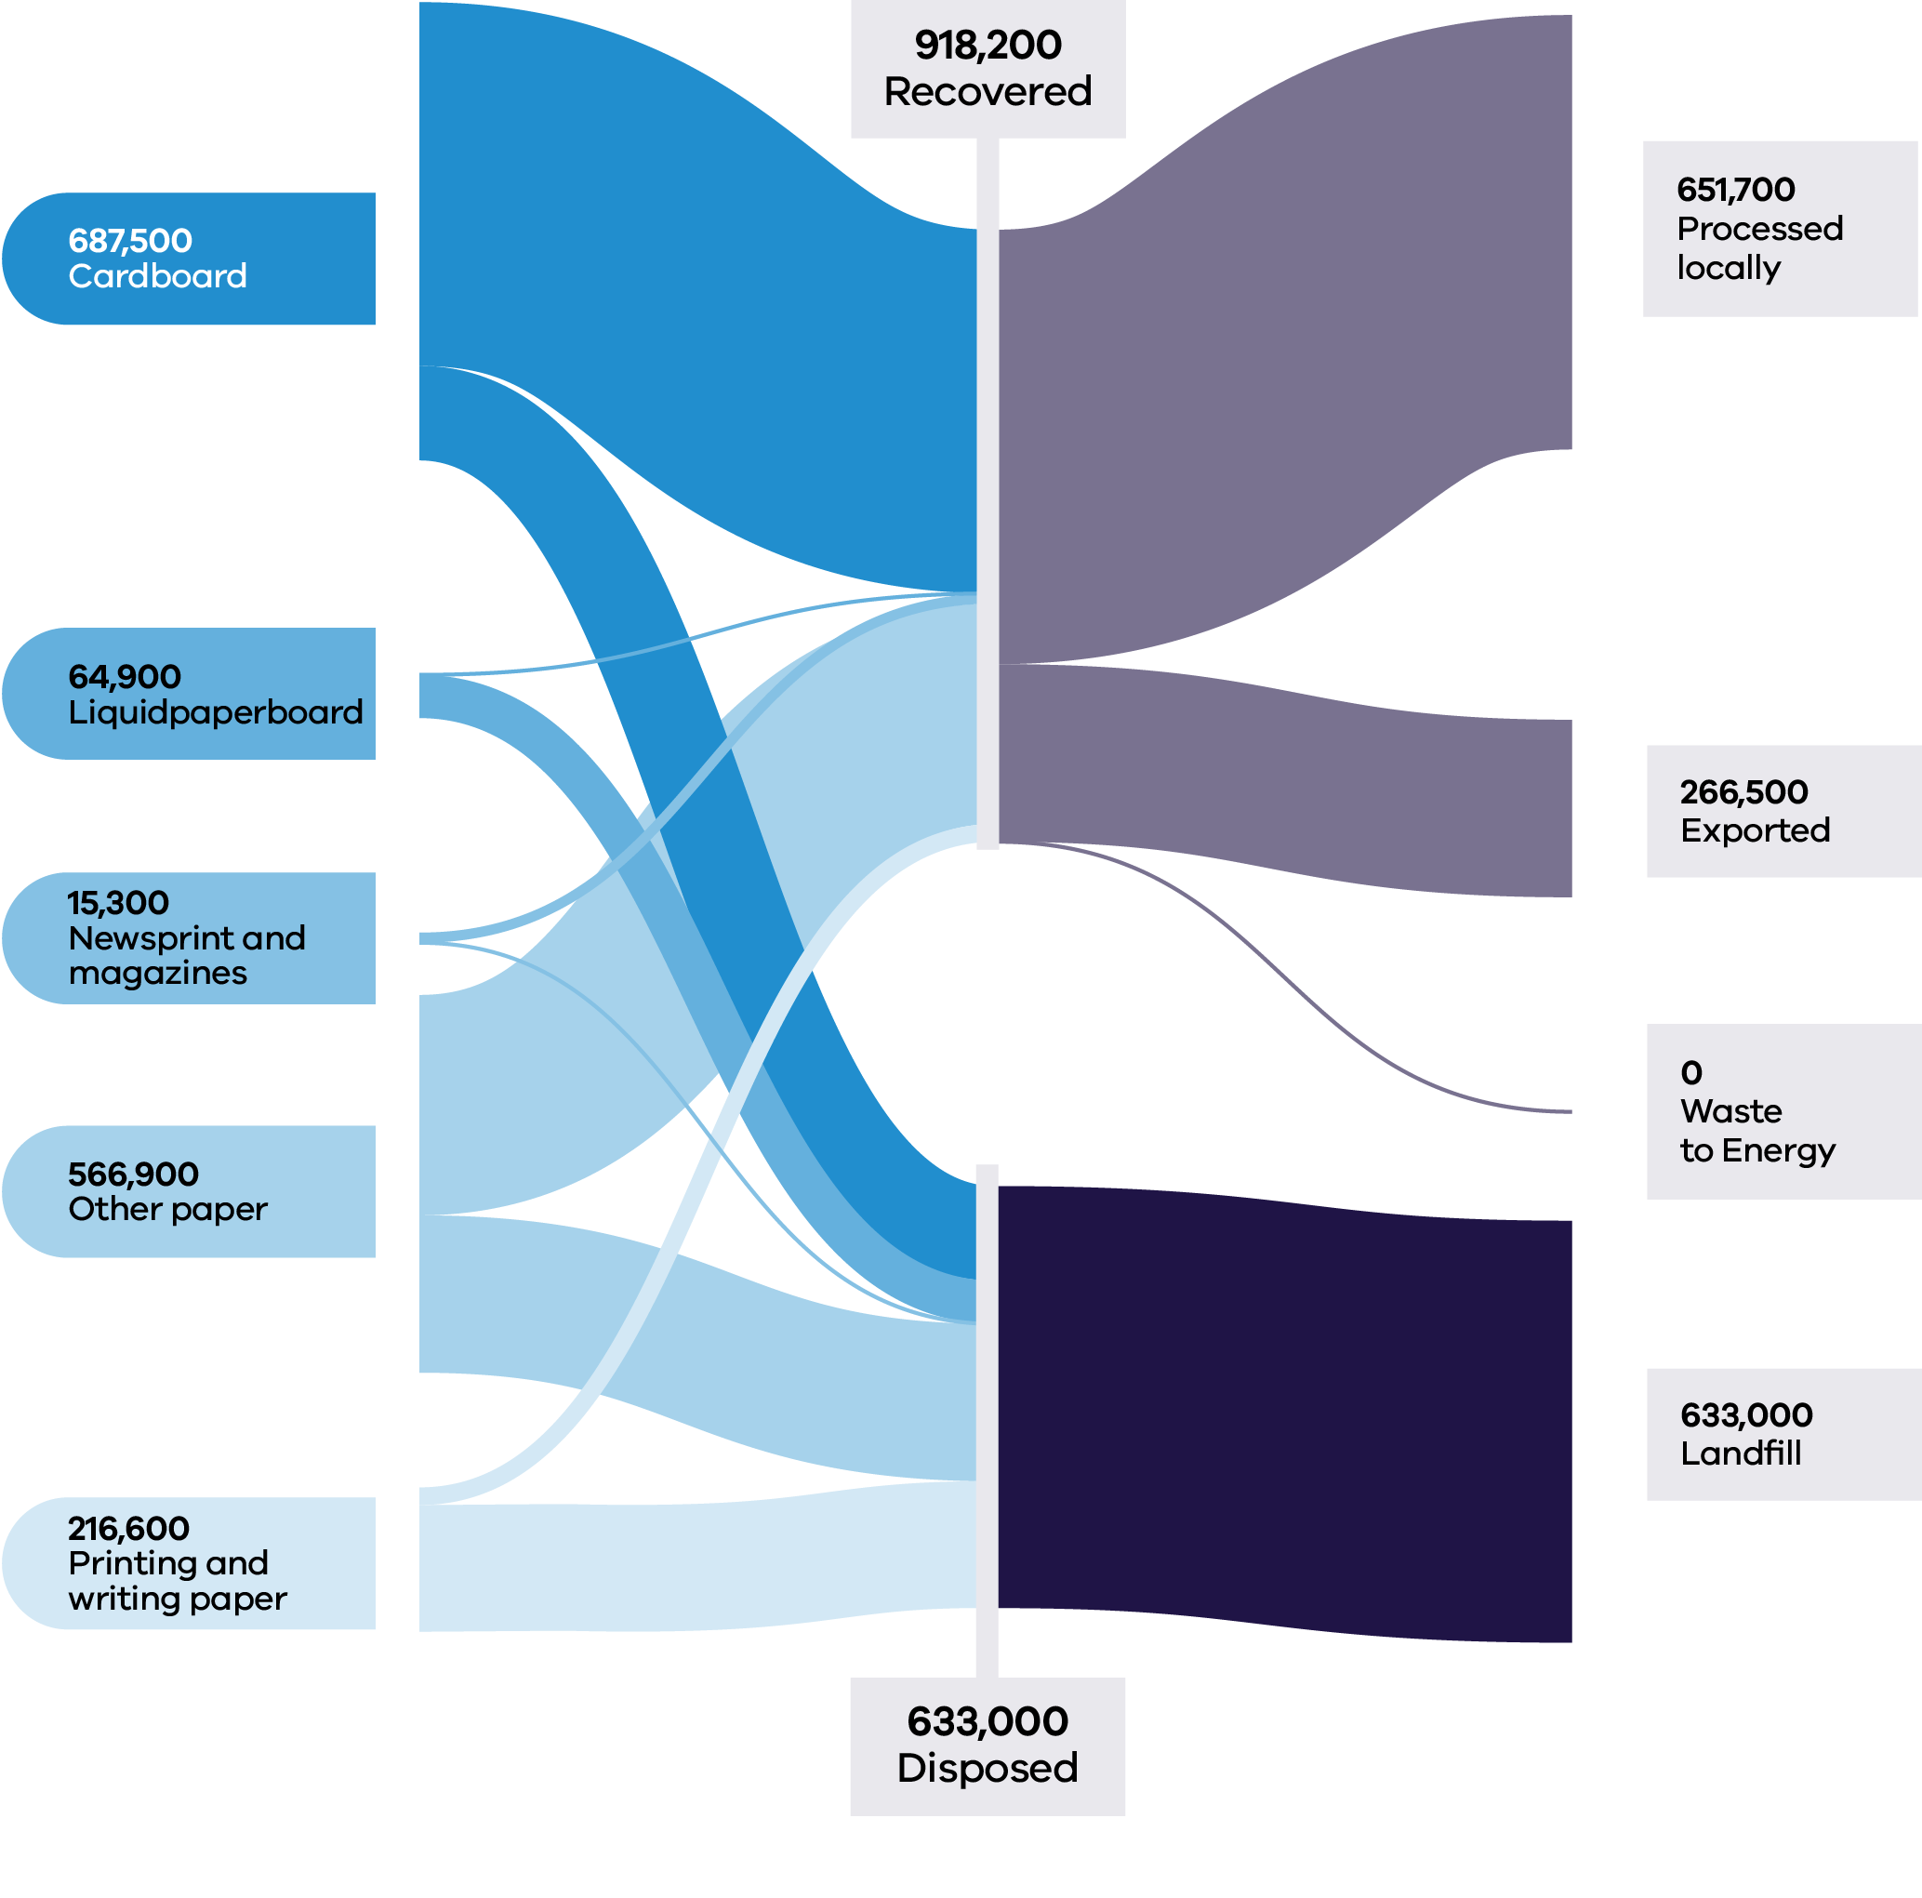

It is estimated that over $80M was lost in value to landfill in 2022–23, as compared to $66M lost in value from the sector in Victoria in 2021–22 (based on 2021–22 commodity values).

The price of kraft pulp stayed steady in 2024 after reaching historic high levels of nearly AUD$1,800 per tonne in September 2022, and the price falling significantly in early 2023 (Trading Economics 2024).

Approximately 29% of all paper and cardboard recovered in 2022–23 was exported out of Victoria (266,500 tonnes), with more material exported from the MSW sector than the C&I sector (Table 10). Similar tonnages were exported to international markets in 2021–22 (Recycling Victoria 2024a).

Table 10: Paper and cardboard flows by stream and material sub-groups for 2022–23 (Recycling Victoria 2024b)

| Stream | Generated | | Recovered for reprocessing | | | Disposed | Recovery rate |
| --- | --- | --- | --- | --- | --- | --- | --- |
|  |  |  | **Processed locally** | **Exported** | **Total** |  |  |
|  | **Tonnes** | **Proportion** | **Tonnes** | **Tonnes** | **Tonnes** | **Tonnes** | **%** |
| MSW | 574,200 | 37% | 176,600 | 123,000 | 299,600 | 274,600 | 52% |
| C&I | 968,700 | 62% | 475,100 | 143,500 | 618,600 | 350,100 | 64% |
| C&D | 8,400 | 1% | 0 | 0 | 0 | 8,400 | 0% |
| **Total** | **1,551,200** |  | **651,700** | **266,500** | **918,200** | **633,000** | **59%** |

| Stream | Generated | | Recovered for reprocessing | | | Disposed | Recovery rate |
| --- | --- | --- | --- | --- | --- | --- | --- |
|  |  |  | Processed locally | Exported | Total |  |  |
|  | Tonnes | Proportion | Tonnes | Tonnes | Tonnes | Tonnes | % |
| Card-board | 687,500 | 44% | 420,800 | 124,700 | 545,500 | 141,900 | 79% |
| Liquid Paper board | 64,900 | 4% | 0 | 0 | 0 | 64,900 | 0% |
| News-print & maga-zines | 15,300 | 1% | 10,400 | 4,900 | 15,300 | 0 | 100% |
| Other paper (mixed) | 566,900 | 37% | 194,000 | 136,900 | 330,800 | 236,100 | 58% |
| Printing/writing paper | 216,600 | 14% | 26,500 | 0 | 26,500 | 190,100 | 12% |
| **Total** | **1,551,200** |  | **651,700** | **266,500** | **918,200** | **633,000** | **59%** |

### Developments and changes

CDS Vic, in operation over the last year, has removed glass and beverage packaging from the commingled kerbside bin stream, leaving less contaminated and cleaner material.

An increase in Victoria’s capacity and capability to recover paper and cardboard occurred over the past year, with Visy commissioning a new drum pulper at the Coolaroo site in August 2023. The pulper has potentially added an extra 95,000 tonnes of processing infrastructure annually, thus doubling the Victorian capacity (Recycling Victoria 2024b).

Recent closures of paper manufacturing machines have taken place at Sorbent (closure of several machines from October 2023 to March 2024) and Opal Australian Paper Maryvale Mill (closure of white paper machine in 2023), thereby reducing the local processing capacity (Recycling Victoria 2024b).

The Australian Government sought feedback in August 2023 on proposals to regulate mixed paper and cardboard exports from 1 July 2024 by imposing a maximum contamination rate of 5%, tightening to 3% in 2026. This means that higher value, cleaner materials can continue to be exported, but lower grade materials will require domestic processing.

RMIT University recently partnered with Intrax Consulting Engineers and Citywide Service Solutions Pty Ltd to research the application of recycled cardboard in residential and commercial construction. This project is investigating the use of treated cardboard mixture to replace aggregates in production of concrete panels and timber trusses in both commercial and residential buildings. The reprocessing system will crush and shred cardboard waste materials and combine it with recycled plastic resin to form a product that replaces the traditional building materials (Venkatesan et al. 2023).

### Market issues and challenges

Over the next 30 years, the paper and cardboard waste stream is projected to grow by 47%, with Victorians expected to generate over 2.6 million tonnes by 2053. Cardboard and other paper together make up 81% of the waste stream and this is projected to increase to approximately 91% in 2053.

There remain challenges in the separation of paper grades, particularly in the MSW sector. This may impact the ability for domestic manufacturers of paper and cardboard to drive recovery.

Another recycling challenge is that the cellulose fibres that form the base for the manufacture of paper and cardboard. These fibres undergo structural changes during the process, particularly during drying or water removal. Paper with long fibres, like white office paper, offer the most flexibility for recycling, while paper with short fibres, like newsprint grade, offers lower quality recycling options.

### Focus areas for greater circularity – paper and cardboard

The analysis highlights the following opportunities for improvements to this material stream:

* Investigate options to improve sorting to reduce contamination and allow different material grades to be collected and recycled to maximise higher order end markets and meet export regulations.
* Investigate opportunities to use materials with a lower recovery rate where appropriate as a substitute for higher quality material streams.
* Support the market to utilise opportunities to collect and recover high quality cardboard streams from C&I sector.

## Plastics

Plastics are used to make many modern products including:

* packaging
* household goods
* synthetic textiles
* furniture
* pipes, hoses and cabling

plastic film

Existing end markets for plastics include:

* the built environment
* electrical and electronic applications
* industrial applications
* transport and logistics
* packaging

energy recovery.

### Market performance

The overall recovery rate for plastics in Victoria in 2022–23 was 23%. This was the lowest performing recovery rate across the key material streams but was consistent with the recovery rate for 2021–22 (23%), and slightly better than the recovery rate for 2020–21 (18%).

Figure 14: Plastic generated, recovered for processing and disposed of in 2022–23 (tonnes) (Recycling Victoria 2024b)

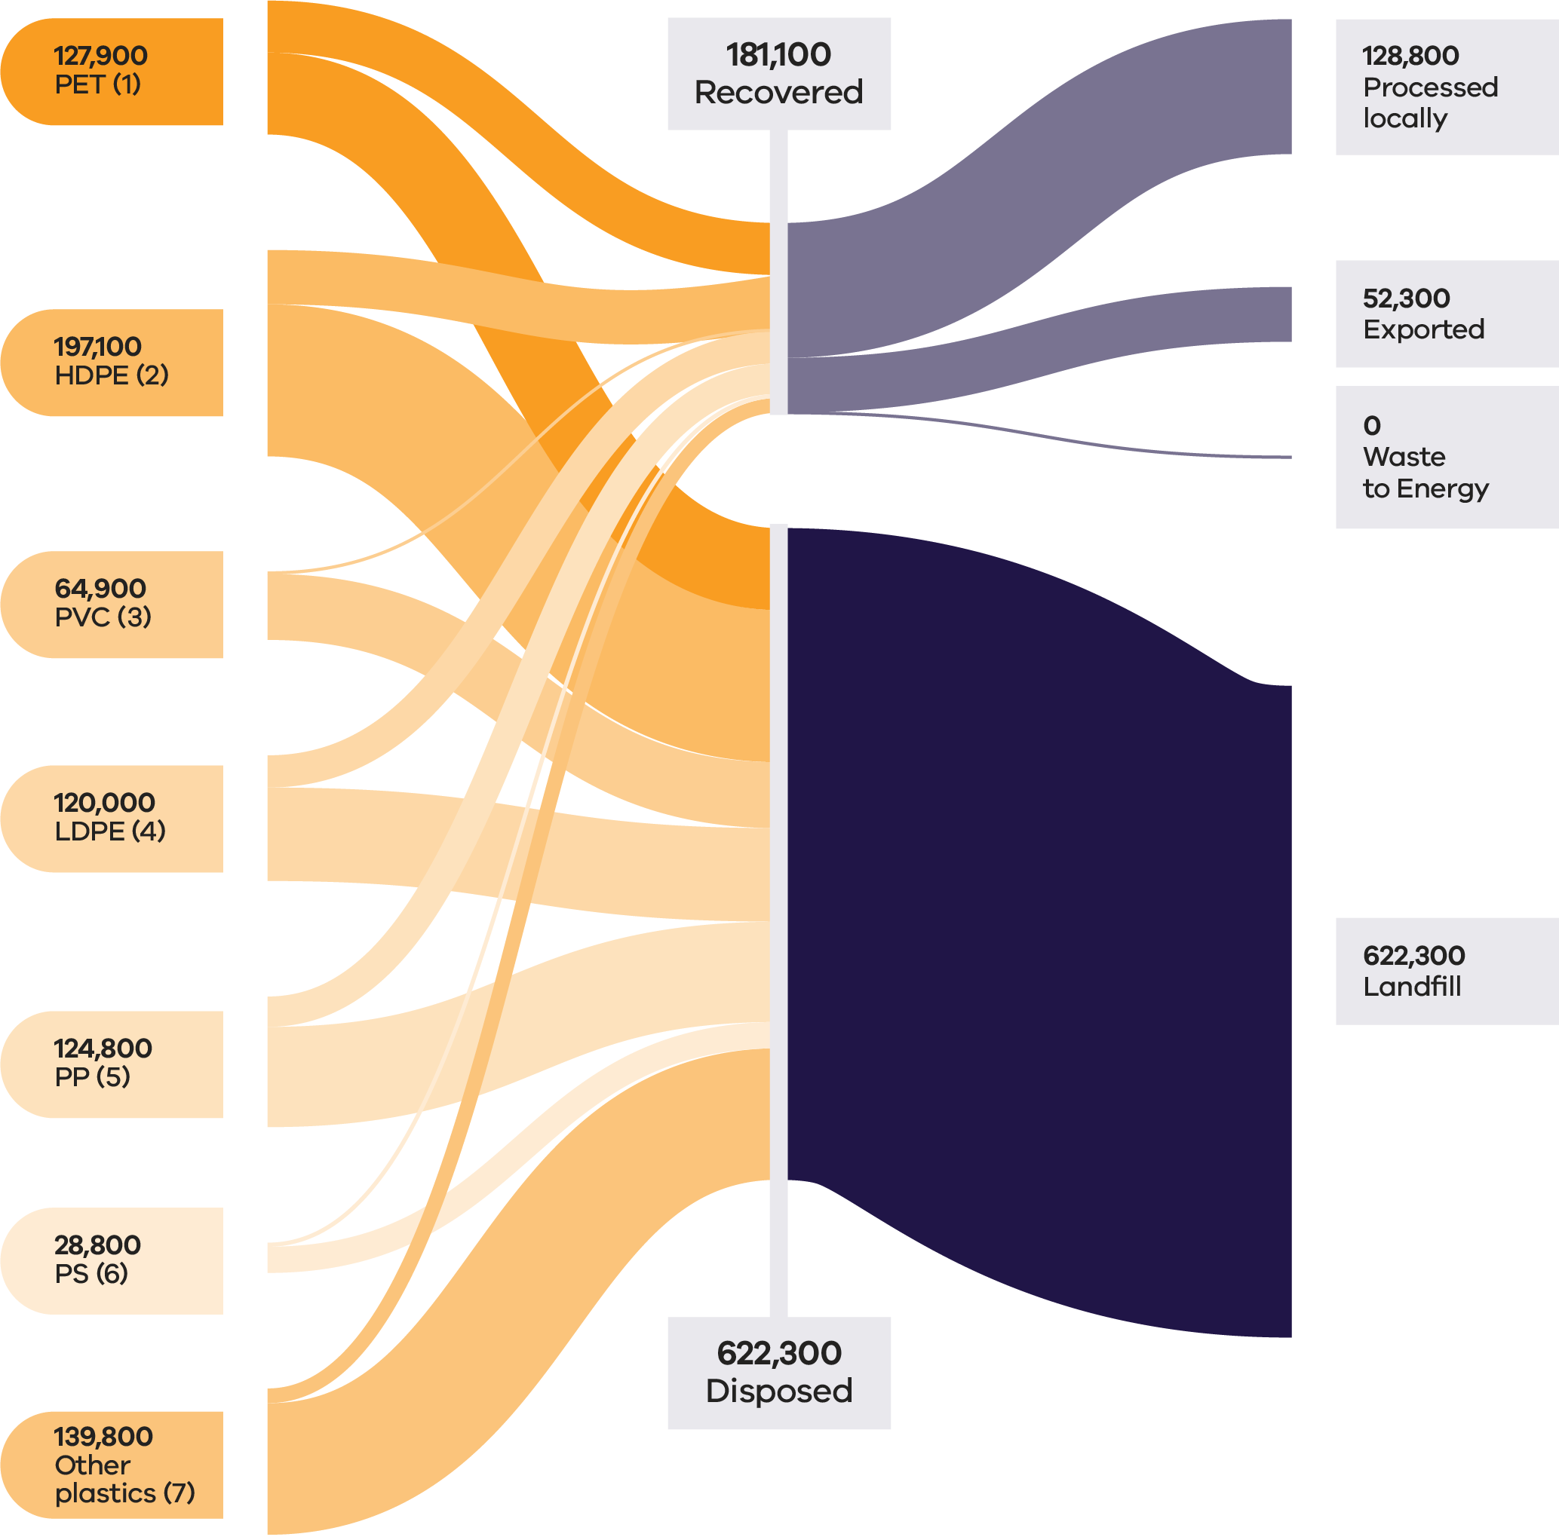

In 2022–23, plastics accounted for approximately 5% of all waste generated by weight in Victoria. The unrealised market value of plastics lost to landfill was ~$536 million based on 2022–23 commodity values, the highest value lost to landfill out of all material types.

Fluctuations in the price of fossil fuels directly impact the cost of new plastic and the economics of recycling plastics. When oil prices rise, recycled plastics become more commercially attractive; when oil prices fall recycled plastics become less commercially attractive as a feedstock.

Market prices for recycled plastic were above long-term historical averages throughout 2023–23 (Recycling Victoria 2024d). Prices for recycled PET ranged from a high of around AUD$1,200 per tonne and fell to around AUD$420-$500 per tonne by end of the financial year. Prices for recovered HDPE followed a similar pattern, averaging AUD$900–$1,100 for the financial year.

While Victoria does export plastics for reprocessing, export bans and licensing requirements currently limit international end market opportunities for processors, in favour of local solutions. Approximately 24% of all recovered plastics (42,300 tonnes) was exported interstate or internationally for processing in 2022–23.

Table 11: Plastic flows by stream and material sub-groups for 2022–23 (Recycling Victoria 2024b)

| Stream | Generated | | Recovered for reprocessing | | | Disposed | Recovery rate |
| --- | --- | --- | --- | --- | --- | --- | --- |
|  |  |  | **Processed locally** | **Exported** | **Total** |  |  |
|  | **Tonnes** | **Proportion** | **Tonnes** | **Tonnes** | **Tonnes** | **Tonnes** | **%** |
| MSW | 443,300 | 55% | 101,900 | 33,300 | 135,200 | 308,100 | 31% |
| C&I | 337,400 | 42% | 23,700 | 18,400 | 42,200 | 295,200 | 12% |
| C&D | 22,700 | 3% | 3,200 | 600 | 3,700 | 19,000 | 16% |
| **Total** | **803,400** |  | **128,800** | **52,300** | **181,100** | **622,300** | **23%** |

| Stream | Generated | | Recovered for reprocessing | | | Disposed | Recovery rate |
| --- | --- | --- | --- | --- | --- | --- | --- |
|  |  |  | Processed locally | Exported | Total |  |  |
|  | Tonnes | Proportion | Tonnes | Tonnes | Tonnes | Tonnes | % |
| PET (1) | 127,900 | 16% | 32,800 | 16,700 | 49,600 | 78,300 | 39% |
| HDPE (2) | 197,100 | 25% | 36,900 | 14,900 | 51,800 | 145,300 | 26% |
| PVC (3) | 64,900 | 8% | 2,000 | 0 | 2,000 | 62,900 | 3% |
| LDPE (4) | 120,000 | 15% | 16,200 | 14,500 | 30,700 | 89,300 | 26% |
| PP (5) | 124,800 | 16% | 25,000 | 4,000 | 29,000 | 95,800 | 23% |
| PS (6) | 28,800 | 4% | 3,200 | 700 | 3,900 | 25,000 | 13% |
| Other  plastics (7) | 139,800 | 17% | 12,600 | 1,500 | 14,100 | 125,700 | 10% |

While low, Victoria’s recovery rates are higher than all jurisdictions other than South Australia (based on 2021–22 national data). The overall recovery rate obscures the fact that some plastics, such as PET and HDPE are more easily recycled and have higher recovery rates than other types.

Table 12: All plastics material types - recovery rate and recycling characteristics

| Plastics type | Recovery rate 2022−23 and recycling characteristics |
| --- | --- |
| PET (1) Polyethylene Terephthalate | (39%)  PET is the easiest plastic to recycle. It’s a clear, tough, solvent resistant plastic. It’s used for water, soft drink and detergent bottles. It’s recycled into bottles and polyester fibres. |
| HDPE (2) High Density Polyethylene | (26%)  HDPE is a common plastic, and in the rigid form is usually white or coloured, and is used for milk bottles, shampoo bottles and cleaning products. HDPE bottles are recycled into more bottles or bags. |
| PVC (3) Polyvinyl chloride | (3%)  PVC is commonly used in pipes, toys, furniture and packaging. It’s difficult to recycle and contains harmful chemicals. |
| LDPE (4) Low Density Polyethylene | (26%)  LDPE is usually a soft, flexible plastic that’s used for different kinds of wrapping, bread bags, produce bags and bin bags. LDPE is recyclable. However, rigid LDPE products are much easier to recycle than flexible and soft versions of plastic. |
| PP (5) Polypropylene | (23%)  PP is a hard but still flexible plastic. It’s used for ice cream containers and lids and plastic take away containers. Polypropylene is recyclable. It can be separated from other plastic types, melted into a liquid, cooled, and turned into pellets, then used to form new plastics. However, polypropylene loses its strength and flexibility as it goes through the recycling process. |
| PS (6) Polystyrene | (13%)  PS is used to make cups, foam food trays and packing materials. It’s also known as Styrofoam and presents challenges due to its bulky yet very light nature, making it difficult to recycle. |
| Other Plastics | (10%) |

### Developments and changes

From 1 July 2022, the federal export restrictions increased the amount of material that must be reprocessed domestically, leading to significant investment in mechanical plastic reprocessing in Victoria. These investments and technologies are now operating at scale and are anticipated to play a critical role now and into future years.

Polyvinyl chloride (PVC) and polystyrene (PS) continue to be proactively phased out by many brand-owners, and the quantities of these polymers in kerbside collections are low and continue to fall. This is likely to improve the overall recovery rate for plastic in the future.

There is growing focus on improving plastic recovery due to increased environmental awareness, stricter regulations and consumer preference for sustainable products. Governments are enforcing policies to reduce plastic waste, while companies and consumers are shifting towards recycled materials for environmental benefits. Economic incentives also make recycled plastics an attractive alternative, contributing to a robust and expanding future market for recycled plastics.

Major advances are being made through a focus on innovation and significant investments in research and development, process technology and environmental protection. These advances span the use of sustainable bio-based and plastics waste feedstocks for polymer production, innovative materials and designing for recyclability to significant progress in cutting-edge chemical recycling technologies.

Victorian based company APR Plastics is progressing technology to meet the demand from food manufacturers packaging made from fully recycled material. Following the success of a pilot project that turns soft plastics into oils for plastic remanufacture, through a process known as pyrolysis, APR is scaling up the process. The company aims to commission a demonstration plant in Bacchus Marsh in early 2025 and a sorting facility in Dandenong by mid-2025 (Korycki 2024).

### Market issues and challenges

Plastic waste in Victoria is projected to grow by around 50% over the next 30 years, generating over 1.2 million tonnes by 2053.

Multiple factors limit the recovery of plastics. Contamination in feedstock streams increase processing costs. Virgin plastics remain comparatively inexpensive, undercutting the competitiveness of recycled products. Furthermore, manufacturers require clean, monomer feedstock while the abundance and diversity of different polymers in collections streams present sorting and processing challenges.

Soft plastics remain particularly challenging to recycle as a complex, low value, high volume material. Recycled polymers degrade with each use, necessitating the need for virgin polymers for some applications. Recovered PVC, for example, has a low market value due to not being fit for reuse in plumbing applications.

Plastic packaging is also problematic due to inconsistent products that are not designed for circularity. The Australian Government is seeking to mandate obligations for packaging to be designed for circularity and make industry responsible for the packaging, including soft plastics, they place on the market.

### Focus areas for greater circularity – plastics

The analysis highlights the following opportunities:

* Continue to seek efforts for national and/or state-based product stewardship for packaging to ensure market development is incentivised and financially viable.
* Support and promote improved product design for better recycling and reuse outcomes, including the minimisation of difficult to recycle plastics including business to consumer PVC, composite flexible and PS packaging.
* Continue to support the ban of avoidable and problematic plastic items, especially single use items.
* Increase processing capability and capacity where needed to aim for the highest order beneficial recycling outcomes.
* Support the continued deployment of mechanical reprocessing, chemical processing proven at scale and emerging technologies to provide increased capability for challenging plastic types and increased system capability to support kerbside collection of soft plastics.

## Tyres

Tyres are a composite product made from natural and synthetic rubber, steel wire, textile fibres, carbon black and other additives. At end-of-life, tyres are generally managed in 2 streams involving mechanical size reduction, granulating and crumbing for local manufacturing (predominantly tyres without textile fibres), and shredding for export as tyre derived fuel (predominantly tyres with textile fibres).

Whole baled tyres have been banned from landfill in Victoria since 1 July 1993 and export of all whole tyres, including baled tyres was banned from 1 December 2021 under the Council of Australian Government national waste export regulations.

Victoria is the largest producer of granules and crumb in Australia, receiving tyres from surrounding states to meet demand for these materials, and is the third largest producer of tyre shred.

Victoria has been a leader in the use of crumb rubber in road construction with the use of rubber in spray seals since the 1960s and it was the first state to introduce specifications for recycled crumb rubber in asphalt.

### Market performance

The overall recovery rate for tyres in Victoria in 2022–23 was 74% which is consistent with the recovery rate of 76% observed in 2021–22, but less than the recovery rate of 86% observed in 2020–21. C&I was the largest contributor to the generation of tyres (90%) and maintained a similar recovery rate (77%) to that observed in 2021–22 (79%) but lower than that observed in 2020–21 (88%).

Some truck and bus tyres are sent for retreading, although the local retreading industry has declined over the past couple of decades with the introduction of cheaper truck and bus tyres entering Australia.

Almost 42,000 tonnes of tyres were recovered in Victoria in 2022–23 with a recovery rate of 74%. The greatest recovery rate was reported in the C&I waste stream (77%).

It is estimated that $2.8M of value was lost to landfill for this material in Victoria in 2022–23 (based on 2021–22 commodity values) compared to $5.6M in 2021–22.

Approximately 43% (18,200 tonnes) of all recovered tyres were exported from Victoria in 2022–23 (Table 13). A total of 32,918 tonnes of tyres were exported internationally in 2021–22. Victoria continues to be reliant on overseas markets, with tyre derived fuels as the primary export market. Most of this is sent to Asia to be used as a coal replacement in high heat applications such as in cement kilns.

Figure 15: Tyres generated, recovered for processing, and disposed of in 2022–23 (tonnes) (Recycling Victoria 2024b)

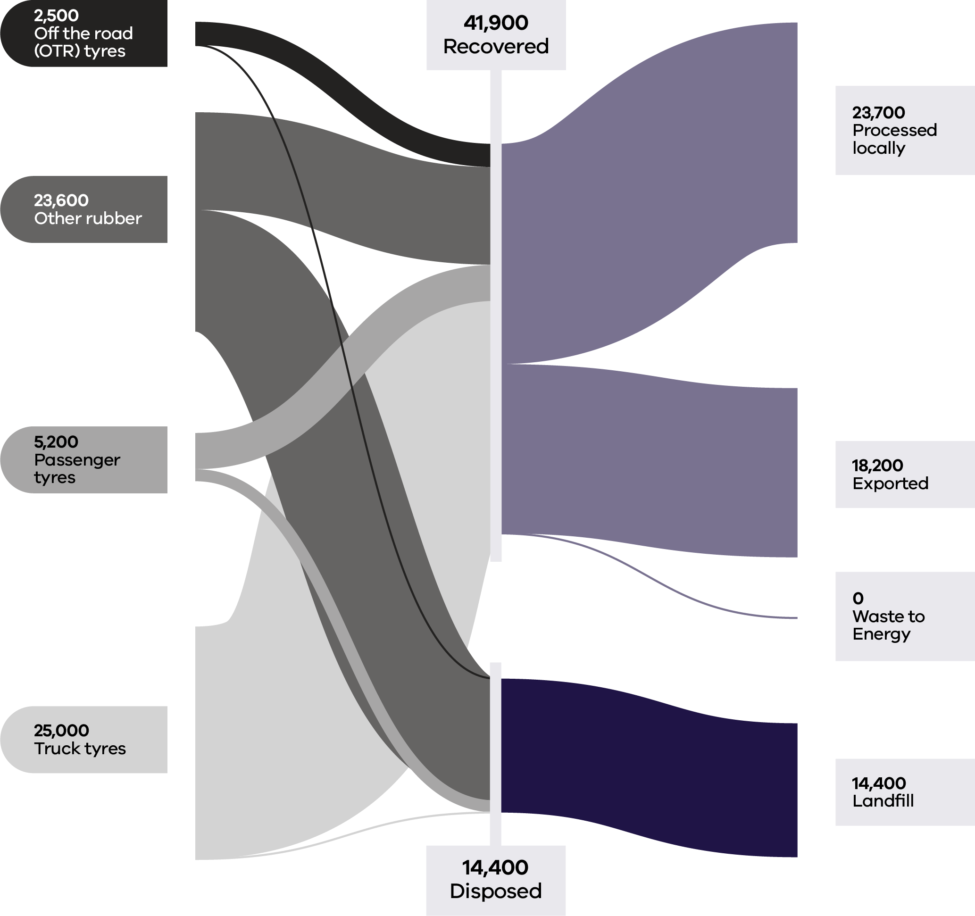

Table 13: Tyres flows by stream and material sub-groups for 2022–23 (Recycling Victoria 2024b)

| Stream | Generated | | Recovered for reprocessing | | | Disposed | Recovery rate |
| --- | --- | --- | --- | --- | --- | --- | --- |
|  |  |  | Processed locally | Exported | Total |  |  |
|  | Tonnes | Proportion | Tonnes | Tonnes | Tonnes | Tonnes | % |
| MSW | 5,200 | 9% | 1,200 | 1,600 | 2,800 | 2,500 | 53% |
| C&I | 50,700 | 90% | 22,500 | 16,600 | 39,100 | 11,600 | 77% |
| C&D | 300 | 1% | 0 | 0 | 0 | 300 | 0% |
| **Total** | **56,300** |  | **23,700** | **18,200** | **41,900** | **14,400** | **74%** |

### Developments and changes

Recent product development successes include the development by Saferoads, a new generation of road safety barriers that uses tyre derived material to increase public safety and reduce waste. The City of Greater Geelong is using more than 50 tonnes of recycled crumbed rubber to upgrade local sporting precincts (City of Greater Geelong 2024). The recycled rubber has been sourced from used truck tyres and will see the athletics track at Landy Field in South Geelong installed with a base rubber and sealer coat.

Recycled rubber is also being used to upgrade asphalt paths in golf courses in regional Victoria.

### Market issues and challenges

Tyres and rubber waste is expected to grow to 130,000 tonnes by 2053, representing a 44% increase on 2023 tonnages.

Western Australia presented a discussion paper to the Environment Ministers’ meeting in June 2023, identifying 3 broad challenges the tyre sector faces:

* Risks and costs to the environment and communities.
* Missed opportunities for recovery and the loss of resources.

Limitations and inequities of the current industry-led framework where efficacy and success are constrained by industry participants currently avoiding or not fully meeting responsibilities under the scheme (Government of Western Australia Department of Water and Environmental Regulation 2024).

A lack of cost-efficient solutions can lead to stockpiling or dumping, even if there is enough infrastructure capacity to meet the demand. In Australia approximately 11.3 million tyres were illegally dumped, stockpiled, hidden in warehouses or put into landfill in 2022–23 (Scott, 2023). Tyre dumping is a challenge across Victoria, particularly in rural areas. EPA works to prevent illegal tyre dumping by inspecting mechanics and tyre stores to ensure they are legally disposing of used tyres (Hermant and Kent, 2024).

### Focus areas for greater circularity

The analysis highlights the following opportunities for this material stream:

* Support Australian product stewardship (in development).
* Build market resilience through supporting increased uptake of tyre-derived products such as in government procurement.
* Support data sharing across Australian jurisdictions, to improve quality and measurements of end market products.
* Investigate business models to minimise waste and keep materials at highest use for longer.
* Support increased infrastructure capability to achieve higher order use and more circular outcomes, such as expanded use of crumb rubber, including reprocessing passenger tyres for crumb rubber.
* Investigate re-treading of truck and bus tyres to help higher order outcomes in the circular economy; support for new products, including the use of reclaimed rubber.

## Textiles

Textile waste is composed of discarded:

* clothing
* sheets
* curtains
* carpets
* bedding

other items made from natural or artificial fibres.

Clothing makes up the largest component of the waste stream. Other textiles make up the rest which includes bedding carpet soft furnishings and mattresses.

Textile waste is a concern because a large portion of discarded textiles end up in landfill.

In addition to taking up space in landfills, the production of new textiles to replace those discarded consumes 98 million tonnes of non-renewable resources like oil to produce synthetic fibres, fertilisers to grow cotton, and chemicals to produce dye, globally each year (Sustainability Victoria 2023).

Textile waste can be repurposed through various end markets to support sustainability and reduce landfill impact. Key markets include recycling waste into new textiles or fibres, upcycling into accessories or home décor, and using waste as insulation, building materials, or stuffing for products. Agricultural applications like composting and crop protection, along with energy recovery through waste to energy plants, are additional options. Textile waste can also serve as raw materials for industries like paper production and automotive manufacturing or be transformed into bioplastics for eco-friendly goods.

Mechanical and chemical recycling of textiles produces commercial textile fibres for use by textile and apparel companies in new clothing products. Strong international export markets exist for second-hand clothing.

### Market performance

Victoria recovers just under a quarter (24%) of all textile material generated (Table 14). The recovery rate is almost wholly dependent on exports (excluding the proportion of textiles that are reused). Of the 3 contributing sectors, households (MSW) contribute the most to the total tonnes generated and have the highest recovery rate (44%). C&I is the next largest contributor to total tonnes generated (44%) and has a less optimal recovery rate than that for households (1%).

It is estimated that almost $200M value was lost to landfill through disposal in 2022–23 (based on 2021–22 commodity values), as compared to ~$155M in 2021–22.

Of the 66,800 tonnes of textiles recovered in 2022–23, over 97% was exported. Almost all recovered clothing (99%) is exported for reprocessing as this waste material is relatively lightweight and has relatively low transport costs (Recycling Victoria 2024b).

Figure 16: Textiles generated, recovered for processing, and disposed of in 2022–23 (tonnes) (Recycling Victoria 2024b)

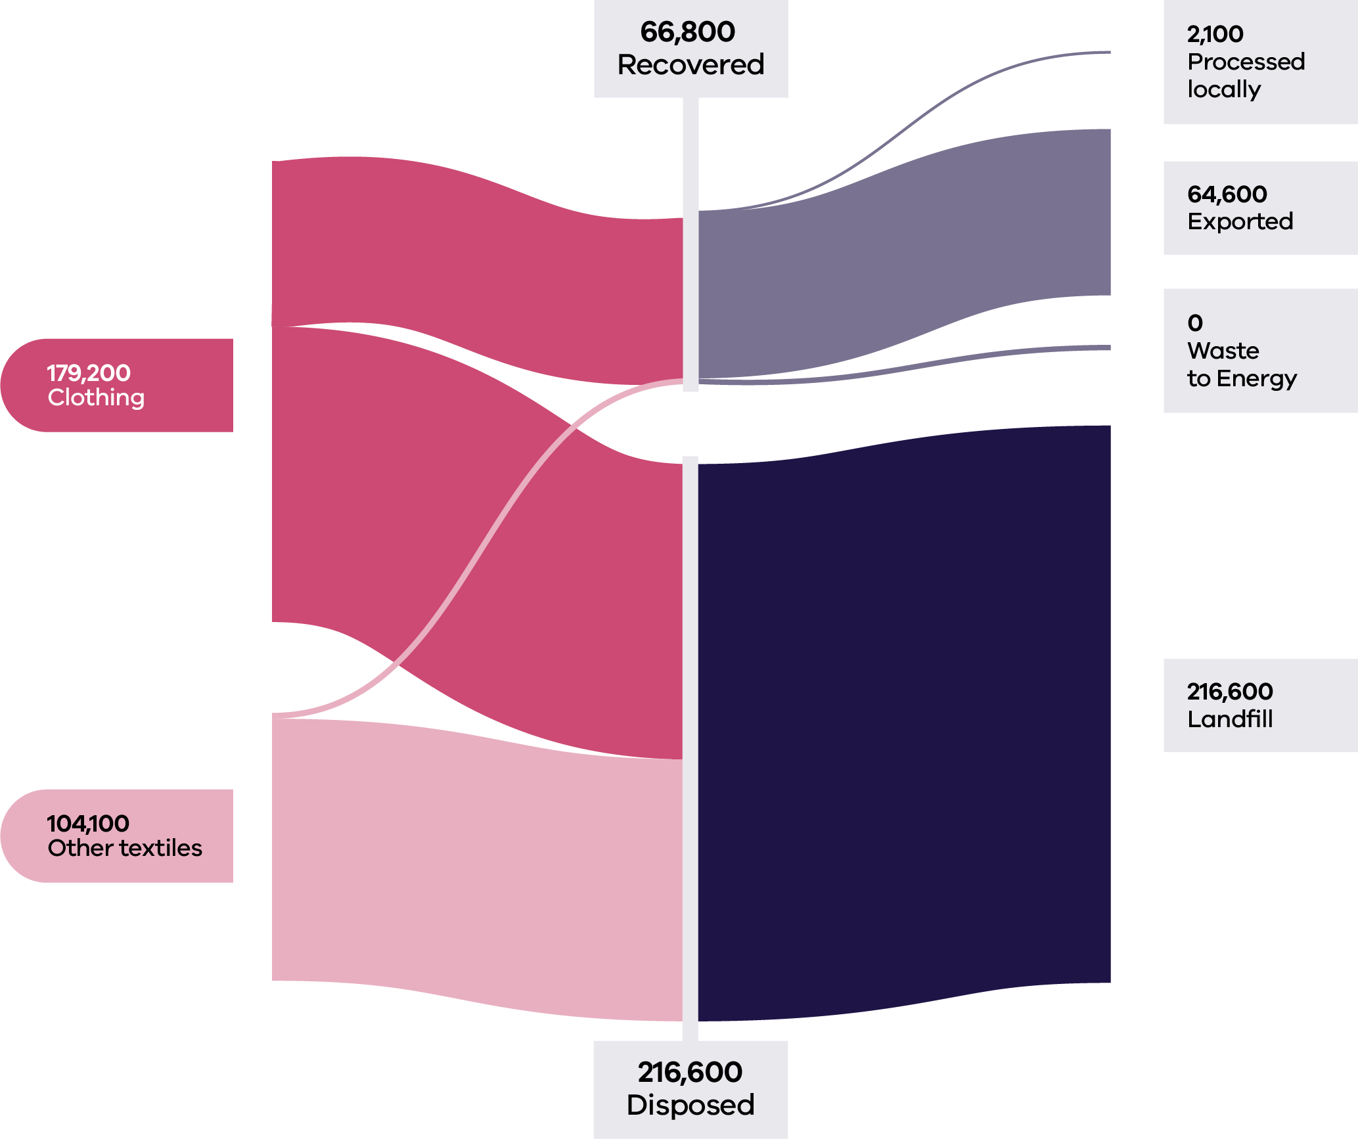

Table 14: Textile flows by stream and material sub-groups for 2022–23 (Recycling Victoria 2024b)

| Stream | Generated | | Recovered for reprocessing | | | Disposed | Recovery rate |
| --- | --- | --- | --- | --- | --- | --- | --- |
|  |  |  | Processed locally | Exported | Total |  |  |
|  | Tonnes | Proportion | Tonnes | Tonnes | Tonnes | Tonnes | % |
| MSW | 148,600 | 52% | 1,700 | 64,100 | 65,800 | 82,800 | 44% |
| C&I | 124,200 | 44% | 400 | 600 | 1,000 | 123,200 | 1% |
| C&D | 10,500 | 4% | 0 | 0 | 0 | 10,500 | 0% |
| **Total** | **283,300** |  | **2,100** | **64,600** | **66,800** | **216,600** | **24%** |

| Stream | Generated | | Recovered for reprocessing | | | Disposed | Recovery rate |
| --- | --- | --- | --- | --- | --- | --- | --- |
|  |  |  | Processed locally | Exported | Total |  |  |
|  | Tonnes | Proportion | Tonnes | Tonnes | Tonnes | Tonnes | % |
| Clothing | 179,200 | 63% | 400 | 64,100 | 64,500 | 114,800 | 36% |
| Other  textiles | 104,100 | 37% | 1,700 | 600 | 2,300 | 101,800 | 2% |
| **Total** | **283,300** |  | **2,100** | **64,600** | **66,800** | **216,600** | **24%** |

### Developments and changes

The textile waste stream is projected to grow to over 400,000 tonnes annually by 2053, which reflects growth of over 53% over the period.

Seamless, Australia’s clothing product stewardship scheme, became operational on 1 July 2024, with the mission to make Australian clothing circular by 2030. The funding for this program will be a financial contribution made by member organisations of 4 cents for every new piece of their clothing placed in the market. This funding will be directed towards 4 priority areas:

* Incentivising businesses to design more durable, repairable, sustainable and recyclable clothes.
* Growing the market for new business models based on repair, reuse, remanufacturing and rental.
* Establishing sorting and collection systems for effective reuse of wearable items and recycling of non-wearables.

Empowering citizens to make the right choices in acquiring, reusing, caring and disposal of clothes.

The Victorian Government has invested over $630,000 to reduce textile waste generation by 600 tonnes per year via a range of initiatives:

* Australian fashion label A.BCH is connecting the oversupply of textile materials with demand through an online marketplace (Circular Sourcing n.d.).
* Global outdoor brand Kathmandu is leading a project to intercept used, damaged or faulty products destined for landfills and repair them for resale under the Kathman-REDU label (Circular Economy Business Innovation Centre 2023).
* Neighbourhood Collective Australia is developing op-shops and slow fashion hubs (Sustainability Victoria 2023).
* Phillip Island Community and Learning Centre is creating a repair centre for heavy materials like tents, caravan annexes, utility tonneaus and surfboard covers.

### Market issues and challenges

The textile waste stream is projected to grow to over 400,00 tonnes annually by 2053. This presents an opportunity for an improved recovery solution.

Victoria has 2 facilities that process textile waste into recycled fibre and 2 mattress preprocessors. There is currently a limited market in Australia for recovered textiles, with 127 Australian textile production businesses in Australia (Recycling Victoria 2023).

Addressing the state’s lack of recycling capability is challenging due to the limited opportunities for local reuse and the relatively low product value (Recycling Victoria 2024b). Domestic textile reprocessing is generally limited to mechanical fibre recycling. Although mechanical fibre recycling technologies are well established, there remains a challenge in commercially scaling up the recycling of the huge quantity and diversity of plastic fibre-based materials contained in textiles such as carpets and mattresses (Recycling Victoria 2024b).

For many articles of clothing, elements present on a textile product, such as fasteners, buttons, zippers or similar items may be a disruptor to the recycling process and often need to be removed before the product is suitable as feedstock for recycling. This results in high costs to sort and deconstruct textiles prior to recycling.

‘Fast fashion’ lines are made from poor quality fabric with low durability but are attractive to the consumer due to low cost.

Synthetic chemicals classed as per- and polyfluoroalkyl substances (PFAS) are often used in clothing and other textiles to repel water, oil and dirt, and provide thermal stability and durability. The presence of PFAS in textiles can be a barrier to longer use, reuse and recyclability, negatively influencing the sector’s shift to a more circular economy.

Given the economic challenges for a local market, there is continued reliance on international exports for textile waste.

### Focus areas for greater circularity – textiles

The analysis has highlighted the following opportunities for this material stream:

* National product stewardship building off Seamless.
* Support improved collections services and consumer access to donation bins.
* Promote the design of textiles for longer life, reuse and repair to drive towards an overall reduction in consumption.
* Investigate onshore processing of clothing that reaches end-of-life and cannot be reused/repaired.
* Support the continued development of markets for recycled textiles.

## Emerging materials

Several materials were identified in the inaugural Circular Economy Market Report as emerging materials in Victoria, including photovoltaics (solar panels), batteries and wind turbines.

The Victorian Government has legislated renewable generation targets of 65% by 2030 and 95% by 2035, as well as storage targets of at least 2.6GW by 2030 and at least 6.3GW by 2035. These targets translate to approximately 25GW additional large and small-scale generation capacity from 2024 to 2035, requiring installation of an additional 27 million new solar panels and 900 new wind turbines (DEECA 2024a).

Recycling the eventual waste streams from these energy sources will require significant infrastructure capacity and capability advancement. The ecological and climate benefits of using recycled materials are not yet fully accounted for in the costs of the materials used in renewable energy, which means suitable secondary materials regularly compete on price with primary materials that are often cheaper (European Environment Agency 2021). In addition, the technical processes to recycle much of this waste is currently still evolving.

### Photovoltaic systems e-waste

End-of-life PV systems are a form of electronic waste (or e-waste), which is defined as waste in the form of electrical or electronic equipment, devices or machines that are driven by an electric current or electromagnetic field (Solar Victoria 2024). In simple terms, this means any device that has a plug, battery or power cord that is no longer working or wanted is e-waste, including solar PV panels and associated PV waste including inverters, attached cabling and racking. PV could also potentially cover household energy storage batteries.

These systems comprise Australia’s fastest growing electronic waste stream, reflecting Australia’s status as an early developer of solar technology and, more recently, as a world leader in adopting rooftop solar.

As of the end of October 2024, over 780,000 Victorian households and commercial establishments had installed rooftop solar panels (Clean Energy Regulator 2024). The size of solar systems installed has grown alongside the number of installations, with the average system capacity having increased from 3.3 kW in 2012 to 8.62 kW in Q1 2024 (Australian Energy Council 2024).

Currently, Victoria’s solar capacity is 6GW, comprising 5GW of rooftop solar and 1GW of utility-scale solar. By July 2035, this capacity will need to expand to 15.6GW, including 12.6GW of distributed rooftop solar and 3GW of utility-scale solar (Australian Energy Council, 2024).

Modelling undertaken for the Victorian Government forecasts that tonnages of PV system e-waste (including inverters, batteries and solar panels) will increase significantly by 2035 with growth rates of around 20% per annum. This equates to PV system e-waste tonnages approximately doubling every five years to 2035 (Sustainability Victoria 2021).

### Barriers to circularity

Inevitably, solar panels reach an end-of-life. While the designed life for solar panels is typically 25–30 years, solar PV systems can have a shorter life due to weather damage, installation errors, or manufacturing serial defects, as well as cell defects (which include degradation of the cell anti-reflective coating, and discoloration or delamination of the cell). In addition, some panels are removed from rooftops and solar farms prior to end-of-life, for example if an inverter fails or a new battery gets installed, triggering a wholesale replacement with new panels (Stock, 2024). The falling PV system cost also possibly encourages households and industry to upgrade working solar panels earlier than end-of- life thereby creating additional waste.

Victoria currently lacks an established and proven capacity to process PV panels beyond basic processing of recyclable components, such as aluminium frames (Recycling Victoria, 2024a). In Victoria Elecsome has recently entered the market as the first Australian solar panel upcycling plant that operates by transforming end-of-life solar panels into higher value products. Elecsome’s total capacity is one million panels per annum.

To be reused, solar panels need to be broken down so each component, including glass, aluminium, copper, plastic and silicon, can be separated. This requires extensive heavy machinery.

Key challenges in PV recycling, in economic and technological terms, are the delamination, separation and purification of the silicon from the glass and the semiconductor thin film. The PV panel can be described as a “sandwich” of laminates comprising glass, adhesive, solar cells and a backing sheet. The strong adhesion needed to ensure durability of the panels across a range of weather conditions provides challenges in disassembly of the same panels at end-of-life.

The current cost of recycling each solar panel in Australia is $28, roughly 6 times the cost of sending it to landfill ($4.50) (Hill 2023).

By weight, a solar panel is more than 70% glass, with the remainder being aluminium, silica, plastic, and small amounts of precious metals. On average, $22.60 worth of materials could be potentially recovered from a typical 20 kg solar panel, resulting in a material value of over $1000 per tonne of solar panels (Deng 2024).

Various research groups are taking up the challenge of extracting valuable materials from PV panels. In 2024 the Victorian Government announced that the inaugural Breakthrough Victoria Challenge will focus attention on reducing solar waste in landfills.

### Support for circularity

The Australian Government aims to increase local manufacturing to capture a bigger market share through the Future Made in Australia policy which will support renewables development locally (Australian Government 2024).

Another funding initiative, the Sunshot program, is aimed at supporting the domestic production of solar panels and innovative manufacturing facilities in Australia across the solar PV supply chain. The solar PV supply chain includes polysilicon production, production of ingots, wafers, solar PV cells, and solar module assembly. Detailed work on the Sunshot program is currently underway through the Australian Renewable Energy Agency (ARENA 2024). Round one funding decisions are due before the end of December 2024.

The Basel Convention was established to control international movements of hazardous waste, though an amendment adopted in 2022 also controls transboundary movement of non-hazardous e-waste commencing 1 January 2025. This impacts the management of non-hazardous e-waste plastics, which have historically been sold to overseas processing facilities.

Based on the extended-producer responsibility principle, the EU Waste Electrical and Electronic Equipment directive requires all producers supplying PV panels to the EU market (wherever they may be based) to finance the costs of collecting and recycling end-of-life PV panels put on the market in Europe.

Photovoltaics have been listed by the Australian Government on the Minister for the Environment and Water’s priority list for product stewardship since 2016–17. The Australian Government has committed to develop a mandatory product stewardship scheme to reduce waste from small electrical products and solar photovoltaic systems. A discussion paper was released on the proposed regulations for consultation in June 2023 (DCCEEW 2023b). The definition of a small-scale solar PV system in the discussion paper are those with up to 100 kW of capacity. The regulations pertaining to small-scale PV systems would have requirements in relation to the amount of material recovery, a collection network mechanism and awareness raising about sustainability. Unlike large-scale systems, legacy waste (sourced from systems that were installed prior to the commencement of the scheme) would be covered under the regulations.

The key outcomes sought under an e-waste regulatory product stewardship scheme (DCCEEW 2024e) including solar photovoltaic (PV) systems are to:

* reduce waste going to landfill, especially harmful materials found in e-waste
* increase recovery and re-use of valuable materials in a safe, scientific and environmentally sound manner
* provide convenient access to recycling services for e-products and solar panels across Australia
* help Australia take responsibility for its own waste and re-use the materials to make other products, and support Australia’s transition to a circular economy
* encourage all those involved in the creation, sale, use and disposal of e-products to act in a way that is consistent with reducing waste to landfill.

### Wind turbines

Victoria’s wind power infrastructure became operational in the last decade and has a typical 20-year lifespan (Clean Energy Council 2023). With wind farms continuing to become a more prominent component in Australia’s energy transformation, local communities hosting wind farms are interested in understanding life cycle aspects of energy infrastructure assets.

The Australian Energy Council reports that currently, Victoria has approximately 715 onshore wind turbines across the state in operation and will require around 130% increase in onshore wind capacity to meet the 2035 target. Additionally, 222 offshore wind turbines will need to be developed and in operation by 2035 for the 4GW target to be met, with 111 of them needing to be online by 2032 to meet a 2GW interim target (Monaghan 2024).

Recycling wind turbines has several challenges. Internationally, processing is still under development for turbine blades made of lightweight materials like carbon fibre, glass fibre and composite materials, with further research and implementation needed. The large scale of blades can make transportation costs prohibitive for long-distance hauls where recycling facilities may be located far away (European Environment Agency 2021).

There is currently no clear large scale recycling option for carbon-fibre in Australia (Clean Energy Council 2023). To improve circularity of wind turbines, repair options are under development. Barriers to realising this option include design intellectual property barriers, and economic viability (Clean Energy Council 2020).

### Batteries

Batteries are used in consumer products from mobile devices to laptop computers and in toys, appliances and tools. The use of batteries is growing rapidly worldwide, driven by growth in renewable energy storage systems from domestic scale household batteries through to large storage systems. Demand for renewable energy production and storage is also driven upwards by the increased electrification of the transport sector, as the number of electric vehicles (EVs), e-bikes and scooters continue to grow at an exponential rate.

The global battery market consists of primary batteries (which are non-rechargeable) and secondary batteries (which are rechargeable). Just under 75% of batteries in the global market are secondary batteries, typically lead acid batteries and lithium-ion batteries.

The market direction is strongly moving to lithium-ion batteries becoming the most common battery type (Battery Stewardship Council, 2020). Compared to lead acid batteries, lithium-ion batteries are lighter, less bulky and have longer cycle lives.

By 2035, Australia could be generating 137,000 tonnes of lithium battery waste annually (McKell Institute 2022). As a result, a domestic recycling industry for lithium batteries could be worth $603 million to $3.1 billion in just over a decade (Zhao et al 2021).

Lithium-ion batteries can be highly flammable. Fire services in Victoria and Queensland respond to lithium-ion battery fires almost every day (Lu 2024). More than half of Australians still dispose of used batteries in kerbside collection in recycling or landfill bins. Education and awareness are key to behavioural change, as 95% of Australians surveyed said they would be willing to take used batteries to a collection point once they were made aware of drop-off locations.

Almost all discarded lithium-ion batteries will still hold some charge. Currently, lithium-ion batteries are considered end-of-life when they are unable to continue to sufficiently power an application or a device. EV batteries need replacing when they reach 70–80% of original capacity and no longer meet performance standards. This presents an opportunity to repurpose these batteries for other applications, most notably in stationary storage or as secondary batteries that are still operational and effective – meaning that the approach lends itself to the circular economy principles of “use longer” and “use again.”

### Barriers to circularity

In 2021, Australia recycled 99% of lead acid batteries, compared to just 10% of lithium-ion batteries (CSIRO 2020).

The Association for the Battery Recycling Industry (ABRI) identified numerous issues and barriers to lithium battery recycling including the lack of consumer awareness around battery types, the limited access to collection systems and the challenge of logistics since lithium batteries are classified as dangerous goods.

In a recent submission to the Productivity Commission’s review of circular economy opportunities (Productivity Commission 2024), ABRI identified the following unique opportunities and comparative advantages to become a world leader in lithium battery recycling technology and supporting services:

Strong research and resources sector capability in hydrometallurgy underpinning the development of exportable technology to recover materials from lithium black mass.

Development of containers to support safe transport and storage.

Development of solutions for safe collection and, possibly partial processing to reduce transport costs, in regional and remote areas.

### Support for circularity

In April 2024 the Victorian Government announced funding for 2 companies (Ecobatt and Enviropacific) to establish lithium-ion processing and recycling facilities in Campbellfield and Stawell respectively. Following a change in ownership, the Enviropacific project has been discontinued. Ecobatt has requested a change of capacity that represents more than a 50% reduction from the original proposal but will come online earlier than originally planned.

The Battery Stewardship Council (BSC) launched B-cycle, which has been in operation since 2022 as a cooperative network of businesses that collect, sort and recycle used batteries in a safe and sustainable way. It has received support of all state and the Australian Governments and has the authorisation of the Australian Competition and Consumer Commission (ACCC). B-cycle has 285 organisations that provide over 5,300 drop off points nationwide. Nearly 800 tonnes of batteries were collected in Victoria in 2023 as part of the B-cycle scheme, a 33% increase from 2022. The focus for B-cycle has been consumer batteries, while the mandate of the BSC included electric vehicle batteries and battery energy storage systems (B-cycle 2023).

The Commonwealth Department of Industry, Science and Resources published the National Battery Strategy in May 2024 to provide a pathway for Australia to move up the battery value chain and capitalise on key opportunities. The main actions of the strategy are:

$523.2 million Battery Breakthrough to provide a targeted production incentive to support local manufacturers to build capabilities and focus on producing high-value battery products.

$20.3 million Building Future Battery Capabilities measure to build future battery capabilities and strengthen national collaboration. This includes funding to deliver a supply chain navigator tool, battery innovation and scale-up program, best practice guidelines and standards, and provide battery industry skills and training.

$1.7 billion for the Future Made in Australia Innovation Fund (including batteries in addition to other priorities) to support innovation, commercialisation, pilot and demonstration projects and early-stage development in priority sectors – including manufacturing clean energy technologies such as batteries.

$5.6 million for the Australian Made Battery Precinct to conduct foundational work to support the establishment of the Australian Made Battery Precinct, in partnership with the Queensland Government (DISER 2024).

At the June 2024 Environment Ministers Meeting all ministers agreed that battery related fires require greater interventions across the entire life cycle. They decided that Victoria, New South Wales, and Queensland governments would jointly accelerate work towards product stewardship for all batteries, including through the development of a draft Regulatory Impact Statement (RIS), informed through informal consultation with industry and government. At the December 2024 Environment Ministers Meeting, ministers discussed the findings of the draft RIS, prepared by New South Wales and Victoria, examining options for these reforms. Recognising the need to act quickly to reduce the risks of battery fires, ministers discussed progression of aligned state-led reforms for mandatory battery product stewardship, with NSW intending to introduce legislation in 2025.

# Government policy and action

Transition towards a circular economy is taking place at all levels of government in Australia. Governments at the national, state, and local levels are employing circular economy principles in the development of policy and regulation. Figure 17 below outlines the key policies, strategies and legislation currently in place across Australia.

All levels of government are also employing financial and non-financial levers to stimulate progression to a circular economy. At a high level these include:

* financial incentives (such as loans and capital grants)
* non-financial incentives such as
* market-based instruments
* non-market-based instruments
* removing obstacles to circularity.

Figure 17: National and state circular economy related policies (source: DCCEEW 2024a)

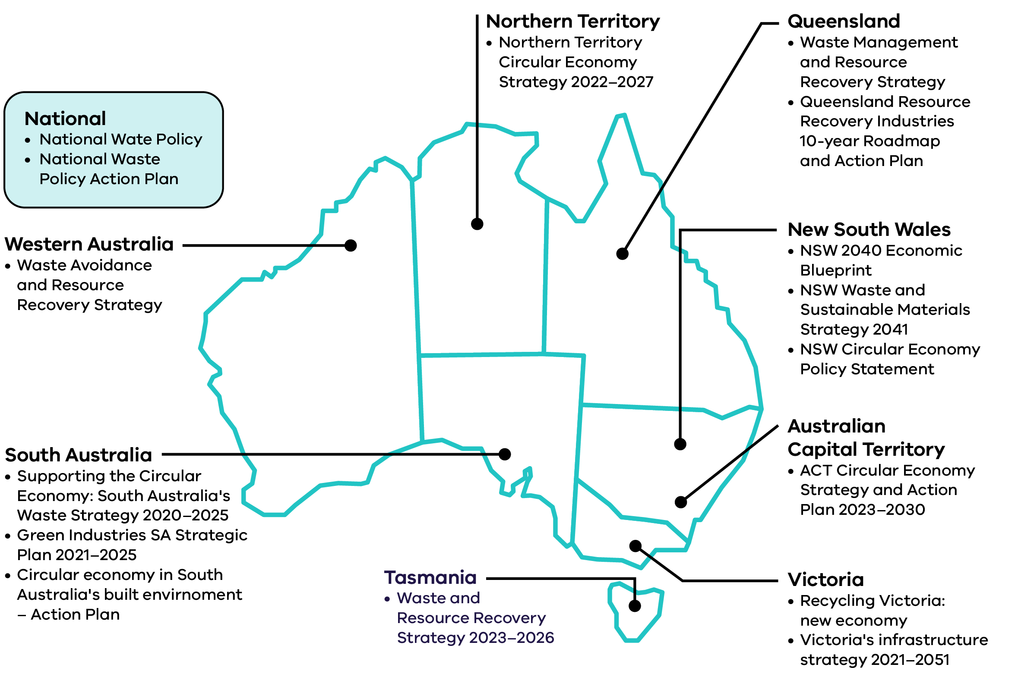

## National action towards a circular economy

**Some of the key actions taken by the Australian Government to facilitate the transition to a circular economy since the previous Circular Economy Market Report are outlined below.**

### Circular Economy Ministerial Advisory Group

The Australian Government is supporting the transition to a circular economy through the Circular Economy Ministerial Advisory Group who released their final report The Circular Advantage (DCCEEW 2024b) in December 2024. The report talks to national policy, economics and investment settings, net zero, the built environment and design and consumption of products. The report also recommends ways the government can boost Australia’s circular economy through improving the country’s domestic manufacturing capabilities through reuse, repair and recycling. The report made 14 core recommendations including the introduction of a new National Circular Economy Policy Framework (DCCEEW 2024b).

Australia’s Circular Economy Framework sets out Australia’s 10-year commitment to progress a circular economy, with a goal to double Australia’s circularity by 2035. To achieve this, the framework sets targets to:

* shrink Australia’s per capita Material footprint by 10%
* lift Australia’s material productivity by 30%

safely recover 80% of Australia’s resources.

### Recycling Modernisation Fund (RMF)

The Recycling Modernisation Fund continued to support the expansion of Victoria’s capacity to sort, process and remanufacture glass, plastic, paper and cardboard during 2023–24 (DCCEEW 2024f). During 2023–24 $134 million was invested, including $40 million government co-funding and $94 million third party funding, to support improved capacity and recovery across material recovery facilities, glass recycling facilities, paper recycling facilities and plastic recycling facilities (DCCEEW 2024f). The additional sorting and recycling capacity funded by the RMF supports Victoria’s transition to a circular economy by allowing more materials to be reused, recycled or remanufactured when they are no longer useful or required for the initial purpose.

### Australian Packaging Covenant Organisation product stewardship scheme accreditation

The Australian Packaging Covenant Organisation (APCO) product stewardship scheme (accredited by the Australian Government in 2022) has continued to progress work to improve the design of packaging to reduce waste and improve recyclability with a focus on achieving the 2025 National Packaging Targets and implement product stewardship projects targeting the recovery of specific material streams.

### National Packaging Reform

The Australian Government is considering potential options to reform Australia’s packaging regulation with consultation undertaken in October 2024 (DCCEEW 2024i). This will help the government to understand the impacts reforms will have on communities, businesses, regulators and the environment.

### National Design Standard Working Group

In 2024, the Australian Government established an independent National Design Standard Working Group who developed a Design for Kerbside Recyclability Grading Framework. The Framework aims to encourage best practice design while allowing packaging to perform essential functions. Consultation on the Framework will commence in early 2025.

### Environmentally Sustainable Procurement Policy

The Environmentally Sustainable Procurement (ESP) Policy came into effect for government procurements of construction services at or above $7.5 million from 1 July 2024 (DCCEEW 2024g). The policy leverages Australian Government procurement to promote circular economy principles and deliver on Target 4 of the National Waste Policy Action Plan (DCCEEW 2024h). The focus of the policy is increasing climate, environmental and circular economy outcomes. It targets the construction, furniture and equipment, ICT and textile industries through Australian Government procurement practices.

Productivity Commission review on resource efficiency impact on economic growth The Productivity Commission, an independent research organisation and advisor to government on economic, social and environmental issues, announced an inquiry into Australia’s opportunities in the circular economy in August 2024. The inquiry will identify priority circular economy opportunities and advise on how best to measure progress and address barriers (Productivity Commission 2024).

## Victorian Government actions towards a circular economy

**Some of the key actions taken by the Victorian government to progress a circular economy since the last Circular Economy Market Report are outlined below.**

### Circular Economy Business Support Fund

The Circular Economy Business Support Fund has continued to support Victorian businesses to reduce waste and extend the life and value of products and materials currently wasted. Round 3 recipients were announced on 17 November 2023. Round 3 funding was granted to support projects that enhance the capability and capacity of Victorian industry to identify, implement, commercialise and scale circular solutions. These projects prevent, minimise or eradicate waste and pollution, while prolonging the use of products and materials at highest value. The projects must improve the environmental outcomes of products, services, industries, supply chains or systems and contribute to Victoria’s transition to a circular economy.

### The Circular Economy Innovation Fund

The Circular Economy Innovation Fund has continued to support Victorian businesses and collaborative partnerships to undertake projects that improve awareness and understanding of circular economy and enhance circular economy business innovation in Victoria. Round 4 recipients were announced on 16 July 2024. Round 4 funding was granted to projects that increase the capacity of Victorian businesses to act on circular economy through:

* delivering capability building training / skills development program for businesses and entrepreneurs
* delivering a challenge, incubator or accelerator program for businesses and entrepreneurs

developing a collaborative action plan by an industry association for transition to a circular economy covering a specified industry sector or supply-chain.

Together, the Circular Economy Innovation Fund and Business Support Fund launched 14 projects this year that collectively diverted 1,500 tonnes of waste, introduced 13 new circular products and services, and generated 24 new full-time equivalent (FTE) jobs.

### Continued waste levy relief rebate program for the charitable recycling sector

The Victorian Government has continued to provide ongoing waste levy relief for eligible charitable reuse organisations. This support covers the cost of disposing of materials to landfill that have been donated but cannot be sold for reuse or recycled. This relief helps keep the charitable sector viable so that it can continue to support the circular economy by providing a market for on selling of donated goods.

### Container deposit scheme

In its first year of operation, more than 1 billion containers were received at refund collection points. Containers collected by the scheme were able to be transformed into all kinds of new recycled materials, creating new economic opportunities across Victoria, increasing the recycling of drink cans, bottles and cartons to reduce Victoria’s litter by up to half and contributing to Victoria’s target of diverting 80% of all material away from landfill by 2030.

### Four bin waste and recycling reform

The Victorian Government has continued to assist councils and Alpine Resorts Victoria (ARV) to phase in new standardised 4 stream household waste and recycling system. This has included supporting councils and ARV to buy new bins, improve drop-off facilities, deliver education campaigns, and ensure that they have the infrastructure in place to roll out these reforms. Separation of household waste and recycling into the 4 streams helps facilitate a circular economy by increasing the volume and quality of materials that can be recovered for recycling and reuse and allows the Victorian economy to get the most value from its resources. To date, 57 of the 79 councils have adopted FOGO services, and 36 councils have introduced access to separate glass collection.

### Waste to energy licences

Regulations were finalised to set the waste to energy cap limit and establish the cap licencing process. On 10 December 2024, the Victorian Government released the Economic Growth Statement – Victoria: Open for Business which commits to:

* setting the waste to energy cap at 2 million tonnes per annum initially to enable more municipal, commercial and industrial waste to be used to generate energy rather than go to landfill

preparing an additional RIS, for consultation in early 2025, on increasing the cap limit to 2.5 million tonnes per annum.

The Victorian Waste to Energy Framework recognises the role of waste to energy to divert waste from landfill, noting that it sits below reuse and recycling in the waste hierarchy (Recycling Victoria 2024e). The Framework supports appropriate investment in waste to energy and includes a cap on the amount of waste that can be heat treated to recover energy, to place a limit on the amount of waste materials can be treated this way.

### Recycled First Policy

The Recycled First Policy has continued to support a circular economy by driving innovation and supporting a sustainable Victorian market for reused and recycled materials in Victoria’s large transport infrastructure projects. Over the last year, high quantities of crushed concrete and site-won materials have been adopted in transport projects, while small quantities of emerging waste materials such as plastics have also been used.

### Victorian Recycling Infrastructure Plan

The Victorian Recycling Infrastructure Plan (VRIP) was published in October 2024 and identifies infrastructure needs and gaps, driving innovation and potential investment where it is needed most to support Victoria’s circular economy. The VRIP provides:

* industry, local government and investors with in-depth infrastructure needs analysis to consider recycling capacity and capability
* place-based assessments of each material stream
* regional opportunities

land use planning.

The Waste, Recycling and Resource Recovery Investment Prospectus was published to accompany the VRIP and further support circular economy infrastructure development.

### Circular Economy Risk, Consequence and Contingency Plan 2024

The Circular Economy Risk, Consequence and Contingency Plan 2024 was published outlining the risks of disruption to essential waste, recycling and resource recovery services in Victoria. This annual plan and the regulatory framework ensures that contingency plans are developed and implemented to improve resilience of the sector and minimise the impact of any serious disruptions to service delivery.

### Behaviour change initiatives

In 2023–2024, there was continued delivery of the Small Acts, Big Impact statewide campaign through public relations, direct mail, stakeholder engagement, events and council support.

The Circular Economy Communities Fund concluded in June 2024, achieving positive behaviour changes for over 82,000 Victorians, creating 103 jobs, leveraging 134,000 volunteer hours, and reducing waste to landfill by 2,300 tonnes. As part of this initiative, a Community Organisation Capability Building Program delivered 23 education workshops attended by 533 individuals and hosted 12 forums, producing 6 capability statements for specialised waste recovery streams.

# Conclusion

This CEMR 2025 provides market insights to government, industry and the community on the circularity of key material streams in Victoria, informed by Victorian market sector data for 2022–23 and other sector information.

Analysis of recent trends in resource recovery shows steady performance in the C&D sector, a positive trend in household MSW recovery, and challenges in maintaining or improving recovery rates of specific material streams in the C&I sector. While Victoria recovered and circulated an estimated $1.8 billion worth of materials back into the economy in 2022–23, the potential value of $1.3 billion lost to landfill illustrates the benefit of continued action.

The publication of 3 new national circular economy metrics help benchmark and track Victoria’s circular economy performance, informing policy decision making and investment choices. This is the first publication of metrics in Australia at a jurisdictional level.

With the timely release of the Circular Economy Ministerial Advisory Group final report The Circular Advantage and Australia’s Circular Economy Framework, the opportunities for collaboration across governments, industry sectors and the community have never been greater, as are the opportunities to learn from national and international experiences.

Victoria has the conditions to support further investment in the waste and recycling sector, including with continuing strong government policy to enable and encourage growth, strong domestic demand, and facilitating a collaborative research and development environment to support innovation.

To transform Victoria’s economy into a modern, resource efficient and competitive circular economy market, areas for strengthening circularity within each material stream have been highlighted in this report.

Recycling Victoria has outlined priorities for the market for the next year:

* Explore opportunities for improved overall circularity in the Victorian commercial and industrial sector.
* Support the introduction of Australia’s Circular Economy Framework, through data and information sharing across Australian jurisdictions.
* Maintain efforts towards improved circularity of challenging material streams such as solar panels, organics, plastics and textiles.

Build strategic partnerships with potential investment stakeholders, focussing on key opportunities in the Victorian circular economy market.

The Circular Economy Market Report will continue to evolve as key actions are progressed and new data is made available, reflecting the continued commitment and transition toward a stronger circular economy for all Victorians.

# References

ABC (2022) [War on Waste: Food waste can be valuable - ABC Education](https://www.abc.net.au/education/war-on-waste-food-waste-can-be-valuable/13723612), ABC website, accessed 18 December 2024.

ABRI (Association for the Battery Recycling Industry) (2024) *Submission – Opportunities in the Circular Economy 31 October 2024*, Correspondence to the Productivity Commission.

ABS (2020) [Waste Account, Australia, Experimental Estimates, 2018-19 financial year | Australian Bureau of Statistics](https://www.abs.gov.au/statistics/environment/environmental-management/waste-account-australia-experimental-estimates/latest-release), ABS website, accessed 18 December 2024.

Accenture (2015) [The Circular Economy Could Unlock $4.5 trillion of Economic Growth, Finds New Book by Accenture](https://newsroom.accenture.com/news/2015/the-circular-economy-could-unlock-4-5-trillion-of-economic-growth-finds-new-book-by-accenture), Accenture website, accessed 18 December 2024.

Allen M, Lane R and Healy, S. (2024) [National-Reuse-Measurement-Guidelines_Ver2_23_Oct_2024.pdf](https://www.charitablereuse.org.au/wp-content/uploads/2022/11/National-Reuse-Measurement-Guidelines_Ver2_23_Oct_2024.pdf), Charitable Re-Use website, accessed 18 December 2024.

ARENA (Australian Renewable Energy Agency) (2024) [Solar Sunshot - Australian Renewable Energy Agency (ARENA)](https://arena.gov.au/funding/solar-sunshot/), ARENA website, accessed 18 December 2024.

ASR (2024) [Gravel, Aggregates, and Soil Guide - ASR Materials](https://asrmaterials.com/aggregates-and-soil-guide/), ASR website, accessed 18 December 2024.

Australian Government (2024) [Future Made in Australia](https://futuremadeinaustralia.gov.au/index), Australian Government website, accessed 18 December 2024.

Battery Stewardship Council (2020) [BSC-Australian-battery-market-analysis-Project-report-2020.pdf](https://bcycle.com.au/wp-content/uploads/2024/02/BSC-Australian-battery-market-analysis-Project-report-2020.pdf), BSC website, accessed 18 December 2024.

B-cycle (2023) [B-cycle-Positive-Charge-Report-20231207.pdf](https://bcycle.com.au/wp-content/uploads/2023/12/B-cycle-Positive-Charge-Report-20231207.pdf), B-cycle website, accessed 18 December 2024.

Bell J and Martin S (2024) [What happens to wind farms in Victoria when turbines reach the end of their lives? - ABC News](https://www.abc.net.au/news/2024-07-18/can-old-wind-farm-turbines-be-recycled/104062334), ABC website, accessed 18 December 2024.

Business Models Inc. (2024) [The business model of Too Good To Go.](https://www.businessmodelsinc.com/en/inspiration/blogs/too-good-to-go-is-here-to-stay-to-tackle-our-food-waste-challenge), Business Models Inc. website, accessed 18 December 2024.

Circular Economy Business Innovation Centre (2023) [Funded project – Kathmandu apparel life extension pilot | CEBIC](https://www.cebic.vic.gov.au/grants-funding-and-investment/funded-projects/funded-project-kathmandu-apparel-life-extension-pilot), CEBIC website, accessed 18 December 2024.

Circular Economy Initiative (n.d.) [Circular Economy in Germany - Circular Economy Roadmap for Germany — Circular Economy Initiative](https://www.circular-economy-initiative.de/circular-economy-in-germany#:~:text=The%20Circular%20Economy%20Roadmap%20for%20Germany%20is%20a%20scientifically%20based,from%20politics%2C%20industry%20and%20science), CEI website, accessed 18 December 2024.

Circular Sourcing (n.d.) [Home - Circular Sourcing](https://www.circularsourcing.world/), Circular Sourcing website, accessed 18 December 2024.

City of Greater Geelong (2024) [Old trucks in new track to do the trick at Landy Field - City of Greater Geelong](https://www.geelongaustralia.com.au/clubs/news/item/8dd02599b6ddc43.aspx), City of Greater Geelong website, accessed 18 December 2024.

Clean Energy Council (2020) *Response to the inquiry of waste management and recycling of wind turbines and solar PV panels*. Correspondence to the Standing Committee on Industry, Innovation, Science and Resources. Department of the House of Representatives.

Clean Energy Council (2023) [Winding Up Decommissioning, Recycling and Resource Recovery of Australian Wind Turbines](https://assets.cleanenergycouncil.org.au/documents/Wind-turbine-recycling-report-2023.pdf#asset:6271214:url), Clean Energy Council website, accessed 18 December 2024.

Clean Energy Regulator (2024) [Small-scale installation postcode data | Clean Energy Regulator](https://cer.gov.au/markets/reports-and-data/small-scale-installation-postcode-data), CER website, accessed 18 December 2024.

CSIRO (2020) [Lithium-ion battery recycling - CSIRO](https://www.csiro.au/en/research/technology-space/energy/energy-in-the-circular-economy/battery-recycling), CSIRO website, accessed 18 December 2024.

CSIRO (2024) [Australian material flow analysis to progress to a circular economy: Summary report](https://research.csiro.au/circulareconomy/wp-content/uploads/sites/303/2024/03/24-00034_ENV_REPORT_MaterialFlowAnalysisToCircularEconomy_Summary_WEB_240305-2.pdf), CSIRO website, accessed 18 December 2024.

Dalla Costa S and De Meillon M (2002) [Improving Australia’s glass recycling - CSIRO](https://www.csiro.au/en/news/All/Articles/2022/August/glass-recycling), CSIRO website, accessed 18 December 2024.

Danish Ministry of Environment and Gender Equality (2018) [Danish Strategy for Circular Economy | European Circular Economy Stakeholder Platform](https://circulareconomy.europa.eu/platform/en/strategies/danish-strategy-circular-economy), European Union website, accessed 18 December 2024.

Deng R (2024) [Research Reports](https://www.acap.org.au/post/research-reports), Australian Centre for Advanced Photovoltaics website, accessed 18 December 2024.

Dennis J (2024) [First solar panel recycling plant in Queensland opens, expected to recycle 240,000 panels a year - ABC News](https://www.abc.net.au/news/2024-10-07/solar-panel-recycling-plant-landfill-glass-precious-metals-/104440218), ABC website, accessed 18 December 2024.

DCCEEW (Department of Climate Change, Energy, the Environment and Water) (2023a) [Environment Ministers’ Meeting Communique 9 June 2023](https://www.dcceew.gov.au/sites/default/files/documents/emm-communique-09-june-2023.pdf), DCCEEW website, accessed 18 December 2024.

DCCEEW (Department of Climate Change, Energy, the Environment and Water) (2023b) [Wired for change: Regulation for small electrical products and solar photovoltaic systems - DCCEEW](https://www.dcceew.gov.au/about/news/regulation-small-electrical-products-solar-photovoltaic-systems), DCCEEW website, accessed 18 December 2024.

DCCEEW (Department of Climate Change, Energy, the Environment and Water) (2024a) *Circular Economy Ministerial Advisory Group: Interim Report*, DCCEEW.

DCCEEW (Department of Climate Change, Energy, the Environment and Water) (2024b) *Circular Economy Ministerial Advisory Group: Final Report*. DCCEEW.

DCCEEW (Department of Climate Change, Energy, the Environment and Water) (2024c) [Home | ANGA](https://greenhouseaccounts.climatechange.gov.au/), DCCEEW website, accessed 18 December 2024.

DCCEEW (Department of Climate Change, Energy, the Environment and Water) (2024d) [National waste and resource recovery reporting - DCCEEW](https://www.dcceew.gov.au/environment/protection/waste/publications/national-waste-resource-recovery-reporting), DCCEEW website, accessed 18 December 2024.

DCCEEW (Department of Climate Change, Energy, the Environment and Water) (2024e) [Minister’s product stewardship priority list - DCCEEW](https://www.dcceew.gov.au/environment/protection/waste/product-stewardship/ministers-priority-list#photovoltaic-systems-electrical-and-electronic-products), DCCEEW website, accessed 18 December 2024.

DCCEEW (Department of Climate Change, Energy, the Environment and Water) (2024f) [Investing in Australia’s waste and recycling infrastructure - DCCEEW](https://www.dcceew.gov.au/environment/protection/waste/how-we-manage-waste/recycling-modernisation-fund), DCCEEW website, accessed 18 December 2024.

DCCEEW (Department of Climate Change, Energy, the Environment and Water) (2024g) [Environmentally Sustainable Procurement Policy and Reporting Framework - DCCEEW](https://www.dcceew.gov.au/environment/protection/waste/sustainable-procurement/environmentally-sustainable-procurement-policy), DCCEEW website, accessed 18 December 2024.

DCCEEW (Department of Climate Change, Energy, the Environment and Water) (2024h) [2024 National Waste Policy Action Plan](https://www.dcceew.gov.au/sites/default/files/documents/national-waste-policy-action-plan-2024.pdf), DCCEEW website, accessed 18 December 2024.

DCCEEW (Department of Climate Change, Energy, the Environment and Water) (2024i) [Reforming packaging regulation - DCCEEW](https://www.dcceew.gov.au/environment/protection/waste/packaging/reforming-packaging-regulation), DCCEEW website, accessed 18 December 2024.

DCCEEW (Department of Climate Change, Energy, the Environment and Water) (2024j) [Australia’s Circular Economy Framework - DCCEEW](https://www.dcceew.gov.au/environment/protection/circular-economy/framework), DCCEEW website, accessed 18 December 2024.

DEECA (Department of Energy, Environment and Climate Action) (2024) [Service standard and associated regulations for the provision of household waste and recycling services](https://www.vic.gov.au/sites/default/files/2024-09/Circular-Economy-%28Waste-Reduction-and-Recycling%29-etc.-Regulations-2024-Regulatory-Impact-Statement.pdf), DEECA website, accessed 18 December 2024.

DISER (Department of Industry, Science and Resources) (2024) [National Battery Strategy | Department of Industry Science and Resources](https://www.industry.gov.au/publications/national-battery-strategy), DISER website, accessed 18 December 2024.

DTF (Department of Treasury and Finance) (2024) [Being realistic about the challenges | Victorian Budget 24/25](https://www.budget.vic.gov.au/being-realistic-about-challenges), DTF website, accessed 18 December 2024.

DTP (Department of Transport and Planning) (2023) [Victoria in Future 2023 Population and Household Projections to 2051 November 2023](https://www.planning.vic.gov.au/__data/assets/pdf_file/0022/703453/DTP0552-Victori-in-Future-2023-report.PDF), DTP website, accessed 18 December 2024.

Ecobatt (n.d.) [Eco Batt - Your Battery Recycler](https://www.ecobatt.net/), Ecobatt website, accessed 18 December 2024.

ecologIQ (2024) [Recycled-First-Summary-Report.pdf](https://bigbuild.vic.gov.au/__data/assets/pdf_file/0006/855384/Recycled-First-Summary-Report.pdf), ecologIQ website, accessed 18 December 2024.

Ellen Macarthur Foundation (n.d.) [What is a circular economy? | Ellen MacArthur Foundation](https://www.ellenmacarthurfoundation.org/topics/circular-economy-introduction/overview), Ellen Macarthur Foundation website, accessed 18 December 2024.

EPA (Environment Protection Authority Victoria) (2024) [Managing waste soil | Environment Protection Authority Victoria](https://www.epa.vic.gov.au/for-business/waste/waste-classification/managing-waste-soil), EPA website, accessed 18 December 2024.

EPA (Environment Protection Authority Victoria) (n.d.) [Waste levy | Environment Protection Authority Victoria](https://www.epa.vic.gov.au/for-business/find-a-topic/landfill-guidance/waste-levy), EPA website, accessed 18 December 2024.

European Commission (2020) [Circular economy action plan - European Commission](https://environment.ec.europa.eu/strategy/circular-economy-action-plan_en), European Commission website, accessed 18 December 2024.

European Environment Agency (2021) [emerging-waste-streams-opportunities-and.pdf](https://www.eea.europa.eu/downloads/ee4fddc9201e4e94ab8b5adc07709510/1676039557/emerging-waste-streams-opportunities-and.pdf), European Environment Agency website, accessed 18 December 2024.

European Parliament (2024) [Right to repair: Making repair easier and more appealing to consumers | News | European Parliament](https://www.europarl.europa.eu/news/en/press-room/20240419IPR20590/right-to-repair-making-repair-easier-and-more-appealing-to-consumers), European Parliament website, accessed 18 December 2024.

Financial Times (2023) [Too Good to Go sees food waste as opportunity that’s too good to miss](https://www.ft.com/content/abeb4ea9-1566-4d3d-bb05-e1ccee84609b), Financial Times website, accessed 18 December 2024.

French Government (2018) [Circular Economy roadmap of France: 50 measures for a 100% circular economy | European Circular Economy Stakeholder Platform](https://circulareconomy.europa.eu/platform/en/strategies/circular-economy-roadmap-france-50-measures-100-circular-economy), European Union website, accessed 18 December 2024.

Government of the Netherlands (n.d.) [Circular Dutch economy by 2050 | Circular economy | Government.nl](https://www.government.nl/topics/circular-economy/circular-dutch-economy-by-2050), Government of the Netherlands website, accessed 18 December 2024.

Government of Western Australia, Department of Water and Environmental Regulation, *National End-Of-Life Tyres Options Project*. Final report (draft) October 2024, Government of Western Australia.

Harvard Business School (2020) [Too Good To Go: A Win-Win-Win Situation - Digital Innovation and Transformation](https://d3.harvard.edu/platform-digit/submission/too-good-to-go-a-win-win-win-situation/), Harvard website, accessed 18 December 2024.

Hermant N and Kent L (2024) [Australia produces millions of used tyres a year but many still go to landfills - ABC News](https://www.abc.net.au/news/2024-04-13/australia-produces-millions-of-used-tyres-a-year/103694962), ABC website, accessed 18 December 2024.

Hill S (2023) [Sustainable Future: The Path of Solar Panel Recycling in Australia - Solar Incentives](https://solarincentives.com.au/sustainable-future-the-path-of-solar-panel-recycling-in-australia/#:~:text=Recycling%20a%20solar%20panel%20in%20Australia%20costs%20approximately,as%20the%20low%20value%20of%20the%20materials%20recovered%E2%80%8B%E2%80%8B), Solar Incentives website, accessed 18 December 2024.

Kitchen C (2024) [Made in Australia: The Solar Challenge](https://www.energycouncil.com.au/analysis/made-in-australia-the-solar-challenge/), Australian Energy Council website, accessed 18 December 2024.

Korycki L (2024) [APR Plastics finds solution for soft plastics recycling challenge - Waste Management Review](https://wastemanagementreview.com.au/apr-plastics-finds-solution-for-soft-plastics-recycling-challenge/), Waste Management Review website, accessed 18 December 2024.

KPMG (2020) [Potential economic pay-off of a circular economy](https://assets.kpmg.com/content/dam/kpmg/au/pdf/2020/potential-economic-pay-off-circular-economy-australia-2020.pdf), KPMG website, accessed 18 December 2024.Laita (2019) [The updated Finnish road map to a circular economy offers a new foundation for funding well-being - Sitra](https://www.sitra.fi/en/news/updated-finnish-road-map-circular-economy-offers-new-foundation-funding-well/), Sitra website, accessed 18 December 2024.

Livium (n.d.) [Battery Recycling | Livium](https://liviumcorp.com/battery-recycling/), Livium website, accessed 18 December 2024.

Lu D (2024) [‘Fastest-growing fire risk’: why do lithium batteries keep exploding across Australia? | Lithium-ion batteries | The Guardian](https://www.theguardian.com/technology/2024/nov/15/lithium-ion-battery-explosions-why-fire-risk-e-bikes), The Guardian website, accessed 18 December 2024.

McKell Institute (2020) [McKell-LIB-Recycling-in-South-Australia-.pdf](https://mckellinstitute.org.au/wp-content/uploads/2022/05/McKell-LIB-Recycling-in-South-Australia-.pdf), McKell Institute website, accessed 18 December 2024.

Monaghan T (2024) [A tale of two approaches: How does Victoria’s energy plan differ from the 2024 ISP?](https://www.energycouncil.com.au/analysis/a-tale-of-two-approaches-how-does-victoria-s-energy-plan-differ-from-the-2024-isp/), Australian Energy Council website, accessed 18 December 2024.

O’Sullivan J (2021) [Australia’s future construction recycling industry — Construction and Demolition Recycling | MET Recycling](https://www.metrecycling.com.au/news-1/the-future-of-australias-construction-recycling-industry), Met Recycling website, accessed 18 December 2024.

OECD (2024) [Monitoring Progress towards a Resource-Efficient and Circular Economy | OECD](https://www.oecd.org/en/publications/monitoring-progress-towards-a-resource-efficient-and-circular-economy_3b644b83-en.html), OECD website, accessed 18 December 2024.

PACE (n.d.) [Platform for Accelerating the Circular Economy](https://pacecircular.org/), PACE website, accessed 18 December 2024.

Planet Ark (2024) [Paper and Cardboard in the City of Perth Council area - Planet Ark Recycling Near You](https://recyclingnearyou.com.au/paper-cardboard/PerthWA), Planet Ark website, accessed 18 December 2024.

Plant R, Wilmot K and Ege C (2014) *Contaminated Soil Wastes in Australia. [Prepared for the Australian Department of the Environment]*. Institute for Sustainable Futures, University of Technology, Sydney.

Productivity Commission (2024) [Opportunities in the circular economy - Public inquiry - Productivity Commission](https://www.pc.gov.au/inquiries/current/circular-economy#draft), Productivity Commission website, accessed 18 December 2024.

Project Drawdown (2020) [Reduced Food Waste | Project Drawdown](https://drawdown.org/solutions/reduced-food-waste), Project Drawdown website, accessed 18 December 2024.

Quarry (2020) [Replenishing contaminated soils in recycled aggregates applications - Quarry,](https://www.quarrymagazine.com/replenishing-contaminated-soils-in-recycled-aggregates-applications) Quarry website, accessed 18 December 2024.

Recycling Victoria (2020) [Victoria’s plan for a circular economy | vic.gov.au](https://www.vic.gov.au/victorias-plan-circular-economy), Victorian Government website, accessed 18 December 2024.

Recycling Victoria (2023) [RV_Strategic-Plan_2023-26_Final.pdf](https://www.vic.gov.au/sites/default/files/2023-10/RV_Strategic-Plan_2023-26_Final.pdf), Victorian Government website, accessed 18 December 2024.

Recycling Victoria (2024a) [circular-economy-market-report-2024_0.pdf](https://www.vic.gov.au/sites/default/files/2024-03/circular-economy-market-report-2024_0.pdf), Victorian Government website, accessed 18 December 2024.

Recycling Victoria (2024b) [Victoria’s waste projection model dashboard | vic.gov.au](https://www.vic.gov.au/victorias-waste-projection-model-dashboard), Victorian Government website, accessed 18 December 2024.

Recycling Victoria (2024c) [Victorian Recycling Infrastructure Plan | vic.gov.au](https://www.vic.gov.au/victorian-recycling-infrastructure-plan), Victorian Government website, accessed 18 December 2024.

Recycling Victoria (2024d) [Attachment 5 - Market Insights Report - Recovered Metal Packaging.docx](https://www.vic.gov.au/sites/default/files/2024-11/RV-Market-Insights-Reports-Recovered-metal-packaging-June-2024.pdf), Victorian Government website, accessed 18 December 2024.

Recycling Victoria (2024e) [Waste to Energy Scheme   
| vic.gov.au](https://www.vic.gov.au/waste-energy-scheme), Victorian Government website, accessed 18 December 2024.

Recycling Victoria (2024f) [RV_Waste,-Recycling-and-Resource-Recovery-Investment-Prospectus-2024.pdf](https://www.vic.gov.au/sites/default/files/2024-10/RV_Waste%2C-Recycling-and-Resource-Recovery-Investment-Prospectus-2024.pdf), Victorian Government website, accessed 18 December 2024.

Recycling Victoria (2024g) [Circular Economy Risk, Consequence and Contingency Plan | vic.gov.au](https://www.vic.gov.au/circular-economy-risk-consequence-and-contingency-plan-2024), Victorian Government website, accessed 18 December 2024.

Republic of Slovenia (2023) [Circular Economy – Resource Efficiency | GOV.SI](https://www.gov.si/en/registries/projects/the-recovery-and-resilience-plan/about-the-recovery-and-resilience-plan/green-transition/circular-economy-resource-efficiency/), Republic of Slovenia website, accessed 18 December 2024.

Reset (2024) [Fact Sheet: Global Food Waste, Management, and Environmental Impact – Digital for Good | RESET.ORG](https://en.reset.org/global-food-waste-and-its-environmental-impact-09122018/#:~:text=One%20third%20of%20the%20world%27s%20edible%20food%20is,problem%20with%20tremendous%20financial%2C%20ethical%20and%20environmental%20costs), Reset website, accessed 18 December 2024.

Resources Victoria (2023) [Quarry materials - Resources Victoria](https://resources.vic.gov.au/geology-exploration/quarry-materials), Victorian Government website, accessed 18 December 2024.

Schandl H, Walton A, Okelo W, Kong T, Boxall NJ, Terhorst A and Porter NB (2023) [Australia’s comparative and competitive advantages in transitioning to a circular economy](https://www.chiefscientist.gov.au/sites/default/files/2024-04/23-00596_ENV_REPORT_AustraliasComparativeAndCompetitiveAdvantages_WEB_240404.pdf), Office of the Chief Scientist, accessed 18 December 2024.

Scott E (2023) [Australia Sees Waste Tyre Pile Growing | Tyre and Rubber Recycling](https://www.tyreandrubberrecycling.com/articles/news/australia-sees-waste-tyre-pile-growing/), Tyre and Rubber Recycling website, accessed 18 December 2024.

Solar Victoria (2024) [How to manage end-of-life solar PV | solar.vic.gov.au](https://www.solar.vic.gov.au/manage-end-life-solar-pv), Victorian Government website, accessed 18 December 2024.

Stock P (2024) [Through the roof: how a Brisbane shed is turning old solar panels into silver and copper | Solar power | The Guardian](https://www.theguardian.com/environment/2024/oct/23/australia-renewable-energy-solar-waste), The Guardian website, accessed 18 December 2024.

Sullivan B (2022) [What’s Going on with Steel Prices | Highland Machine](https://www.highlandmachine.com/steel-prices-where-they-were-where-theyre-headed-and-what-it-means-for-you/), Highland Machine website, accessed 18 December 2024.

Sustainability Victoria (2021) [Report-Waste-PV-system-materials-flow-analysis-public.pdf](https://assets.sustainability.vic.gov.au/susvic/Report-Waste-PV-system-materials-flow-analysis-public.pdf), Randell Environmental Consulting, Sustainability Victoria website, accessed 18 December 2024.

Sustainability Victoria (2022) [Powering innovative solutions to reduce textiles waste in Victoria | CEBIC](https://www.cebic.vic.gov.au/news/articles/powering-innovative-solutions-to-reduce-textiles-waste-in-victoria), Circular Economy Business Innovation Centre website, accessed 18 December 2024.

Sustainability Victoria (2023) [Our war on textile waste | Sustainability Victoria](https://www.sustainability.vic.gov.au/news/news-articles/our-war-on-textile-waste), Sustainability Victoria website, accessed 18 December 2024.

Sustainability Victoria (2024) [Recycling infrastructure modernisation | Sustainability Victoria](https://www.sustainability.vic.gov.au/our-work/recycling-infrastructure-modernisation), Sustainability Victoria website, accessed 18 December 2024.

Sustainable Business Magazine (2024) [How Too Good To Go - Sustainable Business Magazine](https://sustainablebusinessmagazine.net/agriculture/how-too-good-to-go/), Sustainable Business Magazine, accessed 18 December 2024.

The State of Victoria (2021) [Circular Economy (Waste Reduction and Recycling) Act 2021 | legislation.vic.gov.au](https://www.legislation.vic.gov.au/as-made/acts/circular-economy-waste-reduction-and-recycling-act-2021), Victorian Legislation website, accessed 18 December 2024.

The White House (2023) [Readout of the White House Convening on Right to Repair | The White House](https://www.whitehouse.gov/briefing-room/statements-releases/2023/10/25/readout-of-the-white-house-convening-on-right-to-repair/), White House website, accessed 18 December 2024.

Trading Economics (2024) [Kraft Pulp - Price - Chart - Historical Data - News,](https://tradingeconomics.com/commodity/kraft-pulp) Trading Economics website, accessed 18 December 2024.

Treasury (2023) [Measuring What Matters Statement | Treasury.gov.au](https://treasury.gov.au/publication/p2023-mwm), Australian Government website, accessed 18 December 2024.

Tyre Stewardship Australia (2023) [Australian-Tyre-Consumption-2022-23.pdf](https://www.tyrestewardship.org.au/wp-content/uploads/2023/11/Australian-Tyre-Consumption-2022-23.pdf), Tyre Stewardship Australia website, accessed 18 December 2024.

United Nations (n.d.a) [THE 17 GOALS | Sustainable Development](https://sdgs.un.org/goals), United Nations website, accessed 18 December 2024.

United Nations (n.d.b) [Facts and Figures | United Nations](https://www.un.org/en/actnow/facts-and-figures), United Nations website, accessed 18 December 2024.

United States Department of Energy (2022) [https://www.energy.gov/sites/default/files/2022-03/Solar-Energy-Technologies-Office-PV-End-of-Life-Action-Plan_0.pdf](https://www.energy.gov/sites/default/files/2022-03/Solar-Energy-Technologies-Office-PV-End-of-Life-Action-Plan_0.pdf#:~:text=Annual%20PV%20module%20EOL%20volumes%20may%20reach%20up,of%20the%20materials%20is%20recyclable%20with%20current%20technologies), United States Department of Energy website, accessed 18 December 2024.

Venkatesan S, Afroz M, Navaratnam S and Gravina RJ (2023) Circular-Economy-Based Approach to Utilizing Cardboard in Sustainable Building Construction. *Buildings* 13(1):181.

Wilson K (2019) [Mending hearts: how a ‘repair economy’ creates a kinder, more caring community](https://theconversation.com/mending-hearts-how-a-repair-economy-creates-a-kinder-more-caring-community-113547), The Conversation website, accessed 18 December 2024.

WWF (2021) [Reducing Food Waste is Imperative: Solutions for Food Loss](https://www.worldwildlife.org/initiatives/food-waste), World Wildlife Fund, accessed 18 December 2024.

WWF (2024) [Publications | WWF](https://www.worldwildlife.org/publications?page=2), World Wildlife Fund, accessed 18 December 2024.

Zhao Y & Rüther T & Bhatt A and Staines J. (2021) [Australian landscape for lithium ion battery recycling and reuse in 2020](https://www.fbicrc.com.au/wp-content/uploads/2021/03/CSIRO-Report-Australian-landscape-for-lithium-ion-battery-recycling-and-reuse-in-2020.pdf), Future Battery Industries CRC website, accessed 18 December 2024.

# Appendix 1: Data method and quality

## 1.1 Data rounding

Figures in the CEMR 2025 have been rounded and as a result individual values may not add up to totals in a table or other tables and figures across the report. Additionally, calculated percentage figures are based on the unrounded data and may be different to those calculated using the rounded figures in the report.

## 1.2 Data sources

The waste and resource recovery dataset presented in this report is compiled from a range of internal Recycling Victoria and external datasets. The external datasets are sourced by Recycling Victoria and standardised by material and source sector to produce a comprehensive dataset on resource recovery and disposal in Victoria by financial year. The datasets, collection mechanisms and the data provider are summarised below.

Table 15: External datasets sourced by Recycling Victoria

| Dataset | Data collection mechanism | Data publisher |
| --- | --- | --- |
| Local material recovery (excluding plastics and tyres) | Victorian Recycling  industry annual survey | Recycling Victoria |
| Local material recovery (plastics) | Australian Plastics Fates and Flows survey | Blue Environment |
| Local material recovery (tyres) | Australian Tyre Consumption and Recovery | Tyre Stewardship Australia |
| Exports of material for recovery | Australian Border Force Export Declaration | Australian Bureau of Statistics |
| Landfill disposal | Waste Levy Statement  returns | Environment Protection Authority Victoria |
| Landfill composition | Landfill composition audit | Sustainability Victoria |

## 1.3 Data quality and updates

Significant effort is made by Recycling Victoria to ensure that all data presented in the CEMR 2025 is reliable and accurate. All data collected and collated by Recycling Victoria undergoes a rigorous data quality assurance and quality check process prior to publication.

Data that is reported directly to Recycling Victoria via the voluntary industry annual survey is self-reported by facilities before being validated by Recycling Victoria. Validation is done by:

* comparing individual responses to the previous years data.
* examining trends in aggregated data and identifying underlying drivers
* consulting with individual facilities and organisations on recycling activities and trends within material speciality

adjusting figures for double counts, which are captured in the survey as part reported transfer of materials between Victorian reprocessors facilities.

Given the voluntary and consultative nature of the survey data collected, it is not surprising that the data may be liable to variability from year to year or errors. As such, Recycling Victoria may update historic data based on the latest available knowledge. This means that historical figures presented in this report may differ from those presented in the Circular Economy Market Report 2024, which used the 2020–21 financial year for its latest year of data. The best efforts have been made by respondents and Recycling Victoria to mitigate any changes and to report representative trends and insights. As such, Recycling Victoria is confident that the findings of this report are representative of the waste management, resource recovery and circular economy trends in Victoria at the time of writing.

For the latest updates to the historic published dataset, please visit the Recycling Victoria Data Hub at [Victoria’s waste projection model dashboard | vic.gov.au](https://www.vic.gov.au/victorias-waste-projection-model-dashboard)

The CEMR 2025 provides data and discusses changes in generation and circularity for material streams which have occurred since the inaugural 2024 Circular Economy Market Report.

This report uses 2022–23 data, which is the most current data available at time of writing. The inaugural report uses 2020–21 data. Comparisons and changes discussed in the report are over a 2 year period. Where possible, data for 2021–22 has been included in tables to demonstrate change.

Throughout this report, hazardous and ash waste materials are excluded, for tracking of waste generation, recovery, disposal, and recovery rates in Victoria.

## 1.4 Circular economy metric methods

A range of values are used to calculate the circular economy metrics presented in this report. These values are defined as:

Domestic Material Consumption (DMC):

* The balance of domestic material extraction plus recycled materials plus imports minus exports.
* This value has been calculated based on the proportion of DMC for Victoria to Australia as estimated by CSIRO in 2019.
* This proportion is then applied to the DMC value for Australia for 2022–23 (UNEP IRP 2024, Global Material Flow and Resource Productivity Database).

Based on this calculation, we estimate **Victoria’s DMC to be 156,796,400 tonnes in 2022–23.**

Secondary Material Consumption (SMC):

Secondary (recycled) materials used in an economy.

* This value is based on the sum of the following values for Victoria:
* the local recycling of non-hazardous waste, sourced from industry surveys.
* the local recycling of hazardous waste and ash material, sourced from the National Waste and Resource Recovery Report 2024 (DCCEEW 2024d)
* the amount of secondary material content of imports to Victoria, provided by CSIRO.
* Since SMC is a value of consumption, recycled exported materials should be subtracted from this value as they are not consumed in Victoria. At this stage there are no reliable values on exported recycled materials, and it is not included in the calculation. Recycled exported materials have also been excluded in the calculation for Australia.

From these data sources, we estimate the **SMC for Victoria to be 11,786,000 tonnes in 2022–23.**

Total Material Footprint (TMF): the total amount of raw materials extracted to meet final consumption demands. This value has been calculated based on:

* The proportion of TMF for Victoria to Australia as estimated by CSIRO in 2019.
* This proportion is then applied to the TMF value for Australia for 2022–23 (UNEP IRP 2024, Global Material Flow and Resource Productivity Database).

Based on this calculation, we estimate **Victoria’s MF to be 189,744,700 tonnes in 2022–23.**

Population: The estimated residential population in Victoria in 2022–23 is based on:

* Australian Bureau of Statistics dataset 3101.0 National, state and territory population.
* The value for Victoria has been averaged from the 4 quarterly values from 2022–23.

The estimated population for **Victoria in 2022–23 is 6,745,700**.

Gross State Product (GSP): The GSP for Victoria in 2022–23 is based on:

* ABS dataset 5220.0 Australian National Accounts: State Accounts.
* The value for Victoria has been averaged from the 4 quarterly values from 2022–23.

The estimated **GSP for Victoria in 2022–23 is AU$547,400,000,000.**

The values outlined above are used to calculate the following metrics:

the Circularity Rate is calculated as:

$$Circularity rate= \frac{Secondary Material Consumption (tonnes)}{Domestic Material Consumption (tonnes)}$$

the measure of **Material Footprint** is calculated as:

$$Material Footprint=\frac{Total Material Footprint (tonnes)}{Population (count)}$$

the measure of **Material Productivity** is calculated as:

$$Material Productivity=\frac{Gross State Product (AU\$)}{Domestic Material Consumption (kg)}$$

# Publication information

## Acknowledgements

We acknowledge and respect Victorian Traditional Owners as the original custodians of Victoria’s land and waters, their unique ability to care for Country and deep spiritual connection to it.

We honour Elders past and present whose knowledge and wisdom has ensured the continuation of culture and traditional practices.

DEECA is committed to genuinely partnering with Victorian Traditional Owners and Victoria’s Aboriginal community to progress their aspirations.

## Copyright

© The State of Victoria Department of Energy, Environment and Climate Action, January 2025.

## Creative Commons

This work is licensed under a Creative Commons Attribution 4.0 International licence, visit the [Creative Commons website](http://creativecommons.org/licenses/by/4.0/) (<http://creativecommons.org/licenses/by/4.0/>).

You are free to re-use the work under that licence, on the condition that you credit the State of Victoria as author. The licence does not apply to any images, photographs or branding, including the Victorian Coat of Arms, and the Victorian Government and Department logos.

ISBN 978-1-76176-056-3 (Print)

ISBN 978-1-76176-057-0 (pdf/online/MS word)

## Disclaimer

This publication may be of assistance to you but the State of Victoria and its employees do not guarantee that the publication is without flaw of any kind or is wholly appropriate for your particular purposes and therefore disclaims all liability for any error, loss or other consequence which may arise from you relying on any information in this publication.

## Accessibility

To receive this document in an alternative format, phone the Customer Service Centre on 136 186, email [customer.service@delwp.vic.gov.au](mailto:customer.service@delwp.vic.gov.au), or contact National Relay Service on 133 677. Available at DEECA website ([www.deeca.vic.gov.au](http://www.deeca.vic.gov.au/)).

**End of document.**