# Government policy and action

Transition towards a circular economy is taking place at all levels of government in Australia. Governments at the national, state, and local levels are employing circular economy principles in the development of policy and regulation. Figure 17 below outlines the key policies, strategies and legislation currently in place across Australia.

All levels of government are also employing financial and non-financial levers to stimulate progression to a circular economy. At a high level these include:

* financial incentives (such as loans and capital grants)
* non-financial incentives such as
* market-based instruments
* non-market-based instruments
* removing obstacles to circularity.

Figure 17: National and state circular economy related policies (source: DCCEEW 2024a)

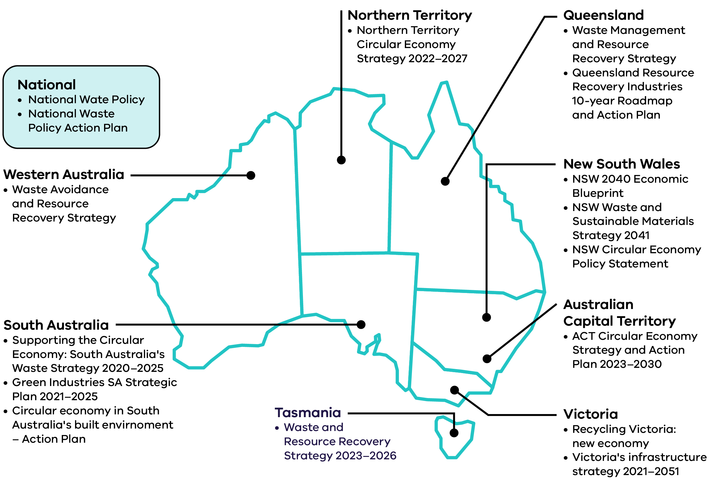

## National action towards a circular economy

**Some of the key actions taken by the Australian Government to facilitate the transition to a circular economy since the previous Circular Economy Market Report are outlined below.**

### Circular Economy Ministerial Advisory Group

The Australian Government is supporting the transition to a circular economy through the Circular Economy Ministerial Advisory Group who released their final report The Circular Advantage (DCCEEW 2024b) in December 2024. The report talks to national policy, economics and investment settings, net zero, the built environment and design and consumption of products. The report also recommends ways the government can boost Australia’s circular economy through improving the country’s domestic manufacturing capabilities through reuse, repair and recycling. The report made 14 core recommendations including the introduction of a new National Circular Economy Policy Framework (DCCEEW 2024b).

Australia’s Circular Economy Framework sets out Australia’s 10-year commitment to progress a circular economy, with a goal to double Australia’s circularity by 2035. To achieve this, the framework sets targets to:

* shrink Australia’s per capita Material footprint by 10%
* lift Australia’s material productivity by 30%

safely recover 80% of Australia’s resources.

### Recycling Modernisation Fund (RMF)

The Recycling Modernisation Fund continued to support the expansion of Victoria’s capacity to sort, process and remanufacture glass, plastic, paper and cardboard during 2023–24 (DCCEEW 2024f). During 2023–24 $134 million was invested, including $40 million government co-funding and $94 million third party funding, to support improved capacity and recovery across material recovery facilities, glass recycling facilities, paper recycling facilities and plastic recycling facilities (DCCEEW 2024f). The additional sorting and recycling capacity funded by the RMF supports Victoria’s transition to a circular economy by allowing more materials to be reused, recycled or remanufactured when they are no longer useful or required for the initial purpose.

### Australian Packaging Covenant Organisation product stewardship scheme accreditation

The Australian Packaging Covenant Organisation (APCO) product stewardship scheme (accredited by the Australian Government in 2022) has continued to progress work to improve the design of packaging to reduce waste and improve recyclability with a focus on achieving the 2025 National Packaging Targets and implement product stewardship projects targeting the recovery of specific material streams.

### National Packaging Reform

The Australian Government is considering potential options to reform Australia’s packaging regulation with consultation undertaken in October 2024 (DCCEEW 2024i). This will help the government to understand the impacts reforms will have on communities, businesses, regulators and the environment.

### National Design Standard Working Group

In 2024, the Australian Government established an independent National Design Standard Working Group who developed a Design for Kerbside Recyclability Grading Framework. The Framework aims to encourage best practice design while allowing packaging to perform essential functions. Consultation on the Framework will commence in early 2025.

### Environmentally Sustainable Procurement Policy

The Environmentally Sustainable Procurement (ESP) Policy came into effect for government procurements of construction services at or above $7.5 million from 1 July 2024 (DCCEEW 2024g). The policy leverages Australian Government procurement to promote circular economy principles and deliver on Target 4 of the National Waste Policy Action Plan (DCCEEW 2024h). The focus of the policy is increasing climate, environmental and circular economy outcomes. It targets the construction, furniture and equipment, ICT and textile industries through Australian Government procurement practices.

Productivity Commission review on resource efficiency impact on economic growth The Productivity Commission, an independent research organisation and advisor to government on economic, social and environmental issues, announced an inquiry into Australia’s opportunities in the circular economy in August 2024. The inquiry will identify priority circular economy opportunities and advise on how best to measure progress and address barriers (Productivity Commission 2024).

## Victorian Government actions towards a circular economy

**Some of the key actions taken by the Victorian government to progress a circular economy since the last Circular Economy Market Report are outlined below.**

### Circular Economy Business Support Fund

The Circular Economy Business Support Fund has continued to support Victorian businesses to reduce waste and extend the life and value of products and materials currently wasted. Round 3 recipients were announced on 17 November 2023. Round 3 funding was granted to support projects that enhance the capability and capacity of Victorian industry to identify, implement, commercialise and scale circular solutions. These projects prevent, minimise or eradicate waste and pollution, while prolonging the use of products and materials at highest value. The projects must improve the environmental outcomes of products, services, industries, supply chains or systems and contribute to Victoria’s transition to a circular economy.

### The Circular Economy Innovation Fund

The Circular Economy Innovation Fund has continued to support Victorian businesses and collaborative partnerships to undertake projects that improve awareness and understanding of circular economy and enhance circular economy business innovation in Victoria. Round 4 recipients were announced on 16 July 2024. Round 4 funding was granted to projects that increase the capacity of Victorian businesses to act on circular economy through:

* delivering capability building training / skills development program for businesses and entrepreneurs
* delivering a challenge, incubator or accelerator program for businesses and entrepreneurs

developing a collaborative action plan by an industry association for transition to a circular economy covering a specified industry sector or supply-chain.

Together, the Circular Economy Innovation Fund and Business Support Fund launched 14 projects this year that collectively diverted 1,500 tonnes of waste, introduced 13 new circular products and services, and generated 24 new full-time equivalent (FTE) jobs.

### Continued waste levy relief rebate program for the charitable recycling sector

The Victorian Government has continued to provide ongoing waste levy relief for eligible charitable reuse organisations. This support covers the cost of disposing of materials to landfill that have been donated but cannot be sold for reuse or recycled. This relief helps keep the charitable sector viable so that it can continue to support the circular economy by providing a market for on selling of donated goods.

### Container deposit scheme

In its first year of operation, more than 1 billion containers were received at refund collection points. Containers collected by the scheme were able to be transformed into all kinds of new recycled materials, creating new economic opportunities across Victoria, increasing the recycling of drink cans, bottles and cartons to reduce Victoria’s litter by up to half and contributing to Victoria’s target of diverting 80% of all material away from landfill by 2030.

### Four bin waste and recycling reform

The Victorian Government has continued to assist councils and Alpine Resorts Victoria (ARV) to phase in new standardised 4 stream household waste and recycling system. This has included supporting councils and ARV to buy new bins, improve drop-off facilities, deliver education campaigns, and ensure that they have the infrastructure in place to roll out these reforms. Separation of household waste and recycling into the 4 streams helps facilitate a circular economy by increasing the volume and quality of materials that can be recovered for recycling and reuse and allows the Victorian economy to get the most value from its resources. To date, 57 of the 79 councils have adopted FOGO services, and 36 councils have introduced access to separate glass collection.

### Waste to energy licences

Regulations were finalised to set the waste to energy cap limit and establish the cap licencing process. On 10 December 2024, the Victorian Government released the Economic Growth Statement – Victoria: Open for Business which commits to:

* setting the waste to energy cap at 2 million tonnes per annum initially to enable more municipal, commercial and industrial waste to be used to generate energy rather than go to landfill

preparing an additional RIS, for consultation in early 2025, on increasing the cap limit to 2.5 million tonnes per annum.

The Victorian Waste to Energy Framework recognises the role of waste to energy to divert waste from landfill, noting that it sits below reuse and recycling in the waste hierarchy (Recycling Victoria 2024e). The Framework supports appropriate investment in waste to energy and includes a cap on the amount of waste that can be heat treated to recover energy, to place a limit on the amount of waste materials can be treated this way.

### Recycled First Policy

The Recycled First Policy has continued to support a circular economy by driving innovation and supporting a sustainable Victorian market for reused and recycled materials in Victoria’s large transport infrastructure projects. Over the last year, high quantities of crushed concrete and site-won materials have been adopted in transport projects, while small quantities of emerging waste materials such as plastics have also been used.

### Victorian Recycling Infrastructure Plan

The Victorian Recycling Infrastructure Plan (VRIP) was published in October 2024 and identifies infrastructure needs and gaps, driving innovation and potential investment where it is needed most to support Victoria’s circular economy. The VRIP provides:

* industry, local government and investors with in-depth infrastructure needs analysis to consider recycling capacity and capability
* place-based assessments of each material stream
* regional opportunities

land use planning.

The Waste, Recycling and Resource Recovery Investment Prospectus was published to accompany the VRIP and further support circular economy infrastructure development.

### Circular Economy Risk, Consequence and Contingency Plan 2024

The Circular Economy Risk, Consequence and Contingency Plan 2024 was published outlining the risks of disruption to essential waste, recycling and resource recovery services in Victoria. This annual plan and the regulatory framework ensures that contingency plans are developed and implemented to improve resilience of the sector and minimise the impact of any serious disruptions to service delivery.

### Behaviour change initiatives

In 2023–2024, there was continued delivery of the Small Acts, Big Impact statewide campaign through public relations, direct mail, stakeholder engagement, events and council support.

The Circular Economy Communities Fund concluded in June 2024, achieving positive behaviour changes for over 82,000 Victorians, creating 103 jobs, leveraging 134,000 volunteer hours, and reducing waste to landfill by 2,300 tonnes. As part of this initiative, a Community Organisation Capability Building Program delivered 23 education workshops attended by 533 individuals and hosted 12 forums, producing 6 capability statements for specialised waste recovery streams.